Pollen Morphology of Some Phyllanthus Species in Nigeria

Wahab, Olasumbo Monsurat¹ and Ayodele, Abiodun Emmanuel²

^{1.} Department of Crop Production Technology, Federal College of Forestry, Ibadan. Nigeria
^{2.} Department of Botany, University of Ibadan, Ibadan. Nigeria
olasumbowahab@yahoo.com

Abstract: Circumscription of the genus Phyllanthus has been a cause of much confusion and disagreement. The fact that many herbaceous Phyllanthus species grow in similar habitats and share common vernacular names in Nigeria give rise to misidentifications. Field and Herbarium observations of some Phyllanthus species show that there are similarities of highly conspicuous morphological features, making identification of the species difficult. The pollen grain morphology of 18 field specimens comprising 10 Phyllanthus species using light microscope was therefore analysed in the present study with the aim of providing additional information on their taxonomy. The pollen type of the species have 3 – colporate, finely reticulate pollen without much ornamentation. Pollens were prolate, subprolate in shape in all taxa except P. muellerianus which was oblate–spheroidal. The pollen grains ranged in size from small in P. amarus, P. muellerianus, P. maderaspatensis, P. pentandrus and P. reticulatus to medium in P. maderaspatensis, P. capillaris, P. niruroides, P. odontadenius and P. urinaria. The smallest pollen size was observed in P. muellerianus being 12.4μm by 13.0μm while the largest pollen size was observed in P. capillaris being 31.5μm by 23.25μm. The colpi length ranged from 12.2μm in P. muellerianus to 26.75μm in P. urinaria while the percentage polar over equatorial axis ranged from 95.4% in P. muellerianus to 145.8% in P. niruroides. Information obtained from the study do not only corroborate the existing information on the genus, they can be used in conjunction with other characters to delimit the species in the genus.
[Wahab, Olasumbo Monsurat and Ayodele, Abiodun Emmanuel. Pollen Morphology of Some Phyllanthus Species in Nigeria. N Y Sci J 2018;11(10):40-45]. ISSN 1554-0200 (print); ISSN 2375-723X (online). http://www.sciencepub.net/newyork. 6. doi:10.7537/marsnys111018.06.

Keywords: Phyllanthus species; pollen characters; taxonomic implications; Nigeria

1.Introduction
Phyllanthus is one of the 79 genera of Phyllanthaeceae (http://www.the plantlist.org) which include Margaritaria L.f., Flueggea Willd, Securinega Comm.ex Juss, Antidesma Burm, Bridelia Willd, Cicca Baill, Hymenocardia Walli ex Lindi, Uapaca Baill. All of these genera are found in Nigeria. Margaritaria is sister to all genera of Phyllanthaceae with phyllantoid branching (Samuel et al., 2005). The genus Phyllanthus has a diversity of growth forms including terrestrial or floating aquatics, pachycaulous succulents, trees, shrubs, climbers, annual and perennial herbs. Some species have flattened leaf-like stems or modified branchlets called phylloclades. All these growth forms are distributed in all tropical and subtropical regions of both hemispheres (Webster, 1994). They are found in open and shaded conditions in rocky areas, waste grounds, roadsides, on termitaria, cultivated fields and swamps in different vegetational zones including the grassland, derived savanna and rainforest. According to Webster (1994) and Silva (2009), despite the variety of growth forms, almost all Phyllanthus species express a specific type of growth called “phyllanthoid branching” in which the leaves on the main (vertical) plant axes are reduced to cataphylls while leaves on the plagiotropic (horizontal) axes are deciduous and floriferous. Indeed, leaf flower is the common name for all Phyllanthus species and ‘Phyllanthus’ means ‘leaf and flower’ because the flowers as well as the fruits are associated with the leaf (Cabiesses 1993). Govaerts et al., (2000) reported that with increasing knowledge from molecular phylogenetic studies and more genera being embedded in the genus Phyllanthus, the species number has increased tremendously making it a giant and heterogeneous genus.
The circumscription of the genus has been a cause of much confusion and disagreement. The fact that many herbaceous Phyllanthus species grow in similar habitats and share common vernacular names in Nigeria give rise to misidentifications. Field and Herbarium observations of some Phyllanthus species show that there are similarities of highly conspicuous morphological features, making identification of the species difficult.
The heterogeneity in plant architecture in association with pollen grain ornamentation were proposed as the main taxonomic characters to establish the sections within the genus (Webster, 1956, 1957, 1958, 1988, 1994a, 1999, 2002; Webster & Airy Shaw, 1971; Webster & Proctor, 1984). These structures were shown to be an important tool in understanding the evolution of Phyllanthus species at section and subsection levels.
The pollen grain morphology of Phyllanthus species using light microscope was therefore analysed in the present study with the aim of providing additional information on their taxonomy.

2. Materials and Methods
The method of acetolysis and slide preparation after Erdtman (1952) and terminologies used in description of the pollens were based on that of Erdtman (1952) and Moore et al., (1991). To each numbered plastic centrifuge tube containing pollen sample from flower buds of 18 field specimens and preserved in 50% ethanol was added 5ml of acetolysis mixture (9 parts acetic anhydride to 1 part concentrated Sulphuric acid) and heated in a water bath from 70ºC to boiling point, stirring occasionally. This was left in the boiling water for 5 minutes. Acetolysis mixture left over was then poured into the special bottle labeled ‘Acetolysis waste’. It was centrifuged while still hot and decanted into the special bottle, distilled water was added and shaken vigorously with a mixer, centrifuged and decanted. This was repeated four times to rinse off the acetolysis mixture. Fifty percent aqueous glycerol was added and then left for at least 30 minutes, later vigorously mixed on the mixer, centrifuged for 10 minutes and then decanted. It was mixed thoroughly and stored in well labeled vials from where aliquots of it were mounted on slides.
Mounting of slides
Slides were cleaned with cotton wool soaked in ethanol and labeled appropriately, a drop or two of the aliquot were then placed at the center of the slide and covered with a cover slip for it to spread evenly. The sides of the cover slip were sealed with nail varnish and then studied under the light microscope, Photomicrographs of the specimens were taken using Leica CME with a digital microscope eyepiece attached and photo explorer 8.0 SE basic software. All slides were deposited in the herbarium of the Department of Botany, University of Ibadan, Ibadan, Nigeria.

3. Results
The qualitative and quantitative pollen morphological characters of some of the species in the genus Phyllanthus are presented in Table 1. The pollen type of the species studied have 3 – colporate, finely reticulate pollen without much ornamentation. Pollens were prolate, subprolate in shape in all taxa studied except P. muellerianus which was oblate–spheroidal (Table 1, Plate 1d). The pollen grains ranged in size from small in P. amarus, P. muellerianus, P. maderaspatensis, P. pentandrus and P. reticulatus to medium in P. maderaspatensis, P. capillaris, P. niruroides, P. odontadenius and P. urinaria (Table 1). The smallest pollen size was observed in P. muellerianus being 12.4μm by 13.0μm while the largest pollen size was observed in P. capillaris being 31.5μm by 23.25μm. The colpi length ranged from 12.2μm in P. muellerianus to 26.75μm in P. urinaria (Table 1) while the percentage polar over equatorial axis ranged from 95.4% in P. muellerianus to 145.8% in P. niruroides.

Table 1: Qualitative and Quantitative pollen characters of Phyllanthus species in Nigeria
Taxa | Polar axis (P)  (µm) | Equatorial axis (E)  (µm) | Colpi length  (µm) | Pollen class | P/E (%) | Pollen size
Phyllanthus amarus | 17.5(20.75±2.06)22.5 | 15.0(16.75±1.21)17.5 | 15.0(18.5±1.75)20.0 | Subprolate | 123.9 | Small
P. capillaris | 25.0(31.5±3.16)35.0 | 20.0(23.25±1.69)25.0 | 22.5(25.75±2.65)30.0 | Prolate | 135.5 | Medium
P. maderaspatensis | 20.0(23.0±3.07)27.5 | 12.5(18.25±2.65)22 | 20.0(21.0±1.29)22.5 | Subprolate | 126.0 | Small
P. muellerianus | 11.0(12.4±0.84)14.0 | 12.0(13.0±0.67)14.0 | 11.0(12.2±0.79)13.0 | Oblate-spheroidal | 95.4 | Small
P. niruri | 25.0(30.75±4.42)37.5 | 17.5(22.25±3.22)27.5 | 17.5(24.0±4.12)30.0 | Prolate | 138.2 | Medium
p. niruroides | 25.0(26.25±1.32)27.5 | 15.0(18.0±1.97)20.0 | 22.5(24.5±1.97)27.5 | Prolate | 145.8 | Medium
P. odontadenius | 22.5(28.25±3.34)32.5 | 17.5(22.2±2.49)25.0 | 20.0(23.0±1.97)25.0 | Subprolate | 127.0 | Medium
P. pentandrus | 22.5(24.0±1.29)25.0 | 17.5(18.25±1.21)20.0 | 20.0(21.5±1.29)22.5 | Subprolate | 131.5 | Small
P. reticulatus | 15.0(16.5±1.75)20.0 | 12.5(14.0±1.29)15.0 | 15.0(16.25±1.32)17.5 | Subprolate | 117.9 | Small
P. urinaria | 22.5(25.5±2.84)30.0 | 12.5(18.25±2.37)20.0 | 22.5(26.75±2.90)30.0 | Prolate | 139.7 | Medium

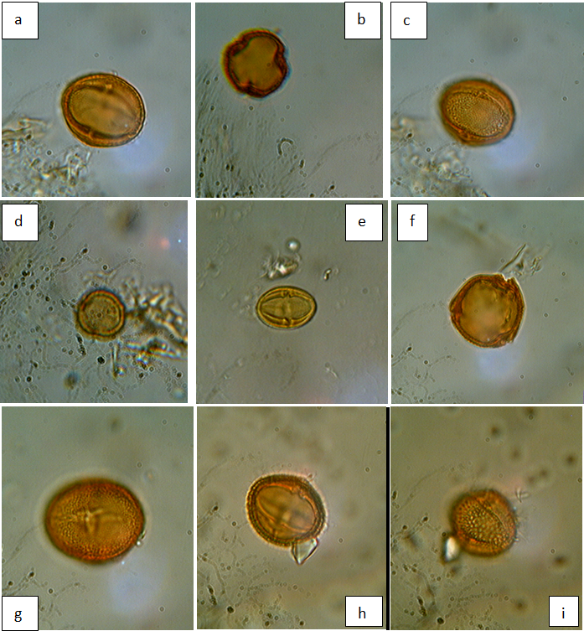
Plate 1: Photomicrographs of pollen grains of Phyllanthus species in Nigeria.
a: Equatorial view of Phyllanthus amarus
b: Polar view of Phyllanthus amarus
c: Equatorial view of Phyllanthus amarus showing reticulate pattern
d: Polar view of Phyllanthus muellerianus
e: Equatorial view of Phyllanthus niruri
f: Polar view of Phyllanthus niruri
g: Equatorial view of Phyllanthus niruri showing reticulate pattern
h: Equatorial view of Phyllanthus pentandrus
i: Polar view of Phyllanthus pentandrus showing reticulate pattern

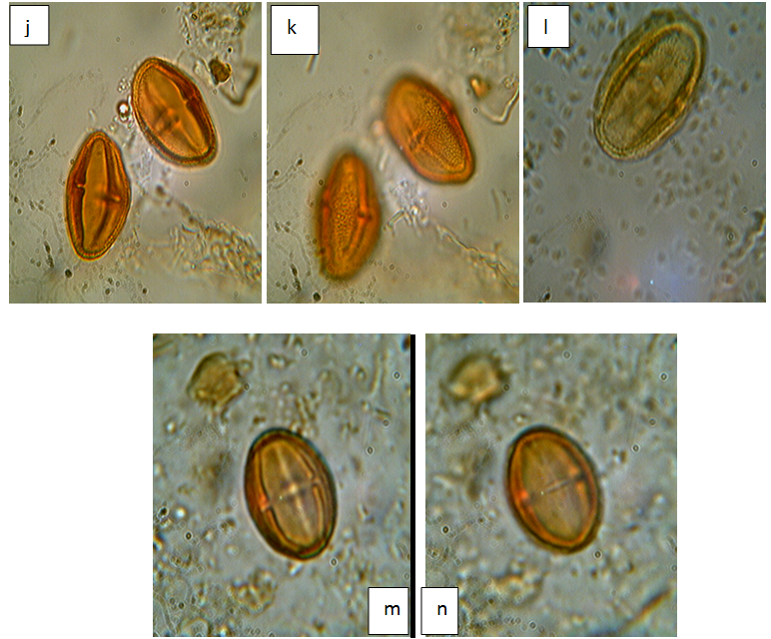
Plate 2: Photomicrographs of pollen grains of Phyllanthus species in Nigeria.
j: Equatorial view of Phyllanthus odontadenius
k: Equatorial view of Phyllanthus odontadenius showing reticulate pattern
l: Equatorial view of Phyllanthus urinaria
m: Equatorial view of Phyllanthus capillaris
n: Equatorial view of Phyllanthus capillaris

4. Discussion and Conclusion
Pollen morphology and evolutionary characteristics in the genus Phyllanthus have been extensively studied (Punt, 1962, 1967, 1972, 1980; Punt and Rentrop, 1974; Bor, 1979; Meewis and Punt, 1983; Lobreau-Callen et al., 1988; Webster, 1994a, 1994b). Webster (1956) reported pollen morphology and architectural pattern of the species to be considered the main characteristics useful in Phyllanthus taxonomy. He reported that a large number of Phyllanthus species showed 3–colporate and reticulate pollen grains which have been reported in the primitive tribes of Phyllanthoideae. These structures were shown to be an important tool in understanding the evolution of Phyllanthus species at section and sub-section levels. This led Webster (1956, 1957 & 1958) to propose species of the section Phyllanthus as the ancestors of section Chroretropsis. In the present study, pollens were reported to be prolate or subprolate in shape except P. muellerianus which was found to be oblate-spheroidal (Table 1, Plate 1b and 1d). This could be regarded as a diagnostic feature to distinguish P. muellerianus from other taxa studied.
Webster (1956-1958) accumulated much phytomorphological, cytotaxonomical (Webster and Ellis, 1962) and other taxonomical data that some species were considered primitive and others appeared to be advanced. Hence Punt (1967) reported that pollen morphology might give additional support for the position of Webster’s primitive and advanced taxa and that if their pollen morphology and taxonomy would arrive at the same conclusion, it would mean a real advance in the subdivision of the genus. Webster (1956) suggested that there is a relationship between Phyllanthus and the presumably primitive genera Securinega, Andrachne and Savia of the same family having found out that some species of Phyllanthus e.g Phyllanthus maderaspatensis (also documented for Nigeria) which show relationships with their genera are the most primitive ones in the genus. Thus, Punt (1962); Webster (1956) and Kӧhler (1965) logically concluded that the characteristics (tricolporate, distinctly prolate, reticulate and an elongated endoaperture) which the pollen grains of their taxa exhibit are also primitive. In addition, Punt (1967) also recognized that the so called ‘primitive’ pollen grains of the genus Phyllanthus are already ‘advanced’ in comparison to the other pollen types in the plant kingdom. A number of evolutionary trends within the genus Phyllanthus have already been presented by Punt (1967) and due to more recent and extensive investigations, a reconsideration with regard to the evolutionary trends within Phyllanthus was presented by Meewis and Punt (1983) where P. amarus type was reported to include only one species P. pentandrus with many more species (such as P. odontadenius from Africa and P. fraternus from other continents) from the subgenus Phyllanthus. Hence the information obtained from the present study on the pollen morphological characters of the Phyllanthus species do not only corroborate the existing information on the genus, they can be used in conjunction with other characters to delimit the species in the genus. In addition, the reported presence of identical pollens can only be resolved when other lines of evidence are examined.

Corresponding author
Wahab Olasumbo Monsurat
Department of Crop Production Technology,
Federal College of Forestry, Ibadan. Nigeria
Telephone: +234-802 3516 870
E-mail: olasumbowahab@yahoo.com

References
- The Plant List. Version 1. Published on the internet, 2010; http://www.the plantlist.org/ (accessed 8/8/2016)
- Samuel, R., Kathriarachchi, H., Hoffmann, P., Barfuss, M., Wurdack, K.J. and Chase, M.W. Molecular phylogenetics of Phyllanthaceae: Evidence from plastid matK and nuclear PHYC sequences. American Journal of Botany 2005; 92: 132–141.
- Webster, G.L. Classification of the Euphorbiaceae. Annals of the Missouri Botanical Garden 1994a; 81: 3-32.
- Webster, G.L. Synopsis of the genera and suprageneric taxa of Euphorbiaceae Annals of the Missouri Botanical Garden 1994b; 81: 33–144.
- Silva, M.J. Neotropical Phyllanthaceae. In: Milliken, W. Klitgard, B. & Baracat, A. (2009) Onwards Neotripikey-Interactive key and information resources for flowery plants of the Neotropics htt://www.kew.org/ science/tropamerica/ neotropikey/families/Phyllanthaceae.htm 2009.
- Cabieses, F. Apuntes de medicina traditional. La Racionalizcion de lo lrracional. ‘Notes on Traditional Medicine.’Consejo Nacional de Ciencia Y Technologia CONCYTEC Lima- Peru 1993; pp 414.
- Govearts, R., Frodin, D.G. and Radcliffe-Smith, A. World checklist and Bibliography of Euphorbiaceae. 2000; 4 vols. Royal Botanic Gardens, Kew.
- Webster, G.L. Studies on the Euphorbiaceae, Phyllanthoideae II. The American species of Phyllanthus described by Linnaeus. J. Arnold Arb 1956; 37(1): 1-14.
- , G.L. A monograpgic study of the West Indian species of Phyllanthus. Journal of the Arnold Arboretum 1956-1958; 37: 91-122, 217-268, 340-359; 38: 51-80, 170-198, 295-373; 39: 49-100, 111-212.
- , G.L. A revision of Phyllanthus (Euphorbiaceae) in eastern Melanesia. Pacific Science 1988; 40: 88–105.
- , G.L. Phyllanthus. In: Berry, P.E, Yatskievych K, Holst B.K, eds. Flora of the Venezuelan Guayana 1999; Vol.5. St Louis: Missouri Botanical Garden Press, 191-205.
- , G.L. A synopsis of the Brazillian taxa of Phyllanthus section Phyllanthus (Ephorbiaceae). Lundellia 2002; 5:1-26.
- , G. L. and Airy-Shaw, K. H. A provisional synopsis of the New Guinea taxa of Phyllanthus (Euphorbiaceae). Kew Bull. 1971; 26(1): 85-109.
- , G.L and Proctor G.R. A new species of Phyllanthus (Euphorbiaceae) from the Cayman Island. Rhodora 1984; 86: 121–125.
- Erdtman, G. Pollen morphology and Plant taxonomy: angiosperms. Chronica Botanica Co. Waltham, Massi USA. 1952; 539p.
- Moore, P.D., Webb, J.A and Collinson, M. Pollen analysis. Blackwell, London, 1991; pp 226.
- Punt, W. Pollen morphology of Euphorbiaceae with special reference to taxonomy. Wentia 1962; 7: 1-116.
- , W. Pollen morphology of the genus Phyllanthus (Euphorbiaceae). Review of Palaeobotany and Palynology 1967; 3: 141-150.
- , W. Pollen morphology and taxonomy of section of Ceramanthus Baillon s. l. of the genus Phyllanthus (Euphorbiaceae). Review of Palaeobotany and Palynology 1972; 13: 213-228.
- , W. Pollen morphology of the Phyllanthus species (Euphorbiaceae) occurring in Guinea. Review of Palaeobotany and Palynology 1980; 31: 155-177.
- , W. and Rentrop, J. Pollen morphology of the Phyllanthus species occurring in the continental United States. Review of Palaeobotany and Palynology 1974; 16: 243-261.
- Bor, J. Pollen morphology and the bi- reticulate exine of the Phyllanthus species (Euphorbiaceae) from Mauritius and Reunion. Review of Paleobotany and Palynology 1979; 27: 149-172.
- Meewis, B and Punt, W. Pollen morphology and taxonomy of the subgenus Kirganelia (Jussieu) Webster (genus Phyllanthus, Euphorbiaceae) from Africa. Review of Palaeobotany and Palynology 1983; 39: 131-160.
- Lobreau-Callen, D., Punt, W. and Schmid, M. Pollen morphology and taxonomy of the Phyllanthus species (Euphorbiaceae) native to New Caledonia. Review of Palaeobotany and Palynology 1988; 54: 283-304.
- Webster, G.L and Ellis, J.R. Cytotaxonomic studies in the Euphorbiaceae subtribe Phyllanthinae. American Journal of Botany 1962; 49: 14-18.
- Köhler. E. Die Pollen morphologie der biovulaten Euphorbiaceae and ihre Bedeutung füdie Taxonomie. Grana Palynologica. 1965; 6: 26-120.

10/25/2018

