Effects of Heavy Metals on floristic attributes in human-influenced wetlands within Uyo Metropolis, Akwa Ibom State, Nigeria

Ita, R. E.

Department of Botany and Ecological Studies, University of Uyo, P.M.B.1017, Uyo, Akwa Ibom State, Nigeria.
Corresponding Author: alwaizfwesh247@yahoo.com

Abstract: Human perturbations evidenced in various forms have led to the consistent deposition of heavy metals, contamination and deterioration of wetlands in Akwa Ibom State. Heavy metal contamination in wetlands is a menace faced throughout the world and requires urgent attention due to the fact that above their permissible limits, they become toxic to plants and also affect their growth and distribution. To this end, it was pertinent to assess the effects of heavy metals on floristic attributes in human-influenced wetlands within Uyo metropolis, Akwa Ibom State, Nigeria. Systematic sampling was carried out using a quadrat of 5m × 5m spaced at regular intervals of 20 m. Density and frequency were determined for respective plant species. Soil samples were collected using a soil auger at different rooting depths (0 – 15cm and 15 – 30cm) and analyzed for Pb, Zn, Fe, Ni and Cd using standardized methods. The results showed numerical variations as 17 and 11 flora species were encountered in the rural and urban wetlands, respectively. In the rural wetland, Elaeis guineensis was the most dominant species in terms of density (3200±0.20 stems/ha) and frequency (60%) while and Persicaria senegalensis dominated in density (1200±0.13 stems/ha) and frequency (100%) in the urban wetland. Assessment of the heavy metal contents in the soils revealed that the mean values of Fe (713.22 ± 59.39), Pb (5.95 ± 0.42), Zn (88.54 ± 8.03) and Cd (1.53 ± 0.65) were higher in the urban wetland while Ni (9.45 ± 1.56) was higher in the rural wetland. The effects of heavy metals on plant distribution was established using regression analysis. With regards to the density and frequency of species in the rural wetland, Fe and Pb showed a positive relationship while Ni, Cd and Zn related negatively with these vegetation parameters. In the urban wetland, Fe and Ni related positively with density and frequency while Pb, Cd and Zn associated negatively with these vegetation components. This result clearly depict that heavy metals above their tolerance levels have detrimental effects on the growth of plants and as such, human activities around wetlands should be monitored to ensure the protection and sustenance of this ecosystem over time.
[Ita, Richard Ekeng. Effects of heavy metals on floristic attributes in human-influenced wetlands within Uyo Metropolis, Akwa Ibom State, Nigeria. N Y Sci J 2018;11(10):10-18]. ISSN 1554-0200 (print); ISSN 2375-723X (online). http://www.sciencepub.net/newyork. 2. doi:10.7537/marsnys111018.02.

Keywords: Heavy metals, flora, anthropogenic activities, wetlands, density, frequency, soil.

- Introduction
Wetlands in tropical areas are constantly undergoing threats and degradation from industrial and domestic activities. As a result of these, pollutants are being released in copious amounts into the water and soil over time. Among these pollutants, heavy metals have been reported to be very toxic to humans and plants in high quantity (Duffus, 2002; Lenntech, 2004). Others such as Cr, Pb, Cd, and As exhibit extreme toxicity even at trace levels (Miller et al., 2003). The gradual release and accumulation of heavy metals in wetlands are not without consequences to humans and plants especially when they are being transported along the food chain.
Plants have the potentials of accumulating essential metals such as Ca, Co, K, Mo, Na, Mg and Mn, from the soil. During this process certain non-essential metals like Al, Cd, Ni, Pb, Cr, As and Hg, which do not have any contribution in biological function also accumulate in the plants (Djingova and Kuleff, 2000). When this happens, the breakdown of these metals becomes impossible and when their concentrations in the plant cells increase above threshold levels, the consequences may be direct toxicity to plant by destroying cell structure and hindering the function of many cytoplasmic enzymes (Assche and Clijsters, 1990). Moreover, indirect toxic effects may be evidenced by substitution of nutrients at cation exchange spots in plants (Taiz and Zeiger, 2002). According to Schaller and Diez (1991), increased heavy metal concentrations in the soil can cause elevated crop uptake and also pose stress on plant growth (Schmidt, 2003). At higher quantities, they inhibit growth and obstruct metabolic processes which can result in death of plants.
Wetland ecosystems in the tropics are being devalued by various human activities leading to their destruction and degradation at varying spatial and temporal scales. This can go a long way to causing a decline in plant community inhabiting these habitats. Consequently, this study is aimed at assessing the effects the individual heavy metals have on the composition of plant species in terms of their growth and frequency.
2. Materials and Methods
2.1. Study Area
This study was carried out in Mbak Akpan Ekpenyong and Udoudoma wetlands within Uyo metropolis, Akwa Ibom State (Figure 1). Both represent the rural and urban wetlands, respectively. The rural wetland located at the outskirt of the state capital, is less disturbed by human activities while the urban wetland is highly characterized by anthropogenic activities like waste disposal, infrastructural and residential developments, washing and bathing. Akwa Ibom State is located in the coastal Southern part of Nigeria, lying between longitudes 7º 25’E and 8º 25’E’, and latitudes 4º 32’N and 5º 33’N. The area is characterized by two distinct seasons; dry and rainy seasons. The total annual rainfall varies from 4000mm along the coast to 2000mm inland. The average humidity is about 75% to 95%. Temperature values are relatively high in Akwa lbom State throughout the year, with the mean annual temperatures varying between about 26°C to 36°C (AKSG, 2008). The specific coordinates of the ponds are delineated in Table 1.

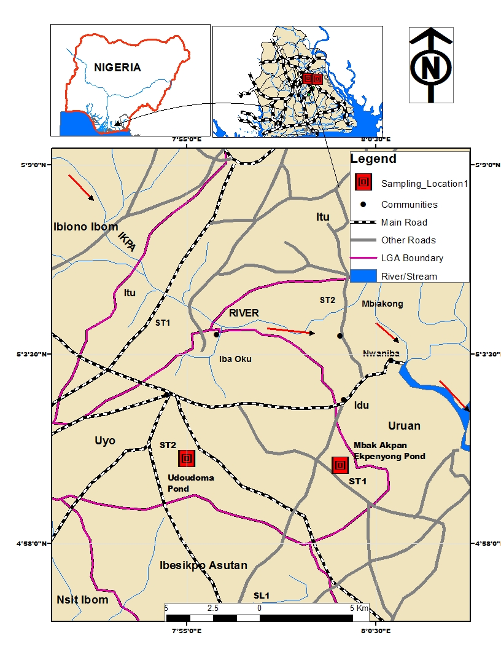

Figure 1: Map of the study area showing sampling stations

Table 1: Coordinates of the Study areas
 | Longitudes | Latitudes
Rural wetland | 7º 59’ 9” E | 5º 0’ 7” N
Urban wetland | 7º 55’ 19” E | 5º 0’ 35” N

2.2. Vegetation and Soil Sampling
Four vegetation plots were used for this study. In each plot, two (2) belt transects were laid and in each transect, vegetation and soil were sampled systematically (Cochran, 1963) in four (4) 5 m × 5 m quadrat spaced at regular intervals of 20 m. In each quadrat, frequency and density were determined for individual species. Using a soil auger, soil samples were obtained at two different rooting depths (0 – 15 cm and 15 – 30 cm) in each of the quadrat and preserved in labeled ziploc bags for laboratory analyses. Known plant species were identified to family, genus, and species level with the aid of manuals developed by Johnson (1997), Okezie and Agyakwa (1998) and Arbonnier (2004). Unknown plant species were collected for proper identification and confirmation with the voucher specimens in Botany and Ecological Studies Herbarium, University of Uyo, Uyo.

2.3. Determination of Vegetation parameters
2.3.1. Density: The density of plant species was estimated by enumerating all plants present in each plot using the method outlined by Cochran (1963).
2.3.2. Frequency: This was calculated as a ratio of the number of quadrat occupied by a species to the total number of quadrat thrown multiplied by 100.

2.4. Physicochemical analysis of Heavy metals in soil samples
Soil samples were ground, mixed, and divided into fine particles that could pass through a 0.5-mm sieve. Soil samples were digested by adding 2 g of soil to 15 ml of concentrated nitric acid and perchloric acid at a ratio 1:1, and allowed to stand for 135 minutes until the mixture became colourless. The samples were filtered and washed with 15 ml of deionized water, and made up the filtrate to 100 ml in a standard flask. Five heavy metals (lead, iron, zinc, cadmium, and nickel) were determined in the filtrate at their respective wavelengths using an atomic absorption spectrophotometer (AAS).

2.4 Statistical analysis
Mean and standard error were computed from replicates of physico-chemical parameters using Statistical Package for Social Sciences (SPSS 20.0). Regression analysis was also done using SPSS 20.0 to show the effects the heavy metals had on the floristic attributes.

3.0 Results
3.1 Floristic Composition
Seventeen (17) plant species belonging to twelve (12) families and sixteen (16) genera were recorded from the rural wetland (Table 2) while eleven (11) plant species representing ten (10) families and ten (10) genera were recorded from the urban wetland (Table 3).
In the rural pond, Elaeis guineensis had the highest density and frequency values of 3200±0.20 stems/ha and 60% while Pentaclethra macrophylla had the lowest density (160 ± 0.11 stems/ha).
In the urban pond Persicaria senegalensis dominated in density (1200±0.13 stems/ha) and frequency (100%). Commelina communis, Gliricidia sepium, Ludwigia erecta and Lagenaria breviflora had the least density of 80±0.40, 80±0.11, 80±0.10 and 80±0.41 stems/ha, respectively.

Table 2: Floristic composition of the rural pond
Plant species | Family | Habit | Density (stems/ha) | Frequency  (%)
Alchornea cordifolia | Euphorbiaceae | Shrub | 640±0.00 | 20
Barteria nigritiana | Passifloracaceae | Tree | 960±0.00 | 40
Cnestis ferruginea | Connaraceae | Shrub | 240±2.13 | 20
Commelina lagosensis | Commelinaceae | Herbaceous | 320±0.50 | 20
Crassocephalum crepidioides | Asteraceae | Herbaceous | 240±1.23 | 20
Culcasia scandens | Aracaceae | Herbaceous | 2400±5.32 | 20
Cyrtosperma senaglense | Araceae | Herbaceous | 1040±1.23 | 20
Dissotis rotundifolia | Melastomaceae | Herbaceous | 1600±1.32 | 20
Elaeis guineensis | Aracaceae | Tree | 3200±0.20 | 60
Longocarpus griffoneonus | Fabaceae | Shrub | 240±0.20 | 20
Nephrolepis cordifolia | Lomariopsidaceae | Shrub | 320±0.81 | 20
Palisota hirsuta | Commelinaceae | Herbaceous | 480±0.02 | 20
Pentaclethra macrophylla | Fabaceae | Tree | 160±0.11 | 20
Raphia hookeri | Aracaceae | Tree | 400±0.69 | 20
Sida acuta | Malvaceae | Grass | 400±1.32 | 20
Synsepalum dulcificum | Sapotaceae | Tree | 240±0.10 | 20
Urena lobata | Malvaceae | Herb | 320±2.10 | 20
S.E = Standard error

Table 3: Floristic composition of the urban pond
Plant species | Family | Habit | Density (stems/ha) | Frequency  (%)
Azolla africana | Salviniaceae | Floating macrophyte | 400±0.00 | 40
Commelina benghalensis | Commelinaceae | Herb | 160±0.12 | 20
Commelina communis | Commelinaceae | Herb | 80±0.40 | 20
Elaeis guineensis | Aracaceae | Tree | 240±0.30 | 20
Gliricidia sepium | Euphorbiaceae | Tree | 80±0.11 | 20
Kyllinga diffusa | Cyperaceae | Sedge | 240±0.30 | 20
Lagenaria breviflora | Curcubitaceae | Creeper | 80±0.41 | 20
Ludwidgia erecta | Onagraceae | Herbaceous | 80±0.10 | 20
Nymphaea lotus | Nymphaeceae | Floating macrophyte | 240±0.24 | 40
Panicum maximum | Poaceae | Herbaceous | 320±0.14 | 20
Persicaria senegalensis | Polygonaceae | Herbaceous | 1200±0.13 | 100
S.E = Standard error

3.2 Heavy metals Contents in the Soil
The heavy metal contents in soils of the two wetlands is presented in Table 4. The values for Fe (713.22 ± 59.39), Pb (5.95 ± 0.42), Zn (88.54 ± 8.03) and Cd (1.53 ± 0.65) were higher in the urban wetland while high Ni (9.45 ± 1.56) value was recorded in the rural wetland.

Table 4: Heavy metal contents of soil in the wetlands
Heavy metals  (mg/kg) | Rural wetland | Urban wetland
Fe | 663.65 ± 69.81 | 713.22 ± 59.39
Ni | 9.45 ± 1.56 | 8.41 ± 1.57
Pb | 4.73 ± 0.20 | 5.95 ± 0.42
Zn | 80.23 ± 3.57 | 88.54 ± 8.03
Cd | 1.06 ± 0.16 | 1.53 ± 0.65

3.2.1 Heavy metal–plant relationships
The interrelationships between heavy metals and plant attributes (density and frequency) revealed that in the rural wetland Fe and Pb showed a positive relationship with density and frequency (Figures 2 and 4) while Ni, Cd and Zn related negatively with density and frequency of plant species (Figures 3, 5 and 6).
In the urban wetland, Fe and Ni showed a positive relationship with density and frequency (Figures 6 and 7) while Pb, Cd and Zn associated negatively with plants’ attributes of density and frequency (Figures 8, 9 and 10).

Fig. 2: Regression of Fe with density and frequency

Fig. 3: Regression of Ni with density and frequency

Fig. 4: Regression of Pb with density and frequency

Fig. 5: Regression of Cd with density and frequency

Fig. 6: Regression of Zn with density and frequency

Fig. 7: Regression of Fe with density and frequency

Fig. 8: Regression of Ni with density and frequency

Fig. 9: Regression of Pb with density and frequency

Fig. 10: Regression of Cd with density and frequency

Fig. 11: Regression of Zn with density and frequency

4. Discussion
4.1. Floristic composition
The vegetation physiognomy of the study areas differed in species composition owing to the responses of plant species to different environmental factors and gradients. The total number of plant species obtained from the two wetlands were low when compared with 59 species reported by Mulatu et al. (2014) in a similar ecosystem. The low values in species composition in this study may be a reflection of anthropogenic activities characterized by intense disturbances such as wastes discharge, infrastructural encroachment and selective exploitation. This view corroborates with the findings of Pitchairamu et al. (2008). These researchers opined that undisturbed vegetation stands are characterized by high species richness while disturbed vegetation stands showed low species richness. Variations also occurred in density and frequency of occurrences of species in the wetlands. This may confirm the different production levels of biomass in the sampled plots across the wetlands. Anthropogenic perturbations may further account for low density and frequency values obtained for some species in the ponds. The dominance of Elaeis guineensis and Persicaria senegalensis in the rural and urban ponds may reflect their inherent abilities to adapt to hydric conditions as well as highlighting their wide ecological amplitudes.

4.2 Heavy metal – plant relationships
Regression analysis according to Ubom (2003) is a technique for examining the association between response and explanatory variables. This is established clearly in this study. Fe had a positive relationship with density and frequency of plant species in the rural and urban wetlands. The function of iron in plants cannot be overlooked as it plays a vital role in photosynthesis by aiding chlorophyll synthesis and maintenance of chloroplast structure. This view upholds the earlier reports of Briat et al. (2007) and also confirms the recent findings of Rout and Sahoo (2015) that deficiency of iron causes nutritional disorder in plants resulting in poor growth and yield. Pb associated positively with plants’ density and frequency in the rural wetland and negatively with these vegetation parameters in the urban wetland. The synergistic relationship between Pb with density and frequency of species in the rural pond is not clearly understood but rather this relationship may be interpreted and elucidated in terms of tolerance to this contaminant. This may denote that plant species with high tolerant abilities to this heavy metal infiltration had high density and frequency values while those sensitive with low tolerance to this pollutant had low density and frequency values. This view further affirms the negative relationship of Pb with these vegetation parameters (density and frequency) in the urban wetland. Density and frequency of species related negatively and positively with Ni in the rural and urban wetlands, respectively. This inverse and direct relationships in these ponds may be construed to be a function of the different tolerant capabilities of species to this contaminant. This inverse association may also be inferred to mean that the concentrations of Ni in the soil were high and consequently critical to the growth parameters of the plant species found in the rural wetland. The inability of plant species to adapt to this contaminant might have also yielded the inverse relationship evidenced between Ni and growth parameters of plants (density and frequency) in the rural wetland. Negative relationship patterns evidenced between Cd and Zn with plants’ density and frequency may expound that the concentrations of these heavy metal contaminants in the soil were too high and might have resulted in a decline in growth due to the inability of species to adapt favourably under such environmental stress factors. This substantiates the reports of Sanita´di Toppi and Gabbrielli (1999) that Cd when present in excessive amount in the soil can directly or indirectly inhibit plants’ physiological processes such as, photosynthesis, respiration, cell elongation, plant–water relationships, nitrogen metabolism and mineral nutrition, resulting in poor growth and low biomass. Similar assertions were also made by Weigel and Jäger (1980) and Moya et al. (1993). Studies have shown that high zinc concentrations in the soil can result in phytotoxicity and impairment of photosynthetic processes leading to reduced growth and yield potentials (Doncheva et al., 2001). Early researchers like Collins (1981) had also confirmed that growth inhibition is a general phenomenon associated with zinc toxicity.

5. Conclusion
The study shows that human activities around wetlands have contributed substantially to high concentrations of toxic heavy metals in wetlands. The release of these metals are not devoid of consequences to the flora species inhabiting this fragile ecosystems. While some species are able to adapt, those with low tolerance level show inhibition in growth parameters. The levels of heavy metals in the soils varied remarkably in the wetlands as a function of different intensities of anthropogenic perturbations. Concentrations of Pb, Zn, Fe, and Cd were higher in the urban wetland while Ni concentration was higher in the rural wetland. Heavy metal-plant interactions revealed positive and negative relationships with each other. Conclusively, the information obtained from this study show that the apportionments of heavy metals in wetlands stem from human activities and these metals above their tolerant levels have detrimental impacts on plant species. Hence, appropriate monitoring plans around wetlands should get underway to prevent further contamination and deterioration of this ecosystem.

References
- AKSG (2008). Geography and Location about Akwa Ibom State. Retrieved from http://www.aksg.online.com. Accessed September, 2018

- Assche, F. and Clijsters, H. (1990). Effects of metals on enzyme activity in plants. Plant Cell Environment, 24: 15 – 23.

- Briat, J. F., Curie, C. and Gaymard, F. (2007) Iron utilization and metabolism in plants. Curr. Opin. Plant Biol., 10: 276 – 282.

- Cochran, W. G. (1963). Sampling techniques. 2nd ed. New Delhi: Wiley Eastern Limited, p. 413.

- Duffus, J. H. (2002). Heavy metals – a meaningless term. Pure Appl. Chem., 74:793 – 807.

- Collins J. C. (1981). Zinc. In: Lepp N.W. (ed.). The effect of heavy metal pollution on plants. Applied Science Publishers. pp. 145–170.
- Djingova, R. and Kuleff, I. (2000). Instrumental techniques for trace analysis. In: Trace elements:
Their distribution and effects in the environment Vernet, J. P. (ed.). Elsevier Science Ltd., United Kingdom, 146p.

- Doncheva, S. Z., Stoyanova, V. and Velikova. O. (2001). Influence of succinate on zinc toxicity of pea plants. Journal of Plant Nutrition, 24(6):789 – 804.

- Johnson, D. E. (Ed.) (1997) Weeds of Rice in West Africa. UK: Imprint Design. p. 15 – 89.

- Lenntech (2004) water treatment and air pollution. Water treatment, Lenntech, Rotterdamseweg. Netherlands. Available from www.excelwater.com/thp/filters/water–purification. Retrived May 14th, 2017.

- Miller, C. V., Foster, G. D. and Majedi, B. F. (2003). Baseflow and stormflow metal fluxes from two small agricultural catchments in the coastal plain of Chesapeake Bay Basin, United States. Appl. Geochem. 18(4): 483 – 501.

- Moya, J. L., Ros, R. and Picazo, I. (1993). Influence of cadmium and nickel on growth, net photosynthesis and carbohydrate distribution in rice plants. Photosynthesis Res., 36:75 – 80.

- Mulatu, K., Hunde, D. and Kissi, E. (2014). Impacts of Wetland Cultivation on Plant Diversity and Soil Fertility in South-Bench District, South West Ethiopia. African Journal of Agricultural Research, 9(39): 2936 – 2947.

- Okezie, I.A. and Agyakwa, C.W. (Eds.) (1998) A Handbook of West African weeds. International Institute of Tropical Agriculture (IITA) Nigeria. African Book Builders Ltd. p. 10 – 65.

- Pitchairamu, C., Muthuchelian, K. and Siva, N. (2008). Floristic Inventory and Quantitative Vegetation Analysis of Tropical Dry Deciduous Forest in Piranmal, Forest, Eastern Ghats, Tamil Nade, India. Ethnobotanical Leaflets, 12: 204 – 216.

- Rout, G. R. and Sahoo, S. (2015). Role of Iron in Plant Growth and Metabolism. Reviews in Agricultural Science, 3:1 – 24.

- Sanita´ di Toppi, L. and Gabbrielli, R. (1999). Response to cadmium in higher plants. Environ Exp Bot., 41: 105–130.
- Schaller, A. and Diez, T. (1991). Plant specific aspects of heavy metal uptake and comparison with quality standards for food and forage crops.

- Taiz, L. and Zeiger, E. (2002). Plant Physiology. Sinauer Associates, Sunderland, U.S.A 690p.
- Ubom, R. M. (2003). Biometry. 2nd edition, Uyo: Abams publishers. 210 p.

- Weigel, H. J. and Jäger, H. J. (1980). Subcellular distribution and chemical forms of cadmium in bean plants. Plant Physiol., 65:480 – 482.

10/9/2018

