Modelling the Influence of Relative Humidity on Photosynthetically Active Radiation from Global Horizontal Irradiation in Six Tropical Ecological Zones in Nigeria

Nwokolo Chukwujindu Samuel ¹, Ogbulezie C. Julie ¹, Toge Christal ², John-Jaja Alwell Syvia ³

^{1.} Department of Calabar, Faculty of Science, University of Calabar, Nigeria
^{2.} Department of Botany, Faculty of Science, University of Ibadan, Ibadan, Nigeria
³ Department of Animal Science, Faculty of Agriculture, Babcock University, Ilisha-Remo, Nigeria
Telephone: +2348066806702; nwokolosc@stud.unical.edu.ng

Abstract: In this study, modelling the influence of relative humidity on photosynthetically active radiation (PAR) from global horizontal irradiation (GHI) in six tropical ecological zones in Nigeria (Latitude 4.75-13.067ºN and Longitude 3.333-13.16ºE) using 22-year data (July 1983- June 2005) was analysed. The evaluated values of the PAR clearness index indicates that the prevailing sky condition in the Southern tropical zones is partly overcast while the Northern tropical zones experienced clear sky condition. The annual relative humidity reveals that Port Harcourt, Owerri, Ikeja and Abuja are heavily overcast whereas Maiduguri and Sokoto are partly overcast. From the analyses of the influence of relative humidity on PAR clearness, it was observed that the absorption of GHI in the near infrared (NIR) portion of the solar spectrum is greatly enhanced in the Southern tropical zones as a result of high relative humidity and prolonged rainfall thereby reducing PAR parameters in the zone compare to the Northern tropical zones. The quadratic regression correlation model developed deeming from the model performance test indicates that the proposed model could be used to estimate PAR accurately when the annual relative humidity is greater 64% in the six tropical ecological zones in Nigeria and other locations with comparable sky condition to Nigeria.
[Nwokolo Chukwujindu Samuel, Ogbulezie C. Julie, Toge Christal, John-Jaja Alwell Syvia. Modelling the Influence of Relative Humidity on Photosynthetically Active Radiation from Global Horizontal Irradiation in Six Tropical Ecological Zones in Nigeria. N Y Sci J 2018;11(9):21-35]. ISSN 1554-0200 (print); ISSN 2375-723X (online). http://www.sciencepub.net/newyork. 3. doi:10.7537/marsnys110918.03.

Keywords: Equatorial line; Ecological modelling; Radiometric fluxes; PAR irradiation; Tropics; Global Horizontal Irradiation

1. Introduction
Photosynthetically active radiation (PAR) on the horizontal surface is the photon energy required to model photosynthesis of single plants leaves and plant communities (Alados et al., 1996). Plants ultimately needs PAR as an energy requirement to convert carbon iv oxide (CO₂) and water (H₂O) through photosynthesis into glucose which is used to synthesize structural and metabolic energy needed for plant growth, development, respiration as well as stored vegetative products that result in plant biomass. This radiation component (PAR) can be seen in the process plants used in synthesizing their food as given by the chemical equation:

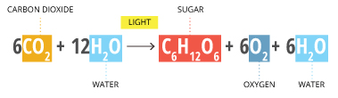 (1)

Where the light represents PAR wavelength range (0.4-0.7µm) that is best fit for photosynthesis to occur (McCree, 1972).
The proper prediction and clear understanding of PAR is not only important for single plant leaves and plant communities but a viable irradiance energy needed for many applications such as energy management, hydrological process and biometeorology, crop production, remote sensing of vegetable, carbon cycle modeling and calculating the euphotic depth in the ocean (McCree, 1972; Wang et al., 2007). In a broad sense, PAR is an indispensable atmospheric parameter nature required for proper distribution of varieties of plants communities and perfecting the ecosystem in the horizons across different continents and regions of the world. The oxygen (O₂) required by man and animal for respiration is equally powered by PAR. Therefore, the study of PAR is a necessity for understanding how plants, animals and man interact and relate with its immediate environment.
Despite these enormous significance of PAR, there are very few standard weather stations able to measure PAR across the globe particularly in Africa and often there is no data available in the location of interest.
In order to correct these anomalies, Williams (1976) conducted a simulation for a wide variety of climatic conditions and observed that the ratio of PAR to global horizontal irradiation (H) is constant between 0.4 and 0.7µm. Tsubo and Walker (2005) investigated worldwide values of routine measured ratio of PAR to GHI between 0.4 and 0.7µm and observed that the ratio basically falls between 0.43-0.49. Moon (1940) computed the spectral distribution of direct sunlight for sea level and suggested that PAR to H was between 44% and 45% at places of low altitudes when the sun was more than 30° above the horizon. Several researchers estimated PAR to be 45% of GHI (Meek et al., 1984; Howell et al., 1983; Li et al., 2010). In Ilorin, Nigeria, (Udo and Aro, 1999) measured hourly and monthly PAR using LI-190SA quantum sensor and reported the constant ratio of between 0.42-0.47.
It is therefore imperative to analyse PAR using H, H_{o}, clearness index and relative humidity parameters since there is no standard station that measures PAR in the selected stations. This will produce PAR data as a baseline for further scientific and environmental research without the substantial cost of the instrumentation network that would otherwise be needed. The aim of this research paper is to develop an empirical model for estimating the influence of relative humidity on photosynthetically active radiation from global horizontal irradiance in six tropical ecological zones in Nigeria.

2. Material and Methods
2.1 Study Area
Nigeria is situated in the tropics between 3°E to 15°E of longitude and 4°N to 14°N of latitude. It is bordered by the Gulf of Guinea to the south, Benin to the West, Niger to the North and Cameroon and Chad to the East. Nigeria comprises 36 states and its Federal Capital Territory, Abuja. Nigeria has a total land area of 923,768sqkm including 13,000sqkm of water, a border length of 4,047km and a coastline of 853km. The highest point in Nigeria is Chappal Waddi at 2,419m (7,936ft) and the lowest is the Atlantic Ocean (0m). The main rivers in Nigeria, River Niger and River Benue, converge in Lokoja (Kogi State) and empty into the Niger Delta, the location of a large area of Central African Mangroves. The climate and vegetation of Nigeria is equatorial in the south, tropical in the center, and arid in the north. There are two distinct seasons in the country: the rainy season and the dry season. Nigeria is indeed a unique tropical country that cuts across all tropical ecological zones. From the Atlantic Ocean down to the edge of the Sahara, all tropical ecological zones are found. These include: the southern zone of Mangrove swamp located between latitude 4º and 6º 30’ N, the Tropical rainforest found around latitude 6⁰ 30’ to 7⁰ 45’ stretching from the southwest to the southeast, the Guinea Savannah belt around latitude 7º 45’ N to 10N, the Sudan Savannah belt around 10⁰N to 12⁰N and the Sahel Savannah in areas above latitude 12⁰N. She is endowed with an annual average daily sunshine of 6.25 hrs ranging between 3.5 hours at the coastal areas and 9.0 hours at the far northern boundary. The minimum and maximum hours of sunshine amount to 0.1 and 9.9 hours respectively. Similarly, it has an annual average daily global solar radiation of about 18.9 MJm⁻²day⁻¹ per day varying between 12.6 MJm⁻²day⁻¹ per day at the coastal areas and 25.2 MJm⁻²day⁻¹ per day at the Northern boundary. The minimum and maximum temperatures are 9.7 and 41.5°C respectively (Etuk et al. 2016).
The long term monthly mean daily global horizontal irradiation (H), rainfall /precipitation, temperature and relative humidity (RH) for the period of 1983-2005 for the selected state capitals and locations whose tropical ecological zones, coordinates and elevations listed in Table 1 and Fig. 1 were obtained from the National Aeronautics and Space Administration (NASA) atmospheric science data center. The H data measured in kwhm⁻²day⁻¹ were converted to MJm⁻²day⁻¹ using a factor of 3.6.
2.2 Acquisition of data

Table 1: States, State Capitals, Coordinates and Tropical Ecological Zones for the selected Stations in Nigeria
States State Latitude Longitude Elevation Tropical Ecological
Capitals (Degree North) (Degree East) (Meters) Zones
Rivers Port Harcourt 4.75 7.00 117 Mangrove Swamp
Imo Owerri 5.485 7.035 176 Mangrove Swamp
Lagos Ikeja 6.583 3.333 73 Tropical Rain Forest
FCT Abuja 9.067 7.483 484 Guinea Savannah
Borno Maiduguri 11.85 13.16 377 Sudan Savannah
Sokoto Sokoto 13.067 5.233 331 Sahel Savannah

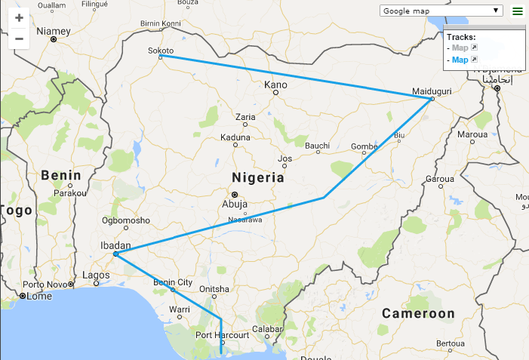
Fig. 1. Map of Nigeria showing the study stations

2.3 Theoretical Formulation of PAR Parameters from GHI Parameters
The modelling of PAR involves the correlation of monthly mean daily PAR to meteorological data such as H, extraterrestrial H, clearness index and relative humidity. Tsubo and Walker (2005) proposed a simple quadratic equation which relates PAR to H and clearness index. However, different relations of linear models were used extensively in PAR studies for estimation of the diffuse, direct and global PAR (Alados and Alados-Arboledas, 1999; Alados et al., 1996; Leonardo et al., 2011; Li et al., 2010) amount from the atmospheric parameters.
In order to generate an appropriate model for the study stations in addition to (Alados and Alados-Arboledas, 1999; Alados et al., 1996; Leonardo et al., 2011; Li et al., 2010) type model, a linear correlation expression which is based on meteorological parameters such as PAR, extraterrestrial PAR, relative humidity (RH) and clearness index (k_{t}) are investigated in this research paper and their performance are calculated statistically in the form:
(2)
Where bi represents the empirical coefficients, the PAR clearness index defined in equation (3), RH the relative humidity.
(3)
From equation (3)
(4)
But, (5)
Therefore, extraterrestrial PAR can be estimated as:
(6)
Various measuring techniques and climatic parameters have been used in developing empirical models for estimating PAR. In this research paper, the constant ratio of 45% of measured H data as generalized by several researchers (Moon, 1940; Williams, 1976; Howell et al. 1983; Meek et al. 1984; Li et al. 2010; Tsubo and Walker, 2005) was used to obtain the PAR data. Therefore, PAR can be estimated as follows:
(7)
The clearness index (k_{t}) can be estimated as:
(8)
Where GHI the global horizontal irradiation.
The extraterrestrial solar radiation on the horizontal surface is given as follows:

(9)

the solar constant, is the latitude of the location, is the solar declination is the mean sunrise hour angle for the given month and D the number of days of the year starting from first January. For a given month, the solar declination and the mean sunrise hour angle can be evaluated by the following equations and respectively.
(10)
(11)
A computer statistical software program (IBM SPSS 21) was used to compute the regression constants at 95% confidence level employed to obtaining the coefficient of determination (R²).

3. Results
The monthly mean daily extraterrestrial solar radiation (H_{o}), Global Horizontal Irradiation (H), Photosynthetically Active Radiation (PAR), extraterrestrial PAR (PAR_{o}), cleanness index (K_{t}), PAR cleanness index, rainfall, temperature and relative humidity for Port Harcourt, Owerri, Ikeja, Maiduguri and Sokoto representing the six tropical ecological zones are presented in Table 2 – 7.
The following observations were deduced from the analyses of the Influence of relative humidity and it performance on PAR are presented in Table 8 and Fig. 2 – 7.

Table 2: Monthly Mean Daily Values of Global Horizontal Irradiation (GHI), Extraterrestrial solar radiation (H_{o}), Clearness Index (k_{t}), Calculated (cal) and Predicted (pre) Photosynthetically Active Radiation (PAR), Temperature (T), Rainfall/Precipitation (R), Relative Humidity (RH) and PAR clearness index (k_{tp}) for Port Harcourt.
Seasons H_{o} k_{t} RH T R k_{tp PAR (cal)} _{PAR} (pre)
(MJm⁻²day⁻¹) (MJm⁻²day⁻¹) (%) (ºC) (mm) (MJm⁻²day⁻¹) (MJm⁻²day⁻¹)
All Conditions

JAN 18.72 34.52 0.54 75.69 25.60 32.12 0.61 8.42 8.67
FEB 18.86 36.40 0.52 78.22 26.60 48.96 0.58 8.49 8.33
MAR 17.28 37.66 0.46 82.08 26.00 126.96 0.52 7.78 7.33
APR 16.56 37.40 0.44 83.74 26.10 180.72 0.50 7.45 6.74
MAY 15.23 36.14 0.42 84.34 26.00 224.16 0.47 6.85 6.74
JUN 12.74 35.21 0.36 83.53 25.30 231.12 0.41 5.73 6.32
JUL 11.66 35.50 0.33 82.61 24.50 226.32 0.37 5.25 6.75
AUG 12.31 36.58 0.34 83.46 24.20 204.24 0.38 5.54 6.68
SEP 12.35 37.19 0.33 85.38 24.20 237.60 0.37 5.56 6.16
OCT 13.25 36.50 0.36 85.95 24.80 220.56 0.41 5.96 5.86
NOV 15.16 34.85 0.44 84.97 25.00 99.12 0.50 6.82 5.90
DEC 17.82 33.77 0.53 80.72 25.30 40.08 0.59 8.02 6.98
AVE 15.16 35.98 0.42 82.56 25.30 156.08 0.48 6.82 6.84

Rainy Season

APR 16.56 37.40 0.44 83.74 26.10 180.72 0.50 7.45 6.20
MAY 15.23 36.14 0.42 84.34 26.00 224.16 0.47 6.85 6.02
JUN 12.74 35.21 0.36 83.53 25.30 231.12 0.41 5.73 5.83
JUL 11.66 35.50 0.33 82.61 24.50 226.32 0.37 5.25 5.83
AUG 12.31 36.58 0.34 83.46 24.20 204.24 0.38 5.54 6.05
SEP 12.35 37.19 0.33 85.38 24.20 237.60 0.37 5.56 6.25
OCT 13.25 36.50 0.36 85.95 24.80 220.56 0.41 5.96 6.17
AVE 13.44 36.36 0.37 84.14 25.06 84.14 0.42 6.05 6.05

Dry Season

JAN 18.72 34.52 0.54 75.69 25.60 32.12 0.61 8.42 8.54
FEB 18.86 36.40 0.52 78.22 26.60 48.96 0.58 8.49 8.54
MAR 17.28 37.66 0.46 82.08 26.00 126.96 0.52 7.78 8.07
NOV 15.16 34.85 0.44 84.97 25.00 99.12 0.50 6.82 6.95
DEC 17.82 33.77 0.53 80.72 25.30 40.08 0.59 8.02 7.47
AVE 17.57 35.43 0.50 80.34 25.58 69.65 0.56 7.91 7.91
Table 3: Monthly Mean Daily Values of Global Horizontal Irradiation (GHI), Extraterrestrial solar radiation (H_{o}) , Clearness Index (k_{t}), Calculated (cal) and Predicted (pre) Photosynthetically Active Radiation (PAR), Temperature (T), Rainfall/Precipitation (R), Relative Humidity (RH) and PAR clearness index (k_{tp}) for Owerri.
Seasons H_{o} k_{t} RH T R k_{tp PAR (cal)} _{PAR} (pre)
(MJm⁻²day⁻¹) (MJm⁻²day⁻¹) (%) (ºC) (mm) (MJm⁻²day⁻¹) (MJm⁻²day⁻¹)
All Conditions

JAN 19.91 34.09 0.58 68.30 25.30 23.04 0.66 8.96 9.32
FEB 20.12 36.11 0.56 72.40 25.70 40.32 0.63 9.06 9.23
MAR 19.15 37.55 0.51 81.30 25.60 109.44 0.57 8.62 8.04
APR 18.32 37.51 0.49 83.70 25.70 159.12 0.55 8.25 7.61
MAY 16.99 36.43 0.47 84.70 25.60 203.12 0.52 7.65 7.22
JUN 15.52 35.57 0.44 85.80 24.70 219.12 0.49 6.98 6.87
JUL 13.86 35.78 0.39 84.50 24.00 222.14 0.44 6.24 7.13
AUG 13.57 36.76 0.37 84.10 23.90 211.68 0.42 6.11 7.39
SEP 14.18 37.19 0.38 86.00 24.10 234.48 0.43 6.38 7.15
OCT 15.37 36.29 0.42 86.20 24.40 207.12 0.48 6.92 6.94
NOV 17.42 34.45 0.51 83.20 24.60 78.72 0.57 7.84 7.07
DEC 19.04 33.30 0.57 76.50 24.70 26.88 0.64 8.57 7.88
AVE 16.96 35.92 0.47 81.39 24.86 144.62 0.53 7.63 7.66

Rainy Season

APR 18.32 37.51 0.49 83.70 25.70 159.12 0.55 8.25 7.34
MAY 16.99 36.43 0.47 84.70 25.60 203.12 0.52 7.65 6.99
JUN 15.52 35.57 0.44 85.80 24.70 219.12 0.49 6.98 6.68
JUL 13.86 35.78 0.39 84.50 24.00 222.14 0.44 6.24 6.90
AUG 13.57 36.76 0.37 84.10 23.90 211.68 0.42 6.11 7.14
SEP 14.18 37.19 0.38 86.00 24.10 234.48 0.43 6.38 6.96
OCT 15.37 36.29 0.42 86.20 24.40 207.12 0.48 6.92 6.76
AVE 15.40 36.50 0.42 85.00 24.63 208.15 0.47 6.93 6.97

Dry Season

JAN 19.91 34.09 0.58 68.30 25.30 23.04 0.66 8.96 9.03
FEB 20.12 36.11 0.56 72.40 25.70 40.32 0.63 9.06 9.21
MAR 19.15 37.55 0.51 81.30 25.60 109.44 0.57 8.62 8.77
NOV 17.42 34.45 0.51 83.20 24.60 78.72 0.57 7.84 7.89
DEC 19.04 33.30 0.57 76.50 24.70 26.88 0.64 8.57 8.16
AVE 19.13 35.10 0.55 76.34 25.18 55.68 0.61 8.61 8.61

Table 4: Monthly Mean Daily Values of Global Horizontal Irradiation (GHI), Extraterrestrial solar radiation (H_{o}) , Clearness Index (k_{t}), Calculated (cal) and Predicted (pre) Photosynthetically Active Radiation (PAR), Temperature (T), Rainfall/Precipitation (R), Relative Humidity (RH) and PAR clearness index (k_{tp}) for Ikeja.
Seasons H_{o} k_{t} RH T R k_{tp PAR (cal)} _{PAR} (pre)
(MJm⁻²day⁻¹) (MJm⁻²day⁻¹) (%) (ºC) (mm) (MJm⁻²day⁻¹) (MJm⁻²day⁻¹)
All Conditions

JAN 19.01 33.66 0.56 71.80 26.10 14.64 0.64 8.55 9.04
FEB 19.76 35.82 0.55 74.80 26.50 27.36 0.63 8.89 9.04
MAR 19.66 37.44 0.53 81.90 26.40 69.60 0.59 8.85 8.00
APR 18.76 37.66 0.50 83.50 26.50 104.83 0.56 8.44 7.71
MAY 17.14 36.68 0.47 83.90 26.40 137.04 0.53 7.71 7.43
JUN 14.54 35.89 0.41 84.20 25.20 187.20 0.46 6.54 7.21
JUL 14.22 36.11 0.39 83.50 24.80 151.68 0.44 6.40 7.40
AUG 14.33 36.94 0.39 83.80 24.40 103.20 0.44 6.45 7.50
SEP 14.72 37.15 0.40 85.10 24.80 149.04 0.45 6.63 7.29
OCT 16.38 36.04 0.45 85.40 25.20 126.24 0.51 7.37 7.01
NOV 17.82 34.06 0.52 82.60 25.60 39.12 0.59 8.02 7.14
DEC 18.61 32.83 0.57 75.50 25.90 17.04 0.64 8.38 8.16
AVE 17.08 35.86 0.48 81.33 25.70 93.92 0.54 7.69 7.74

Rainy Season

APR 18.76 37.66 0.50 83.50 26.50 104.83 0.56 8.44 7.37
MAY 17.14 36.68 0.47 83.90 26.40 137.04 0.53 7.71 7.14
JUN 14.54 35.89 0.41 84.20 25.20 187.20 0.46 6.54 6.96
JUL 14.22 36.11 0.39 83.50 24.80 151.68 0.44 6.40 7.06
AUG 14.33 36.94 0.39 83.80 24.40 103.20 0.44 6.45 7.20
SEP 14.72 37.15 0.40 85.10 24.80 149.04 0.45 6.63 7.12
OCT 16.38 36.04 0.45 85.40 25.20 126.24 0.51 7.37 6.88
AVE 15.73 36.64 0.43 84.20 25.40 137.04 0.48 7.08 7.11

Dry Season

JAN 19.01 33.66 0.56 71.80 26.10 14.64 0.64 8.55 8.58
FEB 19.76 35.82 0.55 74.80 26.50 27.36 0.63 8.89 8.92
MAR 19.66 37.44 0.53 81.90 26.40 69.60 0.59 8.85 8.80
NOV 17.82 34.06 0.52 82.60 25.60 39.12 0.59 8.02 7.96
DEC 18.61 32.83 0.57 75.50 25.90 17.04 0.64 8.38 8.13
AVE 18.97 34.76 0.55 77.32 26.10 33.55 0.61 8.54 8.48

Table 5: Monthly Mean Daily Values of Global Horizontal Irradiation (GHI), Extraterrestrial solar radiation (H_{o}), Clearness Index (k_{t}), Calculated (cal) and Predicted (pre) Photosynthetically Active Radiation (PAR), Temperature (T), Rainfall/Precipitation (R), Relative Humidity (RH) and PAR clearness index (k_{tp}) for Abuja.
Seasons H_{o} k_{t} RH T R k_{tp PAR (cal)} _{PAR} (pre)
(MJm⁻²day⁻¹) (MJm⁻²day⁻¹) (%) (ºC) (mm) (MJm⁻²day⁻¹) (MJm⁻²day⁻¹)
All Conditions

JAN 21.17 32.00 0.66 25.00 25.60 2.83 0.74 9.53 9.91
FEB 21.92 34.85 0.63 29.90 26.20 6.72 0.71 9.87 10.53
MAR 22.57 37.08 0.61 56.00 26.60 24.48 0.68 10.16 9.78
APR 21.82 37.91 0.58 76.80 25.40 65.76 0.65 9.82 8.83
MAY 20.09 37.44 0.54 82.00 24.90 120.72 0.60 9.04 8.44
JUN 18.22 36.86 0.49 84.60 24.00 152.40 0.56 8.20 8.17
JUL 15.98 36.97 0.43 85.60 23.10 193.20 0.49 7.19 8.14
AUG 15.08 37.37 0.40 85.60 23.00 215.28 0.45 6.79 8.22
SEP 17.03 37.04 0.46 84.50 23.50 186.72 0.52 7.66 8.21
OCT 19.12 35.32 0.54 80.00 23.70 85.44 0.61 8.60 8.06
NOV 21.53 32.83 0.66 56.20 24.40 9.12 0.74 9.69 8.65
DEC 21.10 31.39 0.67 30.60 25.30 2.40 0.76 9.49 9.46
AVE 19.64 35.59 0.56 64.73 24.60 88.76 0.63 8.84 8.87

Rainy Season

APR 21.82 37.91 0.58 76.80 25.40 65.76 0.65 9.82 10.17
MAY 20.09 37.44 0.54 82.00 24.90 120.72 0.60 9.04 8.59
JUN 18.22 36.86 0.49 84.60 24.00 152.40 0.56 8.20 7.74
JUL 15.98 36.97 0.43 85.60 23.10 193.20 0.49 7.19 7.48
AUG 15.08 37.37 0.40 85.60 23.00 215.28 0.45 6.79 7.56
SEP 17.03 37.04 0.46 84.50 23.50 186.72 0.52 7.66 7.80
OCT 19.12 35.32 0.54 80.00 23.70 85.44 0.61 8.60 8.63
AVE 18.19 36.99 0.49 82.73 23.94 145.65 0.55 8.19 8.28

Dry Season

JAN 21.17 32.00 0.66 25.00 25.60 2.83 0.74 9.53 9.46
FEB 21.92 34.85 0.63 29.90 26.20 6.72 0.71 9.87 10.24
MAR 22.57 37.08 0.61 56.00 26.60 24.48 0.68 10.16 10.53
NOV 21.53 32.83 0.66 56.20 24.40 9.12 0.74 9.69 9.32
DEC 21.10 31.39 0.67 30.60 25.30 2.40 0.76 9.49 9.22
AVE 18.97 34.76 0.55 77.32 26.10 33.55 0.61 8.54 9.75

Table 6: Monthly Mean Daily Values of Global Horizontal Irradiation (GHI), Extraterrestrial solar radiation (H_{o}), Clearness Index (k_{t}), Calculated (cal) and Predicted (pre) Photosynthetically Active Radiation (PAR), Temperature (T), Rainfall/Precipitation (R), Relative Humidity (RH) and PAR clearness index (k_{tp}) for Maiduguri.
Seasons H_{o} k_{t} RH T R k_{tp PAR (cal)} _{PAR} (pre)
(MJm⁻²day⁻¹) (MJm⁻²day⁻¹) (%) (ºC) (mm) (MJm⁻²day⁻¹) (MJm⁻²day⁻¹)
All Conditions

JAN 20.20 31.39 0.64 20.50 23.80 0.72 0.72 9.09 9.28
FEB 22.68 34.16 0.66 17.10 25.70 0.48 0.75 10.21 10.22
MAR 24.12 36.79 0.66 20.40 29.70 2.16 0.74 10.85 10.88
APR 23.83 38.02 0.63 39.20 30.80 16.32 0.71 10.72 10.54
MAY 22.90 37.87 0.60 54.80 29.20 43.44 0.68 10.30 9.92
JUN 21.49 37.44 0.57 68.90 27.20 83.28 0.65 9.67 9.28
JUL 19.55 37.48 0.52 78.80 25.30 146.40 0.59 8.80 8.92
AUG 18.50 37.62 0.49 78.50 25.10 171.12 0.55 8.33 8.97
SEP 20.05 36.90 0.54 71.60 26.00 101.52 0.61 9.02 9.05
OCT 21.20 34.78 0.61 44.10 27.90 26.88 0.69 9.54 9.47
NOV 21.02 31.97 0.66 22.60 27.50 0.96 0.74 9.46 9.39
DEC 19.26 30.38 0.63 21.80 24.70 0.96 0.71 8.67 8.95
AVE 21.23 35.40 0.60 44.86 26.90 49.52 0.68 9.56 9.57

Rainy Season

APR 23.83 38.02 0.63 39.20 30.80 16.32 0.71 10.72 8.43
MAY 22.90 37.87 0.60 54.80 29.20 43.44 0.68 10.30 9.15
JUN 21.49 37.44 0.57 68.90 27.20 83.28 0.65 9.67 9.87
JUL 19.55 37.48 0.52 78.80 25.30 146.40 0.59 8.80 10.34
AUG 18.50 37.62 0.49 78.50 25.10 171.12 0.55 8.33 10.42
SEP 20.05 36.90 0.54 71.60 26.00 101.52 0.61 9.02 10.40
OCT 21.20 34.78 0.61 44.10 27.90 26.88 0.69 9.54 10.49
AVE 21.08 37.16 0.57 62.27 27.40 84.14 0.69 9.48 9.87

Dry Season

JAN 20.20 31.39 0.64 20.50 23.80 0.72 0.72 9.09 9.20
FEB 22.68 34.16 0.66 17.10 25.70 0.48 0.75 10.21 10.20
MAR 24.12 36.79 0.66 20.40 29.70 2.16 0.74 10.85 10.79
NOV 21.02 31.97 0.66 22.60 27.50 0.96 0.74 9.46 9.26
DEC 19.26 30.38 0.63 21.80 24.70 0.96 0.71 8.67 8.84
AVE 21.46 32.94 0.65 20.48 26.28 1.06 0.73 9.66 9.66

Table 7: Monthly Mean Daily Values of Global Horizontal Irradiation (GHI), Extraterrestrial solar radiation (H_{o}) , Clearness Index (k_{t}), Calculated (cal) and Predicted (pre) Photosynthetically Active Radiation (PAR), Temperature (T), Rainfall/Precipitation (R), Relative Humidity (RH) and PAR clearness index (k_{tp}) for Sokoto.
Seasons H_{o} k_{t} RH T R k_{tp PAR (cal)} _{PAR} (pre)
(MJm⁻²day⁻¹) (MJm⁻²day⁻¹) (%) (ºC) (mm) (MJm⁻²day⁻¹) (MJm⁻²day⁻¹)
All Conditions

JAN 19.69 30.42 0.65 15.20 23.50 0.24 0.73 8.86 9.22
FEB 23.08 33.44 0.69 13.20 25.50 0.24 0.78 10.38 10.17
MAR 24.73 36.43 0.68 17.20 29.40 1.68 0.76 11.13 11.00
APR 25.74 38.09 0.68 30.70 31.40 6.72 0.76 11.58 11.21
MAY 25.31 38.30 0.66 50.50 30.40 30.48 0.74 11.39 10.84
JUN 24.88 38.02 0.65 67.70 27.80 63.84 0.74 11.19 10.39
JUL 22.54 37.94 0.59 77.90 25.80 118.32 0.67 10.14 10.16
AUG 20.63 37.84 0.55 79.50 25.50 159.12 0.61 9.28 10.09
SEP 21.64 36.72 0.59 73.60 26.30 80.88 0.66 9.74 9.92
OCT 21.71 34.16 0.64 44.30 28.20 12.24 0.71 9.77 9.79
NOV 20.84 31.07 0.67 18.50 27.20 0.48 0.75 9.38 9.36
DEC 18.90 29.34 0.64 16.10 24.30 0.24 0.72 8.51 8.88
AVE 22.47 35.15 0.64 42.03 27.10 39.54 0.72 10.11 10.09

Rainy Season

APR 25.74 38.09 0.68 30.70 31.40 6.72 0.76 11.58 11.67
MAY 25.31 38.30 0.66 50.50 30.40 30.48 0.74 11.39 10.06
JUN 24.88 38.02 0.65 67.70 27.80 63.84 0.74 11.19 10.39
JUL 22.54 37.94 0.59 77.90 25.80 118.32 0.67 10.14 10.02
AUG 20.63 37.84 0.55 79.50 25.50 159.12 0.61 9.28 9.94
SEP 21.64 36.72 0.59 73.60 26.30 80.88 0.66 9.74 9.84
OCT 21.71 34.16 0.64 44.30 28.20 12.24 0.71 9.77 10.05
AVE 23.20 37.30 0.62 60.60 27.91 67.37 0.70 10.44 10.43

Dry Season

JAN 19.69 30.42 0.65 15.20 23.50 0.24 0.73 8.86 9.13
FEB 23.08 33.44 0.69 13.20 25.50 0.24 0.78 10.38 10.12
MAR 24.73 36.43 0.68 17.20 29.40 1.68 0.76 11.13 10.85
NOV 20.84 31.07 0.67 18.50 27.20 0.48 0.75 9.38 9.20
DEC 18.90 29.34 0.64 16.10 24.30 0.24 0.72 8.51 8.78
AVE 21.45 32.14 0.67 16.04 25.98 0.58 0.75 9.65 9.62

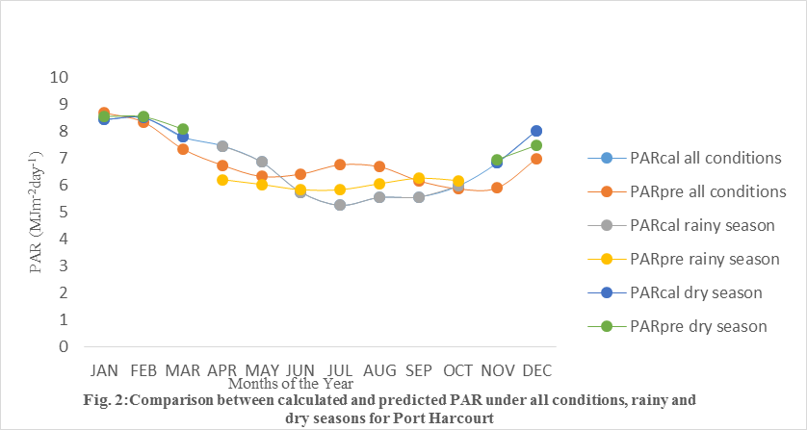

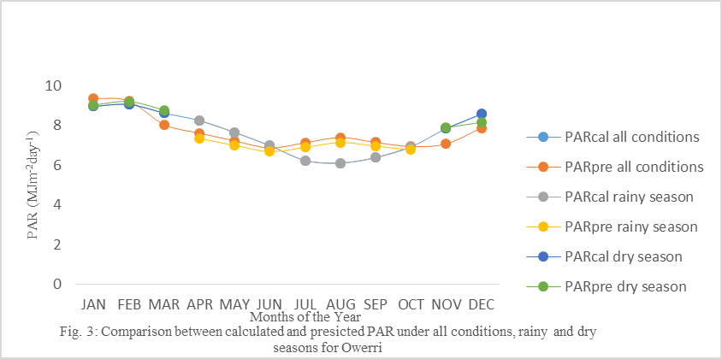

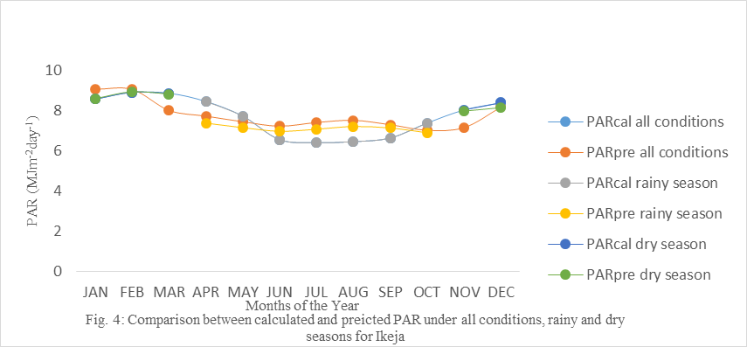

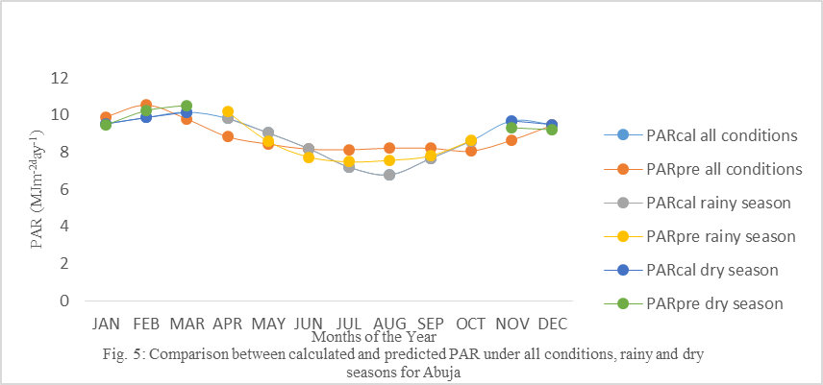

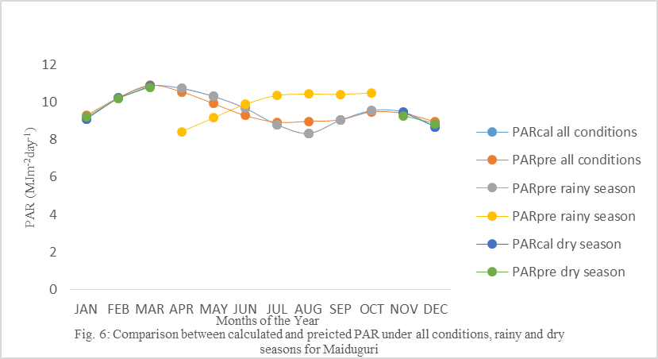

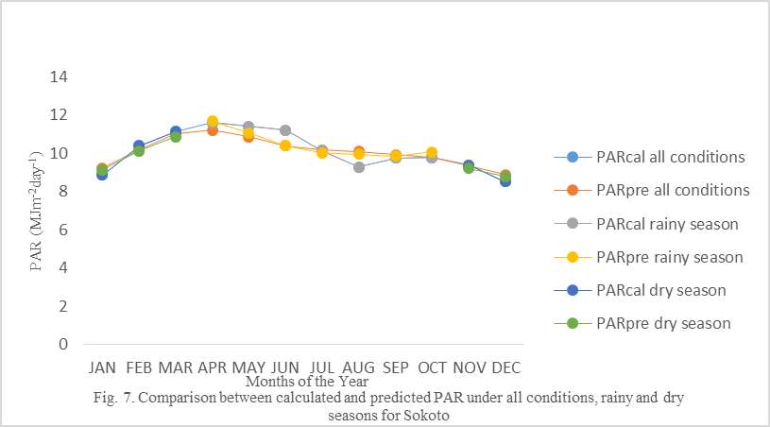

Table 8: Statistical Results for the Validation of the of Predicted (model) Photosynthetically Active Radiation PAR in terms of their Capability for Estimating the Photosynthetically Active Radiation for Port Harcourt, Owerri, Ikeja, Abuja, Maiduguri and Sokoto.

Stations Seasons b₀ b₁ R² MBE MPE RMSE

Port Harcourt All Conditions 2.300 -2.209 0.554 -0.0017 -0.15 0.19
Rainy Season 0.118 0.354 0.006 0.0000 0.00 0.00 Dry Season 1.597 -1.293 0.800 -0.0010 0.00 0.06

Owerri All Conditions 1.484 -1.167 0.697 -0.0025 -0.10 0.16
Rainy Season 1.277 -0.941 0.030 -0.0057 -0.12 0.18
Dry Season 1.074 -0.603 0.814 0.0000 0.00 0.00

Ikeja All Conditions 1.651 -1.364 0.611 -0.0042 -0.13 0.18
Rainy Season 0.990 -0.600 0.004 -0.0043 -0.11 0.18
Dry Season 0.997 -0.491 0.853 0.0012 0.06 0.02

Abuja All Conditions 0.866 -0.369 0.735 -0.0025 -0.10 0.18 Rainy Season 2.111 -1.875 0.828 -0.0129 -0.13 0.10
Dry Season 0.763 -0.095 0.210 0.0000 0.00 0.08

Maiduguri All Conditions 0.790 -0.247 0.892 0.0832 -0.03 0.06
Rainy Season 0.661 0.049 0.021 -0.0557 0.07 0.05
Dry Season 0.816 -0.406 0.323 0.0000 0.00 0.03

Sokoto All Conditions 0.779 -0.141 0.596 0.0017 -0.01 0.09 Rainy Season 0.835 -0.224 0.619 0.0008 -0.37 0.10
Dry Season 0.796 -0.300 0.079 0.0025 0.01 0.07

4. Discussions
4.1 Variation of Atmospheric Parameters
It is also observed that PAR increases with latitude from Lat 4.4 – 13.03ºN along the tropical ecological zones from the Far Southern Zone of Mangrove Swamp (FSZMS) of Port Harcourt to the Far Northern Zone of Sahel Savannah (FNZSS) of Sokoto while relative humidity, rainfall and PAR_{o} increases from the FNZSS of Sokoto to the FSZMS of Port Harcourt as expected for a tropical sites (Udo and Aro, 1999; Miskolczi et al., 1997). This variation were mainly due to trends in cloudiness and associated atmospheric moisture with the movement of the Hadley cell circulation system along the equatorial line.
The Nigeria weather condition is classified into two seasons. Dry and wet season. Dry season is attributed to the influence of Inter Tropical Convergence Zone (ITCZ) producing Tropical Continental (TC) associated with dry and dusty North-East winds (easterlies) which blows from the Sahara desert and finally prevailed over Nigeria. Thus producing the dry season conditions. The implication is that there is a prolonged dry season in the far North, while the far South undergoes short dry period annually.
With the movement of the ITCZ into the Northern hemisphere, the rain-bearing South westerlies prevail as far inland as possible to bring rainfall during the rainy season. This results to prolonged rainy season in the far South while the far North undergoes short rainy periods annually.
The dry season starts in April and ends in October. The rainy season is characterized by overcast and heavy rain clouds. This give rise to relatively low PAR, K_{t}, k_{tp}, temperature and high relative humidity, and rainfall as observed between the months of May and October compared to the dry season months as shown in Table 2 – 7.
The lowest PAR of 5.25MJm⁻²day⁻¹ was recorded in the month of July; k_{tp} registered 0.37 and 0.33 in the months of July and September respectively for the FSZMS at Port Harcourt compared the maximum PAR of 11.58MJm⁻²day⁻¹ recorded in the month of April; k_{tp} and k_{t} reported 0.78 and 0.69 in the month of February respectively for FNZSS of Sokoto. This variation could be attributed to the presence of heavy clouds and prolonged rainfall in the FSZMS of Port Harcourt and the presence of clear weather and prolonged dry season in the FZSS of Sokoto as clouds more radiation in the infrared waveband (0.7 – 3.0µm) than in PAR waveband (0.4 – 0.7µm).
The minimum temperature of 23.00^{oC} was registered in the month of August for the North Central Zone of Guinea Savannah, NCZGS of Abuja primarily caused by relief, topography and elevation of the station and local climate of the station compared to the maximum temperature of 31.40ºC recorded in the month of April for the FNZSS of Sokoto. This variability could be due to the presence of dry and dusty wind from the Sahara desert, clear weather and prolonged dry season in the region.
The lowest Relative Humidity (RH) of 13.20% was recorded in the month of February while the minimum rainfall registered for 0.25mm in the months of January, February and December for the FNZSS of Sokoto. This is primarily due to the prevailing ITCZ producing TC associated with dry and dusty North-East winds (easterlies) producing clear weather hence reducing the amount of relative humidity and rainfall in the station, compared to FSZMS that recorded minimum RH and rainfall of 75.69% and 33.32mm in the month of January respectively.
The annual mean daily PAR for the FSZMS (Port Harcourt) is 6.82MJM⁻²day⁻¹ while the monthly mean daily PAR for the FNSZSS (Sokoto) as 10.11MJm⁻¹day⁻¹. Favourably, in dry season in the months of November, December and January – March, the monthly mean daily PAR enhanced to 7.71MJm⁻¹day⁻¹ for the FSRMS of Port Harcourt and reduced to 9.65MJm⁻¹day⁻¹ for the FNZSS of Sokoto. However, in the rainy season between the months of April and October, the monthly mean daily PAR reduced to 6.05MJm⁻¹day⁻¹ for the FSZMS of Port Harcourt and enhanced to 10.44MJm⁻¹day⁻¹ for FNSZZ of Sokoto.
Moreover, the annual mean daily temperature for the FSZMS (Port Harcourt) is 25.30ºC compared to 27.10ºC observed in the FNZSS (Sokoto). In the rainy season, the value reduced slightly to 25.06ºC for FSZMS and enhanced slightly to 27.91ºC for FNZSS. During the dry season, the value slightly enhanced to 25.58ºC for Port Harcourt and reduced greatly to 25.98ºC for Sokoto.
Similar trend were observed for relative humidity and rainfall region for the FNZSS (Sokoto) and FSZMS (Port Harcourt) for annual, rainy and dry seasons respectively. The annual mean daily RH and rainfall recorded 82.56% and 156.08mm respectively for FSZMS and 42.03% and 39.54mm respectively for FNZSS of Sokoto. However, during the dry season, the values reduced to 80.14% and 69.65mm for RH and rainfall regime at Port Harcourt respectively and 16.04% and 0.58mm for RH and rainfall regime at Sokoto respectively. Favourably, the value enhanced to 84.14% and 217.82mm for RH and rainfall respectively at FSZMS of Port Harcourt, and 60.60% and 67.37mm respectively for FNZSS for Sokoto. This discrepancy is due to the influence of heavy rainfall, cloudiness, associated atmospheric moisture in the wet season along with the equatorial line from FSZMS to the FNZSS and vice versa.
4.2 Classification of Atmospheric Parameters
4.2.1 Classification of PAR Cleanness Index (k_{tp})
PAR cleanness index (k_{tp}) is the ratio of daily PAR to daily extraterrestrial PAR. It gives the percentage depletion by the sky of the incoming PAR and therefore indicates, both the level of availability of PAR and changes in the atmospheric condition in a given locality. The PAR cleanness index (k_{tp}) varied between the range of 0.42 – 0.70 be the months of April to October in the rainy season and 0.60 – 0.75 between the months of November – March in the dry season with an annual mean of 0.48 – 0.72 from FSZMS (Port Hacourt) to the FNZSS (Sokoto). Applying weather condition classification of: (1) heavy overcast weather (k_{tp}<0.35), (2) partly overcast weather (0.70<k_{tp}<0.35) and (3) clear weather (k_{tp}>0.70). The prevailing weather under all conditions of the Southern tropical zones located between latitude 4.75 – 6.58ºN along mangrove and tropical rainforest for Port Harcourt, Owerri and Ikeja are partly overcast weather except the months of July to September in Port Harcourt characterized with heavily overcast weather. The implication is that in the heavily overcast weather condition, the PAR component to the GHI increases temporarily with increase in H and then increases rapidly as the heavily overcast weather become clearer. This implies that PAR radiation increasing linearly with H during clear weather. This explains why the average level of availability of PAR increase from 6.82MJm⁻¹day⁻¹ in the FSZMS (Port Harcourt) to 7.63MJm⁻¹day⁻¹ in the South-East of tropical rainforest (Owerri) to 7.69MJm⁻¹day⁻¹ in the South-West (Ikeja) as the latitude increases from 4.75 – 6.58ºN respectively in the Southern tropical ecological zones of Nigeria under all condition. A decline in the magnitude of PAR were registered in the rainy season as result of decrease in the k_{tp} in the Southern tropical zones while an appreciate values of k_{tp} were recorded in the dry season thereby enhancing the PAR values.
The dominating weather under all conditions at the Northern tropical zones located between latitude 9.067 – 13.067ºN along the Guinea Savannah to Sahel Savannah at Abuja, Maiduguri and Sokoto are clear weather in the dry season between the months of November to March and partly overcast for all sky conditions, and clear weather in the rainy season between the months of April to October from FNZSS (Sokoto) to North-Central of Abuja. The implication is that in the partly overcast weather condition, the PAR component of the H increases temporarily with increase in H and then increases rapidly as the partly overcast weather become clearer. This indicates that PAR radiation increases linearly with H during clear weather (k_{tp}>0.7). This is the reason the mean values of PAR increases from 8.84MJm⁻¹day⁻¹ in the North-central zone of Guinea Savannah (NCZGS) of Abuja to 9.56MJm⁻¹day⁻¹ in the North-East zone of Sudan Savannah (NFZSS) of Maiduguri to 10.11MJm⁻¹day⁻¹ IN FNZSS of Sokoto as the latitude increases from 9.067 – 13.067ºN respectively in the Northern tropical ecological zones of Nigeria. However, decrease in the magnitude of PAR were observed in the rainy season as a result of decrease in the k_{tp} in the Northern tropical zones while an enhanced values were registered in the dry season.
4.2.2 Classification of Relative Humidity
Relative humidity is the ratio of the partial pressure of water vapour to the equilibrium vapour pressure of water at a given temperature. The monthly mean relative humidity (RH) varied between the range of 60.60 – 84-14% in the rainy season, 16.04 -80.34% in the dry season; and 42.03 - 82.56% annually from Sokoto (ENZSS) to Port Harcourt (FSZMS). Employing weather condition classification of (1) Heavily overcast weather (RH >70), (2) partly overcast (70< RH<40) and (3) clear weather (RH <40). The southern tropical zones of Port Harcourt, Owerri and Ikeja show similar and remarkable characteristics of heavily overcast weather (84.14%, 85.0% and 84.40%) condition in the rainy season; 80.34%, 76.34% and 8.54% in the dry season; and 82.56%, 81.39% and 81.33% for all condition respectively as shown in Table 2 – 7. This could be attributed to moderate temperature prolonged rainy season with closed range of latitude and moderate water vapour required for attaining high relative humidity in the southern tropical zones.
However, the Northern ecological zones observed decreasing relative humidity with increasing clear skies and latitude. Abuja recorded heavily overcast weather (82.73%) in the rainy season, clear weather (39.54%) in the dry season and partly overcast weather (64.73%) for all conditions. Maiduguri located at latitude 11.85⁰N registered partly overcast weather (62.27%) in the rainy season, clear weather in the dry season and partly overcast weather (44.86%) for all conditions; compared to Sokoto located at latitude 13.06⁰N that recorded partly overcast weather (60.60%) in the rainy season, clear weather (16.04%) in the dry season and partly overcast weather (42.03%) for all conditions. This implies that Maiduguri and Sokoto are dominated by partly overcast weather condition irrespective of the cloud.in some months while Abuja is controlled by partly overcast weather in spite of partly overcast and clear weather condition observed in some month. This discrepancy could be due to prolonged dry season, less water vapor and hot or warm air from the KNZSS of Sokoto to the NCZGS of Abuja as shown in Table 2 – 7.
4.2.3 Influence of Relative Humidity on PAR
The following observations were deduced from the analyses of the result of influence of relative humidity on PAR. This is similar to the result obtained by Udo et al., (2000); Udo and Aro (1999); Miskolczi et al., (2007); Tsubo and Walk (2005); Anjoriu et al., (2014); Ibrahim and Usman (2012). Similar weather variation and characteristics range (0.554 – 0.892) were observed between the annual PAR clearness index and relative humidity for the selected location in tropical ecological zones as shown in Table 8. This reveals that PAR is optimally controlled by relative humidity in Nigeria in spite of the low correlation obtained in the rainy season. The minimum correlation obtained was 0.554 recorded for Port Harcourt in the FSZMS while the maximum was 0.892 registered for Maiduguri in North-East of Sudan Savannah. This discrepancy is due to high annual relative humidity observed at Port Harcourt 82.56% compared to 44.86% recorded at Maiduguri since during the period of high relative humidity, the energy in the PAR region formed greater part of H thereby reducing PAR cleaness index at Port Harcourt than period of low relative humidity thus increasing the PAR clearness index in Maiduguri. This explains why observation of H in the near inframed (NIR) portion of the solar spectrum is greatly reduced whereas relative humidity is almost transparent to PAR wavelength. Thus, increasing H in the NIR range resulted in a lower PAR cleaness index at Port Harcourt compare to Maiduguri.
However, the correlation were generally weaker during rainy season (April – October) with the range of 0.004 – 0.030 in the southern tropical zones (Ikeja, Port Harcourt and Owerri respectively) compared to the Northern tropical zones that revealed appreciable PAR cleaness index range of 0.021 – 0.828 in Maiduguri, Sokoto and Abuja respectively in the same season. Thus, variation are due to prolonged rainy season together with existing high relative humidity in the Southern tropical zones compared to the Northern tropical zones with existing low relative humidity and low rainfall period within the rainy season. Thus, the energy in the PAR region formed a greater part of H in the southern tropical zones thereby reducing PAR clearness index compared to Northern tropical zones.
During the dry season, the southern tropical zones generally recorded higher correlation coefficient of 0.800 – 0.853 compared to the Northern tropical zone 0.079 – 0.323 as presented in Table 8. This is as a result of decrease in relative humidity and low influence of ITCZ producing TC associated with dry and dusty North-East winds which blow from the Sahara desert compared to high influence of prolonged harmattan season in the Northern tropical zones. Hence, the energy in the PAR region formed a smaller part of H in the southern tropical zones thereby increasing PAR cleaness index compared to the Northern tropical zones.
From Table 8, it can be seen that the average annual PAR for Port Harcourt, Ikeja, Abuja, Maiduguri, Sokoto are 6.82 MJM⁻² day⁻¹, 7.63MJM⁻²day⁻¹, 7.69MJM⁻²day⁻¹, 8.84MJM⁻²day⁻¹, 9.56MJM⁻²day⁻¹ and 10.11 MJM⁻²day⁻¹ for all weather conditions (January – December). The radiation obtained throughout the year is high for the six tropical ecological zones. This indicates that plants have high potential for PAR utilization at any time of the month as the fluxes are generally >5 MJM⁻²day⁻¹.
Hence, plants can be grow at any time of the year provided other condition such as soil moisture content, temperature and relative humidity are favourable.
The empirical constant of the proposed model varied for B_{o}, B₁, R¹, R²a and standard error from one tropical ecological zone to another are presented in Table 8. This could be attributed to the seasonal variation of PAR principally caused by the influence of relative humidity, local climate, rainy and dry season, and the movement of the Hadley and circulation system along the equatorial line in the atmosphere which differs from one tropical ecological zone to another.
There was a constant increase in intercept (bo) of 0.779 – 2.300 from the FNZSS of Sokoto to FSZMS of Port Harcourt for all weather conditions (January – December); while irregular pattern of 0.118 – 2.111 in Port Harcourt and Abuja respectively for rainy season and 0.763 – 1.597 in Abuja and Port Harcourt respectively for dry season. These values are comparable to the report of (Abolfazi, 2014, Aguiar et al., 2011; Escobede et al., 2008).
The coefficient of determination (R²) is generally high for the six zones considered in this research paper. This implies that the regression line fit the sets of data adequately. The value of coefficient of determination ranged from 0.554 – 0.892 for FSZMS of Port Harcourt and North – East Zone of Sudan savannah of Maiduguri respectively for all conditions. This implies that 554 – 89.2% of the relative humidity can be accounted using PAR clearness index for all conditions. While 0.79 – 85.30% of the relative humidity could be accounted employing PAR clearness index in the dry season compared to 0.4 – 82.80% recorded for rainy reason in the six tropical ecological zones.
During the rainy season months, the climate in Nigeria is colder and drier in the dry season month. For a given value of PAR Kt, the corresponding relative humidity in the dry seasons is higher than the corresponding PAR clearness index considering all months of the year. On the other hand, for a given value of PAR clearness index, the corresponding relative humidity in the rainy season is much lower compared to dry season values corresponding relative humidity considering all month of the year.
The explanation for this behaviour is that, during the rainy season, the cloud activity is more intense and the atmospheric water content is larger than during the dry season hence yielding comparatively lower values of monthly PAR. This behaviour is comparable to the result obtained in literature (Udo et al, 2006; Udo and Aro, 1999; Miskolczi et al., 2007; Tsubo and Walker, 2015; Anjorin et al., 2014; Ibrahim and Usman, 2012).
The correlation between the calculated and predicted PAR using the proposed model for the six tropical zones are displayed in terms of PAR_{cal} - PAR_{pre} line plots. The annual, rainy season and dry seasonal values of calculated and predicted PAR line plots (Fig. 2 - 7) are based on 270, 158 and 112 pairs of points selected from the calculated PAR values.
4.2.4 Model Performance
To determine the performance of the predictive model, Willmott (1981) suggested mean bias error (MBE), root mean square error (RMSE) and mean percentage error (MPE) as good statistical indicators for evaluating the error between the calculated and predicted values. MBE provides information on the long-term performance of model studied. RMSE provides information on the short-term performance of the model as it allows a term-by-term comparison of the actual deviation between the predicted value and calculated values. Generally, small values of MBE and RMSE is desirable (Halouani et al., 1993; Ituen et al., 2012). MPE is an overall measure of estimation bias. It provides information regarding underestimation or overestimation of estimated data. A positive MPE value gives the average amount of over-estimation in the predicted values and vice versa. These relations are given as:
(12)
(13)
(14)
Where N is the total number of observation, Ci is the ith calculated PAR values, Pi is the ith predicted PAR values and other symbols retain their usual meaning. From Table 8, it is obvious that the predicted models systematically fitted the calculated data owing to the relatively small values obtained from MBE and RMSE as recommended by several researchers mentioned earlier.
In the case of all the conditions (January – December) derived for Port Harcourt, Owerri, Ikeja, Abuja, Maiduguri and Sokoto performed excellently as expected for a tropical sites (Udo et al. 1999). A positive MBE indicates that the model over-estimated PAR systematically. While Abuja under-estimated in rainy season, Port Harcourt under-estimated in the dry season. Also, a negative MBE indicates that the model under-estimated PAR systematically. Curiously, in this period, the cloud activity is enhanced in Abuja and Port-Harcourt stations.
However, the best performance is obtained in the dry season (October – March). This is comparable to the result obtained in literature (Udo et al, 2006; Udo and Aro, 1999; Miskolczi et al., 2007; Tsubo and Walker, 2015; Anjorin et al., 2014; Ibrahim and Usman, 2012). Tthe proposed model from all sky conditions (January – December) under-estimated PAR below 5mJm⁻²day⁻¹ and over-estimates PAR > 5MJm⁻²day⁻¹ during the dry season for all stations. Owerri, Ikeja, Maiduguri and Sokoto underestimated PAR systematically during the rainy season while Port Harcourt and Maiduguri overestimated PAR during the rainy season. This shows that the proposed model statistically fitted the calculated PAR values for all conditions (January – December), rainy season (April – September) and dry season (October – March) for the selected stations in six tropical ecological zones in Nigeria.
In conclusion, the analysis of the influence of PAR clearness index on relative humidity based on the radiation data recorded for Port Harcourt, Owerri, Ikeja, Abuja, Maiduguri and Sokoto representing the six tropical ecological zones in Nigeria were investigated for rainy season, dry season and annually. The annual PAR clearness index indicates that the prevailing weather condition in the Southern tropical zones indicates that Port Harcourt, Owerri and Ikeja are partly overcast and Abuja, Maiduguri, and Sokoto experienced clear weather condition (Northern tropical zones). However, the annual relative humidity reveals that Port Harcourt, Owerri, Ikeja and Abuja are heavily overcast while Maiduguri and Sokoto are partly overcast. We analyses the influence of relative humidity on PAR cleaner index and found that the value of the parameter decreased as the relative humidity increased, that is, the weather condition varied from heavily overcast to clear weather. It was equally revealed that the absorption of GHI in the near infrared (NIR) portion of the solar spectrum is greatly enhanced in the Southern tropical zones as a result of high relative humidity and prolonged rainy season thereby reducing the PAR Clearness index in the zone. While the absorption of GHI in the NIR portion of the solar spectrum is increased in the Northern tropical zones a result of high influence of prolonged dry season thereby increasing the PAR Clearness index in the region.
Generally, the proposed model suitably predicted stations in the Southern tropical zones (Port Harcourt, Owerri and ikeja) and North-Central zone (Abuja) and underestimated stations in the North-East (Maiduguri) and North-West (Sokoto). For the purpose of accuracy in estimation, we therefore recommend that the proposed model will work efficiently for any station where relative humidity is greater than 64% annually. This research paper is the first attempt to qualify PAR parameters in the six tropical ecological zones in Nigeria; thus our model can be used to estimate PAR parameters for locations with similar climatological condition where GHI data are readily available and Relative humidity is greater than 64% annually.

Acknowledgements:
Our thanks go to the NASA Langley Research Center Atmospheric Science Data Center Surface meteorological and Solar Energy (SSE) web portal supported by the NASA LaRC POWER Project for the data used for this research paper. We also wish to thank all the authors cited in this paper for their research works that has made this research possible.

Corresponding Author:
Nwokolo Samuel
Department of Physics
University of Calabar
Calabar, Nigeria
Telephone: +2348066806702
E-mail: nwokolosc@stud.unical.edu.ng

References
- Abolfazi M-H. Estimating photosynthetically active radiation (PAR) using air temperature and sunshine duration. J. Biod. Environ. Sci., 2014; 5(4), 371–377.
- Aguiar LJG, Fischer GR, Ladle RJ, Malhado ACM, Justino FB, Aguiar RG, Costa JMN. Modeling the photosynthetically active radiation in South West Amazonia under all sky condition. Theor. Appl. Clmatol., 2011; DOI 10.1007/s00704-011-0556-z.
- Alados I, Moreno IF, Arboledas LA. Photosynthetically active radiation: measurements and modelling. Agric. For. Meteorol. 1996; 78: 121–131.
- Alados I, Arboledas LA. Validation of an empirical model for photosynthetically active radiation. Int J Climatol. 1999; 19: 1145–1152.
- Anjorin OF, Utah EU, Likita MS. Estimation of hourly photosynthetically-active radiation (PAR) from hourly global radiation (GSR) in Jos, Nigeria. Asi. Rev. Environ. and Eart. Sci. 2014; 2: 43-50.
- Escobedo JE, Gomes EN, Oliveira AP, Soares J. Modeling hourly and daily fractions of UV, PAR and NIR to global solar radiation under various sky conditions at Botucatn, Brazil. Appl. Energ., doi:10.1016/j.apenergy.2008.04.013.
- Etuk ES, Nwokolo SC, Okechukwu AE, John-Jaja SA. Analysis of Photosynthetically active radiation overe six tropical ecological zones in Nigeria. Journal of Geography, Environment and Earth Science International. 2016; 7: 1 – 15 .
- Howell TA, Meek DW, Hatfield JL. Relationship of photosynthetically active radiation to shortwave radiation in the San Joaquin Valley. Agric. For. Meteorol. 1983; 28: 157–175.
- Ibrahim BB, Usman A. Variation Characteristics of Photosynthetically Active Radiation (PAR) Over Ilorin in the Tropics, Physic. and Spac. Scien. 2012; 12: 2249-2254.
- Ituen EE, Esen NU, Nwokolo SC, Udo EG. Prediction of global solar radiation using relative humidity, maximum temperature and sunshine hours in Uyo, in the Niger Delta Region, Nigeria. Advances in Applied Science Research, 2012; 4: 1923-1937.
- Li R, Zhao L, Ding YJ. Monthly ratios of PAR to global solar radiation measured at northern Tibetan Plateau, China. Sol. Energ. 2010; 84: 964–973.
- McCree KJ. Test of current definitions of photosynthetically active radiation against leaf photosynthesis data. Agric. For. Meteorol. 1972; 10: 443–453.
- Meek DW, Hatfield JL, Howell TA, Idso SE, Reginato RJA. Generalized relationship between photosynthecally active radiation and solar radiation. Agron. J. 1984; 76: 939-945.
- Miskolczi F, Aro TO, Iziomon M, Pinker RT. Surface radiation fluxes in sub Sahel Africa, J. of Appl. Meteo. 1997; 36: 521-530.
- Moon P. Proposed standard solar radiation curves for engineering use. J. Frankl. Inst., 1940; 230: 583-618.
- National Aeronautics and Space Administration (NASA) atmospheric science data center, http://eosweb.larc.nasa.gov/sse/.
- Tsubo M, Walker S. Relationships between photosynthetically active radiation and clearness index at Bloemfontein, South Africa. Theor. Appl. Climatol., 2005; 80: 17–25.
- Udo SO, Aro TO. Global PAR related to global solar radiation for Central Nigeria. Agric. For. Meteorol. 1999; 97: 21–31.
- Udo SO, Aro TO, Akpabio LE. Characteristics of diurnal pattern of global photosynthetically active radiation at Ilorin, Nigeria. Nigeri. J. of Phy., 2006; 18: 223-226.
- Wang Q, Kakubari Y, Kubota M. Variation of PAR to global solar radiation ratios along altitude gradient in Naeba Mountain. Theo. and Appl. Clima., 2007; 87: 239-253.
- Williams JG. Small variation in the photosynthetically active radiation of solar radiation on clear days. J. Arch. Meteor. Geophs. Bioclim. 1976; 33: 89-98.
- Willmott CJ. On the validation of models. J. Phys. And Geogr. 1981;2: 184-194.

9/25/2018

