**Isolation of squalen bioactive compounds on purification from Bulbophyllum kaitense root extract by qualitative and quavantitative method their evaluated**

Dr. Kalaiarasan. A*

Centre for Bioscience and Nanoscience Research, Coimbature, Tamil Nadu, India.

[myla_kalai@yahoo.com](mailto:myla_kalai@yahoo.com)

**Abstract:** Squalene is a natural 30 carbon organic compounds originally obtained for commercially purposes primarily from shark liver oil although plant sources of vegetable oils are now as including amaranth seed, rice bran, wheat germ and olives. All plants and animals produce squalene as a biochemical intermediate including humans. Squalene used as well as cosmetic, immunological adjuvant in influenza vaccine, mediterranean diet, natural moisture, and chemo preventive, antibodies in their blood and anti tumor. The *bulbophyllum kaitense* orchid is a major role of higher source bio active compounds in the plants. It has been very useful and renewable source in the process of bio active purification compounds in plants. According to the ethno botanical information gather in kolli hills triple people. Hence the present investigations have been made to identifying the squalene compound of *bulbophyllum kaitense* root extract using TLC and bio chemical derivation method. Furthermore, the isolation of the squalene higher source of compounds is carried out by privative HPLC and HPTLC using the standardized solvent system.

[Dr. Kalaiarasan. A. **Isolation of squalen bioactive compounds on purification from Bulbophyllum kaitense root extract by qualitative and quavantitative method their evaluated.** *N Y Sci J* 2018;11(8):81-89]. ISSN 1554-0200 (print); ISSN 2375-723X (online). <http://www.sciencepub.net/newyork>. 12. doi:[10.7537/marsnys110818.12](http://www.dx.doi.org/10.7537/marsnys110818.12).

**Keywords:** Squalene, immunological, *bulbophyllum kaitense,* TLC, HPLC, HPTLC and standardized.

1. **Introduction:**

Standardization of herbal formulations is essential in order to make an assessment of the quality drugs, based on the concentration of their active principles, physical, chemical, phyto-chemical, standardization, In-vitro and In-vivo parameters. The quality assessment of herbal formulations is of paramount importance in order to justify their acceptability in modern system of medicine (Arun rasheed 2012). In recent years the interest for the characterization of organic compounds from plants has been developed. The GC–MS is an ideal technique for qualitative and quantitative analysis of volatile and semivolatile compounds (Iordache et al., 2009).

The isolation and partial purification of bioactive compounds from the crude methanol extracts of the leaves of *Ageratum houstonianum*. The quantification and the identification of compounds in the crude extract and active bands iso-lated by preparative TLC were accomplished using GC-MS analysis. The most important compounds identified in the crude extract and active bands (AB-1 and AB-2) were 6-acetyl-7-methoxy-2, 2-dimethylchromene, hexadecanoic acid and squalene (Zeeshan1 et al., 2012). In several studies conducted on the Triterpenoids are biosynthesized in plants by the cyclization of squalene, a triterpene hydrocarbon and precursor of all steroids (Phillips et al., 2006). Another report the Triterpenoids is a large family of compounds synthesized by plants that have a common chemical structure. Triterpenoids are metabolites of isopentenyl pyrophosphate oligomers and represent the largest group of phytochemicals. It has been estimated that more than 20,000 triterpenoids exist in nature (Liby et al., 2007).

They can further be subclassified into diverse groups including cucurbitanes, cycloartanes, dammaranes, euphanes, friedelanes, holostanes, hopanes, isomalabaricanes, lanostanes, limonoids, lupanes, oleananes, protostanes, sqalenes, tirucallanes, ursanes and miscellaneous compounds (Setzer and Setzer, 2003). Observed the chromatographic of the compounds serves to be a very useful and reliable source in the process of bioactive compounds screening in plants. It has been reported that the plant *Lippia nodiflora* possesses the antihypertensive potential. Hence in the present study, an attempt has been made to identify the phytochemical constituents of *L. nodiflora* using TLC and chemical derivatization method. Further, the isolation of the same compound is carried out by preparative HPTLC using the standardized solvent system viz., hexane: toluene: ethyl acetate (2:15:0.5). The confirmation of the isolation was done by GC-MS (Rekha Gadhvi et al 2013).

HPTLC analysis was carried out to determine the coumarin compounds profile in three *Polygonum* species. The methanol extract of *P. chinense, P. glabrum* and *P. barbatum* whole-plant samples 9 and 6 compounds, respectively, and were compared with coumarin standards. Among the compounds, 3 compounds in each sample of *P. chinense* and *P. glabrum* were identified as coumarin compounds and the others were unknown while all the 6 compounds were unknown in *P. barbatum*. One coumarin compound each from *P. glabrum* and *P. barbatum* showing same peak R*f* values (0.08). All other compounds detected in the three *Polygonum* species showed no similarities in their R*f* values (Ezhilan 2014). The GC/MS analysis of ethanol extract of Bulbophyllum kaitense revealed that the existence of glycerin (29.52%) cis-z-a- Bisabolene epoxide (23.96%) 3,3, 4, 4, Tetra- methoxystibene (3.69%) 6,10-Dodecadien – 1- yn – 3 – 01, 3, 7, 11- trim ethyl. (3.29%), 3 – tert lox methyl) hex -5-ene -1, 2 – diol. (3.13%), 2h – Pyran, 2- (7- heptade lynyloxy) tetra hydro (2.63%) 1- Heptatrucitabik. (2.16%) Phenol, 2- methoxy -4- propyl (1.90%), 3- (Adamantan- 2- yliden - methoxymethyl)- Phenol (1.66%) Cyclohexane, 1,3,5- trim ethyl – 2- octadegcy (1.36%) Tetradecanoic acid (1.30%) 3,9 – Epoxy – pregnance – 11a, 20 – diol, 3a – methoxy – 18- [N-methyl –N- (2;4 epoxy ethyl) amino]. (1.10%). The identification of bioactive components in leaf parts of Bulbophyllum kaitense. Rechib by GC-MS is the first report (Kalaiarasan 2011).

Twenty Five compounds in Ethanol extract were identified Bioactive by Gas chromatography –Mass spectrometry (GC-MS). This analysis revealed that Bulbophyllum Kaitense Pseudobulbs contain mainly 1,14 – Tetradecanediol (4.023%) 10- Undecyn -1-01 (10.74%) 1, Octanol, 2 – bytyl – (7.20%) 2H-1- Benzopyran -6 -01, 3, 4 - dihydro – 2,8 – dimethyl -2 – (4,8,12 – trimethyl tridecyl) –[2R –[ 2R*(4R*,8R*)]] – [e” – Tocopherol]. Squalene (1.53%) 3,3′, 4, 4′ - Tetramethoxystilbene (1.17%) 2- (2- Hydroxy – 2 – p - methoxyphelethyl) - 5- methyl (1.09%) Ethyl homovanillate (0.97%) 2 (1H) – Phenanthrenone, 3,4,4a, 9,10,10a- Hexahydro – b- hydroxyl -1,1, 4a- trimethyl -7- (1- methylethyl.) (4aS-trans) – (0.80%) Decanoic acid. Ethyl ester (0.76%) (Kalaiarasan 2011).

The bioactive constituents present in stem parts of Bulbophyllum kaitense. Rechib belongs to the family Orchidaceae. Six compounds in ethanolic extract. were identified by gas chromato graphy (GC-MS). This analysis revealed that Bulbophyllum kaitense Rechib stems contain mainly n-Hexadecanoic acid (57.93%) a-bisabolol (6.99%) 2,4,5- Trihydroxypyrimidine (2.62%). It is the first report of identification of bio active constituents from stem parts of Bulbophyllum kaitense Rechib by GC-MS (Kalaiarasan 2011). Analgesic, anesthetic, antiviral cancer preventive, fungicide, rodenticide emetic, vasodilator, cox-1 & cox-2 inhibitor, thypocholesterolemic, candidicide, diwretic, immunostimulant, chemopreventive, lipoxygena Se-inhibitor, pesticide, antidermatitic, Antileukemic, Hepatoprotective, hypo holoesterms lemic, antilcerogenic, vasodilator, antispasmodic, antibronchitic, anticoronary, antiarthritic. The plants is used is few years ago is kolli hills agathiyammuniver. The plants have been used is indigenous medicine. This information was gathered by questioning local tratitinal healers and knowledgeable village people of kolli hills the aim of the present investigation was to evaluate the effectof Bulbophyllum Kaitense. Pseudobulb extract of anitinflammatory experimental is human red Blood Cell membranes stabilization (Kalaiarasan 2012).

Squalene (23.22%) Methtl 3 – bromo-1 – adamantaneacetate (13.03%) Didodecyl phthalate (3.52%) 1,2- Benzenedicarboxylic acid, butyl 2 – methylpropyl ester (3.45%) Nonane, 1-iodo-(2.77%) 3,4- Hexanediol 2.5 – dimethyl –p (2.10%) 3- Buten – 2-01- (1.12A%) 2,4 – Dimethyl Cyclopentanol (1.05%) This is the first report of identification of Bio active constituents from Root parts of Bulbophyllum Kaitense (Kalaiarasan 2012). The leaf extract of *Bulbophyllum kaitense* is very excellent biosreductant for the synthesis of silver and gold nanoparticles and synthesized nanoparticles antagonistic active against human pathogens (Kalaiarasan 2015) and (Kalaiarasan 2015).

Wu et al (2006) noticed taht the isolated and elucidated four acylated anthocyanins from the purple-red flowers of *B. striata* respectively. N6-(4-hydroxy benzyl) adenine riboside. *Cephalanceropsis gracilis* showed significant cytotoxicity (Ikeda et al., 2005). cephalandole B isolated from *Crematra appendiculata,* showed selective inhibition of muscannic M 3 receptor (Lo et al., 2004). He et al (2006) studied that aloifol isolated Nidema boothi, showed spasmolytic action. isorhamnetin-7-O-b-D [glucopyranoside istolated from the ethanolic extract of *Anoectochilus roxburghii* (Chen et al., 2007). 3,7- Dihydroxy- 2,4,6-trimethoxy phenanthrene compound isolated from *B.* *odoratissiumu*, showed cytotoxicity activity (Matsuda et al., 2004).

Find out the future aim of the author a major contradicting focusing in the area of the biochemical is the evaluation of these were identified sequalene compound in the Bulbophyllum kaitense orchid plants are isolation in the pure forms. The thin layer chromatographic methods as very useful process are biochemical evaluation. This made to use highly suitable basic chromatographic methods for plant are the squalene compound referring to as the thin layer chromatography plate the compound crutched the through rune by column chromatography have been collect the separated compound has been carried out for the preparative further continue processes of high pressure layer chromatography and high pressure thin layer chromatography method the final separation was confirmed quantitative analysis in the squalene compound.

**Squalene compound structure of formula:**

[Systematic IUPAC name](https://en.wikipedia.org/wiki/Chemical_nomenclature#Systematic_name) : (6*E*,10*E*,14*E*,18*E*)-2,6,10,15,19,23-Hexamethyltetracosa-2,6,10,14,18,22-hexaene. Chemical formula: C30 H5, Molar mass: 410.7g-1mol-1, Appearance: Pale yellow, translucent. Density: 0.858g Cm-, Melting point: -5˚C. (23˚F; 268K), Boiling point 285˚C (545˚F; 558K) at 3.3 kPa. Viscosity: -12 cP (at 20˚C).



**Isolation of squalene compound in plant root**

**aqueous extracts**

**Quantitative analysis**

The general principle involved in thin layer chromatography is similar to that of column chromatography, i.e., adsorption chromatography. In the adsorption process the solute competes with the solvent for the surfaces sites of adsorbent. Depending on the distribution coefficients the compounds are distributed on the surface of the adsorbent of course, in thin layer chromatography the partition effect is the separation is also not ruled out. The adsorbent normally used contains a binding agent such as calcium sulphate which facilitates the holding of the adsorbent to the glass plate.

**Preparation of crude extracts**

100 g of root was powder and extracted separately in soxhlet apparatus using aqueous solvent systems. The extract were filtered through a cotton plug followed by what man filter paper No. 1 and then concentrated by using a rotary evaporator 40 – 50˚C and reduced pressure to get 6.05 g yield from aqueous fraction respectively. The extracts were preserved in airtight containers and kept at 4˚C until further use the extracts were tested for thin layer chromatography analysis and column chromatography.

**Thin layer chromatography**

The stationary phase is prepared as slurry with water or buffer at 1:2 and applied to a glass plate or an inert plastic or aluminum sheet, as thin uniform layer by means of a spreader such as glass rod or pipette or using a thin layer chromatography applicator. (0.25 mm Thickness for analytical separations and 2.5 mm Thickness for preparative separations are prepared). Calcium sulphate Ca SO4 ½ H2 O; (Gypsum) (10 – 15%) is incorporated to adsorbent as a binder, as it facilitates the adhesion of the adsorbent to the plate. After application of the adsorbent, the plates are air – dried for 10 – 15 minutes and then oven-dried for 10 – 15 minutes at 100˚C - 110˚C. This process is also known as activation of the adsorbent. The plates can be used immediately or stored in desiccators.

**Sample applications**

A line was lightly with a pencil about 1.5 – 2.0 cm from the bottom. If the Thin layer is too soft to draw a pencil line, place a scale at the bottom and spot at as distance 1.5 cm. Note down the order the samples are spotted using capillary tubes at 1.5 cm distances between them for preparative Thin layer chromatography, the sample is applied as a band across the layer rather than as a spot.

**Plate development**

The chromatographic tank was filled with developing solvent to depth of 1.5 cm and equilibrated for about 5 hrs. The Thin layer plate was placed gently in the tank and allowed to stand for about 6 minutes, make sure that the spot do not touch the solvent directly. Capillary action caused the solvent to ascent as in paper chromatography and the separation of compounds takes place. As the solvent front reaches about 1 – 2 cm from the top of the plate, the plate is removed, solvent front is marked with a pencil immediately and allowed to air dry placing the plate upside down.

**Squalene**

The sample was extracted with 10 ml methanol on water bath (60˚C / 5minutes). The filtrate was condensed by evaporation, added a mixture of water and EtOAc in the ratio of 10:1 and mixed throughly. The EtOAc phase thus retained is used for chromatography the squalene spots were separated using n Hexane and Ethyl Acetate solvent mixture in the ratio of 19:1. The color and Rf value of these spots were recorded. The squalene spots were scratched and tested for column chromatography.

**Column chromatography**

The bottom of the column was first plugged with little glass wool and then clean sand bed was placed over the glass wool. The sand bed serves to give a flat base to the column of the absorbent. Then the dried silica Gel 100 – 200 mesh was poured into the column. After 2/3rd of the column was filled with the powder, it was tabbed, and set aside. After that, a filter paper disc and sand bed were placed over the adsorbent in order to avoid the disturbance of the adsorbent, as fresh mobile phase was added to the column in the initial stages of development. The Ethanol (50%) extract of sample was placed over the filter paper disk and used to isolate the active constituents. The crude ethanol extract of sample was subjected to column chromatography over silica gel 100 – 200 mesh. The column was eluted with solvents of increasing order of polarity. The fractions were collected in 25 ml each and allowed to evaporate to get the residue.

**Methanolic root extract by HPLC**

HPLC analysis was carried out for the component separated in thin layer chromatography. It was performed on shimadzu, HPLC – 530, AC18 gravity column (Aldrich cat No – 37, 763 – 5, 10g) was wetted with 100 ml of HPLC grade methanol and then washed with 50 ml of Milli – Q water. A 50 ml aliquot of crude extract was added to the column and allowed to adsorb. The column was washed with 100 ml of Milli – Q water to remove water soluble methanol to remove less polar material. A 70% methanol solution was then added to the column and 2.0 ml fractions collected fractions were analysed on a spherisorb ODS – 2 C18 analytical column (250 × 4.6 mm, 5 micron) using a 20 minute linear gradient of 15 – 35% acetonitrile in 8 mM ammonium acetate, with a 10 minute isocratic elution at 35% acetonitrile (8mM ammonium acetate). Peak detection was achieved using a GBC LC 1250 fast scanning UV/V is detector set at 238 nm. Eluting peaks were scanned between 200 mm and 300 nm with 1 nm intervals to determine absorbance maxima and minima.

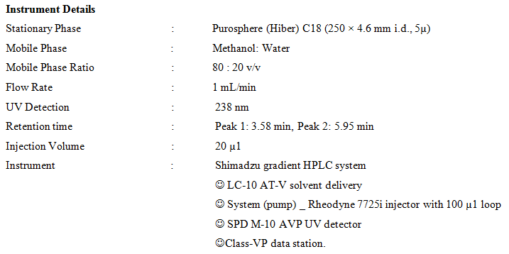

**HPTLC Finger printing of methanolic root extract**

Plant extracts were dissolved in respective solvents. Sample was applied on 0.22mm thick silica gel plate by making use of camag automatic TLC sampler. Sample was applied as band and is not spot. Chromatogram was developed with active stationary, mobile and vapor phases. Stationary phase plat was put into the mobile phase stationary phase plat was put into the mobile phase containing organic solvents like hexane: ethyl acetate: methanol in the ratio of 1:2:1. Stepwise automatic procedure was followed at room temperature to run the column. Automatic developing chamber was used to develop the chromatogran. Chemical compounds are quantitatively and evaluated through spectral scanner. Scanning was controlled by camag software ©1998 available in the instrument. Computerized scanning HPTLC report provided the information’s like Rf value, λ max and % of chemical constituents present in the sample. The results were recorded and interpreted.

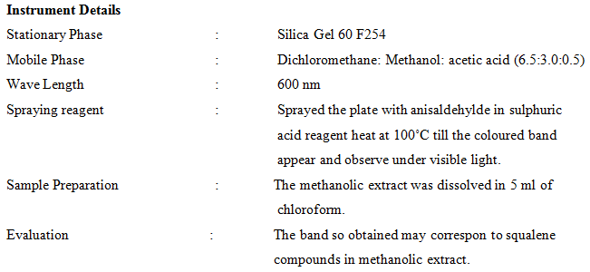

**Result:**

**Qualitative analysis of using Thinlayer chromatography screening of squalene compound.**



Fig 1. Squalene fraction analysis Bulbophyllum kaitense root extract of thinlayer chromatographic

Observed that the present investigation are screening of the squalene in the plant root extract with basic preliminary procedure was starting step in the process. The bio active potential of partially isolated compound is preparative thin layer chromatographic. Thin layer chromatography process revealing that the possible spot of squalene compound. The shows were color and Rf value of sualene compound found to be spots were 0.153 recorded given in (Fig.1). The squalene spots were scratched and through tested continues process for column chromatographic.

**Successive are squalene compound was purified using for Column Chromatography**

The thinlayer chromatography analysis of squalene compound was done. The squalene compounds were filtered and collected on the isolated compound using column chromatography. The shows on results of are given in fig.2.

**Confirmation of compound are HPLC analysis of root extract and sualene standard solvent.**



Fig 2. Separation of squalene compound isolation of Bulbophyllum kaitense root extract in column chromatographic



Fig 3. HPLC squalene standard display and peak table



Fig 4. HPLC methenolic root squalene extract peak display and peak table



Fig 5. HPTLC Fingerprinting of Bulbophyllum kaitense methanolic root squalene extract under 366nm and 254nm.



Fig 6. Three dimensional views



Fig 7. HPTLC squalene standard peak display and peak table

Accuracy was investigated for HPLC method the best chromatographic condition were adequately selected to develop a reversed phase liquid chromatography method that method working in isocratic mode allowed the determination of plant squalene extract and standard squalene solvent. HPLC a linear correlation was found between absorbance and peak area and retention time of compound matches with HPLC retention time of standard. The plant squalene extract retention time of the compound is 3.57 minutes and the retention time of the standard with is 3.58. Since retention time is similar we speculate that compound could be squalene separated compound has been carried out for final separation was confirmed. The summarized in fig 3. Followed for quantitative analysis of HPTLC method.

**HPTLC Finger printing analysis of root extract**

Find out the newly established method was successfully applied to the simultaneously quantitative and qualitative analysis. The densitometry HPTLC analysis of methanolic root extract was high performed for development of characteristic finger printing profile. The methanol root extract sample gave six bands with Rf value 0.27, 0.40, 0.50, 0.66, 0.73 and 0.88. The Rf value of methanolic root extract was found to be 0.73, which is closer to 0.74. Rf value at 0.74 is a squalene. The percentage yields of squalene = 85.579 mg/100g of squalene. The results are summarized in Plate. The present investigation provides a chromatographic finger printing of bioactive isolation compounds and is a suitable for conforming the identify and purity of medicinal plant raw material.



Fig 8. HPTLC methanolic root squalene extract peak display and peak table

**Conclution**

The estimate demand of the squalene compound is greatly increased in the past few years for its renewable natural source of plant. Through several studies were successfully completed for compound isolation HPTC method. Phytochemical study area focus would bring a lot of benefits for the largest population of develop and developing countries. We assume the squalene compound could be useful as highly pharmacological treatment as well as conservation of this orchid plant family. To determine the clear separation of squalene compound the great handle to be faced during the isolation of pure compound from in the orchid.

**Acknowledgment**

We sincerely thank the Dr. S. Ahmed John, Professor and Head PG and Research Department of Botany, Jamal Mohamed College (Autonomous).

Tiruchirappalli-620 020 Tamil Nadu. India.

**Reference**

1. Arun Rasheed, Sravya Reddy B, Roja C.2012. Inter. J. Of Phytotherapy, 2(2): 74-88.
2. Chen, Y., Xu, J., Yut, H., Qin, C.W., Zhangt, Y., Liu, Y. and Wang 2007. J. *Bulbophyllum odoratissimum* 3,7-Dihydroxy-2,4,6-trimethoxyphenanthrene. J. Korean Chem. Soc. 51: 352-355.
3. Iordache A, Culea M, Gherman C, Cozar O. 2009. Characterization of some plant extracts by GC–MS. Rom Nuc Inst Meth Phy Res. 267:338–42.
4. Zeeshan M, Rizvi1 S.M.D, Khan1 M.S, Kumar A, 2012. Isolation, partial purification and evaluation of bioactive compounds from leaves of *Ageratum houstonianum*. Excli Journal. 11:78-88. Phillips DR, Rasbery JM, Bartel B, Masuda SP. 2006. Biosynthetic diversity in plant triterpene cyclization. Curr Opin Plant Biol. 9: 305–314.
5. Kalaiarasan A, Kumar P, Ahmed john S, 2011. GC/MS determination of Bioactive Components of *Bulbophyllum kaitense*. Reichib Leaves Estern Ghats in India. New York Science Journal, 4(10): 46-49.
6. Kalaiarasan A, Ahmed John S. 2011. GC-MS Analysis of Bulbophyllum Kaitense Rechib. Pseudobulbs Estern Ghats of India. In Journal of Chemistry and Applications. (3) 3: 215-220.
7. Kalaiarasan A, Ahmed John S. 2011. Some bioactive constitutents of GC-MS analysis of Bulbophyllum kaitense rechib. stem estern ghats of india. In Journal of Pharma and Bio Sciences. (2) 4: 156-160.
8. Kalaiarasan A, Ahmed John S. 2012. In-vitro screening for anti-inflammatory activity of Bulbophyllum kaitense. rechib. pseudobulb extract by HRBC method. Eastern peninsular flora in south india. In Journal of Scientific and Research Publications. 2 (7): 1-5.
9. Kalaiarasan A, Kumar P, Ahmed John S. 2012. Bio-chemical investigation of B*ulbophyllum kaitense* rechib. root by gc-ms. Estern ghats of india. Nature and Science. 10 (2); 29-31.
10. Kalaiarasan A, Chinnappa R. 2015. Orchid leaf mediated biosynthesis of silver and gold nanoparticles with antagonistic activity against human pathogens.European Journal of Academic Essays. 2(11): 66-74.
11. Kalaiarasan A, Chinnappa R. 2015. Orchid plant natural source for the synthesis of silver and gold nanoparticles with antagonistic analysis. Nature and Science. 13(11): 25-35.
12. Liby KT, Yore MM, Sporn MB. 2007. Triterpenoids and rexinoids as multifunctional agents for the prevention and treatment of cancer. Nat. Rev. Cancer. 7: 357-369.
13. Setzer WN, Setzer MC. 2003. Plant-derived triterpenoids as potential antineoplastic agents. Mini Rev. Med. Chem. 3: 540–556.
14. Rekha Gadhvi, Reddy M. N. Gaurav J, Mishra. 2013. Isolation of terpenoids constituents from *Lippia nodiflora* by preparative HPTLC method. In, Journal of Medicinal Plants and Alternative Medicine. 16: 104-109.
15. Ezhilan B, Neelamegam R. 2014. HPTLC Determination of coumarin compounds profile in three *Polygonum* species. International journal of pharmaceutical chemistry research. 3: 2: 18-24.
16. He, C., Wang, C., Guo, S., Yang, J. and Xiao, P., 2006. A Novel Flavonoid Glucoside from *Anoectochilus roxurghii* (Wall) Lindl. J. Integrative Plant Biol., 48: 359-363.
17. Ikeda, Y., Nonaka, H., Furumai, T. and Igarashi, Y., Cremastrine, 2005. A pyrrolizidine alkaloid from *Cremastra appendiculata*. J. Nat. Prod. 68: 572-573.
18. Lo, S.F., Mulabagal, V., Chen, C.L., Kuo, C.L. and Tsay, H.S., 2004. Bioguided fractionation and isolation of free radical scavenging components from in vitro propagated chinese medicinal plants *Dendrobium tosaense makino* and *Dendrobium moniliforme* SW.J. Agric. Food Chem. 52: 6916-6919.
19. Matsuda, H., Morikawa, T. and Yoshikawa, M., 2004. Antiallergic Phenanthrenes and stibenes from the tubers of *Gymnadenia conopsea*. Planta Medica., 70: 847-855.
20. Wu, B., He, S. Pan, Y. 2006. New dihydrodibenzoxepins from *Bulbophyllum kwangtungense*. Planta Medica. 72: 1244-1247.

**About Authors**

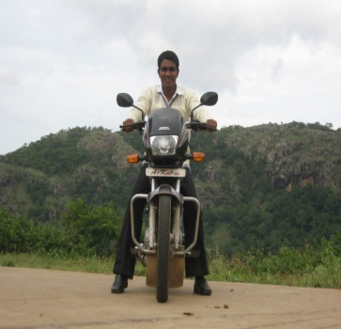

Dr. AKALAIARASAN M.Sc., M.Ed., M.Phil., Ph.D. Obtained his starting in Bachelor of Science in Bishop Heber College Tiruchirappalli During in 2001 to 2004. He stayed Master of Science in Kandaswami Kandar’s College in 2004 to 2007. Did bachelor Education stated in St.Joseph’s Educational Trust Tuticorin in 2007 to 2008. Research stated Master of Education in Varruvan Vadivelen College of Education in 2008 to 2009, Imprested in research Master of Philosophy in Vinayaka Mission’s Annapoorna College of Education in 2009 to 2010. My achievement of research stated in Philosopher completed Jamal Mohamed College in 2010 to 2013. He has published more than 15 papers in reputed International Journals and obtained that attend the two international conference and five national conference. He is eleven presented papers on the conference. But in the still bright of research interests are focusing in nanotechnology, plant taxonomy, microbiology, biotechnology, biochemistry and molecular biology of center for bioscience and nanoscience research, Coimbatore, Tamilnadu, India.

**Pictorial Abstract**

**Isolation of squalen bioactive compounds on purification from Bulbophyllum kaitense orchid**

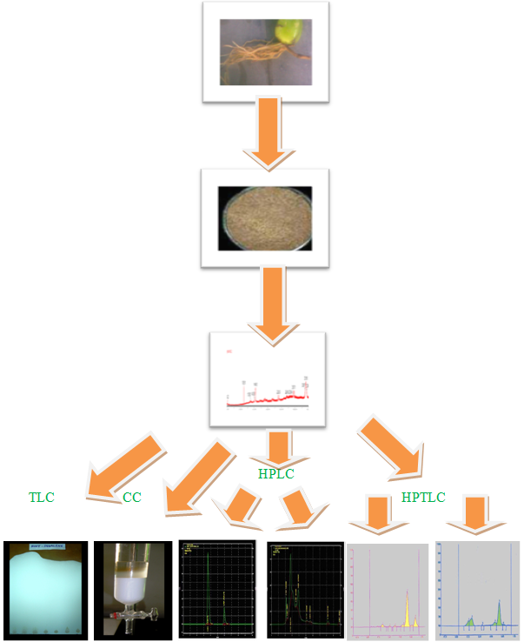

8/25/2018