Determination of Capsaicin Content and Pungency Level of Five Chili Peppers Grown in Egypt

Mohamed El Badrawy ^{1,2}

¹Ecole Oasis Internationale, Quarters 3 and 7, Zahraa El Maadi, Cairo, Egypt
²Department of Chemical and Biological Engineering, University of British Columbia, Vancouver Campus, Vancouver BC V6T 1Z3, Canada
mohamed.elbadrawy99@gmail.com

Abstract: The objective of this study is to determine the concentration of capsaicin in 5 commonly used chilies in Egypt and evaluate their potential for use in various industries. The 5 peppers that were used were: Harif, Hajin Mourad, Oroun, Orly Mohsen and Hajin Ammar. The extraction of capsaicin is carried out using ethanol as solvent in a water bath at a temperature of 80°C. HPLC analysis is then performed for the quantification of capsaicin. The mobile phase of HPLC consists of H₂O and acetonitrile in a ratio of 50:50. The detection wavelength was 222 nm. The results show that "Oroun" had the highest concentration of capsaicin (4,886.65 ± 105.53 mg/kg) and a pungency level of 78,186.40 SHU, while "Hajin Mourad" had the lowest concentration of capsaicin (2141.85 ± 40.65 mg / kg) and a pungency level of 34 269.60 SHU.
[Mohamed El Badrawy. Determination of Capsaicin Content and Pungency Level of Five Chili Peppers Grown in Egypt. N Y Sci J 2018;11(8):77-80]. ISSN 1554-0200 (print); ISSN 2375-723X (online). http://www.sciencepub.net/newyork. 11. doi:10.7537/marsnys110818.11.

Keywords: Scoville Heat Unit; Capsaicin; High Performance Liquid Chromatography; Pepper

1. Introduction
Peppers are fruits that are grown in most parts of the world. Peppers contain compounds called capsaicinoids, which are responsible for its pungent taste. The capsaicinoids are the following: capsaicin, dihydrocapsaicin, nordihydrocapsaicin, homocapsaicin and homodihydrocapsaicin (Kosuge and Furuta, 1970). Capsaicin (8-methyl-N-vanillyl-trans-6-nonenamide) is the most abundant capsaicinoid in peppers, and represents about 80% of the total capsaicinoids in the spice (Kraikruan et al., 2008). Gradually, the concentration of capsaicin in peppers became a major criterion for their commercialization in the agricultural market, on a global scale.
Capsaicin is used in the pharmaceutical industry, particularly in the production of topical pain relief creams as well as in the production of oleoresin (Nwokem et al., 2010). Topical creams of capsaicin relieve pain due to diseases such as arthritis and diabetic neuropathy. Capsaicin also acts as an antioxidant that can prevent bacterial infections (Goci et al., 2013). The production of oleoresin is also dependent on the capsaicin content of the peppers. Oleoresin is a substance used in the formulation of several pharmaceuticals, food dyes and gelatin. Capsaicin has also been proven effective against high cholesterol levels and obesity (Kempaiah et al., 2008).
The food industry also benefits from capsaicin as seen through the production of eggs, sauces and powders. The production of pungent sauces and powders is mainly dependent on peppers. The determination of the degree of pungency of peppers becomes vital in this production as it gives manufacturers a better sense of precision. With the variety of degrees of pungency that sauces and powders are manufactured at occur at different heat, the capsaicin concentration of peppers must be considered.
Peppers are also used for safety measures through the production of pepper spray. Pepper spray is an irritant to the eyes and respiratory system, and is used as an effective self-defense weapon.
In 1912, Wilbur Scoville invented the Scoville scale, which classifies peppers in SHU (Scoville Heat Units) according to their degree of pungency and capsaicin concentration (Scoville, 1912). The Scoville scale starts from 0 SHU up to a maximum of 16,000,000 SHU. There are five levels of pungency classified using SHU: non-pungent (0–700 SHU), mildly pungent (700–3,000 SHU), moderately pungent (3,000–25,000 SHU), highly pungent (25,000–70,000 SHU) and very highly pungent (>80,000 SHU).
High Performance Liquid Chromatography allows for the identification and quantification of the capsaicinoid content of peppers. The robustness, simplicity and accuracy of this method make it the best alternative in this study. The results of this study should give more insight into the potential industrial applications of the tested peppers.

2. Material and Methods
The 5 peppers used in this study are: Harif, Hajin Mourad, Oroun, Orly Mohsen and Hajin Ammar. All peppers are varieties of capsicum annuum species and were purchased from local markets in the regions in which they were grown. All peppers were dried and reduced to powdered form.
Extraction of capsaicin
Extraction of capsaicin was done as described by Collins et al (1995). 5g ground sample of each pepper was placed with 50 ml ethanol (Jeulin, France) in a 120 ml Teflon-lined glass. The glass was contained in a water bath set at 80°C for a duration of 4 hours. The supernatant was extracted and filtrated through a 0.45 μm filter (CHMLAB, Spain) and placed in a Parafilm-covered vial and stored in a refrigerator at 7°C until chromatographic analysis.
Choice of Solvent
For the extraction of capsaicin, the solvent must therefore be amphiphilic as the capsaicin molecule is amphiphilic itself. The best amphiphilic organic solvent found for the extraction of capsaicin, giving the highest yield, is ethanol (Nagoth et al., 2014).
Calibration Curve
A capsaicin standard (ClearSynth, Canada) was diluted using ethanol in order to form the stock solution. The standard curve was made using standard solutions of capsaicin of the following concentrations: 640 mg/dm³, 320 mg/dm³, 160 mg/dm³, 80 mg/dm³ and 40 mg/dm³. The standard solutions were analyzed through HPLC and a graph of the values of the area under the curve against capsaicin concentration was plotted.
HPLC Conditions
Chromatography was performed through UltiMate 3000 HPLC (Thermo Fisher Scientific, USA). The mobile phase employed was acetonitrile: H₂O (50:50, v/v) (Fisher Scientific, USA). The detection wavelength was set a 222 nm. A C18 column (Thermo Fisher Scientific, USA) was used and its temperature was set at 60°C. The flow rate was set at 1.5 mL/min. A sample volume of 10 μL was analyzed. The duration of analysis was set at 10 minutes. The software Chromeleon 7 (Thermo Fisher Scientific, USA) was used for analysis.
Capsaicin content calculation and Scoville Heat Unit Conversion
The SHU of a pepper is obtained through multiplying its capsaicin concentration (mg/kg) by 16. The capsaicin content of a pepper is obtained through dividing its SHU by 16 x 10⁶ and then multiplying it by 100.

3. Results
The calibration curve (Figure 1) obtained was plotted based on the data in Table 1.

Table 1. Calibration curve plot data for capsaicin standard
Capsaicin concentration (mg/dm³) | Area Under Curve (mAU. min)
40 | 0.214
80 | 0.462
160 | 0.583
320 | 1.226
640 | 2.227

The applied fitting curve was Y = 0.0033*X + 0.1217 with r²=0.9948.

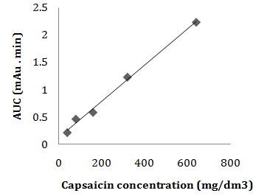
Figure 1. Calibration curve for capsaicin standard

Using the above curve equation, the capsaicin concentration, and hence the SHU, for the tested peppers were extrapolated.

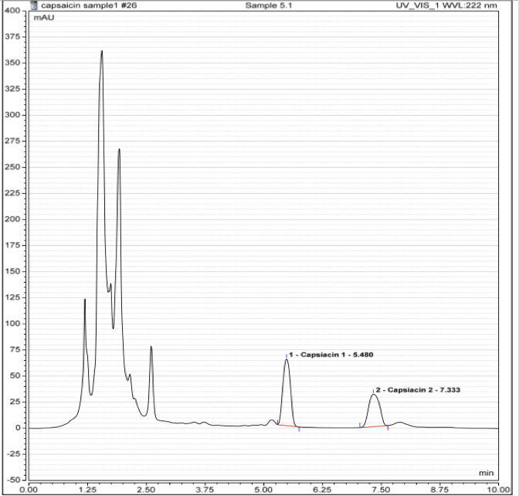 Figure 2. Example of HPTLC chromatogram of an “Oroun” sample
The first peak in figure 2 is representative of the presence of capsaicin and its AUC is used for the calculation of the concentration of capsaicin. The second peak is representative of the presence of dihydrocapsaicin.

Table 2. Capsaicin content details for the five tested peppers
Pepper variety | Capsaicin concentration (mg/kg) ± SD | SHU | Capsaicin content (%)
Hajin Ammar | 3106.94 ±317.56 | 49,711.04 | 0.31
Orly Mohsen | 2747.06 ±230.85 | 43,952.96 | 0.27
Harif | 2690.01 ±78.14 | 43,040.16 | 0.27
Hajin Mourad | 2141.85 ±40.65 | 34,269.60 | 0.22
Oroun | 4886.65 ±105.53 | 78,186.40 | 0.49

The SHU values ranged between 34 269.60 SHU and 78 186.40 SHU, corresponding to "Hajin Mourad" and "Oroun" respectively.

4. Discussions
HPLC was an effective method in separating, identifying and quantifying the various capsaicinoids of the peppers. As seen in Figure 2, two visible peaks are distinguishable.
The results obtained are considered accurate through the comparison of the results to that of literature. “Harif” is the local name given to the “Cayenne” pepper in Egypt. Cayenne has a SHU value within 30,000 – 50,000 SHU while Harif has a value of 43,040.16 SHU.
All peppers used in this study, with the exception of “Hajin Mourad” fall within the pungency limit (0.25- 1.33%) for the production of self-defense pepper sprays (22).
All peppers used in this study could potentially be used for the production of low concentration topical capsaicin cream, as the capsaicin content of all peppers is <1%. None of the peppers tested could be used for the production of high concentration topical capsaicin cream, as it requires an 8% capsaicin content. “Oroun” is the only pepper that could be used for the production of oleoresin, as it’s barely reaches the minimum value of capsaicin content set by the BPC, which is 0.5%.
All peppers tested are classified as “highly pungent” and can be used as a source of capsaicin in the food industry because they have relatively high capsaicin content. Based on such data, food products with precise degrees of pungency can be produced. In addition, the marketing of these products, with their SHU value, could be carried out in order to meet the needs of consumers.
The five tested peppers have capabilities for a variety of industrial applications. The method used in this study is advantageous to industries because it is simultaneously reliable and accurate and time efficient.
Acknowledgements:
Author is grateful to the Department of Chemistry at The American University in Cairo, especially Mr. Ahmed Omia for his support to carry out this work.

Corresponding Author:
Mohamed El Badrawy
Department of Chemical and Biological Engineering Vancouver Campus, University of British Columbia
Vancouver BC, V6T 1Z3, Canada
Telephone: 604-782-6381
E-mail: mohamed.elbadrawy99@gmail.com

References
- Kosuge S., Furuta M. Studies on the Pungent Principle of Capsicum. Part XIV: Chemical Constitution of the Pungent Principle. Journal of Agricultural and Biological Chemistry 1970; 34: 248-256.
- Kraikruan W., Sukprakarn S., Mongkolporn O., Wasee S. Capsaicin and Dihydrocapsaicin Contents of Thai Chili Cultivars. Kaserart Journal 2008; 42: 611-616.
- Usman, M., Rafii, M., Ismail, M., Malek, M., & Latif, M. Capsaicin and Dihydrocapsaicin Determination in Chili Pepper Genotypes Using Ultra-Fast Liquid Chromatography. Molecules 2014; 19(5): 6474-6488.
- Lambert, JW. Molecular Study Of Capsaicin in Aqueous and Hydrophobic Environments. VTechWorks 2006.
- Nagoth J., Raj J. Impact of Organic Solvents in the Extraction Efficiency of Therapeutic Analogue Capsaicin from Capsicum chinense Bhut Jolokia Fruits. International Journal of Pharmaceutical and Clinical Research 2014; 6(2): 159-164.
- NWOKEM, C.O. et al. (2010) Determination of Capsaicin Content and Pungency Level of Five Different Peppers Grown in Nigeria. New York Science Journal 2010;3(9).
- Weiss E.A. (2002). Spice Crops. CABI Publishing International, New York, 2002; 411.
- Halina B, Jan D., Agnieszka N. Capsaicinoids In Hot Pepper Depending On Fruit Maturity Stage And Harvest Date. Acta Sci. Pol., Hortorum Cultus 2013; 12(6), 183-196.
- WH, Anger. Low-concentration topical capsaicin for chronic neuropathic pain in adults. Clin J Oncol Nurs. 2014;18(1): 123-4.
- Collins M.D., Mayer-Wasmund L., Bosland P.W. Improved Method for Quantifying Capsaicinoids in Capsicum using High- Performance Liquid Chromatography. HortScience 1995; 30: 137-139.
- Othman ZA, Ahmed YB, Habila MA, Ghafar AA. Determination of capsaicin and dihydrocapsaicin in Capsicum fruit samples using high performance liquid chromatography. Molecules 2011; 16(10): 8919-29.
- Goci E, Haloçi E, Vide K, Malaj L. Application and comparison of three different extraction methods of capsaicin from capsicum fruits. Albanian Journal of Pharmaceutical Sciences 2014;1(1):16-9.
- Kempaiah R. K., Manjunatha H., Srinivasan K. Protective Effect of Dietary Capsaicin on Induced Oxidation of Low-Density Lipoprotein in Rats. Journal of Molecular and Cellular Biochemistry 2005; 275: 7-13.
- Scoville W.L. Note on capsicum. Journal of the American Pharmaceutical Association 1912; 1:453.

8/25/2018

