**A Curved Hole Creation with A Square Curved Copper Electrode by Electrical Discharge Machining and a New Mechanism Technique**

Hossameldin Hussein1, S. Habib2, Sayed. A. Abdallah2 and S.S. Mohamed2

1Higher Technological Institute, 10th of Ramadan city, Egypt.

2Shoubra Faculty of Engineering, Benha University, Cairo, Egypt.

[hossameldin@hti.edu.eg](mailto:hossameldin@hti.edu.eg)

**Abstract:** In this study, we concentrated on the creation of curved hole using a proper mechanism and a squared curved pure copper electrode, as holes are mostly machined by traditional operations like drilling which is just a combination of straight holes. So we designed a new mechanism technique, which consists of a squared curved electrode, an arm and a free arm holder to do it with the electrical discharge machining, which is settled on an electrical discharge machine (EDM). We got from the experimental results that the new mechanism could help in creating a curved hole with any radius depending on the length of the arm and adjusting the dimension of the mechanism.

[Hossameldin Hussein, S. Habib, Sayed. A. Abdallahand S.S. Mohamed. **A Curved Hole Creation with A Square Curved Copper Electrode by Electrical Discharge Machining and a New Mechanism Technique.** *N Y Sci J* 2018;11(8):73-76]. ISSN 1554-0200 (print); ISSN 2375-723X (online). <http://www.sciencepub.net/newyork>. 10. doi:[10.7537/marsnys110818.10](http://www.dx.doi.org/10.7537/marsnys110818.10).

**Keywords:** EDM, Curved hole, Square curved copper electrode, new mechanism technique**.**

**1. Introduction**

There are a lot of ways to make the holes. Fabricating holes are playing various roles in a variety of products. However, fabricated holes with the practical machining ways are almost straight. A typical example of unsuitable cases is pipe lines built in mechanical systems, which are utilized for passing a working fluid through them. The pipe line is usually machined by drilling operation. This forms a pipe line of polygonal-line structure that a series of straight holes are connected. It is natural that the pipe line has several joint points of straight holes. These points have the problems that a flow of a working fluid is sharply bent, which causes pressure loss of the working fluid, and that burrs are easily formed in joining straight holes by drilling, which brings grave damages to the mechanical system equipped with such a pipe line when the burrs are stripped and mixed to the working fluid. Such pipe lines are nowadays employed in pneumatic components and hydraulic equipments, as well as water channels fabricated in molds. In case of water channels in molds, the influences brought by their polygonal-line shape are more serious. Water channels play a role to control the thermal condition in molding by flowing coolant through them. Accordingly, their arrangement in the molds is very important to suppress the defects occurring in each stage of molding process, namely, to achieve high productivity. [1-4].

The aim of this paper is to study the possibility of creating curved holes by using a squared curved copper electrode and study its wear rate and to know how it is possible to use that new mechanism.

**2. Experimental Work**

2.1 Preparation of the Mechanism for obtaining the curved hole as shown in **Fig. 1**.

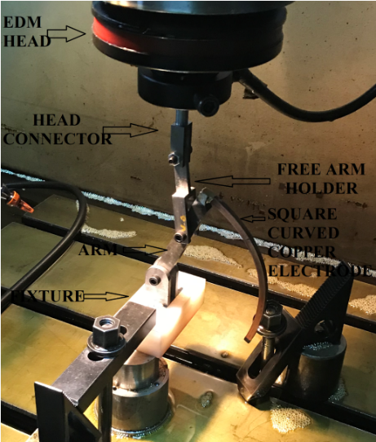

**Fig. 1.** The new Mechanism

**2.1.1 The arm**

The arm is made from steel C45 and the function of the arm is to hold the curved electrode's holder after welding them together by brazing process and its length is really important as it should be equal to the value of the curved electrode holder's radius. Its chemical composition is given in **Table 1**.

**Table 1. The Chemical composition of C 45**

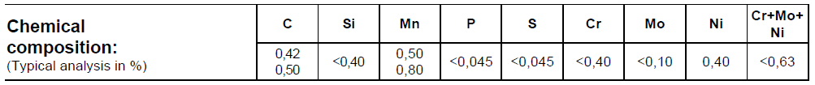

**2.1.2 The Squared Pure Copper Electrode**

A square curved electrode of pure copper (USN C80100) made by rolling process on a rolling machine with a cross section of 6mm. x 6mm. length and width. The electrode's chemical composition of copper (UNS C80100) is given in **Table 2**.

**Table 2. The chemical composition of copper (UNS C80100)**

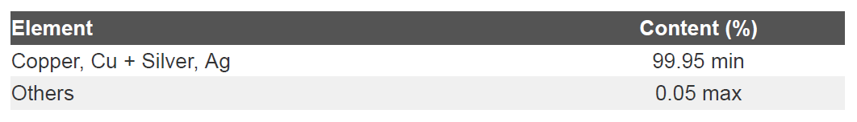

**2.1.3 The free arm holder**

The free arm holder which made from the C45 steel is to hold and let the arm moves circularly free when the EDM's head moves vertically.

**2.2 EDM Machining & Parameters**

We used the sinker EDM machine (HO CHEN) PNC EDM 75A at EL SAFAA Plast's Company as shown in **Fig. 2**.Also the working conditions are listed in **Table 3**.

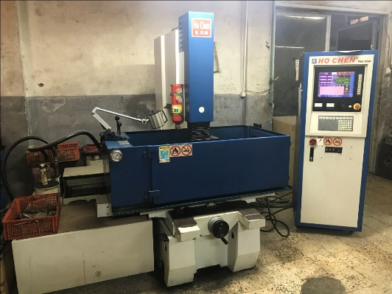

**Figure 2**. Electrical Discharge Machine

**Table 3. EDM drilling conditions**

**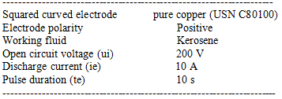**

**2.3 Preparation of workpiece**

The workpiece is made also from C45 steel with dimension 200x150x20 mm as shown in **fig. 3**.

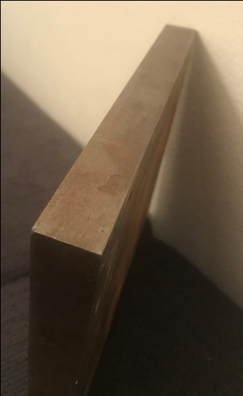

**Fig. 3. The Work piece**

**2.4 Machining**

After the preparations for making the squared curved hole by the electrical discharge machine (EDM) and the new mechanism as shown in **Fig. 4**, we put the mechanism on the EDM mentioned above submerged in the kerosene and after we finished, we measured the electrodes dimensions and weights before and after the process plus the inlet and outlet dimensions of the squared hole and then we took the work piece to make the radiography test with X-Ray with the parameters in **Table 4**.

**Table 4. The parameters used in the X-Ray radiography test**

|  |  |
| --- | --- |
| **Source** | X- Ray – Andrex 300kw |
| **Tube Voltage** | 150 KV |
| **Film Type** | Kodak AA400 |
| **SFD** | 700mm |
| **Tube Current** | 3mA |
| **Exposure Time** | 4.0 Min |
| **Processing** | Manual |

The wear of the electrode was measured by the following equation:

Electrode wear rate = $\frac{Electrode weight before machining - Electrode weight after machining}{time }$ (gram/min.)

**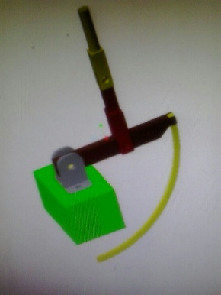**

**Fig. 4.** The new mechanism

**3. Experimental Results and Discussion**

3.1 Machining Table as shown in **Table 5**.

**Table 5. Machining output**

|  |  |  |  |
| --- | --- | --- | --- |
| X  (mm) | Y  (mm) | Electrode's Dimension Before Machining | Electrode's Dimension After Machining |
| 45.6 | 51.5 | 6mm. x 6mm. | 5.9mm. x 5.9mm. |

The shape of the squared curved electrode after and before machining as shown in **Table 6**.

**Table 6. The shape of the electrode before and after the machining**

|  |
| --- |
| C:\Users\fun station\Desktop\square before.bmp  Before Machining |
| **C:\Users\fun station\Desktop\square after.png**  After Machining |

The shape of the workpiece after making the required holes shown in **Fig. 5**.

**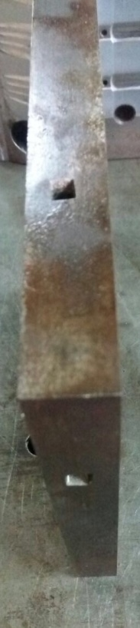**

**Fig. 5.** The workpiece after machining

The dimensions and the shape of the inlet and outlet hole as shown in **Table 7**.

**Table 7. The shape and the dimensions of the inlet and outlet hole**

|  |  |
| --- | --- |
| Hole's Inlet dimensions | Hole's Outlet dimensions |
| 6.2mm. x 9mm. | 6mm. x 6.2mm. |
| C:\Users\fun station\Desktop\inlet.bmp | C:\Users\fun station\Downloads\SHAREit\iPhone 7\photo\IMG_3085.JPG |

**3.2 Wear Table**

Electrode Wear Rate = 0.00319 (gram/minute)

The weight of the electrode before and after the machining as shown in **Table 8**.

**Table 8. The weight of the electrode before and after the machining**

|  |  |
| --- | --- |
| Weight of the Electrode Before Machining  (gram) | Weight of the Electrode After Machining  (gram) |
| 51.70 | 51.47 |

**3.3. The radiography test's visions**

The shape of the curved hole using the X-Ray as shown in **Fig. 6**.

**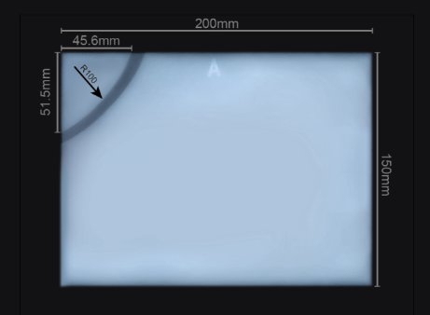**

**Fig. 6.** The X-Ray for the curved hole

**4. Conclusions**

We found in this paper that the new mechanism with a square curved copper electrode could make the radius we need but has some disadvantages such as in the inlet hole as the electrode's curve, it widen the entrance of the inlet hole as not only the beginning of the hole enters but also some of the rest of the curved hole, and we recommend to put a head to the electrode to not let the rest of the curve touches the required hole.

**References**

1. Sameh Habib, Akira Okada and Sho Ichii, Effect of cutting direction on machining of carbon fiber reinforced plastic by electrical discharge machining process, International Journal of Machining and Machinability of Materials 13(4):414 – 427, January 2013.
2. Sameh Habib, Hai Wang, Akira Okada and Yoshiyuki Uno, EDM characteristics of carbon fiber reinforced plastic, 16th International Symposium on Electromachining, ISEM 2010, January 2010.
3. Sameh Habib, Study of the parameters in electrical discharge machining through response surface methodology approach, Applied Mathematical Modeling 33(12):4397 – 4407, December 2009.
4. Hai Wang, Akira Okada, Takafumi Uwano, Sameh Habib and Yoshiyuki Uno, Study on electrical discharge machining characteristics of electrically conductive ceramics, 9th International Conference on Progress of Machining Technology, February 2009.

8/25/2018