Battered Piles under Lateral Loads using Strain Wedge Model and Current Practice

Mohamed Ashour¹; Ahmed Alaa Eldin²; Mohamed G. Arab³

¹Associate Professor of Civil Engineering, Dept. of Mechanical and Civil Engineering, Alabama A & M University,
Normal, Alabama 35762.
²Teaching Assistant at Mansoura High Institute for Engineering and Technology, Egypt.
³Assistant Professor, Civil & Environmental Engineering Department, College of Engineering, University of Sharjah, UAE; and Assistant Professor, Structural Engineering Department, Faculty of Engineering, Mansoura
University, Egypt
Mohamed.Ashour@aamu.edu; mg_arab@mans.edu.eg; ah.a.eldin@gmail.com

Abstract: The Strain Wedge (SW) model, LPILE and Finite Element program (MIDAS GTS-NX) are used to study pile and soil typical parameters impact on the lateral response of single battered piles. The influence of pile battering angle, sand relative density, and pile cross sectional shape are presented in addition to the prediction of the soil wedge geometry infront of the pile. In SW model and LPILE analyses, the soil is modeled as a Beam on Elastic Foundation (BEF) with a set of non-linear p-y curves (i.e., modulus of subgrade reaction, E_{s}) which accounts for soil and pile properties. Mohr-Coulomb soil failure criteria is employed in MIDAS soil modeling with a Tetrahedron meshing. The used approaches have been compared with field test results. Negative battered piles sustain greater resistance compared to the piles with positive battered angles. The larger the sand relative density the more the battered pile ability to withstand lateral loads. The three techniques are used to predict the pile lateral deflection, bending moment, and shear force along the pile length. Unlike the other two techniques, MIDAS predicts less bending moments and shear forces for positive battered piles, which is also highly influenced by the interface element controlling parameter (i.e., the virtual thickness, t_{v}).
[Mohamed Ashour; Ahmed Alaa Eldin; Mohamed G. Arab. Battered Piles under Lateral Loads using Strain Wedge Model and Current Practice. N Y Sci J 2018;11(7):20-28]. ISSN 1554-0200 (print); ISSN 2375-723X (online). http://www.sciencepub.net/newyork. 4. doi:10.7537/marsnys110718.04.

Keywords: Strain Wedge, Battered pile, Lateral load, Finite Element, Modeling.

Introduction
Battered piles are used instead of vertical piles to resist high lateral loads as applied to bridge piers and off-shore and retaining structures. Battered piles are classified as negative and positive battered piles in accordance with the directions of lateral load and pile battering as demonstrated in Fig. 1.

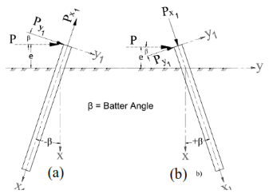
Fig. 1. Types of battered piles (a) Negative battered pile (b) Positive battered pile

The behavior of battered piles subjected to lateral loads has limited studies in the literature. The negative battered piles have greater resistance than that of vertical and positive battered ones in sandy soils as concluded from full-scale lateral load tests (Alizadeh and Davisson, 1970; Nimityongskul et al., 2012) and model scale tests (Juvekar and Pise, 2008; Murthy, 1964; Meyerhof and Ranjan, 1973; Meyerhof and Yalcin, 1994; Manoppo, 2010). Sastry et al. (1995) suggested that the lateral capacity, and the magnitude and position of maximum bending moment of a flexible battered pile can be estimated by solving an equivalent rigid vertical pile subjected to an inclined load. Where, the load inclination angle equals to the angle between the pile axis and the horizontal. Based on the model tests performed by Sastry et al. (1995), the maximum bending moment for positive battered piles is higher than that of negative battered ones. Ong (2015) investigated the effect of the interface elementsensitivityparameters used in Finite Element (FE) modelson the response of laterally loaded vertical piles in sandy and clayey soils. The ratio between the interface normal stiffness (K_{n}) and soil Young`s modulus (E) ata reference level should be from 1 to 10 and 10 to 100 in sandy and clayey soils, respectively, as concluded by Ong (2015). Hazzar et al. (2017) investigated the response of battered piles subjected to lateral loads and the influence of vertical loads on the pile lateral performance. FLAC^{3D} (Itasca 2009), Finite Difference computer software, was utilized by Hazzar et al. (2017) to study battered piles in sandy soils and the results exhibited that the vertical load, pile batter angle, and the soil relative density significantly influence the lateral response of battered piles in sandy soils. Hazzar et al. (2017) shows that the negative batter piles lateral response is significantly dependent on the batter angle and sand relative density while the positive battered does not seem to significantly fluctuate with batter angle and soil density.
There are limited studies from the literature that predict the lateral capacity and overall response of the battered piles (i.e., pile deflection, bending moment, and shear force). So, this paper presents a detailed study on the response of battered piles subjected to lateral loads in sandy soils using the SW method, LPILE and MIDASGTS-NX as a Finite Element numerical solution.

Strain Wedge Method Concepts
The SW model correlates the traditional one-dimensional Beam on Elastic Foundation (BEF) (Eq. 1 and Fig. 2c) to an envisioned three-dimensional soil-pile interaction (Figs. 2a and b). Young’s modulus of the soil (E) at the face of the passive soil wedge is related to the corresponding horizontal subgrade modulus (E_{s}). It should be noted that the SW model employs a soil stress-strain relationship (ε - ∆σ_{h}) which is developed based on the concepts of the conventional triaxial test (Ashour et al. 1998). The deflection pattern of the pile along its depth (y versus depth x) is related to the soil strain (γ) developing in the passive wedge in front of the pile. Furthermore, the BEF line load (p) for a given deflection is related to the horizontal stress change (∆σ_{h}) acting at the face of the mobilized passive wedge (Fig. 2b). More details on the basics of the SW model are presented in Ashour et al. (1996 and 1998). Detailed SW formulations are presented in a different study to account for the pile inclination (Ashour et al. 2018). The modified formulations are employed in a FORTRAN code using the flowchart shown in Fig. 3.

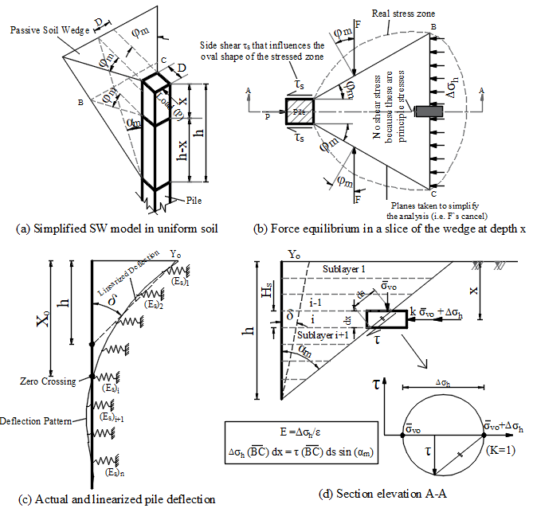
Fig. 2. Strain Wedge model basic concept (Ashour et al. 2018)
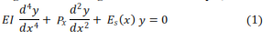
Where EI is the pile flexure rigidity and P_{x} denotes the axial load at the pile segment.
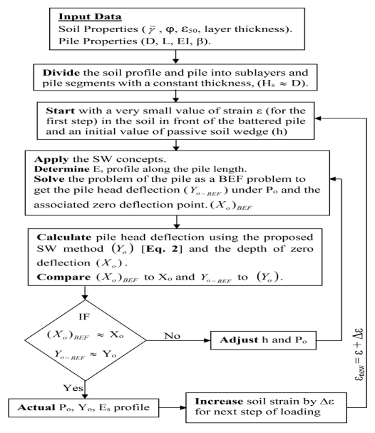
Fig. 3. The flow chart of the SW method

Due to pile battering, the applied lateral load (P) is decomposed intothe components P_{y1} and P_{x1} (perpendicular and axial components, respectively, Fig. 1). The geometry (i.e., the size) of the passive soil wedge grows with advancing lateral load at the pile head. The size of the wedge changes as a function of the soil properties (i.e., friction angle, φ, effective unit weight, γ, and strain at 50% of stress, ε₅₀) and pile properties (pile diameter, D, bending stiffness, EI, and pile-head condition). The basic SW model concepts presented by Ashour et al. (2018)are applied in the x₁ - y₁ plane under lateral load P_{y1} where P_{y1} = P cos (β) and P_{x1} = P Sin (β). β is the pile battering angle shown in Fig. 1. The pile head displacement (y₁) in y₁-direction (Fig. 1) is determined as a function of the pile deflection angle and associated strain in the passive soil wedge. The pile head-deflection in the (horizontal) y-direction is calculated as

Modeling
Figure4portrays the general layout and meshing of the MIDAS model used in the analysis of the soil-pile system. A pile with diameter (D) and total length (L) is embedded in the sandy soil with an inclination angle (β). While the total thickness of the soil stratum is selected as (L cos (β) + 6D) and the Tetrahedron mesh size is extended to a horizontal distance of 16D from the center of the pile to release the effect of model boundary conditions (Hazzar et al.2017). All displacements are restrained at the bottom of the soil domain while the external vertical faces are fully fixed in the X- and Y-directions.
LPILE and SW model are used to solve the problem of laterally loaded piles as a BEF made up of a set of nonlinear p-y curves (i.e., non-linear springs) representing the soil and pile properties contributions to the resulting soil-pile interaction as demonstrated in Fig. 2c. These p-y curves depend on the soil properties and the pile width (Reese et al., 1974) or account for more pile properties such as the pile bending stiffness, pile-cross sectional shape and pile-head fixity condition as employed in the SW model by Ashour and Norris (2000). For battered piles, LPILE (Reese et al. 2004) applies a multiplier to the p-y curves of an equivalent vertical pile to anticipate the response of the battered one. In contrast, the SW approach generates its own p-y curves along the pile based on the pile and soil properties.

MIDAS Soil Modeling
The non-linear behavior of the sandy soil is simulated using the Mohr-Coulomb model which is commonly used in geotechnical engineering practice. Table 1 summarizes the soil properties used in the parametric study.

Table 1. Sand Properties Used in Parametric Study
Sand State | Dr (%) | γ(kN/m³) | φ (degree) | ν* | E* (kN/m²) | ε₅₀
Loose | 30 | 17 | 30 | 0.25 | 15000 | 0.0052
Medium Dense | 60 | 19 | 35 | 0.30 | 30000 | 0.0037
Dense | 80 | 21 | 40 | 0.35 | 60000 | 0.0028
* Values of soil Poisson`s ratio (ν) and modulus of elasticity (E) are assumed according to Bowles (1996).

Table 2. Piles Properties Used in Parametric Study
No. | Material | Section | D (mm) |  | t (mm) |  | L (m) | EI (kN-m²) | Interface Parameters
 |  |  | B_{f} | H_{w} | t_{f} | t_{w} |  |  | Sand State | Q_{u} (kN/m²) | K_{t} (kN/m³) | K_{n} (kN/m³)
1 | Steel | H-Section | 345 | 371 | 12.8 | 12.8 | 20 | 70578 | Loose | 2700 | 1800 | 19800
 |  |  |  |  |  |  |  |  | Medium | 4600 | 3400 | 38000
 |  |  |  |  |  |  |  |  | Dense | 6300 | 6600 | 73000
2 | RC | Circular | 345 |  | - |  | 20 | 70353 | Medium | 3100 | 3400 | 38000
B_{f}= Flange width t = Pipe thickness t_{f} = Flange thickness
H_{w} = Web height t_{w} =Web thickness

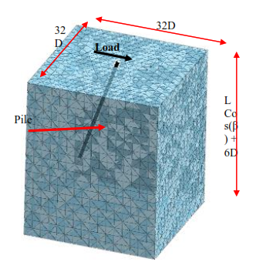
Fig. 4. Typical mesh used for MIDAS analysis

MIDAS Pile Modeling
The pile is modeled as a linear-elastic material with the pile properties displayed in Table 2.

Soil-Pile Interface Modeling
The soil-pile interface is defined in MIDAS using a pile element with three parameters: 1) the ultimate shear force (Q_{u}), 2) the shear stiffness modulus (K_{t}), and 3) the normal stiffness modulus (K_{n}), each per total pile length. The ultimate shear force is calculated by dividing the pile axial load by the pile length and the pile element thickness. In the absence of pile test data, MIDAS user manual recommends using design standards to calculate the ultimate skin friction. The β-method (Bowles 1996) is used herein to calculate ultimate skin friction (Q_{s}). Using a pile element thickness of 1m, the values of Q_{u} are determined for axial load as in Table 2. This assumption is assumed to limit the failure to either the soil or the pile and limit the relative displacement between the pile and the soil. It should be noted that MIDAS user manual has no criteria to calculate the value of Q_{u} for lateral load and battered pile. Also, MIDAS user manual suggests the following empirical formulations to define the values of K_{t} and K_{n}.

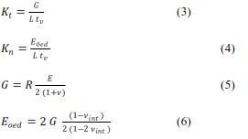

Where, L is the pile length and R is a strength reduction factor represents the friction between sand and pile which ranges from 0.6 to 0.7 in case of steel and 0.8 to 1 for concrete. t_{v} is a virtual thickness for the interface element that has a value between 0.01 to 0.1 as recommended in MIDAS user manual and Ong (2015). The higher the stiffness difference between soil and pile, the smaller the value of t_{v}. ν_{int.} is the interface Poisson`s ratio which has a value of 0.45 (MIDAS user manual).

Validation

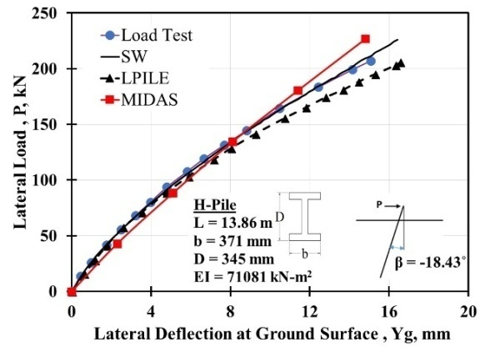
Fig. 5. Calculated and measured response of laterally loaded battered pile at Arkansas River

Alizadeh and Davisson (1970) performed a full-scale lateral load test on negatively battered steel H-section pile (β = -18.43˚) with a flexure stiffness EI of 71081kN-m² and a pile length (L) of 13.8m at Arkansas river site. As reported by Meyer and Reese (1979), the pile was a free-head driven pile in sandy soil with 18.06 kN/m³ unit weight and 9.89 kN/m³ submerged unit weight. The soil’s angle of internal friction (ϕ) was 38° and the water table was 0.4m below the ground surface. The pile-head (i.e., the location of loading (e), Fig. 1) was 0.15m above the ground surface. For MIDAS, The pile interface parameters are used to be 1300 kN/m², 4000 kN/m³, and 45000 kN/m³ for Q_{u}, K_{t}, and K_{n}, respectevely. Figure 5 presents the measured pile-head response at the ground surface and the LPILE, MIDAS, and SW model results. A good agreement is found between the measured data and MIDAS, LPILE, and SW results. However, the results of MIDAS are very sensitive to the interface element parameters specially the parameter t_{v} which is used with a value of 0.1 in the present study. More details about the sensitivity of t_{v} presented in Ong (2015).

Parametric Study
The SW model, MIDAS and LPILEprocedures are utilized in performing a series of analyses on laterally loaded battered piles embedded in loose, medium dense, and dense sands. The current study concentrates on the influence of typical soil/pile properties on the lateral response of battered piles. Such properties include the pile battering angle (β), relative density of sandy soil (D_{r}), and pile cross section shape. The study also presents a comparison between the passive wedge size obtained from SW model and MIDAS. Tables 1 and 2 present the soil and pile properties used in the analysis, respectively. For each sand density, the values suggested by Bowles (1996) for the sand modulus of elasticity (E) and other soil properties are employed. The response of battered piles is investigated for several values of batter angles β that ranged from -20 to +20 degrees.

Analysis and Results

Pile batter angle
Figure 6 presents the lateral response of battered piles for β = ±20˚ and ±10˚. The utilized medium dense sand and pile properties are presented in Tables 1 and 2, respectively. A good agreement between the SW model, LPILE, and MIDAS results can be observed in Fig. 6a with negative battered piles, which is not the case with the positive battered piles shown in Fig. 6b. MIDAS results are not in good agreement with the predicted response of positive battered piles obtained from the SW model and LPILE even by changing the value of t_{v} from 0.01 to 0.1 (Figs. 6b and 7) as recommended in MIDAS user manual and Ong (2015).

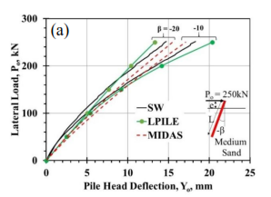 | 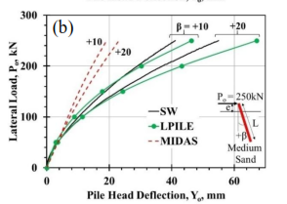
Fig. 6. Response of laterally loaded battered pile a) Negative battered b) Positive battered

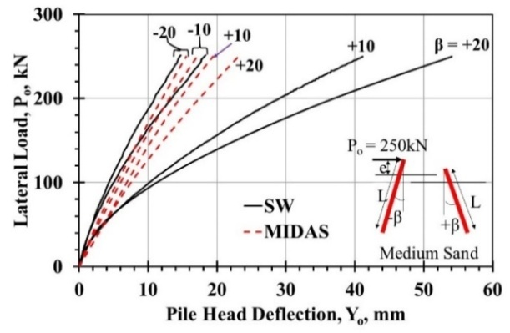
Fig. 7. Response of laterally loaded battered pile

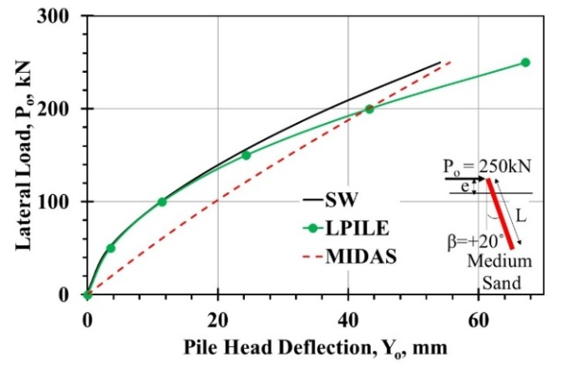
Fig. 8. Response of laterally positive battered pile (t_{v} = 0.8)

MIDAS can be used to predict the response of laterally loaded positive battered piles by using t_{v} equals to 0.8 as shown in Fig. 8. The resistance of the negative battered piles is greater than that of the positive battered ones. Likewise, the higher the value of negative battering angle the higher the stiffness of the pile. In contrast, the higher the value of positive battering angle the softer the stiffness of the battered pile.

Sand relative density (D_{r})
The pile-soil lateral resistance increases by changing the state of sand from loose to dense for both negative and positive battered piles as presented in Fig.9. As shown in Fig. 9a, the difference between MIDAS's predictions of lateral response of negative piles and those from the other two techniques decreases by increasing the sand relative densities to exhibit very good agreement in the case of dense sand. On the other hand, the SW model provides moderate predictions for the positive pile in loose, medium dense and dense sands compared to the results obtained from MIDAS and LPILE (Fig. 9b). It can be noticed that LPILE provides a softer pile head response and MIDAS predicts a stiffer one compared to the results of the SW model.

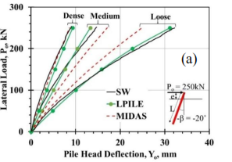 | 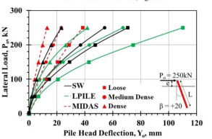(b)
Fig. 9. Influence of sand relative density on the response of laterally loaded battered piles for a) Negative battered b) Positive battered

Pile cross section
The medium dense sand and piles No. 1 and 2 (Tables 1 and 2) are used to study the influence of pile cross section on the lateral response of battered piles. The SW and LPILE results indicate that the circular cross section has less resistance compared to the pile with an H-section. On contrast and unexpectedly, MIDAS provides a stiffer pile head response for the pile with a circular cross section as demonstrated in Fig. 10.

Deflection pattern
Figure 11 presents the profile of pile lateral deflections along the pile length. A very good agreement can be observed between the three techniques used in this paper for the negative battered pile (Fig. 11a). As previously noted, MIDAS results are obtained based on t_{v} = 0.1 do not match those predicted by other methods for positive battered piles (Fig. 11b).
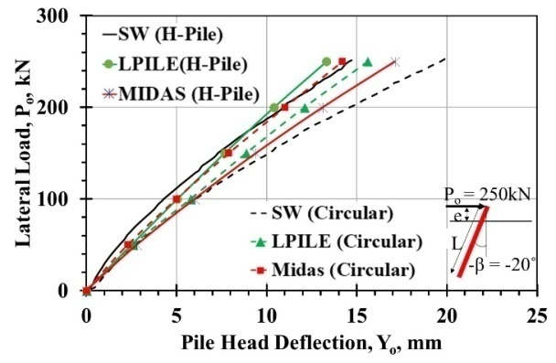
Fig. 10. Pile lateral deflection profile for Negative battered pile

Bending moment and shear force
Figures12and 13 display the bending moment and shear force diagrams along the pile, respectively. For the same lateral load, the maximum bending moments of positive battered piles are greater than those of the negative battered piles which agree with the results presented by Sastry et al. (1995). The medium dense sand and pile No. 1 properties described in Tables 1 and 2, respectively, were utilized in the analysis. The straining actions (i.e., bending moments and shear forces, Figs. 12 and 13) determined from MIDAS are less than those calculated from the other two techniques.

Wedge size
Once the battered pile deflects, a mobilized passive soil wedge develops in front of the pile. The wedge size/geometry is controlled by the mobilized fanning angle (φ_{m}), the width of the wedge face ($\overline{BC}$), and the wedge height (h) (i.e., the depth to the first zero-deflection point) (Fig. 2). Figure14portrays the wedge size at the ground surface predicted using SW method and MIDAS. A reasonable agreement can be observed for the negative battered pile as shown in Fig. 14a. As in Fig. 14b, MIDAS predicts larger soil passive wedge which may explain the relatively stiff response of the positive battered piles compared to the SW model one (Figs. 6b, 7and8b). The value of h of the negative battered pile is equal to 3.17m and 4.0m for the SW model and MIDAS, respectively, as shown in Fig. 11a. For the positive battered pile, the SW model and MIDAS provide an h of 3.62m and 3.65m, respectively, as demonstrated in Fig. 11b.

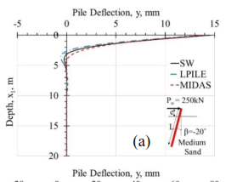 | 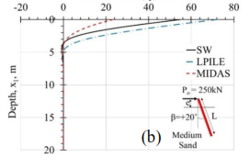
Fig. 11. Pile lateral deflection profile a) Negative battered b) Positive battered

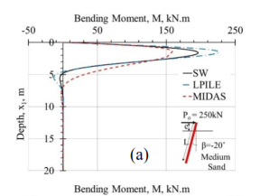 | 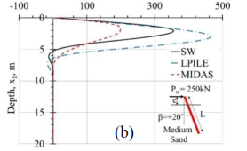
Fig. 12. Bending moment diagram, a) Negative battered b) Positive battered

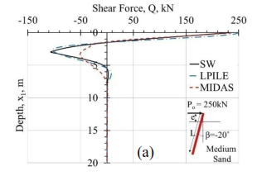 | 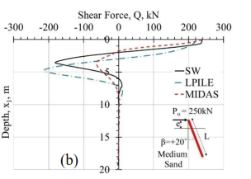
Fig. 13. Shear force diagram, a) Negative battered b) Positive battered

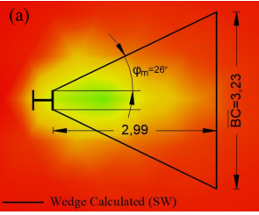 | 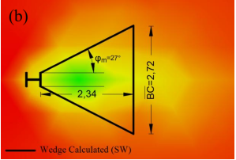
Fig. 14. Wedge size at ground surface predicted by SW and MIDAS a) Negative battered b) Positive battered piles

Summary and Conclusion
The SW model, LPILE, and MIDAS GTS-NX are used to assess the response of battered piles subjected to lateral loads. The SW approach predicts the behavior of laterally loaded batter piles as a function of soil and pile properties (bending stiffness, cross-sectional shape, and head fixity). As expected, the lateral behavior of batterd piles is highly influenced by the magnitude and direction of the pile batter angle in addition to the soil properties (i.e., sand relative density). The SW model and LPILE can be used to determine the pile lateral deflection and straining actions (i.e., bending moment, and shear force) along the pile length for negative and positive battered piles unlike MIDAS which predicts less bending moments and stiffer pile head response with positive battered piles. MIDAS can be utilized to analyze the positive battered piles by modifying the controlling parameter of the interface element (i.e., the virtual thickness, t_{v}) to be0.8. However, MIDAS interface element needs extended sensitivity analysis to relate the interface parameters to soil and pile properties including the pile battering angle. Despite the good agreement of the SW results with field test, additional field results are surely needed to validate the predicted straining actions.

References
- Alizadeh, M., and Davisson, M. T. (1970). “Lateral load tests on piles-Arkansas River project.” Journal of Soil Mechanics and Foundations Div. 96(5), PROC PAPER 7510, 1583 - 1604.
- Ashour, M., Alaa Eldin, A., and Arab, M. G. (2018). “Battered Piles in Sandy Soils under Lateral Loads.” Under review, J. Geotech. and Geoenviron. Eng., ASCE, GTENG-7087.
- Ashour, M., Norris, G., and Pilling, P. (1998). “Lateral loading of a pile in layered soil using the Strain Wedge model.” J. Geotech. and Geoenviron. Eng., 124(4), doi:10.1061/(ASCE)1090-0241(1998)124:4(303), 303-315.
- Ashour, M., and Norris, G. (2000). “Modeling lateral soil-pile response based on soil-pile interaction.” J. Geotech. and Geoenviron. Eng., doi:10.1061/(ASCE)1090-0241(2000)126:5(420),420-428.
- Ashour, M., Pilling, P., Norris, G., and Perez, H. (1996). “Development of a strain wedge model program for pile group interference and pile cap contribution effects.” Report – CCEER-96-4, FHWA, and CALTRANS, University of Nevada, Reno, 274pp.
- Bowles, L. E. (1996). “Foundation analysis and design.” McGraw-hill.‏
- Hazzar, L., Hussien, M.N. and Karray, M., (2017). Numerical investigation of the lateral response of battered pile foundations. International Journal of Geotechnical Engineering, 11(4), pp.376-392.
- Juvekar, M. S., and Pise, P. J. (2008). “Behavior of rigid batter piles and pile groups subjected to horizontal load in sand.” Indian Geotechnical Journal, 38(2), 221-242.‏
- Manoppo, F. J. (2010). “Behavior of the ultimate bearing capacity of single flexible batter pile under horizontal loads in homogeneous sand.” ‏Dinamika TEKNIK SIPIL 10(2), 116-119.
- Meyerhof, G. G., and Ranjan, G. (1973). “The bearing capacity of rigid piles under inclined loads in sand. II: Batter piles.” Canadian Geotechnical Journal, 10(1), 71-85.‏
- Meyer, B. J., and Reese, L. C (1979). “Analysis of single piles under lateral loading.“ Report (No. FHWA-TX-79-38+ 244-1 Intrm Rpt.), TX: Center for Highway Research, University of Texas at Austin.‏
- Meyerhof, G. G., and Yalcin, A. S. (1994). “Behavior of flexible batter piles under inclined loads in layered soil.” Canadian Geotechnical Journal,30(2), 247-256.‏
- Murthy, V. N. S. (1964). “Behavior of battered piles embedded in sand subjected to lateral loads.” Proc., Symp. on Bearing Capacity of Piles, CBRI, Roorkee, India, 142–153.
- Nimityongskul, N., Barker, P., and Ashford, S. (2012). “Effects of Soil Slope on Lateral Capacity of Piles in Cohesive and Cohesionless Soils.” Research Report of a Research Project Funded by Caltrans under Facilities Contract No. 59A0645, Oregon State University, Kiewit.
- Ong. Y. H, (2016). Back analysis of laterally loaded pile behavior using Midas/GTS to determine stiffness modulus of pile-soil interface. Japanese Geotechnical Society Special Publication, 2(35), 1279-1284.‏
- Reese, L. C., Cox, W. R., and Koop, F. D. (1974). “Analysis of laterally loaded piles in sand.” Offshore Technology in Civil Engineering Hall of Fame Papers from the Early Years, 95-105.‏
- Reese, L. C., Wang, S. T., Isenhower, W. M., and Arrellaga, J. A. (2004). Computer program Lpile plus version 5.0 technical manual. Ensoft, Austin, TX.‏
- Sastry, V.V. R., Koumoto, T. and Monoppo, F.J. “Bearing capacityand bending moment of flexible batter piles in homogeneous soilunder horizontal loads”. Bul, fac. Agr. Saga univ. 79, 77-85, 1995.
- Technology, M. I. 2014. Midas Users Manual. GTS NXV2.1, Korea.

7/11/2018

