Analysis of Linear and Nonlinear Aggregations between Meteorological Parameters and Soil Temperature at Different Depths (Case Study; Synoptic Station of Shiraz)

Reza Sadegh Mansouri ¹, Ali Heidari ² and Mona Golabi ³

^{.1} Irrigation and Drainage Master Student, Faculty of Water Engineering, Shahid Chamran University of Ahvaz, Iran
mansoory947@yahoo.com
^{2.} Bachelor of Science, Faculty of Water Engineering, Shahid Chamran University of Ahvaz, Iran
^{3.} Assistant Professor of Irrigation and Drainage Department, Faculty of Water Engineering, Shahid Chamran University of Ahvaz, Iran

Abstract: Soil temperature is one of the important variables in hydrological, meteorological, agricultural and climatological studies, which is necessary to be measured and estimated. Due to the fact that soil temperature is measured only at synoptic stations in the country, the lack of stations is a major challenge in many agricultural studies. In the present study linear and nonlinear regression relationships between meteorological parameters including air temperature, relative humidity, sunshine hours and temperature in the depths of soil (5,10,20,30,50,100 cm) at the Meteorological Station of Shiraz in a ten-years period (2005 to 2015) were studied. The data are measured on a daily basis at 3 a.m, 9 a.m and 3 p.m. The results showed that the highest linear and nonlinear determination coefficient between mean air temperature and soil temperature at 3 a.m and in the 5 cm depth are R²= 94.19 and R² = 94.28, respectively. The highest linear and nonlinear determination coefficient between relative humidity and soil temperature at 3 p.m and in the 10 cm depth are R² = 64.38 and R² = 0.033, respectively and The highest linear and nonlinear determination coefficient between sunshine hours and soil temperature at 3 p.m in the depth of 20 cm are R² = 28.22 and R² = 21.22, respectively. The air temperature was more correlated with the soil temperature over the other two parameters. Also, nonlinear regression coefficients were more than the linear regression. Finally, the most appropriate relationships for different hours and depths were selected and verified with using the data from 2016. Validation results showed that the presented relationships have acceptable accuracy and these relationships can be used to obtain soil temperature at different hours and depths.
[Reza Sadegh Mansouri, Ali Heidari and Mona Golabi. Analysis of Linear and Nonlinear Aggregations between Meteorological Parameters and Soil Temperature at Different Depths (Case Study; Synoptic Station of Shiraz). N Y Sci J 2018;11(6):69-79]. ISSN 1554-0200 (print); ISSN 2375-723X (online). http://www.sciencepub.net/newyork. 11. doi:10.7537/marsnys110618.11.

Keywords: Soil temperature, Meteorological parameters, Validation, Regression, Weather station, Shiraz

1. Introduction
The temperature is one of the main characteristics of soil, so that the growth and development of plant and the development of soil processes depends on its changes. In this regard, surface temperature and depth of soil are not measured continuously, therefore, we often encounter with the lack of Soil data, while meteorological parameters are measured continuously. Soil temperature is one of the important variables in the hydrological studies, agriculture meteorology and climatology (Béhaegel et al., 2007). On the other hand, heat behavior in the soil has a significant effect on the activity of microorganisms in the soil, the absorption of important elements such as phosphorus and potassium and other biological activities within the soil. Soil temperature at different depths has different temporal and spatial behaviors. According to studies, thermal flow inside the soil is affected by various variables such as air temperature, solar radiation, wind speed, season and physical properties of soil (Najafi et al., 2008). Due to this, estimation of the soil temperature, especially near the surface of the earth, which is more volatile, is somewhat problematic (Mihalakakou, 2002). The soil temperature is measured in synoptic stations with different types of sensors or conventional thermometers. Soil temperature measurement with a sensor is costly and requires skilled labors and continuous monitoring. Several different sensors or thermometers are needed to determine the spatial variations of soil temperature at different depths (Sabziparvar and Tabari, 2010). Therefore, providing statistical and empirical methods that are able to provide acceptable results in soil temperature estimation can be a suitable solution for estimating this variable at unplanned points (Pelauborg, 2002). Due to the effect of soil temperature on soil reactions and microorganisms, so far many studies have been carried out on soil temperature estimation.
Ghuman and Lay (1982) evaluated the temperature of the equator regions using Fourier analysis and compared the results with the observed temperature. Their results indicate a high accuracy of Fourier analysis in this field. Zheng et al (1993) estimated the soil temperature at 10 centimeter depth in 6 climatic samples in the United States using air temperature and linear regression. Usowicz and walczak (1994) presented a mathematical model of heat flow in soil for predicting soil temperature. This model includes an equation and a physical-statistical model for evaluating thermal properties as a function of moisture and volume density, which uses a finite-difference differential equation to solve the heat transfer equation. Their results showed that the estimated values ​​of soil temperature in the proposed model have acceptable accuracy. Heusinkveld et al (2004) estimated the temperature of soil in a sandy soil in a desert region in northern Israel using harmonic analysis and soil heat conductivity studies. Pelauborg (2002) conducted a study to provide simple and empirical relationships for estimating soil temperature at a depth of 10 cm in Denmark. Meyhalakako (2002) used in Athens and Dublin to estimate the temperature of the soil from the diagnostic function and artificial neural network with air temperature, relative humidity and solar radiation as input variables. Veronez et al (2006) estimated the surface temperature in a city in Brazil using latitude and longitude and the use of artificial neural networks. Najafi Mood and et al (2008) studied the relationship between temperature and depth of soil in Khorasan Razavi province. The results indicated that a second order regression equation was suitable for each depth of soil. Tabari et al (2011) compared the performance of multi-layer perceptron artificial neural network with multivariable linear regression method for estimating daily soil temperature at 5, 10, 30, 50 and 100 cm depths in dry area of ​​Iran. For entering the two models of the neural network and multiple linear regressions, the daily average of meteorological parameters including temperature, solar radiation and relative humidity were used. The results of the comparison between these two models showed that the artificial neural network has a higher accuracy in estimating the daily temperature of the soil in the study area. In another study, Chaychi et al. (2008) estimated the soil surface temperature in a monthly scale in Tehran province using of NOAA satellite imagery. Ghaeminia et al (2009) simulated the depth of soil using a sinusoidal pattern and investigated the affecting atmospheric factors in Yazd and concluded that sinusoidal equations have the capability and efficiency to predict the temperature variations of different depths of the soil. Parsafar and Maroofi (2010) have extracted regression relationships between soil temperature at different depths and meteorological parameters. The results showed that the maximum linear correlation coefficient between air temperature and soil temperature was at 3 o'clock and 20 cm depth, and the highest non-linear coefficient of determination between air temperature and soil temperature was at 3 o'clock and 10 cm depth. The maximum linear correlation coefficient between sunshine hours and relative humidity and soil temperature was observed at 3 o'clock afternoon and 10 cm depth. The results also showed that there was a lower coefficient of explanation between meteorological parameters and soil temperature at a depth of 100 cm. Air temperature was more correlated with soil temperature compared with the other two parameters. Also, the nonlinear regression coefficients were more than linear regression. Yazdani et al (2011) performed soil temperature modeling with the help of meteorological parameters. Investigations showed that the air temperature, evapotranspiration and evaporation respectively had the highest correlation with soil temperature at 5 cm depth.
Unfortunately, despite the importance of access to soil temperature data, little studies have been done to estimate soil temperatures in the country. Due to this, soil temperature is measured only in synoptic stations of the country and in some cases it also has statistical gaps, it is important to determine the temperature in places without a station in a great number of studies. In this research, on the basis of daily data in a synoptic station in Shiraz, during a ten-years period (2005 to 2015), experimental relationships have been represented to estimate the daily temperature of soil at depths of 5, 10, 20, 30, 50 and 100 centimeters with using of meteorological parameters.

2. Material and Methods
Shiraz is located in the central part of Fars province, in the Zagros Mountains (Figure 1) and has temperate climates. Shiraz is located between 29⁰36 N latitude and 52⁰32 E longitude and its elevation from the sea level varies from 1480 to 1670 meters in different parts of the city. Fars province has two dry and semi-arid climates. The city of Shiraz is located in the southwest of the country and its climate is Mediterranean. The average temperature in July (the warmest month) is 30 ° C, in January, the coldest month, 5 ° C, in April is 17 ° C, and in October is 20 ° C, and the average annual temperature is 18 ° C. Annual mean rainfall in Shiraz is 337.8 mm. "The geographical position of Shiraz is shown in figure (1)."
This study was carried out by using the daily and hourly data recorded in the Meteorological Station of Shiraz during a ten-years period (2005 to 2015). Information was obtained from Fars province meteorological organization. The used Meteorological data included air temperature, relative humidity, sunshine hours on a daily scale, and soil temperature at depths of 5, 10, 20, 50 and 100 cm At 3a.m, 9a.m and 3p.m. Using the available data, the best linear and nonlinear relationships were derived based on the accuracy of the determination of R². After determining the best equation for time and depth by using the data of 2016, the extracted equations were verified. In other words, the measured and computed amounts were compared using the coefficient of determination of R² and then analyzed.

Fig. 1- Geographic location of the study station

The coefficient of determination (R²) is the ratio of the defined variations (variables) to the total variations (variables). This measurement allows us to determine how much a prediction of a model or chart could be insurable. The value of this coefficient is in the range 0 R ² 1 and represents the percentage of the readers closest to the regression line. For example, when R² = 0.85, it means that 85% of the total variation of y can be defined through the linear relationship between x and y (through the regression equation), and 15% of the variables y remain undefined. The determination coefficient is a criterion for the regression line to represents how the readers have been defined. If the Regression line passes from all points, it can capture all the variables, and being more far from points, it has less capable. The coefficient of determination is shown by the following equation.
R²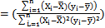 (1)
In (1), Yi and Xi are the real and estimated data, and Ῡ are mean of Xi and Yi data and n is the number of evaluation samples.

3. Results and Discussion
Analysis of the results of linear and nonlinear regression between mean air temperature and soil temperature
Linear regression relationships between average air temperature and soil temperature at depths of 5, 10, 20, 30, 50 and 100 cm are shown in Table (2). According to Table (2), it is found that the most suitable equation obtained at 5 and 10 cm depths at 3 a.m, at 20 cm depth, at 9 a.m and at 30, 50 and 100 cm depths, Equations at 3 p.m have higher R² values. The nonlinear regression relationships between the average temperature and soil temperature at different depths have been presented in Table (3). The results of this table show that, like linear regression, the maximum determination coefficients in 5 and 10 cm depths are at 3 a.m and then at 20, 30, 50 and 100 cm at 3 p.m. In general, due to the simplicity of the application of linear equations in practice, it is recommended to use linear equations to estimate the soil temperature using medium air temperature. The results showed that in the early hours of the day there is a greater correlation between soil temperature and air temperature in the surface depths, and with over time, the correlation between soil temperature and air temperature increases in lower depths.

Analysis of the results of linear and nonlinear regression between relative humidity and soil temperature
Linear regression relationships between relative humidity and soil temperature at depths of 5, 10, 20, 30, 50 and 100 are shown in Table (3). According to the results of Table (3), it is seen that the highest coefficient of determination at all depths is at 3 p.m. The maximum linear determination coefficient is at 3 p.m at 5 cm depth and the lowest linear determination coefficient is at 3 a.m at a depth of 100 cm. In the following, the nonlinear regression relationships between temperature and soil temperature in different depths of soil are presented in Table (4). The results of Table 5 show that, like linear regression, the highest coefficient of determination of R² at all depths is at 3 p.m. Also, the maximum linear determination coefficient is at 3 p.m at a depth of 5 cm and the lowest linear determination coefficient is at 3 a.m at a depth of 100 cm. According to the results of the above tables, it is shown that these determination coefficients are less than the coefficients of determination between air temperature and soil temperature.
The results of the tables showed that the highest coefficient of determination in the linear and nonlinear regression relationships between the relative humidity and the air temperature at different depths was similar and was at 3 p.m. In both linear and nonlinear states, the coefficient of determination decreases with increasing depth. In general, linear regression relationships have a higher determination coefficient over linear regression relationships. Therefore, in practice, it is recommended that nonlinear regression models must be used to estimate the soil moisture by the relative humidity.

Table 1. Linear Regression Relations Between Different Depth Temperatures and Average Air Temperature in Hours Measured at Shiraz Station
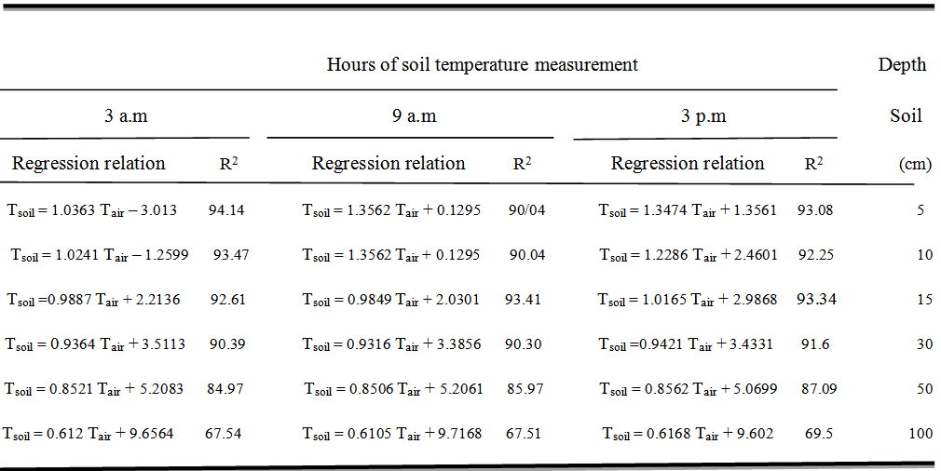

Table 2. Non-linear regression relations between temperature of different depths of soil and average temperature of air in measured hours at Shiraz station
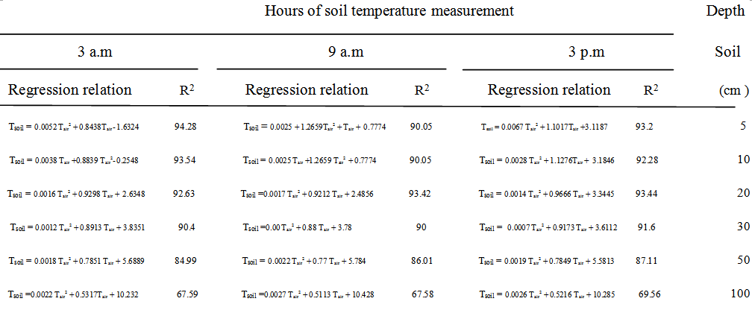

Table 3. Linear regression relationships between soil temperature and relative humidity in measured hours at Shiraz station
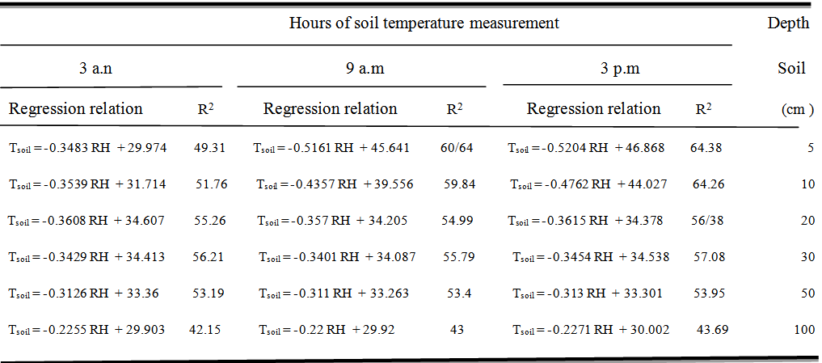

Table 4. Nonlinear regression relations between soil temperature and relative humidity in measured hours at Shiraz station
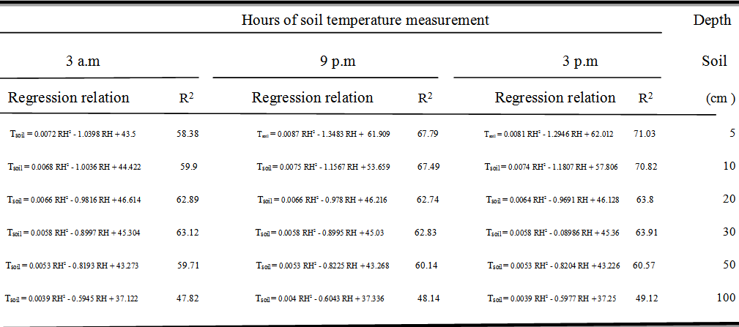

Analysis of the results of linear and nonlinear regression between average air temperature and sunny hours
The linear regression relationships between sunshine hours and soil temperature at different depths are shown in Table (5). According to table (5), the maximum correlation coefficient between sunshine hours and soil temperature is 3 p.m and at a depth of 20 cm. the lowest correlation coefficient between these two parameters is also at 3 a.m and at a depth of 50 cm from the surface of the soil. The nonlinear regression relationships between sunshine hours and soil temperatures in different depths are presented in Table (6). The results of Table (6) also showed that the maximum explanation coefficient is at 3 p.m at 20 cm depth and the lowest coefficient of variation is at 9 a.m and at a depth of 30 cm from the soil surface. The results of the tables showed that the linear and nonlinear determination of the sunshine hours and soil temperature at different depths were significantly lower than the soil moisture determination coefficients with the other two parameters of the air temperature and relative humidity. In general, the results of linear and nonlinear regression between sunshine hours and soil temperature at different depths did not show a good correlation between the two parameters. So, there is no statistical and scientific justification for estimating the soil temperature.

Table 5. Linear Regression Relations Between Different Depth Temperatures and Sunny Hours in Hours Measured at Shiraz Station
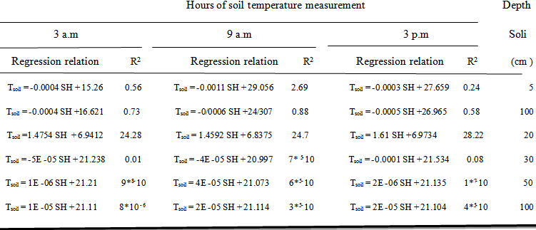

Table 6. Nonlinear regression relations between depth of soil and sunshine hours in measured hours at Shiraz station
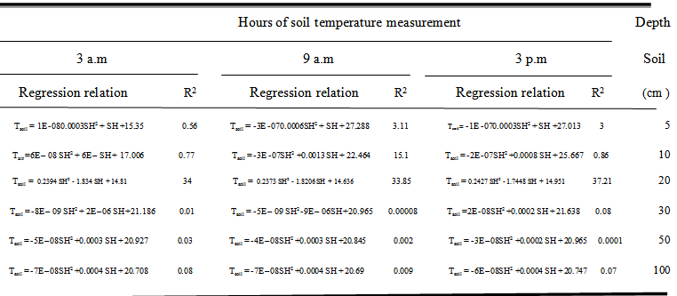

Verifying the most appropriate linear and nonlinear regression relationships
After analyzing the relationships, the most appropriate relationships for different hours and depths were selected and verified by using data from 1395. Regarding the linear and nonlinear regression relationships, the linear regression relationships of the mean air temperature and nonlinear relative humidity correlation relations with soil temperature were selected as the most appropriate relationships. Table (7) shows the most suitable relationships for soil temperature estimation.

Table 7. The most suitable relationships for estimating soil temperature in different hours and depths and the verification results of these relations at Shiraz station
The most suitable linear regression relationships between mean air temperature and soil temperature at different depths and hours
R² | Depth (cm) | Measurement clock | Regression relation
94.14 | 5 | 3 a.m | 3.013 T_{air} – 1.0363 = T_{soil}
93.47 | 10 | 3 a.m | 1.2599 T_{air} – 1.0241 = T_{soil}
93.41 | 20 | 9 a.m | 2.0301 T_{air} + 0.9849 = T_{soil}
91.6 | 30 | 3 p.m | 3.4331 T_{air} + 0.9421= T_{soil}
87.09 | 50 | 3 p.m | 5.0699 T_{air} + 0.8562 = T_{soil}
69.5 | 100 | 3 p.m | 9.602 T_{air} + 0.6168 = T_{soil}
The most suitable nonlinear regression relationships between mean relative humidity and soil temperature at depths and hours
77.03 | 5 | 3 p.m | 012/62+ RH² -1.2946 RH 0.0081 = T_{soil}
70.82 | 10 | 3 p.m | +57.806 RH² -1.1807RH 0.0074 = T_{soil}
63.8 | 20 | 3 p.m | +46.128 RH² -0.9691RH 0.0064 = T_{soil}
63.91 | 30 | 3 p.m | +45.36 RH² -0.8986RH 0.0058 = T_{soil}
60.57 | 50 | 3 p.m | +43.226 RH² -0.8204RH 0.0053 = T_{soil}
49.12 | 10 | 3 p.m | 37.25+ RH² -0.5977RH 0.0039 = T_{soil}

The results of validation are the most appropriate regression relations
In order to verify the regression relationships, first, soil temperature was calculated by using the Meteorological data of 2016 and then the soil temperature was compared with the measured data. Figures (2) and (3), show the results of validation of the most suitable linear regression relationships of the air temperature and nonlinear regression relationships with the soil temperature at different depths and hours using the weather data of 2016, respectively.
Calculated temperature using regression relations(℃)

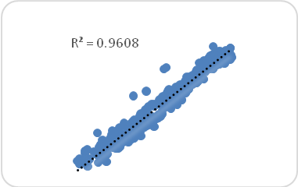 | 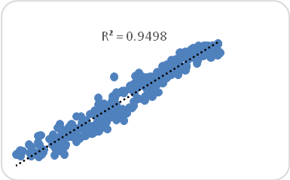
At 3 a.m, the depth is 5 cm | At 3 a.m, the depth is 10 cm
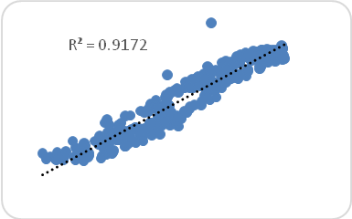 | 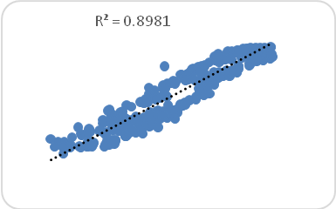
At 9 a.m, the depth is 20 cm | At 3 p.m the depth is 30 cm
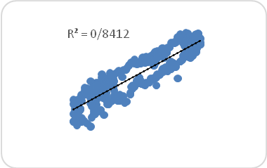 | 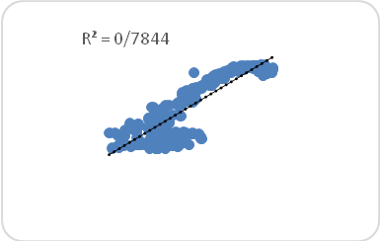
At 3 p.m, the depth is 50 cm | At 3 p.m, the depth is 100 cm
Figure 2. The results of validation are the most suitable linear regression relationships between mean air temperature and soil temperature at different hours and depths in Shiraz station

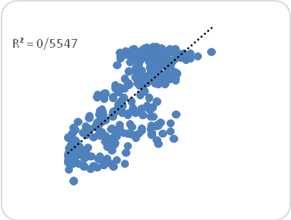 | 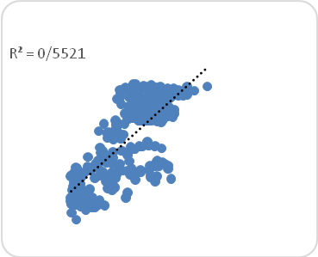
At 3 p.m the depth is 5 cm | At 3 p.m the depth is 10 cm
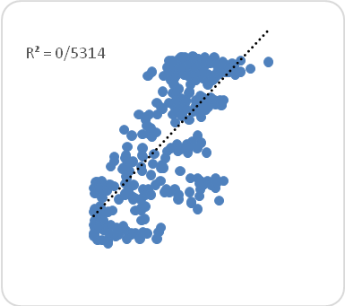 | 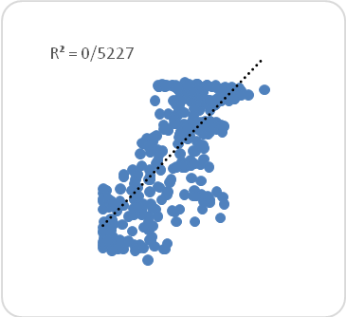
At 3 p.m the depth is 20 cm | At 3 p.m the depth is 30 cm
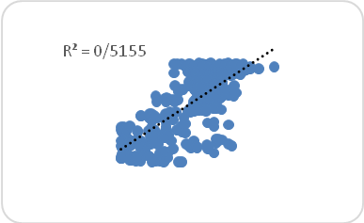 | 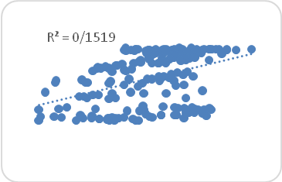
At 3 p.m the depth is 50 cm | At 3 p.m the depth is 100 cm
Figure 3. The results of validation of the most suitable nonlinear regression relations between relative humidity and soil temperature at different hours and depths in Shiraz station

The results from the above tables confirm the accuracy of the regression relations obtained in this study. Also, the results of validation showed that linear regression relations between the average air temperature and soil temperature are more accurate than the nonlinear regression relations between relative humidity and soil temperature. In general, the results of the verification of the most important regression relations presented show that it is possible to use the obtained regression equations to obtain the soil temperature at different hours and depths.
The results of this study showed that the amount of determination coefficient (R²) between meteorological parameters and soil temperature at different depths for linear regression is lower than nonlinear regression (second order), which is consistent with the results of Parsafar and Maroofi (2010). The results of this study led to the presentation of a quadratic equation and a linear equation for each depth of soil per hour. Also, the results showed that the amount of determination coefficient in different depths was at 3 p.m and this result indicated that the measurement time is effective in estimation. Regarding the regression relationships between air temperature and soil temperature, both equations for depths of 5 and 20 cm have more coefficients (R²) than the depths of 50 and 100 cm. The trend of decreasing the determination coefficient (R²) at lower depths is consistent with the results of Parsafar and Maroofi (2010), Najafi Mood et al (2008) and Sabziparvar et al (2010). Also, the results of Jafari Golestani et al. (2007), at Sari station for one year at depths of 7 and 20 cm, showed that at the depth of 20 cm (R²> 90), which is consistent with the results of this study. The proposed determination coefficients by Najafi Mod et al (2008) for one-year period in semi-arid Khorasan Razavi cold stations are less than the determination coefficients in the present study because those are the average coefficient of determination of the relationships between the average temperature of the air and the depth of 20 cm soil was declared as 0.82. Also, in this study, soil temperature was more correlated with air temperature over the two other parameters. Among the factors used in all climates, the average daily air temperature has the highest correlation with soil temperature in all studied climates. Regarding the correlation between relative humidity and soil depths, the results showed that the lowest coefficient of determination (linear and nonlinear) is related to a depth of 100 cm. The results of correlation between relative humidity and soil depth indicated that the lowest coefficient of determination (linear and nonlinear) is related to the depth of 100 centimeters. Sunshine hours are less dependent on the other two parameters over the soil temperature, which is consistent with the results of Parsafar and Maroofi (2010).

4. Conclusion
Providing simple and acceptable mathematical relationships with the least necessary parameters and away from specific complexities is a common model that can be used and it is useful for a wide range of users, so that by measuring parameters Meteorology, the depth of the soil can be predicted. On the other hand, due to the fact that better and faster germination requires a favorable temperature, it is possible to determine the time or depth for the seed to provide this temperature. For farmers, the number of days needed to germinate after planting is important, and the very high and very low temperatures cause germination to be delayed. Also, due to the fact that root crop density of most crops is to 30 cm depth, for these reasons, these equations can be widely used to determining the date of cultivation of various agricultural products, and the amount of damage to the structure and drainage facilities and the water pipe network of cities. In this research, linear and nonlinear regression relationships between meteorological parameters including air temperature, relative humidity, sunshine hours and temperature in depth of soil (5,10,20,30,50,100 centimeters) at the Meteorological Station of Shiraz in a ten-years period (2005 to 2015) were investigated. The results of this research are as follows.
- The maximum linear and nonlinear determination coefficient between relative humidity and soil temperature was at 3 p.m at 10 cm. The maximum linear and nonlinear determination coefficient between sunshine hours and soil temperature was 3 p.m at 20 cm depth.
- The maximum linear and nonlinear determination coefficient between relative humidity and soil temperature was at 3 p.m at 10 cm. The maximum linear and nonlinear determination coefficient between sunshine hours and soil temperature was 3 p.m at 20 cm depth.
- The air temperature was more correlated with the soil temperature over the other two parameters. Also, nonlinear regression coefficients were more than linear regression.
- The results of linear and nonlinear regression between sunshine hours and soil temperature at different depths did not show a good correlation between the two parameters. So, there is no statistical and scientific justification for estimating soil temperature.
- Average linear regression relationships and nonlinear regression relationships of relative humidity with soil temperature were selected as the most appropriate relationships for estimating soil temperature in depths and hours.
- In general, the results showed that the amount of determination coefficient in different depths and times can be different, and this result showed that the depth and hour of measurement are effective in estimating these coefficients.

References
- Béhaegel, M. Sailhac, P. and G. Marquis. 2007. On the use of surface and ground temperature data to recover soil water content information. J. Appl. Geophys. 62: 234–243.
- Chaychi, M., M. Koochak Zadeh, M, Shahabifar.2008. Comparison of Different Daily Algorithms in Surface Temperature Estimation Using NOAA Satellite Images. Second National Conference on Irrigation and Drainage Networks Management, Ahvaz.
- George, R. K. 2001. Prediction of Soil Temperature by using Artificial Neural Networks Algorithms. Nonlin. Anal. 47: 1737-1748.
- Ghaeminia, A.M, H.R. Azimzadeh, M.H.Mobin. 2009. Simulation of depth of depth of soil and investigation of some atmospheric factors affecting it (Case study: Synoptic station of Yazd). Quarterly Journal of Research on Range and Desert of Iran. 18 (1): 42 - 57.
- Ghuman, B. S., Lal, R. 1982. Temperature regime of a tropical soil in relation to surface condition and air temperature and its Fourier analysis. Soil Sci. 134: 133-140.
- Heusinkveld, B. G. Jacobs, A.F.G. Holtslag, A. A. M. and S.M. Berkowicz. 2004. Surface energy balance closure in an arid region: role of soil heat flux. Agric. and Forest Meteorol. 122: 21–31.
- Keryn, I. P. Polglase, P.J. and P.J. Smethurst. 2004. Soil temperature under forests: a simple model for predictingsoil temperature under a range of forest types. Agric. and Forest Meteorol. 121: 167–182.
- Meteorological Organization of Iran 2008. Climatic weather data 1996-2005. Information and Statistics Center, Tehran.
- Mihalakakou, G. 2002. On estimating soil surface temperature profiles. Energy and Buil. 34: 251-259.
- Najafi-Mood, M.H., Alizadeh, A., Mohamadian, A., and Mousavi, J. 2008. Investigation of relationship between air and soil temperature at different depths and estimation of the freezing depth (Case study: Khorasan Razavi), J. Water and Soil. 22: 2. 456-466. (In Persian).
- . Parsafar, N. And p. Maroofi. 2012. Regression equation between soil temperature at different depths and meteorological parameters (Case study: Hamadan), Journal of Agricultural and Natural Resources, Water and Soil Sciences, 62 (16).
- . Plauborg, F. 2002. Simple model for 10 cm soil temperature in different soils with short grass. Eur. J. Agron. 17: 173 – 179.
- Sabziparvar, A. And Tabari, H. 2010. Estimation of daily average soil temperature in some climatic samples of Iran using meteorological data. Scientific and Research Journal of Water and Science (Science and Technology of Agriculture and Natural Resources). 14 (52): 125 - 137.
- Tabari, H., Sabziparvar, A., and Ahmadi, M. 2011. Comparison of artificial neural network and multivariate linear regression methods for estimation of daily soil temperature in an arid region. Journal of Meteorology and Atmospheric Physics, 110: 135-142.
- Usowicz, B. and R. Walczak. 1994. Soil temperature prediction by numerical model. Polish J. Soil Sci. 28(2): 87-94.
- Veronez, M. R., A. B. Thum, A. S. Luz and A. R. Da Silva 2006. Artificial neural networks applied in the determination of soil surface temperature – SST, 7th International Symposium on Spatial Accuracy Assessment in Natural Resources and Environmental Sciences.
- Yazdani, B., B. Ghahram N, g. Farahi, H. Noori. 2010. Modeling of depth of soil temperature with the help of meteorological parameters. Journal of Soil and Water Conservation Research. 19 (4).
- Zheng, D. Raymond Hunt Jr. E. and S.W. Running. 1993. A daily soil temperature model based on air temperature and precipitation for continental applications. Clim. Res. 2: 183-191.

6/22/2018

