Spatial Characterization of Flora Diversity and Soil Relations using GIS-Based Models in a Riverine Wetland of Imo River Basin.

Ogbemudia, F. O., *Ita, R. E., Mbong E. O. and Okoroafor, O. V.

Department of Botany and Ecological Studies, University of Uyo, P.M.B 1017 Uyo, Akwa Ibom State, Nigeria
Corresponding author: alwaizfwesh247@yahoo.com

Abstract: The use of Geographic Information Systems (GIS) in sciences for generating maps capable of reflecting variability trends is gaining fast global acceptance. Against this backdrop, GIS-based models were spatially used to characterize flora diversity and soil relations in a riverine wetland of Imo River Basin. Soil and vegetation were sampled systematically using a 10m × 10m quadrat. The vegetation assemblage comprised of 9 species from 5 families. High frequency of occurrence was recorded by Nypa fruticans (75%) and Acrostichum aureum (75%). Nypa fruticans dominated in density (541.78±155.90 st/ha), Rhizophora mangle was the tallest species (8.33±1.25m) while Avicennia africana (2.56±1.57 m²/ha) and Phoenix reclinata (0.836±0.10 m²/ha) dominated in crown coverage and basal area, respectively. GIS techniques showed variability in Shannon-Weinner, evenness and dominance diversity indices spatially by delineating five classes. Of these classes, station 4 dominated both in species richness (Class 5: 1.09 – 1.17) and evenness (Class 5: 0.76 – 0.8) while station 2 had highest dominance value (Class 5: 0.59 – 0.64). For the nutrient composition, GIS mapping also showed variations spatially outlining various classes. Station 2 being close to the sea recorded the highest phosphorus contents (Class 5: 2.07 – 2.17) while station 3 had the least range of values (Class 1: 1.66 – 1.76). Station 3 had the highest values for total nitrogen (Class 5: 0.35 – 0.37) and organic carbon (Class 5: 13.55 – 14.8). Conclusively, this study confirms that geo-statistical modelling are effective tools in site evaluation and environmental monitoring and can be applied in many areas of research particularly where spatial variability and distribution are weighty.
[Ogbemudia, F. O., Ita, R. E., Mbong E. O. and Okoroafor, O. V. Spatial Characterization of Flora Diversity and Soil Relations using GIS-Based Models in a Riverine Wetland of Imo River Basin. N Y Sci J 2018;11(5):59-66]. ISSN 1554-0200 (print); ISSN 2375-723X (online). http://www.sciencepub.net/newyork. 7. doi:10.7537/marsnys110518.07.

Keywords: GIS-based indices, Plant diversity, Soil, Riverine Wetland, Imo River Basin.

1. Introduction
Wetlands according to Ramsar Convention (2011) are “areas of marsh, fen, peat-land or water, whether natural or artificial, permanent or temporary, with water that is static or flowing, fresh, brackish or salt including areas of marine water, the depth of which at low tide does not exceed 6 meters’’. Wetlands vary in typologies and sizes but the pivotal point in this study is on riverine wetland. Riverine wetlands are wetlands that are situated on the fringes of rivers, streams and creeks. They can be natural or artificial and may be linked to palustrine, estuarine, lacustrine and marine wetlands (Stein, 2005). High variability exist in water levels in riverine wetlands and as such, it may hold water periodically or permanently and in some cases may remain dry for long period of time. Due to the variability in riverine wetland habitats, variations in plant species composition and distribution are also noticeable. Riverine wetlands support diversity of plant species of woody, shrubby and herbaceous forms. These species contribute vastly towards primary production and other hydro-chemical processes in the wetland (Seabloom, 2003). Their importance in wetlands is not unprecedented and cannot be unnoticed as they provide protection, support and food to aquatic fauna (Tessier et al., 2004). They also aid in erosion control, filtering and sedimentation, oxygen enrichment in water, absorption of pollutants as well as cycling of nutrients (Seabloom, 2003; Ita et al., 2017). For these plants to proliferate, they must be well acclimatized to the prevailing environmental (soil) conditions in this wetland. Soils in wetlands are characterized by a high degree of spatial variability due to a combination of physical, chemical and biological processes that operate with different intensities at different scales (Ita et al., 2017).
How prevailing environmental conditions influence species diversity and distribution in an ecosystem is one of the most important subject of investigation when studying community structure (Molles, 1999). For a proper appraisal, survey and conservation of ecosystems, diversity indices are widely used (Mouillot and Leprêtre, 1999). The most common indices used in quantifying landscape composition are Shannon and Simpson indices. While the former emphasizes the richness component of diversity, the latter stresses the evenness component (Nagendra, 2002). It is believed that these indices have the potential to map diversity if appropriate tools and methods are selected. At this point, geographic information systems (GIS) recognized recently by conservationists can be a very suitable and powerful tool in the spatial characterization and delineation of ecosystems (Dogan 2001). The spatial nature of the biological data lets GIS to develop spatial models which can be used as a solution for predictive mapping (Gottfried et al., 1998).
Anthropogenic upheavals such as deforestation, overgrazing of riverine vegetation by livestock (particularly in the dry season), selective exploitation of mangrove species (Rhizophora and Avicennia) for timber, construction of traditional boat and fuelwood, clearance of shoreline vegetation and trampling due to fishing activities are the major threats faced by endemic wetlands. Despite this, information on phytodiversity in relation to and soil relations in our wetland ecosystems lag behind their terrestrial associates. Also, information on the spatial characterization of plant species and soil relations in wetlands using GIS in Akwa Ibom State is very scanty. If these were available they would have contributed to the advocacy for better conservation and management of indigenous wetland ecosystems and effective utilization of their resources by all.

2. Material and Methods
2.1 Study Area
The study was conducted in a mangrove forest of Utaewa Village in Ikot Abasi Local government Area of Akwa Ibom State. The swamp serves as an intertidal zone separating the riparian communities with the Sea. The vegetation is typically a mangrove with evidences of Nypa invasion. The coordinates of the specific stations are presented in Table 1.

Table 1. Coordinates of the specific stations
Stations | Longitude | Latitude
Station 1 | 7º 31’ 39.85” E | 4º 35’ 52.47”
Station 2 | 7º 31’ 39.24” E | 4º 35’ 54.07”
Station 3 | 7º 31’ 29.97” E | 4º 35’ 54.17”
Station 4 | 7º 31’ 31.18” E | 4º 35’ 54.08”

2.2 Vegetation and Soil Sampling
Systematic (vegetation and soil) sampling method (Cochran, 1963) was used to sample the vegetation using a quadrat of 10 m x 10 m. In each quadrat, vegetation components (plants) were identified to species level and their frequency and density were enumerated. Unknown plant species specimens were collected for identification and confirmation from voucher specimens in the Botany and Ecological studies Departmental Herbarium, University of Uyo, Uyo. The parameters determined for the vegetation were density, frequency, height, basal area and crown cover. Soil samples were obtained at two depths; 0 – 15 cm and 15 – 30 cm using a soil auger in each of the quadrats. In all a total of 30 soil samples were collected and taken to the laboratory for their physicochemical analyses.
2.2.1 Determination of Vegetation Parameters
2.2.1.1 Density
Density of plant species was determined using the method of Cochran (1963).
2.2.1.2 Frequency
The frequency of each species occurrence was calculated thus:

Frequency = $\frac{Number of occupied quadrat for a species}{Total number of quadrats thrown}$ × 100

2.2.1.3 Height
The height of woody species were measured using a Haga altimeter (43913 model). The reading was taken 15 m away from the base of the woody plant from where the crown was sighted through the eye piece of the altimeter and the upper reading taken. The base of the woody plant was similarly sited and the lower altimeter readings taken. The height of each species was calculated using the relation:
Height (m) = Algebraic sum of the reading of the top and bottom of each plant × horizontal distance from observer to each species divided by scale factor used on the altimeter.
2.2.1.4 Basal Area
This was calculated using the relation:
Basal Area = $\frac{C^{2}}{4π}$
Where 4π = 4 × 3.142 = 12.568
C = girth size of the species at breast height
2.2.1.5 Crown Cover
The crown cover of woody plant species was determined by the crown cover diameter method (Muller- Dombios and Ellenberg, 1974).
2.3. Physicochemical Analysis of Soil Samples
Approved standard methods were used in analyzing soil samples. Soil Particle sizes, organic carbon, total nitrogen and available phosphorus were determined using the Hydrometer method, Walkey Black wet oxidation method, Micro-Kjeldahl method and Bray No 1 method (Jackson, 1992). Electrical conductivity, exchangeable acidity and pH were determined using a conductivity meter (Jenway Pcm 128723 model), titration with 1N KCL (Kramprath, 1967) and Beckman’s glass electrode pH meter (Mcclean, 1961), respectively. Total Exchangeable Bases were determined by EDTA titration method while sodium and potassium were determined by photometry method. The Effective Cation Exchange Capacity (ECEC) was calculated by the summation method (that is summing up of the Exchangeable Bases and Exchange Acidity (EA). Base Saturation was calculated by dividing total Exchangeable Bases by ECEC multiplied by 100.
2.4 Statistical Analysis
Statistical Package for Social Sciences (SPSS, Version 20.0) and Paleontological software were employed for descriptive statistics, analysis of variance and diversity indices. Species diversity indices such as Shannon-Wiener, Simpson, Dominance and Evenness were used to give information on the plant community richness and distribution across the study plots.

3. Results
3.1 Floristic Composition
The floristic composition of the River Basin is presented in Table 2. A total of nine (9) species belonging to five families were found in the wetland. High frequency values (75%) were associated with species such as Nypa fruticans and Acrostichum aureum while Rhizophora mangle, Laguncularia racemosa, Pandanus candellabrum and Phoenix reclinata had the least frequency of 25%, respectively. Height of species varied markedly in the wetlands with the tallest species being Rhizophora mangle (8.33±1.25m) and the shortest being Laguncularia racemosa (3.00±0.00m). Nypa fruticans was the most abundant species with a density value of 541.78±155.90 st/ha while Laguncularia racemosa had the lowest density value of 25.00±0.00 st/ha). Highest crown coverage was observed in Avicennia africana (2.56±1.57 m²/ha) while Machaerium lunatum had the lowest crown coverage (0.701±0.074 m²/ha). Phoenix reclinata had the largest basal area (0.836±0.10 m²/ha) while Laguncularia racemosa had the lowest (0.0032±0.00 m²/ha).
3.2 Physicochemical Characteristics of Soil

Table 2. Floristic Composition of Imo River Basin
Species | Family | Frequency (%) | Density  (stems/ha) | Height  (m) | Crown cover (m²/ha) | Basal  Area (m²/ha)
Acrostichum aureum | Pteridaceae | 75 | 108.00±47.14 | - | - | -
Avicennia africana | Rhizophoraceae | 50 | 100.00±50.00 | 6.38±0.18 | 2.56±1.57 | 0.0839±0.01
Laguncularia racemosa | Rhizophoraceae | 25 | 25.00±0.00 | 3.00±0.00 | 0.785±0.00 | 0.0032±0.00
Machaerium lunatum | Fabaceae | 50 | 150.00±50.00 | 7.50±0.50 | 0.701±0.07 | 0.0306±0.01
Nypa fruticans | Arecaceae | 75 | 541.78±155.90 | 4.78±3.12 | 2.01±0.89 | 0.391±0.09
Pandanus candelabrum | Arecaceae | 25 | 50.00±0.00 | 4.00±0.00 | 0.785±0.00 | 0.064±0.001
Phoenix reclinata | Arecaceae | 25 | 250.00±10.00 | 7.50±3.20 | 5.64±2.41 | 0.836±0.10
Rhizophora mangle | Rhizophoroceae | 25 | 75.00±0.00 | 8.33±1.25 | 1.897±0.97 | 0.059±0.01
Terminalia superba | Combretaceae | 50 | 75.00±25.00 | 4.55±1.50 | 0.711±0.07 | 0.4040±0.01
Table 3. Mean (± S.E.) Soil Characteristics of Stations in Imo River Wetlands
Parameters | Station 1 | Station 2 | Station 3 | Station 4
Sand | 56.20±2.3 | 58.200±2.1 | 79.200±2.21 | 45.200±2.00
Silt | 11.82±1.40 | 13.820±0.61 | 8.820±1.61 | 22.820±0.60
Clay | 31.980±5.81 | 27.780±3.41 | 11.820±1.32 | 31.980±10.98
pH | 4.650±0.02 | 5.200±1.07 | 3.900±0.60 | 5.500±0.40
Electrical Conductivity | 3.340±0.62 | 2.820±0.45 | 2.430±0.12 | 3.310±0.13
Organic Matter | 12.830±2.31 | 12.430±1.71 | 14.800±2.01 | 9.770±1.52
Total Nitrogen | 0.330±0.001 | 0.2950±0.13 | 0.370±0.07 | 0.240±0.00
Average Phosphorus | 1.995±0.01 | 2.165±0.61 | 1.660±0.40 | 1.670±0.21
Calcium | 11.000±2.0 | 11.495±2.41 | 7.600±0.61 | 8.880±0.62
Mg | 3.620±1.14 | 3.380±1.02 | 2.800±0.02 | 2.110±0.01
Na | 0.490±0.01 | 0.345±0.08 | 0.270±0.00 | 0.420±0.21
Potassium | 0.330±0.02 | 0.460±0.01 | 0.300±0.01 | 0.260±0.00
Exchange Acidity | 3.100±0.41 | 2.900±0.0 | 2.500±0.30 | 2.400±0.40
Effective cation exchange capacity | 17.990±3.6 | 19.130±3.4 | 13.470±1.23 | 14.070±3.02
Base Saturation | 82.730±10.4 | 84.485±5.1 | 81.440±5.21 | 82.940±1.86
S.E = Standard error

The physiochemical properties of the soil is presented in Table 3. Among the particle size class, sand fragment dominated spatially and this was followed by clay and silt fragments. Station 3 had the highest sand content (79.200±2.21) while station 4 had the least (45.200±2.00). The proportion of clay was greatest in stations 1 (31.980±5.81) and 4 (31.980±10.98) while the least clay content was recorded in station 3. Silt fragment was more abundant in station 4 (22.820±0.60) and less abundant in station 3 (8.820±1.61). However, the pH of the soil ranged between extremely acidic to strongly acidic. Stations 4 (5.500±0.40) and 3 (3.900±0.60). Electrical conductivity had the highest and least values in stations 4 (3.340±0.62) and 3 (2.430±0.12). The proportions of organic matter and total nitrogen were highest in station 3 (14.800±2.01 and 0.370±0.07) while station 4 had the least values for these parameters (9.770±1.52 and 0.240±0.00). Mg had a highest value of (3.620±1.14) in station 1 and a least value of (2.110±0.01) in station 4. Na recorded a highest value of 0.490±0.01 in station 1 and the least value of 0.270±0.00 in station 3. However, potassium had the highest and least values in stations 2 (0.460±0.01) and 4 (0.260±0.00). Exchange acidity values ranged between 2.400 and 3.100 with the highest and least values obtained in stations 1 (3.100±0.41) and 4 (2.400±0.40). The values for Effective Cation Exchange Capacity and base saturation were highest in stations 2 (19.130±3.4 and 84.485±5.1) while the least values for these parameters were obtained in station 3 (13.470±1.23 and 81.440±5.21).

3.3 Geospatial Modeling and relative Dynamism of Environmental variables.
The use of Geographic Information Systems Software (GIS) in generating computer-based maps showed spatial variability trends for soil variables (Figures 1 – 3). The map delineated the river basin with the four sampled stations lying in between. Generally, contour linings and colour aberrations denoted intensity or weakness of simulated variables. Geospatial modelling was done for nutrients (available phosphorus, nitrogen and organic matter) and diversity indices (dominance, evenness and Shannon Weinner).

3.3.1 Geospatial Distribution of Soil Nutrients
The different levels and distribution of available phosphorus in the vegetation plots within Imo River Basin is presented in Figure 1. Available phosphorus contents in the soil was lower in stations 3 and 4 while a progressive increase in the seaward direction with peak values were observed in station 2. Five classes were delineated for this parameter namely; class 1 (1.66 – 1.76), class 2 (1.77 – 1.86), class 3 (1.87 – 1.96), class 4 (1.97 – 2.06) and class 5 (2.07 – 2.17).
Figure 2 shows the levels and distribution of total nitrogen in sampled plots. The percentage of total nitrogen content was very low in station 4 but it progressively increased with peak values in station 3. Five classes were highlighted for this parameter namely; class 1 (0.24 – 0.27), class 2 (0.28 – 0.29), class 3 (0.30 – 0.32), class 4 (0.33 – 0.34) and class 5 (0.35 – 0.37).
The levels and distribution of organic matter in the soil as presented in Figure 3 revealed that organic matter content was low in station 4 but it increased progressively in other stations with peak values obtained in station 3. Four classes were identified for this parameter namely; class 1 (9.77 – 11.03), class 2 (11.04 – 12.29), class 3 (12.30 – 13.54) and class 4 (13.55 – 14.80).

3.3.2 Geospatial Trends in Diversity Indices

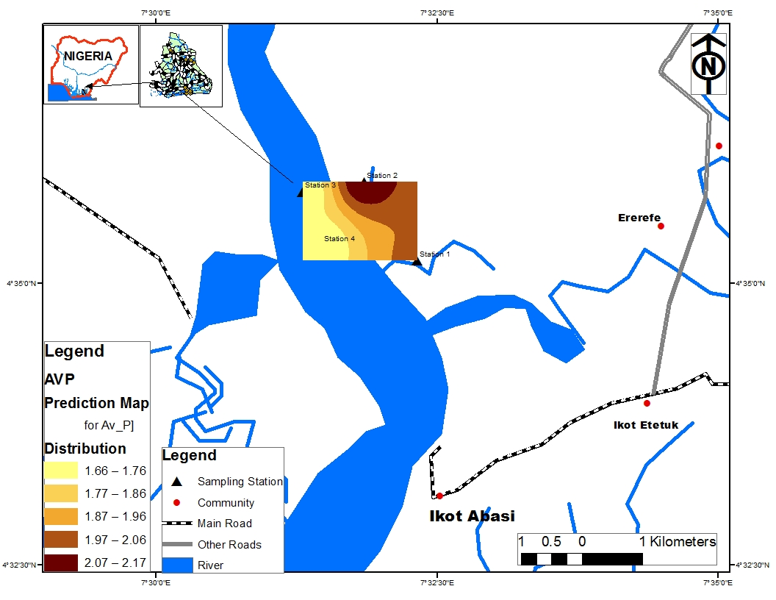
Figure 1. Spatial Distribution of Available Phosphorus

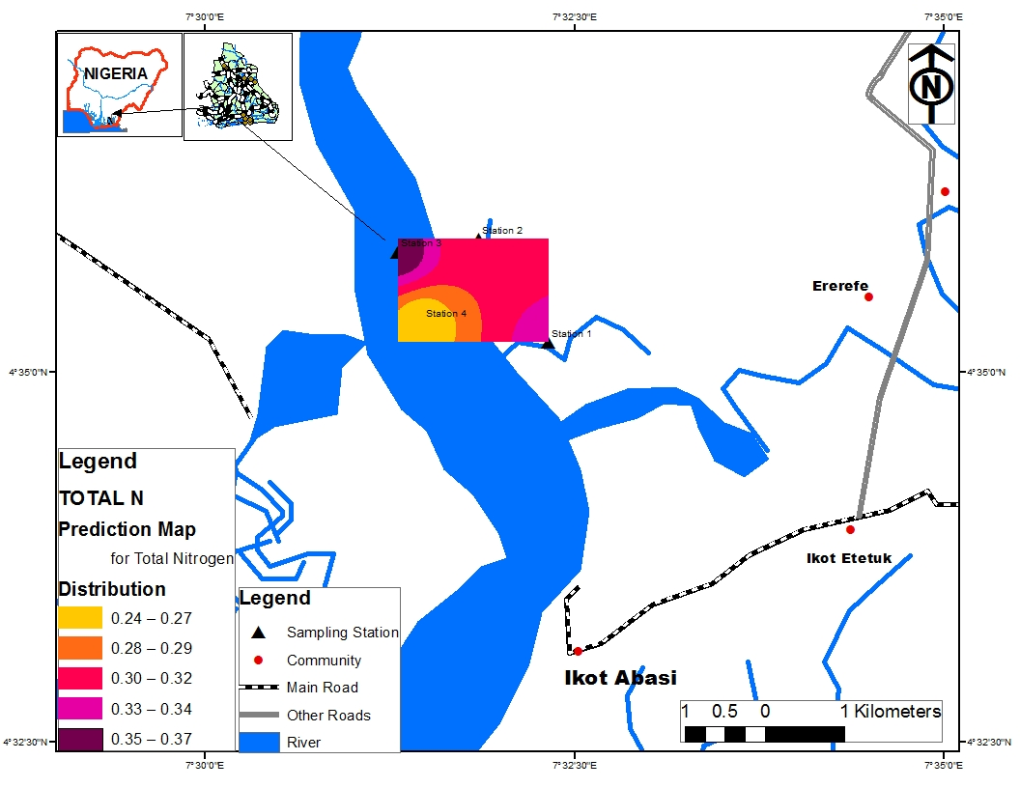
Figure 2. Spatial Distribution of Total Nitrogen

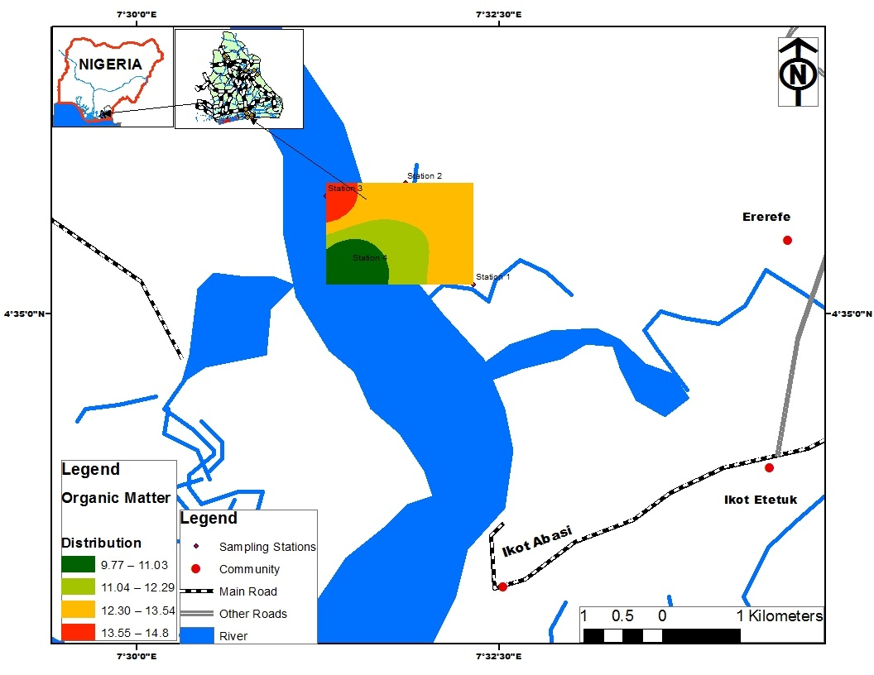
Figure 3. Spatial Distribution of Organic Carbon

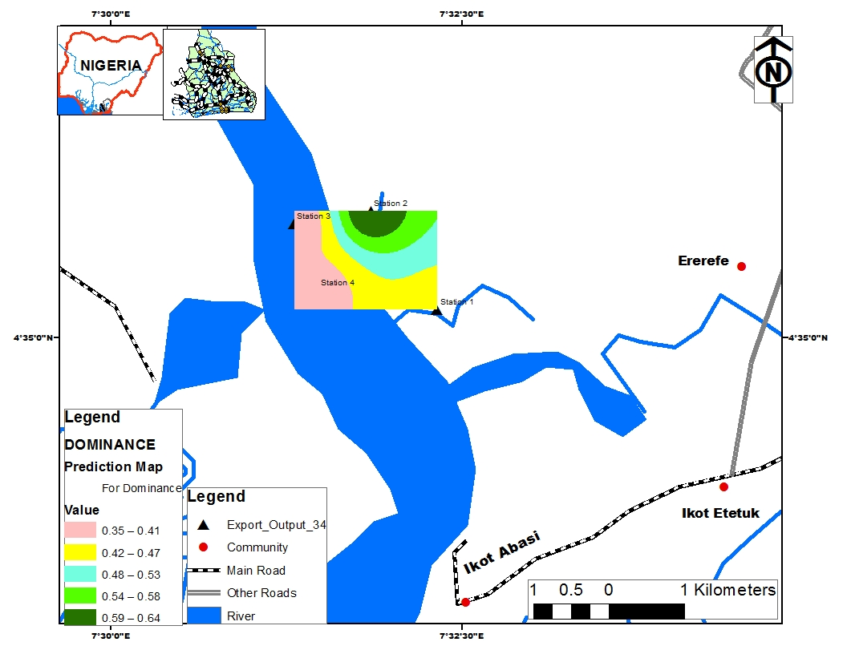
Figure 4. Spatial Rate of Dominance in Species

The level of dominance in vegetation plots is shown in Figure 4. The variability in dominance across the plots revealed five classes viz: class 1 (0.35 – 0.41), class 2 (0.42 – 0.47), class 3 (0.48 – 0.53), class 4 (0.54 – 0.58) and class 5 (0.59 – 0.64). Evenness trend showed marked variability across the vegetation plot (Fig. 5). Five classes were distinguished namely: class 1 (0.52 – 0.58), class 2 (0.59 – 0.63), class 3 (0.64 – 0.69), class 4 (0.70 – 0.75) and class 5 (0.76 – 0.80).
For the Shannon Weinner diversity index, variability was observed across the sampled plot. Five distinct classes were delineated namely: class 1 (0.73 – 0.82), class 2 (0.83 – 0.91), class 3 (0.92 – 0.99), class 4 (1.00 – 1.08) and class 5 (1.09 – 1.11).

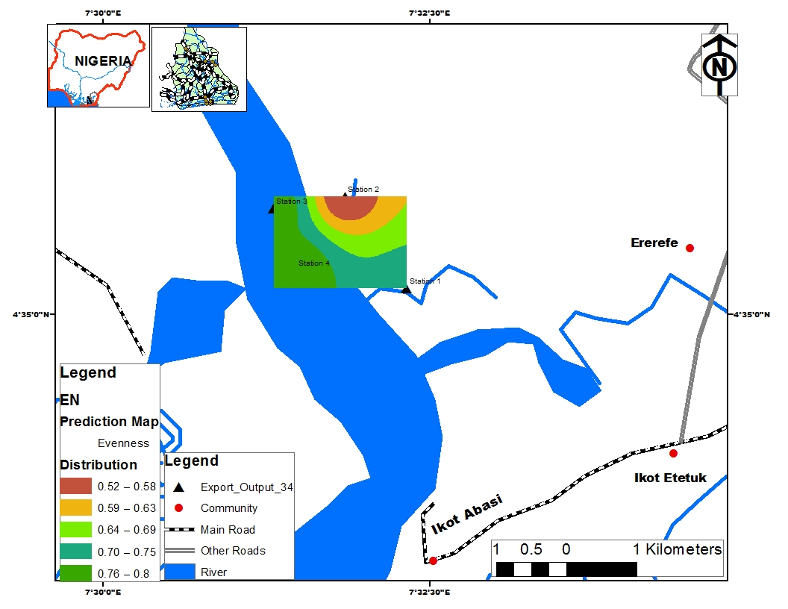
Figure 5. Spatial rate of Evenness in Species

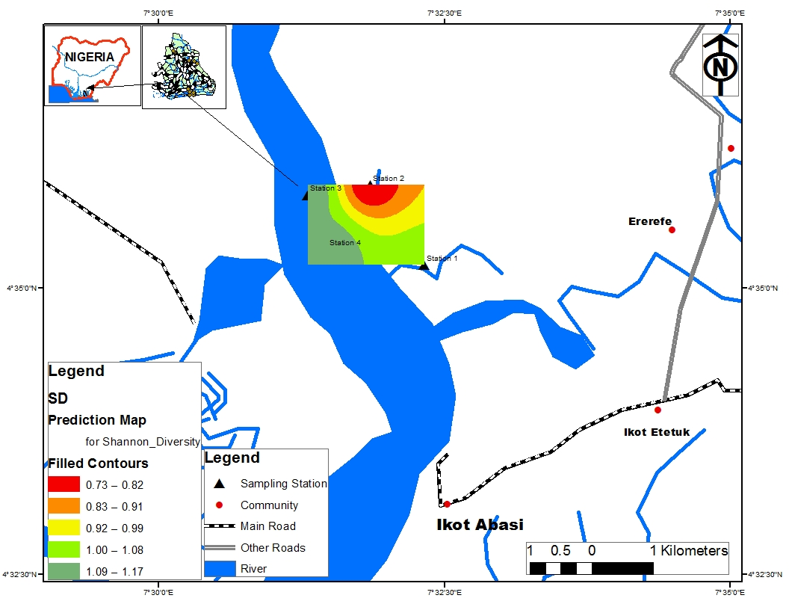
Figure 6. Shannon Wienner index of diversity

4. Discussion
There is ample evidence from this study that the vegetation of Imo River Basin is part of the leftover indigenous mangrove swamp forest in Akwa Ibom State. This is so because the principal members of its physiognomy do not differ from those reported by Ukpong (1997) for other mangrove swamps. However, the species composition in this study varies when compared with the flora compendium reported by Ubom et al. (2012). This gap is probably because the latter researchers enlisted species present in fresh water swamp forest. In all, it can be construed that the terrain is bestowed with diagnostic imprints of autochthonous flora. Also, variations in the floristic attributes were evidenced in this study. Disparities in values of density, height, basal area and crown cover are not unrelated with age differences and (or) growth behaviour of individual species. This differences might also be an indication of the varying intensities of anthropogenic exploitation, natural disturbances or reproductive efficiencies of individual species (Ita, 2018). The density values found in this research create a conception of an interspecific competition in this ecosystem. For instance, a close range in density values of 50 – 75 stems/ha was observed for Terminalia superba, Rhizophora mangle and Pandanus candelabrum. Massive proliferations and occurrences of Nypa fruticans in large colonies may accentuate its intrinsic ability to adapt to prevailing ecological conditions, wide ecological amplitude and microsite variability in this wetland. This may confirm the reports of Ukpong (2002) that Nypa is well developed in density and structure regardless of whether the swamps consist of the open or close types. The massive establishment of Nypa fruticans may also be allied to its exotic nature and high invasiveness in many creeks, beaches and estuaries in the Niger Delta region, displacing the autochthonous mangrove species. The low frequency and density associated with species such as Rhizophora mangle is linked to the sequence of human activities, particularly harvesting of the tree for fuelwood or construction.
According to Rozpondek et al. (2016) Geographic Information Systems (GIS) and geo-statistical modelling serve as tools in site evaluation and environmental monitoring. They can be applied in many areas of research particularly where spatial variability and distribution are substantial. In this, the likelihoods include the credible assessment of the accuracy of the models, accompanying the process of prediction and the production of spatial variability in the form of maps (Djeneba, 2015). This is evidenced in this study as it gave a first-hand information and visualization of the various impacts of human and natural disturbances such as deforestation, selective exploitation, bush burning and tidal inundation on the cycling and retention of nutrients in the wetland. The spatial distribution of soil variables is advantageous as it offers the possibility of site-specific conservation and nutrient management strategies in ecosystems (Djeneba, 2015). For instance, eclectic patches of available phosphorus in the stations most proximal to the sea is not unprecedented but rather confirms the sea as being a natural source of phosphorus recycling. The varnishing shades obtained spatially for phosphorus distribution in other stations (1, 3 and 4) may be an attribute of dilution effects. The high nutrient levels (total nitrogen and organic carbon) recorded in station 3 may highlight the fact the environmental conditions favoured a high rate of leaf fall, litter putrefaction and nutrient retention in this site. This had been confirmed by Brady and Weil (1996) and Ita et al. (2017). These researchers in their study reported that litter upon decomposition, is a major source of nutrients in the soil. This may further imply that this station is nutrient-rich.
Notably, from the options of the GIS imprints, station 2 is a focal point in this study due to the fact that it recorded the least diversity, least evenness and highest dominance values. This may be attributed to the fact that this station is close to the sea which is characterized by high levels of salinity and strong tidal regimes. These two factors (salinity and tidal regimes) combine to form a critical micro habitat within the ecosystem and was maximized and dominated only by Nypa fruticans. This may further connote that this station is primarily restricted to species with high degree of tolerance to salinity and tidal fluctuations. The occurrence of only Nypa fruticans in station 2 (close to the sea) in this study agrees with the ecological gradient study performed on this species by Ukpong (1991). In his study, Nypa fruticans belonged to ecological group 4 since this species dominated habitats where salt concentration was plentiful in supply. Its lone occurrence (Nypa fruticans) in this station (Nypa fruticans) may further authenticate the high dominance value of this station. Furthermore, the high Shannon index and evenness values obtained in station 4 should not be overlooked as this station reflects the peak of flora diversity in the wetland. This was clearly seen in this study as this station was characterized by mixed flora of obligate and facultative mangrove species. The high diversity and evenness values in station 4 may be allied to suitable pedological and hydrological conditions and less human interference (selective exploitation and logging). Also, station 4 being the crux of plant diversity in this wetland should be monitored periodically and protected against human encroachment and perturbations.

Conclusion and Recommendations
Forested wetland soils are complex systems resulting from various intricate interactions between abiotic (tides and physiography) and biotic (activities of plants, humans and invertebrates) factors, that keep changing even within short distances. Environmental attributes such as salinity, tidal fluctuations and soil nutrients are key drivers in plant species occurrences and distribution in wetlands. The use of geo-referenced data spatially to model the soil nutrients, vegetation richness and distribution in this study gave a clear pictorial representation of the current status of this wetland and presents ecologists with informed choices on effective management and protection of this wetland. In a résumé, spatial modelling and mapping using GIS-based indices are important tools in ecology and conservation biology and should be encouraged as these can help in quantifying information about biota diversity and their various habitats.

Corresponding Author:
Ita, Richard Ekeng
Department of Botany and Ecological Studies, University of Uyo, P.M.B 1017, Akwa Ibom State, Nigeria.
Telephone: 08069290525
E-mail: alwaizfwesh247@yahoo.com

References
- Brady, N. C. and Weil, R. (1996). The Nature and Properties of Soils. New York: Macmillan Publishing Company, p. 881.
- Djenaba, D. (2015). Integration of remote sensing and geographic information system in soil fertility management in Mali. Published Ph. D thesis submitted to the department of crop and soil sciences. Faculty of agriculture, Kwame Nkrumah University of science and technology, Kumasi, Ghana.
- Dogan H.M. 2001. The applications of geographic information systems and remote sensing in agriculture. Global Space Activities and Potential in Turkey, 1st International Space Symposium, the General Commandership of Air Force Proceedings, Ankara, Turkey. pp. 265–271.
- Gottfried, M., Pauli, H. and Grabherr, G. (1998). Prediction of vegetation patterns at the limits of plant life: a new view of the Alpine-Nival ecotone. Arctic Alpine Res., 30: 207–221.
- Ita, R. E. (2018). Influence of Seasonality Gradients on Phytodiversity Richness in Rural and Urban Wetlands.
- Ita, R. E., Ogbemudia, F. O. and Udo, N. S. (2017). Influence of Pedological Regimes on Plants Distribution in a Lacustrine Wetland in Uyo, Akwa Ibom State, Nigeria. Researcher, 9(8): 16 – 21.
- Molles M. C. (1999). Ecology, Concepts and Applications. International Edition, WCB/McGraw Hill Companies Inc., Boston, USA.
- Mouillot D. and Leprêtre A. 1999. A comparison of species diversity estimators. Res. Popul. Ecol., 41(2): 203–215.
- Nagendra H. (2002). Opposite trends in response for the Shannon and Simpson indices of landscape diversity. Appl. Geog., 22(2): 175–186.
- Ramsar (2011). The Ramsar Manual, Ramsar and Its mission, Brief History. http://www.ramsar.org/cda/en/ramsar-march11/main/ramsar/1%5E250444000 0. Last accessed February 20, 2018.
- Rozpondek, K. and Wancisiewicz, K. (2016). Analysis of the distribution of impurities in the bottom sediments using a GIS in the coastal zone of a body of water in the river Ostrows Osza White. Engineering and Environmental Protection 19(1): 37- 49.
- Seabloom, E. W. (2003). The development of vegetative zonation patterns in restored prairie pothole wetlands. Journal of Applied Ecology, 40: 92 – 100.
- Stein, J. L. (2005). Landscape characteristics of Queensland Freshwater Biogeographical Provinces, Centre for Resource and Environmental Studies, Australian National University. p. 154.
- Tessier, C. Cattaneo, A. Pinel-Alloul, B. Galanti, G. and Morabito, G. (2004). Biomass composition and size structure of invertebrate’s communities associated to different types of aquatic vegetation during summer in Lago di Candia (Italy). Journal of Limnology, 63(2):190– 198.
- Ubom, R. M., Ogbemudia, F. O. and Benson, K. O. (2012). Soil vegetation relationship in fresh water swamp forest. Scientific Journal of Biological sciences, 1(2): 43-51.
- Ukpong, I. E. (1991). The performance and distribution of species along soil salinity gradients of mangrove swamps in southeastern Nigeria. Vegetatio, 95: 63 – 70.
- Ukpong, I. E. (1997). Vegetation and its Relation to Soil Nutrient and Salinity in the Calabar Mangrove Swamp, Nigeria. Mangroves Salt Marshes, 1: 211–218.
- Ukpong, I. E. (2002) The Nypa fruticans threat in estuaries east of the Niger Delta, Nigeria.
- Trans. Nig. Soc. Biol. Conserv. (Special Edition). The Status of Conservation Renewable Natural Resources in the Niger Delta Area of Nigeria, p. 55 – 65.

5/18/2018

