Geophysical Survey Using Vertical Electrical Sounding (Ves) For Groundwater Exploration In Parts Of Merab Abaya, Gamo-Gofa Zone, Southern Ethiopia

Alemayehu Ayele

Department of Geology, Collage of Natural and Computational Science, Wachamo University PO Box 1176, Addis Ababa, Ethiopia, E-mail: alex.ayele8@gmail.com

Abstract: Electrical resistivity investigation was carried out around Gamo-Gofa area, Merab Abaya, Southern regional state, in order to study the subsurface geologic layer (groundwater potential Zones) with a view of determining the depth to the bedrock and thickness of the geologic layers. Vertical Electrical Sounding (VES) using Schlumberger array was carried out at twelve (12) VES stations, 7 VES at Fetale, 3VES at Doshe and 2 VES at Yayke kebles. WDJ-terrameter was used for the data acquisition. The field data obtained have been analyzed using computer software (1DIX) which gives an automatic interpretation of the true resistivity. The VES results revealed heterogeneous nature of the subsurface geological sequence. The geologic sequence beneath the study area is composed of hard top soil (clayey and silt soil), weathered layer, partly weathered or fractured basement and fresh basement. The study mainly focuses on the evaluation of the groundwater potential of Merab Abaya and designed for the purpose of pressurized irrigation development.
[Alemayehu Ayele. Geophysical Survey Using Vertical Electrical Sounding (Ves) For Groundwater Exploration In Parts Of Merab Abaya, Gamo-Gofa Zone, Southern Ethiopia. N Y Sci J 2018;11(5):49-58]. ISSN 1554-0200 (print); ISSN 2375-723X (online). http://www.sciencepub.net/newyork. 6. doi:10.7537/marsnys110518.06.

Key words: Vertical Electrical sounding (VES), Hydro-geological conditions, Aquifer, geo-electric sections, Pseudo-section

Introduction
The problem of the global warming is becoming the main issue of the world as well as the country which results increase in temperature and decrease in rainfall both in amount and distribution. This unreliable rainfall and desertification in turn reduce the production return from the existing limited natural resource. The problem is becoming the main constraint for increasing agricultural production. The study area is more affected with rainfall scarcity. To avoid this rainfall dependent cultivation using groundwater for irrigation purpose is paramount important to escape out farmers. Hence, the use of geophysics is used to overcome this problem.
The use of geophysics for irrigable groundwater exploration has increased over the last few years due to the rapid advances in computer software’s and associated numerical modeling solutions. Analysis of this measurement can reveal how the physical properties of the earth’s interior vary vertically and laterally. Moreover, the method helps to acquire information about the subsurface over a substantial area in a reasonable time frame and in a cost-effective manner (Flathe, 1964). The electrical geophysical survey method is the detection of the surface effects produced by the flow of electric current inside the earth. The electrical techniques have been used in a wide range of geophysical investigations such as mineral exploration, engineering studies, geothermal exploration, archeological investigations, permafrost mapping and geological mapping.
The Vertical Electrical Sounding (VES) has proved very popular with groundwater prospecting due to simplicity of the techniques. The Schlumberger array was used in this investigation to delineate water bearing formations (aquifers), because of its better depth interpretation and its usefulness in mapping subsurface aquifers and groundwater exploration this method find more superior compared to other methods (Egai, 2013).

Materials and Methods
The Study area
The study area is located in North of Arba-Minch town, about 60km at the middle of Arba Minch to Sodo asphalt road which is 0357000mE to 0361700mE and 0698000mN to 0710000mN and the altitude ranges from 1310 to 1394m. The study area covers about three rural kebeles which cover 60km². The area is found at the western side Abaya lake catchment, at the eastern Lake Abaya and at margin bounded between West Gamo Mountain, south Merab Abaya town and north Wajifo village. The study area is controlled by different mountains such as Lomene at south East, Gonga at south, Tirga at east, Derke Ridge at south, kola Barena and Yayke at west. Topographically the area is characterized by plain land and hill side of Gamo mountain ridge.

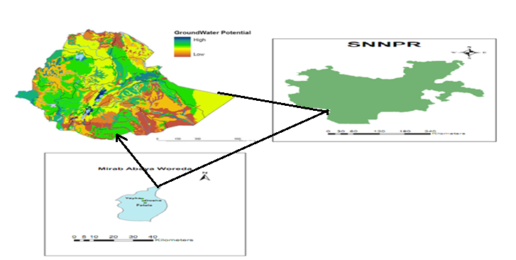
Figure 1. Location map of the study area in Gamo- Gafo Zone

Methodology, instruments and data
Vertical Electrical Sounding (VES) Technique
The use of electrical resistivity measurements has been a favourite tool of geophysics for over 200 years because of the wide range of resistivity values found in nature. Resistivities in various geologic settings can be found ranging from less than 1ohm-meter for ore bodies to over 10000 ohm-meters for Precambrian gneiss. This represents a greater dynamic range for this technique than most of the commonly used methods. Electrical resistivity techniques have been used in many geological formations for characterizing the subsurface for many years. (Roman, 1951; Heather etal, 1999). The choice of the best array for a field survey depends on the type of structure to be mapped, the sensitivity of the resistivity meter and the background noise level (Loke, 2001).
A number of surface geophysical methods can be used for the purpose of groundwater site investigation out of which the electrical resistivity method (Vertical Electrical Sounding) has found increasing application. Schlumberger Configuration was used to carry out vertical electrical sounding for the determination of the depth to bedrock and the thickness of layers because of its sensitivity to signal response ( Ozebo, 2011). Twelve vertical soundings were carried out on the field. This was done by changing the distance between the current electrodes so that the depth range to which the current penetrates changes (Telford et al, 1976).
A succession of apparent resisivity reading was taken for increasing electrode spacings. The half electrode spacing of the current electrode (AB/2) and its corresponding potentials (MN) on log-log paper were recorded. The instrument used for this survey is WDJA-Terrameter and its accessories (the connecting cables, clips, four Reels of long electronic cables and electrodes, hammers and battery which is inbuilt power source
A Global Positioning System (Garmin, 2007) was used to record position locations and timings of series of discrete
VES reading measurements. The electrodes used are made of steel, that is, aluminum or stainless which are driven into the surface of the earth for few centimeters with the aid of hammer for good electrical contact. The electrodes were connected to their reels (current and potential) by wire from the reel of long cable. Four reels were used on the field, two of which are reels with cables of about 1000metres in length connecting current electrodes while the other two reels with cables of about 200 meters in length were connecting the voltage electrodes.
The apparent resistivity values are plotted against the half-current spacing’s on the log-log graph. Guided by the general trend of the field curves were made. The plots generate the field curves.
Reconnaissance geomorphological, geological and hydrogeological field mapping exercise was carried out in order to have a picture of the geology of the site. Some precautions were taken during the Vertical Electrical sounding survey ensured that the electrodes were hammered well in to the ground to allow firm contact. Vertical Electrical Sounding was done along three profiles in Fetale, three Doshe and two profiles in Yayke kebeles.
Geology of the study area
The Ethiopian Rift is covered with Cenozoic volcanic, Tertiary and Quaternary sediments except the appearance of patchy Precambrian rocks. The volcanic rocks are dominantly fissural basaltic lava flows, rhyolites and ignimbrites associated with volcano-clastic tuff and ash deposits (Mohr, 1967). Older volcanic units (Pre-Pliocene) outcrop on the rift escarpment or mar-gin and recent volcanics cover the entire rift floor (Kazmin, 1981). The Main Ethiopian Rift (MER), close to which the investigation site is located, contains abun-dant acidic lavas and ignimbrites which are associated with central volcanoes containing wide calderas. Quaternary central volcanic prod-ucts cover the axial rift. On the MER, per-alkaline silicic ignimbrites, unwelded pyroclastics and minor lavas related to fissural eruptions of regional extent are the most abundant volcanic rocks (Tenalem Ayenew et al., 2008).
When considering regional structures, the rift floor and its escarpments are highly faulted. The faults in the MER are parallel and sub-parallel to the NE–SW trending rift axis (Giday Woldegebriel et al., 1990). The Rift floor is affected by several faults that form smaller horst and graben structures. The NNE-SSW and N-S trending faults are the dominant faults (Kazmin, 1980).
Geology of the study area and its surroundings
The general geologic setup of the study area and its surroundings, which are located close to the western margin of the Main Ethiopian Rift, is as given in Figure 3. The following are the important lithostratigraphic units of the area (Merla et al., 1979; Kazmin, 1981; Seifemichael Berhe et al., 1987; Mengesha Tefera et al., 1996; Dereje Ayalew et al., 2006 and the references there in; Efrem Beshawered, 2010).
At a local scale, the site is covered by thick recent sediment deposits at the central part and rock at margin, river cut and road exposures and ridges. Cenozoic volcanic rocks and thick recent residual deposits characterize the study area. Local geologic setup of the study area was described based on the observations of river cut and road section. Lithological units of as depicted in figure 2.
Basalt: It is an extrusive igneous rock which formed from the rapid cooling of basaltic lava. It is characterized by dark fresh color and dark gray weathered color. It is compositionally mafic. These basalts are mainly covered by ridges, mountains and some of flat area. They are mostly exposed around road cuts, river cuts and at hill sides. These basalts characterized by fractured and weathered so that there is good capacity to hold groundwater.
Rhyolite: It is a type of extrusive volcanic igneous rock formed on the surface of the earth by cooling of magma. It is an extrusive equivalent of plutonic rock granite. This type of rock unit characterized by felsic in composition, fine grain size and it has grey fresh colour and light grey weathered colour. It covered central and western part of the study area. It is also weathered and fractured at mountain area and massive at plate land.
Ignimbrite: It is classified into two according to its hardness. These are welded ignimbrite and poorly welded ignimbrite. But the ignimbrite appeared in our study area is poorly welded ignimbrite. It is exposed along gentle to flat surface and characterized by different colour. The fresh sample has grey light and light green colour and weathered sample has grey colour. It has very low degree of welding and aphanitic in texture. It has felsic in composition.
Unconsolidated sediments: The study area is covered with alluvial soils at the flat lands on the foot of mountain, banks of rivers, gullies and hill sides. The alluvial deposit ranges in grain-size from fine grain soil to granular soils such as sand, gravel and boulders. Fine grain soils (silt and clay) widely observed around the center of flat lands. Granular soils are widely observed along streams and near to the foot of mountains. These soils are mostly dark and some places gray in color, loose to stiff and in places stratified. Colluvial deposits are common along foot of steep slopes of Gamo mountain ridge. The rivers/streams in the basin mostly display a wide range of flow (Maximum-Minimum flow) and come to the flat land as flash/distributed flows. The flashy/distributed nature of valley. Its thickness ranges from 3 to 10m when measured on But measured in existing borehole and interoperated from electrical resistivity data the thickness of unconsolidated is averaged 70m. Generally the thicknesses of these unconsolidated deposits are uneven because of the depositional environment and undulating topography of under laying rocks. The weathering condition of rock is not uniform due to different mineralogical composition and erodability of rocks this undulating topography is formed beneath unconsolidated sediments.
Data Processing
Nowadays we are entering and living in a digital era where most of our activities are being helped by digital equipment. New invention in science lead the world of engineering develops rapidly. A long time ago hydrogeologist and petrophysic scientist calculated and analyzed geoelectrical sounding data manually but now, the developing technology born new method to analyze geoelectrical sounding data.
Geoelectrical sounding data can be calculated and analyzed digitally by using 1DIX Software. The data obtained was later subjected to computer assisted iterative interpretation using 1-D inversion technique software (IXID interpex, USA). This programme was used to perform quantitative analysis and interpretation of the field curves. The software requires that the operator introduce the number, thickness, and of the resistivity’s of the subsurface layers. The theoretical curve for the initial input parameters is compared with the measured data. The starting model and its corresponding resistivity are transformed, refined or modified by the programme to obtain a best fit relation to the field data. The method of iteration was performed until fitting error between field data and synthetic model curve becomes least and constant. Thus, the software yields the number, thickness and resistivity of the various layers. The processed and interpreted data using 1DIX Software is shown figure 3. The pseuosction and geoelectric section is finished by using IPWINIP2 software.
The RMS (Root Mean Square) fitting error is used as an indication of the fit between the synthetic data generated from the model and the actual data themselves. The method for calculating this error depends on the type of data being used. For Vertical electrical sounding data, the RMS error is calculated by summing the squares of the difference in the log of the apparent resistivities. This result is divided by the number of data points and the square root is taken. Inverse modeling is used to existing model for each sounding as a starting model and performs a multi-iteration inversion on each sounding in turn. Equivalence analysis determines the approximate range of equivalent models on all soundings on the profile which have a valid inverse solution.

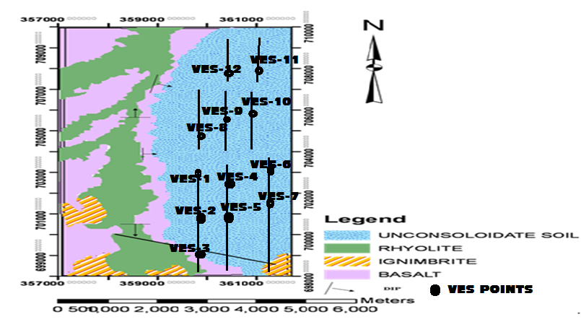
Figure 2. Geological map and VES points of the study area and its surroundings

Results And Discussions
Electrical resistivity Sounding (VES)
During the present study, interpretation of the geophysical data (Vertical Electrical Sounding) has been carried out to give a meaningful geological interpretation and examine the suitability of the groundwater for irrigation purpose. In the following sections, interpretation of the Vertical Electrical Sounding is done.
Parallel Profiles P1, P2 and P3 Fetale Kebele
These three profiles including 7VES run almost parallel to each other and are oriented in a near south-north direction. The data was collected with AB/2 spacing at about 500m. The interpretations are given below as follows. And the inverted curves of all VES are depicted in figure 3. The type of curve model is three layers. The geological response of the study area based up on the resistivity variation of ρ1, ρ2 and ρ3 are H-type or bowel shaped curve (ρ1>ρ2<ρ3). The geophysical variation of the 9 VES around target area is very similar. It indicates continuous and isotropic materials around study area. The first geological layer is very high resistive in all VES possibly considered as top compact soil and the second layer is a little bit low resistive layer and finally very high resistive layer implies very high competent rocks. When see closely VES-1 it exhibits depth possibilities of groundwater potential area. It contains two shallow aquifers at different depth. The first 3- 11m with low resistivity 3ohm-m and the second >40m with low resistivity 15ohm-m. VES-2 also shows similar response to VES-2. The inverted data with equivalence of VES-2 demonstrates shallow and deep aquifers with 5 geo-electric layers. Furthermore, the shallow aquifer occurred 1.5-20m with resistivity 8 0hm-m while deep aquifers > 100m with resistivity 10 ohm-m. VES-3 response is almost alike with VES-1 and VES-2. It has five geo-electrical layers. Probably shows two types of aquifers shallow from 2.5-14m with resistivity of 6 ohm-m and deep aquifer >99m with resistivity of 14 ohm-m. VES-4 show 5- geophysical layers. It depicts that two groundwater potentials at different depths such as 4- 12m with resistivity 3 ohm-m and 30-99m with resistivity of 99 ohm-m. VES-5 Inverted data of true resistivity shows low resistivity zone (8ohm-m) at the shallow depth ( 6-15m) and 35ohm-m at the depth (>20m ). They can be possibly interpreted as good potential for groundwater. VES-6 displays probably low resistivity zone at the depth 4-30m with resistivity 8 0hm-m (generally shallow aquifer). But, when observe clearly the subsurface response of this true resistivity curve there is no good potential to hold groundwater. VES-7 inverted data shows low resistivity zone (6 ohm-m) at the depth 4-35m and > 40m depth with resistivity 9 ohm-m can be interpreted as good potential for groundwater. The detailed potential zones and their corresponding VES are shown as in the table 1. In addition to that, pseudo section and geo-electric section is completed in 8 VES points to verify continuation of subsurface resistivity cross-section. The both section shows there is low resistivity zone at right flank near to VES-1 as shown in figure 3, so this is possibly has ground potential to develop in the future.
Vertical Electrical Sounding (VES) at Doshe and Yayke Kebele
The reply of 3 VES that were done in this target overlapped each other and gives the confidence to identify potential areas.
The processed data of VES-1 doshe kebele shows 4 subsurface layers. The 3rd layer with resistivity 8ohm-m and depth 3-40m can take as good potential for groundwater.
The VES-2 resistivity and depth graphs depict those 4 layers. From these the last (3rd) layer with resistivity 8 0hm-m and depth 8-30m is probably deduced as good potential for groundwater. The VES-3 inverted data confirms 4 geo-electrical layers. The 3rd layer with resistivity 8 0hm-m and depth 2-14 m well-thought-outs as good potential for groundwater. The picture is given in figure 3.
The 2 VES were done in Yayke kebele. VES -1show almost consistent ground response with bore hole data. Bore hole nearby show >100m highly resistant basalt. In addition to that, it is expected that highly fractured basalt so that good potential about 25m-100m. Furthermore, VES-2 reveals 5 layers. Depth versus resistivity curve shows two shallow aquifers such as with resistivity 3 and 5 ohm-m with depth of 14-20m and 50-100m respectively. The corresponding resistivity and potential area of this site given in the figure 3 and table 2.

Table 1. Summary of all 7 VES points of Fetale Kebele
Area | True resistivity (O-m) | Depth (m) | Depth of Aquifer | Conclusions (GW potential)
Fetale Kebele
P1-VES-1 | 3, 15 | 3- 11, >40 | Shallow | Good
P1-VES-2 | 8, 10 | 1.5-20, > 100 | Shallow and deep | Very good potential
P1-VES-3 | 6, 14 | 2.5-14, >99 | Shallow and deep | Very good potential
P2-VES-4 | 3, 99 | 4- 12, 30-99 | Shallow | Good potential
P2-VES-5 | 8, 35 | 6-15, >20 | Shallow | Good potential
P3-VES-6 | 8 | 4-30 | Shallow (??) | No potential
P3-VES-7 | 6, 9 | 4-35, > 40 | Shallow | Good potential

Table 2. Show the summary of 5VES around Doshe and Yayke kebele
Area | True resistivity (ohm-m) | Depth (m) | Type of aquifer | Conclusions (GW)
DOSHE KEBELE
VES-1 | 8 | 3-40 | Shallow | very good
VES-2 | 8 | 8-30 | Shallow | good
VES-3 | 8 | 8-30 | Shallow | good
YAYKE KEBELE
VES-1 | 6 | >20m | Shallow | Good
VES-2 | 3, 5 | 14-20, 50-100 | Shallow | Very Good

P1-VES-1 at Fetale kebele HK type
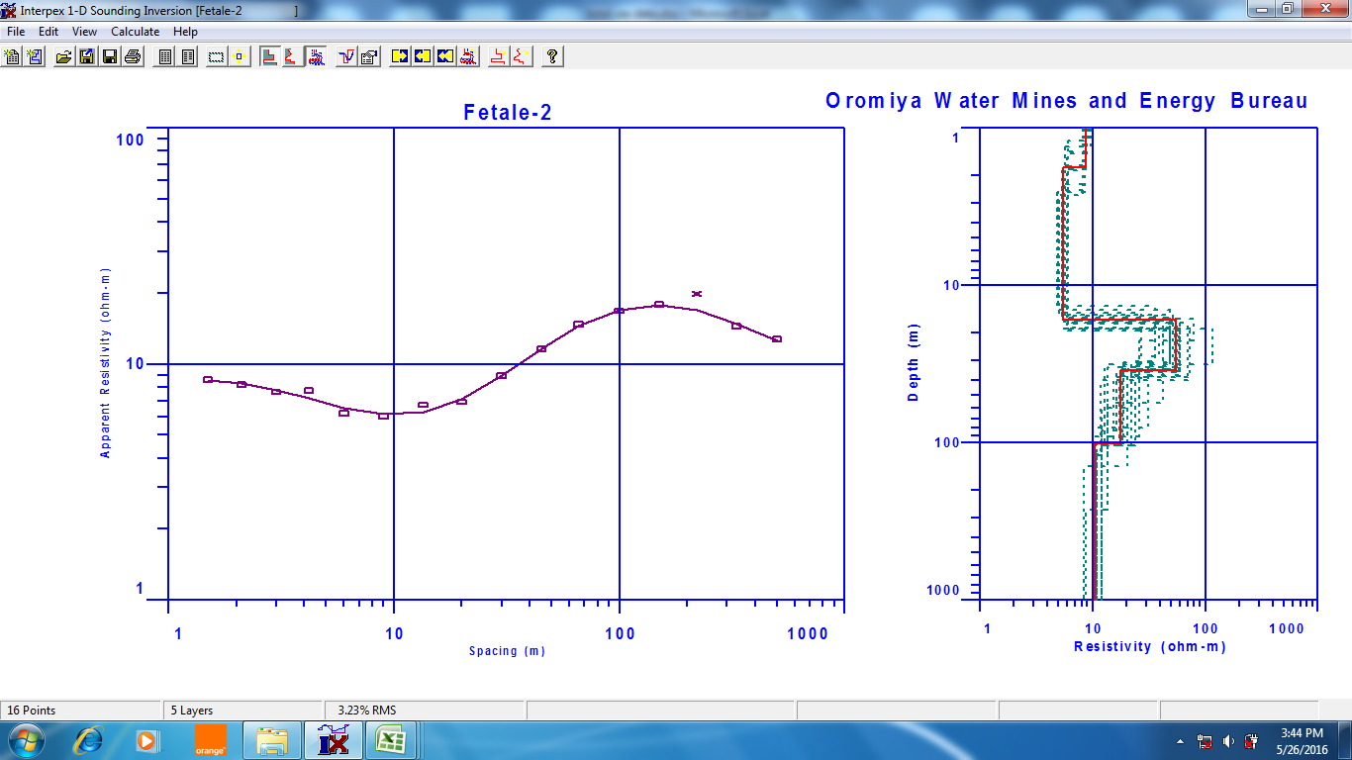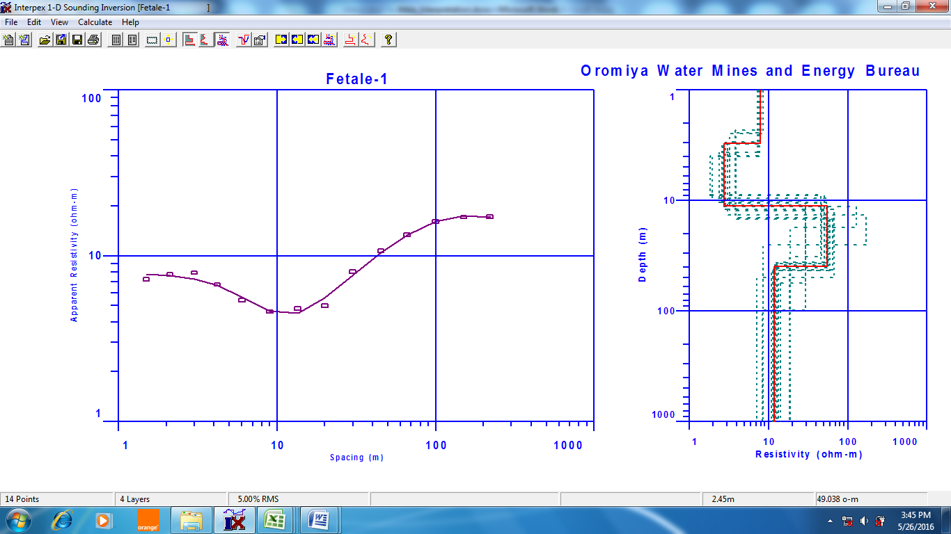

P1-VES-2 Fetale kebele HK type curve
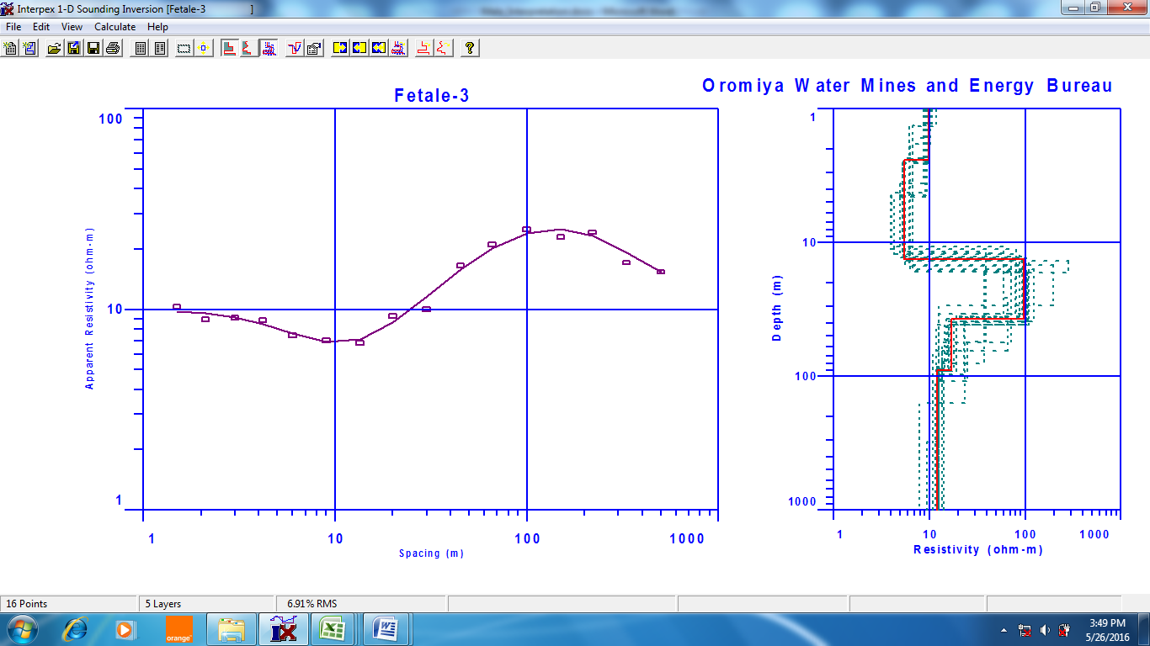

P1-VES-3 Fetale kebele HK Type curve

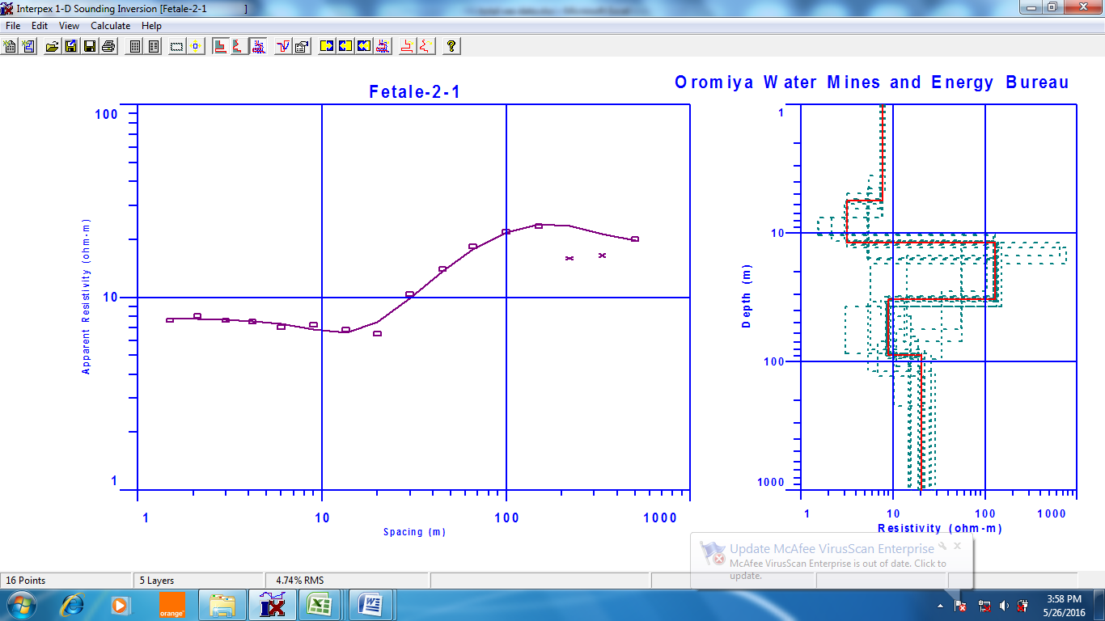

P2-VES-5 Fetale kebele HK Type curve
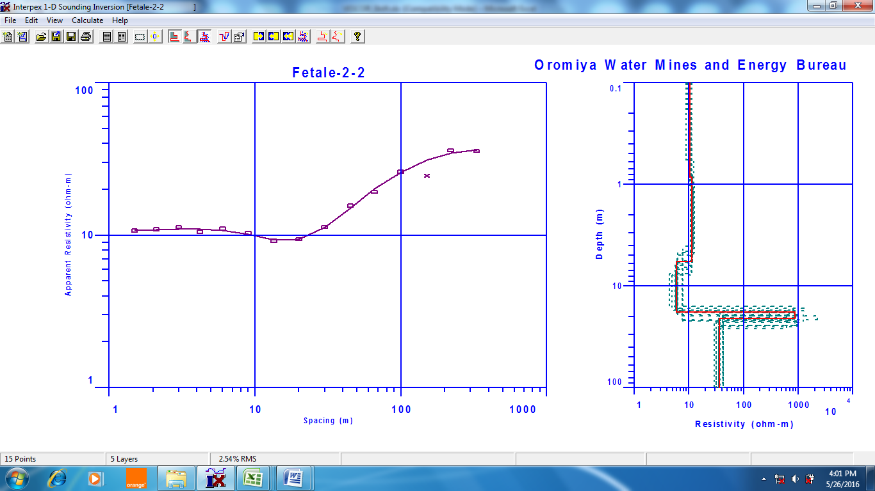

P2-VES-4 Fetale kebele KQ Type curve
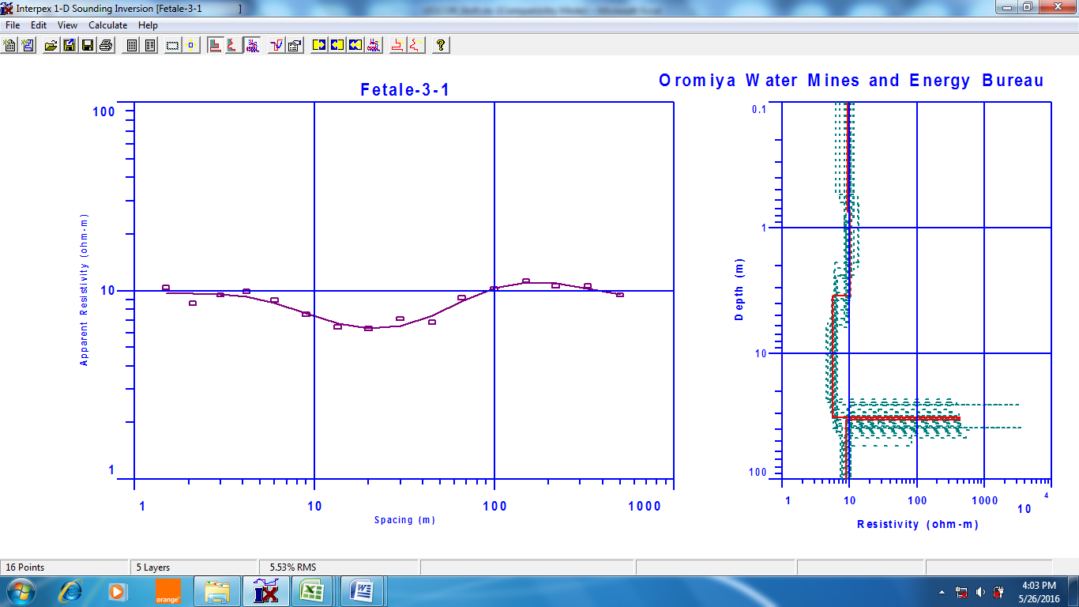

P2-VES-6 Fetale kebele HK Type curve
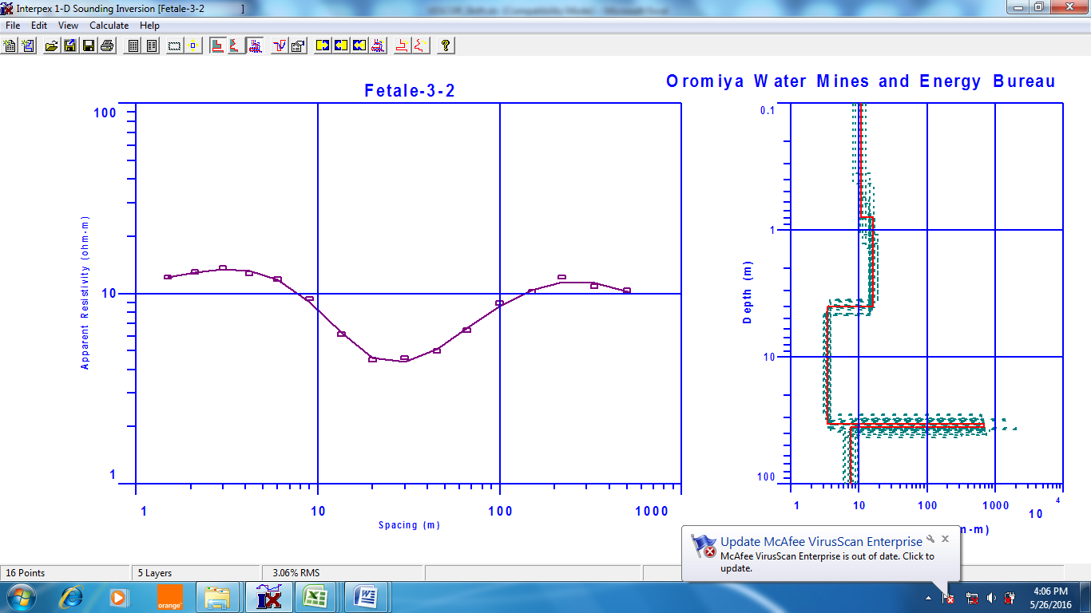

P3-VES-7 Fetale kebele HK Type curve
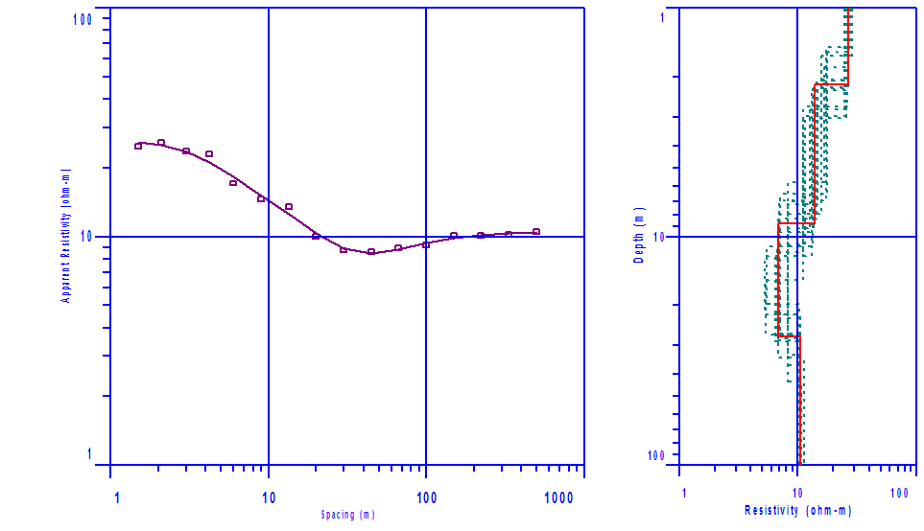

VES-2 Doshe kebele HH Type curve

VES-1 Doshe kebele QQ Type curve

VES-3 Doshe kebele HH Type curve

VES-1 Yayke kebele HQ Type curve
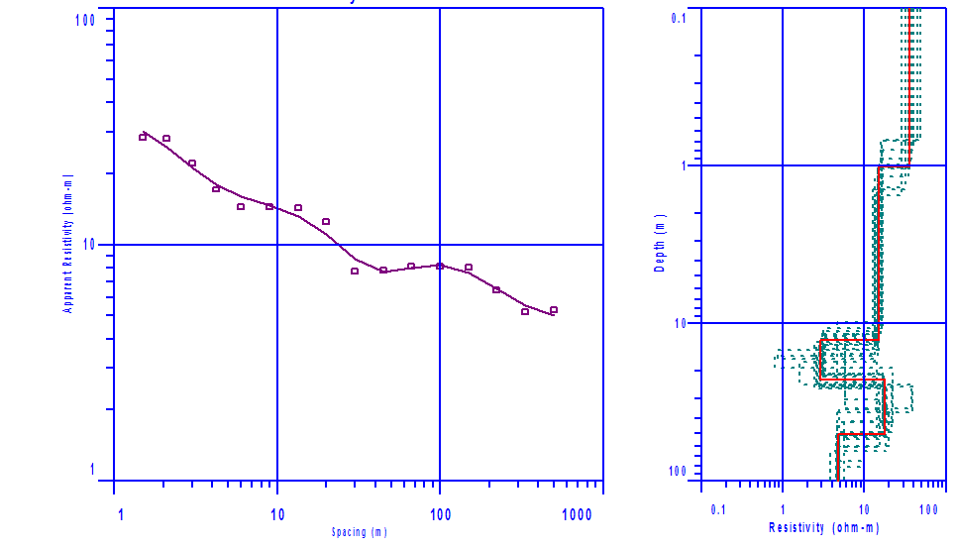

VES-2 Yayke kebele QQ type curve
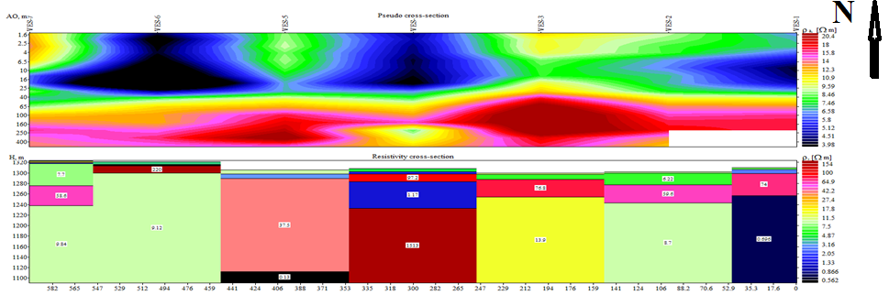
Figure 3. Shows all 12 VES Survey, 8 VES fetale geo-electric and puedo-section around the study area

Conclusions
The geophysical survey using VES techniques employed in this work have mapped the stratification of the subsurface from their resistivity responses. As verified through correlation with the lithologic log from a nearby borehole, the methods have mapped the different subsurface layers with a very good resolution. The methods additionally give a ‘synoptic view’ of the groundwater potential site and enable the identification of specific areas of groundwater potential subsurface layer parameters such as resistivity and thickness to be considered during drilling design. The work exemplifies the viability of, specially, the high resolution Vertical Electrical Sounding (1D imaging technique to characterize groundwater potential site with very good accuracy. Finally, the study shows P1-VES-2 (10ohm-m with depth >100m) and P1-VES-3 >99m) at Fetale kebele, VES-1 (8 ohm-m with depth <40 m) at Doshe kebele and VES-2 (58 ohm-m with depth 50-100m) at Yayke is the recommendable site for groundwater development in the future.

Reference
- Dereje Ayalew, Marty, B., Barbey, P., Gezahegn Yirgu and Endale Ketefo (2006). Sub-lithospheric source for Quaternary alkaline Tepi shield, southwest Ethiopia. Geochemical Journal 40:47–56.
- Egai, A.O., (2013). Environmental impacts of crude oil activities in Aguobiri, Southern Ijaw LGA, and Bayelsa State. Unpublished M.Sc. thesis university of Benin, Nigeria.
- Ephrem Beshawered (2010). Geology of the Akaki-Beseka Area, Basic Geosciences Mapping Core process, Geological Survey of Ethiopia. Addis Ababa, Ethiopia.
- Flathe, H., (1964). New ways for interpretation of geoelectric resistivity measurements in the search for and delineation of aquifers: Internat. Assn. of Sci. Hydrology Bull., 9th year, 1, 52.
- Garmin (2007). Garmin eTrex’ HC Series, Personal Navigator Owner’s Manual, Garmin Corporation, 48 pp.
- Heather, L. Reccelli-Synder, Berth, A stahl, Jeffrey L Leberfinger, P.G., and Jeffrey J Warren. (1999): Electrical Imaging: A method for identifying potential collapse and other karst features near roadways. Science Applications international cooperation Middletown Pennsylvania.
- Kazmin, V. (1980). Transform Faults in the East African Rift system, Geodynamic Evolution of the Afro-Arabian Rift System.
- Kazmin, V. (1981). Geological Map of the Ethiopian Rift. Addis Ababa, Ethiopia.
- Loke, M. H. (2001): Electrical imagine survey for environmental and engineering studies: A practical guide to 2D and 3D surveys.
- Merela, G., Abbate, E., Azzuroli, A., Bruni, P., Canuti, P., Fazzouli, M., Saari, M. and Tacconi, P. (1979). Explanation of the Geological Map of Ethiopia and Somalia with the Major Landforms. Consiglio Nazionale delle Ricerche, Firenze.
- Mohr, P.A. (1967). The Ethiopian Rift System, Bulletin of Geophysical Observatory. Addis Ababa. 11:1–65.
- Ozebo V. C. and Ajiroba S. O. (2011): Groundwater Assessment in Apapa coastline Area of Lagos Using Electrical Resistivity Method. Journal of Emerging Trends in Engineering and Applied Sciences (JETEAS), 2(4), 673-679.
- Roman, Irwin. (1951): resistivity reconnaissance in American Society of testing and materials. Symposium on surface and subsurface reconnaissance: American society oftesting materials special technical publication122, p171-220.
- Seifemichael Berhe, Belay Desta, Nicoletti, M. and Mengesha Tefera (1987). Geology, geochro-nology and geodynamic implications of the Cenozoic magmatic province in W and SE Ethiopia. Journal Geological Society London144:213–226.
- Telford W. M., Geldart, L. P., Sherif R. E., and Keys D. A. (1976): Resistivity Methods, Applied Geophysics, Cambridge University Press, and Cambridge Pgs. 632 – 701.
- Tenalem Ayenew, Molla Demlie and Wohnlich, S. (2008). Hydrogeological framework and occurrence of ground water in the Ethiopian Aquifers. Journal of African Earth Science 52(3):97–113.

5/18/2018

