Biological studies on moringa leaf extracts and its relationship with obesity and diabetes mellitus diseases

Maha A. Hijazi

Food and Nutrition Department, Faculty of Home Economics, King Abdul-Aziz University, Saudi Arabia.
mhijazi@kau.edu.sa

Abstract: This study was conducted to investigate the effect of moringa leaf extract consumption on obesity and diabetes mellitus diseases. Thirty five Albino rats weighting (190 ± 20g) were divided into 5 equal groups, one was kept as normal control, while, the other 4 groups were injected byalloxan after induction of obesity. Obese diabetic rats were fed orally with 100,200 and 300mg moringa leaf extract. Body weight gain (BWG), feed intake (FI), feed efficiency ratio serum liver enzymes (aspartate aminotransferase and alanine aminotransferase), renal enzymes (superoxide dismutase, glutathione peroxidase and catalase), serum lipids profiles (total cholesterol and triglycerides, high density lipoprotein, and low density lipoprotein) and glucose levels were examined. The obtained results revealed that moringa leaf extracts contains several classes of phytochemicals with other compounds, are able to prevent or inhibit obese and diabetes complications through liver serum enzymes lowering activity, renal enzymes lowering and enhancing the serum lipid profile. In conclusion, moringa leaf extracts produce anti-obesity and antidiabetic effects in obese diabetic rats. These results provide scientific evidence to substantiate the traditional use of moringa leaf as a drink in treating obesity and diabetes.
[Maha A. Hijazi. Biological studies on moringa leaf extracts and its relationship with obesity and diabetes mellitus diseases. N Y Sci J 2018;11(4):21-28]. ISSN 1554-0200 (print); ISSN 2375-723X (online). http://www.sciencepub.net/newyork. 3. doi:10.7537/marsnys110418.03.

Key words: moringa leaf extract, phytochemicals, serum glucose, liver functions, kidney functions

1. Introduction
Obesity is an excessive fat accumulation in the body that results from an imbalance between energy intake and energy expenditure. It is associated with genetic, metabolic and behavioral components. Despite of a major contribution of genetic susceptibility, the rapid development of obesity might reflect great changes of other factors such as dietary habit (Archer, et al. 2007).
Obesity, especially the abdominal type, is a health problem that constitutes metabolic syndrome and increases the incidence of various diseases, including diabetes, hypertension, dyslipidemia and atherosclerosis. The increased levels of systemic oxidative stress that occur in obesity may contribute to the obesity-associated development of these diseases (Matsuda and Shimomura, 2013).
Diabetes mellitus or simply diabetes is a group of metabolic diseases in which a person has high blood sugar. This high blood sugar produces the symptoms of frequent urination, increased thirst, and increased hunger. Untreated diabetes can cause many complications. Acute complications include diabetic ketoacidosis and nonketotic hyperosmolar coma. Serious long-term complications include heart disease, kidney failure and damage to the eyes (Alberti et al., 1998; WHO, 2015). Diabetes is due to either the pancreas does not producing enough insulin or because cells of the body do not respond properly to the insulin that is produced (Gardner and Dolores et al., 2011). According to the World Health Organization (WHO) criteria, obesity is defined by a body mass index (BMI) of 30 kg/m2 or greater. A BMI above the healthy range of 18-25 kg/m2 is common in Western cultures and has been linked to both consumption of a Western diet (i.e. high saturated fat, high calorie content), and sedentary lifestyles. (WHO 2015). Individual is considered obese when the amount of fat tissue is increased to such an extent that physical and mental health are affected and life expectancy reduced (Graves 2010). The prevalence of overweight and obesity is increasing at an alarming rate in developed and developing countries throughout the world. The World Health Organization (WHO) predicts that by 2015, ~2.3 billion adults will be overweight and >700 million will be obese. Obesity rates in adolescents are also increasing with 200 million school age children overweight globally (Heal et al 2013), Furthermore, the highly prevalent rate of obesity is not only in middle-aged adults, but also in children and young adults Mackenbach et al 2008. Moringa oleifera belongs to the family of Moringacaea, a fast growing drought resistant tree but now distributed worldwide in the tropic and sub tropics and is cultivated extensively in central and South America, Africa, Indonesia, Mexico, Malaysia, the Philippines, and India (Fuglie et al., 1999). Moringa oleifera is an edible plant. Different parts of moringa plant contain important minerals as K, Ca, P, Fe, and are a good source of protein, vitamins, beta-carotene, amino acids and various phenolics as zeatin, quercetin, β-sitosterol, caffeoylquinic acid and kaempferol (Anwar et al., 2012) and high concentrations of natural dietary antioxidants: Vitamins A, C and E. Moringa provides high concentrations of four natural dietary antioxidants: Vitamins A, C, E and phenolics (Gowrishankar et al., 2010). Moringa is a rich source of ascorbic acid helps in insulin secretion. It is interesting to note that certain nutrients like vitamins B1, B2, B12, pantothenic acid, vitamin C, protein and potassium - along with small frequent meals containing some carbohydrate - can actually stimulate production of insulin within the body (Quisumbing, 1978).
The aim of this study was conducted to investigate the effect of moringa leaf extract consumption on obesity and diabetes mellitus diseases.

2. Material and Methods:
Thirty five albino rats of Wistar strain weighed 180-200g, were obtained from the Experimental Animal Unit of King Fahd Medical Research Center, King Abdul-Aziz University, Jeddah, Saudi Arabia.
Preparation of Plant Material:
The leaf of Moringa were collected, dried and milled to the powder using the grinding machine. 500 g of moringa leaf powder were macerated in 1200 ml of ethanol with thorough shaking at regular interval for 72h at room temperature (25±1°C). The extract was filtered using Whatman No. 1 filter paper. The filtrate was concentrated using the rotary evaporator to obtain the slurry of the extract. The semi-pastry extract was dried and stored in the refrigerator and used for the study.
Experimental design
All biological experimental were done at Rats (n=35) were housed individually in wire cage in a room maintained at 25±2 and kept under normal healthy condition. All rats were fed on basal diet ( casein 12.5%, corn oil 10%, minerals mixture 4%, vitamin mixture 1%, fiber 5%, DL methionine 0.3%, choline chloride 0.2% and completed to 100% by corn starch according to (Ain 1993) for one week before starting the experimental for acclimatization after one week period, the rats were divided into two main groups. Group 1 negative control group (7 rats) in this group, rats were kept on basal diet and tap water. Group 2obese diabetic rats groups (28 rats): in this group, rats were kept for four weeks on high fat diet to induce obesity. High fat diet prepared from fine ingredients per 100 g according to (Negm2002). The diet had the following composition: fats 20%, ( tallow 10% +corn oil 10 %), casein 12.5%, salt mixture 3.5%, vitamin mixture 1%, fiber 5%, DL methionine 0.3%, choline chloride 0.2%and corn starch up to 100g according to Ain 1993. After induction of obesity, the obese rats were injected by alloxan 1`50mg/kg body weight according to the methods described by Desai and Bhide 1985. One week after the injection of alloxan fasting blood samples were obtained to estimate fasting serum glucose. Rats having fast serum glucose more than 160 mg/dl were considered diabetics (Nddg 1994). All the obese-diabetic rats were classified into 5 groups. Group A: negative control group, in which normal rats fed on basal diet all experimental periods (28days). Group B: positive control group, in which obese diabetic rats fed on high fat diet all experimental periods. Group c: In which, obese diabetic rats fed a high fat diet and 100mg orally / day. Group D: In which, obese diabetic rats fed a high fat diet and 200mg orally / day. Group E: In which, obese diabetic rats fed a high fat diet and 300mg orally / day.
Blood sampling
In all experimental groups, blood samples were collected after 12 hours fasting at the end of each experimental, in which the rats were scarified under ether anesthesia. Blood samples were received from portal vein into clean dry centrifuge tubes in which blood samples left to clot in it at room temperature then centrifuged for 10 minutes at 3000 rpm to separate the serum. Serum was carefully aspirated and transferred into clean cuvate tubes. All blood and serum samples were stored in frozen at -20 C for biochemical analyses (Malhotra 2003).
Determination of Feed Intake (FI), Body Weight Gain (BWG) and Feed Efficiency Ratio (FER):-Daily feed intake (FI) per group was calculated throughout the experimental period (14 days). The biological values of different diets were assessed by the determination of body weight gain percent (BWG%) which was calculated at the end of the experimental period as well as feed efficiency ratio (FER) was calculated twice a week, according to the method of (Chapman et al., 1959).
Determination of Serum glucose was measured by enzymatic GOD / POD kits according to the method by (Trinder, 1969).
Determination of Serum cholesterol was determined according to the method described by (Allain et al., 1974), using a Spectrophotometer (Thermo Fisher Scientific Genesys, USA) adjusted at 500 nm wave length.
Determination of serum triglycerides were determined according to the method described by (Trinder, 1969), using a Spectrophotometer (Thermo Fisher Scientific Genesys, USA) at 500 nm wavelength.
Determination of Serum high density lipoprotein cholesterol was calorimetrically determined according to the method described by (Lopes-Virella et al., 1977), using a Spectrophotometer (Thermo Fisher Scientific Genesys, USA) at 500 nm wave length.
Determination of Serum low density lipoproteins cholesterol was calorimetrically determined according to the method described by (Fridewald et al., 1972). The concentration of the sample was calculated from the following equation: LDL-c concentration (mmol/L) = Total cholesterol – ( TG2.2+ HDL-c).
Determination of Serum aspartate aminotransferase (AST) activity and alanine aminotransferase (ALT) activity: Serum aspartate aminotransferase (AST) activity and alanine aminotransferase (ALT) activity were estimated enzymatically based on color reaction formation. The developed color was measured according to the method described by (Bergmeyer et al., 1978) using a Spectrophotometer (Thermo Fisher Scientific Genesys, USA) adjusted at 505 nm wave length. The concentration was calculated by matching the reading of optical density of concentration of the sample with that of the standard solution.
Statistical analysis
Statistical analysis was presented as mean ± SD and the statistical significance between all groups and control were analyzed by means of an Analysis of Variance (ANOVA) followed by Dunnet’s multiple comparison tests. P-values less than 0.05 were considered significant.

3. Results and discussion
Effect of moringa leaf extract on Body weight gain (BWG), Feed intake (FI) and Feed efficiency ratio (FER) in obese diabetic rats are illustrated in Table (1). Feeding of rats on high-fat diet were significantly (P<0.05) increased the body weight gain (BWG), Feed intake (FI) Feed efficiency ratio (FER) and compared to group A normal control. Oral intake of moringa leaf extract in doses of 100, 200and 300 mg/kg to obese diabetic rats were showed gradual reduction in the body weight gain, Feed intake (FI) feed efficiency ratio (FER) in obese diabetic rats by increasing the doses of moringa leaf extract. Maximum reduction in the Body weight gain (BWG), Feed intake (FI) and Feed efficiency ratio (FER) in obese diabetic rats were observed with Group E obese diabetic rats treated with 300 mg moringa leaf extract followed by Group D obese diabetic rats treated with 200 mg moringa leaf extract and Group C obese diabetic rats treated with 100 mg moringa leaf extract compared with Group B obese diabetic rats (positive group). These results are agreement with Onyema et al., 2006.

Table (1). Effect of moringa leaf extract on Body weight gain (BWG), Feed intake (FI) and Feed efficiency ratio (FER) in obese diabetic rats.
Treatments | Body weight gain (BWG) | Feed intake (FI) | Feed efficiency ratio (FER)
Group A normal control | 23.56e | 19.47^{c} | 0.056e
Group B obese diabetic rats | 57.09ª | 25.57ª | 0.080ª
Group C obese diabetic rats treated with 100 mg MLE | 47.65^{b} | 24.54ª | 0.071^{b}
Group D obese diabetic rats treated with 200 mg MLE | 38.28^{c} | 20.20^{b} | 0.068^{c}
Group E obese diabetic rats treated with 300 mg MLE | 27.77^{d} | 19.95^{c} | 0.062^{d}
Values with different superscripts within the column are significantly different at p< 0.05.

Effects of Moringa leaf extract on Blood Glucose level in obese diabetic rats are shown in Figure (1). Group B obese diabetic rats (positive group) were showed increased in blood glucose compared to Group A normal control. Oral intake of moringa leaf extract in doses of 100, 200 and 300 mg/kg to obese diabetic rats were showed gradual reduction in the blood glucose in obese diabetic rats by increasing the doses of moringa leaf extract. Maximum reduction in the blood glucose level were observed with Group E obese diabetic rats treated with 3000 mg MLE followed by Group D obese diabetic rats treated with 200 mg MLE and Group C obese diabetic rats treated with 100 mg MLE compared with Group B obese diabetic rats (positive group).
The effect of moringa leaf extract on total cholesterol and triglycerides in obese diabetic rats are presented in Figure (2). Feeding of rats on high fat diet were increases in serum total cholesterol (TC) and triglycerides (TG) compared to group A normal control. Oral intake of the moringa leaf extracts in doses of 100, 200 and 300 mg/kg to obese diabetic rats were decreased the levels of total cholesterol TC and triglycerides TG compared to the positive control group. Maximum reduction in the total cholesterol (TC) and triglycerides (TG) were observed with Group E obese diabetic rats treated with 300mg moringa leaf extract followed by Group D obese diabetic rats treated with 200 mg moringa leaf extract and Group C obese diabetic rats treated with 100 mg moringa leaf compared with Group B obese diabetic rats (positive group). They attributed the hypolipidemic effects of moringa leaf extract due to their contents of polyphenols in moringa leaf which inhibit the intestinal absorption of cholesterol and reduce serum cholesterol levels in experimental animal models. Huang, et al., 2004.

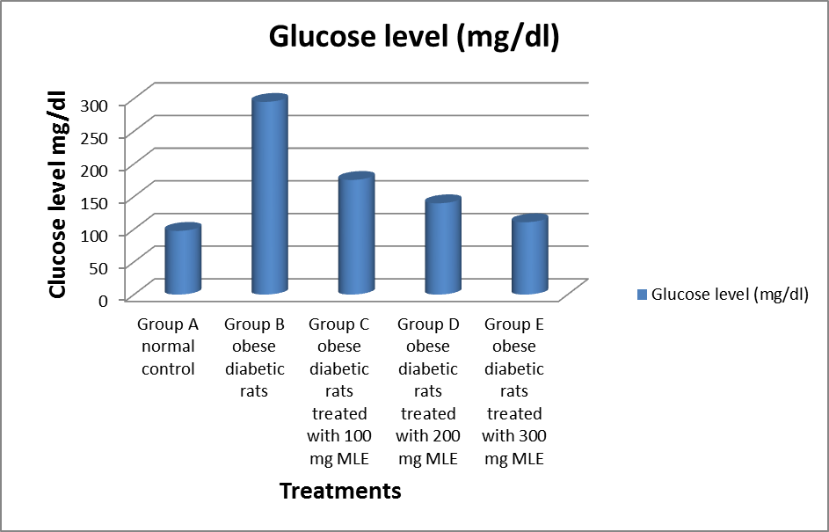
Fig. (1). Effects of Moringa leaf extract on Blood Glucose level in obese diabetic rats
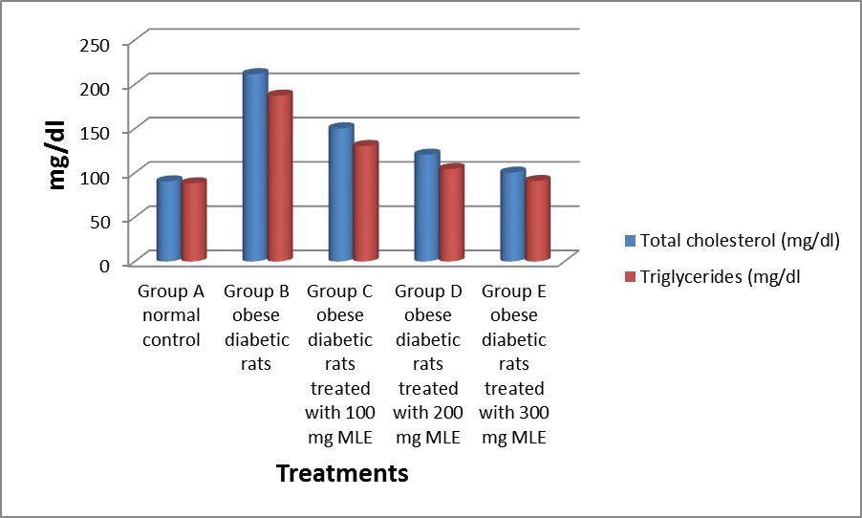
Fig (2). The effect of moringa leaf extract on total cholesterol and triglycerides in obese diabetic rats

The effect of moringa leaf extract on high density lipoprotein (HDL), and low density lipoprotein (LDL) in obese diabetic rats are shown in Figure (3). Feeding of rats on high fat diets were decreased serum high density lipoprotein (HDL) and increased low density lipoprotein (LDL) when compared to group A (negative control rats). Oral intakes of moringa leaf extract in doses of 100,200 and 300 mg/kg to obese diabetic rats were increased serum HDL-c and decreased LDL-c compared with group B (the positive control groups).

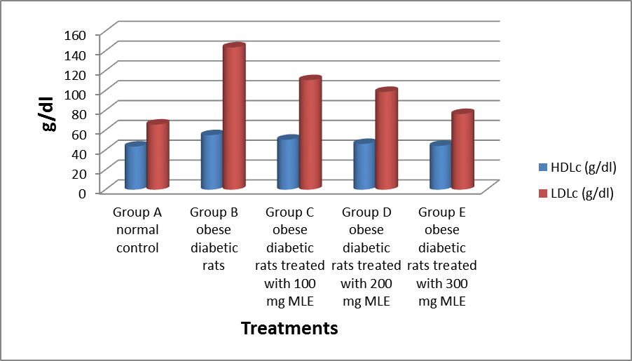
Fig (3). The effect of moringa leaf extract on high density lipoprotein (HDL), and low density lipoprotein (LDL) in obese diabetic rats

The effect of moringa leaf extract on liver enzymes aspartate aminotransferase (AST) and alanine aminotransferase (ALT) in obese diabetic rats are presented in Figure (4). Rats fed on high fat diet were increases in serum levels of liver enzymes aspartate aminotransferase (AST) and alanine aminotransferase (ALT) compared to with group a normal control rats. Moringa leaf extract in doses 100, 200 and 300 mg/kg when given to obese diabetic rats were decreased the aspartate aminotransferase (AST) and alanine aminotransferase (ALT) enzymes compared to the group B (positive control group). These results are agreement with Moselhy and Ali 2009.

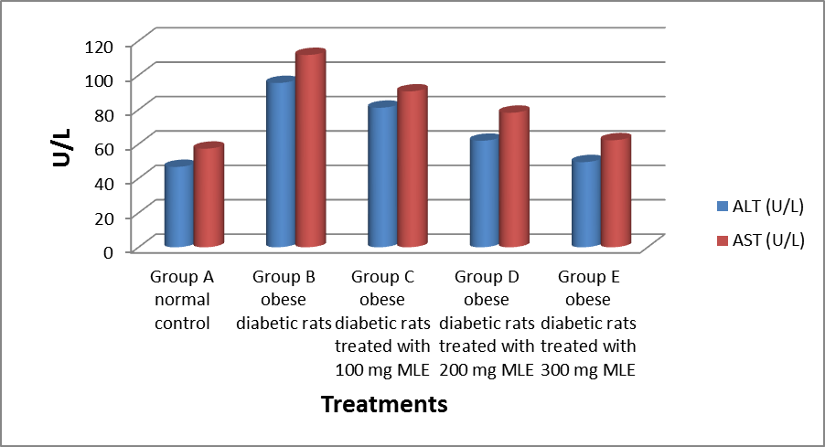
Fig (4). The effect of moringa leaf extract on liver enzymes aspartate aminotransferase (AST) and alanine aminotransferase (ALT) in obese diabetic rats.

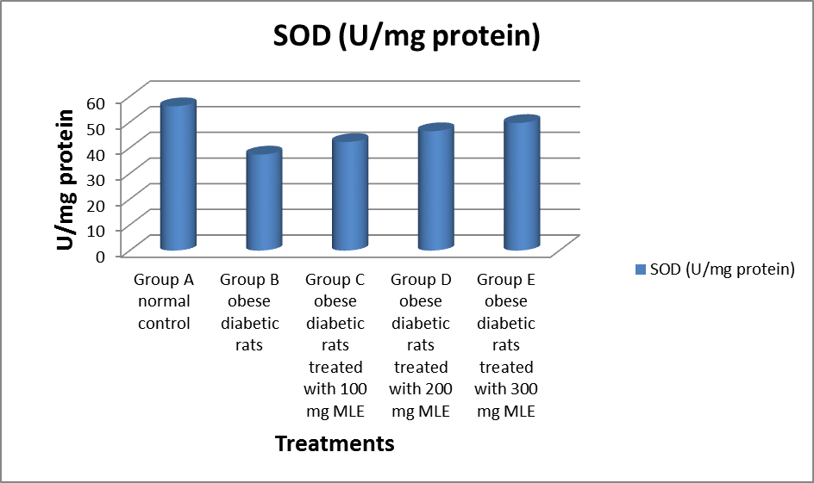
Fig. (5). Effects of moringa leaf extract on activities of superoxide dismutase (SOD) enzymes in obese diabetic rats.

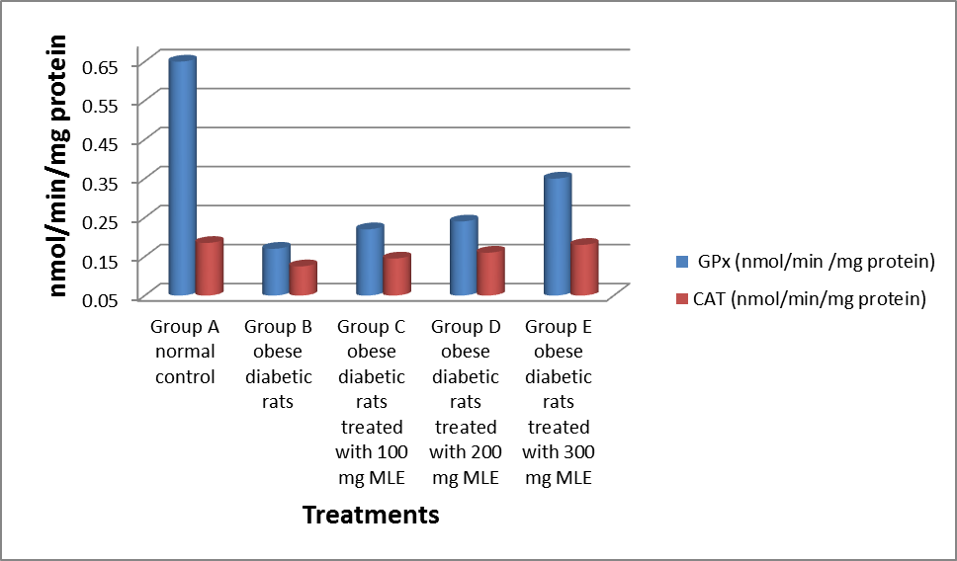
Fig. (6). Effect of moringa leaf extract on activities of tissue glutathione peroxidase (GPx) and catalase (CAT) enzymes in obese diabetic rats.

The effect of moringa leaf extract on superoxide dismutase (SOD), glutathione peroxidase (GPx) and catalase (CAT) in obese diabetic rats are presented in Figure (5) and figure (6). Feeding rats on high fat diet were decreased in superoxide dismutase (SOD), glutathione peroxidase (GPx) and catalase (CAT) compared to group A normal control. Oral intake of moringa leaf extract in doses of 100, 200and 300 mg/kg to obese diabetic rats were increased renal tissue levels of SOD, GPx and CAT enzymes by increasing concentration of moringa leaf extracts when compared with group B obese diabetic rats ( positive control group). These results are confirmed with Wang, et al. 2011.
The medicinal plants and culinary herbs which possess antihyperlipidemic and antidiabetic activities have gained much attention, especially those with little toxicity properties. The biological value of plants depends on their bioactive constituents such as saponins, anthocyanins, flavonoids, polyphenols, diterpenes, triterpenes and other phytochemicals Patel, et, al. 2012.

References
Alberti, K. G. and Zimmet P. Z. 1998. Definition, diagnosis and classification of diabetes mellitus and its complications. Part 1: diagnosis and classification of diabetes mellitus provisional report of a WHO consultation. Diabet. Med. 15:539–553.
Allain, C. C., Poon, L. S., Chan, C. S. G., Richmond, W. and Fu, P. C. 1974. Enzymatic determination of total serum cholesterol, Clinical Chemistry, 20 (4): 470-475.
Anwer R., Khursheed S. and Fatma T. 2012. Detection of immune active insulin in Spirulina. J. Appl. Phycol. 24: 583–591.
Archer, Z. A., J. Corneloup, D. V. Rayner, P. Barrett, K. M. Moar and J. G. Mercer, 2007. Solid and liquid obesogenic diets induce obesity and counter regulatory changes in hypothalamic gene expression in juvenile Sprague Dawley rats. Journal of Nutrition, 137(6): 1483-149.
Bergmeyer, H. U., Scheibe, P. and Wahlefeld, A. W. 1978. Optimization of methods for aspartate aminotransferase and alanine aminotransferase. Clinical chemistry, 24: 58-73.
Chapman, D. G., Castillo, R. and Campbell, J. A. 1959. Evaluation of protein in foods: 1-A Method for the determination of protein efficiency ratio, Canadian Journal of Biochemistry and Physiology, 37(5): 679-86.
Friedewald, W. T., Leve, R. I. and Fredrickson, D. S. 1972. Estimation of the concentration of low-density lipoprotein cholesterol in plasma, without use of the preparative ultracentrifuge. Clinical Chemistry, 18: 499-502.
Fuglie L. J. 1999. The Miracle Tree: Moringa oleifera: Natural Nutrition for the Tropics. Church World Service, Dakar, pp: 68. Revised in 2001 and published as The Miracle Tree: The Multiple Attributes of Moringa; pp: 172.
Gardner D. G. and Dolores R. 2011. "Chapter17". Greenspan's basic & clinical endocrinology (9th ed.). New York: McGraw-Hill Medical. ISBN 0-07-162243-8.
Gowrishankar R. and Kumar M.2010. Trace element studies on Tinosporacordifolia (Menispermaceae), Ocimum sanctum (Lamiaceae), Moringaoleifera (Moringaceae), and Phyllanthusniruri (Euphorbiaceae) using PIXE. Biol Trace Elem Res., 133: 357–363.
Graves B. W. 2010. The obesity epidemic: scope of the problem and management strategies, J Midwifery Women’s Health, 55(6), 568–78.
Heal D. J., Gosden J., Smith S. L.,2013. A review of late-stage CNS drug candidates for the treatment of obesity, International Journal of Obesity: 37,, 107-117.
Huang, B. W., M. T. Chiang, H. T. Yao and W. Chiang, 2004. The effect of high- fat and high-fructose dieton glucose tolerance, plasma lipid and leptin levels inrats. Diabetes Obesity and Metabolism, 6(2): 120-126.
Lopes-Virella, M. F., Stone, P., Ellis S. and Colwell, J. A. 1977. Cholesterol Determination in High-Density Lipoproteins Separated by Three Different Methods, Clinical Chemistry, 23(5): 882-884.
Mackenbach J. P., Stirbu I., Roskam A. J. R., Schaap M. M., Menvielle G., Leinsalu M. 2008. Socioeconomic inequalities in health in 22 European countries, N Engl J Med.: 2468—81.
Matsuda, M. and I. Shimomura, 2013. Increased oxidative stress in obesity: implications for metabolic syndrome, diabetes, hypertension, dyslipidemia, atherosclerosis and cancer. Obstetrics Research and Clinical Practice, 5: 330-341.
Moselhy, S. S. and H. K. Ali, 2009. Hepatoprotective effect of cinnamon extracts against carbon tetrachloride induced oxidative stress and liver injury in rats. Biology Research, 2(1): 93-98.
Neveen S. Ismail 2014. Protective Effects of Aqueous Extracts of Cinnamon and Ginger Herbs2014. Against Obesity and Diabetes in Obese Diabetic Rat World Journal of Dairy & Food Sciences 9 (2): 145-153,
Onyema, O., Farombi, E., Emerole, G., Ukoha, A. and Onyeze, G. 2006. Effect of Vitamin E onmonosodium glutamate induced Hepatotoxicity and oxidative stress in rats. Indian Journal of Biochemistry and Biophsics, 43: 20-24.
Patel, D., S. Prasad, R. Kumar and S. Hemalatha, 2012. An overview on antidiabetic medicinal plants having insulin mimetic property. Asian Pacific Journal of Tropical Biomedicine, 2(4): 320-330.
Quisumbing E.1978. Moringa oleifera Lam, Medicinal plants of the Philippines. Katha Publication Company, Inc., 346-349.
Trinder, P. 1969. Enzymatic method of glucose estimation, Journal of Clinical Pathology, vol. 22: 246.
Wang, G. G., X. H. Lu, W. Li, X. Zhao and C. Zhang, 2011. Protective effects of Luteolin on diabeticnephropathy in STZ-induced diabetic rats. Evident Based Complementary Alternative Medicine 32317.
WHO, 2015. Obesity and overweight, WHO: World Health Organization.

4/7/2018

