**Shear Strength of Prestressed Concrete Deep Beams and Current Design Methods**

A. Asran1, H. El-Esnawi2, A. Hafiz3, M.A. Eita4

1Prof. Civil Engineering Dept., Faculty of Engineering, Al-Azhar University, Cairo, Egypt

2Ass. Prof. Civil Engineering Dept., Faculty of Engineering, Al-Azhar University, Cairo, Egypt

3Lecturer Civil Engineering Dept., Faculty of Engineering, Al-Azhar University, Cairo, Egypt

4Lecturer Assistant, Civil Engineering Dept., Higher Technological Institute 10th of Ramadan City, Egypt

[Mostafa_anter55@yahoo.com](mailto:Mostafa_anter55@yahoo.com)

**Abstract:** In this paper, fourteen un-bonded post-tensioned deep beams without web reinforcement were tested under monotonically increasing single load up to failure. The investigated parameters included; the clear span to height ratio ($L_{n}/h$), the beam size h, the average pre-compression ($P_{e}/A$), and the Concrete compressive strength $f_{c}^{'}$. In addition, the validity of some models was examined against test results. The assessment those models indicated some models to be conservative while other models overestimated the shear capacity of the tested beams. The model developed by S. Teng et al. was found to be in a good agreement with test results.

[A. Asran, H. El-Esnawi, A. Hafiz, M.A. Eita. **Shear Strength of Prestressed Concrete Deep Beams and Current Design Methods.** *N Y Sci J* 2018;11(3):46-53]. ISSN 1554-0200 (print); ISSN 2375-723X (online). <http://www.sciencepub.net/newyork>. 7. doi:[10.7537/marsnys110318.07](http://www.dx.doi.org/10.7537/marsnys110318.07).

**Keywords:** deep beams; diagonal tension; prestressed concrete; shear strength; Post-tensioned.

**1. Introduction:**

The design of deep beams is a significant subject in structural engineering practice. For instance, deep beams are usually used in the design of transfer girders, shear walls, corbels, offshore structures, and pile caps. In addition, applying pre-stressing to deep beams notably enhances their flexural and shear capacities [1-3].

Despite the importance of prestressed deep beams, a limited number of experimental studies have been conducted on their shear behavior, especially, experiments on un-bonded post-tensioned deep beams. In addition, there is no agreement between the previous researchers onanintegrated approach to either model the shear behavior or determine the shear strength of unbounded post-tensioned deep beams [4-9].

The aim of this paper is to experimentally investigate the effect of some parameters on the shear strength of un-bonded post-tensioned deep beams without web reinforcement. The investigated parameters are the clear span to height ratio $L_{n}/h$, the beam size h, the average pre-compression $P_{e}/A$, and the Concrete compressive strength $f_{c}^{'}$. In addition, the accuracy of some shear strength models are examined against the experimental results of the current study.

**2.1Previous suggested shear strength models for deep beams**

In the following sections, some of the existing shear strength models for deep beams are reviewed. Some of these models are simple equations that represent the shear strength of deep beams in terms of nominal concrete shear strength; other models adopt more sophisticated methods such as the strut and tie approach.

**2.1.1 ACI Code model**

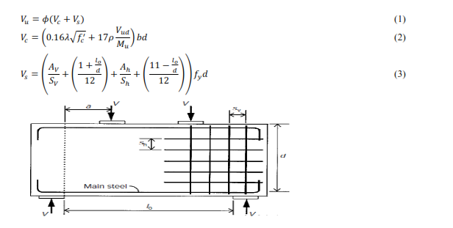

**Figure. 1** Notation for the ACI Code method

The ACI Code 318.14 [2] model is applicable to beams having a clear span to depth ratio (L0/d) less than four. According to ACI code model, the shear strength of concrete beams at the critical section is computed by the following equations, as shown in figure 1.

For beams having (L0/d) less than five, the contribution of the horizontal web reinforcement to carrying shear stresses is more obvious than that of vertical web reinforcement [8]. This observation is also valid for beams with a/d ≤1.

**2.1.2 CEB-FIP model**

The design equation presented by CEB-FIP Model [10] is valid for simple beams having span to depth ratio (L0/d) less than 2.0 and for continuous beams having span to depth ratio less than 2.5. The shear strength is lesser of the two following equations



**2.1.3 S. Teng et al. model**

S. Teng et al. [14] proposed an equation for shear strength of pre-stressed deep beams. This equation is an extension of an original equation from CIRIA Guide 2[11]. The original equation of CIRIA Guide 2[11] is written below.



Where C1 is 1.4 and 1.0 for normal and lightweight concrete, respectively, C2 is 300 Mpa for deformed bars and 130 Mpa for plain rounded bars. b and h are the width and depth of beam, respectively, A is the typical bar area intersecting the diagonal shear crack as shown in figure 2, and ft is the tensile splitting strength of the concrete ($f_{t}=0.4\sqrt{f_{cu}} to 0.5\sqrt{f_{cu}}$).

In order to account for the effect of pre-stressing, S. Teng et al. [8, 12] modified the value of concrete tensile strength ft as follows.



Where $P_{e}sinθ$ is the effective pre-stressing force in the direction of the dotted line as shown in figure 3.

|  |  |
| --- | --- |
|  |  |
| **Figure 2**. Typical bar area crossing the shear crack in CIRIA Guide 2 model. | **Figure 3.** Idealization of the pre-stressing force acting on the shear crack in S. Teng model. |

**2.1.4Tan and Mansur model**

Tan and Mansur model utilizes a simplified strut and tie approach to calculate the ultimate shear strength of ordinary and pre-stressed deep beams as shown in figure 4. The ultimate shear strength $V_{u}$ is given by the minimum value of the followingequations [4]:

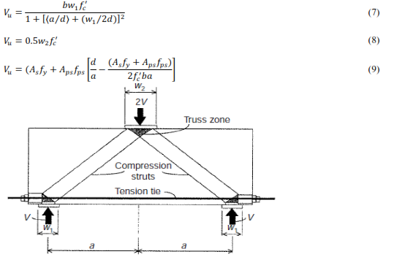

**Figure 4.** Tan and Mansur truss model

Equations 7 and 8 determine the ultimate capacity of the bottom and top nodal zones, respectively. Tan and Mansur model [4] assumes the axial strength of the diagonal strut is governed by these nodal zones. In addition, equation9 determines the tensile capacity of the tie and accounts for both ordinary and pre-stressing reinforcement.

**2.1.5 K.H. Tan et al. Direct Strut and Tie Model**

Using strut and tie approach, K.H. Tan et al. [13] developed a simple and direct model for shear strength of pre-stressed deep beams. According to K.H. Tan et al. [15], the shear strength of pre-stressed deep beams is the minimum value of the following two equations:

K.H. Tan et al. [13] model is based on the stability of the lower node. For the case of a lower node subjected to biaxial compression-tension stress state, equation 10 will govern the beam shear capacity. Nevertheless, in case of a lower node subjected to biaxial compression-compression stress state, equation 11 is the governing equation. In K.H. Tan et al. [13] model, the amount of ordinary reinforcement, pre-stressing reinforcement, and web reinforcement contribute to the concrete tensile strength ($f_{t}$) as follows:

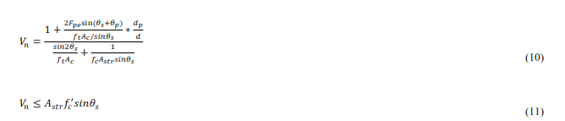

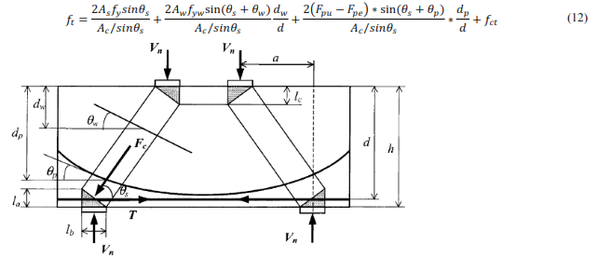

**Figure 5.** K.H. Tan et al. STM

**2.1.6Guo-Lin et al. Modified Strut and Tie Model**

Guo-Lin developed a modified strut and tie model (MSTM) for the shear strength of pre-stressed deep beams [7] as shown in figure 6. In Guo-Lin model, the effect of pre-stressing is represented by equivalent external loads build in the model. In addition, the Kupfer-Gerstle tension compression criterion is adopted to account for concrete softening effect. Guo-Lin evaluated this model against 56 test results of pre-stressed deep beams, the evaluation showed good agreement. The MSTM is given in following equations.

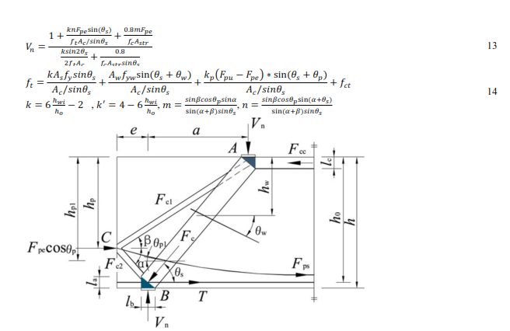

**Figure. 6**GUO-LIN et al. MSTM

**Table 1**. Properties and comparison of sixteen simply supported unbonded post-tensioned deep beams

|  |  |  |  |  |  |  |  |  |  |  |  |  |
| --- | --- | --- | --- | --- | --- | --- | --- | --- | --- | --- | --- | --- |
| **Beam Specimen** | **L** | $$L_{n}$$ | **b** | **h** | $$h_{o}$$ | $$a$$ | $$l_{b}$$ | $$f_{c}^{'}$$ | $$f_{t}$$ | $$A_{s}f_{y}$$ | $$F_{pe}$$ | $$V_{exp.}$$ |
| mm | mm | mm | mm | mm | mm | mm | Mpa | Mpa | (KN) | (KN) | (KN) |
| **G1B1** | 2800 | 2400 | 150 | 600 | 550 | 1200 | 100 | 48.4 | 4.8 | 361.8 | 86 | 336.9 |
| **G1B2** | 2500 | 2100 | 150 | 600 | 550 | 1050 | 100 | 45.9 | 4.3 | 361.8 | 86 | 371.1 |
| **G1B4** | 1900 | 1500 | 150 | 600 | 550 | 750 | 100 | 45.1 | 4.4 | 361.8 | 86 | 702.7 |
| **G2B1** | 2200 | 1800 | 150 | 500 | 450 | 900 | 100 | 44.4 | 4.3 | 306.68 | 72 | 377.6 |
| **G2B3** | 2200 | 1800 | 150 | 700 | 650 | 900 | 100 | 45.1 | 4.4 | 412.65 | 100 | 600.4 |
| **G2B4** | 2200 | 1800 | 150 | 800 | 750 | 900 | 100 | 44.3 | 4.29 | 463.5 | 115 | 581.1 |
| **G3B1** | 2200 | 1800 | 150 | 600 | 550 | 900 | 100 | 49.1 | 4.7 | 361.8 | 168 | 628.9 |
| **G3B2** | 2200 | 1800 | 150 | 600 | 550 | 900 | 100 | 46.6 | 4.6 | 361.8 | 132 | 601.9 |
| **G3B3** | 2200 | 1800 | 150 | 600 | 550 | 900 | 100 | 52.4 | 4.9 | 361.8 | 109 | 508.35 |
| **G4B2** | 2200 | 1800 | 150 | 600 | 550 | 900 | 100 | 56.6 | 5.3 | 361.8 | 86 | 492 |
| **G4B3** | 2200 | 1800 | 150 | 600 | 550 | 900 | 100 | 64.3 | 5.9 | 361.8 | 86 | 546.4 |
| **G4B4** | 2200 | 1800 | 150 | 600 | 550 | 900 | 100 | 73.3 | 6.7 | 361.8 | 86 | 593.3 |
| **G-B1(a)** | 2200 | 1800 | 150 | 600 | 550 | 900 | 100 | 43.5 | 4.2 | 361.8 | 86 | 442 |
| **G-B1(b)** | 2200 | 1800 | 150 | 600 | 550 | 900 | 100 | 46.1 | 4.3 | 361.8 | 86 | 458 |

**3.0Shear strength of tested beams**

Figure 7 shows the shear strength against different parameters relationships for the tested specimens. To make this comparison, normalization had been made by dividing ${V_{u}}/{bd\sqrt{f_{c}^{'}}}$ in the first three group.

**3.1 Effect of clear span to height ratio ($L_{n}/h$)**

The increase of clear span to height ratio ($L_{n}/h$) decreased the shear strength. The decrease of shear strength was more obviously with the increase of ($L_{n}/h$) from 2.5 to 3.0. Increase of ($L_{n}/h$) more than 3.0 the shear strength decrease with less significant.

**3.2 Effect of beam size**

For all beams (except G2B4) the shear strength increased with increase of beam size. This was regarded to for specimen G2B4 (h=800mm.), local bearing failure occurred below the loading plate (in the upper nodal zone).

**3.3 Effect of average pre-compression ($P_{e}/A$)**

Increasing the average pre-compression ($P_{e}/A$) from (1.21) to (1.46) increase the shear strength of the tested specimens significantly. Decreasing ($P_{e}/A$) less than (1.21) or increasing ($P_{e}/A$) more than (1.46) does not affect the shear strength.

**3.4 Effect of concrete strength $f_{c}^{'}$**

The beams shear strength was increased with the increase of the concrete compressive strength.

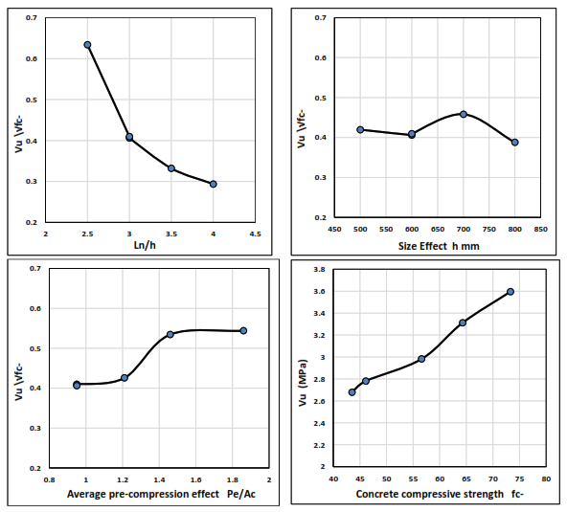

**Figure 7** shear strength of tested beams

**4. The accuracy of current shear strength equations**

In the following sections, the validity of some pre-stressed deep beams shear strength models is evaluated. These models are namely the ACI model, CEB-FIP, S. Teng et al., Tan and Mansur, K-Tan et al., and Guo-Lin et al. model. The evaluation of these models is conducted by comparing the experimental results of the current study with models predictions as shown in figure 13.

**4.1 The ACI 318.14 predictions**

The predictions of the ACI 318.14 [2] model were very conservative for all test specimens. The mean value of $\left(\frac{V_{pred.}}{V_{exp.}}\right)$ was 0.46. However, this model was mainly adopted in the ACI 318.14 [2] provisions for predicting the shear strength of ordinary deep beams, it does not account for the effect of pre-stressing. The ACI 318.14 [2] model was included in our comparison to clarify the need of ACI 318.14 [2] to develop a new model to account for the effect of pre-stressing.

**4.2 The CEB-FIP model predictions**

The CEB-FIP [10] model overestimated the shear strength of most of the test specimens. The mean value of $\left(\frac{V_{pred.}}{V_{exp.}}\right)$ was 1.22. In addition, the predictions of this model was relatively scattered, the standard deviation was 0.22. This equation can be used as an upper bound for the shear strength of prestressed deep beams. However, S.Teng et al. [8] also reported this recommendation.

**4.3 S. Teng et al. model predictions**

S. Teng et al. model [8] provided the most accrete predictions against experimental test results with closely scattered predictions. The mean value of $\left(\frac{V_{pred.}}{V_{exp.}}\right)$ was 0.94, and the standard deviation was 0.175. According to S.Teng et al. model, the concrete tensile strength $f_{t}$ is enhanced by the contribution of the effective pre-stressing force ($\frac{P_{e}sinθsinϕ}{bh}$). However, S.Teng et al. model [8] overestimatedthe shear strength of specimen G2B4. The failure of this specimen was bearing failure at the top nodal zone rather than failurein the diagonal strut. Thus, S. Teng model did not account for this failure mode.

**4.4 Tan and Mansur model predictions**

Tan and Mansur model [4] predictions were relatively conservative with closely scattered predictions. The mean value of $\left(\frac{V_{pred.}}{V_{exp.}}\right)$ was 0.735, and the standard deviation was 0.11. In Tan and Mansur model, the effect of pre-stressing was taken into account as an increased tensile capacity of the tieby a value of ($A_{ps}.f_{ps}$). The effect of pre-stressing on enhancing the softening behavior of the compression strut was not taken into account. Therefore, the predictions of Tan and Mansur model for the shear strength of specimens having relatively high pre compression ($P_{e}/A$) ratio (G3B1, G3B2) was very conservative.

**4.5 K. Tan et al. model predictions**

K. Tan et al. model [13] overestimated the shear strength of most of the tested specimens with closely scattered predictions. The mean value of $\left(\frac{V_{pred.}}{V_{exp.}}\right)$ was 1.32, and the standard deviation was 0.21. However, K. Tan et al. [13] verified their model against several types of pre-stressed deep beams; the verification indicated their model to overestimate the shear capacity of beams without web reinforcement.

K. Tan et al. model is based on the stability of the bottom nodal zone, which is subjected to either biaxial tension-compression stress state, or biaxial compression-compression stress state. For the case of biaxial tension –compression stress state, the concrete compressive strength is reduced due to the softening effect of the tensile stress. Therefore, K. Tan et al. proposed a linear interaction between the concrete tensile and compressive stresses based on the Mohr-Coulomb theory [14] as follows:



Where f1 and f2 are the principal tensile and compressive stresses at the nodal zone, respectively.

**4.6 Guo. Lin et al. MSTM predictions**

Guo. Lin et al. model [7] (MSTM) overestimated the shear strength of the tested specimens with widely scattered predictions. The mean value of $\left(\frac{V_{pred.}}{V_{exp.}}\right)$ was 1.80, and the standard deviation was 0.29. The fact that Guo. Lin et al. model overestimated the shear strength of the current study specimens can be regarded to the following:

* Guo. Lin et al. utilizes main and secondary struts carrying compressive forces. But, no sufficient confinement for these struts was present in the tested specimens. Therefore, this approach may be misleading especially when web reinforcement is absent.
* Guo. Lin et al. adopted Kupfer and Gerstle approach [15] for the linear interaction between the tensile and compressive stresses at the bottom nodal zone. In their approach $\frac{f_{1}}{f_{t}}+λ\frac{f_{2}}{f_{c}^{'}}=1$, where λ=0.8. However, using λ=0.8 led to higher values of Vn. Therefore, the authors suggests using λ=1 for more realistic predictions especially when no web reinforcement was present. This recommendation was also suggested by [15].

**5.0 Conclusions**

1. Decreasing the clear span to height ratio ($L_{n}/h$) from 4.0 to 2.5 increased the beams ultimate shear strength. The ultimate shear strength increased with the increase of the beam size from 500 mm. to 800 mm. Increasing the average pre-compression ($P_{e}/A$) from (1.21) to (1.46) increase the shear strength of the tested specimens significantly. There no significant effect beyond these limits. The increase of the concrete compressive strength beam was increased shear strength.
2. The predictions of the ACI model were very conservative for all test specimens, Tan and Mansur model predictions was relatively conservative, and the CEB-FIB model overestimated the shear strength of most of the test specimens.

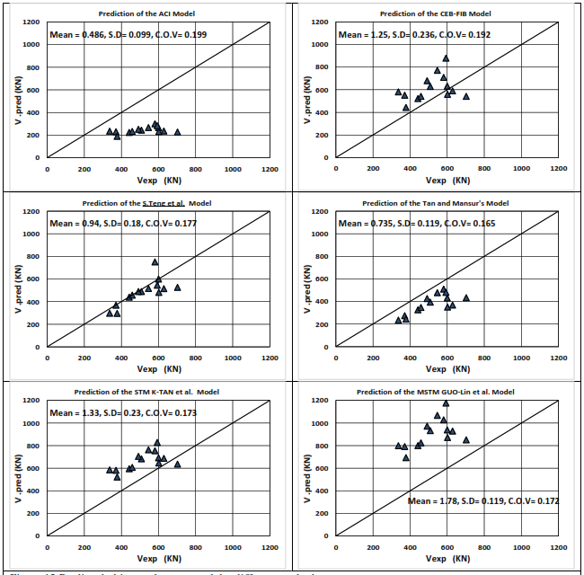

**Figure 12** Predicted ultimate shear strength by different methods

1. K. Tan et al. model (STM), Guo-Lin et al. model (MSTM), and the CEB-FIB model overestimated the shear strength most of the test specimens.
2. S. teng et al. model predictions were in good agreement and accurate with test results.

**Notations**

$a$ Shear span of deep beam

$A$ Area of typical bar crossing the diagonalshear crack

$A_{s}.A_{ps}$ Areas of unstressed and prestressed steel, respectively

$b.d.h$ Width, overall depth and height ofdeep beam, respectively

$f_{c}^{'}$ Concrete cylinder strength

$f_{cu}$ Concrete cube strength

$f_{ps}$ Stress in prestressing steel when the beamfails

$f_{pe}$ effective Stress in pre-stressing steel

$f_{py}$ yield Strength of 7 wire strand

$f_{t}$ Tensile splitting strength of concrete

${(l}_{o-}L_{n}).x_{e}$ Clear span and clear shear span, respectively

$M_{u}.V_{U}$ Ultimate moment and shear force at thecritical section

$S_{v}.S_{h}$ Spacing of vertical and horizontal webreinforcements

$y.α$ Depth and angle of intersection between steel bar and the diagonal crack

$W_{1}.W_{2}$ Widths of bearing plates at reaction andloading points

$β$ Slope of draped tendon crossing a diagonalcrack

$ρ$ Percentage of main steel, $A_{s}$/bd

$A_{h}$ Area of horizontal web reinforcement

$A_{v}$ Area of vertical web reinforcement

$ρ_{h}.ρ_{v}$ Total horizontal and vertical steel ratios, respectively

$f_{y}$ Yield strength of web reinforcement orunstressed steel

$f_{yh}.f_{yv}$ Yield stresses of horizontal and verticalreinforcements

$ϕ$ reduction factor for shear, material resistance factor or slope of a diagonal crack

$V_{u}.V_{n}$ nominal shear strength

$V_{pred.}.V_{exp.}$ calculated nominal shear strength, measured ultimate shear strength, respectively

**References:**

1. KONG F. K. (Ed.). Reinforced Concrete Deep Beams. Blackie and Son, London, 1990.
2. AMERICAN CONCRETE INSTITUTE COMMITTEE 318.14 Building Code Requirements for Structural Concrete. ACI, Detroit, 2014.
3. ALSHEGEIR A. and RAMIREZ J. A. Strut-tie approach in pre-tensioned deep beams. ACI Structural Journal, 1992, 89, 296–304.
4. TAN K. H. and MANSUR M. A. Partial pre-stressing in concrete corbels and deep beams. ACI Structural Journal, 1992, 89, 251–262.
5. K. H. Tan and K. Tong, Shear behavior and analysis of partially prestressed I-girders. The Structural Engineer Volume, December 1999,77, pp.28-34.
6. Tan K. H., and Lu, H. Y., Size Effect in Large Prestressed Concrete Deep Beams, ACI Structural Journal, Nov-Dec. 1999, V. 96, No. 6, pp. 937-947.
7. Guo-Lin Wang, Shao-Ping Meng. Modified strut-and-tie model for prestressed concrete deep beams. Engineering Structures, 2008, 30, 3489-3496.
8. TENG S., KONG F. K. and POH S. P. Shear strength of reinforced and prestressed concrete deep beams. Part II: the supporting evidence. Structures and Buildings, 1998, 128, No. 2, 124–143.
9. Stephan J. Foster and R. lan Gillbert, Experimental studies on high strength concrete deep beams, ACI STRUCTRAL JOURNAL, Vol.95, No.4, 1998. Pp.382-390.
10. COMITE´ EURO-INTERNATIONAL DU BE´ TON/FE´ DE´RATION INTERNATIONALE DE LA PRE´CONTRAINTE. CEB-FIP Model Code 2010. Cement and Concrete Association, London.
11. CONSTRUCTION INDUSTRY RESEARCH AND INFORMATION ASSOCIATION. The Design of Deep Beams in Reinforced Concrete. Ove Arup and Partners, CIRIA, London, 1977 (reprinted 1984), CIRIA Guide 2.
12. TENG S., KONG F. K. and POH S. P. Shear strength of reinforced and prestressed concrete deep beams. Part 1: current design methods and a proposed equation. Structures and Buildings, 1998, 128, No. 2, 112–123.
13. Tan KH, Tong K, Tang CY. Direct strut-and-tie model for prestressed deep beams. ASCE J Struct. Eng. 2001; 127(9):1076_84.
14. Cook, R. D., and Young, W. C. (1985). Advanced mechanics of materials, Macmillan, New York.
15. Kupfer H, Gerstle KH. Behavior of concrete under biaxial stress. Proc ASCE J Eng Mech Div 1973; 1999(EM4):853_66.

3/13/2018