Effect of Pre-Compression on Unbonded Fully and Partially Post-Tensioned Concrete Beams under Cyclic Loading.

A. El-Thakeb¹, H. El-Esnawi², A. Hafiz³, M. A. Asran ⁴

¹Prof. Civil Engineering Dept., Faculty of Engineering, Al-Azhar University, Cairo, Egypt
²Ass. Prof. Civil Engineering Dept., Faculty of Engineering, Al-Azhar University, Cairo, Egypt
³Lecturer Civil Engineering Dept., Faculty of Engineering, Al-Azhar University, Cairo, Egypt
⁴ Lecturer Assistant, Civil Engineering Dept., Higher Technological Institute 10th of Ramadan City, Egypt
eng.m_asran@hotmail.com

Abstract: A total of four pre-stressed beams, three of them are partial pre-stressed concrete beams and one fully pre-stressed beam are tested under cyclic vertical displacement to investigate the dynamic behaviors of partial and fully pre-stressed concrete beams. In the design of pre-stressed concrete beams it is necessary to estimate their deflections under service loads in order to satisfy the requirements of serviceability limit state. The moment of inertia of cracked section as well as Branson’s effective moment of inertia can be easily determined. The computed deflections are compared with experimental results, including beams with variable PPR ratio to evaluate the accuracy of the equation for cracked moment of inertia, which was suggested precast/pre-stressed concrete institute (PCI) Design Handbook. [ 9] for pre-stressed concrete beams, is also evaluated in the study. The results of this study indicate that the PCI equation can give satisfactory results compared with experimental results.
[A. El-Thakeb, H. El-Esnawi, A. Hafiz, M. A. Asran. Effect of Pre-Compression on Unbonded Fully and Partially Post-Tensioned Concrete Beams under Cyclic Loading.. N Y Sci J 2018;11(3):39-45]. ISSN 1554-0200 (print); ISSN 2375-723X (online). http://www.sciencepub.net/newyork. 6. doi:10.7537/marsnys110318.06.

Key words: pre-stressed beams, cyclic loading, Inertia, effective moment

1. Introduction.
Deflection analysis of pre-stressed beams is more complex, as the tendon stress that is assumed constant at all sections must be determined from the deformation of the entire structure. Naaman and Alkhairi [ 8 ] proposed a method for analysis of pre-stressed members under service load using the bond reduction coefficient, which essentially converted the UPC beams to the equivalent cases with bonded tendons, so that the previous analytical solutions for beams with bonded tendons could be used. The computation of bond reduction coefficients Ω before cracking from basic principles of mechanics is simple. However, the computation of ‘‘exact” bond reduction coefficient Ω_{cr} at the cracked state for different types of loading and tendon profiles is extremely difficult [6 ].
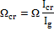 | (1)
Where Ω_{cr,} Ω are the bond reduction coefficient at cracked and uncracked state respectively, I_{cr,} I_{g} are the cracked and uncracked moment of inertia respectively.
There are two methods [10] to determine the short-term deflections of partially pre-stressed concrete (PPC) beams, namely bilinear computation method and that using Branson’s effective moment of inertia I_{e}. In the bilinear computation method, the deflection before cracking is computed using the gross moment of inertia I_{g}, while the additional deflection after cracking is calculated using the cracked section moment of inertia I_{cr}. The method using Branson’s effective moment of inertia I_{e} was first applied to PPC members by Shaikh and Branson [11] in 1970. Since then, improvements have been made to the equation for I_{e} by different researchers. They mainly focus on: (a) the level of applied moment M at which the expression of I_{e} should be used; (b) the reference load or state of member deformation from which cracking moment M_{cr} is measured; and (c) the section axis about which I_{cr} is calculated. Rao and Dilger [10] compared four such methods based on I_{e} for their accuracy in deflection prediction, and recommended the simplified method by Shaikh and Branson [11] that gave an accurate but slightly conservative prediction. Tadros et al. [12] proposed a more rigorous and accurate method for deflection prediction by integration of curvatures at key sections along the span using the method of I_{e}. Scholz [6] suggested a simple method using the span-to-effective depth limits for the first-level deflection assessment of PPC members. Chern et al. [5] put forward a numerical method to evaluate the deformation of progressively cracking PPC beams. They concluded that consideration of tensile strain softening in concrete improved the predictions compared to classical theory that ignored the tensile resistance of concrete. However, the effect is not large and it mainly affects the initial post-cracking stage.
2. Estimatated equation of I_{cr} by Enoch K. H. Chan [4].
Au et al. [1] extended the capability of Pannell’s coefficient λ, which was the ratio of length of equivalent deformation region L_{e} to the neutral axis depth C at critical section, to the cracked section analysis of partially pre-stressed concrete members under service load. They found that, under service load after cracking of the beam and until the yielding of non-pre-stressed steel, λ was insensitive to the variation of the combined reinforcement index. The cubic equation established by Au et al. [1] for the neutral axis C of a cracked T-section shown in Fig. 1.

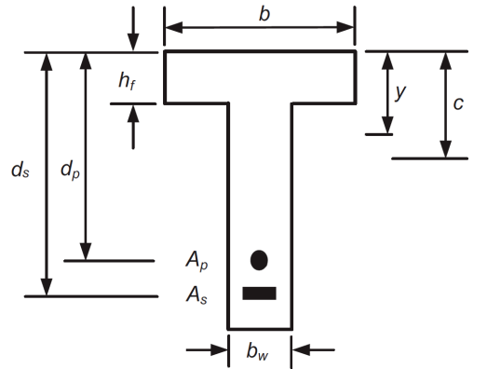
Fig. (1). Typical section

(2)
Where the constant coefficients g are given as.

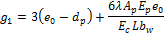 | (2a)
 | (2b)
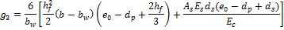 | (2c)

The centroid of the cracked section below the top fiber y given by.

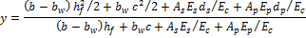 | (3)

Finally the cracked moment of inertia I_{cr} is given by:

(4)

where A_{p} and A_{s} are the cross sectional areas of pre-stressing and non-pre-stressed steel respectively; b and b_{w} are the widths of flange and web respectively; d_{p} and d_{s} are the depths to centroids of pre-stressing and non-pre-stressed steel respectively; E_{c} is the modulus of elasticity of concrete; E_{p} and E_{s} are the modulus of elasticity of pre-stressing and non-pre-stressed steel respectively; h_{f} is the thickness of flange; L is the distance between end anchorages; F is the decompression; e₀ is the distance between decompression F and resultant force R, which is obtained as e₀ = M/R from the total applied moment M.

3. PCI Design Handbook’s equation:
In computing I_{cr}, the PCI Design Handbook [9] has proposed a simplified equation for bonded partially pre-stressed concrete beams as.
(9)

where ρ_{p} = A_{p}/bd_{p} and ρ_{s}=A_{s}/bd_{s} are the ratios of pre-stressed and non-pre-stressed steel respectively. A_{p} and A_{s} are the cross sectional areas of pre-stressing and non-pre-stressed steel respectively, d_{p} and d_{s} are the depths to centroids of pre-stressing and non-pre-stressed steel respectively, the modular ratios for non-pre-stressed steel and pre-stressing steel is defined as n_{s}=E_{s}/E_{c} and n_{p}= E_{p}/E_{c} respectively, E_{c} is the modulus of elasticity of concrete; E_{p} and E_{s} are the modulus of elasticity of pre-stressing and non-pre-stressed steel respectively.

4. Chinese code equation:
In computing I_{e} for cross sections without tension flanges, the Chinese Code [27] recommends the following equation for UPPC beams.

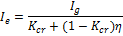 | (10)
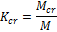 | (10a)
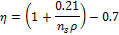 | (10b)
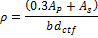 | (10c)

Chinese code equation only applies to UPPC beams with conventional steel tendons,

5. Effective moment of inertia developed by Branson.
Experimental investigations show that when a UPPC beam is loaded, the load–deflection curve normally exhibits three stages, namely (1) elastic, (2) cracked-elastic and (3) plastic as shown in Fig. 2. The transition from the first to the second stage is caused by the development of cracks at the bottom of the beam, while the transition from the second to the third stage is caused by yielding of the non-pre-stressed steel. The deflection of a UPPC beam depends on whether the section is cracked or uncracked. When the section is uncracked, the gross moment of inertia Ig can be used for deflection calculation. When cracking occurs in a UPPC member, theoretically, the cracked moment of inertia I_{cr} should be used for the sections at which cracks develop while the gross moment of inertia should be used for the sections between cracks. However such refinement is impractical and unwarranted for the accuracy of deflection evaluation, not to mention the random nature of cracking. The actual stiffness of the beam lies between E_{c}I_{g} and E_{c}I_{cr}, depending on the extent of cracking, distribution of loading, and contribution of concrete between the cracks to tension. Generally, as the load approaches the yield load level of non-pre-stressed steel, the stiffness value approaches E_{c}I_{cr}. Consequently, the effective moment of inertia I_{e} developed by Branson [9] applied as an average value along the span of a simply supported beam.

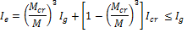 | (11)

Where M_{cr} and M are the cracking and total applied moment at the beam critical section, respectively. I_{g} and I_{cr} are the gross and cracking moment of inertia of beam section, respectively.
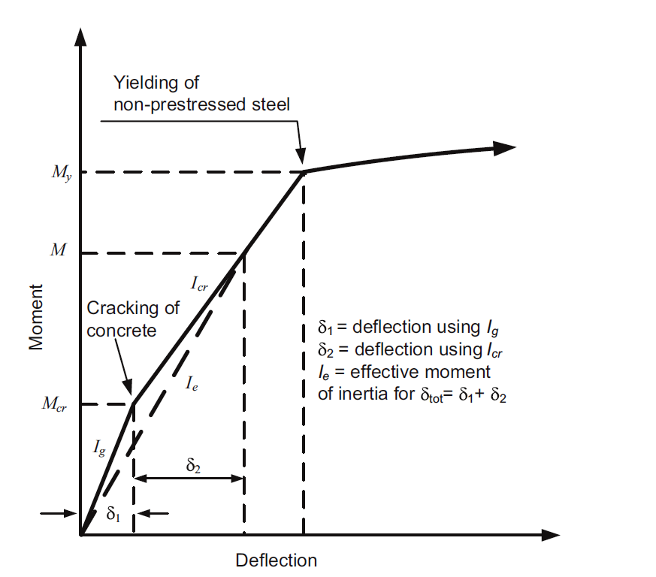
Fig. (2). Typical moment –deflection curve for pre-stressed beams.

6. Experimental Program
6.1. Description of specimens
A total of four half scale post-tensioned simple beams were tested under cyclic load up to failure. The main parameter among the tested specimens is the pre-compression value or other definition is the partially pre-stressed ratio (PPR).
6.2. Specimen’s fabrication and pre-stressing process
The pre-stressing force was applied at 75% of the ultimate strength of the strands. One mono barrel anchor was installed at one end of the beams since all beams had one live end and deed end. A hydraulic jack that was calibrated was used in the pre-stressing process. The stressing forces were transferred from the hydraulic jack to the strands along four equal stages ranging from 25% to 100% of the required force. The force in the strands was measured using the elongation of the strands was measured at every stressing stage. Pre-stressing presses was done immediately before testing to avoid occurrence of long term losses. Fig (5) shows the pre-stressing process.
6.3. Instrumentation
Two Linear Variable Distance Transducers (LVDTs) with 0.01 mm accuracy were used to measure the mid-span deflections of all beams. The electrical resistance strain gauges, which were attached to steel bars and concrete, were connected to a data acquisition system to record the data. Finally, the data were collected using a data acquisition system and ‘‘lab view’’ software at a rate of 2 sample per seconds.
6.4. Test setup and loading procedure
Fig. (6) Shows the details of the test set-up. It should be noted that the test arrangement was symmetrical about the mid-span section of all beams. Each beam was loaded in two loading points bending. The beams were subjected to a uni-directional cyclic loading up to failure, using a hydraulic actuator of 250 kN capacity. The load was applied on the beams using a stroke displacement control system, which divided the machine load that was applied through a steel spreader beam 1.5 m in length, as shown in the figure. The cyclic loading was achieved by increasing the stroke with 2 mm increments each two cycles until failure. as shown in fig (6).

7. Test results and discussion
7.1 Crack pattern and failure mode
Table (3) Summarize the details of the test process of all the tested beams. On the other hand, Fig. (7) Shows the total load versus the mid span deflection of all the tested beams.
7.3. Evaluation of Chinese code and Chan equations under cyclic load.
As Eq. (8) and (10) only applies to UPPC beams with conventional steel and unbonded tendons and tested under static loading, those specimens in the experimental program with steel bonded tendons and tested under cyclic loading are re-analysed by Eq. (8) and (10) taken from the Chinese Code and Chan equation for comparison. Results for all specimens in the experimental program are shown in Fig. (8). the estimated deflections calculated by Chinese Code and Chan are not only on the unsafe side, but also less accurate than the proposed method using Eq. (12). However, for specimens B3-25-PP-0.73 and B4-25-PP-0.62 the deflections computed by the Chinese Code and Chan equation are more accurate. The proposed method is more accurate than the Chinese Code, while for specimen B3-25-PP-0.73, predictions of the proposed method and the Chinese Code are almost identical.

Table (1). Details of tested specimens
Details specimens | Beam specimens
 | B1-25-FP-1 | B2-25-PP-0.87 | B3-25-PP-0.73 | B4-25-PP-0.62
Top RFT | 2Ф10 | 2Ф10 | 2Ф10 | 2Ф10
Bottom RFT | ------- | 2Ф8 | 2Ф10 | 2Ф12
Shear RFT | 10Ф10/m | 10Ф10/m | 10Ф10/m | 10Ф10/m
PT strand | 0.6” | 0.6” | 0.6” | 0.6”
PPR ratio | 1 | 0.87 | 0.73 | 0.62

Table (2). Mechanical properties of concrete.
Mechanical properties | Beam specimens
 | B1-25-FP-1 | B2-25-PP-0.87 | B3-25-PP-0.73 | B4-25-PP-0.62
F’_{c} (mPa) | 31.17 | 31.17 | 31.17 | 31.17
F_{t} (mPa) | 2.9 | 2.9 | 2.9 | 2.9
* Where (B1, B2, B3----) is the beams code is given as the beam number.
* The value (25) refers to concrete compressive strength.
* FP or PP refers to fully or partially pre-stressed respectively.
* The value (1, 0.87, 0.73, and 0.62) refers to (PPR).

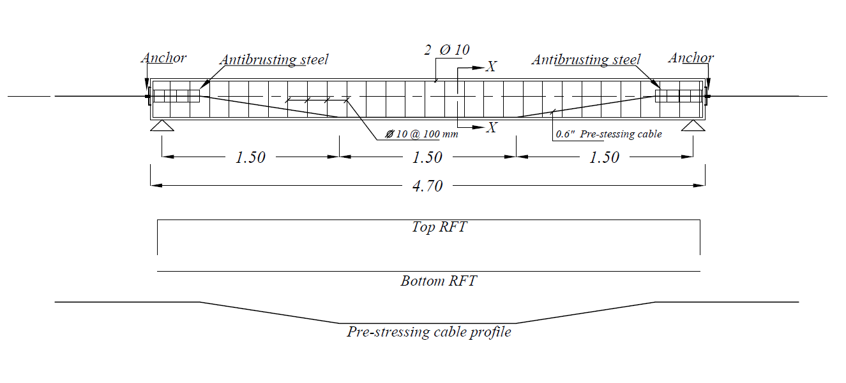
Fig. (3) Reinforcement details of specimen’s

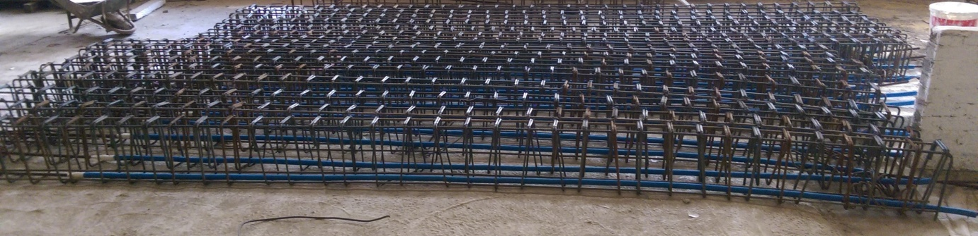
Fig (4) Reinforcement cages
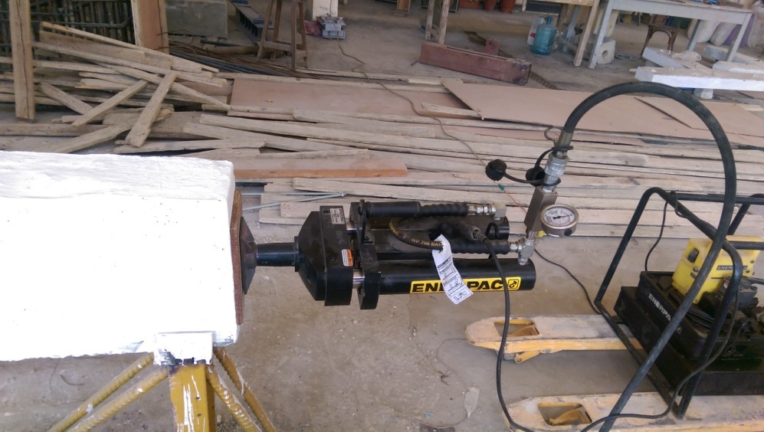
Fig (5) Pre-stressing process.

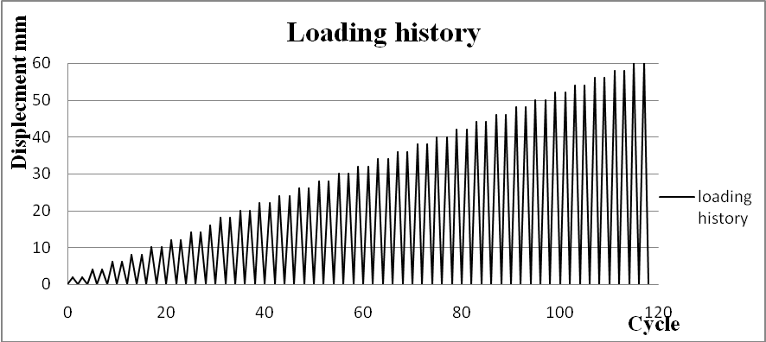
Fig (6) Loading history

Table (3) Summarize the details of the test process of all the tested beams
Parameters | Beam specimens
 | B1-25-FP-1 | B2-25-PP-0.87 | B3-25-PP-0.73 | B4-25-PP-0.62
Cracking load Pcr (kN) | 37.08 | 29.3 | 26.5 | 17.2
Yielding load Py (kN) | ----- | 92.7 | 72.1 | 39.94
Max. load Pmax (kN) | 107.8 | 111.83 | 95.9 | 64.5
Ultimate load Pu (kN) | 86.24 | 89.46 | 68.72 | 51.6
Ult. deflectionΔ (mm) | 54.12 | 68.8 | 61.6 | 47.96
Failure cycle | 70 | 86 | 93 | 74
Failure patterns | Many parallel vertical cracks at pure bending especially at the mid-span of the beams where the moments are large. A few inclined cracks could be observed at flexure-shear sections and Concrete crushed and spalled off at pure bending sections and loading points with cutting of steel bars at tension side and buckling of longitudinal steel bars at compression side.
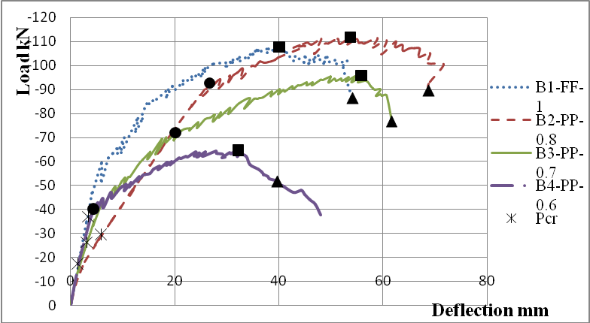
Fig. (7) Total load versus the mid span deflection of all the tested beams.

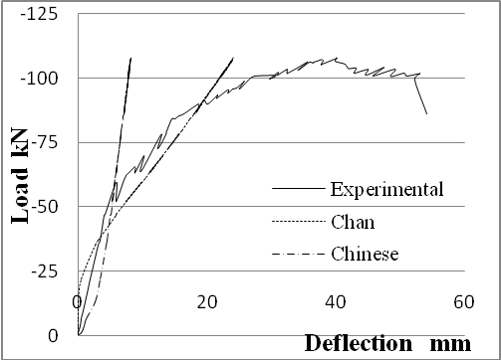 | 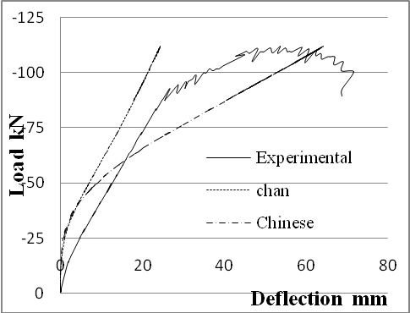
B1-25-FP-1 | B2-25-PP-0.87
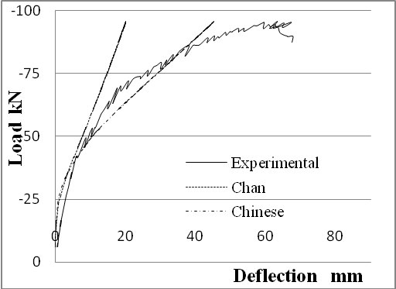 | 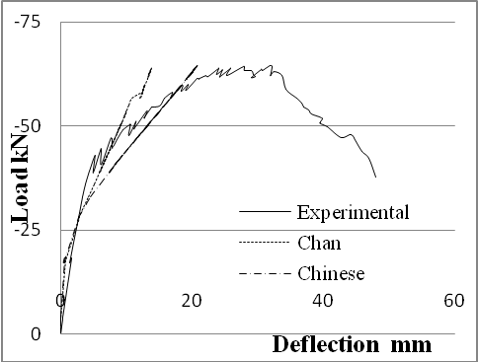
B3-25-PP-0.73 | B4-25-PP-0.62
Fig. (8) Comparison of experimental results with Chinese code and Chan equations.

8. Conclusions.
Estimate the short term deflections in pre-stressed concrete beams tested under uni-directional cyclic loading by converting the cross sectional area of pre-stressing tendons and pre-stressing force to the equivalent cross sectional area of non-pre-stressed steel. Then the moment of inertia of cracked section as well as Branson’s effective moment of inertia in a pre-stressed beam can be determined. equation for moment of inertia of cracked section, which was originally suggested by the Chinese code, PCI Design Handbook’s and Chan for bonded partially pre-stressed concrete beams, is also evaluated in the study. It is found that the Chinese Code and Chan equation in two specimens in the test program are more accurate, while for specimen B3-25-PP-0.73, predictions of the proposed method and the Chinese Code are almost identical. Compared with the method recommended by the PCI Design Handbook’s, the proposed method is more accurate in most of the cases examined. However, PCI equation can also give satisfactory results but in some cases its less accurate than the proposed method.

References
- Au FTK, Du JS, Cheung YK. Service load analysis of unbonded partially prestressed concrete members. Mag Concr Res 2005;57(4):199–209.
- Au FTK, Du JS. Partially prestressed concrete. Prog Struct Eng Mater 2004;6(2):127–35.
- Branson DE, Trost H. Unified procedures for predicting the deflection and centroidal axis location of partially cracked non-prestressed and prestressed concrete members. ACI J 1982;79(2):119–30.
- Chan EKH. Experimental and numerical studies of concrete beams prestressed with unbonded tendons. Master of Philosophy Thesis. The University of Hong Kong; 2008.
- Chern JC, You CM, Bazant ZP. Deformation of progressively cracking partially prestressed concrete beams. PCI J 1992;37(1):74–85.
- GB50010-2010. Code for design of concrete structures. Beijing: China Architecture and Building Press; 2010 [in Chinese].
- Harajli MH, Kanj MY. Service load behavior of concrete members prestressed with unbonded tendons. J Struct Eng, ASCE 1992;118(9):2569–89.
- Naaman AE, Alkhairi FM. Stress at ultimate in unbonded post-tensioned tendons: Part 2 – proposed methodology. ACI Struct J 1991;88(6):683–92.
- PCI Design Handbook. Precast and prestressed concrete. 6th ed. Chicago: recast/Prestressed Concrete Institute; 2004.
- Rao SVKM, Dilger WH. Evaluation of short-term deflections of partially prestressed concrete members. ACI Struct J 1992;89(1):71–8.
- Shaikh AF, Branson DE. Nontensioned steel in prestressed concrete beams. PCIJ 1970;15(1):14–36.
- Tadros MK, Ghali A, Meyer AW. Prestress loss and deflection of precast concrete members. PCI J 1985;30(1):114–41.

3/13/2018

