Assessment of Hand Grip Strength Using Modified Sphygmomanometer versus Dynamometer In Stroke Patients

Nawal Abd El-Raouf Abou-Shady¹, PhD, Tamer H. Emara², PhD, Ibrahim M. I. Hamoda³, PhD, Nada M. Waziry¹, B.SC

¹Department of Neuromuscular disorders and its surgery, Faculty of Physical Therapy, Cairo University, Egypt.
²Department of Neurology, Faculty of Medicine, Ain Shams University, Egypt.
³Department of Neuromuscular disorders and its surgery, Faculty of Physical Therapy, Kafr Elsheikh University, Egypt.
Email: nadawaziry91@gmail.com

Abstract: Background: Grip strength is an important indicator of an individual’s hand function and is tested in different hand and wrist disorders and even in other conditions that grossly affect the strength of the muscles. One of the pathologies that greatly affects grip strength is stroke. Stroke is a sudden loss of neurologic functions caused by an interruption of the blood flow to the brain. It is the leading cause of disability with residual neurologic deficits that persistently impair functions. Different tools in grip strength testing can be used such as hand dynamometers and alternatively, a modified sphygmomanometer. Objective This study was to compare the validity of modified sphygmomanometer with hand dynamometer in grip strength measurement among post- stroke patients. Methodology Thirty individuals with post- stroke in sub-acute phase of both genders, aged 45 to 60 were included in the study. Pearson correlation coefficient test was used to analyze the data. Results revealed that both hand-held dynamometer and modified sphygmomanometer have a positive moderate significant correlation between mean values of measuring hand grip strength of post- stroke (P=0.001). Conclusion Either of the two instruments can be used to assess the baseline and post-treatment measure for hand grip in post stroke. However, the results can be interpolated for The Modified Sphygmomanometer Test (MST) also provides objective and adequate measures at low-cost.
[Nawal Abd El-Raouf Abou-Shady, Tamer H. Emara, Ibrahim M. I. Hamoda, Nada M. Waziry. Assessment of Hand Grip Strength Using Modified Sphygmomanometer versus Dynamometer In Stroke Patients. N Y Sci J 2018;11(3):20-25]. ISSN 1554-0200 (print); ISSN 2375-723X (online). http://www.sciencepub.net/newyork. 3. doi:10.7537/marsnys110318.03.

Keywords: assessment; physical therapy; stroke; muscle strength; hand grip strength; hand function.

Introduction
Hand is an essential organ used in activity of daily living (ADL) and grip strength plays an important role in prevention of injury and rehabilitation as it becomes a routine part of clinical evaluation and assessment (1).
Grip strength is one of the components that have been tested while evaluating hand function. It also provides an objective index of the functional integrity of the upper extremity. Measurement of grip strength is also an important component of hand rehabilitation as it is a measure of the effectiveness of therapy (2). Handgrip strength is an objective measure of muscular function in the upper extremity and has been used as a marker of frailty in older adults (3).
Adequate functioning of the upper limbs (UL) is required for the performance of most activities of daily living (ADL). UL impairments may affect the performance of meaningful tasks, such as reaching and grasping (4,5). Despite the non-linear relationships between muscle strength and function throughout the recovery process following a stroke (6).

Subject selection
Thirty stroke patients in this study. They were selected from the outpatient's Clinic of Neurology, Faculty of Physical Therapy, Cairo University, Kasr Al Aini hospital, stroke unit. Their age was ranged from 45 to 60 years from both sexes.
Patients who were participated in this study were assessed their affected hand grip strength and non-affected hand grip strength with dynamometer and modified sphygmomanometer.
Design of the study:
One factorial one shot design study was used. A single trained investigator was evaluated all patients and collected all data to eliminate inter-investigator errors.
Assessment instrumentations:
Modified ash worth scale (MAS):
This scale is one of the methods that have been proposed for measuring muscle tone. It involves manually moving a limb through the range of motion to passively stretch specific muscle groups. Ashworth has described a five-point ordinal scale for grading the resistance encountered during such passive muscle stretching.
Medical Research Council Scale:
The Medical Research Council (MRC) of Great Britain system is the best known and most commonly used muscle strength grading system for manual muscle testing (MMT) worldwide. MRC was used to assess the motor power of intrinsic muscles of the hand for both groups. Each item was recorded on a scale from zero to five, the patient was asked to repeat each task three times and the highest score was taken. The patient was encouraged without any feedback about his performance.
Modified Sphygmomanometer:
The modified sphygmomanometer test (MST) is another method that can be applied in clinical settings for the assessment of muscle strength. The MST is applied using a simple adaptation of very common, portable, low-cost equipment; the conventional sphygmomanometer, which is commonly used by health professionals for the assessment of blood pressure (7, 8).
Hand Grip Dynamometer
The gold standard for the evaluation of isometric strength is the portable dynamometer (9), which provides objective strength values and has good sensitivity (10). However, the clinical applicability of the dynamometer is limited for most professionals, especially in developing countries, where stroke is a burden on the public health system (11).
Procedures
The Portable Dynamometers and Sphygmomanometers, purchased factory-calibrated for the completion of this study, were used as per the manufacturers’ instructions. After the adaptation of the sphygmomanometer to the bag method and before using it for data collection, the recommended calibration procedures were performed (9).
The patients underwent hand grip strength measurement using the modified sphygmomanometer and hand-held dynamometer by a singly examiner carried out the tests. They were instructed to sit in a straight-backed chair with shoulders adducted in neutral, arms unsupported and elbows flexed at 90°and forearm in neutral and wrist 0-30° dorsiflexed and 0-15° ulnarly deviated. The instruments were set to zero before each test and placed on the patient’s hand. The patients were asked to grasp (palmar closure) the hand-held dynamometer and/or modified sphygmomanometer with a maximal force upon the instruction of the examiner (12). The test was repeated three times for the right hand with a 60-second interval between each procedure. The mean value was used in the analysis of data (13) (Fig. 1,2).

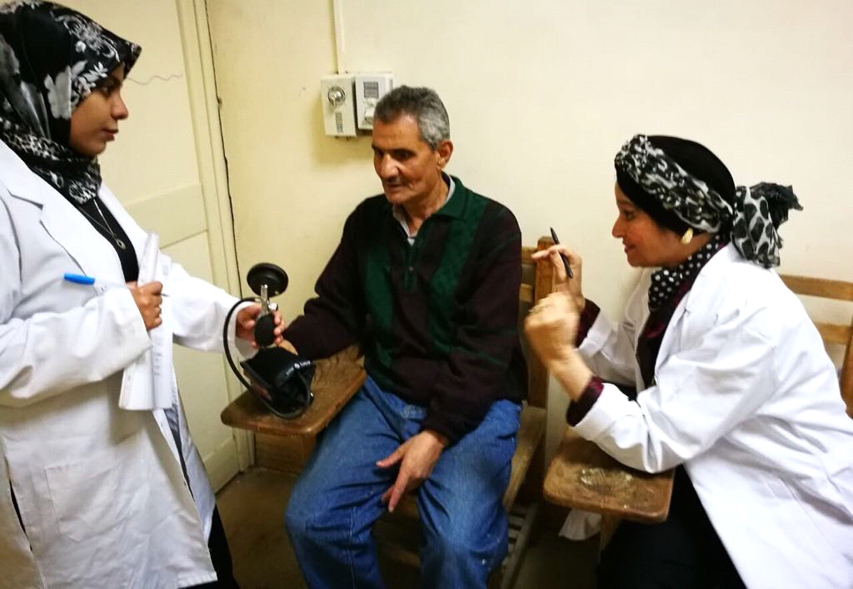
Assessment of handgrip strength with the Modified Sphygmomanometer Test for both sides

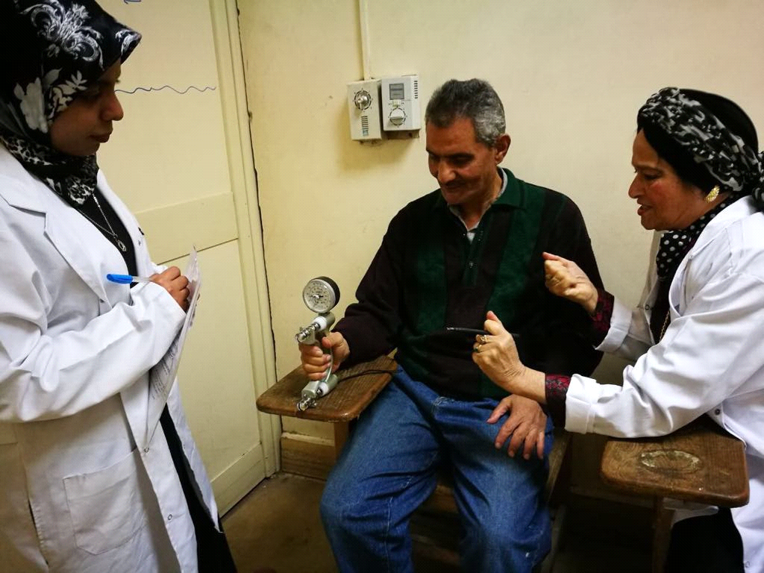
JAMAR hand Grip dynamometer used to measure hand grip strength for both sides

3. Results
The main purpose of this study was to compare the difference between Modified Sphygmomanometer and Dynamometer in assessing hand grip strength in stroke patients........
Statistical analysis was conducted using SPSS for windows, version 22 (SPSS, Inc., Chicago, IL). "paired t test" was used to compare between “affected side” and “non affected side” for handgrip strength measured with dynamometer as well as for handgrip strength measured by Sphygmomanometer, The Pearson correlation coefficient was calculated to determine whether the handgrip strength values obtained by using the Sphygmomanometer was valid with and those obtained by handgrip dynamometer. The alpha level was set at 0.05.
General characteristics of the patients in the study
The mean values of age, gender, weight, height and duration of illness were 53.9± 5.14 years, 77.9±6.56 kg, 172.83±5.66 cm and 14.43±6.77 months respectively.

Table (1): General characteristics of the patients in the study
Variables | Mean±SD
Age (months) | 53.9±5.14
Height (cm) | 77.9±6.56
Weight (kg) | 172.83±5.66
Duration of illness (months) | 14.43±6.77

Correlation between mean values of handgrip strength measured by Dynamometer and Sphygmoma-nometer at the affected side:
Pearson correlation coefficient (r) between mean values of handgrip strength measured by Dynamometer and handgrip strength measured by Sphygmomanometer was 0.582. The results indicated that there was a positive moderate significant correlation between mean values of handgrip strength measured by Dynamometer and handgrip strength measured by Sphygmo-manometer (P=0.001). This means that the Sphygmomanometer was valid to measure handgrip strength as handgrip dynamometer (table 2 and fig. 3).

Table (2): Correlation between mean values of handgrip strength measured by Dynamometer and Sphygmomanometer at the affected side.
Handgrip strength | Dynamometer | Sphygmomanometer
Mean±SD | 27±18.22 | 73.33±28.83
r | 0.582
p-value | 0.001*
r: Pearson correlation, *Significant: P <0.05

Correlation between mean values of handgrip strength measured by dynamometer and Sphygmomanometer in the affected si
Correlation between mean values of handgrip strength measured by Dynamometer and Sphygmomanometer at the non- affected side:
Pearson correlation coefficient (r) between mean values of handgrip strength measured by Dynamometer and handgrip strength measured by Sphygmomanometer was 0.595 kg The results indicated that there was a positive moderate significant correlation between mean value of handgrip strength measured by Dynamometer and handgrip strength measured by Sphygmomanometer (P=0.001). This means that the Sphygmomanometer was valid to measure handgrip strength as handgrip dynamometer (table 3 and Figure 4).

Table (3): Correlation between mean values of handgrip strength measured by Dynamometer and Sphygmomanometer at the non- affected side.
Handgrip strength | Dynamometer | Sphygmomanometer
Mean±SD | 42±18.87 | 106.83±30.91
r | 0.595
p-value | 0.001*
r: Pearson correlation, *Significant: P <0.05

Correlation between mean values of handgrip strength measured by dynamometer and Sphygmomanometer of the non-affected side.
Results of Ratio Handgrip strength with Dynamometer of both sides:-
The statistical analysis of the mean differences of handgrip strength in the (affected side) and (non-affected side) that measured by dynamometer were discussed as the following: The mean value of handgrip strength with dynamometer in the (affected side) was 27± 18.22 kg while the mean value of handgrip strength for the (non-affected side) was 42±18.87. "Paired t test" revealed that there were statistical reduction of the handgrip strength at affected side in comparing to non-affected side (t= -11.424, P= 0.0001) and the ratio between affected and non-affected side was 0.64 as shown in (Table 4, Figure. 5).

Table (4): Comparison between mean values of hand grip strength ratio of both affected and non affected sides with Dynamometer.
 | Handgrip Strength by Dynamometer
 | Affected side | Non-Affected side
 | 27 | 42
±SD | ±18.22 | ±18.87
MD | -15
Ratio (Affected/non-affected) | 0.64
T-value | -11.424
P-value | 0.0001
Level of significance | S
= Mean, ± SD= Standard deviation, MD =Mean difference, P-Value=Probability level,

Comparison between mean values of handgrip strength ratio of affected and non-affected sides with Dynamometer
Results of Handgrip strength with Sphygmomanometer for both sides:-
The statistical analysis of the mean differences of handgrip strength in the (affected side) and (non-affected side) that measured by Sphygmomanometer were discussed as the following:
The mean values of handgrip strength with Sphygmomanometer in the (affected side) was 73.33± 28.83 while the mean values of handgrip strength for the (non-affected side) was 106.83±30.91. "Paired t test" revealed that there were statistical reduction of the handgrip strength at affected side in comparing to non-affected side (t= -8.246, P= 0.0001) and the ratio between affected and non-affected side was 0.68 as shown in (Table 5. Figure. 6).
Mean values of handgrip strength between affected and non-affected sides with Sphygmomanometer
Summary of statistical results:

Table (5): Comparison between mean values of hand grip strength ratio of both affected and non-affected sides with Sphygmomanometer.
 | Handgrip Strength by sphygmomanometer
 | Affected side | Non-Affected side
 | 73.33 | 106.83
±SD | ±28.83 | ±30.91
MD | -33.5
Ratio (Affected/non-affected)*100 | 0.68
T-value | -8.246
P-value | 0.0001
Level of significance | S
= Mean, ± SD= Standard deviation, MD =Mean difference, P-Value=Probability level,

Table (5): comparing mean values and ratio of handgrip strength for affected and non-affected side in both measurements (Dynamometer and Sphygmomanometer).
handgrip strength | Affected side | Non affected side | MD | Ratio | t-value | p- value
 | Mean± SD | Mean± SD
Dynamometer | 27±18.22 | 42±18.87 | -15 | 0.64 | -11.424 | 0.0001*
Sphygmomanometer | 73.33±28.83 | 106.83±30.91 | -33.5 | 0.68 | -8.246 | 0.0001*
*Significant level is set at alpha level <0.05 SD: standard deviation MD: Mean difference
p-value: probability value

Table (6): Correlations between mean values of handgrip strength using Dynamometer and Sphygmomanometer at affected and non- affected sides.
Handgrip Strength | Affected side | Non-affected side
Dynamometer and Sphygmomanometer | r =0.582  p=0.001* | r =0.595  p=0.001*
*Significant at alpha level 0.05.

Discussion
The present study demonstrated that the grip strength values obtained with the MST presented a significant positive correlation and similar magnitude (moderate) with those obtained by using a handgrip dynamometer for global strength and of the paretic UL in the subacute phase of the stroke. In addition, the predictive grip strength measured with the MST was similar to that measured with a handgrip dynamometer for patients in the subacute phase. Among the variables considered as possible predictors (gender, age, weight, height and duration of illness). The similarity of the statistical results, considering the measurements obtained with the MST and a handgrip dynamometer, reinforce the positive results that have been pointed out for the validity of the MST (14).
Therefore, in addition to the appropriate test-retest and adequacy of the concurrent validity for the assessment of muscle strength in patients with stroke (15,16).
The grip strength values obtained by using the MST can also be used for a better understanding of the motor characteristics of the paretic UL of these patients, in the subacute phase, which reinforces its validity and applicability. In the present study, moderate correlations were found between hand grip strength of the paretic UL measured with a portable dynamometer and the MST. In addition, the global UL strength was the only predictor of grip strength in all of the patients analyzed by the MST and portable dynamometer in the subacute phase of the stroke. According to the authors of these studies (17,18), grip strength obtained with a handgrip dynamometer is a good indicator of the hand grip strength of patient with stroke, having the advantage of being fast and easy to measure. Considering the results of the present study, the same can be said for grip strength obtained by using both a handgrip dynamometer and the MST. A limitation of this study was the small number of patients with high degrees of disability. Another limitation was the presence of an independent examiner to read and record the measurements. Although this is not common in clinical practice, this procedure was adopted to ensure the internal validity of the study.
In conclusion, grip strength values obtained with the MST presented a significant positive correlation and similar magnitude (moderate) with those obtained by using a handgrip dynamometer of the paretic UL in patients in the subacute phase of stroke. The results of the patients were significant and similar to those obtained by using a handgrip dynamometer and the MST in these patients. Therefore, we recommend measuring grip strength with the MST in patients in the subacute phase of stroke to establish a predictive relationship with global strength of the paretic UL, as the MST provides objective and low-cost measurements, is accessible, and has presented similar statistical results to those obtained with a manual dynamometer. Further studies are necessary to assess the correlation of grip strength obtained with the MST with other outcomes, and for discriminative, predictive, and evaluative purposes.

References
- Amaal HM Ebrahim and Manal Salah eldien, Basic Science Department. Faculty of Physical Therapy. Cairo University. Department of Pediatrics. Faculty of Physical Therapy. Cairo University, Normal Handgrip Strength for Egyptian Children in Prepubertal Developmental stage, Bull. Fac. Ph. Th. Cairo Univ. 2008; Vol. 13, No. (1).
- Shyam Kumar AJ, Parmar V, Ahmed S, Kar S and Harper WM. A study of grip endurance and strengh in different elbow positions. J Orthop Traumatol, 2008; 9:209–211.
- Dias FM, Costa SO, Pereira de Freitas J, et al. Functional capacity of oldest old living in a long-stay institution in Rio De Janeiro, Brazil. J Phys Ther Sci, 2014, 26: 1097–1105.
- Harris JE, Eng JJ. Paretic upper-limb strength best explains arm activity in people with stroke. Phys Ther 2007; 87: 88–97.
- Faria-Fortini I, Michaelsen SM, Cassiano JG, Teixeira-Salmela LF. J Rehabil Med 47 Upper extremity function in stroke subjects: relationships between the International Classification of Functioning, Disability, and Health domains. J Hand Ther 2011; 24: 257–265.
- Geyh S, Cieza A, Schouten J, Dickson H, Frommelt P, Omar Z, et al. ICF Core Sets for stroke. J Rehabil Med 2004; 44: 135–141.
- Helewa A, Goldsmith CH, Smythe HA. The modified sphygmoman-ometer–an instrument to measure muscle strength: a validation study. J Chronic Dis 1981; 34: 353–361.
- Kaegi C, Thibault MC, Giroux F, Bourbonnais D. The interrater reliability of force measurements using a modified sphygmomanometer in elderly. Phys Ther 1998; 78: 1095–1103.
- Stark T, Walker B, Phillips JK, Fejer R, Beck R. Hand-held dynamometry correlation with the gold standard isokinetic dynamometry: a systematic review. PM & R 2011; 3: 472–479.
- Hébert LJ, Maltais DB, Lepage C, Saulnier J, Crête M, Perron M. Isometric muscle strength in youth assessed by hand-held dynamometry: a feasibility, reliability, and validity study. Pediatr Phys Ther 2011; 23: 289–299.
- Feigin VL, Lawes CM, Bennette DA, Barker-Collo SL, Paraq V. Worldwide stroke incidence and early case fatality reported in 56 population-based studies: a systematic review. Lancet Neurol 2009; 8: 355–369.
- Souza LAC, Martins JC, Moura JB, Teixeira-Salmela LF, De Paula FV, Faria CDCM. Assessment of muscular strength with the modified sphygmomanometer test: what is the best method and source of outcome values? Braz J Phys Ther. 2014;18(2):191-200.
- Lucareli, P.R.G., M.O. Lima, F.P.S. Lima, R.O. Gimenes, J.G.A. Lucareli, S.A. Garbelotti Junior, T.Y. Fukuda, J.E. Pompeu. Of methods of measurement of the finger flexor muscles’ strength through dynamometry and modified manual sphygmomanometer. Einstein.2010; 8(21):205-8.
- Ashton, L.A., & S. Myers. Serial Grip Strength Testing-Its Role In Assessment Of Wrist And Hand Disability. Internet Journal of Surgery. 2004; 5 (2).
- Bohannon RW. Adequacy of hand-grip dynamometry for characterizing upper limb strength after stroke. Isokinet Exerc Sci. 2004;12(4):263-5.
- Souza LAC, Martins JC, Teixeira-Salmela LF, Lara EM, Moura JB, Aguiar LT, et al. Validity and reliability of the modified sphygmomanometer test to assess strength of the lower limbs and trunk muscles after stroke. J Rehabil Med. 2014;46(7):620-8.
- Martins JC, Teixeira-Salmela LF, Castro e Souza LA, Aguiar LT, Lara EM, Moura JB, et al. Reliability and validity of the modified sphygmomanometer test for the assessment of strength of upper limb muscles after stroke. J Rehabil Med. 2015.
- Bohannon RW. Adequacy of simple measures for characterizing impairment in upper limb strength following stroke. Percept Mot Skills. 2004;99(3 Pt 1):813-7.

3/3/2018

