**Huntington Disease resolution using an effective RNA strand displacement technique**

Dr. Russell Hanson PhD. 1, Jason Fuller 1, Andrew Cheng 1, Yoonsung Joshua Ryu 2, Si On Jessica Kim 3, Catherine Joh 3, Erin Cho 4, Sohee Lee 3, Jeong Woo Rachel Kwon 3, Minuk Kim 3, Timothy Kim19, Julia Lee 3, Abraham Lee 3, Wooyoung Justin Park 5, Erik Kim 6, Stacy Kim 7, Yunsu Eric Ha 8, Joo Hyung Daniel Lee 9, Christi Kim 10, Yeji Cho 11, Justin Lee 12, Jeehwan Kim 13, Esther Yu 14, Jun Kim 15, Sungbin Kim 16, Tabby Yoon 16, Si Yeon Sean Cho 17, Jamie Lee 18, Marianne Lee 3

1 Institute of Genomics and Multiscale Biology, Department of Genetics and Genomic Sciences, Icahn School of Medicine at Mount Sinai Hospital

2 Yongsan International School of Seoul, Seoul, South Korea

3 Stuyvesant High School, New York NY

4 Kent School, Kent CT

5 Avenues: The World School, New York NY

6 Port Richmond High School, Staten Island NY

7 Staten Island Technical High School, Staten Island NY

8 St. Francis Preparatory School, Fresh Meadows NY

9 Brooklyn Technical High School, Brooklyn NY

10 The Bronx High School of Science, Bronx NY

11 Hunter College Campus School, New York NY

12 Canterbury School, New Milford CT

13 Choate Rosemary Hall, Wallingford CT

14 Rye High School, Rye NY

15 New York University, New York NY

16 Columbia University, New York NY

17Avon Old Farms School, Avon CT

18 School of Visual Arts, New York NY

19 Greenwich High School, Greenwich CT

[hdresolutionigem@gmail.com](mailto:hdresolutionigem@gmail.com)

**Abstract:** Huntington’s disease (HD) is a disorder that progresses with age and affects the motor, cognitive, and psychiatric abilities of an individual. It is primarily caused by the expansion of CAG trinucleotide in the first exon of the huntingtin (Htt) gene that results in abnormally long polyglutamine tract in the protein. Several pharmaceutical and genetic interventions have been developed, however so far there has been no success in curing the disease. In an attempt to understand the disease and find a cure for it, we are developing a strategy for treating the disease by the exchange of mutated RNA for normal RNA in the cell. This method would effectively remove mutated RNA from the cell and would be effective in reducing the copied number of mutated RNA. The strategy of RNA strand displacement in vitro would make use of a duplex of mutated strand and a guide RNA. The mutated strand in this duplex would be replaced by corrected strand via attachment to a toehold. Both the strands would be attached to different fluorophores such that when one strand is replaced by the other there will be a shift in the fluorescence intensity of the fluorescent proteins. This method is quite promising because it will target mutated RNA directly instead of DNA, which is a difficult task, and would prevent further production of mutant protein. However, the method needs further investigation both *in vitro* and *in vivo* before it can be used as a potential cure for Huntington’s disease.

[Russell Hanson, Jason Fuller, Andrew Cheng, Yoonsung Joshua Ryu, Si On Jessica Kim, Catherine Joh, Erin Cho Sohee Lee, Jeong Woo Rachel Kwon, Minuk Kim, Timothy Kim, Julia Lee, Abraham Lee, Wooyoung Justin Park, Erik Kim, Stacy Kim, Yunsu Eric Ha, Joo Hyung Daniel Lee, Christi Kim, Yeji Cho, Justin Lee, Jeehwan Kim, Esther Yu, Jun Kim, Sungbin Kim, Tabby Yoon, Si Yeon Sean Cho, Jamie Lee, Marianne Lee. **Huntington Disease resolution using an effective RNA strand displacement technique.** *N Y Sci J* 2018;11(3):1-8]. ISSN 1554-0200 (print); ISSN 2375-723X (online). <http://www.sciencepub.net/newyork>. 1. doi:[10.7537/marsnys110318.01](http://www.dx.doi.org/10.7537/marsnys110318.01).

**Keywords:** Huntingtin, Huntington’s disease, brain disease, genetic disorder

**1. Introduction**

Neurological disorders comprise 6.3% of all global diseases (Neurological Disorders: Public health challenges, World health organization, 2006). In 2005, these disorders combined contributed to 92 million DALYs (disability adjusted life years), which is a measure of years of healthy life lost as a result of disability and is projected to increase to 103 million in 2030 (approximately a 12% increase).

Huntington’s disease (HD) is a highly prevalent neurodegenerative disorder with higher incidence in Europe, North America, and Australia. It is a rare autosomal dominant neurodegenerative disorder of the central nervous system, which is characterized by personality changes, motor impairment and psychiatric symptoms (Harper, 1991). Average age of onset of the disease is 30-50 years but sometimes it can start as early as 20 years resulting in Juvenile huntington’s disease. It is primarily caused by the expansion of CAG trinucleotide in the first exon of the huntingtin (Htt) gene that results in abnormally long polyglutamine tract in the protein (Huntington’s Disease Collaborative Research Group, 1993). This protein with abnormal repeat expansion has been shown to aggregate both *in vitro* and *in vivo* (Scherzinger et al., 1997).  It has been observed that selective neuronal population in the cortex and striatum undergo cell death due to mutation in the huntingtin gene (Vonsattel et al., 1985). Huntingtin protein is normally localized in cell bodies, dendrites and nerve terminals of neurons. Immunohistochemical staining reveals presence of protein majorly in cytosol and vesicles however, a fraction of protein is also found associated with the microtubules.

The extended stretch of glutamate in the mutated protein is believed to confer with the neurodegeneration phenotype by abnormal protein-protein interaction. Abnormal protein interaction could either alter the original function of the protein or interfere with the protein’s interaction with its partners. Former mechanism has been proved in a study that uses antibody against the pathogenic polyglutamine stretch. Excess number of polyglutamine repeats may cause formation of polar zippers, which leads to joining of protein molecules. This abnormal interaction of huntingtin protein causes accumulation and abnormal precipitation of the protein leading to selective apoptosis of the neurons (Perutz, 1996).

Several therapies have been proposed for huntington disease which would prevent neuronal apoptosis. However, these therapies are relatively ineffective in treating patients (Beglinger et al., 2009; Brusa et al., 2009; Curtis et al., 2009; Huntington's disease Study Group, 2006). These pharmaceutical interventions have little benefits and are ineffective at halting the disease progress. The main cause of huntington's disease is neuronal death following protein aggregation and several therapies target prevention of neuronal death. This death can be suppressed by either administering growth factors that are required for survival and support of the cell or by removing the mutant protein responsible for the cell death.

Another powerful approach for targeting HD is gene therapy. Although there are several potential gene therapies available, knocking out mutant genes using a vector-expressed editing tool is the best option. However, this method has its own limitations and challenges. In order to address this issue, we have devised a strategy that involves targeting the mutated HTT gene using RNA strand replacement method (Sulc P. et al., 2015). This strategy of strand displacement involves invasion of a single-stranded invading strand (corrected strand) into a duplex that has a complex of both substrate strand (guide RNA) and incumbent strand (mutated strand). Both the mutated and corrected strands are complementary to the guide RNA, but the mutated strand is usually a few bases shorter. When bound to the mutated strand, the guide RNA hence has a short single-stranded overhanging region (a toehold) to which the corrected strand can bind. In order to monitor strand exchange in real time we have added two different fluorophores (GFP and RFP) with mutated and corrected strand such that when the exchange happens intensity of fluorophore attached to mutated fluorophore goes down and that of corrected strand goes up.  In this study we have attempted to generate clones for mutated and corrected HTT sequences along with fluorophore. Our goal was to attempt a toehold strand displacement of mutated HTT with a corrected strand.

**2. Materials and Methods**

**A. Cloning** **Plasmid isolation**

Plasmid was isolated from bacterial cells using alkaline lysis method. Bacterial culture was spun at maximum speed for 30sec at 4°C. Supernatant was discarded and cells were resuspended in 100μl of ice cold alkaline lysis solution I with vigorous shaking. Following this 400 μl of alkaline lysis solution II was added to the tube and tube was inverted 5-6 times gently. Alkaline lysis solution III was then added to the tube and contents of the tube were mixed by repeated inversion. Tubes were kept on ice for 5 min and were subjected to centrifugation for 5 min at maximum speed at 4°C. Supernatant was transferred to new tube and 950 μl of ethanol was added to the tube containing supernatant. The tube was inverted several times and contents were mixed, following which tubes were centrifuged at maximum speed for 5 min at 4°C. Supernatant was discarded and ice cold 70% ethanol was added to the tube containing DNA pellet.  Following centrifugation at maximum speed for 5 min, ethanol was discarded and the pellet was dried at room temperature.

**B. Transformation**

50μL of competent cells were aliquoted into a 2mL tube. 1μL of 10pg/ul control DNA was added into 2mL tube containing the competent cells. DNA was gently mixed with the competent cells using a pipette and the mixture was kept on ice for 30min. Tubes were gently agitated at an interval of 15min and kept back on ice. Subsequently, heat shock was given to the cells at 42°C for 1 min in a water bath. Following heat shock, cells were incubated in ice for 5 min. Cells were then revived using SOC media. 200 μl of SOC media at room temperature was added to the competent cells. Cells were gently mixed with the SOC media and tubes were kept at 37°C for 2 hours in a shaker/rotor. From the transformation mixture, 20 and 200 μl aliquots were plated on the agar plates using a spreader or a glass beads. Agar plates were incubated overnight (14-18hrs) in 37°C incubator. Using control DNA transformation, competent cell efficiency was checked by counting the colonies on the plate. Colonies containing plasmids with genomic region of interest were screened using colony PCR and were stored as glycerol stocks for further use.

**C. Agarose gel electrophoresis and visualization**

Agarose gel was prepared by mixing agarose in TBE buffer and boiling the mixture. Clear solution was then poured in a casting tray with comb and was kept till a solid gel was obtained. Meanwhile Ethidium bromide solution was prepared by adding 10ul of 10mg/ml EtBR to 200ml water. The solution was stored in the dark before use. Following gel electrophoresis, gel was incubated in EtBr solution for 15min at room temperature. Staining of the gel was followed by destaining with water. Gel was visualized under transilluminator. Used EtBr solution was sterile filtered into a light blocking container and stored at room temperature for re-use.

**D. Polymerase chain reaction**

Flanking regions were added to the AddGene HTT sequence of Exon 1 by Polymerase chain reaction. Equimolar amounts of flanking region and AddGene HTT DNA were added at concentrations ranging from 1-500ng. PCR product was amplified using set of primers. Following conditions were used for the DNA amplification.

For high fidelity amplification of DNA, Q5 High-Fidelity DNA polymerase was used. Reaction was setup by adding the following components: Q5 High-Fidelity DNA polymerase (12.5 μl), 10uM forward and reverse primer (1.25ul each), template DNA (<1000ng), nuclease free water upto 25 μl. Thermocycling condition was set-up with an initial denaturation at 95°C for 30sec, annealing between 50-72°C for 30sec and final extension at 72°C for 2min.

**E. Ligation**

Ligation reaction was set-up by adding vector and insert in 1:3 ratio respectively. The following components were added in the ligation mixture: 10X T4 DNA ligase buffer (2 μl), T4 DNA ligase (1 μl), Vector DNA (50ng), insert DNA (37.5ng), Nuclease free water (17 μl). Reaction was gently mixed by pipetting and incubated at 16°C overnight. For blunt end ligation, reaction was incubated either at 16°C overnight or for 2 hrs at room temperature. Following overnight incubation, ligase was inactivated by heating at 65°C for 10min. DH5α was transformed using this ligation mixture.

**F. NEBuilder HiFi DNA assembly reaction protocol**

This protocol was used to assemble 2 or more DNA fragments in to the vector. For optimal efficiency of assembly, ratio of each of the fragments with respect to vector was calculated using NEB calculator. Recommended DNA molar ratio of vector to insert for 2-3 insert fragment assembly is 1:2 and for 4-6 fragment assembly is 1:1. Final reaction was setup by adding insert and vector in desired ratio along with NEBBuilder HiFi DNA assembly master mix. Samples were incubated in thermocycler at 50°C for 15 min. Following incubation samples were stored on ice before taken for transformation. NEB 5-α or 10-β competent E.coli cells were transformed using this mixture.

**G. Competent cells efficiency**

Competent cells were thawed on ice and pre-chilled on ice for 5 min. Three different concentration of DNA (50pg/ μl, 10pg/ μl and 10pg/ μl) were used to test efficiency of competent cells. To 50 μl of competent cells, 10 μl of DNA of different concentrations was added. Competent cells were mixed with DNA gently by tapping on the tube and kept on ice for 30min. Following incubation, cells were given heat shock at 42°C for 45sec. Tubes were transferred to ice and were kept there for 5min. For reviving bacterial cells, 950 μl of SOC media was added to each of three tubes. Tubes were then incubated at 37°C in a rotor shaker for 1hr.  After 1 hr, 100 μl of culture from each tube was plated on LB-agar plates. Plates were incubated overnight at 37°C and colonies were screened the next day.

**H. LB agar plates preparation**

Bacterial cells were plated on LB-agar plates. LB agar plates were made by dissolving 3.75g agar in 250ml of 1X LB agar medium.  Media was autoclaved for 1hr. Following autoclaving, media was allowed to cool down and 2.5 ml of 25mg/ml kanamycin was added to the media. Immediately after 30ml of media was poured in each of the petri dishes and allowed to set.

**I. Restriction digestion**

Addgene plasmids containing exon 1 of HTT gene were restriction digested to excise the gene fragment. Following concentration of plasmids was used for digestion: DNA plasmid 40261 (1117.9 ng/ μl) and DNA plasmid 40262 (106.1 ng/ μl).  Restriction digestion was carried out by adding 5ul of 10X NEB Buffer, 1 μl of Stu1, 1 μl of cac81 and 33 μl of nuclease free water in an eppendorf tube. Tube was incubated at 37°C for 15min. Digested plasmid was run on agarose gel and gel was visualized by EtBr stain.

**J. Gel extraction**

Addgene plasmid was digested using Stu1 and cac81 enzymes to release the gene fragment. Gel slices containing the gene fragment were cut from the gel using a scalpel. Gel slices were weighed and gel solubilization buffer was added to the slices in a 3:1 ratio.  Tubes were incubated at 50C to dissolve gel. The solution containing the gene fragment was transferred to column and centrifuged for 1min. Flow through was discarded and 500ul of wash buffer was added to the column. Column was centrifuged at 12000 rpm for 1 min and flow through was discarded. Following washing, column was placed in recovery tube and 50ul of elution buffer (E1) was added to the column.  Prior to centrifugation, tube was incubated at room temperature for 1 min. Gene fragment was recovered by centrifugation at 12000g for once minute. Purified fragment was run on agarose gel and its concentration was measured.

**3. Results**

**Computational modeling**

To generate optimal sequence of the substrate strand and the toehold for RNA displacement strategy, two different softwares - ViennaRNA and mFold were used. Using these softwares, various models of diseased Huntington’s mRNA strands with varying numbers of CAG repeats were created (Figure 1).

All the models generated were then compared to identify a common hairpin loop within the 5’UTR region to target. The structure of the toehold of the substrate strand was identified using the hairpin loop. The entire substrate strand to be used for RNA displacement strategy is mostly complementary to a synthetic-mRNA strand that codes for the normal HTT gene followed by a fluorophore. It is believed that the RNA strand displacement will be able to readily occur as the toehold of the chaperone has a small RNAi like sequence that is specific to the hairpin loop of the diseased mRNA.



**Figure1: Model folding calculations, visualizations allowed prediction of the position of a usable a hairpin loop for strand displacement.**

The robustness of the 5’UTR hairpin loop identified using various softwares was tested further. RNAi sequences predicted by additional tools like RNAi_central, Genescript design centre, siDesign center, RNAi express and BLOCK-iT RNAi designer were used. The RNAi strains generated using these softwares were then aligned with our predicted hairpin target using UGENE program Figure 2. It was seen that the majority of the RNAi strains generate, bound to the chosen hairpin region identified using ViennaRNA and mFold softwares.

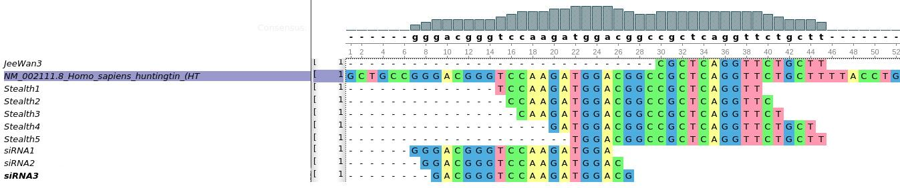

**Figure 2: RNAi prediction software used for checking the sanity of our predicted sequence using UGENE.**

**Testing of digestion and primer designing using benchling**

Prior to *in vitro* experiments, all the parts including primers and plasmids, of the cloning process were added to benchling and the process of plasmid digestion was tested using Benchling software. Filling out Exon 1 using a custom miniGene, the subsequent assembly of the remaining HTT exons were diagramed. Plasmid sequences received from Addgene along with primers for Exon1, minigene flanks and G-blocks were added to the benchling platform. Exon1 is the sequence of the HTT gene containing CAG repeats and 5’UTR. Benchling was also used to run virtual digests and aided us in hand-picking primers for vector assembly adaptation. The resulting assembled DNA fragment gave a better vision of the assembly of the Exon1 Figure 3. Besides Exon1, G blocks were also assembled in benchling. This was used for designing primers to amplify the G-Blocks.

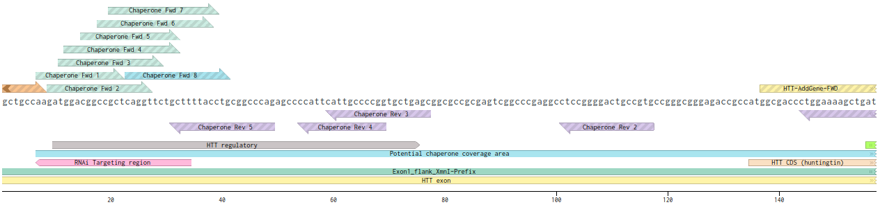

**Figure 3: Virtual digests and primer designing using benchling software.**

**To couple IDT flanking sequences to Addgene HTT sequences**

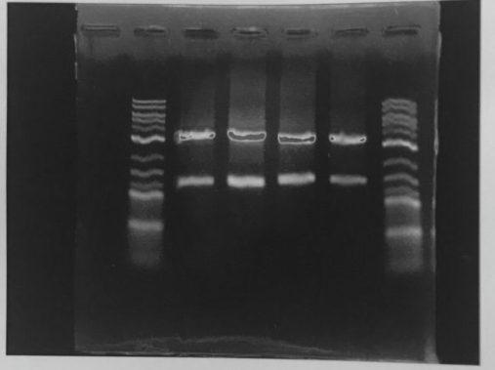

**Figure 4: Restriction digestion of the Addgene plasmid containing HTT sequence. Lane 2 and 4 shows digestion of plasmid 40261 and lane 3 and 5 shows digestion of plasmid 40262. Lane 1 and lane 6 show 2 log ladder.**

Our goal was to attempt a toehold strand displacement of mutated HTT with a corrected strand. For three sequences one HTT mutated, one HTT corrected and guide RNA were needed.  Two plasmids were brought from Addgene (40261 and 40262), which contained HTT sequences. The only difference between the two plasmids was the difference in the number of CAG repeats (which is seen in Huntington’s patients). Plasmid containing the HTT sequence (Exon1) was combined with flanking suffix and prefix adapter sequences by PCR reaction such that at the end of reaction the HTT sequence was combined with IDT flanking sequences. This new Exon1 was ready to be ligated to pSB1C3 plasmid.

**Integrate HTT sequence with 5’UTR and high GC content 3’ end adaptors**

Plasmid received from Addgene was checked for integrity using agarose gel electrophoresis. It was digested to remove fragment of interest. Because double digest did not result in sufficiently strong band plasmid was digested with STU1 and larger STU1 fragment, which contained the HTT gene was isolated instead (Figure 4).

The 144 nucleotide sequence containing 23Q repeat and 296 nucleotide sequence containing 74Q repeat were amplified using PCR (Figure 5).

The remaining upstream 5’UTR and high GC content 3’UTR were added to the amplified plasmid via isothermal assembly (Figure 6).

3A assembly was then used to clone Exon1 into pSB1C3 plasmid (Figure 7). E.coli was transformed with this plasmid and shipped to iGEM headquarters.

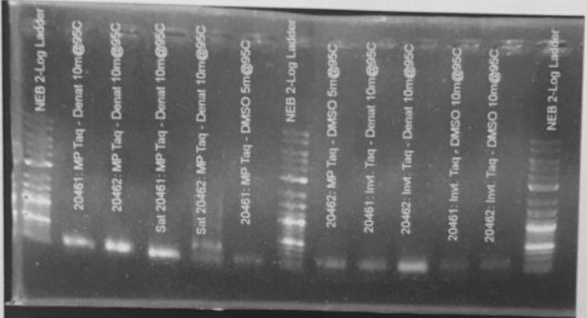

**Figure 5: PCR for amplification of 144 and 296 nucleotide sequence. PCR was done to amplify 144 and 296 nucleotide sequence which amounts to 23Q and 74Q repeat**

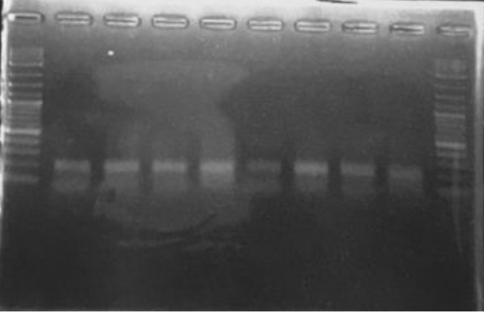



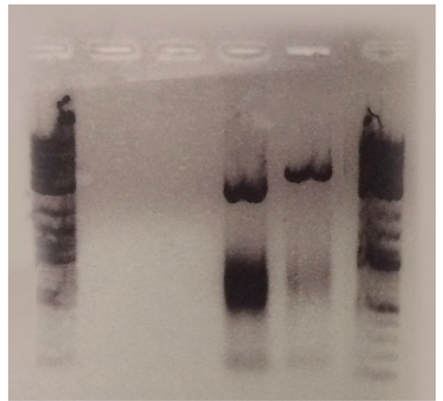



**4. Discussion:**

To date there is no definite cure for Huntington’s disease mainly because of the complications involved with the disease. Huntington is a late onset disease and its symptoms manifest only after a certain age, by which time the victim is already compromised and succumbs to the symptoms of Huntington’s. Although there are several interventions available to suppress the symptoms, there is no definite therapy available to treat the disease.

In an attempt to develop a short term cure for Huntington’s disease, we planned to use RNA strand displacement strategy whereby a corrected HTT RNA strand would invade into an existing mutated RNA-guide RNA duplex and replace the mutated RNA from its site (Figure 8). When introduced into cells, our synthetic strand would be complexed with a guide, or chaperone, strand. In a cell that is not expressing the diseased-state Huntingtin, the complex would not have any effect, as the guide strand would block translation. However, if a cell is expressing mutant Huntingtin, the guide strand would have affinity with both diseased and corrected Huntington mRNA, but it would have a greater affinity for the diseased type. The guide strand is designed to bind to a toehold in diseased Huntingtin mRNA.

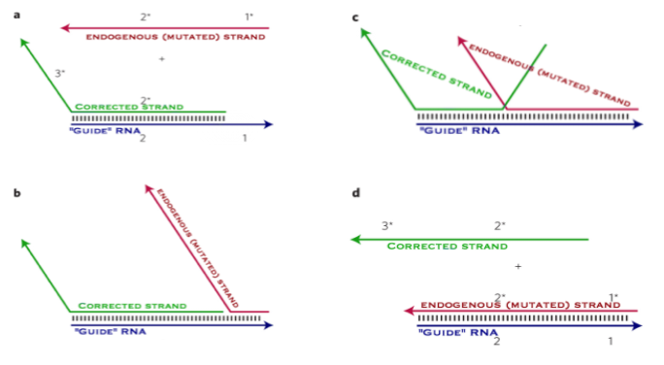

**Figure 8: RNA strand displacement strategy**

The process by which, strand replacement would be confirmed is by observing the changes in the fluorescence of fluorophores attached to the corrected and mutated RNA strand simultaneously.  As the mutated strand gets replaced the fluorescence associated with that mutated RNA strand would start decreasing due to lack of expression, however the fluorescence associated with the invading strand which is corrected HTT RNA strand would simultaneously start increasing. Since it only works in the presence of disease-state Huntingtin, a treatment using RNA strand displacement should have no side effects. An additional advantage of this technology is that we’re replacing faulty mRNA with functional mRNA instead of eliminating mRNA from the equation entirely and only cells actively using huntingtin protein would be affected by the treatment. We also don’t have to get into the nucleus to affect changes, making a treatment more simple to develop and deliver.

Although the strategy sounds simple, there were several complications associated with it. As the HTT gene is large, multiple G-blocks were required to form the full length HTT gene. We attempted assembling the remainder of HTT gene using G-blocks, however these experiments were not very successful. Therefore, we tried to use 2 way isothermal assembly to reassemble all the parts. We also tried to assemble all the parts using with 5 way assembly as well. However, due to lack of appropriate intermediate primers only a part of assembly was generated and hence remaining planned experiments are still in progress.

RNA strand replacement strategy could be a potential therapy for treating Huntington’s disease. However further research needs to be done to prove effectiveness of the strategy.

**Attribution:**

We are grateful to the following people for their significant contributions in this research: Sunyoung Oh, Frank Farkhod Muradov, Tarjani Agrawal and Chris Avrich.

**Corresponding Author:**

Dr. Russell Hanson, PhD. Associate Professor

Institute of Genomics and Multiscale Biology, Department of Genetics and Genomic Sciences, Icahn School of Medicine at Mount Sinai Hospital

Email: [hdresolutionigem@gmail.com](mailto:hdresolutionigem@gmail.com)

**References**

1. The Huntington’s disease Collaborative Research Group (1993) A novel gene containing a trinucleotide repeat that is expanded and unstable on Huntington’s disease chromosomes. Cell 72(6): 971–983.
2. Scherzinger E, et al. (1997) Huntingtin-encoded polyglutamine expansions form amyloid-like protein aggregates in vitro and in vivo. Cell 90(3): 549–558.
3. Harper Peter S., editor. Huntington’s Disease, Major Problems in Neurology. Philadelphia: W.B. Saunders Company, Ltd; 1991.
4. Vonsattel J. P et al., (1985) Neuropathological Classification of Huntington’s disease. J Neuropathol Exp Neurol 44(6): 559–77.
5. Perutz MF et al., (1996) Glutamine repeats and inherited neurodegenerative diseases: Molecular aspects. Curr Opin Struct Biol 6:848-858.
6. Beglinger L. J. et al., (2009) Randomized controlled trial of atomoxetine for cognitive dysfunction in early Huntington disease J. Clin. Psychopharmacol., 29: 484-487.
7. Brusa L. et al., (2009) Treatment of the symptoms of Huntington's disease: preliminary results comparing aripiprazole and tetrabenazine Mov. Disord. 24: 126-129.
8. Curtis A. et al., (2009) A pilot study using nabilone for symptomatic treatment in Huntington's diseaseMov. Disord., 24: 2254-2259.
9. Šulc, Petr et al. (2015) Modelling Toehold-Mediated RNA strand displacement Biophysical Journal, 108(5): 1238 – 1247.

2/28/2018