**Establishment of a Unique sustainable Platform and its required Strategies in Logistics**

M.H.Tabrizi1, Hua-ming Song2

**1** Department of Economics, Management, Nanjing University of Science and Technology, Nanjing, 210094, P.R. China. E-mail: m.mirfattah1@outlook.com

2 Department of Economics, Management, Nanjing University of Science and Technology, Nanjing, 210094, P.R. China. E-mail: [huaming@njust.edu.cn](mailto:huaming@njust.edu.cn)

**Abstract:** Logistics is one of the permanent elements in each organization that has the basic role in coordinating the variety districts of one organization. This fact is observed in outsourcing companies obviously. In this paper, the awareness of needs to preserve the environment and establish one sustainable and stable development evolved as the platform with its strategies in one case study for designing the logistical systems is determined. According to this method, the basis and common platform data in pertaining to the stuff in relevant actions, has been considered and involved in organization including (repairs, Transportation, managerial supportive chain and etc.) and all are designed, generated and controlled by one unique information system. After acquiring the experiences of our research group, this method is performing in the large organization and has been simplified the jobs in their logistical affairs. The following results are obtained in implementation of this system: 1) At least 40% reduction in operational expenses. 2) raising the productivity by producing: (1) The standard sustainable common language; (2) The systematic and informational situation; (3) The social memory.

[M.H.Tabrizi, Hua-ming Song. **Establishment of a Unique sustainable Platform and its required Strategies in Logistics.** *N Y Sci J* 2018;11(2):92-100]. ISSN 1554-0200 (print); ISSN 2375-723X (online). <http://www.sciencepub.net/newyork>. 13. doi:[10.7537/marsnys110218.13](http://www.dx.doi.org/10.7537/marsnys110218.13).

**Keywords:** Coding; DSS; DBMSL(DBMSL-Database Management System of Logistics); Logistics; Productivity.

1. **Introduction**

At present era, the transferring information and accessibility to that is as a significant matter in fact. The organization would be successful at the tasks in relevant that properly could transfer the relevant data and use them as well. For applying the suitable information and proper making decision, is required the system in which can manipulate the management board in decision making. There is only one Decision Support System (DSS) that is able to appropriate the different options for making decision in available to the decision makers, by organizing the information and processing data. The complexity of decision making would be observed in different levels in logistics affairs and the stuff would be as one origin existence is played a central role in transferring the logistical information. Then, the existing of one integrated information system would be observable at last. For achieving the proper DSS in logistics, that is necessary to identify and cluster the information pertaining to the stuffs and to develop the standard sustainable common language. In this process, the unique code is allocated to each unit of items and is identified it in logistic informational cycle of the organization.

In coding the stuffs, the variety of systems and procedures have been implemented. For instance, CELL plant has chosen one 10 digit code for coding the material and the equipment, also General Motors plant has suggested one integrated system for coding the spare parts. However, the most important coding and informing system that is able to do as outsourcing organization, is called Nato. Nato is launched after II World War (1947) that would be developed in several countries later.

Presently, this important coding system is introduced as DBMSL. In this system, one new approach is innovated and applied in the process of designing the information and support system is identified as “the organic information system for logistics” in which has done better than NATO system functionally. Finally, there are some reports on the implemental consequences.

1. **The Principals of Logistics**

**2.1 Logistics Process**

Logistics is as a unique procedure and frame that conducts and controls the processes including of programming, allocating the control of sources (financially and humanity) existing in districts of distribution, supporting, making and purchasing, on the other words logistics is a developed system that is supporting all the required activities such as transportation, warehousing, distribution, production, etc. from the time of making till delivery time to meet customer. Logistics is not exclusive to one economical or military organization perhaps each district of productive or services needs their own special logistics.

**2.2 Logistics Objectives**

In this paper, the objectives of logistics in organization based on the objectivity of organizations are different. We can divide the objectives for logistics in two;

1. Economically, business organizations, rising the profits are coincide to give the proper services to the customers.
2. In military organizations, operational ingenuity is based on supportive and coordinating of the sectors in logistics.

**2.3 Parts in logistics**

The sectors in logistics are included of activities and sources involved in logistics system such as purchase, production, warehouse, distribution, sale, transportation, maintenance. One organization is able to keep all sections or some of them in its cycle as shown in figure (1) the simple schema of logistics.

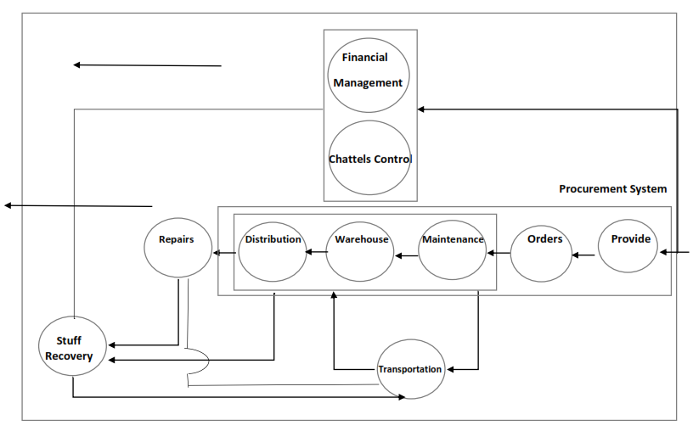

*Figure 1. The simple schema of logistics in organization*

**2.4 the requirements of data in logistics**

In one cycle of logistical operation, data has significant role if date is transferred to the decision maker properly and on time. It’s lead to be developed and simplified in systems and is improved from reproducing and energy wasting or time-wasting. If there are several activities in variety parts of logistics management which are done independently from each other, at the present situation, logistics management is faced to mass of information pertaining to the required stuffs in the operation that would repeat in different groups. On the other side, the complexity of variety of stuff, developing the geographical locating of stuffs and equipment, specializing the logistics activities, all are factors that need to apply a common and integrating information system, properties and operations.

**2.5 Stuff rolling in logistic activities**

A logistic activity is begun when a demand or request is submitted by the customer to the system. This demand is for receiving the items or for having services directly. For responding to the customer’s demand, we should do some logistic activities, while by starting one logistic activity, the other parts is going to be influenced of it and responded to this fact. As observed, the stuff plays significant role in logistics as one sustainable developed structure. (Figure 2) according to the above explanations, one logistic system can do tasks properly to process the information based on one common sustainable language to control and manipulate them.

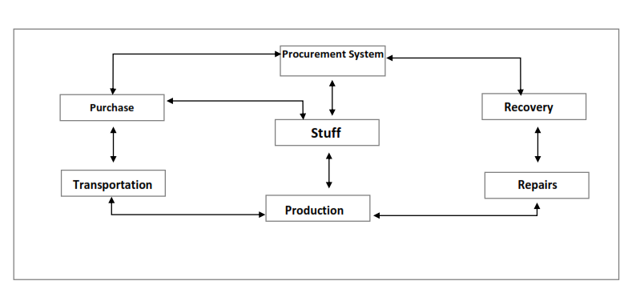

*Figure 2. The importance of the stuff in Organization*

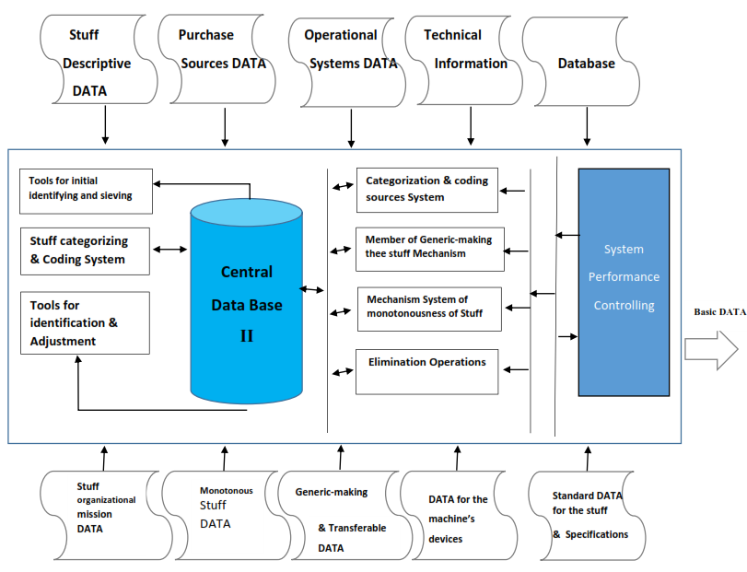

*Figure 3. DBMSL Model*

1. **DBMSL (**Data Base Management System of Logistics**) and Implications with the application in System**

The Data Base Management System of Logistics (DBMSL) that is prevailed upon the basic information of logistics by managing and organizing. This system is included in a group of special activities toward to implementing a logical approach for identifying and categorizing the stuff in organization and while it can provide the essential background for cooperating the logistics elements. Meanwhile DBMSL is designed for the large organizations that compound of several large organizations (each organization may have divided into some smaller organizations) the stuff data as soon as entrance to the system would be identified, recorded and coded and according to the data coding, one common ID will be developed in whole of organization and in the organs. In DBMSL is observed some special database in pertaining to the stuff as a social memory and all the districts of organization can use of this social memory based on their needs where is shown in figure 3 by considering the common ID in organization and variety of information.

* 1. **Sustainable Development Strategies**

Sustainable and stable development strategy should also meet these requirements. Many methods and policies are used in strategic management levels and practice to prepare insight into the operating requirement of organization and system and define adequate strategies. This system is intensively manipulated and controlled, however all different organizational parts can record into the system and code all of them. The central core of DBMSL is integratively responsible for all the task of leadership, planning and controlling these parts that can support all the needs and activities according to the nets and computerized equipment which is connected to the different centers of logistics. Systematically, DBMSL is compound of three levels such as the level of Management and control, operations, clients that all of these three levels would support the decision maker from lowest point to top point of organization. In figure 4 is appeared the levels of systems.

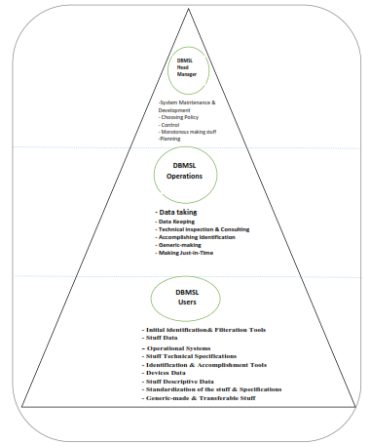

*Figure 4. The systematic level of DMBSL*

***3.2. DBMSL District and limitation***

DBMSL as the other system, has obviously specific district and limitations. This system has property of the internal and external reactions that is acted pertaining to the stuff. These reactions has special influence on the environment or influenced by them. However, DBMSL is in action as a cooperator in the cycle of logistic operation so that the logistic in organization would be in DBMSL environment. Logistic as a surrender encompasses DBMSL and there is a direct impressible from request time or start of a logistic mission would be launched and has been continuing to end of mission. It cannot be easily made obvious the DBMSL environment so that this system is controlling many clients and has indefinite services related to them. This system can answer to their informational and operational needs. It should be mentioned that these clients are the same internal and external systems as well. Therefore we can consider to the DBMSL in a simple comprehension as whole of organization where in act to the identification part and coding the stuff part. Figure 5 appears the DBMSL location in organization.

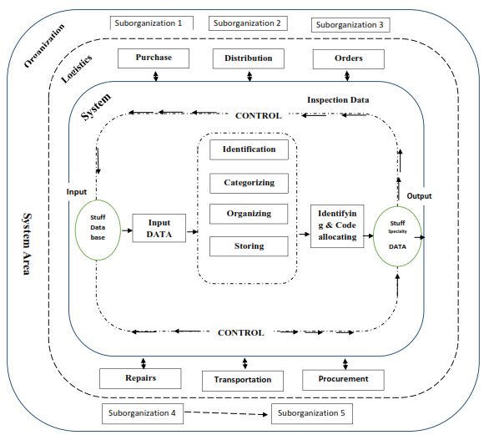

*Figure 5. DBMSL location in Organization*

**3.3. DBMSL Objectives**

The most important purpose of organization in implementing the DBMSL is improving the logistic operation and reducing the costs. This overall purpose is obtained of the following minor objectives and strategies.

1. To identify the equal stuff in whole of organization by coding and allocating the exclusive name for each stuff to a one individual.
2. To lot the stuff in special classes so that the similar stuff is put into a controllable clusters.
3. To identify the relations among the stuff in different clusters.
4. To establish a standardized and common ID for the inter-organizational communication by using the standardized data encyclopedia and an equal coding.
5. To simplify the external communications in logistic activities.
6. To produce a social memory for the stuff.
7. To provide the possibility of the electronic data processing.
8. To access to a general Decision Support System.

**3.3. The Framework of categorizing and coding of the stuff in DBMSL**

Accordance with the dispersed spectrum of the stuff which are used into ultra-firm organization. It’s necessary to be considered one specific and general index and pattern of categorizing for identifying and categorizing in DBMSL.

After identifying and categorizing, it would be allocated one nominal ID and code to each stuff for having one sustainable and stable ID. This code is concluded of ten digits that shows the stuff location in DBMSL categorizing system. Based on this ten-digit code, it would be easy to access all the stuff specifications.

**3.4. Authorities of DBMSL**

DBMSL can provide a compatible background for developing a Decision Support System by a useful database in which can manage one part of information of the stuff thus gives to decision maker.

In initial design of this system, the number of the stuff is predicted to twenty million ones that has authorized the development of higher range. This system can support one centralized management in the whole organization as well and can be easily developed in physical and geographical levels. Decision taking levels is determined in this system and in the specific process of clients in different levels can use and make decision the mentioning data.

**3.5. DBMSL Strategic Requirements**

DBMSL strategic requirement refers to all the tools and organs that are used in identifying, coding and even marketing DBMSL data. These strategies are as following in brief:

* Structure of categorizing: is a framework for informing the relation among the groups of the stuff according to the categorizing indices.
* Queue pattern: a specific pattern for determining and coding the stuff for simplifying and standardizing the stuff nominal ID
* Manual books: has property of the mentioned data related to the stuff for user’s applying.
* Monotonousness pattern: for preventing the variety of the stuff’s trademarks of a special pattern is used for identifying the common specifications of the stuff.
* Instructions: concluded of all the implementing instructions of DBMSL and applying the relevant activities.
* Information forms: the special information forms are used for doing the DBMSL activities.
* Standards: all the global standards is applied in pertaining to the stuff specifications.
* Generic-making: is a technique that causes to prevent of increasing the trademarks for an item of the stuff and identifying the substitutable sources.

1. **The Logistic systematic information Approach**

In designing DBMSL, is used of the constructing method so that all the system needs are ascending from top to down. After analysing the system of logistic and its needs, a new systemic approach with special hypothesizes is considered that would explain in the latter titles.

**4.1. The relevant data sorts to the stuff**

In DBMSL encyclopaedia, is considered to stuff specifications in two sides.

**4.1.1. The stuff Database**

The stuff database is referred to the stuff specification in the fixed logistic cycle and cannot be changed through the organization operations.

This information would be necessary for all logistic parts and distributed among the different districts as a common ID. This data is generally made out of the logistic system framework and called as the environment data, such as the stuff code, the stuff ID, the stuff’s technical specification, the stuff’s supplying sources, the stuff’s relations, the stuff’s standards and etc.

**4.1.2. The stuff operational data**

The stuff operational data is referred to the information which is changeable in the logistic operation cycle and valued in different ranges through the logistic operations.

The data is generally made in the logistic system framework and called as the devoted and operational data for each logistical item.

With this approach, DBMSL can make a social memory (concluded of a group of the databases) in pertaining to the database of the stuff for logistic so that all the logistic districts can use it commonly.

**4.2. The Logistic systematic database background**

In DBMSL is determined a new approach for managing and organizing the whole of system, in this method would be manipulated and controlled centrally and after processing will be given to the logistic terms. Each of the logistic terms can be applied and designed independently. They can make and develop the essence of databases but it’s impossible to produce these information independently and should use the common social memory of the stuff which is distributed in the logistics.

The significant point in systematic thought is cooperating among the logistical terms which is based on this systematic background. Meanwhile the made social memory produces an identified and common ID for all the logistical terms and districts in the whole system and answer to all requests in the best way. In this way, in logistical operations, precise and speed arising synchronizingly.

This systematic thought, is developing in a global organization that each one of the related organizations can make and develop the essential databases in the internal operation and use of their coding but for doing a logistical activity in the significant level of organization is necessary to use of the social memory related to the databases of the stuff and cannot make the database of the stuff in the significant level of organization. As shown the role of databases in partial and national logistic cycle in Figure 6.

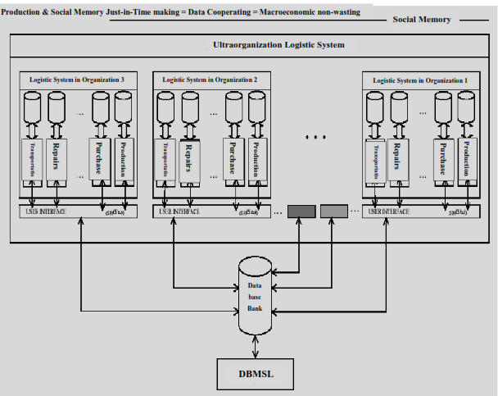

*Figure 6. The role of database in integrating the partial and national logistic*

1. **Discussion and Conclusion**

As obtained the following results by applying the logistic data:

1. Reducing the direct and indirect overhead costs.
2. Preventing the doing the operations similar to the different terms of logistic.
3. Making high flexibility in doing technical duties for each logistic term.
4. Integrating and cooperating in doing the operation among the logistic terms.
5. Rising the profitability for reducing bureaucracy and making a common ID.
6. Reducing the inventory stock in the logistic terms.
7. Possibility of a centralized management, efficiency on the logistic leadership.

As the obvious result by applying DBMSL in the large organization. This large organization concluded of some major organizations that each one of them divides into minor collections. In past situation, the organization stuff is stored in different warehouses in all over the country. Each of these warehouses, responsible for providing of their own sustainable logistical needs and do their duty independently. However, some of the similar stuff were kept in several warehouses in different derivatives from organizations as the surplus of needs caused of not having any common ID of the stuff for doing logistical activities in the significant organization and that was not possible for time-consuming and high expenses and the existence of DBMSL has many other different reasons for generating. Hereby, we point to some profits on organization’s implementation in percentages are as follow:

1. The reduction of inventory stocks (30%).
2. The reduction of overhead costs (40%) .
3. The reduction of warehouses areas and cases (250%).
4. The reduction of volume of logistical operation and omit the repeating tasks (40%).
5. The reduction in volume of export orders (10%).
6. The reduction of volume of the internal purchases of platform (15%).
7. To identify the useless stuff and exit them from the platform (9%).
8. Recovery the stuff in warehouses (5%).
9. To concentrate on the logistics management (25%).
10. The reduction of available expenses and find the sustainable and stable data (7%).
11. To identify the vague stuff and add them into platform properties (33%).
12. To improve the profitability (40%).

These are summarized below;

*Figure 7. The forehead of implementation of DBMSL strategies on system as profit (in percent)*

As the results of DBMSL shown, DBMSL can make a considering improvement in logistical affairs for a new approach of systematic and mechanism and categorizing properly that is acted in data taking for the stuff. This system can simplify and coordinate the logistical affairs by applying a sustainable common ID and developing a social memory. DBMSL, as observed through practical experiences and engaging the strategies in system, it can lead to developed large organizations and international contracts for doing common economic and military activities and even is able to support the logistical operations in this level. The latter steps of the process which is influenced on the DBMSL comprehensive concepts. Developing these comprehensive concepts are in designing an integrated logistical management system (ILMS). In an ILMS, all the terms are based on DBMSL database and act according to a logical systematic approach.

**Acknowledgement**

* We would like to thank the two anonymous reviewers for their comments.
* We would like to thank the editors and the anonymous reviewers for their suggestions in improving the quality of this paper, and we are also grateful to the other people in the team “----” for collaboration and discussion.
* The authors would like to express their sincere thanks to the anonymous referees and editors for their time and patience devoted to the review of this paper.
* The author would like to express their gratitude to their higher committee for Education Development (HCED) in country for the financial support in this study. Also, the authors would like to the anonymous referees whose thorough reviews and insights comments made a valuable contribution to this manuscript.

**Reference**

1. Candido, G., Barata, J., Colombo, A.W., Jammes, F.: SOA in reconfigurable supply chains: A research roadmap. Engineering Applications of Artificial Intelligence 22, 939-949 (2009).
2. Chandra, C., Grabis, J.: Supply Chain Configuration: Concepts, Solutions, and Applications, Springer: New York (2008).
3. Chopra, S., Meindl, p.: Supply Chain Management: London, Prentice Hall (2012).
4. Hernandez, B., Jimenez, J., Martin, M.J.: Key website factors in e-business strategy. International Journal of Information Management 29, 362-371 (2009).
5. Klein, R., Rai., A.: Interfirm strategic information flows in logistics supply chain relationships. MIS Quarterly: Management Information Systems 33, 735-762 (2009).
6. Lambert, D.M., Cooper, M.C., Pagh, J.D.: Supply Chain Management: Implementation Issues and Research Opportunities, International Journal of Logistics Management, The, Vol. 9 Iss; 2, pp.1-20 (1998).
7. Lee, H.L., Whang, S.: Information Sharing in a supply chain. International Journal of Technology Management 20, 373-387 (2000).
8. Melo, M.T., Nickel, S., Saldanha-da-Gama, F.: Facility location and supply chain management – A review, European Journal of Operational Research, vol. 196, no.2, pp. 401-412 (2009).
9. Strunk, A.: Qos-aware service composition: A survey, Proceedings of the 8th IEEE European Conference on Web Servces, ECOWS 2010, PP. 67-74 (2010).
10. Swaminathan, J.M., Tayur, S.R.: Models for supply chains in e-business. Management Science 49, 1387-1406 (2003).
11. Trappey, C.V., Trappey, A.J.C., Lin, G.Y.P., Liu, C.S., Lee, W.T.: Business and Logistics hub integration to facilitate global supply chain linkage. Proceedings of the Institution of Mechanical Engineers, Part B: Journal of Engineering Manufacturing 221, 1221-1233 (2007).
12. http://www.nato.into/structure/AC/135/brocher/chapters/8 services training.htm.

2/25/2018