Diversity and distribution of Aedes mosquitoes in Nigeria

¹Chukwuekezie Okechukwu Chimaeze*, ¹Nwankwo Aldophus Chukwuemeka, ¹Nwosu Emmanuel Okechukwu

¹Dogunro Festus Ayorinde, ¹Nwangwu Udoka Chukwubuofu, ¹Onwude Cosmas Ogbonnaya, ¹Ezihe Ebuka Promise, ¹Agashi Nneka Obiageli, ¹Anumba Joseph Uche, ¹Anioke Clementina Chekwube, ¹Anokwu Stephen Okechukwu, ¹Orizu Francis Uzoma, ¹Okoronkwo-Agwu Angela Ifeoma, ¹Eloy Emelda Idam, and ¹Okoye Chukwuebuka Kingsley.
¹National Arbovirus and Vectors Research Centre (NAVRC), Enugu, #33 Park Avenue, PMB 01573, Enugu, Enugu State, Nigeria.
chukwuekezieo@yahoo.com

Abstract: Aedes mosquitoes are vectors of yellow fever, Zika, dengue, chikungunya, West Nile diseases among others. These mosquitoes bite both humans and animals alike during the day, particularly in the mornings and evenings. This study sought to understand their diversity, distribution and abundance in Nigeria. Ovitrapping, larval surveys and human landing collections were used to sample for vectors in 14 states of the country and the Federal Capital Territory (FCT). This cuts across the 6 geopolitical zones of the Federation. A total of 8,659 Aedes mosquitoes, consisting of nine (9) different species were collected. Aedes albopictus 3,651(42%) constituted majority of the collections, while Aedes circumluteolus 40 (0.5%) was the least collected. All nine species collected in the surveillance were present in Enugu State, while Kaduna State, with the least diversity, had only one species. The study revealed the overwhelming presence of domestic, peri domestic and canopy breeders of the genus, Aedes, in the Country. These include those that transmit some of the most dreaded diseases across the globe. Hence, there is need to continuously update available data on these mosquitoes. This should be the basis for effective vector control and the eventual elimination of Aedes-related diseases in Nigeria.
[Chukwuekezie Okechukwu Chimaeze, Nwankwo Aldophus Chukwuemeka, Nwosu Emmanuel Okechukwu. Diversity and distribution of Aedes mosquitoes in Nigeria. N Y Sci J 2018;11(2):50-57]. ISSN 1554-0200 (print); ISSN 2375-723X (online). http://www.sciencepub.net/newyork. 7. doi:10.7537/marsnys110218.07.

Keywords: Aedes, mosquitoes, diversity, distribution, Nigeria

1. Introduction
Aedes mosquitoes are usually black, with characteristic white or silver markings on their bodies. They were formerly found in tropical and sub-tropical areas, but have now spread to all continents excluding Antarctica (Bonizzoni et al., 2013). This spread was aided hugely by man-made activities, including the sale of used tyres. Unlike most other mosquitoes, they are active and bite both humans and animals only during the daytime. Their peak biting periods are early mornings and evenings, before dusk.
Aedes species normally breed in transient water collections. These include collections in tree cavities, leaf axils, bamboo stumps, rock pools and artificial containers (including tin cans, coconut shells, water storage containers, discarded vehicle tyres, broken earthen and ceramic wares). These breeding habits keep them in close proximity with man, facilitating also disease transmission. They lay their eggs just above the water level. As a result, water waves/ripples or increases in water volume lead to hatching of viable eggs.
Members of the Aedes genus are known vectors for numerous viral infections. The two most prominent species are Aedes aegypti and Aedes albopictus which transmit Zika virus and other viruses that cause dengue fever, yellow fever, West Nile fever, Chikungunya, and Eastern equine encephalitis, among other less notable diseases. Some studies conducted in Nigeria revealed that the major Aedes mosquito species include: Ae. aegypti, Ae. albopictus, Ae. africanus, Ae. luteocephalus, Ae. simpsoni complex, Ae. vittatus (Service, 1974; Adeleke, 2008; Aigbodion and Uyi, 2013 and Chukwuekezie et al., 2016). They are important vectors of Yellow fever, Dengue fever, Chikungunya, West Nile and Zika viral diseases, as well as many other arboviruses. Some can also transmit filarial worms.
There has been re-emergence of yellow fever in the Country, since the last case in Kano State, in the year 2000. Between July and December, 2017, there were 341 suspected cases of yellow fever reported from 16 states (Abia, Anambra, Borno, Edo, Enugu, Kano, Katsina, Kogi, Kwara, Kebbi, Lagos, Nasarawa, Niger, Oyo, Plateau, and Zamfara states). Of these, 6 states (Kano, Kebbi, Kogi, Kwara, Nasarawa and Zamfara) reported confirmed cases of the disease (WHO, 2017). This is a confirmation that at present, there is circulation of the virus in the vectors in several parts of the country.
There is need for continuous collection and collation of data on Aedes species, which will be indispensable in formulating effective control strategies. The present study therefore sought to determine the diversity and distribution of Aedes mosquitoes in Nigeria.

2. Materials and Methods
Aedes mosquitoes were studied for eight years, from the year 2007 to the year 2014 in 14 states and the FCT, spanning the six geo-political zones of Nigeria.
2.1 Mosquito Collection Techniques
2.1.1 Ovitrapping
Ovitraps were used to collect eggs of Aedes mosquitoes. Each ovitrap consisted of a plastic cup (dark colour preferable) one-third filled with clear water, lined internally with a strip of white cloth (ribbon) measuring 3cm in width and a length equal to the internal perimeter of the cup. Care was taken to ensure that part of the ribbon was above the water line. The cups were positioned in shaded and cool places where children and/or animals around the homes will not disturb them. In an attempt to lay their eggs just above the water line/level, the mosquitoes oviposit on the ribbon (s). After 48 hours, the ribbons were removed from the cups and air-dried at room temperature. Eggs on each ribbon was counted and recorded accordingly. They were then preserved in well labelled containers for transportation, counting, storage, flooding/soaking, eventual hatching and rearing to adult stage.
2.1.2 Larval Sampling/Survey
Larvae were sampled from various man-made water collections such as cans, coconut shells, water storage containers, discarded vehicle tyres, broken earthen and ceramic wares among others. Ladles, pipettes, bowls and buckets were utilized for this activity. The collections were introduced into well labelled plastic containers with lids. They were eventually taken to the insectary for rearing to the adult stage.
2.1.3 Human Landing Collection
Adult Aedes mosquitoes were collected using human baits between 4:30pm and 8pm during the study periods. Collections were recorded at intervals of 15 minutes to gather more information on the vector biting activities. To collect mosquitoes, the lower legs of the collectors were exposed such that when they perched to take a blood meal the mosquitoes were collected using test tubes. The opening of the tube was plugged with cotton wool to prevent escape of the mosquito.

Table 1. Collections from different states and the Federal Capital Territory (FCT)
S/N | State | Year | Species
 |  |  | Ae.aegypti | Ae.albopictus | Ae.africanus | Ae.leutocephalus | Ae.cumminsi | Ae.taylori | Ae.vittatus | Ae.simpsoni | Ae.circumluteolus
1 | Abia | 2009 | 45 | 53 | 107 | 47 | 0 | 0 | 0 | 0 | 0
 |  | 2012 | 3 | 20 | 34 | 4 | 0 | 0 | 0 | 0 | 0
2 | Delta | 2007 | 5 | 21 | 247 | 59 | 0 | 0 | 0 | 0 | 0
 |  | 2011 | 8 | 18 | 29 | 15 | 0 | 0 | 0 | 0 | 0
 |  | 2012 | 30 | 54 | 255 | 69 | 0 | 0 | 0 | 0 | 0
 |  | 2013 | 46 | 45 | 33 | 86 | 0 | 0 | 0 | 0 | 0
3 | Enugu | 2008 | 15 | 12 | 1 | 3 | 1 | 1 | 2 | 0 | 0
 |  | 2011 | 27 | 42 | 15 | 12 | 0 | 1 | 2 | 2 | 0
 |  | 2012 | 160 | 189 | 31 | 52 | 1 | 0 | 15 | 8 | 1
 |  | 2013 | 101 | 550 | 2 | 4 | 1 | 0 | 0 | 3 | 0
 |  | 2014 | 805 | 2012 | 0 | 1 | 9 | 0 | 0 | 225 | 0
4 | Imo | 2012 | 7 | 27 | 17 | 11 | 0 | 0 | 0 | 0 | 0
 |  | 2014 | 287 | 146 | 103 | 58 | 0 | 0 | 0 | 0 | 0
5 | Anambra | 2008 | 1 | 17 | 50 | 117 | 2 | 0 | 0 | 7 | 10
 |  | 2012 | 136 | 38 | 5 | 8 | 4 | 0 | 2 | 1 | 0
 |  | 2014 | 171 | 204 | 12 | 0 | 0 | 0 | 1 | 34 | 0
6 | Akwa Ibom | 2011 | 4 | 22 | 20 | 36 | 0 | 0 | 7 | 0 | 0
7 | Ondo | 2010 | 6 | 23 | 7 | 0 | 0 | 0 | 0 | 2 | 4
8 | Ebonyi | 2010 | 17 | 35 | 31 | 82 | 4 | 0 | 7 | 0 | 6
 |  | 2012 | 1 | 6 | 13 | 72 | 0 | 1 | 0 | 0 | 0
9 | Ogun | 2011 | 11 | 41 | 0 | 2 | 0 | 0 | 3 | 0 | 0
10 | Cross River | 2010 | 1 | 5 | 47 | 53 | 0 | 1 | 0 | 0 | 12
11 | Benue | 2007 | 84 | 55 | 49 | 492 | 29 | 39 | 4 | 0 | 4
 |  | 2010 | 29 | 7 | 1 | 61 | 0 | 5 | 3 | 0 | 0
12 | Taraba | 2010 | 29 | 9 | 0 | 25 | 0 | 2 | 3 | 0 | 3
13 | Kebbi | 2011 | 2 | 0 | 0 | 1 | 0 | 0 | 1 | 0 | 0
14 | FCT | 2011 | 21 | 0 | 0 | 0 | 0 | 0 | 1 | 0 | 0
15 | Kaduna | 2010 | 3 | 0 | 0 | 0 | 0 | 0 | 0 | 0 | 0
 | TOTAL |  | 2055 | 3651 | 1109 | 1370 | 51 | 50 | 51 | 282 | 40
 |  | Grand Total |  |  |  |  |  |  |  |  | 8659

From the result above, Aedes aegypti (24%) was collected in all the states sampled. Aedes albopictus (42%) was the most abundant of all the collections made, while Aedes circumluteolus (0.5%) was the least abundant species.
2.2 Hatching of Eggs and Rearing of Mosquitoes to Adults
The ribbons containing the eggs were placed into well labelled clean bowls. Clean/clear water devoid of Aedes eggs was poured into the bowl till the ribbons were submerged. The bowl was immediately covered with a net to prevent oviposition by another mosquito and possible escape of emerging adult mosquitoes. As eggs hatched, the ribbon was removed and air-dried. The larvae were then counted. The entire process was repeated 3 times to ensure all the viable eggs hatched.
The larvae were fed with animal feed. Water in the bowls was changed every other day to prevent pollution. As soon as adults emerged, they were collected by means of a mouth aspirator and introduced into a well-labelled test tube.
2.3 Mosquito Identification
Mosquito identification was done at the adult stage. Adult mosquitoes from ovitrapping, larval surveys and human landing collections were all identified using the keys of (Edwards, 1941; Gillet, 1972 and Huang, 1979). The mosquitoes were chilled to death in a test tube and then identified to species level using stereomicroscopes.

3. Results

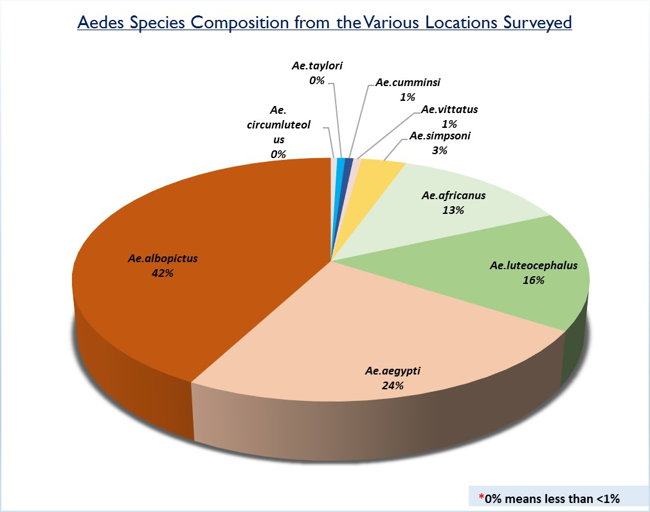
Figure 1. Aedes species composition from the study

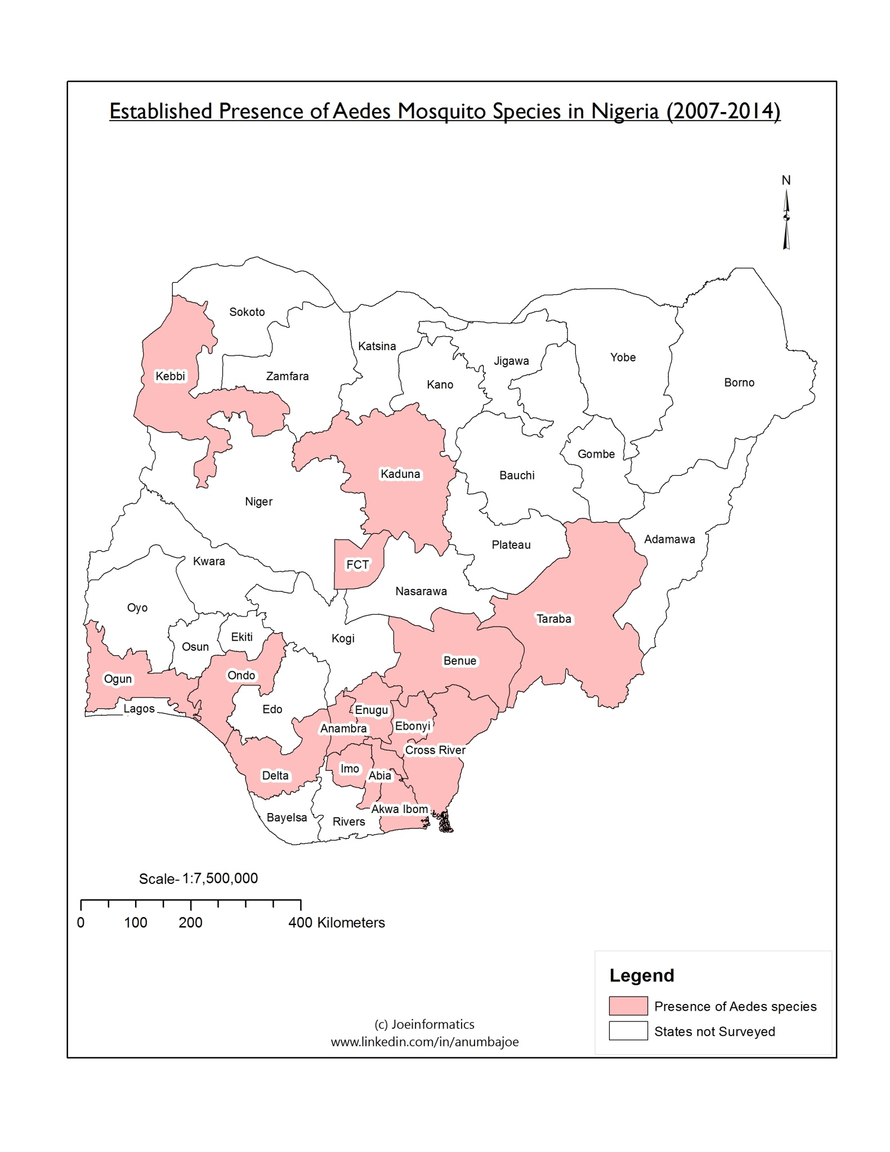
Figure 2. Map showing states from where Aedes species were collected

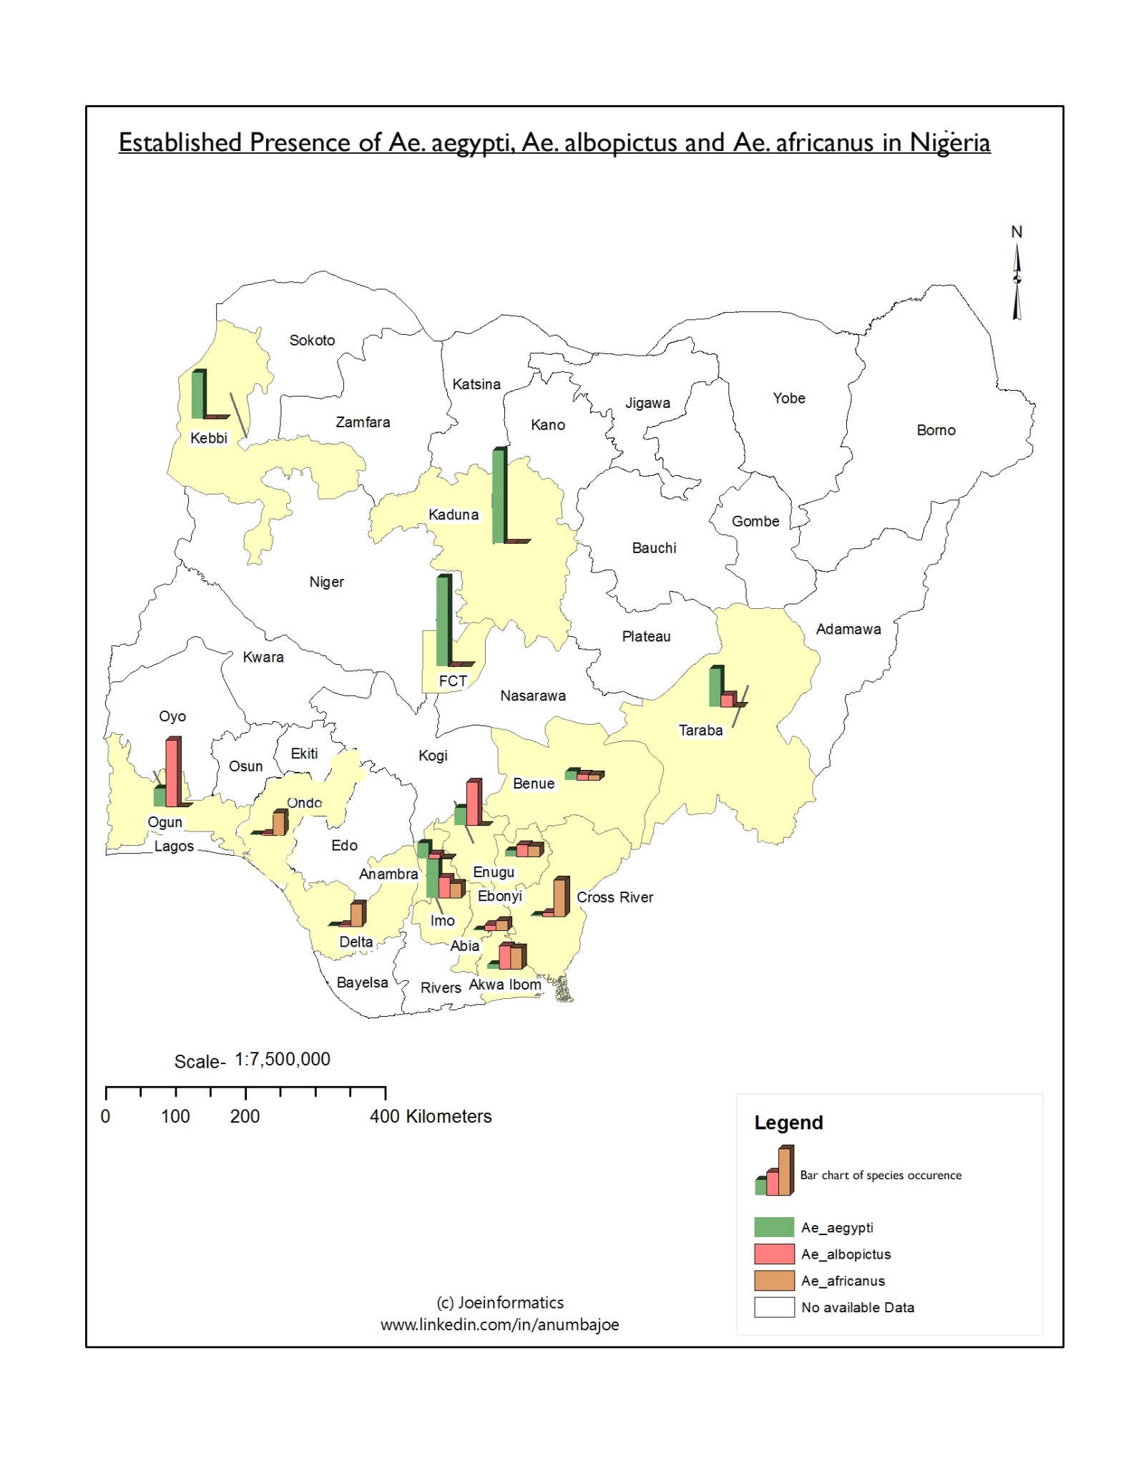
Figure 3: Established presence of Aedes aegypti, Ae. albopictus and Ae. africanus in the locations surveyed

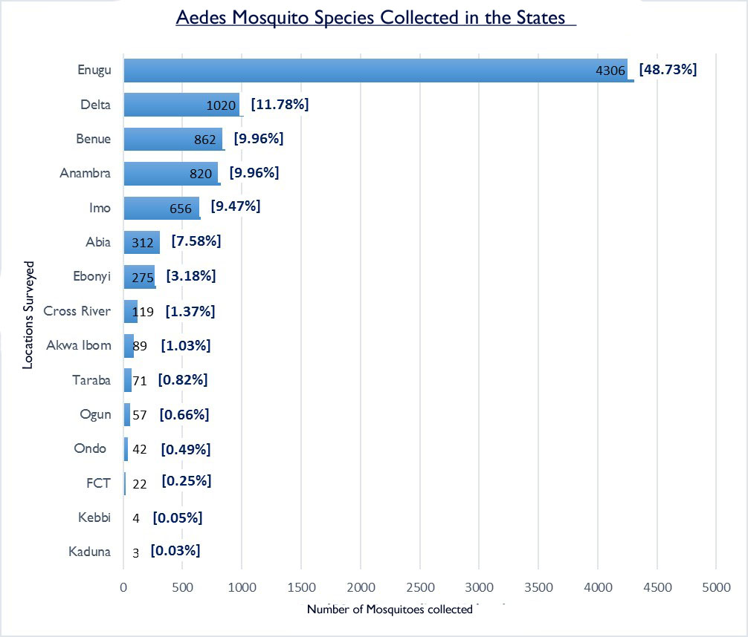
Figure 4. Aedes species collected per State

All the Aedes species (Ae. aegypti, Ae. albopictus, Ae.africanus, Ae. luteocephalus, Ae. vitattus, Ae.cumminsi, Ae.simpsoni complex, Ae.circumluteolus, Ae. taylori) were collected in Enugu, while in Kaduna State, only Aedes aegypti was collected. The four most abundant species collected were Ae.aegypti, Ae.albopictus, Ae.africanus and Ae.luteocephalus.

4. Discussion
Outbreak of arboviral infections such Zika, Dengue, Yellow fever, Chikungunya among others have always been associated with Aedes species. Though there are bits/fragments/inedequate of information on Aedes species and the diseases they transmit in different parts of the country, there is no concise ecological record of Aedes species in the country. The National Arbovirus and Vectors Research Centre (NAVRC) is saddled with the responsibility to study the ecology, bionomics, distribution and seasonal variation of disease vectors, especially arbovirus vectors. Hence, the Centre embarked on this study. From 14 states and the FCT (all from the 6 geopolitical zones), a total of 9 different species of the Aedes genus were collected. This is the widest coverage done by any group on Aedes species in the country. The findings corroborate those of (Service, 1974; Chukwuekezie et al., 2016; Nwoke and Eboh, 1988; Onyido et al, 2009; Lawal et al., 2012 and Idowu et al., 2012).
The findings showed that Aedes aegypti was present in all the States visited. This agrees with the findings of (Surtees, 1967), who reported that Aedes aegypti occurs throughout Nigeria, from the coastal swamp zone to the Northern Guinea/Sudan savannah. On its part, Aedes albopictus was the dominant species from the collections. This was no surprise, as it had been described as one of the most invasive species because of the way it spread globally (Bonizzoni et al., 2013). Aedes africanus, one of the vectors for sylvatic yellow fever, was quite prominent in some southern states (Delta, n=564; Abia, n=141 and Imo, n=120) which are in the tropical rain forest zone.
Breeding of these species were predominantly in man-made containers such as cans, tyres, earthen pots among others as observed in the study of Onyido et al., (2008). Nwoke and Nwoke (2006) observed that the habit of littering the environment with discarded containers among dwellers provides good breeding sites for these mosquitoes. A near uniform peak biting period between 7am – 9am and 5pm – 7pm) which was observed during the day, further buttresses their proclivity for diurnal biting activities.
It is worthy of note that members of the Aedes simpsoni complex (collected through use of human baits) were collected from Anambra, Enugu and Ondo States, suggesting that the species collected may be Aedes bromeliae, the widely distributed anthropophagic member of the complex in Africa (Huang, 1979). The four most abundant Aedes species collected were Ae. aegypti, Ae. albopictus, Ae. africanus and Ae. luteocephalus. Aedes albopictus (42%) was the most abundant, while Ae. circumluteolus (0.5%), was least abundant of all the collections. However, comparisons were not made with respect to the various sites and species of vectors collected. This was because there were discrepancies in: the number of visits to the various states; sampling duration; number of collectors; months and years of sampling. The findings however, give an insight into the Aedes fauna in various locations of the country.
Findings of this study give credence to the potential public health threats posed by Aedes mosquitoes in Nigeria as this becomes increasingly more important when the species have very high hunger for feeding on man, high reproductive potential and remarkable longevity (Gordon and Lavoipierre, 1976). NAVRC, Enugu, has continued with studies on these species and some are on-going. This study provides basic information on the Aedes species in the Country. The adult and larval abundance is a risk factor for arboviral diseases in the country. This is evident in the surge in cases of yellow fever in Nigeria. Therefore, organized and continuous surveillance will not only give Nigeria a data base of the Aedes species but will help in policy changes and planning a targeted vector control strategy.

5.0 Conclusion
Aedes mosquitoes are abundant and widely distributed across Nigeria. This is an enormous risk factor that demands continuous and systematic surveillance across the different geopolitical and ecozones of the country. Such sustained surveillance must be standardized for adequate comparisons within and among states. Also, there is need for inclusion of vector viral incrimination and insecticide resistance monitoring in subsequent studies. This will enhance early warnings of possibility of disease outbreaks and adequate emergency preparedness and response.

Acknowledgements:
The Centre (NAVRC) is grateful to the Federal Government of Nigeria for the financial support to carry out this study. We also appreciate the support of various State Governments, Local Government Councils, and communities where parts of this work were done. Without your support, this study would not have been a success.

Corresponding Author:
Dr. Okechukwu Chimaeze Chukwuekezie,
Immediate Past Chief Medical Officer/National Coordinator,
National Arbovirus and Vectors Research Centre, #33 Park Avenue, GRA, Enugu, Enugu State, Nigeria,
Telephone: +2348033905784,
E-mail: chukwuekezieo@yahoo.com

References
- Bonizzoni M, Gasperi G, Chen X and James A. The invasive mosquito species Aedes albopictus: current knowledge and future perspectives. Trends Parasitol. 2013; 29(9):460-468.
- Service MW. (1974). Survey of relative prevalence of potential yellow fever vectors in Northwest Nigeria. Bulletin World Health Organisation, 1974; 50: 487-494.
- Adeleke MA. Mosquito species breeding in artificial containers in Ikenne farm settlement, Ogun State, Nigeria. BSc. Dissertation submitted to the University of Agriculture, Abeokuta, pp35, 2008.
- Aigbodion FI. and Uyi OO. Temporal Distribution of and Habitat Diversification by Some Mosquitoes (Diptera: Culicidae) Species in Benin City, Nigeria. Journal of Entomology, 2013; 10: 13-23.
- Chukwuekezie OC, Nwangwu UC, Ogudu EO, Okoronkwo AI, Okoye, CK, Onuora EN, Obisi NV, Anielozie C, Orizu FU and Igu PO. A cross sectional survey of Yellow fever and Dengue virus vectors in four communities of Ayamelum Local Govt Area (L.G.A), Anambra State, Southeast Nigeria. New York Science Journal 2016; 9 (3).
- Edwards FW. Mosquitoes of the Ethiopian region. Adlard and Son Limited, London and Dorking, England, 1941; 127-128, 151-155.
- Gillet JD. Common African mosquitoes and their medical importance, 1972; 62-93.
- Huang Y-M. Medical entomology studies - XI. The subgenus Stegoqia of Aedes in the Oriental region with keys to the species (Diptera: Culicidae). Contrib. Am. Entomol. Inst. (Ann Arbor), 1979; 15(6): l-79.
- Nwoke BEB, Eboh, J. A study of larval pupal bionomics of Culicine mosquitoes breeding in artificial containers in Okigwe and Enirons. Nigeria Journal of Environment, 1988; 3, 67 – 73.
- Onyido AE, Ezike VI, Ozumba NA, Nwankwo ACN and Nwankwo EA. Yellow fever vectors‘ surveillance in three satellite communities of Enugu municipality, Nigeria. Nigerian Journal of Parasitology, 2009; 30(1): 13 – 17.
- Lawal MD, Fabiyik JP, Mohammed AA, Alayande MO, Mohamuda A, Usman M and Mohammed IS. “Preferred breeding sites of different mosquito species in Sokoto Township and Environs”. Continental Journal of 3−Biological Sciences, 2012; 5(1): 1.
- Idowu OA, Adeleke MA, Aina, T.M. Assessment of indoor breeding activities of mosquitoes during the dry season in Abeokuta, southwestern Nigeria. Journal of Environmental Health Research, 2012; 12(1): 25–30.
- Surtees G. The distribution, density and seasonal prevalence of Aedes aegypti in West Africa. Bulletin of the WHO, 1967; 36(4): 539-540.
- Onyido AE, Ozumba NA, Ezike OC, Nwosu EO, Nwaorgu OC, Ikpeze O.O. Mosquito fauna of a tropical museum and zoological garden complex. Animal Research International, 2008; 5(2): 852-858.
- Nwoke BEB, Nwoke EA. Contributions of occupational hazards and environmental degradation on emergence and re-emergence of diseases. Book of proceedings, 3rd Annual National Conference of Occupational Safety and Environmental Health Management in Nigeria, November 8-11th, 2006, Nnamdi Azikiwe University Awka, Anambra State Nigeria, 2006; 7-16.
- Gordon RM, Lavoipierre MMJ. Entomology for Students of Medicine, 4th Printing. Blackwell Scientific Publications, Oxford. London, Edinburgh and Melbourne, 1976; 353pp.
- WHO. Yellow Fever – Nigeria, 2017; www.who.int/csr/don/22-december-2017-yellow-fever-nigeria/en/. Accessed on 11 February, 2018.

2/25/2018

