Potential Impacts of Yeast Extract in Cucumis Sativus for Enhancing Protection Against Cucumber Mosaic Disease

Mahmoud R. Sofy*, Abd El-Monem M.A. Sharaf, Mohamed E. El-Nosary and Ahmed R. Sofy

Botany and Microbiology Department, Faculty of Science, Al-Azhar University, 11884 Nasr City, Cairo, Egypt
*mahmoud_sofy@yahoo.com

Abstract: Cucumber mosaic disease caused by Cucumber mosaic virus leads to substantial cucumber production losses in Egypt and worldwide. So, we study the impact of CMV Egyptian isolate on plant height, growth parameters, carbohydrates, and antioxidant activities in Cucumis sativus L. alfa-beta and the use of yeast extract hopping to abolishing the harmful belongings of CMV on these plants. DAS-ELISA confirmed the infectivity of CMV Egyptian isolate. The results indicated that CMV challenged plants were reductions in shoot & root length, fresh & dry weight of shoot and root, leaves number, fruits number, fruits weight, fruits hold, soluble carbohydrates, glutathione reductase and ascorbate peroxidase when being compared with an absolute control plants. On the other hand, challenged treatment (soaked seeds with yeast extract + CMV) showed arise value in all measured parameters when being compared with and challenged control plants. It can conclude that yeast treatment improved the systemic acquired resistance against CMV.
[Sofy MR, Sharaf AMA, El-Nosary ME and Sofy AR. Potential Impacts of Yeast Extract in Cucumis Sativus for Enhancing Protection Against Cucumber Mosaic Disease. N Y Sci J 2018;11(1):77-83]. ISSN 1554-0200 (print); ISSN 2375-723X (online). http://www.sciencepub.net/newyork. 11. doi:10.7537/marsnys110118.11.

Keywords: Cucumber mosaic virus, Cucumis sativus, Yeast extract, Morphology measurements, Biochemical changes

1. Introduction
Stress factors (a biotic and biotic) reflect and specify the plant morphology and called as "stress" and have negative effect (s) on growth, development, quality, quantity and can reduce average plant productivity by 65 to 87%, depending on the plants and stage (s) and also give various permanent or temporary damage (s) according to length of exposed period, violence/density, developmental stage, age, etc. [1].
Plants are under constant assault by biotic agents, including viral, bacterial and fungal pathogens, parasitic plants and insect herbivores, with economic and ecological impact [2].
Certain biochemical and physiological changes associated with virus infection include the oxidative burst [3], growth inhibition, changes in pigment content, chlorophyll synthesis and antioxidant enzyme systems [4]. Altered active oxygen species (AOS) formation occurs under biotic and abiotic stress. This alteration causes direct or indirect damage to plants, leading to the appearance of epidemiological symptoms [5].
Plant viruses affect physiological processes such as photosynthesis [6], by decreasing the photosynthesis rate, pigment contents [4], soluble sugar contents and reducing starch accumulation [7]. Peroxidase is the first to show changes in its activity during viral infection stages, where it shows an increase in its activity in Cucurbita pepo plants infected with viruses such as CMV [7, 8].
SAR in plants is analogous to the innate immunity in animals and was first described by Chester [9], who referred to it as “acquired physiological immunity.” Administration of viral disease can also be expert through the initiation of plants natural defenses, e.g., systemic acquired resistance [10].
Systemic acquired resistance against viral infection has been recognized using Biotic and Abiotic inducer [8, 11, 12, 13].
The biological control of plant diseases has received considerable attention and appeared as an alternative to chemical control. Microorganisms can be used as bio fertilizers to promote crop growth and protect crops from pathogens by inducing plant defense responses via a signaling network of cellular pathways [14].
Generally, some yeast fungi protect crops by activating an induced systemic resistance [15]. Many studies have been published on the development of biological control agents, such as plant growth-promoting fungi [16].
The developing price of pesticides and consumer demand for pesticide-free food have led to a search for alternates for these chemical products. There are also a number of fastidious diseases, i.e., virus and viroid diseases, for which chemical solutions are few, ineffective, or non-existent [17].
So, the goal of this scholarship is to study the influence of viral infection on morphological changes and metabolism of cucumber plants and also the use of yeast extract hopping to abolishing the harmful belongings of Cucumber mosaic virus on these plants.

2. Material and Methods
2.1. Source of cucumber seeds and yeast extract
Seeds of cucumber plant category alf-beta were obtained from Agriculture Research Centre, Ministry of Agriculture, Giza, Egypt, and grown in seed trays containing perlite. Seedlings were cultivated under natural lighting, day/night temperature of approx. 22/20°C and 60% mean relative humidity. One-week-old seedlings were potted in soil and grown under the same conditions.
Yeast extract was kindly provided by Agriculture Research Center (ARC) Giza Egypt. It was filtered through a filter paper, and the filtrate was obtained.

2.2. Cucumber mosaic virus (CMV) inoculation
A CMV isolate was isolated from naturally infected cucumber plants (Cucumis sativus) showing distinct viral symptoms were collected from Sharkia and Ismailia Governorates, Egypt. The virus isolate was detected using polyclonal antibody specific CMV kits provided by DAS-ELISA according to Clark and Adams [18]. The virus was checked on Chenopodium amaranticolor L. and reisolated from a single lesion. The extraction of resulted local lesions was inoculated on the healthy Nicotiana glutinosa plants as a CMV propagative host (unpublished data).

2.3. Methods of Planting, Treatments, and Collection of Samples
A pot experiment was carried out in the greenhouse of Botany and Microbiology Department, Faculty of Science, Al-Azhar University, Cairo, Egypt to evaluate yeast extract for inducing systemic resistance in cucumber plants against CMV. Surface sterilized seeds were soaked in the following treatments for 2 hrs before planting. A randomized complete block design was used with two treatments and two controls, where each consisted of eight replicate pots and two plants per pot. Treatments included sterilized seeds were soaked in yeast extract (T1), T1 + CMV (T2), in addition to a virus challenged control (ChC, water-soaked seeds) and absolute control (AC, water-soaked seeds, and no virus). The pots were maintained in a greenhouse under natural lighting, day/night temperature of approx. 22/20°C and 60% mean relative humidity. After two weeks of growth, the two true-leaf seedlings of the plants with treatment T2 in addition to the challenged control (ChC) were challenged inoculated mechanically with CMV inoculum. The plant samples were collected for analysis when the plants were 45 days old.

2.4. Morphological, Physiological and Metabolic Changes
2.4.1. Morphological Measurements
The shoot height (cm), the root height (cm), leaves a number, fruits number, fruits weight (g), fruits hold (%), as well as the fresh and dry weight of both shoot and root (g), were measured.
2.4.2. Determination of Soluble Carbohydrates
Total soluble carbohydrates were estimated according to the method of Umbriet et al. [19].
2.4.3. Antioxidant Enzymes Activities
Antioxidant enzymes were extracted according to the method of Mukherjee and Choudhuri [20]. Ascorbate peroxidase (ASC) and glutathione reductase (GR) activities were measured according to the methods of Chen et al. [21] and Karni et al. [22], respectively.

2.5. Statistical Analysis
All statistical calculations were done using SPSS (statistical package for the social science version 20.00) statistical program at 0.05 level of probability [23]. Quantitative data with parametric distribution were done using analysis of variance the two-way ANOVA and Post hoc-LSD tests (the least significant difference). The confidence interval was set to 95% and the margin of error accepted was set to 5%. The p-value was considered non-significant (NS) at the level of > 0.05, significant at the level of ≤ 0.05, 0.01 and highly significant at the level of ≤ 0.001.

3. Results
3.1. Growth Parameters
Figures (1, 2, 3, 4, 5 & 6) indicated that Cucumis sativus L. plants infected with Cucumber mosaic virus, resulted in significant decreases in shoot length, root length, the fresh and dry weight of both shoots and roots when being compared with absolute control plants. On other hand, cucumber plants infected with CMV and treated with yeast extract resulted in significant decreases in shoot length and fresh weight of both shoots and roots, as well as significant increase in shoot dry weight and insignificant increase in root length, while insignificant decrease in root dry weight when being compared with absolute control plants.
From this work (Figs. 7, 8, 9 & 10) illustrated that Cucumis sativus L. plants infected with CMV, lead to significant decreases in leaves number, fruits number, fruits weight, and fruits hold, while insignificant in fruits hold when being compared with healthy plants. On the other hand, cucumber plants infected with CMV and treated with yeast extract lead, significant decreases in fruits weight, but significant increase in fruits hold, and insignificant in leaves number when being compared with healthy plants.

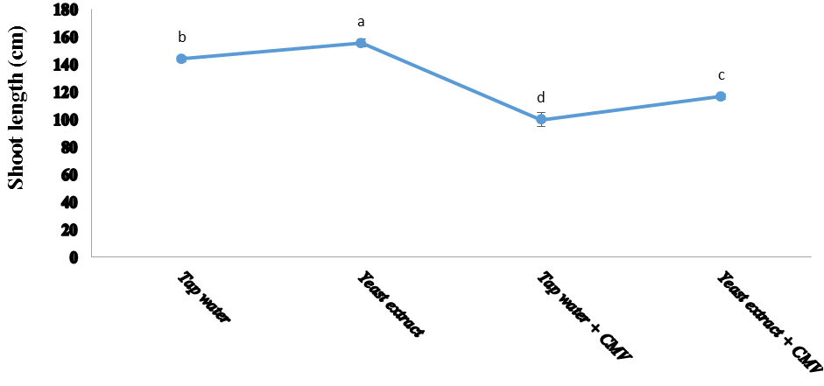
Figure 1. Effect of tap water and yeast extract on shoot length of healthy and infected cucumber plants

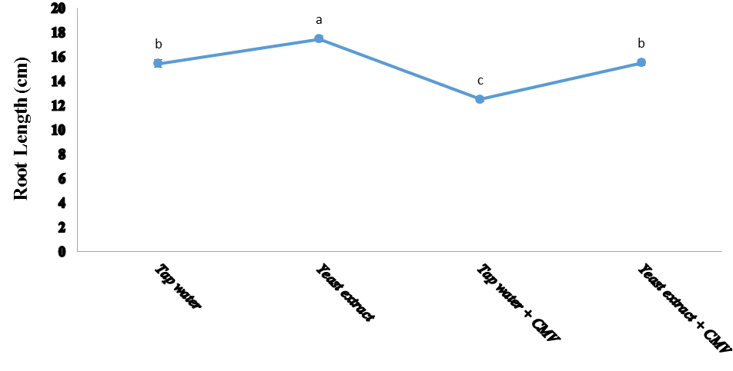
Figure 2. Effect of tap water and yeast extract on root length of healthy and infected cucumber plants

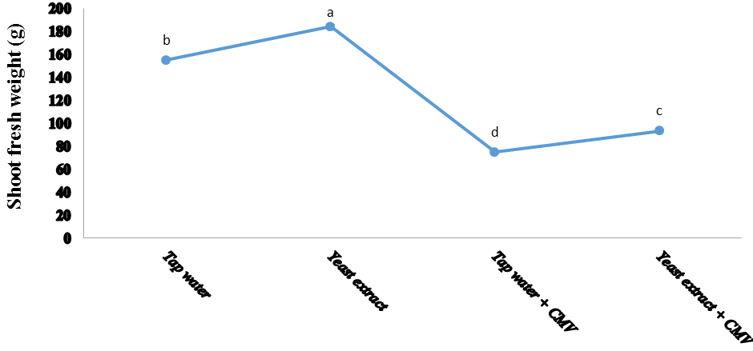
Figure 3. Effect of tap water and yeast extract on shoot fresh weight of healthy and infected cucumber plants

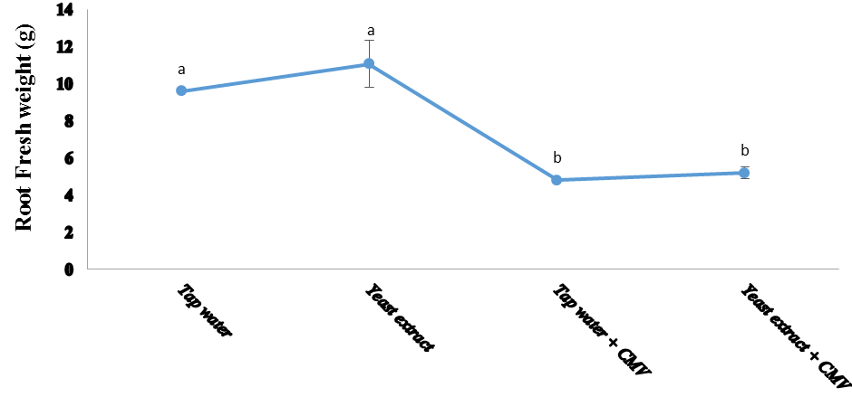
Figure 4. Effect of tap water and yeast extract on root fresh weight of healthy and infected cucumber plants
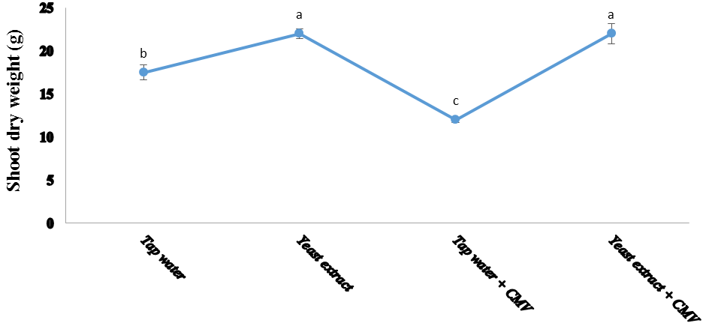
Figure 5. Effect of tap water and yeast extract on shoot dry weight of healthy and infected cucumber plants

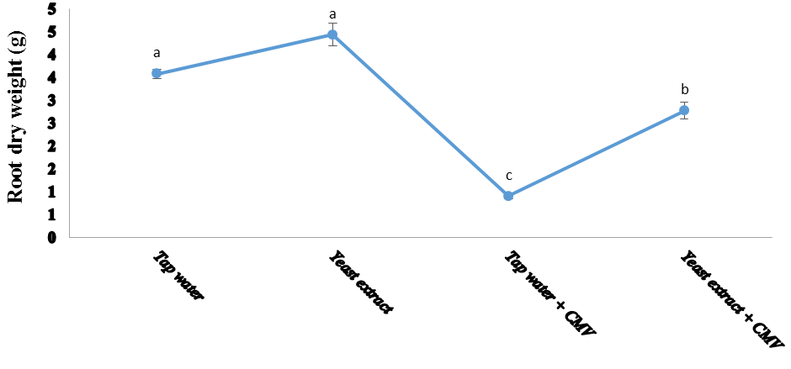
Figure 6. Effect of tap water and yeast extract on shoot dry weight of healthy and infected cucumber plants

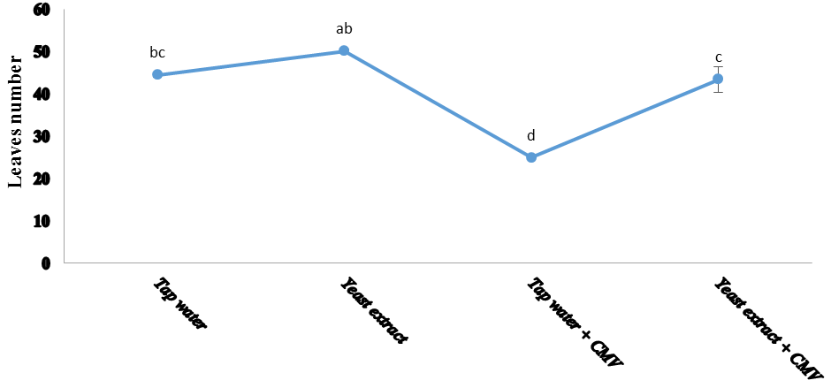
Figure 7. Effect of tap water and yeast extract on leaves number of healthy and infected cucumber plants

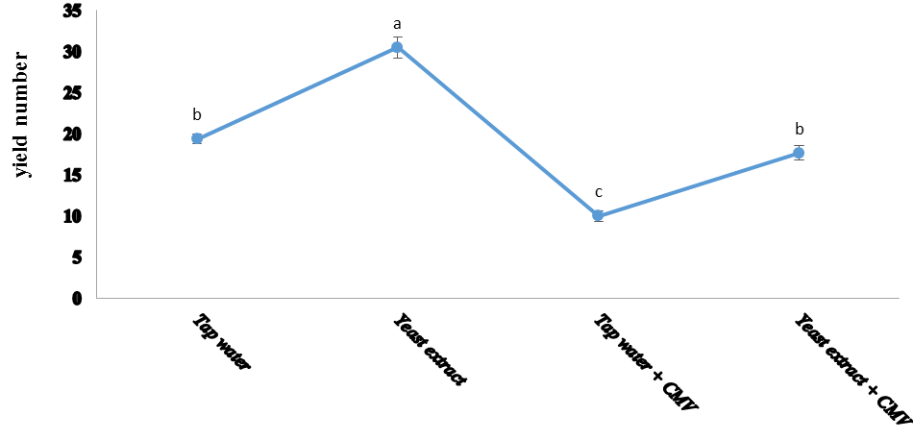
Figure 8. Effect of tap water and yeast extract on fruits number of healthy and infected cucumber plants
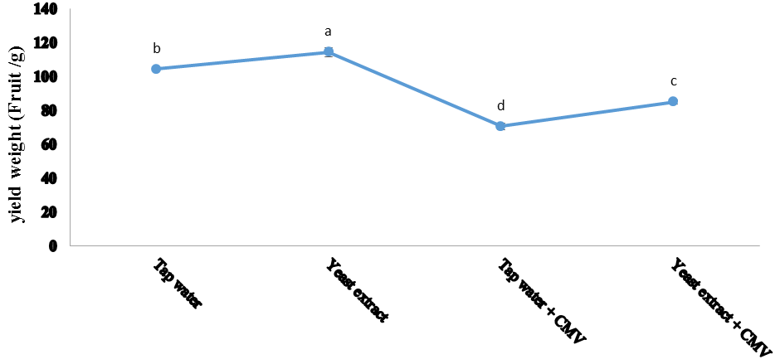
Figure 9. Effect of tap water and yeast extract on fruits weight of healthy and infected cucumber plants

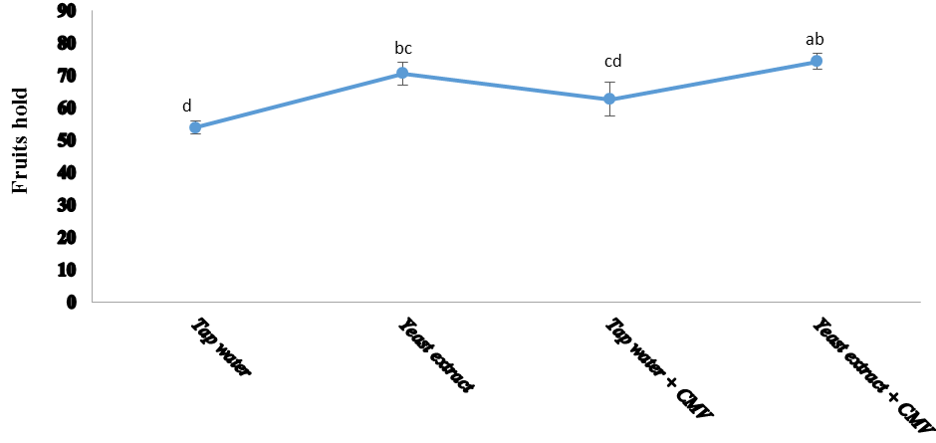
Figure 10. Effect of tap water and yeast extract on fruits hold of healthy and infected cucumber plants

3.2. Soluble Carbohydrate
The result of this work (Figs. 11 & 12) showed that Cucumis sativus L. plants infected with CMV, lead to significant decreases in carbohydrates shoot and fruits when being compared with healthy plants. While, in infected treatments, significantly decreasing in carbohydrates shoot and fruits were observed in cucumber plants, where infected yeast extract significant decrease in carbohydrates fruits, but insignificant in carbohydrates shoot when compared with absolute control plants.

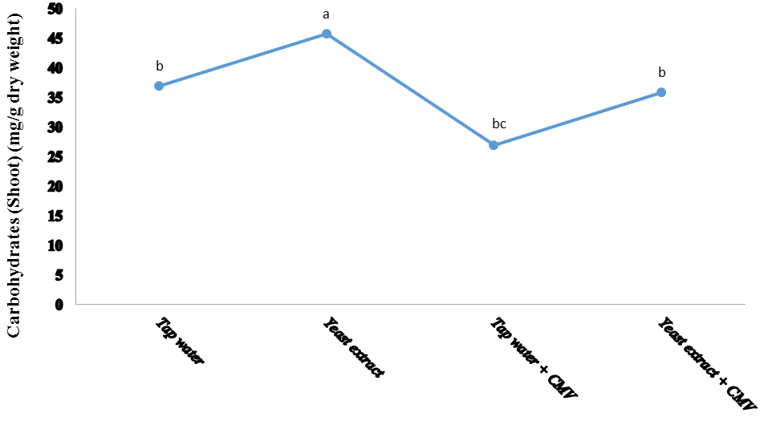
Figure 11: Effect of tap water and yeast extract on dry weight carbohydrates of healthy and infected cucumber plants
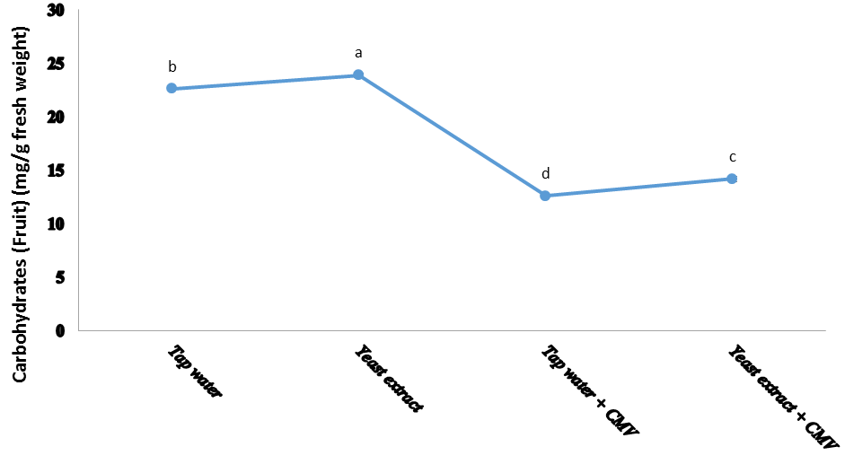
Figure 12. Effect of tap water and yeast extract on fresh weight carbohydrates of healthy and infected cucumber plants

3.3. Antioxidant Enzymes Activities
The influence of viral infection and treatment with yeast on the actions of ascorbate peroxidase (ASC) and glutathione reductase (GR) are shown in Figs. (13 & 14). In virus injected leaves, the antioxidant enzymes activities (ASC and GR) increase significantly when compared to that of the healthy control. Also, the rise reached the highest value in challenged treatment [yeast] when compared with absolute control plants.

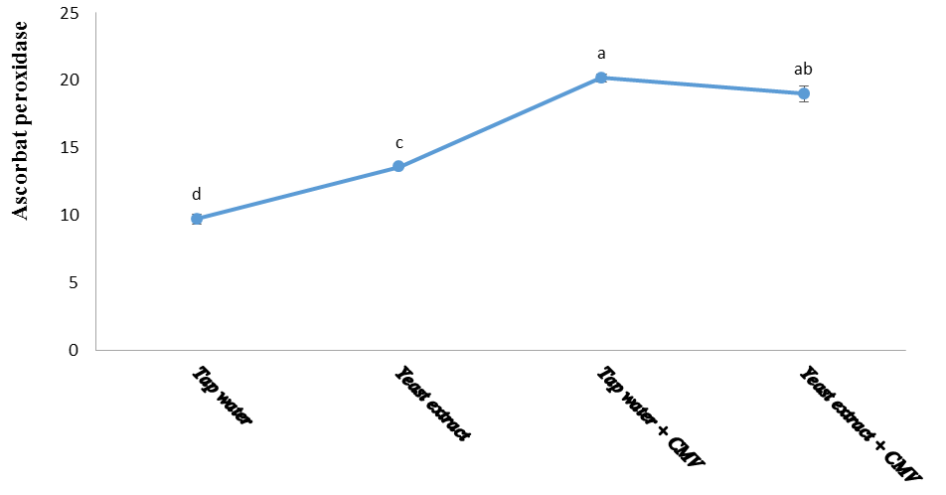
Figure 13. Effect of tap water and yeast extract on ascorbate peroxidase of healthy and infected cucumber plant

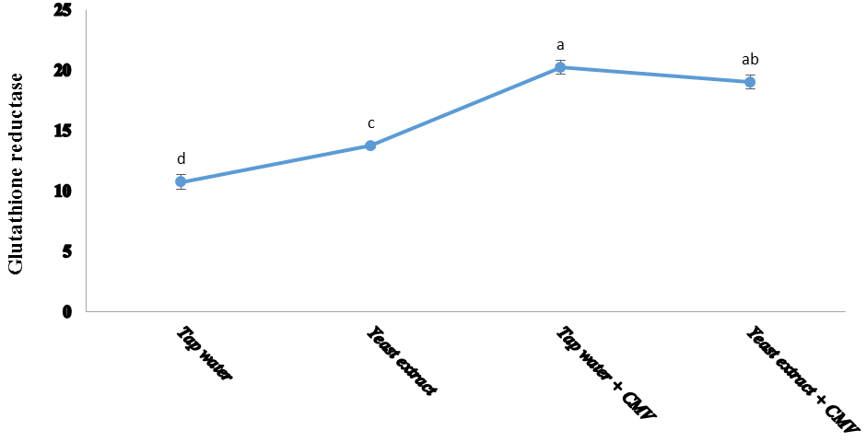
Figure 14. Effect of tap water and yeast extract on glutathione reductase of healthy and infected cucumber plants

4. Discussion
The objective of this study was induction systemic acquired resistance (SAR) in Cucumis sativus L. alfa-beta plants against virus infection with CMV upon priming with yeast extract treatment and subsequent challenge inoculation of the plant with the virus. No strategies are currently available to completely protect these plants against the virus, but a common feature of induced resistance to the disease is the priming of plant tissues by elicitors that allows rapid deployment of active defense mechanisms against invading pathogen [24]. We try to realize this purpose; many experiments were successive to deduce if induction of systemic acquired resistance was successfully achieved could also protect Cucumis sativus L. alfa-beta plants against infection by CMV. During the present work, two inducer seeds-soaked treatments (yeast extract) were tested for their potentiality as resistance inducers in the treated plants.
This work illustrated that Cucumis sativus L. alfa-beta plants infected with Cucumber mosaic virus, resulted in significant decreases in leaves number, fruits number, and fruits weight but insignificant in fruits hold when being compared with healthy plants. On the other hand, cucumber plants infected with CMV and treated with yeast extract resulted in significant decreases in fruits weight, but significant increase in fruits hold and insignificant in leaves number when being compared with healthy plants. These results in agreement with Sikora et al. [25] and Gianessi et al. [26]. As well as, the CMV infection in Indonesia cause a decrease in tomato yield, approximately 50 to 100%, and dry yeast is a natural bio-substance suggested to have stimulating, nutritional and protective functions when used on vegetables. Foliar application of yeast was found to increase growth, yield and quality of many vegetable crops [27, 28, 29], where improving growth and productivity of vegetable crops by application of active yeast extract on pea [30, 31], beans [32], eggplant [33] and potato [34],
The present work proved that, Cucumis sativus L. plants infected with CMV, lead to significant decreases in carbohydrates shoot and fruits, when being compared with healthy plants. Too, in infected treatments, significantly decreasing in carbohydrates shoot and fruits were observed in cucumber plants, where infected yeast extract significant decrease in carbohydrates fruits, but insignificant in carbohydrates shoot when compared with healthy plants. It has been acknowledged that the virus infection leads to decreased sugar levels in plant tissues, where the plants have the ability to modulate their sugar pools to act either as a source of carbon and energy or to use as signals and perhaps as putative priming agents to intensify immune reactions [35, 36]. Like results were verified where the Cucumis sativus L. leaves infected with cucumber mosaic virus were having a low concentration of carbohydrates, which increases the chances of the establishment of the virus. Where yeast extract was suggested to participate in a beneficial role during vegetative and reproductive growths. This through improving flower formation and their set in some plants due to its high auxin and cytokinins content and enhancement carbohydrates accumulation [37].
Yeast extract stimulatory effects on cell division and enlargement, protein and nucleic acid synthesis and chlorophyll formation [38], in addition to its content of cryoprotective agent, i.e., sugars, protein, amino acids and also several vitamins [39]. A lot of resistance enzymes that have been related to systemic acquire resistance comprise ascorbate and glutathione reductase [40, 41]. These enzymes also transport about freedom of molecules that elicit the first steps in the initiation of resistance, phytoalexins and phenolic compounds [42]. In virus injected leaves, the antioxidant enzymes activities (ASC and GR) increase significantly when compared to that of the absolute control. Also, the increase reached the highest value at challenged treatment yeast extract when equated to that of the absolute control. These results are in promise with Vitti et al. [43], where they showed that tomato plants infected with CMV had significantly increased ASC compared with control, which may lead to the induction of defense responses according to several studies [44, 45].
The changes in biochemical components in mesta plant infected with yellow vein mosaic disease were studied by Arpita and Subrata [46], they described that the enzyme assays exposed lower activity of CAT and GR enzymes in diseased plants in comparison with healthy ones; in difference, a marked increase in activities of PPO and SOD was found in diseased plants as compared with the respective healthy plants. The compatible and incompatible plant-virus interactions between Vigna mungo and Mungbean yellow mosaic india virus were studied by Subrata [41], they informed that the activity of GR sharply increased upon MYMIV infection at 3 dpi (day post infection) during incompatible interaction and gradually increased up to 2.3-fold at 14 dpi compared to that of the control. While there was a steady increase in the GR activity during compatible interaction from 7 dpi (day post infection) onwards and significant level was attained at 14 dpi, CAT activity declined significantly at 3 and 7, dpi as compared to that of the control during incompatible interaction. Whereas CAT activity increased significantly from 7 dpi during compatible interaction and 1.8-fold increment was noted at 14 dpi. The activity of APX was induced significantly from 3 dpi during the incompatible interaction, whereas a significant increase in APX activity was recorded from 7 dpi onwards during incompatible interaction.

5. Conclusion
The goal of this scholarship is to study the influence of viral infection on morphological changes and metabolism of cucumber plants and also the use of yeast extract hopping to abolishing the harmful belongings of Cucumber mosaic virus on these plants. It can conclude that yeast extract treatment increases the Cucumis sativus L. alfa-beta plants resistance against CMV.

Corresponding Author
Dr. Mahmoud R. Sofy
Botany and Microbiology Department
Faculty of Science
Al-Azhar University, 11884 Nasr City, Cairo, Egypt
E-mail: mahmoud_sofy@yahoo.com

References
- Gursoy M, Balkan A and Ulukan H (2012). Ecophysiological Responses to Stresses in Plants: A General Approach. Pakistan Journal of Biological Sciences, 15(11): 506-516.
- Pimentel D (2002). Biological Invasions: Economic and Environmental Costs of Alien plant, Animal and Microbe Species. CRC Press, Boca Raton, FL, USA, pp: 384.
- Low PS and Merida JR (1996). The oxidative burst in plant defense function and signal transduction. Physiol Plant, 96: 533-542.
- Milavec M, Ravnikar M and Kovac M (2001). Peroxidases and photosynthetic pigments in susceptible potato infected with potato vims YNTN. Plant Physiol Biochcm, 39: 891-898.
- Mittler R (2002). Oxidative stress, antioxidants and stress tolerance. Trends Plant Sci, 7: 405-410.
- Miteva E, Hristova D, Nenova V and Maneva S (2005). Arsenic as a factor affecting virus infection in tomato plants: changes in plant growth, peroxidase activity and chloroplast pigments. Sci Hortic, 105: 343-358.
- Tecsi LI, Smith AM, Maule AJ and Leegood RC (1996). A Spatial analysis of physiological changes associated with infection of cotyledons of marrow plants with Cucumber mosaic virus. Plant Physiology, 111(4): 975-985.
- Sofy MR, Sharaf AMA, Noufl M and Sofy AR (2014a). Physiological and Biochemical Responses in Cucurbita pepo Leaves Associated with Some Elicitors-Induced Systemic Resistance against Zucchhini yellow mosaic virus. International Journal of Modern Botany, 4(2): 61-74.
- Chester KS (1933). The problem with acquired physiological immunity in plants. The Quarterly Review of Biology, 8(3): 275-324.
- Ryals J, Neuenschwander U, Willits M, Molina A, Steiner H and Hunt M (1996). Systemic acquired resistance. Plant Cell, 8: 1809-1819.
- Park SW, Kaimoyo E, Kumar D, Mosher S and KIcssig DF (2007). Methyl salicylate is a critical mobile signal for plant systemic acquired resistance. Science Washington, 318(5847): 113-116.
- Megahed AA, El-Dougdoug KA, Othman BA, Lashin SM, Ibrahim MA and Sofy AR (2013). Induction of resistance in tomato plants against Tomato mosaic tobamovirus using beneficial microbial isolates. Pak. J. Biol. Sci., 16(8): 385-390.
- Sofy AR, Attia MS, Sharaf AMA and El-Dougdoug KA (2014b). Potential impacts of seed bacterization or Salix extract in faba bean for enhancing protection against bean yellow mosaic disease. Nature and Science, 12(10): 67-82.
- Bhardwaj D, Ansari MW, Sahoo RK and Tuteja N (2014). Biofertilizers function as key player in sustainable agriculture by improving soil fertility, plant tolerance and crop productivity. Microb Cell Fact, 13: 66.
- Nürnberger T and Brunner F (2002). Innate immunity in plants and animals: emerging parallels between the recognition of general elicitors and pathogen-associated molecular patterns. Curr Opin Plant Biol, 5 318e324.
- Lyon GD and Newton AC (1997). Do resistance elicitors offer new opportunities in integrated disease control strategies. Plant Pathology, 46: 636–641.
- Gerhardson B (2002). Biological substitutes for pesticides. Trends Biotechnol, 20: 338-343.
- Clark MF and Adams A (1977). Characteristics of the microplate method of enzyme linked immunosorbent assay for the detection of plant viruses. J of Gen Virology, 34: 475-483.
- Umbriet WW, Burris RH, Stauffer JF, Cohen PP, Johsen WJ, Lee page GA, Patter VR and Schneicter WC (1969). Manometric techniques, manual describing methods applicable to the studs of tissue metabolism. Burgess publishing co., U.S.A; P.P.239.
- MuKherjee SP and Choudhuri MA (1983). Implication of water stress-induced changes in the level of endogenous ascorbic acid and hydrogen peroxide in Vigna seedlings. Physiologia Plantarum, 58(2): 166-170.
- Chen Y, Cao XD, Lu YX and Wang R (2000). Effects of rare earth metal ions and their EDTA complexes on antioxidant enzymes of fish liver. Bull Environ Contam Toxicol, 65: 357-365.
- Karni L, Moss S and Tel-OR E (1984). Glutathione reductase activity in heterocysts and vegetative cells of cyanobacterium Nostoc muscrum. Arch Microbiol, 140: 215-217.
- Snedecor GW and Chochran WG (1982). Statistical Methods. 7th ed. Iowa State Univ. Press. Iowa, USA.
- Mandal S, Kar I, Mukherjee AK and Acharya P (2013). Elicitor-induced defense responses in Solanum lycopersicum against Ralstonia solanacearum. The Scientific World J, 12: 201–218.
- Sikora EJ, Gudauskas RT, Murphy JF, Porch DW, Andrianifahanana M, Zehnder GW, Bauske EM, Kemble JM and Lester DFA (1998). A multivirus epidemic of tomatoes in Alabama. Plant Disease, 82(1): 117-120.
- Gianessi L, Sankula S and Reigner N (2003). Plant Biotechnology: Potential Impact for Improving Pest Management in European Agriculture: Tomato-Virus-Resistant Case Study. Washington DC: The National Center for Food and Agricultural Policy, 18(9): 821-839.
- Abou El-Nasr ME, El-Shabrawy RA and Abd El-Rahman MM (2001). Effect of bread yeast application and some nutrient elements on squash (Cucurbita pepo L) plant growth, yield and fruit quality under conditions of the early summer planting. J Agric Sci Mansoura Univ, 26(7): 4451-4464.
- Kabeel MM and Sand FMA (2005). Effect of organic and biofertilizer on growth, yield and fruit quality of cucumber grown under clear polyethylene low tunnels. J Agric Sci Mansoura Univ, 30(5): 2827-2841.
- Fawzy ZF (2007). Increasing productivity of head lettuce by foliar spraying of some bio- and organic compounds. Egypt J Appl Sci, 22(10): 237-247.
- Tartoura EAA (2001). Response of pea plants to yeast extract and two sources of N-fertilizers. J Agric Sci, Mansoura Univ, 26(12): 7887-7901.
- El-Desuki M and El-Greadly NHM (2006). Response of pea plants to foliar application of yeast extract. J Agric Sci Mansoura Univ, 31(10): 6667-6674.
- Amer SSA (2004). Growth, green pods yield and seeds yield of common bean (Phaseolus vulgaris L) as affected by active dry yeast, salicylic acid and their interaction. J Agric Sci Mansoura Univ, 29(3): 1407-1422.
- El-Tohamy WA, El-Abagy HM and El-Greadly NHM (2008). Studies on the effect of Putrescine, Yeast and Vitamin C on Growth, Yield and Physiological Responses of Eggplant (Solanum melongena L.) Under Sandy Soil Conditions. Australian J. of Basic and Applied Science, 2(2): 296-300.
- Ahmed AA, Abd El-Baky MMH, Zaki MF and Faten S (2011). Effect of foliar application of active yeast extract and zinc on growth, yield and quality of potato plant (Solanum tuberosum L). J of Applied Sci Research, 7(12): 2479-2488.
- Shalitin D and Wolf S (2000). Cucumber mosaic virus infection affects sugar transport in melon plants, Plant Physiology, 123: 597-604.
- Gómez-Ariza J, Campo S, Rufat M, Estopà M, Messeguer J, San Segundo B and Coca M (2007). Sucrose-mediated priming of plant defense responses and broad-spectrum disease resistance by overexpression of the maize pathogenesis-related PRms protein in rice plants. Molecular Plant Microbe Interactions, 20(7): 832-842.
- Barnett JA, Payne RW and Yarrow D (1990). Yeasts characteristics and identification. Cambradge. Camb. CBZBR, pp 999.
- Wanas AL (2006). Trails for improving growth and productivity of tomato plants grown in winter. Annals Agric Sci Moshtohor, 44(3): 466-471.
- Mahmoued TR (2001). Botanical studies on the growth and germination of mahnolia (Magnolia grandiflora L.) plants. M. Sci. Thesis. Fac. of Agric. Moshtohor, Zagazig Univ., Egypt.
- Van Loon LC (1997). Induced resistance in plants and the role of pathogenesis-related proteins. European Journal of Plant Pathology, 103: 753-765.
- Subrata K, Dipjyoti C, Anirban K and Amita P (2013). Proteomics approach combined with biochemical attributes to elucidate compatible and incompatible plant-virus interactions between Vigna mungo and Mungbean yellow mosaic india virus. Proteome science, 11: 15.
- Van Loon LC, Bakker PAHM and Pieterse CMJ (1998). Systemic resistance induced by rhizosphere bacteria. Annu Rev Phytopathol, 36: 453-483.
- Vitti A, Pellegrini E, Nali, C, Lovelli S, Sofo A, Valerio M, et al. (2016). Trichoderma harzianum T-22 Induces Systemic Resistance in Tomato Infected by Cucumber mosaic virus. Frontiers in Plant Science, 7: 1520.
- Alscher RG, Erturk N and Heath LS (2002). Role of superoxide dismutase (SODs) in controlling oxidative stress in plants. J Exp Bot, 53: 1331–1341.
- Broxton CN and Culotta VC (2016). SOD Enzymes and Microbial Pathogens: Surviving the Oxidative Storm of Infection. PLoS Pathogens, 12(1): e1005295.
- Arpita C and Subrata KG (2008). Alteration in biochemical components in mesta plants infected with yellow vein mosaic disease. Brazilian Journal of Plant Physiology. 20(4), 267-275.

1/24/2018

