Bacteriological studies on gram negative bacteria isolated from some faecal and water samples in pasture of calves and goat

Abd El Hamid, T.M.¹ and I.A. Saleh²

¹Educational Hospital, Faculty Veterinary Medicine Cairo University, Egypt
²Faculty of Veterinary Medicine, Cairo University, Egypt
elerefaeytaher@yahoo.com

Abstract: Bacteriological study for 168 samples, consisted of 46 water samples collected from drinking droughts in small pasture incorporated with 122 faecal samples from diarrheic animals (goats and calves) and diarrheic attendants in the same pasture was carried out to elucidate the possible enteric bacteria encountered. Bacterological investigation showed that E.coli, salmonella spp., Aeromonas hydrophila and Pseudomonas aerogenosa were recovered in a numbers of 36,26,23 and 21 with a total incidence of 33.9, 24.5,21.7 and 19.8% respectively from studied (faecal and water ) samples. Pathogencity test of E.coli isolates using suckling mouse technique showed that 28 (77.8%) isolates produced heat stable enterotoxin (ST). Salmonella Typhimurium, S. Enteritidis, S. Anatum and S. Typhi were serologically identified with a number of 12,9,4, and 1 respectively. Escherichia coli was the most prevalent isolates in all studied samples and serological identified into:O119,O111,O55 and O85 serotypes.
[Abd El Hamid, T.M. and I.A. Saleh. Bacteriological studies on gram negative bacteria isolated from some faecal and water samples in pasture of calves and goat. N Y Sci J 2017;10(12):129-135]. ISSN 1554-0200 (print); ISSN 2375-723X (online). http://www.sciencepub.net/newyork. 15. doi:10.7537/marsnys101217.15.

Keywords: Gram negative, faecal, water, calves, goat

1. Introduction
water is an important vehicle for the transmission of the diseases. These types of bacteria are designed as water-born microorganisms. Water was reported to serve as a persistent vehicle especially for the transmission of the enteropathogenic bacteria ( Al mawly et al.2014 ).
Different bacterial pathogenic agents were reported to be isolated from different water supplies. Salmonella was isolated from water contaminated with sewage (El seedy et al.2016). The presence of enteropathogenic E.coli in drinking water indicates that a health hazard exist because of the possible presence of pathogens (APHA 1995). Aeromonas species have been considered as a major water born microorganism that causes infection (Brochardt et al. 2003, Asmaa 2015). Isolation of Aeromonas and Pseudomonas aerogenosa from different types of water had been reported (Gibotti et al. 2000).
Diarrhea is a complex disease in human and causes a significant economic impact in animals due to the heavy losses. Generally the previously mentioned water-born enteric bacteria are true pathogens that cause diarrhea in different animals and human. (Hornitzke et al. 2005).
Escherichia coli and salmonella among other enteric bacteria were the main encountered microorganisms in calve diarrhea. Escherichia coli diarrhea is considered as one of the major problems facing livestock production in Egypt (Islam et al. 2015). Aeromonas species have been recognized as enteric pathogen for human and animals. Pseudomonas aerogenosa was incriminated in the induction of pathological condition in domestic animals and human (Wong et al. 2000). Pseudomonas aerogenosa and aeromonas have been associated with human diarrhea diseases and extra intestinal infections (Nikibin et al. 2012).
A number of diarrheic cases was recorded in calves, goats and some owners in small pasture and attention was paid for the probability of water pollution. Hence, it was designed to carry out a bacteriological study for water samples, collected from different sources in that area incorporated with faecal samples collected from a diarrheic animals as well as diarrheic attendants to elucidate the possible enteric bacterial cause encountered as well as the possible correlation with water pollution.

2. Materials and methods
A total of 168 samples consisted of 46 water samples from the animal drinking draughts (underground water) and 122 faecal samples from 58 diarrheic calves, 28 diarrheic goats and 36 diarrheic attendants in the same pasture were collected from small pasture forming grouping in which no water pipe supplies was available. Water samples were collected under sterile condition and transported with the faecal samples in ice box as quick as possible.
Detection of indole-positive faecal coliform (presumptive E.coli in water samples was carried out by using the multiple tube fermentation techniques (MPN)confirmed by Eijkman test according to standard methods for examination of water and waste water
Isolation of E.coli and salmonella spp:
Each water samples divided into two portions then centrifugated in cooling centrifuge (4°C) for 30 minutes. One sediment mass of water and faecal samples streaked directly and indirectly after inoculation into selenite F.broth and nutrient broth over night at 37°C onto sheep blood agar, MacConkey agar, salmonella-shigella agar and eosin methylene blue agar plates and incubated aerobically at 37°C for 24h. The suscepected growing surface colonies are identified according to Quinn et al (2000).
Isolation of A.hydrophila and Pseudomonas aerogenosa:
The second sediment mass of water samples were resuspended in 10 ml peptone water (pH7.2) and incubated at 37°C for 24 hr for enrichment of Aeromonas and Pseudomonas aerogenosa faecal samples were inoculated into alkaline peptone water (pH8.6) over night at 37°C then both of them streaked onto plates of pseudomonas agar, A eromonas agar (xylose lysine desoxycholate ) at 37°C for 24 hours. Identification of growing surface colonies was done as above.
Serotyping of E.coli isolates was done by using slide agglutination test using “Wellcome E.coli diagnostic anti-sera”.
Serological identification of salmonella isolates was carried out according to Kauffmann-White scheme (kufmann 1973).
Pathogencity test:
All E.coli isolates were tested for the ability of production of heat stable toxin by infant mouse test (Robins et al. 1983).
DNA extraction. DNA extraction from samples was performed using the QIAamp DNA Mini kit (Qiagen, Germany, GmbH) with modifications from the manufacturer’s recommendations. Briefly, 200 µl of the sample suspension was incubated with 10 µl of proteinase K and 200 µl of lysis buffer at 56^{O}C for 10 min. After incubation, 200 µl of 100% ethanol was added to the lysate. The sample was then washed and centrifuged following the manufacturer’s recommendations. Nucleic acid was eluted with 100 µl of elution buffer provided in the kit.
Oligonucleotide Primer. Primers used were supplied from Metabion (Germany) are listed in table (1):
PCR amplification. Primers were utilized in a 25- µl reaction containing 12.5 µl of Emerald Amp Max PCR Master Mix (Takara, Japan), 1 µl of each primer of 20 pmol concentration, 4.5 µl of water, and 6 µl of DNA template. The reaction was performed in an Applied biosystem 2720 thermal cycler.
Analysis of the PCR Products.
The products of PCR were separated by electrophoresis on 1.5% agarose gel (Applichem, Germany, GmbH) in 1x TBE buffer at room temperature using gradients of 5V/cm. For gel analysis, 20 µl of each PCR product were loaded in each gel slot. A gene ruler 100 bp DNA Ladder (Fermentas, Germany) were used to determine the fragment sizes. The gel was photographed by a gel documentation system (Alpha Innotech, Biometra) and the data was analyzed through computer software.

Table (1 ): Primers sequences, target genes, amplicon sizes and cycling conditions.
Target gene | Primers sequences | Amplified segment (bp) | Primary denaturation | Amplification (35 cycles) |  |  | Final extension | Reference
 |  |  |  | Secondar denaturation | Annealing | Extension
Stx2 | CCATGACAACGGACAGCAGTT | 779 | 94˚C 10 min. | 94˚C 1 min. | 58˚C 1 min. | 72˚C 1 min. | 72˚C 10 min. | Dipineto et al., 2006
 | CCTGTCAACTGAGCAGCACTTTG
eaeA |  | 248 | 94˚C 5 min | 94˚C 30 sec | 51˚C 30 sec. | 72˚C 30 sec. | 72˚C 7 min | Bisi-Johnson et al., 2011
 | ATG CTT AGT GCT GGT TTA GG
 | GCCTTCATCATTTCGCTTTC

3. Results
The results showed that a total of 106 different pathogenic microorganisms were recovered from the 168 examned samples. Out of 46 water samples, 32 were positive. Similarly 37,17, and 20 samples were positive from the 58,28, and 36 faecal samples examned from diarrheic calves, goats and human respectively. Ecoli, salmonella spp., Aeromonas hydrophila and Pseudomonas aerogenosa were recovered in a numbers of 36,26,23, and 21 with a total incidence of 33.9,24.5,21.7, and 19.8% respectively. (Table 1).
All water samples were investigated for indole-positive faecal coliform (presumptive E.coli ) revealed faecal pollution and the MPN/100 ml water were ranged from 11 to 540. .
Serological identification of the E.coli isolates reveled 4 serotypes, 36 were serotyped in 4 groups viz:O119,O111,O55, and O86 with a number of strains 6,4,4 and 3 respectively. The rest 19 strains were untyped (Table 2).
Serological identification of the recovered 26 salmonella strains showed that 12 were belonged to S. Typhimurium. Also, 9 and 4 strain proved to be S. Enteritidis and S. Anatum respectively. The last one strain proved to be S.Typhi (Table 3).
All Ecoli isolates cultured on sheep blood agar had haemolytic activities with an incidence of 100%. Pathogencity test were done for Ecoli isolates by infant mouse test where 28 isolates were enterotoxigenic with an incidence of 77.8. The incidence of enteric pathogenic strains isolated from the three main origin of samples viz.: water, animals, (calves and goats ) and human arranged in descending from is shown in table (4). The most prevalent and common bacterial species was E.coli followed by salmonella spp., Aeromonas hydrophila and Pseudomonas aerogenosa. S.Anatum was not isolated from human samples while S. Typhi was isolated from water samples only. (Table 5).

Table (1): G-ve enteric bacteria isolated from different investigated sources (water, calves, goats and human).
Sample origin | Water (46) |  | Calves (58) |  | Goats (28) |  | Human (36) |  | Total isolates
Isolates | No | % | No | % | No | % | No | % | No | %
E.coli | 10 | 21.7 | 13 | 22.4 | 7 | 25.0 | 6 | 16.7 | 36 | 33.97
Salmonella Species | 5 | 10.9 | 11 | 18.9 | 5 | 17.9 | 5 | 13.9 | 26 | 24.53
A.hydro-phila | 9 | 19.6 | 7 | 12.1 | 2 | 7.1 | 5 | 13.9 | 23 | 21.69
Pseudomonas aerogenosa | 8 | 17.4 | 6 | 10.3 | 3 | 10.7 | 4 | 11.1 | 21 | 19.81
Total | 32 | 69.6 | 37 | 63.8 | 17 | 60.7 | 20 | 55.6 | 106 | 100

Table (2): Haemolysin activities enterotoxin production and serotyping of Escherichia coli strains isolated from the studied samples.

Table (2) serological identification of E.coli isolates (36)
E.coli serogroup | No
O119 | 6
O111 | 4
O55 | 4
O86 | 3
unidentified | 19
Total | 36

Table (3) percentage calculated according to serological identification of Salmonella isolates (26)
Salmonella serogroup | O Antigen | No | Source
S.typhimurium | 114,5,12 | 12 | Water, animal,human
S.enteritidis | 119,12 | 9 | Water, animal, human
S.anatum | 3,16 | 4 | Water, animal
S.typhi | 9,12, | 1 | water

Table (4): Enteric bacteria isolated from the three main origins of samples viz.: water, animals and human arranged in descending form.
Water | Descending no | Animal Calves and goats | Descending no | Human | Descending no
E.coli | 10 | E.coli | 20 | E.coli | 6
A.hydrophila | 9 | Salmonella Spp. | 16 | Salmonella Spp | 5
Pseudomonas aerogenosa | 8 | Pseudomonas aerogenosa | 9 | A.hydrophila | 5
Salmonella Spp | 5 | A.hydrophila | 9 | Pseudomonas aerogenosa | 4

Table (5): Incidence of isolated bacteria in correlation to the samples origin.
Isolates | Total | Sample origin
 |  | Water (46) |  | Animal (86) |  | Human (36)
 |  | No | % | No | % | No | %
1. E.coli | 36 | 10 | 21.7 | 20 | 23.3 | 6 | 16.7
2. Salmonella spp. | 26 | 5 | 10.9 | 16 | 18.6 | 5 | 13.9
S.Typhimurium | 12 | 2 | 4.3 | 7 | 8.1 | 3 | 8.3
S.Enteritidis | 9 | 1 | 2.2 | 6 | 6.9 | 2 | 5.6
S.Anatum | 4 | 1 | 2.2 | 3 | 3.5 | 0 | 0.0
S.Typhi | 1 | 1 | 2.2 | 0 | 0.0 | 0 | 0.0
3. A.hydrophila | 23 | 9 | 19.6 | 9 | 10.5 | 5 | 13.9
4. Pseudomonas aerogenosa | 21 | 8 | 17.4 | 9 | 10.5 | 4 | 11.1
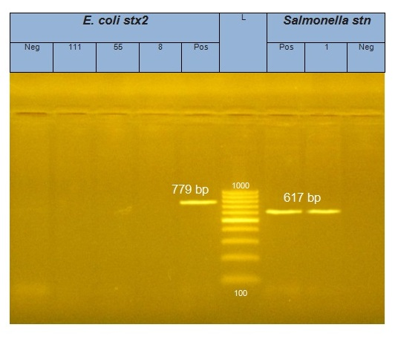
L: represents the molecular size marker (100-1000 bp DNA ladder)
Neg: Negative control
Pos: Positive control of stn (617bp)
1: positive for stn gene (617bp)

Photo (1): Electrophoretic pattern of shigatoxin2(stx2) gene in different E.coli isolates:

6 | 5 | 4 | Pos | L | 3 | 2 | 1 | Neg
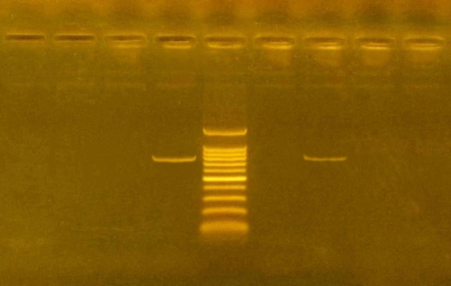
Agarose gel electrophoresis of stx2 virulent gene among DNA products of E. coli isolates: Lane l:100-1500 bp DNA ladder, pos: control positive, Neg: control negative lane 2: E. coli isolate had stx2 virulent gene at 779bp, lane 1,3,4,5,6: negative samples.

Photo (2): Electrophoretic pattern of (eaeA) gene in different E.coli isolates:

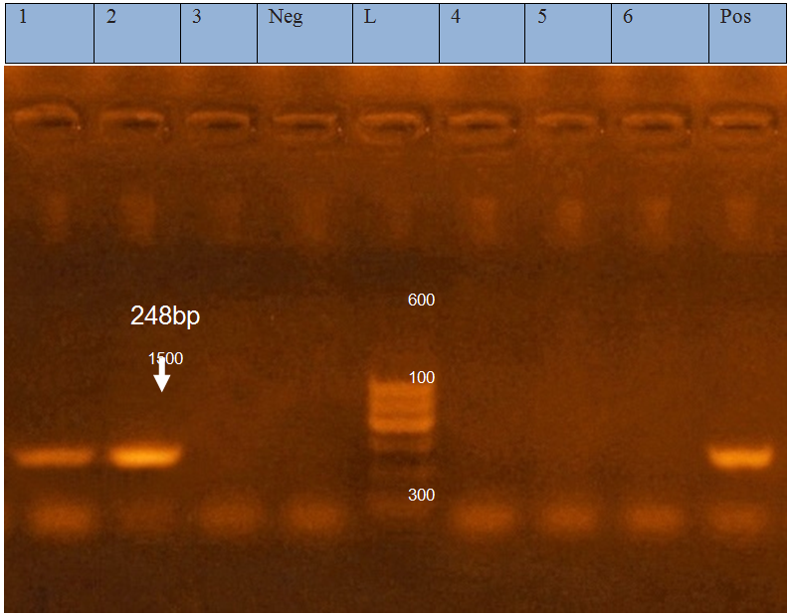
Agarose gel electrophoresis of eaeA virulent gene among DNA products of E. coli isolates: Lane l:100-600 bp DNA ladder, pos: control positive, Neg: control negative lane 1,2: E. coli isolates had eaeA virulent gene at 248 bp, lane 3,4,5,6: negative samples.

Table (6): Occurrence of some virulent genes of E.coli isolated
Isolates | Virulence genes of E.coli
 | Stx2 | eaeA
1 | - | +
2 | + | +
3 | - | -
4 | - | -
5 | - | -
6 | - | -

4. Discussion
A complex, variety of factors considered as a life threatening causes for both animals and human. Environment, habits, immunity and microbial contamination play an important role in disease condition such as diarrhea. Generally water-borne disease constitutes a major hazard for animals and human. During our study four pathogenic enteric bacteria were recovered, namely: Escherichia coli, Salmonella spp., Aeromonas hydrophila and Pseudomonas aerogenosa. Escherichia coli diarrhoea was studied by many authors (Gharieb et al.2015). E coli showed to be predominant bacterial cause. It considered one of the major problems all over the world (Badouei et al. 2010).
The results showed that E.coli was recovered from diarrheic cases with incidence ranged from 16.7% in human to 23.3 in animals. This incidence goes in parallel with that previously reported which reached 17%, in human (El shaboury et al.,1999). In animals, our results agreed with that reported by (Tanios et al.,2000 ). Also in Water our results (21.7 %) agreed with that previously reported (Ali,2002).
Serologically the 36 isolated E.coli strains from different sources viz. water, calves, goats and human, 6 strains were serotyped as O119,4 as O111,4 as O55 and 3 as O86. The rest 19 strains were untyped with the available diagnostic sera in agreement with that previously isolated from water.
In human, and animals the most prevalent Ecoli serotype was O119 which agreed with the published data. (Rivas et al.2015).
It is interesting to mention that incidence of haemolysin activities of E. coli which goes in parallel with available data; for 36 recovered E. coli strains tested by infant mouse test showed that 28 were toxigenic with an incidence of 77.8% in agreement with the previous reports. (Sepehriseresht et al. 2009).
Salmonella microorganisms constituted the second important isolated enteric bacteria. The highest incidence (18.6%) of salmonella spp. was recovered from diarrheic animals and followed by diarrheic human (13.9%) and the lowest incidence in water (10.9%). Serotyping of the isolated 26 strains revealed that 12, 9, 4 and 1 were identified as S. Typhimurium, S. Entritidis, S. Anatum and S. Typhi J: espectively. S. Typhimurium proved to constitute the most prevalent serovar. (Coura et al. 2015).
It is worthy to denote that our result of salmonella spp. agreed with that reported in human and in animal (Dumontet, et al. 2003). In water, lower incidence was reported. It was important to mention that although S. Typhi, the important pathogen for human, was isolated in a lower incidence (2.2%) from water, while couldn't be isolated from human samples.
Aeromonas hydrophila and Pseudomonas aerogenosa showed the highest incidence from water samples as they were recovered in incidence of 19.6% and 17.4% respectively. The same two types of microorganisms were recovered from diarrheic animals with an incidence of 10.5% for both and thus showed higher incidence with human samples which showed incidence of 13.9% and 11.1% for the two types respectively. These results could be summarized in that A. hydrophila was highest in water 19.6% followed by human (13.9%) and least with animals (10.5%). Pseudomonas aerogenosa goes in the same way where the highest incidence was from water (17%) followed by human 11.1% and least with animals (10.5%).
Isolation of Aeromonas hydrophila from different water sources was reported continuously and considered a major water born microorganism. Attention has been focused on A. hydrophila as a cause of severe enteritis with diarrhea in human being since 1995. Recently, it was recovered from diarrheic animals and our results goes in parallel with that cited. Our results showed that the recovery of A. hydrophila with an incidence of (19.6%) agreed with that of water samples which ranged from 15.4% to 25.7% (57) and in (13.9%) human. (Sahar et al. 2001).
In this study, incidence of Pseudomonas aeroginousa was in water, animal and human (17.4, 10.7 and 11.1% respectively) which agreed with that previously recorded (Branhama, et al. 2005).
Dealing with Pseudomonas aerogenosa seasonal variation in its abundance in the samples of surface water in Europe was reported ( Pragsam et al. 2016) Gibotti et al.2000).
Amplification of stx2 and aeaA genes resulted in a single amplicon with a size of approximately779 and 248 bp, respectively for E. coli strains indicating these genes as in photo (1,2) El-Seedy et al. (2016)
E coli strains recovered from subclinical mastitic cases were found invasive with incidence of 50 % carrying (aeaA) gene. This result is not corresponding with that by Islam et al. (2015) who found that none of isolated E coli strains was invasive. In this study 16.66 % of isolated E. coli carried stx2 gene as one of the most important virulence factors. A similar prevalenceof 23.8% is reportedby (Momtaz, 2010).
In other study, 30.8% of udders were E.coli-positive for this gene (Cobbold and Desmarchelier, 2000). Our finding show ever differed from those recorded by Dogan et al., (2006) and Bean et al., (2004) who have not established stx genesin their studies.
Conclusion and Recommendation
Water pollution by enteric organisms particularly true fecal type E.coli is a problem facing owners in animal farms. Infected animal by various species of G-ve enteric bacteria is the main source for water supplies pollution and also contact the human in the appreciate farm.E.coli, Salmonella, A. hydrophila and Pseudomonas are major enteric pathogens infected animals and consequently polluted water supplies and transmitted to human being, this strict hygienic measures should be applied in animal farms and small pasture to prevent water pollution, human infection from infected animal and control this cycle.

References
- Ali, N. A (2002): Zoonotic importance of Entero pathogenic E. coli (EPEC). Ph. D. Thesis, Zoonoses, Fac. Vet. Med. Zagazig Uni.
- Al Mawly, J:, Grinberg A:, Prattley, D:, Moffat, J, French N. (2014). Prevalence of endemic enteropathogens of calves in New Zealand dairy farms. New Zealand veterinary journal, (19):1-18.
- Asmaa, M. B. (2015): relationship between microorganismsand immunological paramaters in calves with diarrhea. D. V. SC thesis microbiology and fungus fac. vet. med, Alexuniv.
- American Public Health Association "APHA" (1995): Standard methods for examination of water and waste water. APHA Fifteenth street, N 19th ed., Washington, DC 2005.
- Badouei, M. A.; Salehi, T. Z.; Khorasgani, M. R.; Tadjbakhsh, H. and Brujeni, G. N. (2010): incidence and characterization of enterohaemorrhagic Escherichia coli isolates from diarrheic calves. Comparative clinical pathology, 19(3):295-300.‏
- Bisi-Johnson, M. A.; Obi, C. L.; Vasaikar, S. D.; Baba, K. A. and Hattori, T. (2011): Molecular basis of virulence in clinical isolates of Escherichia coli and Salmonella species from a tertiary hospital in the Eastern Cape, South Africa. Gut Pathogens 2011, 3:9.
- Brochardt, M. A.; Stemper, M. E. and Stendridge, J. H. (2003): Aermonas isolated from human diarrheic stool and ground water compared by pulsed field gel electrophoresis. Emerg. Infect. Dis., 9 (2): 224 – 228.
- Coura, F. M:, Freitas, M. D., Ribeiro, J:, de Leme, R. A:, de Souza, C. D:, Alfieri, A. A., & Heinemann, M. B. (2015). Longitudinal study of Salmonella spp., diarrheagenic Escherichia coli, Rotavirus, and Coronavirus isolated from healthy and diarrheic calves in a Brazilian dairy herd. Tropical animal health and production, 47(1), 3-11.‏
- Dipineto, L.; Santaniello, A.; Fontanella, M.; Lagos, K.; Fioretti, A. and Menna, L. F. (2006). Presence of Shiga toxin-producing Escherichia coli O157: H7 in living layer hens. Letters in Applied Microbiology 43 (2006) 293–295.
- Murugkar, H. V.; Rahman, H. and & Dutta, P. K. (2003): Distribution of virulence genes in Salmonella serovars isolated from man & animals. Indian J Med Res., 117:66-70.
- Dumontet, S.; Pasquale, V.; Mancino, M.; Normanno, G. and Krovacek, K. (2003): Incidence and characterization of Aeromonas spp. Environmental and human samples in Southern Italy. New microbial., 26(2): 215-225.
- El. Shaboury, F. A.; Khadr, A. M. and Bedair, T (1999): Prevalence of enterotoxigenic E. coli in calves in Kafer El Sheikh Governorate. Beni – Suef Veterinary Medical Journal 9 (2).
- El-Seedy, F. R.; Abed, A. H.; Yanni, H. A. and Abd El-Rahman, S. A. A. (2016): Prevalence of E. coli and Salmonella in neonatal diarrheic calves. Beni-Suef University Journal of Basic and Applied Sciences.
- Gharieb, R. M.; Fawzi, E. M.; Attia, N. E. and Bayoumi, Y. H. (2015): province of calf diarrhea in Sharkia, Egypt: diagnosis; prevalence, virulence profiles and zoonotic potential of the bacterial cause.‏International Journal of Agriculture Science and Veterinary Medicine, 3(2):71-87.
- Gibotti, A.; Saridakis, H. O.; Pelayo, J. S.; Tagliari, K. C. and Falcao, D. P. (2000): Prevalence and virulence properties of Vibrio cholerae non — 01, Aeromonas spp. and Pseudomonas aerogenosaisolated from Cambe Stream (State of Parana, Brazil) Journal of Applied Microbiology. 89: 70-75.
- Hornitzky, M. A.; Mercieca, K.; Bettelheim, K. A. and Djordjevic, S. P. (2005): Bovine feces from animals with gastrointestinal infections are a source of serologically diverse atypical enteropathogenic E. coli and Shiga toxin-producing E. coli Strains that Commonly Possess intimin. Applied and Environmental Microbiology, 71(7):3405-12.
- Islam, M., Sultana, S., Das, K., Sharmin, N. And Hasan, M. (2008): Isolation of Plasmid- Mediated Multidrug Resistant Escherichia coli. Int. J. Sustain. Crop Prod. 3(5):46-50.
- Islam, A. K. M. A.; Rahman, M.; Nahar, A.; Khair, A. and Alam, M. M. (2015): Is0lation of pathogenic Escherichia coli from diarrheic calves in selective area of Bangladesh. Bangladesh Journal of Veterinary Medicine, 13(1):45-51.
- Kaufmann, F. (1973): Serological diagnosis of Salmonella species. Kaufmann-White scheme, Copenhagen, Denmark.
- Momtaz, H. (2010): Investigation of virulence factors in Escherichia Coli isolated from clinical and subclinical bovine mastitis. Bulgarian Journal of Veterinary Medicine, 13, No 2, 122−12.
- Nikbin, V. S., Aslani, M. M, Sharaf, Z. (2012): molecular identification and detection of virulence genes among pseudomonas aeroginosa isolated from different infections origins. Iran. J. Microb.4(3)118-123.
- Pragasam, A. K, Raghanividha. M, Anandans. S. (2016): characterization Pseudomonas aeruginosa with discrepant carbapenum susceptibility profile. Annals of clinical microbiology and antimicrobials.15:1-4.
- Rivas, L.; Mellor, G. E.; Gobius, K. and Fegan, N. (2015): Identification and typing strategies for pathogenic Escherichia coli. Chapter 3, Briefs in Food, Health, and Nutrition.
- Sahar, R.; Zaki, H.; Ansam, M. Salman and Seleim R. S. (2001): Exotoxingenicity of Aeromonas species isolated from different sources. Inhibitory effect of essential oils on their growth. Veterinary Medical J., 49 (1): 111-12%.
- Sepehriseresht, S.; Salehi, T. Z.; Sattari, M.; Tadjbakhsh, H. and Aslani, M. M. (2009): Identification of Shigatoxigenic Escherichia coli from fecal samples of calves by molecular and serological methods. Comparative Clinical Pathology, 18(1):53-7.‏.
- Tanios, Ad.; Zaki, E. R.; El. Shernoby, R.; Mona A. El-Shabrawy and Seleim, R. S. (2000): Role of enteric bacteria in the aetiology of neonatal buffalo calves diarrhea. Vet. Med. J. Giza Vol. No.
- Wong TY, Tsui HY, So Mketal. (2000): Pseudomonas aerogenosainfection in Hong Kong: retrospective study of 167 laboratory confirmed cases. Hong Kong Med. J. 6:375-80.
- World Health organization (1971): International standards for drinking water. 3rd Ed., Geneva.

12/25/2017

