An In-Vitro Evaluation of Various Surface Treatments on the Shear Bond Strength of Resin Cement Bonded to Base Metal Alloy

Abdulelah M. BinMahfooz, BDS, DScD*

*Assistant Professor, Department of Oral and Maxillofacial Prosthodontics, Faculty of Dentistry, King Abdulaziz University, Jeddah, Saudi Arabia.

Abstract:Resin-bonded fixed partial dentures (RBFPDs) have appeared to prevent the excessive preparation of dental tissue with complete crown and reliable restorative alternative to conventional short span fixed dental prostheses.The most recurrent cause offailure of this type of restoration is de-bonding at the metal-cement junction. The purpose of this study was to evaluate the influence of different surface treatment of base metal alloy bonded with 2 different resin cements on the shear bond strength. Thirty discs of nickel chromium alloy were produced and divided into 3 groups according to various surface treatments, group I sandblasted,group II chemically etched; and group III laser treated. The three groups were further subdivided into subgroups Aand B,according to the resin cement used. The discs were bonded to the enamel surface of extracted natural central and lateral incisors with Panavia F2.0 (subgroup A) and Bistite II DC (subgroup B)resin luting cement. All bonded sampleswe restored in saline for 48 hours followed by thermos-cycling. Shear bond strength of all the specimens was measured by an Instron universal testing machine. Our results revealed a statistical significant difference between group (II) and group (III) and high shear bond strength value was observed with Panavia F 2.0 in laser group (III). Representative samples of each group were examined by means of scanning electron microscope (SEM). Based on the obtained results it can be concluded that laser has been proven as an effective tool for the metal surface treatment. The highest shear bond strength was recorded with laser metal surface treatment combined with Panavia F 2.0 resin cement.
[Abdulelah M. BinMahfooz An In-Vitro Evaluation of Various Surface Treatments on the Shear Bond Strength of ResinCement Bonded To Base Metal Alloy. N Y Sci J2017;10(12):64-69]. ISSN 1554-0200 (print); ISSN 2375-723X (online). http://www.sciencepub.net/newyork. 7. doi:10.7537/marsnys101217.07.

Keywords:surface treatment, luting cements, laser, bondstrength, SEM

1. Introduction:
Dental implant has the opportunity to offer patients minimally invasive fixed and potentially esthetic replacement resolution for single tooth replacement. However, implant may not be the best option for tooth replacement in many patients and which are looking for fixed replacement ⁽¹⁾.Dentistsfrequentlychoose resin retained fixed partial dentures as a preservative method that enables a fixed prosthetic replacement of missing teeth. A distinguished benefit of this method is minimaltooth reduction in comparison totraditionalfixed dental prosthesis⁽²⁾.The resin-bonded retainers have been successful only when the principles havebeen followed closely;especially metal preparations, tooth preparation with a specific metal design, and intra oral bonding steps⁽³⁾.
The retention of cast restorations depends on the adhesion between the cast alloy retainer and the luting cement, the cohesive strength of the luting cement itself and the adhesions between the luting cement and tooth structure. Although successful bonding has been achieved at the latter two sites, adhesion between the alloy and the cement is relatively inconsistent and a common site of failure.The actual mechanism of bonding between the alloy and cement is still elusive. Different theories have described the bonding mechanism as a function of mechanical, chemical or combination of both mechanical and chemical factors. Chemical bonding is reported to provide good metal-cement bonding. A link isformed between the oxides on the alloy surface and the lutingcement. Mechanical bonding between the alloy and cements proposes mechanical keying of the adhesive into the fine and minute irregularities of the substrate surface. It is of value to mention that large and deep irregularities of the alloy surface might lead to inclusion of voids at the alloy-cement junction disturbing proper wetting and subsequently reducing the bond strength⁽⁴⁾.
However, previous studies recommend the use of resin cements mostly described as filled dimethacrylate–based polymers that display low solubility and high tensile strength^{(5,6)}.Different preparation designs have been proposed by various authors, with varying claims for increasing retention and resistance forms which are essential to the success of resin bonded fixed partial dentures (RBFPDs) ^{(7,8)}.A variety ofsurface treatments have been employed to increase the bond strengths between the metal and the luting resin, including roughness of the metal surface, mechanical retention methods like undercuts, micro-retention methods like sandblasting, tin plating, electrolytic etching and theuse of metal bonding agents and laser surface treatment⁽⁹⁻¹⁰⁾.
Laser is one of the greatest inventions of the 20th century and its continued development has been an exciting chapter in the history of engineering and technology science. Initially, laser found only limited use in industrial applications, due to complexity and high cost; however, the evolutionary advances in laser technology weretranslated into significant improvement in the economical and performance parameters ⁽¹¹⁾.There have been much excitement and argument over the uses of laser in dentistry over the last years.Laser have been used successfully in operative dentistry for caries inhibition, detection and removal, in endodontics for disinfection of the root canals, in periodontics for scaling and curettage, in orthodontics for brackets bonding and de-bonding and lastly for etching laminate veneers ⁽¹²⁾.Accordingly, the aim of the present study was to evaluate the shear bond strength of metal alloy treated with various surface treatment, bonded with different types of resin cement and then surface characteristic was performed with scanning electron photomicrography (SEM).

2. Materials and Methods
Thirty freshly extracted human maxillary anterior teeth were cleaned, pumiced and stored in 0.9% saline. A flat surface was prepared on the labial enamel surface with a new diamond disc under water. Samples were checked under 10X magnification to make certain preparation was only in enamel. Each tooth was individually mounted in cylindrical support (2.5 x 2cm)with self-curing acrylic resin up to 2.0 mm of the cement-enamel junction. The mounted prepared teeth were stored in 0.9% saline at room temperature until needed.
Thirty wax discs (7 mm diameter and 5 mmthickness) were gained from a special metallic mold. The wax patterns were invested(Bellavest SH&BegoSol, Bego, Germany) and casted in a nickel-chromium (Ni-Cr) alloy,(Wiron 99Bego, Germany)following the manufacturer’s instructions.A new metal was applied for casting using a calibrated induction casting machine(Fornax,Bego, Germany).The sprues of all cast specimens were cut off using separating disc. All discs were examined using magnifying lens, thosepresenting imperfections were excluded. All discs were ultra-sonically cleaned in ionized distilled water for10 minutes.
Surface treatments:
All the casted nickel-chromium (Ni-Cr) alloy samples were divided into 3 tested groups for different surface treatments as following:
Group (I) (Sandblasting group):10specimens (casted Ni-Cr) were sandblast with 50µm aluminum oxide (Al2O3) (Korox, Bego, Germany) in a sandblasting machine(Easy Blast, Bego, Germany), at a distance of 5 mm and under a pressure of 75 psi for 15 seconds. Resulting in a dull frosty metal surface appearance then cleaned with steamer (Triton, Bego, Germany) for 2 minutes.
Group (II) (acid etching group):10specimens(casted Ni-Cr) were chemically treated using a metal etching gel (Meta –Etch, Gresco products, Inc, Stafford, TX, USA), consists of 12% hydrochloric acid and 4% nitric acid. It was placed on the surface to be etched until the gel turns green (25 minutes), and then the discs were rinsed with tap water and cleaned ultrasonically with distilled water for 3 minutes. The manufacturer instruction wasfollowed.
Group (III) (lased group):10 specimens (casted Ni-Cr) were lased. An Nd: YAG laser system (Continuum NY 81-30 USA)at the infrared wavelength (ג =1064) was used.The laser beam was reflected at 90°angle on the alloy disc which was fixed on a special holder having a central cavity of 7mm diameter and 1mm depth via a special flat fully reflected dielectric mirror (Melles Groit 02 MPG) held at 45°incident angle. The exposure power densities (210 MW /cm²)and the number of pulses was1800 per minute (30 pulses /second).The average power, in watt, was first measured using a power meter (Astral A 30 Scientech USA). Then the average power was divided by the repetition rate (30 pulses/sec) to calculate the energy/pulse in joules. The peak power in Mega Watt (MW) was calculated by dividing the energy/pulse by pulse duration (7 nanoseconds).The power density was calculated by dividing the peak power density by the area exposed to the laser energy. The alloy disc having a diameter of 0.7cmhas an area (nr²) equal to 0.38 cm².The number of pulses was calculated by adjusting the time of exposure using stopwatch. The total exposure density was calculated by multiplying the power density by the number of pulses (210 MW/cm² X 1800=378000 MW /cm²).
The three surfacestreatment testedgroups were then subdivided into 2 subgroups (A&B).Two resin luting cements were used: Panavia F 2.0 (Kuraray America, Inc.)for subgroup (A) and Bistite II DC (Tokuyama America, Inc.) for subgroup (B). For each of the 3-surface treatment tested groups, 5specimens were bonded to extracted teeth with Panavia F 2.0 (subgroup A) and the other 5specimens were cemented with Bistite II DC, (subgroup B) according to manufacturer's recommendation. A thin layer of cement was coated to the whole surface of the disc, and then bonded to the tooth. A static load of 1kg was applied to the specimens until polymerization was achieved. All specimens were reserved in 0.9% saline at 37°C for 48 hours before measured. Then subjected to thermocycling for 500 cycles between 5°C and 55°C with a 1 minute dwell time ⁽¹³⁻¹⁴⁾.Samples were preserved in distilled water for additional 24 hoursbefore testing. Each tooth was adjusted in order to keep the bonded surfaces of the tooth and the metal disc parallel to the direction of force created by the Instron universal testing machine(Comten Industries, USA).Ashear force was utilized to each specimen using crosshead speed of 0.05 cm/minute. The force required to break the bond was recorded in Newton(N)and the shear bond strength was calculated in Mega Pascal(MPa) for each specimen according to the following equation: Shear bond strength(MPa)=Failure Load/surface area (mm2).Representative sample of each group was examined by scanning electron microscope (SEM) (Joel, Japan) to demonstrate the mode of failure of the cement of the different test groups.
The collected data were statistically analyzed usingSPSS, version 21 software. Distribution Quantitative data were described using mean and standard deviation. T-test was used tocompare between the 2subgroups. For comparison among all the 3groups ANOVA test was used. Significance of the obtained results was judged at the 5% level.

3. Results:
The shear bond strength values (MPa), of the different tested groups (I,II,III) were presented in (Table 1,Figure 1).
ANOVA test used for comparing the mean shear bond strength values among the 3 groups (I,II,III) used Panavia F 2.0 cement (subgroup A) and Bistite II DC cement (subgroup B) revealed a statistical significance difference at 5% level (p=0.001 and 0.012).
Student t-test used for comparing between the use ofPanavia F 2.0 cement (subgroup A) and Bistite II DC cement (subgroup B) in group (I,sandblasting) displayed no statistical significance difference, while in group (II,acid etching) and group (III,laser) displayed a statistical significance difference between the two resin cements at 5% level respectively (p=0.011 and 0.001).
From the previous results, we notice that the highest shear bond strength value (36.98 MPa)was found with Panavia F 2.0 cement in the laser group (III), followed by Bistite II DC cement (29.04 MPa) in the same group.
Scanning electron miscopy (SEM) of the 3 tested groups sandblasted (group I), acid etching (groupII) and laser group III before bonding are displayed in (Fig. 2, 3, and 4) respectively. SEM results displayed primary adhesive failure at the metal cement junction in sandblasted (group I) and acid etch (group II), while laser group (III) displayed a mixed failure mode (adhesive and cohesive). (Fig. 5)

Table (1). The mean values of shear bond strength (MPa) of the different tested groups using different types of cements (subgroup A and B).
Subgrouping | Surface treatment of tested groups
 | (Group I)Sandblasting | (Group II)Acid etching | (Group III)Laser | F | p
Panavia F 2.0cement(subgroup A) | 24.11±3.06 | 27.02± 2.66 | 36.98 ± 3.71 | 12.98 | 0.001*
Bistite II DCCement(subgroup B) | 21.66± 1.68 | 23.01± 2.03 | 29.04± 3.62 | 6.15 | 0.012*
t | 1.64 | 2.72 | 3.11
p | 0.103 | 0.011* | 0.001*
F test (ANOVA) with repeated measures for comparing between different methods of treatment.
t and p values for Student t-test for comparing between the two subgroups
*: Statistically significant at p ≤ 0.05

Fig (1):Shear bond strength mean value of different tested groups.

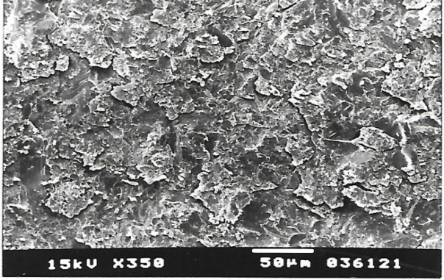
Fig. (2): SEM of sandblasted metal surface treatmentspecimengroup (I)before bonding (SEM photograph, original magnification 350×).

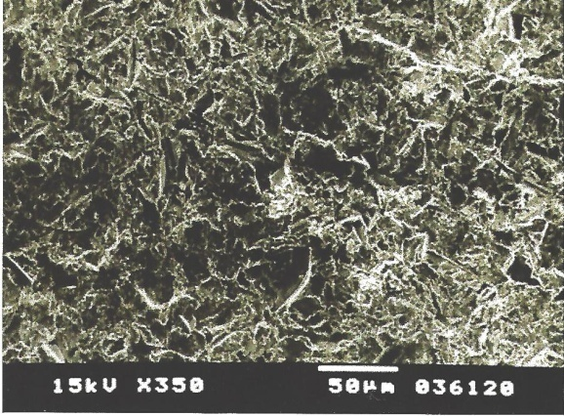
Fig. (3): SEM of acid etch metal surface treatment specimen group (II) before bonding (SEM photograph, original magnification 350×).

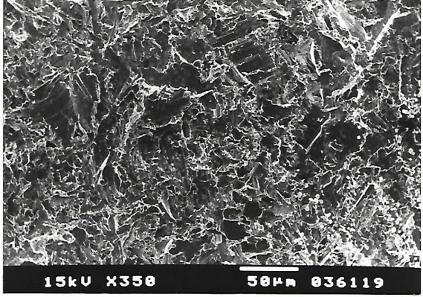
Fig. (4):SEM of laser metal surface treatment specimen group (III)before bonding (SEM photograph, original magnification 350×).

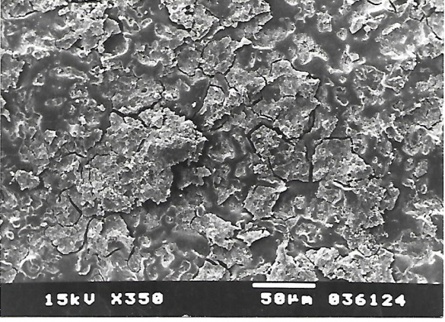
Fig. (5):SEM of laser specimen group (III) in de-bonding presenting cohesive and adhesive failure (SEM photograph, original magnification 350×).

4. Discussion:
Many variables affect the success of resin retained fixed partial dentures. Resin-bonded fixed partial dentures (RBFPDs) have appeared to prevent the excessive preparation of dental tissue with complete crown and reliable restorative alternative to conventional short span fixed dental prostheses⁽¹⁾. The type of alloy used to fabricate the metal substructure of the crown may affect its retention^{(13, 14)}.
Metal nickel-chromium (Ni-Cr) alloy was selected in our study based on thestudy by Walker et al who reported that base metal alloys, (Ni-Cr) are preferred over gold alloys due to their enhanced bond to resin cements^{(15,16)}.
In this study metal alloysurfaces (Ni-Cr) was treated with 3 different methods of surface treatments to improve the micro-roughness and macro-mechanical retention. The different surface treatment was used in the study to enhance the bond strength of the restoration to the cement⁽¹⁷⁾. All specimens in this study were subjected to standardized procedure for cementation, storage and thermocycling. To simulate the clinical situation, in our study,castings were cemented to enamel of extracted teeth with Panavia F 2.0 (subgroup A) and the other subgroup specimens (B) were cemented with Bistite II DC. The selection of the resin cement in the present study was based on their high compressive and tensile strengths, low solubility in the oral fluids, good adherence to dental structures and alloy and aesthetic qualities^{(18,19)}. Cement or luting agent is one of the most important factors controlling the amount of retention to prevent dislodgement of (Ni-Cr) alloy specimens during mastication^{(20,21)}.
Sandblasting and acid etching of the internal surface of the retainer are the most popular methods as metal surface treatments. The two methods were used and selected to compare with the laser surface treatment. Sandblasting surface treatment with aluminum oxide 50 µm supposed to enhance the bonding capacity of cement to the metal substructure, Sandblasting is inexpensive and may improve adhesive and cement wetting because of the mechanical removal of surface debris.And due to the chemical communication of the resin with the oxide layer on the metal surface^{(22,23,24)}. Our results revealed no statistical significant shear bond strength in group (I) using Panavia F 2.0 cement (subgroup A) or Bistite II DC cement (subgroup B).This result was in agreement with Goswami et alwho showed that sandblasting only produced less shear bond strength than clinically accepted⁽²⁵⁾.
Acid etching of dental surface with an acid used to remove the smear layer andopen enamel tubules, increase retention of resin sealant, and promote mechanical retention enamel removes.The results of acid etching group (II) displayed a statistical significant shear bond strength of the metal alloy surface bonded to Panavia F 2.0 cement (subgroup A) or Bistite II DC cement (subgroup B). This result may be due to dissolving hydroxyapatite crystals which permits penetration of the ﬂuid adhesive components to provide micromechanical retention. Acid etching of enamel improved retention by eroding hydroxyapatiteformations and facilitating penetration by the development of resin tags⁽²⁶⁾.
Laser was described as an excellent tool for material removal.Nd:YAG laser system was chosen to be compared to these previous metal treatments and to examine the variation in the metal cement bond strength. Our results revealed that the highest cement bond strength values recorded in thelaser group (III), this may be related to the surface roughness with minute depressions(Fig.4) into which the cement might have flowed. The different orientations of the linear scratches and tubular arrangement shown in this group might have further helped in the mechanical retention of the cement onto the alloy.This result was in agreement with laboratory results obtained by Shereen ⁽¹²⁾who demonstrated that the shear bond strength of lased cobalt chromium was significantly higher than acid etched specimens of the same alloy and Grover et al ⁽²⁷⁾they reported that Nd: YAG laser surface treatment produced excellent surface roughness and obtained the highest bond strength values.Further support of these findings was related to Vallittu et al ⁽²⁸⁾ who referred the cohesive bonding failure obtained with the sandblasted alloy surface to the numerous micro-irregularities revealed in the SEM analysis that might have offered good retention with the cement material. Also the resin luting cement used dispersing apparatus in this study enables the dentists to always distribute correct proportion of the base and catalyst,while older brands distributed the power and liquid independently, leading to alternation in the applied measure of powder or liquid and resultant inconsistency in the quality of the mix⁽²⁹⁾.
Thermocycling and water storage influence the mode of tensile failure of resin bonded base metal alloy,thethermocycling should be included in all studies of bonded metal restorations. In the present study 1 minute dwell time was used to allow the specimens to reach equilibrium in every water bath since a variety of thermocycling cycle numbers and dwell time have been recorded with their effect in many studies and the effect of thermocycling may be larger in the metal bonded to enamel situation where the resin cement would be between 2 materials with different coefficients of thermal expansion^{(30,14)}.
SEM surface analysis was intended as a verification of the role of the surface topography in the mechanical bonding between the alloy and the cement. ⁽¹⁸⁾Subjective evaluation of SEM at 350-power magnification revealed differences that were representative of the results reported in this study. The lased specimens (Fig.4) revealed not only more exposed surface area and deeper etched pattern but also evidence of large and deeper pores.The formulation of the results obtained in this study is that laser has succeeded in enhancing the metal cement bonding of base metal alloy.

Conclusions:
Based on the results of this study, the following conclusions can be drawn:
Laser have been proven as an effective means for metal surface treatment and significantly enhanced shear bond strength to base metal alloy compared to sandblasting and acid etching.
The highest shear bond strength was obtained with laser surface treatment in combination with Panavia F 2.0 resin cement.

References:
- Barwacz CA, Hermandez M, Husemann R. Minimally invasive preparation and design of a cantilevered, All ceramic, resin bonded fixed partial denture in the esthetic zone: a case report and descriptive review. J of Esthetic and Restorative Dent.2014; 26:314-23.
- Petrie CS, Eick JD. Williams K, Spencer P. A comparison of three alloys surface treatments for resin- bonded prostheses. J Prosthodont.2001; 10:217-23.
- Doukoudak A, Tzortzopoulou E, Gray S. Acomparison of the shear strength of chemically versus electrolytically etched metal retainers. J Prosthet Dent.1992;67: 614-16.
- Anusavice KJ. Shen C, Ralph Rawls H. Phillips Science of dental materials. 12thedition, WS Saunders Co, 2012.
- Tanaka T, Nagata K, Takeyama M.: META opaque resin- A new resin strongly adhesive to nickel-chromium alloy. J Dent Res.1981; 60:1697-706.
- Hussey DL, pagi C, linden GJ. Performance of 400 adhesive bridges fitted in a restorative dentistry department. J Dent.1991; 19:221-25.
- Arora V, Shama MC, Dwivedi R. Comparative evaluation of retentive properties of acid etched resin bonded fixed partial denture. Med J Armed Forces India.2014; 70:53-57.
- Verzijden A; Creugers NHJ; Van Hof MA. A metal analysis of two different trials on posterior resin-bonded bridges. J Dent.1994; 22; 29-32.
- Caughey AD. Sandblasting and tinplating surface treatment to improve the bonding with resin cements. Dental Update.1993; 20:153-7.
- Abouch Y, Mudassir A, Elderton RJ. Resin to metal bonds mediated by adhesion promoters’. Dent Mater.1991; 7:279-80.
- Atrill DC, Farrar SR, King TA, Dickinson MR, Davies RM, Blinkhorn AS. Er: YAG (λ=2.94 µm) laser etching of dental enamelas an alternative to acid etching. Lasers Med Sci 2000;15:154-61.
- Shereen AA. Evaluation of laser treatment of different types of ceramometallic alloys. Ph D. Cairo University, 2001.
- Dündar M, Ozcan M, Cömlekoglu ME, Güngör MA. A preliminary report on short-term clinical outcomes of three-unit resin-bonded fixed prostheses using two adhesive cements and surface conditioning combinations. Int J Prosthodont 2010;23:353.
- Filho F.H.B. L., Ribeiro R.F., de Souza R.F., Macedo A.P., de Almeida R.P.: Tensile Strength of Resin Cements Used with Base Metals in a Simulating Passive Cementation Technique for Implant-Supported Prostheses. Brazilian Dental Journal 2016;27(6): 739-743.
- Walker MP, Spencer P, Eick JD. Effect of simulated resin-bonded fixed partial denture clinical conditions on resin cement mechanical properties. J Oral Rehabil 2003; 30(8):837–46.
- Aboush YE, Estetah N. A prospective clinical study of a multipurpose adhesive used for the cementation of resin-bonded bridges. Oper Dent 2001; 26(6):540–5.
- Al-Helou H., Swed E. Effect of metal type and surface treatment on shear bond strength of resin cement (in vitro study ) J Indian Prosthodont Soc. 2016; 16(1): 49–52.
- Pan YH, Ramp LC, Lin CK, Liu PR. Comparison of seven luting protocols and their effect on the retention and marginal leakage of a cementretained dental implant restoration. Int J Oral Maxillofac Implants 2006;21:587-592.
- Orsi IA, Vardi FK, Pieroni CHP, Ferreira MCCG, Borie E. In vitro tensile strength of luting cements on metallic substrates. Braz Dent J 2014;25:136-140.
- Hill EE. Dental cements for definitive luting: a review and practical clinical considerations. Dent Clin North Am 2007;51:643–58.
- Hill EE, Lott J. A clinically focused discussion of luting materials. Aus Dent J 2011;56: (1 Suppl):67– 76
- Osman SA, McCabe JF, Walls AW. Bonding adhesive resin luting agents to metal and amalgam. Eur J Prosthodont Restor Dent 2008;16:171- 176.
- Denizoglu S, Hanyaloglu CS, Aksakal B.: Tensile bond strength of composite luting cements to metal alloys after various surface treatments. Indian J Dent Res 2009;20:174-9.
- Gurbuz A, Inan O, Kaplan R, Ozturk AN.: Effect of airborne-particle abrasion on retentive strength in overtapered fixed prosthodontic restorations. Quintessence Int 2008;39: e134-8.
- Goswami MM, Gupta SH, Sandhu HS. Evaluation of shear bond strength of composite resin bonded to alloy treated with sandblasting and electrolytic etching. Indian Prosthodont Soc.2014; 17:98-103.
- Wang Y, Spencer P. Effect of acid etching time and technique on interfacial characteristics of the adhesive-dentin bond using differential staining. Eur J Oral Sci 2004;112:293-299.
- Grover N, Nandlal B. An in vitro evaluation of the effect of sandblasting and laser surface treatment on the shear bond strength of a composite resin to the facial surface of primary anterior stainless steel crowns. J of Clin and Exp Dent.2015; 7:119-25.
- Vallittu PK, Foss H. Adhesion of glass ionomer cement to ceramometal alloy. Int J Prost Dent.1997; 24:560-5.
- Rubo JH, Pegoraro LF. Tensile bond strength of composite resin cement for bonded prosthesis to various dental alloys. J Prosthet Dent.1995; 74:230-34.
- Fonseca RG, Almeida JG, Haneda IG, Adabo GL. Effect of metal primers on bond strength of resin cements to base metals. J Prosthet Dent 2009;101:262-268.

12/4/2017

