Effect of Plant Extracts and carbofuran on the Growth and Yield Parameters of Waterleaf (Talinum triangulare L.) (Jacq.) Willd Infected with Meloidogyne javanica in Nigeria

*A. B. Nwauzoma^{1,} P. C. Nnadi ², E.T. Jaja¹

^{1, 2}Department of Plant Science and Biotechnology; ²Department of Forestry and Environment; Rivers State University Nkpolu-Oroworukwo, Port Harcourt, Nigeria

Abstract: Leaf extracts of Jatropha curcas and Cymbopogon citratus, root extract of Chromolaena odorata and Carbofuran 5G were tested for their nematicidal properties on M. javanica were studied. Five weeks old stem cuttings of waterleaf (T. triangulare) were planted in bags containing 5 kg of sterilized soil and inoculated with 5,000 eggs of M. javanica at 20, 35 and 50% concentrations. A control without nematode, plant extracts and nematicide, thereafter uninoculated-untreated plant (Uit) and another with nematode egg suspension, but no plant extract and nematicide, [ (inoculated untreated (Ut)] were included and laid out in a completely randomized design, with four replications. Data on plant height (cm), leaf area (m²) and fresh and dry weight of shoots and roots (g) were collected and analysed. J. curcas leaf extract at 20% and the uninoculated-untreated (Uit) resulted to significantly taller plants (31.75 and 31.00 cm) respectively, compared to the inoculated and untreated (Ut) plants (11.25 cm) at 9 WAI. Fresh root weight was higher in the Uit plants (2.38g) and carbofuran (2.35g) at 35%, compared to the others. There was no significant difference in dry shoot weight between uninoculated-untreated and inoculated-untreated plants, although visual observation show that dry shoot and root weights were less in plants treated with plant extracts and carbofuran. Therefore, J. curcas and C. odorata extracts could be used to improve growth in waterleaf and other susceptible hosts affected by root-knot nematodes.
[ A. B. Nwauzoma P. C. Nnadi, E.T. Jaja. Effect of Plant Extracts and carbofuran on the Growth and Yield Parameters of Waterleaf (Talinum triangulare L.) (Jacq.) Willd Infected with Meloidogyne javanica in Nigeria. N Y Sci J 2017;10(12):21-26]. ISSN 1554-0200 (print); ISSN 2375-723X (online). http://www.sciencepub.net/newyork. 3. doi:10.7537/marsnys101217.03.

Key words: Carbofuran, Plant extracts, Talinum triangulare, Meloidogyne javanica.

- Introduction
Plant parasitic nematodes are major pathogens of fruits, vegetables and food crops in different parts of the world (Osei et al, 2011). The root-knot nematodes (Meloidogyne species) are the most devastating (Khan and Khan, 1994; Williams-Woodward and Davis, 2001). Globally, over 90 species of root-knot nematodes have been described (Netscher and Sikora, 1990) with Meloidogyne arenaria, M. javanica and M. incognita accounting for almost 90% of the damages resulting thereof (Castagnone-Sereno, 2002); and they remain the most destructive group of nematodes (Fawole et al., 1992). The most visible symptom is the appearance of swellings or giant galls on the roots of affected plant (Olsen, 2000; Stonton, 2001), causing root deformation thus affecting nutrient and water uptake (Sikora and Greco, 1990).
Waterleaf (Talinum triangulare) of the family Portulacea is a vegetable crop consumed in Nigeria and Cameroon and other parts of West and Central Africa (Udoh and Etim, 2008). As a short duration vegetable, it serves as a recipe and softener in food preparation with other rigid fibrous vegetables like ‘Atama’ (Heinsia crinata), fluted pumpkin (Telferia occidentalis) and Gnetum africanum to prepare ‘Afang’, a special type of soup native to southern part of Nigeria. Both the leaves and the young shoots are consumed in large quantities in the southern part of Nigeria (Ibeawuchi et al., 2007). T. triangulare has high quantity of crude fiber (11.12%), crude ash (33.98%), and protein (22.1%), (Akachuku and Fawusi, 1995). As a result of these, waterleaf is becoming increasingly important in ensuring food and nutrition security as the production serves as a balancing source of revenue to subsistence farmers (Udoh and Etim, 2008).
T. triangulare is highly susceptible to nematode attacks, especially in the tropics (Sikora and Fernandez, 2005). The use of synthetic nematicides is considered as the most effective and practical way to control plant-parasitic nematodes among crop plants (Adesiyan, 1992). However, high toxicity and persistence of the nematicides poses serious concern to the environment. This is in addition to non-availability and demand for skilled labour during application, since waterleaf is mostly cultivated by subsistence farmers in Nigeria (Adesiyan, et al. 1990).
Many plants are known to have nematicidal properties which may be utilized as organic amendments or biopesticides (Agbenin et al., 2005; Egunjobi & Onayemi, 1981). Works by Egunjobi and Afolami (1994) and Onifade and Egunjobi (1994) support the toxicity of plant extracts against plant nematodes. Jatropha curcas is a drought-resistant, bio-fuel plant that thrives well in marginal soils (Izuogu et al., 2013). Its pesticidal properties against plant parasitic nematodes are documented (Habou et al., 2011). Chromolaena odorata (L.) also known as siam is a tropical weed of the family Asteraceae. The nematicidal properties of C. odorata have been reported by Fatoki and Fawole (2000). Also, Adegbite (2003) indicate that C. odorata extracts inhibited egg-hatch in M. incognita. Cymbopogon citrates, family Poaceae is a tall monocotyledonous perennial plant cultivated in Africa and Central and South America and other tropical countries (Ernst, 2008). C. citratus is consumed in various forms because of its high antioxidant levels. Adegbite and Adesiyan (2005) reveal that leaf extracts of lemon grass have nematicidal properties and confirmed by Izuogu (2009) and Izuogu and Oyedunmade (2009). These plants are readily available, cheap, renewable, biodegradable and improve soil texture and fertility (Feizi et al., 2014). The present study evaluates the nematicidal properties of the leaves of J. curcas and C citratus and root extracts of C. odorata and a synthetic nematicide (carbofuran) on the growth of water leaf infected with M. javanica.

- Materials and Methods
The experiment was conducted in the Department of Plant Science and Biotechnology, University of Port Harcourt, Nigeria: [ (04º 51’ N and 07º 03’E and 10 m altitude above sea level) Nwauzoma & Dappa, 2013]. The vegetation is characterized by high humidity, temperature and rainfall. Top soil was collected from a newly excavated land close to the department, sieved and sterilized by heating in a large metal drum for 4 hrs and allowed to cool for 72 hrs (Gautam & Goswami, 2002). Then, 5kg of the (sterilized) soil was transferred into bags and arranged on slabs to avoid contamination. The stem cuttings of T. triangulare were bought from the Mile 3 market in the Port Harcourt metropolis, Rivers State, Nigeria. Fresh leaves of Jatropha curcas, and Cymbopogon citratus and roots of Chromolaena odorata were collected from the University botanical garden and authenticated in the departmental herbarium. Carbofuran was purchased at the Rivers State Agricultural Development Project (ADP), Port Harcourt, Nigeria, while pure culture of Meloidogyne javanica eggs was graciously supplied by the International Institute for Tropical Agriculture (IITA), Ibadan, Nigeria.
Fresh, mature and healthy leaves and roots of the respective plant materials were thoroughly washed and air-dried in the laboratory and ground into powder using electric grinder and stored in air-tight plastic containers. The extracts were prepared by dissolving 25g of each sample in 250 ml of hot water and allowed to stand for 24 hrs, and then strained through a sieve and collected in a plastic container and further filtered using Whatman No.2 filter paper to obtain the crude extract. The filtrate was the stock solution (representing 100 % concentration) and used within 24 hrs of preparation (Adegbite & Adesiyan, 2005). The stock solution was serially diluted with 80, 65 and 50 ml of distilled water to obtain the respective 20, 35 and 50 % concentrations of each extract. Granules of Carbofuran 5G was applied at the rate of 3kg a.i/ha (0.3g/bag) and serially diluted to obtain similar concentrations.
Pure culture of M. javanica eggs was multiplied and extracted from three months old infected tomato roots, using the sodium hypochlorite (NaOCI)-extraction method (Hussey & Baker, 1973). Thus, galled roots of tomato (Lycopersicum esculentus) with egg masses were cut into small pieces (1-2 cm) and put into a container of 200 ml 0.5% NaOCI solution and agitated strongly to dissolve the gelatinous egg mass. The content was emptied into 200 mesh sieve to retain the roots and the debris nested on 500 mesh sieve to retain the eggs. The retained eggs were then washed in slow flowing cold tap water to remove traces of NaOCl. The galled roots were further rinsed with water to obtain more eggs. The number of eggs per ml of the suspension was estimated by counting 4 samples of 1 ml each of the number of eggs and juveniles under a microscope. This was then adjusted to 5000 eggs with the second stage juveniles per ml by concentrating in 3.5 ml of water.
Sandy-loam topsoil collected from a newly excavated land close to the department was steam-heated in a large metal drum for 4 hrs and allowed to cool for 72 hrs (Gautam and Goswami, 2002). Then, the soil was sieved and 5 kg was transferred into 25 cm diameter bags and arranged on slabs to avoid contamination. Three stem cuttings (5 cm long) of T. triangulare were planted in each bag, which was thinned three weeks after planting, leaving only the most vigorous plant in each bag. Then 5000 eggs with second stage juveniles of M. javanica were inoculated by pouring into each hole around the root tips using a graduated syringe (Hussey and Boerma, 1981). One week after inoculation, soil around the roots of the waterleaf plants was carefully scooped out to a depth of 5 cm, and the plant extracts and carbofuran were applied around the roots of plants and covered with soil. The control had no nematode, plant extracts and cabofuran, thereafter uninoculated-untreated (Uit) and another had nematode suspension, but no extracts and nematicide [inoculated-untreated (Ut)]. The experiment was a factorial in a completely randomized design, with four replications and lasted for 16 weeks. The plants were maintained under adequate moisture, temperature and humidity and kept weed free.
Data on plant height (cm) was obtained by measuring the plants from base of soil to the tip of longest leaf at 3, 6 and 9 weeks interval after inoculation (WAI). The leaf area (m²) was determined by measuring the leaf from base to its tip and the width from the widest point, using a ruler and multiplying the values (Akonye and Nwauzoma, 2003). Destructive sampling was done after 15 weeks which was the duration of the experiment, uprooting the plants carefully and rinsed under running water and root length (cm) was measured using a ruler. The respective fresh weight of shoot and root were determined by cutting the stem of the top line and immediately weighing the shoot and root using an electronic weighing balance. The dry weight was obtained by drying the shoot and root to a constant weight in room temperature. All data were subjected to Analysis of variance (ANOVA) using the Statistical Analysis System (SAS 1997). The Least Significance Difference (LSD) was used to separate the means at 5% probability level.

Results and Discussion
Root knot nematodes are major limiting factors to plant growth and yield (Osei et al, 2011). The use of synthetic nematicides is no longer attractive due to concern for human health and environment, hence the search for plant-based products as feasible alternatives (Talapatra, et al, 2007). The effect of the various treatments on the growth of waterleaf (Talinum triangulare) at 3, 6 and 9weeks after inoculation is shown in Table 1. Plants that were treated with different botanicals, carbofuran and uninoculated, untreated plants were significantly taller than inoculated untreated plants. This shows that the plant extracts have positive nematicidal properties which when incorporated into the soil reduced the damaging effect of the nematodes on the plants. The application of J. curcas and C. citratus extracts at 20 and 50% concentrations, 9 WAI recorded plant height of 31.75 and 28.75cm, respectively, including C. odorata at 50% with 30.43cm and this differed significantly (p≤0.05) from the control (11.25 cm). It is believed that the nematicidal properties present in the extracts reduced the number of galls, unlike in the untreated plants which were heavily galled. The galls in the later would have resulted to the translocation of adequate water and nutrients from the vegetative organs to the galled parts, thereby reducing plant growth. A similar result was obtained by Agu (2008) in which rare root-galls were reported in soybean intercropped with resistant pepper, Amaranthus and Telfairia. According to the author, intercropping soybean with Amaranthus and Telfairia reduced galling by preventing nematode population around soybean plants, resulting to plant growth. Galls are known to decrease the uptake of minerals, especially, N, P and K and also do not translocate adequate water and nutrients to vegetative organs for photosynthesis (Trudgill, 1987; Agu, 2008).
Table 2 shows the effect of the different treatments on the number of leaves, seeds and flowers. The uninoculated untreated control (UiT) produced significantly higher (P≤0.05) number of leaves, seeds and flowers with 25.75, 13.50 and 6.00 respectively, compared to the plants treated with plant extracts and carbofuran. The result further showed that plants treated with C. citratus extract and carbofuran at the various concentrations had more number of leaves compared to others. Earlier reports by Hussey (1985) indicate that M. incognita infection reduced significantly the number of leaves per plant and tuber yields on sweet potato. Furthermore, increase in concentration of the treatments did not result to corresponding increase in the number of the traits studied.
Result on the fresh and dry weight of shoot and root of T. triangulare inoculated with M. javanica under different concentrations of plant extracts and carbofuran (Table 3) show that the control (uninoculated untreated and inoculated untreated) plants had higher fresh shoot weight of 10.36g and 10.02g, respectively, followed by J. curcas at 50% concentration (8.91g). This value was significantly higher compared to the other treatments, but in the control. C. odorata at 35% concentration had the least fresh shoot weight (5.16g) followed by J. curcas extract at 50% concentration with fresh shoot weight of 6.50 g. The highest fresh root weight occurred in the uninoculated untreated control plants (2.38 g), while carbofuran treated plants had the lowest fresh root weight (1.26g). Although these values were not significantly different, however it showed the effect M. javanica could have on the root and shoot system of T. triangulare, if unchecked. Therefore, the application of these botanicals was able to suppress the root-knot damage. The significantly higher root weight as observed in the controls may be attributed to the production of galls. As reported by Ogaraku, (2007), galling and proliferation of lateral roots by infected plants might be due to abnormal secretion of growth hormones induced by root-knot nematode, thus explaining the relative higher root weight of infected plant. These galls or giant cells provide a nutrient sink to the nematode, resulting in higher root weight.
Table 3 further show that J. curcas treated plants also had the lowest dry shoot weight (1.36g), while the inoculated-untreated plants had the highest (3.06g) which was significantly higher than for other treatments (P≤0.05). The highest fresh root weight occurred in the uninoculated untreated control plants (2.38g), while Carbofuran treated plants had the lowest fresh root weight (1.26g) and this can be significantly compared with other treatments across the level of concentrations.
Several plant extracts have been reported to have nematotoxic properties (Sosamma and Jayasree, 2002). Our study revealed that extracts from Jatropha curcas leaves, lemon grass (Cymbopogon citratus), and siam weed root (Chromolaena odorata) roots were effective in the management of root knot nematode infection on T. triangular. The effect of extracts varied, though not correspondingly with increasing concentrations. The use of these plant materials are preferable because they are less risky for breeding pest resistance, safe for the environment, require little or no skill, less dangerous to non-target organisms and pest recovery, has less unfavorable end product on plant growth and above all, least expensive. Therefore, these botanicals are recommended for the effective control of waterleaf root-gall nematode in soils infested with M. javanivca.

Table 1: Effect of plant extracts and carbofuran on plant height (cm) of T. triangulare inoculated with M. javanica.
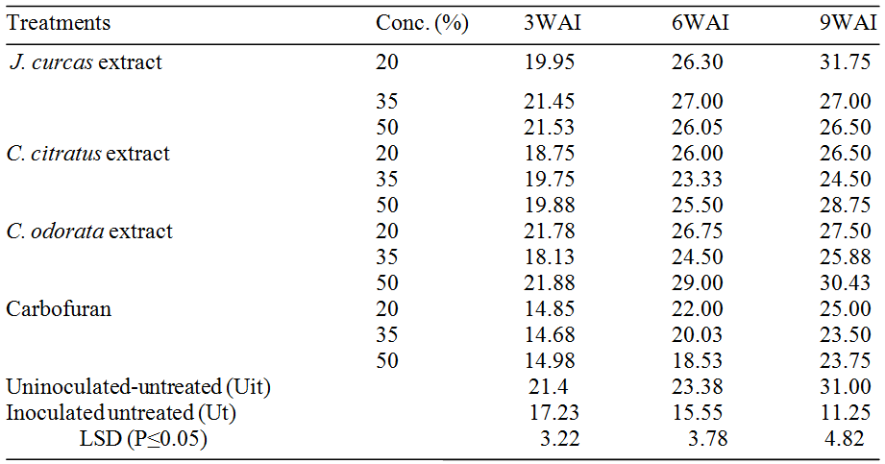
WAI: Weeks after inoculation.

Table 2: Mean performance of treatments on the leaf area, stem sizes and root lengths of Talinum triangulare after inoculating with M. javanica
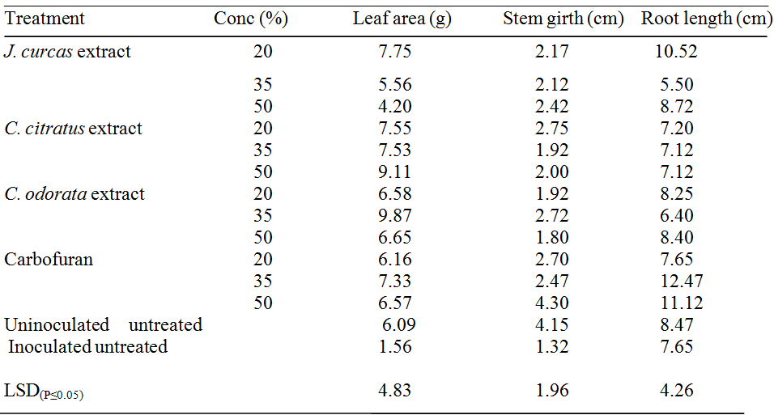

Table 3: Effect of plant extracts and carbofuran on the mean the fresh and dry weight of shoot and root in T. triangulare inoculated with M. javanica.
Treatment | Conc. (%) | FSW | FRW | DSW | DRW
J. curcas extract  C. citratus extract  C. odorata extract  Carbofuran  Uninoculated untreated (Uit)  Inoculated untreated (Ut)  LSD _{(P≤0.05)} | 20  35  50  20  35  50  20  35  50  20  35  50 | 7.53  5.69  6.50  7.53  7.28  8.91  8.04  5.16  6.03  8.19  6.13  7.43  10.36  10.02  4.25 | 1.48  1.29  1.98  1.48  1.76  1.65  1.75  1.30  1.37  1.26  2.35  1.52  2.38  1.85  1.17 | 1.36  1.70  1.84  2.40  2.44  2.62  2.56  1.63  1.98  2.14  1.69  1.77  3.06  2.88  1.49 | 0.39  0.28  0.68  0.42  0.37  0.35  0.46  0.32  0.34  0.28  0.49  0.29  0.39  0.64  0.39
FSW (fresh shoot weight); FRW (fresh root weight); DRW (dry root weight); DSW (dry shoot weight).

Acknowledgements:
The authors are grateful to the International Institute for Tropical Agriculture (IITA), Ibadan, Nigeria for providing the pure of International Institute for Tropical Agriculture (IITA), Ibadan, Nigeria and the University of Port Harcourt for the laboratory space.

Corresponding Author:
Dr. Nwauzoma, A. Barth
Department of Plant Science and Biotechnology,
Rivers State University, Nkpolu-Oroworukwo, Port Harcourt, Nigeria.
Telephone: +234(7036532794); E-mail: drnwabarth@yahoo.com

References
- Adegbite AA.Comparative effects of Carbofuran and water extract of Chromolaena odorata on growth, yield and food components of root-knot nematode-infested soybean (Glycine max (L.) Ph.D Diss., University of Ibadan, Ibadan, Nigeria, 2003.
- Adegbite AA, Adesiyan SO. Root extracts of plants to control root-knot nematode on edible soybean. World Journal of Agricultural Science 2005; Vol.1, No.1, pp. 18-20, ISSN1817-3047.
- Adesiyan SO, Caveness FE, Adeniji MO, Fawole B. Nematode Pests of Tropical Crops. Heinemann Educational Books (Nigeria) Ltd., p. 114. 1990.
- Adesiyan S.O. Chemical Control of nematode pests of some economic crops. In proceedings of the first regional symposium of the Biology and control of nematode pests of food crops in Africa. University of Ibadan, Nigeria, pp. 283-294, 1992.
- Agbenin NO, Emechebe AM, Marley PS, Akpa AD. Evaluation of nematicidal action of some botanicals on Meloidogyne incognita in vivo and in vitro. Journal of Agriculture and Rural Development in the Tropics and Subtropics, 2005; 106: 29–39.
- Agu CM. Effects of Intercropping on Root-Gall Nematode Disease on Soybean (Glycin max (L) Merril. New York Science Journal, 2008 Vol. 1 (1), pp. 43-46.
- Akachuku CO, Fawusi MAO (1995) Growth Characteristics, Yield and Nutritional Value of Waterleaf, Talinum triangulare (Jacq) Wild in a Semi-Wild Environment, Discovery and Innovation; 7:163-172.
- Akonye LA, Nwauzoma AB. Growth measurement in plants. In: Research Techniques in Biological and Chemical Sciences (Eugene N. Onyeike and Julian Osuji, eds.), pp. 147-155. Springfield Publishers Ltd., Owerri, Imo State, Nigeria, 2003.
- Castagnone-Sereno P. Genetic variability in pathogenetic root-knot nematodes, Meloidogyne spp. and their ability to overcome plant resistant genes. Nematology, 2002, 4: 605-608.
- Fawole B, Egunjobi OA, Adesiyan SO, Babatola OA, Idowu AA. The Biology and Control of Nematode Pests of Food Crops in Africa. Heineman Educational Books (Nig) Ltd. 1992.
- Egunjobi OA, Onayemi SO. The efficacy of water extract of neem (Azadirachta indica) leaves as a systemic nematicide. Nigeria Journal of Plant Protection, 1981; 5: 70–74.
- Egunjobi OA, Afolami SO. Effects of Azadirachta indica leaf extracts on the population of Pratylenchus brachyurus and the growth and yield of Zea mays. Nematologica 1994; 22:125-132.
- Ernst E. "Chiropractic: a critical evaluation". Journal on Pain Symptom Management 2008; 35 (5): 544-62.
- Fatoki OK, Fawole B. Identification of nematicidal ingredients from Neem leaves, Siam weed leaves and roots. Afr. J. Plant Prot., 2000; 10, 33 – 48.
- Feizi A, Mahdikhani-Moghadam E, Azizi M, Roohani H. Inhibitory effect of Allium cepa var. aggregatum, Salvia officinalis and Kelussiaodor atissima essence on the root-knot nematode (Meloidogyne javanica) and extraction of active ingredients. Journal of Plant Protection 2014; 28, 220-225.
- Gautam C, Goswami BK. Different combinations of neem cake and carbofuran against Meloidogyne incognita on Vigna radiata. International Journal of Nematology 2002; Vol. 12, 1: 106-110.
- Habou ZA, Haougui A, Mergeai G, Haubruge E, Toudou A, Verheggen FJ. Insecticidal effect of Jatropha curcas oil on the aphid (Aphis fabae) and on the main insect pests associated with cowpeas (Vigna unguiculata) in Niger. Tropicultura 2011; 29 (4):226-229.
- Hussey RS, Baker RR. A comparison of methods of collecting inocula of Meloidogyne spp. including a new technique. Plant Dis. Rep. 1973 57: 1025-1028.
- Hussey RS, Boerma RH. A green-house screening procedure for root-knot nematode resistance in soybeans. Crop. Sci. 1981; 21:794-796.
- Hussey RS. Host-parasitic relationship and associated physiological changes In: Sasser, J.N. and Carter, C.C. (Eds An advanced Treatise on Meloidogyne: Biology and Control) Raleigh, North Carolina State University Press 1985; Pp 143-153.
- Ibeawuchi II, Nwufo MI, Oti NN, Opara CC, Eshett ET. Productivity of Intercropped Green (Amaranthus cruentus)/ Waterleaf (Talinum triangulare) with Poultry Manure Rates in Southeastern Nigeria. Journal of Plant Sciences 2007; 2(2): 222-227.
- Izuogu NB. Pathogenicity and control of Meloidogyne incognita (Kofoid and White) Chitwood on fluted pumpkin (Telfairia occidentalis Hook F.) Ph.D. Thesis 2009; University of Ilorin, Nigeria.
- Izuogu NB, Oyedunmade EEA. Effects of methanolic extracts from the leaves of brimstone, cassia, lemon grass and Chanca piadra on Meloidogyne incognita in the laboratory. J. Agric.C.Res. Development 2009; 8:53-60.
- Izuogu NB, Badmos AA, Raji SO. The potency of Moringa oleifera and Jatropha curcas leaf extracts as control for root-knot nematode in maize (Zea mays). Inter. Jour. Phytofuels and Allied Sciences 2013; Vol 2 (1): pp. 116-124.
- Netscher C, Sikora RA. Nematode Parasites of Vegetables. In: M. Luc, Sikora, R.A., J. Bridge (eds.); 2nd Edn. Plant Parasitic Nematodes in Subtropical and Tropical Agriculrure, Wallingford, UK. CAB International1990; Pp. 237-283.
- Nwauzoma AB, Dappa MS. Ethnobotanical Studies of Port Harcourt Metropolis, Nigeria. ISRN Botany 2013; Article ID 829424, http://dx.doi.org/1155/2013/829424.
- Khan MR, Khan MW. Single and Interactive effects of root knot nematode and coal-smoke on okra. New Phytologist1994; 126: 337-342.
- Ogaraku AO. The Effect of Animal Manures on Susceptibility of Cowpea VAR. Moussa Local to Infection by Root-knot Nematode; Meloidogyne javanica Treub. Pakistan Journal of Biological Sciences 2007; 10:2980-2983.DOI:10.3923/pjbs.2007.2980.2983URL: http://scialert.net/abstract/?doi=pjbs.2007.2980.2983
- Olsen M. Root-knot Nematodes cooperative extension, University of Arizona, College of Agriculture and Life Sciences, Arizona2000.
- Onifade AK, Egunjobi OA. Suppression of Meloidogyne incognita populations with water hyacinth and water lettuce in Nigeria. Afro-Asian J. Nematol. 1994; 4: 96-100.
- Osei K, Addico R, Nafeo A, Edu-Kwarteng A, Agyemang A, Danso Y, Sackey-Asante J. Effect of some organic waste extracts on hatching of Meloidogyne incognita eggs. Afr. Jour. Of Agric. Res. 2011; Vol. 6 (10), pp. 2255-2259.
- SAS Institute SAS user’s guide: Statistics, version 6.09 SAS Institute, Cary NC, USA. 1997.
- Sikora RA, Greco N. Nematode Parasites of Food Legumes. In: M. Luc, R.A. Sikora and J. Bridge (Eds.), 2nd Edn. Plant Parasitic Nematodes in Subtropical and Tropical Agriculture. CAB International, Wallingford, UK;1990, pp: 181-235.
- Stonton J. Tomato root knot nematodes: Biology and Control. Department of Primary Industries and Fisheries. G. Stirling (edn.), 2001; Biological Crop Protection.
- Sosamma JM, Jayasree WE (2002) Effect of leaf extracts on the mortality of root-knot nematode, Meloidogyne incognita juveniles. Indian Jour. Nematol., 32: 183-233.
- Talapatra K, Das R, Saha AK, Das P. In vitro antagonistic activity of a root endophytic fungus towards plant pathogenic fungi. Jour. Applied Biology & Biotech. 2017; Vol. 5 (02), pp. 068-069.
- Trudgill DL. Effects of rates of a nematicide and of fertiliser on the growth and yield of cultivars of potato which differ in their tolerance of damage by potato cyst nematodes (Globodera rostochiensis and G.pallida) Plant and Soil 1987; 104, 235-243.
- Udoh EJ, Etim NA. Measurement of Farm-Level Efficiency of waterleaf (Talinun triangulare) Production among city farmers in Akwa Ibom State, Nigeria. Journal of Sustainable Development in Agriculture and Environment. 2008; Vol. 3(2):47-54.
- Williams-Woodward JL, Davis JF. Meloidogyne incognita and M. arenaria reproduction on Dwarf hollies and Lantana. Supplement Jour. Nematol. 2001.

11/15/2017

