**Incorporating mechanical properties of HTPB propellant to a viscohyperelastic constitutive model over a large range of strain rates**

Muhammad Jamshed Khan, Chen Xiong, Tong xin, Hanif ullah, Abid Ullah, Omer Musa1

Department of Mechanical Engineering, Nanjing University of Science and Technology, Nanjing 210094, P. R. China

[Jamshed.khan100@yahoo.com](mailto:Jamshed.khan100@yahoo.com)

**Abstract:** In this paper, the mechanical properties of hydroxyl-terminated polybotadiene (HTPB) propellant were tested at 293K in various loading conditions. The experiments were carried out by via the split Hopkinson pressure bar (SHPB) and universal testing machine. The results show that the stress is directly proportional to the strain, the stain rate was found within the elastic limit, and when the modulus incremented, the strain rate increases in each condition. Consequently, the mechanical properties of HTPB propellant should be rate dependent. In integration, predicated on the model proposed by Yang pouriayevali, a modified visco-hyperelastic constitutive model has been proposed to describe the mechanical properties of HTPB propellant over a strain rates ranged from 3.33×10s-1 to 2000s-1.

[Muhammad Jamshed Khan, Chen Xiong, Tong xin, Hanif ullahAbid Ullah, Omer Musa. **Incorporating mechanical properties of HTPB propellant to a viscohyperelastic constitutive model over a large range of strain rates.** *N Y Sci J* 2017;10(10):94-100]. ISSN 1554-0200 (print); ISSN 2375-723X (online). <http://www.sciencepub.net/newyork>. 14. doi:[10.7537/marsnys101017.14](http://www.dx.doi.org/10.7537/marsnys101017.14).

**Keywords:** HTPB, SHPB, compressive properties, constitutive model

**1. Introduction**

HTPB propellant is a solid fuel utilized in rocket motor because of its high energy density as well as its light weight. Rocket motor is either a high oxygen containing fuel or a cumulating of fuel plus oxidant, whose combustion take place inside the motor engine and engendered sizably voluminous volume of sultry gases (conventionally the temperature of 3000 and a pressure of). This kind of solid propellant loading is inclined to fortify not only static loading, such as its own weight but withal fortifies the dynamic loading such as vibrating, temperature cycle, transient pressure impact by ignition and dynamic high overload. The mechanical properties of HTPB propellant are very sensitive to the environmental temperature and strain rate. It is compulsory to study the mechanical properties at different strain rates and temperatures. In past, many scholars have studied polymers materials utilizing different methods in order to modify their mechanical properties. Sook-Ying Ho (2002) was studied the effect of temperature and rate dependence mechanical properties of composite materials. Guo et al. (2007) calculated the effects of maximum elongation and low strength on the tensile strength of NEP propellant, predicated on dissipative particles dynamic theory at the mesoscale size. Li et al. (2008) was evaluated the molecular chain on the phase separation and the effect of temperature on the binder of NEPE propellant. Zhang et al. (2013) studied the compressive mechanical properties of composites material at high strain rates. Chou S C et al. (1973) was studied the effects of temperature and rate dependent mechanical properties of the composites material. Guo et al. (2007) evaluated the rate dependent tensile mechanical Properties of NEPE Propellant. Kolsky et al. (1994) investigated the mechanical properties of composites materials under high loading. Frew et al. ( 2002) calculated the dynamic compressive mechanical properties of soft materials. Song et al. (2004) was used split Hopkinson pressure bar tests on soft materials to determine the dynamic stress equilibrium. Bergstrom and Boyee (1998,2011) was describe the mechanical properties of elastomers by using two networks one is called equilibrium network and the other one is eight chain network, with a relaxed configuration. This constitutive model is appropriate to the material response over a high range of strain rates. Shim et al. (2004) was developed the integral type of viscohyperelastic constitutive model to define the compressive mechanical properties of soft materials under high strain rates. Yang et al. (2000) calculated a visco-hyperelastic constitutive model to described the behaviour of incompressible material under high loading, Pouriayevali et al. (2011,2012) modified the Maxwell element to make an visco-hyperelastic model to described the both rate dependent and strain dependent properties of composites material. Therefore, Song et al. (2003 was modified a correction quantity to the model while he studied the uniaxial compressive mechanical response of EPDM composites. Song et al. (2004) modified the strain rate into the model to presents the both tensile and compressive mechanical properties of EPDM composites. This constitutive model structure is very complicated; it is difficult to analyze the model parameters values.

SHPB is one the oldest technique which is used to find the dynamic mechanical properties of materials is shown in fig 1. Zhao, H., and Gary, G. (1996) was used SHPB methods to define the dynamic mechanical properties of materials in the high strain rates. Frew et al. (2001,200) studied the compressive mechanical properties of rock material by using Split Hopkinson pressure bar technique. Frew et al. (2002) was used Pulse shaping methods for testing brittle materials with a split Hopkinson pressure bar. Seo et

al. (2005) studied the effect of temperature for the titanium alloy using the SHPB technique. Forrestal et al. (2007) did various research almost soft materials at very high strain rates. They found that the supposition of identical stress in the thick specimens under dynamic experiment was not suitable. Saraf et al. (2007) studied mechanical properties of soft matters under dynamic loading. Naik N K et al. (2011) was studied the very high strain rate compressive properties of epoxy under loading. Sherwood J A et al. (1992) an investigation of constitutive modeling and reproduction of energy absorbing polyurethane foam under impact loading. Bernstein et al. (1965) an investigation about stress relaxation with finite strain. Yang et al. (2016) studied the Compressive mechanical properties of HTPB material at low, intermediate, and high strain rates. In the present study, we will find the uniaxial compressive mechanical properties of HTPB propellant under various loading conditions.

In this paper, for the first time we will use the Split Hopkinson pressure bar apparatus (SHPB) and universal testing machine to get the uniaxial compressive mechanical curves of HTPB propellant. Besides, we have proposed a viscohyperelastic constitutive model to describe the uniaxial compressive mechanical properties of HTPB over a large range of strain rates.

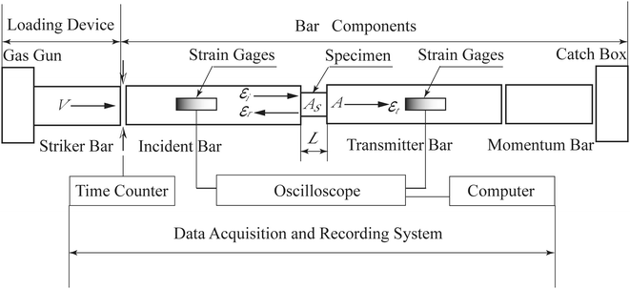

Figure 1: Schematic of SHPB

**2. Material and Methods**

**2.1 Specimen**

The experimental material is a HTPB composite propellant of three components. The mass fraction of each component is as follows: aluminum powder (Al) 12.1%, ammonium perchlorate (AP) 65.3%, matrix HTPB rubber and other components 22.6%. The samples were made into a cylindrical test piece of ∅8.0 × 10 mm by a mechanical processing method. When processing, pay attention to ensure that the specimen diameter and length of the error within the allowable range, the upper and lower bottom of the plane enough smooth and smooth. After processing in the incubator in the incubator for 24 hours, remove the machine processing residual stress.

The compressive mechanical properties of the HTPB propellant were tested using Split Hopkinson pressure bar apparatus for high strain rates and universal testing machine for low strain rates. The SHPB is an perfect machine to find the mechanical properties of the materials. Qinlu et al. (2008) The SHPB bar was made of LC4 aluminum, young modulus is E=74GPa and the density is ρ=2770kg/m³, the elastic wave velocity is c=5123m/s, the size of the incident bar and transmitted bar were both 1400mm, and the length of the sticker bar was taken to be 400mm. The tested specimens are located between the twostraight bars is called incident bar and transmitted bar. At the end of the incident bar a stress waves is formed which propagates through the bar toward specimens, this waves are reaching the specimens split into two smaller wave, one of each transmitted wave travels through the specimen and into the transmitted bar causing plastic deformation of the specimen. The other wave called the reflected wave, is reflected away from the specimens and travels back down the incident bar, and the stress-strain can be calculated from the amplitude of the incident, transmitted and reflected waves is shown in the figure no. 2. The dynamic experiments were performed at different air gun pressure of (0.2 MPa, 2 MPa, 20 MPa) at room temperature.

The low strain rate experiment is done by using universal testing machine is shown in the Fig. 3. The experimental material is generally placed in between the two plates that distribute the applied load across the entire surface area of two opposite faces of the test sample and then the plates are pushed together by a universal test machine causing the sample to flatten. A compressed sample is usually shortened in the direction of the applied forces and expands in the direction perpendicular to the force. The quasi-static experiment carried out at different temperatures (10℃, 30℃, 50℃) and different strain rates (3.33×10ˉ⁴sˉ¹, 3.33×10ˉ³sˉ¹, 3.33×10ˉ²sˉ¹ and 3.33×10ˉ¹sˉ¹).

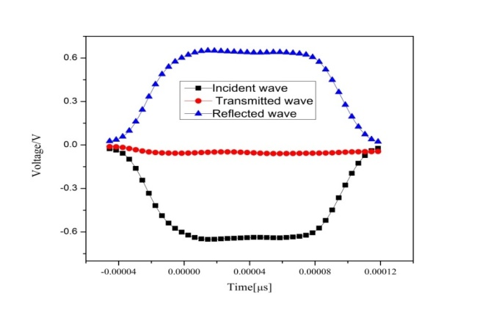

Figure 2 SHPB waves

**3. Results**

**3.1 Quasi-static compression result**

The quasi-static compression experiments of the HTPB material were done by using universal testing machine. Therefore, the low strain rate compression tests were conducted at different temperatures (10℃, 30℃, 50℃) and different compressive rates of (.2mm/min, 2mm/min, 20mm/min, and 200mm/min) the corresponding strain rates are (3.333×10-4s-1, 3.333×10-3s-1, 3.333×10-2s-1, and 3.333×10-1s-1), respectively. From the experimental results, the modulus of the HTPB propellant increases with decrease the temperature or increasing the strain rate. The engineering strain of HTPB propellant is about 0.20%, thus, the deformation will increase. The mechanical curve at the rate of 20mm/min is evident, for the impact loading at very higher speed. When the strain reached at 0.25, the modulus is decreased and the strain reached at constant level. The low strain rate results are shown Fig. 3.

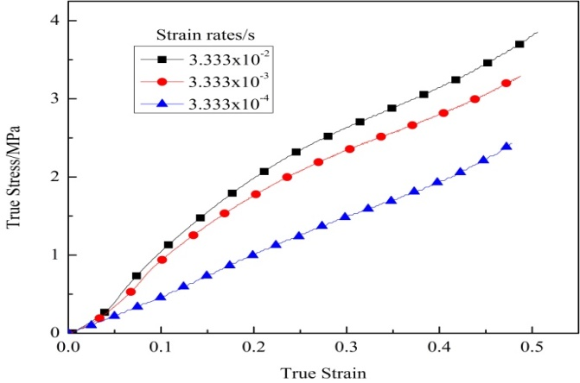

Figure 3: True stress-strain compression curve at quasi-static testing.

**3.2 Dynamic compression result at high rain rate**

The high strain rate compressive experiment mostly studies the strain rate correlation of the mechanical properties of the HTPB propellant. Therefore, the experiment is carried out at 293K. The specimen is kept at the corresponding temperature in advance. In the experiment, the specimen is between the rods. The surface of the lubricating oil reduces the friction, and the resulting signal curve is smoother the shaped piece (90) is added between the bullet and the incident rod. The high strain rate results is shown in the fig. 4. The mechanical curves of the HTPB propellant can be obtained at different high strain rates (1100sˉ¹,1600sˉ¹and 2000sˉ¹). The HTPB propellant can produce about 21% of engineering strain. In fig. 5 it is shown that the stress is directly proportion to the strain within elastic limit and the strain rate also, the young modulus is also directly proportional to the strain rate. According to the one dimensional stress wave theory the strain, strain rate can be defined as,

 (1)

 (2)

 (3)

**4. Proposed model**

The physical model of proposed model is shown in fig 5. This Constitutive model is consists of element A, element B and element C. Element B represents the viscoelastic response under low strain rate and element C denote the viscoelastic response in very high strain rate is range from 3.33x10-4s-1 to 2000s-1.. Based on experimental result, we know that the mechanical properties of HTPB composite material clearly rate dependent under high and low strain rates.

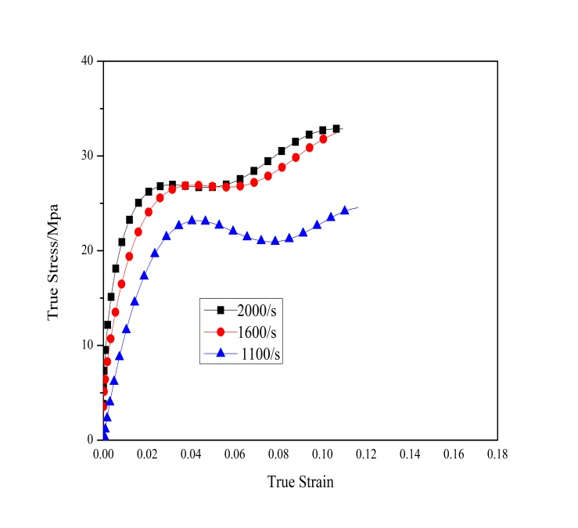

Figure 4: True stress-strain curve at high strain rate compression testing

**4.1 Hyper-elasticity**

As we know that the strain energy U can be define as;

 (4)

where I1 and I2 are the invariant of the left Cauchy green deformation tensor, Cij is constant.

According to the Rivlin and young, as we know that

 (5)

Pe=is the undetermined pressure

I=Cauchy strain tensor

α₁ and α₂ are the material parameters and B is the Cauchy deformation tensor is define as

  (6)

The relation between the strain invariant and stretch is

 (7)

From equation (2) and (4), as we know that

 (8)  (9)

From equation (8) and (9)

 (10)

Assuming the strain energy function

 (11)

The relationship of Cauchy tensor and stretch of element A is

 (12)

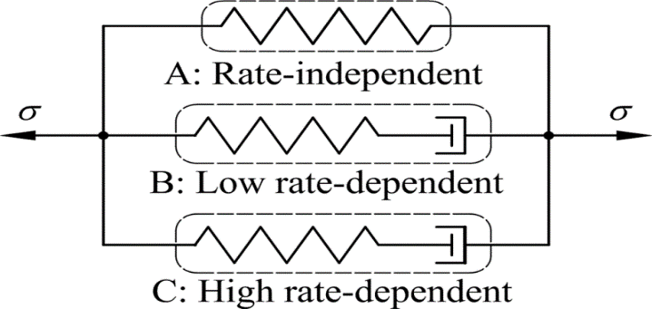

Figure 5: visco-hyperelasticity physical model

**4.2 Viscoelasticity**

It is the property of material that associate both viscos and elastic features when undergoing deformation, the constitutive relationship for a homogeneous, isotropic and incompressible viscoelastic material can be expressed as

 (13)

Ω is the frame-dependent matrix function.

Assuming that the spring stiffness in elements A and C proportional to the element C. The response of the element B and element C under instantaneously applied load are

 (14)

 (15)

E1 and E2 are constants.

Pouriayevali suggested the relation between the and is

 (16)

The total stress on the element B can be expressed in the term of the equation (16)

Therefore the total stress on the B is

 (17)

For uniaxial compression and can be written as

 (18)

Similarly,

 (19)

The relaxation function is

 (20)

Therefore, the total stress on element B is



 (21)

Similarly, the total stress on element C is

 (22)

**4.3 Visco-hyperelasticity**

The viscohyperelastic model consists of elements A, B and C, therefore, the total stress of the model is given by,

 (23)

When the applied load is slow, then we will ignore element C, therefore, the constitutive model will become

 (24)

If the material produced deformation under applied load, so the viscous element B cannot respond in time and element B equals to the spring element. Therefore, the high strain rate will become;

 (25)

**5. Model validation**

The mechanical properties of HTPB were further investigated by fitting the parameters of the modified ZWT model to a subset of the low and high strain rate compression results by the means of least square method. The results indicate that the mechanical properties of HTPB can be well predicted for the other strain rates not included in the fitting process.

**5.1 Parameters calibration**

The complete constitutive model of HTPB is given by Eq. (23). For describing the mechanical properties of HTPB over a wide range of strain rates, Eq. (24) and Eq. (25) are integrated, and put, such that the equations can be deduced.

(a) Quasi-static compression conditions:

 (26)

(b) Dynamic compression conditions:

 (27)

As we know that from the above analysis, the stress-strain curves at 3.33×10ˉ⁴sˉ¹ equal to the static state, thus, we got the values of parameters and  in element A by fitting the static curve at 293K, and then put the values of  and  in Eq. (24) to get  and  by fitting the curve at the strain rate 3.33×10ˉ³sˉ¹. Finally, put the values of  and  in Eq. (25) to get the value of  and  by fitting the curve at the strain rate of 2000sˉ¹. These are the required parameters of the model to describe the mechanical properties of HTPB propellant, which are listed in Table 1.

Compression of the ZWT model with the experimental data employing fitting process is shown in the Fig 6(a) and (b), which is indicated generally good agreement. The accuracy of the model is verified by comparing the predicted stress-strain curve of the visco-hyperelastic constitutive model with the quasi-static and dynamic experimental results obtained at strain rates of 0.000333s-1 and 2000s-1.

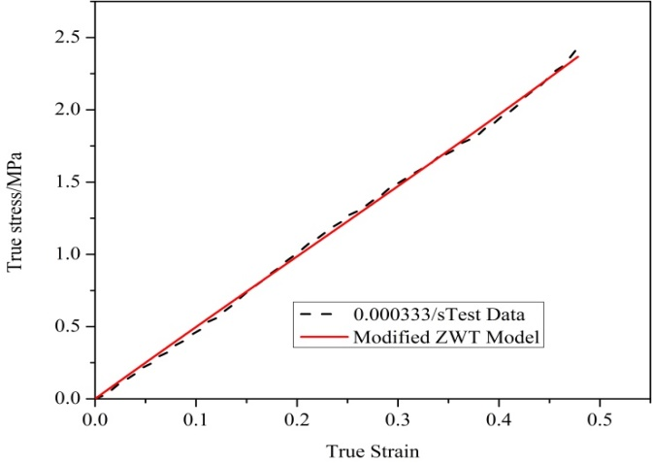

Figure 6(a): Compression of model with experimental results

**6. Conclusion**

The compressive mechanical properties of HTPB propellant were tested using universal testing machine and SHPB. From the experimental results, the compressive mechanical properties of HTPB should be rate-dependent under various loading conditions. Moreover, based on the Yang and Pouriayevali visco-hyperelastic model, we have proposed a visco-hyperelastic constitutive model to describe the mechanical properties of HTPB propellant under various loading conditions. The results show that the stress is directly proportional to the strain within the elastic limit, the strain rates are ranged from 3.33×10ˉ⁴ to 2000sˉ¹.

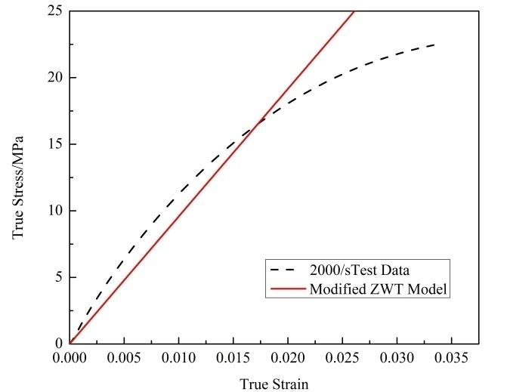

Figure 6 (b)

**Table 1. Values of different parameters**

|  |  |  |  |  |  |  |
| --- | --- | --- | --- | --- | --- | --- |
| Material | (MPa) | (MPa) | (MPa) | (MPa) |  |  |
| HTPB | -1.9438 | 0.2683 | -1.395 | 913.9345 | 0.8678 | -6.527 |

**Conflict of interest**

The authors declare that they have no conflict of interests.

**Corresponding Author:**

Muhammad Jamshed Khan

Department of Mechanical Engineering, Nanjing University of Science and Technology, Nanjing 210094, P. R. China Telephone: 0086-15951864436

E-mail: [jamshed.khan100@yahoo.com](mailto:jamshed.khan100@yahoo.com)

**References**

* 1. Ho, S.-Y., 2002, "High strain-rate constitutive models for solid rocket propellants," Journal of propulsion and power, 18(5), pp. 1106-1111.
  2. Guo, X., Zhang, X.-p., and Zhang, W., 2007, "Effect of tensile rate on mechanical properties of NEPE propellant," Journal of Solid Rocket Technology, 30(4), p. 321.
  3. Li, S., Liu, Y., Tuo, X., and Wang, X., 2008, "Mesoscale dynamic simulation on phase separation between plasticizer and binder in NEPE propellants," Polymer, 49(11), pp. 2775-2780.
  4. Zhang, J., Zheng, J., Chen, X., Sun, C., and Xu, J., 2014, "A Thermovisco-Hyperelastic Constitutive Model of NEPE Propellant Over a Large Range of Strain Rates," Journal of Engineering Materials and Technology, 136(3), p. 031002.
  5. Chou, S., Robertson, K., and Rainey, J., 1973, "The effect of strain rate and heat developed during deformation on the stress-strain curve of plastics," Experimental mechanics, 13(10), pp. 422-432.
  6. Gray, G. T., and Blumenthal, W. R., 2000, "Split-Hopkinson Pressure Bar Testing of Soft Materials," Materials Park, OH: ASM International, 2000., pp. 488-496.
  7. Kolsky, H., 1949, "An investigation of the mechanical properties of materials at very high rates of loading," Proceedings of the Physical Society. Section B, 62(11), p. 676.
  8. Frew, D., and Forrestal, M., 2002, "Dynamic compression testing of soft materials," Journal of Applied Mechanics, 69(3), pp. 214-223.
  9. Song, B., and Chen, W., 2004, "Dynamic stress equilibration in split Hopkinson pressure bar tests on soft materials," Experimental mechanics, 44(3), pp. 300-312.
  10. Bergström, J., and Boyce, M., 1998, "Constitutive modeling of the large strain time-dependent behavior of elastomers," Journal of the Mechanics and Physics of Solids, 46(5), pp. 931-954.
  11. Bergström, J., and Boyce, M., 2001, "Constitutive modeling of the time-dependent and cyclic loading of elastomers and application to soft biological tissues," Mechanics of materials, 33(9), pp. 523-530.
  12. Shim, V., Yang, L., Lim, C., and Law, P., 2004, "A visco-hyperelastic constitutive model to characterize both tensile and compressive behavior of rubber," Journal of Applied Polymer Science, 92(1), pp. 523-531.
  13. Yang, L., Shim, V., and Lim, C., 2000, "A visco-hyperelastic approach to modelling the constitutive behaviour of rubber," International Journal of Impact Engineering, 24(6), pp. 545-560.
  14. Pouriayevali, H., Guo, Y., and Shim, V., 2011, "A visco-hyperelastic constitutive description of elastomer behaviour at high strain rates," Procedia Engineering, 10, pp. 2274-2279.
  15. Pouriayevali, H., Guo, Y., and Shim, V., 2012, "A constitutive description of elastomer behaviour at high strain rates–A strain-dependent relaxation time approach," International Journal of Impact Engineering, 47, pp. 71-78.
  16. Song, B., Chen, W., and Weerasooriya, T., 2003, "Quasi-static and dynamic compressive behaviors of a S-2 glass/SC15 composite," Journal of Composite Materials, 37(19), pp. 1723-1743.
  17. Song, B., Chen, W., and Cheng, M., 2004, "Novel model for uniaxial strain‐rate–dependent stress–strain behavior of ethylene–propylene–diene monomer rubber in compression or tension," Journal of Applied Polymer Science, 92(3), pp. 1553-1558.
  18. Zhao, H., and Gary, G., 1996, "On the use of SHPB techniques to determine the dynamic behavior of materials in the range of small strains," International Journal of Solids and structures, 33(23), pp. 3363-3375.
  19. Frew, D., Forrestal, M. J., and Chen, W., 2001, "A split Hopkinson pressure bar technique to determine compressive stress-strain data for rock materials," Experimental mechanics, 41(1), pp. 40-46.
  20. Shan, R., Jiang, Y., and Li, B., 2000, "Obtaining dynamic complete stress–strain curves for rock using the split Hopkinson pressure bar technique," International Journal of Rock Mechanics and Mining Sciences, 37(6), pp. 983-992.
  21. Frew, D., Forrestal, M. J., and Chen, W., 2002, "Pulse shaping techniques for testing brittle materials with a split Hopkinson pressure bar," Experimental mechanics, 42(1), pp. 93-106.
  22. Seo, S., Min, O., and Yang, H., 2005, "Constitutive equation for Ti–6Al–4V at high temperatures measured using the SHPB technique," International Journal of Impact Engineering, 31(6), pp. 735-754.
  23. Forrestal, M., Wright, T., and Chen, W., 2007, "The effect of radial inertia on brittle samples during the split Hopkinson pressure bar test," International Journal of Impact Engineering, 34(3), pp. 405-411.
  24. Saraf, H., Ramesh, K., Lennon, A., Merkle, A., and Roberts, J., 2007, "Mechanical properties of soft human tissues under dynamic loading," Journal of biomechanics, 40(9), pp. 1960-1967.
  25. Naik, N., Shankar, P. J., Kavala, V. R., Ravikumar, G., Pothnis, J. R., and Arya, H., 2011, "High strain rate mechanical behavior of epoxy under compressive loading: experimental and modeling studies," Materials Science and Engineering: A, 528(3), pp. 846-854.
  26. Sherwood, J. A., and Frost, C. C., 1992, "Constitutive modeling and simulation of energy absorbing polyurethane foam under impact loading," Polymer Engineering & Science, 32(16), pp. 1138-1146.
  27. Bernstein, B., Kearsley, E., and Zapas, L., 1965, "A study of stress relaxation with finite strain," Rubber Chemistry and Technology, 38(1), pp. 76-89.
  28. Yang, L., Xie, K., Pei, J., Sui, X., and Wang, N., 2016, "Compressive mechanical properties of HTPB propellant at low, intermediate, and high strain rates," Journal of Applied Polymer Science.
  29. Qinlu, Y., Yulong, L., Hejun, L., Shuping, L., and Lingjun, G., 2008, "Quasi-static and dynamic compressive fracture behavior of carbon/carbon composites," Carbon, 46(4), pp. 699-703.

10/23/2017