**Nonlinear Dynamic Finite Element Analysis of Hardened Aircraft Shelter Subjected To Blast Load**

Abdel Hamid I. Zaghw1, Kamal G. Metwally2 and Ahmed M. Emarah3

1Professor, Department of Civil Engineering, Cairo University, Giza, Egypt

2Ass. Professor, Department of Civil Engineering, Beni-Suef University, Beni-Suef, Egypt

3Dissertation Scholar, Department of Civil Engineering, Cairo University, Giza, Egypt

[engbari@gmail.com](https://mg.mail.yahoo.com/neo/b/compose?to=engbari@gmail.com)

**Abstract**: The use finite element software programs to predict the behaviour of structures under different loading patterns and conditions can be considered today as a default analyses technique especially for conventional load patterns and common use structures such as buildings. Structures that are designed to resist blast loads mainly are considered as a special structure in which the dynamic response is required to be predicted accurately for different loading scenarios and which should be analyzed by special software programs rather than the commercial one. Blast field tests are dangerous, expensive, and always have limited size of explosions. So, the analysis of an air craft shelter subjected to general purpose 500 lb bomb at its middle span was done using two advanced finite element software programs LS-DYNA and WAI-MAZ to verify the use of different finite element software programs in blast load analysis. Response was evaluated for the mid-span displacement time history analysis of the shelter. The displacement response closely captures the same shape for both. The displacement value was extremely in close agreement between the two software programs.

[Abdelhamid I. Zaghw, Kamal G. Metwally and Ahmed M. Emarah. **Nonlinear Dynamic Finite Element Analysis of Hardened Aircraft Shelter Subjected To Blast Load.** *N Y Sci J* 2017;10(10):59-67]. ISSN 1554-0200 (print); ISSN 2375-723X (online). <http://www.sciencepub.net/newyork>. 8. doi:[10.7537/marsnys101017.08](http://www.dx.doi.org/10.7537/marsnys101017.08).

**Keywords:** Blast Load, LS-DYNA, WAI-MAZ, Aircraft Shelter, Dynamic Response, Finite Element

**1. Introduction**

The investigation of the structural dynamic response of structures under blast loads by field experiment is dangerous and limited to the scale of explosion. Consequently, the need for a trusted finite element model (FEM) to be used for an accurate simulation to investigate the structural dynamic response of structures under blast loads is urgently required nowadays. There are many finite element software programs can be used, besides, there are many parameters involved in each stage which make it extremely difficult to use a trusted finite element model in complex problems. This is due to the fact that the smallest change in any of the parameters may significantly change the results. Therefore, it is extremely important to understand each parameter and use it properly and accurately in the construction of the finite element model. The advanced general purpose finite element modelling software program LS-DYNA which was developed by Livermore Software Technology Corporation (LSTC). LS-DYNA version 9.71-R4.2 is a transient dynamic finite element program with an advanced solver which mainly based on explicit time integration methodology (LSTC, 2006). LS-DYNA’s advanced pre and post-processor LS-PrePost used to post processor the results to generate fringe plots and response diagrams (LSTC, 2011). Results obtained from the FEM were compared with those from modelled and designed by a trusted well-known organization that used the WAI-MAZ software. A scientific definition of explosion can be quoted from Strehlow and Baker: “In general, an explosion is said to have occurred in the atmosphere if energy is released over a sufficiently small time and in a sufficiently small volume so as to generate a pressure wave of finite amplitude traveling away from the source. This energy may have originally been stored in the system in a variety of forms; these include nuclear, chemical, electrical or pressure energy, for example. However, the release is not considered to be explosive unless it is rapid enough and concentrated enough to produce a pressure wave that one can hear. Even though many explosions damage their surroundings, it is not necessary that external damage be produced by the explosion. “All that is necessary is that the explosion is capable of being heard”, (Strehlow and Baker, 1976). This definition refers to explosions in air. There are three types of explosions: physical, nuclear or chemical explosions. The most commonly used explosives are condensed. They could be solids or liquids. When an explosion occurs, the explosive material violently decomposes which produces heat and gas. If the explosive is in contact with solid material the expansion of gas will generate shock pressures. However, if this expansion happens in a non-solid medium such as air, what it will generate is called blast waves (Mays and Smith, 2001). In the past decades, numerical simulations have became essential in investigating the response of the structures under blast loads. There are two common approaches of modelling structures. The first is the discrete approach which also known as micro modelling, which involves separate modelling of each element, so the interaction between the elements are included in the modelling. Many of researches have used micro modelling approach to study the complex behaviour of structures. The second method is the continuous approach or continuum modelling which also known as macro modelling in which the interaction between the element joints is excluded so the joints are blended into a single continuum where equivalent properties of the homogenized composite material are used. The results from both approaches had been found reasonably similar. However, since the special model resulted in larger computational time it was concluded that the continuous approach will save a lot of time in modelling large structures (Wang et al., 2009). The continuous approach has become more attractive to researchers since the discrete modelling method is very complex and computationally extensive especially for models that simulating large structures. However, since the failure in structures often occurs in the weak joints micro modelling approach is strongly more capable of capturing all the possible failure modes than the macro modelling and as a result it can provide the best insight to behaviour of structures. For this reason, if any one need to go through the effort of detailed special modelling of structure elements, more reliable predictions and investigations of the response of the structure would be achieved. The discrete approach is adopted in developing the model of the aircraft shelter subjected to blast loading in the current study considering three main elements arch, soil, and burster slab.

**2. Objectives of the Study**

The objective of this paper is to verify the validity and reliability of using finite element models of LS-DYNA software program in future studies on structures subjected to blast loads instead of physical field experiments which are complicated in collecting data accurately and due to their expensively and danger to human life by the unsafe nature of blast loading behaviour.

**3. Methods**

The verification was done by constructing a finite element model by LS-DYNA software against another trusted software but with different assumptions to validate different options of blast load inputs. A Hardened Aircraft Shelter had been modelled and designed by a trusted organization, which is specialized in the design of structures subjected to blast loads using the most accurately computational fluid dynamics WAI‐MAZ software. The validation process have been done on the midpoint displacement time history which is the most important parameter that allows us to judge on damage that have been done and the effect on overall stability of the structure. A comparison study between two software programs LS-DYNA and WAI‐MAZ software was done. The advanced general purpose finite element modelling software program LS-DYNA which developed by Livermore Software Technology Corporation (LSTC). LS-DYNA version 9.71-R4.2 is a transient dynamic finite element program with an advanced solver which mainly based on explicit time integration methodology (LSTC, 2006). LS-DYNA’s advanced pre and post-processor LS-PrePost used to post processor the results to generate fringe plots and response diagrams (LSTC, 2011). FEM have been created to validate the use of the finite element software LS-DYNA in blast load simulation. The Hardened Aircraft Shelter had been modelled and designed by a trusted organization, which is specialized in the design of structures subjected to blast loads using the most accurately computational fluid dynamics WAI‐MAZ software. The shelter was designed to resist direct hit of general purpose 500 lb bomb on its mid-span. The HAS is configured as a structure with a formed reinforced concrete arch. Each end of the arch is closed by a concrete end-wall, which contains a hanger door opening. The end-walls are structurally isolated from the arch, and provide horizontal support for the hanger doors. The HAS includes an earth cover and a reinforced concrete burster slab.

**3.1. Units, Dimensions and Geometry**

Millimeter is used for length, second for time, ton for mass, and newton for force. The air craft shelter is constructed as a reinforced concrete arch of 500mm thickness and 17000mm diameter covered by sandy medium graded soil from all sides with a layer of 8400mm thickness from sides and 1500mm from top covered from top by a burster slab of 600mm thickness and 8650mm width. Only half length of the shelter of 25000mm on the axis of symmetry was modeled to reduce the model’s time solving process while the total height of the shelter reached about 12000mm as shown in Figure 1.

**3.2. Parts**

Parts are defined in this model under *PART cards. Part-1 represents the reinforced concrete arch and part-2 represents the soil where part-3 represents the reinforced concrete burster slab. Each part card in LS-DYNA input deck includes material identification and section identification which are defined in *MAT and *SECTION sections respectively in the input file. *MAT card contains material properties information and *SECTION card contains element properties information.

**3.3. Elements**

Elements used in this FEM are 8-node solid elements and are included in *SECTION_SOLID card. Length, width and height of each element is divided in to 755mm max for each direction.

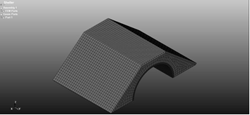

**Figure 1: Isometric View for the Finite element model of the shelter**

**3.4. Material Models Definition**

The material model for [part-1: reinforced concrete arch] is *MAT_RIGID which is a rigid material model. The required parameters in the material cards for *MAT_ELASTIC are: mass density, Young’s modulus and Poisson’s ratio. The material model for [part-2: sandy graded soil] is *MAT_SOIL_AND_FOAM which is a very simple material model and works in some ways like a fluid, it should be used only in situations when soils and foams are confined within a structure or when geometric boundaries are present. The required parameters in the material cards for *MAT_SOIL_AND_FOAM are: mass density, bulk and shear modulus, and plastic yield constants. [Part-3: reinforced concrete burster slab] is *MAT_ELASTIC which is an elastic material model. The required parameters in the material cards for *MAT_ELASTIC are: mass density, Young’s modulus and Poisson’s ratio. Table 1 summarizes LS-DYNA’s input parameters used for the simulations.

**3.5. Hourglass Control Definition**

Hourglass control must be incorporated in the code under *HOURGLASS card to avoid the zero energy modes. The default algorithm was used.

**3.6. Contact Interfaces Definition**

In this model each PART is attached to its neighbor PART using *CONTACT_AUTOMATIC_GENERAL contact type.

**3.7. Boundary Condition Definition**

*BOUNDARY_SPC cards, Translational parameters DOFX, DOFY, DOFZ, DOFRX, DOFRY and DOFRZ in the code was assigned with 1 to restrain the movement and rotation at boundaries.

**Table 1.** **Parameters Assigned to the Default Model**

|  |  |  |
| --- | --- | --- |
| Parameter | Value | Unit |
| Reinforced Concrete Mass Density (Arch) | 2.5E-9 | Ton/mm3 |
| Reinforced Concrete Young’s Modulus (Arch) | 2.8E+4 | MPa |
| Reinforced Concrete Poisson’s ratio (Arch) | 0.3 | - |
| Reinforced Concrete Mass Density (Burster Slab) | 2.5E-9 | Ton/mm3 |
| Reinforced Concrete Young’s Modulus (Burster Slab) | 2.0E+4 | MPa |
| Reinforced Concrete Poisson’s ratio (Burster Slab) | 0.2 | - |
| Soil Mass Density | 2.0E-9 | Ton/mm3 |
| Soil Bulk’s Modulus | 1.5E+4 | MPa |
| Soil Shear Modulus | 2.0E+5 | MPa |
| Soil Plastic Yield Constants A1, A2 & A3 | (4.35E-6, 250, 0.542) | - |

**3.8. Blast Load Definition**

The shelter in the experimental test were subjected to direct hit of 500 lb bomb which generated by detonation of 250 Kg of TNT at zero standoff distance from the top surface of the burster slab at the middle of the shelter length. In the FEM the *LOAD_BLAST_INHANCED option was used to apply pressure loads to the shelter due to explosion. The ConWep model (Hyde, 1991) is incorporated in LS-DYNA based on a study by Randers-Pehrson and Bannister (1997). The ConWep algorithms calculate the pressure values by taking into account the angle of incidence of the blast wave. *LOAD_BLAST_INHANCED must be used with *LOAD_SEGMENT_SET where a segment set corresponding to the face of the burster slab on which the pressure will be applied is created. In *LOAD_SEGMENT_SET, the parameter LCID in defining load curve must be input as (-2) in order to call ConWep function algorithms to determine the pressure for the segment. Once the segment set is created, properties of the explosive must be specified under *LOAD_BLAST_INHANCED card. The inputs include equivalent mass of TNT, detonation location, unit system and type of explosion. The above Table 2 summarizes all the parameters and their defined values which had been used in this model. Because the charge is hitting the slab surface, a value of 1 is assigned to (ISURF) which defines the type of explosion used as hemispherical surface burst “charge is located on or very near the ground surface, initial shock wave is reflected and reinforced by the ground”. Using a value of 5 to IUNIT will allow converting the default units into LS­DYNA’s units.

**Table 2. Blast load parameters**

|  |  |  |  |
| --- | --- | --- | --- |
| Parameter | Description | Value | Unit |
| WGT | equivalent TNT mass | 0.250 | ton |
| XBO | x-coordinate of explosion point | 18500 | mm |
| YBO | y-coordinate of explosion point | 0.00 | mm |
| ZBO | z-coordinate of explosion point | 12000 | mm |
| IUNIT | unit conversion flag | 5 | ton, mm, s, MPa |
| ISURF | type of burst | 1 |  |

**4. Results and Discussions**

**4.1. WAI‐MAZ Numerical Results for Hardened Aircraft Shelter**

Blast pressures from the specific explosive threats for this structure, 500 lb bombs, are most accurately calculated using computational fluid dynamics. WAI‐MAZ is used for the calculations for this effort. This code produces accurate and efficient numerical calculations necessary to characterize the spatial and temporal resolution of the air blast and resulting structural loads. Key features incorporated in WAI‐MAZ are:

* A 2D/3D Euler solver that uses the second‐order TVD (Total Variation Decreasing) scheme by Harten (Harten, 1983). The TVD scheme is constructed to capture shocks in the computational domain and minimize the Gibbs oscillations behind the shock fronts.
* A variety of equations‐of‐state (EOS), including the JWL (Jones‐Wilkins‐Lee) model which accurately describes the gas products of HE detonations.
* A detonation model that calculates the energy release from explosives in various geometries, e.g., spheres, cylinders or boxes. Simultaneous or sequential detonations of any number of explosive charges can be modelled anywhere in the computational grid. The detonation can be initiated anywhere inside the explosive charge.
* Adaptive Zoning, which allows spatial resolution to be automatically be concentrated where numerical detail is most needed, such as along blast shock fronts and structure surfaces. This is particularly important when performing 3D calculations, when computational efficiency is required.

Detonation of cased weapons, such as the 500 lb and 1000 lb bombs considered here, produces fragment loading on nearby surfaces. Fragment loading is modelled with the FRAGSIM tool, developed by WAI based on algorithms defined in [UFC 3‐340‐01]. FRAGSIM defines the particle masses, initial spatial coordinates, and initial velocities from fragments generated by the detonation of the two bomb types. These particles are then modelled as spheres in the finite element analysis, and their impacts with the structure (with the associated energy transfer) are modelled via side-line logic. Structural response to blast, whether local deformations of individual structural elements or disproportionate collapse of the global structure, is an inherently dynamic event. The explosive standoffs and fragment loading considered in the blast analyses performed for this effort dictate that simplified tools, such as single degree of freedom‐based tools, will not provide the necessary level of accuracy. The most accurate tool for predicting complex responses is a first principles‐based explicit finite element code. The calculations documented in this report are performed with WAI’s proprietary code NLFLEX, a nonlinear, transient analysis finite element code. NLFLEX has been validated through pretest predictions and post‐test correlation with small‐scale and large‐scale tests for a large number of air blast, impact, ground shock and thermal loading situations. Above‐ground, surface‐flush, shallow‐buried and deeply‐buried structural responses have been simulated for both civilian and military construction. The NLFLEX software has been recognized by [DOD] and US Government agencies as one of the most advanced tools of its kind in use today As stated before, the effects of two weapons on the HAS burster slabs are considered in this study. The 500 lb bomb is placed at the mid‐span (width and length) of the burster slab, which is considered to be the worst case scenario for deflection of both the burster slab and the underlying arch. [UFC 3‐340‐01] defines the explosive weights and dimensions for the 500 lb weapon, and defines Tritonal as the explosive type. The MAZ calculations assume the explosives are uncased and use effective explosive weights for the weapon, which are adjusted from the actual explosive weights to account for energy lost to case break‐up (based upon WAI’s experience from previous work with cased and uncased explosives). The vertically oriented 500 lb weapon effects are modelled using a quarter‐symmetry grid. The peak pressure and impulse contours below the 500 lb weapon on the burster slab roof surface. The vertical orientation produces a peak pressure of 2545.0 ksi and impulse of 13.8 ksi‐ms on the burster slab. The maximum displacement measured at the mid span of the burster slab and under the 500 lb bomb was 0.23” (5.85 mm) while the maximum displacement measured at the mid span of the concrete arch was 0.06” (1.525 mm).

Figures 2 and 3 show the finite element model while figures 4, 5, and 6 show the values of the mid span deflection under the blast load.



**Figure 2: Shelter Finite Element Model by WAI-MAZ**



**Figure 3: Numerical Mid-Point Displacement Time History by WAI-MAZ**

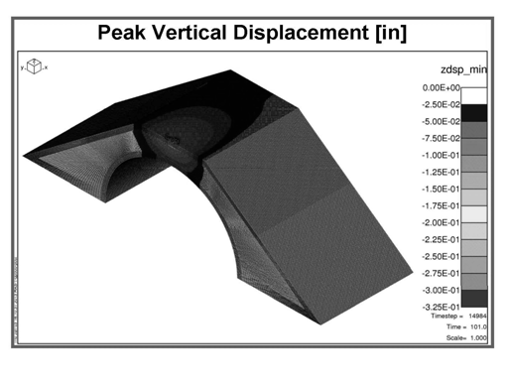

**Figure 4: Peak vertical displacement during analysis – 3D**

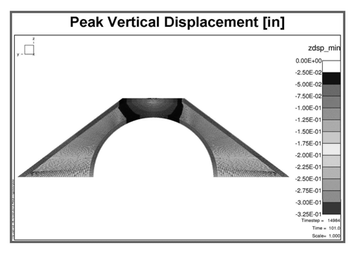

**Figure 5: Peak vertical displacement contours during analysis- Elevation**

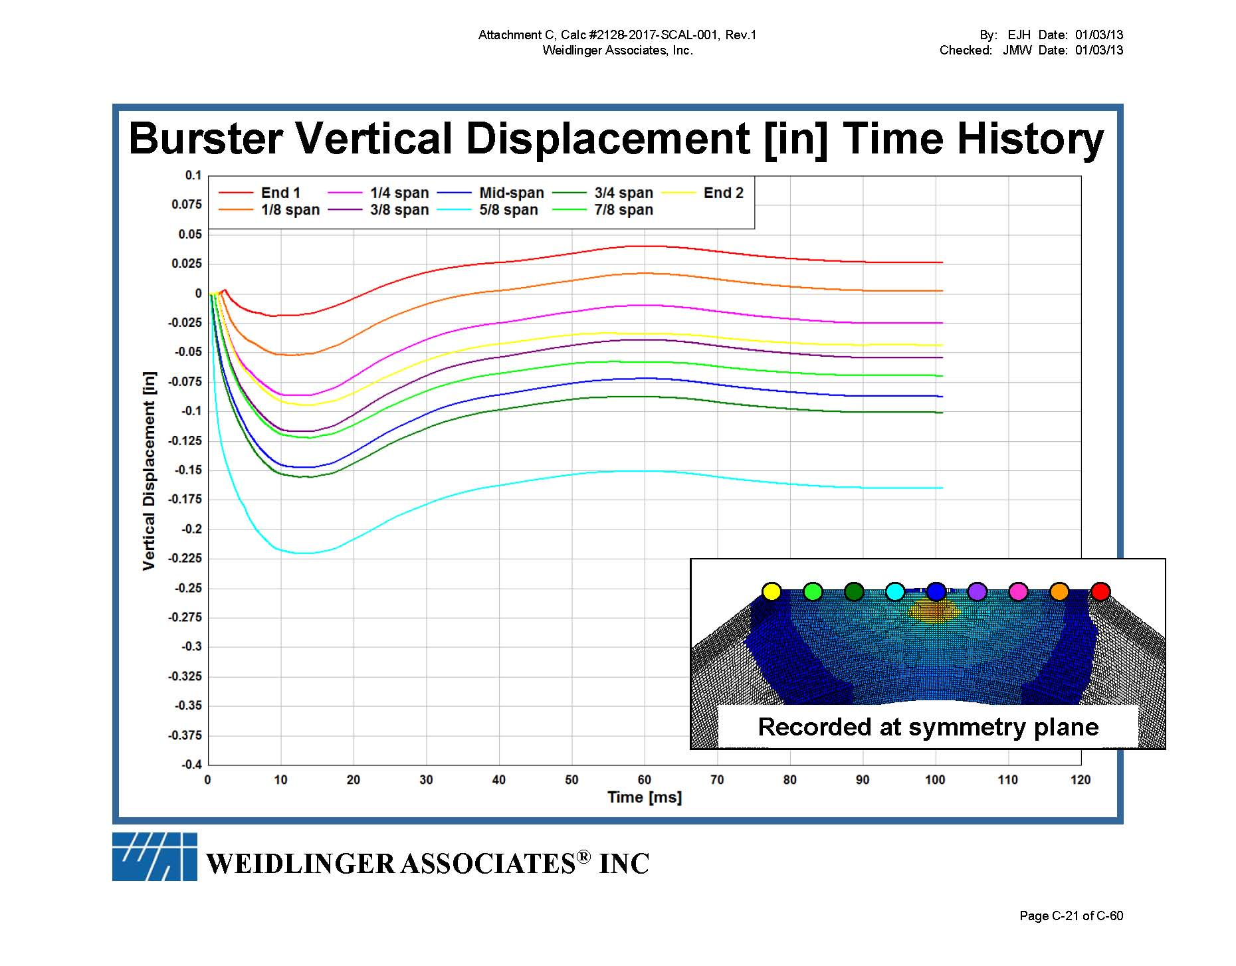

**Figure 6: Peak vertical displacement time history of The Arch**

**4.2. LS-DYNA Numerical Results for Hardened Aircraft Shelter**

The process of developing the finite element model was described before in details. The behaviour of the finite element model of the shelter is described in this section in terms the mid-span centre displacement which corresponds to the displacement data resulted from the model described before. For this purpose, the D3Plots generated by LS-DYNA solver is opened in the LS-PrePost. A node at the centre of the shelter just under the bomb is selected and node displacement time history in Z-direction is plotted. The following figure 7 illustrates the displacement response output by LS-PrePost:

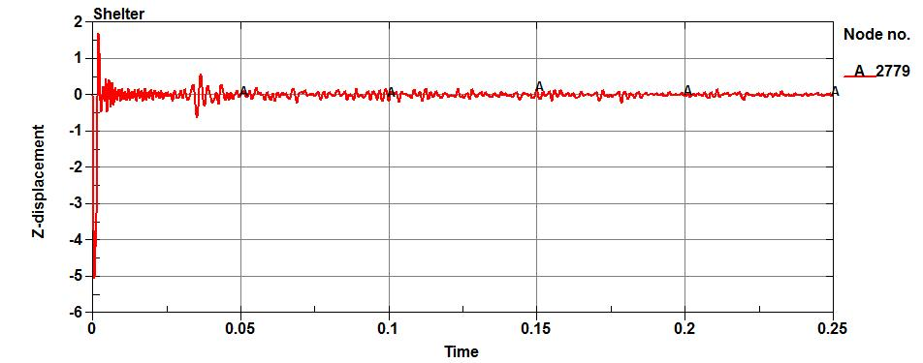

**Figure 7: Peak vertical displacement time history of the burster slab**

**4.3. Comparison between the two numerical models results**

In the previous sections the displacement at the mid-span of the shelter in both finite element models was illustrated. In order to validate the developed FEM, the results from the model of LSDYNA are compared with the results of the WAI-MAZ model. The main criterion parameter on which the credibility of the FEM is tested is the close agreement of the maximum negative displacement (the first peak in the plots above) within 12% error. Therefore, in this study a small value for error (12%) is reached in order to improve the accuracy of the model. When a structure is subjected to blast load which is a case of loading with an extremely short duration and a magnitude lot larger than any other load that will be ever applied to the structure in its design life, ***then only the maximum positive displacement becomes what is critical for the structure’s survival***. The first positive (rebound) displacement is less than the negative peak due to structure’s damping. Also the vibrations values of the burster slab displacements which represented in the curve after the peak mid-span displacement varies ups and downs. Therefore, the first maximum negative displacement at the burst slab’s mid-span is most important factor which is the reason why typical failure criterion is often defined in terms of maximum mid-span displacements. Hence, the key parameter in the verification process is the accuracy of this value which is why a small amount of error is expected from the FEM predicted results. Other criteria used for assessing the accuracy of the FEM is the proximity of general pattern of the displacement response, the values of the displacements and the times at which they occur. It should be noted that the magnitude of displacement have a higher priority than their times of occurrence since the difference between times would be within milliseconds which in reality does not effect on anything in terms of design or damage assessment. So in summary, as long as the first positive displacement in the two FEM models resulted from two different finite element software is closely match with each other (12% error) with the pattern of the peak displacement response, then the FEM is considered valid. It can be observed from Figure 8, that the maximum negative displacement from the LSDYNA finite element model is (5.1) mm. This value is in extremely close agreement with the corresponding value obtained by WAI-MAZ software 0.225” (5.7 mm) at figure **7** with only 12% error. The displacement response closely captures the same shape for both. Also we noted that the arrival time required in the two models response plot is zero msec. Also due to the fact that LSDYNA model is modelled for 250 msec while the WAI-MAZ modelled only for 120 msec, the comparison between two models’ results is focused on the first 120 msec. However, it should be mentioned that even after 120 msec, the curve pattern remains the same as before the value of 120.

**5. Conclusions**

This study showed that although the variety of the parameter’s definition and modelling philosophy techniques of each finite element program, different finite element software programs can be used to predict an accurate simulation for a hardened aircraft shelters subjected to blast loadings. Small tolerance of difference between the result values of each program was obtained. Displacement time history is the most critical parameter to study under blast load for shelters.

**References**

1. Schlamp, R. J., Hassig, P. J., Nguyen, C. T., Hatfield, D. W., Hookham, P. A., “MAZ User’s Manual,” Defense Nuclear Agency Contract Report, Contract No. DNA001‐91‐C‐0153.
2. Smith, et al. (1994). Blast and Ballistic Loading of Structures, Butterworth‐Heinemann Ltd.
3. Mould, et al. (1993) “A Rate‐Dependent Three Invariant Softening Model for Concrete,” published in Studies in Applied Mech., Mech. and Materials and Structures, Ed. by G. Voyiadjis, L. Bank and L. Jacobs, Elsevier.
4. NAVFAC DM7‐02 (1986). ”Soils and Foundations Design Manual: Foundations and Earth Structures”, Naval Facilities Engineering Command.
5. Dynasupport, LS-DYNA Support (2011). http://www.dynasupport.com/howtos/element/hourglass.
6. Hyde (1991), "Conwep-Conventional Weapons Effects Computer Code", US Army Engineer Waterways Experimental Station.
7. LSTC, Livermore Software Technology Corporation (2006), Ls-Dyna Theory Manual. Livermore, California.
8. LSTC, Livermore Software Technology Corporation (2007), Ls-Dyna Keyword User's Manual-Version 971 Livermore, California.
9. UFC (2008), Unified Facilities Criteria. Structures to Resist the Effects of Accidental Explosions, Department of Defense, United States of America.
10. Wahab, et al. (2016), “Performance of double reinforced concrete panel against blast hazard”, Int. J. Comput. Conc., 18(4), 807-826.
11. Abou-Zeid, et al. (2011), "Response of arching unreinforced concrete masonry walls to blast loading." J. Struct. Engin., 173(10), 1205-1214.
12. Chang, David B., and Young, Carl S. (2010), "Probabilistic estimates of vulnerability to explosive overpressures and impulses." Journal of Physical Security”.
13. Mazek, S.A. and Mostafa, M.A. Wahab (2015), “Impact of composite materials on buried structures performance against blastwave”, Int. J. Struct. Engin. Mech., 53(3), 589-605.
14. Strehlow, et al. (1976). "The Characterization and Evaluation of Accidental Explosions." Progress in Energy and Combustion Science 2, no. 1 (1976): 27-60.
15. Mays, et al. (2001) edition, Blast Effects on Buildings, Thomas Telford publications, Thomas Telford services ltd, 1 Heron Quay, London, ISBN: 0727720309.
16. Wang, Ming, et al. (2009), "Prediction of fragment size and ejection distance of masonry wall under blast load using homogenized masonry material properties" International Journal of Impact Engineering, 36(6), 808-820.

9/24/2017