Examining the impact of information technology infrastructures on supply chain performance in petrochemical company of Fanavaran (Mahshahr)

Majid Bayani ¹, Dr. Ghanbar Amirnezad ^{2*}

¹Department of Business Management, Faculty of Humanities, Persian Gulf International Branch, Islamic Azad University, Khorramshahr, Iran
²Department of Business Management, Faculty of Humanities, Persian Gulf International Branch, Islamic Azad University, Khorramshahr, Iran
Corresponding Author: Dr. Ghanbar Amirnezad ^{2*}

Abstract: The present study aimed to investigate the impact of information technology infrastructures on supply chain performance in petrochemical company of Fanavaran (Mahshahr). The research hypotheses have been examined through SPSS and LISREL software. Generally, the research results show that the factors of government, economy, organizational culture, human force, management and technical factor have a positive and significant impact on supply chain performance in petrochemical company of Fanavaran. Therefore, it is recommended that, given that using information technology in supply chain requires suitable cultural, economic, management and... infrastructures, organizations should try to strengthen the proposed factors using necessary guidelines.
[Majid Bayani, Ghanbar Amirnezad. Examining the impact of information technology infrastructures on supply chain performance in petrochemical company of Fanavaran (Mahshahr). N Y Sci J 2017;10(7):42-49]. ISSN 1554-0200 (print); ISSN 2375-723X (online). http://www.sciencepub.net/newyork. 6. doi:10.7537/marsnys100717.06.

Key words: information technology, supply chain performance, government, economy, organizational culture.

Introduction
As competition was intensified in the decade after 1992, and markets became global, some challenges regarding appropriate place, appropriate time and the lowest cost for products and services were created; therefore, due to these challenge, organizations began to realize the fact that in order to improve efficiency within the organization, the whole supply chain must become competitive. Recognizing and implementing supply chain management has become a necessary prerequisite for remaining in the competition and increasing profitability in the global competition.
Review of literature
Domestic research literature
Sanayei et al. (2011) have conducted a study entitled “the impact of information technology on value chain of Iranian sample export companies”. The research findings show that using information technology in value chain of companies is able to improve the speed and accuracy of performing value chain processes, directly, and the cost of performing the processes, indirectly, and in this way increase the operational capability of companies.
Farsi Jani et al. (2011) in their study have examined and explained the role of information technology in management performance of cold chain in global class organizations. The results of this analysis confirmed all three research hypotheses. At the end of the article, conclusions have been presented along with recommendations for future research.
Norang et al. (2011) have conducted a study entitled “Development of a supply chain management performance evaluation model, using balanced scorecard”. Finally, it is concluded that this model is better and superior compared to other models.
Foreign research
Pinnario De Barris et al. (2015) in a study have examined the processes and benefits of using information technology in supply chain management, with an analysis of published articles. In this project it is concluded that there is an opportunity for progress in processes related to production and development of products or services.
Merriniji et al. (2014) have conducted a study entitled “the impact of information technology on development of competitive advantage of supply chain”. The empirical findings from examining 76 manufacturing companies in Greece confirmed the role of IT techniques and methods in establishing a sustainable competitive advantage based on supply chain management. In this article, management concepts have been discussed.
Vienna Weingarten et al. (2011) have investigated the impact of Electronic Business (EB) software programs used in supply chain on operational performance level. Their research showed that the level of readiness for performing electronic business among the key suppliers in supply chain is able to adjust and strengthen the mentioned relationships.
Research hypotheses
The main hypothesis of research
- Information technology infrastructures have a positive and significant impact on supply chain performance in petrochemical company of Fanavaran.
Sub-hypotheses
- The factor of government, as an infrastructure of information technology, has a positive and significant impact on supply chain performance in petrochemical company of Fanavaran.
- The factor of economy, as an infrastructure of information technology, has a positive and significant impact on supply chain performance in petrochemical company of Fanavaran.
Research method
In this research, we aimed to examine the impact of information technology infrastructures on supply chain performance in petrochemical company of Fanavaran. The research method type in this research is descriptive-analytical, and it is applied in terms of the purpose.
Statistical population
The statistical population of this study is consisted of all specialists, experts and managers of organizations active in the supply chain of petrochemical company of Fanavaran of Mahshahr. Their number, after referring to the organization, was obtained as 950 ones.
Testing the hypotheses
Testing the main hypothesis
Information technology infrastructures impact supply chain performance in petrochemical company of Fanavaran.
Designing H₀ hypothesis
Information technology infrastructures impact supply chain performance in petrochemical company of Fanavaran.
Designing H₁ hypothesis
Information technology infrastructures do not impact supply chain performance in petrochemical company of Fanavaran.
Structural equations model
The following figure shows the results of testing the main hypothesis through structural equations modeling. The following figure indicates the standard coefficient (R) among the information technology infrastructures affecting supply chain performance.

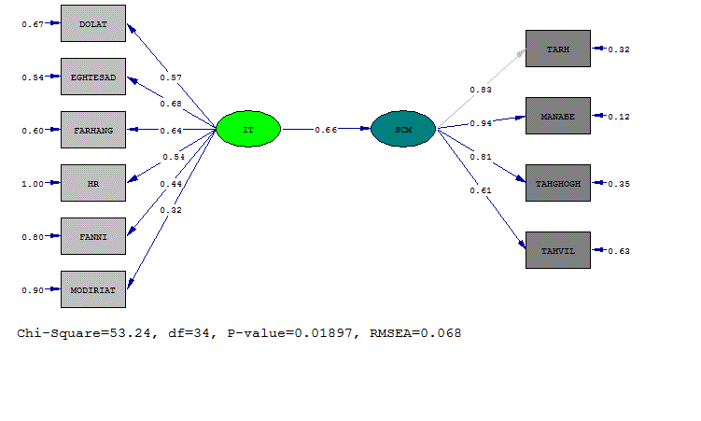

The factor loads inserted on the arrows are all above the absolute value of 0.50 which indicates that the related indexes are good measures for latent variables. Another statistic which is used to reject or accept the measures, is T-value that given that the absolute value of all relations is greater than 2, it can be concluded that the obvious variables are good measures for measuring latent variables

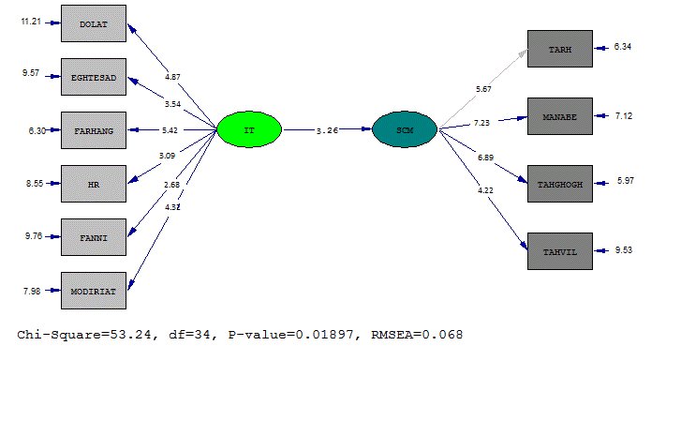

As can be seen, firstly, given the significance of t value (1.96<3.26), the main hypothesis is confirmed at 95% confidence level. Secondly, appropriate validity and fitness of the model is confirmed, because RMSEA value is lower than 0.07 and the ratio of chi 2 to degree of freedom is also lower than 4, and ultimately p-value is also greater than 0.05.
Path analysis test
Path analysis test in standard mode

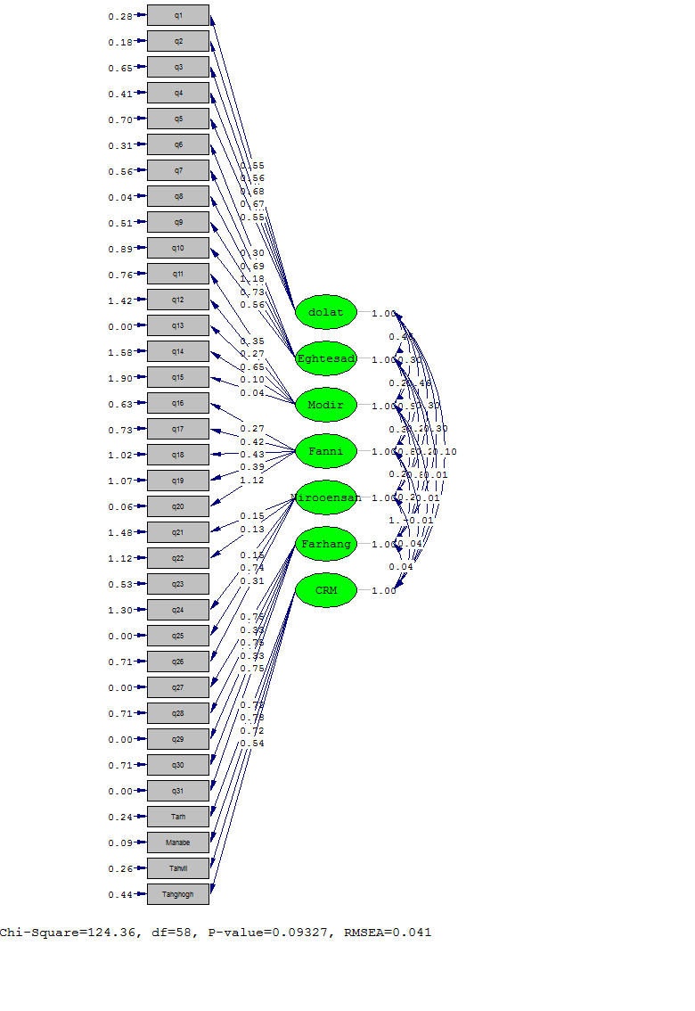
Path analysis test in T-Value mode
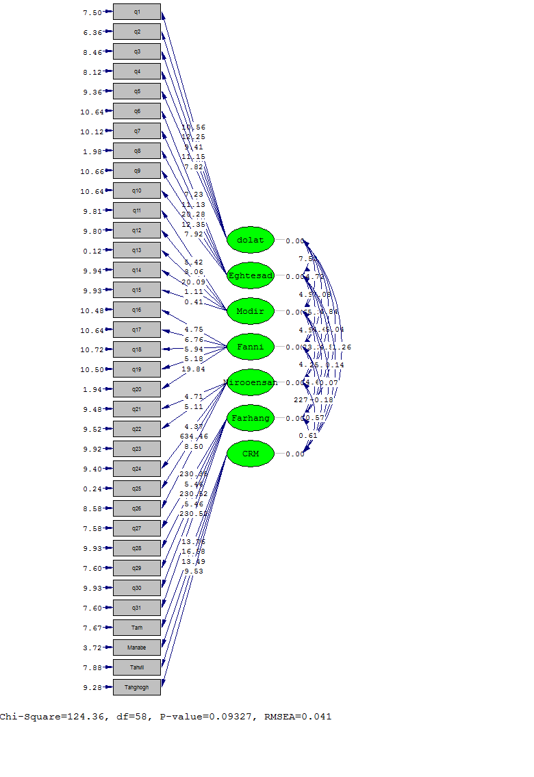

Testing the first sub-hypothesis
Designing H₀ hypothesis
The factor of government, as one of the information technology infrastructures, impacts supply chain performance in petrochemical company of Fanavaran.
Designing H₁ hypothesis
The factor of government, as one of the information technology infrastructures, does not impact supply chain performance in petrochemical company of Fanavaran.

Structural equations model

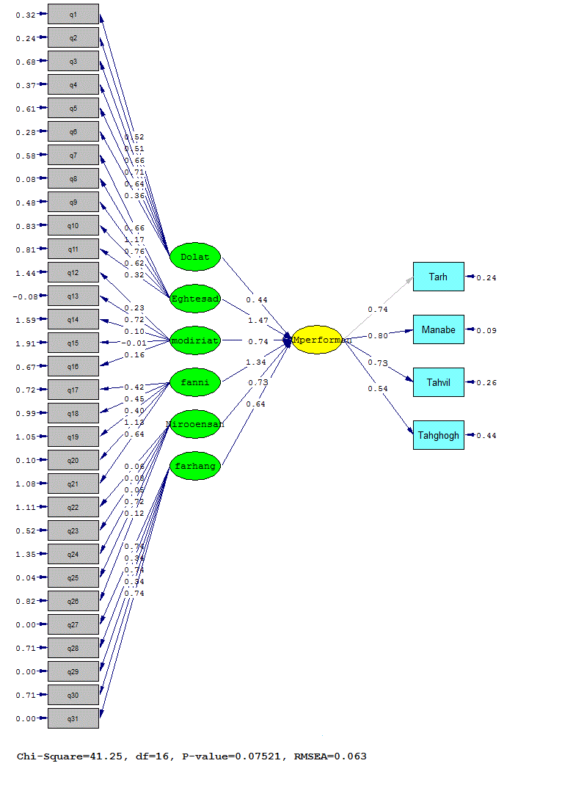

As mentioned earlier, if the amount of is low, the ratio of to degree of freedom (df) is lower than 4, RMSE is lower than 0.07 and also P-value is greater than 0.05, then it can be concluded that the implemented model has a suitable fitness. Standard coefficient of the existing relation, in case that t value is greater than 2 or lower than -2, will also be significant at 95% confidence level.
Testing the second sub-hypothesis
Designing H₀ hypothesis
The factor of economy, as one of the information technology infrastructures, impacts supply chain performance in petrochemical company of Fanavaran.
Designing H₁ hypothesis
The factor of economy, as one of the information technology infrastructures, does not impact supply chain performance in petrochemical company of Fanavaran.
Structural equations model

As mentioned earlier, if the amount of is low, the ratio of to degree of freedom (df) is lower than 4, RMSE is lower than 0.07 and also P-value is greater than 0.05, then it can be concluded that the implemented model has a suitable fitness. Standard coefficient of the existing relation, in case that t value is greater than 2 or lower than -2, will also be significant at 95% confidence level.

Conclusion
The main hypothesis of research
Given the significance of t value, the main hypothesis is confirmed at 95% confidence level. Secondly, suitable validity and fitness of the model is confirmed, because RMSEA value is lower than 0.07 and the ratio of chi 2 to degree of freedom is also lower than 4, and finally, p-value is also greater than 0.05. Thus, the above hypothesis is confirmed.
Today, in a supply chain information is an important factor for good and efficient decision-making for development and survival, and therefore, it involves two purposes of coordination and prediction and planning. Given the importance of information flow and its role in supply chain, it can be said that supply chain, compared to individualistic institutes, has three special characteristics including more coverage, more access channels and desirable quality of information.
Information technology improves distribution and transmission of information, and improves efficiency of supply chain effectively. IT improves cooperation relationships in the two domestic and foreign aspects, and prevents occurrence of bullwhip effect.
- Sub-hypothesis 1
The results obtained from statistical analysis indicate that: if the amount of is low, the ratio of to degree of freedom (df) is lower than 4, RMSE is lower than 0.07 and also P-value is greater than 0.05, then it can be concluded that the implemented model has a suitable fitness. Standard coefficient of the existing relation, in case that t value is greater than 2 or lower than -2, will also be significant at 95% confidence level. Therefore, the above hypothesis is confirmed.
Information technology development has provided an effective support for supply chain management. Among the tasks of governments is to create necessary infrastructures for development of information technology such as guaranteeing the safety of using IT equipment at any time and place, production and using of strategic products of communications and information technology.
- Sub-hypothesis 2
Firstly, given the significance of t value, the second sub-hypothesis is confirmed at 95% confidence level. Secondly, appropriate validity and fitness of the model is confirmed, because RMSEA value is lower than 0.07, and the ratio of chi 2 to degree of freedom is also lower than 4, and finally, p-value is also greater than 0.05. The results of this hypothesis are consistent with the findings of Nazemi et al. (2011).
The good and economic performance of any company is related to the efficient performance of the supply chain and focusing on its triple macro processes. After some decades that companies were focusing only on the internal processes of their supply chain, now companies have to, in addition to their internal section, focus on other sections of supply chain in upstream sectors (relationship with suppliers) and downstream sectors (relationship with customers). The best method in managing supply chain is not to focus on a particular sector and to increase the total profit of the chain; and this chain can reach the required result sooner through using information technology.

Reference
- Acar, A. Zafer, Uzunlar, M. Bora. (2014). The effects of process development and information technology on time-based supply chain performance, Procedia - Social and Behavioral Sciences 150, 744 – 753.
- Belcourt, M. (2006). Outsourcing: the benefits and risks, human resoue management review, Vol.16,269-279.
- Borney. (1990). Outsourcing: The debate between rraditional management theory and organizational econoilcs. Acadamy of Management, Review Vol.17, No.3.
- Davies, D. M. (1980) Approriate information Technology. International Information & Library Review International Library Review, 17. pp. 247-258.
- Donaldson, L., (1990), the ethereal hand: organization economics and roangement theory. Academy of Management, journal Vol. 15m No.3.
- Lalonde, B. J., (1998), Building a supply chain relationship. Supply chain Management Review 2 (2, Fall).
- Marinagi, Catherine, Trivellas, Panagiotis, Sakas, Damianos, (2014) The impact of Information Technology on the development of Supply Chain Competitive Advantage, Procedia - Social and Behavioral Sciences 147, 586 – 591.
- Martnsons, R. Davison, D. Tse, (1999) the balanced scorecard: a foundation for the strategic management of information systems, Decision support systems 25 (1) 71-88.
- Obara Magutu, Peterson, Aduda, Josiah, Bitange Nyaoga, Richard. (2015). Does Supply Chain Technology Moderate the Relationship between.
- Pinheiro de Barros, Alexandre, Satiko Ishikiriyama, Celia, Cordeiro Peres, Rafael, Francisco Simões Gomes, Carlos. (2015). Processes and benefits of the application of information technology in supply chain management: an analysis of the literature, Procedia Computer Science 55, 698 – 705.
- Porter, M. E. (1985). Technology and Compet IT ive advantage. Journal of Business Strategy, 5(3), 6078.
- Scale Manufacturing Firms in Kenya, NTERNATIONAL STRATEGIC MANAGEMENT REVIEW 3, 43–65.
- Supply Chain Strategies and Firm Performance? Evidence from Large-.
- Thrope, peter (1984) The impact of new information technology in the developing countries Journal of Information technology in the developing countriers Journal of Information Science & pp. 213-220.

9/22/2017

