**Industrial Potentials of Clay Deposits in Igboora and Its Environs, Southwestern, Nigeria**

Adewole John Adeola Oluduro Richard Ewuola and Oluwatosin David Pase

Department of Geology and Mineral Sciences, Crawford University, Igbesa, Ogun State, Nigeria

[johnadeola@crawforduniversity.edu.ng](mailto:johnadeola@crawforduniversity.edu.ng)

**Abstract:** Three residual clay deposits from Maya, Eruwa, and Igboora are part of the basement complex of south western Nigeria were investigation was to evaluate their industrial application and Economic Importance. X-ray diffraction (XRD) method was used to determine the mineralogical compositions of the clays. The elemental compositions were determined using Inductively Coupled Plasma Mass Spectrometry (ICPMS) and Atomic Absoption spectrometer (AAS). Physical properties such as grain size analysis, colour, specific gravity, plasticity index, and thermal characteristic were determined to evaluate their industrial applications. The XRD results showed that kaolinite and Illite are the dominant minerals and quartz, k-feldspar, Anatase, occurred as the major non clay minerals. The geochemical results showed that minor and major elements that constitute the clay were SiO2, Al2O3, and Fe2O3, were 53.51%, 43.68%, and 45.58% respectively constituting 99.41% of the bulk composition. Evaluation of the clay thermal characteristics, firing colour, water absorption capacities and shrinkage value showed that the brownish Maya and Igboora clay, could serve as a raw materials for ceramics, brick making and other structural wares.

[Adewole John Adeola Oluduro Richard Ewuola and Oluwatosin David Pase. **Industrial Potentials of Clay Deposits in Igboora and Its Environs, Southwestern, Nigeria.** *N Y Sci J* 2017;10(9):88-98]. ISSN 1554-0200 (print); ISSN 2375-723X (online). <http://www.sciencepub.net/newyork>. 13. doi:[10.7537/marsnys100917.13](http://www.dx.doi.org/10.7537/marsnys100917.13).

**Keywords:** Igboora, weathering, residual clay, ceramics, kaolinite

1. **Introduction**

The Precambrian basement complex of Southwestern Nigeria consists predominantly of gneisses, schists and quartzites with emplacement of granitic and basic rocks. Some of the basement rocks have been greatly weathered to form residual soils. In Southwestern Nigeria, extensive occurrences of such residual bodies have been reported by various scientists. Emofurieta et, al. (1995) examined the secondary geochemical and mineralogical dispersion patterns associated with lateritization process in Ile-Ife, southwestern Nigeria. Kehinde-Phillips et. al. (1995) described the mineralogy and geochemistry of the weathering profiles over amphibolites, anthophylite and talc schists in the Ilesha schist belt, southwestern Nigeria. Bolarinwa (2006) examined the mineralogy and geochemistry of the weathering profiles above basement rocks in Ibadan and concluded that the weathering profiles are composed of quartz, kaolinite, goethite and limonite. Ige et al. (2005) studied the mineralogy and geochemistry of lateritic weathering profiles on ultramafic rock bodies around Mokuro in Ile-Ife area, southwestern Nigeria and observed that the weathering is towards lateritization. According to Adeola and Dada (2017) the weathered products in Awa-Oru Ijebu are predominantly clay and lateritic materials. These clay deposits are kaolinitic clay and plastic kaolin which are found to be very good raw materials for the industrial production of ceramics, paints and refractory, low alumina chemical pharmaceutical products and as additives in cement industry.

Clay is one of the earliest mineral substances utilised by man, it played an extremely important part in ancient civilisation, record of which were preserved in brick buildings, monuments, pottery, and inscriptions upon clay tablets. Clay is a very useful industrial material from which many domestic and commercial wares can be manufactured. Although clays are traditionally used for building construction, pottery and ornamental wares in Nigeria, yet clay deposits have not been utilized adequately considering the quality and quantity of its occurrence in different parts of the country.

Recent geological investigations revealed that quite a number of the residual and sedimentary clay bodies which could be economically viable have not been adequately assessed and utilized. With the increase in population, there is need for provision of jobs, building bricks and household equipment. The present study is therefore necessary to evaluate the residual clay bodies in Igboora, Maya and Eruwa areas southwestern Nigeria (Figure1) and it will also serve as scientific contribution towards provision of scientific data on the available local raw material for ceramic industries.

**2. Geological Settings**

The investigated areas (Maya, Eruwa, Igboora) lie within the basement complex of southwestern Nigeria (Figure1). The Nigeria basement complex is part of the Pan-African mobile belt lying to the east of the West-African craton creacted about 500 million years ago consisting of early to late Proterozoic crystalline rocks of granites, migmatites and quartzites overlain by a sequence of low grade politic schists. In the south-western Nigeria, older granite makes up about 20% of the basement complex outcrops. The crystalline rocks in south-western Nigeria are generally deeply weathered due to the intensive weathering process resulting from prolonged and heavy annual rainfall (= 1600mm), steadily prevailing moderately high tropical temperature (26ºC-28ºC) and the acidic (Ph 4.20-7.98) nature of the environment. (Osanyibi 1999).

The areas of study is predominantly made up of migmatite, granite and porphyritic granite. The central part comprising Maya and Eruwa is dominantly made up Migmatite and porphyritic granite. Mineralogically, migmatite consists of feldspar, quartz, hornblende and biotite. Porphyritic granite which is the second abundant rock type in Igboora aixis extends from Kodowo to Eruwa and Maya (Figure 2). The colour is grey and texturally medium grained. It contains both felsic and mafic minerals which are randomly distributed within the rock consist of accessory minerals.

Studies of the geologic occurrence and utilization of both residual and sedimentary clays for burnt bricks, ceramics, paper and agricultural purposes are documented by many workers such as Mesida (1978), Ajayi and Agagu (1981), Emofurieta (1988), Emofurieta and Salami (1988), Aribisala (1989), Elueze (1993), Elueze and Bolarinwa (1995), Bolarinwa (2001). Results of their investigations show that quite a substantial quantity of clay bodies of industrial proportions abound in southwestern Nigeria. Malomo (1983) in his investigation of weathering and weathered products in Nigeria rocks reported that kaolinite is the major clay mineral in Nigeria soil occurring in the humid to the sub-humid climatic condition.. Adeyemi et al (1997) investigated engineering geological properties of some southwestern Nigeria lateritic clay deposit for production of bricks and as construction materials.

**3. Material and Methods**

Clay samples were obtained from profiles above basement rocks at Igboora, Maya and Eruwa. Sixty samples comprising four samples each were collected from residual profiles above pegmatite, granite gneiss and granite. Clay mineralogy was determined using X-ray Diffraction (XRD) at Activation Laboratory in Canada. The X-ray diffraction analysis was performed on a Panalytical X’Pert Pro diffractometer, equipped with a Cu X-ray source and an X’celerator detector, operating at the following conditions: voltage: 40 kV; current: 40 mA; range: 5-80 deg 2θ; step size: 0.017 deg 2θ; time per step: 50.165 sec; divergence slit: fixed, angle 0.5°. The crystalline mineral phases were identified in X’Pert High Score Plus using the PDF-4 Minerals 2013 ICDD database. The quantities of the crystalline minerals were determined using the Rietveld method. The Rietveld method is based on the calculation of the full diffraction pattern from crystal structure information. The X-ray power diffraction patterns were obtained using a Siemens. Elemental compositions of the clay samples were determined using Inductively Coupled Plasma-Mass Spectrometer (ICP-MS). For ICP-MS, microwave high pressure/temperature decomposition of samples (230o C, 7.0Mpa; Paar Physical Multiwave sample preparation system) using Merck Suprapurs grade reagents (HF, HCIO4, HNO3 and HCl). All measurements were made on a Sciex/Perkin-Elmer ELAR 6000 ICP-MS. Chemical Index of Alteration (CIA) was calculated from the elemental data to determine the intensity of weathering. Grain size distribution data were obtained by conducting grain size analysis in two parts: sieve analysis for coarse grained fraction, such as gravel and sand and sedimentation for silt and clay fraction, plasticity tests, density measurement, linear shrinkage and water absorption capacity of the were determined in order to assess the industrial suitability.

**4. Results**

**4.1 Field work and macro-petrography**

In Maya, the major clay occurrence of clay is at the western part of town (Profile 1). A 4m thick profile over migmatite is exposed along the newly constructed Maya-Iseyin highway road and it is essentially residual. The presence of relic structures of parent rock strongly supported its insitu nature. Three distinct layers were identified based on colour, texture, and relic structures in the saprolitic zone (Figure 3). The upper horizon which is the topsoil is generally light brown in colour and is about 0.5m thick. It contains rootlet of plants and rich in organic matter (humus). This layer is friable and contains some pebbles of quartz. Below this layer is a reddish and partly consolidated laterite which is about 1.5m in thickness. The lateritic layer grades gradually into the underlying clayey horizon. In this layer, the organic content has almost disappeared. Underlying the laterite layer is the clayey layer which is about 3.8m thick. The clay layer is underlain by saprolitic zone which probably graded into the bedrock. The clay zone is characterized by some whitish and reddish spots consist of quartz and kaolinite while the red spots are mainly iron oxides. Kaolinite is derived from the decomposition of feldspar while the iron rich spots are formed as a result of the decomposition of ferromagnesian mineral such as biotite that is present in the primary rock. The contact between the clay horizon and the bedrock is gradational.

Profile 2 is located above granite at Eruwa. A fresh profile of about 3.9m was encountered as a result of newly dug soak away at New Eruwa. Three distinct layers were identified based on texture, colour and relic structures in the saprolite zones. The upper horizon which is the top soil is light brownish in colour and its about 1.0m in thickness. This layer contains angular pebbles of quartz and some organic matter inform of plant rootlets and decomposed leaves. Below this horizon is a gray brownish and partly consolidated laterite and the thickness of this layer is about 2m and grades gradually into the clayey horizon which contains virtually no organic matter.

Profile 3 is located above granite. A 3.5m thick profile was exposed at Kodowo, Igboora (Figure3). The developed profile over granite is essentially residual and there is no evidence of large scale movement of the soil except for the local down slope wash. Based on texture, colour and relic structures in the saprolite zones, three distinct layers were identified. The upper brownish horizon which is about 0.4m in thickness constitutes the top soil. This layer contains pebbles of quartz as a result of weathering and some organic matter mainly plant rootlets and decomposed leaves. Underlying this horizon is a gray – brownish and partly consolidated laterite layer and the thickness of this layer is about 2.5m and grades gradually into the underlying clay in which the organic matter has almost disappeared completely. The clay zone is characterized by some whitish and reddish spots consist of quartz and kaolinite while the red spots are mainly iron oxides.



(c)

(b)

(a)

(a)

(c)

(b)

Figure 3: Weathered profiles of the study areas

1. - Maya brown clay, (b) - Eruwa clay variety,

(c )- Igboora clay

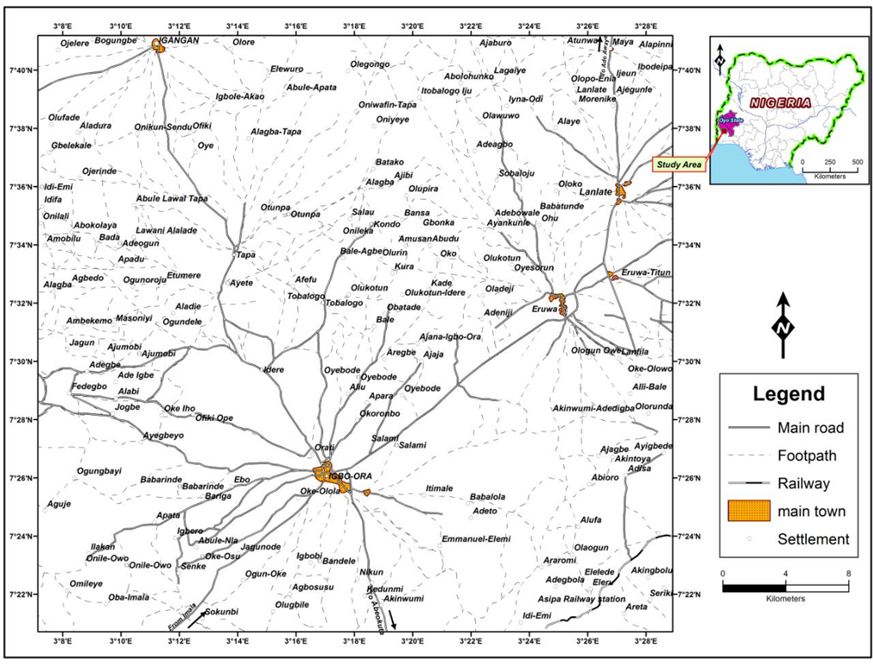

Study Area

Figure 1: The location map of Igboora clay deposits

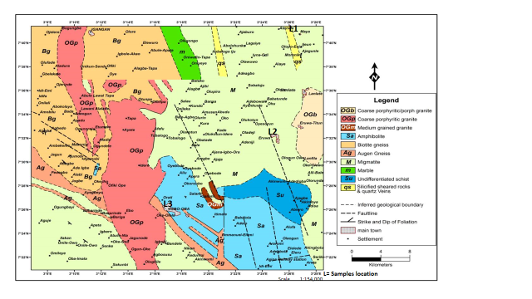

Figure 2: Geologic map of Igboora and its environs

( Nigeria Geological Survey Agency, 2004)

(a.u).

(a)

(c)

(a.u).

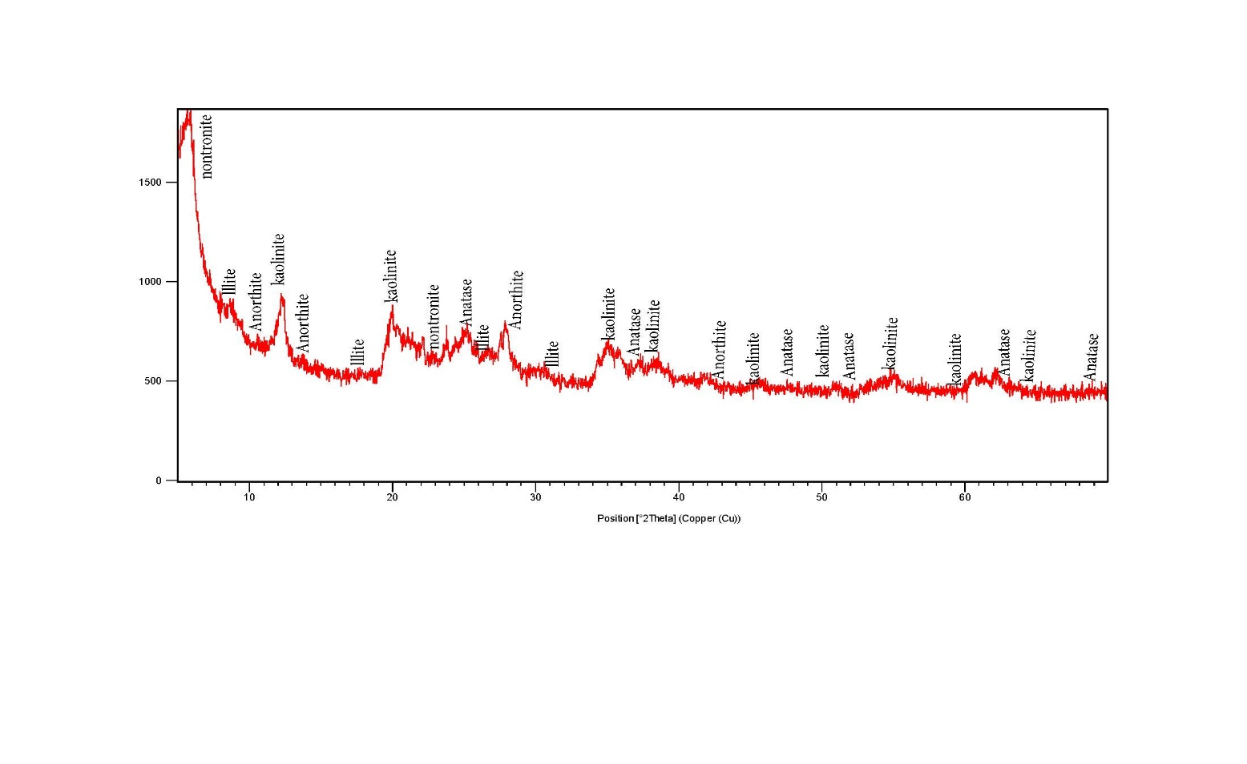

(a.u).

(b)

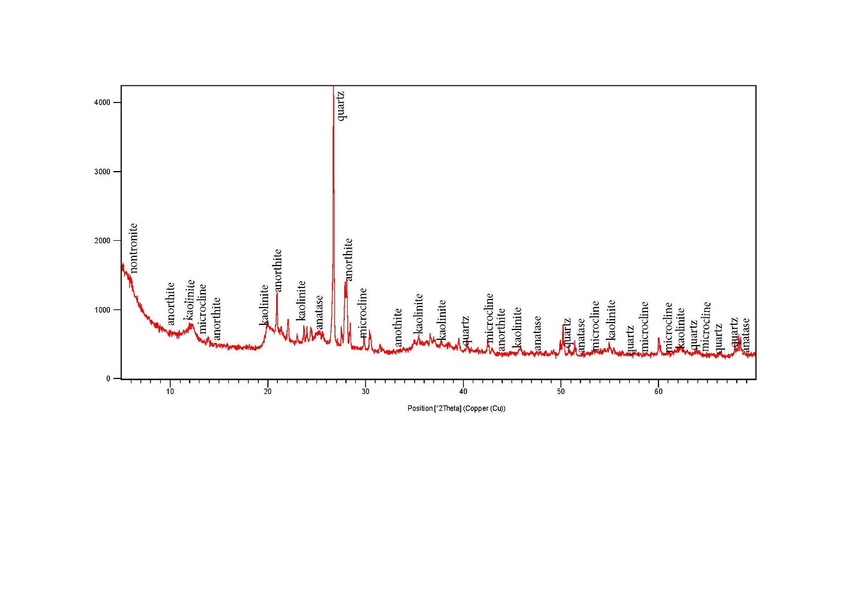

(a.u).

(c)

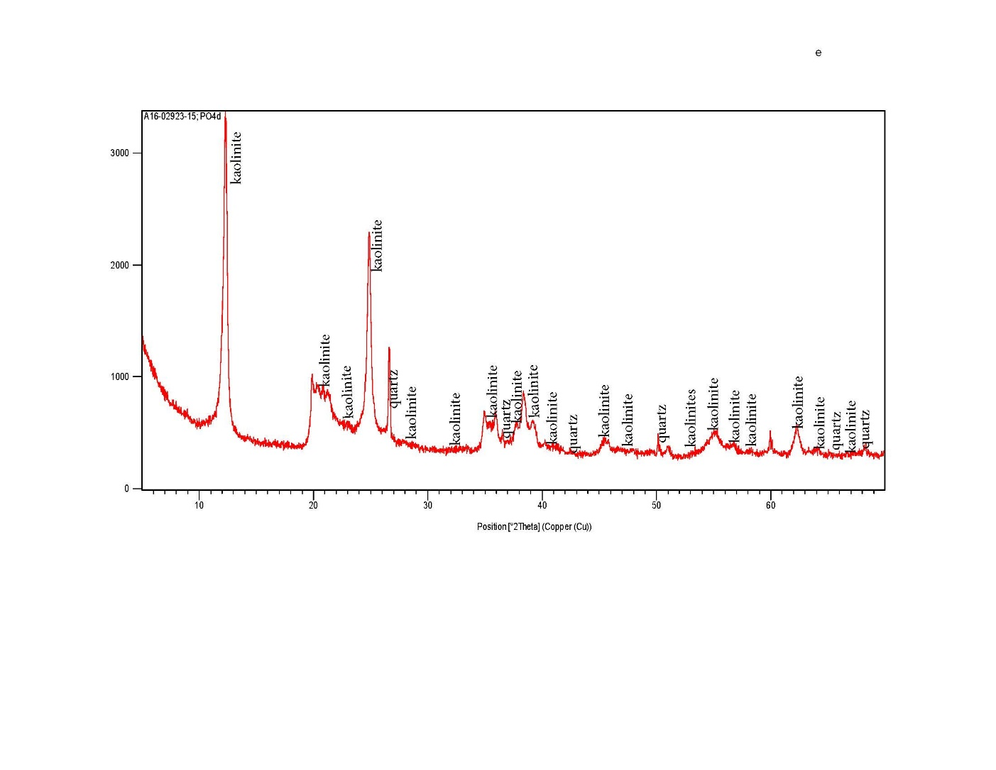

Figure 4: X ray diffractograms of the clay samples

(a) -Maya brown clay, (b) - Eruwa clay variety, (c)- Igboora clay body

(note: a.u. = arbitrary unit)

**4.2 Mineralogy**

The X- ray diffractograms of clay deposits on the migmatite, porphyritic granite and granite are presented in (Figure 4) The diffractograms showed that kaolinite is the predominant clay minerals in all the samples while illite (24.9%) which is next is only present in Maya clay and not found in Eruwa and Igboora clays. The concentrations of kaolinite are 52.1%, 65.8% and 97.5% in Maya. Eruwa and Igboora clays respectively. The non clay minerals are mainly quartz, feldspar and anatase. The presence of microcline is also remarkable in Eruwa sample.

Quartz is identified by its typical peaks at d= ~3.34 Å and d= ~ 4.26 Å while feldspar are identified at d= ~3.19Å and d = 3.23Å. In addition, muscovite is identified by the sharp diffraction peaks at d=~10 Å and d= ~3.34 Å, while kaolinite is identified by its peaks at d = ~7.14Å, d= ~4.36Å and d= ~3.57Å in the oriented and non-glycolated samples. As presented in Table 2, Eruwa clay contained appreciable high content of quartz compared to other locations and Anatase occurred as traces in Maya and Eruwa clays.

**4.3 Geochemistry**

The average chemical composition of major and trace elements on the clays are presented in Table 2. The mean composition of SiO2 in Maya, Eruwa, and Igboora are 46.68%, 53.51%, 45.58% respectively. This shows that the SiO2 in Eruwa is relatively very high compared to other clay deposits. The relative SiO2 concentration in Maya and igboora clays are comparable with Idi Ayunre, Akure (Chocolate) and Akure brown clays (Adeola, 2015) and Ara Ijero clay (Bolarinwa, 1988) while that of Eruwa clay is lower compared with Idi-Ayunre and Akure brown clays (Adeola 2015). Al2O3 content is relatively higher in Igboora (32.29% ) than Eruwa and Maya clay deposits. From Table 2. The iron concentration is generally high in all the the areas. The high content of Fe2O3 in Maya clay is responsible for the dark brownish colouration. The average Iron concentrations in Eruwa and Igbora are 7.35% and 5.65% respectively. CaO, K2O, MgO, MnO abundances constitute about 5% in Maya clay deposit but are generally low and less than 0.5% in Eruwa and Maya clays. The following low values of CaO, Na2O, K2O, P2O5, MgO and LOI resulted from leaching doing chemical weathering of the parent rocks. The concentration values for CaO are 1.22%, 1.76%, 0.11% and Na2O are 0.83%, 2.26% and 0.05% and P2O5 are 0.92%, 1.90%, 0.39% in Maya, Eruwa, and Igboora. TiO2 is very low in Igboora clay but high in Maya and Eruwa with average of 1.69% and 1.09% respectively. P2O5 is relatively low in Eruwa and relatively high in Maya and Igboora with average of 0.72% and 0.39% respectively.

Major elements abundances show that the clay samples have SiO2, (ca.47.59%), Al2O3 (ca. 23.70%) and Fe2O3 (ca. 9.22%) constituting more than 80% of the bulk chemical compositions. Al2O3 and SiO2 contents are lower while Fe2O3 is generally high in the area. Fe2O3, K2O, MgO, CaO, Na2O are higher in Maya clay samples than Eruwa and Igbora clays.

A comparison of the of the chemical compositions of the clays with industrial requirement as presented in Tables 3 and 4 showed that Eruwa clay compared favourably with Plastic Fire Clay (Huber, 1985). The values of SiO2 and Al2O3 are within the industrial specification except that Fe2O3 is a little bit higher. The SiO2 and Al2O3 contents of Igboora clay also compared with China clay (Huber, 1985). None of the clays meet Florida clay specification. Based on chemical compositions, the clays could be adequately employed in the production of ceramics because the chemical compositions fall within the limits of industrial applications.

Table 1: Average chemical compositions of the clays in Igboora area

|  |  |  |  |  |  |  |
| --- | --- | --- | --- | --- | --- | --- |
|  | **Maya** |  | **Eruwa** |  | **Igboora** |  |
| **OXIDES** | **Average** | **Range** | **Average** | **Range** | **Average** | **Range** |
| SiO2 | 43.68 | 43.3-44.68 | 53.51 | 52.75-54.27 | 45.58 | 45.49-46.11 |
| Al2O3 | 16.95 | 16.89-17.02 | 21.77 | 21.65-21.89 | 32.39 | 31.57-33.29 |
| Fe2O3 | 14.65 | 14.99-14.32 | 7.35 | 7.60-7.80 | 5.65 | 5.63-5.74 |
| MnO | 0.52 | 0.00-0.10 | 0.02 | 0.02-0.02 | 0.01 | 0.01-0.01 |
| MgO | 4.1 | 4.09-4.11 | 0.45 | 0.45-0.46 | 0.25 | 0.23-0.25 |
| CaO | 1.22 | 1.22-1.22 | 1.76 | 1.68-1.85 | 0.11 | 0.11-0.11 |
| Na2O | 0.83 | 0.84-0.89 | 2.26 | 2.06-2.46 | 0.05 | 0.05-0.05 |
| K2O | 1.5 | 1.47-1.54 | 0.43 | 0.42-0.45 | 0.31 | 0.31-0.31 |
| TiO2 | 1.69 | 1.00-2.38 | 1.09 | 1.07-1.12 | 0.39 | 0.39-0.39 |
| P2O5 | 0.72 | 0.74-0.75 | 0.10 | 1.10-0.10 | 0.39 | 0.38-0.39 |
| LOI | 13.77 | 13.40-13.94 | 10.36 | 10.13-10-59 | 14.67 | 14.31-14.86 |
| TOTAL | 94.25 |  | 99.41 |  | 99.42 |  |
| Trace element (ppm) | |  |  |  |  |  |
| Ba | 451 | 446-456 | 531.5 | 555-508 | 81 | 80-82 |
| Sr | 232 | 231-233 | 418 | 394-442 | 16 | 11-18 |
| Y | 16 | 16-16 | 11.5 | 11-12 | 10.5 | 10-11 |
| Sc | 20 | 20-21 | 13.5 | 13-14 | 22 | 21-24 |
| Zr | 224 | 222-226 | 521 | 518-524 | 152 | 144-161 |
| Be | 3 | 3-3 | 1 | 1-1 | 2 | 2-2 |
| V | 143 | 143-143 | 88 | 87-89 | 52 | 50-53 |
| silicate and Aluminium ratio (%) | | |  |  |  |  |
| S.R | 1.38 | 0.730.71- | 1.83 | 0.54-0.55 | 1.19 | 0.80-19.51 |
| A.R | 1.15 | 1.12-1.18 | 2.96 | 2.75-2.88 | 5.73 | 5.60-5.79 |
| MgO +CaO | 5.32 | 5.31-5.33 | 2.21 | 2.14-2.3 | 0.36 | 0.22-0.36 |
| Na2O + K2O | 2.33 | 2.29-2.38 | 2.69 | 2.48-2.91 | 0.36 | 0.35-0.36 |

**4.4 Industrial Properties**

The industrial properties such as grain size distribution, thermal characteristics, specific gravity, plasticity indices and colour were evaluated. The results of the industrial properties are presented in Table 5. After firing, the colour of the fired pellets ranged from brown to redish brownish in consonance with the high percentage of iron compound that are present in them. Maya clay has the highest iron compounds hence the redish brownish colour. Loss on ignition ranged from 10.36% to 14.67% with mean average of 12.93%. The average values of water absorption capacities of the fired pellets are 8.75% 7.54% and 7.76% for Maya, Eruwa and Igboora respectively. The linear shrinkage are 12.5% and 11% to in pellets of Maya and Eruwa. The specific gravity of Maya, Eruwa and Igboora are 2.57, 2.55 and 2.60 respectively.

The grain size distribution of the clay materials over the various rocks types are presented in Table 5. Generally, grain size distribution affect the plasticity and stability of the clay to be used as industrial material. However, higher clay constituent increases the plasticity and stability. The analysis presented below shows that the percentage of clay content increases with depth in the profiles. Result from the grain size analysis presented shows the average values of 37%, 33%, and 40% for Maya, Eruwa and Igboora clays respectively. The clay content of Eruwa clay is lower than that of Maya and Igboora clay is more sandy. The clay samples in both Eruwa and Maya are sandy while Igboora clay silty with Small amount of sand.

Based on the percentage of clay, silt and sand, the textural classification of the residual clay in Igboora and its environs are displayed in field of Folks (1974). The diagram shows that the Maya clay plots within the muddy sand, and while Eruwa clay and Igboora clay plot with the sandy mud. (Figure 5).

**5. Discussions**

The field investigation revealed that Maya, Eruwa and Igboora clays are basically residual and dominantly kaolinitic. Eruwa clay is sandy and characterized with low plasticity. Igbora contains the highest percentage of clay - kaolinite with very low quartz and therefore highly plastic while only Maya clay contains kaolinite and illite and moderately plastic. The presence of goethite indicates that the ferromagnesian mineral such as biotite has been completely weathered and converted to geothite. This actually responsible for the brown colouration in the clays.

Comparing the chemical composition with the standard industrial references, Maya and Eruwa clays can be used for the production of paint because of the high silica and low alumina concentration but all the clays in this area are quite recommended for the production of ceramics. Based on chemical composition, all can serve as good raw materials for the production of refractory bricks with further beneficiation Eruwa clay compared favourably with Plastic Fire Clay (Huber, 1985). The values of SiO2 and Al2O3 are within the industrial specification except that Fe2O3 is a little bit higher. The SiO2 and Al2O3 contents of Igboora clay also compared with China clay (Huber, 1985). None of the clays meet Florida clay specification. Based on chemical compositions, the clays could be adequately employed in the production of ceramics because the chemical compositions fall within the limits of industrial applications.

In determining the accurate engineering properties of soil, the proposed Cassangrade (1948) plasticity chart is generally employed (Figure7) The chart incorporate a boundary called “A-Line” which starts from the liquid limit of 20 and runs diagonally upward to the right with a slope of 0.73. The line demarcates the inorganic clays from inorganic silts and organic clays. From the result, the liquid limit is higher than the plastic limit (Table 4). This agrees with the general trend observed by Adeyemi (2001), Adegbuyi (2015) and Adeola and Dada (2017) in Isara, Akure and Awa Oru clays. The difference between these two limits called the Plasticity Index is an important geotechnical parameter. When the value of the plastic limit is close to that of the liquid limit, soil is said to be non-plastic. From this result, non of the plasticity and plasticity index values is close to each order. Consequently, the clays in Igboora area can be said to be plastic. Plots of plastic limit and plasticity indices on the Bain (1971) mouldability chart (Figure 6) indicate that the clay bodies from Igboora area generally possess moderate mouldabilitty. It must be noted that the shrinkage and mouldability of the clays, which largely determined the industrial suitability are affected by the grain size distribution and the mineralogy of the clay. Kaolonitic clay is characterized by lack of expandable lattice, low swelling potential and low shrinkage.

Comparing the chemical and mineralogical compositions of the clay raw materials with the Fabbri and Fiori (1985) ternary diagrams, these clays could be employed in the of ceramics industry for the production of traditional ceramic products. Fabbri and Fiori (1985) ternary diagrams are the most suitable to define and visualize compositional fields. Igboora clay falls near the global fields of red-stone ware and this is suggests that Imoto clay is the only suitable material for the production of red-stone ware products. The chemical composition of Maya is quite similar to the clay materials from Bailen area and Greece being used for the production of Red-stoneware as reported by Gonzalez et al. (1997) and Oikonomopoulus et al. (2007). The amount of alkalis (Na2O + K2O) concentration in Maya, Eruwa and Igboora clays is favourably compared with Moro and Chulilla clays employed for the production of ceramic in Castellon (Mesenguer 2011).



Figure 5. Textural classification of Maya, Eruwa and Igboora clays (after Folks (1974)).

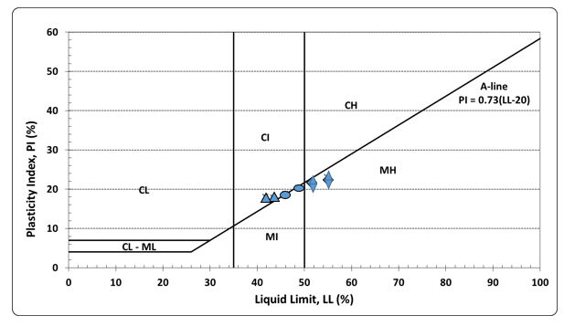

Figure 6: Plasticity chart for the classification of clay bodies (after Casangrande, 1948)

* = Maya clay deposit = Eruwa clay deposit = Igboora clay deposit



|  |  |  |  |  |  |  |
| --- | --- | --- | --- | --- | --- | --- |
| Table 2: Mineralogical compositions of the different types of clays in the area. | | | | | | |
|  | Minerals | Maya Clay | Eruwa Clay | Igboora Clay | **Reference** Sample | Sample |
|  |  | % | % | % | (A) | (B) |
|  | Kaolinite | 65.8 | 52.1 | 97.5 | 85 | 85 |
|  | IIIite | 24.9 | n.d | n.d | 15 |  |
|  | Smectite |  |  |  |  |  |
|  | K-feldspar | n.d | 2.3 | n.d |  | 3 |
|  | Hematite |  |  |  |  |  |
|  | Geothite |  |  |  |  |  |
|  | Gibbsite |  |  |  |  |  |
|  | Quartz | n.d | 16.1 | 2.5 | Trace | 4 |
|  | Plagioclase | 9.3 | 28.9 | n.d |  |  |
|  | Anatase | 1 | 0.5 | n.d |  |  |
|  | Other |  |  |  |  | 8 |
|  | Total | 101 | 99.9 | 100 | 100 | 100 |

(A) Huber (1985), (B) National fertilizer company of Nigeria (NAFCON 1985) recommended value **n.d. not detected**



Figure 8: Ternary diagram SiO2/Al2O3 + TiO2/Fe2O3 + MgO + K2O + CaO + Na2O

(After Fabbri and Fiori, 1985)



Figure 7: Triangular chart of Fiori et al. (1989) for the clay materials studied. (Fe2O3 + CaO + MgO)/Al2O3/Na2O + K2O)

Clays are used in the production of building bricks. The material must contain 40% to 60% clay-silt particles to ensure adequate mouldability. The major clay minerals suitable for brick production are kaolinite, illite, and vermiculite. They are also employed in the production of roofing, wall and floor tiles, stoneware, pipes, sanitary wares and fittings for sewage drainage. The clays at Maya and Igboora (43.68% and 45.53%) meet ceramic production requirements. China clay is commonly used for this purpose. The clay to be used must be white, fine grained, free from iron oxide and mica. The clay from Eruwa area meets the requirements and with further beneficiation it could be used as a coating pigment to give a smoother, glossier surface for high quality printing paper.

Beneficiated kaolinite clay is employed as inert extender or filler in paint production. Clay competes with CaCO3. Talc and gypsum. The clay to be used as filler must be fine grained. At least <2um particles must be between 80% and 90%. The clay from the weathered profile at Igboora can be used for the production of paints while Maya and Eruwa clays have fine particles less than the requirement, hence not suitable for the production of paints.

Table 3. Comparison of chemical composition of Igboora clays with industrial specifications

|  |  |  |  |  |  |  |
| --- | --- | --- | --- | --- | --- | --- |
| Oxides | *Maya  ( %) | *Eruwa  ( %) | * Igboora  ( %) | Reference  (A ) % | Reference  **(**B) % | Reference  (C) % |
| SiO2 | 43.68 | 53.51 | 45.58 | 52.92 | 57.67 | 46.88 |
| Al2O3 | 16.95 | 21.77 | 32.39 | 9.42 | 24.00 | 37.65 |
| Fe2O3 | 14.65 | 7.73 | 5.65 | 3.65 | 3.23 | 0.88 |
| MgO  o  gO | 4.1 | 0.45 | 0.25 | 0.08 | 0.30 | 0.13 |
| CaO | 1.22 | 1.76 | 0.11 | 1.91 | 0.70 | 0.03 |
| Na2O | 0.83 | 2.26 | 0.05 | 0.03 | 0.20 | 0.21 |
| K2O | 1.5 | 0.43 | 0.31 | 0.98 | 0.50 | 1.60 |
| P2O5 | 0.92 | 0.01 | 0.01 | 0.02 | - | - |
| MnO | 0.52 | 0.02 | 0.01 | - | - | - |
| LOI | 13.77 | 10.36 | 14.67 | 10.19 | 10.50 | 12.45 |
| Total | 98.14 | 98.30 | 99.03 | 79.20 | 97.10 | 99.83 |
| *Average values for 5 samples   1. Florida Active Kaolinite (Huber, 1985) (B)– Plastic Fire Clay, St Louis (Huber, 1985) 2. – China Clay (Huber, 1985) | | | | | | |

Table 4: Comparison of Maya, Eruwa and Igboora clays with some industrial chemical specifications

|  |  |  |  |  |  |  |
| --- | --- | --- | --- | --- | --- | --- |
| Oxides | *Maya  ( %) | *Eruwa  ( %) | * Igboora  ( %) | Reference | | |
| (A) % | **(**B) % | (C) % |
| SiO2 | 43.68 | 53.51 | 45.58 | 47.90-48.30 | 67.57 | 51.0-70.0 |
| Al2O3 | 16.95 | 21.77 | 32.39 | 37.90-38.40 | 26.50 | 25.0-44.0 |
| Fe2O3 | 14.65 | 7.73 | 5.65 | 13.40-13.80 | 0.50-1.20 | 0.2-0.7 |
| MgO  o  gO | 4.1 | 0.45 | 0.25 | 0.20-0.30 | 0.10-0.19 | 0.2-0.7 |
| CaO | 1.22 | 1.76 | 0.11 | 0.03-0.25 | 0.18-0.30 | 0.1-0.2 |
| Na2O | 0.83 | 2.26 | 0.05 | 0.20-0.35 | 0.20-1.50 | 0.8-3.5 |
| K2O | 1.5 | 0.43 | 0.31 | 0.40-0.10 | 1.10-3.10 | - |
| P2O5 | 0.92 | 0.01 | 0.01 | 0.02 | - | - |
| MnO | 0.52 | 0.02 | 0.01 | - | - | - |
| LOI | 13.77 | 10.36 | 14.67 |  | - | - |
| Total | 98.14 | 98.30 | 99.03 | - | - | - |

*Average values for 5 samples

(A)- Paints (Payne, 1961) (B)- Ceramics (Singer and Sonja, 1971), (C)- Refractory Bricks, (Parker, 1967)

Table 5: Physical and firing properties of the Maya, Eruwa and Igboora clays

|  |  |  |  |  |  |  |  |  |  |
| --- | --- | --- | --- | --- | --- | --- | --- | --- | --- |
|  |  | Atterberg Limits | | |  |  |  |  |  |
| Profile | Clay | LOI (%) | LSK (%) | WAC (%) | S.G | Colour |
|  | Fraction | LL (%) | PL (%) | PI (%) |  |  |  |  |  |
| *Maya clay | 37 | 42.57 | 24.57 | 18.01 | 8.17 | 12.50 | 8.75 | 2.57 | Brown |
| *Eruwa | 33 | 47.32 | 27.71 | 19.61 | 10.36 | 11.00 | 7.54 | 2.55 | Brown |
| *Igboora | 40 | 53.23 | 30.84 | 22.39 | 114.67 | 11.00 | 7.76 | 2.60 | Redish brown |
| * Average values for 5 samples  LOI – Loss on ignition, LSK – Linear Shrinkage, WAC – Water absorption capacity,  PL – Plasticity limit, LL – Liquid limit PI – Plasticity index | | | | | | | | |

High quality kaolinite clay is used to produce mist kaolinite, a proper mixture for stomach upset. Kaolin is also employed in powdered from as dusting agents for tablets and foods. The clay must be of necessity be fine grained, chemically inert, fine grained, with low density and low abrasive characteristic. It must also possess good slip for maximum leaf coverage. The chemical ingredient in fertilizers are commonly carried and dispersed in 20%-30% clay media. The clay density meets these requirements.

Refractories, find their widest and most significant usage in pyrometallurgical processes, including iron and steel. They are also used in glass tanks, cement kilns, ceramic plants, utility boilers, refineries and paper. The clay should fire to a white colour, have low firing shrinkage: CaO content <1%, iron minerals <1.5%, SiO2,> 60%: MgO>30% alkalis (K20 + Na20) <4%, Al2O3< 2.5% and loss on ignition value <6%. All these condition could be met by all the clays in with little beneficiation.

**Conclusion**

The study reveals that clay deposits in Maya, Eruwa and Igboora are kaolinitic clay. This kaolinitic clay is found to be very good raw materials for the industrial production of ceramics, paints and refractory, low alumina chemical pharmaceutical products and as addictive in cement industries.

**Corresponding Author:**

Dr. Adewole John Adeola

Department of Physical and Earth Sciences

Crawford University

Km 8 Atan – Agbara Road, Igbesa, Igbesaland

Ogun State

Telephone: 234 8 038120171

E-mail: [johnadeola@crawforduniversity.edu.ng](mailto:johnadeola@crawforduniversity.edu.ng)

**References**

1. Adeola A.J. and Dada R.G. (2017): Mineralogical and geochemical trends in lateritic weathering profiles on basement rocks in Awa-Oru Ijebu and its environ, southwestern Nigeria. *Global Journal of Geological Sciences,* Vol.15, pp 1-11.
2. Adegbuyi O., Ojo G.P., Adeola A.J**.** and Alebiosu M.T. (2015) Compositional and industrial assessment of Isua Akoko, Akure. Ayadi and Ode Aye clay deposits of Ondo State, Nigeria. *Global Journal of Pure and Applied Sciences*. Vol. 21, 38-46.
3. Ajayi, J. O. and Agagu,O. K. (1981): Mineralogy of primary clay deposits in the basement complex areas of *Nigeria.” Journal of Mining and Geology*, Vol. 1 no. 18, pp 27-30.
4. Aribisala, O.A. (1989). Sourcing for of local raw materials and investment opportunity in the building/construction industrial sectors, Proceedings of National Workshop of the *Association of Housing Corporation of Nigeria*.
5. Bolarinwa, A.T. (2006). Mineralogy and geochemistry of the weathering profiles above basement rocks in Ibadan, southwestern, Nigeria. *Global Journal of Geological Sciences* Vol. 4, No. 2, pp 183-191.
6. Bolarinwa, A.T. (2001). Compositional characteristics and economic potentials of the lateritic profiles over basement and sedimentary rocks in Ibadan-Abeokuta area, southwestern Nigeria, *Unpublished doctoral dissertation)*. University of Ibadan, Nigeria.
7. Casagrande, A. (1948). Classification and identification of soils. *Transaction of the America Society of Civil Engineers*. pp 113- 901.
8. Elueze, A.A. (1993. Indications from Nigeria on the industrialization and employment potentials of non-metallic minerals resources. *AGID* News, 74/75. pp. 23-27.
9. Elueze A.A. and Bolarinwa A.T. (1995). Assessment of functional applications of lateritic clay bodies in Ekiti environs, southwestern Nigeria. *Journal of Mining and Geology* 31(1). Pp.79-87.
10. Emofurieta, W.O. (1988). Geochemistry, mineralogy and economic potentials of a pegmatite residual soil profile in SW Nigeria, *Journal of Science*, 22 (1 & 2), pp. 91-98.
11. Emofurieta, W.O. Aladesawe, A.I. and Ogunseiju, P. (1995). Secondary geochemical and mineralogical dispersion patterns associated with lateritization process in Ile-Ife SW Nigeria, *Journal of Mining and Geology* 31 (1). Pp. 39-51.
12. Fabri B. and Fiori C. (1985) Clays and complementary raw material for stoneware tile. Miner. Petrogr. Acta, 29-A. 535-545.
13. Fiori C., Fabri B., Donati G, and Venturi I. (1989) Mineraligical composition of the clay bodies used in the Italian tile industry*. Appl. Clay Science* 4, 461-474.
14. Folk, R, L. (1974). Petrology of sedimentary rocks. Hemphill Publishing Co. Texas 78793. 182pp.
15. Huber, J.M. (1985). Kaolin clays. Huber Corporation (Clay Division) Georgia, USA.
16. Ige, O.A., Durotoye, B. and Oluyemi, A.E. (2005). Mineralogy and geochemistry of lateritic weathering profiles on ultramafic rock bodies around Mokuro in Ile-Ife area, southwestern Nigeria*. Journal of Mining and Geology* 41 (1), pp. 11-18.
17. Kehinde-Phillips,.O.O And Tietz, G.F. (1995). The mineralogy and geochemistry of the weathering profiles over amphibollite and Talk-schists in the Ilesha scist belt, southwestern *Nigeria Journal of Mining and Geology*, Vol. 31, No. 1 pp 53-62.
18. Malomo, S., Obademi, M.O., Odedina, P.O. and Adebo, O.A. (1983). An investigation of the peculiar characteristics of lateritic soil from southern Nigeria. *Bulletin of the international Association of Engineering Geology*. 28, 197-206.
19. Mesenguer S. (2011). Geology and application of clays used in Castellon ceramic cluster (NE. Spain*). Journal of Geography and Geology,* 3(1).
20. Mesida, E.A. (1978). Utilization of some lateritic clay for burnt bricks. *Journal of Mining and Geology* 15(2). pp.108-114. .
21. NAFCON, (1985): Tender document for the supply of kaolin from Nigeria sources.
22. Oikonomopoulos I., Perraki Th., Kaouras G. and Antoniadis P. (2007). Mineralogical study of inorganic intercalated seams achlada lignite deposits (NW GREECE). Bulleting of the *Geological Society of Greece* vol. XXXVII, 906- 917V 50 (4), p. 233-231.
23. Parker, E.R. (1976). Materials data book for engineers and scientists. Publ McGraw-Hill Book Co., New York. 283p.
24. Payne, H.F. (1961). Organic coating technology. Vol. II: Pigments and pigments coatings. John Wiley and sons, Inc. New York. pp 796.
25. Singer, F and Sonja, S.S. (1971). Industrial Ceramics, Publ. Chapman & Hall: London, pp. 18-56.

9/2/2017