Advantage of Intrathecal Nulbuphine Compared with Intrathecal Morphine as Analgesic in Cesarean Delivery

Emad Abdel Rahman El Tamamy¹, Mofeed Fawzy Mohammed¹, Mohamad Ibraheem Almohandes and Mahmoud Saeed Nasr ²

¹Obstetrics and Gynecology Department, Faculty of Medicine, Al-Azhar University, Egypt
² Egyptian Ministry of Health, El Galaa Teaching Hospital, Cairo, Egypt.
Mahmoudds486@gmail.com

Abstract: Objectives: To compare advantage of intrathecal nulbuphine with intrathecal morphine as analgesic after ceserian delivary. Method: From Augest 2016 to March 2017, One hundred fifty healthy female patients at full term presented to Al Galaa Hospital for elective cesarean delivery with spinal anesthesia were enrolled in this study. They divided as follow; fifty given bupivicine (group I), fifty given bupivicine plus nulbuphine (group II), fifty given bupivicine plus morphine (group III). Chi-square and Student’s t-test: were used accordingly for statistical analysis of the data. Result: Nulbuphine has rapid onset of sensory and motor block, short period of analgesia without producing pruritis, nausea and vomiting But, morphine has slow onset of sensory and motor block, long lasting analgesia with pruritis, nausea and vomiting. Conclusion: nalubuphine produce early and good intraoperative analgesia without side effects, but morphine produce long lasting analgesia with side effects.
[Emad Abdel Rahman El Tamamy, Mofeed Fawzy Mohammed, Mohamad Ibraheem Almohandes and Mahmoud Saeed Nasr. Advantage of Intrathecal Nulbuphine Compared with Intrathecal Morphine as Analgesic in Cesarean Delivery. N Y Sci J 2017;10(9):63-71]. ISSN 1554-0200 (print); ISSN 2375-723X (online). http://www.sciencepub.net/newyork. 9. doi:10.7537/marsnys100917.09.

Keywords: Intrathecal Nulbuphine, Intrathecal Morphine, Analgesic, Cesarean Delivery.

1. Introduction
Spinal anesthesia is the preferred means for cesarean section, being simple to perform, economical and produces rapid onset of anesthesia and complete muscle relaxation. It carries high efficiency, involves less drug doses, minimal neonatal depression, awake mother and lesser incidences of aspiration pneumonitis. However, it also produces a fixed duration of anesthesia, postdural puncture, headache, hypotension and lesser control of block height (Fyneface-Ogan S., 2012). Bupivacaine, an amide type of local anesthetic, has high potency, slow onset (5–8 minutes) and long duration of action (1.5–2 hours). For cesarean section intrathecal dose of hyperbaric bupivacaine is 12 to 15 mg (Bogra J et al., 2005). Cesarean delivery requires traction of peritoneum and handling of intraperitoneal organs, resulting in intraoperative visceral pain. With higher doses of hyperbaric bupivacaine, incidence of intraoperative visceral pain associated with higher blocks is reduced (Arzola C and Wieczorek P M., 2011). Opiods have been a choice in regional (intrathecal and epidural routes) anesthesia to improve the antinociceptive effect of local anesthetics. Nalbuphine, and Morphine, are being used intrathecally, together with local anesthetics in cesarean section (Berger J M., 2005) The first report on the use of intrathecal opioids (ITO) for acute pain treatment was in 1979 by Wang and colleagues. Use of ITO as adjuncts has a definite place in the present regional anesthesia practice. Various opioids have been used along with bupivacaine to prolong its effect, to improve the quality of analgesia and minimize the requirement of postoperative analgesics. (Mukherjee A et al., 2011). The aim of the study was to compare the intra-operative and post-operative analgesic effect of intrathecal Nalbuphine as an adjuvant to bupivacaine during cesarean delivery and intrathecal Morphine as an adjuvant to Bupivacaine during cesarean delivery.

2. Patients and Methods
From Augest 2016 to March 2017, One hundred fifty healthy female patients at full term presented to Al Galaa Hospital for elective cesarean delivery with spinal anesthesia were enrolled The patients were divided into three groups all the patients were received the same amount of local anesthetic (2 ml 0.5% heavy Bupivacaine). fifty patients were received an intrathecal injection of 2 ml of 0.5% hyperbaric Bupivacaine (group I), fifty patients were received an intrathecal injection of 2ml of 0.5% hyperbaric Bupivacaine plus Nalbuphine (0.8mg) (group II)., fifty patients were received an intrathecal injection of 2ml of 0.5% hyperbaric Bupivacaine plus 0.2mg Morphine (group III). Chi-square and Student’s t-test: were used accordingly for statistical analysis of the data. The inclusion criteria for the study include: Criteria of spinal anesthesia (Normal coagulation profile), Age range between 24-34 years old, Weight range between 60 to 100 kg, Height 160 to 180 cm, Free of medical disorder, Gestation age 37-40weeks. The Exclusion criteria for the study include: If supplemental IV fentanyl will be required during surgery, Insufficient intraoperative analgesia, Infection at site of injection, If the patient has any coagulopathy disorder or receiving any anticoagulant drugs, If the patients with known history of allergy to local anesthetics drugs, Failed spinal anesthesia. Informed consent will be obtained from all women before participation. In our study all patients were clinically assessed and routine preoperative investigations were done (e.g CBC, PT, PTT, INR, liver function tests and kidney function tests and ECG) for evaluation of the patient medical status and no premedication was given. On arrival to the operating room, continuous monitoring with electrocardiography, non invasive blood pressure and pulse oximetry had started. A suitable peripheral vein was cannulated and Ringer's solution 10 ml/kg/15 minutes (preload) was given to patients before the procedure. The patient was put in the sitting position with leaning forward. sterilization by Povidone Iodine in a circular manner with covering the back by sterilized towels just exposing the spinal segments to be injected. Dural puncture was performed at L4–L5 interspace or L3-L4 with a 22 gauge spinal needle. The blocks were performed with the patient in the sitting position. Then the patient was placed in the supine position with elevation of the head by a pillow, oxygen mask was used 5litres/minute. Conscious level and level of sensory block and motor block were assessed and recorded during the whole time of the procedure to follow up any change. Blood pressure was measured noninvasively every 5 minutes if the mean arterial blood pressure decreased by more than 20% below pre anesthetic level the patient was given intermittent doses of ephedrine 5-10 mg IV. Heart rate was recorded every 5 minutes and O₂ saturation was recorded by pulse oximetry every 5 minutes. The neonatal Apgar scores at 1 and 5 min after delivery was calculated by an attending pediatrician. A urinary catheter was left in situ and was removed 24 hours later. Observation and reporting of any complications either related to spinal block or allergic reactions to the drugs injected: Hypotension, Bradycardia, Pruritis, Nausea and Vomiting, Shivering, Rash, Bronchospasm were recorded

3. Result
Statistical analysis:
Data were analyzed using Statistical Program for Social Science (SPSS) version 20.0. Quantitative data were expressed as mean± standard deviation (SD). Qualitative data were expressed as frequency and percentage
The following tests were done:
- A one-way analysis of variance (ANOVA) when comparing between more than two means.
- Chi-square (X²) test of significance was used in order to compare proportions between two qualitative parameters.
- Probability (P-value)
- P-value <0.05 was considered significant.
- P-value <0.001 was considered as highly significant.
P-value >0.05 was considered insignificant.
One hundred fifty patients were enrolled. they randomlly allocated as follows; fifty patients in group (I), fifty patients in group (II), fifty patients in group (III).
There were no significant difference in demographic data among groups Table (1).
Table (2) shows highly statistically significant difference between groups according to onset of sensory and motor block.
The onset of sensory and motor block was faster in group (II) compared to group (I), (III).
Table (3) shows highly statistically significant difference between groups according to analgesic data.
The duration of complete and effective analgesia were significantly increased group (III) compared to group (I), (II).
Table (4) shows highly statistically significant difference between groups according to intraoperative pain.
This table shows statistically significant difference between groups according delivery.
Twenty one patients reported pain during surgery; three of them received fentanyl during caesarian delivery.
Nine patients reported pain during surgery in group (I) ''Six patients reported pain during delivery and Three patients reported pain during skin closing ''. No patient reported pain in group (II), Twelve patients reported pain in group (III) ''Six patients reported pain during delivery and the rest of the patients reported pain during to skin closing ''.
Table (5) shows statistically significant difference between groups according to total dose of IV ketolac. The cumulative doses of different analgesic administrated within first 24 hr are summarized in Table (10).
No statistical difference were found for total consumption of paracetamol among groups.
The administration of ketolac was reduced in group (III) compared to group (I), (II).
Table (6) shows statistically significant difference between groups according to non of pruritus. Postoperative pruritis occurred only in twenty six patients of group (III), the rest show no pruritis.
No pruritis occurred in group. (I), (II).
Table (7) shows statistically significant difference between groups according to no symptoms present. Post operative nausea and vomiting were observed in twelve patients of group (III), seven of them show symptoms, but no treatment was required and five patients only show symptoms and given treatment.
Thirty eight patients of group (III) show no symptoms.
No symptoms were observed in group (I), (II).

Table (1): Comparison between groups according to demographic data.
 | Group I  (n=50) | Group II  (n=50) | Group III  (n=50) | F/x2* | p-value
Height (cm) | 167.84±5.03 | 164.82±6.03 | 165.83±4.02 | 1.092 | 0.181
Weight (kg) | 81.41±11.06 | 80.40±11.06 | 76.38±10.05 | 1.556 | 0.258
Age (years) | 30.15±4.02 | 31.16±5.03 | 31.16±5.03 | 1.141 | 0.189
Nulliparous | 24 (48%) | 16 (32%) | 19 (38%) | 1.360* | 0.225
Duration of pregnancy (wk) | 38.89±1.0 | 39.20±1.01 | 39.30±1.01 | 1.037 | 0.172

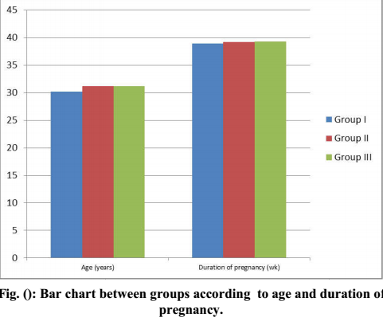

Table (2): Comparison between groups according to onset of sensory and motor block.
Parameter | Group 1 | Group 2 | Group 3 | P value
Onset of sensory block (min) | 3.03± 1.03 | 1.43±0.57 | 4. 52±1.24 | <0.001
Onset of motor block (min) | 4.47 ± 1.46 | 3.47±1.01 | 5.24±1.55 | <0.001

Fig. (2): Bar chart between groups according to onset of sensory and motor block.

Table (3): Comparison between groups according to analgesic data.
 | Group I (n=50) | Group II (n=50) | Group III (n=50) | ANOVA | p-value
Complete analgesia (min) | 148.74±45.23 | 176.88±62.31 | 276.38±229.14 | 2.853 | <0.001
Effective analgesia (min) | 193.97±77.39 | 213.06±72.36 | 587.93±448.23 | 2.621 | <0.001

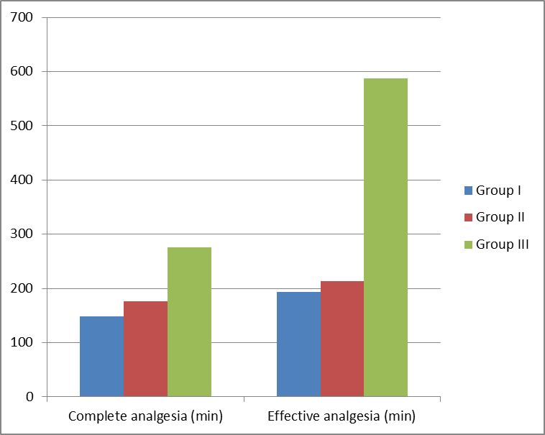
Fig. (3): Bar chart between groups according to analgesic data

Table (4): Comparison between groups according to Pain.
Pain | Group I  (n=50) | Group II  (n=50) | Group III  (n=50) | Chi-square | p-value
Intraoperative pain (%) | 9 (18%) | 0 (0%) | 12 (24%) | 2.453 | <0.001
Incision | 0 (0%) | 0 (0%) | 0 (0%) | 0.000 | 1.000
Delivery | 6 (12%) | 0 (0%) | 6 (12%) | 9.487 | 0.021
Skin closing | 3 (6%) | 0 (0%) | 6 (12%) | 3.426 | 0.337
Total No. of intraoperative fentanyl requests | 1 (2%) | 0 (0%) | 2 (4%) | 0.923 | 0.221

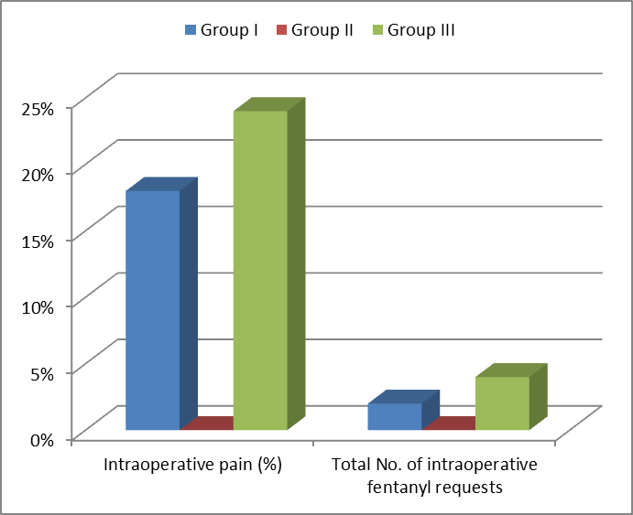
Fig. (4): Bar chart between groups according to Pain.

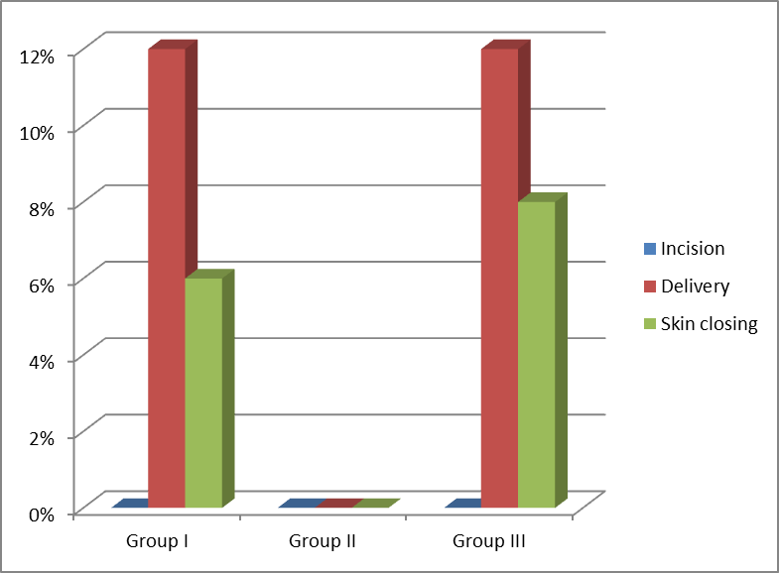
Fig. (5): Bar chart between groups according to No. of patients with pain during cesarean delivery

Table (5): Comparison between groups according to supplemental analgesic requirements.
 | Group I  (n=50) | Group II  (n=50) | Group III  (n=50) | ANOVA | p-value
VAS score at first report of pain | 2.21±2.01 | 1.71±1.01 | 1.91±1.01 | 0.414 | 0.709
Total no. of anaglesic interventions/ patients at 24h | 3.22±1.01 | 4.32±1.01 | 4.62±2.01 | 0.302 | 0.210
Total dose of IV propacetamol (mg/patients at 24h) | 4221±1608 | 5330.5±1435.2 | 5226±2010 | 0.365 | 0.447
Total dose of IV ketorolac (mg/ patient at 24h) | 48.24±22.11 | 44.22±18.09 | 29.15±25.13 | 2.184 | 0.021
Total dose of subcutaneous morphine (mg/patient at 24h) | 1.01±3.02 | 2.01±4.02 | 3.02±4.02 | 0.508 | 0.654

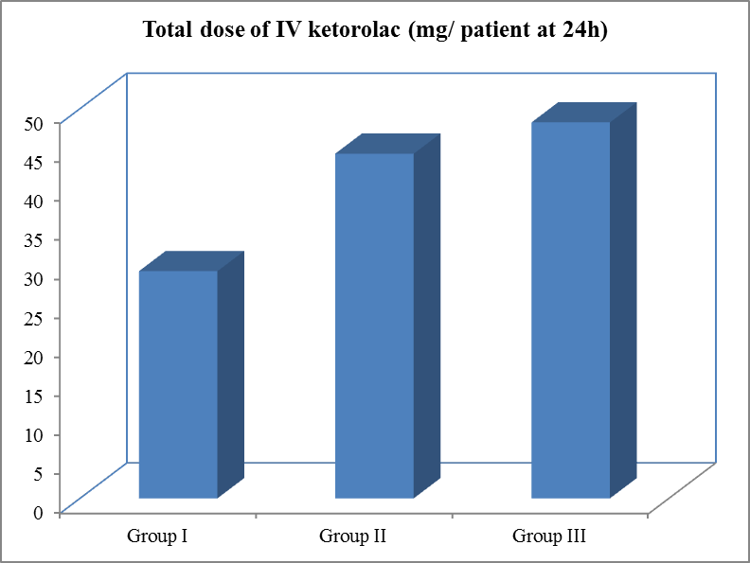
Fig. (6): Bar chart between groups according to total dose of IV ketorolac (mg/ patient at 24).

Table (6): Comparison between groups according to pruritus.
(no. of patients) | Group I  (n=50) | Group II  (n=50) | Group III  (n=50) | x2* | p-value
Non | 50 (100%) | 50 (100%) | 24 (48%) | 15.382 | 0.013
Mild | 0 (0%) | 0 (0%) | 16 (32%) | 2.681 | 0.081
Moderate | 0 (0%) | 0 (0%) | 3 (6%) | 0.050 | 0.958
Severe | 0 (0%) | 0 (0%) | 7 (14%) | 1.995 | 0.114

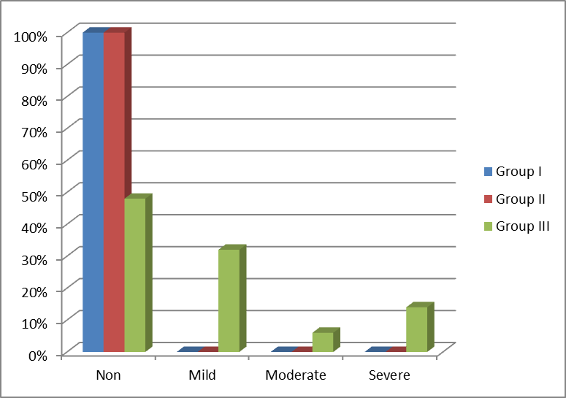
Fig. (7): Bar chart between groups according to pruritus

Table (7): Comparison between groups according to Nausea and vomiting.
Nausea/ vomiting (no. of patients) | Group I  (n=50) | Group II  (n=50) | Group III  (n=50) | x2* | p-value
No symptoms present | 50 (100%) | 50 (100%) | 38 (76%) | 9.810 | 0.025
Symptoms present (nausea and/ or vomiting) but treatment not required | 0 (0%) | 0 (0%) | 7 (14%) | 0.850 | 0.461
Symptoms present and treatment given | 0 (0%) | 0 (0%) | 5 (10%) | 0.935 | 0.507

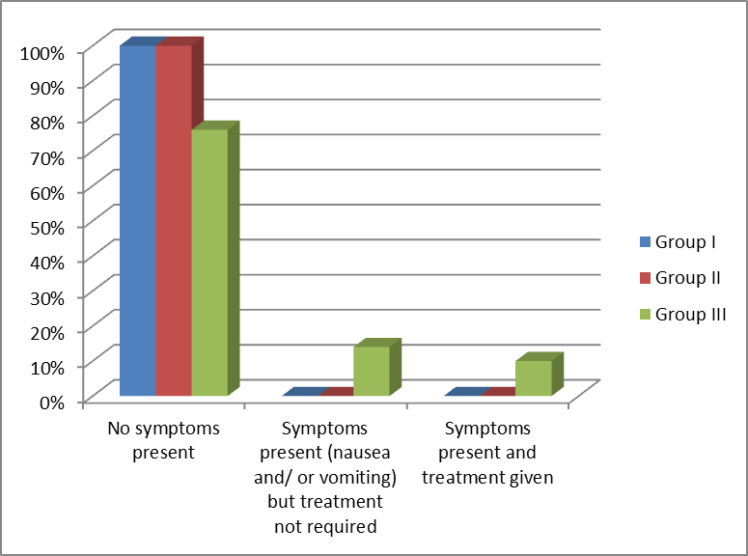
Fig. (8): Bar chart between groups according to Nausea and vomiting.

4. Discussion:
Recent trends of obstetric anesthesia show increased popularity of regional anesthesia among obstetric anesthetists. General anesthesia is associated with higher mortality rate in comparison to regional anesthesia. However, regional anesthesia is not without risk. Deaths in regional anesthesia are primarily related to excessive high regional blocks and toxicity of local anesthetics. Reduction in doses and improvement in technique to avoid higher block levels and heightened awareness to the toxicity of local anesthetics have contributed to the reduction of complications related to regional anesthesia (Kettner S. C et al., 2011). These days 0.5% heavy Bupivacaine is used commonly for spinal and epidural anesthesia. It was decided tocombine anesthesia with lesser doses of Bupivacaine (Bachmann M et al., 2012) Intrathecal opioids have certain specific advantags like rapid onset of action, sympathetic and motor nerve sparing activity, technical ease of administration, simplicity of post operative management. Intrathecal opioids cause segmental analgesia by binding to opioid receptors in the dorsal horn of the spinal cord. They significantly prolong the duration of analgesia without affecting motor or autonomic nervous function. They may, however, be associated with a number of dose-dependent side effects. The most serious side effect of intrathecal opioids is respiratory depression, while the most common side effect is pruritus. Other undesirable side effects include nausea, vomiting, urine retention, and sedation (Prakash et al., 2006). Intrathecal administration of local anesthetic and opioid combinations is based on the clinical observation that their combination limits the regression of the sensory block seen with local anaesthetics alone and improves the quality of dynamic pain relief (Prakash et al., 2006). In the present study, the postoperative analgesic requirements and the spinally mediated analgesic effects of Bupivacaine (hyperbaric) 0.5 % in combination with Morphine (0.2mg) or Nalbuphine (0.8 mg) in patients undergoing elective cesarean section were observed and recorded In regards to the onset of sensory and motor block, the onset of sensory and motor block is more rapid with Nalbuphine than Morphine and this significant difference may be explained by the high lipid solubility and rapid tissue uptake of Nalbuphine more than Morphine, and this needs further investigations. In relation to the postoperative side effects, hypotention were recorded in the studied groups and statistically no significant difference were found between the groups. Also in the present study, No statistically significant difference in the H.R and SPO2 between the two studied groups, neither bradycardia nor desaturation of the oxygen were recorded. The fetal ARGAR score in our study, Shows no statistically significant difference between the two studied groups. The Result of the present study showed that onset of sensory and motor blockage was faster and time taken to attain complete sensory and motor block was shorter in Nulbuphine group compared to Morphine group and Buvicaine group. The Result of the present study showed that duration of complete and effective analgesia are longer in Morphine group as compared with Nulbuphine and Buvicaine groups. The Result of the present study showed that there was intraoperative pain with Buvacine and Morphine groups but not present with Nulbuphine group. The Result of the present study showed that there was postoperative nusea, vomiting pruritus in Morphine but not presnt in Nulbuphine group. The results of the present study correlates well with other studies where it was observed that addition of Nalbuphine or Morphine allowed a significant reduction in pain score. The Result of the present study are similar to result done by (BHOSLE and Shehla Shakooh Pooja (2014) in which 60 patients scheduled for lower limb, lower abdominal surgery which were given Bupivacaine alone, Bupivacaine +,8 mg Nalbuphine intra thecally. It's conclusion was; Addition of,8 mg Nalbuphine as adjuvant to spinal anesthesia leading to faster onset of sensory and motor block and prolonged duration of sensory and motor block. Fournier et al 2011 have also demonstrated administration of intrathecal Nalbuphine 400ug and Intrathecal Morphine resulted in a significantly faster onset of pain relief with Nalbuphine but duration of analgesia is shorter than with Morphine. In contrast to these studies, Tiwari et al 2011 in their study have shown that onset of sensory and motor blockade was not affected by adding Nalbuphine intrathecally. Seventy five patients posted for lower limb and lower abdominal surgeries received either 0.2mg or0.4 mg Nalbuphine or plain Bupivacaine intrathecally This disparity in the onset of blockage could be related to lower dose of Nalbuphine used in this study. In 2011, Mukherjee et al formulated a study to determine whether Nalbuphine prolongs analgesia by comparing with control and to find out the optimum dose of intrathecal Nalbuphine by comparing the0.2, 0.4, 0.8mg doses which prolonged post operative analgesia without increased side effects. It was observed that effective analgesia increased with increase in concentration and the ultimate observation of prolongation of analgesia was with 0.4mg of Nalbuphine with 0.5% hyperbaric Bupivacaine without any side effects. Mostafa et al, in 2011 demonstrated that intrathecal Nalbuphine produce good postoperative analgesia without side effect. A study conducted by Obara M et al (2003), who explored the effect of intrathecal Nalbuphine added to hyperbaric Bupivacaine on the characteristics of subarachnoid block in patients undergoing cesarean section. The results of their study showed that the maximum level of sensory blockade was significantly higher in the Nalbuphine group as compared with the control group (this group received Bupivicaine and normal saline). Also, the required amount of intraoperative analgesics was smaller in the Morphine group, although the difference was not significant. They concluded that addition of intrathecal Nalbuphine to hyperbaric Bupivacaine in parturients undergoing cesarean section improved quality of anesthesia without producing significant side effects. The results of the present study also agree with Chavda H et al (2009) and its study concluded that the addition of Nalbuphine (0.8mg) intrathecally provide improved postoperative analgesia and hemodynamic stability. The first study which used intrathecal Nalbuphine was conducted by culebras x, et al (2000) who compared intrathecal morphine (0.2mg) added to hyperbaric Bupivacaine with different doses of intrathecal Nalbuphine (0.2mg), (0.8 mg) and (1.6mg) added to hyperbaric Bupivacaine in cesarean section and their study concluded that intrathecal Nalbuphine 0.8 mg provides good intraoperative and early postoperative analgesia without side effects. Nalbuphine 1.6 mg did not increase efficacy but increased complications so, the dose 0.8mg was chosen in this study. They also reported that the post-operative analgesia lasted significantly longer in the Morphine group. There was no maternal or newborn respiratrory depression and the neonatal conditions (Apgar scores and arterial blood gas values) were similar for all groups. also, this study agreed with our study, as it found that the best dose of Nalbuphine to be injected is 0.8 - 1.6 mg. Lin ML 2002 had compared intrathecal Nalbuphine 400 ug added to hyperbaric Bupivacaine with intrathecal Morphine 400ug and concluded that intrathecal Nalbuphine in adose of 400ug prolongs intra-operative and post-operative analgesia with fewer side effects. The result of the present study agree with Yoon et al 2002. study in which sixty obstetric patients scheduled for cesarean section under spinal anesthesia. Patients received Morphine 0.1 mg or Nalbuphine 1 mg or Morphine 0.1 mg with Nalbuphine 1 mg in addition to 0.5% Bupivacaine (10 mg) and concluded that effective analgesia was prolonged in the Morphine group and Morphine with Nalbuphine group, but the incidence of pruritus was significantly lower in the Nalbuphine group. Their study is in accordance with the finding of our study. Sapate et al2013. observed the effects of intrathecal Nalbuphine (0.5 mg) with 0.5% spinal Bupivacaine (3 mL). They concluded that Nalbuphine provided better quality of SAB as compared to Bupivacaine alone and also enhanced the postoperative analgesia. No patients in their study developed any side effects. Verma et al2013.. in his study concluded that addition of Nalbuphine to hyperbaric Bupivacaine was effective in prolonging the duration of sensorimotor block and enhancing the postoperative analgesia. Ahmed et al 2016. evaluated the potentiating effect of intrathecal Nalbuphine with Bupivacaine for postoperative analgesia in three different doses (0.8, 1.6, and 2.4 mg) in a randomized control study. They concluded that the combination of intrathecal Bupivacaine with Nalbuphine significantly prolonged postoperative analgesia as compared to control group and a 1.6 mg dose showed the best results. Karadjova, D et al 2013 had studied the combination of reduced dose of local anesthetics (9mg of hyperbaric Bupivacine) with intrathecal Nalbuphine in comparison with higher doses of local anesthetics alone during cesarean delivery. He concluded that adding of Nalbuphine to reduce dose of local anesthetics can produce adequate spinal anesthesia with minimal side effects. The results of our study agree with Tiwari AK, et al., (2011) which conducts a study comparing intrathecal Bupivacaine and a Combination of Nalbuphine 200 ug,400 ug and Bupivacaine for Subarachnoid Block. Their study concluded that Nalbuphine (400 μg) significantly prolongs the duration of sensory blockade and postoperative analgesia without any side effect or complication when introduced intrathecally along with hyperbaric Bupivacaine.
Summary: One of the primary aims of anesthesia is to alleviate the patient’s pain and agony, by permitting the performance of surgical procedures without any discomfort. Relief of postoperative pain has gained real importance in recent years considering the central, peripheral and immunological stress response to tissue injury. Any expertise acquired in this field should be extended into the postoperative period, which is the period of severe, intolerable pain requiring attention. So there is a need for extended analgesia without any side effects to achieve this goal. The use of opioids in intrathecal or epidural anesthesia has become popular to optimize postoperative analgesia. However, opioid-induced side effects, such as respiratory depression, nausea, vomiting, urinary retention and pruritus, limit their use. Several investigations have shown that intrathecal or epidural administration of opioids produces a dose dependent modulation of spinal nociceptive processing in animals and humans and is not associated with sedation. The purpose of this study was to assess the postoperative analgesic requirements and the spinally mediated analgesic effects of intrathecal Nalbuphine as an adjunct to intrathecal Bupivacaine after cesarean section in comparison to intrathecal Bupivacaine plus Morphine. One Hundred Fifty female patients came to EL-Galaa Maternity Teaching Hospital for cesarean delivery, They were randomly allocated into three equal groups (50 patients) group I, II and group III. Group I: Bupivacaine: Patients received an intrathecal injection of 10mg of 0.5% heavy (hyperbaric) Bupivacaine, Group II: Bupivacaine-Nalbuphine: Patients received an intrathecal injection of 10mg of 0.5% heavy (hyperbaric) Bupivacaine plus 0.5 ml (0.8 mg) Nalbuphine., Group III: Bupivacaine-Morphine: Patients received an intrathecal injection of 10mg of 0.5% heavy (hyperbaric) Bupivacaine plus 0.2 mg Morphine. All patients were assessed and monitored for: Hemodynamics: ECG for heart rate, and non-invasive arterial pressure, respiratory rate and arterial oxygen saturation, onset of sensory block, onset of motor block, duration of analgesia, duration of motor block, fetal APGAR score, adverse effects as: hypotension, bradycardia, respiratory depression, urinary retention, pruritus, shivering, nausea and vomiting were recorded. Results of this study showed that the addition of a small dose of Nalbuphine or Morphine to Bupivacaine in spinal anesthesia moderately prolonged the time of postoperative analgesia, While the duration of analgesia was more prolonged and the adverse effects were minimal with the group of Nalbuphine compared with Morphine.

Conclusion and Recommendations
We concluded that either intrathecal Nalbuphine (0.8 mg) combined with (10 mg) Bupivacaine or intrathecal Morphine 0.2mg combined with (10 mg) Bupivacaine improves intraoperative analgesia and prolong early postoperative analgesia in cesarean section. The onset of analgesia was early or faster and the incidence of side effects was lower in Nalbuphine group than in the Morphine group. There was statistically significant more rapid onset of sensory and motor block in Nalbuphine group than in Morphine group but Morphine produce long lasting analgesia with side effects. Analgesics (Nulbuphine- Morphine) should be used in spinal anesthesia as adjuvant to Bupivacaine in order to improve intraoperative analgesia and prolong early postoperative analgesia in caesarian section. Nulbuphine in concern should be used asit has many advantage over Morphine such as rapid onset of action and less side effects.

References
- Ahmed F, Narula H, Khandelwal M, Dutta D. Acomparative study of three different doses of nalbuphine as an adjuvant to intrathecal bupivacaine for postoperative analgesia in abdominal hysterectomy. Indian J Pain 2016;30:23-8.
- Arzola, C., & Wieczorek, P. M. (2011). Efficacy of low-dose bupivacaine in spinal anaesthesia for Caesarean delivery: systematic review and meta-analysis. British journal of anaesthesia, 107(3), 308-318.
- Bachmann, M., Pere, P., Kairaluoma, P., Rosenberg, P. H., & Kallio, H. (2012). Randomised comparison of hyperbaric articaine and hyperbaric low-dose bupivacaine along with fentanyl in spinal anaesthesia for day-case inguinal herniorrhaphy. European Journal of. Anaesthesiology (EJA), 29(1),22-27.‏ Berger, J. M. (2005, June). Opioids in anesthesia. In Seminars in anesthesia, perioperative Medicine and Pain (Vol. 24, No. 2, pp. 108-119). WB, Saunders
- BHOSLE, Shehla Shakooh Pooja (2014). Intrathecal Nalbuphine: An Effective Adjuvant for Post Operative Analgesia. Innovative Journal of Medical and Health Science,, 4.2.‏
- Bogra, J., Arora, N., & Srivastava, P. (2005). Synergistic effect of intrathecal fentanyl and bupivacaine in spinal anesthesia for cesarean section. BMC anesthesiology, 5(1), 5
- Chavada H, Mehta PJ and Vyas AH (2009): A Comparative Study of Intrathecal nalbuphine and morphine with Bupivacaine Heavy for Postoperative Analgesia. The Internet Journal of Anesthesiology; 20: 2-8
- Culebras X, Gaggero G, Zatloukal J, et al. (2000): Advantages of intrathecal nalbuphine, compared with intrathecal morphine, after cesarean delivery: an evaluation of post operative analgesia and adverse effects. Anesth Analg. 2000;91:601-605.
- Fournier R, Van Gessel E, Macksay M, Gamulin Z. Onset and offset of intrathecal morphine versus nalbuphine for postoperative pain relief after total hip replacement. Acta Anaesthesiol. Scand.2000;44:940-5.)
- Fyneface-Ogan, S. (2012). Anesthesia for Cesarean Section. In Cesarean. Delivery, Intech.
- Karadjova, D., Sivevski, A., Kuc, A., Cakovska, M., Spasovski, S., & Popovska, S. (2013). Intermittent epidural bolus versus continuous epidural infusion for labor analgesia: 11AP2‐5. European Journal of Anaesthesiology (EJA), 30, 169-170.‏.
- Kettner, S. C., Willschke, H., & Marhofer, P. (2011). Does regional anaesthesia really improve outcome?. British journal of anaesthesia, 107(suppl_1), i90-i95.‏
- Lin ML. The analgesic effect of subarachnoid administration of tetracaine combined with low dose of morphine or nalbuphine for spinal anaesthesia. Ma Tsui Hsueh Tsa Chi 2002;30:101-5.
- Mostafa GM, Mohamad FM, Farrag WS. Which has greater analgesic effect: Intrathecal nalbuphine or intrathecal tramadol? JAm Sci2011;7:480-4.
- Mukherjee A, Pal A, Agrawal J, Mehrotra A, Dawar N. Intrathecal nalbuphine as an adjuvant to subarachnoid block: What is the most effective dose? Anesth Essays Res 2011;5:171-5.
- Obara M, Sawamura S, Satoh Y, Chinzei M, Sekiyama H, Tamai H (2003): The effect of intrathecal nalbuphine added to hyperbaric bupivacaine for caesarean section. Masui;52: 378-382.
- Pedersen H, Santos AC, Steinberg ES, Schapiro HM, Harmon TW, Finster M. Incidence of visceral pain during cesarean.
- Prakash S, Gupta A, Deshpande A and Kale K. S (2006): The effect of intrathecal midazolam 2.5mg with bupivacaine on postoperative pain relief in patients undergoing orthopaedic surgery. Journal of Anaesthesia and Clinical Pharmacology; 24 (2): 189-192.
- Sapate M, Sahu P, Thatte WS, Dubey R. A randomized double blind controlled study of the effects of adding nalbuphine to spinal bupivacaine for lower abdominal surgeries in elderly patients. Anaesth Pain Intensive Care 2013;17:145-8.
- Tiwari AK, Tomar GS, Agrawal J. Intrathecal Bupivacaine in Comparison With a Combination of Nalbuphine and Bupivacaine for Subarachnoid Block: A Randomized Prospective Double-Blind Clinical Study. Am J Ther.2011 Sep 8. veering B. focus on Adjuvants in regional Anesthesia. Euro Anesthesia. 2005;28-31:217–21.
- Verma D, Nathani U, Jain DC, Singh A. Postoperative analgesic efficacy of intrathecal tramadol versus nalbuphine added to bupivacaine in spinal anesthesia for lower limb orthopaedic surgery. J Evol Med Dent Sci 2013;2:6196-206..
- Yoon JY, Jee YS, Hong JY. A Comparison of analgesic effects and side effects of intrathecal morphine, nalbuphine and morphine-nalbuphine mixture for pain relief during a caesarean section. Korean J Anaesthesiol 2002;42:627-33.

8/23/2017

