Removal of Chromium (VI) from Synthetic Water Using Activated Charcoal and Banana Peel

Kamar Taiwo Oladepo ¹, Peter Oluwatobiloba Odetola ¹, Oyewole Funsho Ogunwobi ¹, Olawunmi Funmi Rotimi ¹

^{1.} Department of Civil Engineering, Obafemi Awolowo University, Ile-Ife 220005, Nigeria
koladepo1@yahoo.com

Abstract: The study examined the adsorption of hexavalent chromium [Cr (VI)] from aqueous solution by activated charcoal and banana peel. The effects of contact time and adsorbent dose on the adsorption of Cr (VI) from synthetic aqueous solution were investigated. Cr (VI) simulated synthetic solution of 9.12 mg/l was used as the adsorbate. Batch method was used to conduct the experiment by varying contact time and the adsorbent dose. Results from the experiments indicated that the adsorption efficiency of banana peel (68.53%) was greater than that of activated charcoal (67%) at optimum time of 30 minutes. It was observed that the adsorption of Cr (VI) in water onto activated charcoal and banana peel was a pseudo-second order kinetic process. In order to investigate the sorption isotherm, the Langmuir and Tempkin isotherm models were analyzed. It was observed that the experiment fitted more into the Langmuir isotherm model having R² values of 0.855 and 0.786 for activated charcoal and banana peel, respectively compared to Temkin model having R² values of 0.741 and 0.768, respectively, for activated charcoal and banana peel. Therefore, banana peel can be employed as an effective adsorbent and substitute for commercially available activated carbon for the removal of Cr (VI) from aqueous solutions.
[Oladepo KT, Odetola PO, Ogunwobi OF, Rotimi OF. Removal of Chromium (VI) from Synthetic Water Using Activated Charcoal and Banana Peel. N Y Sci J 2017;10(9):46-52]. ISSN 1554-0200 (print); ISSN 2375-723X (online). http://www.sciencepub.net/newyork. 6. doi:10.7537/marsnys100917.06.

Keywords: Heavy metals; adsorption; adsorbate; pseudo-second order; Temkin

1. Introduction
The toxological importance of heavy metals in the ecosystem, agriculture and human health has spurred widespread attention in recent times (Malkoc et al., 2006). This is moreso since, in contrast to organic pollutants (which are susceptible to biological degradation), metal ions do not degrade into harmless end-products (Pandal et al., 2017). Among the heavy metals of concern, chromium has become a source of health problem due to its release into the environment (Romero-Gonzalez et al., 2005). Chromium exists in the environment in two major oxidation states; trivalent and hexavalent. The hexavalent form is known to have 100-fold more toxicity than trivalent chromium, for both acute and chronic exposures because of its high water solubility and mobility, as well as easy reduction (Saha et al., 2011). According to Mohanty et al. (2005), strong exposure to the hexavalent form of chromium causes cancer in the digestive tract and lungs and may cause epigastric pain, nausea, vomiting, severe diarrhea and haemorrhage. Chromium is used in industrial processes such as steel production, paints and pigments manufacturing, chrome electroplating, leather tanning, textile dyeing, wood preservation, canning, photography, anticorrosion control, fertilizer production, petroleum refining and agriculture (Dubey and Gopal, 2007; Saha et al., 2011; Li, 2014; Khan et al., 2016). As observed by Saha et al. (2011), hexavalent chromium in ground water has generally been assumed to be anthropogenic (man-made) contamination from the discharge of chromium-containing wastes into the environment from the afore-mentioned industrial processes. The allowable concentrations of Cr (VI) in drinking water and inland surface water are 0.05 and 0.1 mg/l, respectively (Dubey and Gopal, 2007). Hence, it is required to reduce Cr (VI) concentration in water meant for drinking.
The conventional wastewater treatment methods of removing Cr (VI) include chemical precipitation, electrochemical recovery, flotation, filtration, ion exchange, chemical oxidation or reduction, membrane separation, and adsorption (Demiral et al., 2008; Panda et al., 2017). The major disadvantages of these methods are production of large volumes of wastes and high operational costs. According to Yavuz et al. (2006), adsorption can be an effective and versatile method for removing chromium and it solves the problems of sludge disposal and renders the system more economically viable, especially if low-cost adsorbents are used. In this context, agricultural waste materials have been recognized as possible alternative adsorbents mainly due to the fact that they are easily available, cost-effective and highly efficient in adsorbing different kinds of heavy metal ions (Montanher et al., 2005; Nasernejad et al., 2005). Examples of agricultural wastes that have been investigated include banana peel (Li, 2014), rice husk (Khan et al., 2016), walnut hull (Wang et al., 2009), and groundnut husk (Dubey and Gopal (2007).
Bananas are produced in 135 countries and territories across the tropics and subtropics. 107 million tonnes were produced in 2013; about 17 million tonnes (or 16%) were from Africa (FAO,2015). According to Osewa (2017), Nigeria is one of the largest banana and plantain growing countries in Africa and produces 2.74 million tonnes of banana annually. Osun State has been identified as one of the major banana growing areas in Nigeria. Banana peels have been reported to constitute about 20-40% of the wastes generated in high banana planting regions of Africa, the Americas, India and southeast Asia (Umoh, 1998; Thomas et al., 2002).
Ife-North Local Government area is one of the 30 Local Government areas in Osun State, Nigeria with its headquarters at Ipetumodu. The main source of water for various uses in the area is groundwater. Previous studies conducted indicated high levels of chromium (above the stipulated standard of 0.05 mg/l) in some of the sampled hand-dug wells and boreholes located in the local government area (Oluyemi et al., 2010; Jeje and Oladepo, 2014). Banana peels can serve as a vehicle for water treatment, and in this present work, we have reported the use of banana peels as an adsorbent for the removal of chromium and compared its performance with a commercial activated charcoal. The banana peels are available in large quantities in the local government area and are usually discarded as a solid waste. Therefore, the objectives of this study are to determine the adsorption characteristics of activated charcoal and powdered banana peels and compare the adsorption properties of these adsorbents by using kinetic and equilibrium studies.

2. Material and Methods
Preparation of adsorbents: The two adsorbents used for this experiment are activated charcoal and banana peel. Commercial grade activated charcoal was used and it was procured from a local supplier; the manufacturer is BDH Chemicals Ltd. Poole, England. Matured yellow banana peels were collected from Awolowo Hall of residence, Obafemi Awolowo University, Ile-Ife. The peels were cut into small pieces and washed thoroughly with distilled water and then sun-dried for five days. Plate 1 shows some of the raw banana peels. The dried peels were grinded to powder and then rinsed with distilled water to remove impurities. The banana peel powder was then poured into a tray and dried in the oven for 24 hours at a temperature of 100ºC. Thereafter, it was sieved by using sieve no 40 (425 µm) to remove coarser particles. The banana peel powder was then stored in a cool dry place until it was being used. The charcoal was also grinded and sieved to remove coarse particles.

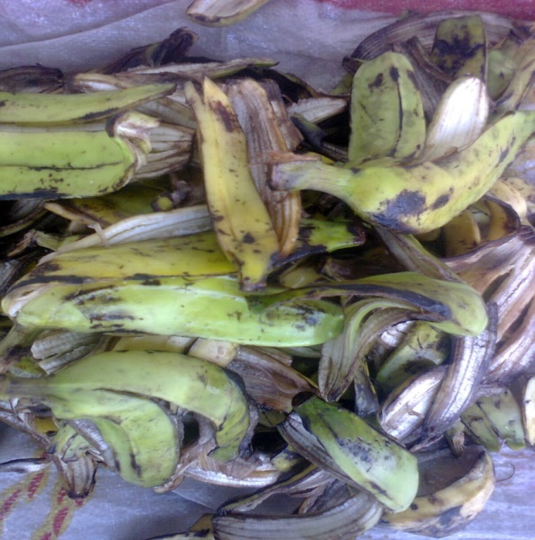
Plate 1: Raw banana peel

Preparation of the adsorbate: Chromium (VI) stock solution was prepared by dissolving reagent grade potassium dichromate (K2CrO7) powder in distilled water. 2.83 g of K₂Cr₂O₇ was dissolved in about 500 ml of distilled water in a volumetric flask and mixed thoroughly; distilled water was then added to the 1000 ml mark to give a stock solution containing 1000 mg/l of Cr (VI). The pH level of the prepared solution was then adjusted to 7.0 to meet the limit set by WHO (2006) by adding 0.1 N HCl and 0.1 N NaOH as required. This solution was then taken to the Centre for Energy Research and Development (CERD), Obafemi Awolowo Universtiy, Ile-Ife to ascertain the initial concentration of Cr (VI) using Atomic Absorption Spectrophotometer.
Adsorption experiments: Batch method was adopted in this work. In order to determine the effect of parameters (pH, adsorbent dose and contact time), the adsorption experiments were performed by batch equilibrium method. The contact times used were 5, 10, 20, 30 and 40 minutes while the adsorbent dosages were 1, 2, 3, 4, and 5 g/l. The effect of pH was investigated by measuring the pH of the final solution at the end of each experiment. The experiments were carried out in 250 ml of beaker by mixing a pre-weighed amount of adsorbent with 100 ml of the Cr (VI) solution. All experiments were performed at room temperature (27ºC) and continuous stirring was provided during each experiment with the aid of a mechanical stirrer (Plate 2) operated at a speed of 180 rpm. After each experiment, each sample was filtered and the filtrate kept in a thoroughly washed and rinsed bottle for further tests.
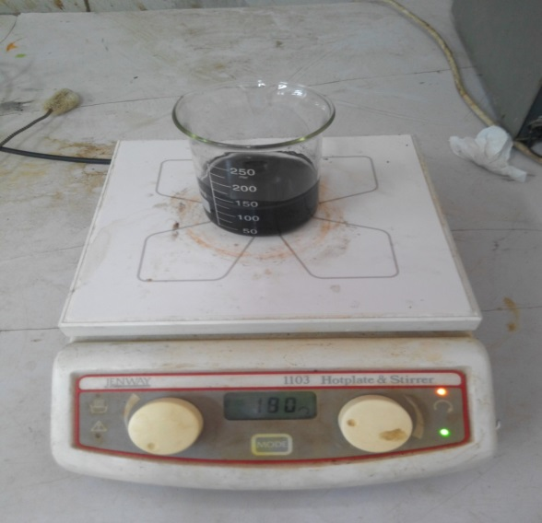
Plate 2: Mechanical stirring of the mixture

The amount of Cr (VI) adsorbed was calculated from the difference in Cr (VI) concentrations in aqueous solution before and after each experiment. The adsorption capacity and intensity were modelled by the Langmuir and Temkin isotherms. The amount of Cr (VI) adsorbed and the percent removal of Cr (VI) from solution were calculated using Eqs. 1 and 2, respectively:
(1)
(2)
where qe is the adsorption capacity in mg/g, Co and Ce are the initial and equilibrium concentrations of Cr (VI) in mg/l, respectively, V is the volume of Cr (VI) solution in l, and m is the mass of the adsorbent in g (Al-Sou'od, 2012).
Determination of the concentration of Cr (VI) concentration: The samples were appropriately labelled and taken to the laboratory at the Centre for Energy Research and Development (CERD), Obafemi Awolowo University, Ile-Ife for determination of Cr (VI) concentrations by using standard methods (APHA, 1998). Preparation of samples was carried out by using acid digestion. The procedure consisted of adding 2.5 ml of concentrated HNO₃ to 25 ml of water sample in a clean Teflon beaker before 2 ml of sample was injected into the machine by flow method. Detection limit was set in the range of 0.2 - 1.0 mg/l. The pH of each filtrate was determined by using Hanna HI 2211 pH/ORP meter.

3. Results and Discussion
The initial concentration of Cr (VI) was 9.12 mg/l.
Effect of contact time: Figures 1a and 1b show the effect of contact time using activated charcoal and banana peel, respectively. It was observed that the percentage adsorption of Cr (VI) ion was increasing with time until a time is reached when there was no more increase and at a point, a decrease was observed. The general pattern of the curve in Figure 1 revealed that the optimal removal efficiencies are 67% and 68.53% for activated charcoal and banana peel, respectively at the equilibrium time of 30 minutes.

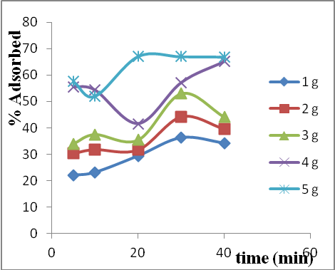
(a)

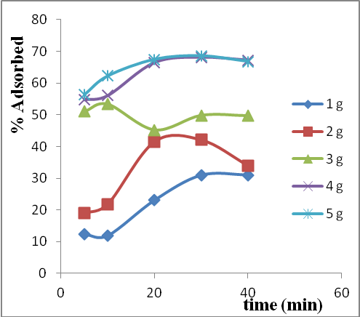
(b)
Figure 1: Effect of contact time on adsorption of Cr (VI) in water using (a) activated charcoal (b) banana

Effect of adsorbent dose: The effect of the adsorbent dose on the adsorption of Cr (VI) in water was investigated at optimum removal or at equilibrium time. The concentration of chromium was reduced by 36.29%, 44.08%, 53.07%, 65.13% and 67.11% for 1, 2, 3, 4 and 5 g of activated charcoal, respectively after treatment. For banana peel, the concentration was found to have been reduced by 31.03%, 42.11%, 53.29%, 68.09% and 68.53%, respectively for 1, 2, 3, 4 and 5 g after treatment. Metals adsorption efficiency was increased with increase in adsorbent dose. Between 1 g and 3 g, there were large increase in adsorption and between 4 g and 5 g there was little increase in adsorption, this revealed that the adsorption sites remain unsaturated during the adsorption reaction from 1 g to 3 g whereas the number of sites available for adsorption increased when the adsorbent dose was increased until the site became saturated when the adsorbent dose was 4 g or 5 g. Adsorption of chromium with varying adsorbent dosage is shown in Figure 2.

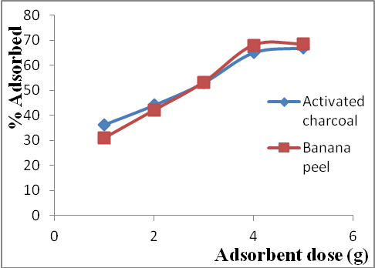
Figure 2: Comparison of the effect of adsorbent dose on adsorption of Cr (VI) in water

The pH level after treatment: It was observed that the pH of the treated water drastically reduced from neutral to very acidic. As contact time increases, pH level reduces. Also, as adsorbent dose was increased, the pH level was reducing. Figure 3 shows variation in pH level as contact time was increased for 1, 2, 3, 4 and 5 g adsorbent doses.
Percentage of Cr (VI) removal: Comparing the optimum percentage adsorption of activated charcoal and banana peel, it was discovered that banana peel has a greater efficiency in chromium removal than the activated charcoal. Figure 4 is a bar chart comparing the effectiveness of both adsorbent media in terms of their equilibrium concentration, that is, concentration after treatment. It was also discovered that water treated with activated charcoal was more acidic than that treated with banana peel. Therefore it would be more preferred to use banana peel to treat or reduce the concentration of chromium (VI) in water.

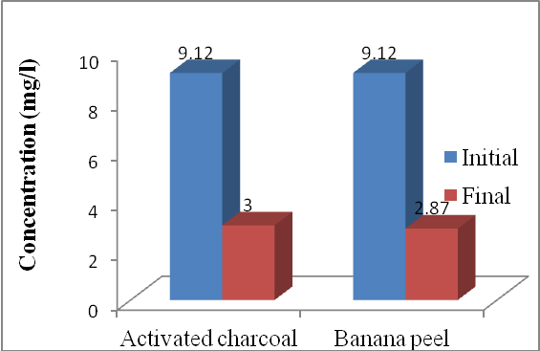
Figure 4: Comparison of the adsorption of Cr (VI) in water using activated charcoal and banana peel

Adsorption kinetic modelling: To find the potential rate-controlling steps involved in the process of adsorption of Cr (VI) onto activated charcoal and banana peel in water, both pseudo first-order and pseudo second-order kinetic models have been used to fit the experimental data. Kinetic study was carried out at optimized conditions from 5 to 40 min.
The pseudo-first-order kinetic model was described by Abas et al. (2013) as:
(3)
The linear form is given as:
(4)
where q_{e} is the amount of Cr (VI) adsorbed at equilibrium (mg/g), q_{t} is the amount of Cr (VI) adsorbed at any time t (mg/g), k₁ is the reaction rate constant for pseudo-first order reaction kinetics (mgg⁻¹min⁻¹).

Table 1: Calculated kinetic parameters for pseudo first-order kinetic model for the adsorption of Cr (VI) using activated charcoal and banana peel
Adsorbent | Dose (g) | q_{e}exp (mg/g) | q_{e}cal (mg/g) | k₁(min⁻¹) | R²
Activated charcoal | 1 | 0.331 | 0.192 | 0.057 | 0.990
 | 2 | 0.201 | 0.080 | 0.031 | 0.883
 | 3 | 0.161 | 0.064 | 0.020 | 0.824
 | 4 | 0.149 | 0.027 | -0.002 | 0.001
 | 5 | 0.123 | 0.034 | 0.098 | 0.920
Banana peel | 1 | 0.283 | 1.004 | 0.201 | 0.814
 | 2 | 0.192 | 0.057 | 0.036 | 0.092
 | 3 | 0.162 | 0.022 | 0.017 | 0.403
 | 4 | 0.155 | 0.064 | 0.020 | 0.824
 | 5 | 0.125 | 0.017 | 0.055 | 0.574
q_{e} cal- calculated values of q_{e}; q_{e}exp -experimental values of q_{e}

The kinetics of the adsorption process of both activated charcoal and banana peel was studied for adsorbent doses of 1 g, 2 g, 3 g and 5 g. Table 1 gives the summary of the analysis and parameter of the pseudo first order kinetic model. It is observed that the values of q_{e} exp varied considerably relative to that of q_{e} cal. The R² value for each dose is generally low; these observations suggest that the pseudo-first-order model is not suitable for modelling the adsorption of Cr (VI) onto activated charcoal and banana peel in water.
The pseudo second-order kinetic model has the following form (Khan et al., 2016);
(5)
The linearized form is given as;
(6)
where q_{e} is the amount of Cr (VI) adsorbed at equilibrium (mg/g), q_{t} is the amount of Cr (VI) adsorbed at any time t (mg/g), k₂ is the reaction rate constant for pseudo-second order reaction kinetics (mgg⁻¹min⁻¹).
Adsorption isotherm modelling: The calculated parameters for the data of second order kinetic model are summarized in Table 2. The correlation coefficient was nearly equal to unity and calculated q_{e} cal value was very close to the experimental value of qe exp. The results indicated that the pseudo-second-order adsorption mechanism is predominant for the adsorption of Cr (VI) onto activated charcoal and banana peel and it is considered that the rate of the Cr (VI) adsorption process is controlled by the chemisorption process, that is, the rate-limiting step is the chemical sorption or chemisorption involving valence forces through sharing or exchange of electrons between adsorbent and adsorbate as covalent forces (Ofomaja, 2008).
Adsorption isotherm modeling: Adsorption equilibrium data were fitted to the Langmuir and Temkin isotherms. The data being the values taken at equilibrium time which in most of the experimental results taken as 30 minutes. Necessary parameters such as the q_{e}, C_{e} and T values were calculated before.
Langmuir isotherm model: The Langmuir isotherm is based on the monolayer adsorption of chromium ions on the surface of absorbent sites and is expressed as Eq. 7:
(7)
The linear form as given by Sarin and Pant (2006) is expressed as Eq. 8:
(8)
where q_{e} (mg/g) is the adsorption capacity at equilib-rium, C_{e} (mg/l) is the equilibrium concentration, Q_{max} is the maximum monolayer adsorption capacity (mg/g), b is the Langmuir constant (l/mg) related to the energy of adsorption.
Figure 5 shows the plot of 1/q_{e} against 1/C_{e} for both adsorbents. The necessary parameters are as shown in Table 3. The maximum monolayer adsorption capacity, Q_{max} was found to be -2.016 and 0.615 mg/g for activated charcoal and banana peel, respectively. The correlation coefficients (R²) are 0.855 and 0.786 for activated charcoal and banana peel, respectively. This clearly suggests that the adsorption of Cr (VI) onto activated charcoal and banana peels follows the Langmuir isotherm though activated charcoal seems to fit much better because it has higher R² value. The R_{L} values for both adsorbents were also calculated. R_{L} is a dimensionless constant referred to as the separation factor and was calculated as given by Panda (2017), Eq. 9:
(9)

Table 2: Calculated kinetic parameters for pseudo second-order kinetic model for the adsorption of Cr (VI) using activated charcoal and banana peel
Adsorbent | Dose (g) | q_{e}exp (mg/g) | q_{e}cal (mg/g) | k₂(mgg⁻¹ min⁻¹) | R²
Activated charcoal | 1 | 0.331 | 0.363 | 0.494 | 0.982
 | 2 | 0.201 | 0.200 | 1.380 | 0.962
 | 3 | 0.161 | 0.151 | 1.982 | 0.940
 | 4 | 0.149 | 0.150 | 1.675 | 0.906
 | 5 | 0.123 | 0.125 | 6.175 | 0.998
Banana peel | 1 | 0.283 | 0.452 | 0.201 | 0.835
 | 2 | 0.192 | 0.196 | 0.036 | 0.901
 | 3 | 0.162 | 0.151 | 0.017 | 0.995
 | 4 | 0.155 | 0.161 | 0.020 | 0.998
 | 5 | 0.125 | 0.126 | 0.055 | 0.999
q_{e} cal- calculated values of q_{e}; q_{e}exp -experimental values of q_{e}
Being plotted into the isotherm models.

Table 3: Langmuir isotherm parameters at initial concentration of 9.12 mg/l
Adsorbent | Q_{max} (mg/g) | b (l/mg) | R_{L} | R²
Activated charcoal | -2.016 | -0.0196 | 1.218 | 0.855
Banana peel | 0.615 | 0.0975 | 0.529 | 0.786

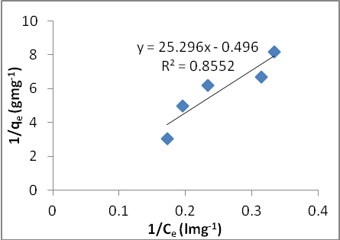
(a)

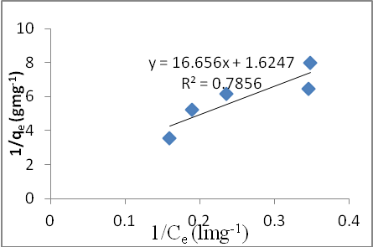
(b)
Figure 5: Langmuir isotherm plot for adsorption of Cr (VI)-(a) activated charcoal (b) banana peel

R_{L} value for activated charcoal is 1.220, which is greater than one (R_{L} > 1). This implied that the adsorption process is an unfavourable one. R_{L} for banana peel was found to be less than one (R_{L} < 1), that is 0.529 which indicates that the adsorption is a favourable process. Thus, banana peel could be preferred to activated charcoal in the adsorption of low concentration of Cr (VI).
Tempkin isotherm: This isotherm contains factors that explicitly take into account the adsorbent-adsorbate interactions. As implied in the equation, its derivation is characterized by plotting the quantity adsorbed qe against lnCe and the constants were determined from the slope and intercept.

The model is given by the following equation (Demiral et al., 2008);
(10)
This was then linearized to become;
(11)
where B₁=RT/b_{T}, q_{e} is the equilibrium adsorption capacity, A is the Temkin isotherm equilibrium binding constant (l/g), b_{T} is the Temkin isotherm constant, R is the universal gas constant (8.314 J/mol/K), T is the absolute temperature (K) and C_{e} is the equilibrium concentration.
Figure 6 shows the plot of q_{e} against lnC_{e} for doses of 1, 2, 3, 4 and 5 g of adsorbent while Table 4 shows the summary of the isotherm parameters derived from the plot of Figure 6. The R² values for activated charcoal and banana peel were 0.741 and 0.768, respectively. The R² value of banana peel was higher than that of activated charcoal which showed that banana peel data fitted better into the Temkin isotherm model than activated charcoal.

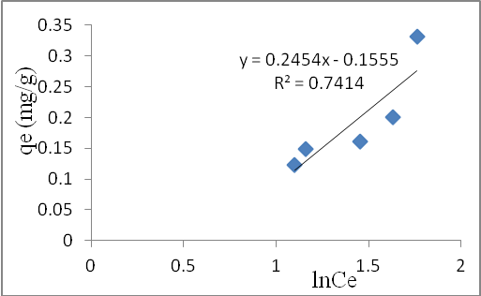
(a)

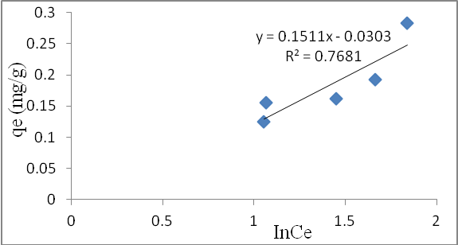
(b)
Figure 6: Temkin isotherm plot for adsorption of Cr (VI)-(a) activated charcoal (b) banana peel

Table 4: Tempkin isotherm parameters at initial concentration of 9.12 mg/l
Adsorbent | A (l/mg) | b_{T} | R²
Activated charcoal | 0.531 | 10163.6 | 0.741
Banana peel | 0.818 | 16509.4 | 0.768

4. Conclusions
Based on the results of the present investigation, it was concluded that the optimum adsorption time for chromium (VI) ion removal at the specified adsorption dose for both activated charcoal and banana peel was 30 minutes; maximum adsorption was found to be 67% and 68.53% at 5 g dose of activated charcoal and banana peel, respectively. The Langmuir isotherm model fitted better to the experimental data than the Tempkin isotherm model with R² values of 0.855 and 0.786 for activated charcoal and banana peel, respectively. Adsorption of Cr (VI) followed pseudo-second order kinetics. Langmuir and Tempkin isotherm equations were fitted to the equilibrium adsorption data; the former isotherm yielded a better fit.

Corresponding Author:
Dr. Kamar Taiwo Oladepo
Department of Civil Engineering
Obafemi Awolowo University
Ile-Ife 220005, Nigeria
Telephone: +2348033633546
E-mail: koladepo1@yahoo.com

References
- Abas SNA, Ismail MHS, Kamal ML, Izhar S. Adsorption Process of Heavy Metals by Low-Cost Adsorbent: A Review. World Applied Sciences Journal 2013;28 (11):1518-1530.
- Al-Sou'od K. Adsorption isotherm studies of chromium (VI) from aqueous solutions using Jordanian pottery materials. APCBEE Procedia 2012;1:116 – 125.
- APHA. Standard methods for the examination of water and wastewater. 18th ed. American Public Health Association. Washington. 1998.
- Demiral H, Demiral I, Tumsek F, Karabacakoglu, B. Adsorption of chromium (VI) from aqueous solution by activated carbon derived from olive bagasse and applicability of different adsorption models. Chemical Engineering Journal 2008;144:188–196.
- Dubey SP, Gopal K. Adsorption of chromium (VI) on low cost adsorbents derived from agricultural waste material: A comparative study. Journal of Hazardous Materials 2007;145: 465–470.
- Food and Agriculture Organazation (FAO). 2015. Banana facts. World banana production, exports and imports. Accessed 27 June 2017. Available: http://www.fao.org/resources/infographics/infographics-details/en/c/297695/
- Jeje JO, Oladepo KT. Water supply technologies: Momentous effects on sanitation systems in Nigeria. International Journal of Civil and Environmental Research. 2014; 1(4):141-151.
- Khan T, Isa MH, Mustafa MR, Yeek-Chia H, Baloo L, Manana TS, Saeed MO. Cr (VI) adsorption from aqueous solution by an agricultural waste based carbon. RSC Advances 2016;6:56365–56374.
- Li X-D. Study on removal of trivalent chromium from wastewater by banana peel. Advanced Materials Research 2014;1048:444-447.
- Malkoc E, Nuhoglu Y, Dundar M. Adsorption of chromium (VI) on pomace—An olive oil industry waste: Batch and column studies. Journal of Hazardous Materials 2006; B138:142–151.
- Mohanty K, Jha M, Meikap BC, Biswas MN. Removal of chromium (VI) from dilute aqueous solutions by activated carbon developed from Terminalia arjuna nuts activated with zinc chloride. Chem. Eng. Sci. 2005; 60:3049–3059.
- Montanher SF, Oliveira EA, Rollenberg MC,. Removal of metal ions from aqueous solutions by sorption onto rice bran. J. Hazard. Mater. 2005; B.117:207-211.
- Nasernejad B, Zalah TE, Pou BB, Bygi ME, Zamani A. Comparison for biosorption modeling of heavy metals [Cr (III), Cu (II), Zn (II)] adsorption from wastewater by carrot residues. Process Biochem. 2005; 40:1319-1322.
- Ofomaja AE. Sorptive removal of methylene blue from aqueous solution using palm kernel fibre: effect of fibre dose. Biochem. Eng. Journal 2008;40 (1):8–18.
- Oluyemi EA, Adekunle AS, Adenuga AA, Makinde WO. Physico-chemical properties and heavy metal content of water sources in Ife North Local Government Area of Osun State, Nigeria. African Journal of Environmental Science and Technology. 2010; 4(10):691-697.
- Osewa O. 2017. Nigerian States And What They Produce. Accessed 16 June 2017. Available: http://www.nairaland.com/2521578/nigerian-states-what-produce.
- Panda H, Tiadi N, Mohanty M, Mohanty CR. Studies on adsorption behavior of an industrial waste for removal of chromium from aqueous solution. South African Journal of Chemical Engineering 2017;23:132-138.
- Romero-Gonzalez J, Peralta-Videa JR, Rodriguez E, Ramirez SL, Gardea-Torresdey JL. Determination of thermodynamic parameters of Cr (VI) adsorption from aqueous solution onto Agave lechuguilla biomass. J. Chem. Thermodyn. 2005;37:343–347.
- Sarin V, Pant KK. Removal of chromium from industrial waste by using eucalyptus bark. Bioresource Technology 2006; 97:15–20.
- Saha R, Rumki Nandi R, Saha B. Sources and toxicity of hexavalent chromium. Journal of Coordination Chemistry 2011; 64(10):1782-1806.
- Thomas HE, Christelle R, Sebastien NR, Laser W, Schulman MD. A comparison of liquid hot water and steam pretreatments of sugar cane basse for bioconversion to ethanol. Biores. Technol. 2002; 81:33-44.
- Umoh IB. Commonly used fruits in Nigeria. In: Nutrition quality of plant, Osagie AU, Eka OU, editors. Benin City: Foods Post Harvest Research Unit, University of Benin, Nigeria. 1998.
- Wang XS, Li ZZ, Tao SR. Removal of chromium (VI) from aqueous solution using walnut hull. Journal of Environmental Management 2009;90:721-729.
- WHO. Guidelines for drinking-water quality, 3rd ed. World Health Organization, Geneva. 2006.
- Yavuz R, Orbak I, Karatepe N. Factors Affecting the Adsorption of Chromium (VI) on Activated Carbon. Journal of Environmental Science and Health Part A 2006;41:1967–1980.

8/19/2017

