Transdermal Nitroglycerin in Patients with Mild Pre-eclampsia: Effect on Maternal Uterine and Fetal Umbilical Arteries Resistance Indices

Amr Mohamed Ibrahim Mostafa¹, Yahia Abd El Salam Wafaa², Mohamed Hesham Anwar², Mohamed Ibrahim Mostafa³

¹Resident of Obstetrics and Gynaecology at Al-Galaa Maternity Teaching Hospital, Egypt
²Professor of Obstetrics and Gynaecology, Faculty of Medicine, Al Azhar University, Egypt
³ Consultant Obstetrician and Gynaecologist at Al-Galaa Maternity Teaching Hospital, Egypt
Dr.mero.mi@gmail.com

Abstract: Objective: to find out the effect of using transdermal nitroglycerine patches on maternal uterine and fetal umbilical arteries in women suffering from mild pre-eclampsia in third trimester. Patients & methods: This is a prospective interventional clinical trial study conducted at Al-Galaa Maternity Teaching Hospital including 50 singleton pregnant women with mild pre-eclampsia (gestational age range from 28 to 36 weeks) with informed written consent. In this study, comparison of the resistance index (RI) and the pulsatility index (PI) of the uterine and umbilical arteries as well as maternal blood pressure before and after application of a transdermal nitroglycerin patch (average dose 0.2 mg/h) for a period of 3 days was done, comparison between day 0 (no patch) and day 3 after administration of the first dose of nitroglycerin were performed using paired sample t-test after testing data for normality using the Kolmogrov-Smirnov test. Results: A significant decrease in mean umbilical artery RI from 0.74 ± 0.04 SD to 0.69 ± 0.06 SD and PI from 1.33 to 1.18 ± 0.19 SD. Significant decrease in mean uterine artery RI from 0.63 ± 0.05 SD to 0.60 ± 0.05 SD and PI from 1.09 to 1.04 ± 0.14 SD. The study also showed a significant decline of mean value of mean arterial blood pressure (2×diastolic blood pressure + systolic blood pressure / 3) from 105 ± 3.31 SD to 100 ± 4.21 SD after using the patches. Conclusion: The use of transdermal nitroglycerin in patients with mild pre-eclampsia (28-36 weeks of gestation) is associated with a significant reduction in the RI and PI of the uterine and umbilical arteries, as well as of maternal blood pressure.
[Amr Mohamed Ibrahim Mostafa, Yahia Abd El Salam Wafaa, Mohamed Hesham Anwar, Mohamed Ibrahim Mostafa. Transdermal Nitroglycerin in Patients with Mild Pre-eclampsia: Effect on Maternal Uterine and Fetal Umbilical Arteries Resistance Indices. N Y Sci J 2017;10(9):23-27]. ISSN 1554-0200 (print); ISSN 2375-723X (online). http://www.sciencepub.net/newyork. 3. doi:10.7537/marsnys100917.03.

Keywords: Transdermal; Nitroglycerin; Patient; Maternal Uterine; Fetal Umbilical Artery; Resistance Indices

1. Introduction:
Pre-eclampsia is one of the most frequent pregnancy complications, and, in its severe form, is one of the main causes of maternal and perinatal morbidity and mortality. The etiology and pathophysiology of pre-eclampsia have not yet been clearly established. Impaired immunological adaptation and genetic incompatibility seem to be involved in deficient trophoblastic implantation (Trapani et al 2011). Placental hypoxia and endothelial dysfunction may lead to pre-eclampsia through an exacerbated systemic inflammatory reaction (Poston et al 2006). Maternal organ systems that are susceptible to excessive inflammation and endothelial damage are the central nervous system, lungs, liver, kidneys, systemic vasculature, coagulation, the heart, the placenta and fetus are also at risk. The more organ systems that are affected, the more maternal and perinatal complications arise. (Steegers et al 2010).
The definitive treatment for pre-eclampsia is delivery, particularly in severe cases with evident placental insufficiency. However, the potential benefits of early delivery have to be weighed against the risks of extreme prematurity. (Trapani et al 2011)
Nitric oxide is a potent vasodilator, especially of the venules, and is also an inhibitor of platelet aggregation. (Pober et al 2007) During pregnancy, nitric oxide is synthesized in the uteroplacental tissues and endothelial cells, helping to keep the vascular resistance of the fetoplacental and uterine circulations low (Reynolds et al 2009). The properties of nitric oxide donors can be potentially explored for the treatment of pre-eclampsia. One of its limitations is the development of tolerance, which can be reduced with intermittent administration. Headache is one of the few reported side effects of glyceryl trinitrate use (Trapani et al 2011).
Nitric oxide donors have been previously studied in several obstetric complications, including premature labor, prevention of pre-eclampsia, intrauterine growth restriction and hypertensive crisis. Transdermal glyceryl trinitrate is one such nitric oxide donor which reaches stable serum concentrations as early as 2 hours after administration. As glyceryl trinitrate is metabolized quickly, continuous administration is recommended, with the transdermal route being the most convenient mode of administration (Trapani et al 2011).
Doppler velocimetry is a non-invasive method used to evaluate resistance to blood flow in the uteroplacental and fetoplacental circulations. Previous smaller studies have suggested a potential benefit of glyceryl trinitrate in patients with pre-eclampsia or placental insufficiency (Trapani et al 2011).

2. Patients and Methods:
This was a prospective interventional clinical trial study conducted at Al-Galaa Maternity Teaching Hospital from May 2014 to May 2016, including 50 singleton pregnant women with mild pre-eclampsia and abnormal uterine and umbilical arteries Doppler waveforms after informed written consent.
Inclusion criteria were singleton pregnant women with mild pre-eclampsia, gestational age ranging from 28 and 36 weeks, intact membranes, increased resistance indices of umbilical and uterine arteries; and exclusion criteria were women having other medical disorders eg. anaemia, fetal malformation, serum creatinine < 1.5 mg/dl, absent or reversed diastolic flow of umbilical artery, severe pre-eclampsia and eclampsia. Severe pre-eclampsia was defined as: having persistent symptoms of headache, new-onset of visual disturbances or severe right upper quadrant or epigastric pain unresponsive to medication and not accounted for by an alternative diagnoses, systolic BP ≥ 160 mm Hg or diastolic ≥ 110 mm Hg on 2 occasions 4 hours or more apart while the patient is on bed rest, thrombocytopenia (platelet count < 100,000/μL), impaired liver function as indicated by abnormally elevated blood levels of liver enzymes (to twice normal concentration), progressive renal insufficiency (serum creatinine > 1.5 mg/dL or a doubling of the serum creatinine in the absence of other renal disease, new-onset cerebral disturbances or occurance of pulmonary edema. Uterine artery Doppler velocity waveforms were considered abnormal when the mean RI between the left and right uterine arteries was ≥0.58.
Umbilical artery Doppler velocity waveforms were considered abnormal when the RI was greater than the 95th percentile for gestational age. Nitroderm patch 5 mg (Novartis PharmaAG, Stein, Switzerland) was applied to the abdomen skin, on midinguinal point (6 hours on right side then 6 hours on left side & removed for 12 hours) releasing nitroglycerin at a rate of 0.2 mg/h. The dosage was kept constant during the study. On the first day of the study, patients did not receive glyceryl trinitrate (control day). During the next 3 days, the patch was applied at 9:00 a.m. on right midinguinal point till 3:00 p.m. then site is changed to left midinguinal point and the patch was removed at 9:00 p.m. to allow patch free time of 12 hours to decrease tolerance. Mean arterial blood pressure (2×diastolic blood pressure + systolic blood pressure / 3) was noted all through the study time. Data was tested for normality by applying the Kolmogorov–Smirnov test with a significance level of 5%.
Paired samples t-test used to compare changes in mean RI and PI of the umbilical & uterine arteries before and after glyceryl trinitrate administration with a significance level of P < 0.05.

3. Results:
Among the 50 patients who were initially enrolled, three could not follow the study protocol and were excluded from the final analysis: two patients had severe headaches requiring glyceryl trinitrate patch removal, and a third patient with clinical symptoms and signs suggestive of imminent eclampsia received magnesium sulfate. Headache was the most common side effect, occurring in 29 (58%) of 50 patients. However, in only 2 cases (4%) was the pain severe enough to require interruption of the glyceryl trinitrate treatment. The other patients had symptomatic relief with administration of analgesics and adaptation to the medication. 3 cases (6%) showed hyperemia where the patch was applied, but there was no need to interrupt the study. A significant decrease in mean umbilical artery RI from 0.74 ± 0.04 SD to 0.69 ± 0.06 SD and PI from 1.33 to 1.18 ± 0.19 SD. Significant decrease in mean uterine artery RI from 0.63 ± 0.05 SD to 0.60 ± 0.05 SD and PI from 1.09 to 1.04 ± 0.14 SD. The study also showed a significant decline of mean arterial blood pressure from 105 ± 3.31 SD to 100 ± 4.21 SD after using the patches. This study included 50 Primigravidae cases of mild pre-eclampsia of different maternal age and gestational age.
Table (1) shows that mean age was 25.18 years ± 3.916 SD & mean gestational age was 32.68 weeks ± 2.084 SD.

Table 1: Descriptive analysis for patients according to maternal age and gestational age:
 | Min. | Max. | Mean | ±SD
Maternal Age (years) | 19 | 34 | 25.18 | 3.916
Gestational Age (weeks) | 28 | 35 | 32.68 | 2.084

Table (2) shows that mean value for umbilical artery RI before treatment was 0.74 ± 0.04 SD & after treatment was 0.69 ± 0.06 SD.Mean value for umbilical artery PI before treatment was 1.33 ± 0.18 SD & after treatment was 1.18 ± 0.21 SD.Mean value for uterine artery RI before treatment was 0.63 ± 0.05 SD & after treatment was 0.60 ± 0.05 SD.Mean value for uterine artery PI before treatment was 1.09 ± 0.16 SD & after treatment was 1.04± 0.17 SD.Mean value for mean arterial blood pressure (MAP) before treatment was 105 ± 3.31 SD & after treatment was 100 ± 4.21 SD.

Table 2: Descriptive analysis calculating the mean value for data obtained before & after treatment:
 | Mean |  | Standard Deviation (±SD) |  | Minimum |  | Maximum
 | Before | After | Before | After | Before | After | Before | After
Umbilical Artery RI | 0.74 | 0.69 | 0.04 | 0.06 | 0.67 | 0.57 | 0.85 | 0.81
Umbilical Artery PI | 1.33 | 1.18 | 0.18 | 0.21 | 0.93 | 0.84 | 1.65 | 1.63
Uterine Artery RI | 0.63 | 0.60 | 0.05 | 0.05 | 0.58 | 0.54 | 0.77 | 0.76
Uterine Artery PI | 1.09 | 1.04 | 0.16 | 0.17 | 0.88 | 0.85 | 1.56 | 1.55
Mean Arterial Blood Pressure (MAP) | 105 | 100 | 3.31 | 4.21 | 99 | 93 | 116 | 111

Table 3: Paired sample t-test for comparing mean value for umbilical, uterine arteries & MAP before & after treatment:
 | Mean |  | 95% C.I.for OR |  | P | Sig.
 | Before | After | Lower | Upper
Umbilical Artery RI | 0.74 | 0.69 | 0.038 | 0.068 | 0.0014 | HS
Umbilical Artery PI | 1.33 | 1.18 | 0.098 | 0.211 | 0.0037 | HS
Uterine Artery RI | 0.63 | 0.60 | 0.013 | 0.030 | 0.0052 | HS
Uterine Artery PI | 1.09 | 1.04 | 0.006 | 0.086 | 0.0064 | HS
Mean Arterial Blood Pressure (MAP) | 105 | 100 | 3.788 | 6.273 | 0.023 | S

The P value for comparison of mean Umbilical artery RI before & after treatment was 0.0014 indicating highly significant result. The P value for comparison of mean Umbilical artery PI before & after treatment was 0.0037 indicating highly significant result. The P value for comparison of mean Uterine artery RI before & after treatment was 0.0052 indicating highly significant result. The P value for comparison of mean Uterine artery PI before & after treatment was 0.0064 indicating highly significant result. The P value for comparison of mean value for mean arterial pressure before & after treatment was 0.023 indicating significant decrease in blood pressure.

4. Discussion:
A drug that could improve maternal and fetal hemodynamics in the setting of early pre-eclampsia is a desirable goal for at least palliation of this ominous and prevalent condition. The decrease in uteroplacental vascular resistance with the use of intravenous, sublingual and transdermal glyceryl trinitrate has been demonstrated in previous studies of a smaller sample size and with more heterogeneous enrollment criteria (Ali RM et al 2015).

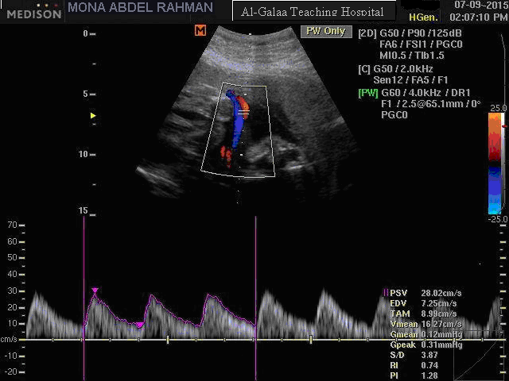  Doppler indices of Umbilical artery before treatment: RI=0.74 & PI=1.28 | 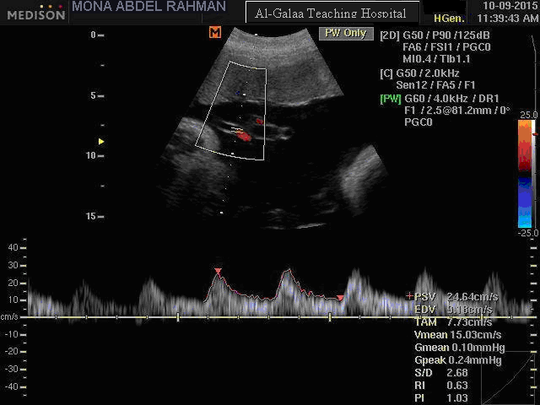  Doppler indices of Umbilical artery after 3 days of nitroglycerin treatment: RI=0.63 & PI=1.03
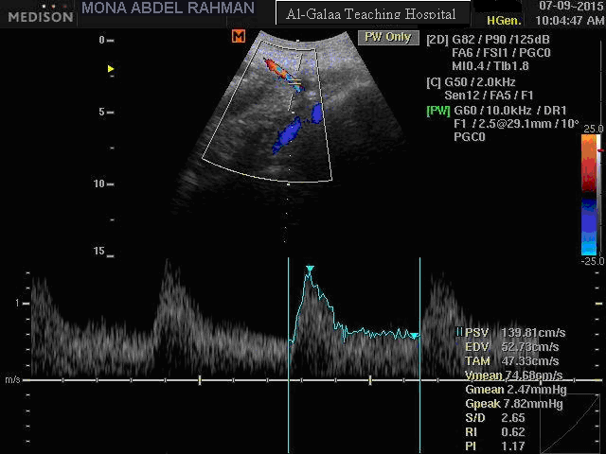  Doppler indices of Uterine artery before treatment: RI=0.62 & PI=1.17 | 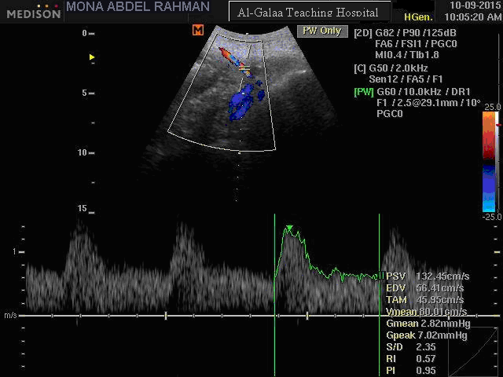  Doppler indices of Uterine artery after 3 days of nitroglycerin treatment: RI=0.57 & PI=0.95
Figure 1: Umbilical and Uterine arteries RI and PI before and after treatment

This study shows the effect of using transdermal nitroglycerin patches to improve the uteroplacental blood flow reflected by a significant decrease in the mean umbilical artery RI from 0.74 ± 0.04 SD to 0.69 ± 0.06 SD and a significant decrease in mean uterine artery RI from 0.63 ± 0.05 SD to 0.60 ± 0.05 SD. In the present study, improvement in the uteroplacental circulation was evident when comparing the results before and after nitroglycerin patch application. In contrast to previous studies with more heterogenous inclusion criteria, all patients were primigravidae, their mean age was 25.18 years ± 3.916 SD and mean gestational age was 32.68 ± 2.084 SD weeks, all patients were suffering from mild pre-eclampsia with higher Doppler indices of umbilical & uterine arteries and not receiving antihypertensive drugs. In this study, when compared with the first day (without nitroglycerin patch), Doppler examination after three days of nitroglycerin patch application showed a highly significant decrease in the PI and RI of the uterine and umbilical arteries, The mean arterial blood pressure decreased significantly from 105 ± 3.31 SD to 100 ± 4.21 SD with nitroglycerin use (P value < 0.05).
The results of this study showed that nitroglycerin patches caused significant decrease in mean umbilical artery RI and significant decrease in mean uterine artery RI and agrees with Luzi et al who studided fetomaternal hemodynamic effects in ten pregnant women with mild pre-eclampsia with mean gestational age of thirty weeks and found a significant decrease in umbilical artery PI in cases of pre-eclamptic women after 20 and 30 minutes of sublingual administration glyceryl trinitrate administration. (Luzi et al 1999).
Grunewald et al demonstrated that the decrease in the PI of the umbilical artery was more pronounced in patients who already had abnormal Doppler waveforms before the initiation of therapy, as was the case in our study. (Grunewald et al 1995).
In contrast to this study, Grunewald et al. found that the PI of Uterine artery did not change significantly after nitroglycerin use; this may be attributed to different sample as Grunewald et al. studied nitroglycerin effect in severe pre-eclampsia as compared to this study. This study also showed a significant decline of mean arterial blood pressure from 105 ± 3.31 SD to 100 ± 4.21 SD after using the patches. Nitroglycerin patch caused a significant decrease in the mean arterial blood pressure, as patients did not receive antihypertensive treatment before or during the study other than nitroglycerine patch and it was evident that the patch helped to maintain blood pressure around target blood pressure. None of the patients had severe hypotension or tachycardia in this study. (Grunewald et al 1995).
Cetin et al studied the effect of glyceryl trinitrate on hypertension in women with severe pre-eclampsia, HELLP Syndrome, and eclampsia in fifty five women with mean gestational age of 33 weeks, twenty four of which had severe pre-eclampsia, sixteen had HELLP syndrome, and fifteen had eclampsia and found the same hypotensive effect of intravenous glyceryl trinitrate, they also found that systolic blood pressure of severe pre-eclampsia group was significantly lower than those of the HELLP syndrome and eclampsia groups. (Cetin et al 2004).
Headache was the most common side effect, observed in 58% of the patients. Headache was well controlled with common analgesics and disappeared or decreased with adaptation to the medication.

Conclusion:
- Transdermal nitroglycerin caused significant decrease in the RI and PI of both maternal uterine and fetal umbilical arteries indicating improvement of blood flow in uteroplacental circulation. A significant decrease in maternal blood pressure was also noted. The easy administration route of transdermal patches has helped better compliance though it may be of higher cost than the sublingual & infusion routes.
- The effect on umbilical and uterine arteries Doppler indices after using transdermal nitroglycerin patches in mild and severe pre-eclampsia was conflicting between different studies. Comparing the use of transdermal nitroglycerin in both conditions in future studies is mandatory to determine the efficacy of nitroglycerin in both conditions.
- Transdermal nitroglycerine is to be considered as a line of treatment in mild pre-eclampsia combined with other drugs.

References:
- Ali RM, Salah D and Mansour DY. The effect of nitroglycerin infusion versus hydralazine infusion as antihypertensive therapy in acute management of patients with severe pre-eclampsia. Ain-Shams J Anaesthesiol 2015; 499–504.
- Cetin A, Yurtcu N, Guvenal T, Imir AG, Duran B and Cetin M. The effect of glyceryl trinitrate on hypertension in women with severe preeclampsia, HELLP syndrome, and eclampsia. 2004; 37–46.
- Grunewald C, Kublickas M, Carlstrom K, Lunell NO, Nisell H. Effects of nitroglycerin on the uterine and umbilical circulation in severe preeclampsia. Obstet Gynecol 1995; 86: 600–604.
- Luzi G, Caserta G, Iammarino G, Clerici G, Di Renzo GC. Nitric oxide donors in pregnancy: fetomaternal hemodynamic effects induced in mild preeclampsia and threatened preterm labor. Ultrasound Obstet Gynecol 1999; 14: 101–109.
- Pober, Jordan S., and William C. Sessa. Evolving functions of endothelial cells in inflammation. Nature Reviews Immunology 7.10,2007: 803-815.
- Poston, Lucilla. Endothelial dysfunction in pre-eclampsia. Pharmacol Rep 58. Suppl,2006: 69-74.
- Reynolds, Lawrence P., et al. Uteroplacental vascular development and placental function: an update. International Journal of Developmental Biology 54.2-3,2009: 355-365.
- Steegers EAP, Dadelszen PV, Duvekot JJ, Pijnenborg R. Preeclampsia. Lancet 2010; 376: 631–644.
- Trapani, A., L. F. Gonçalves, and MM de S. Pires. Transdermal nitroglycerin in patients with severe pre-eclampsia with placental insufficiency: effect on uterine, umbilical and fetal middle cerebral artery resistance indices. Ultrasound in Obstetrics & Gynecology 38.4, 2011: 389-394.

8/15/2017

