Outcome of surgical intervention with different modalities in treatment of lumbar canal stenosis.

Ahmed Mohamed Shaker Eidarous Elakhras ¹, Ahmed M. El Sherif² and Mostafa Elsyed Mohamed³

¹Neurosurgical Department, Kafr-Elsheikh University Hospitals, Egypt.
² Neurosurgical Department, Faculty of Medicine, Al-Azhar University, Egypt.
ahmed1alakhras@gmail.com

Abstract: Background: Neural decompression for lumbar spinal stenosis (LSS) can be performed, besides conventional lumbar laminectomy, by many other surgical Techniques. Objective: The goal of this study is to assess clinical and radiological outcome of surgical intervention with different modalities in treatment of lumbar canal stenosis. Methods: A number of 46 patients with lumbar spinal stenosis were divided into two groups: group A, patients with central canal stenosis (no.=25), consists of patients that underwent a laminectomy procedure and group B, patients with lateral canal stenosis (no.=21), consists of cases where fenestration was used. Outcome was assessed postoperatively. Two parameters were evaluated (MRS) And Patient satisfaction. Results: The level of pain was reduced in both patient groups. Cases in group A: maintained higher levels of back pain in the first postoperative period versus group B. Improvement was faster for those operated by unilateral approach. At follow-ups, (MRS) values were very similar. Conclusions: Decompression by fenestration approach is an efficient method that represents the first option of treatment for patients with lateral lumbar spinal stenosis with unilateral or predominantly unilateral symptoms. For patients with severe central stenosis, classic laminectomy remains the first surgical choice.
[Ahmed Mohamed Shaker Eidarous Elakhras, Ahmed M. El Sherif and Mostafa Elsyed Mohamed. Outcome of surgical intervention with different modalities in treatment of lumbar canal stenosis. N Y Sci J 2017;10(8):158-163]. ISSN 1554-0200 (print); ISSN 2375-723X (online). http://www.sciencepub.net/newyork. 18. doi:10.7537/marsnys100817.18.

Key words: lumbar spinal stenosis, laminectomy, unilateral approach.

1. Introduction:
With widespread MRI use, an increasing number of patients are diagnosed with lumbar spinal stenosis (LSS).
CT-scan and MRI have brought on better information regarding the morphology of the spinal canal and revealed its stenosis, which can be central or lateral. The failure of conservative therapy encourage doctor for the discovery of different surgical techniques for decompression of the affected nervous elements, which have better results than conservative treatment. (Siebert; et al, 2009).
Laminectomy has been the gold standard of surgical treatment for central lumbar spinal stenosis, Subsequently, less invasive techniques have been used: unilateral laminectomy, bilateral fenestration and foraminotomy, unilateral fenestration and foraminotomy with ipsilateral and contralateral nerve root decompression (Armin; et al., 2008). The goal of the study is to assess clinical and radiological outcome of surgical intervention with different modalities in treatment of lumbar canal stenosis including fenestration and laminectomy. (Chiu, 2006), (Kim and Albert, 2007)

2. Patients and methods:
The study was conducted on 46 consecutive patients with lumbar spinal stenosis. Diagnosis was based on clinical symptoms (e.g.: neurogenic claudication, leg pain) and signs, correlated with MRI.
Preoperatively, conservative therapy for 3 to 6 months failed to improve symptoms for all cases included.
In cases with neurogenic claudication and a central LSS on MRI, a standard lumbar laminectomy was performed. For patients with unilateral or predominantly unilateral radicular pain and lumbar MRI showed lateral recess and/or foraminal stenosis, fenestration at the most affected side and bilateral decompression of nerve roots at the affected level was performed.
For both groups of patients, a prospective, retrospective analysis was carried out on operative time, postoperative hospital length of stay and complications that occurred (e.g.: incidental durotomy). Neurological examinations performed preoperatively and during follow-up assessed (MRS) and patient satisfaction.

3. Results:
46 patients who underwent lumbar decompression surgery. First group had been operated by conventional laminectomy Second group had been operated by minimally invasive technique ( fenestration).
The clinical and radiographic outcomes were analyzed in all patients. The first group consisted of 14 males and 11 females with an average age of 46 years (range: 28 to 64 years). The second group consisted of 12 males and 9 females with an average age of 47 years (range: 29 to 65 years) 21 patient operated for fenestration surgery, all of them had foraminal or lateral recess stenosis. The other 25 patient operated for conventional laminectomy surgery, all cases had central stenosis, but only 8 cases of them had both foraminal & central stenosis. Regarding the length of incision (cm) in fenestration surgery, it was smaller (with the mean ± SD (5.5 ± 1.1)) than in laminectomy surgery in which the length of incision was larger (with the mean ± SD (6.25 ± 1.25)). There was statistically significant difference between groups according to skin incision. Fenestration surgery done on 21 patients, 11 cases operated for single level, 7 cases operated for double levels and 3 cases operated for triple levels of surgery. Laminectomy done on 25 patients, 8 cases operated for single level, 12 cases operated for double level and 5 cases operated for triple levels of surgery. As regards to the duration of surgery (minutes) in fenestration surgery, it was shorter with mean ± SD (102.5±12.81) than in laminectomy surgery which was longer with mean ± SD (71.3 ± 8.75). The duration of hospital stay was shorter and The duration of return to work also was shorter than it in laminectomy. There was highly statistically significant difference between groups according to demographic data. There was no obvious difference between the two studied groups in the postoperative complications. Also there was no root injury cases. This shows no statistically significant difference between groups according to complications. there was no statistically significant difference between groups according to patient’s satisfaction. This shows no statistically significant difference between groups according to MRS.

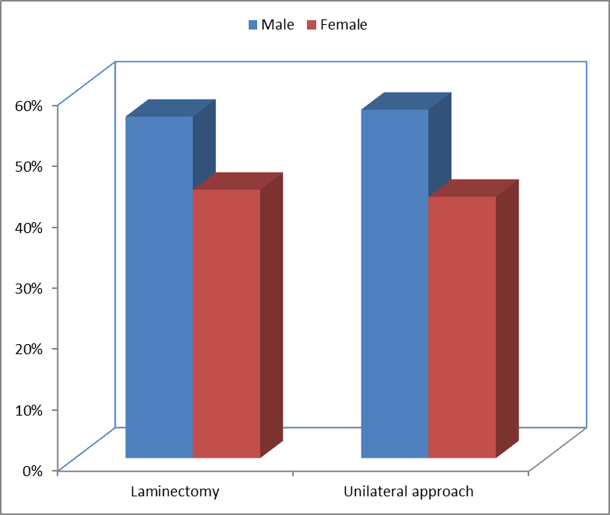
Fig (1): Bar chart between groups according to demographic data.

Table (1) demographic data.
Demographic Data | Laminectomy (N=25) | fenestration (N=21)
Sex
Male | 14 (56%) | 12 (57.14%)
Female | 11 (44%) | 9 (42.86%)
Age (years)
Range | 28-64 | 29-65
Mean±SD | 46.46±5.16 | 47.47±6.22

Table (2): comorbidities in both groups.
Comorbidities | Laminectomy (N=25) | fenestration (N=21)
HTN | 14 (56%) | 9 (42.86%)
DM | 3 (12%) | 4 (19.05%)

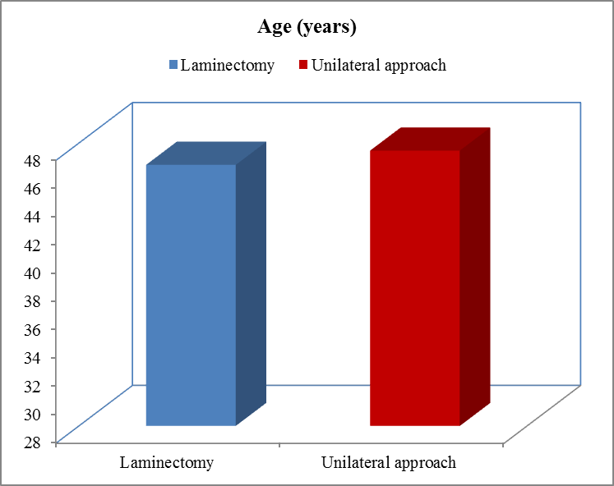
Fig (2): Bar chart between groups according to age (years)

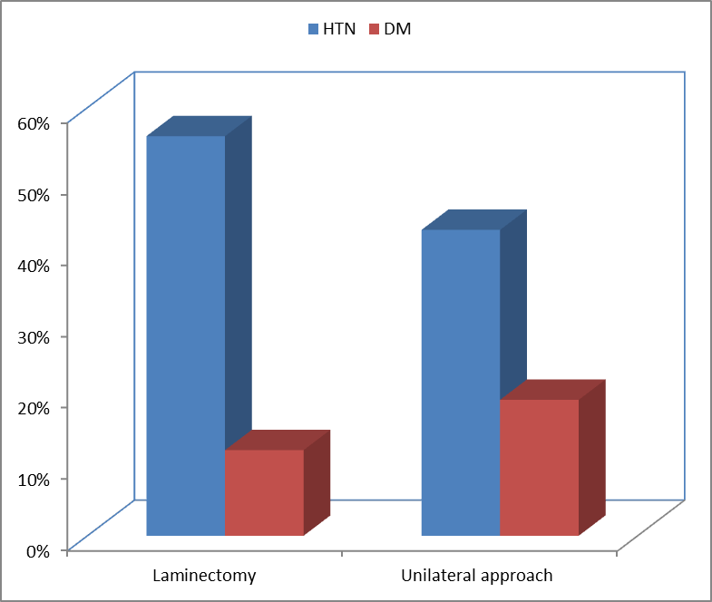
Fig (3): Bat chart between groups according to comorbidities.

Table (3): stenosis type.
Stenosis type | Laminectomy (N=25) | fenestration (N=21)
Central | 25 (100%) | 0 (0%)
Lateral | 8 (32%) | 21 (100%)
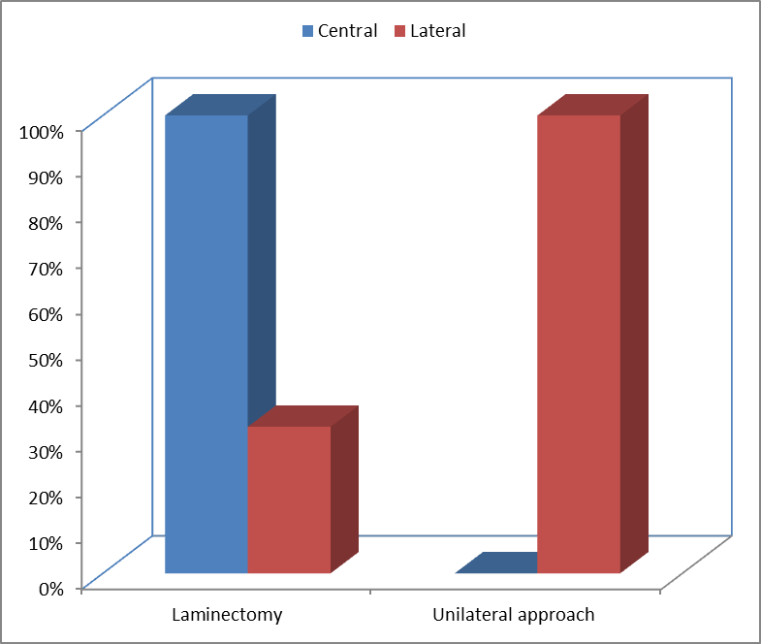
Fig (4): Bar chart between groups according to stenosis type.

Table (4): symptoms in both groups.
Symptoms | Laminectomy (N=25) | fenestration (N=21)
Leg pain | 17 (68%) | 17 (81%)
LBP | 23 (92%) | 21 (100%)
Neurogenic claudication | 22 (88%) | 4 (19%)
Unilateral | 12 (48%) | 18 (85.7%)
Bilateral | 14 (56%) | 3 (14.3%)

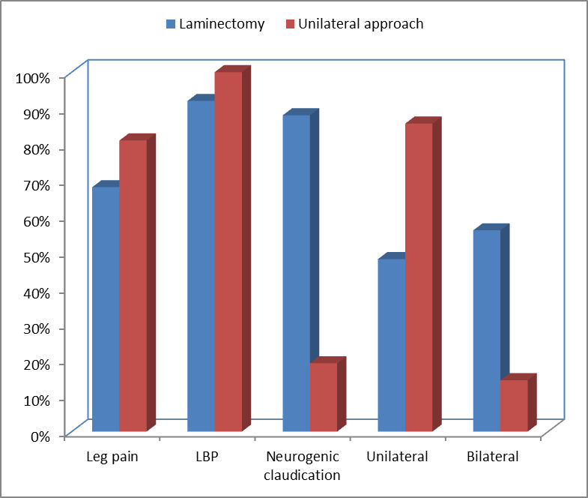
Fig (5): Bar chart between groups according to symptoms.

Table (5): Comparison between groups according to skin incision (cm).
Skin incision (cm) | Laminectomy (N=25) | fenestration (N=21) | t-test | p-value
Range | 3-9.5 | 3-8 | 3.185 | 0.002
Mean±SD | 6.25±1.25 | 5.5±1.1

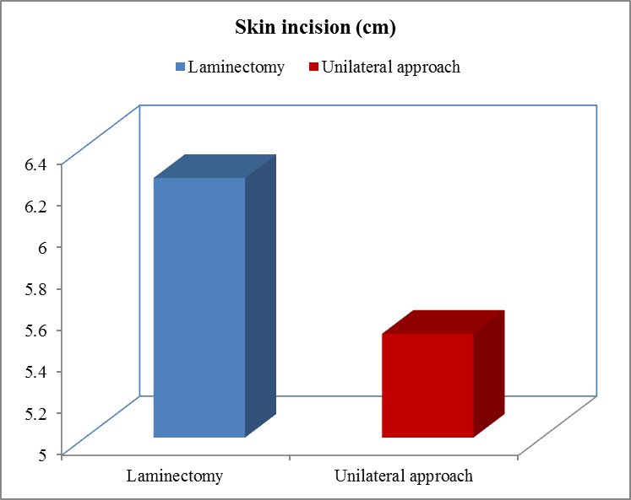
Fig (6): Bar chart between groups according to skin incision (cm).

Table (6): No. of operated levels.
No. of operated levels | Laminectomy (N=25) | fenestration (N=21)
One | 8 (32%) | 11 (52.4%)
Two | 12 (48%) | 7 (33.3%)
Three | 5 (20%) | 3 (14.3%)

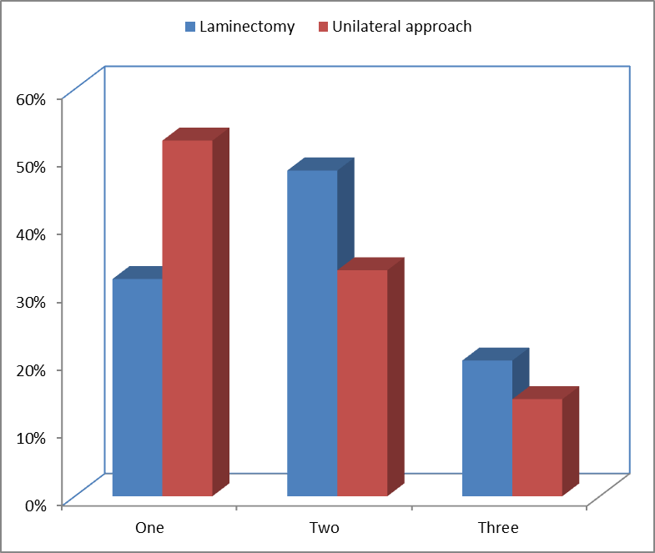
Fig (7): Bar chart between groups according to No. of operated levels.

Table (7): level of stenosis.
Level of stenosis | Laminectomy (N=25) | fenestration (N=21)
L2 - L3 | 1 (4%) | 2 (8%)
L3 - L4 | 4 (16%) | 4 (19%)
L4 - L5 | 12 (48%) | 9 (42.86%)
L5 - S1 | 8 (32%) | 6 (28.6%)

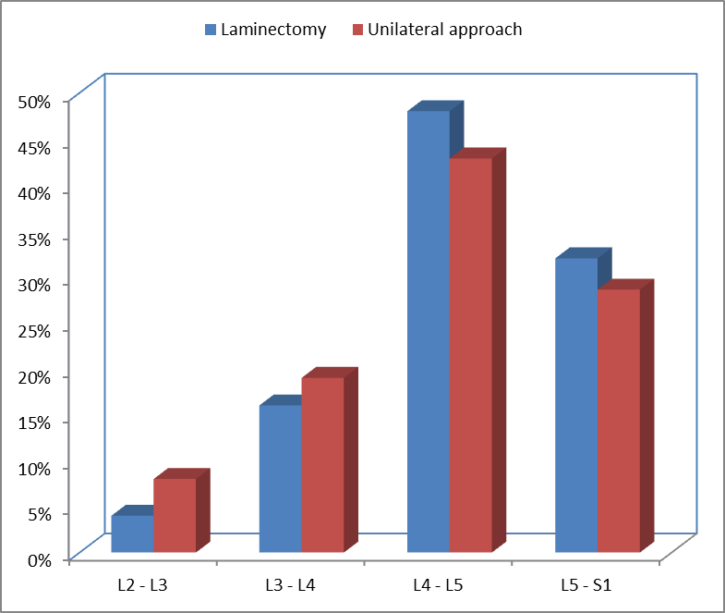
Fig (8): Bar chart between groups according to level of stenosis.

Table (8): Comparison between groups according to operation time in minutes.
Operation time in minutes | Laminectomy (N=25) | fenestration (N=21) | t-test | p-value
Range | 70-135 | 45-95 | 14.221 | <0.001
Mean±SD | 102.5±12.81 | 71.3±8.75

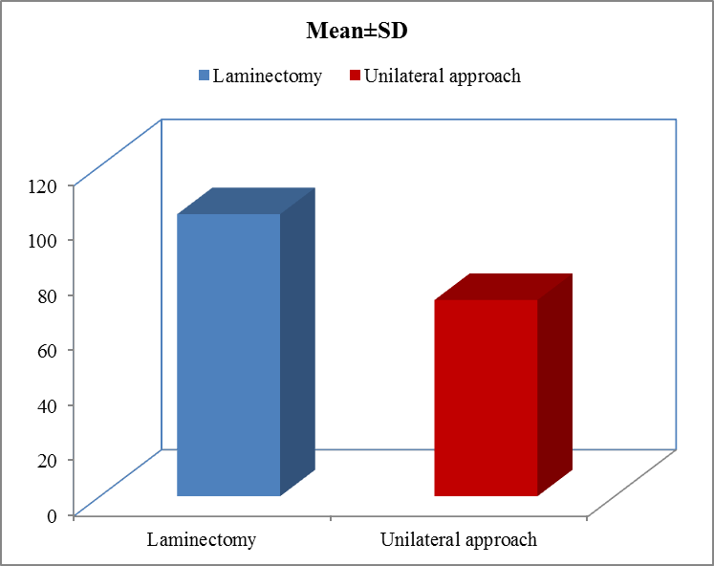
Fig (9): Bar chart between groups according to operation time in minutes.

Table (9): Comparison between groups according to hospital stay (days).
Hospital stay (days) | Laminectomy (N=25) | fenestration (N=21) | t-test | p-value
Range | 2-8 | 2-4 | 11.740 | <0.001
Mean±SD | 6.51±1.33 | 3.94±0.78

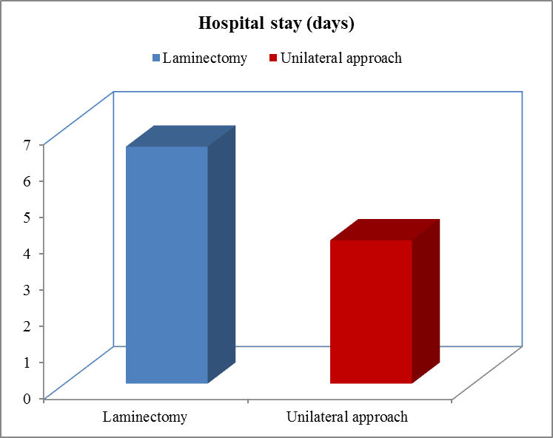
Fig (10): Bar chart between groups according to hospital stay (days).

Table (10): Comparison between groups according to return to work by month.
Return to work by month | Laminectomy (N=25) | fenestration (N=21) | t-test | p-value
Range | 1-3 | 0.5-1.5 | 5.811 | <0.001
Mean±SD | 2.26±0.45 | 1.13±0.23

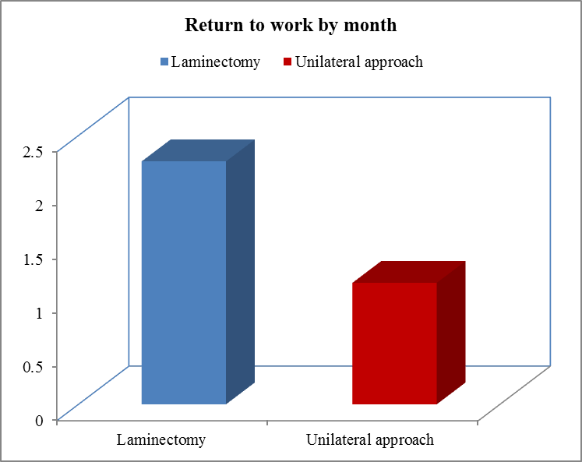
Fig (11): Bar chart between groups according to return to work by month.

Table (11): Comparison between groups according to complications.
Complications | Laminectomy (N=25) | fenestration (N=21) | x2 | p-value
Intra operative | 5 (20%) | 4 (19.1%) | 0.000 | 1.000
Sensory deficit persist | 1 (4%) | 1 (4.8%) | 0.048 | 0.826
Dural tear | 5 (20%) | 4 (19%) | 0.000 | 1.000
CSF leak | 5 (20%) | 4 (19%) | 0.000 | 1.000
Total | 16(64%) | 13(61.9%) | 0.000 | 1.000

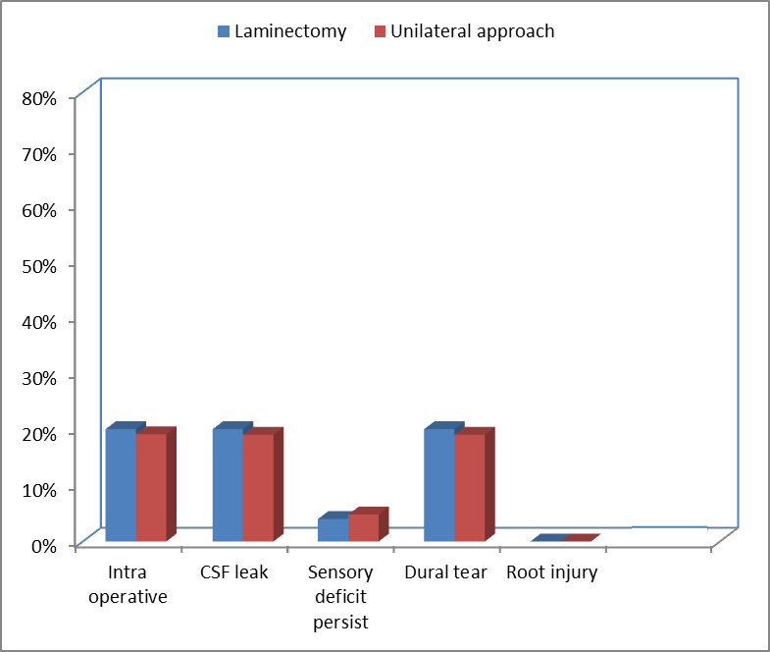
Fig (12): Bar chart between groups according to complications.

Table (12): Comparison between groups according to patient satisfaction.
Patient satisfaction | Laminectomy (N=25) | fenestration (N=21) | x2 | p-value
Excellent | 3 (12%) | 1 (4.8%) | 0.759 | 0.859
Good | 17 (68%) | 15 (71.4%)
Fair | 4 (16%) | 4 (19%)
Poor | 1 (4%) | 1 (4.8%)

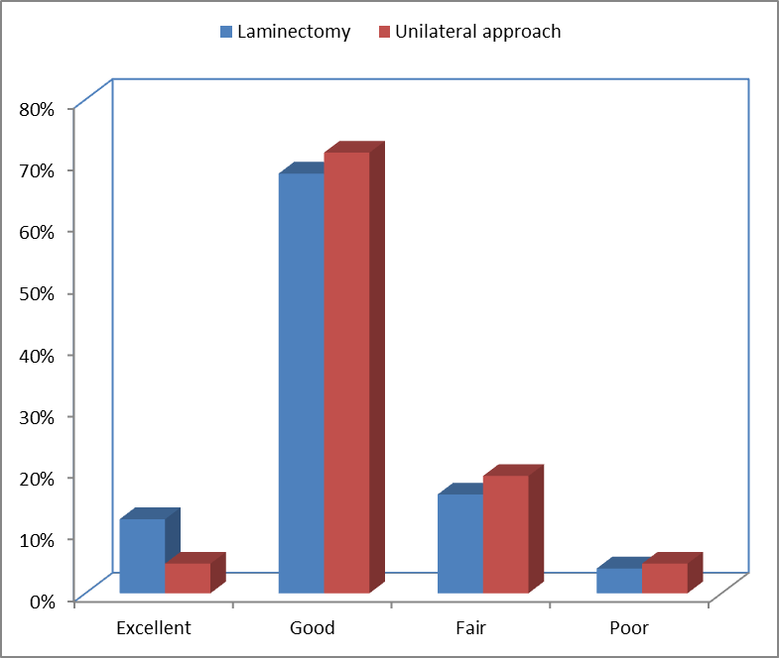
Fig (13): Bar chart between groups according to patient satisfaction.

Table (13): Comparison between groups according to MRS.
MRS | Laminectomy (N=25) | fenestration (N=21) | x2 | p-value
0 | 3 (12%) | 1 (4.8%) | 0.759 | 0.859
1 | 17 (68%) | 15 (71.4%)
2 | 4 (16%) | 4 (19%)
3 | 1 (4%) | 1 (4.8%)
4 | 0 (0%) | 0 (0%)
5 | 0 (0%) | 0 (0%)
6 | 0 (0%) | 0 (0%)

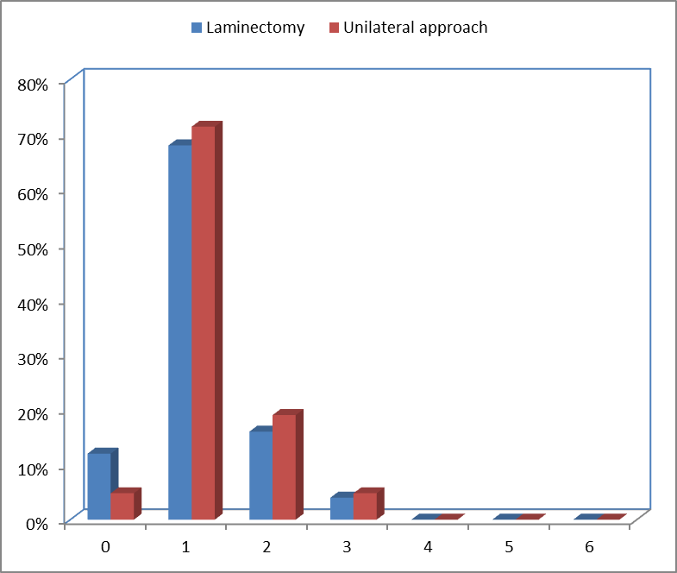
Fig (14): Bar chart comparison between groups according to MRS.

4. Discussion
lumbar spinal stenosis is better treated surgically than by nonsurgical means. Laminectomy is the classical technique in the surgical treatment of lumbar spinal stenosis. This approach allows for decompression of nervous elements at 1 or more levels. The disadvantages of this method consist of: prolonged postoperative pain, atrophy of the paravertebral muscles and spinal destabilization when discectomy or fecetectomy are associated. Different surgical techniques for decompression have been implemented, among them being bilateral or unilateral fenestration at the stenosed level.. We are now applying the two techniques (laminectomy or fenestration) depending on the type of LSS. In the case of a severe central lumbar spinal stenosis, the decompression is achieved with the use of bilateral laminectomy, with ablation of the ligamentum flavum and the internal third of the facet. A discectomy is associated only if a disc protrusion of appropriate size is present. In the case of lateral recess or foraminal stenosis, decompression is performed with the use of fenestration and fecetectomy at the respective level. These patient have either an alternating radiculopathy, or a bilateral radiculopathy predominant on one side. All patients were operated on by fenestration with foraminotomy, undercutting of the base of the spinous process and resection of the contralateral ligamentum flavum. This type of approach is mini-open, with a skin incision of 3-8 cm The average operative duration was significantly higher in the laminectomy group (102.5 versus 71.3 minutes). Regarding complications, In our study, 21 patient had fenestration surgery 4 patient of them showed intraoperative complication in the form of Dural tear. 1 case was repaired intraoperatively. While the other 3 cases the tear was lateral and we put muscle and fat without repair. And we didn't oblige to convert the fenestration to formal laminectomy in any case. The other 25 patients had conventional laminectomy surgery 5 patients of them showed intra operative complications in the form of Dural tear. 3 cases were repaired intraoperatively, While the other case the tear was ventrolateral and we put muscle and fat without repair. In recent years, several studies on minimally invasive interventions for LSS have been published, with results comparable to those of “open” interventions. (Khoo LT, Fessler RG, 2002) In our opinion, by fenestration approach, results as good as in the case of laminectomy can be obtained, in regard to medium and long term outcomes. By using this approach, lumbar pain levels are reduced faster and operative time and post-operative hospital length of stay are shortened.
However, each technique targets a different category of patients: laminectomy for central LSS and fenestration approach for lateral LSS. Regarding the latter, especially when the symptoms are unilateral, an “open”, wide approach may be waived. Patients with bilateral laminectomy continue to experience higher levels of pain for the first postoperative month when compared to cases with a unilateral approach. pain may be caused by ischemia of the paravertebral muscle, an opinion shared by Datta et al (Datta; et al., 2004). In cases with a fenestration and foraminotomy approach, the paravertebral muscles are retracted unilaterally and the operative time is shorter. They presented reduced postoperative hospitalization and begin recovery earlier with mean 6.5 days in laminectomy and 3.9 days in fenestration.
Evaluation of MRS during follow-up has shown continuous improvement, Similar results have been reported by other studies e.g. that by Khoo LT, Fessler RG. (Khoo LT, Fessler RG, 2002).
Improvement obtained with fenestration and foraminotomy, a less invasive method, when compared to bilateral laminectomy, although the difference in results at 6 months and 1 year is not statistically significant. Longer follow-up would be helpful in evaluating if additional surgery becomes necessary for both groups, because LSS is a progressive condition.

Conclusion
Neurogenic claudication, low back pain and leg pain of patients with lumbar canal stenosis are alleviated by surgical treatment. Laminectomy is indicated for patients with severe lumbar spinal stenosis especially those including central canal stenosis. In the case of foraminal stenosis, by using a fenestration approach with ipsilateral and contralateral decompression, similar results can be obtained.Both techniques led to significant improvement in clinical outcome.The Fenestration approach is faster, safer, short duration of hospital stay, with minimal effect on spinal stability and not inferior regarding neural decompression and overall pain relief.

References
- Armin SS, Holly LT, Khoo LT. Minimally invasive decompression for lumbar stenosis and disc herniation. Neurosurgery Focus 2008; 25: 11.
- Chiu JC. Interspinous process decompression (IPD) system (X-STOP) for the treatment of lumbar spinal stenosis. Surg Technol Int 2006; 15: 265–75.
- Datta G, Gnanalingham KK, Peterson D: Back pain and disability after lumbar laminectomy: is there a relationship to muscle retraction? Neurosurgery 54(s6), 2004:1413-1420.
- Findlay, G.F.G.: Neurologic symptoms of lumbar spinal stenosis. In: Lumbar Spinal Stenosis. Edited by:
- Parke WW, Bono CM, Garfin SR: Applied anatomy of the spine. In: Herkowitz.H.N, Garfin.S.R, Eismont.F.J et al (eds). The spine (sixth edition). Elsevier saunders. 2011:15-53.
- Siebert E, Prüss H, Kllagebicl R, Failli V, Einhaüpl KM, Schwab JM. Lumbar spinal stenosis: syndrome, diagnostics and treatment. Nature Reviews Neurology 2009; 5: 392-403.
- Thome C, Borm W, Meyer F. Degenerative Lumber Spinal Stenosis. Current Strategies in Diagnosis and Treatment. Dtsh Arztebl Int 2008; 105: 373 - 9.
- Toyone T, Tanaka T, Kato D, Kaneyama R, Otsuka M. Patients’ expectations and satisfaction in lumbar spine surgery. Spine 2005; 30: 2689-94.
- Widelec, J., Bacq, C., and Peetrons, P.: Conventional x-rays and coputed tomographic scan in lumbar spinal stenosis. In: Lumbar Spinal Stenosis. Edited by: Gunzburge, R. and Szpalski, M., Lippincott Williams & Wilkins; 2000, Inc. pp 91-96.
- Wilmink, J.T.: Diagnostic imaging in the lumbar spinal stenosis: Dynamic myelograghy, computed tomograghic myelographiy, magnetic resonance imaging, and magnetic resonance myelograghy. In: In: Lumbar Spinal Stenosis. Edited by: Gunzburge, R. and Szpalski, M., Lippincott Williams & Wilkins; 2000, Inc. pp 97-107.
- William F. Donaldson III, Ezequiel H. Cassinelli, Eric J. Graham. Segmental Instability: Anatomic, Biomechanical, and Clinical Considerations. In Adult & Pediatric Spine, 3rd Edition; Lippincott Williams & Wilkins;, 2004. P.978– P.984.
- Wong D; Transfeldt E. Musculoskeletal Anatomy, Neuroanatomy, and Biomechanics of the Lumbar Spine. In: Macnab's Backache, 4th Edition. Lippincott Williams & Wilkins; 2007. ch 1: P 1–20.
- Weinstein JN, et al. Surgical versus nonsurgical therapy for lumbar spinal stenosis. N Engl J Med 2008; 358: 794-810.
- Yucesoy K, Sonntag VK. Terminology confusion in spinal surgery: laminotomy, laminoplasty, laminectomy. J Neurosurg. Feb 2000;371-92.

7/24/2017

