Define the Geopressure Ramps Based on Well Logs in Edfu and Saqqara Oil Fields, Gulf of Suez- Egypt

Esam A. Gawad1, Ali E. Farag2, Mohamed A. Elkhawaga3, Wael K. Abdelghany3, Radwan A.E3

1Geology Department, Faculty of Science, Al-Azhar University, Egypt

2Freelance prof. of Practice, Cairo University, Egypt

3Geomechanic SpecialistGulf of Suez Petroleum Company (GUPCO), Egypt

[khawagama@gupco.net](mailto:khawagama@gupco.net)

**Abstract:** The understanding of the abnormal pore pressure is becoming increasingly important to both drilling and completion operations. Actually, the optimum well design requires, understanding of pore pressures, fracture pressure. If the abnormal pressures are not accurately predicted prior to drilling, catastrophic incidents could occur as kicks, well blowouts and well pack off.The high rates of sedimentation in Edfu and Saqqara especially through the Miocene time has created state of disequilibrium compaction that finally lead to the development of overpressure through certain horizons. The paper addresses defining the geopressure horizons in addition to the magnitudes of these abnormal pressures.Using datasets of five wells (three in Edfu field and two in Saqqara field) including well logs data (GR, resistivity and Sonic) and well site reports that including detailed about drilling problems are used to calculate and calibrate the pore pressure. In the paper, Eaton's resistivity and sonic methods are used for pore pressure calculation with some modification in the Eaton exponent to be fit in the area of interest. In Eaton method, the pore pressure calculated based on the primary generation of the overpressure deflection than the normal compaction trend due to the compaction disequilibrium and effective stress theory.Edfu and Saqqara fields are case studies in the GOS region illustrate how to define the horizons of the geopressure and to improve pore pressure prediction in sedimentary formations.

[Esam A. Gawad, Ali E. Farag, Mohamed A. Elkhawaga, Wael K. Abdelghany, Radwan A.E. Define the Geopressure Ramps Based on Well Logs in Edfu and Saqqara Oil Fields, Gulf of Suez- Egypt. *N Y Sci J* 2017;10(8):136-149]. ISSN 1554-0200 (print); ISSN 2375-723X (online). <http://www.sciencepub.net/newyork>. 16. doi:[10.7537/marsnys100817.16](http://www.dx.doi.org/10.7537/marsnys100817.16).

Keywords: Geopressure Ramps; Pore Pressure; Edfu Oil Field; Saqqara Oil Field; Gulf of Suez

# Introduction

The studied area includes two recently discovered fields characterized by structural traps; namely Edfu and Saqqara fields. The data from four wells were used in this, two in Edfu and the other two wells are located in Saqqara field. Edfu and Saqqara are located almost 1.2 and 2.5 km respectively west of Morgan field as seen in the figure 1.

The first well in the Edfu field (Edfu-A1) was drilled in October 2001 and successfully penetrated and the targeted Nubia and Nezzazat formations with a remarkable oil production. While Saqqara first well (Saqqara -1) was drilled in 2003.

In the Edfu field, the most of the production is mainly coming from Nezzazat and Nubia Formations, recently the Lower Rudies sandstone Formation was discovered as a secondary target, while in Saqqara filed, the production coming only from Nezzazat and Nubia Formations.

The Study aims mainly to detect the abnormal geopressure by calculating the pore pressure using well logs data. Four wells with incomplete sets of Drilling parameters, resistivity and sonic data are utilized for this purpose.

# Structure Setting

Edfu and Saqqara oil fields in the central Gulf of Suez rift basin due to the south of the Morgan accommodation zone, the dip of the beds are due to SW direction with an amount of 15 to 25 degrees in the Pre-Miocene strata and 5-10 for Early to Middle Miocene strata. The faults affected in beds are dipping to NE direction. The figure 2 shows a general unscaled cross section supported by well data.

As shown in the figure 2, the structural framework for the studied is mainly defined by a set of NW trending faults that have Clysmic trend and other oblique faults.

The Clysmic NW faults trending faults were active during the Early Miocene time and created half graben like basin, where the thick Miocene clastics were accumulated on the down thrown side.

# Stratigraphy

Generally, the Gulf of Suez subsidence formed originally during Early Paleozoic time as a narrow embayment of the Tethys and intensively rejuvenated during the rifting phase of the Great East Africa Rift System in Lower to Middle Tertiary time, Great accumulations of sediments from this fast subsiding depression, interrupted at times by a general and regional uplift with subsequent erosions. Surface on fault blocks or over a tilted surface on fault blocks in the Gulf of Suez and in the northern part of the Red sea.

The Lower Miocene clastic is unconformably overlain the Pre-Miocene formations in the structural lows between titling fault blocks or over a tilted blocks. High energy of Carbonate builds ups were developed along the high edges of the uplifted fault blocks. The Middle Miocene is characterized by the imminent development of evaporitic series, especially in the graben areas of the Gulf. Thick anhydritic and calcareous sequence formed along the margins of the grabens giving way to thick salt basin ward. The thickest salt is present near the junction of the Red sea and the Gulf of Suez. The general stratigraphic sequence of the study area can be summarized as follows. Figure 3 shows generalized stratigraphic column of the Gulf of Suez.

## Post Zeit Formation

These deposits extend from the sea bed to the anhydrite and shale intercalations marking the top of the Zeit Formation. The thickness of this sedimentary cover is about 1200 feet true vertical depth. The Post-Miocene rock units consist mainly of limestone, loos sand, clay and minor gypsum or anhydrite streaks.

## Zeit Formation

The Gebel El-Zeit well No. 1 is the type locality of the Zeit Formation, and The Zeit Formation thickness is about +/- 4000 ft TVD. It consists of anhydrite and shale intercalations with sand, sandstone streaks and few salt bodies.

The shale is gray, light gray and dark gray, moderately firm to soft, blocky to sub-blocky, occasionally sub-flaky, non - calcareous.

Due to high rates of deposition, the Zeit Formation is considered one of the trouble zones in the studying area. The pressurized shale is observed while drilling, especially against the thick shale body at base Zeit formation which is called Shale five that cause source of the drilling string stuck pipe. Thick anhydrite bodies creating a good sealing that prevent pressure to escape.

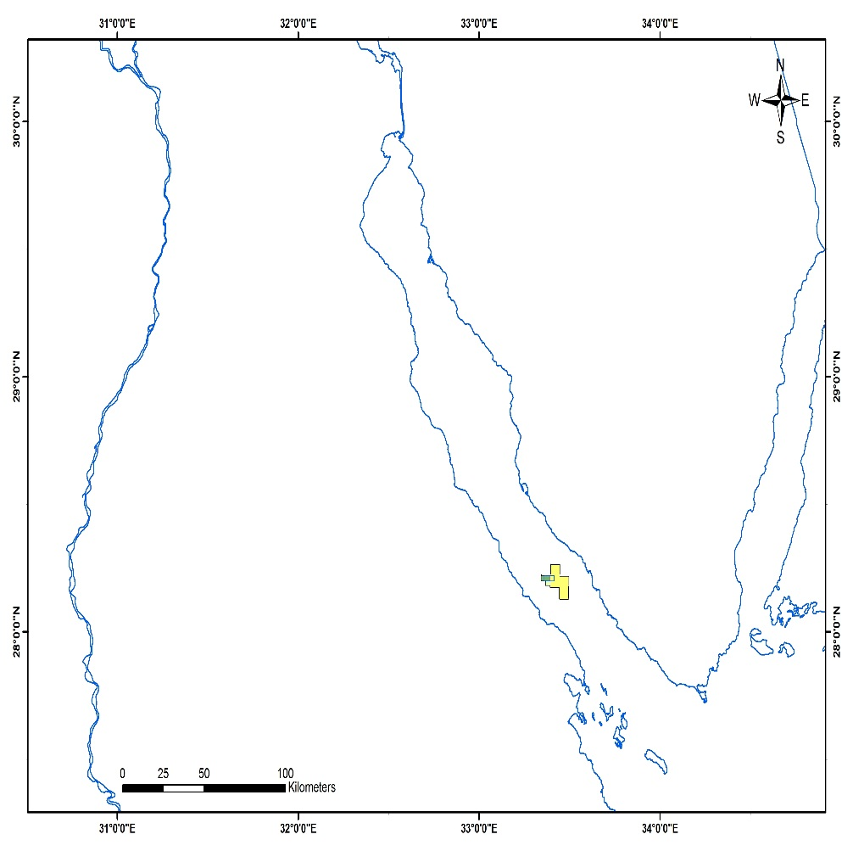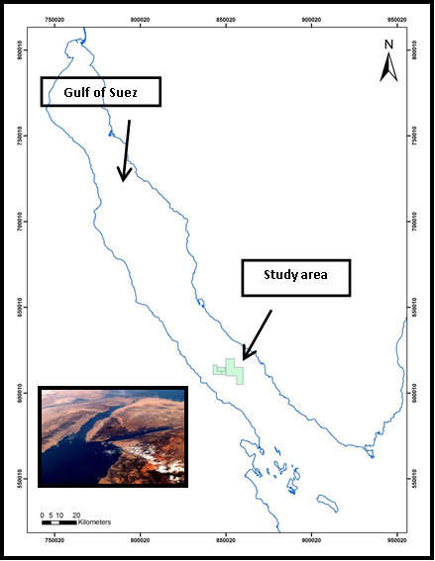

**Figure 1: Location Map of Edfu-Saqqara Oil Fields, Gulf of Suez, Egypt.**

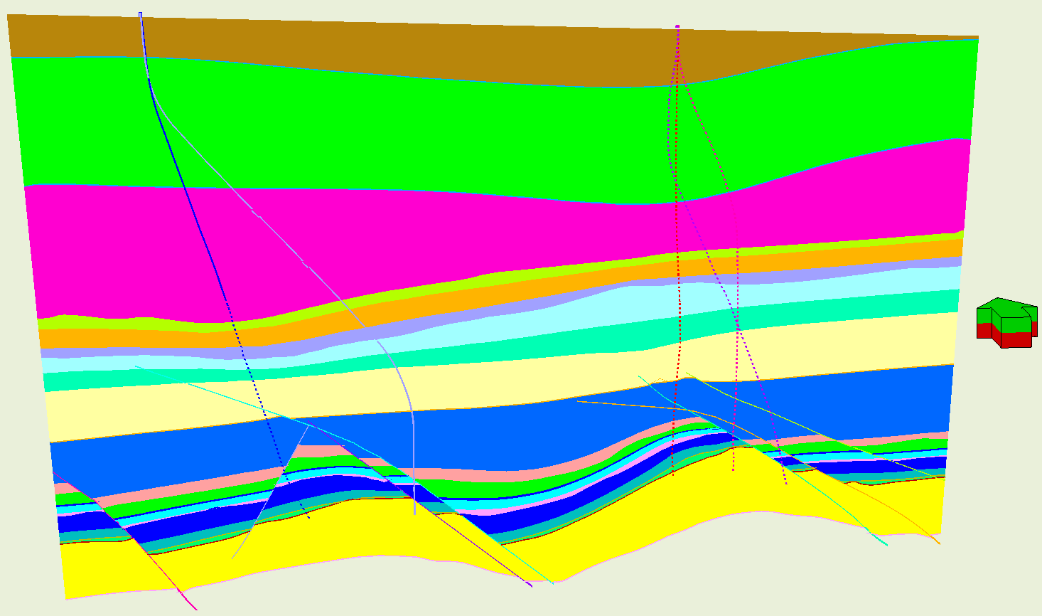

**Figure 2: Generalized E-W Cross section shows the simple structure model in the area of interest**

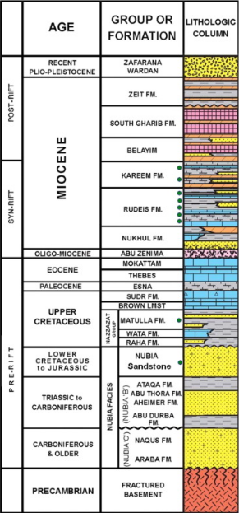

**Figure 3 Simple Stratigraphic Coulmin of the Gulf of Suez**

## South Gharib Formation

The South Gharib Formation occupies the section between the Belayim Formation at the base, and the Zeit Formation at the top. The South Gharib Formation was deposited in water of high salinity and consequently is deprived of fauna (Said and El-Heiny, 1967). The thickness of the South Gharib Formation is about 1500 ft TVD, consisting of a typical massive cyclic evaporites sequence, consisting of thick salt bodies and shale interbeded with anhydrite streaks separated every salt cycle.

The South Gharib salt plays a role of seal and cap rock for any porous and permeable rocks. Many drilling string stucks, tight holes have been faced while drilling these thick bodies of salt. Salt water flow could exist from any porous zone interbeded between the salt. Also time plays an important factor in casing collapse due to salt mobility, so another casing always set against South Gharib Formation.

## Belayim Formation

The type locality of the Belayim Formation is the Belayim oilfield, Gulf of Suez. According to the EGPC stratigraphic committee (1964), the Belayim Formation is subdivided into four members; from top to bottom, Hammam Faraun, Feiran, Sidri and Baba. In the study area, the Belayim Formation varies in thickness and facies (Nabih, 1992).

### D.1 Hammam Faraun Member

The Hammam Faraun Member is represented by a massive body of shale, sand and carbonates. The sandstone is water wet in Saqqara and Edfu fields.

### D.2 Feiran Member

The Feiran Member consists mainly of massive anhydrite bodies in between thin shale streaks and in few cases sandstone bands.

### D.3 Sidri Member

The Sidri Member is a thin unit compared to other members of the Belayim Formation. It mainly consists of sandstone interbeded with streaks of shale, in some areas and in rare cases includes very thin streaks of anhydrite.

### D.4 **Baba Member**

The Baba Member consists mainly of anhydrite/salt intercalated with thin streaks of shale.

## Kareem Formation

In the studied area, Kareem formation has no subdivisions. It consists of clastic, with interbeds of limestone. The formation (in other Gulf of Suez fields) is divided into two members, Shagar Clastic Member at the top and Markha evaporites and Carbonate Member at the bottom. Generally, the Kareem Formation underlains the evaporites phase of Belayim Formation and was deposited during the end phase cycle of sedimentation. The shale is light gray, greenish gray, brownish gray, blocky to sub blocky, soft to moderately firm, occasionally sticky, calcareous to highly calcareous, occasionally grading to highly argillaceous limestone.

## Rudeis Formation

The Rudies Formation shows a sharp change to wide and deep marine environment, as indicated by the abundant presence of pelagic foraminifera and outer shelf, and bathyal benthonic fauna (Schutz, 1994). In the area of interest, the Upper Rudies formation can be divided into Asl and Hawara members. If non calcareous Hawara shale is detected, whereas Lower Rudies called Mheiherrate member is presented as marl facies below Hawara shale. Rudies is water bearing reservoir in Edfu and Saqqara fields. Recently there is indication for oil presence in the Lower Rudies sand in Edfu field.

### F.1 Upper Rudies

In the area of study, the Upper Rudies formation is divided from top to bottom into Asl and Hawara formation. The Asl formation consists mainly of limestone interbeded with shale and minor sand streaks. While, the Hawara member is consists mainly of shale interbeded with limestone.

### F.2. Lower Rudies (Mheiherrate) Formation

Mheiherrate member is consists mainly of limestone interbeded with shale and sandstone streaks. Drilled wells cuttings showed that the limestone is dark gray, gray, brownish gray, tannish gray, tannish white, occasionally tannish gray, cryptocrystalline, occasionally fine crystalline, moderately hard to moderately soft, slightly argillaceous to highly argillaceous grading to highly calcareous shale. Occasionally silty, occasionally sandy to highly sandy. The shale is dark gray to light gray, light to dark brown blocky, occasionally flaky, firm, soft to moderately firm, occasionally silty, non to slightly calcareous. In Edfu filed the lower Rudies sand is a oil bearing reservoir while the sand facies completely changed in Saqqara field.

## Nukhul Formation

The Nukhul Formation overlies the Thebes massive limestone Formation and underlies the marine Miocene beds of the Rudeis Formation. The Nukhul Formation in its type locality is mainly composed of shallow marine limestone, interbedded with shale and thin streaks of sandstone. Anhydrite is preserved in basal part of the Nukhul formation.

## Thebes Formation

Drilled wells cuttings showed that the Thebes Formation is composed of Limestone with dark brown, brown, occasionally dark tan, cryptocrystalline to very fine crystalline, hard to very hard, occasionally moderately hard, and slightly argillaceous to argillaceous, occasionally highly argillaceous. The limestone, including vary percent of dark brown chert fragments increase in top and middle parts while decrease towards the bottom.

## Esna Shale

Esna Shale is represented by a relative thin shale bed. As interpreted from the ditch cuttings; Shale is tannish gray, light gray, brownish gray, occasionally dark gray, sub blocky to blocky, soft to moderately firm, pyritic in parts, glauconitic in parts, calcareous to highly calcareous, occasionally grading to highly argillaceous limestone.

## Sudr – Brown Limestone Formations

Surd formation includes limestone with brownish gray, dark gray, dark brown, gray, light gray, off white, white, cryptocrystalline to very fine crystalline, dense, moderately hard to hard as noticed from the ditch cuttings. The Sudr Formation was deposited under open marine conditions, with less organic–rich sediments.

While Brown limestone Formation is found to be of dark brown, brown, light brown, occasionally cryptocrystalline to very fine crystalline, moderately hard to hard, slightly argillaceous to argillaceous, with carbonaceous matter. Brown limestone rich in organic matter and is considering the main source rock in the Gulf of Suez.

## Matulla Formation

The Matulla Formation unconformably overlies the Wata Formation. Matulla formation is considered the best and the widest reservoir in the Pre-Miocene sequence, after the Pre-Cenomanian sandstone reservoir (Nubia formation) and is mainly composed of sandstone, siltstone, shale and limestone.

## L. Wata Formation

This formation is composed mainly of limestone with some interbeds of shale and sandstone. It overlies the Cenomanian section. The clastic unit in some wells can be considered as a good reservoir and produced big amount of oil. The Wata Formation sediments reflect shallow marine environments (Schutz, 1994).

## M. Raha Formation

The Raha formation unconformably overlyied the so-called Nubia A in the sense of oil geologists; it is composed mainly of sandstone, shale and interbeds of limestone.

## N. Nubia Sandstone Formation

Generally The Pre-Cenomanian clastics (Nubia) overly the Basement rocks and mainly composed of sandstone and shale intercalations. The sandstone is differentiated into three members, which are named A, B & C. Member A is mainly composed of medium to cross-bedded red sandstones of braided-river environment, with occasional shale layers. The Nubia sandstone is considered as the main oil reservoir in the Gulf of Suez.

# Workflow and Methodology

The Pore pressure and fracture pressure model (PPFG) required integration of different kinds of data. These data include the No drilling surprise, indirect and direct methods.

## 4.1No Drilling Surprise:

This model includes the drilling problems that occur during different operations and the methods of solving. Two models are utilized for the two fields:

### **4.1.1No drilling Surprise Events for Edfu Wells**:

**Table 1: Edfu Drilling Summary Model**

|  |  |  |  |
| --- | --- | --- | --- |
| **Fm** | **Problems** | **Operation** | **Action** |
| Zeit | 5% - 10% Caved Shale | Drilling | Raising M.WT from 13 ppg to 13.8 ppg, hole stable with 13.8 ppg. The zone of caving usually started from 2900’ TVDss |
| S.GH | Water Flow | Drilling | Had salt water flow with different mud weights ranges from 11-13.5 ppg. Wells are static with an increase the mud weight from 13 ppg to 13.5 ppg. |
| Tight hole | Tripping | Had tight hole due to slat creeping and shale, applying over pull, hole stable with 13.8 ppg |
| Hole Stuck | Tripping | Had drilling string stuck while tripping in and out due to slat creep. Pumping low salinity water is necessary to dissolve the salt around the drilling string |
| HF | Partial Loss | Drilling | Had 25 barrels per hour to 60 barrels per hour, the mud between 13.2 ppg and 13.5 ppg. |
| Complete Loss | Drilling | Had a complete loss of circulation when the mud weight increased than 13.6 ppg |
| Baba | Tight Hole | Tripping | Had tight hole due to slat creeping, applying over pull, hole stable with 13.8 ppg |
| Hole Stuck | Tripping | Had drilling string stuck while tripping in and out due to slat creeping. Pumping low salinity water is necessary to dissolve the salt around the drilling string |
| Kareem | Partial loss | Drilling | Had partial losses 15 barrels per hour to 25 barrels per hour by 9 ppg to 9.2 ppg. The losses increased to 120 bph when the mud weight reached to 10.7 ppg. |
| Complete loss | Drilling | Had a complete loss of circulation with 13.3 ppg, cured by spotting LCM pill. |
| U.Rudies | Partial loss | Drilling | Had 10 bph - 50 bph by 8.5 ppg to 9.4 ppg mud weight. These losses were experiencing in limestone. The fracture in the limestone cannot detect except by direct measurements. |
| Complete Loss | Drilling | Had severe complete loss of circulation by 9.2 ppg (more than 15,000 brls), cured by reducing the mud weight to 8.5 ppg, and put three cement plug. |
| L.Rudies | Partial loss | Drilling | Had from 8.5 ppg to 9.4 ppg. These losses were experiencing in limestone. The fracture in the limestone cannot detect except by direct measurements. |
| Well Flow | Drilling | Had to barrels gain with 9.2 ppg, circulation for 20 min without problem |
| Caved shale | Drilling | Had pressurized shale, increasing the mud weight 9.2 ppg to 10.25 ppg. |
| Nukhul | Well Flow | Connection | Had increase in the mud return flow with mud bubbles, lead to increase the mud weight from 10.4 to 10.7 ppg. |
| Nubia | Partial losses | Drilling | 10 bph - 15 bph have been taken by 10 ppg and 10.2 ppg, spot LCM pills |
| Complete loss | Drilling | Had a complete loss by 10.7 ppg, reducing the mud weight to 10.6 ppg, spot LCM. The losses always took place after +/- 150’ TVD from the top part. |

**4.1.2 No drilling Surprise Events for Saqqara Wells:**

**Table 2: Edfu Drilling Summary Model**

|  |  |  |  |
| --- | --- | --- | --- |
| **FM** | **Problems** | **Operation** | **Action** |
| P.Zeit | Partial losses | Drilling | Had a partial loss ranged fro5 4 bph to 60 bph. The mud weight ranged from 8.9 ppg to 9.2 ppg. The losses that we had in this formation is not related to sand fracture pressure. It is due to sand permeability. |
| Zeit | Partial losses | Drilling | Seepage losses 5 brls by mud weight ranges from 9.5 ppg to 9.6 ppg, without action. |
| Tight Hole | Tripping | Had a tight hole in shale with 9.6 ppg. Perform ream and back ream, then pass free. |
| Caved shale | Drilling | Had 15 % mechanical shale on the shale shaker, increase the mud weight from 13 ppg to 13.3 ppg. Observed the same percent occurred again, increased the mud weight to 13.8 ppg. Finally the hole gets stable. |
| S.GH | Tight hole | Connection | Had tight hole due to slat creeping and shale, applying overpull, hole stable with 13.8 ppg |
| Sidri | Partial loss | Drilling | Seepage losses 8 brls by mud weight was 13.8 ppg, no action was taken. |
| Tight hole | Connection | Had tight while connection with 13.8 ppg, applied 15 klbs overpull then pass free. |
| Baba | Tight hole | Tripping | Had tight hole due to slat creeping and shale, applying overpull, hole stable with 13.8 ppg |
| Kareem | Partial loss | Drilling | Seepage losses 8 brls by mud weight was 9.7 ppg, no action was taken. |
| Complete loss | Connection | Had a complete loss by 13.8 ppg, pump LCM pill, and then the losses stopped. |
| U.Rudies | Partial loss | Drilling | Seepage losses increased to 17 bph by mud weight was 9.2 ppg, no action was taken. |
| L.Rudies | Connection gas | Connection | Had 15 % connection gas with different ranged of mud weight ranged from 9.8 ppg to 12.6 ppg. The source of connection gas could relate to a high ration of organic matter in the Lower Rudies not to formation pore pressure. So the percent of high ration of connection gas is considered time dependent. |
| Pack Off | Hole cleaning | While performing wiper trip had hole pack off and sidetrack the well. The mud weight was 10.1 ppg - 10.5 ppg. Had another hole packed off while the mud weight was 12.5 ppg, but working on it till the drilling assembly got free. |
| Caved shale | Drilling | Had 10 % - 30% mechanical shale and 20 % - 25% increase in cutting after pumping high weighted pills then had 1.9% trip gases. The mud weight was 12. |
| Background gas | Drilling | Had increasing in the background gas reached to 17%, while drilling with 12.6 ppg, close the well and circulation through choke till gases reduced to 3%. |
| Tight hole | Tripping | Had many tight holes while tripping or connection with mud weight ranged from 10.1 ppg to 11.4 ppg, applied overpull then the assembly got free. |
| Partial losses | Drilling | Had many martial losses ranged from seepage losses to 30 bph while the mud weight ranged from 10 ppg to 11.3 ppg. Spot LCM, the hole became stable. |
| Pack off | connection | While made connection, hole packed off. Open the jar till string got free. |
| Nukhul | Losses | Tripping | While pumping high weighted pill for cleaning, had 30 brls losses over 4.5 hours, the losses stopped without action. The mud weight was 12.2 ppg. |
| Well Flow | Drilling | Had increase in the mud return flow with mud bubbles, lead to increase the mud weight from 11.4 to 11.1 ppg.  Had 4 barrels per hour water flow with 11.4 ppg, kill the well by 11.8 ppg and raising the mud weight to 12.2 |
| Thebes | Losses | Drilling | While drilling had 7 brls losses, spot lcm then the losses stopped while the mud weight was 10.1 ppg. |
| Wata | Partial loss | Coring | Had 3-5 bph losses, while drilling against limestone, spot LCM then the losses stopped. |
| Nubia | Partial loss | Coring | Had 5 bph losses while, taking core samples with 11.7 ppg, no action was taken. |

## 4.2 Pore Pressure Estimation Methodology:

There are a number of methods available for the pore pressure prediction and detection over a single well. In this study, indirect and direct methods, data are used to predict the pore pressure. The indirect method (for shale intervals) includes Eaton methods, including Drilling exponent, resistivity and sonic data. While the direct pressure measurement is against the sans

### 4.2.1 Indirect methods:

It includes three methods, Eaton drilling exponent, Resistivity and Sonic. These methods are described below;

#### 4.2.1.1 Eaton D-exponent:

Rehm and McClendon (1971) proposed that the relationship between penetration rate, weight on bit, rotary speed, and bit diameter may be expressed in the following general form:



Where:

R = penetration rate (ft/hr)

N = rotary speed (rpm)

B = bit diameter (in)

W = weight on bit (Klbs)

a = matrix strength constant (dimensionless)

d = formation “drillability” exponent (dimensionless)

DXc = corrected d-exponent (dimensionless)

N.FBG = normal formation balance gradient (lb/gal)

ECD = effective circulating density (lb/gal)

In a constant lithology, the d-exponent should increase as the depth, compaction and the differential pressure across bottom increase. Upon penetration of a geopressure zone, compaction and differential pressure will decrease, this decrease will be reflected by a decrease in the d-exponent.

The disadvantages of using drilling exponent include some factors such as lithological variation, drilling hydraulics and bit types. Drilling hydraulics also affects the drilling exponent, whenever the drilling hydraulics are changed, there will be a change in the DXc. Different drilling mechanisms with different bits cause changes in drilling response which is reflected by DXc scatter and trend offsets. When drilling into a transition zone using a dull bit this will make the evaluation difficult and the decrease in the DXc as a result of the decreased differential pressure to be partially or even totally masked by the increase due to the bit wear.

Using a simple ratio method, it is possible to relate DXc deviations (on a semi-log plot) to the magnitude of geopressure:

Po=Pn* (DXCn/DXCo)

Where:

Po= actual pore pressure at depth of interest (psi) or formation balance gradient (lb/gal EQMD)

Pn = normal pore pressure (psi) or FBG (lb/gal EQMD)

DXco = observed DXc at the depth of interest

DXcn = expected DXc on normal trend line at the depth of interest.

There is some limitation of this method, it can be only used to calculate pore pressure in only pure shale or in pure. Also DXc exponent value is affected by lithology, poor hydraulics, type of bit, bit wear motor or turbine and unconformities in the formation (Hussein Rabia, 2002).

#### 4.2.1.2 Eaton Resistivity:

The Eaton Method is one of the more widely used quantitative methods. This method applies a regionally defined exponent to an empirical formula. His study assumes there is a normal pore pressure with a fixed gradient, and the pore pressure is calculated as below for resistivity (Eaton, 1972, 1975):

PP = OBG – (OBG - PPN) (Ro/ RN) x

Where;

PP = Pore Pressure Gradient (ppg)

OBG = Overburden Gradient (ppg)

PPN = Normal Pore pressure Gradient (ppg)

Ro = Observed Resistivity (ohms-m)

RN = Normal Resistivity (ohms-m)

x = Eaton Exponent (dimensionless), which is 1.5 in 1972 and 1.2 in 1975.

In this study, the fitting parameters are 0.9 instead of regional Eaton fitting exponent.

Some corrections should be taken in the consideration when using the resistivity in pore pressure calculation. Those corrections directly related to the nature of the resistivity tool itself. Enlargement hole diameter due to washout can create a pseudo geopressure zone due to the presence of this zone below the normal compaction trend. The bottom hole temperature increases the conductivity which reduces the resistivity reading.

#### 4.2.1.3 Eaton Sonic:

The Eaton Method is typically applied to seismic or acoustic velocity data. The fitting default values for Eaton sonic a= 1 and n = 3 and the pore pressure is calculated as below for sonic (Eaton, 1975):

PP = OBG - (OBG-PPN) * a * (∆T /∆TN)x

Where

PP = Pore Pressure Gradient (ppg)

OBG = Overburden Gradient (ppg)

PPN = Normal Pore pressure Gradient (ppg)

∆T = Observed Sonic (ms/ft)

∆TN = Normal Sonic (ms/ft)

x = Eaton Exponent (dimensionless), which is 3.

Many trials are used to modify fitting parameter (x) of Eaton resistivity using range from 1-3, Also the results are close to each other +- 0.3 ppg, the better results which controlled with pore pressure related problems while drilling were when use n=1.56.

### 4.2.2 Direct Formation pressure measurements

The [repeat formation tester (RFT)](http://wiki.aapg.org/Wireline_formation_testers) tool was designed to measure formation pressure quickly and accurately. It measures pressure at specific points on the borehole wall. Formation pressure is measured by the formation sampler when it is extended from the tool to contact the formation. In this paper, the RFT data help to identify the Virsion pressure to calibrate the calculated pore pressure that obtained from the indirect methods especially in the reservoir sections.

# Pore Pressure Results Calculation

## 5.1 Edfu-A1 Well:

## The pore pressure was calculated according to available data of resistivity and sonic and calibrated by well drilling reports.

As seen in the model, the normal compaction trend ranged from 8.3 to 8.65 ppg. Well problem events has been used as an alternative to the absence of well logs data especially in the surface section. Presence of several tight spots reflect with specific mud weight gave an indication of pressure ramp. The pore pressure. Using the mud weight and equivalent circulating density as indication for the pore pressure, the pore pressure was considered 9 ppgat 1300’ TVD to prove the first high pressure ramp in the Zeit formation. Through the Zeit formation, the pore pressure increased gradually from 9 ppg to 12.6 ppg. The top of abnormal pressure occurred through three successive and convergent ramps up as 9.7, 10.3 and 11.6 and 12.6 ppg stages. The used mud weight was lower than the required which lead to presence of pressurized shale through the Zeit formation and salt water flow against the South Gharib formation, which led to the temporary close for the well, increasing the mud weight to 13.9 ppg and continue drilling. These pressure ramps were proved using Eaton sonic and calibrated by the presence of pressurized shale and salt water flow.

Through the Belayim formation, a regression of pore pressure occurred and recorded 9.9 ppg. A complete loss of circulation was occurring through the porous Facies by 1.39 ppg mud weight. To continue drilling this section, the mud weight was reduced to 13.4 ppg. A Normal compaction trend was observed in the Kareem Formation, the estimated pore pressure was 8.5 ppg according to sonic data. Some partial mud loss occurred lead to reduce the mud weight gradually from 13.4 to 9.1 ppg.

In the Upper Rudies formation, the drilled mud, was with 9.2 ppg and the estimated pore pressure was 8-8.5 ppg. While the pore pressure was estimated as 7.2 ppg in the Lower Rudies formation.

A gas kick occurred while drilling with 10.2 ppg and the action was to increase the mud to 10.7 ppg. The model shows high pore pressure ramp in the Nukhul Formation recorded 10.7 ppg based on Eaton Sonic and resistivity equations.

A good matching data were observed between RFT data at the reservoir intervals and estimated pore pressure. The pore pressure was measured in the reservoir section Matulla, Wata, Raha and Nubia Formations between 8.6 ppg to 8.9 ppg while the estimated pore pressure in Nubia Formation by the logging was between 8.97 ppg and 9.36 ppg. While by using RFT data, the estimated pore pressure in Matualla was 9.3 ppg - 9.4 ppg while was 9.5 ppg in Nubia Formation. Figure 4 shows the pore pressure model of the Edfu-A1 Well.

## **5.2** Edfu-A4 Well:

In this well, the sonic and resistivity data are available in Kareem formation at 6500’ TVDss. In the surface section and due to lack of well logs data, the calculated pore pressure depends on the Eaton drilling exponent method and controlled by drilling problem events and the used mud weight with the guide of drilling exponent.

In the Zeit Formation, the pore pressure increased from normal compaction trend to 9 ppg at 1300’ TVDssand recorded the first high pressure ramp. This ramp is interpreted according presence of tight at the mentioned depth.

By using the Eaton DXc method, the calculated pore pressure ramped up gradually at 2500’ 2690’ and 3120’ TVDss and recorded 10.5, 11.2 and 13 ppg respectively. This section was drilled with mud weight and from 10 to 13.8 ppg without pore pressure related problems. The high ramp of the pore pressure continued to cover the section of the South Gharib formation.

In Belayim formation, the calculated pore pressure regressed to 10 ppg. A complete loss of circulation was marked this formation by 14 ppg that had cured by pump LCM and reducing the mud weight to 13.3 ppg.

In Kareem Formation, the pore pressure was calculated by resistivity and sonic and DXc as 7.7 ppg, 8.3 and 8.7 respectively. The most likely interpreted pore pressure is 8.3 ppg.

In ASL formation, the pore pressure was 8 ppg and 8.5 ppg for resistivity and DXC respectively, while its record 7.3 for sonic method. While in Hawara Formation the pore pressure is record 8 ppg using resistivity and sonic data while records 7.3 in DXC method. The most likely interpreted pore pressure is 8.3 ppg.

The Lower Rudies Formation, the pore pressure was relatively matching values for all method as 8.3 ppg. The section from Kareem to base Lower Rudies formation was drilled with 9.3 ppg mud weight without pore pressure related problems.

The section of base Lower Rudies, Nukhul, Esna, Sudr and Brown L.ST Formations is marked by lack of shale streak except in Esan, the most likely pore pressure is considered to be a 8.9 ppg. The mud weight was 10.2 ppg without pore pressure related problems.

The reservoir section (Matulla, Wata, Raha and Nubia formations), the calculated pore pressure was 8 ppg, 9.2 ppg and 8.7 ppg for resistivity, sonic and DXC methods respectively. Direct pressure measurements were recorded for the sandstone reservoirs, the sand pressure ranged between 9 ppg to 8.9 ppg EMWT. The sonic tool gave a good pressure result, especially in the reservoir section. The most likely interpreted pore pressure for the shale is 9.3 ppg. Figure 5 shows the pore pressure model of the well.

## Sqqara-2A Well:

This well is a sidetrack from GS323-2 well. The kick off point was in Kareem Formation. The well was drilledas one hole section from Kareem till the final total depth in Nubia formation with mud weight window ranged from 11 to 11.7 ppg.

Eaton Resistivity and sonic were used to calculate the pore pressure, howeverthe final interpreted data wererelying only on thesonic data because the resistivity gave inaccurate results against the whole intervals. Drilling problems also aid to control the pore pressure results.

The normal compaction trend is observed in Kareem and Upper Rudies 1 (ASL) while it slightly increased to 8.8 ppg in Upper Rudies 2 (Hawara) Formation.

Sequential cycles of increases and decreases in the pore pressure through the Lower Rudies formation. The calculated pore pressure started as 8.8 ppg in the Upper part, then 7.9 ppg was recorded especially in the middle part. Thesonic and resistivity failed to predict the high peak of the pore pressure, hence the maximum pore pressure recorded by sonic log was10 ppg. High gas kick reached up to 15 % with 11.4 ppg, the action was to increase the mud weight to 12 ppg. Another gas kick occurred, reached up to 18% and cut the mud weight to 11.7 again, this kick was killed after closing the well and increasing the mud weight to 12.2 ppg. The gas kick corrected the calculated pressure to be a 12 ppg against the basal Lower Rudies formation.

Through the Nukhul formation another Cycle of gas kick occurs reached 15% lead increase the mud weight to again to 12.7 ppg. The gas flow considered a good calibration for the pore pressure. The interpreted pore pressure for the Nukhul was 12.6 ppg.

Through the reservoir section, the interpreted pore pressure was calculated as 9ppg for the shale intervals which typically matched with RFT Data for the sand intervals. Figure 6 shows the pore pressure model of the well.

## 5.4 Sqqara-3 Well:

According to the available data, the calculated pore pressure was depending on the DXc on the surface section till the top of Kareem, then using a resistivity log to calculate the rest intervals started from 8180’ TVDss. The sonic data were absent in this well. Also the drilling problems are considered a strong tool to calibrate the calculated pore pressure from resistivity.

The pore pressure was close to normal 8.6 ppg till 1310’ TVD whereas the pore pressure slightly increased to 9 ppg through Zeit Formation. The calculated pore pressure ramped up gradually at 1800, 2300’ 2600’ TVDss and recorded 10.5, 11.2 ppg respectively. There is some uncertainty in the fourth ramp ranged from 11.9 to 12.8 ppg.

The high pressure ramp continued against South Gharib Formation. The base Zeit and South Gharib formation were drilled by 13.5 ppg without pore pressure related problems.

The cycle of pore pressure regression was recorded against the Belayim formation ranged between 8.5-10 ppg (according to DXc and drilled mud weight). Drilling of this formation in Saqqara field differs from that in Edfu field, whereas this formation was drilled in Saqqara without problems while in Edfu, this formation faced complete loss of circulation.

Through Kareem, Upper Rudies and Upper section of Lower Rudies Formations, a maximum recorded pore pressure ranged between 8-8.5 ppg. The lower pore pressure can be explained that this formation could be communicated with another producer formation that effect on its pressure or this formation could be deposited in low saline water.

A gradual increase in the pore pressure started from 9 ppg and reached to 10.5 ppg. Both DXC and Resistivity Eaton methods were able to catch a phenomena of high pressure. A high gas kick occurred and reached up to 18% lead to shut in the well and increase the mud weight to 10.5 ppg.

7” liner was set @ 11732’ MD in the middle thick body of shale, the lines were set in a wrong position where a stuck occurred at the base of the shale body due to high pressure. After running the liner, cycles of pore pressure increasing and decreasing were observed along the Lower Rudies appeared on facing losses and high gas peaks. The most likely interpretation that the drilling was 0.4 ppg underbalance.

The lack shale body in the reservoir section, make a difficulty to the calculate pore pressure against these intervals. Figure 4 shows the pore pressure model of the well. Figure 7 shows the pore pressure model of the Saqqara-3 well.

## 5.4 Sqqara-3 Well:

According to the available data, the calculated pore pressure was depending on the DXc on the surface section till the top of Kareem, then using a resistivity log to calculate the rest intervals started from 8180’ TVDss. The sonic data were absent in this well. Also the drilling problems are considered a strong tool to calibrate the calculated pore pressure from resistivity.

The pore pressure was close to normal 8.6 ppg till 1310’ TVD whereas the pore pressure slightly increased to 9 ppg through Zeit Formation. The calculated pore pressure ramped up gradually at 1800, 2300’ 2600’ TVDss and recorded 10.5, 11.2 ppg respectively. There is some uncertainty in the fourth ramp ranged from 11.9 to 12.8 ppg.

The high pressure ramp continued against South Gharib Formation. The base Zeit and South Gharib formation were drilled by 13.5 ppg without pore pressure related problems.

The cycle of pore pressure regression was recorded against the Belayim formation ranged between 8.5-10 ppg (according to DXc and drilled mud weight). Drilling of this formation in Saqqara field differs from that in Edfu field, whereas this formation was drilled in Saqqara without problems while in Edfu, this formation faced complete loss of circulation.

Through Kareem, Upper Rudies and Upper section of Lower Rudies Formations, a maximum recorded pore pressure ranged between 8-8.5 ppg. The lower pore pressure can be explained that this formation could be communicated with another producer formation that effect on its pressure or this formation could be deposited in low saline water.

A gradual increase in the pore pressure started from 9 ppg and reached to 10.5 ppg. Both DXC and Resistivity Eaton methods were able to catch a phenomena of high pressure. A high gas kick occurred and reached up to 18% lead to shut in the well and increase the mud weight to 10.5 ppg.

7” liner was set @ 11732’ MD in the middle thick body of shale, the lines were set in a wrong position where a stuck occurred at the base of the shale body due to high pressure. After running the liner, cycles of pore pressure increasing and decreasing were observed along the Lower Rudies appeared on facing losses and high gas peaks. The most likely interpretation that the drilling was 0.4 ppg underbalance.

The lack shale body in the reservoir section, make a difficulty to the calculate pore pressure against these intervals. Figure 4 shows the pore pressure model of the well. Figure 7 shows the pore pressure model of the Saqqara-3 well.

# Summary and Conclusion:

In this study, the pore pressure was calculated by using different methods, these methods are Eaton corrected drilling exponents, resistivity and sonic methods. With the integration of drilling problems which plays a role of calibrations for calculating pore pressure, the final interpreted pore pressure considered the most likely pore pressure one. The study investigated the pore pressure calculations in two adjacent fields to define the geopressure horizons in the two fields.

Through the surface section, especially in the Zeit formation, four pressure ramps are deflected from the hydrostatic pressure (increasing or decreasing) in the two fields. The first is 9 ppg and was detected between 1100’ – 1300’ TVDss. The second and the third ramp which describes the intervals between 2300’ – 2600’ TVDss, the pore pressure is calculated between 10 to 11.7 ppg. The fourth ramp always marked the middle, base Zeit formation and continued through the Sough Gharib formation. The value of the ramp ranges between 12.4 – 13.4 ppg. The drilling problems support the calculated pressure ramps. Tight holes, pressurized caved shale and salt water flow are a good calibrations for pore pressure estimation during these intervals.

The fifth geopressure ramp is detected in the Belayim formation. The pore pressure is 10 ppg. With caution of the calculated pore pressure by a different method, the pore pressure has an uncertainty range about +/- 1 ppg in this formation.

In Kareem formation, the deflection lower than the hydrostatic pressure presents the abnormal pore pressure. The pore pressure calculated from 7-8.3 ppg. The pressure confirmed by recent RFT data which recorded 7.2 ppg. This formation significantly depleted water reservoir, although it has never been produced. Some opinions suggested pressure communication between Edfu and Morgan oil producer which cause this kind of depletion or the salinity of the formation was fresh water gradient.

The Upper Rudies and the Upper part of the Lower Rudies formations gives the normal compaction trend of the pore pressure. The middle and base of the Lower Rudies formation detect the seventh geopressure horizon. In Edfu field, the estimated pore pressure ranged between 9 – 11.3 ppg, while in Saqqara field reached to 12.5 ppg. Well control events occurred in this interval as water flow, gas kick and shale pack off.

The eighth geopressure ramps id detected in the Nukhul formation. In Edfu field, the calculated pore pressure is between 9.2 ppg to 10.2 ppg while, in the Saqqara field ranged between 9.3 ppg to 11.3 ppg. The Nukhul formation also considers a source of gas kick.

Below the Nukhul formation, till the top of the reservoir section, there is uncertainty detect the abnormal pressure due to lack of shale intervals.

The RFT proves that, the presence of strong aquifer support can compensate the high production rate of through the reservoirs. Also the matching between the pressure in the Edfu and Saqqara field proves the presence of communication between the two fields. Figure x shows the different measure pressure of the reservoirs +/- 300 psi which gave the same equivalent mud weight 8.9 to 9 ppg, as shown in the figure 8.

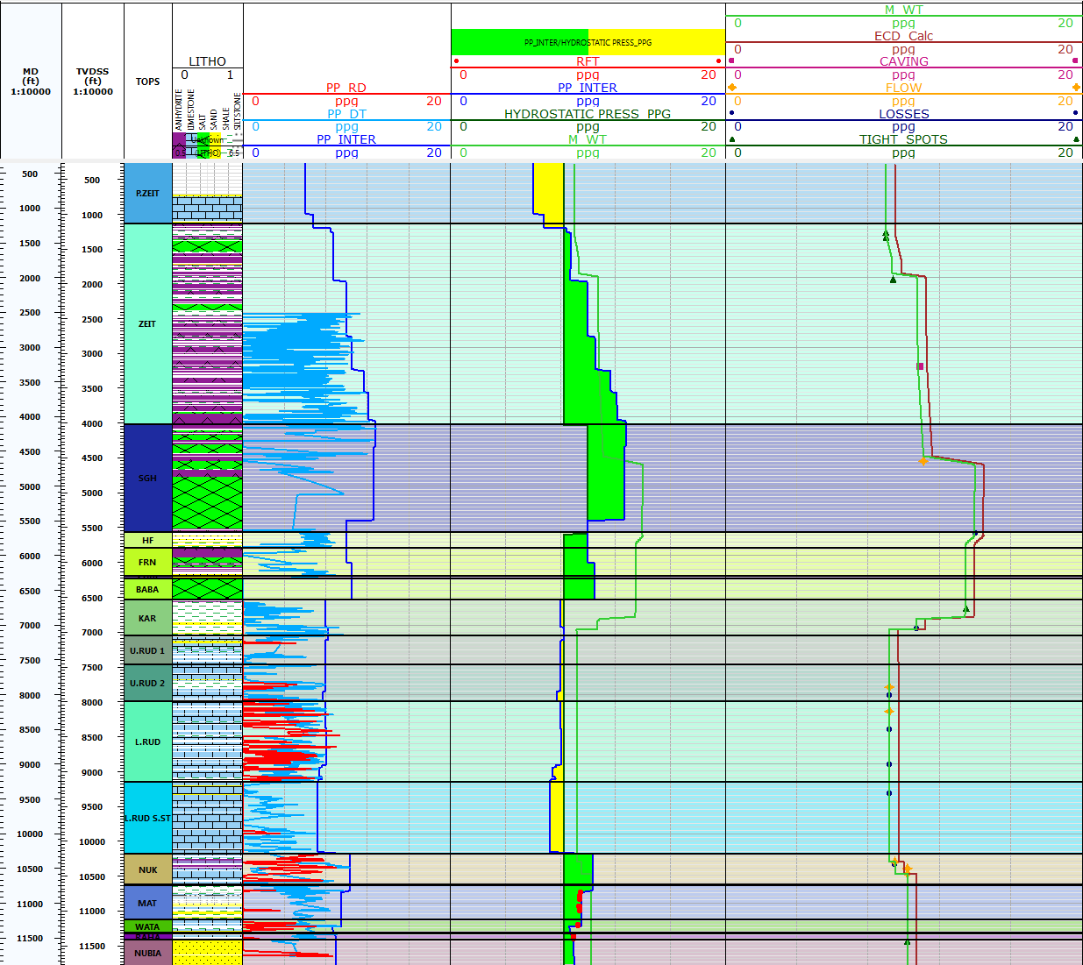

**Figure 4: Edfu-A1_Pore Pressure Model**

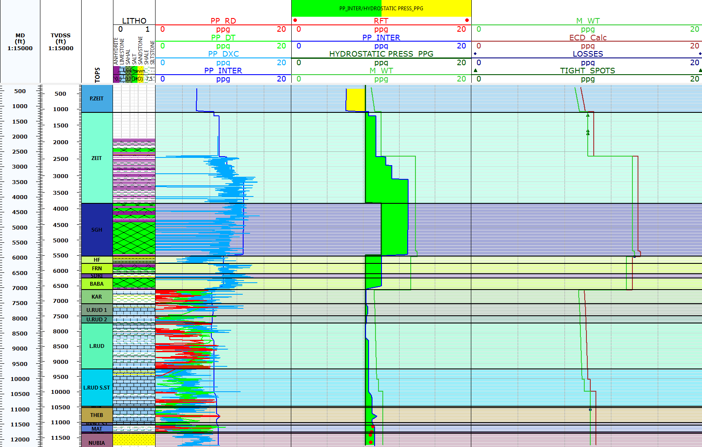

**Figure 5: Edfu-A4_Pore Pressure Model**

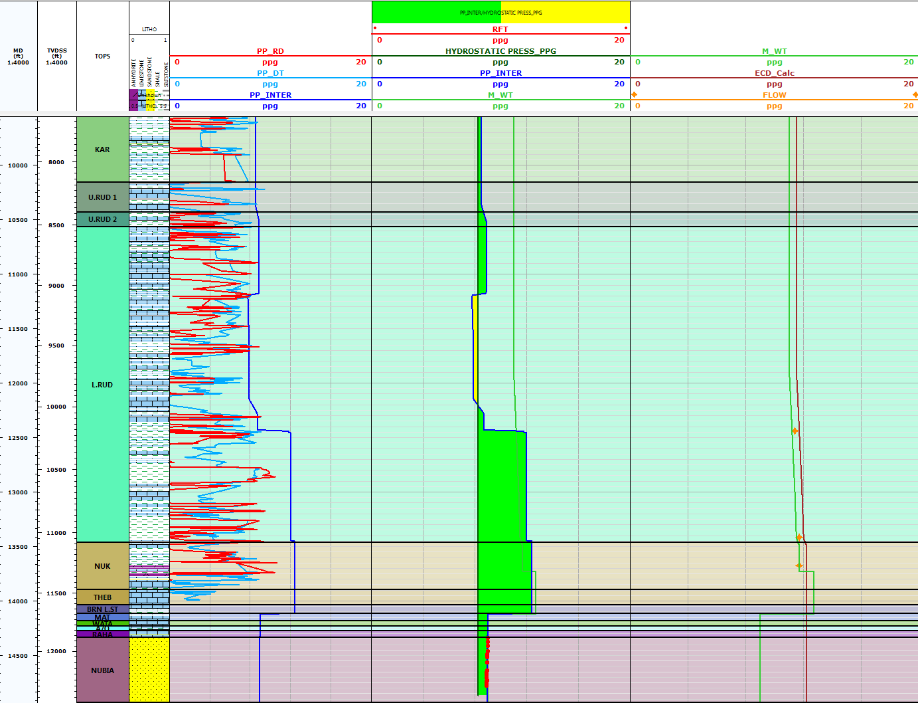

**Figure 6: Saqqara-2A_Pore Pressure Model**

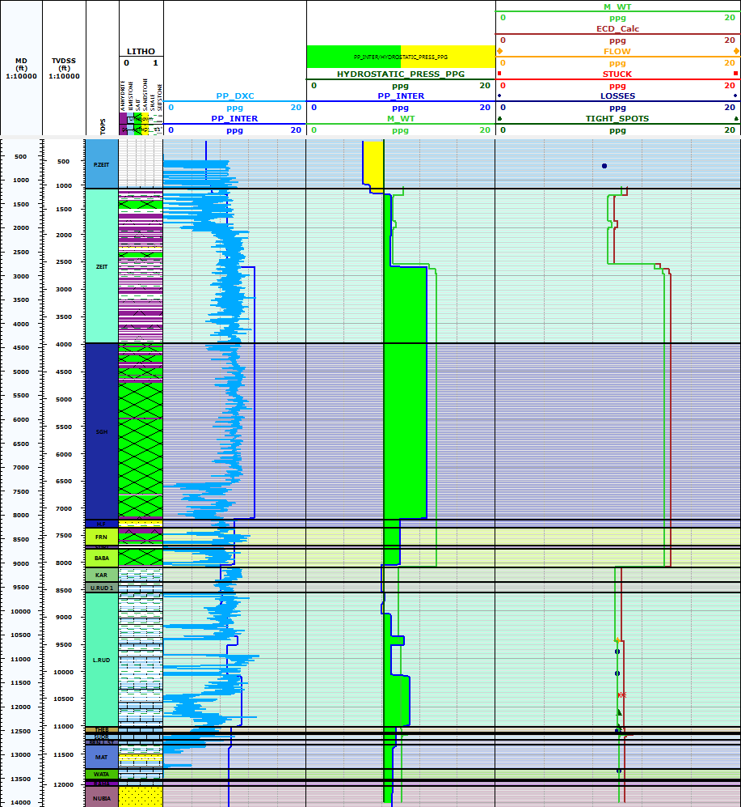

**Figure 7: Saqqara-3_Pore Pressure Model**

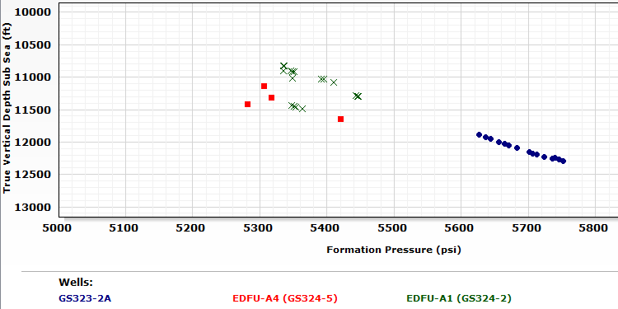

**Figure 8: Reservoir Pressure Measurements in the /reservoir Intervals**

# Recommendations

After calculating the pore pressure through two fields using different methods, the best results that can be used in the further wells is the mud design against the high pressure zones. The study suggest to drill the Zeit and South Gharib formations with high mud weight ranged from 13 to 13.8 ppg. Also in the Lower Rudies and Nukhul formation, the mud weight have to be between 10 and 10.7 in Edfu field, especially in Nukhul formation. While in Saqqara field, the mud weight should be higher than 12.2 ppg.

Also, the study recommend to run density and sonic data from the surface to accurately define the pore pressure and reduce the uncertainty especially in the surface section.

# References

1. Eaton, B. A., “The Effect of Overburden Stress on Geopressure Prediction from Well Logs”, Journal of Petroleum Technology, August, 1972.
2. Eaton, B. A., “The Equation for Geopressure Prediction from Well Logs”, SPE 5544, 1975.
3. Nabih, N. A.; 1992: Some oil geological studies on west Belayim Oilfield, Gulf of Suez area; M.Sc. Thesis, Faculty of Science, Cairo Univ., 126 P.
4. Rabia, H. (2002). “Well Engineering and Constructions”. https://sites.google.com/site/directionaldrillingclub/.../well-engineering.
5. Rehm and McClendon (1971); “Abnormal Formation Pressure”. Courtesy of the Spciety of Petroleum Engineer of A.I,M,E, Fig.4.8.dc-plot.
6. Said, R. and El-Heiny, I.;1967: Planktonic foraminifera from the Miocene rocks of the Gulf of Suez region, Egypt; Contrib. Cushman Foundation Foram. Research 18, pp.14-26.
7. Shahin, A. N., A. H. Hassouba, and L. M. Sharaf, (1994): ”Assessment of Petroleum Potential in the Northern Gulf of Suez”, Egyptian General Petroleum Corporation, 12th Exploration Production Conference, Cairo, Vol. II.

7/19/2017