3D Geomechanical Earth Model Based on Well Logs in Edfu and Saqqara Fields, Gulf of Suez, Egypt

Esam A. Gawad1, Ali E. Farag2, Mohamed A. Elkhawaga3, Wael K. Abdelghany3, Radwan A. E3

1Geology Department, Faculty of Science, Al-Azhar University, Egypt

2Freelance prof. of Practice, Cairo University, Egypt

3Geomechanic SpecialistGulf of Suez Petroleum Company (GUPCO), Egypt

[khawagama@gupco.net](mailto:khawagama@gupco.net)

**Abstract:** The understanding of the geomechanical properties is becoming increasingly important to both drilling and completion operations. Actually, the optimum well design requires, understanding of pore pressures, fracture pressure and stresses magnitude and directions. The paper addresses performing and distribution of 3D geomechanical properties model using PETREL software to reduce and mitigate the drilling hazards. The study includes detailed workflow including two pivots; the first is data preparation and calculation through 1D models. These data include, complete pore pressure calculation, compute the principle stress magnitudes and geomechanical models. This part is achieved using TECHLOG software. The second step includes the distribution the property through the 3D structural and facies models. The output including 3D cubes of well logs (GR, RHOB and DT), principle stresses (vertical stress, maximum and minimum horizontal stress), interpreted pore pressure, fracture pressure and finally mechanical earth model (Young’s modulus, shear modulus, bulks modulus, Poisson’s ratio, Compressive strength). Prior this step, 3D structural and facies models are built to ensure well and accurate distribution of these properties through the model. The resulting of the mechanical earth model helps effectively to improve the wellbore stability predictions. It provides well path optimization through safe mud weight window to prevent or minimize formation fluid influx, shear failure and drilling fluid loss during drilling, and a target well that is optimally aligned for completion operations.

[Esam A. Gawad, Ali E. Farag, Mohamed A. Elkhawaga, Wael K. Abdelghany, Radwan A. E. 3D Geomechanical Earth Model Based on Well Logs in Edfu and Saqqara Fields, Gulf of Suez, Egypt. *N Y Sci J* 2017;10(8):113-129]. ISSN 1554-0200 (print); ISSN 2375-723X (online). <http://www.sciencepub.net/newyork>. 14. doi:[10.7537/marsnys100817.14](http://www.dx.doi.org/10.7537/marsnys100817.14).

Keywords: Mechanical Earth Model, 3D Pore Pressure; Edfu Oil Field; Saqqara Oil Field; Gulf of Suez

# Introduction

The studied area includes two recently discovered fields characterized by structural traps; namely Edfu and Saqqara fields. The data from four wells were used in this, two in Edfu and the other two wells are located in Saqqara field. Edfu and Saqqara are located almost 1.2 and 2.5 km respectively west of Morgan field as seen in the figure 1.

The first well in the Edfu field (Edfu-A1) was drilled in October 2001 and successfully penetrated and the targeted Nubia and Nezzazat formations with a remarkable oil production. While Saqqara first well (Saqqara -1) was drilled in 2003.

In the Edfu field, the most of the production is mainly coming from Nezzazat and Nubia Formations, recently the Lower Rudies sandstone Formation was discovered as a secondary target, while in Saqqara filed, the production coming only from Nezzazat and Nubia Formations.

The Study aims mainly to detect the abnormal geopressure by calculating the pore pressure using well logs data. Four wells with incomplete sets of Drilling parameters, resistivity and sonic data are utilized for this purpose.

# Structure Setting

Edfu and Saqqara oil fields in the central Gulf of Suez rift basin due to the south of the Morgan accommodation zone, the dip of the beds are due to SW direction with an amount of 15 to 25 degrees in the Pre-Miocene strata and 5-10 for Early to Middle Miocene strata. The faults affected in beds are dipping to NE direction. The figure 2 shows a general unscaled cross section supported by well data.

As shown in the figure 2, the structural framework for the studied is mainly defined by a set of NW trending faults that have Clysmic trend and other oblique faults.

The Clysmic NW faults trending faults were active during the Early Miocene time and created half graben like basin, where the thick Miocene clastics were accumulated on the down thrown side.

# Stratigraphy

Generally, the Gulf of Suez subsidence formed originally during Early Paleozoic time as a narrow embayment of the Tethys and intensively rejuvenated during the rifting phase of the Great East Africa Rift System in Lower to Middle Tertiary time, Great accumulations of sediments from this fast subsiding depression, interrupted at times by a general and regional uplift with subsequent erosions. Surface on fault blocks or over a tilted surface on fault blocks in the Gulf of Suez and in the northern part of the Red sea.

The Lower Miocene clastic is unconformably overlain the Pre-Miocene formations in the structural lows between titling fault blocks or over a tilted blocks. High energy of Carbonate builds ups were developed along the high edges of the uplifted fault blocks. The Middle Miocene is characterized by the imminent development of evaporitic series, especially in the graben areas of the Gulf. Thick anhydritic and calcareous sequence formed along the margins of the grabens giving way to thick salt basin ward. The thickest salt is present near the junction of the Red sea and the Gulf of Suez. The general stratigraphic sequence of the study area can be summarized as follows. Figure 3 shows generalized stratigraphic column of the Gulf of Suez.

# Workflow and Methodology

Four essential steps are required for delivering geomechanical model. These steps including pore pressure model, mechanical earth model, stress directions and wellbore stability model.

## 4.1 Pore Pressure Model:

The pore pressure model including overburden pressure gradient, pore pressure and fracture pressure.

### 4.1.1: Pore pressure Discussion:

The next discussion includes discussion of the overburden, pore pressure and fracture pressure calculations as the following:

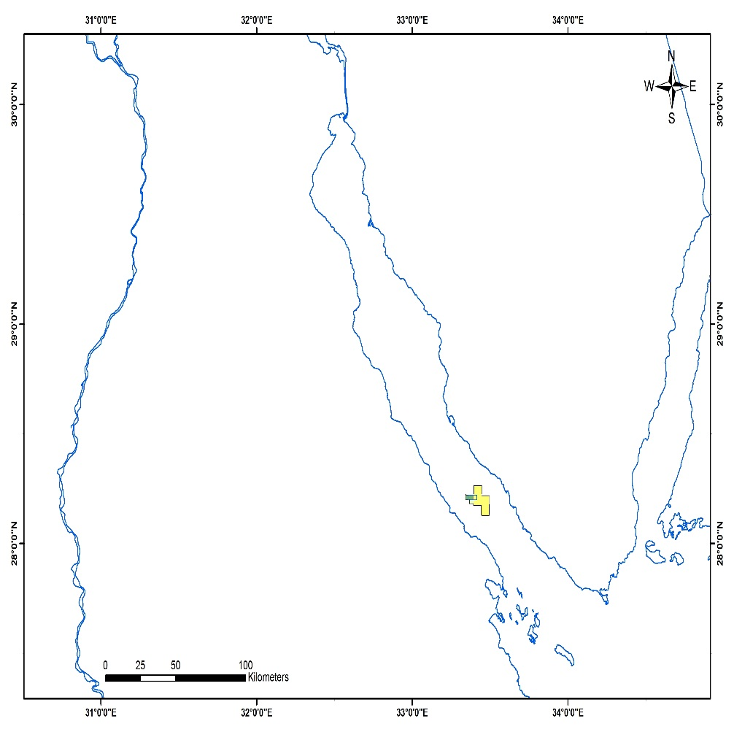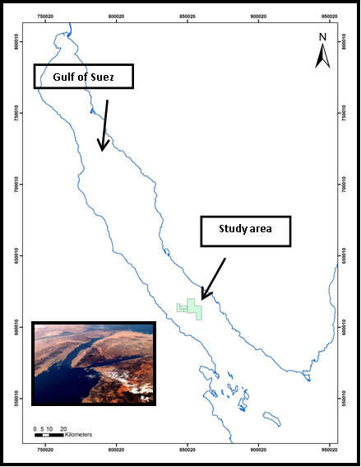

**Figure 1: Location Map of Edfu-Saqqara Oil Fields, Gulf of Suez, Egypt.**

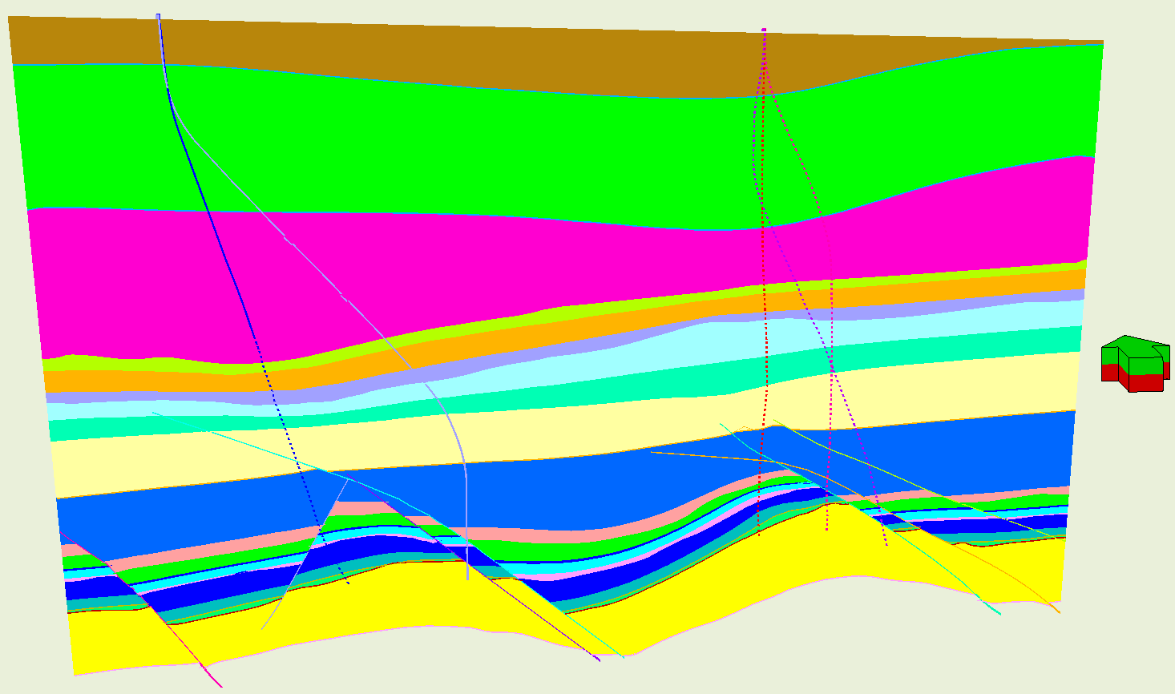

**Figure 2: Generalized E-W Cross section shows the simple structure model in the area of interest**

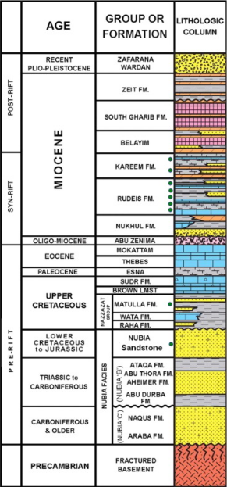

**Figure 3 Simple Stratigraphic Coulmin of the Gulf of Suez**

#### 4.1.1.1: Overburden pressure

In this study, an Amocoimperial equation is used to construct the density from the surface section. The method assumes that, the average bulk density below the sea floor is estimated by an empirical equation obtained from statistical data from the Gulf of Mexico (Rakesh and Chandrashekhar, 2015).

ρamoco = ρmudline + [ (TVD-Air Gap-Water Depth)/3125)]α

Where

ρamoco is in ppg and all depths are in feet, and

ρmudline: mud line density in ppg

a: exponent coefficient, default = 0.6

In this thesis, the density at mudline was plotted and ranged between 2.05 g/cc and 2.15 g/cc. The exponent coefficient was 0.9 unitless to 1 unitless instead of 0.6 unitless as the fit parameters with the measured density.

Whenever the density curve is available, the building Overburden gradient will be the first step to build the pore pressure model. The overburden stress is calculated from the bulk density as follow:

v= g ∑ 0TVDρb (Z)dz

Where:

vis the vertical stress or overburden stress at depth TVD

bis the bulk density (including the water section above sea floor.

g is the gravitational constant.

#### 4.1.1.2: Pore pressure Calculation

Eaton’s equations is the most popularly used model for pore pressure Calculation. An integration between Eaton drilling exponent, Resistivity and Sonic have contributed to deliver the most likely interpreted pore pressures calculation. These methods are described below;

##### 4.1.1.2.1Eaton D-exponent:

Rehm and McClendon (1971) proposed that the relationship between penetration rate, weight on bit, rotary speed, and bit diameter may be expressed in the following general form:



Where:

R = penetration rate (ft/hr)

N = rotary speed (rpm)

B = bit diameter (in)

W = weight on bit (Klbs)

a = matrix strength constant (dimensionless)

d = formation “drillability” exponent (dimensionless)

DXc = corrected d-exponent (dimensionless)

N.FBG = normal formation balance gradient (lb/gal)

ECD = effective circulating density (lb/gal)

Using a simple ratio method, it is possible to relate DXc deviations (on a semi-log plot) to the magnitude of geopressure:

Po=Pn* (DXCn/DXCo)

Where:

Po= actual pore pressure at depth of interest (psi) or formation balance gradient (lb/gal EQMD)

Pn = normal pore pressure (psi) or FBG (lb/gal EQMD)

DXco = observed DXc at the depth of interest

DXcn = expected DXc on normal trend line at the depth of interest.

There is some limitation of this method, it can be only used to calculate pore pressure in only pure shale or in pure. Also DXc exponent value is affected by lithology, poor hydraulics, type of bit, bit wear motor or turbine and unconformities in the formation (Hussein Rabia, 2002).

##### 4.1.1.2.2 Eaton Resistivity:

The Eaton Method is one of the more widely used quantitative methods. This method applies a regionally defined exponent to an empirical formula. His study assumes there is a normal pore pressure with a fixed gradient, and the pore pressure is calculated as below for resistivity (Eaton, 1972, 1975):

PP = OBG – (OBG - PPN) (Ro/ RN) x

Where;

PP = Pore Pressure Gradient (ppg)

OBG = Overburden Gradient (ppg)

PPN = Normal Pore pressure Gradient (ppg)

Ro = Observed Resistivity (ohms-m)

RN = Normal Resistivity (ohms-m)

x = Eaton Exponent (dimensionless), which is 1.5 in 1972 and 1.2 in 1975.

In this study, the fitting parameters are 0.9 instead of regional Eaton fitting exponent.

##### 4.1.1.2.3 Eaton Sonic:

The Eaton Method is typically applied to seismic or acoustic velocity data. The fitting default values for Eaton sonic a= 1 and n = 3 and the pore pressure is calculated as below for sonic (Eaton, 1975):

PP = OBG - (OBG-PPN) * a * (∆T /∆TN)x

Where

PP = Pore Pressure Gradient (ppg)

OBG = Overburden Gradient (ppg)

PPN = Normal Pore pressure Gradient (ppg)

∆T = Observed Sonic (ms/ft)

∆TN = Normal Sonic (ms/ft)

x = Eaton Exponent (dimensionless), which is 3.

Many trials are used to modify fitting parameter (x) of Eaton resistivity using range from 1-3, Also the results are close to each other +- 0.3 ppg, the better results which controlled with pore pressure related problems while drilling were when use n=1.56.

#### 4.1.3: Fracture pressure

The Fracture pressure is the pressure in the wellbore at which a formation will crack. In this thesis, Eaton method is used to identify the fracture pressure.

Eaton's method requires pore pressure, Poisson ratio, and the overburden gradient. In the absence of a leak-off test data which consider a direct measure for formation pressure fracture, Eaton (1997) published two analytical relations for an effective Poisson’s ratio in shale () as a function of depth below mud line.



FG = K *(OVG –  PP) +  PP

K = (υ/υ-1)

Where,

FG = Fracture Gradient (ppg)

PP = Pore Pressure Gradient (ppg)

OBG = Overburden Gradient (ppg)

υ = Poisson's Ratio (dimensionless).

K is the stress ratio (unitless).

In this thesis, Eaton equation was applied on both sand and shale. The Poisson’s ratio of was used fixed number 0.4 for shale, while in the sandstone was ranged from 0.2 to 0.33 according to the Equation.

### 4.1.2: Pore pressure Model Results:

The results of the pore pressure model of the well is summarized in the table below as the following;

#### 4.1.2.1 Edfu-A1 Well:

**Table 1: Edfu-A1 summarized Pore pressure and Fracture pressure:**

|  |  |  |  |  |  |  |
| --- | --- | --- | --- | --- | --- | --- |
| **Formation** | **Overburden Pressure Gradient**  **(ppg)** | **Pore Pressure**  **(PPG)** | **Fracture Pressure** | | | |
| **Sandstone** | | **Limestone** | **Shale** |
| **PO (unitless)** | **FP**  **(ppg)** | **FP**  **(ppg)** | **FP**  **(ppg)** |
| P>ZEIT | 0 – 15.3 | 7 | 0.33 | +/- 10.5 | +/- 11 | +/- 15 |
| ZEIT | 15.3 – 17.1 | 8.4 -1 2.1 | 0.33 | +/- 14.7 | +/- 15.8 | +/- 16.6 |
| SGH | 17.1 - 17.55 | 12.6 | Salt | | | |
| HF | 17.55 - 17.78 | 9.96 | 0.319 | +/- 13.5 | +/- 15.5 | +/ -17.6 |
| FRN | Salt | | | |
| SDRI | 10.5 | 0.33 | +/- 14 | +/- 15.3 | +/- 16.4 |
| BABA | Salt | | | |
| KAREEM | 17.78 - 17.89 | 8 | 0.25 | +/- 11.2 | +/- 14.6 | +/- 15.9 |
| ASL | 17.89 - 18 | 0.25 | +/- 11.26 | +/- 14.6 | +/- 15.8 |
| HAWARA | 0.25 | +/- 11.28 | +/- 14.6 | +/- 15.9 |
| L.RUD | 18 – 18.48 | 0.25 | +/- 11.4 | +/- 14.7 | +/- 16 |
| L.RUD SND | 7.2 | 0.2 | +/- 9.96 | +/- 14.51 | +/- 15.99 |
| NUK | 18 – 18.77 | 10.4 | 0.2 | +/- 12.32 | +/- 15.62 | +/- 16.8 |
| MAT | 9.5 | 0.22 | +/- 12 | +/- 15.4 | +/- 16.71 |
| WATA | 8.98 | 0.21 | +/- 12 | +/- 15.4 | +/- 16.71 |
| RAHA | 8.98 | 0.21 | +/- 11.47 | +/- 15.25 | +/- 16.59 |
| NUBIA | 8.98 | 0.21 | +/- 11.5 | +/- 15.3 | +/- 16.6 |

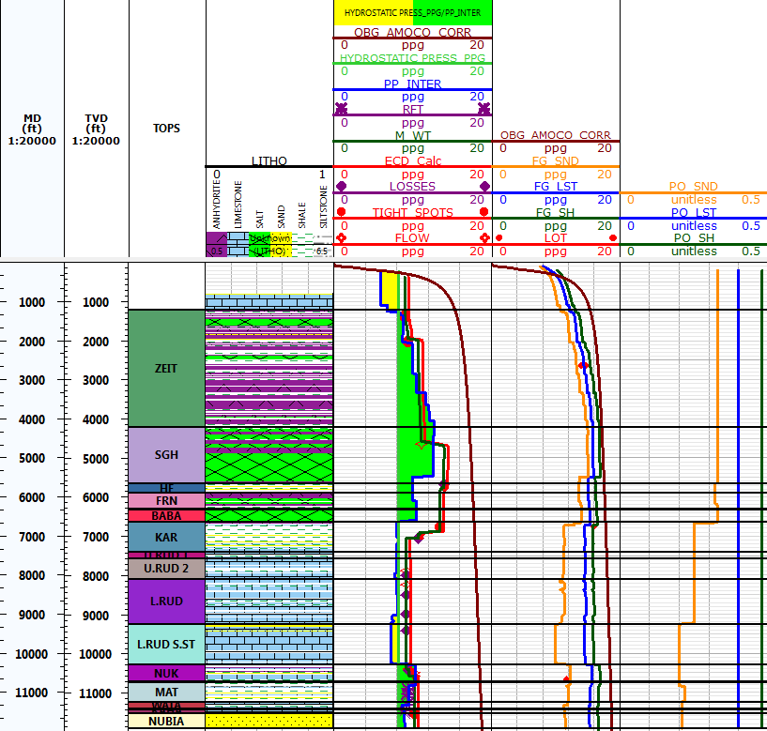

**Figure 4: Edfu-A1_ Pore Pressure Model**

#### **4.1.2.2** Edfu-A4 Well:

**Table 2Edfu-A4summarized Pore pressure and Fracture pressure:**

|  |  |  |  |  |  |  |
| --- | --- | --- | --- | --- | --- | --- |
| **Formation** | **Overburden Pressure Gradient**  **(ppg)** | **Pore Pressure**  **(PPG)** | **Fracture Pressure** | | | |
| **Sandstone** | | **Limestone** | **Shale** |
| **PO (unitless)** | **FP**  **(ppg)** | **FP**  **(ppg)** | **FP**  **(ppg)** |
| P.ZEIT | 0 - 15.1 | 7 | 0.33 | +/- 10.5 | +/- 11 | +/- 15 |
| ZEIT | 15.1 – 17 | 8.6 - 13 | 0.33 | +/- 14.8 | +/- 15.6 | +/- 16.7 |
| SGH | 15.1 – 17 | 13 | Salt | | | |
| HF | 17 – 17.77 | 10 | 0.319 | +/- 13.5 | +/- 15 | +/ -17 |
| FRN | 10 | Salt | | | |
| SDRI | 10 | 0.33 | +/- 13.8 | +/- 15.1 | +/- 17.1 |
| BABA | 10 | Salt | | | |
| KAREEM | 17.77 – 17.87 | 8.3 | 0.25 | +/- 11.5 | +/- 14.7 | +/- 17.2 |
| ASL | 17.87 – 17.99 | 8.3 | 0.25 | +/- 11.7 | +/- 14.8 | +/- 17.2 |
| HAWARA | 8.3 | 0.25 | +/- 11.6 | +/- 14.8 | +/- 17.2 |
| L.RUD | 17.99 – 18.5 | 8.2 - 8.6 | 0.22 | +/- 11.3 | +/- 15.1 | +/- 17.6 |
| L.RUD SND | 8.6 – 8.9 | 0.22 | +/- 11 | +/- 15.4 | +/- 17.8 |
| Thebes | 18.5 – 18.7 | 8.6 | 0.22 | +/- 11.6 | +/- 15.4 | +/- 17.8 |
| MAT | 9.2 | 0.22 | +/- 11.6 | +/- 15.5 | +/- 18 |
| NUBIA | 9.2 | 0.22 | +/- 11.6 | +/- 15.5 | +/- 18 |

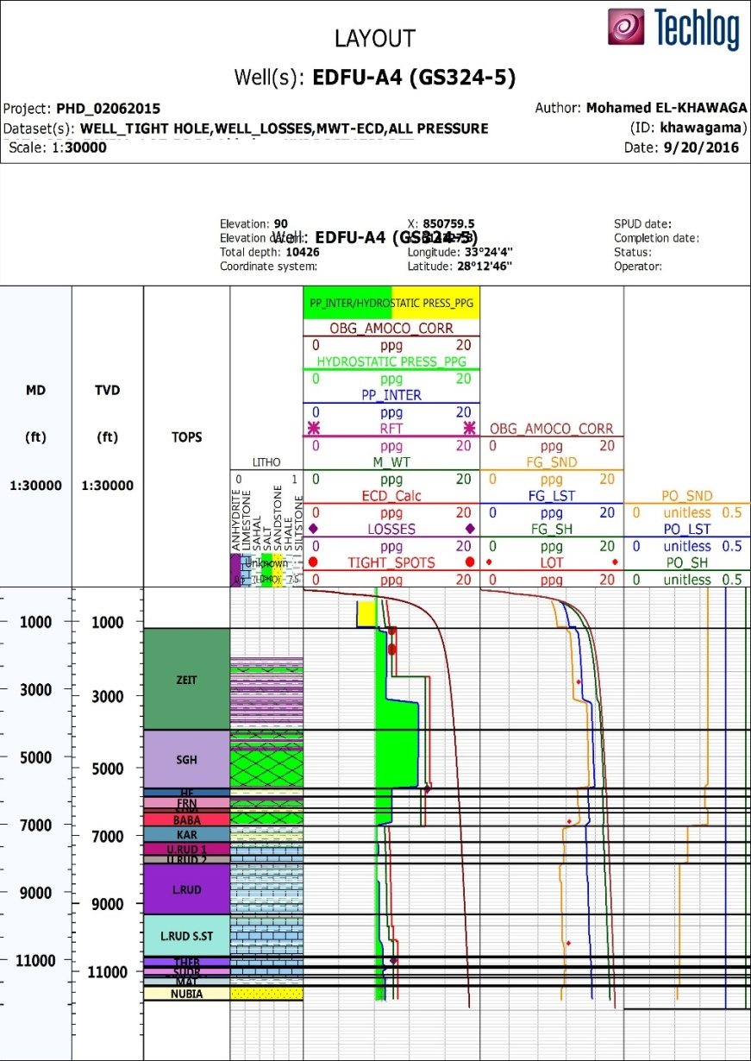

Figure 5: Edfu-A4_Pore Pressure Model

#### 4.1.2.3 Sqqara-2A Well:

|  |  |  |  |  |  |  |
| --- | --- | --- | --- | --- | --- | --- |
| **Formation** | **Overburden Pressure Gradient (ppg)** | **Pore Pressure**  **(PPG)** | **Fracture Pressure** | | | |
| **Sandstone** | | **Limestone** | **Shale** |
| **PO (unitless)** | **FP**  **(ppg)** | **FP**  **(ppg)** | **FP**  **(ppg)** |
| KAREEM | 17.5 – 17.68 | 8.5 | 0.262 | +/- 11.89 | +/- 14.73 | +/- 16 |
| ASL | 17.68 - 17.74 | 8.5 | 0.262 | +/- 11.9 | +/- 14.82 | +/- 16 |
| HAWARA | 8.88 | 0.262 | +/- 12 | +/- 14.93 | +/- 16.2 |
| L.RUD | 17.74 - 18.2 | 7.8 - 12 | 0.3 - 0.22 | +/- 12.6 | +/- 15 | +/- 16.5 |
| NUK | 18.2 - 18.45 | 12.4 | 0.22 | +/- 12.78 | +/- 15.77 | +/- 17 |
| THBES | 12.4 | 0.22 | +/- 12.49 | +/- 15.71 | +/- 17 |
| SUDR - BROWN LST | 9 | 0.22 | +/- 12.17 | +/- 15.64 | +/- 16.6 |
| MAT | 9 | 0.22 | +/- 12 | +/- 15.6 | +/- 16.9 |
| WATA | 9 | 0.22 | +/- 11.9 | +/- 15.4 | +/- 16.8 |
| RAHA | 9 | 0.22 | +/- 11.78 | +/- 15.55 | +/- 16.8 |
| NUBIA | 9 | 0.22 | +/- 11.78 | +/- 15.55 | +/- 16.8 |

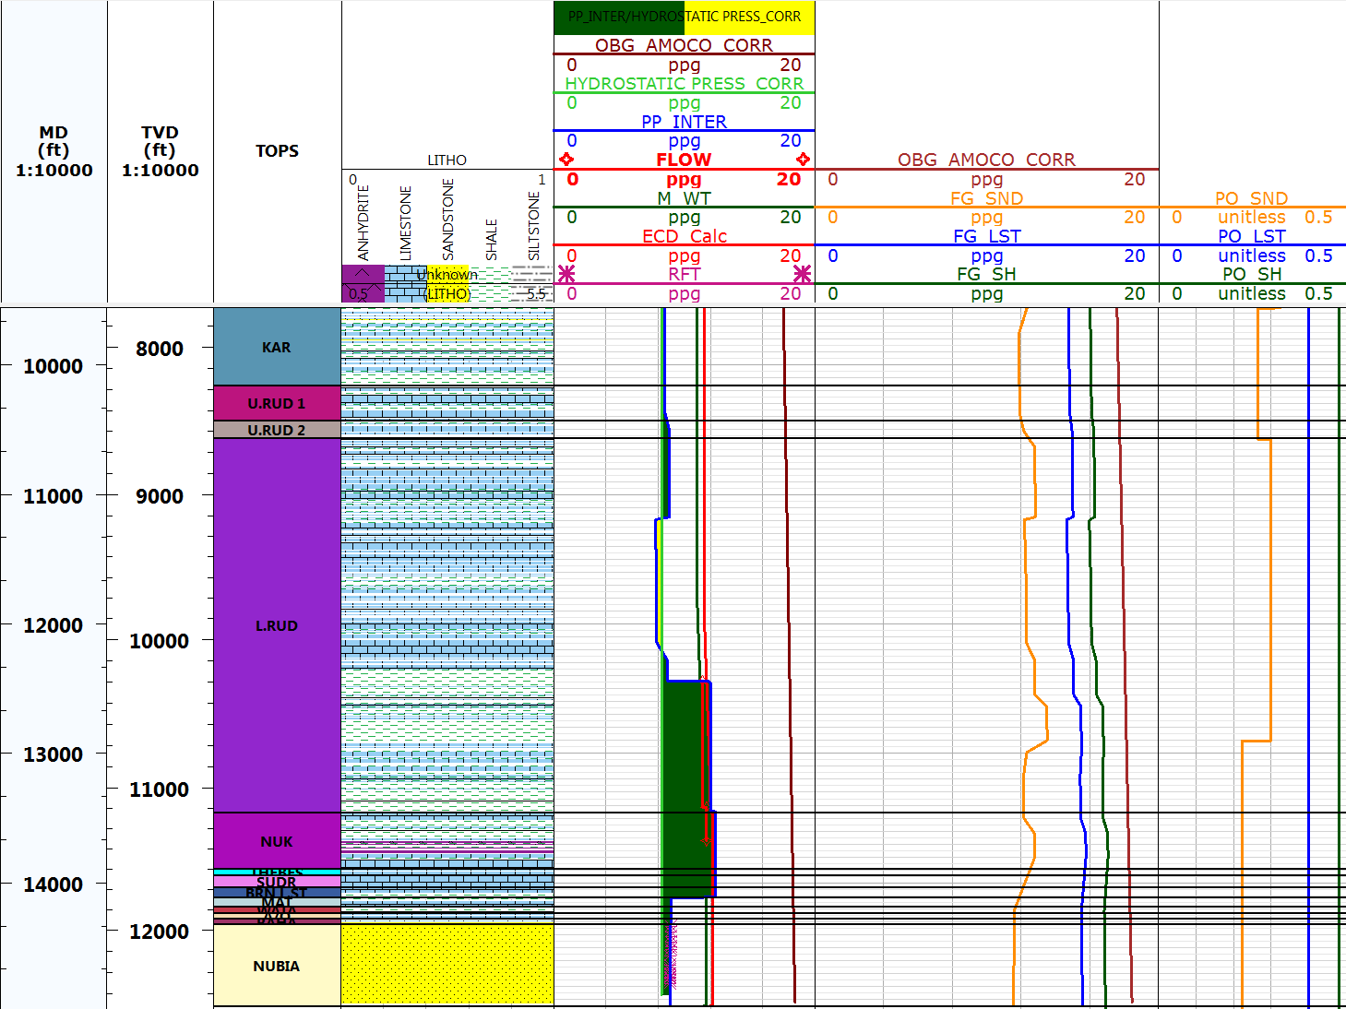**Figure 6: Saqqara-2A_Pore Pressure Model**

#### 4.1.2.4 Sqqara-3 Well:

|  |  |  |  |  |  |  |
| --- | --- | --- | --- | --- | --- | --- |
| **Formation** | **Overburden Pressure Gradient (ppg)** | **Pore Pressure**  **(PPG)** | **Fracture Pressure** | | | |
| **Sandstone** | | **Limestone** | **Shale** |
| **PO (unitless)** | **FP**  **(ppg)** | **FP**  **(ppg)** | **FP**  **(ppg)** |
| P.ZEIT | 0 - 15 | 6 7 | 0.33 | +/- 10.5 | +/- 11 | +/- 15 |
| ZEIT | 15– 17 | 8.9 – 12.8 | 0.33 | +/- 14.9 | +/- 15.6 | +/- 16.63 |
| SGH | 15.1 – 17.88 | 12.8 | Salt | | | |
| HF | 17.88 - 18 | 9.93 | 0.319 | +/- 13.64 | +/- 15.21 | +/ -16.41 |
| FRN | 9.93 | Salt | | | |
| SDRI | 9.93 | 0.33 | +/- 13.87 | +/- 15.25 | +/ -16.46 |
| BABA | 9.93 | Salt | | | |
| KAREEM | 18 – 18.1 | 8 | 0.264 | +/- 11.57 | +/- 14.65 | +/- 15.94 |
| ASL | 18 – 18.15 | 8 | 0.264 | +/- 11.59 | +/- 14.67 | +/- 15.97 |
| L.RUD | 18.15 – 18.6 | 7.9 – 10.9 | 0.3 | +/-13.5 | +/- 15 | +/- 16.5 |
| THEBES | 18.5 – 18.54 | 9.4 | 0.3 | +/- 13.29 | +/- 15.4 | +/- 16 |
| SUDR -BROWN LST | 9.4 | 0.3 | +/- 13.3 | +/- 15.41 | +/- 16.72 |
| MAT | 9.2 | 0.222 | +/- 11.8 | +/- 15.33 | +/- 16.74 |
| WATA | 9.2 | 0.222 | +/- 11.9 | +/- 15.35 | +/- 16.69 |
| RAHA | 9.2 | 0.222 | +/- 11.9 | +/- 15.35 | +/- 16.7 |
| NUBIA | 9.2 | 0.222 | +/- 11.9 | +/- 15.37 | +/- 16.72 |

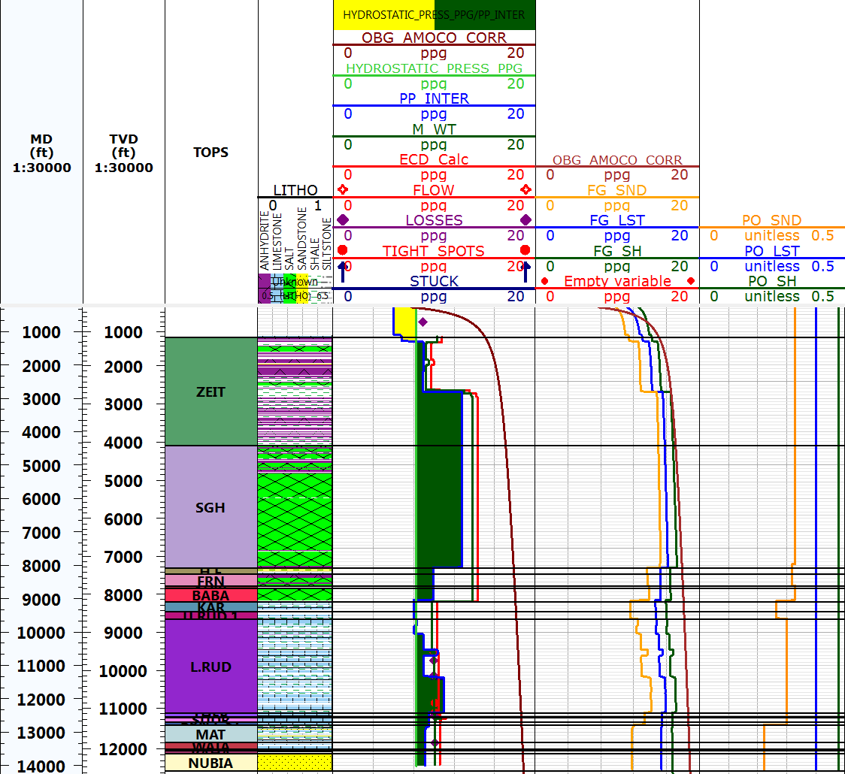

**Figure 7: Saqqara-3_Pore Pressure Model**

## 4.2 Mechanical Earth Model

The MEM model workflow includes elastic and rock strength parameters. Elastic parameters including Young’s, shear and bulk modulus, Biot coefficient and Poisson’s ratio. While the rock strength, including Unconfined Compressive Strength (UCS), angle of friction and tensile strength.

### 4.2.1 Mechanical Earth Model Calculation:

Targets of this model include, optimizing the wells trajectories on the basis of the in-situ stress analysis (orientation, magnitude) and the reservoir polygon. Understanding the wellbore trajectory in terms of in-situ stress gives the chance to design the well for minimizing the risk of losing the wellbore.

#### 4.2.1.1 Elastic Properties:

The Elastic properties include, properties of Bulk modulus, Shear modulus, Young’s modulus and Poisson’s ratio. Elasticity is the property of matter that causes it to resist deformation in the volume or shape. The elastic properties are described as the following;

Bulk modulus is the change in volume under hydrostatic pressure (i.e., the ratio of stress to strain) (K is the reciprocal of compressibility.). Shear modulus is when the force change the angel in an object. Simply shear stress can be defined as shear stress divided by shear strain Young’s modulus is an elastic constant that is the ratio of longitudinal stress to longitudinal strain or uniaxial compressive (tensile) stress to the resultant strain. An additional parameter, Poisson’s ratio, σ, is a measure of the geometric change of shape under uniaxial stress (Fjaer, E. et al 1992).

(Lucier, Zoback 2006), described well logging formulas to describe the elastic properties as the following;

* € = P [ (3ΔTs2-4ΔTc2)/ (ΔTs2-ΔTc2)*1.34*1030]

Where, µ is Bulk’s modulus ΔTs and ΔTs is compressional and shear sonic

* µ = P/ΔTs2*1.34*1030

Where µ is shear modulus, ΔTs is shear sonic

* (€)= (P/ ΔTs2) [ (3ΔTs2-4ΔTc2)/ (ΔTs2-ΔTc2)*1.35*1030]

Where € is Young’s modulus, ΔTs and ΔT is shear and compressional sonic respectively

* ν =1/2 [ (ΔTs2-2ΔTc2)/( ΔTs2-ΔTc2)]

Where ν is Poisson’s ratio, ΔTs and ΔT is shear and compressional sonic respectively

#### 4.2.1.1 Rock strength Properties:

The rock strength including properties of unconfined compressive strength, internal friction coefficient and tensile strength. The UCS and internal friction coefficient (μ) are the most important rock strength parameters.

Horsrud, 2001, created an empirical relations between compressional sonic and measured UCS to deliver for the strength of shale were calibrated for samples collected from the North Sea and Gulf of Mexico where high porosity, unconsolidated Tertiary or younger shales are dominant. This method is a global equation and gave a good results which can be used especially due to lack of calibrated lab tests in GOS. The Horsrud formula is:

UCS = 1.35*(304.8/ΔT) 2.6

Where UCS is a uniaxial compressive strength (psi), DT is a compressional slowness (ms/ft) and the constant numbers in the formula are fitted for calibrations.

The parameter measures the ability of rock to withstand a share stress. The typical value of the friction Angle is 20~25 degree for Clay-Supported and 35~40 degree for Grain-Supported. (Shlumberger media).

Lal’s empirical equation generally underestimates the internal friction angle for shales with VP less than 3000m/s, i.e. poorly consolidated or unconsolidated weak shale (Chang et al, 2006).

he formula is:

Φ=sin−1 (VP −1000)/ (VP+1000)

Where, Φ is internal friction angle and VP is compressional velocity with m/s

The tensile strength is the capacity of a material or structure to withstand loads tending to elongate, as opposed to [compressive strength](https://en.wikipedia.org/wiki/Compressive_strength). In laboratory, There a simple the simple correlation to compute tensile strength directly from UCS strength.

TSTR = K * UCS

Where; K is facies and zone based factor, default is 0.1.

This default value is based on the Griffith Elastic-brittle theory which gives the ratio of compressive strength versus tensile strength for 8 ~ 12 (Bieniawski, 1967). The mechanical earth model are presented below;

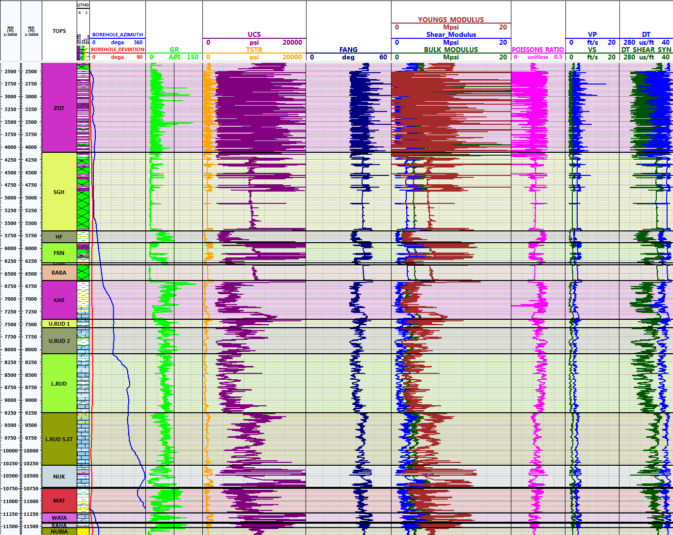

**Figure 8: Edfu-A1_Mechanical Earth Model**

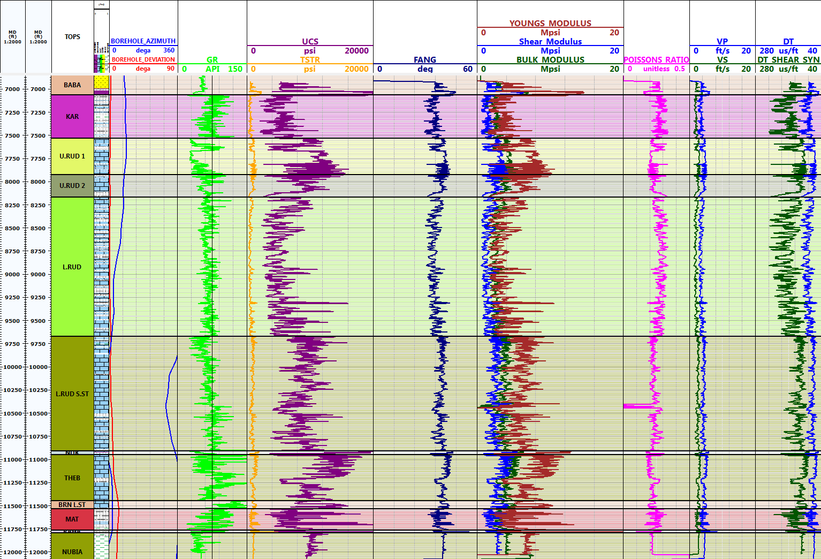

**Figure 9: Edfu-A4_Mechanical Earth Model**

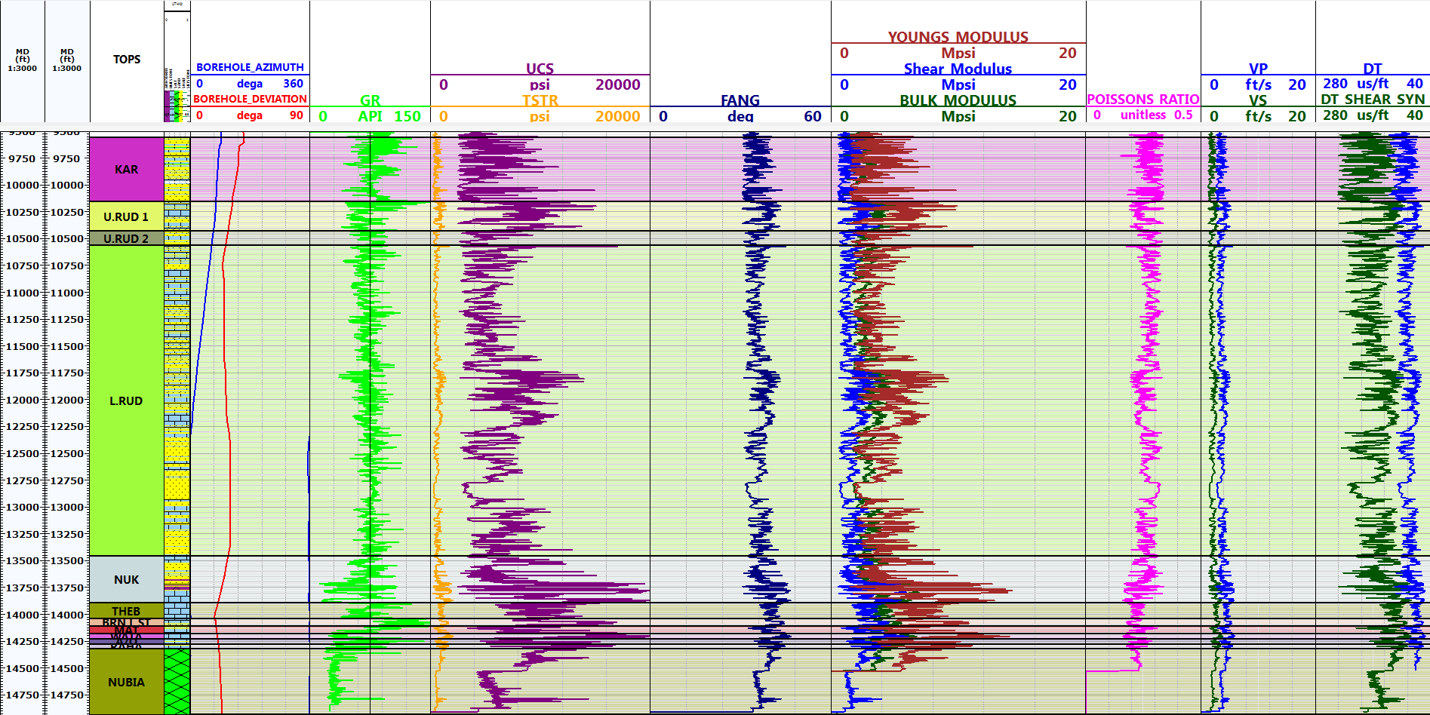

**Figure 10: Saqqara-2A_MEM**

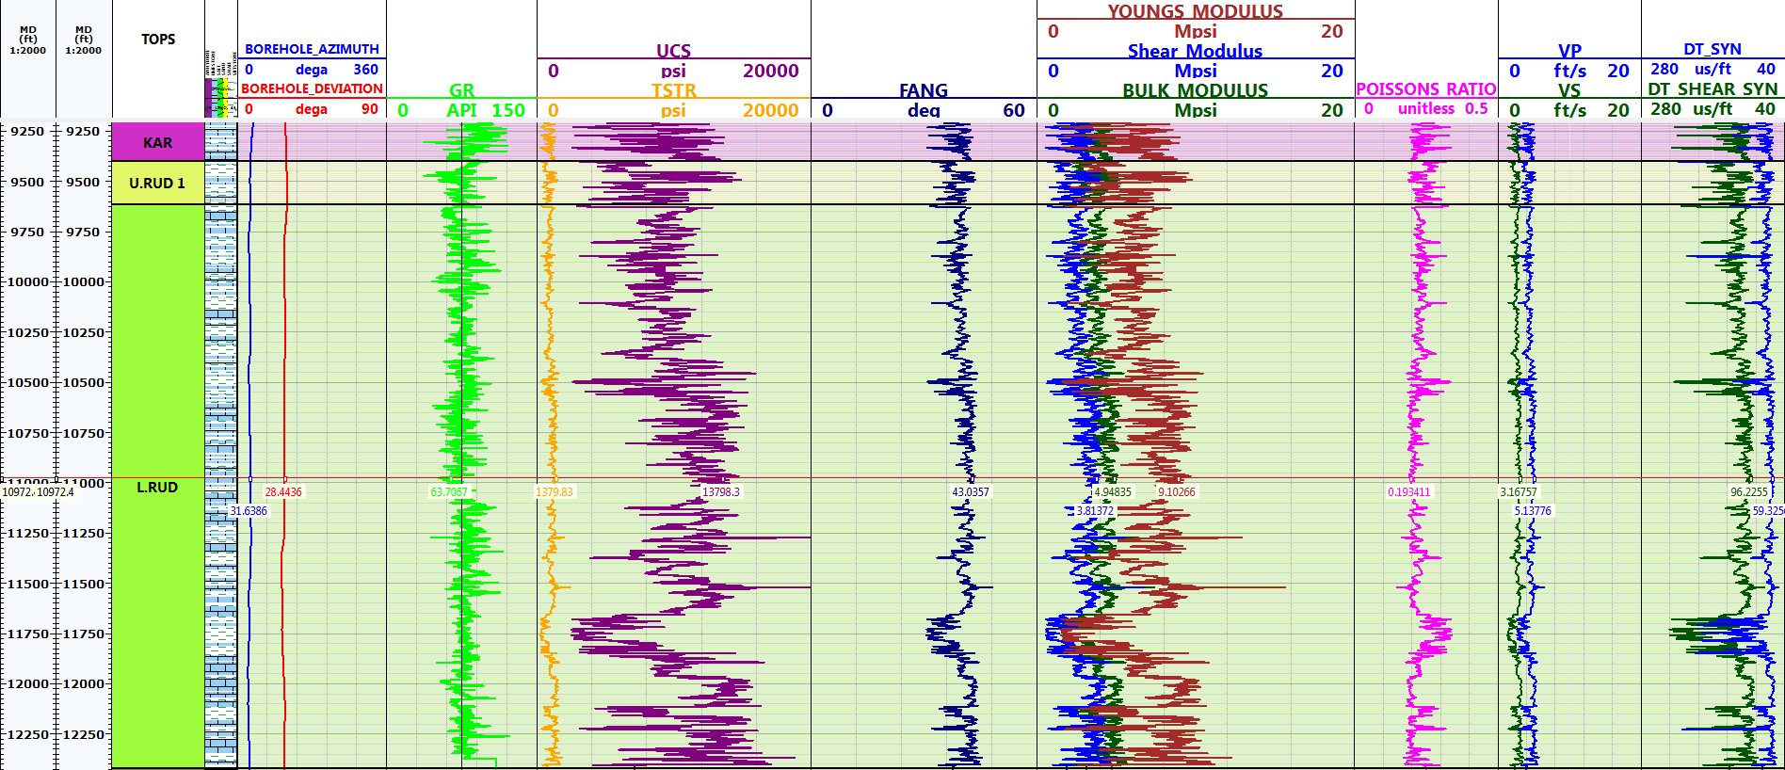

**Figure 11: Saqqara-3_MEM**

## 4.3 Maximum Horizontal Stress Direction

The wellbore stability application focuses on the use of the stress model to minimize the potential for stress-related wellbore failures by predicting stable mud windows, defining stable wellbore trajectories, and selecting optimal casing points. Existing techniques for estimating the maximum (SHmax) and minimum (Shmin) horizontal stresses are based on analyzing borehole breakouts and borehole pressure necessary to fracture the surrounding formation, respectively (Desroches and Kurkjian, 1998; Gough and Bell, 1982; Moos and Zoback, 1990; Roegiers, 1989; Zoback et al., 1985).

Through the Lower Rudies sandstone formation, the induced fractures occur as slightly inclined cracks on opposite sides of the borehole wall (180 degree). While in another interval (in the same formation), the predominant induced fracture was oriented typically in E-W direction (90º). The stereonet shows the summary of the induced fracture direction towards the 60º and 90º respectively.

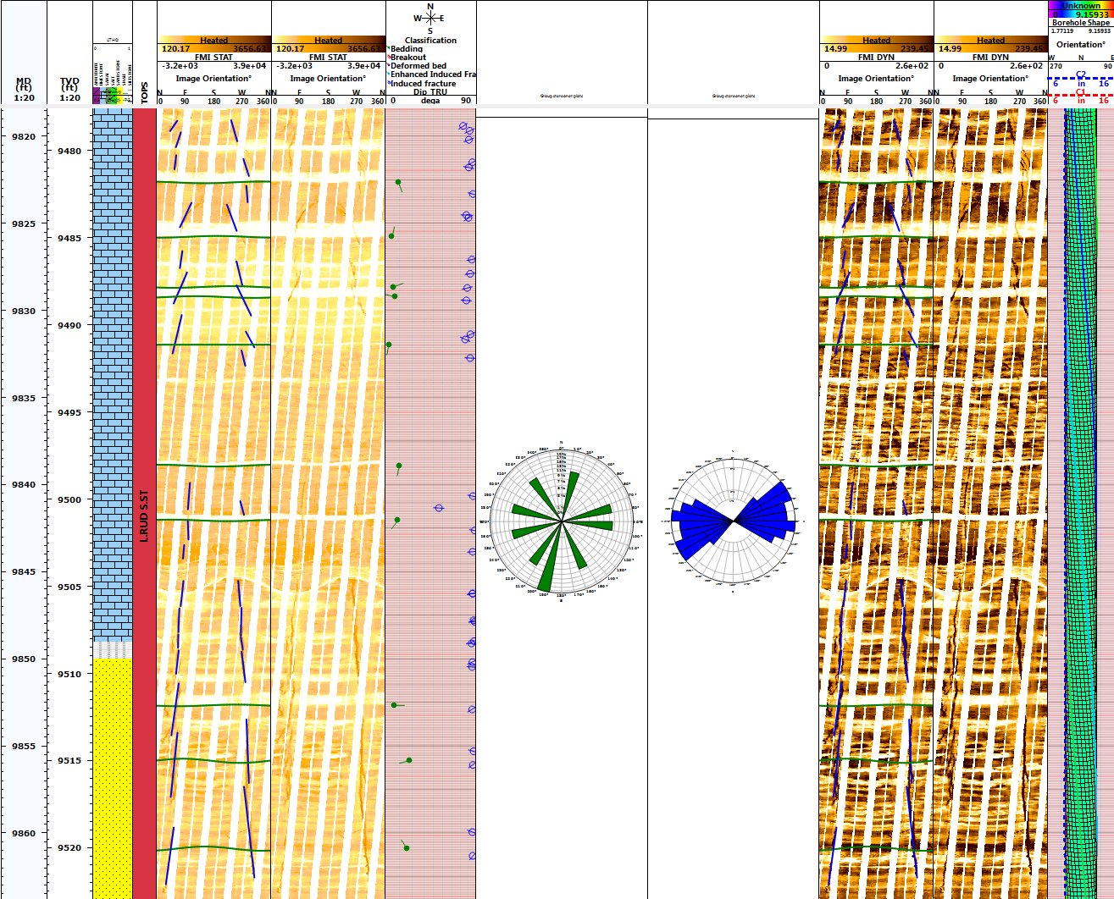

**Figure 12Drilling induced Fracture through L. Rudies Formation oriented predominantly in 60 and 90 º N**

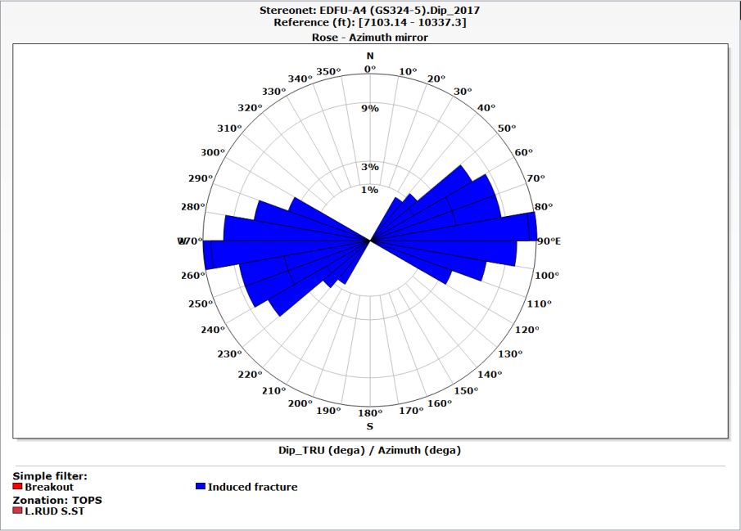

**Figure 13: Drilling induced Fracture through L.Rudies Formation oriented predominantly in 90 º N**

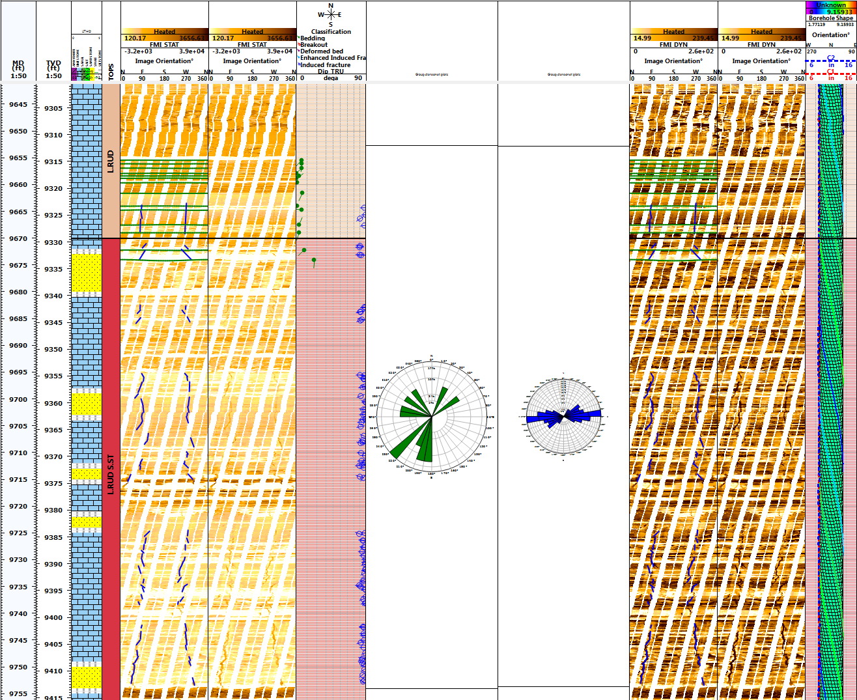

**Figure 14: Drilling induced Fracture through L. Rudies Formation oriented toward NE (90 º)**

## 4.4Geomechanical Models

Construction of 1D of geomechanical model required some key inputs, these inputs, including full pore pressure fracture gradient model, far and near stresses (magnitude and orientation) and mechanical earth model.

Targets of this model include, optimizing the wells trajectories on the basis of the in-situ stress analysis (orientation, magnitude) and the reservoir polygon. Understanding the wellbore trajectory in terms of in-situ stress gives the chance to design the well for minimizing the risk of losing the wellbore.

The geomechanical model estimated from the top of the Post Zeit formation till Nubia formation. The summary of the model assumed the SH max azimuth is assumed to be N90°E and the stress regime is normal fault regime i.e., Sv<SHmax< Shmin.

The results were approached based Schlumberger Techlog software. In this software, Schlumberger experts combined geomechanics data, an MEM, and wellbore-stability analysis with a depth-of-damage approach. The depth of damage analysis, predicted the severity of wellbore instability to give drillers a sense of the wellbore’s likely conditions and behavior. It also provides the model with several mud weight windows as window of possible losses, tunnel failure possible (from 0-5%), manageable failure (5-10%) and high risk curve limit (10-20%) as seen in figures (7.11 and 7.12) (SLB media files).

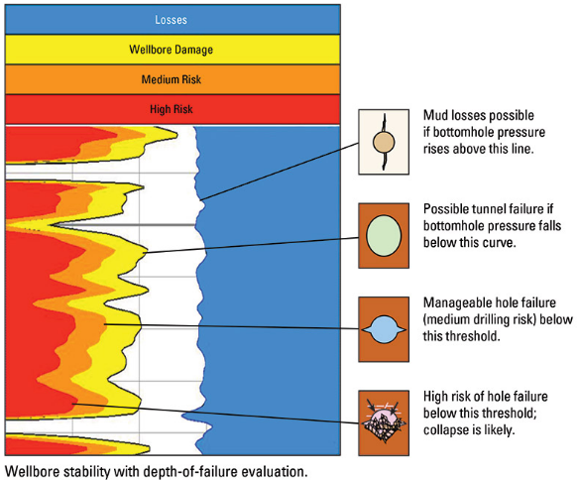

**Figure 15: Wellbore Stability with Depth of Failure Evaluation. (After SLB Media)**

### 4.3.1 Edfu-A1, 1.D geomechanical model:

Through the surface section, no significant wellbore stability related problems occurred. In Base Zeit formation, mechanical and pressurized caved shale was observed. This shale appeared due to using lower mud weight than the required to prevent caved shale problems. Also, salt water flow in the South Gharib formation was occurred due to underbalance drilling which killed after raising the mud weight to 14.5 ppg.

Complete loss of circulation occurred after penetrating Belayim clasticsby 14.5 ppg mud. The losses cured after reducing the mud weight 9.9 ppg. This mud weight was able to prevent wellbore stability problems. 9 5/8” casing set in base Baba member in Belayim formation.

In 8 ½” Hole Section, the top of Kareem formation is shale and the used mud weight was 13.5 ppg. As shown from the model the mud weight was very high to prevent the shale problems. The mud weight reduced to 10.7 ppg before hitting expected Kareem sand (7.9 ppg), but this mud weight was still high enough to fracture the sand. The losses were cured after reducing the mud weight to 9.1 ppg.

A series of losses and well flow (interpreted as cross flow and ballooning effect) occurred in both sand and shale while drilling the rest of Kareem till the base of Lower Rudies formation without action.

Another pore pressure ramp-up (10.4 ppg) occurred in the Nukhul formation. The used pore pressure was 9.5 ppg, which led to gas flow. The mud weight increased twice to 10.5 ppg, but another gas flow occurred. Finally 7” liner was set after killing the gas flow. Through Nukhul formation the mud weight was in 10 % depth of damage and the caliper was refer to some hole enlarged reached to 9.1 inch (0.6 inch) in original 8.5” hole.

Through the reservoir, no significant wellbore stability related problems occurred except a little tight hole. The caliper indicates that, the hole gave a minor hole washout reached to 6.2 or 6.3 inch in original 6” hole. Figure (7.13) illustrates and summarize the full geomechanical model. Figure 13 shows the geomechanical mosel of the Edfu-A1 well.

### 4.3.2 Edfu-A4, 1.D geomechanical model:

At the top of Zeit formation, the pore pressure is 9.5 ppg and the mud weight was 10 ppg. Some manageable tight holes occurred while tripping and the mud weight was able to handle tights problems. As the normal casing design in the field, 13/8” casing set to cover the thick salt and loose sand in the Post Zeit and Zeit formations.

At the base Zeit formation, the pore pressure ramped up to 13 ppg and the same pore pressure continues in the same value through the South Gharib formations. The used mud weight 13.8 to 14 ppg.

Had complete loss once penetrating HF sand with high mud weight (14 ppg), these losses mitigated after the mud weight to 13.3 ppg. This mud weight was able to prevent wellbore stability problems.

Through Kareem formation and the pore pressure was 8.4 ppg and the mud weight was 9.4 ppg which was enough to keep the hole stable without problems.

Through Upper and Lower Rudies formations, the pore pressure was between 8.2 and 8.6 ppg and the mud weight between 9.2 to 9.6 ppg. 7” liner set in the Lower Rudies sand stone before drilling underlain formations. A little increase in pore pressure 8.9 ppg is recorded against base lower Rudies sandstone formation accompanied with gradual increasing in the mud weight from 9.7 ppg to 10.2 ppg. Through the reservoir section no wellbore stability related problems occurred and the caliper indicates that. As seen in the model (figure 14), the mud weight was appropriate along the whole well. Some interval shows that, the mud weight was below minimum shear failure mud weight and restricted in 5% depth of damage. From this model, drilling in 5% depth of damage zone still safe and manageable even without intensive well cleaning, especially in the vertical or nearly vertical well (the angel ranges from 1 degree to 12 degree).

### 4.3.3 GS323-2A, 1.D geomechanical model:

GS323-2A is a sidetrack well from GS323-2 original well due to mechanical problems. The geomechanical model of this well was designed from middle Kareem to Nubia formations.

GS323-2A was drilled as one hole section as 8 ½” hole section. As seen in the figure (15), In Kareem and Asl (U.Rudies1) formations, the estimated pore pressure is 8.5 ppg to 8.6 ppg and the mud weight is 11 ppg. As shown from the model (figure 7.16), the mud weight was stuffiest to keep the hole stable and in very good shape.

In Hawara formation (U.Rudies 2), the pore pressure is slightly ramped up to 8.8 ppg without change in the mud weight. The controversial is that observation of pore pressure regression to 7.9 ppg, then suddenly the pore pressure ramped up again to 12 ppg and gas kick occurred. The mud weight increased to 11.4 in the static and the ECD reached to 11.9 ppg. The increasing in pore pressure, creating a kind of instability against the Lower Rudies formation led to hole enlargement 8.7 inches in the direction of SHmin (Breakout) direction.

Through the Nukhul formation, the pore pressure ramped up 12.4 ppg, another gas kick occurred led to increasing the mud weight to 11.7 ppg and the ECD to 12.2 ppg (0.2 ppg underbalance). Due to underbalance drilling, manageable hole enlargement (9.9 inches in 8.5 inches original hole) occurred in 5% depth of damage (figure 7.18). The low angel deviated well (19 degree) and drilling cleaning practice keeping hole enlargement under control. Another difference between Saqqara and Edfu fields that, the zone of Lower Rudies and Nukhul is highly pressurized in Saqqara and nearly is normal in Edfu field. The pore pressure regressed to 9ppg from Thebes to top Nubia formation. This section drilled successfully with 11.7 ppg without any well wellbore instability problems and the caliper gave ganging hole performance problems.

Generally, Matulla and Raha are not an oil producer in the Saqqara field (lack of sand).

The estimated pore pressure is 8.9 ppg, which is the same pore pressure of Nubia formation in Edfu field. It could illustrate the same pressure regime and prove some pressure communication between the two fields along the reservoir section. The geomechanical model of this well shows that, the mud weight was insufficient to prevent well control problems and associated hole enlargement.

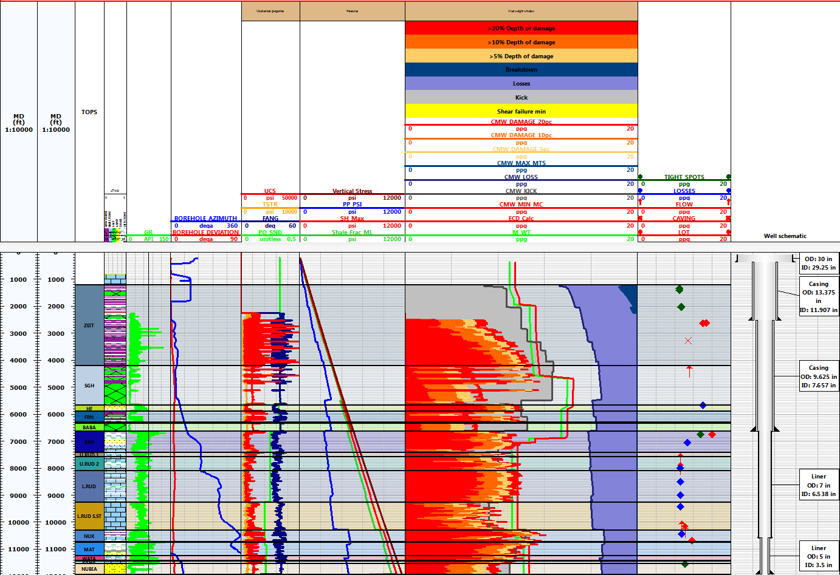

**Figure 16: Esgdfdfu-A1_1D Geomechanical Model**

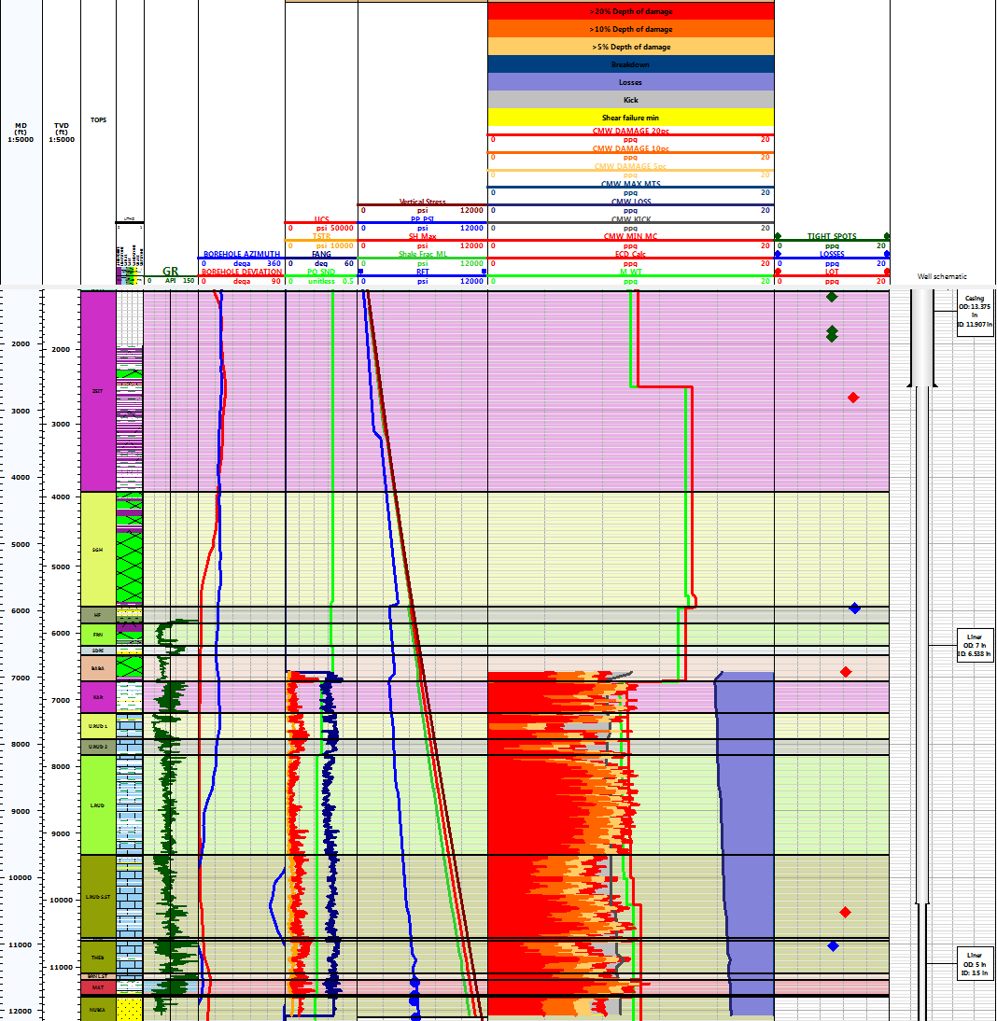

**Figure 17: Edfu-A4_1D Geomechanical Model**

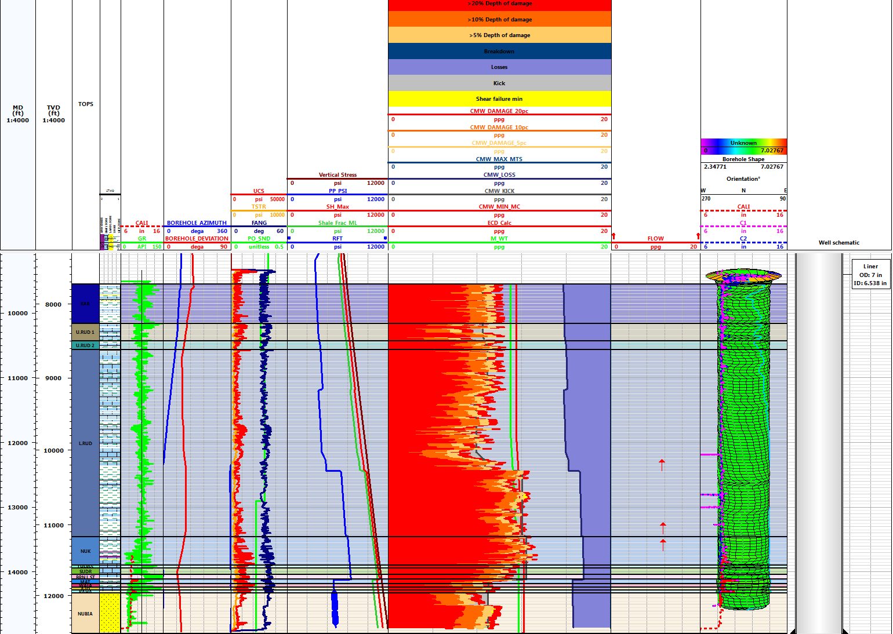

**Figure 18: Saqqara-2A_1D Mechanical Earth Model**

### 4.3.4 GS323-3, 1.D

According to available data, The geomechanical model designed from Kareem to base Lower Rudies.

Through Kareem, Asl and Hawara formations, the estimated pore pressure is varying between 8.3 – 7.9 ppg and the mud weight is 9.8 ppg. No wellbore stability problems observed against this section and the mud weight kept the hole in good shape.

Through Lower Rudies formation, the estimated pore pressure increased to 10.4 ppg and overcome the mud weight pressure. Gas flow occurred due to 0.4 ppg under balance, this flow if stopped after raising the mud weight. Loss of circulation is occurred due to high permeable sand cured by pumping LCM without changing in the mud weight. While tripping, the hole partially packed off and the model proves this accident. The used mud weight was in the zone in 20% depth of damage which indicates a very critical point for borehole collapse. This observation proved the 20% of depth of damage considered collapse point even in low angle deviated well (27 degree). The drilling string got free after applying torque and applying overpull. Some tight spots are observed and the model shows that the drilled mud weight was in 5% depth of damage, which considered manageable zone.

There are no data was available below Lower Rudies formation to complete the geomechanical model. But based on the mud weight and drilling problem the model shows that the mud weight was suitable and keeping the well stable. Figure (16) shows the 1D geomechanical model of the GS323-3 well.

# Summary and Conclusion:

In this study, four geomechanics models weredesigned in two adjacent fields, two in every field. The drilling in these fields are perilous due to high well control problems that occurred due to insufficient mud weight that used while different operations.

Generally, In Zeit and South Gharib formations, the pore pressure increased rapidly in successive four pressure ramps, theses ramps were accompanied by presence of and Well instability issues well control in Zeit and South Gharib respectively. Mechanical caved shale and salt water flow observed due to the use of inappropriate weight in theses formation.

Through the Nukhul formation, especially in Saqqara oil field, the pore pressure includes high rampof the pore pressure (12.4 ppg) as compared to the higher and lower formations. Usually high gas kick occurred due to underbalance drilling. Also manageable hole enlargement occurredin 5% depth of damage zone.

The low angel deviated well (19 degree) and drilling cleaning practice keeping hole enlargement under control.

Another difference between Saqqara and Edfu fields that, the zone of Lower Rudies and Nukhul is highly pressurized in Saqqara and nearly is normal in Edfu field.

As an observation from the previous results, the drilling in 5% depth of damage zone is safe to intensive drilling practice, and the drilling in 20% depth of damage is still safe but with the drilling practice especially hole cleaning is necessary to keep the well under control.

The study also discussed the direction of the maximum horizontal stress. As a result of image interpretation that pointed to the direction is in 90 degree. So, the well that are in close to the zero and 180 hole azimuth will required higher mud weight than those which in the second and the third quarters, if the hole angel is neglected.

The well is drilled in the first and fourth quarters and theses quarters are.

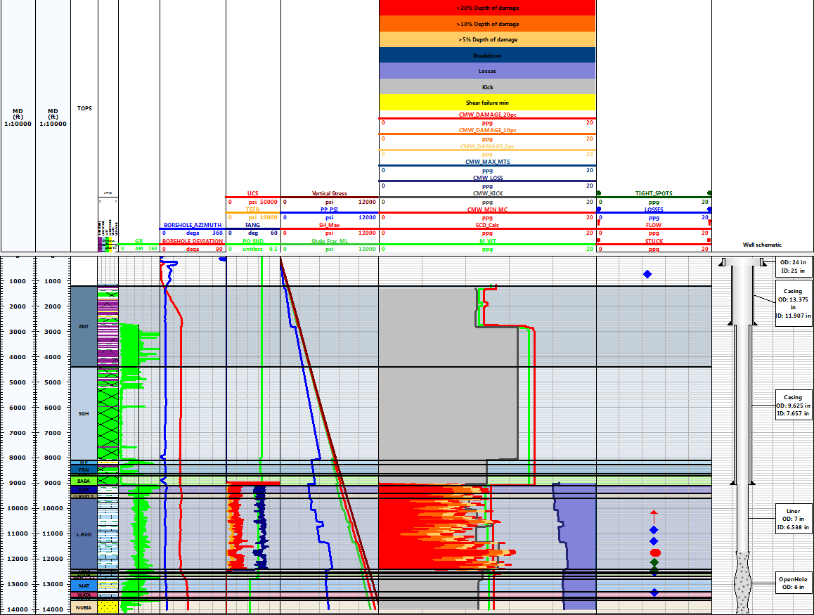

**Figure 19: Saqqara-3_1D Geomechanical Model**

# Recommendations;

Thebest results that can be used in the further wells is the mud design against the high pressure zones. The study suggest to drill the Zeit and South Gharib formations with high mud weight ranged from 13 to 13.8 ppg. Also in the Lower Rudies and Nukhul formation, the mud weight have to be between 10 and 10.7 in Edfu field, especially in Nukhul formation. While in Saqqara field, the mud weight should be higher than 12.2 ppg

Also, the study recommend to run density and sonic data from the surface to accurately define the pore pressure and reduce the uncertainty especially in the surface section.

# References

* 1. Eaton, B. A., “The Effect of Overburden Stress on Geopressure Prediction from Well Logs”, Journal of Petroleum Technology, August, 1972.
  2. Eaton, B. A., “The Equation for Geopressure Prediction from Well Logs”, SPE 5544, 1975.
  3. Nabih, N. A.; 1992: Some oil geological studies on west Belayim Oilfield, Gulf of Suez area; M.Sc.Thesis, Faculty of Science, Cairo Univ.,126 P.
  4. Rabia, H. (2002). “Well Engineering and Constructions”. https://sites.google.com/site/directionaldrillingclub/.../well- engineering.
  5. Rakesh Roshan Rana, C.Chandrashekhar (2015), “Pore Pressure Prediction a Case Study in Cambay Basin”. Geohorizons, January 2015/38.
  6. Rehm and McClendon (1971); “Abnormal Formation Pressure”. Courtesy of the Spciety of Petroleum Engineer of A.I,M,E, Fig.4.8.dc-plot.
  7. Said, R. and El-Heiny, I.;1967: Planktonic foraminifera from the Miocene rocks of the Gulf of Suez region, Egypt; Contrib. Cushman Foundation Foram. Research 18, pp.14-26.
  8. Shahin, A. N., A. H. Hassouba, and L. M. Sharaf, (1994): ”Assessment of Petroleum Potential in the Northern Gulf of Suez”, Egyptian General Petroleum Corporation, 12th Exploration Production Conference, Cairo, Vol. II.

7/19/2017