The Influence of the Digital Revolution on the Architectural Trends and its Impact on the Architectural Thinking in the Beginning of the 21st Century

Alaa Aldeen Alsayed Fared¹, Ahmed Ahmed Kamel Metwally², Abdel Salam Ahmed Soliman³

¹Professor of Architecture Faculty of Engineering Al Azhar University, Egypt
²Visiting Assistant Lecturer in Architectural Engineering Department–Faculty of Engineering, Obour Institute for Engineering & Technology-Cairo-A.R.E, Engineer in the New Urban Communities Authority - El-Shorouk Cairo - A.R.E
³ Architecture Faculty of Engineering Al Azhar University, Egypt
aarch2020@yahoo.com

Abstract: A great deal of technological changes took place in the last two decades, such as computer sciences and applications, which guaranteed the absolute domination of digital technologies above all; this was the beginning of so called digital revolution. Since architecture is very much connected to the community, it individuals and activities, there was a strong connection between contemporary architecture and digital revolution; since the architectural innovation has become integrally connected between human creativity and artificial intelligence, which is represented in tangible and intangible, and realist and virtual. Considering architectural innovation and creation processes as presented in architectural design stages, they are considered the base point of professional interest of architects. This means that architectural design has a special significance as they represent the direct product of architectural innovation and creation process, and that is why the architects pay attention to involve the available cutting edge technologies for the interest of architecture, through the development of architectural innovation and creation process and the use of digital technology and its applications for the interest of the innovation process. That is why it was necessary to study the technological effects of the digital revolution and its applications in the fields related to architecture, and the reflection of all that is on the contemporary architectural thinking, and the new architectural innovation and creation it presents. That is the field of the study.
[Alaa Aldeen Alsayed Fared, Ahmed Ahmed Kamel Metwally, Abdel Salam Ahmed Soliman. The Influence of the Digital Revolution on the Architectural Trends and its Impact on the Architectural Thinking in the Beginning of the 21st Century. N Y Sci J 2017;10(8):89-105]. ISSN 1554-0200 (print); ISSN 2375-723X (online). http://www.sciencepub.net/newyork. 12. doi:10.7537/marsnys100817.12.

Keywords: New Modernity – Fractal – Intellectual Trends – Digital Revolution – Constructional Technology.

- Technological Development and its Influence on the Modern and Contemporary Architecture
  - Introduction & Preliminary
During the middle of the nineteenth century, the influence of the industrial revolution on architecture became conspicuous, along with the development of the construction materials, among which: glass, Iron & steel, reinforced concrete, and other materials. This led to the capability of unprecedented vertical extension of the buildings, especially with the invention of the electrical elevator by the American Inventor Elisha Otis (1811-1861) in (1854), the thing that prompted the same direction.
During the twentieth century, the direct influence of technology on the architecture was apparent either in the materials, construction methods, execution methods, or others. This was obvious through various architectural trends which prevailed along this century, starting from the heading towards the modernity architecture, the international model architecture, then the late modernity architecture, and finally the post-modernity architecture, the use of advanced technologies architecture, the fractal architecture and others.
  - The Digital Technology and the Late Twentieth Century and the Early Twenty First Century Architecture
The late twentieth century witnessed rapid advancement in the science fields through what is known by the digital revolution, which changed the form of life. This revolution also had its influence on architecture; the computer programs were used in many fields, the most important was its contribution in producing new architectural formations; known as "digital formations", through finding three-dimension imaginative models to imitate the reality where the primitive details are accurately shown, as well as other applications.
The Technological Development and its Influence on the Contemporary Architectural Trends
During the last two decades, the world witnessed an unprecedented revolution in the fields of developing the digital technology and its applications along with establishing new items for the architectural structure, where these new items became various such as using fractal forms, primitive geometric forms, organic forms, or hybrid forms with all their types, as well as other architectural trends such as the trend of "new modernity", "imaginative / virtual architecture", and other trends. These trends were not able to be developed and used if it were not for the development in the digital technology and its applications in the field of architecture, the most important of these modern architectural trends:
2- 1 Fractal Forms
The fractal form is considered one of the most important developments in architecture "post modernity". This trend refers to the fact that the rational thinking is complemented by the contradiction between the two opposites; for instance it works on suspicion of the seriousness of the surface meaning, the form and the superficial identification between them, in this context the Architect Peter Eisenman says:
Architecture shall be moved away from the stagnancy of these contradictions and their values such as the contradiction between the construction and the ornamentation, and between abstraction and personification, and between the person and the land. The architecture has to begin exploring the medium between these contradictions. The fractal is the enemy of the traditional architecture, as it affirms that the traditional values and creeds are by no means correct, while this direction is still rousing arguments on the international level, as it is rejected by some people such as the critic Wolfgang Pehnt, who describes it as being an aesthetic disaster, the aestheticism of absurd, ugliness, and assault.
At the same time, many of the international architecture pioneers adopts it like the famous architect Philip Johnson and others. This kind of architecture and this contemporary architectural trend are concerned with deconstructing architecture mass into a number of similar and incongruous units, and then they are rearranged and assembled in a different shape other than anything traditional and ordinary. What distinguishes this architectural trend is that it destroys any differences between drawing and sculpture and merging them in a new and contemporary architectural crucible. It describes the natural shapes such as the mountains, sea waves, tree branches, tree leaves, snow balls and others. This architectural trend is generally divided into three main types:
- Cinematic Sectioning
- Zigzag & Shard Forms
- Collision & Inclination Forms
2-1-1 Cinematic Sectioning
The American theorist and architect (Charles Jencks) likened fractal forms to a form of cinematic sectioning, such as pictures are in sequence and similar and not identical but in the end it forms a wholesome, as an example of such buildings the project of the Yokohama pier port terminal in Japan on 1987-2002. It was designed by (foreign office architect) group. It is a marine passengers station designed as an extension of the ambient ecology through set of shocking surfaces that cover the various elements of the project where loads is transferred to the ground through these surfaces which suit the Japanese topographic rocky nature influenced by earthquakes. The building expresses real revolution in architectural form and synchronizes with the ambient natural ecology from the uncut of the shape and its reflections on cross section and internal spaces³-(shape 1).

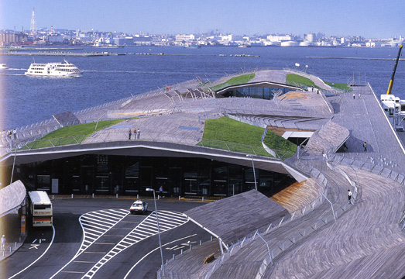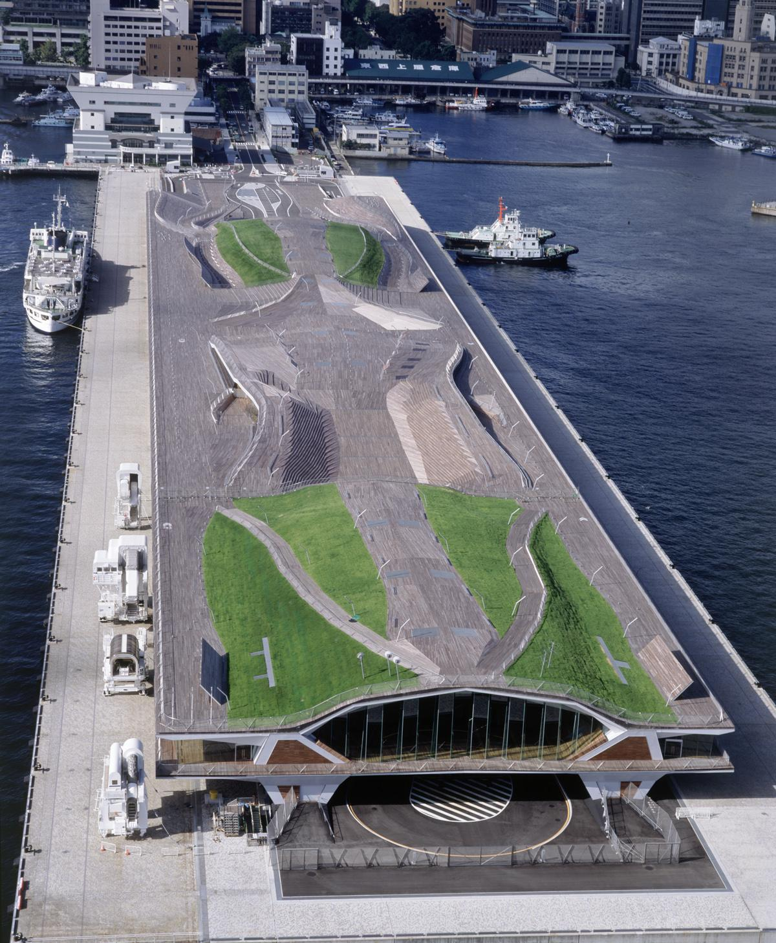
Shape1: (The Yokohama Pier Port Terminal), (Gaban, 2002 by the architect Foreign Office Architect)
Source http://en.wikipedia.org/wiki/% Csanbashi_Pier/3-3-2017

2-1-2 Zigzag & Shard Forms Architecture
The works of The American Jewish architect (Daniel Libeskind) are considered the most distinguished works of this architectural trend. One of the most famous models executed through this trend is the Jewish Museum, Berlin in Germany in 1999, in which the zigzag & shard forms were used. It represents sudden fractions with no links to any limits or angles representing fractal of David's hexagon star. He also used main axis of movement points to places where the famous Jews lived in Berlin to express continuity and eternity of Jewish existence in Germany despite of the holocaust and exile (according to Jewish claims) which he expressed in two axes that cross with the main axis. The zigzag line expresses the course of history and feeling of troubles as the pedestrian cross flying beams in the building⁶. The building openings are executed in random irregularly longitude, as if they represent the stabs the Jewish body got from the enemies (as they claim) along the Jewish history that extends for tens of centuries!!!! (shape 2).

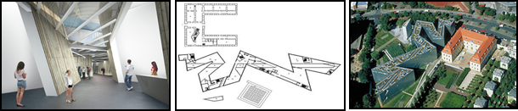
Shape 2: (Jewish Museum, Berlin), Germany, Berline, 1989-1999, by the architect Daniel Libeskind),
Sourse http://en.wikipedia./Jewish_Museum_Berlin/20-3-2017

2-1-3 Collision & Inclination Forms
The famous architect Frank Gehry is considered one of the pioneers f this trend. He sees architecture as a democracy that expresses various ideas in conflict. He expresses this through these collision shapes in his forms. One of his most famous forms, designed through this trend (Ray and Maria stata center), is Stata lap for computer and intelligent sciences in Massachusetts state in America in 2004 where mass design expresses conflict of ideas between scientists of different specializations who work inside this center⁷. This produces new ideas and supports spirit of innovation and invention. (shape3)

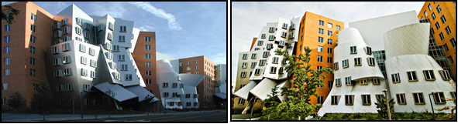
Shape 3: Stata lap for computer and intelligent sciences (Ray and Maria stata center), in Massachusetts state in America (2004) by the architect Frank Gehry
Source http:///en.wikipedia.org/wiki/stata-center 20-3-2017

Gehry's project dancing house in Czech Prague (1996-1992) shape 4, which is considered a model of fractal forms and its attitude to produce collision and inclination forms⁷. It embodies two dancing persons and 99 concrete panels were used with different shapes and dimensions designed with the help of computers, plus several other models. Gehry executed this with the same attitude such as (Walt Disney Concert Hall) in L.A in 2003 and other models.

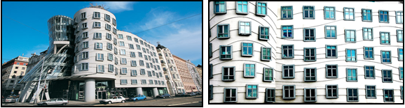
Shape 4: (dancing house) Prague Czech (1992-1996) architect Frank Gehry
Source http:///en.wikipedia.org/wiki/dancing house 20-3-2017

2-2 Primitive Geometric Forms
Building forms are linked to Primitive Geometric Forms with sphere, cone, cylinder, pyramid, prism, and other shapes. They are shapes easily to be recognized and awarded. Such shapes in human mind are linked to clarity and beauty. The architect task lays in confirming shapes drawings with ornamental lines on the mass body or the inclined shape cross with similar shape or with straight shape, without this drawing the shape loses a lot of its influence on the reciever⁸.
One of the most important models executed of distinguished forms through this attitude is using Geometric Forms the building of (London City Hall) 2000-2002.
Designed by the British architect (Norman Foster) the project mass takes the shape of baseball ball or inclined and deformed egg. It was designed to give the least surface exposure to sun- the sphere has surface area less than the surface area of a cube with the same volume with 25% -the north façade is covered with normal glass while the southern façade is designed to cover the upper stories of the building the rest lower stories to hinder sun rays computer programs and technologies to let the building accomplishes the highest environmental capability saving 65% of the energy capacity compared to other similar traditional office buildings. Special programs were used to study the effects of sun rays on the glass cover of the building and its spaces and the architectural analysis of the building ⁹-(shape 5).

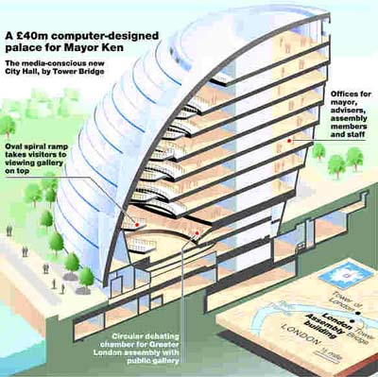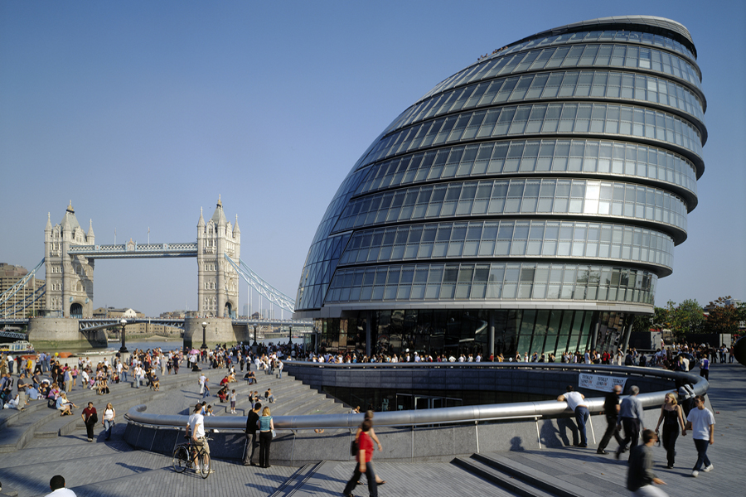
Shape 5: London City Hall in the city of London in England (2000-2002) By the architect: Norman Foster
Source http:///en.wikipedia.org/wiki/ London City Hall 4-4-2017

2-3-3 Organic Forms
The organic form attitude in architecture aims at the beauty integrity which means the integrity of the members in performing their tasks and the nature form of the building conditioning the ambient environment. Generally, it is divided into two main types:
1-Flora Forms
2- Fauna forms
2-3-1 Flora Forms
Organic flora forms is considered one of the form that inspire and blast architectural creativity and innovation 3 the American Architect (Frank Lloyd Wright) employed it in innovating the mushroom column of the Johnson laboratories. It is also used by the British architect (Norman Foster) in his building of (Swiss Re or 30 St Mary Axe) in London-England in 1997-2004-(shape 6).

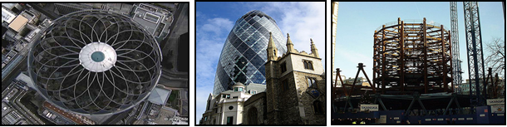
Shape 6; Building of Swiss re company or 30 St Mary Axe in London-England on (1997-2004-) (Norman Foster)
Source http:///en.wikipedia.org/wiki/ 30 St Mary Axe 8-4-2017

He developed pineapple fruit shape using computer by employing external mesh on the shaped as specific cells and woks as a substitute to the traditional columns. The building with its special design save energy consumption reaching 50% compared to similar traditional buildings. By using spiral yards, it makes differences in air pressure which generate internal air current. The building façade consists of two glass layers surrounding a vacuum which ventilated by electronic directed curtains. The form of the building is designed to increase the usage of day light and makes watching external natural scenery available to those who stay in the depth of the building ³.
2-3-2 Fauna Forms
It is an architecture which takes its inspiration from the animals body formations in addition to inspiration of the human body ⁸, one of the main models executed according to this trend is the building of the Turning Torso tower in Malmo Sweden (2001-2006) made by the Spanish architect "Santiago Calatrava" where he inspired the shape of the human torso in his sculptural design. The tower building has the shape of nine separate knuckles penetrated by concrete spinal chord which contains vertical distribution elements and the elements of the tower building services. The concrete tiles stand from the structural core and twisted in 90degree angel from the bottom to the summit of the tower reaching 190 meters height¹² –(shape 7).

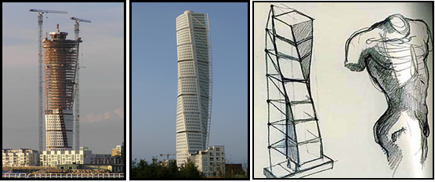
Shape 7 the building of the turning torso tower in Malmo Sweden (2001-2006) made by the Spanish architect "Santiago Calatrava".
Source http:///en.wikipedia.org/wiki/ turning-torso 10-4-2017

Caltrava repeated employing this body element in the building of (Ciutat de les Arts I les Ciencies) in the city of Valencia in Spain (1996-2009) where the building represented human eye shape and the movement of its eyelid around in a mass design rising from water, which open and close in a sticking out shed that rise and sink.
The architect showed his creativity in designing this building. The shape design and the movements that the skeleton of the building can do depicts the human eye where the sky dome is the eye pupil and the ceiling is the eye lid open and close as a real eye. When the body is reflected on water, the eye image shows utterly. The eye lid guarantees an axial system mounted on central torsos fixed with stops, when the moveable skeleton opens it reveals the internal ball and illuminates it, that makes it look as if it floating, then the space beside the planetarium becomes completely or partially covered or uncovered according to the ceiling position⁶-(shape 8).

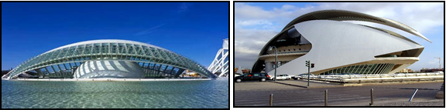
Shape 8: City of arts and sciences in Valencia Spain (1996 -2009) the Architect Santiago Caltrava
Source http:///en.wikipedia.org/wiki/ ciutat_de _artsi les ci %c3%A8ncies_/ 12-4-2017

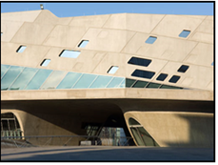
Shape 9: (Phaeno science center) in Wolfs burg in Germany of the architect Zaha Hadid (2000-2005)
Source http:///en.wikipedia.org/wiki/ phapeano- science- center_/ 20-4-2017

One of the important models which inspired its formations from the fauna forms is (Phaeno science center) in Wolfsburg in Germany of the architect Zaha Hadid (2000-2005) who borrowed the animal shape in her design, where the building designed to be raised over the ground on cone shaped legs with different sizes similar to the style of le Corbusier columns of which he raised his famous form in Marseille¹³-(shape 9).

2-4 Complication /hybrid forms
2-4-1 Undulation forms
Undulation forms is considered one of the modern and contemporary architecture attitudes based when it is founded on digital technology and its applications in architecture forms. It is called undulation forms, it is a type of architecture that uses computer programs that deduce digital undulated forms, besides supple elastic shapes that couldn’t be obtained by traditional means of design and drawing ³. The most important model of this form trend is (Experience Music Project in Seattle in 2000in Washington designed by the architect Frank Gehry. His design shows the application of supple surfaces in forming the external building⁷ (shape10).

Shape 10: (experience music project in Seattle in) 2000 designed by the architect Frank Gehry
Source http:///en.wikipedia.org/wiki/ EMP-Museum/ 20-4-2017

2-4-2 Helical forms
Old classical architecture knew how to employ Helical forms since it was innovated as ornamental element in classical Greek order through ionic order where the columns carried a volute crown which enabled it to spread through Comosite Order in the Roman architecture. It has been shown later in an awesome unique innovation in the Islamic Architecture in Iraq, where it was implemented in Samrra mosque minaret, then in Egypt in the mosque of Ahmed Ibn Tolon before it was reproduced again in modern architecture by (Frank loyed Wright), the modern architect in Gogenhim Museum in New York. His ideas was based on accomplishing the rising volute space effectuating the main space of the museum building resembling the shape of a cliff¹⁴.
From engineering and architectural point of view, Volute shape expresses the continuous transfer around lineal center, with the rise upward and set out to the infinite, and it confirms the feeling of turning upward or downward which magnifies the vital dynamic energy in the space, which increases the psychological familiarity with the surrounding environment and that what contemporary architecture tried to tackle in an abstract philosophical form. (Staten Island Institute for Arts and Sciences) designed by the American Architect Peter Eisenman in the Island of Staten in USA (1997-2001) is considered one of the most accomplished examples regarding this trend. Where models of movement and the building shape are mixed by putting white taped volutes in the half transparent glass, making traffic movement is a source of volutal form. Computer was used in arranging set of panels and sections. They rise and turn in adjacent movements that give interactive design with motion⁷. (shape 11).

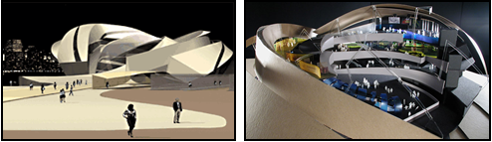
Shape 11: the project of (staten island institute for arts and sciences) designed by the American Architect Peter Eisenman in the island of staten in USA (1997-2001)
http://www.eisenman archetects.com/21-4-2017

2-3-3 Crystal forms

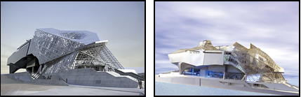
Shape 12: the project of (muse des confluences) in the French city of lyon (2007-2014) designed by the Austrian (Coop Himmelblau Group).
Source: http://fro wikipidia.org/wiki/mus%c3%a9e-desconfluences/22-4-2017.

Bauhause school pioneers defined the crystal world as it is the world of symbolism and the free spirit and as a bridge to what is beyond nature. (Walter Groupius used crystallization to express the trend to break static solid shape for the perpendicular surfaces by entering dynamic inclined surfaces¹¹.
By the end of the twentieth century and the beginning of twenty fist century architects headed to employ crystal prism form, the main representation of this trend is the project of (Muse Des Confluences) in the French city of lyon (2007-2014) designed by the Austrian (Coop Himmelblau Group) it is a museum specialized in natural sciences and human civilization where blue and grey crystal glass formations were internally lightened to express this trend to work as a bridge to what is beyond nature¹⁵ –(shape 12).
Reviewing these trends of architecture and contemporary architectural thoughts, it is now clear that the computer and its technologies, and applications contributed in developing architectural forms and changing it from ideas into tangible reality, this took place by computer programs by designing untraditional forms besides the aid of aerodynamic in executing these shapes or forms, in addition to analyze and study the wind effects on them.
2-5 New Modernity Architecture
Through the last three decades of the twentieth century, new trends expressing future architecture exist, in the seventies and eighties architects were interested in shaping the form of (post modernity) which reflects the future picture through reanimating the past heritage in a different way by respecting the architectural and cultural and civilized heritage of the societies in a modernized way and untraditional style, some people may see this trend has founded conservative image depending on reviving the past but with no expression of contemporary technology and specially with the clear appearance of information revolution and its different influences. The main evidence of those who believe in that idea is the disappearance of the works of many who adopt this trend, in the lead of this notion, the pioneer of this architectural trend (Michel graves) who on the opposite of other architects who adapt late modernity architecture before as their interest as fully directed to future, trying to reach modern contemporary and developed form, achieve great deal of flexibility through the ideal use and ambition to express technology. It was achieved by what this architecture bear of scientific features about science and advanced technology and what will be discovered in the future.
By the beginning of the ninety's of the 20th century, the trend was about Fractal or deconstruction forms. As future visions are differed by the means of absolute contradiction with the past.
And introducing new unfamiliar formula using technological achievements which doesn't bear serenity inside the old days sickness, (Fractal or Deconstruction forms) search for new ideas never handled before whether in (Modernity) or (Post Modernity) forms. Some researchers ⁸ of those who oppose this trend see this vision is against past and at the same time against future. It occurred as a result of the state of cultural despair at a time where humanity and the world witness conflicts and disputes, so it depends on a belief that present is the final form of existence paving the path to the appearance of new thinking trend called (New Modernity) forms.
(New Modernity) forms goes far away from most of the big visions of the future which (Modernity) called for. Instead of that it tries to deal with present problems using digital technology and employing it with optimistic future expectations.
One of the prominent defendant toward (New Modernity) is the French architect (Jean Nouvel) who thinks that the most important factor in the coming stage is not represented in the whole history of architecture, but every thing continues in the world the in mean time because he doesn’t think that buildings belong to the future. It should be smart enough and benefit from the available technologies, it must also attract feelings and senses. Briefly you can say" every event has its own speech".
This vision based on care in present is the care for future. What happens now effects strongly on architecture in the future. One of the main buildings Jean Nouvel designed on (New Modernity) trend is the project of Paris philharmonic in France, of which he started executing from 2006 expected to end on 2014. Its designs is inspired by the hidden feelings music do to the audience, and the flow of imaginations and flying in heavens, so the lines of the building flow and float easily and smoothly inside and outside the building. The building is not consisted of stories in the traditional meaning but it consists of place levels flow through each other till they interfere and float. This feeling is accomplished technologically through smart constructional suspension system for these levels which made of steel. The formations consists of levels and turnings and smallest details were tested by means of modern technology, to give the most accurate level inside the halls in order to give the receiver this attractive feeling and senses requested visually before auditory. This leads to a continuous harmony among all elements inside the hall ¹⁷ (shape 13).

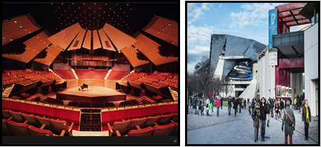
Shape 13: (Paris Philharmonic- Philharmonie de Paris) in the French city of parise (2006-2014) Architect) Norman Foster): http://en.wikipedia.org/wiki/Jean_Nouvel/23-4-2017 Source

The future form study will depend on what already happening on the real world in present, testing and highlight it as a future assumption. Thus we can found future vision of the new forms, its dimensions based on modern technology which has developed fast by the beginning of the 21st century, which in turn forms the input to Future Architecture. By pondering these different trends of contemporary architectural thoughts, it is obvious how computer and its techniques and applications contribute in developing architectural formations and changing it from solid ideas into tangible reality using to design the untraditional architectural formations programs, whereas it has been benefited from computer programs to produce such (digital formations) by finding imaginary three dimensional models to simulate reality which all spatial details show accurately.
The role of Modern and contemporary technology was not only about programs and taking advantage of it to draw new languages and vocabulary for the architectural formation but also it extended to technological development in the fields of building and developing construction materials and developing of construction material. It also extended to other developed technologies made by digital revolution in several fields such as light technologies and plastics industries and other applications that make a colossal and effective role to spur architects to innovate new creations. Consequently, all these have effect on contemporary international forms ideas and thoughts.
3- The Effects of Technological Developments on Contemporary International Forms
A lot of developments and innovations in the field of building have its big role to spur architects to creativity thus they fulfill their creative architectural ideas and dreams where used technology in making a lot of buildings is the main motive of forms ideas and thoughts specially in the 20th century. The requirements of building and its needs for innovating new materials and what results from them in new shapes and forms arose the dawn of forms ideas based on constructing building. ²⁴
One of the main building models executed according to this architectural trend is the German (Pavilion at the Expo 67 Montreal) which the German Engineer (Frei Otto) designed, as the light structure Otto used on the shape of a tent covering enormous space of this exhibition is considered new innovated form. The idea of a tent is an old one but the architectural formation and its acquaintance with the building and internal space in addition to structural development made its form innovative. One of the most important examples that explain the extent of technological developments affects on the architectural formation in the second half of the20th century, is Sydney opera house (1973-1957) designed by the Danish architect (John Utzon). By the structure of Sydney opera house, modern technology helped executing the husky concrete ceiling made of husk concrete on the shape of overlapped sails that form the structural shape of the building. It became as the milestone of the city of Sydney. The Spanish architect (Santiago calatrva) used the same husk concrete structure when he made the design of Tenerife opera house 2003 in the Spanish Canary Islands.
With the existence of the techniques of (Digital Revolution) which included its reflections and effects in the field of architecture, and the developing of digital technology and taming it to draw new languages and vocabulary of architectural formation, the abilities of modern digital technology was not mere accomplishing design creativity of the architectural shape but its influence extended to methods of executing structure materials where digital technology interacted to produce smart materials innovated as a result of interfering traditional materials with tiny electronic systems³.
This smart materials are identified as materials that have developed technological characterizations capable of changing and transform to suit the surrounding circumstances. It also has the ability to sense energy and store it till needed plus being of light weight, heavy duty, remote controlled and easy to install and dismantle. New materials have been employed in a developed way in the architectural form because of its vast abilities in the field of free artistic formation. Some examples for these materials: titanium, glass, aluminum and plastic materials and photo technologies such as (LCD) and others. These materials have a great role in changing architectural formation language one of such material is:
3-1 Titanium material and form trend to (sculptural forms)
Sculpture forms are known since the beginning of history. Over many historical civilization man used to sculpture his home and form it in several methods. During modern times architects employed their formation abilities to apply available techniques to produce (sculpture forms). One of the distinguished architects is, Antonio Gaudi who was skillful in his distinguished works in employing modern structure materials at this time to serve his form trend toward (Sculptural forms)⁸, as in Casa Mila in Barcelona (1905-1915) and the church of the sacred family in Barcelona (Sagrada Familia). During the second half of the twentieth century, the Husk Concrete has been used to produce (Sculptural forms), for instance Sherzad 1987, TWA company building in John Kennedy Airport in New York In 1962 designed by Eero Saarinen and Opera Sydney.
With the existence of the digital technology, material of titanium was employed to do the active role in producing (Sculptural forms). Titanium is a bright light weight metal in addition it is stainless white silver colored used specially in making strong alloys specially with aluminum and iron. First discovery of titanium was in the year 1791. And it was not used outside laboratories till 1932 when it was prepared for commercial use whereas military industries consume enormous quantities of titanium alloys in aircraft and jet engines industries as it is light and strong.
In the field of architecture thanks for Frank Gehry who employed titanium panels in covering a lot of his works. (Guggenheim Museum Bilbao) in Spain in 1997 is considered the most important building in which Gehry used the material of titanium. Gehry borrowed the shape of a ship in his design of the museum in this coastal city and used titanium panels like fish scales which contributed in giving the building Organic expression. Also, computer technology alsohas been used by using one the most important available program back then (catia) to simulate the skeleton structure and the building shape. It was impossible to design it by drawing or designing traditional methods. The museum with its unique form depicts important model of Gehry works which considered important models of sculpture and Organic forms of which he employed Titanium as a structure material ¹⁸ (shape 14).

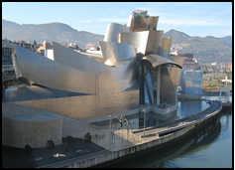
Shape 14: (Guggenheim Museum, Blbao), in the Aspania city of Blbao (2007), Architect (Frank Gehry)
Source http://en.wikipedia.org/wiki/Frank_Gehry/24-4-2017.

3-2 Aluminum Material
Aluminum is considered one of the lightest structure materials weight compared to volume. Its density is one third of iron and copper, besides aluminum has other important characterizations such as: its high resistance of rust and good resistance to fire as it is not burning as it melts but on 660 centigrade degrees, and it is relatively late degree burning to reach, its great resistance of erosion makes it long living material. Aluminum is used in our region in windows frames, besides it is sometimes used for covering few building structure elements (columns and beams). It may be resulted from our lack of information about different kinds of aluminum and its characterizations, though these characterizations could determine the fields that we can use Aluminum.
Within the second half of the twentieth century, aluminum industry has been developed to play big role in structure industry and to also contribute largely in construction field. It is used on a large scale in construction. It contributes a lot in the architectural formations and also in suspension ceilings, in addition to pre-manufactured buildings as well as in executing space ceiling units and walls covers and fine isolating sheets and others. The most important model of which aluminum is employed as principal structure material is (the Imperial Museum North) in Manchester, England in the year (1997-2001) designed by the architect (Daniel Libeskind) where he used bright aluminum sheets to cover ceilings and walls completely that made the building shining in the day light. Using aluminum in covering the building added expressions of strength to the military memorial structure so the visitor felt as if he is inside an aircraft²⁰ –(shape 15).

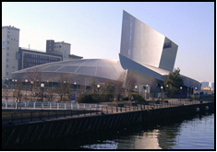
Shape 15: (Imperial War Museum North) in the England city of Manchester (2007)) Architect (Daniel Libeskind)
Source http: Imperial_War_Museum_North/25-4-2017

3-3 Glass And Thinking Architectural Attitude (new transparent forms)
Glass continued to be domineering modern structure material since using it for the first time in a contemporary manner in the middle of the twentieth century in the construction of the (Crystal Palace) in London in the year (1851) to witness the first half of the twentieth century depending on glass by several thinking architectural trend like (international style) trend. This trend approved the conceptions of (transparency) and (simplicity) in designing the external facades and executing it as thinking method achieved through using glass surfaces to cover these facades. The second half of the twentieth century witnessed a great development in (glass) industry and its applications, new types of glass appeared and also many available kinds of glass developed like strengthened glass, glass tiles, glass fibers and others. The advanced technologies made glass with special sensitivity to light and heat known these types which adopt with amount of light and heat in the building ⁸.
Thus glass participated greatly in the architectural formation in the digital technology age as a transparent material or reflective material of what is around it from buildings and nature. It also gives the building neutrality if it was used as flat area but if it was used as separate and movable sheets, it gives a changing awesome shape.
One of the most important buildings that show the importance of glass as a building material during this era the structure of (Torre Agbar) in the Spanish city of Barcelona (1999-2004) designed by the French architect (Jean Nouvel) which is considered the third highest building in Barcelona¹⁷. It became a new symbol of the city. The color of the building changes as a result of using outer glass cover, where heat sensors were put around the tower. This sensors regulate the opening or closing glass curtains which resulted in reducing consumption of power used by air-conditioners -(shape 16).

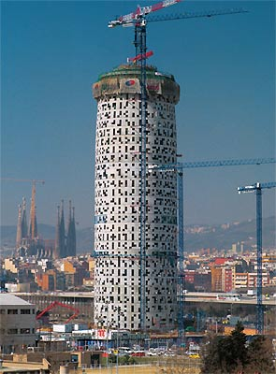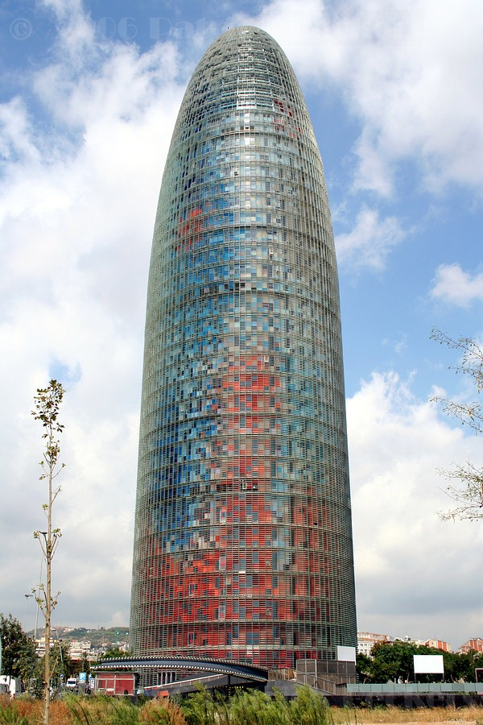
Shape 16: (Torre Agbar), in the Aspen city of Barcelona (2007), Architect (Jean Nouvel): Source http://en.wikipedia.org/wiki/Torre_Agbar/25-4-2017

Prada store in Tokyo in the Japanese capital designed by Swiss Architects (Herzog & Demeron) (1999-2003) is considered the most important models of which glass was used in a different way. Glass is used in the building façade as units of crystals includes all types of lenses (convex –bulbs etc) Herzog and Demeron describe them as optical interactive units between the user of the building and the surrounding environment-(shape 17).

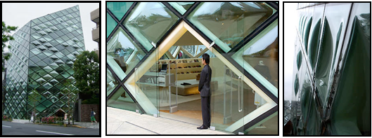
Shape 17: (Prada Store, Tokyo (, in the Jaban city of Tokyo (1999-2003), Architect (Herzog & de Meron).
Source http://www.galinsky.com/buildings/pradatokyo/index.htm/25-4-2017

3-4 Light Technologies And Architectural Thinking Trend To Produce (imaginative and assumptive forms).
The digital era accompanied with increase dependence on modern digital technologies as it appeared through buildings as models of this trend, one of this models is using screens in the buildings as a part of the wall formation as a result walls changed into information transfers consequently, it has become a part of many future and new designs. The effect of these electronic facades differ according to the type of technology used. There are several types of technologies among these advanced technologies (LED), (PIX), (LCD).
3-4-1 (LED) technology
(LED) technology is an abbreviation of light emitting diode, this technology depends on covering façade with group of glass discs and through computer program lightening of each disc is controlled with led lighting technology. The building facades are changed into active interaction facades using screens where every disc represents the building unit of the façade. In day light, discs are used as reflective mirror of lighting. One of the most important buildings that use this technology is the façade of Korean shopping mall building in Seol South korea in the year (2003-2004). designed by UN studio group (shape 18).

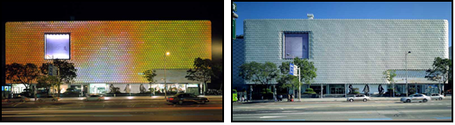
Shape18: (Korean Shopping mall building) in the Korya city of coal (2003-2004), designed by the architect (UN Studio)
Source http://www.e-architect.co.uk/korea/galleria_department_store_seoul.htm/25-4-2017

3-4-2 Light (PIX) Technology
It is circular florescent lighting units combined with external facades, and by the means computer special programs, the façade is turned into large screen. One of the important buildings which implemented the (PIX) light technology is the (modern art museum –Grazer Kunsthause or Graz Art Museum) in the city of Grazer in Austria 2000-2003. It was built in the occasion of celebrating the city as the capital of the European culture in the year 2003. Designed by team of British architects (Peter Cook) and (Colin Fournier). The building shows cook architectural trends toward innovative formation of the building mass, using of modern technology which one of it is) light technology (PIX) in the external facades and the body of the building, besides his special vision of accepting the other (Friendly Aliens). Or being familiar with whatever strange. That what cook's philosophy expresses, by combining all modern technology elements together with what the traditional red-tiled-covered buildings represent ²¹. (shape 19)

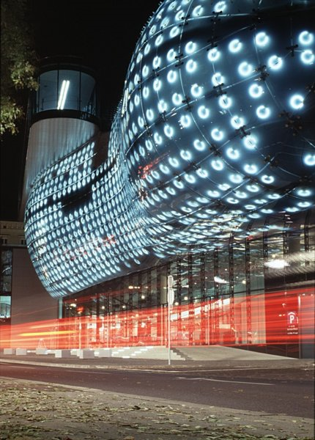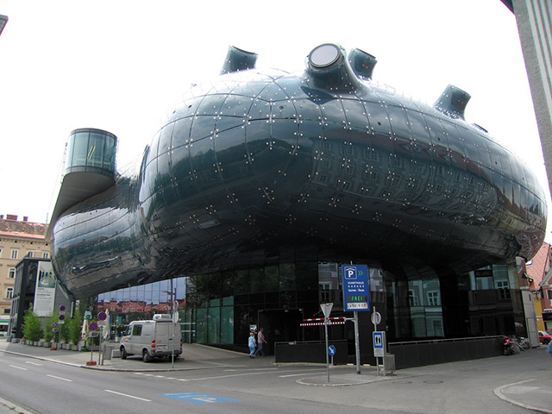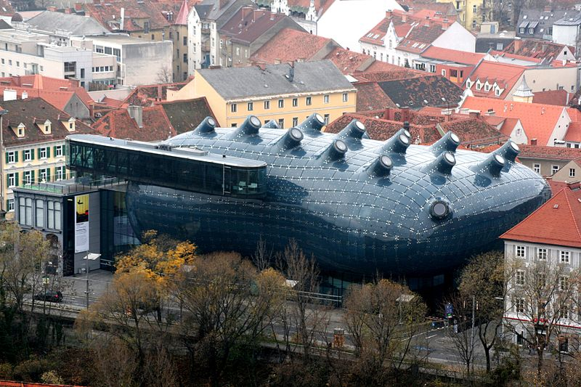
Shape 19: Use PIX technology, (Imperial War Museum North) in the England city of Manchester (2007), Architect (Daniel Libeskind)
Source http: Imperial_War_Museum_North/25-4-2017

3-4-3 LCD
They are flat limited –thickness screens consist of 6 layers that contain number of colored molecules or mono colored. They work with very little electronic energy and it is used to show by using computer. Special screens with (TFT-LCD) technologies may be used, that can be seen in direct sun light where the lightning degree is as 4 times as the normal lightning.
LCD technologies is used in designing many modern and contemporary buildings, one of them is the Digital House Project in the USA (1997-1998) by the two Iranian architects (Hariri & Hariri) where the elements of this digital house were distributed around digital axis skeleton made of iron covered with glass and made of liquid crystal material (Active Matrix liquid Crystal Displays) the walls of the rooms contain (l CD) screens to substitute screens of personal computers, for example in bedrooms or following the virtual guests in the dining room and other applications include all house spaces²² –(shape 20).

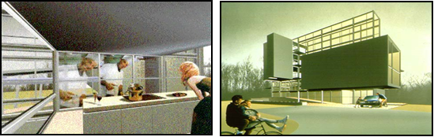
Shape 20: Use LCD technology, (Digital House), United States of America (1997-1998), For the two architects
(Hariri & Hariri)
Source http://www.haririandhariri.com/26-4-2017

Thus we see that architecture is affected very much by this enormous technology developments the world witnessed during information revolution and digital revolution era. This development included all aspects of architecture as architects started using every new and available way of architectural expression and structure systems and structure materials to make technology in a continuous state of update, all the abovementioned is to serve forms and thinking and architectural innovations.
The pace evolution has gone so fast in the fields of specialized programs, added to that construction material industry and both the execution means and the used erection systems. These have fulfilled a lot of contemporary architecture requirements.
4- Technological influences on architecture future and mental forms trend in the 21st century
Communication technologies made a revolution in the world of institutional structures and work places in offices or administrative buildings which led to medical surgeries operations, banks transactions selling, purchasing operations and governmental services, libraries and museums. All of these are being implemented through computer technologies.
With the growing benefits of capabilities of the systems and the internet in a more developed manner in the 21 century, it is expected to have a radical change in life systems and work systems inside the cities, consequently changing styles of the current buildings take place, in addition to its function to the various functions. In general, change is expected to include the three components of architecture: (function), (form) and (construction).
4-1 The Function part in the new buildings type
A change in the functional pattern is expected to take place. This change represented in two axes:
First: Jobs of the building are interfered as many whereas different and various functions could gather under one ceiling (Mega Structures) and at the same building.
Second: Some jobs are canceled or omitted, consequently omitting some spaces that used to do these jobs in the traditional types of building. It may reach the omission of the whole building as its jobs do not exist anymore in the society.
4-1-1 Multi functions structures (Mega Structure)
They are the structures that have more than one job or one activity at the same time in one Mega Structure, as Archigram intellectual pioneers group called them. They are the buildings that contain part or a whole of the city activity. One building could contain a whole residential district or a whole neighborhood.²⁴
One of the pioneers of this trend of the contemporary architect is (Rata Isozaki) the Japanese architect who suggested the idea of forming an integrated community which consists of service structure complex from hospital to laboratories, social services centers, trade center, conference hall and others. All these facilities exist Inside one building under one ceiling. He also took in consideration different systems of services such as school system, library system, pollution control system, artistic services and others. Thus he classified three types of city work systems (control), (services) and information. The center is linked with neighboring residence by web of generators to produce power-(shape 22).
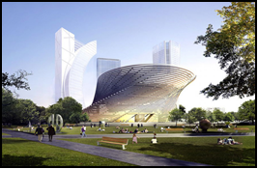
Shape 20: (Mega structure), (City Life Project, Milan), In Milan (Italian) (2011 - 2014), For the architect Arata Isozaki
Source http://www.flickriver.com.22-4-2017

4-1-2 Omitting some traditional spaces⁸:
The new life in the information technology era has led to decreasing social relations between people, thus it is expected to cancel some job spaces based on these social relations. Some examples for these spaces are (halls, guest reception rooms) in residents' building. It is already canceled in many residence because of the closeness created by the developed means of communication, specially mobiles, internet and its applications, and others.
It is expected to cancel some other spaces from the buildings like public halls to deal with the crowds in administrative buildings and banks because of the great abilities of the internet, which make it available to get administrative services and transactions done without need to move from your place before your personal computer at home or at your workplace.
Shops will change into store rooms for goods, as showing goods will be on the internet in special sites. A person can choose what he wants to get at home after paying its price in store bank account to reach the consumer at home he also can follow the goods while moving from shop to home.
Future and health care experts expect the present trends move away from the traditional types of hospitals and direct toward emergency hospitals and external clinics.
With the development of the (E-mails) capacities which reach to the ability of sending digital mails and pictures etc. It is expected to affect post agencies buildings leading to end these building or decreasing its size at least and that what happens in many countries in the world.
With the increase of (video conferences) idea, it substitutes the present conferences and this may lead to clear some halls in the buildings which specialized in holding these conferences (conference halls) besides saving costs of travel and residence.
4-2 Visual Arts in the New Types of Architecture
It is confirmed now the effects of information revolution on the types and shapes of contemporary and future architecture. It is linked with group of considerations, of which the most important is the spirit of technology that dominates the era and affects the shape of the buildings and their styles, I addition to the change expected to happen in the internal design of the buildings and its jobs and the formation of their spaces, and consequently reflect on the outlook of the building. The shape of digital house for instance will differ from what is traditionally known as house. It is expected that stereotyping will dominate in the building in addition to some other factors in forming the systems of control and how to connect private electronic sets and information webs.
The architectural shape and job of the new shop will be different from the known shop, as the shape of the shop internally and decorations attract consumers to it will practically atop to exist, customers are attracted to goods which they can be seen on electronic sites^{.25}
4-3 The Structural Part in the New Forms Types
Regarding the expected spread of automatic operations of the buildings through the perception of (digital architecture) that is close to the perception of (smart architecture), buildings will develop through sensitive surface between internal space and external environment. The outer cover will be developed into a new outer cover dominated by good qualities and innovation that are taken from the used technology in structure.
But in the case of (digital forms) spread in their comprehensive conception by controlling all inner activities in the building, it will consequently affect structure materials choices and structure style. The relation between structure and architecture will vary according to the nature of every building individually.
In the case of mega structures which are multi jobs and expected to spread and its role becomes apparently clear in the present century decades. The relation between structure and architecture will be of that type called (true structural high tech) and in the case of (digital structure) with electronic control systems the type of relation between structure and architecture will be of the type called structure symbolized. Architecture changes and develops according to technological development the world will witness. (Architecture) as art, science and industry is forever will reflect every development the present world witnesses⁸.
It is clear from what is mentioned above that (digital tectonics) will play the main role in design operations and architectural innovation in the future. Analysis studies will change both individual cultural view and sociological view of the architectural design plus capabilities of its new digital elements in linking elements and thinking of design operations with architectural product.
5-Results & Recommendations
5-1 Study Results
- Digital revolution introduced enormous capabilities that helped developing digital technology and enabled it to draw new languages and vocabularies to the architectural formation, the thing which made architecture design operation become creative operation without any hindrance horizons before the architect to innovate and create new architect and opened new unprecedented architectural formation with the aid of most recent computer technologies programs.
- What the international architectural fields witness today as a result of the effects of digital and information revolutions and computer programs technology whether in the field of architecture design or developed or smart structure materials or modern structure styles represent new stage or era that forms a large step to transition in the international architecture with the beginning of the second decade of the 21st century.
- As a result of architectural creativity that contemporary digital technology in the field of drawing new languages and vocabularies to the architectural formation, this allowed developing several former architectural thinking trends like the attitude of fauna formations but with new forms and innovated technologies. Other new trends also appeared that could not be executed but without the aid of digital technology like the attitude toward the production of fractal or deconstruction, primitive geometric forms and new modernity forms etc.
- With the appearance of the digital revolution technologies, the effects of modern digital technologies were not mere accomplishment of creative design of architectural form, but they extended their effects to the ways of execution and structure materials, where digital technology interacted to produce smart modern materials innovated as a result of the interaction between traditional materials with electronic systems.
- Being smart materials that were produced as a result of digital revolution technologies, they were considered materials that have developed technological characterizations able to change and transform to suit ambient circumstances. They have the ability to feel energy stored and release it as needed, so it was employed in a developed way in the architectural formation because it enjoy vast abilities in free artistic formation. Thus appeared new architectural trends like producing imaginative or verbal form and other modern form trends.
- It is expected with the great magnifying benefits of the abilities of web systems in a way more developed in the near future fundamental change that will occur in life style and work in the city. It will be followed by change in present buildings and facilities in all kinds and jobs, also changes in the way these different jobs are performed. Such things require restudy of space elements forming various types of building from the side of architects.
- As a result of technological and technical development, architects will get vast experiences as a result of the ability to simulate building digitally as well as living and roaming inside its different spaces and correct design mistakes before execution. This is available now but on a limited scale.
- Architect is a part of the environment and the society where he lives interacts and integrates with its renewed or various affairs under systems and accomplishments of the era. Thus he has to interact positively with what science produces not to ignore and deny it. Yet, on the opposite side he must introduce something new to his community to fulfill its needs and requirements in a way characterized by the aware and true kind of development.
  - Study recommendations
- The architect must exert efforts to fully benefit from all aspects of technological development in architectural work and in all fields related to it, whether it concerns architectural design as finding new languages and vocabularies that suits the spirit of the present era, or concerns employing modern structure materials and styles of structure and executing technologies to serve architecture work and developing it to avoid architecture being backward from the society developments everywhere in the era of digital revolution.
- Architects should change from being users of digital technology applications into the field of to architecture to contribute in research and developing of computer applications to serve their designs purposes.
3- The architect should seek the intellectual trend that suits and is harmonized with the product architecture environment, along with the place and local effects with their various characteristics. In the same time he should not ignore the technological side that expresses the spirit of the era.
4- It is important to develop the academic study programs in architectural educational institutes either in architectural design syllabus or others to adequate the variable modern technology produced by digital and to make student get knowledge and training about modern digital technologies and its various applications in all architectural work fields.
5- Specialized architectural research centers whether in universities or related research authorities should care for supporting serious scientific research to employ modern digital technologies and its applications and develop it in architectural fields to adequate society's conditions, abilities and its needs.
6- The importance to search the future of architecture and its importance through regarding great sociological changes and variables that was resulted from modern digital technologies and their various applications that changed many basics of buildings' functions and how to secure the architectural harmony with these requirements.

References
- Yasser Ahmed Farghaly, Architectural Thinking at the end of 20th century, Master paper, Faculty of Fine Arts –Alexandria University, (2004), P 12.
- Abeer Samy Yousef, Dialectical View to a New Dimension of Architectural Design & Structure Technology, Third International Conference of the Association of "Architectural Design with the Aid of Computer", Cairo (2007), Pages 1-5.
- Dr. Essam Eldin Badran, Creative Abilities of Modern Technologies in Architectural Formations, (Cairo Engineering Research Magazine, Helwan University 2008, P 9.
- Ali Raafat, Deconstruct Contents out of Shape and Surroundings, Arab structure periodical (2005), March Issue No: 1, Cairo P 33.
- Dr. Hisham Gresha, Relativity and Fractility, Cairo: Anglo Egyptian Press (2011) P 74.
- Agnoletto, M. (2006). Masterpieces of Modern Architecture, VMB Publishers, Vercelli pp. 32- 273.
- Isenberg, Barbara. (2009). Conversations with Frank Gehry, Knopf; First Edition, New York, pp. 12- 164.
- Dr. Khalid Mahmoud Heyba, Contemporary Architecture & Technology: Critical View of Digital Technology's Effects on Dominating Architectural Trends with the Commence of 21st C, Engineering & Architecture, the Magazine of Om Elkora University (2013), Volume 5, Issue 1, P 58.
- Foster, Norman. Reflections, Prestel Publishers, London 2005, pp. 27- 109.
- Erfan Samy, Organic Architecture Theories, Cairo 1968, United Colors Print Institute, Cairo 1968.
- Mustafa Baghdady, Nubi Mohamed Hasan, Architecture Theories.
- Studying changes in the western architectural thinking through history. Scientific publications & press houses-king Saud University, Alryadh. 2009. Pages 141-178.
- Ahmed Ahmed Kamel. (Architecture & Technology) study on the effects of technological developments on contemporary Architecture identity. (master degree paper –Faculty of Engineering Alazhar University 2012) page 30.
- Jodidio, Philip. (2012). Zaha Hadid, Taschen, Germany, pp. 24- 76.
- Hassan Qebesy, famous architectural engineering thinkers, Frank Loyed Wright. Qabes, inc. Publisher Beirut (1992) page205.
- Monninger, Michael. Coop Himmelblau, Taschen, Germany, (2010). pp. 41- 83.
- Orringer, Julie. (2011). The Invisible Bridge, Vintage, New York, pp. 34- 79.
- Casamonti, Marco. (2009). Jean Nouvel (Minimum, Essential Architecture Library Motta Publishers, Milano, Italy, pp. 63- 113.
- Kunsthaus, Graz: innovative museum design, cultural and urban regeneration Unit of – Architecture, Built Environment and Planning Institution: University College London, P 5.
- Hariri, Gisue and Mojgan. (2006). Hariri and Hariri Houses, Rizzoli Publishers, New York, pp. 17- 128.
- Wael Salah Eldin Bahlool Khalil, The Effects of Digital Evolution on the fields of job and architectural formation (Cairo, Scientific Pamphlet of Urban Researches Magazine (Issue 10.2013) Pages 1-11.
- Asaad Hasan Ali, Gorge Mahfouz, Modern Materials in Modern Covering, Reality & Horizons, Damascus engineering sciences university-Volume 22 issue first Damascus2001 page 11.
- Omar Hashem, The Effect of Contemporary Technology on Facades Architectural Formation in the Arab World. (Unpublished Master Degree Paper –Faculty of Engineering –Cairo University 2000), page 151.
- Mohamed Mohamed Aweyda, Future Architecture. structure world. issue 84 Cairo (2000) Page 31.
- Nuby Mohamed Hassan, Values of Creativity in Architectural Design (Asyut: The Fourth International Architectural conference. faculty of Engineering, Asyut University 2000) Page 10.
- Nuby Mohamed Hassan. Information Architecture view of obscure Architectural creativity in the twenty first century (Asyut: The Fourth International Architectural conference, Faculty of Engineering, Asyut University 2000) Page 11.
Electronic Websites on the Internet:
- http://en.wikipedia.org/wiki/% Csanbashi_Pier/3-3-2017.-1.
- http://en.wikipedia./Jewish_Museum_Berlin/20-3-2017.-2.
- http://en.wikipedia.org/wiki/Stata_Center/20-3-2017.-3.
- http://en.wikipedia.org/wiki/Dancing_House/20-3-2017.-4.
- http://en.wikipedia.org/wiki/City_Hall_ (London)/4-4-2017.-5.
- http://en.wikipedia.org/wiki/30_St_Mary_Axe/8-4-2017.
- http://en.wikipedia.org/wiki/Ciutat_de_les_Arts_i_les_Ci%C3% A8ncies/12-4-2017.
- http://en.wikipedia.org/wiki/Phaeno_Science_Center/20-4-2017.
- http://en.wikipedia.org/wiki/EMP_Museum/20-4-2017
- http://www.eisenmanarchitects.com/21-4-2017.
- http://fr.wikipedia.org/wiki/Mus%C3%A9e_des_Confluences /22-4-2017.
- http://en.wikipedia.org/ /Hearst_Tower_%28New_York_ City%29 /22-4-2017.
- http://en.wikipedia.org/wiki/Jean_Nouvel/22-4-2017.-14
- http://en.wikipedia.org/wiki/Frank_Gehry/22-4-2017.15-.
- http: Imperial_War_Museum_North/22-4-2017.-16.
- http://en.wikipedia.org/wiki/Torre_Agbar/22-4-2017-17.
- http://www.galinsky.com/buildings/pradatokyo/index.htm/22-4-
- http://www.e-architect.co.uk/korea/galleria_department_store_seoul.htm/22-4-2017-19.
- http://en.wikipedia.org/wiki/Kunsthaus_Graz.
- http://www.haririandhariri.com/22-4-2017-21.
- http://www.flickriver.com.22-4-2017.

7/17/2017

