**Vulnerability and adaptation measures of faba bean under climate change conditions in North Nile Delta and Middle Egypt**

El-Marsafawy, Samia M; N. G. Ainer and M. A. M. Ibrahim

Soil, Water and Environment Research Institute (SWERI), Agricultural research Center (ARC), Egypt

[Samiaelmarsafawy797@hotmail.com](mailto:Samiaelmarsafawy797@hotmail.com)

**Abstract:** This study was conducted to assess the adverse impacts of climate change on some faba bean varieties and to find out the possible options to overcome such negative impacts through adaptation strategies. A field trial was carried out during the two successive winter seasons 2010/2011 and 2011/2012 at Sakha (North Nile Delta area) and Giza (middle Egypt), agricultural research stations. Each experiment included four tested faba bean varieties; Sakha2 (V1), Sakha3 (V2), Giza3 (V3) and Giza843 (V4). The Decision Support System for Agrotechnology Transfer "DSSAT" program was run using input data in weather, soil and crop management. Simulations were carried out on data covering 25 - 30 years under the normal weather conditions and climate change conditions. The results indicated that productivity of faba bean will vary between few decrease or increase under climate change conditions. The change percent in faba bean seed yield ranged between -3 and +5 % at Sakha; and between -9 and +0.2% at Giza. Additionally crop water productivity has declined significantly under climate change conditions ranging from-4 to-12% in Sakha,-9 to-18% in Giza. Regarding adaptation strategies, the results showed that the highest seed yield under climate change was given by V4 when sown on 19th Nov. at Sakha and V1 when sown on 10th Dec. at Giza. Increasing the amount of irrigation water by 10 or 20% at Sakha site led to increase crop productivity by 3% and 6%, respectively. While reducing the amount of irrigation water 10 to 20% reduced productivity by 3 to 26%. At Giza, increasing amount 10 % could increase yield by 3 % and up to 4 % with increasing amount 20 %. However, decreasing amount of irrigation water 10 to 20 % could decrease yield from 3 % up to 12 %. Lastly, under water shortage that facing Egypt, the results showed that skipping the last irrigation has the least negative effect on marketable crop yield.

[El-Marsafawy, Samia M; N. G. Ainer and M. A. M. Ibrahim. **Vulnerability and adaptation measures of faba bean under climate change conditions in North Nile Delta and Middle Egypt.** *N Y Sci J* 2017;10(8):77-88]. ISSN 1554-0200 (print); ISSN 2375-723X (online). <http://www.sciencepub.net/newyork>. 11. doi:[10.7537/marsnys100817.11](http://www.dx.doi.org/10.7537/marsnys100817.11).

**Keywords:** Climate change, DSSAT, Adaptation options, faba bean

**1. Introduction**

Beans group are one of the popular legume crops worldwide including Egypt with their high protein content of about 25%. Beans are part of the diet for Egyptian and many other countries. Common bean is the second important commercial legume crop after soybean (Singh *et al.*, 1999).

Recent climatological studies found that the global surface air temperature has increased by 0.76 C° from 1850 to 2005. In addition, warming over the last 50 years has been recorded at 0.13 C° per decade (IPCC, 2010). The impact of climate change (CC) will lead to a decrease in crop productivity, but with important difference between regions (McCarthy *et al.*, 2001). The effects of CC on crop production are very complex, depending on the temperature regime and the crop. High temperatures can lead to low yields due to increasing development rates and higher respiration as well as evapotranspiration (Nonhebel, 1993).

Based on the third assessment report (TAR) prepared by Gitay *et al.* (2001), they reported that climate change will impact food, fiber and forests around the world due to its effects on plant growth and yield of elevated CO2, higher temperatures, altered both precipitation and transpiration regimes, and increased frequency of extreme events, as well as modified weed, pest and pathogen pressure.

Rosenzweig *et al.* (2002) concluded that under scenarios of increased heavy precipitation, production losses due to excessive soil moisture would double in the U.S. by2030 to US$3 billion/yr. Moniruland Mirza (2002) computed an increased risk of crop losses in Bangladesh from increased flood frequency under climate change. In scenarios with higher rainfall intensity, Nearing *et al.* (2004) projected increased risks of soil erosion, while van Ittersum *et al.* (2003) simulated higher risk of salinisation in arid and semi-arid regions due to more water loss below the crop root zone. Howden *et al.* (2003) focused on the consequences of higher temperatures on the frequency of heat stress during growing seasons, as well on the frequency of frost occurrence during critical growth stages. Parry *et al.* (2007) indicated that yields of grains and other crops could decrease substantially across the African continent because of increased frequency of drought, even if potential production increases due to increases in CO2 concentrations.

Worldwide, water has become a commodity of strategic importance because of increasing demands due to rapidly increasing population, social changes, and the increase industrial growth.

The agricultural sector is the largest user of water in Egypt with its share exceeding 80% of the total national demand from water. In view of the expected increase in water demand from other sectors, such as municipal and industrial water supply, the development of Egypt’s economy strongly depends on its ability to conserve and manage its water resources.

At present, water annual capita share for different purposes is less than the water poverty edge of 1000 m3 with continuous decreasing and it expecting to reach the scarcity level of less than 500 m3 in the near future, particularly under the annual high growth of national population. Hence, at this situation of water shortage, it is difficult to make any progress in any sector of development.

Egypt is one among the countries that strongly likely to the severe adverse impacts of the climate change phenomenon, particularly on decreasing both water supply and crop yield and vice versa regarding crop water needs e.g. increasing crop water needs.

The aim of the present investigation is to find out the adverse impacts of climate change on faba bean production, crop water productivity, and how to decrease such negative effects.

**2. Materials and methods:**

**Selection of the experimental sites**

To achieve the mentioned objectives, two sites were selected at Sakha and Giza experimental stations to conduct the concerning field trials. Sakha site represents the conditions and circumstances of the middle northern part of Nile Delta, while Giza site is located in the middle Egypt.

Sakha site lies at 31º-07´ N. Latitude and 30º- 57´ E Longitude with an elevation of about 20 metre above mean sea level, while Giza site lies at 30º -03´ N Latitude and 31º -13´ E Longitude with an elevation of about 19 metre above mean sea level. Data of particle size distribution (Klute,1986) and some soil chemical parameters (Jackson,1973) of the two sites are presented in Table 1. Results indicated that the soil of Sakha site is characterized with very high clay content, low organic matter, light in both salinity and alkalinity levels. With respect to Giza site, the soil is having high clay content, Low organic matter and salinity levels.

Some soil moisture constants and bulk density at Sakha and Giza sites are presented in Table 2. Data indicated that the soil at each site is having high field capacity and wilting point as a result of the high clay content. Therefore, the available water in the effective root zone of 60 cm soil depth which can be used by the growing plants is fairly high.

**Table 1: Particle size distribution and some soil chemical analysis at Sakha and Giza sites.**

|  |  |  |
| --- | --- | --- |
| **Particle size distribution** | **Sakha** | **Giza** |
| Sand % | 16.13 | 15.95 |
| Silt % | 23.77 | 30.51 |
| Clay % | 60.10 | 53.18 |
| Textural class | Clayey | Clayey |
| **Chemical analysis** | | |
| Organic matter % | 1.37 | 1.80 |
| Available N ppm | 62.76 | 40.00 |
| Available P ppm | 10.45 | 19.00 |
| Available K ppm | 101.98 | 304.00 |
| Ecmmhos / cm | 1.92 | 2.65 |
| Ph, 1: 2.5 suspension | 8.40 | 7.40 |

**Table 2: Soil moisture constants and bulk density for Sakha and Giza experimental sites.**

|  |  |  |  |  |  |
| --- | --- | --- | --- | --- | --- |
| Soil depth (cm) | Field capacity (%,wt) | Wilting point (%,wt) | Available moisture (%,wt) | Bulk density  (kg/ m3) | Available moisture (mm) |
| **Sakha site** | | | | | |
| 00 – 15 | 47.50 | 25.82 | 21.68 | 1.26 | 40.98 |
| 15 – 30 | 39.78 | 21.62 | 18.16 | 1.30 | 35.41 |
| 30 – 45 | 38.40 | 20.87 | 17.53 | 1.29 | 33.92 |
| 45 - 60 | 36.39 | 21.41 | 14.98 | 1.38 | 31.01 |
| Average | 40.52 | 22.41 | 18.46 | 1.31 | Total = 141.32 |
| **Giza site** | | | | | |
| 00 – 15 | 41.80 | 18.60 | 23.20 | 1.20 | 41.80 |
| 15 – 30 | 33.70 | 17.50 | 16.20 | 1.20 | 29.20 |
| 30 – 45 | 28.40 | 16.90 | 11.50 | 1.20 | 20.7 |
| 45 - 60 | 28.00 | 16.50 | 11.50 | 1.30 | 22.4 |
| Average | 32.98 | 17.38 | 15.60 | 1.23 | Total = 114.1 |

Table 3 represents the agro-meteorological data at Sakha and Giza sites in 2010/2011 and 2011/2012winter seasons which were obtained from the Agro-meteorology and Climate Change Unit; Soils, Water and Environment Research Institute (SWERI); Agricultural Research Center (ARC), (unpublished data).

**Table 3: Average of agro-meteorological data at Sakha and Giza sites in 2010/2011 and 2011/2012 winter seasons.**

|  |  |  |  |  |  |  |  |  |  |  |  |  |
| --- | --- | --- | --- | --- | --- | --- | --- | --- | --- | --- | --- | --- |
| Month | T, max | T, min | W.S | R.H. | S.R | R.F | T, max | T, min | W.S | R.H. | S.R | R.F |
|  | **Sakha site (2010/ 2011)** | | | | | | **Sakha site (2011/ 2012)** | | | | | |
| November | 26.8 | 10.9 | 0.7 | 68 | 315 | - | 24.0 | 10.5 | 0.8 | 70 | 315 | - |
| December | 22.6 | 8.6 | 0.8 | 71 | 250 | 91 | 20.2 | 6.4 | 0.6 | 74 | 250 | 15 |
| January | 21.0 | 5.8 | 0.5 | 70 | 273 | 18 | 10.1 | 8.4 | 0.7 | 69 | 273 | 33 |
| February | 21.7 | 6.9 | 0.7 | 66 | 344 | 23 | 11.4 | 9.6 | 0.8 | 69 | 344 | 33 |
| March | 22.5 | 6.7 | 0.9 | 70 | 435 | 14 | 14.3 | 12.3 | 1.1 | 69 | 435 | 43 |
| April | 26.5 | 9.9 | 1 | 66 | 517 | 27 | 19.0 | 17.1 | 1.0 | 64 | 517 | - |
| May | 30.0 | 13.2 | 1.2 | 59 | 576 | - | 22.6 | 20.8 | 1.2 | 63 | 576 | - |
|  | **Giza site (2010/ 2011)** | | | | | | **Giza site (2011/ 2012)** | | | | | |
| November | 28.6 | 17.1 | 3.8 | 68 | 326 | - | 24.5 | 13.3 | 1.3 | 65 | 326 | 1.0 |
| December | 23.6 | 12.1 | 3.1 | 63 | 268 | - | 23.6 | 12.1 | 1.3 | 63 | 268 | - |
| January | 21.2 | 9.7 | 2.3 | 68 | 280 | 1.8 | 19.2 | 8.3 | 1.4 | 61 | 280 | 2.6 |
| February | 22.9 | 11.3 | 3.2 | 56 | 354 | 2.0 | 20.7 | 9.0 | 1.4 | 59 | 354 | 0.4 |
| March | 24.8 | 11.9 | 5.2 | 57 | 441 | - | 23.6 | 11.3 | 1.8 | 61 | 441 | - |
| April | 28.7 | 15.2 | 3.4 | 51 | 519 | 1.2 | 30.7 | 15.9 | 1.8 | 51 | 519 | - |
| May | 32.8 | 18.7 | 4.3 | 50 | 585 | - | 34.2 | 20.0 | 1.6 | 51 | 585 | - |

Where:T max., T min. = maximum, minimum temperatures °C; W.S = wind speed (m/ sec); R.H. = relative humidity (%); S.R = solar radiation (cal/ cm2/ day) and R.F = rainfall (mm).

**Agricultural practices**

Seedbed preparation was executed as recommended by ARC. A basal dose of P- fertilizer equals 72 Kg P2O5/ ha was added as ordinary super phosphate during seedbed preparation. In order to attain high uniformity distribution of applied irrigation water, soil surface of the experimental field was leveled using laser technique. Four tested faba bean varieties; Sakha2 (V1), Sakha3 (V2), Giza3 (V3) and Giza843 (V4) were assessed in Randomized Complete Blocks Design, each with four replicates. During the two growing seasons, sowing was executed on 19/11/2010 and22/11/2011 at Sakha and 11/11/2010 and 18/11/2011 at Giza. The field trial plot was 42 and 30 m2 at Sakha and Giza, respectively. The recommended N- rate of 36 kg N/ ha, as urea of 46.5% N, was applied before the life irrigation (first following sowing). Surface irrigation which considered as the traditional method was the watering method usedin these experimental field trials.

**Vulnerability study**

Vulnerability study for some faba bean varieties under climate change conditions was estimated with the BEN- GRO model included in the Decision Support System for Agrotechnology Transfer (DSSAT3.5), (Tsuji et al., 1998). Equilibrium doubled CO2 climate change scenarios were derived from the Canadian Climate Center (CCCM) and the Geophysical Fluid Dynamic Laboratory (GFD3) general circulation models (GCMs). The simulation was performed for a period of 25 years (1975 – 1999) for Sakha and 30 years (1960 – 1989) for Giza.

Simulation of crop water productivity was estimated according to Smith (2002). Crop water productivity is defined as Crop yield / Water consumptive used as ET.

**Adaptation Studies**

Analysis of adaptation scenarios were executed in connection with the following three aspects:

1. **sowing dates:**
2. 19th Nov. (Base under current)
3. 19th Nov. (Base under climate change)
4. 1st Nov.
5. 10th Nov.
6. 1st Dec.
7. 10th Dec.
8. 20th Dec.
9. **Irrigation water amounts:**
10. Base amount (under current)
11. Base amount (under climate change)
12. Base amount -10%.
13. Base amount -20%.
14. Base amount +10%.
15. Base amount +20%.
16. **Skipping irrigation at different growth stages:**
17. Base treatment (without skipping under current).
18. Base treatment (without skipping under climate change).
19. Skipping the second irrigation.
20. Skipping the third irrigation.
21. Skipping the fourth irrigation.
22. Skipping the fifth irrigation.
23. Skipping the sixth irrigation.

**3. Results and Discussions**

1. **Vulnerability studies on faba bean yield under climate change conditions (GCM climate change scenarios).**

Increasing temperature resulting from climate change may be useful for certain varieties of faba bean and this is evident in the following results. The results showed that the increase in temperature in the site of Sakha will cause change in productivity of faba bean varieties from 2633, 1654, 1882 and 2695 to 2581, 1742, 1821 and 2667 kg/ ha for V1 up to V4, respectively. The change percent reached about -2, +5, -3 and -1 % for the same respective varieties (Figs. 1-2).

The same trend was found at Giza site. Results as presented in Fig. 3 found that the change in the productivity of varieties was from 3861, 2233, 3373 and 3213 to 3757, 2237, 3073 and 3085 kg/ ha, respectively. The change percent was -3, +0.2, -9 and -4 % (Fig. 4). From these results it appears that productivity of faba bean will vary between few decrease or increase under climate change conditions.

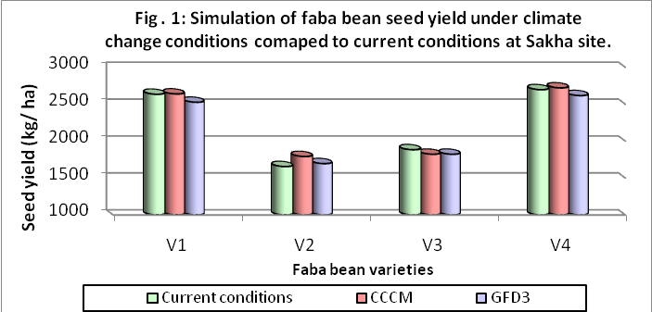

Note: V1= Sakha2 variety, V2= Sakha3 variety, V3= Giza3 variety, V4= Giza843 variety.

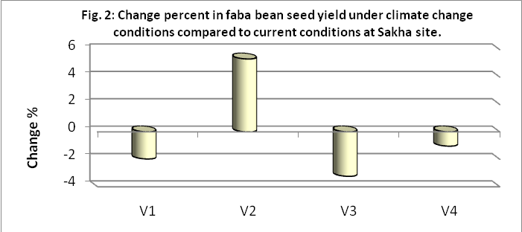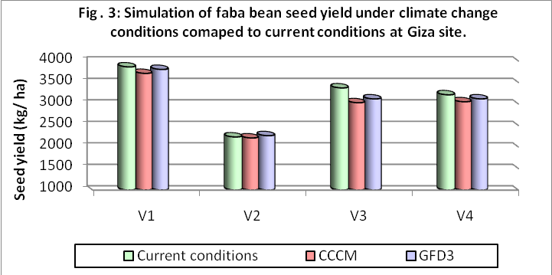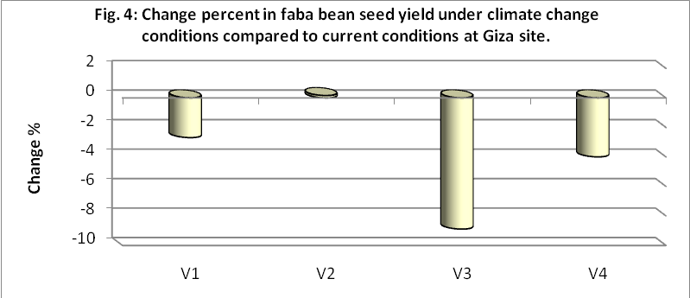

1. **Vulnerability studies on crop water productivity (CWP) under climate change conditions**

Although the impact of climate change on the productivity of faba bean diversity is between slight decrease and slight increase, the crop water productivity dropped so much. This is due to increase water consumption and decrease seed yield in the study sites under climatic changes conditions. Figures 5to 8 indicate the direction of crop water productivity under current and climate change as well the rate of change at Sakha and Giza sites. Results clearly show that the CWP at Sakha changed from 0.77, 0.49, 0.55 and 0.79 kg/ m3 under current conditions to 0.69, 0.47, 0.49 and 0.71 kg/ m3 under climate change for V1 up to V4, respectively. The change percent reached of -11, -4, -12 and -10 % with the same respective varieties.

At Giza, CWP changed from 0.98, 0.57, 0.86 and 0.82 kg/ m3 to 0.86, 0.51, 0.71 and 0.71 kg/ m3 for V1 up to V4, respectively. According to these results the change percent of CWP reached about -12, -9, -18 and -13 %, respectively.

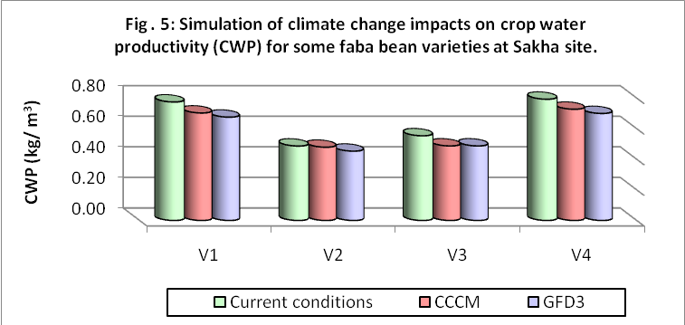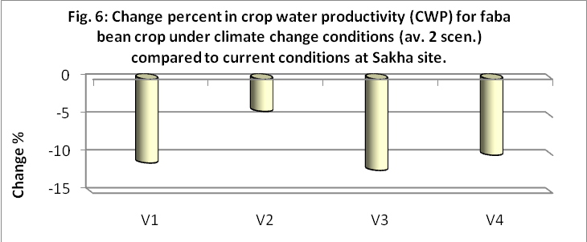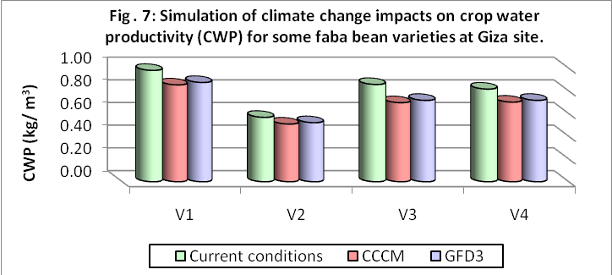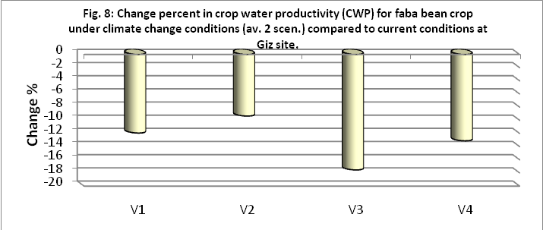

1. **Adaptation studies for faba bean seed yield under climate change.**

**3-1- Adaptation under sowing dates:**

Results as presented in Fig. 9 illustrate that the optimum sowing date at Sakha site is 1st Dec. for all varieties except V4 which superior on 19th Nov. The highest seed yield under climate change was given by V4, sown on 19th Nov. (2667 kg /ha); and the lowest was given by V2, sown on 1st Nov. (1647 kg/ ha).

Regarding Giza site, the optimum sowing date is10th Dec. for all varieties except V2, which superior on 1st Dec. (Fig. 10). The highest seed yield (3956 kg/ ha) under climate change was found for V1, sown on 10th Dec., while, the lowest one registered for V2 when sown on 1st Nov. (2130 kg/ ha) and 20th Dec. (2188 kg/ ha).

**3-2- Adaptation under irrigation water amounts:**

Increase the amount of applied water have had little effect in increasing the productivity of the crop while the water shortage had a significant impact in reducing crop productivity with reduced amount of irrigation water by 20%. Results as recorded in Fig. 11 indicate that increasing the amount of irrigation water by 10 or 20% at Sakha siteled to increase crop productivity by 3% and 6%, respectively. While reducing the amount of irrigation water 10 to 20% reduced productivity by 3 to 26%. The superiority of varieties under excess water amounts was found for V4 followed by V1 when increased irrigation amount 10%. While under conditions of increasing the amount of irrigation water 20%, the productivity increased 2% and 1%, respectively. The lowest ones were found for V2 and V3 especially under deficit irrigation 20 %.

With respect to Giza site, results as recorded in Fig. 12 indicate that increasing amount of irrigation water could be achieved a clear increase in faba bean productivity under climate change conditions. Increasing amount 10 % could increase yield by 3 % and up to 4 % with increasing amount 20 %. However, decreasing amount of irrigation water applied 10 to 20 % could decrease yield from 3 % up to 12 %. The varieties that excelled under conditions of increasing the amount of irrigation water applied were V1 followed by V4 and V3, while, V2 is the lowest variety under climate change.

**3-3- Adaptation under skipping irrigation at different growth stages:**

Skipping irrigation or elongation the period between waterings under climate change conditions will cause major shortfalls in crop productivity. The highest reduction in faba bean productivity at Sakha found for skipping 2nd irrigation (Fig. 13) which resulted in reduction in seed yield by 61, 61, 35 and 63 % for V1 up to V4, respectively. However, skipping last irrigation (3rdirri.) resulted in reduction of 11, 4, 7 and 10 % for the same respective varieties.

As for Giza, results as presented in Fig. 14 clearly show that skipping 3rdirrigation, followed by 2nd and 4thirrigation could reduce crop productivity from 6 to 18 %. Results also indicated that skipping irrigation at the last watering (6thirri.) caused reduction in crop productivity less than the other skipping irrigation treatments.

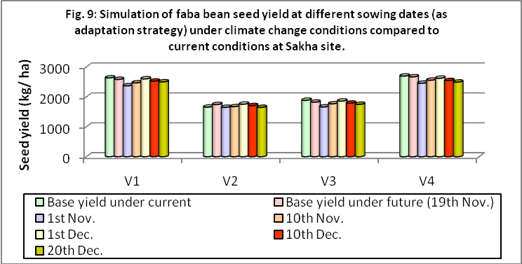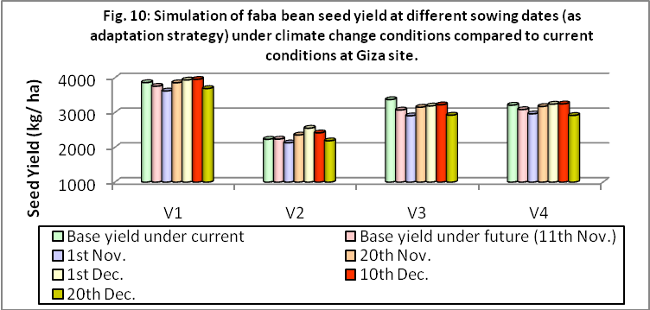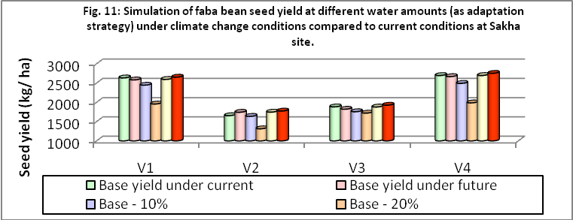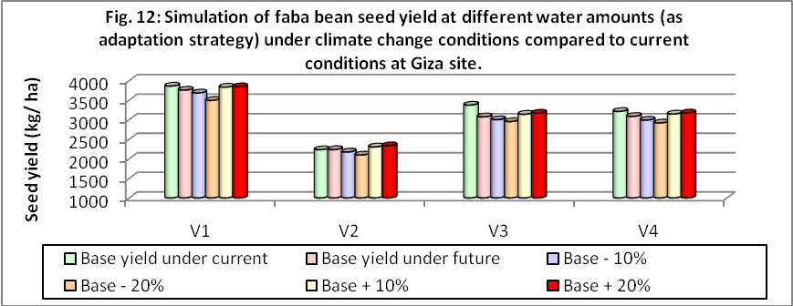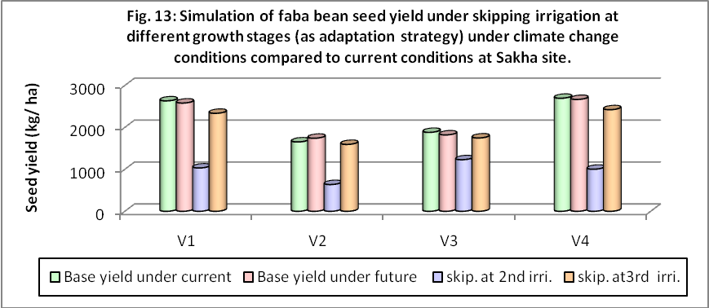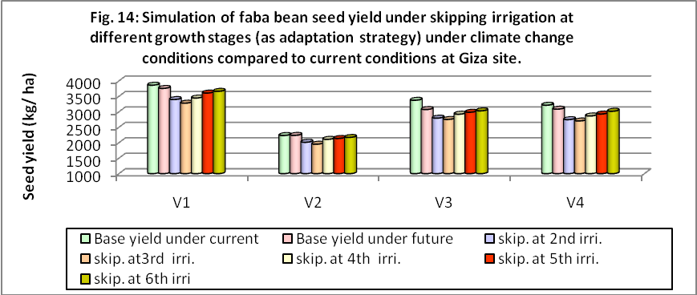

It is worth mentioning that the number of irrigations of faba bean plants during growing season reached 3 irrigations at Sakha and 6 irrigations at Giza as a result of lower temperature and increased rainfall at Sakha.

1. **Adaptation studies for crop water productivity (CWP).**

**4-1- Adaptation under sowing dates:**

Sowing faba bean through 19th Nov. to 1st Dec. at Sakha site (Fig. 15) caused increase CWP from about 2 to 10 % as compared with the other sowing dates. However, sowing on 1st Nov. or 20th Dec. resulted in more reduction in CWP.

Regarding Giza site (Fig. 16), changing sowing date from 11th Nov. (base sowing date) to 1st Dec. resulted in increasing CWP by 5, 14, 4 and 5 % for V1 up to V4, respectively. The highest CWP of 0.91 kg/ m3 consumed water was found for V1when sown on 1st. or 10th Dec. The least ones of 0.49 and 0.50 kg/ m3 were found for V2 when sown on 1st Nov. and 20th Dec., respectively.

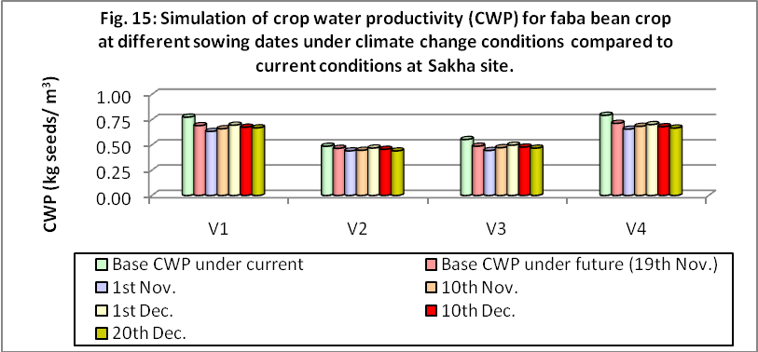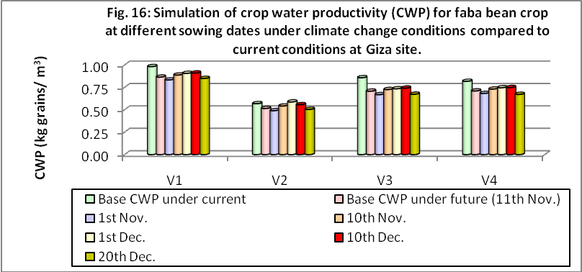

**4-2- Adaptation under irrigation water amounts:**

Results at Sakha as recorded in Fig. 17 show that decreasing irrigation water amounts by 10 or 20 % resulted in decreasing CWP from 6 to 26 %. However, increasing irrigation amounts by 10 or 20 % caused increased CWP up to 6%.

As for Giza (Fig. 18), shortage of irrigation water amounts up to 20 % could be reduced CWP from 4 to 7 %, While, increasing amounts up to 20 % caused increase CWP up to 4%.

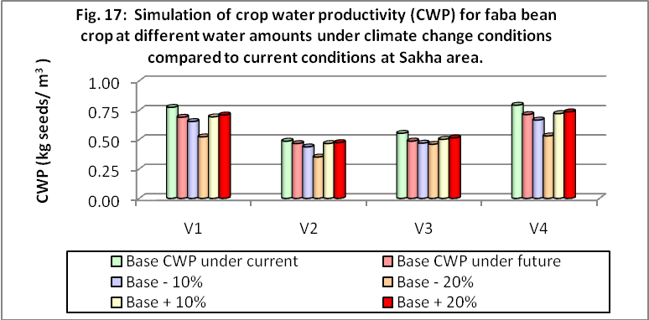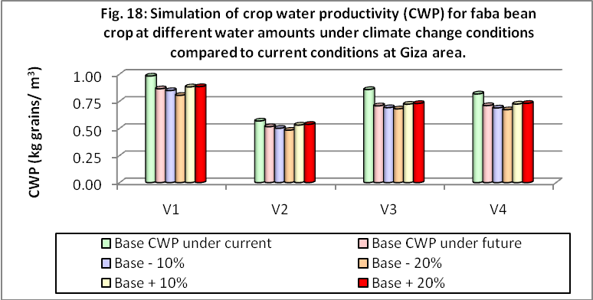

**4-3- Adaptation under skipping irrigation:**

Skipping irrigation for faba bean at 2ndwatering at Sakha site resulted in decreasing CWP of 60, 63, 32 and 62 % for V1 up to V4, respectively, as compared with base treatment (without skipping) under climate change conditions (Fig. 19). However, skipping at 3rdirrigation (last irri.) caused reduction of 9, 8, 4 and 9 % for the same respective varieties.

Concerning Giza site, results as presented in Fig.20 clearly show that skipping irrigation at 3rd followed by 2ndwatering could reduce CWP ranging from 9% to 13 %. Results also show that, skipping irrigation at last watering (6thirri.) recorded less reduction compared with the reduction under other skipping.

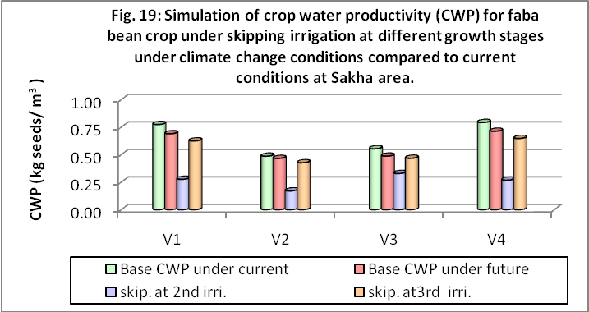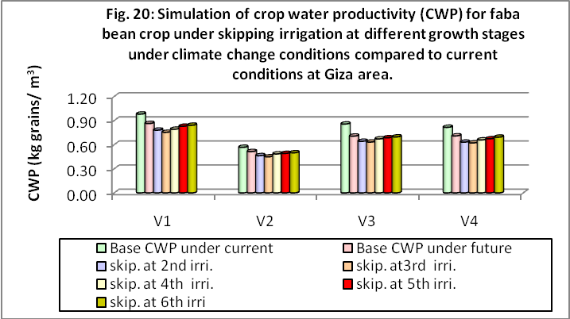

**Conclusions and policy suggestions**

Global Circulation Models (GCMs) and the dynamic crop growth model BEN-GRO through **"DSSAT"** program was used to assess the potential impact of climate change on some faba bean varieties.

Vulnerability of faba bean productivity to climate change ranged between slight decrease and slight increase. Obtained results showed that the change percent of seed yield ranged between -3 and +5 % at Sakha; -9 and +0.2 % at Giza. In addition, the reduction of crop water productivity reached up to 12 % at Sakha and 18 % at Giza.

Choosing the appropriate adaptation strategies can contribute significantly in reducing the negative impact of climate change on the agricultural sector. The results illustrated the promised strategies to identify the suitable adaptation package for faba bean crop in each climatic zone. For example, increasing the amount of irrigation water with 10 - 20% can be contributed in minimizing the adverse impact of climate change.

Under water shortage that facing Egypt, the results showed that skipping the last irrigation has the least negative effect on marketable crop yield.

Moreover, identifying the appropriate crop varieties to be cultivated in each climatic area will have a positive effect on crop productivity under future climatic conditions.

**STDF Acknowledgment**

This project was supported financially by the Science and Technology Development Fund (STDF), Egypt, Grant No.971.

**References**

1. Gitay, H., S. Brown, W.E. Easterling, B. Jallow, J. Antle, M.Apps, R. Beamish, C. Cerri and Coauthors, 2001: Ecosystems and their services. *Climate Change2001:* Impacts, Adaptation and Vulnerability to Climate Change. Contribution of Working Group II to the Third Assessment Report of the Intergovernmental Panel on Climate Change, J.J. McCarthy, O.F. Canziani, N.A. Leary, D.J. Dokken and K.S. White, Eds., Cambridge University Press, Cambridge, 236- 342.
2. Jackson, M. L. (1973). Soil Chemical Analysis. Prentice Hall of India Private. LTD, New Delhi.
3. Klute, A (1986). Methods of soil analysis, part 1,2nd ed. Agron. Monogr.,9, ASA., Madison, W, USA., pp:635-665.
4. Howden, S.M., A.J.Ash, E.W.R. Barlow, C.S. Booth, R. Cechet, S. Crimp, R.M.Gifford, K. Hennessy and Coauthors (2003). An overview of the adaptive capacityof the Australian agricultural sector to climate change – options, costs and benefits. Report to the Australian Greenhouse Office, Canberra, Australia, 157pp.
5. IPCC, 2010. Climate Change 2010: The Scientific Basis, Summary of Policymakers-Contribution of Working Group1 to the IPCC Fourth Assessment Report 2010.
6. McCarthy, J. J., O. F. Canziani, N. A. Leary, D. J. Dokken and K. S. White. (2001). Climate Change Report 2001: Impacts, Adaptation and Vulnerability. Contribution of Working Group II to the Third Assessment Report (TAR). Cambridge Univ. Press, Cambridge, UK, pp: 1005.
7. Monirul, M. and Q. Mirza (2002). Global warming and changes in the probability of occurrence of floods in Bangladeshand implications. *Global Environ. Change*, 12, 127-138.
8. Nearing, M.A., F.F. Pruskiand M.R. O’Neal (2004). Expected climate change impacts on soil erosion rates: a review. *J. Soil Water Conserv*, 59, 43-50.
9. Nonhebel, S. (1993). The importance of weather data in crop growth simulation models and assessment of climate change effects. Ph. D. Thesis. Wageningen Agric. Univ., Wageningen, Netherlands. Pp:120.
10. Parry M.L., O.F. Canziani, J.P. Palutikof, P.J. van der Linden and C.E. Hanson (2007). Climate Change 2007: Impacts, Adaptation and Vulnerability. Contribution of Working Group II to the Fourth Assessment Report **(AR4)** of the Intergovernmental Panel on Climate Change Eds.[Cambridge University Press](http://www.cambridge.org/features/earth_environmental/climatechange/wg2.htm), Cambridge, UK, 976 pp. (<http://www.ipcc.ch/publications_and_data/publications_ipcc_fourth_assessment_report_wg2_report_impacts_adaptation_and_vulnerability.htm>).
11. Rosenzweig, C., F.N. Tubiello, R.A. Goldberg, E. Mills and J. Bloomfield (2002). Increased crop damage in the US fromexcess precipitation under climate change. *Global Environ. Change*, 12, 197-202.
12. Singh, P. S., H. Teran, C. G. Munoz and J. C. Takegami, 1999. Two cycles of recurrent selection for seed yield in common bean. Crop Sci., 39: 391-397.
13. Van Ittersum, M.K., S.M. Howden and S. Asseng (2003). Sensitivity of productivity and deep drainage of wheat cropping systems in a Mediterranean environment to changes in CO2, temperature and precipitation.. *Agr. Ecosyst. Environ.*, 97: 255-273.

7/16/2017