Comparison between seismic codes IBC2016-ASCE07 2010-, UBC97, Eurocode8 and ECP2012 for ten floors concrete building

Prof. Dr. Mohammed Naguib Abou El-Saad, Prof. Assistant Dr. Ahmed Amin Ghaleb, Eng. Mahmoud Al Sakkar

Structural Eng. Department, Faculty of Engineering, Mansoura University, Egypt.
mah241280@yahoo.com

Abstract: After 1992 earthquake and the destructive effects that cause, Egyptian scholars decided to design new structures to resist earthquakes. The Egyptian code was issued since 1993 including seismic loads based on UBC American code. 2003 and later versions, new versions of the code were issued based on the Eurocode8. Although the code is based on the Eurocode8, it extracts some criteria from UBC97. Changing the Egyptian code from the American approach to the European approach arises the question: which one is the best, or in other words what are the advantages and disadvantages in each code to adopt and to avoid respectively. Four ETABS models were completed to study the difference between IBC2016-ASCE07 2010-, UBC97, Eurocode8 and ECP2002 for ten floors concrete tower. Ten floors tower describes the most common range of heights in Egypt. the seismic zone was selected to suit von majority of zones in Egypt and Arabic world. the soil was selected as medium to stiff soil. the system was selected as Concrete-Wall-Bearing System. The comparison of the studied codes showed that the Egyptian code has inconsistency in results in terms of seismic base-shear and story-shear and story responses like story drift ratio due to different load cases and different load combinations.
[Mohammed Naguib Abou El-Saad, Ahmed Amin Ghaleb, Mahmoud Al Sakkar. Comparison between seismic codes IBC2016-ASCE07 2010-, UBC97, Eurocode8 and ECP2012 for ten floors concrete building. N Y Sci J 2017;10(8):52-61]. ISSN 1554-0200 (print); ISSN 2375-723X (online). http://www.sciencepub.net/newyork. 8. doi:10.7537/marsnys100817.08.

Keywords: Earthquake, Seismic Codes, IBC-ASCE07-, UBC97, EC8, ECP, Tower.

1. Introduction
In order to perform a fair comparison between the studied codes, a four ETABS models were adopted for the studied tower. The tower configuration was selected to describe the most commonly used configuration in this range of such height, this tower was designed by the author for the sake of this study.
The tower consists of a main core surrounded by shear wall from both directions to allow for the existence of ramp in the parking floors and multiple apartments in each typical floor.
Four ETABS 2016[1] models were established to include the prescribed tower with the four different studied codes-UBC97, IBC (ASCE), ECP and Ec8-.
2. Seismic Parameters:
The seismic force can be estimated by multiplying the seismic weight by seismic coefficient and importance factor and dividing it by response modification factor and either the period or the square of the period.
For sake of comparison we can correlate different codeformulae to the simple one used in the UBC97:
V=(Cv*I/R*T) *W (1).
Where Cv: Velocity Coefficient depends on seismic zone and site soil condition I: Importance Factor, R: Response Modification Factor, T: Fundamental Mode Period and W: Structure Seismic Weight.
Cv, the velocity coefficient, can be replaced by Sd1 in IBC (ASCE) if the structure period is less than or equal TL and SD1*TL/T if the structure period is more than or equal TL, and can be replaced by 2.5ag*S*TB in ECP and EC8 if the structure period is less than or equal TC and 2.5*ag*S*TB*TC/T if the structure period is more than or equal TC.
2.1 Seismic zone Parameters:
The data assumption for comparison are tabulated in table (1). the seismic zone was selected to suit von majority of zones in Egypt and Arabic world, the same zone of Cairo city with Peak Ground Acceleration (PGA) of 0.15*g in a return period of 475years.
- UBC: the 0.15*g in a return period of 475years is categorized in UBC as zone 2A.
- IBC (ASCE07): the IBC uses the 2475 years PGA to describe the seismic zone not the 475years PGA, a good correlation was mentioned by Z.A. Lubkowski [2], that the 2475PGA=2*475PGA, so the 2475PGA=2*0.15g=0.3g. Ss and S1 are 2.5 and 1 *2475PGA, hence S1=0.3 and Ss=0.75. TL was considered as 8 seconds since it describes the von majority of the world.
- ECP: the 0.15*g in a return period of 475years is used directly in the seismic formula, Curve Type 1 was used since it is the most prevailing curve.
- EC8: the 0.15*g in a return period of 475years is used directly in the seismic formula Curve Type 2 was used since it is the most prevailing curve and it is equivalent to ECP curve type 1.

Table 1 Seismic Zone Parameters [3 to 9].
Code Parameters | PGA for the assigned Return Period | Return Period | Code
Zone 2A | 0.15g | 475 | UBC
S1=0.3, Ss=0.75, TL=8sec. | 0.3g | 2475 | IBC (ASCE07)
ag=0.15g (curve 1), =0.2 | 0.15g | 475 | ECP
ag=0.15g (curve 2), =0.2 | 0.15g | 475 | EC8

2.2 Soil Properties:
The soil was selected as medium to stiff soil with S.P.T value ranging from 15 to 50 [10 to 12].
- UBC: the soil fulfills the mentioned N value is called SD with properties N=15 to 50 blows, the undrained shear strength between 50 to 100 KPa and the shear velocity VS=180 to 360m/sec.
- 2- IBC (ASCE07): the soil fulfills the mentioned N value is called D with properties N=15 to 50 blows, the undrained shear strength between 50 to 100 KPa and the shear velocity VS=180 to 360m/sec.
- 3-ECP: the soil fulfills the mentioned N value is called C with properties N=15 to 50 blows, the undrained shear strength between 70 to 250 KPa and the shear velocity VS=180 to 360m/sec, S value is 1.5.
- 4-EC8: the soil fulfills the mentioned N value is called C with properties N=15 to 50 blows, the undrained shear strength between 70 to 250 KPa and the shear velocity VS=180 to 360m/sec, S value is 1.5.

Table 2 Soil Classifications
Soil | Code
SD | UBC
D | IBC (ASCE07)
C | ECP
C | EC8

2.3 Combination of Seismic Zone and Soil Type:
This combination is given in table 3.

Table 3 Combination of Seismic Zone and Soil Type.
Combination of Seismic Zone and Soil | Code
Ca=0.22, Cv=0.32 | UBC
Fa=1.2, Fv=1.8 | IBC (ASCE07)
TB=0.1, TC=0.25, TD=1.2 | ECP
TB=0.1, TC=0.25, TD=1.2 | EC8

2.4 Importance category:
The importance category was selected as normal building. The importance value is given in table (4).
Table 4 Importance Factor.
Importance Value | Code
1 | UBC
1 | IBC (ASCE07)
1 | ECP
1 | EC8

2.5 Response modification Factor:
The system was selected as Concrete-Wall-Bearing System.
- UBC: the value of R for the Wall-Bearing System=4.5.
- IBC (ASCE07): the value of R for the Wall-Bearing System=4.0.
- ECP: the value of R for the Wall-Bearing System=4.5.
- EC8: the value of R for Ductile Walls in DCM=3.
The response Modification Factor (R) for different studied codes are given in table (5).

Table 5 Response Modification Factor.
Response Modification Factor | Code
4.5 | UBC
4 | IBC (ASCE07)
4.5 | ECP
3 | EC8

2.6 Structure Period:
The structure Period formula (T) is identical in all studied codes, Ct parameter is mentioned for different codes in table (6):

Table 6 Structure Period.
Ct in metric (Ft) | Code
0.0488(0.02) | UBC
0.0488(0.02) | IBC (ASCE07)
0.05 | ECP
0.05 | EC8

2.7 Seismic Weight:
The Seismic Weight for studied codes is summarized in in table (7).
Table 7 Seismic Weight.
Seismic Weight | Code
D | UBC
D | IBC (ASCE07)
D+0.25L | ECP
D+0.15L | EC8

2.8 Modifiers:
The stiffness modifiers were adopted according to different codes requirements, they are tabulated in table (8):

Table 8 Sections Modifiers.
slabs | beams | columns | Cracked walls | Un-cracked walls | Code
0.25 | 0.35 | 0.7 | 0.35 | 0.7 | UBC
0.25 | 0.35 | 0.7 | 0.35 | 0.7 | IBC (ASCE07)
0.25 | 0.5 | 0.7 | 0.35 | 0.7 | ECP
0.5 | 0.5 | 0.5 | 0.5 | 0.5 | EC8

2.9 Dynamic Force Scaling:
The Dynamic Force Scaling were adopted according to different codes requirements:

Table 9 Scaling Target.
Scale | Code
90% | UBC
85% | IBC (ASCE07)
85% | ECP
N.A. | EC8
2.10 In-elastic Drift:
It was adopted according to different codes requirements, it is shown in table (10).

Table 10 In-elastic Drift.
In-elastic Drift | Code
0.7*R*s=0.7*4.5*s | UBC
(Cd/I) *xe= (4/1) *xe | IBC (ASCE07)
0.7*R*s=0.7*4.5*s | ECP
qd*de=3*de | EC8
2.11 In-elastic Drift Acceptance Criteria:
It was adopted according to different codes requirements and was given in table (11).

Table 11 In-elastic Drift Acceptance Criteria.
In-elastic Drift Limit | Code
0.02 (dynamics periods>0.7 sec) | UBC
0.02 | IBC (ASCE07)
0.025 (no non-structural elements attached) | ECP
0.025 (no non-structural elements attached) | EC8

2.12 Earthquake Vertical Component:
It was adopted according to different codes requirements and it was tabulated in table (12) shown below.

Table 12 Earthquake Vertical Component.
Vertical Component | Code
2/3 of horizontal component | UBC
0.2*SDS*D | IBC (ASCE07)
N. A. | ECP
N. A. | EC8

2.13 Load Combinations:
The Ultimate load combinations contains seismic effect only are shown in details in table (13).

Table 13 Ultimate Load Combinations.
 | U1 | U2 | U5 | U7
UBC | 1.4D | 1.2D+1.6L | 1.32D+0.55L+1.1E  Concrete Structures | 0.99D+1.1E  Concrete Structures
IBC (ASCE07) | 1.4D | 1.2D+1.6L | 1.32D+0.5L+1E | 0.78D+1E
ECP | N.A. | 1.4D+1.6L | 1.12D+1.25L+1E | 0.9D+1E
EC8 | 1.35D | 1.35D+1.5L | 1D+0.3L+1E | 1D+1E
Note: vertical component was included in U5 and U7 in IBC (ASCE07) combinations, since Ev=0.2SDS*D=0.2*0.6*D=0.12D, added to U5 and subtracted from U7.

Based on the previous parameters, four models were constructed using CSI ETABS 2016.1, the most professional international software used for the most international iconic towers.
3. Tower description:
The tower plan was selected to be regular as possible to facilitate the comparison. The tower is a typical tower commonly used for an area of 900m2 having square shape, the area has a recess three meters from right and left and one meter recess from back, hence the clear area is 24*29 meters the clear area of tower with slab layout and slab mesh, tower isometric and Lateral-Force-Resisting -System are given in (Fig. (1) a) Slab Layout. and Slab Mesh.. The main structure system was influenced by the parking floorswhich include a ramp of 6.5 width around the internal core to allow for two-way car movement. The distance between walls is eight meters to allow for a uniform module, resulting in three parking spaces between each two walls and two rooms in the typical floors. the plan is identical for the entire tower to facilitate the comparison. The slab was meshed automatically by the software since it is regular.
The lateral force resisting system is a big internal core surrounded by ten shear walls. The slabs, walls and beams dimensions were estimated by the author based on a concept design calculation and were then verified.

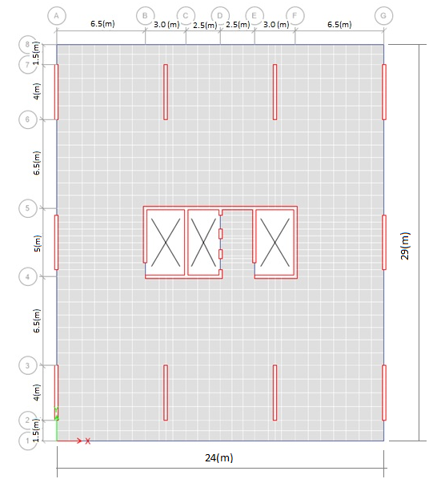
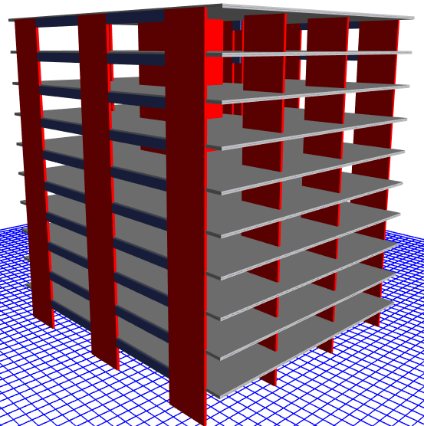
Fig. (1) a) Slab Layout. and Slab Mesh. b) Tower Isometric View c) Lateral-Force-Resisting-System.

4. Output Responses for the Tower.
4.1 Base Shear Calculation.
The base reaction can be sorted descending as follows:
- IBC (ASCE07).
- UBC.
- EC8.
- ECP.
The reason that the IBC (ASCE07) is the biggest among them is that IBC (ASCE07) accounts for 2/3 of the MCE ([ 4], 2011) which may had happened once in a return period of 2475 years, while the other codes adopts DBE which may happen once in a return period of 475 years.
A comparison between UBC and ECP and EC8 Response Spectrum Curve. is shown in fig (2). It can be concluded that the reason that the UBC base shear ([ 3], 1997) is bigger than both the ECP and EC8 is that the velocity coefficient being adopted in UBC is almost double of the one used in ECP and Ec8. That is because the response spectrum curve used in both ECP and EC8 changes from plateau straight line to curve prior to the same change in UBC as in Fig. ( 2) Comparison between UBC and ECP and EC8 Response Spectrum Curve.
The reason that ECPis less than EC8is that the response modification factor in ECP is much bigger than the one used in EC8.
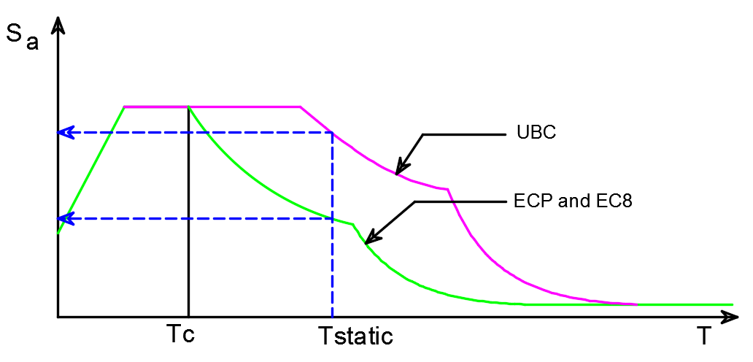
Fig. (2) Comparison between UBC and ECP and EC8 Response Spectrum Curve.

The Egyptian code gives the least value among all the studied international codes, which is problematic and lead to un-inadequate design if such height of towers was designed by other international codes.
The problem under that is that the Egyptian code adopts the Eurocode8 response spectrum, which gives the lesser velocity coefficient but still using the UBC response modification factor, which is much larger that the values used in EC8 codes as in our case.
The following table shows the formula parameters and resulting seismic base shear for the four studied codes in order to reach to better understand the comparison.

Table 14 Ten Floors Tower Force justification among four Codes.
 | CV | SD1 | PGA | S | TC | TD | TL
UBC | 0.32
IBC |  | 0.36 |  |  |  |  | 8
ECP |  |  | 0.15 | 1.5 | 0.25 | 1.2
EC8 |  |  | 0.15 | 1.5 | 0.25 | 1.2

Table 15 Continued.
VELOCITY COEFF | I | R | T |  | W | V
0.32 | 1 | 4.5 | 0.736 |  | 106391.0375 | 10279.32729
0.36 | 1 | 4 | 0.736 | <TL | 106391.0375 | 13009.77361
0.140625 | 1 | 4.5 | 0.641 | <TD | 109658.5375 | 5346.067546
0.140625 | 1 | 3 | 0.641 | <TD | 108351.5375 | 7923.523121

4.2 Base Reactions.
A comparison between the equivalent static force in X and Y directionsis indicated in fig (3) and fig (4) respectively.
One-thing makes the ECP equivalent static base shear increases is that the static period in ECP is scaled up to 1.2 from the basic period formula, however it is scaled up to 1.4 in UBC and IBC (ASCE07), but its effect is minor in this case. The more period we have the lesser equivalent base shear we have.
The following symbols are used: -
Qx: Equivalent Static Load in X direction.
Qy: Equivalent Static Load in Y direction.
Specx: Response Spectrum Load in X direction.
Specy: Response Spectrum Load in Y direction.
Dir X: Component in X direction.
Dir Y: Component in Y direction.

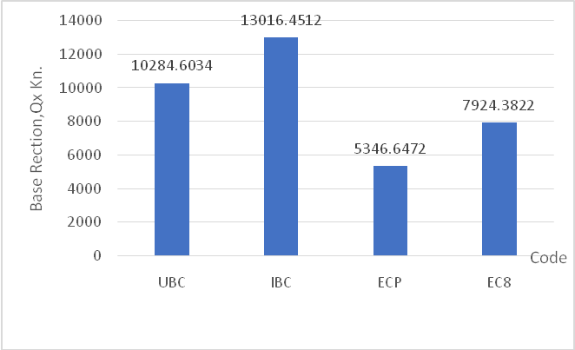
Fig. (3) Ten Floors Base Reactions QX.

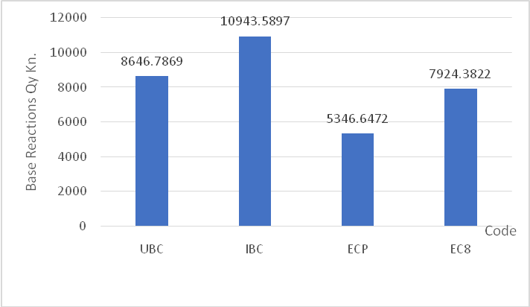
Fig. (4) Ten Floors Base Reactions QY.

A comparison between the response spectrum base shear in X in X and Y directionsis indicated in fig (5) and fig (6) respectivelyindicated the same results because the dynamic response spectrum were scaled up to a bigger portion of the equivalent static load ranging from 0.85 to 0.9 in our study.

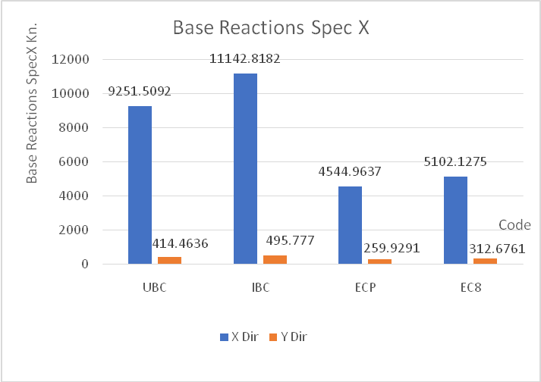
Fig. (5) Ten Floors Base Reactions Spec X.

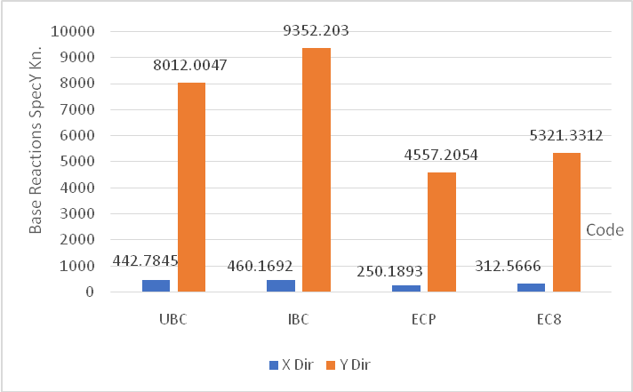
Fig. (6) Ten Floors Base Reactions Spec Y.

However, the EC8 does not require any scaling, scale factor for different codes is shown in Fig. (7).
The scale factor is bigger in UBC and IBC (ASCE07) since the response spectrum values shall be scaled up by a large amount to reach what we describe as the biggest equivalent static base shear.
The scale factor in UBC is bigger that it should be comparing with the IBC (ASCE07) scale since the UBC scales up to 90% while the IBC (Asce07) scales up to 85% only.

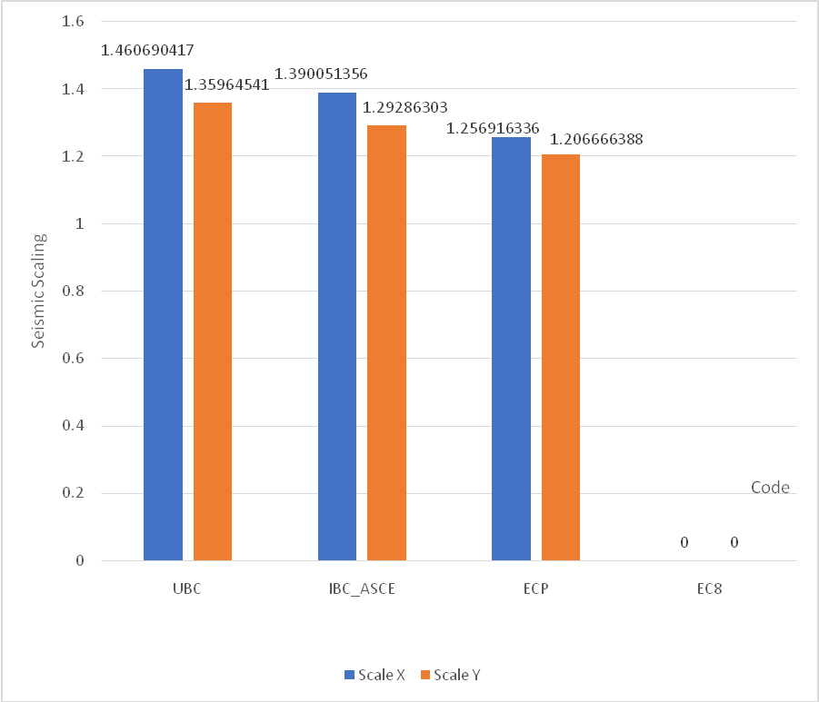
Fig. (7) Ten Floors Seismic Scaling.

With reference to Fig. (8), which explains the periods corresponding for first thirty modes for various codes, the reason to decrease the dynamic force is that the ECP and EC8 mode shapes shows bigger periods after the forth mode than the UBC and IBC (ASCE 07).
The more period means lesser base shear contribution as it is obvious in the response spectrum curve, and that will affect the EC8 base shear specially since there is no scaling exists in EC8.

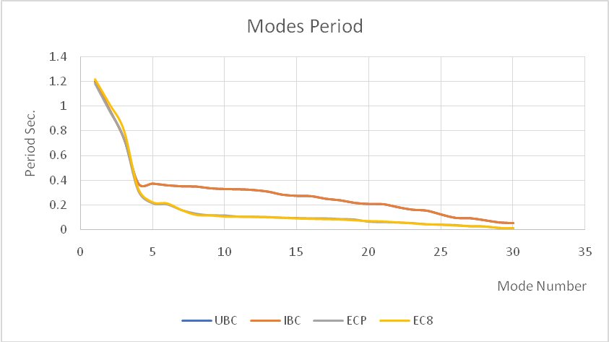
Fig. (8) Ten Floors Mode Period.

A comparison between the ultimate load combinations five and seven, which still indicate the same results and which is important since we use these values in design because the earthquake affects a structure which exhibits a dead and a portion of the live loads is shown in Fig. (9) and Fig. (10).
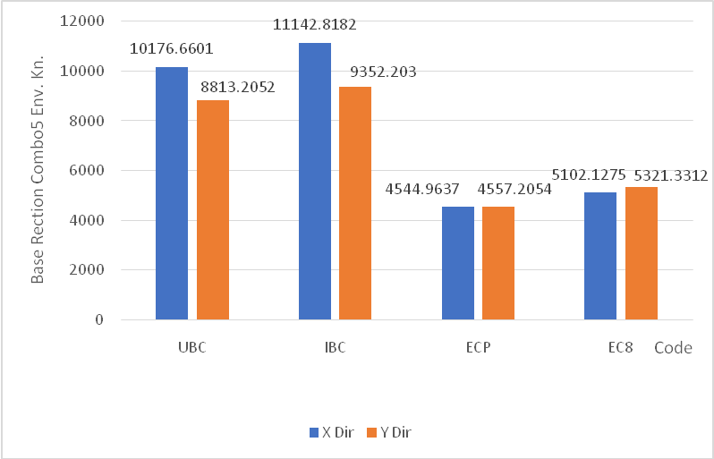
Fig. (9) Ten Floors Base Reactions Combo 5 Env.

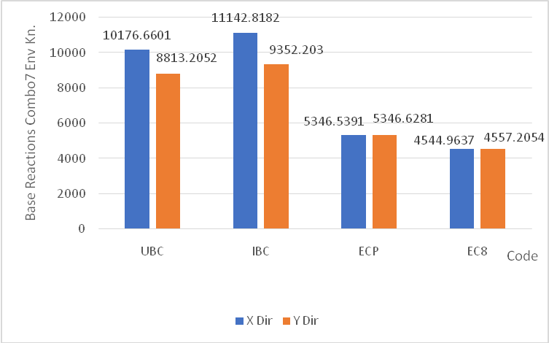
Fig. (10) Ten Floors Base Reactions Combo 7 Env.

4.3 Story Shear.
Story shear vertical distribution among different stories for equivalent seismic static force is shown in Fig. (11), Fig. (12), Fig. (13) and Fig (14).
The curve is a cumulative story shear not story forces, hence it is not a reverse triangle as known for the story forces.
The same sequence of the biggest to smallest story shear follow suit the previous base shear curves, IBC (ASCE07), UBC, EC and finally the ECP.

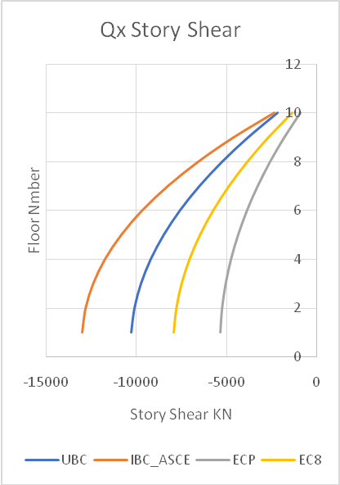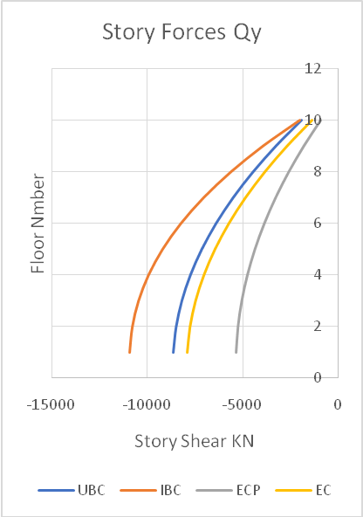
Fig. (11) Ten Floors Story Shear Qx. Fig. (12) Ten Floors Story Shear Qy.

Response spectrum story cumulative shear shows the same sequence however, the curve shape of the EC8 and ECP is a semi-S-shape, which means that the predominant mode shape in EC8 and ECP is not a simple inversed triangle shape.

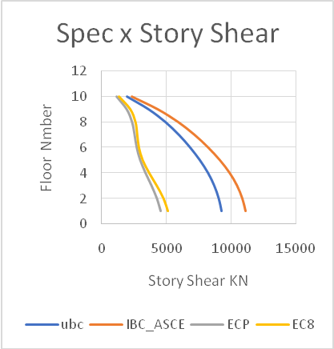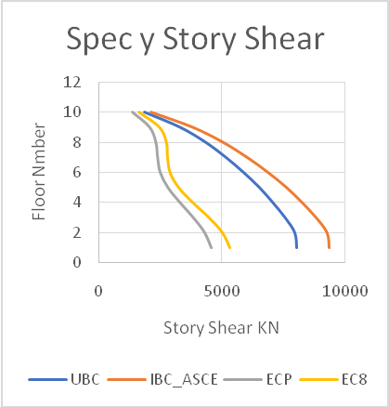
Fig. (13) Ten Floors Story Shear Spec x. Fig. (14) Ten Floors Story Shear Spec y.

4.4 Story Drift.
Drift gives the same sequence as the cumulative shear forces shown in previous set of curves, which is related to the applied force and the structure parameters distribution like mass, stiffness and damping as shown in Fig. (15) Ten Floors Story Drift Spec x., Fig. (17) Ten Floors Story Drift Spec y.), Fig. (18) Ten Floors Story Drift Spec y1.
Since these parameters are the same in all floors, all the tower floors are identical, hence the story drift will directly proportional to the story shear-not force-.
The following figures Fig. (15 to 18) show drift for the basic response spectrum individual cases as follows [13 to 15]:
Spec x: indicates response spectrum case in X direction with no accidental eccentricity.
Spec x1: indicates response spectrum case in X direction with an accidental eccentricity of 5%.
Spec y: indicates response spectrum case in Y direction with no accidental eccentricity.
Spec y1: indicates response spectrum case in Y direction with an accidental eccentricity of 5%.

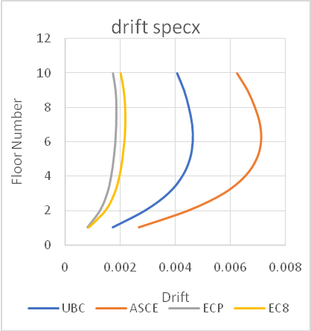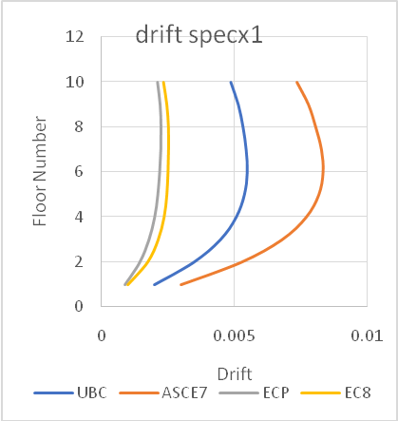
Fig. (15) Ten Floors Story Drift Spec x. Fig. (16) Ten Floors Story Drift Spec x1.

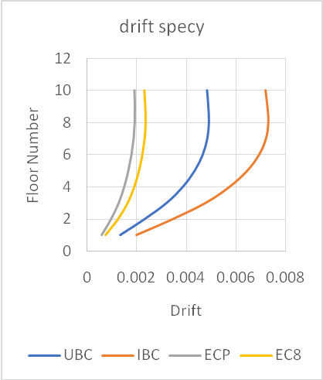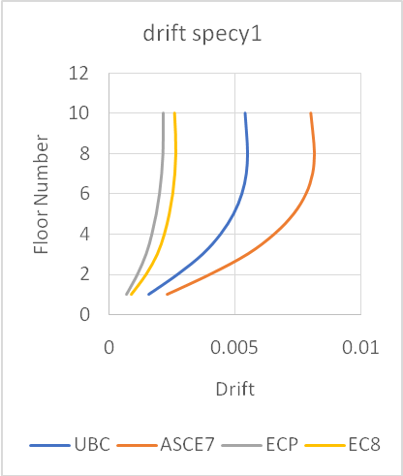
Fig. (17) Ten Floors Story Drift Spec y. Fig. (18) Ten Floors Story Drift Spec y1.

As the earthquake will not affect alone without the existence of dead load and a portion of live load, the actual drift shall be evaluated for different load combinations.
The UBC stated that ultimate load combination shall be adopted in the calculation of the drift; however other codes were silent regarding to which load combination should be adopted.
The first approach logically is to apply the service load combination since the drift is a serviceability limit state, however one important issue is that the earthquake engineering is a performance based design, and it depends mainly on the value of displacement at the ultimate earthquake event. For instance, life safety shall be reached for the design-based earthquake and collapse prevention shall be achieved at the maximum considered earthquake.
The following figures (Fig. (19) Ten Floors Story Drift Combo U5., and Fig. (20) Ten Floors Story Drift Combo U7.) shows both the service combinations and ultimate combinations drift.

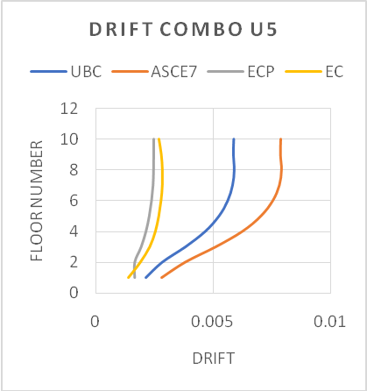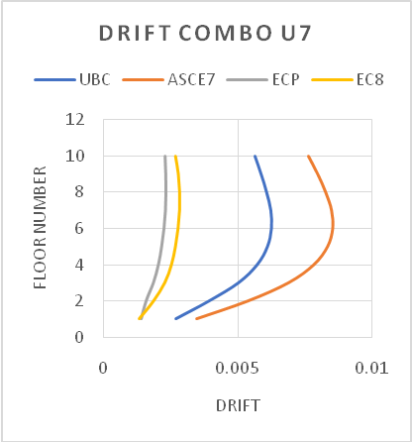
Fig. (19) Ten Floors Story Drift Combo U5. Fig. (20) Ten Floors Story Drift Combo U7.

5. Conclusions:
For low towers having ten floors only, with all previous assumptions for all studied codes, following conclusion can be set:
- IBC has the biggest seismic base shear value since it calculates for return period of 2475 years and other codes calculate for 475 years only.
- EC8 and ECP have the smallest seismic base shear value since the velocity coefficient in these codes is small compared to IBC and UBC.
- ECP seismic base shear value is less than seismic base shear value in EC8, since the R-value in ECP is bigger than its alternative in EC8.
- Dynamic distribution is more realistic since it is being affected by mode shapes which accommodate for both mass and stiffness not for mass only as in equivalent static distribution.
- The code with the biggest equivalent static load will have the biggest scale since the virgin dynamic loads shall be scaled more, except the EC8, since it doesn’t have scale requirements.
This inconsistency must be taken care of in the next Egyptian code versions.

References
- Computers & Structures, I. (2014). CSI Analysis Reference Manual For SAP2000 ETABS SAFE and CSi Bridge. California, USA: Computers & Structures, Inc.
- Z. A. Lubkowski, &. B. (n.d.). Deriving SS and S1 Parameters from PGA Maps. Retrieved from http://www.iitk.ac.in/nicee/wcee/article/WCEE2012_2206.pdf.
- U. (1997). UNIFORM BUILDING CODE.
- I. (2011). International Building Code. USA: INTERNATIONAL CODE COUNCIL, INC.
- A. (2005). ASCE 7-5 American Society of Civil Engineers Minimum Design Loads for Buildings and Other Structures. Virginia USA: American Society of Civil Engineers.
- A. (2010). ASCE 7-10 American Society of Civil Engineers Minimum Design Loads for Buildings and Other Structures. Virginia USA: American Society of Civil Engineers.
- Egyptian-Code, M. D. (2012). Egyptian Code for Minimum Design Loads for Building and other Structures. Cairo, Egypt.: Housing ministry.
- E. (2004). Design of structures for earthquake resistance. Britsh Standards.
- 2.-1. (2003). NEHRP Recommended Provisions for New Buildings and Other Structures, FEMA Publication 450-1. Washington, D.C.: Building Seismic Safety Council BSSC.
- Kramer, S. L. (1996). Geotechnical Earthquake Engineering. Upper Saddle River, United States: Pearson Education (US).
- Choudhury, D. (2015, June 30). Soil Dynamics. Retrieved from nptelhrd: https://www.youtube.com/watch?v=rJyG2L-_nmk.
- Choudhury, D. (2015, April 8). Geotechnical Earthquake Engineering. Retrieved from nptelhrd: https://www.youtube.com/watch?v=q-kHDw37XOM & list=PLbMVogVj5nJRNzx4KtSTVj7qr9OxwY3IF.
- Armouti, N. S. (2008). Earthquake Engineering: Theory and Implementation. Jordan: International Code Council.
- Ghosh, S. K. (2008). Seismic Design of RC Structures Using UBC / ACI Provisions. Dubai UAE.
- Ghosh, S. K. (2003). Seismc Design using Structural Dynamics. USA: ICC Publication.

7/9/2017

