Duplex Ultrasound Guided Balloon Angioplasty of Lower Extremity Arteries in the Treatment of Critical Lower Limb Ischaemia

Alaa El-Din Mostaf Kamal Sharaby, Mohamed Abd El-Hamid Abd El-Rahman and Mohamed Ibraheem Hammoda

Vascular Surgery Department, Faculty of Medicine, Al-Azhar University, Egypt
Hamoda_hr_84@yahoo.com

Abstract: Objective: To assess the using of duplex ultrasound technique during balloon angioplasty of the lower extremity arteries as regard efficacy, safety and results as well as complications in the treatment of cases of critical lower limb ischaemia. Methods: This prospective randomized controlled study was conducted in the vascular surgery department of Al-Azahar University Hospitals during the period from December 2014 to October 2016. 40 patients; 31(77.5%) male and females was 9(22.5%) with critical lower limb ischaemia. All 40 patients were treated with duplex guided balloon angioplasty and stenting. The patients underwent duplex guidance balloon angioplasty for stenotic and occlusion lesions in the lower extremities. Results: the technical success rate was 100% in this study, based on blood flow was regard before accomplishing the procedure by PTA alone in 38 patients (95%) and PTA with stent in two patients (5%) due to dissection and treated with (6x80cm) EV3 (Self –expanding stent. The improvement detected by PSV at the site of arterial lesion before and after PTA in 40 patients. Balloon angioplasty with or without stenting was done for the lesions after successful crossing. Improvement detected by duplex ultrasound (PSV and wave form) of the studied group (40) 100% at 1 month, 80% at 6 month, 77.5% at 1 year. Intraoperative complications, there were dissection occurred in two cases one treated with stent deployment due to hemodynamically residual significant stenosis following angioplasty <30% diameter reduction and the other one treated with multiple successive balloon dilation for 30 second duration and one minute apart, no thrombosis of the SFA, no distal emboli were detected on completion duplex scans. Conclusion: Duplex-guided balloon angioplasty seems to be feasible, safe, effective technique, a bedside procedure and cost effective as well. Compared with fluoroscopy guidance its considerable cheap, feasible, safe, effective technique, abed–side procedure and cost effective as well.
[Alaa El-Din Mostaf Kamal Sharaby, Mohamed Abd El-Hamid Abd El-Rahman and Mohamed Ibraheem Hammoda. Duplex Ultrasound Guided Balloon Angioplasty of Lower Extremity Arteries in the Treatment of Critical Lower Limb Ischaemia. N Y Sci J 2017;10(8):19-28]. ISSN 1554-0200 (print); ISSN 2375-723X (online). http://www.sciencepub.net/newyork. 4. doi:10.7537/marsnys100817.04.

Keywords: Duplex Ultrasound; Balloon Angioplasty; Lower Extremity Artery; Treatment; Lower Limb Ischaemia

1. Introduction:
Critical limb ischaemia (CLI) represents the most advanced form of peripheral arterial occlusive disease (PAOD), manifested by pain at rest, focal or diffuse foot and ankle ulcerations, or gangrene. The rate of PAOD progression to CLI may approach 25%, and these patients have a particularly poor prognosis (Aquino et al., 2001).
Peripheral angioplasty (PA) refers to the use of a balloon to open a blood vessel outside the coronary arteries. It is commonly done to treat atherosclerotic narrowing of the blood vessels. PA can also be done to treat narrowing in veins, etc. Often, peripheral angioplasty is used in conjunction with peripheral stenting and atherectomy. Technically, angioplasty can be used to describe any dimensional treatment of blood vessels, whether enlarging, or reducing diameter, depending on requirements to treat the pathology (Boden and O'Rourke, 2007).
Duplex ultrasonography proposed as new alternative to contrast angiography to avoid the harmful effects of radiation exposure and the risk of acute renal failure. It offers the potential for a less expensive and more informative treatment of ischaemic patient (Wang et al., 2009).
Unquestionably, duplex-guided arterial interventions are particularly beneficial for patients with allergies to contrast material and for those with chronic renal insufficiency. As vascular surgeons perform more endovascular procedures, they will have increased exposure to the deleterious effects of radiation. Unfortunately, these effects are cumulative and permanent and may cause a delayed onset of symptoms. It is now believed that the duplex-guided angioplasties are safe, beneficial, and effective. The potential of these techniques grows exponentially with the advent of new and improved technology and the positive impact on patient care shows great promise and it is anticipated that some of these procedures will eventually be performed in the vascular laboratory or in an office practice setting (Lipsitz et al., 2000).

2. Patient and method:
This prospective randomized controlled study was conducted in the vascular surgery department of Al-Azahar University Hospitals during the period from December 2014 to October 2016. 40 patients; 31(77.5%) male and females was 9(22.5%) with critical lower limb ischaemia. All 40 patients were treated with duplex guided balloon angioplasty and stenting. The patients underwent duplex guidance balloon angioplasty for stenotic and occlusion lesions in the lower extremities.
Follow-up of the patients after the procedure was done by clinical examination with or without special investigations as needed. The study was undertaken after obtaining the approval of the local ethical committee and a written informed consent from each patient.
Inclusion criteria:
All patients with critical lower limb ischaemia who could be treated with balloon angioplasty and stenting rather than surgery are included. TASC A and TASC B groups are included.
Exclusion criteria:
Some patients are excluded according to the following criteria:
- Inevitable amputation.
- Patients who cannot get benefit from balloon angioplasty and stenting and in needs for surgical revascularization.
- Acute on top of chronic ischaemia.
- Poor general condition.
- Patient with long segment of diffuse disease (TASC C).
- Patient with long occlusion (TASC D).
Procedure:
Position of the patient
The patient should be lying flat with the leg externally rotated and the knee is gently flexed and supported.
Position of the interventionist
The sonarist and interventionist stand the right side of the patient, the machine beside the head of the patient and equipment beside the Lt side.
Anesthesia
The procedures are performed with patients under local anesthesia of the puncture site, and whenever indicated, light sedation was is given during inflation of the balloon angioplasty catheter. The general anesthesia may be used because of severe back pain when placed in the supine.
Access
The ipsilateral common femoral artery (CFA) is cannulated with a single-entry needle and the contralateral CFA is cannulated when the ipsilateral site is occluded.
Technique
All interventions are performed under duplex guidance for all cases in the vascular surgery unit laboratory. A linear 7- to 4-MHz probe is used in a sterile plastic cover with coupling gel is used for insonation of the arteries of 4 cm deep or less. A curved 5- to 2-MHz transducer is used to visualize deeper arterial segments, including the distal SFA and the above-the-knee PA. The length of the stenosis is measured with a linear 7- to 4-MHz probe. The heamodynamic study is recorded pre and post procedures.
- Under duplex guidance a short 6F introducer sheath is inserted in an antegrade fashion into the SFA or retrograde in the external iliac artery (EIA) according to the target lesion. If the sheath is inserted in advertently in deep femoral artery, the position is corrected under duplex guidance.
- The guide wire is directed into the SFA and across the PA and is parked distal to targeted lesion. To accomplish this, either a 5F Selective catheter or a 5F Angled Taper are used with the wire to support it and help crossing the lesion successfully.
- All areas of suspected defects are assessed guided by arteriogram if available before dilation by direct diameter-reduction measurement on color or power image, as well as by spectral analyses, haemodynamic study including PSV and wave form changes.5000 units heparin are given intraarterially before balloon dilation.
- The diseased segment is balloon-dilated under duplex visualization. Balloon diameter and length were chosen according to arterial measurements obtained by duplex scanning. 5-, 6-, or 7-mm-diameter balloons should be prepared. Inflation devices are used to inflate the balloons with inflation duration of 1 minute and this may be repeated in some patients according to the resistance. Although multiple dilations of sequential lesions are feasible, matching the length of diffusely stenotic segment to the length of the PTA balloon is optimal to prevent injury to the non-diseased adjoining vessel. The sheath is withdrawn under ultrasonographic control, and heamostasis is secured.
- After retrieval of the balloon angioplasty catheter, a detailed duplex examination of the entire treated segment is performed to identify areas of possible residual stenosis, plaque recoil, or dissection causing flow abnormalities. Arterial stenoses causing more than a 30% luminal diameter reduction or a PSV ratio of 2 or more is considered significant and require placement of a self-expanding stent.
- Completion duplex examinations included visualization of all infrapopliteal arteries; results of these examinations are compared with the ones obtained before the procedure in an attempt to identify possible embolization or thrombosis during balloon angioplasty.
Postprocedure evaluation and follow-up
  - Arterial duplex scanning.
  - PSV and wave form.
  - Pulse-volume recordings.
  - Ankle brachial indexes (ABIs) were routinely obtained before hospital discharge.
  - Patients were advised to schedule follow-up visit in our outpatient office for clinical evaluation, arterial duplex scans, and pulse-volume recording examinations within the first month after discharge and every 6 months thereafter. Arterial patency at each time point was confirmed in the absence of a recurrent stenosis by duplex scanning.
Follow-up Program
Immediately after the procedure, then after one week, one month, six months and after one year.
Follow-up will depend on:
Clinical data, duplex ultrasonography as well as computed tomographic angiography.
Statistical analysis
Data were statistically described in terms of range, mean ± standard deviation (± SD), median, frequencies (number and percentages of cases) when appropriate.
Comparison of numerical variables between the study groups was done using Mann Whitney U test for independent samples when comparing 2 groups and Kruskal Wallis test with posthoc multiple 2-group comparisons when comparing more than 2 groups. To compare categorical data, Pearson Chi square (χ²) test was performed. Fisher’s exact two-tailed probability test was used instead when the expected frequency is less than 5 (i.e. when a Pearson Chi-Square test could not be calculated due to small number of observations).
Correlation between various variables was done using Spearman rank correlation equation for non-normal variables. P values ˂0.05 was considered significant. All calculations were done using SPSS computer programs (Statistical Package for the Social Science; SPSS Inc., Chicago, IL, USA) version 23.
Criteria of success and failure
Technical success
Immediate technical success of SFA angioplasties, as confirmed by completion color flow imaging and spectral analyses, patient is assessed by color flow ultrasonography and haemodynamic study post procedure which is compared with pre procedure in all cases. Technical success is identified as patency of the angioplasty femoral segment with less than 30% residual stenosis and an absence of distal embolism.
Clinical success
Is defined as some combination of symptomatic improvement and objective haemodynamic success.
Symptomatic improvement as decrease claudication, no rest pain and improved wound healing.
Haemodynamic success by PSV less than 1.5m/s, wave form changes and increase in the ABI of more than 0.10.
Patency is defined as maintenance of achieved haemodynamic improvement in the relevant segment.

3. Results

Figure 1: Gender distribution

Figure 2: presentation of studied patients

The present study included 40 patients 31(77.5%) male and females was 9(22.5%) with critical lower limb ischaemia, they were admitted in the vascular surgery unit of Al-Azhar University Hospitals. Their ages ranges between 52 and 76 years. All 40 patients had femoropopliteal occlusive disease that fulfilled the selection criteria and treated with duplex guided balloon angioplasty and stenting. The patients underwent balloon angioplasty under duplex guidance for stenotic and occlusive lesions in the lower extremeities.
Patient population
During the time period reviewed, a total 40 patients were treated with TASC A and B lesions. They were treated due to CLI, 29(72.5%) of them treated due to persistent rest pain more than 2 weeks duration and 11(27.5%) due to tissue loss.
The typical comorbid features associated with PAD were identified. 13 limbs (32.5%) had single-vessel runoff, 27 (67.5%) had multiple-vessel runoff.

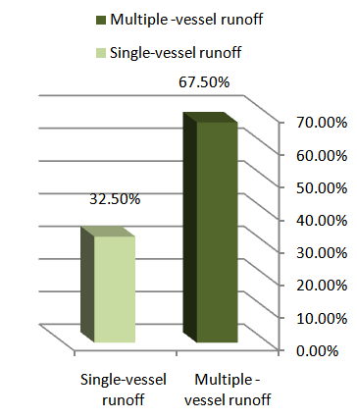
Figure 3: Single-vessel runoff and multiple-vessel runoff.

Procedural Data
1- Access site
The ipsilateral femoral approach was used in 23(57.5%) patients; the contralateral (crossover) approach was used in 17(42.5%) patients.
Immediate outcomes
The technical success rate was 100% in this study, based on 1- blood flow was regard before accomplishing the procedure by PTA alone in 38 patients (95%) and PTA with stent in two patients (5%) due to dissection and treated with (6x80cm) EV3 (Self –expanding stent.
The improvement detected by PSV at the site of arterial lesion before and after PTA in 40 patients. Balloon angioplasty with or without stenting was done for the lesions after successful crossing. Improvement detected by duplex ultrasound (PSV and wave form) of the studied group (40) 100% at 1 month, 80% at 6 month, 77.5% at 1 year.
Intraoperative complications, there were dissection occurred in two cases one treated with stent deployment due to hemodynamically residual significant stenosis following angioplasty <30% diameter reduction and the other one treated with multiple successive balloon dilation for 30 second duration and one minute apart, no thrombosis of the SFA, no distal emboli were detected on completion duplex scans.

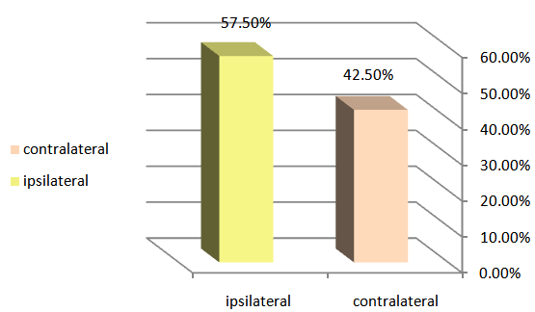
Figure 4: Access site

Risk factors
Lesion characteristics:
In this study, 7 proximal SFA lesions (17.5%), 21 middle SFA lesions (52.5%) and 12 distal SFA lesions (30%) were treated with duplex guided angioplasty. The primary patency rate of proximal SFA lesions at 1, 6, 12 months were 100%, 71.4% and 57.14% respectively. The primary patency rate of middle SFA lesions at 1, 6, 12 months were 100%, 81% and 71.4% respectively. The primary patency rate of distal SFA lesions at 1, 6, 12 months were 100%, 75% and 66.7% respectively.

Figure 5: Lesion characteristics

Table 1: Site of lesion in relation to primary patency
 | Chi-Square | P-value
Log Rank (Mantel-Cox) | 9.291 | 0.010*
Breslow (Generalized Wilcoxon) | 8.281 | 0.016*
Tarone-Ware | 8.816 | 0.012*

There is significant relation between site of lesion and long term patency rates. The middle SFA lesion showed better patency rates than proximal and distal SFA lesions (log Rank p-vlue = 0.01).
In this study, 8 occlusion lesions (20%), 21 stenotic lesions (52.5%) and 11 multiple stenotic lesions (27.5%) were treated with duplex guided angioplasty. The primary patency rate of occlusion lesions at 1,6,12 months were 100%, 67.5% and 50% respectively. The primary patency rate of stenotic lesions at 1,6,12 months was 100%, 82.5% and 70% respectively. The primary patency rate of multiple stenotic lesions at 1,6,12 months was 100%, 77.5% and 65% respectively.

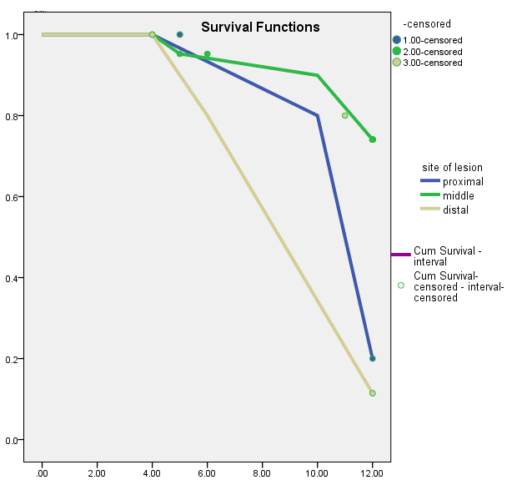
Figure 6: Site of lesion in relation to primary patency

Table 2: Type of lesion in relation to primary patency
 | Chi-Square | P-value
Log Rank (Mantel-Cox) | 12.244 | 0.002*
Breslow (Generalized Wilcoxon) | 12.304 | 0.002*
Tarone-Ware | 12.343 | 0.002*

There is significant relation between type of lesion and long term patency rates. The stenotic lesion showed better patency rates than proximal and distal SFA lesions (log Rank p-value = 0.002).
In this study, 27 lesions (67.5%) were associated with good run off (2-3 vessels) and 13 stenotic lesions (32.5%) were associated with poor run off (0-1 vessels). The primary patency rate for lesions with good run off at 1,6,12 months were 100%, 88.9% and 85% respectively. The primary patency rate for lesions with poor run off at 1,6,12 months were 100%, 53.8% and 30.7% respectively.

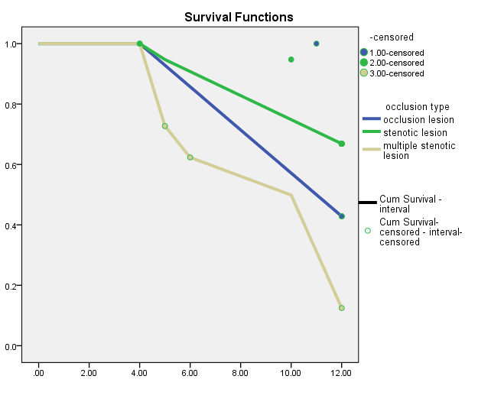
Figure 7: Type of lesion in relation to primary patency

Table 3: Run-off in relation to primary patency
 | Chi-Square | Sig.
Log Rank (Mantel-Cox) | 4.531 | 0.033*
Breslow (Generalized Wilcoxon) | 4.800 | 0.028*
Tarone-Ware | 4.678 | 0.031*

There is significant relation between single vessel runoff and long term patency rates (log Rank p-value = 0.033).

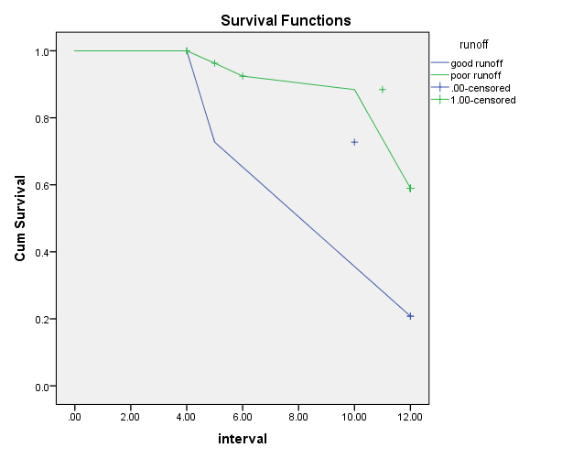
Figure 8: Runoff in relation to primary patency

Table 4: Age in relation to primary patency
 | Chi-Square | p-value
Log Rank (Mantel-Cox) | 0.927 | 0.33
Breslow (Generalized Wilcoxon) | 0.728 | 0.39
Tarone-Ware | 0.832 | 0.36
There is insignificant relation between age≥60 and long term patency rates (log Rank p-value = 0.33).
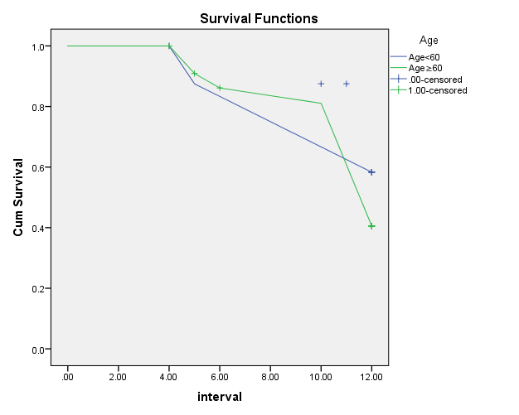
Figure 9: Age in relation to primary patency

Table 5: Diabetes in relation to primary patency
 | Chi-Square | Sig.
Log Rank (Mantel-Cox) | 4.520 | 0.031*
Breslow (Generalized Wilcoxon) | 4.550 | 0.023*
Tarone-Ware | 4.556 | 0.035*
There is significant relation between diabetes and long term patency rates. The nondiabetics showed better patency rates than poor runoff (log Rank p-value = 0.031).
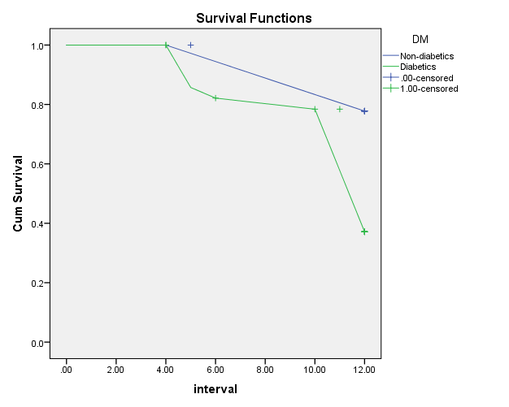
Figure 10: Diabetes in relation to primary patency

There were 32 diabetic patients (80%) and 8 non diabetic (20%). In diabetes group 1, 6, 12, month primary patency rates were 100%, 74 % and 65.2%, in non-diabetes group 1, 6 and 12-month primary patency rates were 100%, 100% and 82.35%. There is significant relation between diabetes and long term patency rates. The non-diabetics showed better patency rates than poor runoff (log Rank p-value = 0.031).

Table 6: Smoking in relation to primary patency
 | Chi-Square | p-value
Log Rank (Mantel-Cox) | 5.835 | 0.016*
Breslow (Generalized Wilcoxon) | 5.597 | 0.018*
Tarone-Ware | 5.743 | 0.017*
There is significant relation between smoking and long term patency rates. The non-smokers showed better patency rates than smokers (log Rank p-vlue = 0.016).
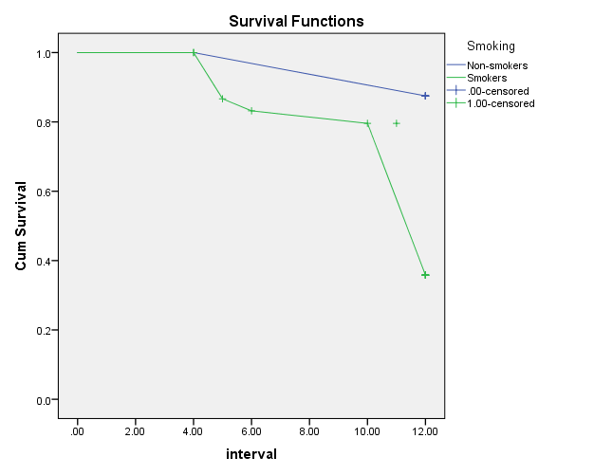
Figure 11: Smoking in relation to primary patency

In our study, 28 patients smoker (70%) and 12 patients non-smokers (40%) were treated with duplex guided angioplasty. Follow up of smoker group at 1, 6 and 12 months resulted in primary patency rates were 100%, 78.5% and 65% respectively. In non-smoker group, 1, 6 and 12-month primary patency rates were 100%, 91.6% and 83.3%. The differences between two groups were significant (P <0.016).

Table 7: Initial hemodynamic response: ABI at discharge
ABI at discharge | Mean±SD | Mini. | Max. | p-value
Non patent | 0.79±0.14 | 0.60 | 1.10 | ˂0.001*
patent | 1.01±0.15 | 0.70 | 1.20
Total | 0.90±0.18 | 0.60 | 1.20
Postprocedure ABIs obtained before patient discharge ranged from 0.6 to 1.2 (mean ± SD, 0.90 ± 0.18; P <0.0001). The differences between patients with long term patency and other patients with no patency were significant (P <0.001).
There was 2 cases (2.5%) died, this occurred in 2 patients with multiple comorbidities after seven months following a successful endovascular intervention, from massive cerebrovascular stroke. Immediate complications occurred following 5 interventions (10.2%). Wire perforation occurred in 2 cases to which 3 minutes balloon dilatation tamponading was done, 2 dissections and retroperitoneal hematoma in one case.

4. Discussion:
Several reports have proved the feasibility of duplex ultrasound-guided PTA as an alternative to conventional PTA with patency rate mounting to 93%. Duplex-guided balloon angioplasty and stent placement seems to be a safe and effective technique for the treatment of infrainguinal arterial occlusive disease (Ascher et al., 2006). Review of data revealed short-term patency and intraoperative complication rates (thromboembolization, hemorrhage, and failed attempts) similar to those in prior series (Desgranges et al., 2004).
The advent of modern duplex scanners capable of delivering high-quality images of the arterial wall and lumen while providing reliable hemodynamic parameters of the infrainguinal arteries facilitated our proposed technique. The magnification provided by these scanners allows better definition of anatomic details. As previously demonstrated, duplex scanners can be used not only to identify the exact location and severity of the occlusive disease process, but also to precisely measure the extent of the lesion (Ascher et al., 2005). In this manner, balloons and stents can be selected according to precisely measured parameters (Sprouse et al., 2004).
In addition to avoiding radiation and contrast exposure, duplex ultrasound helps to confirm the adequacy of PTA by the combined hemodynamic and imaging parameters. (Nadolski and Stavropoulos, 2013).
Standard fluoroscopy balloon angioplasties require contrast material and radiation exposure. Nephrotoxic contrast material can become a challenge in patients presenting with diabetes mellitus or in those with pre-existing renal insufficiency. This approach is particularly advantageous for patients with medical conditions (such as diabetes mellitus or pre-existing chronic renal insufficiency) that predispose them to an increased risk of developing contrast-induced renal failure. Acute renal insufficiency may develop in up to 31% of diabetic patients who undergo intravenous injection of contrast material. Similarly, up to 42% of patients with pre-existing chronic renal failure may experience deterioration of their renal function, and up to 20% of these patients may require hemodialysis treatments. Moreover, 38% of diabetic patients may develop contrast induced renal failure. The risk of contrast induced nephropathy and renal failure especially in patients with renal impairment. The risk of dye inducing allergy and hypersensitivity starting from urticaria up to cardio-pulmonary arrest. Because of such dangers and drawbacks, it is recommended to use the duplex guided angioplasty technique (Hingorani et al., 2012).
As the proportion of minimally invasive arterial procedures increases, vascular surgeons have to be more aware of the potential complications of radiation exposure, particularly to the eyes and gonads. The deleterious effects are cumulative and irreversible. The risk of irradiation exposure for the surgeon and the assistant staff as the lead aprons worn only protect the abdomen and chest while the back still uncovered and unprotected, even the thyroid region is uncovered as there is no thyroid coverage and the same risk could happen to the eyes as special glasses should be worn (Hingorani et al., 2012).
In this study, whenever difficulty was faced during vessel puncture, duplex guidance made access very easy and solved the problem every time. Also, the puncture of the access artery (CFA or SFA) can be guided by ultrasonography, thus helping to prevent any complications such as arterial dissections and to prevent in advertant profundafemoris artery puncture, and if this happened correction of wire to SFA is very easy with duplex guidance.
In this study, identification of the exact location of the vascular lesion precisely and it's accurate length, and its type and also status of run off vessels. Also, we could study the hemodynamics of the lesion before and after the procedure instantaneously. This had helped us to select lesions based on Trans Atlantic Inter- Society Consensus (TASC) recommendation (TASC II, 2015).
Ascher et al stated that balloon angioplasty of the infrapopliteal arteries is feasible under duplex guidance alone. Excellent anatomic and hemodynamic results may be expected from our approach regardless of the extent of the stenotic lesion. However, one should be ready to abandon this approach in favor of a more standard technique whenever duplex visualization of the treated segment is not acceptable, such as in cases of heavily calcified arteries or in very obese patients in whom the target arteries are deeper than 4 cm (Ascher et al., 2005).
In this study, the proper size, length of balloon and the stent according to precise measurements of the vessel diameter and the extent of the lesion could be done according to duplex evaluation. After retrieval of the balloon angioplasty catheter, a detailed duplex examination of the entire treated segment was performed to identify areas of possible residual stenosis, plaque recoil or dissection causing flow abnormalities. All areas of suspected defects were assessed by direct diameter-reduction measurement on color or power image, as well as by spectral analyses, including PSV.
Duplex guided procedures were accomplished in this study by a team consisting of radiologist (sonarist) was responsible for managing the probe during the procedure, and vascular surgeon who was responsible for the steps of PTA and stenting.
In this study, a total 40 patients had TASC A and B lesions were treated by duplex angioplasty for CLI, 29(72.5%) were treated for rest pain and 11(27.5%) were for rest pain associated with tissue loss. The mean age was 61.35 ± 8.59 years. A male predominance (77.5%) was noted, and the typical comorbid features associated with PAD were identified. 13 limbs (32.5%) had single-vessel runoff, 27 (67.5%) had multiple-vessel runoff.
The technical success rate was 100% in this study, based on 1- blood flow was regard before accomplishing the procedure by PTA alone in 38 patients (95%) and PTA with stent in two patients (5%) due to dissection and treated with (6x80cm) EV3 (Self-expanding stent. Intraoperative complications, there were dissection occurred in two cases one treated with stent deployment due to hemodynamically residual significant stenosis following angioplasty < 30% diameter reduction and the other one treated with multiple successive balloon dilation for 30 second duration and one minute apart, no thrombosis of the SFA, no distal emboli were detected on completion duplex scans.
Richard et al 2006 reported immediate technical success was achieved in 49 of 52 treated infrapopliteal arteries, with an overall success rate of 94%. In the remaining three cases, the wire would not traverse a stenotic lesion (two peroneal arteries) or failed to re-enter during a subintimal dissection (one peroneal artery).
Hingorani et al 2004 reported immediate technical success of femoropopliteal angioplasties, as confirmed by completion color flow imaging and spectral analyses, was documented in all cases. Intraoperative and early postoperative complications, local complications included one patient who required groin exploration for expanding hematoma. This was an obese patient who had a high femoral artery bifurcation. No distal emboli were detected on completion duplex scans. There were no early (30 days) postprocedural strokes, myocardial infarctions, or deaths in this series (Hingorani et al., 2004).
Factors affecting short and long term outcome:
Factors that influence the results of endovascular intervention for the ischemic lower limbs are:
- Lesion characteristics.
- Patient demographics.
- Clinical situation.
- Initial hemodynamic response.
Lesion characteristics
In this study, 7 proximal SFA lesions (17.5%), 21 middle SFA lesions (52.5%) and 12 distal SFA lesions (30%) were treated with duplex guided angioplasty. The primary patency rate of proximal SFA lesions at 1, 6, 12 months were 100%, 71.4% and 57.14% respectively. The primary patency rate of middle SFA lesions at 1, 6, 12 months were 100%, 81% and 71.4% respectively. The primary patency rate of distal SFA lesions at 1,6,12 months were 100%, 75% and 66.7% respectively. In summary, there is significant relation between site of lesion and long term patency rates (p-vlue =0.01). The middle SFA lesion showed better patency rates than proximal and distal SFA lesions.
In a study done by Löfberget al 2001, Primary success rates at 12 and 24 months in proximal SFA lesions were 80% and 60%, respectively. The primary success rate of middle SFA lesions limbs were 85%, 75%.
In this study, 8 occlusion lesions (20%), 21 stenotic lesions (52.5%) and 11 multiple stenotic lesions (27.5%) were treated with duplex guided angioplasty. The primary patency rate of occlusion lesions at 1,6,12 months were 100%, 67.5% and 50% respectively. The primary patency rate of stenotic lesions at 1,6,12 months was 100%, 82.5% and 70% respectively. The primary patency rate of multiple stenotic lesions at 1,6,12 months was 100%, 77.5% and 65% respectively.
In summary, there is highly significant relation between type of lesion and long term patency rates (p-value =0.002). The stenotic lesions showed better patency rates than occlusion and multiple stenotic lesions.
Becquemin et al1994 founded Multiple factors have previously been shown to adversely affect patency including type of lesion (stenosis vs. occlusion) and length of lesion. Stenoses are associated with better patency than occlusions.
Market al 2007 reported that The primary success rate at 60 months was 53% in limbs with single SFA stenosis and 42% in those with multiple stenoses (P = NS).
Ascher et al., (2005) reported that no statistically significant difference was found between the technical success rates for those with stenoses as compared with those with occlusions.
In this study, 27 lesions (67.5%) were associated with good run off (2-3 vessels) and 13 stenotic lesions (32.5%) were associated with poor run off (0-1 vessels). The primary patency rate for lesions with good run off at 1,6,12 months were 100%, 88.9% and 85% respectively. The primary patency rate for lesions with poor run off at 1, 6, 12 months were 100%, 53.8% and 30.7% respectively. In summary, there is significant relation between status of run off and long term patency rates (p-value =0.033). Patients with good run off showed a better long term patency rates than patients with poor run off.
Becquemin et al 1994 founded that distal run off adversely affect patency.
Mark et al 2006 reported that patients with poor run off showed poorer long term patency rates than patients with good run off.
Hingorani 2011 reported that 2 years patency rates after femoropopliteal PTA as 55% in limbs with good run off and 23% in limbs with poor run off.
In a study by Guo et al 2015, univariate analysis revealed that number of run-off vessels was associated with re-stenosis/occlusion because significantly higher risk of stenosis/occlusion in patients with two run-off vessels was found compared to patients without run-off vessel (P = 0.046).
Patient demographics:
In this study, 17 patients 40-60 years (42.5%) and 23 patients >60 years (57.5 %) were treated with duplex guided angioplasty. Follow up of the patients for clinical outcome resulted in no significant relation between the age and clinical outcome (log Rank p-value =0.33).
In this study, There were 32 diabetic patients (80%) and 8 non diabetic (20%). In diabetes group 1, 6, 12, month primary patency rates were 100%, 74 % and 65.2%, in non-diabetes group1, 6 and 12-month primary patency rates were 100%, 100% and 82.35%. There is significant relation between diabetes and long term patency rates. The non-diabetics showed better patency rates than poor runoff (log Rank p-value = 0.031). In summary, non-diabetic patients showed better initial and long term patency rates than diabetic patients.
Clark et al 2001 reported that Patients with diabetes have been shown to have worse outcomes than patients without diabetes. Also, Wu et al2014 reported that diabetes mellitus was an independent predictor of risk for primary patency.
In study done by Andrew et al 2007, follow up of diabetes group at 6, 12, 24, and 36-month primary patency rates were 88.7% ± 4.0%, 62.3% ± 6.6%, 55.3% ± 7.0%, and 46.5% ± 7.5%. In non-diabetes group, 6, 12, 24, and 36-month primary patency rates were 90.9% ± 3.3%, 71.8% ± 5.4%, 71.8% ± 5.4%, and 60.9% ± 6.2%; The differences between two groups were not significant (P > 0.05).
In contrast to our study, Guo et al in their study stated that univariate analysis for risk factors, such diabetes mellitus, hypertension, and hyperlipidemia had no relationship with the occurrence of re-stenosis or occlusion (Guo et al 2015).
In our study, 28 patients smoker (70%) and 12 patients non-smokers (40%) were treated with duplex guided angioplasty. Follow up of smoker group at 1, 6 and 12 months resulted in primary patency rates were 100%, 78.5% and 65% respectively. In non-smoker group, 1, 6 and 12-month primary patency rates were 100%, 91.6% and 83.3%. The differences between two groups were significant (P <0.016).
In study done by Schillingeret al reported that cumulative restenosis rates at 6 and 12 months according to patients’ smoking habits were 99 and 190 nonsmokers, 18 and 22 light smokers, 16 and 29 habitual smokers, and 26 and 47 heavy smokers, respectively (P <0.001). Smoking 10 or more cigarettes daily are associated with a reduced rate of intermediate-term restenosis after lower-limb endovascular interventions (Schillinger et al., 2004).

Clinical situation:
In our study, 29 patients (72.5%) were presented were presented with rest pain and 11 patients (27.5%) were presented with tissue loss. Follow up of the patients with rest pain at 1, 6 and 12, month resulted in primary patency rates were 100%, 83.3 % and 72.2% respectively, while follow up of the patients who were gangrene at 1, 6 and 12, month resulted in primary patency rates were 100%, 72.7 % and 54.5% respectively. 7 patient who showed gangrene: 1 patients underwent racket amputation of third toe, 3 patient underwent racket amputation of big toe, 2 patient underwent racket amputation of little toe and 1 patient underwent trans metatarsal amputation of forefoot due to severe infection.
In study done by Ascher et al 2012 for evaluation Clinical failure after percutaneous transluminal angioplasty of the superficial femoral artery, recorded 85 patients, 112 distinct lesions were treated. Indications for treatment were claudication (59%), rest pain (19%), tissue loss (17%), the mean preprocedure resting ABI was 0.66 (range, 0.18-1.05). Clinical success was 98% at 1 month, 79.9 at 6 month, 69% at 1 year, 54% at 2 years, 49% at 3 years, and 40% at 4 years.
Tiia et al 2002 reported that the long-term patency rates of PTA of the femoropopliteal arteries in claudicant patients were poor, the acceptable number of interventions and the low frequency of development of chronic critical ischemia imply the long-term benefits achievable with this treatment.
Initial hemodynamic response:
After duplex guided angioplasty, the extent of improvement in the ABI serves as an indicator of the immediate hemodynamic improvement and also as a prognostic indicator. Postprocedure Postprocedure ABIs obtained before patient discharge ranged from 0.6 to 1.2 (mean ± SD, 0.90 ± 0.18). The differences between patients with long term patency and other patients with no patency were significant (P <0.001).
In study done by Ascher et al 2005 reported Postprocedure ABIs obtained before patient discharge ranged from 0.54 to 1 (mean ± SD, 0.82 ± 0.14; P <.001).
Ascher et al 2006 stated that duplex-guided balloon angioplasty and stent placement seems to be a safe and effective technique for the treatment of infrainguinal arterial occlusive disease. Overall preprocedure and postprocedure ankle-brachial indices changed from a mean of 0.69±0.16 (range, 0.2-1.1) to 0.95±0.14 (range, 0.55-1.3), respectively (P <0.0001).

Conclusion
Duplex-guided balloon angioplasty seems to be feasible, safe, effective technique, a bedside procedure and cost effective as well. Compared with fluoroscopy guidance its considerable cheap, feasible, safe, effective technique, abed–side procedure and cost effective as well.
Duplex-guided arterial interventions are particularly beneficial for patients who are allergic to contrast material and for those with chronic renal insufficiency. Although we appreciate that Duplex angioplasty will not replace conventional PTA, this new method may be superior in selected patients.
Review of our data revealed short-term patency and intraoperative complication rates. Vascular patients are usually high risk patients, being old in age and suffering associated cardiac, cerebral, kidney and atherosclerotic disease.
Technical advantages include direct visualization of the puncture site, accurate selection of the proper size balloon and confirmation of the adequacy of the technique by hemodynamic and imaging parameters. Additional benefits are avoidance of radiation exposure. Although this technique holds considerable potential, longer follow-up will help to fully evaluate its broader applicability.

References
- Aquino R, Johnnides C, Makaroun M, et al (2001). Natural history of claudication: Long-term serial follow-up study of 1244 claudicants. J Vasc Surg. 34(6): 962–970.
- Wang, John; Blebea, John; Kennedy, Tara; Salvatore, Michael; Kelly and Patrick (2009): Journal for Vascular Ultrasound, Volume 33, Number 3, September, pp. (5):150 -154.
- Lipsitz EC, Veith FJ, Ohki T, Heller S, Wain RA, Suggs WD, Lee JC, Kwei S, Goldstein K, Rabin J, Chang D and Mehta M (2000): Does the endovascular repair of aortoiliac aneurysm pose a radiation safety hazard to vascular surgeons?, J Vasc Surg 32(4):704–710.
- Ascher E, Gopal K, Marks N, Boniscavage P, Shiferson A and Hingorani A (2010). Duplex-guided endovascular repair of popliteal artery aneurysms (PAAs): a new approach to avert the use of contrast material and radiation exposure. Eur J Vasc Endovasc Surg 39:769e73.
- Ascher E, Marks NA, Hingorani AP, Schutzer RW and Mutyala M (2006). Duplex-guided endovascular treatment for occlusive and stenotic lesions of the femoralpopliteal arterial segment: A comparative study in the first 253 cases. J Vasc Surg 44:1230-8.
- Ascher E, Marks NA, Hingorani AP, Schutzer RW, Nahata S (2005). Duplex-guided balloon angioplasty and stenting for femoropopliteal arterial occlusive disease: an alternative in patients with renal insufficiency. J Vasc Surg. Dec;42(6):1114 -1121.
- Desgranges P, Boufi M, Lapeyre M, Tarquini G, van Laere O, Losy F, et al (2004). Subintimal angioplasty: feasible and durable. Eur J Vasc Endovasc Surg 28:138-41.
- Sprouse LR II, Meier GH III, Parent FN, De Masi RJ, Glickman MH, Barber GA (2004). Is ultrasound more accurate than axial computed tomography for determination of maximal abdominal aortic aneurysm diameter? Eur J Vasc Endovasc Surg 28:28-35.
- Nadolski GJ, Stavropoulos SW. Contrast alternatives for iodinated contrast allergy and renal dysfunction: options and limitations. J Vasc Surg 2013; 57(2): 593-598.
- Hingorani A, Ascher E, Marks N, et al: New Developments And Updated Results With Duplex Guided PTA And Stenting. J Vasc Surg 2012; 30:475-30.
- TASC II D femoropopliteal occlusive disease: a single center study. BMC Cardiovascular Disorders 2015; 15:44-49.
- Clark TW, Groffsky JL and Soulen MC (2001). Predictors of long-term patency after femoropopliteal angioplasty: results from the STAR registry. J Vasc Interv Radiol 12: 923-33.
- Wu W, Hua S, Li Y, Ye W, Liu B, Zheng Y, Song X, and Liu C (2014). Incidence, Risk Factors, Treatment and Prognosis of Popliteal Artery Embolization in the Superficial Femoral Artery Interventions. PLo S One. 9(9): e107717.
- Andrew MB, Eugene P, Joseph PH et al (2007). Impact of diabetes mellitus on outcomes of superficial femoral artery endoluminal interventions. J Vasc Surg 46:946-58.
- Guo X, Xue G, Huang X, Xie H, Liang W, Zhang J, Lin F and Yao F (2015). Outcomes of endovascular treatment for patients with TASC II D femoropopliteal occlusive disease: a single center study. BMC Cardiovascular Disorders 2015; 15:44-49.

6/7/2017

