Vestibular Evoked Myogenic Potentials in Children with Sensorineural Hearing Loss

Gehan Abdel-Rahman El- Zarea¹, Ahmed M.A.Mahmoud¹, Soha Mohamed Hamada²
and Mohamed Mahmoud Saleh²

¹ENT Department, Audiology unit, Faculty of Medicine, Al-Azhar University, Egypt
² Audiology Department, Hearing and Speech Institute, Egypt
drsalehaudio@gmail.com

Abstract: Background: Epidemiological studies have shown that 1 in 1000 children are born with or present in early childhood with severe or profound hearing impairment (Mueller et al., 1999). More lose their hearing later during childhood. The lack of auditory input from environmental sounds and speech during early childhood interferes with the normal development of the auditory system and prohibits the development of speech and language abilities. Objective: To assess saccular function in children with SNHL through testing cervical vestibular evoked myogenic potentials. Patient and Methods: Control group: They were taken from relatives of patients attending the Audiology unit, Hearing and speech institute. Twenty children (40 ears) aged from 10 up to 18 years (typically developing)with normal hearing sensitivities (age and gender matched with the patient group) were recruited. Their hearing threshold level < 25dB nHL with no history of any general diseases were selected. Patient group: This is a descriptive cross sectional study of 25 children aged from 10 up to 18 years (paediatrics and adolescents) with SNHL presented to Audiology unit, Hearing and speech institute from December 2015 to November 2016.Exclusion criteria:- conductive hearing loss, otitis media, ear drum perforations or any complaints of vertigo or dizziness.A written consent was taken from all the parents of children included in this study. Methods: All patients and controls were evaluated as regards the following:-Full history taking (prenatal, neonatal, postnatal to detect the cause of hearing loss), Otological examination, audiometric examination to detect the level of hearing using pure tone audiometer model Interacoustics AC40 in a sound treated room model Amplisilence E. The hearing loss was divided according to PTA average of Goodman, 1965. Speech audiometry to detect Speech Reception Threshold and Word Discrimination score.Immitancemetry was performed using immitancemeter model Interacoustics AZ26 with a probe tone 220Hz. Acoustic reflexes were done on 500, 1000, 2000 and 4000 Hz ipsilaterally. Vestibular evoked myogenic potential was performed using AUDERA of Grason-Stadler (GSI). Results: Our research confirmed the assumption that VEMPs could be recorded despite the presence of severe degrees of SNHL. SNHL does not affect VEMP P13 and N23 latency values. P13 and N23 latencies were not correlated with the degree of SNHL. VEMP P13 and N23 latencies were not correlated with age in children with SNHL. Conclusion: Our research confirmed the assumption that VEMPs could be recorded despite the presence of severe degrees of SNHL. SNHL is not associated with saccular dysfunction in the pediatric population. Recommendations: Further research on the genes causing SNHL and its relation to VEMP findings are worth undertaking. Including VEMP testing in the battery of investigations for CI candidates is suggested.
[Gehan Abdel-Rahman El- Zarea, Ahmed M.A. Mahmoud, Soha Mohamed Hamada and Mohamed Mahmoud Saleh.Vestibular Evoked Myogenic Potentials in Children with Sensorineural Hearing Loss. N Y Sci J2017;10(8):1-11]. ISSN 1554-0200 (print); ISSN 2375-723X (online).http://www.sciencepub.net/newyork. 1. doi:10.7537/marsnys100817.01.

Keywords: Vestibular evoked myogenic potential, sensorineural hearing loss

Introduction
Epidemiological studies have shown that 1 in 1000 children are born with or present in early childhood with severe or profound hearing impairment (Mueller et al., 1999). Children with deafness are at risk of vestibular dysfunction, because in some forms of inner ear deafness, the damage extends to the vestibular receptors as well. The vestibular evoked myogenic potential (VEMP) is a short latency negative response, which is evoked by brief pulses of air-conducted (AC) sound, bone-conducted (BC) vibration or electrical stimulation (Rosengren et al., 2009). Cervical VEMP records the post-stimulatory tonicalcontraction of the sternocleido-mastoid muscle (Picciotti et al., 2007). VEMPs occurring in the cervical muscles (cVEMP) after intense acoustic stimulation of the ear are polysynaptic responses of otolith-vestibular nerve origin and have become reliable tests to assess the function of the saccule (Zagolski et al., 2008). cVEMP originates in the saccular macula, and then moves to the neurons of Scarpa’s ganglion, through the inferior vestibular nerve, the lateral vestibular nucleus, the medial vestibulospinal tract, and on to the motor neurons of the sternocleidomastoid muscle. VEMPs are independent of the presence of sensorineural hearing loss, where as they are absent in patients whom vestibular de-afferentation has been performed (Erbek et al., 2007). At present, the general consensus is that short latency potentials with an initial positivity (p13 and n23) recorded from ipsilateral sternocleidomastoid muscle in response to air-conducted sounds is saccular dependent (Brantberg et al., 2009). VEMP is a well-tolerated test for screening vestibular function in young children, performed with minimal test time and with reproducible results (Kelsch&Schaefer 2006). Hearing loss is usually diagnosed early in life. Although early intervention focusing on the development of communication skills is initiated, vestibular function deficits in hearing-impaired children are overlooked and not thoroughly investigated. In contrast to the adult population, early detection of peripheral vestibular dysfunction in the pediatric population not only can help clinicians and parents understand the problem but also facilitates children’s learning of compensation strategies for balance control (Rine et al.,2004).
The presented work was a trial to:
To study the value of cervical vestibular evoked myogenic potentials in saccular function testing in children with congenital or acquired sensorineural hearing loss..

Patient and Methods
Subjects in this study were divided into two groups:-
Control group:
They were taken from relatives of patients attending the Audiology unit, Hearing and speech institute. Twenty children (40 ears) aged from 10 up to 18 years (typically developing) with normal hearing sensitivities (age and gender matchedwith the patient group) were recruited. Their hearing threshold level < 25dB nHL with no history of any general diseases were selected.
Patient group:-
This is a descriptive cross sectional study of 25 children aged from 10 up to 18 years (paediatrics and adolescents) with SNHL presented to Audiology unit, Hearing and speech institute from December 2015 to November 2016.
Exclusion criteria:-conductive hearing loss or otitis media, ear drum perforations, any complaints of vertigo or dizziness.
A written consent was taken from all the parents of children included in this study.
Methods:-
All patients and controls were evaluated as regards the following:-
- Full history taking (prenatal, neonatal, postnatal to detect the cause of hearing loss).
- Otologicalexamination.
- Audiometric examination to detect the level of hearing using pure tone audiometer model Interacoustics AC40 in a sound treated room model Amplisilence E.
- Pure tone audiometry was done at frequencies 250, 500, 1000, 2000, 4000 and 8000 Hz.
- Bone conduction was tested at frequencies 500, 1000, 2000, 4000 Hz to exclude any conductive hearing loss.
- The hearing loss was divided (according to PTA average) (Goodman,1965) into:-
- Mild SNHL: between 25 and 40dBHL.
- Moderate SNHL: between 41 and 55dBHL.
- Moderately severe SNHL: between 56 to 70 dBHL.
- Severe SNHL: between 71 and 90 dBHL.
- Profound SNHL: 90 dBHL or greater.
- Speech audiometry:
Speech Reception Threshold (SRT) test: using Arabic BisyllabicWords(Soliman et al., 1985).
Word Discrimination score (WD) test: using Arabic Phonetically Balanced Words(Soliman et al., 1976).
- Immitancemetry was performed using immitancemeter model Interacoustics AZ26 with a probe tone 220Hz to exclude otitis media or any middle ear pathology before VEMP testing. Acoustic reflexes were done on 500, 1000, 2000 and 4000 Hz ipsilaterally.
- Vestibular evoked myogenic potential was performed using AUDERAof Grason-Stadler (GSI).
- First, the skin was cleansed carefully before application of the electrodes to ensure the impedance is less than 5 k ohm.
- The surface electrodes were placed as follows: active electrode on the middle third of the sternocleidomastoid muscle with the reference electrode on the upper sternum and the ground electrode on the forehead.
- Children were placed in sitting position and asked to rotate their head to the opposite side of recording with flexing their head approximately 30 degrees forward to contract the SCM.
- For the recording of VEMP response, Short tone bursts 500 Hz (Blackman2-0-2) were presented through GSI TIP50 insert earphones.
- Stimuli were presented monaurally at intensity of 85 dB nHL at a repetition rate of 8/sec.
- The analysis time window was 0-75 msec and the response of 320 stimuli were averaged.
- The stimulus intensity level of 85 dB nHL was used as a default starting intensity; two trials were obtained at each intensity to ensure the reproducibility.
- If no reliable response was obtained, the VEMP threshold was considered as absent. The VEMP amplitude (peak to peak ), P13 and N23 latencies were measured at a stimulus level of 85dB nHL.
- Waves were evaluated for being present or absent, and P13 and N23 latencies, P13-N23 amplitude and asymmetry ratio were assessed. Positive VEMP was defined as an initial positive polarity (P13), approximately 13 ms after stimulus onset, and subsequent negative polarity (N23), nearly at 23 ms, giving rise to a biphasic P13-N23 wave.
Results :
- The study includes 25 patients (50 ears) which represent 55.6 % and 20 controls (40 ears) which represent 44.4% ( figure1).

Figure (1):Distribution of patients and controls in the studied population.

Gender distribution
- Of the 25 patients 3 cases did not give any VEMP results so they have got out our statistics,10 (45.5%) were females and 12 (54.5%) were males.
- Of the 20 controls 9 (45.0%) were females and 11 (55.0%) were males (table 1 and figure2).
- There was no significant difference between patient and control groups as regards gender as shown in table 1and figure 2.

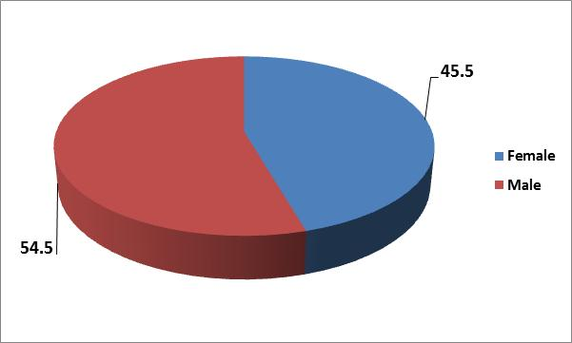
Figure (2): Gender distribution among patientgroup.

Table (1): Genderdistribution among patient and control groups.
 | Patient group | Control group | P value
 | % | %
Female | 45.5% | 45.0% | 0.976
Male | 54.5% | 55.0%

Age distribution among patient and control groups.
- The age of the 25 patients and the 20 controls included in this study ranged between 10 and 18 years with a mean age of patients 13.77±2.74 years and a mean age 13.65±2.74 yearsofthecontrols (Table 2).
- There was no significant difference between patient and control groups regarding age.

Table (2):Age distribution among patient and control groups.
 | Patient group |  | Control group |  | P value
 | Mean | SD | Mean | SD
Age | 13.77 | 2.74 | 13.65 | 2.74 | 0.909

Distribution of the hearing levels.
- The entire control group had normal hearing threshold levels (100%; 25controls; 50 ears).
- The patient group was divided into mild, moderate, moderately severe, Severe and profound SNHL(table 3 and figure 3).

Table (3): Distribution of hearing level among thepatientgroup.
Degrees of hearing levels | Patient group
 | No. | %
Mild hearing loss | 4 | 18.2%
Moderate hearing loss | 5 | 22.7%
Moderately severe hearing loss | 4 | 18.2%
Severe hearing loss | 5 | 22.7%
Profoundhearing loss | 4 | 18.2%

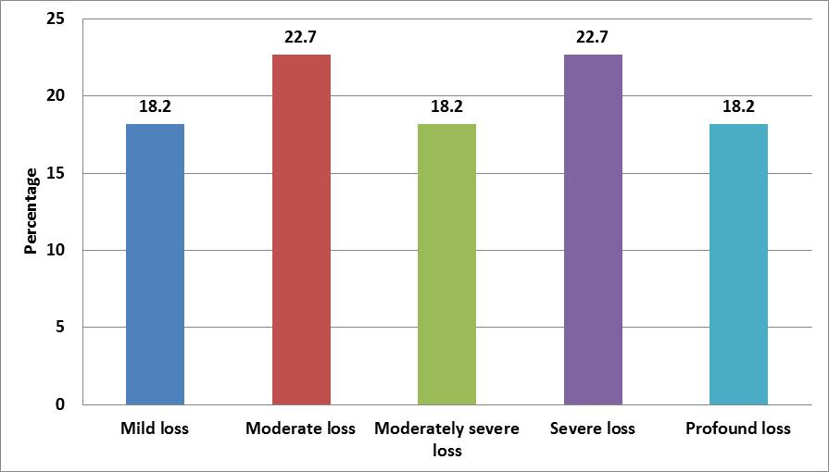
Figure (3): Distribution of hearing level among the patient group.

Distribution of the patientgroup according to etiology (congenital or acquired).
- The percentage of congenital non syndromic SNHL was 45.5% (10 patients) in the patient group.

Table (4): Distribution of patient group according to congenital or acquired hearing loss.
 | Congenital | Acquired
Count | 10 | 12
% | 45.5% | 54.5%

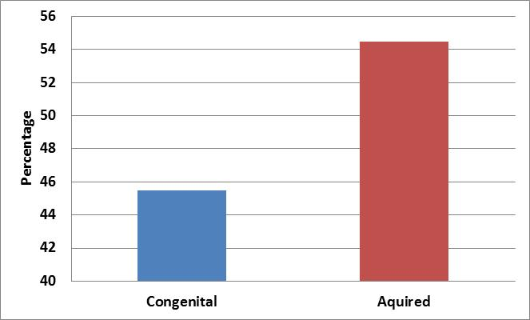
Figure (4): congenital or acquired hearing loss.

Distribution of patient group according to shape of audiogram.
- Fifty percent of the patients have sloping curve,36.4% with flat curve and 13.6% havesaucershapedcurveofhearingloss.(table5 and figure 5).

Table (5): Distribution ofpatientgroup according toshapeof audiogram.
Configuration | Count | %
flat | 8 | 36.4%
sloping | 11 | 50.0%
saucer | 3 | 13.6%

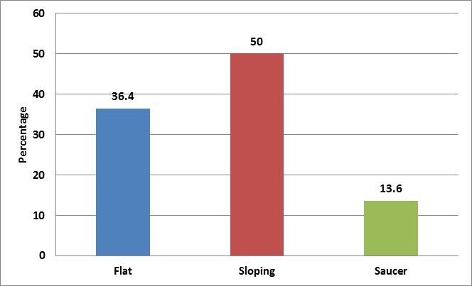
Figure (5): Distribution of thepatient group according to shape of audiogram.
Distribution of VEMP outcomes among the patient and control groups.
- When comparing different VEMP measurements in the patient and control groups, results revealed that the mean P13 latency in the patient group was 15.82±1.324SD at Rt.side&15.92±1.435 SD at lt.side, mean N23 latency was 22.23±1.962 SD at Rt.side&22.49±1.702 SD at lt.side. In the control group, theP13 latency mean was 15.263±2.0889SD at Rt.side&15.414±2.115 SD at lt.side, N23 latency mean was 22.16±2.006 SD at Rt.side&22.056±1.8326 SD at lt.side with a non significant P value between patientsandcontrolsregardingP13 and N23 latencies.
- The mean P13-N23 amplitude in the patient group was 15.897±12.58 SD at Rt.side&14.24±11.24 SD at lt.side. The mean asymmetry ratio in the patient group was 9.989±31.75 SD&in the control group was 0.328±31.774 SD. No significant P value between patients and controls regarding P13-N23 amplitude&asymmetry ratio.
- Results are demonstrated in (table6 and figures6&7).

Table (6): VEMP outcomes distribution among the patient and control groups.
VEMP Outcomes |  | Group |  |  |  | P.Value
 |  | Patients |  | Controls
 |  | Mean | SD | Mean | SD
Rt. | P13latency | 15.82 | 1.324 | 15.263 | 2.0889 | 0.131
 | N23latency | 22.23 | 1.962 | 22.16 | 2.006 | 0.351
 | P13 -N23 amplitude | 15.897 | 12.58 | 12.444 | 6.3792 | 0.465
Lt. | P13latency | 15.92 | 1.435 | 15.414 | 2.115 | 0.351
 | N23latency | 22.49 | 1.702 | 22.056 | 1.8326 | 0.07
 | P13 -N23 amplitude | 14.24 | 11.24 | 12.688 | 6.9313 | 0.84
Asymmetry ratio |  | 9.989 | 31.75 | -0.328 | 31.774 | 0.216
(N.B: Latency =ms; Amplitude=μV).

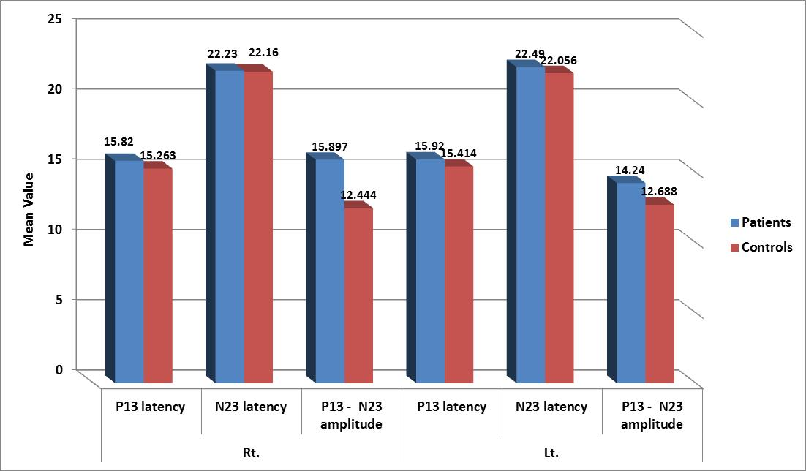

Figure (6): VEMP outcomes distribution among the patients and controls.

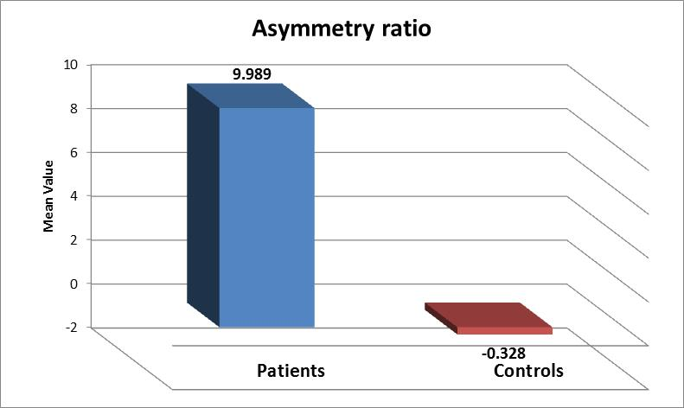
Figure (7): Asymmetry ratio distribution among the patients and controls.

VEMP measurements in relation to Etiology within the patient group.
Table (7) shows no significant difference between congenital and acquired hearing loss in different VEMP outcomes (non-significant P value) except asymmetry ratio which demonstrated a significant difference(figures8&9).

Table (7): VEMP measurements in relation to etiology.
VEMP Outcomes |  | Etiology |  |  |  | P.Value
 |  | Congenital |  | Acquired
 |  | Mean | SD | Mean | SD
Rt. | P13latency | 16.002 | 1.362 | 15.669 | 1.3318 | 0.429
 | N23latency | 23.19 | 1.393 | 21.42 | 2.052 | 0.048
 | P13 -N23 amplitude | 17.66 | 14.72 | 14.428 | 10.934 | 0.767
Lt. | P13latency | 16.39 | 1.497 | 15.52 | 1.3123 | 0.147
 | N23latency | 22.34 | 2.202 | 22.608 | 1.2343 | 0.843
 | P13 -N23 amplitude | 9.132 | 5.181 | 18.494 | 13.264 | 0.041
Asymmetry ratio |  | 27.92 | 28.87 | -6.151 | 25.776 | .034*
(N.B: Latency = ms; Amplitude = μV).

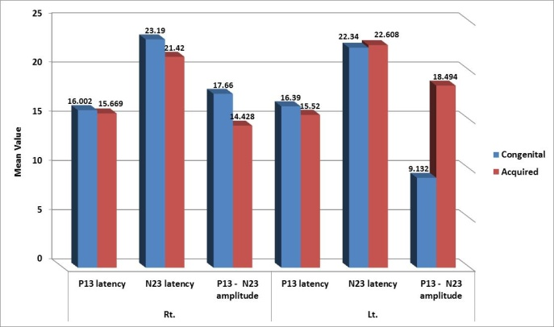
Figure (8): VEMP outcomes in relation to etiology within the patient group.

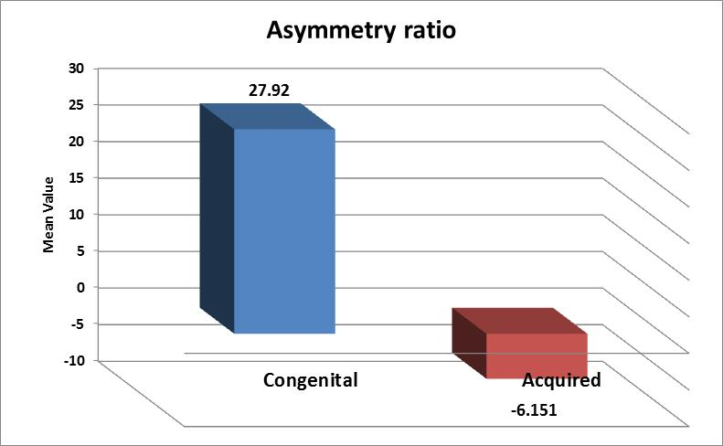
Figure (9): Asymmetry ratio in relation to etiology within the patient group.

Correlation between the degree ofhearing loss and different VEMP outcomes within the patient group.

Table (8):Correlation between the hearing loss and different VEMP outcomes within the patient group.
VEMP outcomes |  | Correlation Coefficient “r” | P value
Rt. | P13 latency | 0.192 | 0.329
 | N23 latency | 0.15 | 0.504
 | P13 N23 amplitude | 0.218 | 0.33
Lt. | P13 latency | 0.329 | 0.134
 | N23 latency | 0.249 | 0.264
 | P13 N23 amplitude | 0.28 | 0.207
Asymmetry ratio |  | -0.308 | 0.2
- Table (8) shows no significant difference between VEMP outcomes anddifferent degrees ofhearing loss in thepatient group.

Correlation between age and different VEMP parameters.

Table (9):Correlation between age and different VEMP outcomes amongthepatientgroup.
VEMP outcomes |  | Correlation Coefficient “r” | P value
Rt. | P13 latency | .121 | .592
 | N23 latency | .042 | 0.854
 | P13 N23amplitude | 0.021 | 0.927
Lt. | P13 latency | 0.1 | 0.656
 | N23 latency | 0.076 | 0.738
 | P13 N23amplitude | 0.026 | 0.91
Asymmetry ratio |  | -0.157 | 0.52
- Table (9) shows no significant correlation between age and different VEMP outcomes in thepatientgroup.

VEMP measurements in relation to shape of audiogram within the patient group;

Table (10): VEMP measurements in relation to shape of audiogram.
VEMP Outcomes |  | Shape of audiogram |  |  |  |  |  | P.Value
 |  | Flat |  | Sloping |  | Saucer-shaped
 |  | Mean | SD | Mean | SD | Mean | SD
Rt. | P13latency | 16.32 | 1.638 | 15.51 | 1.13 | 15.63 | 1.017 | 0.32
 | N23latency | 22.47 | 2.379 | 21.82 | 1.63 | 23.07 | 2.24 | 0.28
 | P13 -N23 amplitude | 9.97 | 4.259 | 17.99 | 13.64 | 23.99 | 20.08 | 0.23
Lt. | P13latency | 15.92 | 1.03 | 15.58 | 1.61 | 17.11 | 1.47 | 0.41
 | N23latency | 22.43 | 2.325 | 22.21 | 1.32 | 23.66 | 0.542 | 0.804
 | P13 -N23 amplitude | 7.239 | 3.732 | 17.11 | 10.77 | 22.36 | 18.92 | *0.01
Asymmetry ratio |  | 27.74 | 24.94 | 2.736 | 27.57 | -1.34 | 51.93 | 0.129
(N.B: Latency = ms; Amplitude = μV).
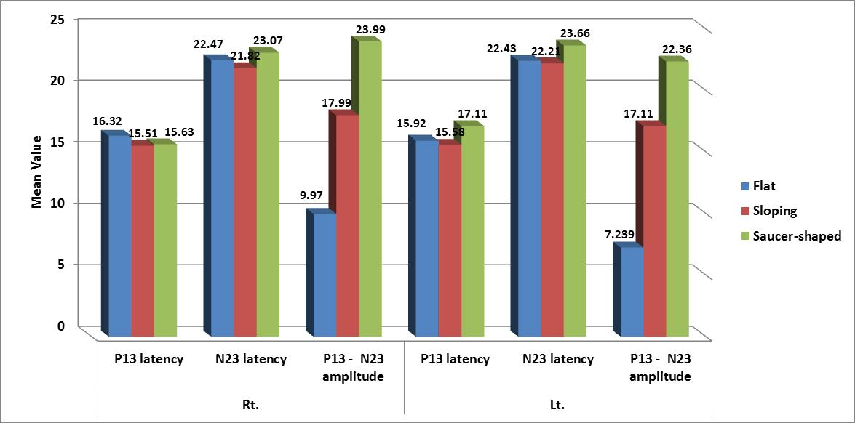
Figure (10): VEMP outcomes in relation to shape of audiogram within the patient group.

- Table (10) shows no significant difference between flat, sloping&saucer-shaped curves in different VEMP parameters (non-significant P value) except for p13N23 amplitude at lt side (figure 10).

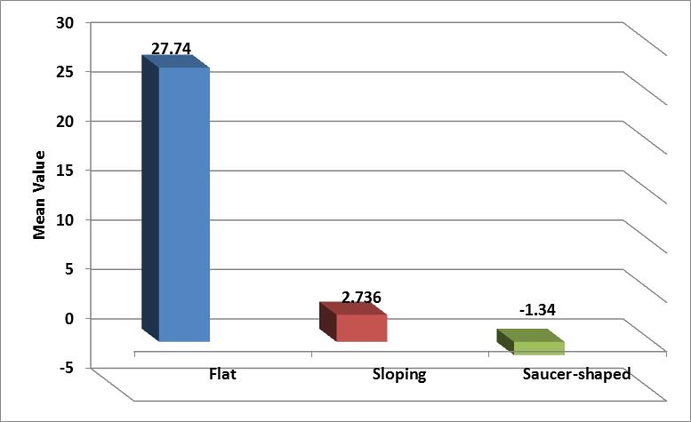
Figure (11): Asymmetry ratio in relation to shape of audiogram within the patient group.

Discussion
Understanding the correlation between vestibular function and hearing impairment is important as vestibular dysfunction may lead to delays in reaching motor milestones which may provide an indication of either a progressive or missed hearing loss. Proper assessment of a gross motor delay (sitting, walking) in the absence of deficits in fine motor function could lead to earlier identification than would occur with the failure to develop language, the true hallmark of hearing loss (Picciotti et al., 2007).
During early development, the otic vesicle divides into several chambers including a utricular chamber, which gives rise to the utricle and the semicircular canals, and a saccular chamber which gives rise to the saccule and the cochlea. The inner ear is often viewed to consist of two separate divisions. The superior division consisting of the three semicircular canals and the utricle and the inferior division which included the saccule and the cochlea (Valente et al., 2005).
Given the anatomic compartmentalization of the saccule and the cochlea, one might predict that saccular function may be more likely to be affected than utricular or semicircular canal function in the presence of an inner ear injury leading to SNHL. It is therefore reasonable to theorize that in some instances, lesions or insults that lead to auditory dysfunction may also lead to dysfunction of the vestibular end organs. In turn, dysfunction of the vestibular end organs may cause disruption in the ability to maintain static and dynamic balance (Valente et al., 2005).
Documentation of vestibular function and dysfunction in children with hearing impairment has a long and rich history, which has indicated that somewhere in the range of 20 to 85% of children with hearing loss demonstrate some form of vestibular end organ dysfunction (Cushing et al., 2008).
This study was conducted on twenty five children (55.6%) with different degrees of SNHL (from mild to profound) and twentychildren (44.4%) with normal hearing levels as the control group ( figure 3).
VEMP was performed to detect saccular function; VEMP response were investigated for(P13 and N23 latencies, P13-N23 amplitude and asymmetry ratio).
Rosengren et al. 2009, confirms that VEMPs can be recorded using acoustic stimulation despite the presence of severe hearing loss. Also our study confirmed that.
VEMP outcome distribution among the patient and control groups revealed that the mean P13 latency in the patient group was 15.82± 1.324atRt.side&15.92±1.435at lt.side, mean N23 latency was 22.23± 1.962at Rt.side&22.49±1.702at lt.side. In the control group, theP13 latency mean was 15.263± 2.0889at Rt.side&15.414±2.115at lt.side, N23 latency mean was 22.16± 2.006at Rt.side&22.056±1.8326 at lt.side with a non significant P value between patients and controls regarding P13 and N23 latencies (table 6 and figures6&7). Children with SNHL presented with within normal P13 and N23 latencies. This was in agreement with Sazgar et al. (2006), who compared the results of VEMP outcome on 50 patients with SNHL to 32 normal hearing volunteers and found that no significant correlation exists between the two groups regarding P13 and N23 latencies.
Also, Kelsh et al. (2006), reported normative data of VEMPs obtained with a click in young children. Their latency values of P13 and N23 were; 11.30 ms ± 1.30 and 17.60 ms ± 1.40 respectively. Picciotti et al. (2007), reported mean latencies of P13 and N23 to be; 16.14 ms ± 2.81 ms and 21.38 ms ± 3.04 respectively.
In our study, The mean P13-N23 amplitude in the patient group was 15.897±12.58 atRt.side & 14.24±11.24at lt.side. The mean asymmetry ratio in the patient group was 9.989±31.75&in the control group was 0.328±31.774(table 6 and figure 7). There was no significant difference between patients and controls regarding P13-N23 amplitude&asymmetry ratio.
Our results are partially consistent with Zhou et al. (2009), who reported abnormal VEMP in 91% of children with SNHL. The thresholds of VEMP were significantly higher (P<.001) and the amplitudes were lower in children with SNHL than those in children with normal hearing. There were no differences in the P13 and N23 latencies between study and control groups. The variability of VEMP amplitude was relatively high primarily owing to variations of the ongoing EMG level.
Correlation between the degree of hearing loss and different VEMP outcomes within the patient group revealed that when comparing the results of the different VEMP outcomes within the different degrees of hearing losses, results revealed no significant correlation between hearing loss and VEMP outcomes among the patient groups of different hearing losses. (Table 8).
Tribukait et al. 2004, found that if the hearing level was better than 90 dB (pure-tone average of 0.5, 1.0 and 2.0 kHz) vestibular function was often normal. For hearing levels of 100-120 dB, otolith function declined significantly. Likewise, the proportion of individuals with vestibular impairment is significantly lower (20 to 36%) in children with hearing threshold of less than 90dB and higher (80%) in those with more severe hearing loss (Sandberg and Terkildsen, 1965; Huygen and Van Rijn, 1993). But hearing thresholds are not predictive for the individual case. More specifically, Rosenblut et al. (1960), demonstrated in their cohort study that 16% of children with relatively good auditory sensitivity demonstrated complete absence of vestibular function, while 43.3% of the children with the poorest auditory sensitivity had normal responses. The relationship between auditory and vestibular function is certainly complex. The intricacy of this interaction is particularly evident in cases where vestibular function is well preserved in the presence of even the most severe auditory dysfunction and in instances where apparently minor losses of auditory function are accompanied by complete vestibular dysfunction (Cushing et al., 2008).
Our results are consistent with Zhou et al. 2009, who did not find a clear relationship between the degree of hearing loss and the severity of saccular dysfunction.
Correlation between age and different VEMP outcomes among the patient group revealed no significantcorrelation between age and VEMP outcomes (table 9). most probably due to narrow age range in our study (10-18 years old).
An increase in both P13 and N23 latencies has been reported with age in many studies (Zapala and Brey, (2004) with age range from 30 to 85 years; Zhou et al., (2009) with age range from 2 to 16 years). However Su et al. (2004), showed that the latencies of click-elicited VEMPs were similar for different age groups ranging from 7 to 75 years; Basta et al. (2005), reported no difference in either latency measurement across age groups.
While both Welgampola and Colebatch(2001) (with age range from 25 to 85 years), and Su et al. (2004), reported no difference in p13 latency as related to age, Welgampola and Colebatch (2001), reported a negative correlation for N23 latency and age and Su et al. (2001), reported a positive correlation between N23 latency and age. Knowing that the degree of SCM contraction does not affect VEMP latencies (Akin et al., 2004); therefore, the disagreement among reported findings may be related to differences in age group or recording techniques such as variations in stimuli and filter setting. In relation to the frequency of the stimuli, P13 latencies were shown to be prolonged as the frequency of the stimulus decreases. (Akin et al., 2003; Rauch et al., 2004).
The age related changes documented in the VEMP response in some studies may be attributed to the subsequent decline in overall neuroanatomy and physiological function as studies indicate that with an increase in age a decrease in the number of otoconia, specifically within the saccule as well as a decreased number of neurons within the medial vestibular nucleus occurs (Welgampola and Colebatch 2001; Tang et al., 2001).
Our study showed no significant correlation between age and P13-N23 amplitude (table 9). Earlier studies reported age-related changes of P13-N23 amplitudes. However, reductions in VEMP amplitude with increased age, has been a finding across some investigators (Su et al., 2001, 2004; Welgampola and Colebatch., 2001; Ochi and Ohashi, 2003; Zapala and Brey, 2004; Basta et al., 2005; Lee et al., 2008).
It is well known that VEMP amplitudes are linearly dependent on the tonic activity of the SCM (Welgampola et al., 2003; Akin et al., 2004; Lee et al., 2008). This effect is possible caused by the decrease of vestibular hair cells (Merchant et al., 2000), Scarpa’s ganglion cells (Velazquez- Villasenor et al., 2000) and cells of the vestibular brain-stem (Tang et al., 2001) during the aging process. This study, however did not confirm this postulation.
However Basta et al. (2007), reported no significant differences in overall muscle tonicity regardless of age coupled with decreased VEMP amplitudes; attributing the decreased VEMP amplitude to a decline in physiologic function.
Comparing VEMP outcomes between congenital and acquired hearing losses shows non significant p value except for P13N23 amplitude at left side and asymmetry ratio (Table 7 and figures8&9).
Correlation of vestibular function with the etiology of the hearing loss will improve counseling for all children with hearing loss and will better define many of these etiologies as well, including improved phenotype genotype descriptions for those with genetic hearing loss (Zhou et al., 2009).
Guilder and Hopkins in their study (1936) examining vestibular responses in children attending a school for the deaf. They noted that with the exception of meningitis, it was absolutely impossible to forecast the vestibular response of a child based on their aetiology of deafness. They saw a range of vestibular responsiveness that spanned from absent to normal across their designated etiologic subgroups, as well as across different categories of residual hearing (Valente et al., 2005).
Although the relationship between vestibular and auditory function is not simple, they do appear to be associated. A number of studies have shown that, at least on a group level, the likelihood of a vestibular impairment relates to the degree of the hearing loss (Goldstein and Landau, 1958; Rosenblut and Goldstein 1960; Sandberg and Terkildsen 1965; Brookhouser and Cre 1982; Huygen and Van Rijn, 1993). There is a general feeling that non-syndromic recessive causes of deafness, of which the most common are defects in the gap junction B2 (GJB2) gene, are not typically associated with concurrent deficits in vestibular end organ function (Todt and Hennies, 2005). This emphasis the need for further studies of the genetic causes of hearing loss in children and its relation to VEMP response.
Although peripheral vestibular function is an important consideration in evaluating children with SNHL, what is likely more important clinically is their ability to maintain balance to a sufficient degree to carry out their activities of daily living (Cushing et al., 2008).
It remains unclear why many hearing-impaired children with abnormal VEMP outcomes do not have complaints of vestibular symptoms. Possible explanations include the following: first, young children are not able to describe dizziness or vertigo to their parents and physicians, second, saccular impairment alone is not enough to cause clinically significant vestibular disturbance, third, chronic peripheral vestibular deficit may generate central compensation, and forth, less attention is paid to subtle manifestations of vestibular dysfunction by caregivers (Zhou et al., 2009).
Variability in the relationship between auditory and vestibular function can certainly be linked to differences in the etiology of the inner ear disorder. In addition to etiology however, the degree of SNHL may also aid in predicting the likelihood of an associated loss of vestibular function (Cushing et al., 2008).
Children may be candidates for unilateral or bilateral CI. We need to be certain that our baseline measures are accurate and adequately reflect functional outcome. An understanding of baseline vestibular function may also allow researchers or physicians to experiment with the properties of CIs in an effort to increase the quality of the sensory information provided to children with concurrent lesions of the cochlea and the labyrinth (Melvin et al., 2009).
Compared to the horizontal SCC, the saccule may be more susceptible to damage than the utricle or SCCs because of its proximity to the insertion path of the implant’s electrode array (Tien and Linthicum., 2002).
Basta et al. (2008), stated that chronic, persisting dizziness after CI surgery is largely based on a dysfunction of the saccular macula which is an integral component of the otolith system. This saccular impairment is induced most likely by the insertion trauma of the cochlear implant electrode when advancing it into the inner ear. A possible co-activation of the IVN by the electrical stimulation might play an additional role in the pathogenesis of the persisting postsurgical dizziness.
VEMP testing will permit parents to be more completely informed of the risk of vestibular impairment should the implant be done on a functional vestibule. Furthermore, this non-negligible risk of permanent vestibular dysfunction would argue against bilateral CI in a single surgical procedure without previous vestibular assessment (Korczynska and Pajor, 2008).
A CI shoud be programmed only after a complete vestibular evaluation, (including VEMP). Cochlear implantation can induce vestibular impairment in 40%-50% of the cases and complete vestibular loss in 9%-10% of cases; therefore, it is critical to check if there is asymmetric vestibular function in order to implant (and put at risk) the less functional vestibule (Wiener-Vacher et al,2012).
The VEMP test proved to be a feasible and relatively easy method to conduct vestibular evaluation in children. The test usually takes only 15 to 30 minutes and is well tolerated by children at any age group. Low-frequency tone bursts, such as 500 Hz, seem to be better stimuli than clicks because they produce more robust VEMP responses. Moreover, less intensity of stimulus is needed for tone bursts than clicks to elicit clear VEMP responses, thus minimizing the exposure of the subjects to an unpleasant loud sound (Zhou et al., 2009).

Conclusion:
Our research confirmed the assumption that VEMPs could be recorded despite the presence of severe degrees of SNHL. SNHL is not associated with saccular dysfunction in the pediatric population.

Recommendations:
Further research on the genes causing SNHL and its relation to VEMP findings are worth undertaking. Including VEMP testing in the battery of investigations for CI candidates is suggested.

References
- Akin F.W., Murnane O.D., Panus P.C., Caruthers S.K., Wilkinson A.E., Proffitt T. Alpini D., Pugnetti L., Caputo D., Cornelio F., Capobianco S. and Cesarini A. Vestibular evoked myogenic potentials in multiple sclerosis: clinical and imaging correlations. Mult. Scler. 2004; 10(3):312–316.
- Basta D., Todt I. and Ernst A. Normative data for P1/N1-latencies of vestibular evoked myogenic potentials induced by air- or bone-conducted tone bursts. Clin. Neurophysiol. 2005; 116: 2216–2219.
- Brantberg K., Westin M., Löfqvist L., Verrecchia L. and Tribukait A. Vestibular evoked myogenic potentials in response to lateral skull taps are dependent on two different mechanisms. Clin. Neurophysiol. 2009;120:974–979.
- Brookhouser P. E. and Cyr D. G. Vestibular findings in the deaf and hard of hearing. Otolaryngol. Head Neck Surg. 1982; 90(6): 773-777.
- Cushing S. L., Jordan K. and Harrison R. Relationship between sensorineural hearing loss and vestibular and balance function in children. Arch. Otorhinolaryngol. 2008; 134. (1): 34-38.
- Erbek S., Erbek S.S., Gokmen Z., Ozkiraz S., Tarcan A. and Ozluoglu L.N. Clinical Application of vestibular evoked myogenic potentials in healthy newborns. Int. J. Pediatr. Otorhinolaryngol. 2007; 71(8):1181-5.
- Goldstein, R. and Landau E. Neurological assessment of some deaf and aphasicm children. Ann. Otol. Rhinol. Laryngol. 1958; 67: 468-479. Adopted from Cushing et al., 2008.
- Huygen, P.L. and Van Rijn P.M. The vestibulo-ocular reflex in pupils at a Dutch school for the hearing impaired; findings relating to acquired causes. Int. J. Pediatr. Otorhinolaryngol. 1993; 25(1-3): 39-47.
- Kelsch, T. A. and Schaefer L. A. Vestibular evoked myogenic potentials in young children: test parameters and normative data. Laryngoscope. 2006; 116(6): 895-900.
- Kim K.S. Occupational hearing loss in Korea. J. Korean Med Sci. 2010; 25: S62-69.
- Korczynska M.J and Pajor A· Prognostic factors for vestibular impairment in sensorineural hearing loss. Eur. Arch. Otorhinolaryngol. 2008; 265:403–407.
- Lee S.K., Cha C.I., Jung T.S., Park D.C. and Yeo S.G. Age-related differences in parameters of vestibular evoked Myogenic potentials. ActaOtolaryngol. 2008;128:66–72.
- Merchant S.N., Velazquez-Villasenor L., Tsuji K., Glynn R.J., Wall C. and Rauch S.D. Temporal bone studies of the human peripheral vestibular system. Normative vestibular hair cell data. Ann. Otol. Rhinol. Laryngol. Suppl 2000; 181:3–13.
- Melvin, M.D., Thuy-Anh N. Charles C. Santina D., John P. and Americo A. The effects of cochlear implantation on vestibular function. Otol. Neurotol. 2009; 30(1): 87–94.
- Ochi K. and Ohashi T. Age-related changes in the vestibular evoked myogenic potentials. Otolaryingol. Head Neck Surg. 2003; 129:655–659.
- Picciotti P.M., Fiorita A., Di Nardo W., Scarano E. and Paludetti G. Vestibular evoked myogenic potentials in children. Int. J. of Pediatric. Otorhinolaryngol. 2007; 71: 29-33.
- Rauch S.D., Zhou G., Kujawa S.G., Guinan J.J. and Herrmann B.S. Vestibular evoked myogenic potentials show altered turning in patients with Meniere’s disease. Otol. Neurotol. 2004; 25:333–338.
- Rine R.M., Braswell J., Fisher D., Joyce K., Kalar K. and Shaffer M. Improvement of motor development and postural control following intervention in children with sensorineural hearing and vestibular impairment. Int. J. Pediatr. Otorhinolaryngol. 2004; 68(9):1141-1148.
- Rosenblut, B. and Goldstein R. Vestibular responses of some deaf and aphasic children." Ann. Otol. Rhinol. Laryngol. 1960; 69: 747-755. Adopted from Cushing et al., 2008.
- Rosengren S.M., Todd N.P.M. and Colebatch J.G. Vestibular evoked myogenic potentials evoked by brief interaural head acceleration: properties and possible origin. J. Appl. Physiol. 2009; 107:841–852.
- Sandberg L. and Terkildsen K. Caloric tests in deaf children. Arch. Otorhinolaryngol. 1965; 81: 350-354. Adopted from Cushing et al., 2008.
- Sazgar V., Dortaj K., Akrami S., Akrami A.R. and Yazdi K. Saccular damage in patients with high-frequency sensorineural hearing loss. Eur. Arch. Otorhinolaryngol. 2006; 263: 608–613.
- Su H.C., Huang T.W. and Cheng P.W. Aging effect on vestibular evoked myogenic potential. Otol. Neurotol. 2004; 25:977–980.
- Tang Y., Lopez I. and Baloh R.W. Age-related change of neuronal number in the human medial vestibular nucleus: a stereological investigation. J. Vestib. Res. 2001;11:357–363.
- Tien H. C. and Linthicum F. H. Histopathologic changes in the vestibule after cochlear implantation." Otolaryngol. Head Neck Surg. 2002; 127(4): 260-264.
- Todt I. and Hennies H. C. Vestibular dysfunction of patients with mutations of Connexin 26. Neuroreport. 2005; 16(11): 1179-1181.
- Tribukait A., Brantberg K. and Bergenius J. Function of semicircular canals, utricles and saccules in deaf children, Acta. Otolaryngol. 2004; 124: 41-48.
- Valente W., Clarck D., Dickman A. comprehensive vestibular evaluation battery with normal hearing and hearing impaired children. Eur. Arch. otolaryngol. 2005; 155: 1433-1438.
- Velazquez-Villasenor L., Merchant S.N., Tsuji K., Glynn R.J., Wall C. and Rauch S.D. Temporal bone studies of the human peripheral vestibular system. Normative Scarpa’s ganglion cell data. Ann.Otol. Rhinol. Laryngol. Suppl. 2000;181:14–19.
- Welgampola M.S. and Colebatch J.G. Characteristics of tone burst-evoked myogenic potentials in the sternocleidomastoid muscles. Otol. Neurotol. 2001; 22:796–802.
- Zagólski O. An acoustically evoked short latency negative response in profound hearing loss infants. Auris. Nasus. Larynx. 2008; 35(3):328-32.
- Zapala D.A. and Brey R.H. Clinical experience with the vestibular evoked myogenic potential. J. Am. Acad. Audiol. 2004;15:198–215.
- Zhou G., Margaret A., Kenna D. and Stevens K., Licameli G. Assessment of Saccular Function in Children WithSensorineural Hearing Loss. Otol. Head Neck Surg. 2009; 135 (NO. 1).

6/6/2017

