**Subsurface Structure and Hydrocarbon Evaluation of Ras Kanayes Area, Western Desert, Egypt**

Abd Elhady, M. A.1, Fathy, M.1, Ghaly, A. 2 and Mahfouz, M.1

1Geology Department, Faculty of Science, Al Azhar University, Cairo, Egypt.

2Apache Petroleum Company, Cairo, Egypt

[Mohamad.mahfoudh@gmail.com](mailto:Mohamad.mahfoudh@gmail.com), m[mahfouz71@yahoo.com](mailto:mahfouz71@yahoo.com)

**Abstract**: Ras Kanayes Oil Field is located at the north western Desert. The Middle Jurassic Khatatba Formation and Lower Cretaceous Alam El Bueib 5B Member is considered to be a good reservoir in the study area. The present work mainly deals with the interpretation of geological and geophysical data to evaluate the hydrocarbon potentials of Alam El Bueib and Khatatba reservoir in Ras Kanayes Oil Field. Isopach, lithofacies and structural maps are constructed to study the subsurface configuration of the study area based on the well-log correlations and seismic interpretation. Wire-line logs, from four drilled wells in the study area are interpreted for petrophysical evaluation. Analytical reservoir rock analysis includes achieving the shale content (Vsh), effective pomrosity (Øeff), water and hydrocarbon saturation (Shr & Sw), and net-pay thickness variation. Also, the vertical and horizontal variations of reservoir parameters are studied through constructing the litho-saturation cross plots and iso-parametric maps of the study area. As a result of the present study, using the subsurface and petrophysical evaluation, the hydrocarbon potentials of the Middle Jurassic Khatatba Formation and Lower Cretaceous Alam El Bueib 5B Member in Alam El Bueib Formation in Ras Kanayes Oil Fields is determined. A new locations is recommended to be a prospect in the study area.

[Abd Elhady, M. A., Fathy, M., Ghaly, A. and Mahfouz, M. **Subsurface Structure and Hydrocarbon Evaluation of Ras Kanayes Area, Western Desert, Egypt.** *N Y Sci J* 2017;10(7):147-159]. ISSN 1554-0200 (print); ISSN 2375-723X (online). <http://www.sciencepub.net/newyork>. 20. doi:[10.7537/marsnys100717.20](http://www.dx.doi.org/10.7537/marsnys100717.20).

**Keywords**: subsurface; structure; hydrocarbon; evaluation; Ras Kanayes Area; Western Desert; Egypt

**1. Introduction**

Ras Kanayes Oil Field was one of oil fields and the most prolific in the Western Desert. **Figure (1)** shows that the Ras Kanayes Oil Field is located at the north Western Desert, between latitudes 30° 35̀ - 31° 15̀ N and longitudes 27° 20̀ - 28° 10̀. it lies in midway between the Alamein and Meleiha oil fields, The El Hamra oil pipeline runs west – east through the Concession. **Figure (2)** shows the distribution of the available seismic lines and wells in the study area.



**Fig. (1) Location Map of Ras Kanayes Area in Egypt (Khalda Petroleum Company)**

**2. Materials and Methodology:**

The present study mainly depends on the use of the available open-hole well log records (electric and radioactivity logs) in the form of composite well logs (Resistivity, SP, GR, Density and Neutron) of four wells distributed in the area of study. In addition to this, twenty 2D and 3D seismic lines are used to delineate the subsurface structural setting.

The subsurface geologic setting is gained through the construction of isopach maps, lithofacies maps, seismic sections, structural cross sections and structure contour maps. The petrophysical evaluation is gained through the computer processed interpretation that passes through the quantitative interpretation technique. The

petrophysical characteristics are illustrated laterally (in the form of iso-parametric maps) and vertically (in the form of litho-saturation cross-plots).

This study is carried out by using the computer software programs, such as Petrel 2014 software program (@schlumberger, 2010), Interactive Petrophysics version 3.5 software program (@schlumberger, 2008).



**Fig. (2) Location Map of available seismic lines and wells in the study area. (Khalda Petroleum Company).**

**Subsurface Geologic Setting**

Geologic setting of the study area is determined by reviewing the general stratigraphy and structural relations, using subsurface data with the aid of isopach, lithofacies and structural maps.

**1- Stratigraphic Geology of Ras Kanayes**

**Schlumberger (1995**) mentioned that the sedimentary cover ( i.e. the sequence of deposits overlying the basement rocks) thickness northwards, reaching more than 35,000 ft in the Abu Gharadig Basin before thinning to 9,800 ft over the Ras Qattara ridge, which marks the northern edge of the basin. Several Western Desert basins have highly deformed sequences of sedimentary rock which formed as a result of extensive cycles of marine transgression combined with at least three organic (mountain-building) phases. The earliest of these phases was the Caledonian Orogeny which occurred during the Middle Paleozoic. The second Phase, the Hercynian Orogeny, took place at the end of the Paleozoic, while the Alpine Orogeny was a Jurassic-Tertiary phase.

In the present study we will focus on the Jurassic and Cretaceous rock units, Fig. (3) Shows the ideal lithostratigraphic column of Ras Kanayes Oil field from the investigated wells. The stratigraphic succession penetrated by the wells drilled in Ras Kanayes area ranges from Khatatba Formation (Bathonian/Jurassic) to Marmarica Formation (Middle Miocene) with a maximum total depth of 14656 ft in Ja27-4 well, one well Ja27-4 reached and penetrated large thickness of Lower Safa Formation, while Ja28-1 & Ja27-3ST have been bottomed in Khatatba Formation (Lower Jurassic), while the minimum drilling thickness in Ja27-1 well has been bottomed in AEB -6 (Lower Cretaceous).



**Fig. (3) Lithostratigraphic column of Ras Kanayes Oil field from the investigated wells**

**1-Khatatba Formation (Middle Jurassic):**

In the study area, the Middle Jurassic rocks, Khatatba Formation is represented in Ja28-1, Ja27-3ST and Ja27-4 well, Khatatba Formation with a maximum thickness of 1207ft in Ja27-3ST well. It consists of shale interbedded by sandstone with limestone streaks.



**Figure (4) Lithofacies map of Khatatba Formation**

Facies distribution map of Khatatba Formation shows distribution of Shale Limestone at most of the area especially along the western and central parts of the study area, and shows gradual change laterally to shale Sand to the eastern part (Fig.4).

**Stratigraphic correlation chart in the study area:**

Stratigraphic correlation **Fig. (5),** runs in NE –SW direction hanged on Alamine Dolomite Formation and connecting the studied wells. It shows that the AEB_6 member and Khatatba Formation are thick in central parts, where AEB# 6 recording its maximum thickness 217 m., and decreases towards the western part recording 79m., and Khatatba Formation recording its maximum thickness 368 m., and decreases towards the western part recording 325m.

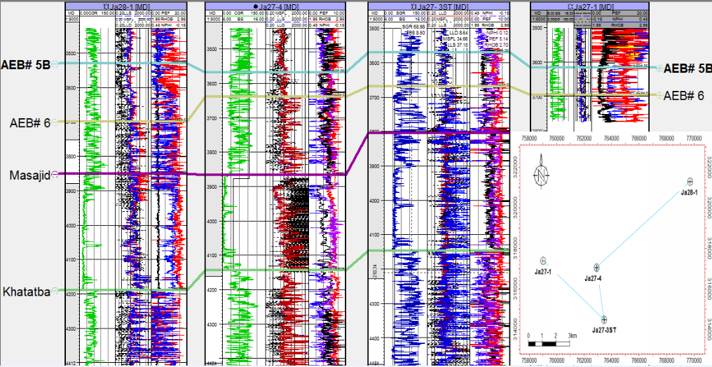

**Fig. (5) Stratigraphic correlation of Ras Kanayes oil field.**

**3- Structural Setting of Ras Kanayes Area**

The Western Desert comprises the area west of the Nile River and Delta. It covers 700.000 sq km, about two-third of the area of Egypt. It extends 1000 km from the Mediterranean Sea to the Sudan border in the south and 600 to 800 km from the Nile Valley to the Libyan border in the west (Schlumberger, 1984).

Generally, the Western Desert is subdivided according to (Said 1962), from south to north into four major tectonic units, namely: Stable shelf, unstable shelf, hinge zone, and Miogeosynclinal. The North Western Desert is characterized by a simple monotonous and almost flat regional extending surface geological structures represented by a number of gently dipping Tertiary strata in the forms of anticlines and synclines, trending northeast and east west, and become exceedingly complicated in the subsurface (**Zittle, 1883**).

According to (Said, 1990), the North Western Desert structure is dominated by faults many of which can be identified from seismic and well data. The majority are steep normal faults and most have a long history of growth. Some of the normal faults suffered strike slip movements during part of their history. Strike slip movements seem to have affected the orientation of many of the fold axes. The strike slip movements were probably related to lateral movements which the African plate underwent during the Jurassic (sinstral) and late Cretaceous (dextral).

**3.1 Seismic Interpretation**

To understand the subsurface structure of the study area, thirteen dip seismic sections are constructed and oriented towards N-S direction, and seven strike seismic sections are constructed and oriented towards E-W direction as is shown in figure (2). The selected seismic sections reflect the subsurface structural features and reveal the following:

**3.1.1 Interpreted seismic section-IL-8425**

The interpreted seismic section-IL-8425 is shown in **Fig. (6)**. It is a dip seismic section and takes the E-W trend. It is located at the central part of the study area and passes near to Ja27-4 well. The interpretation of this section is done by using the time-depth chart constructed using check shot data of Ja27-4 well, so the detection of the two way time of the selected stratigraphic horizons is easily done.

This section passes through the studied rock units (Khoman, Abu Roash F Member, Kharita Formation, AEB# 5A, B& 6 Members, Masajid Formation and Khatatba Formation). This section shows a set of normal faults (F1, F3, F4 and F7) that affect on all the stratigraphic units. F1 and F3 are directed towards the NE-SW trend with a downthrown side directed towards the NW trend, and (F4 and F7) are directed towards the NW-SE trend with a downthrown side directed towards the NE. F3 and F4 form a graben block, F3 and F7 form a horst block, while F1 and F3 are forming a step fault.

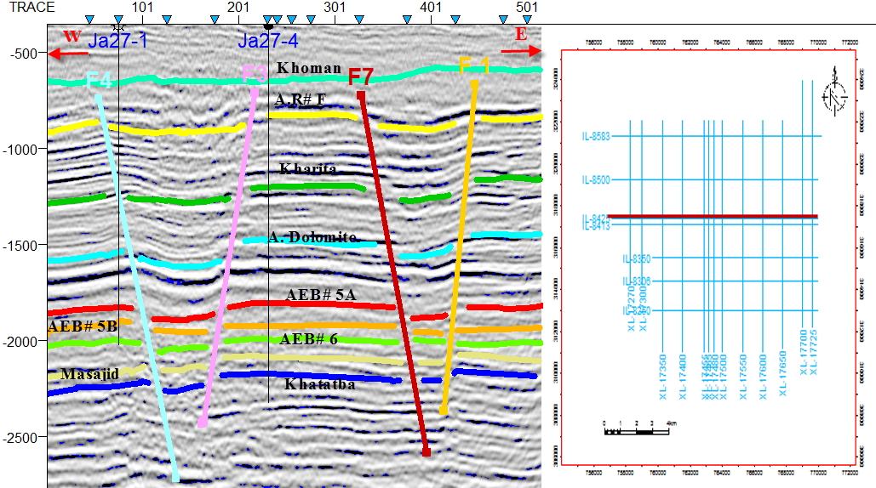

**Fig. (6) Interpreted seismic line IL-8425.**

**3.2 Structure contour maps**

After the interpretation of the seismic sections we construct a time structure contour map and depth structure contour map for each of the selected stratigraphic horizons by using Petrel 2009 software program (@ Schlumberger, 2009). To illustrate the subsurface structural configuration of the study area, four structure contour maps are constructed on selected formations tops (Alam El Bueib# 5B& 6 Member, Khatatba Formation (the last two are reservoirs in the study area).

**3.2.1 Khatatba formation structure contour map**

The structure contour map on top Khatatba Formation is shown in **Fig. (7)**. It shows a set of six normal faults determined from the seismic Sections. The depth values range from 3720 to 4140 m. F1 and F3 takes NE-SW trend with downthrown side directed towards the NW and SW respectively. F2, F5 and F6 are taking the E-W trend with down-thrown side towards the E direction respectively. F4 takes NW-SE trend with downthrown side directed towards the NE trend forming a graben block. All the studied wells are located on the horst block, and located within the three-way dip closure, that is very suitable place for oil and gas accumulations. To delineate the subsurface structure of the study area, structural model Fig**. (7)** is constructed and structural cross sections are done through the study area in different directions. To delineate the subsurface structure of the study area, geologic structural cross sections are constructed.

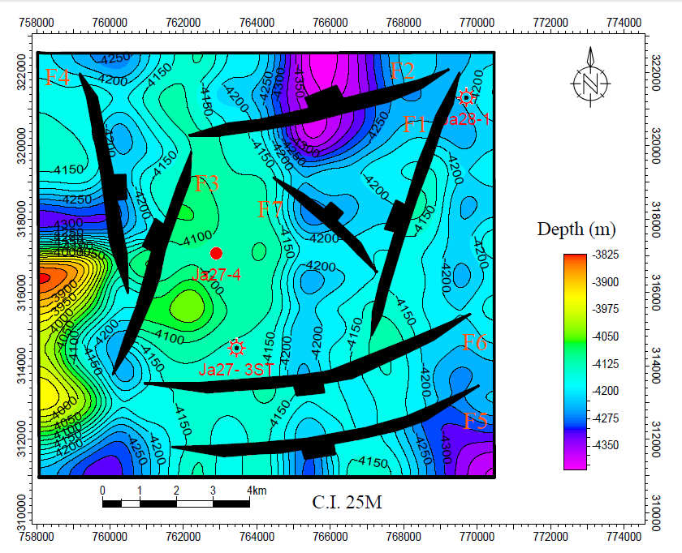

**Fig. (7) Structure contour map on top Khatatba Formation**

**3.3 Geologic Structural Cross Sections**

According to **Tearpock & Bischke (2003),** whenever possible, cross sections should be constructed using the same horizontal and vertical scales (true-scale sections). Special considerations may require that a section be prepared with different (exaggerated) scales, practically when constructing large regional or semi-regional sections.

Typically, it is the vertical scale that is exaggerated. There are certain situations in which a cross section with a vertical exaggeration is required; in fact, it may have some advantages over a cross section with equal scales. Several situations that may require across section with a vertical exaggeration are (1) a section that would be unreasonably long with equal scales, or (2) the need for extensive vertical detail.

**3.3.1 Structural Cross Section**

Several structural cross sections, **Fig. (9 and 10**) have been constructed using the interpreted seismic lines. These structural cross sections reflect that the study area is affected by several normal faults.

**N-S Geologic Structural Cross Section**

**Fig. (9)** Shows the N-S structural cross section. It is located at the Eastern part of the study area. These structural cross section shows that the area is affected by several normal faults forming a horst block, graben and step fault.

**(B) E-W Geologic Structural Cross Section**

**Fig. (10)** shows the E-W structural cross section. It is located at the western part of the study area. These structural cross section shows that the area is affected by several normal faults forming a horst block and graben block.

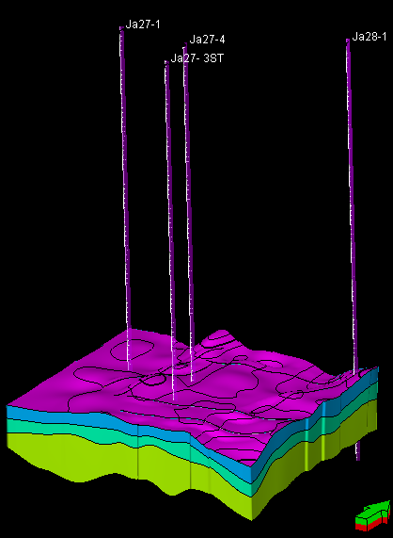

**Fig. (8) Structural model of Ras Kanayes field**

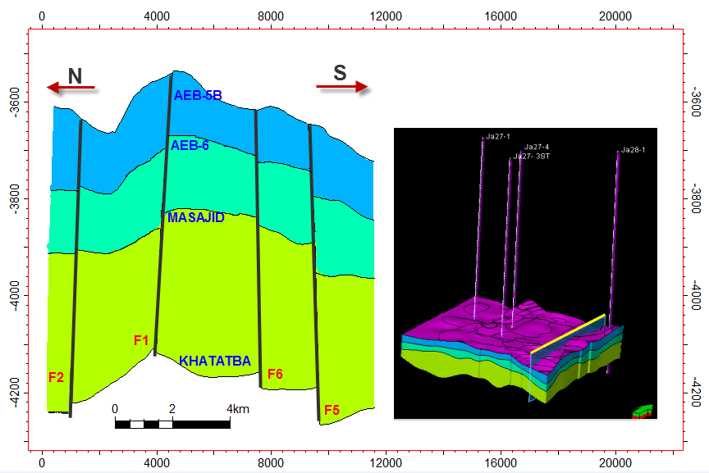

**Fig. (9) N_S structural cross section.**

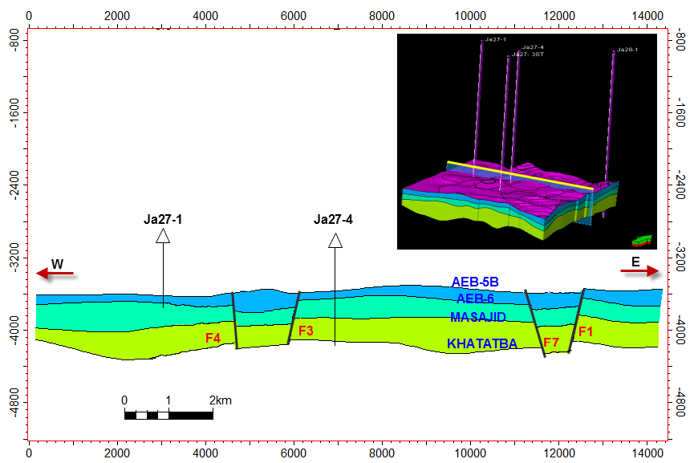

**Fig. (10) E_W structural cross section.**

**4- Reservoir Characterization**

The The value of formation water resistivity (Rw) for Khatatba Formation ranges from 0.1 (Ohm.m.) in Ja27-3ST well to 0.26 (Ohm.m.) in Ja28-1 well. AEB- 6 Member ranges from 0.02 (Ohm.m.) in Ja27-1 to 0.25 (Ohm.m.) in Ja28-1 well, AEB- 5B Member ranges from 0.01 (Ohm.m.) in Ja27-1 well to 0.04 (Ohm.m.) in Ja28-1 well, and AEB- 5A Member ranges from 0.1 (Ohm.m.) in Ja28-1 to 0.68 (Ohm.m.) in Ja27-1. mapped for Khatatba Formation. The cutoffs used for Khatatba Formation are as follows: Effective porosity 10%, Water Saturation 65% and Shale content 35%.

**Table (1):** Shows the petrophysical parameters of Khatatba Formation in Ras Kanayes oil field.

|  |  |  |  |  |  |  |  |
| --- | --- | --- | --- | --- | --- | --- | --- |
| **Well no.** | **Interval**  **( m)** | **Gross**  **( m )** | **Net pay**  **(m)** | **Effective porosity**  **(%)** | **Water saturation**  **(%)** | **Shale content**  **(%)** | **Hydrocarbon saturation**  **(%)** |
| **Ja28-1** | 4190-4550 | 360 | 98 | 26 | 32 | 9 | 69 |
| **Ja27-3ST** | 4148-4516 | 368 | 52 | 17 | 55 | 17 | 45 |
| **Ja27-4** | 4143-4468 | 325 | 58 | 22 | 39 | 14 | 61 |

**4.1 Well-Log Analysis**

Well-log analysis represents the most important stage in the evaluation of petrophysical characteristics (effective porosity, shale content, water saturation, and hydrocarbon saturation). In this investigation, the applied CPI (computer-processed interpretation) quantitative techniques are the using of charts and cross-plots, which in fact based on mathematical calculations using the equations, for example, Archie's water saturation equation.

**4.1.1 Lithological Identification cross-plots**

Identification of lithology is of a particular importance in formation evaluation process. Logs can be used as indicators of lithology. The most useful logs for this purpose are density, neutron and gamma-ray logs.

**Fig. (11) s**hows the neutron-density cross-plots (lithological identification cross plot) of Khatatba Formation in all wells. As is shown in this figure, it is mainly characterized by the predominance of Shale, Limestone with Sandstone streaks.

**4.1.2 Mono-Porosity cross-plot**

In this investigation, water saturation for different horizons is determined by using the resistivity-porosity (mono-porosity) cross-plot.

The value of water saturation in Khatatba Formation ranges from 32% in Ja28-1, 55% in Ja27-3ST. It indicates the probability of presence of hydrocarbon sub-reservoir intervals as the mean value is 50%.

**4.1.3 Dia-Porosity cross-plot**

For the determination of shale volume (Vsh) and effective porosity (Øeff), a combination of porosity logs can be used. Dia-porosity cross-plot is a specific graphical log analysis technique for actual petrophysical evaluation.

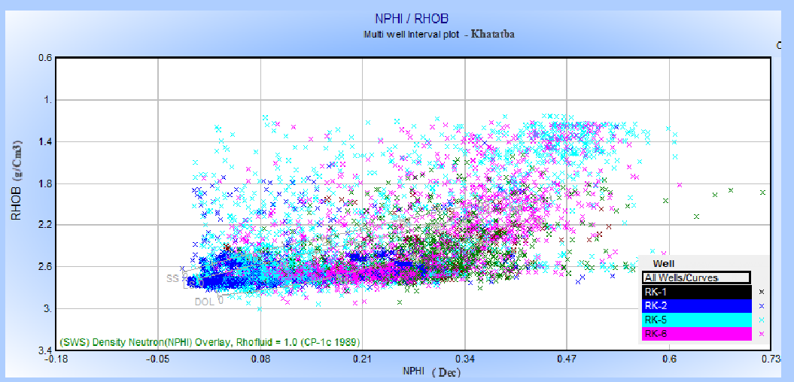

**Fig. (11) shows the neutron-density cross-plots (lithological identification cross plot) of Khatatba Formation**

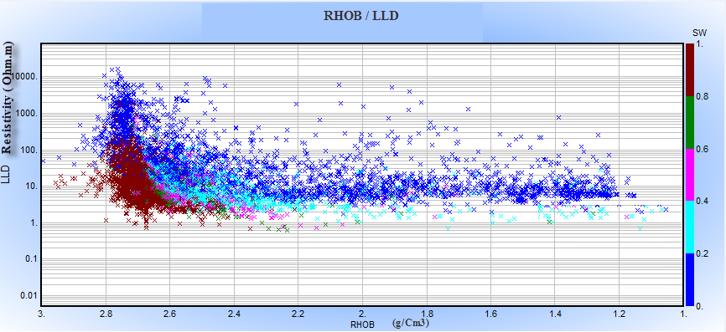

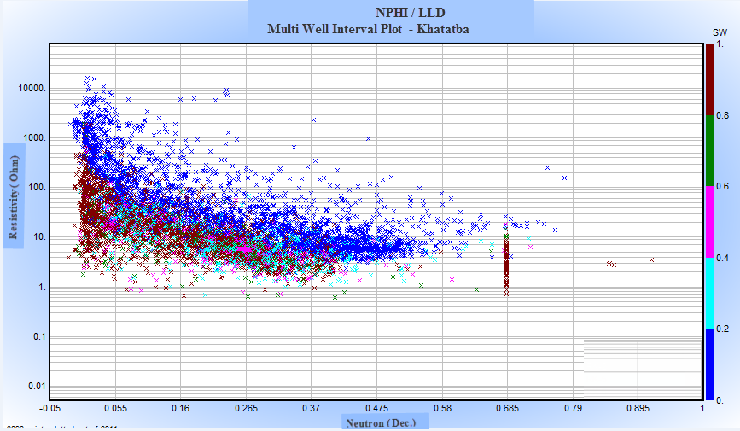

**Fig. (12) Mono-porosity cross-plot of Khatatba Formation in the wells of study area.**

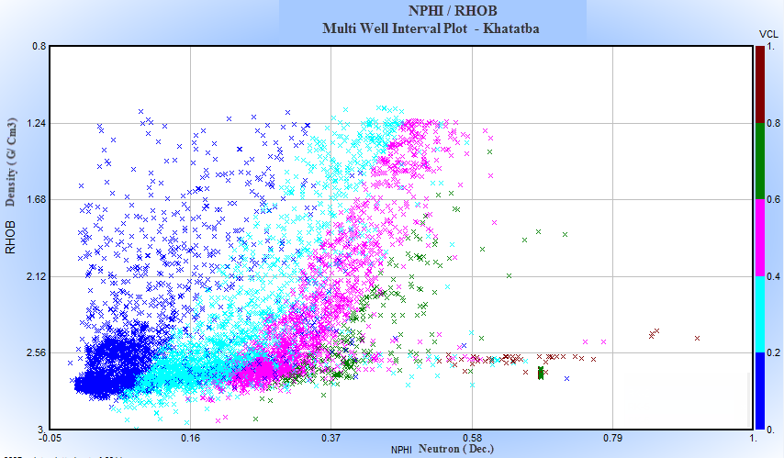

**Fig. (13) Dia-porosity cross-plot for determining the shale volume (Vsh) of Khatatba Formation.**

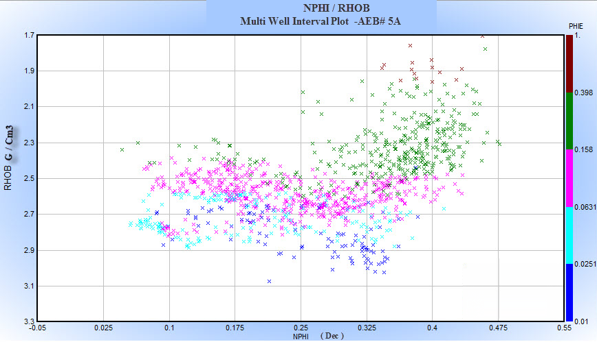

**Fig. (14) Dia-porosity cross-plot for determining the effective porosity (Øeff) of Khatatba Formation.**

In this investigation, **Fig. (13 and 14)** show dia-porosity cross-plot which is carried out to determine the shale volume (Vsh) and effective porosity (Øeff). The following is the using of Dia-porosity (neutron vs. density) cross-plot in the wells in the study area. The value of shale content ranges from 9% in Ja28-1 well, 17% in Ja27-3ST well. It indicates the probability of presence of hydrocarbon sub-reservoir intervals as the mean value is 52 %, while the value of effective porosity ranges from 17% in Ja27-3ST to 26% in Ja28-1. It indicates the probability of presence of hydrocarbon sub-reservoir intervals as the mean value is 49-63%.

**4.2 Illustration of Results**

Petrophysical characteristics that are deduced from the process of well-log analysis are generally varied vertically and laterally. The lateral variation of petrophysical characteristics in the area under investigation could be studied through a number of gradient and saturation maps (iso-parametric maps); that include, net pay (m), shale content (Vsh %), effective porosity (Øeff %), water saturation (Sw %), and hydrocarbon saturation (Shr %) to complete the vision of hydrocarbon potentialities in the study area.

The vertical distribution of the petrophysical characteristics have been performed through the litho-saturation cross-plots by the software program technique. Litho-saturation cross-plots are considered as an important vertical representation for petrophysical characteristics, because they are used for more accurate evaluation in the individual wells and in comparison between the different wells. The litho-saturation cross-plots are presented to give complete vision about the lithological analysis (shale volume and matrix), effective porosity and the internal resolution of the available water and hydrocarbon saturations.

**4.2.1 Lateral Variation of Petrophysical Characteristics**

A number of iso-parametric maps, which are the net pay, shale content, effective porosity, water saturation, and hydrocarbon saturation maps, represent the lateral variation of petrophysical characteristics.

**4.2.1.1 Khatatba Formation Combined Petrophysical Parameters**

**Fig. (15) i**llustrates the combined petrophysical characteristics of Khatatba Formation. This figure shows that the net pay thickness of Khatatba increases towards the northeastern parts of the study area, while the effective porosity increases towards the north eastern parts of the study area. The water saturation decreases towards the northeastern parts of the study area, while the shale content decreases gradually to the northeastern direction of the study area.

|  |  |
| --- | --- |
|  |  |
|  |  |

**Fig. (15) The different petrophysical characteristics of Khatatba Formation in the study area.**

**4.2.2Vertical Variation of Petrophysical Characteristics**

The vertical distribution of hydrocarbon occurrences can be explained and presented through the construction of the litho-saturation cross-plots. Litho-saturation cross-plot is a representation, zone-wise, for the content of fluids and rocks with depth through the studied well. The contents of rocks include shale and matrix, while the contents of fluids include water and hydrocarbon saturation.

**4.2.2.1 Litho-Saturation Cross-plot of Ja27-4 well**

**Fig. (16)** illustrates the computer processed interpretation (CPI) plot for Khatatba Formation in Ja27-4 well. It is encountered at depth ranges from 4143m to 4468m. The gross interval of Khatatba Formation is 325m. As is shown in this figure, it is mainly characterized by the predominance of shale and limestone interbedded with siltstone and sandstone streaks.

In this Formation the shale content ranges between 9% to 17% and the mean value is 9%. The effective porosity ranges between 17% to 26% but the mean value is 17%. The water saturation ranges between 32% to 55% and the mean value is 39%. The net pay is 58m. The hydrocarbon saturation reaches up to 61%.

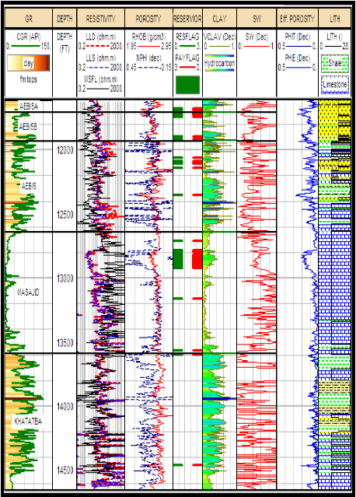

**Fig. (16) The computer processed interpretation (CPI) plot for Khatatba Formation in Ja27-4 well**

**5-Summary and Conclusions**

The present work dealt mainly with the interpretation of both geological and geophysical data to evaluate the hydrocarbon potentials of clastic reservoirs in Ras Kanayes field, Western Desert, Egypt.

To delineate the subsurface structure of the study area, thirteen dip seismic sections are constructed and oriented towards N-S trend, seven strike seismic sections are constructed and oriented towards the E-W trend.

These sections show a set of seven normal faults (F1 to F7). F1 and F3 are taking the NE-SW trend with down-thrown side directed towards the NW direction, while F2, F5 and F6 are taking the E-W trend with down-thrown side directed towards the S direction for F5 and F6, and N direction for F2. Finally F4 and F7 are taking NW-SE trend with down-thrown side directed towards the NE direction. F2 and F6 are forming a horst block. All the studied wells are located on the horst block, and located within the three- way dip closure, that is very suitable place for oil and gas accumulations.

To illustrate the subsurface structure of the study area, five depth structure contour maps are constructed on the top of the selected stratigraphic horizons namely; ( Khatatba Formation).

All resulted petrophysical parameters are represented vertically in Litho-saturation cross-plots and laterally in different types of iso-parametric maps (iso-effective porosity, shale content, water saturation, and net-pay thickness variations). Increase or decrease affecting by structure control. From the subsurface and petrophysical information of this study, we can concluded the petroleum potentialities in the study area. The source rock in the study area is suggested to be Khatatba Formation. The reservoir rock in the study area is represented by AEB-5A, AEB-5B members and Khatatba Formation which consists mainly of sandstone. The seal rock in the study area is represented by the limestone of Masajid Formation. The structural traps in the study area, is represented by fault trap.

**References**

1. Abd El Aziz, A. L. (1994): "Jurassic source rock maturity and thermal history modeling of the Khalda west area, North Western Desert Egypt", E.G.P.C., 12th Petrol. Explor. and Prod. Conf., Cairo, V. 2, pp. 217-233.
2. Barakat, M. G. (1970): "A stratigraphical review of the Jurassic formations in Egypt and their oil potentialities", The 7th. Arab Petroleum Congress, Kuwait, Paper No. 58, 16 p.
3. Dominik, W,; (1985): w. W. G., (1977): Stratigraphic and sedimentologie (Geochemie Schwerminer- alanayse) der oberkreide vov Bahariya and the Korrelation zum Dakhla Becken (western Desert Egypten); Berl, Geowiss, Abh. 62 (A): 1-173.
4. E.G.P.C. (Egyptian General Petroleum Corporation) (1986): "History of oil and exploration, Egypt", EGPC 8th Petrol. Explor. and Prod. Confer., Cairo, pp. 1-34.
5. El Ayouty, M. K. (1990): "Petroleum geology", In, R. Said (ed.), The Geology of Egypt, Balkema, Rotterdam, pp. 567-599.
6. Gluyas, J. and Swarbrick, R. (2004): "Petroleum geoscience", Blackwell Science Ltd. 349 p.
7. Hyne, N. J. (2001): "Petroelum Geology, Exploration, Drilling, and Production", 2nd ed. Penn Well Corporation, 598 p.
8. Khalil, R.M. (2013): "Subsurface Structural Study on Kararma Field, East Bahariya, Western Desert, Egypt" M.Sc. thesis, Fac. Sci., Al Azhar Univerisity, Egypt.
9. Luthi, S. M. (2001): "Geological Well Logs, their use in reservoir modeling", Springer-Verlag Berlin Heidelberg. Exploration and Production Conference. Exploration Vol. 2, pp. 236-262.
10. Moody, G. B. (1961): "Petroleum Exploration Handbook", McGraw-Hill Book Company, Inc.
11. Norton, P. (1967): "Rock stratigraphic nomenclature of the Western Desert", Pan American, U.A.R. Oil Co. Internal Report, 557 p.

7/25/2017