The Possible Curative Role of Fresh Cabbage Juice on Ethanol Induced Gastric Mucosal Injury in Adult Male albino Rat: Histological and Ultra Structural Study.

Walaa H. E. Hamed, Nesreen M. Omar, Wafaa S. H. Eid andNawal A. Hasanin

Department of Histology and Cell Biology, Faculty of Medicine, Mansoura University, Egypt.
walaahamedhistology@yahoo.com

Abstract: Background:Gastric ulcer is the most common disorder of the stomach. Brassica oleracae (Cabbage) is a natural plant which has a protective effect on the gastro-intestinal mucosa.Aim of the work: This work aimed to assess the possible curative role of fresh cabbage juice on ethanol induced gastric mucosal injury.Materials and Methods: Fifty adult male albino rats randomly assigned into five groups were used.Group A1; received distilled water orally by gavage, daily, for one week.Group A2; given raw fresh cabbage juice 200 ml/kg body weight three times per day orally by gavage, for one week.Group B; given a single dose of ethanol 1 ml/ rat then, scarified after one hour.Group C; given a single dose of ethanol 1 ml/ rat and scarified after one week.Group D; given a single dose of ethanol 1 ml / rat orally by gavage followed by administration of raw fresh cabbage juice 200 ml/kg bodyweight three times per day orally by gavage, for one week. Specimens from the fundic mucosa were obtained and processed for light and electron microscopic studies. Statistical study of the ulcer area percent was done.Results: Intragastric application of ethanol induced severe mucosal injury, sloughing of mucosal surface cells and disturbed glandular architecture.By electron microscope the gastric mucosal cells showed variable degenerative changes.Surface mucous cells had irregular nucleus anddamaged apical parts with variable sizedmucous granules released into the lumen. Peptic cellsdemonstratedshrunkennucleus, dilated rER, lysosomes and few zymogen granules.Parietal cells also showed shrunken dense nucleus, dense mitochondria, dilated tubulovesicular system, lysosomes and many cytoplasmic vacuoles. Administration of fresh cabbage juice was associated with preserved gastric histoarchitecture.It also ameliorated the ultrastructural changes induced by ethanol in the fundic mucosal cells. This was accompanied by a significant reduction in the ulcer area percent.Conclusion: Fresh cabbage juice has a potent therapeutic efficacy in ethanol induced gastric mucosal injury.
[Walaa H. E. Hamed, Nesreen M. Omar, Wafaa S. H. Eid andNawal A. Hasanin. The Possible Curative Role of Fresh Cabbage Juice on Ethanol Induced Gastric Mucosal Injury in Adult Male albino Rat: Histological and Ultra Structural Study. N Y Sci J2017; 10(7):68-78]. ISSN 1554-0200 (print); ISSN 2375-723X (online).http://www.sciencepub.net/newyork. 11. doi:10.7537/marsnys100717.11.

Key words: gastritis, ethanol, cabbage, ultrastructure, stomach

1. Introduction
Peptic ulcer is the most common disorder of the stomach.Gastric acid secretion is the main pathogenesis of the ulcers so proton pump blockers or antacids are used to control secretion (Araujo et al., 2011).Ethanol has been used for inducing gastritis and gastroduodenal ulcer in experimental animals. It damages the gastrointestinal tract mucosa by vascular endothelium injury, increasing vascular permeability and edema formation (Miranda-Mendez et al., 2010).
Drugs used for treatment of gastric ulcer show limited efficacy and have many side effects. Natural products such as medicinal plants, herbs, spices and vegetables are recently preferred for prevention and treatment of peptic ulcer (De Lira Mota, 2009).
Plants, Spices, and herbs are natural antioxidants sources protecting from oxidative stress and playing important role in prevention of a lot of diseases. Brassica oleracae (Cabbage) is very useful vegetable crops in the world. There are two types of cabbage; green cabbage and red cabbage. It contains riboflavin, vitamins A, B6, C, thiamine, folate omega-3 fatty acids, protein, glutamine, S – methylmethionine and glucoraphamin. Cabbage leaves and other green vegetables possess anti-ulcer activity. It has a protective effect on the gastro-intestinal mucosa, gastric disorders and liver diseases (Arisha, 2017).

2. Materials and Methods
Materials
- 80% alcohol (ethanol):
80% Ethanol was obtained from Al-Gomhoria Co-operation- Egypt as a solution.
- Raw fresh cabbage juice:200 ml/ kg (Shoaib et al., 2016).
Ingredients: 3 cups (675 gm) chopped green cabbage, 1 ¾ cup (435 ml) distilled water. The chopped cabbage and water were put into the blender at low speed until the water became green tinted. Then a mesh strainer was used to separate the mixtures liquid from the mixtures solid.
Experimental animals
The protocol of the study was approved by the institutional research board (IRB) committee of Mansoura Faculty of Medicine. Fifty adult male Sprague-Dawley rats, weighing (200 ± 10 gm) were used in this study. The animals were housed in metal cages and fed on a commercial basal diet and water ad-libitum for 2 weeks before the experiment for acclimatization. The rats were kept at room temperature (22-26ºC) with a 12-h light: 12-h dark cycle.
Animal grouping
Rats were randomly assigned into 5 groups (10 rats each):
- Group A1 (Control group): fed on the basal diet and received distilled water orally by gavage, daily, for one week.
- Group A2: given raw fresh cabbage juice 200 ml/kg body weight three times per day orally by gavage, for one week (Shoaib et al., 2016).
- Group B: fasted for 12 hours (overnight) then given a single doseof 80% ethanol (1 ml / rat) then they were sacrificed after one hour (Barka et al., 2017).
- Group C:fasted for 12 hours (overnight) then were given a single dose of 80% ethanol (1 ml/ rat) then they weresacrificed after one week.
- Group D: fasted for 12 hours (overnight) then were given a single dose of 80% ethanol (1 ml/ rat) orally by gavage followed by administration ofraw fresh cabbage juice 200 ml/kg body weight three times per day orally by gavage, for one week, then they were sacrificed.
Animals from each group were sacrificed at the appropriate time by decapitation after intraperitoneal injection of thiopental sodium phosphate in adose of 40mg/kg body weight. Samples of fundic mucosa were obtained and prepared for the histological study by light and electron microscopes.
I. Histological study:
- Light microscopic study:
Specimens of the fundus of the stomach were fixed in 10% neutral-buffered formalin fixative and paraffin sections (5 µm thick) were prepared and stained with;
- Hematoxylin and eosin (H&E) stainfor histological study (Hansen et al., 2016).
- Alcian blue/ PAS stain for studying carbohydrate (Prasanna et al., 2017).
- Electron microscopic study:
Very small pieces (1 x 2 mm²) of the fundus of the stomach were rapidly fixed in a mixture of 2.5%. Glutaraldehyde and 2.5% Para formaldehyde (PH 7.3). Semithin sections (1µm) were prepared and stained with 1% toluidine blue. Ultrathin sections (60-80nm) were also prepared, double stained with uranyl acetate and lead citrate for examination and photographing with transmission electron microscope (TEM) (Stirling et al., 2008).
Morphometric and Statistical study:
Data of the ulcer area percentage from each group were tabulated, coded then analyzed using the computer program SPSS (Statistical package for social science) version 17.0 from USA (United States of America). Descriptivestatistics were calculated in the form of Mean ±Standard deviation (SD). In the statistical comparison between the different groups, the significance of difference was tested using ANOVA (analysis of variance) to compare between more than two groups of numerical (parametric) data followed by post-hoc tukey. A P value <0.05 was considered statistically significant.

3. Results
Histological results:
- Light microscopic results:
H&E stain
Sections stained with Hematoxylin and Eosin (H&E) of control group demonstrated normal architecture of gastric mucosa. Numerous fundic glands occupied the whole thickness of the mucosa. The fundic glands were simple tubular glands that extended from the bottom of the gastric pits to the muscularis mucosa. The glands were 3 to 4 times as long as the pits and appeared straight, parallel close to each other and perpendicular to the surface. The gland was divided into the isthmus, the neck, the body and the base (Fig. 1A).
H&E stained sections of group B revealed severe mucosal injury and disturbed glandular architecture. Also, the luminal surface cells and nearly all the cells of the gastric pits were lost.The injury extended to the isthmus and even to the base of the glands. The injured mucosal surface showed sloughing of epithelial cells into the gastric lumen. In some areas, mucosal injury extended to the base of the gastric glands and was associated with separation of the lamina propria from the muscularis mucosa. Moreover, the lamina propria showed congested blood vessels and scattered inflammatory cells (Fig.1B).
In group C, H&E stained sections revealed focal mucosal injuries with raw mucosal surface and shedding of the degenerated epithelial cells into the gastric lumen. In other areas, partial mucosal healing and re- epithelization were detected (Fig.1C).
H&E stained sections of group D revealed that the glandular architecture of the gastric mucosa was nearly re-established. The gastric pits were restored and a continuous layer of the luminal surface cells was observed (Fig. 1D).
Alcian blue/ PAS stain
Alcian blue/ PAS stained sections of the control group demonstrated strong PAS positive reaction in the surface mucous and superficial pit cells. Alcian blue positive reaction appeared in the cells lining thedeep part of the gastric pits and mucous neck cells. PAS positive tissue was also demonstrated in the lamina propria (Fig. 2A). Group B showed complete loss of Alcian blue and PAS staining surface mucosal cells and their exfoliation into the lumen. Some Alcian blue positive cells were observed in the neck region (Fig. 2B).Group Cdisplayed focal loss of PAS positive cells of the surface and superficial gastric pits. Intact gastric mucosa with PAS positive cells covering the surface and gastric pits was also observed. Prominent expansion of the neck region with its Alcian blue positive cells was also noted (Fig. 2C). On the other hand, group Drevealed strong PAS positive reaction in the surface and superficial pit cells. Noticeable expansion of the neck region with its Alcian blue positive cells was also observed (Fig.2D).
- Electron microscopic results:
Group A (Control group):
The surface mucous cells were columnar and had oval basal nucleus with prominent nucleolus. The apical cytoplasm showed ovoid or spherical moderate electron dense mucous granules.Some mitochondria and rough endoplasmic reticulum (rER) were also seen. In addition, the adjacent cells were joined by intercellular junctions (Fig.3A).
Peptic cells contained large basal vesicular nucleus with prominent nucleolus, some scattered mitochondria,parallel cisterns of rough endoplasmic reticulum and Golgi saccules.Variable sized moderate electron dense zymogen granules occupied the apical part of the cell. (Fig 4A).
Parietal cells had rounded vesicular nucleus with prominent nucleolus, intracellular canaliculi, prominent tubulovesicular system, numerous large mitochondria and lysosomes (Fig.5 A).
Group B:
Surface mucous cells were highly distorted.The apical parts were damaged with variable sized mucous granulesreleased into the lumen.Irregular outline of the nucleus,distorted mitochondria and dilated rER were also observed (Fig.3B).
Peptic cells showed dense nucleus, focal dilatations of rER, many lysosomes, dilated Golgi saccules and few moderate electron dense zymogen granules (Fig.4B).
Parietal cells were intensely affected. Parietal cells showed shrunken dense nuclei with irregular outline and wide perinuclear space. Cytoplasmic vacuoles, dense mitochondria, dilated tubulovesicular system and distorted microvilli were also observed (Figs. 5B).
Group C:
The surface mucous cells were cubical in shape. The nucleus appeared dense with irregular outline. The cytoplasm showed apical variable sized moderate electron dense mucous granules (Fig. 3C).
The peptic cellnucleus appeared dense and irregular. The cytoplasm showed rER, Golgi saccules and many variable sized moderate electron dense zymogen granules (Fig. 4C).
Distorted parietal cells were observed. The nuclei appeared shrunken. Their cytoplasm showed dense mitochondria, dilated tubulovesicular system with intracellular canaliculi containing many microvilli (Fig.5C).
Group D:
The surface mucous cells were columnar with irregular basal nucleus. The cytoplasm showed numerous apical moderate electron dense mucous granules.(Fig. 3 D).
The peptic cells had slightly intact large basal oval indented vesicular nuclei. The cytoplasm showed apical moderate electron dense zymogen granules which were variable in size. Also, the cytoplasm contained rER, dilated Golgi saccules and mitochondria.Apical microvilli projecting into the lumen were noticed (Fig.4D).
The parietal cell had intact large central rounded vesicular nucleus. The cytoplasm showed preserved tubulovesicular system and intracellular canaliculi containing microvilli.Slightly intact mitochondria and some lysosomes were also observed (Fig.5D).
Statistical Results

Table (1): Mean ulcer area percentage examined byLM in groups A1,B, C and D.
 |  | Groups |  |  |  | P
 |  | A1 | B | C | D
LM | Mean | 0.00 | 19.11 | 10.39 | 1. 71 | <0.001**
 | ±SD | 0.00 | 3.00 | 2.32 | 0.41
Post-hoc | P1 |  | <0.001** | <0.001** | 0.18
 | P2 |  |  | <0.001** | <0.001**
 | P3 |  |  |  | <0.001**
 | P4 |  |  |  | 0.99
SD: standard deviation P: Probability*: significance <0.05 **: High significance <0.001
Test used: One way ANOVA followed by post-hoc tukeyP1: significance relative to Group A1
P2: significance relative to Group BP3: significance relative to Group CP4: significance relative to Group D

Table (2): Mean ulcer area percentage examined by LM in groups A2,B, C and D
 |  | Groups |  |  |  | P
 |  | A2 | B | C | D
LM | Mean | 0.00 | 19.11 | 10.39 | 1.71 | <0.001**
 | ±SD | 0.00 | 3.00 | 2.32 | 0.41
 | P1 |  | <0.001** | <0.001** | 0.19
 | P2 |  |  | <0.001** | <0.001**
 | P3 |  |  |  | <0.001**
 | P4
SD: standard deviation P:Probability *: significance <0.05 **: High significance <0.001
Test used: One way ANOVA followed by post-hoc tukeyP1: significance relative to Group A2
P2: significance relative to Group BP3: significance relative to Group CP4: significance relative to Group D.

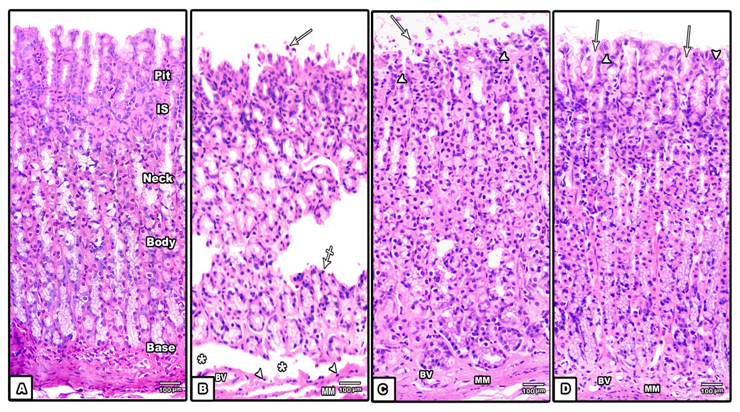
Fig. (1): Representative photomicrographs of H&E stained sections of the gastric mucosa in group (A) showing the fundic glands formed of isthmus (Is), neck, body and base. Group (B) showing severe mucosal injury with sloughed epithelial tissue (arrows). The injury extends to the basal part of the fundic glands (crossed arrow). Inflammatory cells (arrow heads) are also observed in the lamina propria.Note blood congested vessels (BV) and separation of the lamina propria (asterisks) from the underlying muscularis mucosa (MM). Group (C) showing focal mucosal injury with shedding of the mucosal epithelial cells (arrow) into the lumen. Mucosal healing and re-epithelization are also observed (arrow heads). Note muscularis mucosa (MM) and blood vessels (BV) in the lamina propria.Group (D) showing nearly re-established glandular architecture and continuous layer of the luminal surface cells (arrow heads). The gastric pits (arrows) are restored. Note muscularis mucosa (MM) and blood vessels (BV) in the lamina propria.
(H&E x 100)
xt here

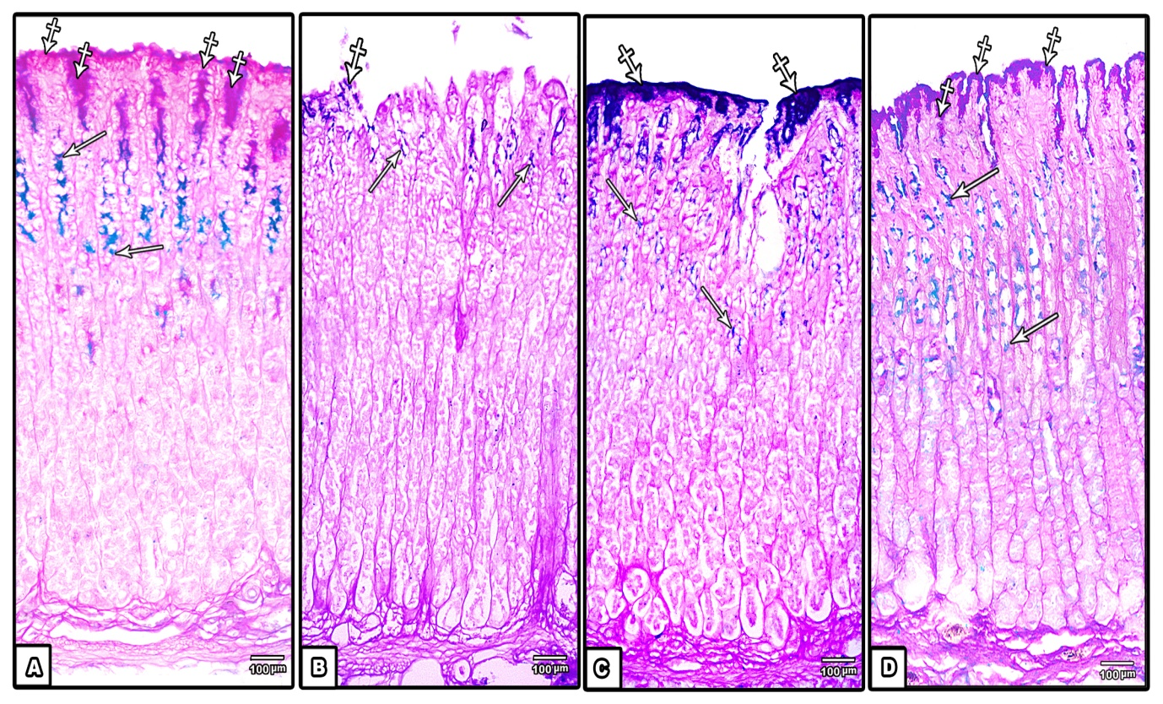
Fig. (2):Representative photomicrographs of Alcian blue/ P.A.S stained sections of the gastric mucosa in group (A) showing strong P.A.S positive reaction in the surface mucous and superficial pit cells (crossed arrows). Alcian blue positive mucus is seen in the deep pit cells and in the neck region (arrows).Group (B) showing exfoliation of PAS (crossed arrow) and Alcian blue staining injured glandular mucosal parts into the lumen. Some Alcian blue positive cells (arrows) are also seen. Group (C) showing focal loss of P.A.S positive surface mucous and superficial pit cells (crossed arrows). Note Intact gastric mucosa covered with P.A.S positive cells. Alcian blue positive mucus is seen in the deep pit cells and in the apparently expanded neck region (arrows).Group (D) showing PAS positive reaction in the surface mucous and superficial pit cells (crossed arrows). Note the apparent expansion of the neck region (arrows) with its Alcian blue positive cells.
(Alcian blue/ PAS x 100)

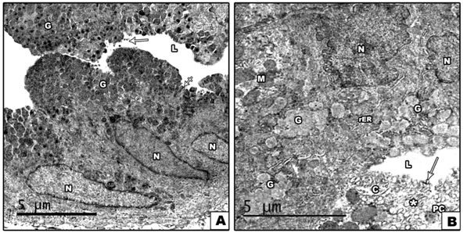

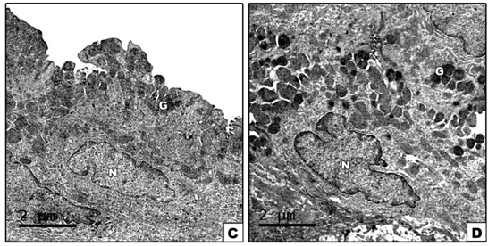
Fig. (3) Representative transmission electron micrographs of the surface mucous cells of the gastric mucosa in group (A): showing columnar cells with basal oval nucleus (N) and apical electron dense mucous granules (G). Note the intercellular junctions (crossed arrows) and scarce microvilli (arrow) projecting into the lumen (L). Group (B): showing damaged surface columnar cells with variable sized mucous granules (G) released into the lumen (L).Irregular outline of the nucleus (N), distortedmitochondria (M) and dilated rER are also observed. A part of damaged parietal cells with distorted tubulovesicular system (asterisk) and intracellular canaliculi (C) is also seen.Note the lumen (L) contains distorted microvilli (arrow).Group (C): showing surface mucous cells with irregulardense nucleus (N) and apical moderate electron dense mucous granules (G). Group (D) showing surface columnar mucous cells with irregular basal nucleus (N) and numerous apical moderate electron dense mucous granules (G).

N
N
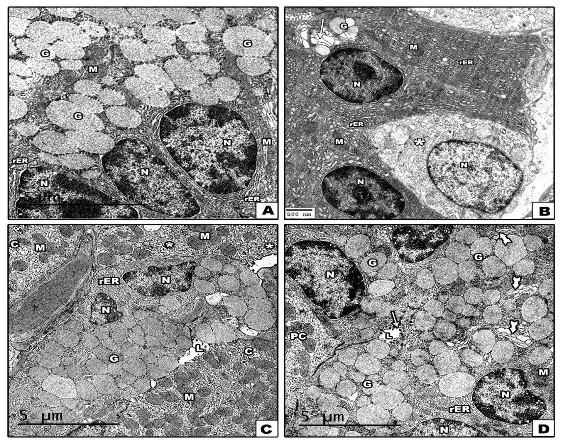
Fig. (4) Representative transmission electron micrographs of the peptic cells of the gastric mucosa in group (A) showing three peptic cells with large basal vesicular nuclei (N), apical numerous moderate electron dense zymogen granules (G) of variable in size, rER and mitochondria (M).Group (B) showing distorted peptic cell with rounded nucleus (N), focal dilatations of rER, dilated Golgi saccules (arrow) and few moderate electron dense zymogen granules (G). Note EE cell (asterisk)is seen. Group (C) showing peptic cell with dense nucleus (N), apical many variable sized moderate electron dense zymogen granules (G) and rER. Note few microvilli project into the lumen (L). Mitochondria (M), tubulovesicular system (asterisks) and intracellular canaliculi (C) of the adjacent parietal cells are also seen. Group (D)showing peptic cells with vesicular indented nucleus (N), apical large zymogen granules (G), dilated Golgi saccules (tailed arrow) mitochondria (m) and intact rER.Apical microvilli (arrows) projecting into the lumen (L) are also noticed.
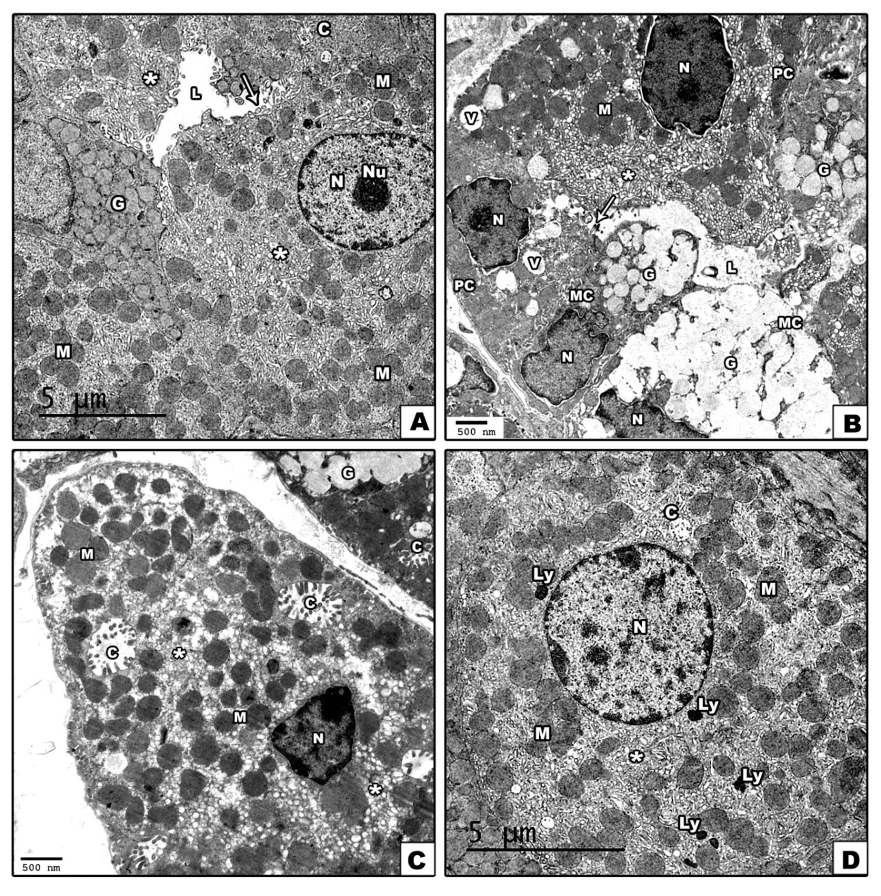
Fig. (5):Representative transmission electron micrographs of the parietal cells of the gastric mucosa in group (A1) showing parietal cells with rounded vesicular nucleus (N), prominent nucleolus (Nu) tubulovesicular system (asterisks), intracellular canaliculi (C), and numerous mitochondria (M). Note mucous granules (G) in the adjacent mucous neck cells. Group (B) showing distorted parietal cells (PC) and mucous neck cells (MC). Parietal cells show shrunken dense nuclei with irregular outline and wide perinuclear space. Cytoplasmic vacuoles (V), dense mitochondria (M), dilated tubulovesicular system (asterisk) and distorted microvilli (arrow) are also observed. (MCs) show oval flattened nucleus (N) and release of mucous granules (G) into the lumen L Group (C) showing parietal cell with shrunken nucleus (N), numerous dense mitochondria (M) and dilated tubulovesicular system (asterisks) with intracellular canaliculi (C).Group (D) showing parietal cell with large vesicular nucleus (N), numerous intact mitochondria (M),some lysosomes (LY) and intact tubulovesicular system (asterisks) and intracellular canaliculi (C).

As shown in table (1, 2), the percentages of ulcer area for group B (19.11± 3) and C (10.39±2.32) rats were significantly higher compared to control groups A1, A2 rats while this percentage for group D rats (1.71± 0.41) showed non-significant change compared to control group A rats. The percentage of ulcer area for group C and D rats showed significant reduction compared to group B rats. However, the percentage of ulcer area for group D rats was significantly lower compared to group C rats.

4. Discussion
Gastric ulcer is a complex pluricausal disease and is known to develop due to lack of balance between aggressive and protective factors affecting the stomach. Various factors have been known to cause gastric mucosal damage, including systemic stresses and the application of local irritants (Hadda et al., 2014).
Many drugs provide optimum cicatrizing response to the ulcerated tissue due to their anti-secretory effect. However, the use of these anti-secretory drugs has been found to be related to development of many pathological conditions such as achloride dependent bacterial growth, gastric cancer, hypergastrinemia and carcinoid tumor (Chia et al., 2016).
Accumulating data has pointed to the effective role of herbal drugs in the protection and treatment of hyperacidity and gastric and duodenal ulcers. These herbal medications could be applied as drugs supplementing or enhancing the activity of synthetic medicines (Ayala et al., 2014).
The current work was performed in order toevaluate the protective effects of fresh cabbage juiceon ethanol induced gastric mucosal injury. Intragastric application of absolute ethanol is the model widely used to induce gastric lesions and to evaluate the gastroprotective and healing activity of many drugs in experimental animals (Hussein et al., 2016).
The microscopic examination of H&E stained sections of the fundic mucosa of (group B) rats obtained after one hour from absolute ethanol administration revealed severe mucosal injury and disturbed glandular architecture. The luminal surface cells and nearly all the cells of the gastric pits were also detached. These results are in parallel to Arisha, (2017) who revealed extensive gastric lesions and distortion in the general architecture of gastric gland. On the other hand, Hussein et al. (2016)demonstrated that intragastric ethanol induced mild desquamations of the epithelial cell lining of the gastric mucosa, few leukocytic infiltrations and mild congestion of the blood vessels.
The microscopic examination of H&E stained sections of the fundic mucosa of (group C) rats revealed focal mucosal injuries with raw mucosal surface, shedding of the degenerated epithelial cells into the gastric lumen and some mucosal vacuoles. These results come in accordance withAbshenas et al.(2014) andBaiubon et al. (2016) who revealed multifocal areas of necrosis and haemorrhage in the entire portion of the gastric mucosa. In contrast, Hussein et al. (2016)demonstrated severe desquamation of the glandular epithelium lining of the gastric mucosa and heavy leukocytic mononuclear infiltration in the gastric mucosa one week after intragstric application of ethanol.
In alcohol treated groups, mucosal damage was also evident in PAS stained sections which revealed loss of PAS positive cells of the surface and superficial gastric pits and their exfoliation into the lumen. This comes in agreement with Kim et al. (2016) who noticed depletion of the PAS stained granules together with a relatively thin mucous coat over the surface of the gastric mucosa after intragastric application of ethanol.
The current histopathological findings observed in alcohol treated groups are in agreement with those of previous researchers who attributed these alterations to decreased antioxidant enzymes such as glutathione, glutathione peroxidase, catalase, and superoxide dismutase (Ismail Suhaimy et al., 2017).
Several mechanisms have been reported to explain the pathogenesis of mucosal ulceration after intragstric ethanol application.Ethanol administration was found to increase the volume of gastric juice secretion and total acidity, decrease bicarbonates and mucus production leading to sloughing ulceration of the mucosa (Prakash et al., 2007). Moreover, Ethanol reduces levels of non-protein sulfhydryl groups, such as glutathione, thereby increasing the reactive oxygen species (ROS) that have an ulcerogenic activity. Ethanol was also found to induce vascular endothelial cell injury leading to a decrease of blood flow which reduces the oxygen and nutrients supply (Carvalho et al., 2011).
In the present study, the fundic mucosa of group B showed areas of partial mucosal healing and re-epithelization. Similar findings were reported bySalim and Rashdi (2013). This partial re-epithelization is mostly mediated by cytokines and growth factors, including the transforming growth factor β, epidermal growth factor and fibroblast growing factors which are essential for healing process (Mnich et al., 2016).
Our study demonstrated that the lamina propria of (group B, C) showed congested blood vessels and scattered inflammatory cells. These results are consistent withthose of Arisha (2017) who attributed these changes to the direct toxic effect of ethanol on the vascular wall leading to ischemia followed by vasodilatation.This may be also attributed to the destructive action of alcohol on the mucosal barrier leading to exposure of capillaries and venules to the harmful effect of hydrochloric acid of the gastric secretion (Hagras et al., 2014).
Electron microscopic examination of ethanol treated rats (group B) revealedmarked distortion of the surface columnar cells and loss of their apical part into the lumen and few variable sized mucous granules released into the lumen. Similar findings were reported byHui and Fangyu, (2017). Cells were also greatly damaged. The nucleus appeared small, dense. The cytoplasm showed dilated rER, lysosomes and few zymogen granules. These results are in accordance withPolat et al. (2011) who attributed these changes to impairment of the tight junction complex morphology and permeability between viable gastric mucosal epithelial cells.
In this work, ethanol produced electron microscopic changes in the parietal cells in the form of, dense irregular nucleus and dense mitochondria, dilated tubulovesicular system and cytoplasmic vacoules. These results are in harmony with Lo et al. (2017)who confirmed that the early signs of parietal cell damage were disruption of their canaliculi and presence of dense bodies which were secondary lysosomes. El-Mehi and El-Sherif (2015)suggested that the vacuolations of parietal cells could be explained by the disruption and dilatation of their intracellular canaliculi together with increased number of microvesicles within their cytoplasm.Moreover, Martinac and Cox (2016)also reported that vacuoles are due to ionic disturbance caused by alcohol with retention of H2o and Na leading to swelling of the cell.
Mitochondrial damage of parietal cells could be explained by lipid peroxidation through formation of free radicals initiating oxidative stress.The free radicals bind to DNA of the mitochondria, resulting in impaired mitochondrial structure (Lakhani et al., 2016). Mitochondrial alterations may be also due to lowered activity of a succinic dehydrogenase cytochrome oxidase and diphosphopyridine nucleotide diaphorase(Singer and Ramsay, 2013).It has been reported that intragastric ethanol could increase Na+ and K+ flow, increase pepsin secretion, promote loss of H+ into the lumen and thereforeinduce direct damage of mucosal cells and finally cause cell necrosis ( Salga et al., 2011; Lee et al., 2012; Liu et al., 2012).
In this study, cabbage exhibited an effective role in the treatment of ethanol induced gastric ulceration. It produced restoration of glandular architecture and cells of the gastric mucosa. These results are in parallel with those of Fatimah, (2008)who mentioned thatBrassica oleracea contained high levels of glutamine, S-methionine, flavonoids and many antioxidant micronutrients; Cu, Mn, Zn, vitamin C, E. Flavonoids can scavenge superoxide,dihydroxyl, peroxide radicals which have membrane stabilizing and lipid peroxidation inhibitory effects.Moreover, the anti-ulcerogenic action of cabbage could be owing to activation of gastric mucosa protection factors, as well as the reduction of the acid secretion and of pepsinogen. Cabbage was also proved to increase the gastric blood flow, mucus and bicarbonate secretions (Chatterjee and Bandyopadhyay, 2014). Furthermore, raw fresh cabbage juice has been shown to attenuate ethanol and stress induced gastric lesions via activation of prostaglandins (PGs), nitric oxide and sensory nerve pathways, thus improving the microcirculation (Pojer et al., 2013).Prostaglandins play essential role in the maintenance of gastric mucosal integrity (Balogun et al., 2015).Prostaglandins were reported to enhance production and activationof molecules for defensive mechanisms as Vascular endothelial growth factor (VEGF) and suppress inflammatory mediators as (histamine, TNF-αand PAF) causing gastrointestinal damage (Aliberti., 2010).

5. Conclusion:
Raw fresh cabbage juice provides an obvious curative effect on ethanol induced gastric mucosal injury; therefore it could be used as a natural alternative for anti-ulcer drugs.

References
- Abshenas, J., Kheirandish, R.,&Salary, A. R. (2014): Gastroprotective effect of mummy on induced gastric ulcer in rats. Comparative Clinical Pathology, 23(2), 305-309.
- Aliberti, J., (2010): 34 Pathogens and Inflammation. Fundamentals of Inflammation, p.448.
- Araujo, D.A.O.V.; Takayama, C.; De-Fariaetal, F.M (2011): “Gastro-protective effects of essential oil from Protiumheptaphyllum on experimental gastric ulcermodels in rats,” Brazilian Journal of Pharmacognosy, vol. 21, no. 4, pp. 721–729.
- Arisha, S. M. (2017): Effect of Saffron Extract on Ethanol-Induced Gastric Ulcer in Albino Rats: Histological, ultrastructure and immunohistochemical Studies. Journal of Bioscience and Applied Research, 3(3), 226-240.
- Ayala, G., Escobedo-Hinojosa, W. I., de la Cruz-Herrera, C. F.,&Romero, I. (2014): Exploring alternative treatments for Helicobacter pylori infection. World J Gastroenterol, 20(6), 1450-1469.
- Baiubon, P., Kunanusorn, P., Khonsung, P., Chiranthanut, N., Panthong, A.,&Rujjanawate, C. (2016): Gastroprotective activity of the rhizome ethanol extract of Zingibersimaoense YY Qian in rats. Journal of Ethnopharmacology, 194, 571-576.
- Balogun, S.O., Damazo, A.S. and de Oliveira Martins, D.T., (2015):Helicteressacarolha A. St.-Hil. et al.: gastroprotective and possible mechanism of actions in experimental animals. Journal of ethnopharmacology, 166, pp.176-184.
- Barka, Z.B., Tlili, M., Alimi, H., Miled, H.B., Rhouma, K.B., Sakly, M., Ksouri, R., Schneider, Y.J. and Tebourbi, O. (2017):Protective effects of edible Rhustripartita (Ucria) stem extract against ethanol-induced gastric ulcer in rats. Journal of Functional Foods, 30, pp.260-269.
- Carvalho, C.A.D., Fernandes, K.M., Matta, S.L.P., Silva, M.B.D., Oliveira, L.L.D. and Fonseca, C.C., 2011: Evaluation of antiulcerogenic activity of aqueous extract of Brassica oleracea var. capitata (cabbage) on Wistar rat gastric ulceration. Arquivos de gastroenterologia, 48(4), pp.276-282.
- Chatterjee, A. and Bandyopadhyay, S.K. (2014): Herbal remedy: an alternate therapy of nonsteroidal anti-inflammatory drug induced gastric ulcer healing. Ulcers, 2014.
- Chia, C. T. W., Miah, I., Jafari, J., Nasr, I., Koumoutsos, I.,&Wong, T. (2016): SUPPLEMENT ARTICLE. Journal of Gastroenterology and Hepatology, 31(3), 7Н441.
- De Lira Mota, K. S.;Dias, G. E. N.;Pinto, M. E. P. et al., (2009): “Flavonoids with gastroprotective activity,” Molecules, vol. 14, no. 3, pp. 979–1012.
- El-Mehi, A. E.,&El-Sherif, N. M. (2015): Influence of acrylamide on the gastric mucosa of adult albino rats and the possible protective role of rosemary. Tissue and Cell, 47(3), 273-283.
- FATIMAH, A.D., 2008:Effect of Aqueous Extract of Brassica Oleracea Leaves (Cruciferae) On Ethanol Induced Gastric Ulcer in Albino Rats (Doctoral Dissertation).
- Gonzales, G.B., Van Camp, J., Smagghe, G., Raes, K. and Mackie, A., 2016: Flavonoid–gastrointestinal mucus interaction and its potential role in regulating flavonoid bioavailability and mucosal biophysical properties. Food Research International, 88, pp.342-347.
- Hadda, T. B., ElSawy, N. A., Header, E. A., Mabkhot, Y. N.,&Mubarak, M. S. (2014): Effect of garlic and cabbage on healing of gastric ulcer in experimental rats. Medicinal Chemistry Research, 23(12), 5110-5119.
- Hagras, G. M. E. B., Mansour, M. A., Ghoneim, N. S., Damhogy, R. A. E. W. E.,&Aziz, S. A. M. A. (2014):Effect of the Anti-Rheumatic Drug Leflunomide (Avara®) on the Pyloric Region of Stomach of Adult Male Albino Rats and the Possible Protective Effect of Ranitidine (Histological and Histochemical Study). Journal of American Science, 10(11).
- Hansen, S. E., Myers, R., Paul, R., Rasmussen, A.,&Taylor, K. (2016): U.S. Patent No. 9,423,322. Washington, DC: U.S. Patent and Trademark Office.
- Hui, S. and Fangyu, W., (2017): Protective effects of bilobalide against ethanol-induced gastric ulcer in vivo/vitro. Biomedicine&Pharmacotherapy, 85, pp.592-600.
- Hussein, S. A., Karousa, M. M., Amin, A.,&Awadalla, M. A. (2016):Curcumin ameliorates Ethanol induced Gastric Mucosal Erosion in Rats via alleviation of Oxidative Stress and Regulation of Pro-Inflammatory Cytokines and NF-kappa B activation. Natural Science, 4(4), 466-476.
- Ismail Suhaimy, N. W., Noor Azmi, A. K., Mohtarrudin, N., Omar, M. H., Tohid, S. F. M., Cheema, M. S.,...&Zakaria, Z. A. (2017):Semipurified Ethyl Acetate Partition of Methanolic Extract of Melastomamalabathricum Leaves Exerts Gastroprotective Activity Partly via Its Antioxidant-Antisecretory-Anti-Inflammatory Action and Synergistic Action of Several Flavonoid-Based Compounds. Oxidative Medicine and Cellular Longevity.
- Kim, H. K., Kim, M. G.,&Leem, K. H. (2016): Extrusion process of Acanthopanaxsenticosus leaves enhances the gastroprotective effect of compound 48/80 on acute gastric mucosal lesion in rats. Journal of Traditional Chinese Medicine, 36(2), 187-196.
- Lakhani, S.R., Finlayson, C.J., Dilly, S.A. and Gandhi, M., (2016): Basic pathology: An introduction to the mechanisms of disease. Crc Press.
- Lee, M.Y.; Shin, I.S.; Jeon, W.Y.; Seo, C.S.; Ha, H.; Huh, J.I. and Shin, H.K. (2012): Protective effect of Bojungikkitang, a traditional herbal formula, against alcohol induced gastric injury in rats.J. Ethnopharmacol.,142:346–353.
- Liu Y.; Tian X.; Gou L.; Fu X.; Li S.; Lan N. and Yin X. (2012): Protective effect of L-citrulline against ethanol-induced gastric ulcer in rats.EnvironToxicol. Pharmacol.; 34:280–287. Fattaha, N. A. A.,&Abdel-Rahman, M. S. (2000). Effects of omeprazole on ethanol lesions. Toxicology letters, 118(1), 21-30.
- Lo, H.Y.G., Jin, R.U., Sibbel, G., Liu, D., Karki, A., Joens, M.S., Madison, B.B., Zhang, B., Blanc, V., Fitzpatrick, J.A. and Davidson, N.O. ( 2017): A single transcription factor is sufficient to induce and maintain secretory cell architecture. Genes&development, 31(2), pp.154-171.
- Martinac, B. and Cox, C.D., (2016):Mechanosensory transduction: Focus on ion channels. Comprehensive Biophysics.
- Miranda-Mendez, A.;Lugo-Baruqui, A.; Armendariz-Borunda,J. (2010): Molecularbasisandcurrent treatment for alcoholic liver disease. Int. J. Environ. Res. Public Health 2-1888.
- Mnich, E., Kowalewicz-Kulbat, M., Sicińska, P., Hinc, K., Obuchowski, M., Gajewski, A.,&Chmiela, M. (2016): Impact of Helicobacter pylori on the healing process of the gastric barrier. World Journal of Gastroenterology, 22(33), 7536.
- Pojer, E., Mattivi, F., Johnson, D. and Stockley, C.S. (2013): The case for anthocyanin consumption to promote human health: a review. Comprehensive Reviews in Food Science and Food Safety, 12(5), pp.483-508.
- Polat B, Albayrak Y, Suleyman B, Dursun H, Odabasoglu F, Yigiter M, Halici Z, Suleyman H. (2011):Antiulcerative effect of dexamedetomidine on indomethacin–induced gastric ulcer in rats. Pharmacol Rep. 63: 518-526.
- Prakash M, Balamurugan M, Parthasarathi K, Gunasekaran G, Cooper E, Ranganathan L (2007): Anti-ulcer and anti-oxidative properties of ‘earthworm paste’ of Lampitomauritii (Kinberg) on Rattusnorvegicus. Eur Rev Med PharmacolSci; 11:9–15.
- Prasanna, L. C., Thomas, H. R., D’Souza, A. S.,&Bhat, K. M. (2017): The histochemical assessment of sulpho-, sialo-, and neutral-mucosubstances in fetal gastric mucosa. International Journal of Research in Medical Sciences, 3(1), 235-238.
- Salga, M. S.;Ali, H. M.; Abdullah, M. A.; Abdelwahab, S. I.;Hussain, P. D. and Hadi, A.H. A. (2011): Mechanistic studies of the anti-ulcerogenic activity and acute toxicity of dichlorido-copper (II)- 4-(25-bromobenzylideneamino) ethyl) piperazin-1-ium phenolate complex against ethanol-inducedgastric injury in rats. Molecules, 16: 8654-8669.
- Salim, A.,&Al Rashdi, A. (2013): Mechanisms of wound healing and gastro protective effects of ethanol leaf extract of JasminumSambac and HemigraphisColorata on HCL/ethanol-induced gastric injury in experimental animals (Doctoral dissertation, University of Malaya).
- Shoaib, P.M., Mounika, J., Wahid, R.M., Vandana, S.V., Chakrapani, B. and Sowmya, S. (2016): EVALUATION OF ANTI ULCER ACTIVITY OF ACETONE EXTRACT OF Brassica oleracea IN ALBINO RATS. EVALUATION, 2(3), pp.923-932.
- Yehia, N. M., Salam, N. F. A., Saleh, H. A.,&Bayomi, N. S. (2014): Effect of α-lipoic acid on fundic gastric mucosal damage induced by acetyl salicylic acid: a histological study. Egyptian Journal of Histology, 37(2), 280-291.
- Yu, C., Mei, X.T., Zheng, Y.P. and Xu, D.H., 2014: Gastroprotective effect of taurine zinc solid dispersions against absolute ethanol-induced gastric lesions is mediated by enhancement of antioxidant activity and endogenous PGE 2 production and attenuation of NO production. European journal of pharmacology, 740, pp.329-336.

6/3/2017

