Evaluation of new modalities in the treatment of refractory over active bladder

Maha Mohammed Elzamek, Ahmed Gamaleldeen Abdelraoof, Mostafa Ezzeldeen Abdelmagid, Ahmed Fahim Abd EL Rahim, Abul-Fotouh Ahmed

Urology department, Faculty of medicine, Al-Azhar University, Cairo, Egypt
Maha_201001@yahoo.com

Abstract: Aim of the work: To evaluate the efficacy & drawbacks of treating refractory OAB by using either intradetrusor injection of botulinum neurotoxin type A versus percutaneous tibial nerve stimulation using patch or needle electrodes. Patients and methods: A prospective review of 40 patients with refractory overactive bladder. The patients included in the study were submitted to full history taking, neurological examination, laboratory investigation and urodynamic studies. Results: Improvement in diurnal frequency (69.1%) 1month post injection, then the improvement decreased gradually to nearly the pre- treatment 12m. post- treatment. Improvement in nocturnal frequency (54.6%) 1 month post injection, then the improvement decreased gradually to nearly the pre- treatment 12m. post- treatment. Dramatic improvement in urgency (83.3%) 1m. and 3m. post injection, then improvement decreased gradually to nearly the pre-treatment 12m. posttreatment. The post voiding volume increased post Botox injection, but not increased post percutaneous PTN and transcutaneous PTN. By percutaneous PTN there were Improvement in diurnal frequency (63.2%) 1month post sessions, then the improvement decreased gradually to nearly the pre- treatment 12m. post- treatment. Improvement in nocturnal frequency (28.9%) 1 month post sessions, then the improvement decreased sharply to nearly the pre- treatment 12m. post- treatment. Dramatic improvement in urgency (83.3%) 1m. and 3m. post sessions, then improvement decreased gradually to nearly the pre-treatment 12m. posttreatment. By transcutaneous PTN there was: Improvement in diurnal frequency (70%) 1month post sessions, then the improvement decreased gradually to nearly the pre- treatment 12m. post- treatment. Improvement in nocturnal frequency (43.4%) 1 month post sessions, then the improvement decreased sharply to nearly the pre- treatment 12m. post- treatment. Dramatic improvement in urgency (75%) 1m. and 3m. post sessions, then improvement decreased gradually to nearly the pre-treatment 12m. post-treatment. Conclusion: The statistically significant efficacy of Botox injection and PTNS is achieved to improve frequency, nocturia, urgency, voided volume and urge incontinence Botox in effective in diabetics while PTNS therapy is safe and effective in treating OAB symptoms but three types had 12 ms effect only and patient need to repeat treatment.
[Maha Mohammed Elzamek, Ahmed Gamaleldeen Abdelraoof, Mostafa Ezzeldeen Abdelmagid, Ahmed Fahim Abd EL Rahim, Abul-Fotouh Ahmed. Evaluation of new modalities in the treatment of refractory over active bladder. N Y Sci J 2017;10(7):64-67]. ISSN 1554-0200 (print); ISSN 2375-723X (online). http://www.sciencepub.net/newyork. 10. doi:10.7537/marsnys100717.10.

Keywords: Evaluation; modalities; treatment; refractory; over active bladder

1. Introduction
Overactive bladder is defined by The International Urogynecological Association and International Continence Society joint defined (OAB) as ‘urgency, with or without urge incontinence, usually with frequency and nocturia (Abrams et al., 2010). OAB has prevalence exceeding 16%, in the USA, which approximately represents 33 million adults [12 million with urge urinary incontinence (OAB, wet) and 21 million without incontinence (OAB, dry)] (Stewart et al., 2003).
The International Consultation on Incontinence (ICI) states that when the first and second lines approach is not fully satisfactory or fails after 8–12 weeks, alternative therapies should be sought out. Failure of medications may include lack of efficacy and/or inability to tolerate adverse drug effects (Abrams et al, 2010).
Refractory OAB is generally investigated with urodynamics to define the underlying mechanisms, identify additional contributory factors and to detect potential risk factors for adverse treatment outcome (Colli et al, 2003).
Botox is one of seven serotypes of neurotoxin derived from Clostridium botulinum. IT inhibits acetylcholine and adenosine-5’-triphosphate (ATP) release at the parasympathetic presynaptic nerve terminal, resulting in reversible chemodenervation and flaccid muscle paralysis (Starkman et al., 2010).
In percutaneous posterior tibial stimulation, the nerve is stimulated thus stimulating the 3rd sacral nerve root. The nerve is reached by insertion of a fine needle approximately three fingerbreadths cephalad to the medial malleolus posterior to the tibia, the aim being to position the needle in close proximity to rather than directly on to the nerve as shown in figure (Mahipal et al., 2016).
Transcutaneous electrical nerve stimulation (TENS) Applied on the S2, S3 dermatome by patch electrodes on medial malleolus and heal (Hasan et al, 1996).

2. Patients, material and methods
This study included 40 patients ≥ 18 y old who were complaining of irritative voiding symptoms, such as frequency, urgency, nocturia, enuresis and urge incontinence, and poor response to antimuscarinic therapy for 3months in a prospective fashion in El-Hussien University Hospital. Between July 2013 and November 2016, informed consent was obtained from the 40 patients (4 men, 36 women) with an average age of 37 yr (range: 18–55) who participated in this study. Exclusion criteria were urinary tract infection, history of urinary incontinence surgery, infravesical obstruction, myasthenia gravis, pregnancy, presence of the possible causes of bladder irritation eg. stones & malignancy. Patients who were using anticholinergics were asked to stop the treatment 2 weeks prior to the procedure.
Spinal aneasthsia was applied prior to cystoscopy. Intradetrusor, trigonesparing injections of 200 U (Botox® Allergan) were performed with a rigid cystoscopy using a 4 mm Olympus needle. 30 sites along the base, posterior and lateral walls of the bladder were injected with 1 ml of solution containing 10 U botn-A (Botox_; Allergan) in normal saline.
For percutaneous PTNS subjects a 34 gauge needle electrode was inserted at a 60 degree angle approximately 5 cmcephalad to the medial malleolus and slightly posterior to the tibia. A PTNS surface electrode was placed on the ipsilateral calcaneus. When the PTNS lead set was connected to the Urgent PC stimulator, a current level of 0.5 to 9 mA at 20 Hz was selected based on each subject’s foot and plantar motor and sensory responses. The patients were be subjected to weekly 30-minute sessions for 12 weeks.
For transcutaneous PTNS subjects two patches electrodes. The nerve was reached by placing of a surface electrode approximately three fingerbreadths cephalad to the medial malleolus and posterior to the tibia. The other surface electrode was placed on the calcaneus of the same foot by a sticky pad which was connected to a low voltage stimulator with an adjustable pulse intensity (from 0-9 mA). The amplitude was slowly increased until the large toe started to flex or the toes fanned. The nerve was then stimulated for 30 minutes for each session.

3. Results

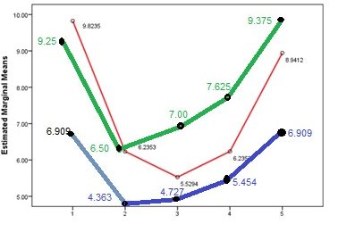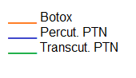
pre- treatment 1month 3months 6m 12m
Post-treatment post- treatment post-treatment post-treatment
Figure 1. The mean diurnal frequency, pre-treatment and at post-treatment follow-up time points in each treatment group

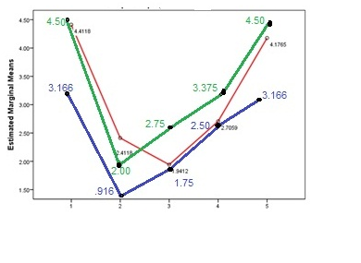
pre- treatment 1month 3months 6m 12m
Post-treatment post- treatment post-treatment post-treatment
Figure 2. The mean nocturnal frequency, pre-treatment and at post-treatment follow-up time points in each treatment group.
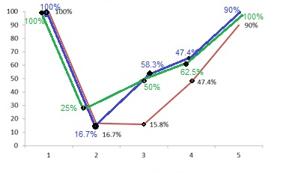
pre- treatment 1month 3months 6m 12m
Post-treatment post- treatment post-treatment post-treatmnt
Figure 3. The frequency distribution of urgency, pre-treatment and at post-treatment follow-up time points in the studied 40 patients
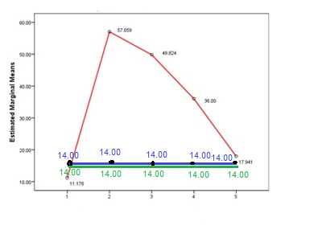
pre- treatment 1month 3months 6m 12m
Post-treatment post- treatment post-treatment post-treatment
Figure 4. The mean post-voiding residual urine volume (mL), pre-treatment and at post-treatment follow-up time points in each treatment group.

By Botox injection there
Improvement in diurnal frequency (69.1%) 1month post injection, then the improvement decreased gradually to nearly the pre- treatment 12m. post- treatment.
Improvement in nocturnal frequency (54.6%) 1 month post injection, then the improvement decreased gradually to nearly the pre- treatment 12m. post- treatment.
Dramatic improvement in urgency (83.3%) 1m. and 3m. post injection, then improvement decreased gradually to nearly the pre-treatment 12m. posttreatment.
The post voiding volume increased post Botox injection, but not increased post percutaneous PTN and transcutaneous PTN.
By percutaneous PTN:
Improvement in diurnal frequency (63.2%) 1month sessions, then the improvement decreased gradually to nearly the pre- treatment 12m. post- treatment.
Improvement in nocturnal frequency (28.9%) 1 month post sessions, then the improvement decreased sharply to nearly the pre- treatment 12m. post- treatment.
Dramatic improvement in urgency (83.3%) 1m. and 3m. post sessions, then improvement decreased gradually to nearly the pre-treatment 12m. posttreatment.
No change in post voiding volume post percutaneous PTN pre-treatment and post-treatment follow-up.
By transcutaneous PTN
Improvement in diurnal frequency (70%) 1month post sessions, then the improvement decreased gradually to nearly the pre- treatment 12m. post- treatment.
Improvement in nocturnal frequency (43.4%) 1 month post sessions, then the improvement decreased sharply to nearly the pre- treatment 12m. post- treatment.
Dramatic improvement in urgency (75%) 1m. and 3m. post sessions, then improvement decreased gradually to nearly the pre-treatment 12m. post-treatment.
No change in post voiding volume post percutaneous PTN pre-treatment and post-treatment follow-up.

References
- Abrams P, Andersson KE, Birder L. Fourth International Consultation on Incontinence Recommendations of the International Scientific Committee: evaluation and treatment of urinary incontinence, pelvic organ prolapse, and fecal incontinence. Neurourol Urodyn 2010; 29(1): 213– 40.
- Colli E, Artibani W, Goka J, Parazzini F, and Wein AJ. Are urodynamic tests useful tools for the initial conservative management of non-neurogenic urinary incontinence? A review of the literature. Eur Urol 2003; 43:63-9.
- Hasan ST, Robson WA, Pridie AK, Neal DE. Transcutaneous electric nerve stimulation and temporary S3 neuromodulation in idiopathic detrusor instability. J Urol 1996: 155:2005–2011.
- Khan S, Panicker J, Roosen A. Complete continence after botulinum neurotoxin type A injections for refractory idiopathic detrusor overactivity incontinence patient-reported outcome at 4 weeks. Eur Urol 2010; 57: 891–6.
- Mahipal Choudhary, Ron van Mastrigt and Els van Asselt. Inhibitory effects of tibial nerve stimulation on bladder neurophysiology Choudhary et al. Springer Plus (2016) 5:35.

6/3/2017

