Clinical significance of glycated haemoglobin in Egyptian patients presented in acute phase of ST elevation myocardial infarction

Ahmed S. Mohamed, Elsayed Abd. Mohamed, Ali I. Attia, and Mohamed M. Ali

Department of Cardiology, Benha Faculty of Medicine, Benha University, Benha, Egypt.
ahmed_ahmed_ahmed2007@yahoo.com

Abstract: In population-based studies, including diabetic and nondiabetic cohorts, glycated hemoglobin A1c (HbA1c) has been reported as an independent predictor of all cause and cardiovascular disease mortality. Data on the prognostic role of HbA1c in patients with acute myocardial infarction (MI) are not univocal since they stem from studies which mainly differ in patients’ selection criteria, therapy (thrombolysis vs mechanical revascularization) and number consistency. The present review is focused on available evidence on the prognostic significance of HbA1c measured in the acute phase in patients with ST-elevation myocardial infarction (STEMI) submitted to primary percutaneous coronary intervention (PCI). We furthermore highlighted the role of HbA1c as a screening tool for glucose intolerance inpatients with STEMI. According to available evidence, in contemporary cohorts of STEMI patients submitted to mechanical revascularization, HbA1c does not seem to be associated with short and long term mortality rates. However, HbA1c may represent a screening tool for glucose intolerance from the early phase on in STEMI patients. On a pragmatic ground, an HbA1c test has several advantages over fasting plasma glucose or an oral glucose tolerance test in an acute setting. The test can be performed in the non-fasting state and reflects average glucose concentration over the preceding2-3 mo. We therefore proposed an algorithm based on pragmatic grounds which could be applied in STEMI patients without known diabetes in order to detect glucose intolerance abnormalities from the early phase. The main advantage of this algorithm is that it may help in tailoring the follow-up program, by helping in identifying patients at risk for the development of glucose intolerance after MI. Further validation of this algorithm in prospective studies may be required in the contemporary STEMI population to resolve some of these uncertainties around HbA1c screening cutoff points. Methods: 100 patients from the attendants of the cardiology department who were admitted with STEMI without known history of diabetes and HBA1C was done in first hour of admission, patients were classified in three groups according to HBA1C < 5.7 & 5.7 to 6.4 & > 6.4. Results: Mortality was statistically significant in patient group with HBA1C above 6.4 with p value (0.006). Mean HBA1C was highly significant in patients with mortality than patients without mortality patients by mean HBA1C in mortality group 7.05 with SD (0.07) while in patient group without mortality mean HBA1C was 6.48 % with SD (0.47) with P value (0.006). Conclusion: Higher HbA1c level should be considered for risk stratification of patients presented by acute STEMI who are amenable to primary PCI. So aggressive management of those high risk patients is mandatory. The present study shows that admission higher HbA1c level in patients presented by acute STEMI is associated with more severe CAD, lower ST-segment resolution, lower rate of complete revascularization TIMI 3 and higher incidence of mortality.
[Ahmed S. Mohamed, Elsayed Abd. Mohamed, Ali I. Attia, and Mohamed M. Ali. Clinical significance of glycated haemoglobin in Egyptian patients presented in acute phase of ST elevation myocardial infarction. N Y Sci J 2017;10(7):35-44]. ISSN 1554-0200 (print); ISSN 2375-723X (online). http://www.sciencepub.net/newyork. 6. doi:10.7537/marsnys100717.06.

Key words: Diabetes, myocardial infarction, HBA1C. Glycated hemoglobin; ST-elevation myocardial infarction; Prognosis; Hyperglycemia; Glucose intolerance.

1. Introduction
The incidence of diabetes mellitus (DM) is increasing. Over the last three decades, a number of epidemiological, clinical and autopsy studies have proposed the presence of diabetic heart disease as a distinct clinical entity. Among diabetic patient every rise in hemoglobin A1C by 1% is associated with 30% increase in all-cause mortality and 40% increase in cardiovascular mortality. Glycated hemoglobin was apotent risk marker of death at follow up only in MI patients without history of diabetes. (1). It has been recently observed among patients with high risk non ST segment elevation acute coronary syndrome that a substantial proportion of patients admitted with high risk acute coronary syndrome had previously undiagnosed diabetes mellitus (12.2%) or prediabetes (10.8%). (2). Hemoglobin A1C has several advantages over fasting plasma glucose or oral glucose tolerance test in acute setting that the test can be performed in non-fasting state and reflects average glucose concentration over preceding 2-3 months.
So it helps in identifying patients at risk for developing of glucose in tolerance after MI & tailoring follow up program for those patients. Patients with HbA1c more than 6.5%showing increase in inflammatory activation (increase in fibrinogen) this suggesting link between acute glucose dys-metabolism and inflammatory activation in early phase of STEMI. (3). As difference from previous studies it is observed that higher HbA1C values can identify subset of patients who in early phase of STEMI show abnormal glucose response to stress as indicated by higher values of glucose, worse glycemic control during intensive care union stay, higher incidence of insulin resistance. all these factors have been associated with increased risk of early death (3).

2. Patients and Methods
Study population
The current study was case-control, one center prospective observational study, conducted at the Benha University Hospital from April 2016 to December 2016. it included 100 patients, from the attendants of the cardiology department who were admitted with STEMI without known history of diabetes and followed up for 4 to 5 weeks from the date of discharge.
Methods
All included patients were subjected to complete and detailed medical history, laboratory investigations, resting standard 12 leads electrocardiogram and transthoracic echocardiography.
Conventional Echocardiography study
Done by an expert operator, who was blinded to the patient randomization group, for the assessment of the following parameters: 1-Left ventricular end diastolic and end systolic diameters (LVEDD, LVESD) using M-mode utilizing the short axis parasternal window at the level of papillary muscles, where LVEDD is made at the onset of the QRS complex and LVESD is made at the minimum chamber size, just before the aortic valve closure. Measurements were made from the leading edge of the septal myocardium to the leading edge of the posterior LV wall (identified on M-mode as the steepest most continuous line). 2- Left ventricular end diastolic and end systolic volumes (LVEDV, LVESV) were calculated by tracing the endocardial borders in apical four-chamber and two-chamber views at end-diastole (at the onset of the QRS) and end-systole (at the onset of T wave) respectively, where the volumes were calculated by the ultrasound system using the biplane method of disks ”Modified Simpson’s method” 3- Ejection fraction (by M-mode and 2D using” Modified Simpson’s method”) 4- Wall motion abnormality; its presence and severity (hypokinesia, akinesia); using apical 4 chamber and parasternal long axis views, 2 chamber view.

3. Results:
Study population
This study was designed as a prospective, randomized, case controlled study that involved 100 patients from the attendants of the cardiology department at “Benha University hospital” who were admitted with STEMI without known history to have diabetes during the period from April to December 2016. The mean age was 56.8±10.6 years (range from 35 to 82 years). 87% percent were males, 16% were hypertensives, 69% were smokers. Table (1 ) and figure (1).

Table (1): Baseline demographic criteria of study population
 |  | N | %
Age | Mean (±SD) | 56.8 (±10.6)
Sex | Male | 87 | 87.0
 | Female | 13 | 13.0

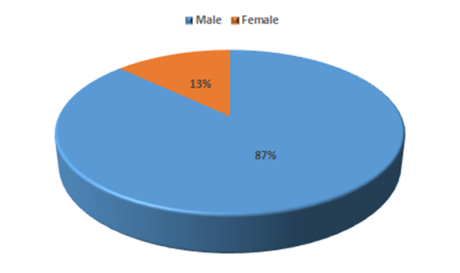
Figure (1) Demographic criteria

Risk factors for STEMI:
The most common risk factor for STEMI was smoking by 69 % followed by hypertension by 16%. table (2) & figure (2).

Table (2) risk factors for STEMI
 | N | %
Smoking | 69 | 69.0
HTN | 16 | 16.0
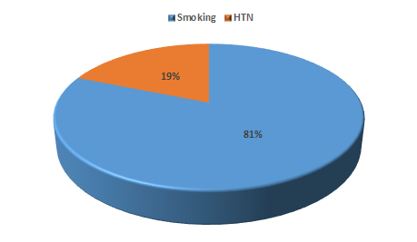
Figure (2) risk factors for STEMI

Hemodynamic data
Both systolic and diastolic blood pressure (SBP, DBP), as well as resting heart rate were measured at randomization with no statistically significant differences between 3 groups (p>0.05). The mean baseline heart rate (HR) was 81.4 ±15.8 bpm with minimum heart rate 54 b/m and maximum heart rate 130b/m, mean baseline systolic BP (SBP) was 117± 16.2 mmHg with maximum range 155 mmHg and minimum range 80 mmHg. The mean baseline diastolic BP (DBP) was 69.6± 9.7 mmHg with minimum 50mmgh and maximum 90mmgh. table (3).

Table (3) Hemodynamic data at randomization
 | Mean | ±SD | Minimum | Maximum
Heart rate | 81.4 | 15.8 | 54 | 130
Systolic BP | 117 | 16.2 | 80 | 155
Diastolic BP | 69.6 | 9.7 | 50 | 90
HR: heart rate, SBP: systolic blood pressure, DBP: diastolic blood pressure.

Local examinationdata:
It was found that among 100 patients in our study that 17 % had abnormalities in cardiac auscultation and 83 % were normal. And 33 % had abnormalities in chest auscultation versus 67 % were normal. table (4) & figure (3).

Table (4) local examination data:
 |  |  |  | N | %
Cardiac Auscultation |  | Abnormal |  | 17 | 17.0
 |  | Normal |  | 83 | 83.0
Chest Auscultation |  | Abnormal |  | 33 | 33.0
 |  | Normal |  | 67 | 67.0

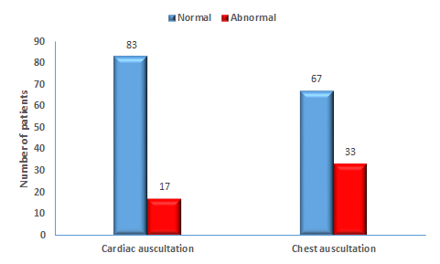
Figure (3) local examination data.

Echocardiographic parameters:
All patients underwent echocardiography at randomization as a baseline assessment. There were no statistical significant differences between 3 groups at randomization. The mean baseline LVEF (%) was 52.9±7.5% with minimum 37 % maximum 67 %. table (5)

Table (5) showing mean EF %
 |  | Mean | ±SD | Minimum | Maximum
EF |  | 52.9 | 7.5 | 37 | 67

We noticed that abnormal wall motion was most commonly in septum by 53 % followed by apex by 52% then anterior wall by 45 % then inferior wall by 37% and the least was posterior wall by 8 %. table (6) & figure (4).

Table (6) resting abnormal wall motion finding by ECHO
 |  |  |  | N | %
Apex wall motion |  | Abnormal |  | 52 | 52.00
 |  | Normal |  | 48 | 48.00
Lateral wall motion |  | Abnormal |  | 28 | 28.00
 |  | Normal |  | 72 | 72.00
Septum motion |  | Abnormal |  | 53 | 53.00
 |  | Normal |  | 47 | 47.00
Anterior wall motion |  | Abnormal |  | 45 | 45.00
 |  | Normal |  | 55 | 55.00
Inferior wall motion |  | Abnormal |  | 37 | 37.00
 |  | Normal |  | 63 | 63.00
Posterior wall motion |  | Abnormal |  | 8 | 8.00
 |  | Normal |  | 92 | 92.00

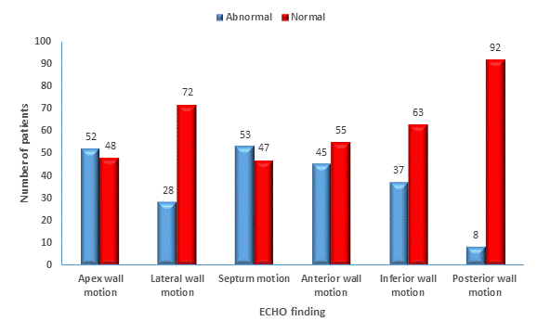
Figure (4) resting abnormal wall motion finding by ECHO.

Site of STEMI according to ECG:
It was found that inferior STEMI was most common occurring STEMI among100 patients included in our study by 36% followed by extensive anterior STEMI by 30% then anteroseptal STEMI by 18 % then anerolateral by 14 % least one in incidence was high lateral STEMI. table (7) and figure (5).

Table (7) site of STEMI according to ECG
 |  | N |  | %
Ext. Anterior MI |  | 30 |  | 30.0
Anterolateral MI |  | 14 |  | 14.0
Antero-septal MI |  | 18 |  | 18.0
Inferior MI |  | 36 |  | 36.0
High Lateral MI |  | 4 |  | 4.0

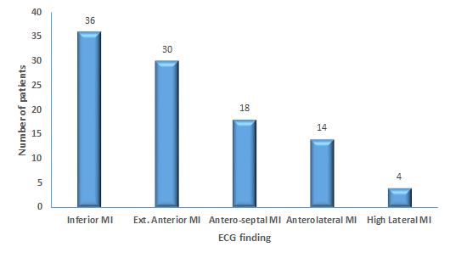
Figure (5) site of STEMI according to ECG

Metabolic panel:
Mean HBA1C among 100 patients was 6.49 % with SD (0.49) with minimum 4 % and maximum 8.7 %. Median blood sugar level was 151 mg / dl with minimum range 80 mg/dl maximum range 390 mg / dl.
Mean serum creatinine was 1.17 mg/dl with SD (0.28) with minimum 0.7 mg /dl and maximum was 2 mg / dl. three groups were compared as regard the baseline metabolic panel. There were no significant differences between 3 groups as regards serum Creatinine level, blood glucose level, (p>0.05). Table (8).

Classification of patients according to HBA1C:
In our study we used Hb A1c levels to categorize patients as diabetic, impaired glucose tolerance and non-diabetics (as per the American Diabetes Association 2003 criteria of Hb A1c <5.7% normal; 5.7% to 6.4% impaired glucose tolerance; ≥6.5% diabetes), percentage of patients discovered to suffer from diabetes was 50%, those who have impaired glucose tolerance was 49%, non-diabetics was 1%. table (9).

Table (8) metabolic panel
 |  | Mean | ±SD | Minimum | Maximum p value
HBA1C (%) |  | 6.49 | 0.47 | 4 | 8.7 >0.05(NS)
Creatinine |  | 1.17 | 0.28 | 0.7 | 2 >0.05(NS)
 |  | Median |  | Minimum | Maximum p value
RBS |  | 151 |  | 80 | 390 >0.05(NS)

Table (9) Classification of patients according to HBA1C
 | N | %
Non diabetic | 1 | 1.0
I.G.T* | 49 | 49.0
Diabetic | 50 | 50.0
*Impaired glucose tolerance

Incidence of complications:
It was found that 35 % from our patients develop complication. table (10).

Table (10) incidence of complication
 |  | N | %
Complication |  | 35 | 35.00%

Types of complications:

Table (11) types of complications by incidence:
 | N | %
Mortality | 2 | 2.00
Re-Infarction | 1 | 1.00
Re-Ischemia | 10 | 10.00
HF | 32 | 32.00
Cardiogenic Shock | 3 | 3.00
Re-hospitalization | 24 | 24.00
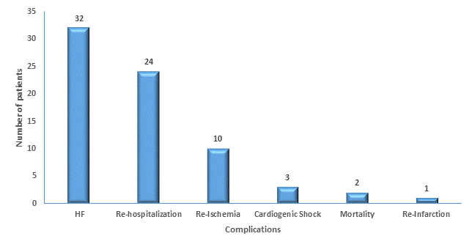
Figure (6) types of complications by incidence

It was found that the highly occurring complication was heart failure by 32 % followed by re-hospitalization by 24 % then re-ischemia by 10%. mortality by 2 % and least occurring complication was reinfarction by 1%. table (11) & figure (6).

Difference between HBA1C in complicated and non-complicated groups
It was found that mean HBA1C was statistically highly significant in complicated group by mean 6.76% with SD (0.5) while mean was 6.34 % with SD (0.39) in non-complicated with P value >0.001. table (12) & figure (9).

Table (12) difference between HA1C percentage in complicated and non-complicated groups with STEMI
 | Complicated STEMI |  | Non complicated STEMI
 | Mean | ±SD | Mean | ±SD | P value
HBA1C | 6.76 | ±0.5 | 6.34 | ±0.39 | <0.001

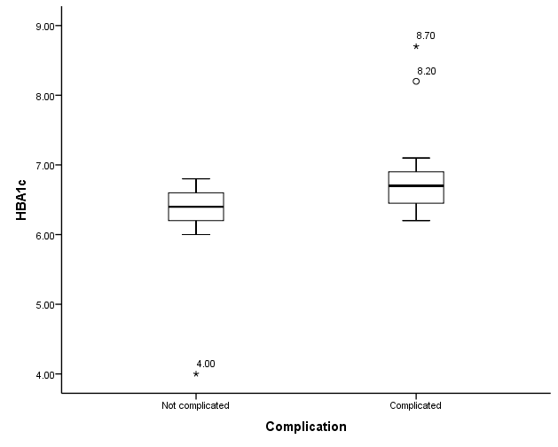
Figure (9) difference between HA1C percentage in complicated and non-complicated groups with STEMI.

Difference of HBA1C in different types of complications
This table shows that mean HBA1C was highly significant in patients with STEMI complicated with heart failure than patients without heart failure as mean HBA1c in complicated group was 6.79 % with SD (0.51) and mean in non-complicated group by heart failure was 6.79 % with SD (0.45) P value <0.001.
Also mean HBA1C was highly significant in patients re-hospitalized than patients not need re-hospitalization by mean HBA1C in re-hospitalized by 6.84 % with SD (0.56) while mean HBA1C in non-re-hospitalized was 6.38 % with SD (0.38) P value < 0.001. Mean HBA1C was highly significant in patients with mortality than patients without mortality patients by mean HBA1C in mortality group 7.05 with SD (0.07) while in patient group without mortality mean HBA1C was 6.48 % with SD (0.47) with P value (0.006). Difference in cardiogenic shock was non statistically significant among two groups with mean HBA1C in patients with cardiogenic shock was 6.83 % with SD (0.25) while mean in patients not developed cardiogenic shock was 6.48 % with SD (0.47) P value 0.05. Also there was non-stastiscally significance between patients who developed re-ischemia as mean HBA1C in group who complicated by re ischemia was 6.74 % with SD (0.58) and mean in patients not complicated with re-ischemia was 6.46 % with SD (0.45) P value 0.143. table (13) & figure (10).

Table (13) difference of HBA1C in different types of complications
 |  |  |  | HBA1c
 |  |  |  | Mean | ±SD | P value
Mortality |  | Yes |  | 7.05 | ±0.07 | 0.006
 |  | No |  | 6.48 | ±0.47
Re-Ischemia |  | Yes |  | 6.74 | ±0.58 | 0.143
 |  | No |  | 6.46 | ±0.45
Heart failure |  | Yes |  | 6.79 | ±0.51 | <0.001
 |  | No |  | 6.34 | ±0.38
Cardiogenic Shock |  | Yes |  | 6.83 | ±0.25 | 0.05
 |  | No |  | 6.48 | ±0.47
Re-hospitalization |  | Yes |  | 6.84 | ±0.56 | <0.001
 |  | No |  | 6.38 | ±0.38

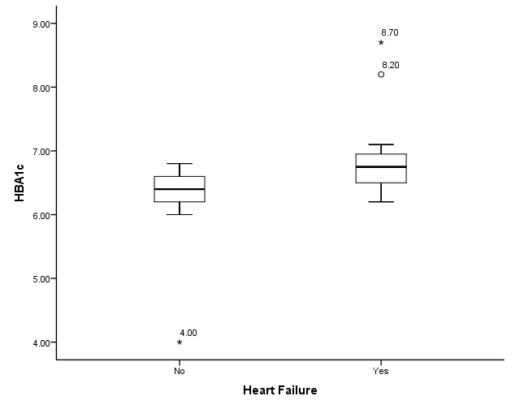

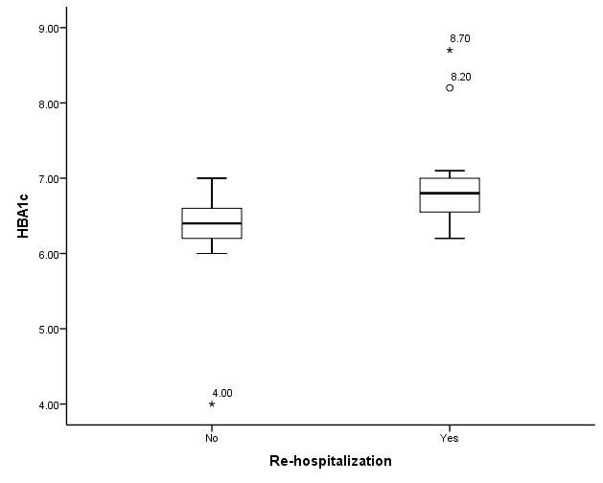
Figure (7) Difference of HBA1C in different types of complications

Logistic regulation analysis for prediction of complication using HBA1C:
This table showing that for every 1% increase in HBA1C risk of complication increase by 60.4 times (odds ratio 60.4). table (14).

Table (14) Logistic regulation analysis for prediction of complication using HBA1C:
 |  | B | S.E. | P value | OR | 95% C.I. for OR
 |  |  |  |  |  | Lower | Upper
HBA1c |  | 4.101 | 0.985 | <0.001 | 60.422 | 8.773 | 416.168
Constant |  | -27.405 | 6.461 | <0.001 | 0
B=Regression coefficients, SE=Standard error of the coefficient, OR=Odds Ratio, 95% CI for OR = 95% confidence interval for the =Odds Ratio. P-value≤0.05 is considered significant

Safety and side effects
The incidence of adverse events though the work was low.
Mortality
Two patients died due to acute cardiogenic shock and fatal arrhythmia (VF) in group A, P value (0.006).

4. Discussion
Though major advances in cardiovascular disease, and specifically the treatment of acute coronary syndrome, have had a significant impact on the morbidity and mortality of patients with acute myocardial infarctions (AMI), diabetes mellitus (DM) continues to put patients with and without a prior history of myocardial infarction at significant cardiovascular risk. Increased blood sugar levels performed during the hospitalization in patients could reflect either previously unrecognized diabetes or that the stress of MI unmasks or worsens the tendency toward hyperglycemia. Therefore, in our study we used HbA1c levels to categorize patients as diabetic, impaired glucose tolerance and non-diabetics (as per the American Diabetes Association 2003 criteria of HbA1c <5.7% normal; 5.7% to 6.4% impaired glucose tolerance; ≥6.5% diabetes). Due to stress hyperglycemia, a method looking only at plasma glucose levels at the time of an AMI cannot be used to predict the prognosis, thus glycosylated hemoglobin (HbA1c) values may reveal diabetes in cases of AMI (4). Glycosylated hemoglobin A1c (HbA1c) is a marker of long-term glycemic control and elevated HbA1cis associated with an increased risk of cardiovascular diseases in patients with diabetes, moreover HbA1c is also associated with all-cause mortality and cardiovascular disease even in absence of diabetes (5). In our present study was conducted on 100 patients admitted by acute STEMI with no past history of DM. candidate for reperfusion therapy either by primary PCI or by thrombolytic therapy, careful history was taken, full lab including HbA1c, cardiac enzymes, fasting and 2h postprandial blood sugar and angiographic finding are taken within month after thrombolytic therapy, then short term follow up period to four weeks was done to detect adverse cardiac events. out of them patient had HbA1c more than 6.4% i.e. they were found to be diabetic. Thus these patients presented to the hospital directly with acute coronary syndrome. Similarly 20 patients (i.e. 18.2%) had HbA1c in the impaired glucose tolerance range (5.7 to 6.4%). Thus patients of DM can have macrovascular complications of diabetes without having the usual symptoms of DM and can directly present with them. This is partly because majority of patients of type 2 DM are asymptomatic and can directly present with chronic complications unlike type 1DM. The classic symptoms of hyperglycemia like polyuria, polydipsia, polyphagia, nocturia, weight loss are often noted only in retrospect when hyperglycemia is noted on laboratory evaluation done either routinely or due to some complication. This finding are similar to other studies like (1) which also reported that myocardial infarction may be the initial presentation of diabetes and that there appears to be a graded rise in cardiovascular risk with increasing degrees of glucose intolerance below the definition of overt diabetes (6) reported that previously undiagnosed diabetes and impaired glucose tolerance are common in patients with an acute myocardial infarction. In a meta-analysis of 20 studies that included almost 100,000 people, (7) showed that there was a curvilinear increase in the risk for a cardiovascular event with increasing glucose intolerance. Similarly, (8) and (9) also showed that diabetic patients without previous myocardial infarction have as high a risk of myocardial infarction as non-diabetic patients with previous myocardial infarction. The presence of DM doubled the age-adjusted risk for cardiovascular disease in men and tripled it in women in the Framingham Heart Study, and it remained an independent risk factor even after adjusting for age, hypertension, smoking, hyperlipidemia, and left ventricular hypertrophy. (10). In the present study there was nostatistical significant difference among different HbA1c groups as regard age, smoking, hypertension. This was concordant with previous studies (11) (12). On the contrary, this was disconcordant with previous studies (4), (13). This discrepancy was explained by the small sample size, different population selection criteria and different types of revascularization in the present study. With respect to sex, there was no significant correlation with elevated HbA1c in these cardiac disease patients; this is in agreement with the study conducted by (4) who studied 100 patients with elevated HbA1c and could not detect any significant correlation between sex and clinical results. In patients aged above 60, In our study we found that for every 1% increase in HBA1C risk of complication increase by 60.4 times (odds ratio 60.4) this agree with meta-analysis of 13 prospective cohort studies, for every one percentage point increase in glycosylated hemoglobin (HbA1c), the relative risk for any cardiovascular event was 1.18 (95% CI 1.10–1.26). (14) Also even with all other factors similar, diabetic patients when compared to those without diabetes, have worse long-term outcomes after an acute coronary syndrome. Sustained chronic hyperglycemia has been shown to be an important cause for complications and poor outcomes in acute myocardial infarction. Studies have shown that there is a persistent progression of diabetic vascular disease despite reversal of hyperglycemia and this effect of prior hyperglycemia on the initiation and progression of diabetic vascular disease is defined as “metabolic memory". Therefore, we assessed the correlation between HbA1c levels and severity and complications of patients admitted with acute myocardial infarction in our hospital. Our study demonstrates that in non DM patients with ST segment elevation MI, elevated glucose levels on admission are associated with larger infarct sizes and increased long term mortality as percentage of patients who develop extensive anterior STEMI was 32% and mean HBA1C was 6.8 % compared to normal glucose levels on admission. Although the patho-physiological mechanism is unknown, this adverse relation of elevated glucose levels on admission with increased mortality is evident, despite the use or method of reperfusion therapy, and adjusting for other predictors of long-term mortality. This sub or pre diabetic state, also known as impaired glucose tolerance (IGT), is associated with a higher incidence of cardiovascular events. (7), (15) As these patients also appear to have an increased mortality after acute MI, specific risk reducing interventions should be considered. Exercise training, dietary modifications and medical intervention reduce the risk of subsequent DM in these patients and may be of value. (16), (17). In our study we found positive correlation between HbA1c levels and complications. Complications was present in 35% of patients (35 patients) the most common being heart failure by 32% we found that mean HBA1C was highly significant in patients with STEMI complicated by heart failure than patients without heart failure as mean HBA1c in complicated group was 6.79 % with SD (0.51) and mean in non-complicated group by heart failure was 6.79 % with SD (0.45) P value <0.001. Both LVD and HF were more common in patients with high HBA1C diabetics as compared to patients with low HBA1C patients. These findings are in agreement in earlier reports of (18) who found that diabetic patients presenting with acute coronary syndrome (ACS) have a worse prognosis. (19) in a prospective study of 48,858 adults with DM showed that each 1% increase in HbA1c was associated with an 8% increased relative risk of HF. The clinical manifestations of an acute myocardial infarction are more severe in diabetics than in non-diabetics. Both acute pulmonary edema and heart failure occurs significantly more in diabetics compared to non-diabetics despite similar infarct sizes and left ventricular ejection fractions suggesting that the left ventricle in diabetes tolerates infarction poorly. Diabetic patients have higher LV mass, wall thickness, and arterial stiffness, reduced resting LV ejection fraction (LVEF) and diminished systolic function and reduced cardiac reserve as compared to individuals without diabetes. They also have increased impairment in coronary flow than non-diabetics which might reflect a prothrombotic state or endothelial dysfunction associated with hyperglycemia. In our study we find statistically significant correlation between admission HbA1c levels and outcome as Mean HBA1C was highly significant in patients with mortality than patients without mortality patients by mean HBA1C in mortality group 7.05 with SD (0.07) while in patient group without mortality mean HBA1C was 6.48 % with SD (0.47) with P value (0.006). It has been well demonstrated that patients with admission hyperglycemia are associated with increased risk of mortality after AMI. This association has been observed not only in diabetic patients but also patients who had no previous diagnosis of diabetes. Recent experimental and clinical studies suggested that rapid elevation of plasma glucose itself increases infarct size. Hyperglycemia activates blood coagulation, aggregates inflammation, attenuates endothelium function, and abolishes ischemic preconditioning., (20). Diabetes and Insulin–Glucose Infusion in Acute Myocardial Infarction (DIGAMI) Study demonstrated that intensive insulin treatment to attain normo-glycaemia reduced mortality after AMI in patients with admission hyperglycemia. (21) This disagree with earlier finding of (21), (12) and (4) who showed that although crude mortality data was higher in patients with elevated HbA1c following adjustment for many cardiovascular risk factors, HbA1c values failed to predict in-hospital mortality. Similarly Hadjadj S, Coisne D et al found no correlation between HbA1c levels and short term outcome of patients. Whereas (22), (and (23) suggested that HbA1c level was also a potent predictor of both in-hospital and long-term mortality. A meta-analysis done by Yao Liu et al found that elevated HbA1c level is an independent risk factor for mortality in CAD patients without diabetes, but not in patients with established diabetes. In our study we didn’t include known diabetic patients but those patients who presented with acute myocardial infarction and then were found to have DM. Another reason explaining this difference might be the short term outcome follow-up in our study (4 weeks).. In the present study there was significant difference among different HbA1c groups as regard number of diseased coronary vessels with higher number of extensive anterior MI, inferior MI. This was concordant with previous studies (4), (13). This goes with the fact that HbA1c increase of one percent is associated with 2.8 fold increase in CAD and in severity of coronary artery lesions, this was explained by the fact that insulin resistance in hyperglycemia promote molecular mechanism by Advanced Glycation End products (AGEs) which are intimately involved in the patho-physiology of cardiovascular disease by stimulating inflammation, contributing to atheroma formation modulating vascular stiffness and the disturbed endothelial function by reduction nitric oxide release, increased vascular smooth muscle proliferation (24), beyond the high risk profile of those patients, it is worth mentioning that even HbA1c value in normal range is associated with presence and severity of CAD (25). On the contrary, this was disconcordant with (26) who found no significant difference between HbA1c level and severity of CAD. This discrepancy was due to that he used Gensini score for assessment of the severity CAD in his study and non-diabetic were only included in his study. In the present study there was significant difference among different HbA1c groups as regard adverse cardiac events, this was concordant with previous studies (4) (13). This goes with the fact that hyperglycemia is associated with large infarct size, more hemodynamic compromise, congestive heart failure, cardiogenic shock and mortality, beyond the fact that diabetic patients with poor glycemic control are at two fold more risk of developing MACE, while good controlled diabetics showed lower rates comparable to non-diabetics. In the present study there was higher percentage of mortality in patients with high HBA1C. Mean HBA1C was highly significant in patients with mortality than patients without mortality by mean HBA1C in mortality group 7.05 with SD (0.07 ) while in patient group without mortality mean HBA1C was 6.48 % with SD (0.47 ) with P value ( 0.006) This was concordant with (4) this goes with the fact that higher HbA1c level at admission was associated with higher baseline characteristics, larger infarct, more extensive coronary artery lesion, lower STR, higher percentage of TMI 1 flow. On the contrary, this was disconcordant with (27) who found that HbA1c values were not related to mortality in short and long term outcome, these discrepancies were related to larger number of consistencies (518 consecutive cases, longer period of follow up, all patients were treated by mechanical revascularization in his study). In the present study we found that diabetes mellitus, and HbA1c over 6.5% were significant predictor of short term adverse cardiac events in (univariate regression analysis) but in (multivariate regression) only HbA1c >6.5% was the actual significant independent predictor outcome. In the present study Regarding to HbA1c, it can predict adverse outcome. This was concordant with (4), this goes with the fact that hyperglycemia is associated with larger infarct size, lower successful response to reperfusion and high risk profile. On the contrary, this was disconcordant with (27), this discrepancies was due to that non diabetic patients were only included in his study.

Statistical methods
The clinical and echocardiographic data obtained at day 0 and 30 days’ post-randomization were collected, verified, revised and then edited on the P.C. and analyzed by using statistical software namely (SPSS 16) special package for special sciences.
The following tests were used:
Mean, Standard deviation (SD), Number and percentage, Student T test for independent samples, Paired T test, Chi square test (X²).
Significance of results Non-significant: P value > 0.05, Significant: P value < 0.05, Highly significant: P value <0.001.

Study Limitations
Small sample size of our study, the results were obtained from a single medical center (Benha university hospitals), Short term follow-up period, which affect interpretation of our results, our study applied on STEMI only, excluding NSTEMI and unstableangina, some patients gave vague history about their medical and cardiac history of being previously ischemic which may affect interpretation results regarding to outcome.

Conclusion
The present study shows that admission higher HbA1c level in patients presented by acute STEMI is associated with more severe CAD, lower ST-segment resolution, lower rate of complete revascularization TIMI 3and higher incidence of mortality. Higher HbA1c level should be considered for risk stratification of patients presented by acute STEMI who are amenable to primary PCI. So aggressive management of those high risk patients is mandatory.

Conflict of interest
The authors declare no conflict of interests.

References
- Khaw KT, Wareham N, Bingham S., et al (2004): Association of haemoglobin A1c with cardiovascular disease and mortality in adults: The European prospective investigation into cancer in Norfolk. Ann Intern Med; 141 (6): 413-420.
- Giraldez RR, Clare RM, Lopes RD, Dalby AJ, Prabhakaran D, Brogan GX, Giugliano RP, James SK, Tanguay JF, Pollack CV, Harrington RA, Braunwald E, Newby LK. Prevalence and clinical outcomes of undiagnosed diabetes mellitus and prediabetes among patients with high-risk non-ST-segment elevation acute coronary syndrome. Am Heart J 2013; 165: 918-925. e2 [PMID: 23708162].
- Deedwania P, Kosiborod M, Barrett E, Ceriello A, Isley W, Mazzone T, Raskin P. Hyperglycemia and acute coronary syndrome: a scientific statement from the American Heart Association Diabetes Committee of the Council on Nutrition, Physical Activity, and Metabolism. Circulation 2008; 117: 1610-1619 [PMID: 18299505 DOI: 10.1161/CIRCULATIONAHA. 107.188629].
- Cakmak M, Cakmak N, Cetemen S, et al. (2008): The value of admission glycosylated hemoglobin level in patients with acute myocardial infarction. Can J Cardiol., 2008; 24: 375-378.
- Naito R, Miyauchi K, Ogita M., et al (2013): Impact of admission glycemia and glycosylated hemoglobin A1c on long-term clinical outcomes of non-diabetic patients with acute coronary syndrome. J Cardiol.; 740 (6):234-238.
- Norhammar A, Tenerz A, Nilsson G, et al. (2002): Glucose metabolism in patients with acute myocardial infarction and no previous diagnosis of diabetes mellitus: a prospective study. Lancet. 2002; 359:2140-2148.
- Coutinho M, Gerstein HC, Wang Y, et al. (1999): The relationship between glucose and incident cardiovascular events. A metaregression analysis of published data from 20 studies of 95,783 individuals followed for 12.4 years. Diabetes Care 1999; 22:233-40.
- Haffner SM, Lehto S, Ronnemaa T., et al (1998): Mortality from coronary heart diasease in subjects with type 2 diabetes and in nondiabetics subjects with and without prior myocardial infarction. N Eng J Med.; 339 (4): 229-234.
- Juutilainen A, Lehto S, Rönnemaa T, et al. (2005): Type 2 diabetes as a "coronary heart disease equivalent": an 18-year prospective population-based study in Finnish subjects. Diabetes Care. 2005; 28:2901-2908.
- Kannel WB, McGee DL. (1979): Diabetes and cardiovascular risk factors: The Framingham study. Circulation. 1979; 59:8-11.
- Chan CY, Li R, Chan JY., et al (2011): The value of admission HbA (1c) level in diabetic patients with acute coronary syndrome. Clin Cardiol. 2011; 34 (8):507-512.
- Timmer JR, Ottervanger JP, Bilo HJ., et al (2006): Prognostic value of admission glucose and glycosylated haemoglobin levels in acute coronary syndromes. Q J M.; 99 (4):237-243.
- Kassaian SE, Goodarzynejad H, Boroumand MA., et al (2012): Glycosylated hemoglobin (HbA1c) levels and clinical outcomes in diabetic patients following coronary artery stenting. Cardiovasc Diabetol. 17; (11): 82.
- Selvin E, Marinopoulos S, Berkenblit G. (2004): Meta-analysis: glycosylated hemoglobin and cardiovascular disease in diabetes mellitus. Annals of Internal Medicine. 2004;141: 421–431.
- Eschwege E, Richard JL, Thibult N et al. (1985): Diabetes, hyperglycemia, hyperinsulinemia and risk of cardiovascular mortality. Findings of the Paris Prospective Survey, 10 years later. Rev Epidemiol Sante Publique 1985; 33:352-57.
- Buchanan TA, Xiang AH, Peters RK et al. (2002): Preservation of pancreatic beta-cell function and prevention of type 2 diabetes by pharmacological treatment of insulin resistance in high-risk hispanic women. Diabetes 2002; 51:2796-803.
- Tuomilehto J, Lindstrom J, Eriksson JG, et al. (2001): Prevention of type 2 diabetes mellitus by changes in lifestyle among subjects with impaired glucose tolerance. N Engl J Med 2001; 344:1343-50.
- Stone PH, Muller JE, Hartwell T, et al. (1989): The effect of diabetes mellitus on prognosis and serial left ventricular function after acute myocardial infarction: contribution of both coronary disease and diastolic left ventricular dysfunction to the adverse prognosis. The MILIS Study Group. J Am Coll Cardiol. 1989; 14:49-51.
- Iribarren C, Karter AJ, Ferrara A., et al (2001): Glycemic Control and Heart Failure among adult patients with diabetes. Circulation.; 103 (22): 2668-2673.
- Ceriello A. (1993): Coagulation activation in diabetes mellitus: the role of hyperglycemia and therapeutic prospects. Diabetologia 1993;36: 1119–1125.
- Corpus RA, O’Neill WW, Dixon SR, et al. (2003): Relation of hemoglobin A1c to rate of major adverse cardiac events in nondiabetic patients undergoing percutaneous coronary revascularization. Am J Cardiol. 2003; 92:1282–86.
- Chowdhury TA, Lasker SS. (1998): Elevated glycated haemoglobin in non-diabetic patients is associated with an increased mortality in myocardial infarction. Postgrad Med J. 1998; 74:480-1.
- Prasad A, Bekker P and Tsimikas S (2012): Advanced glycation end products and diabetic cardiovascular disease. Cardiol Rev.;20 (4):177-183.
- Prasad A, Bekker P and Tsimikas S (2012): Advanced glycation end products and diabetic cardiovascular disease. Cardiol Rev.;20 (4):177-183.
- Ashraf H, Boroumand MA, Amirzadegan A., et al (2013): Hemoglobin A1C in non-diabetic patients: An independent predictor of coronary artery disease and its severity. Diabetes Res Clin Pract. 5872; (8).
- Ertem AG, Bağbancı H, Kılıç H., et al (2013): Relationship between HbA1c levels and coronary artery severity in nondiabetic acute coronary syndrome patients. Turk Kardiyol Dern Ars.; 41(5):389-395.
- Lazzeri C, Valente S, Chiostri M., et al (2012): Glycated hemoglobin in ST-elevation myocardial infarction without previously known diabetes: its short and long term prognostic role. Diabetes Res Clin Pract.; 95(1):14-6.

5/29/2017

