Prevalence of unexplained infertility in patients attending Qena general hospital

Yehia Abdel-Salam Wafa, Mohamed E. Hammour and Ahmed Hussein Ahmed Ali

Obstetrics and Gynecology Department, Faculty of Medicine, Al-Azhar University
Ayc01118226323@gmail.com

Abstract: Unexplained infertility refers to the absence of a definable cause for a couple's failure to achieve pregnancy after 12 months of attempting conception despite a thorough evaluation. Infertility is a common problem in all population groups, and for those who are affected it can become a major tragedy and can lead to significant psychological and physical disturbances. It is important to know about the prevalence of the various factors causing infertility. We assessed all patients attending infertility clinic during the period of study to exclude any patient having organic cause of infertility and select our patients for the study.
[Yehia Abdel-Salam Wafa, Mohamed E. Hammour and Ahmed Hussein Ahmed Ali. Prevalence of unexplained infertility in patients attending Qena general hospital. N Y Sci J 2017;10(7):21-27]. ISSN 1554-0200 (print); ISSN 2375-723X (online). http://www.sciencepub.net/newyork. 4. doi:10.7537/marsnys100717.04.

Key Words: Unexplained infertility – prevalance of Unexplained infertility – diagnostic laparoscopy in Unexplained infertility – male and female work up of Unexplained infertility

1. Introduction
Infertility is defined as the inability to conceive after 1 year of unprotected intercourse of reasonable frequency.
It can be subdivided into primary infertility, that is no prior pregnancies; and secondary infertility referring to infertility following at least 1 prior conception (Mosher, 1991).
Infertility is a common condition, affecting 10 to 15 percent of reproductive aged couples of note, even without treatment approximately halve of women will conceive in the second year of attempting.
Although the prevalence of infertility is believed to have remained relatively stable. During the past 40 years the demand for infertility evaluation and treatment has increased with the well publicized advances in infertility treatment patients now have greater hope that medical intervention will help them to achieve their goals (Chandra, 2010).
Successful pregnancy requires a complex sequence of events, including; ovulation, ovum pickup by the fallopian tubes, fertilization transport of fertilized ovum into the uterus and implantation into receptive uterine cavity with male infertility sperm of adequate number and quality must be deposited at the cervix near the time of ovulation remembering these critical events can help direct a clinician to develop an appropriate evaluation and treatment strategy (Abma,1997, American society of reproductive medicine 2006).
Unexplained infertility may represent one of the most common infertility diagnosis with reported prevalence of up to 30 percent (Dodson, 1987).
The diagnosis of unexplained infertility is highly suggestive and depends on the diagnostic tests performed or emitted and on their level of quality (Gleicher, 2006).
Aim of the work
The aim of our study is to detect the prevalence of unexplained infertility among patients attending infertility clinic in Qena general hospital in order to plan their treatment protocols and to evaluate their clinical outcome.

2. Patients and Methods
The study will include (300) patients with infertility (Infertility is the inability to conceive after a year of unprotected intercourse).
Cases will be selected from infertility clinic of the department of Obstetrics & Gynecology of Qena general hospital.
Patients came seeking medical or even operative treatment for infertility.
Patients included in the study (Patients of unexplained infertility) must have the following criteria:
- Patients in reproductive age period (15 – 40 years).
- 1ry or 2ry infertility.
- Patients with continuous marital life and unprotected intercourse.
- Normal regular cycles.
- Normal results of semen analysis.
- Normal hormonal profile (FSH, LH, PRL, Progesterone, E2) taken in appropriate time.
- Normal pelvic ultrasound (uterus, both ovaries and Douglas pouch).
- Normal hystero-salpingography (HSG).
Exclusion criteria (from the infertility group):
Any infertile patient having any organic cause interfering with pregnancy was excluded from our study.
Statistical analysis:
Data were analyzed using Statistical Program for Social Science (SPSS) version 20.0. Quantitative data were expressed as mean± standard deviation (SD). Qualitative data were expressed as frequency and percentage.
The following tests were done:
- Independent-samples t-test of significance was used when comparing between two means.
- Chi-square (X²) test of significance was used in order to compare proportions between two qualitative parameters.
- Probability (P-value).
- P-value <0.05 was considered significant.
- P-value <0.001 was considered as highly significant.
- P-value >0.05 was considered insignificant.

3. Results
- Total number of infertile patients included in the study was 300. After completing all the investigations mentioned in the inclusion criteria it was found that:
- 42 patients were found to have no apparent cause of infertility (all their investigations were negative) and were diagnosed as having unexplained infertility.
- This represent 14% from total cases seen and this percentage represented the initial prevalence of unexplained infertility in this study.
- The remaining 258 cases were found to have a cause for their infertility (male factor, ovarian, uterine, tubal...…..) and were excluded.
- These 42 patients with presumed unexplained infertility were subjected to diagnostic laparoscopy and were further divided in two groups according to the results of DL:
Group I: 27 case with no cause for their infertility "unexplained" and so the final and actual percentage of UI was 9% of the total examined patients.
Group II: 15 cases were found to have a cause for their infertility such as fibroid, tubal adhesions, or endometriosis which was not detected by HSG.
Group I: thus represents the actual prevalence of unexplained infertility; after adding diagnostic laparoscopy to our investigations in patients attending at Qena General Hospital.
These results indicate that the more we do investigations; the less the prevalence of unexplained infertility will be.

Table (1): Total number of cases, before & after diagnostic laparoscopy and their percentages.
 |  | N | %
UI Before performing Diagnostic laparoscopy |  | 42 | 14%
UI After performing Diagnostic laparoscopy |  | 27 | 9%
Excluded patients with organic cause of infertility |  | 231 | 77%
Total |  | 300 | 100%
Chi-square | X² | 258.433
 | P-value | <0.001*

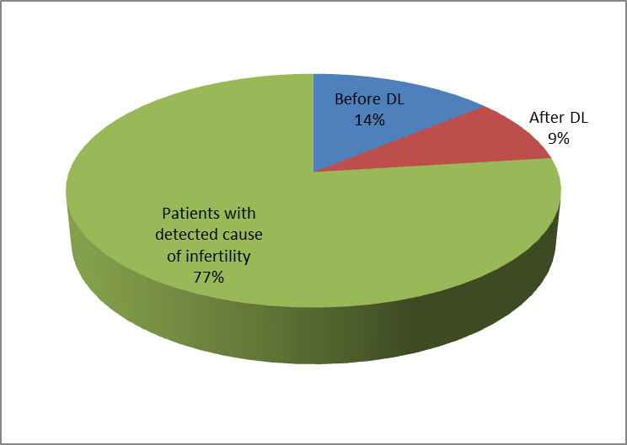
Figure (1): Prevalence of unexplained infertility patients in relation to total number of patients

300 patients attended the infertility clinic at the time of our study, 42 patients were initially diagnosed as unexplained infertility. These patients were subjected to diagnostic laparoscopy and of them only 27 were found to have actually unexplained infertility.
The chart reveals the prevalence of unexplained infertility patient's before and after doing diagnostic laparoscopy.

Table (2): Male and female factors of infertility of the study group.
 | No. | %
Female | 121 | 40.3%
Male | 108 | 36.0%
Combined | 29 | 9.7%
Unexplained Before laparoscopy | 42 | 14.0%
Total | 300 | 100.0%

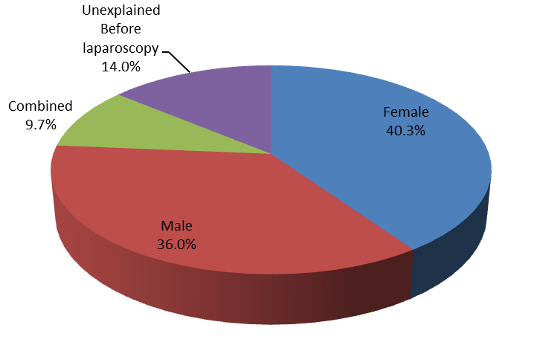
Fig. (2): Pie chartmale and female factors of infertility of the study group.

Table (3): Number of primary & secondary infertility patients in Group I & Group II & their percentages.
 |  | Type
 |  | 1ry | 2ry | Total
Group I | N | 18 | 9 | 27
 | % | 66.7% | 33.3% | 100%
Group II | N | 6 | 9 | 15
 | % | 40% | 60% | 100%
Total | N | 24 | 18 | 42
 | % | 57.1% | 42.9% | 100%
Chi-square | X² | 3.144
 | P-value | 0.046

Number of primary and secondary infertility patients among group I & Group II.

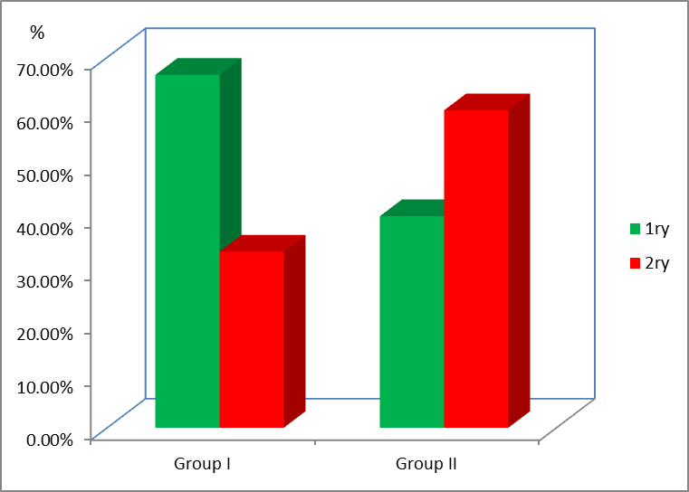
Figure (3): Relation of primary & secondary infertility patients to Group I & Group II.

In Group I:
- The number of primary infertile cases was 18 patients and the percentage was 66.7%.
- The number of secondary infertile cases was 9 patients with a percentage of 33.3%.
In Group II:
- The number of primary infertile cases was 6 patients and their percentage was 40%.
- The number of secondary infertile cases was 9 patients with a percentage of 60%.

Table (4): Age distribution in Group I & Group II.
 | Age (years) |  |  |  |  |  | T-test
 | Range |  |  | Mean | ± | SD | t | P-value
Group I | 18 | - | 36 | 27.10 | ± | 4.71 | -1.143 | 0.144
Group II | 23 | - | 40 | 29.04 | ± | 5.20

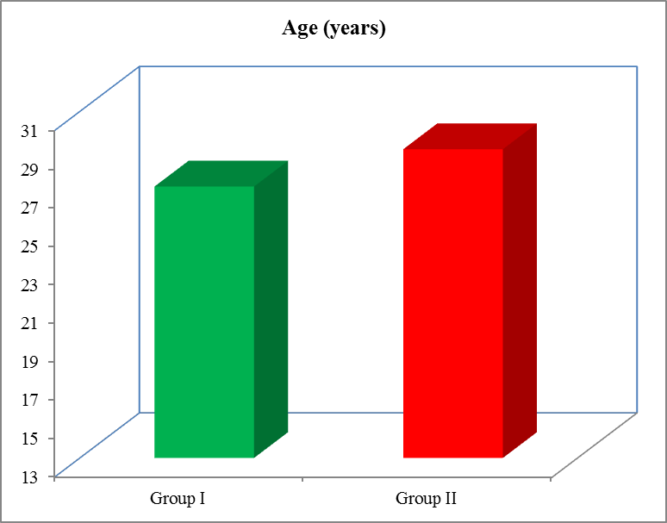
Figure (4): Relation of age distribution to group I & group II.

Age distribution in two groups is not significant
- The mean age of patients in Group I was 27.10 ranging from 18 to 36 years.
- The mean age of patients in Group II was 29.04 ranging from 23 to 40 years.

4. Discussion
Infertility is defined as failure to conceive after one year of regular unprotected intercourse. In Western countries 5 - 14% of women in the child bearing age are infertile.
Unexplained infertility may represent one of the most common infertility diagnoses, with a reported prevalence of up to 30 percent. The diagnosis of unexplained infertility is highly subjective and depends on the diagnostic tests performed or omitted` and on their level of quality. Paradoxically, a diagnosis of unexplained infertility, therefore, will be more often reached if the evaluation is incomplete or of poor quality. Expectant management may be considered, especially with infertility of short duration and with relatively young maternal age. However, if treatment is desired, then IUI, superovulation, and ART are empiric appropriate interventions to consider...." (Gleicher, 2006).
Unexplained infertility (UI) may, indeed, represent the single most frequent female infertility ‘diagnosis’, with a reported prevalence of approximately 25–30% of all infertility (Smith et al., 2003).
Review of the case records of 500 consecutive couples attending one Scottish infertility clinic revealed a group of patients whose infertility remained unexplained after completion of a standard protocol of investigations. Various patient characteristics were examined. About 34% of those were primary infertility and 66% were secondary infertility (Isaksson and Tiitinen, 2004).
In comparison to our study in group I (patient with actual UI after doing diagnostic laparoscopy) 66.7% of cases were primary infertility, and about 33.3% of them were secondary infertility.
Despite improvements in both diagnostic assessment and treatment of infertile couples, many couples still have no explanation for their infertility. Unexplained infertility (the failure to conceive in a couple with no definitive cause for infertility) has an incidence of 10-20% in all infertile couples. The incidence varies with the population studied and with the criteria used. Unexplained infertility is not an absolute condition but rather a relative inability to conceive and many of these couples may conceive without treatment. The treatment options for unexplained infertility are variable and the treatment results are promising. Expectant management can be recommended if the woman is under 28-30 years of age and the infertility duration is less than 2-3 years. In vitro fertilization (IVF) has revolutionized the treatment of infertile couples, as well as profoundly increasing the basic understanding of human reproduction. IVF can be used as both a diagnostic and a therapeutic tool in couples with unexplained infertility. The pregnancy rates with IVF are good, around 40% per treatment cycle (Isaksson and Tiitinen, 2004).
In comparison to Isaksson and Tiitinen study, our study found that the percentage of unexplained infertility in patients after doing laparoscopy is 9 % and this result is similar to the result of their study which ranged between 10% - 20%.
Just a few years ago, unexplained infertility was reported in up to 60% of patients in studies from the medical literature. Even as recently as the last few years, authors have continued to report its prevalence as high as 20% to 25%. A recent textbook summarized several studies dating back to 1950 and quoted an average percent of unexplained infertility of 16.7%. Some recent authors report the percent of unexplained infertility to be between 0% and 6% (Penney.2007).
How can such wide discrepancies in the percentage of unexplained infertility be explained?
Obviously, if one considers, as has been proposed, a semen analysis, evaluation of ovulatory function, a post coital exam, a hysterosalpingogram, and a laparoscopy a complete initial assessment in any couple not conceiving in one year of attempting, a larger number of patients will be diagnosed as unexplained infertility than if additional tests are included or a longer period of infertility is required before making the diagnosis. If one accepts an abnormal parameter as an explanation, expanding the diagnostic tests only slightly reduces "unexplained" infertility dramatically. Apart from the definition of infertility itself, an additional consideration would be the definition of a test as normal in any given practice or clinic. For example, if one uses 60% sperm motility of grade three plus as the lower limits of normal and accepts that any lower value may be associated with infertility, many otherwise "unexplained" male infertility problems become "explained". IVF data clearly indicate, even in the most successful programs, low implantation rates relative to the number of embryos transferred. Defects which lead to problems with implantation are probably much more common than we realize and constitute another area of unexplained infertility for which testing is currently being investigated. Assaying implantation factors may, in fact, lower the percentage of patients identified with unexplained infertility, but do not assist in the initial deliberations regarding therapy. Some authorities would suggest that there is an overlap between certain causes of recurrent pregnancy loss and infertility. In other words, infertility and early recurrent pregnancy loss represent just points of a spectrum. For instance, these physicians might evaluate for the antiphospholipid syndrome, ordering tests usually performed for recurrent pregnancy loss patients, in couples presenting with infertility. If one accepts this as a cause of infertility, then failure to test would place a certain percentage of patients into the unexplained infertility category while, in another office, they would be considered explained infertility (Penney, 2007).
If one believes that laparoscopic management of endometriosis does not improve pregnancy rates then, of course, laparoscopy would not be performed. Although a large, prospective, randomized trial has not been performed, most available data suggest that pregnancy rates are significantly improved by surgical treatment, even if mild or minimal endometriosis exists. So, here is another circumstance where one subscribing to the former position might find unexplained infertility, while one subscribing to the latter position would find explained fertility.
One of the common questions when a patient doesn't conceive during a treatment cycle, regardless of the therapeutic regimen, is "What went wrong, Doctor?" Part of the answer also relates to the concept of unexplained infertility. The concept of unexplained infertility can be quite broad. A couple who has attempted to conceive for three years without success in a sense has already tried thirty-six months; so, assuming they don't conceive in the next cycle or two, they've already demonstrated their chances of conception on a per cycle basis are 3% or less. In fact, those numbers are borne out by more sophisticated studies which indicate that the probability of conception without treatment in such couples is actually in the range of 1% to 3% per month. Therefore, couples need to consider not only the female partner's age, but the duration of infertility in determining whether to proceed to empiric therapy; that is, therapy which is not being addressed to a particular diagnosis which has been established. Therapies which are probably successful in treating unexplained infertility include clomiphene ovulation induction or human menopausal gonadotropin ovulation induction, either of which may be combined with intrauterine insemination, which may itself improve the pregnancy rates in unexplained infertility. More controversial therapies include glucocorticoids, baby aspirin, and heparin. Generally, any treatment regimen extended beyond six months will enter the point of diminishing returns.
Consensus as to the extent of testing required before one can conclude that unexplained infertility exists, or its treatment, will not be forthcoming soon (Penney, 2007).
-To answer the question "How can such wide discrepancies in the percentage of unexplained infertility be explained?" then the accepted answer; according to our study and to previous study; that the diagnosis of unexplained infertility is highly subjective and depends on the diagnostic tests performed or omitted and on their level of quality. Paradoxically, a diagnosis of unexplained infertility, therefore, will be more often reached if the evaluation is incomplete or of poor quality. In our study, at the level of standard protocol of investigations the number of patients with UI was 42, but after adding diagnostic laparoscopy the number of patients with UI decreased to 27 patients with percentage of 9%.
Nine hundred and four patients, who visited the Fertility Clinic at Groote Schuur Hospital Department of Obstetrics and Gynaecology, Cape Town, were classified according to infertility factors. In 36% of all couples a male factor was present, while 57% had a tubal, 29% an ovulatory, 7% a cervical immunological and 6% a uterine factor. Four per cent of all patients had endometriosis, and 2. 4% had unexplained infertility.
The selection criteria at the Fertility Clinic at Groote Schuur Hospital exclude patients who are unmarried, cases in which the couple combined have had more than one child in the past, and 904 patients were admitted to the clinic and investigated. Routine history-taking and examination, the husband was referred for semen analysis and the wife underwent hysterosalpingography and had her day 21 serum progesterone value measured, laparoscopy and if indicated hysteroscopy was performed. During the first 2 months of treatment a postcoital test was also done. Unexplained infertility was very rare in their patients (2.4%). Other studies report much higher prevalence, up to 24% (Templeton and Penney. 2002).
-This study was similar to our study as regards selection criteria and investigations done to all patients attending the infertility clinic except for post coital test and hysteroscopy which was not performed in our study and adding these investigations may be the cause for reduced percentage of UI in their study contrary to other studies.
In conclusion, Templeton and Penney showed that the distribution of infertility factors among their patients is similar to distributions reported by workers elsewhere in the world, with the exception of unexplained infertility, the prevalence of which is 2.4%. The mean age of women seen at the in clinic was 29, 13 years (Templeton and Penney, 2002).
In comparison to our study the mean age of women was 27 years.
The presence of patent fallopian tubes, normal ovulation, and normal sperm parameters may still be associated with subfertility because of distortion of the uterine cavity or the presence of intraperitoneal endometriosis. Frustratingly, in some cases, no abnormality is found on routine investigation and the infertility is labelled “unexplained.”
Unexplained subfertility couple are usually referred for investigation after trying unsuccessfully to conceive for a year. Although the chance of successful spontaneous conception during the subsequent year is about 50%. However, the chance is reduced if the woman has never been pregnant (primary subfertility) or is aged over 30, or the duration of subfertility is longer than three years.
Unexplained infertility is a diagnosis of exclusion. Up to 25% of patients who present for investigation in a reproductive medicine clinic are diagnosed with unexplained fertility. The diagnosis is usually made after investigations show normal semen parameters, ovulatory concentrations of serum progesterone in the mid-luteal phase, tubal patency, and a normal uterine cavity.
It is important to emphasis to couples with a diagnosis of unexplained subfertility that they have only had essential, simple fertility tests that do not always assess function. For example, despite showing tubal patency, normal transport of eggs and sperm in tubes has not been evaluated as no test for this is available. Although a woman may have an ovulatory concentration of serum progesterone and this indicates formation of a corpus luteum, it does not necessarily mean that an egg has been released or that an egg has been picked up in the fallopian tubes. Even for women who ovulate, there is no information about oocyte quality and consequent embryo quality after fertilization. Despite normal semen parameters, the sperm may fail one of the steps needed to fertilize the oocyte. Some or all of these potential causes of infertility may be avoided by using intrauterine insemination with superovulation, in vitro fertilization, or intracytoplasmic sperm injection.
Further tests can be done but they seldom alter management. The “postcoital” test should no longer be done routinely as it is unreliable and seldom alters management (Royal College of Obstetricians and Gynaecologists, 1998).
What couples want is not so much to find out “what is wrong,” but “what can be done for us.” Hence, a pragmatic approach to their treatment should be taken.

Conclusion
Unexplained subfertility is a diagnosis of exclusion. The incidence varies with the population studied and with the criteria used. Unexplained infertility is not an absolute condition but rather a relative inability to conceive.
In our study the initial prevalence of unexplained infertility was 42 cases with a percentage of 14%, but after performing diagnostic laparoscopy, the actual number of patients with UI was found to be 27 cases with a percentage of 9%.
This indicates that the more we increase the investigations needed to detect UI the less prevalence of unexplained infertility will be.

Recommendations
In order to diagnose unexplained infertility, all investigations should be done to exclude the presence of male, ovarian, uterine, or tubal factors of infertility including diagnostic laparoscopy.
The diagnosis of UI is usually made after investigations show normal semen parameters, normal ovulation, tubal patency with DL, and a normal uterine cavity.
Further reliable investigations can be added to reach a proper diagnosis in order to detect the proper treatment for infertility and to avoid the wide discrepancy in the prevalence of unexplained infertility.

Further studies are needed to be done bearing in mind:
- Increasing the number of cases under trial.
- Increasing the period of follow up of the patients.

References
- Abma 1997; Vital health state 23:1,1997.
- American society of reproductive medicine 2006. Effectiveness and treatment of unexplained infertility. fertile sterile 86(suppl4): s248).
- Chandra a 2010: Stephen EH (93,3:725).
- Dodson1987; Fertile sterile 48;441.1987.
- Gleicher N, El-Roeiy A, Confino E, Friberg J 2006. Reproductive failure because of autoantibodies: unexplained infertility and pregnancy wastage. Am J Obstet Gynecol., 160:1376–1385.
- Isaksson R and Tiitinen A 2004. Present concept of unexplained infertility. Gynecol Endocrinol., 2004: 18(5); 278-90.
- Mosher W, Pratt 1991w fecundity and infertility in united states 56:192.
- Penney L L2007. unexplained infertility article. The Fertility Net Work. htm: (573); 443-451.
- Smith S, Pfiefer SM and Collins J2003. Diagnosis and management of female infertility. JAMA.,:290; 17.
- Templeton AA and Penney GC 1982. The incidence, characteristics, and prognosis of patients whose infertility is unexplained. Fertil Steril; 37:175.

5/29/2017

