Diffusion Weighted MRI in Characterization of Hepatic Focal Lesions

A. Hejazy M.B.B.CH, S. Alwagdy M.D & M. A. Abdelatif M.D.

Case series performed at the Department of Diagnostic Radiology, Faculty of medicine Al-Azhar University. Cairo, Egypt. bakrhegazy1987@gmail.com

Abstract: Aim: The aim of this study is to assess the role of Diffusion Weighted Imaging (DWI) technique used in Magnetic Resonance Imaging (MRI) of the liver and its ability to characterize hepatic focal lesions and differentiate them as benign or malignant. Summary: 37 cases with HFLs was investigated by dynamic MRI in conjunction adjacent to DWI Tanique at 3 different b values and ADC measurement for each lesion. DWI proved to be helpful in the characterization of focal liver lesions, but should always be used in conjunction with traditional dynamic MRI since there is great overlap between ADC values of benign and malignant lesions however it shows high sensitivity in diagnosing malignant lesions. So, it seems reasonable to use DWI in conjunction to conventional imaging. We can predict that with more scientific researches the use of DW imaging of the liver will become far more common and may replace routine multiphasic imaging approaches in the near future. Key words: MRI magnetic resonance imaging, DWI diffusion weighted imaging, ADC apparent diffusion coefficient, HFL hepatic focal lesions, SOR standard of reference, HCC hepatocellular carcinoma.
[A. Hejazy, S. Alwagdy and M. A. Abdelatif. Diffusion Weighted MRI in Characterization of Hepatic Focal Lesions. N Y Sci J 2017;10(7):10-14]. ISSN 1554-0200 (print); ISSN 2375-723X (online). http://www.sciencepub.net/newyork. 2. doi:10.7537/marsnys100717.02.

Keywords: Diffusion; Weight; MRI; Characterization; Hepatic; Focal Lesion

1. Introduction:
Diffusion weighted imaging (DWI) is a relatively recent non-contrast imaging tool. It has a high resolution allowing more accurate detection and characterization of FLLs (Galea et al., 2013). Its principle is based upon measuring the random motion of water into a voxel of tissue. It provides quantitative and qualitative information about tissue cellularity, depicting between normal parenchyma and malignant tissues. A recent application of MRI and of DWI in particular is the use of the apparent diffusion coefficient (ADC) value as a measure of the magnitude of diffusion within a tissue (Sinha et al., 2013). Usually, malignant FLLs are characterized by restricted diffusion defined by hyperintensity on the b-800 image and hypointensity on the ADC map. Benign FLLs with fluid content (such as hemangioma or biliary cyst) are characterized by hyperintensity both on the DWI at high b-values, and on the ADC map, behavior is known as "T2-shine through" (Galea et al., 2013). DWI represents an excellent method for detection and differentiation of metastatic liver lesions (Se 87% and Sp 97%) compared to other methods such as triphasic CT (Se 53% and Sp 78%) (Holzapfel et al., 2011). Results of several studies show that diffusion-weighted (DW) MR imaging can help to characterize FLLs by enabling measurement of lesion (ADC) (Parikh et al., 2008).

2. Patient and methods:
From April 2016 to May 2017 prospective study was performed at Al-Azhar university’s hospitals in Cairo, including 37 patients with hepatic focal lesions discovered during routine examination by US or during follow up of known oncological patient. The patients were 27 males and 10 females with mean age 52,8 years. All patients underwent routine conventional MR sequences which was performed on high field system (1.5 Tesla - Philips Achieva) using a phased array coil to cover the whole liver and conventional sequences including T1, T2, chemical shift T1 and triphasic post Gd-DPTA T1WIs. DWI at three b values (b 50, b 500 b 800 s / mm²) and corresponding ADC and ADC value measurements for ROI (regions of interest).
MR protocol used:
Coronal Survey BFFE:
TR=2.85, TE=1.43, Matrix=256x256, slice thickness=15mm, slice gap=3mm and Flip Angle=60º: Scan time = 57 sec.
Axial T1 weighted (T1W) images:
Repetition time (TR)=4msec, echo time (TE)=2msec, matrix 192x192, slice thickness 10mm, slice gap 1-2 mm, and scan time = 15.3 sec.
Coronal T1W-IP SENSE:
TR =10msec, TE=4.6 msec, matrix 384x384 with a slice thickness 3mm, slice gap 0mm and flip angle of 10 degrees, scan time = 1.36 min.
Axial in phase and out phase gradient echo sequence (dual-FFE-BH-SENSE) axial images:
TR= 170msec, TE=4.6msec for in phase and 2.3msec for out phase, matrix 384x384 with slice thickness 10mm, slice gap 2 mm & flip angle = 80, Scan time = 1.20 sec.
Axial T2 weighted (T2W-TSE SENSE):
TR 500-510 msec, TE=90-100 msec, matrix 384 x 384 with a slice thickness 10 mm, slice gap 2mm, FA= 90 degrees & Scan time = 2-5 min.
Coronal T2W-TSE SENSE:
TR =500msec, TE= 100 msec, matrix 528x528 with a field of view: 365, slice thickness 3mm, slice gap 0mm and flip angle of 10 degrees, scan time =1.36 min.
Axial T2 SPAIR (Spectral Attenuated Inversion Recovery) fat suppression sequence:
TR 412 – 418 msec, TE=80msec, matrix 384 x 384 with a slice thickness 10 mm, slice gap 2mm, scan time = 1.12 min. Axial heavy T2 weighted images: TR=737msec, TE=300msec, matrix 400 x 400 with a field of view: 381, slice thickness 10 mm, slice gap 2 mm.
Diffusion study:
Breath hold fat-suppressed single-shot echoplanar DW imaging was performed in the transverse plane with tri-directional diffusion gradients by using three different b values 50, 500 & 800 sec/mm² to increase sensitivity to cellular packing. Parallel imaging with generalized auto- calibrating partially parallel acquisition with an acceleration factor was applied to improve image quality. The other parameters were as follows: (DWI- 3b- RT SENSE / Axial image) repetition time (TR) ≥1.2sec, echo time (TE) = 60 msec, number of excitations (NEX)=3, matrix 192x192 with a slice thickness 10mm, slice gap 1-2mm & scan time 2-3min.
ADC calculation:
The mean ADC of each focal lesion detected was measured by drawing a region of interest (ROI) over the lesion. The ADC was measured twice and the measurements were averaged.
Dynamic study:
Dynamic study was performed after bolus injection of 0.1mmol/kg body weight of Gd-DTPA at a rate of 2ml/s, flushed with 20ml of sterile 0.9% saline solution from the antecubital vein. Dynamic imaging using THRIVE (T1 High Resolution Isotropic Volume Examination) technique which is 3D GRE with fat suppression (SPAIR) performed before and after contrast administration in arterial, porto-venous as well delayed phase. The patient was asked to hold breath at end expiration.
Coronal 2D BOLUS TRACK:
TR =4mses, TE=0.79-1.82 msec, matrix 256x256 with a field of view: 365, slice thickness 3mm, slice gap 0mm and flip angle of 10 degrees, scan time = 2.34 min.
eThrive Dynamic Sense:
TR =3.77-3.85ms, TE=1.79-1.82 msec, matrix 192x192 with a field of view: 365, slice thickness 3mm, slice gap 0mm and flip angle of 10 degrees, scan time=1.01 min. Mean whole scan time=24 min.
Imaging evaluation:
All the study was evaluated by radiologist who had at least 5 years’ experience in hepatic imaging, firstly blind characterization and detection of focal lesions was done, then the diffusion image with ADC value were reviewed and all images results were verified against standard of reference.
Study evaluated by using T1WI, T2WI, DWI and dynamic sequences for lesion detection and characterization. Assessment of The MR features included shape, margin, signal characteristics, pattern of enhancement in the dynamic study and measuring the ADC on the highest b value (b800) then the whole data collected at excel table and provisional diagnosis was done according to MR features, if conclusive it considered final diagnosis, and if was not, biopsy was recommended. Using DWI sequence, calculation of ADC value on the highest b value was done twice and average value was taken then we made statistical relations between results, dynamic pattern, provisional diagnose and histopathological results (if present) for correlation between the ADC value and malignancy. In patients who had different pathological lesions, we considered each lesion as separate case in the demographic study of the lesions.

3. Result:
Of the 37 patients with liver lesions, 21 patients were diagnosed as benign cases and 16 patients with malignant lesions. We noticed that that the most common benign lesion was hemangioma and the most common malignant lesion was HCC. The mean ADC value of benign lesions was 1.89×10⁻³ mm²/sec. ADC values of benign lesions were between 0.774×10⁻³ and 5.2 ± 0.10×10⁻³mm²/sec. The highest mean ADC value was for simple cysts and the lowest was for abscess.
The ADC values of malignant lesions were between 0.650 x10⁻³ mm2/sec and 1.30×10⁻³mm²/sec, with a mean value of 1.1×10⁻³mm²/sec. The ADC measurements of benign and malignant hepatic masses were significantly different with a p value 0.005, and to evaluate the ability of ADC measurement in discrimination of lesions as benign and malignant, we found that cut-off value of ADC which can discriminate the malignant lesions was<1426, with sensitivity of 86.4% specificity of 85.7% positive predictive value of 90.5%, negative predictive value of 80% with diagnostic accuracy of 85.6%.

4. Discussion:
57 lesions were detected all over the study, some patients who had multiple innumerable lesions, 5 lesions were selected. In patients who had lesions of same pathology, average size and ADC value were taken, and in cases with different pathological lesions we considered each lesion as separate case.
In the current study we found 13 male patients with HCC. We also found that 12 (92.3%) out of 13 patients had an evidence of underlying liver cirrhosis. We classify the HCC to non-treated 6 cases and treated 7cases, most of HCC lesions displayed heterogeneous enhancement at the arterial phase, porto-venous, and equilibrium phases, they displayed rapid washout. That was on line with Silva et al., (2009), who found that at dynamic contrast-enhanced imaging, HCC lesions more often demonstrate heterogeneous enhancement During the porto-venous & at equilibrium phases, HCC will show rapid loss of enhancement, becoming iso- or hypointense relative to the liver. In DWI sequence, HCC lesions showed evidence of restricted diffusion with high DW signal on increasing b-values that returned to low signal on ADC maps denoting their high cellular nature or residual tumoral activity after treatment. Mean ADC of HCC (non-treated +failed treated) in our study was (1.13x10⁻³ mm² /sec) which was quite similar to some other studies where Koike et al. (2009), who found mean ADC value of 1.31±0.28x10⁻³ mm²/sec. Bruegel et al. (2008), with mean ADC value of 1.05±0.21x10⁻³ mm²/sec. in cases of post locoregional therapy, DWI can clearly differentiate between viable tumor tissue and necrotic tissues (inherent tumoral necrosis & post radioablation sequel), as viable tumoral tissue appears hyperintense with significantly lower mean ADC values (1.126x10^{­3} mm²/s) and completely ablated and necrotic tissue which appear hypointense with higher mean ADC values (1.905x10^{­3}mm²/s), our study was similar to Schraml et al. (2009) study where viable tumors after RFA appeared as hyper­intense, & necrotic regions were recognized as hypointense areas on DWI.

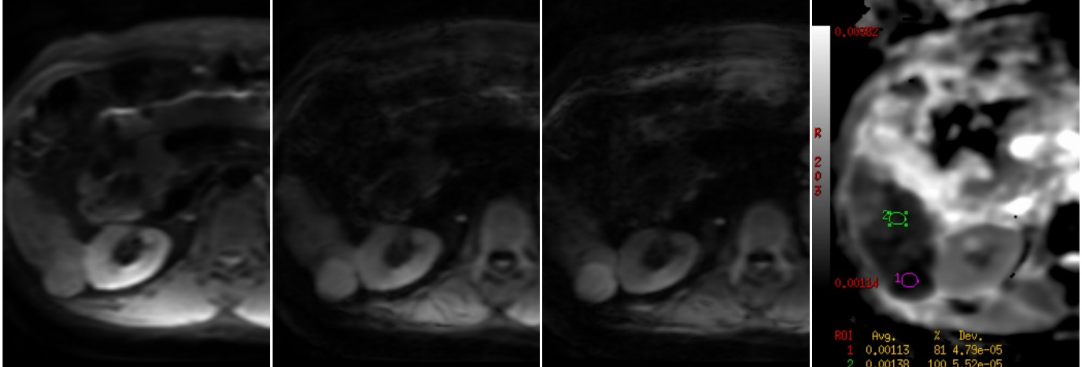
DWIb50
ADC
b800
b500

Figure1; DWI and ADC map showing right lobe HFL with increase in signal intensity on different b values and drop of signal intensity at the ADC map (restricted pattern). ADC value was: 1.13x10⁻³mm²/sec., Diagnosis was HCC.

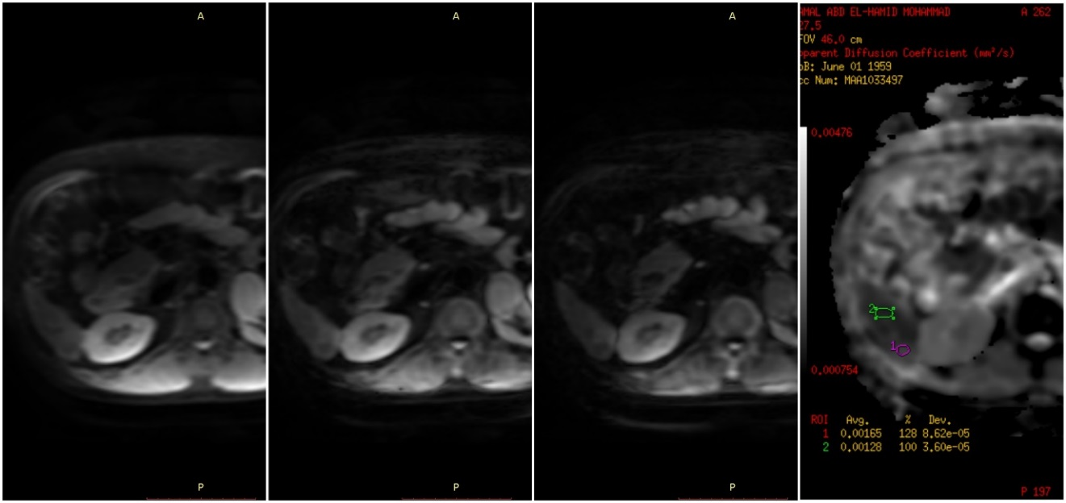
ADC
DWIb50
b800
b500

Figure2; post TACE procedure to the same patient in figure1 followed by dynamic MRI for follow up. On DWIs: the lesion decreased in size and appears isointense to the liver tissue on different b values with no change in signal on ADC map (non-restricted diffusion pattern). ADC value post TACE: 1.65 x10⁻³ mm²/sec, with no residual activity detected.

Hemangioma is the most common benign hepatic lesion as we found 13 lesions out of 29 benign FLLs. In the current study, all lesions displayed low signal on T1-WI, high signal on T2-WI and maintained high signal `light bulb` on heavy T2-WI which is similar to Schneider et al., (2006), where mentioned that on unenhanced T1-weighted MR images, hemangiomas are most commonly visualized as well defined, typically homogeneous, hypointense masses with lobulated borders and, On T2-weighted images they characteristically show marked homogeneous hyperintensity with 'light bulb sign'. On DWI, in 7 cases out of 8, the lesions showed signal intensity loss with increasing b-values and showing high signal intensity on ADC maps denoting benign nature of these lesions (facilitated diffusion) and mean ADC value was (2.022.9x10⁻³ mm²/sec), which was near to other studies such as Bruegel et al. (2008), with mean ADC value of 1.92±0.48x10⁻³ mm²/sec and Koike et al. (2009) with mean ADC value of 1.84±0.45x10⁻³ mm²/sec, on the other hand 1 case out of 8 hemangioma showed hyperintensity along different b-values with drop of signal at the ADC maps denoting restricted diffusion pattern, the mean ADC value was 1.426 ±131x10⁻³mm²/sec, this could be explained by slowing flow of the blood or degeneration inside the lesion specially as it showed type III enhancement pattern.

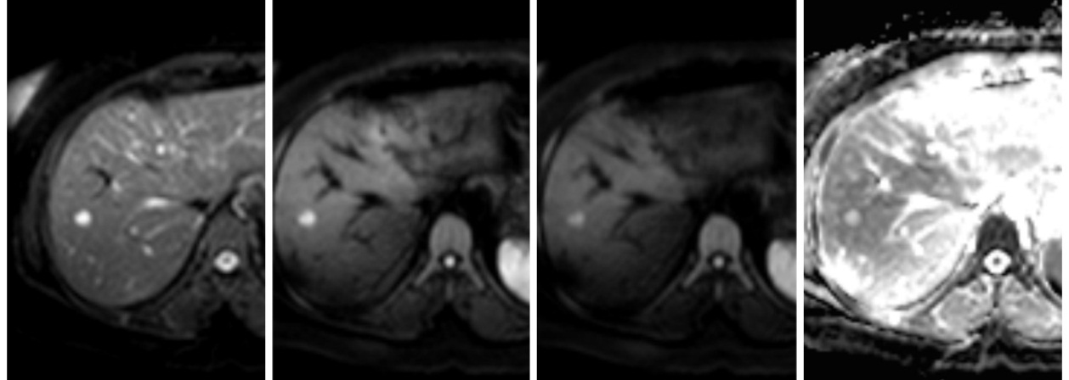
DWIb50
ADC
b800
b500

Figure3: MRI of the liver in female patient with known primary (DCIS). On DWIs: The lesion showed signal intensity loss with increased b-values (thin arrow). On ADC map the lesions appeared hyperintense (yellow arrow) ADC values: 1.9 x10⁻³ mm²/sec. Diagnosis was: Liver hemangioma.

4 cases with metastatic deposits were found, We found 2 cases with colon cancer metastasis, 1case prostatic carcinoma metastasis, 1 case ganglioblastoma metastasis. one case of colonic carcinoma resemble hypovascular metastases in which faint or peripheral rim enhancement was noted at the delayed phase which was similar to Silva et al. (2009) resultsin which hepatic metastases from cancer colon displays delayed enhancement. The lowest ADC values in our study was for metastases with a mean ADC value of 1.003x10⁻³ mm²/sec. This was similar to other studies as Onur et al. (2012) with mean ADC value of 1.05±0.22x10⁻³ mm²/sec, Vergara et al. (2010) with mean ADC value of 1.03±0.17x10⁻³ mm²/sec, and Koike et al. (2009), with mean ADC value of 1.11±0.22x10⁻³ mm²/sec.

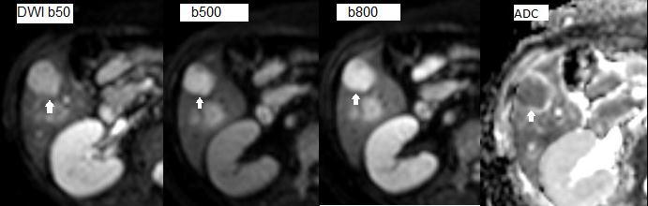
Figure4; 31-year-old female patient, known case of rectal carcinoma. Dynamic MRI of the liver was carried outand On DWIs: The lesions showed persistent high signal intensity with increasing the b value. On the ADC map, the lesion became of low signal, denoting restricted diffusion. ADC value: 0.907x10⁻³ mm²/sec. Diagnosis: metacentric hepatic metastases (adenocarcinoma) pathologically proven.

The ADC measurements of benign and malignant hepatic masses were significantly different with a p value 0.005, which was not similar to previous findings where Onur et al. (2012) stated that the mean ADC values of benign lesions were higher than malignant lesions and these differences were statistically significant for all 3 diffusion gradients with P values of 0.0023, 0.0001, and < 0.0001, but similar to Miller et al. (2010) where stated that the ADC values of benign hepatic lesions were significantly higher than that of malignant hepatic tumors, with a P value < 0.05, Vergara et al. (2010) where stated that the mean ADC value obtained for benign lesions differed significantly from the average for malignant lesions with a p value <0.05 and Demir et al. (2007) Stated that the difference between the mean ADC values of benign and malignant lesions was statistically significant (P < 0.01).

Conclusion:
Actually, using acut-off ADC value to distinguish benign from malignanthepatic focal lesions can be problematic when dealing with solid lesions. Fluid containinglesions such as cysts can be distinguished from solid lesions using DWI; however, the distinction of cysts and hemangiomas from lesions such as HCC and metastases can often be reliably made with conventional imaging. In hepatic MR exams where contrast is contraindicated, DWI may increase diagnostic confidence in the distinction. It is important to recognize that benign lesions such as abscesses, hematomas and some hemangiomas have restricted diffusion pattern. Differentiating solid liver lesions such as metastases, cholangiocarcinoma and HCC, in certain patients, may be difficult on conventional MR sequences and especially without gadolinium; however, diffusion-weighted MR did not help in the distinction due to significant overlap.

References
- Bruegel M, Holzapfel K, Gaa J, et al. Characterization of focal liver lesions by ADC measurements using a respiratory triggered diffusion-weighted single-shot echo-planar MR imaging technique. European Radiology 2008; 18: 477 – 485.
- Galea, Nicola, Vito Cantisani, and Bachir Taouli. "Liver lesion detection and characterization: Role of diffusion‐weighted imaging." Journal of magnetic resonance imaging 2013;37(6) 1260-1276.
- Holzapfel K, Reiser-Erkan C, Fingerle AA, et al. Comparison of diffusion-weighted MR imaging and multidetector-row CT in the detection of liver metastases in patients operated for pancreatic cancer. Abdom Imaging 2011; 36: 179-184.
- Koike N, Cho A, Nasu K, et al. Role of diffusion weighted magnetic resonance imaging in the differential diagnosis of focal hepatic lesions. World Journal of Gastroenterology 2009; 15(46):5805-5812.
- Miller FH, Hammond N, Siddiqi AJ, et al. Utility of Diffusion-Weighted MRI in Distinguishing Benign and Malignant Hepatic Lesions, Journal Of Magnetic Resonance Imaging 2010; 32:138–147.
- Onur MR, Çiçekçi M, Kayalı A, Poyraz AK, Kocakoç E. The role of ADC measurement in differential diagnosis of focal hepatic lesions. European journal of radiology. 2012 Mar 31;81(3): e171-176.
- Parikh T, Drew SJ, Lee VS, et al. Focal liver lesion detection and characterization with diffusion-weighted MR imaging: comparison with standard breath-hold T2-weighted imaging. Radiology 2008; 246: 812-822.
- Schneider G, Grazid L and Saini S. MRI of the Liver: Imaging Techniques, Contrast Enhancement, Differential Diagnosis, Springer, Italy, 2nd edition, 2006; 2: 357- 358.
- Schraml C, Schwenzer NF, Clasen S, et al. Navigator respiratory-triggered DWI in the follow-up after hepatic radiofrequency ablation-initial results. J Magn Reson Imaging 2009; 29: 1308-1316.
- Silva AC, Evans JM, McCullough AE, et al. MRI of Hypervascular Liver Masses: A Review of Current Techniques, Radio Graphics 2009; 29:385–402.
- Sinha R, Rajiah P, Ramachandran I, Sanders S, Murphy PD. Diffusion weighted MR imaging of the gastrointestinal tract: technique, indications, and imaging findings. Radiographics 2013; 33: 655-676.
- Vergara ML, Fernández M and Pereira R. Diffusion-weighted MRI characterization of solid liver lesions, Revista Chilena De Radiología2010; 16 (1): 510.

5/28/2017

