Comparative Study between Letrozole and Tamoxifen Citrate in Treatment of Clomiphene Citrate Resistant Polycystic Ovarian Syndrome

Farid Ibrahim Hassan, Abd Allah Khalil Ahmed, Abd El Raouf Abd El Raouf Abo Nar and Abd El Hamid Mohamed Zaky Elsanhoury

Obstetrics and Gynecology Department, Faculty of Medicine, Al-Azhar University, Egypt
drelsanhoury2014@gmail.com

Abstract: Background: The objective of this prospective randomized study was to make a comparison between the effects of letrozole and tamoxifen (TMX) in ovulation induction in clomiphene (CC)-resistant women with polycystic ovarian syndrome (PCOS). Methods: The study comprised a total of 60 infertile women (60 cycles) with CC-resistant PCOS selected from the clinics affiliated to the Department of Obstetrics and Gynecology of Al-Azhar University. Patients were randomized to treatment with 2.5mg of letrozole daily (50patients, one cycle) or 20 mg of TMX daily (50 patients, one cycle) for 5 days from day 5 of menses and 10000 IU hCG when mature follicles become ≥18 mm in diameter. The chi-square and t-test were used for comparing two groups and p<0.05 was considered significant. Results: The total number of follicles (≥18 mm) in the letrozole group was more than TMX group. The endometrial thickness at the time of hCG administration was significantly higher (p<0.044, at 95% CI) in the letrozole group than that of TMX group (10.2±0.7 vs. 9.1±0.2 mm). Ovulation occurred in 23.33% of cycles in the letrozole group and in 8.89% in the TMX group. Conclusion: Both letrozole and TMX should be considered as optional therapies for CC-resistant women. In addition, letrozole was superior to TMX in achieving a higher pregnancy and ovulation rate and also lesser side effects in comparison to tamoxifen.
[Farid Ibrahim Hassan, Abd Allah Khalil Ahmed, Abd El Raouf Abd El Raouf Abo Nar and Abd El Hamid Mohamed Zaky Elsanhoury. Comparative Study between Letrozole and Tamoxifen Citrate in Treatment of Clomiphene Citrate Resistant Polycystic Ovarian Syndrome. N Y Sci J 2017;10(7):1-9]. ISSN 1554-0200 (print); ISSN 2375-723X (online). http://www.sciencepub.net/newyork. 1. doi:10.7537/marsnys100717.01.

Keywords: Clomiphene resistance, Infertility, Letrozole, Oligomenorrhea, Ovulation induction, Polycystic ovarian syndrome, Tamoxifen.

1. Introduction
Polycystic ovary syndrome (PCOS) is one of the most common causes of anovulatory infertility which affects 4-7% of women worldwide. It is by far the most common cause of hyper androgenic anovulatory infertility and was described more than half a century ago, the underlying cause of this disorder is still uncertain (Weil et al., 1999).
Clomiphene Citrate (CC), a selective estrogen-receptor modulator that antagonizes the negative feedback of estrogen at the hypothalamus with a consequent increase in ovarian stimulation by endogenous gonadotropin has become the most widely prescribed drug for ovulation induction to reverse anovulation or oligoovulation (The Practice Committee of the American Society for Reproductive Medicine, 2013).
The therapeutic strategies for clomiphene citrate resistant patients include the addition of corticosteroid such as: dexamethasone, (Elnashar et al., 2006) extended duration of clomiphene, (Badawy et al., 2008) the use of aromatase inhibitors (Badawy et al., 2008), laparoscopic ovarian drilling, or in vitro fertilization (Thessaloniki, 2008).
Letrozol is an aromatase inhibitor and before the onset of letrozole administration, early pregnancy should be ruled out, since information regarding possible teratogenic effects of this drug is limited (Casper, 2003).
Tamoxifen citrate (TMX) is a triphenyl ethylene derivative with a structure similar to CC. The suggested dose is 20-40 mg daily in ovulation-induction, beginning on cycle day 3, and it continues for 5 days (EL-Gharib et al., 2014). It is less frequently used for ovulation induction as this indication is not licensed, although it is sometimes prescribed for women who experience side effects of Clomiphene citrate (CC) administration, and a meta-analysis has shown the comparative rates of ovulation when compared with Clomiphene citrate (CC) (Brown et al., 2009).
With expectant management female partner should be counceled to achieve a normal Body Mass Index ( BMI), reduce caffeine intake to no more than 250 mg daily (2 cups of coffee) and reduce alcohol intake to no more than 4 standardized drinks per week. Age of female partner influenced the pregnancy rate associated with expectant management (Barbieri, 2001 and Eijkemans et al., 2008).
Before any formal investigations begin, the major causes of infertility and the basic components of the infertility evaluation should be outlined for the couple. The causes of infertility include mainly: ovulatory dysfunction (20-40%), then tubal factor (30%), male factor (30-40%) and the remainder are largely unexplained. Disorders of ovulation account for approximately 30% of the problems identified in infertile couple. Ovulatory dysfunction can be severe enough to prevent conception (anovulation), or only a contributing factor (oligo-ovulation) (Gupta, 2005).
Polycystic ovarian syndrome (PCOS)

Current criteria for the definition of PCOS (Rotterdam ESHRE/ASRM-Sponsored PCOS Consensus Workshop Group, 2004).
Reference | Criteria
NIH, 1990. | To include all of the following:
 | 1) Hyperandrogenism and/or hyperandrogenemia
 | 2) Oligoovulation
 | 3) Exclusion of related disorders
ESHRE/ASRM (Rotterdam), 2003 | To include two of the following, in addition to exclusion of related disorders:
 | 1) Oligo- or anovulation
 | 2) Clinical and/or biochemical signs of hyperandrogenism
 | 3) Polycystic ovaries

According to the table above, the combination of hyperandrogenism and chronic anovulation remained main stay in definition of PCOS for the past half century, this was the basis for the definition of National Institutes of Health (NIH) 1990. Here the ovarian morphology does not form part of this definition in contrast to Rotterdam criteria.
A broad range of laboratory findings has been associated with PCOS. These findings include: elevated serum LH, elevated LH/FSH ratio, elevated serum testostrone and/or Dehydroepianderostendionesulphate (DHEAS), decreased serum sex-hormone binding globulin (SHBG), and recently: hyperlipidemia and hyperinsulinemia (Speroff and Fritz, 2005).
Aim of the work
The aim of our study is to determine the efficacy of tamoxifen citrate (TMX) compared to letrozole in achieving ovulation induction in clomiphene citrate resistant women with PCOS.

2. Patients and methods
This prospective study was carried out on 100 clomiphene citrate resistant infertile women seeking for fertility at Al Hussein University Hospital from November 2015 to January 2017.
The patients were diagnosed with PCOS according to Rotterdam criteria (Brown et al., 2009). Moreover, the patients failed to ovulate after receiving 150mg of clomiphene citrate daily for 5 days per cycle, for at least three cycles and will be arranged at random, by sealed envelopes, into 2 groups, each group will contain 50 patients:
Group (A) received letrozole (Femara; Novartis) with a dose of 2.5mg/day given from day 3-7 of the menstrual cycle, for one cycle.
Group (B) received tamoxifen citrate (TMX) with a dose of 20 mg/ day given from day 3-7 of the menstrual cycle, for one cycle.
This study was approved by the ethical committee of the university.
All women were subjected to history taking, physical examination, counseling and signing a written consent were taken from each case.
Serum FSH and LH levels were measured on the second day of menstrual cycle.
Hysterosalpingography were performed for each case for exclusion of tubal or uterine factor infertility.
Inclusion criteria included:
- Fulfillment of at least two of Rotterdam criteria of PCOS.
- Negative history of medical problems that can affect fertility such as diabetes mellitus, thyroid dysfunction, hyperprolactinemia, congenital adrenal hyperplasia.
- Normal hysterosalpingography (HSG) and BMI between 20 and 30Kg /m.
The exclusion criteriawas include:
- Woman having history of medical problems which affect fertility.
- History of recent hormonal therapy, having pelvic infections and/or having abnormal laboratory findings other than PCOS findings.
Serial trans vaginal ultrasound (TVU) monitorings were conducted for each case for detection of ovulation throughout in each stimulated cycle starting from day 10 of menstrual cycle until reaching folliculer maturation (follicular size (18-24 mm)) from which human chorionic gonadotropin (HCG) at a dose of 10000 IU intramusculary was administered. Ultrasound was also used to measure endometrial thickness at the time of HCG administration.
All women were re- evaluated 48 hours after HCG administration for ultrasound evidence of ovulation.
The ultrasound machine used was Mindray DC 3.
Statistical Methods
The data were be transferred to IBM cards using an IBM personal computer and analyzed with the Statistical Program for Social Sciences V11.0 (SPSS Inc, Chicago, IL).
Descriptive statistics comprised the mean and standard deviation (SD). Analytical statistics comprised the student's t-test to compare between independent quantitative means, and the chi-square test to compare between the different groups with regard to qualitative data. The chosen level of significance is p < 0.05.

3. Results
Our study was carried out on 100 Clomiphene citrate resistant infertile women seeking for fertility at Al Hussein university hospital.
The patients were diagnosed with PCOS according to Rotterdam criteria Moreover, the patients failed to ovulate after receiving 150 mg of Clomiphene citrate daily for 5 days per cycle, for at least three cycles and will be arranged at random, by sealed envelopes, into 2 groups, each group contained 50 patients:
Group (A) received letrozole (Femara; Novartis) with a dose of 2.5 mg/day given from day 3-7 of the menstrual cycle, for one cycle.
Group (B) receivedtamoxifen citrate (TMX) with a dose of 20 mg/ day given from day 3-7 of the menstrual cycle, for one cycle.
Then folliculometry was done to all patients to show response of the ovaries to the drugs.
The results of our study showed that there is no difference between the two groups according to demographic data except in the duration of infertility by months there is a significance defference. (Table 2)
Table (4) showed significance difference between the two groups as regard acheving ovulation after 2 days of injecting 10000 unit of hCG (25 cases (71.4) in letrozol group vs 13 cases (46.4) in tamoxafin group.
Table (5) showed that there were significant differences between the two groups according to number or women get ovulation (35 women in first group vs 28 women in second group) and number of follicles for each ovulated women (median 1.5 vs 1.0).
Table (6) indicated that there is no significant deference between the two groups according to endometrial thickness measured at time of HCG injection.

Table (2): Comparison between the two studied groups according to demographic data
 | Letrozole (n= 50) |  | Tamoxafin (n= 50) |  | Test of sig. | P
 | No. | % | No. | %
Age (years)
≤25 | 29 | 58.0 | 29 | 58.0 |  | 1.000
>25 | 21 | 42.0 | 21 | 42.0
Min. – Max. | 20.0 – 30.0 |  | 20.0 – 30.0
Mean ± SD. | 25.24 ± 3.35 |  | 25.04 ± 3.02 |  | t=  0.314 | 0.755
Median | 25.0 |  | 25.0
BMI (kg/m²)
Min. – Max. | 20.5 – 30.0 |  | 20.5 – 30.0 |  | t=  0.118 | 0.906
Mean ± SD. | 25.24 ± 2.84 |  | 25.31 ± 2.74
Median | 24.60 |  | 24.60
Infertility
Primary | 33 | 66.0 | 26 | 52.0 |    | 0.155
Secondary | 17 | 34.0 | 24 | 48.0
Duration of Infertility (months)
Min. – Max. | 6.0 – 28.0 |  | 6.0 – 20.0 |  | Z=  3.254* | 0.001*
Mean ± SD. | 13.58 ± 5.03 |  | 10.54 ± 3.46
Median | 12.50 |  | 10.0

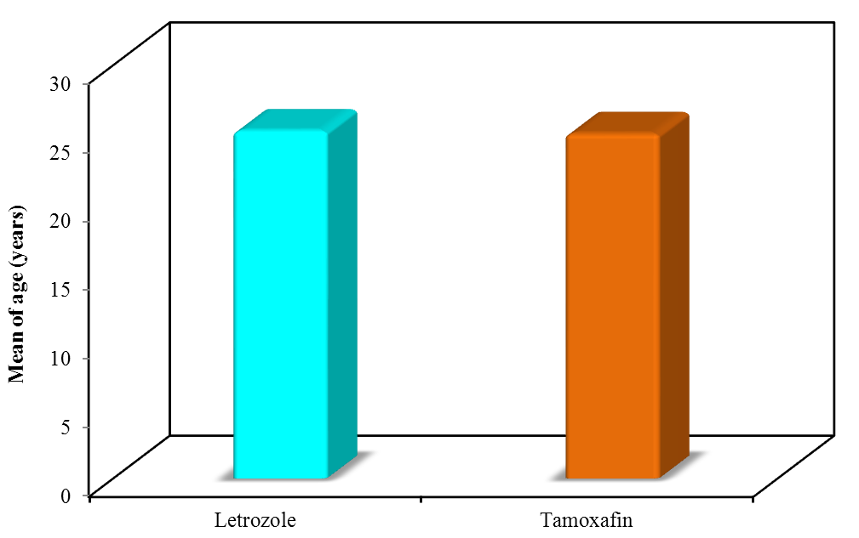
Figure (1): Comparison between the two studied groups according to Age (years)

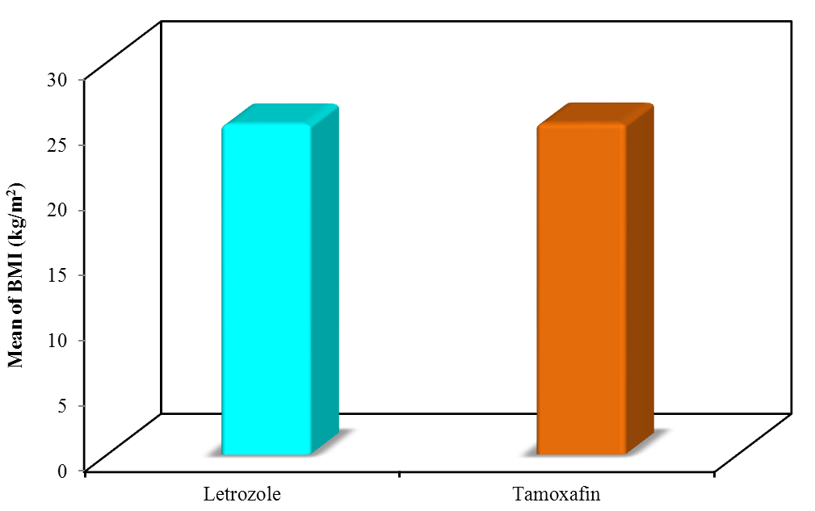
Figure (2): Comparison between the two studied groups according to BMI (kg/m²)

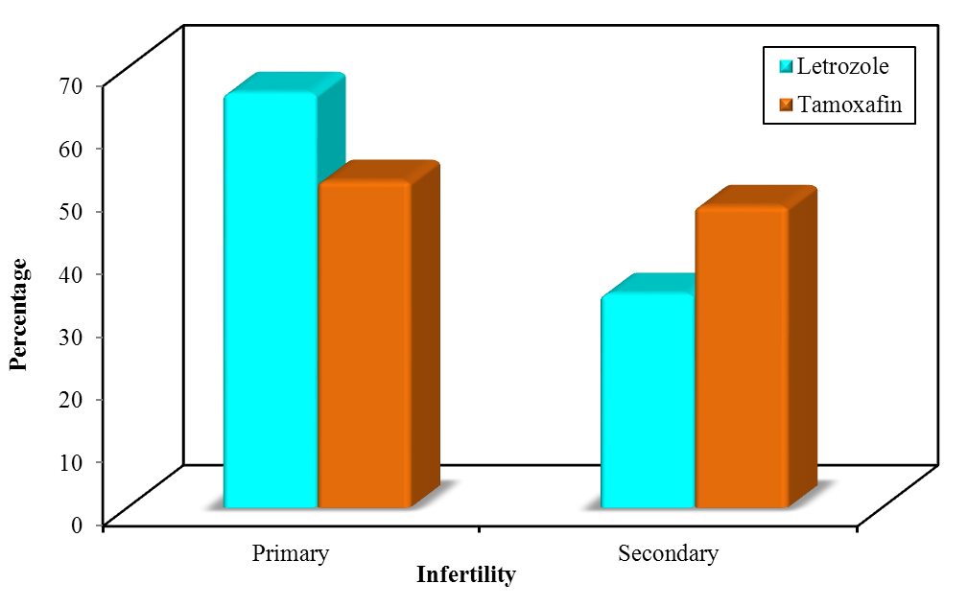
Figure (3): Comparison between the two studied groups according to Infertility

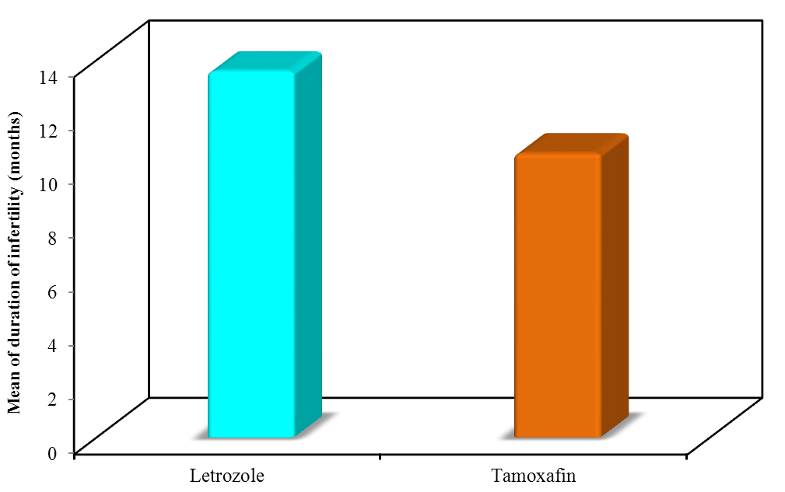
Figure (4): Comparison between the two studied groups according to Duration of Infertility (months)

Table (3): Comparison between the two studied groups according to ovulation
 | Letrozole (n = 50) |  | Tamoxafine (n = 50) |  | P
 | No. | % | No. | %
Ovulation rate
-VE | 15 | 30.0 | 22 | 44.0 | 0.041*
+VE | 37 | 70.0 | 28 | 56.0

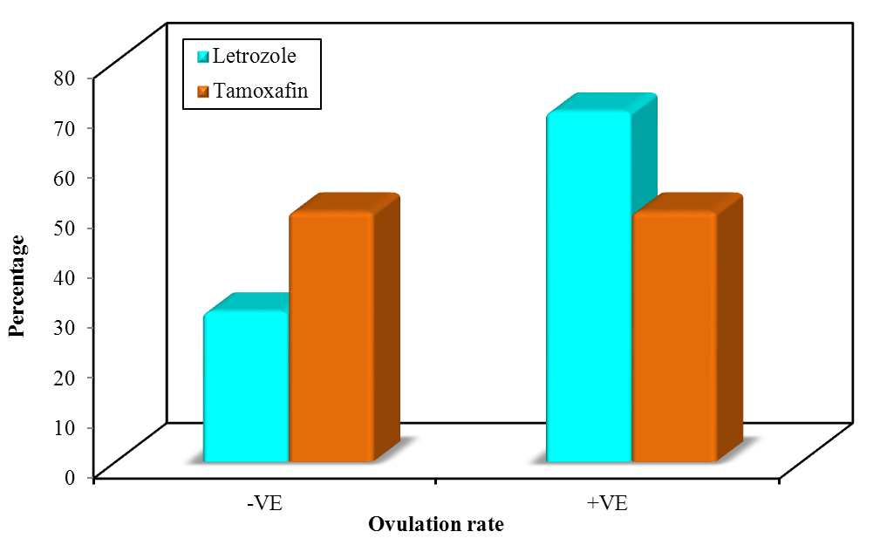
Figure (5): Comparison between the two studied groups according to ovulation

Table (4): Comparison between the two studied group according to the number of patients who Achieving ovulation after dose 10000 hcg after 2 days of reaching maturity.
 | Ovulation rate |  |  |  | P
 | n = 35 |  | n = 28
 | No. | % | No. | %
Achieving ovulation after dose 10000 hcg
-VE | 10 | 28.6 | 15 | 53.6 | 0.044*
+VE | 25 | 71.4 | 13 | 46.4

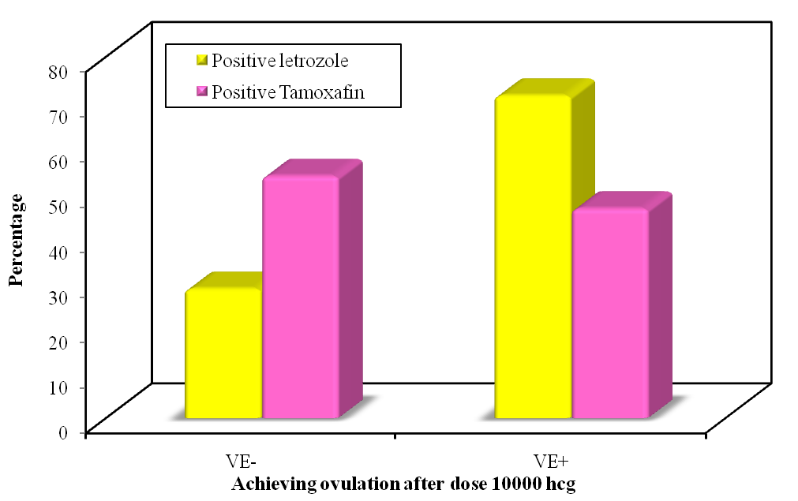
Figure (6): Achieving ovulation after dose 10000 hcg

Table (5): Comparison between the two studied groups according to ultrasonography (No. of mature follicles)
Ultrasonography | Letrozole (n = 50) |  | Tamoxafine ( n = 50) |  | P
 | No. | % | No. | %
No. of follicles
0 | 15 | 30.0 | 22 | 44.0
1 | 10 | 20.0 | 11 | 22.0
2 | 11 | 22.0 | 11 | 22.0
3 | 9 | 18.0 | 5 | 10.0
4 | 5 | 10.0 | 1 | 2.0
Min. – Max. | 0.0 – 4.0 |  | 0.0 – 4.0 |  | 0.045
Mean ± SD. | 1.58 ± 1.36 |  | 1.04 ± 1.12
Median | 1.50 |  | 1.0

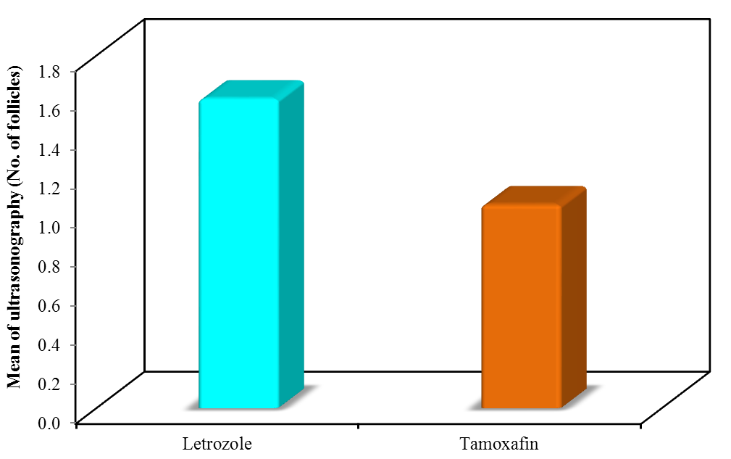
Figure (7): Comparison between the two studied groups according to ultrasonography (No. of mature follicles)

Table (6): Comparison between the two studied groups according to ultrasonography (Endometrial thickness)
Ultrasonography | Letrozole  (n = 50) | Tamoxafine  ( n = 50) | Test of sig. | P
Endometrial thickness (mm)
Min. – Max. | 4.0 – 14.0 | 5.0 – 14.0 | t= 1.507 | 0.135
Mean ± SD. | 9.12 ± 2.89 | 8.28 ± 2.68
Median | 9.0 | 8.0

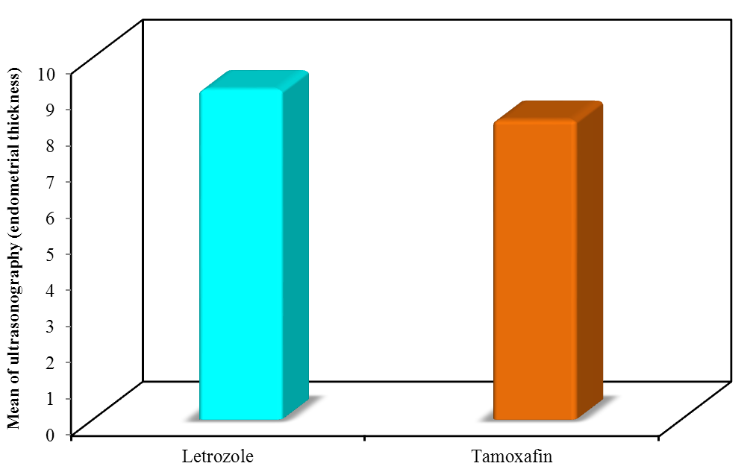
Figure (8): Comparison between the two studied groups according to ultrasonography (Endometrial thickness)

4. Discussion
Polycystic ovary syndrome (PCOS) is one of the most common causes of anovulatory infertility which affects 4-7% of women worldwide. It is by far the most common cause of hyper androgenic anovulatory infertility and was described more than half a century ago, the underlying cause of this disorder is still uncertain.
Clomiphene Citrate (CC), a selective estrogen-receptor modulator that antagonizes the negative feedback of estrogen at the hypothalamus with a consequent increase in ovarian stimulation by endogenous gonadotropin has become the most widely prescribed drug for ovulation induction to reverse anovulation or oligoovulation.
Clomiphene citrate resistance It is defined as failure to ovulate in response to CC on doses of 150mg/day after 3 cycles. CC resistance is an unpredictable and unpreventable event. It is virtually impossible to predict who will respond to which dose of CC. So far there is no general agreement on a standard regimen for management of CC resistant PCOS patients (Homburg, 2005).
Our study compared the efficacy of tamoxifen citrate (TMX) versus to letrozole as an aromatase inhibitor in achieving ovulation induction in clomiphene citrate resistant women with PCOS. In the present study, the ovulation rate with letrozole (70%) was higher than with tamoxifen (50%).
Clomiphene citrate remains the first-line treatment for PCOS-related anovulatory infertility (Legro et al., 2007). Failure to respond to clomiphene citrate occurs in up to 20% of cases which may require the use of injectable gonadotrophins as a second-line treatment. The drawbacks of this approach include its high cost, the potentially life threatening ovarian hyperstimulation syndrome and the significant risk of high order multiple gestations (Mitwally and Casper, 2003). Or it may require laparoscopic ovarian drilling which is not associated with an increased risk of multiple pregnancy or OHSS (Thessaloniki ESHRE/ASRM-Sposered PCOS Consensus Workshop Group, 2008; Vause et al., 2010 ). Both approaches are expensive and risky. In the past few years, the usefulness of letrozole for ovulation induction was investigated (Ganesh et al., 2009).
Several studies found that the effectiveness of letrozole was comparable to that of combined CC and gonadotropin and gonadotropin alone for the induction of ovulation (Sh Tehrani Nejad et al., 2008).
Aromatase inhibitors also act locally in the ovary to increase follicular sensitivity to FSH. This may result from accumulation of intraovarian androgens because they block the conversion of androgen substrates to estrogen. There is evidence that intraovarian androgens stimulate early follicular growth in primates (Ehrmann, 2005).
In study conducted by EL-Gharib et al on 60 women to compare between letrozole and tamoxifen in CC-resistant patients and they concluded that both letrozole and TMX should be considered as optional therapies for CC-resistant women. In addition, letrozole was superior to TMX in achieving a higher pregnancy and ovulation induction rate and lesser side effects in comparison to TMX (EL-Gharib M.N et al., 2014).
Karimi et al. conducted a clinical trial on 100 infertile patients referred to two Iraninan infertility clinics between the years 2001-2003. The patients were divided into two groups. In the first group, 100 mg clomiphene and the second group 50 mg clomiphene+20 mg tamoxifen were given for days 5-9 of menstrual cycle. Duration of medication, endometrial thickness, ovulation and pregnancy rate were studied in both groups. The ovulation rate in the clomiphene group was 54.9% and tamoxifen plus clomiphene group was 73.5% without significant differences between two groups. Positive pregnancy rate in the clomiphene group was 39.2% and clomiphene+tamoxifen group was 61.2%. They concluded that pregnancy rate was more in the clomiphene and tamoxifen regime in comparison with the clomiphene group (Karimi et al., 2002).
Dhaliwal et al. conducted a study to evaluate the role of tamoxifen in women with anovulatory infertility and to define the optimum dose for achieving the best outcome. They reported that 20 out of 70 women conceived, giving a pregnancy rate of 28.5% with a dose of 80 mg tamoxifen/day given from day 5- 9 of the menstrual cycle. They concluded that tamoxifen is a good alternative to clomiphene in women with PCOS and clomiphene-resistant cases (Dhaliwal et al., 2011).

Conclusion
Our results showed significance difference between the two groups as regard acheving ovulation after 2 days of injecting 10000 unit of hCG (25 cases (71.4) in letrozol group vs (13 cases (46.4) in tamoxafin group.
Thus it is recommended to use letrozole to induce induction in clomiphen citrate resistant women.

References
- Badawy A., Mosbah A. and Shady M. (2008). Anastrozole or letrozole for ovulation induction in clomiphene-resistant women with polycystic ovarian syndrome: a prospective randomized trial. Fertil Steril, 89(5):1209-1212.
- Barbieri R. (2001): The initial fertility consultation recommendations concerning cigarette smoking, body mass index, alcohol and caffeine consumption. Am J Obstet Gynaecol, 185:1168-1173.
- Brown J, Farquhar C, Beck J, Boothroyd C and Hughes E (2009). Clomiphene and antioestrogens for ovulation induction in PCOS. Cochrane Database Syst Rev, 7(4): CD002249.
- Casper R.F. (2003). Letrozole: ovulation or superovulation? Fertil Steril, 80(6):1335-7.
- Dhaliwal L.K., Suri V., Gupta K.R. and Sahdev S. (2011): Tamoxifen: An alternative to clomiphene in women with polycystic ovary syndrome. J Hum Reprod Sci, 4(2):76-79.
- Ehrmann D.A. (2005): Polycystic ovary syndrome. N Engl J Med, 352(12):1223-1236.
- Eijkemans M., Lintsen A. and Hunault C. (2008): Pregnancy chances on an IVF/ICS waiting list, a national prospective cohort study. Hum Reprod, 23:1627-1632.
- EL-Gharib M.N., Mahfouz A.E. and Farahat M.A. (2014): Letrozole versus tamoxifenin Treatment of Clomiphene Citrate Resistant Polycystic Ovarian Syndrome Enliven. Gynecol Obestet, 1(1):003.
- Elnashar A., Abdelmageed E., Fayed M. and Sharaf M. (2006): Clomiphene citrate and dexamethazone in treatment of clomiphene citrate-resistant polycystic ovary syndrome: a prospective placebo-controlled study. Human Reprod, 21(7):1805-1808.
- Ganesh A., Goswami S. and Chattopadhyay R. (2009): Comparison of letrozole with continuous gonadotropins and clomiphenegonadotropin combination for ovulation induction in 1387 PCOS women after clomiphene citrate failure: a randomized prospective clinical trial. J Assisted Reprod Genet, 26(1):19-24.
- Gupta J., Mires G. and Khan K. (2005): Core clinical cases in obstetrics and gynaecology: a problem-solving approach. London: Hodder Arnold Publication; 152.
- Homburg R. (2005): Clomiphene citrate- end of an era a mini- review. Human Reprod, 20:2043-2051.
- Karimi Z.M., Ghaforzadeh M., Karimzadeh M.A. and Bokaei M. (2002): Comparison between effect of adding tamoxifen to clomiphene and only clomiphene for infertility managment in PCOS-patients (At infertility & Bahman clinic, 2001-2003, Yazd, Iran). Iran J Obstet Gynecol Infertil, 5(2):10-14.
- Legro R.S., Barnhart H.X., Schlaff W.D., Carr B.R., Diamond M.P., Carson S.A., Steinkampf M.P., Coutifaris C., McGovern P.G., Cataldo N.A., Gosman G.G., Nestler J.E., Giudice L.C., Leppert P.C. and Myers E.R. (2007): Clomiphene, metformin, or both for infertility in the polycystic ovary syndrome. N Engl J Med, 356(6):551-566.
- Mitwally M.F. and Casper R.F. (2003): Aromatase inhibitors for the treatment of infertility. Expert Opin Investig Drugs, 12(3):353-371.
- Rotterdam ESHRE/ASRM-Sponsored PCOS Consensus Workshop Group. (2004): Revised 2003 consensus on diagnostic criteria and long-term health risks related to polycystic ovary syndrome. Fertil Steril, 81:19-25.
- Sh Tehrani Nejad E., Abediasl Z., Rashidi B.H., Azimi Nekoo E., Shariat M. and Amirchaghmaghi E. (2008): Comparison of the efficacy of the aromatase inhibitor letrozole and clomiphen citrate gonadotropins in controlled ovarian hyperstimulation: a prospective, simply randomized, clinical trial. J Assist Reprod Genet, 25(5):187-190.
- Speroff L. and Fritz M. (2005): Clinical gynaecologic endocrinology and infertility. 7thed. Philadelphia: Lippincott Williams and Wilkins; 7:466-498.
- The Practice Committee of the American Society for Reproductive Medicine. (2013). Use of clomiphene citrate in infertile women: A committee opinion. Fertil Steril, 100:341-348.
- Thessaloniki ESHRE/ASRM-Sposered PCOS Consensus Workshop Group. (2008): Consensus on infertility treatment related to polycystic ovary syndrome. Fertil Steril, 89(3):505-522.
- Weil S., Vendola K., Zhou J. and Bondy C.A. (1999). Androgen and follicle-stimulating hormone interactions in primate ovarian follicle development. J Clin Endocrinol Metab, 84(8):2951-6.

5/22/2017

