**Determination of Synthetic Sweeteners in Some Food Commodities using Reversed Phase HPLC**

Reem Tarek Amer1, Ahmed M. Gomaa2, Alaa Edean Fathy Ahmed2, and Mohamed El-Sayed2

1Faculty of Biotechnology, October University for Modern Sciences and Arts.

2QCAP Laboratory, Agriculture Research Center, Ministry of Agriculture, Giza 12311, Egypt.

[Reemt.amer@hotmail.com](mailto:Reemt.amer@hotmail.com)

**Abstract:** Surveillance and monitoring of synthetic sweeteners is important for public health and food safety. For this purpose, synthetic sweeteners levels in different food commodities are controlled by legal regulations.The aim of this study is to determine levels of aspartame, acesulfame potassium and saccharine in different food commodities and to evaluate the maximum use limits according to Codex Alimentarius. The survey was carried out on 83 samples of different food included beverages, canned fruits, sweet corn, chewing gum, cake, toffee and tomato ketchup sauce. In this study, Reversed Phase High Performance Liquid Chromatography was used for the quantitative determination of artificial sweeteners in samples. Synthetic sweeteners were extracted from the sample using deionized water: methanol 1:1 (v/v). The result showed that synthetic sweeteners were found within the Codex Alimentarius Regulations in 92.8 % of the samples. However, some samples were found not appropriate due to adulteration in label information and violation.

[Reem Tarek Amer, Ahmed M. Gomaa, Alaa Edean Fathy Ahmed and Mohamed El-Sayed. **Determination of Synthetic Sweeteners in Some Food Commodities using Reversed Phase HPLC.** *N Y Sci J*2017;10(6):121-128]. ISSN 1554-0200 (print); ISSN 2375-723X (online). <http://www.sciencepub.net/newyork>. 17. doi:[10.7537/marsnys100617.17](http://www.dx.doi.org/10.7537/marsnys100617.17).

**Keywords:** Synthetic Sweeteners**,** Aspartame, Acesulfame k, Saccharine, HPLC.

**1. Introduction**

Synthetic sweeteners are an important class of food additives that provide sweetness sensation hundreds of times stronger than that of sucrose (**Mortensen 2006; Chattopadhyay *et al.,* 2014**). They are commonly used in beverage, food, pharmaceutical industries and confectionary. They are also known as non-nutritive sweeteners as they are of no or little of food energy intake **(Ashok *et al.,* 2013; Choudhary & Rathinasamy, 2014; Mazurek&Szostak, 2011; Kashanian, Khodaei, & Kheirdoosh, 2013**). Food industries take an advantage of artificial sweeteners to produce a reduced calorie or low calorie beverages and food products. Light or diet products are of high customers demand as it can assist in body weight maintenance, obesity treatment and diabetes management. Furthermore, synthetic sweeteners are tooth friendly, which makes them do not undergo micro-floral fermentation of the dental plaque (**Zygler, Wasik, & Namiesnik, 2009; Serdar & Knežević, 2011)**.

Aspartame (ASP), acesulfame Potassium (ACS-K) and saccharine (SAC) are the most commonly used synthetic sweeteners. They are from the most debated food additives due to suspicions of adverse health effects **(Choudhary *et al.,* 2016).** These allegations include causing headache, respiratory difficulties, allergies, dermatological problems, mood variations, seizure and cancers.

The market of the artificial synthetic is of continuous expansion due to the low calorie produces acceptance and the higher customer demand. The European Union and Codex Alimentarius assigned a firmly controlled legislation concerning the usage of synthetic sweeteners **(Gomaa, 2015).** The quantity and the content of synthetic sweeteners added in foodstuff products are also limited by Egyptian regulations which likewise agree with the Codex Alimentarius. The definition of Synthetic sweeteners and their approved limits are in General Standard for Food Additives Codex Stain 192-1995 revised in 2016.

ASP is probably the most controversial artificial high-intensity sweetener on the market with sweetness about 200 times as sweet as sucrose (**Mazurek & Szostak, 2011**). It is known as E951 .it has adverse medical effects attributed to it including multiple sclerosis, systemic lupus, and methanol toxicity, blindness, spasms, shooting pains, seizures, , depression, anxiety, birth defects ,headache, blurred vision, brain tumors, eye problems, numbness, insomnia, memory loss, nausea, slurred speech, hearing problems, neurological and behavioural disturbances (**Ashok *et al.*, 2013**).

ACS-K is a sweetener approximately 200 times sweeter than sucrose. It is also known as E950. The long term exposure to this compound can cause headaches, depression, nausea, mental confusion and loss of appetite **(Agarwal *et al.,* 2016).**

SAC known as E954 is about 300-500 times sweeter than sucrose, but it has a bitter and metallic aftertaste. SAC was banned by US Food and Drug Administration (FDA) on the basis of two generation study on rats, proving saccharin to be carcinogenic producing bladder cancer but the ban was lifted when carcinogenicity was refuted. However, the products using saccharin had to carry a label for potential carcinogenicity until 2000. There are reports about hepato-toxicity of saccharin **(Agarwal *et al.,* 2016).** SAC may increase the risk of evolving diabetes and obesity, due to the false negative impact it provides to the body **(Fowler *et al.,* 2008).**

Although there are multiple determination techniques of synthetic sweeteners in variable food matrices; such as Capillary Electrophoresis and Gas chromatography, but HPLC has become the most employed technique in this field **(Zygler *et al.,* 2009).** The wide range of detectors used in HPLC besides the availability of different separation mechanisms makes HPLC a successful candidate for determination of synthetic sweeteners. Reversed phase HPLC is usually chosen as it is highly developed technique and perfectly suitable for sweeteners separation **(Zygler *et al.,* 2009; Grembecka *et al.,* 2014).**

For customer safety, it is essential to control the artificial sweeteners content in the food products. In order to achieve this information, reliable quantitative analysis method is necessary to measure synthetic sweeteners levels in different food matrices **(Zygler *et al.,* 2009).** Therefore, the objective of this study is to determine aspartame, acesulfame K and saccharine levels in some various food and beverage selective products available in the local market using Reversed Phase High Performance Liquid Chromatography.

**2. Materials and methods**

**Sample collection**

83 samples were purchased from the local market categorized as: beverages, canned fruits, sweet corn, chewing gum, toffee, cake and sauce. The samples with different batch numbers were used in the analysis. Samples stored at room temperature until the time of analysis.

Samples are categorized as beverages consist of instant soft drinks, soft drinks and juice. Instant soft drinks products were obtained from 9 different companies and classified into the following types of flavors: orange, pineapple, mango, apple, peach, tangerine, hibiscus, blueberry, cola, lemon mint, sobia (sweet coconut drink) and tamr-hendy (tamarind). Soft drinks were obtained from 2 companies and categorized as diet soft drinks and normal soft drinks. Juices products were obtained from 8 different companies and included the following flavors: mango, guava, apple, pineapple, orange and cocktail.

Canned fruits were obtained from 2 different companies and categorized as peach, mango and pineapple. Sweet corn was obtained from 4 different companies.

Chewing gum products were collected from 3 different companies and categorized as following: strawberry, fruits, spearmint and watermelon. While toffee was obtained from 2 different companies and were categorized as caramel, raspberry and coffee.

Ice Cream Powder was obtained from 2 different companies categorized as vanilla and chocolate flavors. Cakes were obtained from 4 different companies and categorized as vanilla and chocolate cakes. Finally, 1 sauce sample of tomato ketchup sauce was obtained from 1 company.

**Apparatus**

Chromatographic analysis was carried out using High performance liquid chromatography Agilent 1200 series equipped with , quaternary pump (G1311A), vacuum degasser (G1322), auto sampler (G1313), photodiode array detector (G1315C), analytical column: Agilent C18 5µm × 150× 4.6 mm; or similar quality, software: Chemistation for LC, Rev. A. 09.03 [1417], Laboratory balance, capable of weighing to 0.1 mg, ministart RC 15 syringe filter (0.45 µm) Sartorius, 50 mL plastic tubes with sealing cap, volumetric flasks 25, 50,100, 250, 500 and 1000 mL capacity, pipettes 1, 5, 10, 20, 25, 100 mL, micropipette 1000 µL, graduated cylinder 1000 mL, ultrasonic bath, disposable syringe, centrifuge (Labofuge 400 function line), A pH-meter (Thermo) equipped with a combined glass calomel electrode was employed for pH measurements.

**Reagents**

All chemicals were of high purity or HPLC grade, they include: de-ionized water generated by Milli-Q A10 FOCN53824k, methanol, acetonitrile, potassium dihydrogen phosphate and phosphoric acid. Phosphate Buffer solution – (KH2PO4) 0.0125 mol / liter, pH=3.5 prepared by dissolving 1.71 gm potassium dihydrogen phosphate in 800 ml of de-ionized water in a 1000 ml beaker. Phosphoric acid used to adjust the pH of solution to pH 3.5. The solution was transferred to a 1000 ml vol. flask and completed to mark with de-ionized water.Carrez1: dissolve 15 gm potassium hexa-cyanoferratetrihydrate in 100ml de-ionized water. Carrez 2: dissolve 30 gm zinc sulphateheptahydrate in 100ml de-ionized water EN 1999.

**Calibration and working standards**

500 µg/ml mixture solutions of ASP, ACS-K and SAC were prepared in Deionized water and store in small portions 25 volumetric flask in +4 °C.

Calibration solutions: 10, 50,100 and 200 µg/ml were prepared by diluting the solution mixture from 500 µg/ml standard solution and diluted with de-ionized water to 1 ml.

**Samples Preparation**

An amount of 5 ±0.1 gm of sample was weight in 50 ml centrifuge plastic tube. Two times 10 ml of deionized water: methanol 1:1 were added and shaken well in Geno for 5 minute to facilitate the solubilization of the sweeteners followed by centrifugation at 4,000 rpm for 5 minute. In case of toffee, 1ml of carrez 1 and carrez 2 were added during the extraction. The supernatant were decanted in 25 ml volumetric flask then completed to the mark with deionized water. The volumetric flasks were shaken well then filtered through a membrane of pore size 0.45 µm before injection.

**3. Results and Discussion**

In the present study, synthetic sweeteners were determined using Reversed Phase HPLC as it has high specificity, minimum sample preparation and does not require derivatization. **(Zhu *et al.,* 2005; Wasik *et al.,* 2007; Yang *et al.,* 2009 ; Serdar & Knežević, 2011; Grembecka, *et al.,* 2014; Kubica *et al.,* 2015)**. While the analysis method was retrieved from **Gomaa (2015)** study by which it is simple, precise, satisfactory and rapid method. Figure 1shows Guava juice matrix spiked with the standard50mg kg-1.The recoveries of the ASP, ACS-K and SAC were 90%, 100% and 96%, respectively. These recoveries were within the criteria established by **Codex Alimentarius Commission (2009).**

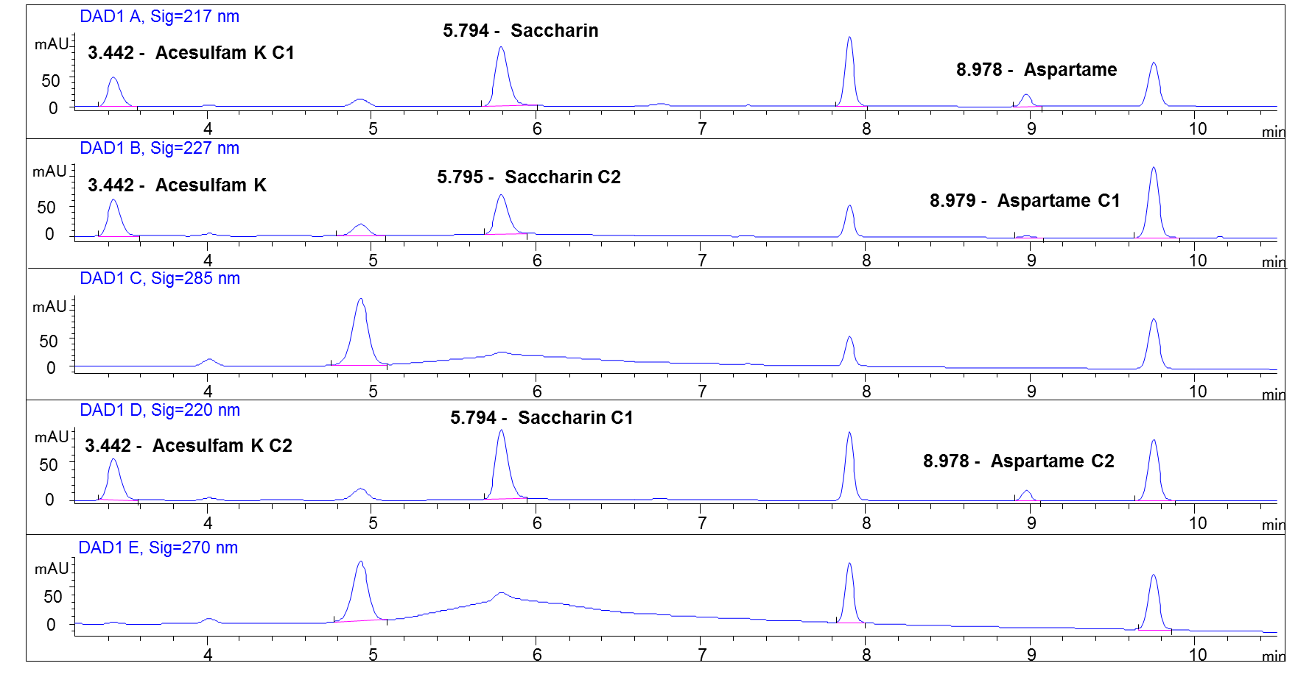

**Figure 1.** Guava juice matrix spiked with standard (50mg kg-1).

Investigations and surveillance of synthetic sweeteners is important for food safety and public health. As a result, ASP, ACS-K and SAC levels in different foodstuffs are controlled by Codex Alimentarius Regulations. This study aims to determine ASP, ACS-K and SAC concentration in 83 food products purchased from market. Tables 1, 2 and 3 shows the number of samples, number of detected samples, mean, positive mean, ranges, violated samples and adulteration samples of ASP, ACS-K and SAC in the analyzed food categories, respectively.

In this study, ASP was detected in instant soft drinks and soft drinks. It showed the highest detection rate in beverages (16 samples out of 53) with a broad range of N/D – 2,785.5 mg kg-1. By which ASP level varies between different flavors and within the same type of flavor. This result corresponds well with the survey conducted in Korea by which beverages ranged between N/D – 2,474.2 mg kg-1 **(Lee *et al.,* 2017)**. Diet soft drinks show ASP range between 189.7 – 390.8 mg kg-1. This result is lower than **Gomaa (2015)** study that shows diet carbonated soft drinks range of 395 –561.5 mg kg-1. As well as **Pesek and Matyska (1997)** survey in USA, which estimates ASP range of diet soft drinks to be426 – 507mg kg-1. In contrast to**Lino *et al.* (2008)** survey in Portugal, that shows ASP range 73 – 89 mg kg-1. Our study directed that all juices did not contain any ASP level. In contrast to, **Serdar and Knežević (2011)** survey held in Croatia that reported ASP ranges in juices are 153.6 - 876.4 mg kg-1. As supported by **Çelik *et al.* (2014),** Variability in ASP levels observed in these studies held in the different countries may be related to the differences in the production technologies. There was 1 violatedand adulterated instant soft drink sample by which it exceeded the Codex Alimentarius regulation by 4.6 times the regulated limit. Figure 2 shows the chromatogram of violated instant soft drink sample. While there was 5 adulterated instant soft drink samples. Consequently, ASP levels in beverages must be kept under control in order to protect consumer health **(Çelik *et al.,* 2014).** All supermarkets own brands or traditional products did not contain any synthetic sweetener.

**Table 1.** Ranges of aspartame content in different food categories.



Notes: a Number of samples by which ASP was detected.

b Mean calculated using the concentration of not detected samples as zero.

c Positive mean calculated using the concentrations of detected samples.

d N/D stands for Not Detected.

e Products that contain synthetic sweeteners label.

f Products that does not contain synthetic sweeteners label.

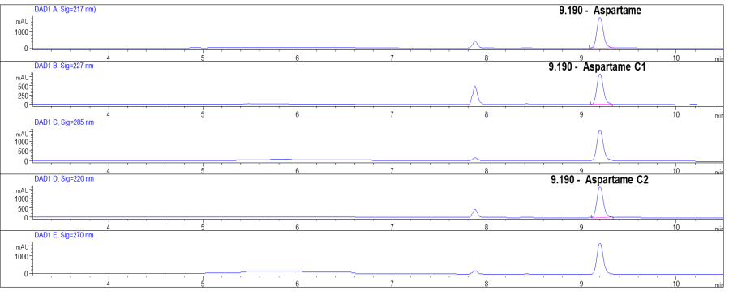

**Figure 2.** ASP detected in Instant Soft Drink Sample.

Furthermore, ASP was detected in chewing gum categorized as: diet chewing gum and normal chewing gum. In the normal chewing gum, 2 adulterated samples was found. ASP was detected in 8 out of 10 samples are in range of 82.8 – 4,841 mg kg-1. On the contrary, **Lee *et al.,* (2017),** detected ASP in 21% only of the total chewing gum samples. This proofs that ASP is the main synthetic sweetener used in chewing gum industries. In this study the positive mean of chewing gum is 2,039 mg kg-1. In agreement with **(Huvaere *et al.* 2012)** study in Belgium that valued ASP positive mean to be 2,151 mg kg-1. While juices, canned fruits, sweet corn, toffee, ice cream powder, cakes and ketchup did not contain ASP.

**Table 2.** Ranges of acesulfame potassium content in different food categories.



Notes: a Number of samples by which ASP was detected.

b Mean calculated using the concentration of not detected samples as zero.

c Positive mean calculated using the concentrations of detected samples.

d N/D stands for Not Detected.

e Products that contain synthetic sweeteners label.

f Products that does not contain synthetic sweeteners label.

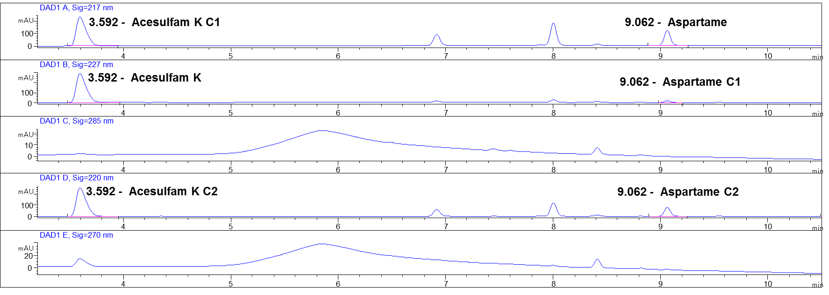

**Figure 3.** ASP and ACS-K detected in a chewing gum sample.

ACS-K was not found in juices, canned fruits, sweet corn, toffee, ice cream powder, cakes and ketchup sauce. Although it was found in instant soft drinks, soft drinks and chewing gum. In instant soft drinks, ACS-K was detected in 7 out of 34 samples in range of 7.3–59.7mgkg-1. This range of ACS-K varies between different flavors and within the same type of flavor. This result corresponds well with **Llamas *et al.* (2008)** study, by which ASC-K was found in instant soft drinks with ranges from 7-12 mg kg-1. There were 5 adulterated instant soft drinks samples by which the label did not contain the addition of ACS-K. In soft drinks, ACS-K was found in the 3 diet soft drinks ranging from 80-143.3 mg kg-1. In contrast with **Lee *et al.* (2017)** survey, by which the carbonated beverages ranged between N/D-46.2 mg kg-1. In chewing gum, ACS-K was found in 6 out of 10 samples ranged between 197.3 – 1,452.7 mg kg-1. In agreement with **Lee *et al.* (2017)** study conducted in Korea, chewing gum ranged from N/D–1122.7 mg kg1.

**Table 3.** Ranges of saccharine content in different food categories.



Notes: a Number of samples by which ASP was detected.

b Mean calculated using the concentration of not detected samples as zero.

c Positive mean calculated using the concentrations of detected samples.

d N/D stands for Not Detected.

e Products that contain synthetic sweeteners label.

f Products that does not contain synthetic sweeteners label.

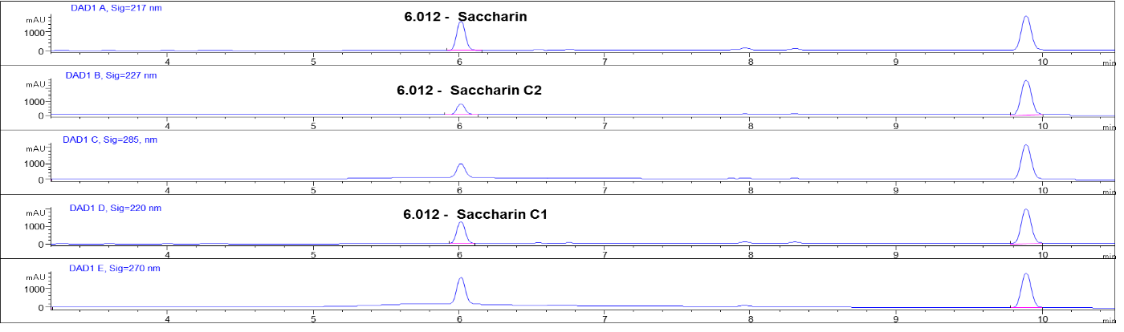

**Figure 4.** SAC detected in cake sample.

SAC was detected in two food categories: ice cream powder and cakes. SAC was found in 5 cake samples out of 7 with range of 292.3 – 703 mg kg-1, by which these samples are violated and adulterated by exceeding the Codex Alimentarius regulations by 1.7-4 times. Cake products are made under pressure and high temperature. Subsequently, SAC is the most suitable sweetener for cake foodstuff due to its heat stability property **(Lee *et al.,* 2017).** In ice cream powder, SAC was found in 1 out of 2 samples with concentration of 596.4 mg kg-1. This sample was considered as adulterated sample **(figure 4).** As stated by **Lee *et al.* (2015),** SAC label may be not added in food product marketing as SAC is perceived negatively by people. Although SAC was not found in all beverages, canned fruits, sweet corn, chewing gum, toffee and sauce. In agreement with **Lee *et al.* (2017)** study held in Korea, SAC was not found in all types of beverages. In contrast to **(Llamas *et al.,* 2008)** study by which there was SAC in instant soft drinks ranged between 5 – 9 mg kg-1.

Synthetic sweeteners were detected in 9 chewing gum samples 9 out of 10 samples. By which 3 samples contain ASP only, 1 samples contain ACS-K only, 1 samples did not contain any synthetic sweetener and 5 out of 10 samples have a blend of ASP and ACS-K. Our study shows that there is a recent tendency to use a mixture of synthetic sweeteners in the chewing gum industry. Figure 3shows a chewing gum samples containing a blend of ASP and ACS-K. The purpose of using blends synthetic sweeteners in chewing gum industry is to avoid the disadvantage of aftertaste of single synthetic sweetener **(Suvardhan *et al.,* 2015).** Thus blends are preferable by food industries due to their complementary effect**.** This result was supported by **Lee *et al.* (2017)** study, by which the most frequently found blend was ACS-K and SAC.

Artificial sweeteners were found in 16 out of 53 beverage products (30.1%). Our data indicate that the use of artificial sweeteners in beverages might be changing. In all drinks, SAC was not detected. As same as **Lee *et al.* (2017)** study that did not found SAC in all beverages. This may be due to the bitterness aftertaste of SAC. While other synthetic sweeteners such as ASP and ACS-K become preferred for beverages in recent years. Among 16 beverage samples, 10 samples contained a blend of ACS-K and ASP. **Lee *et al.* (2017)** survey shows similar results by which 7 of 14 samples detect mixture of ACS-K and ASP in beverages.

Among 83 total foodstuff products, 30 samples (36.1%) contained sweeteners. This result is lower than results from other countries, which reported a 42% detection rate for sweeteners in foodstuff **(Zygler*et al.,* 2012).** The results showed that synthetic sweeteners were found within the Codex Alimentarius Regulations in 92.8% of the samples.The violated sample presented 7.2%, the adulterated samples were 15.6%. While violated and adulterated samples presented 7.2%.It is mandatory to keep the synthetic sweetener label on the food products to warn people who have health problems from synthetic sweeteners. As same as **Çelik *et al.* (2014)** study, it determined some samples contained different ASP levels in contradistinction to the sample labels. For that reason synthetic sweetener levels in food and beverages products must be kept under the control in order to protect the health of the consumer.

**Conclusion**

Synthetic sweeteners are present in many food categories. The present study determined the occurrence of sweeteners in different beverages and food products available in local market. The results showed 92.8% of the samples were within the Codex Alimentarius regulation. Based on these results, the exposure levels of artificial sweeteners are controlled and safe for general population. More surveys are required to screen further food matrices in order to control and monitor the market.

**References**

1. Agarwal, A., Gutch, M., Kumar, S., Mohd, S. R., Kumar, G. A., & Kumar, K. G. (2016). Nonnutritive sweeteners: Pros and cons. CHRISMED Journal of Health and Research, 3(1), 4.
2. Ashok, I., Sheeladevi, R., & Wankhar, D. (2013). Long term effect of aspartame (Artificial sweetener) on membrane homeostatic imbalance and histopathology in the rat brain. Free Radicals and Antioxidants, 3, S42-49. <http://dx.doi.org/10.1016/j.fra.2013.09.003>.
3. CAC.2009. Report of the eighteenth session of the codex committee on residues of veterinary drugs in foods. Thirty-Second Session. Natal (Brazil): Codex Alimentarius Commission.
4. Celik, E., Demirhan, B. E., Demirhan, B., & Yentur, G. (2014). Determination of Aspartame Levels in Soft Drinks Consumed in Ankara, Turkey. Journal of Food Research, 3(6), 156.
5. Chattopadhyay S, Raychaudhuri U, Chakraborty R. (2014). Artificial sweeteners - a review. J Food Sci Technol. 51:611–621.
6. Choudhary, A. K., & Rathinasamy, S. D. (2014). Aspartame induces alteration in electrolytes homeostasis of immuneorgans in wistar albino rats. Biomed PrevNutr, 4, 181-187. <http://dx.doi.org/10.1016/j.bionut.2013.12.006>.
7. Choudhary, A. K., Sundareswaran, L., & Devi, R. S. (2016). Effects of aspartame on the evaluation of electrophysiological responses in Wistar albino rats. Journal of Taibah University for Science, 10(4), 505-512.
8. FAO and WHO (1999) Summary of evaluations performed by the Joint FAO/WHO Expert Committee on Food Additives (JECFA) 1956–1997.
9. Fowler, S. P., Williams, K., Resendez, R. G., Hunt, K. J., Hazuda, H. P., & Stern, M. P. (2008). Fueling the obesity epidemic? Artificially sweetened beverage use and long‐term weight gain. Obesity, 16(8), 1894-1900.
10. Gomaa, A. M. (2015). Validation of Analytical Method for Determination of Synthetic Sweeteners and Caffeine in Juices and Carbonated Beverages by HPLC with Photodiode Array Detection. Middle East Sciences journal, 5(02), 567-572.
11. Grembecka, M., Baran, P., Blazewicz, A., Fijalek, Z., & Szefer, P. (2014). Simultaneous determination of aspartame, acesulfame-K, saccharin, citric acid and sodium benzoate in various food products using HPLC–CAD–UV/DAD. Eur Food Res Technol, 238, 357-365. <http://dx.doi.org/10.1007/s00217-013-2111-x>.
12. Huvaere, K., Vandevijvere, S., Hasni, M., Vinkx, C., & Van Loco, J. (2012). Dietary intake of artificial sweeteners by the Belgian population. Food Additives & Contaminants: Part A, 29(1), 54-65.
13. Kashanian, S., Khodaei, M. M., & Kheirdoosh, F. (2013). In vitro DNA binding studies of Aspartame, an artificial sweetener. J PhotochemPhotobiol B, 120, 104-110. <http://dx.doi.org/10.1016/j.jphotobiol.2013.01.00>
14. Kubica, P., Namieśnik, J., & Wasik, A. (2015). Determination of eight artificial sweeteners and common Stevia rebaudiana glycosides in non-alcoholic and alcoholic beverages by reversed-phase liquid chromatography coupled with tandem mass spectrometry. Analytical and bioanalytical chemistry, 407(5), 1505-1512.
15. Lee, S., Lee, W., Moon, I. C., & Kwon, H. (2015). Consumers Perceptions on Sodium Saccharin in Social Media. Journal of Food Hygiene and Safety, 30(4), 329-342.
16. Lee, Y., Do, B., Lee, G., Lim, H. S., Yun, S. S., & Kwon, H. (2017). Simultaneous determination of sodium saccharin, aspartame, acesulfame-K and sucralose in food consumed in Korea using high-performance liquid chromatography and evaporative light-scattering detection. Food Additives & Contaminants: Part A, 1-12.
17. Lino, C. M., Costa, I. M., Pena, A., Ferreira, R., & Cardoso, S. M. (2008). Estimated intake of the sweeteners, acesulfame-K and aspartame, from softdrinks based on mineral waters and nectars for a group of Portuguese teenage students. Food Addit Contam, 25(11), 1291-1296. <http://dx.doi.org/10.1080/02652030802195309>.
18. Llamas, N. E., Di Nezio, M. S., Palomeque, M. E., & Fernández Band, B. S. (2008). Direct determination of saccharin and acesulfame-K in sweeteners and fruit juices powders. Food Analytical Methods, 1(1), 43-48.
19. Mazurek, S., & Szostak, R. (2011). Quantification of aspartame in commercial sweeteners by FT-Raman spectroscopy. Food Chem, 125, 1051-1057. <http://dx.doi.org/10.1016/j.foodchem.2010.09.075>.
20. Mortensen, A. (2006). Sweeteners permitted in the European Union: safety aspects. Scandinavian Journal of Food and Nutrition, 50(3), 104-116.
21. Pesek, J. J., & Matyska, M. T. (1997). Determination of aspartame by high-performance capillary electrophoresis. 781, 423-428. <http://dx.doi.org/10.1016/S0021-9673(97)00289-6>.
22. Serdar, M., & Knežević, Z. (2011). Determination of Artificial Sweeteners in Beverages and Special Nutritional Products Using High Performance Liquid Chromatography. Arh Hig Rada T oksikol, 62, 169-173. <http://dx.doi.org/10.2478/10004-1254-62-2011-2084>.
23. Suvardhan K, Bathinapatla A, Bisetty K (2015) Do Artificial Sweeteners Cause Side Effects? NMCT 101: 1-2.
24. Wasik, A., McCourt, J., & Buchgraber, M. (2007). Simultaneous determination of nine intense sweeteners in foodstuffs by high performance liquid chromatography and evaporative light scattering detection – Development and single-laboratory validation. Journal of Chromatography A, 1157, 187–196.
25. Yang, D. J., & Chen, B. (2009). Simultaneous determination of nonnutritive sweeteners in foods by HPLC/ESI-MS. Journal of agricultural and food chemistry, 57(8), 3022-3027.
26. Zhu, Y., Guo, Y., Ye, M., & James, F. S. (2005). Separation and simultaneous determination of four artificial sweeteners in food and beverages by ion chromatography. Journal of Chromatography A, 1085(1), 143-146.
27. Zygler, A., Wasik, A., &Namiesnik, J. (2009). Analytical methodologies for determination of artificial sweeteners in foodstuffs. Trend Anal Chem, 28(9), 1082-1102. <http://dx.doi.org/10.1016/j.trac.2009.06.008>.
28. Zygler, A., Wasik, A., Kot-Wasik, A., & Namieśnik, J. (2012). The content of high-intensity sweeteners in different categories of foods available on the Polish market. Food Additives & Contaminants: Part A, 29(9), 1391-1401.

6/21/2017