Comparative Study between Triggering Ovulation with Gonadotropin-releasing Hormone Agonist versus Triggering Ovulation with Human Chorionic Gonadotropin in Patients with Polycystic Ovarian Syndrome

Abd El Moneim Mohamed Zakaria¹, Meky Abd El Moneim Ali², Abd El Monsef Abd El Hamed Sedek¹, Osama Labibe Mousa¹

¹Department of Obstetrics & Gynaecology, Faculty of Medicine, Al-Azhar University, Egypt
² Department of Clinical Pathology, Faculty of Medicine, Al-Azhar University, Egypt
Dr_oss2091992@yahoo.com

Abstract: Background: Polycystic ovarian syndrome (PCOS) is the most common endocrine abnormality among women of reproductive age and is usually associated with oligo-ovulation/anovulation, obesity, and insulin resistance. Hypovitaminosis D may also be a primary factor in the initiation and development of PCOS. Aim of the Study: The aim of this work is to find out whether triggering ovulation with gonadotropin-releasing hormone agonist rather than with human chorionic gonadotropin in patients with polycystic ovaries would provide better result. As regards ovulation rate, the occurrence of luteal phase defect and the pregnancy rate. Patients and Methods: This was a prospective study done at infertility clinic in Gynecology & Obstetrics department of Imbaba General Hospital, Ministry of Health in Geza and El-Sayed Galal University hospital during the period from November 2015 to August 2016. The study included 80 infertile women who were diagnosed as having PCOS (30 patients from Imbaba general hospital & 50 patients from and EL-SAYED GALAL university hospital). Detailed history was taken and complete physical and local examinations were taken on all patients. Results: The present study revealed significant increase of pregnancy rate & ovulatory rate and decrease in luteal phase defect after administration of GnRH-agonist. Conclusion: This study suggests that using of GnRH to trigger ovulation after induction by clomiphene citrate in PCOS patients is a more physiological approach; this protocol will result in enhancement the ovarian function and improvement reproductive outcome. Recommendations: Using CC for induction of ovulation will overlap the short half life of GnRH agonist.
[Abd El Moneim Mohamed Zakaria, Meky Abd El Moneim Ali, Abd El Monsef Abd El Hamed Sedek, Osama Labibe Mousa. Comparative Study between Triggering Ovulation with Gonadotropin-releasing Hormone Agonist versus Triggering Ovulation with Human Chorionic Gonadotropin in Patients with Polycystic Ovarian Syndrome. N Y Sci J 2017;10(6):47-56]. ISSN 1554-0200 (print); ISSN 2375-723X (online). http://www.sciencepub.net/newyork. 7. doi:10.7537/marsnys100617.07.

Key words: PCOS, ovulation, GnRH, reproductive age, oligo-ovulation, anovulation, Hypovitaminosis D

1. Introduction
Polycystic ovary syndrome (PCOS) is a complex endocrine disorder affecting 5–10 % of women of reproductive age. It generally manifests with oligo/anovulatory cycles, hirsutism and polycystic ovaries, together with a considerable prevalence of insulin resistance. Although the aetiology of the syndrome is not completely understood yet, PCOSis considered a multifactorial disorder with various genetic, endocrine and environmental abnormalities. Moreover, PCOS patients have a higher risk of metabolic and cardiovascular diseases and their related morbidity, if compared to the general population (De Leo et al., 2016).
PCOS is not only a reproductive pathology but also a systemic condition and its etiopathogenesis is still not completely understood. Recently, the approach of clinical practice has been a progressive changed and improved towards prevention together with the standard treatments for diseases. Therapeutic tools are represented by hormonal contraceptives, antiandrogen drugs, metformin and inositols (Denison et al., 2016).
In this context, PCOS is an excellent example of pathology in whih early diagnosis and treatment can prevent or delay its typical long-term sequelae. In the past, therapy for PCOS has been centred on treatment of hirsutism and restoration of ovulation. However, it should be taken more into account the observation of hyperinsulinemia and insulin resistance, which are often implicated in the pathogenesis of the syndrome. Due to the fact that these alterations have major repercussions on health in the long period, the researchers should evaluate more appropriate strategies for control of the metabolic alterations of PCOS (Denison et al., 2016).
Aim of the Work

The aim of this work is to find out whether triggering ovulation with gonadotropin-releasing hormone agonist rather than with human chorionic gonadotropin in patients with polycystic ovaries would provide better result. As regards:
- Ovulation rate.
- The occurrence of luteal phase defect.
- The pregnancy rate.

2. Patients and Methods
This was a prospective study done at infertility clinic in Gynecology & Obstetrics department of IMBABA general hospital, Ministry of Health in Gezaand EL-SAYED GALAL university hospital during the period from November 2015 to August 2016. The study included 80 infertile women who were diagnosed as having PCOS (30 patients from Imbaba general hospital & 50 patients from and EL-SAYED GALAL university hospital). Detailed history was taken and complete physical and local examinations were taken on all patients.
Criteria of PCOS in selected patients:
According to the 2003 ESHRE/ASRM (Rotterdam) criteria, PCOS could be diagnosed by having two of the following three features:
- Menstrual irregularity (Oligo- or anovulation).
- Clinical and/or biochemical signs of hyperandrogenism;
- Ultrasound appearance of polycystic ovaries.
NB:
- A typical menstrual cycle lasts for about 28 days, although its length varies from 21-35 days (28±7) The first day of the menstrual bleeding is designated day 1 of the cycle (Sivridis & Giatromanolaki, 2004).
- Oligomenorrhea was defined as cycle duration between 35 days and six months (Palomba et al., 2006).
- Polycystic ovary morphology on ultrasound scan, defined as the presence of 12 or more follicles in each ovary (with one ovary being sufficient for diagnosis) measuring 2-9mm in diameter, and/or increased ovarian volume >10ml. This definition, however, not to be applied to women on the oral contraceptive pill as it changes the ovarian morphology (Rotterdam ESHRE/ASRM, 2014).
Inclusion criteria of patients in the study:
  - PCO diagnosed by clinical, laboratory and radiological criteria.
  - Absent or infrequent ovulation is the only cause of infertility with all other causes of infertility ruled out.
  - Absence of medical or endocrinal disorders that can affect fertility e.g. hyperprolactinemia, thyroid diseases.
Exclusion criteria of patients in the study:
- Clomiphene citrate resistant patients.
- Presence of other factors of infertilitye.g. male, tubal, uterine and cervical factors.
- Past history of abdomino-pelvic surgerye.g. appendectomy and myomectomy.
- Presence of medical or endocrinal disorders that can affect fertilitye.g. hyperprolactinemia and thyroid diseases.
Method of the study:
Clinical evaluation of patients:
(A) History taking:
Personal history:
The following data were collected: patient’s name, age, occupation, address and the husband data include: name, age, occupation, previous marriages and siblings.
  - Duration of marriage.
  - Previous marriages (if any) in regards to duration and previous pregnancies.
Menstrual history:
In regards to age of menarche, rhythm, amount of menstrual flow, length of the cycle, the duration of period the first day of menstrual cycle, dysmenorrhea and intermenstrual spotting or discharge.
Present history including:
The patient's complaint (failure of conception) the following points should be ascertained:
  - Sexual history as regards to frequency, any difficulties or dyspareunia.
  - Male factor:
  - Results of semen analysis following WHO laboratory manual for the Examination and processing of human semen, (2010).
  - Previous lines of therapy (medical treatment or operation for varicocele).
  - History suggestive of ovulation: Regular cycles, mid-cycle pain, discharge or spotting, spasmodic dysmenorrhea and premenstrual tension.
  - History suggestive of tubal factor: Chronic PID, previous appendicitis or pelvic surgery.
  - History suggestive of hormonal disturbance: Galactorrhea, hirsutism, symptoms of hyper or hypothyroidism.
  - History suggestive of cervical factor (erosion, vaginal discharge, chronic backache or cervical cauterization).
  - Previous lines of therapy and any previous investigations and their result.
Past history:
  - Hypertension, diabetes or thyroid dysfunction.
  - Previous abdominal-pelvic surgery.
(B) Examination:
- General examination:
  - Vital signs; pulse, blood pressure and temperature to exclude hypertension, anaemia, hyper or hypothyroidism.
  - Examination of the breast for development and presence of galactorrhea.
  - Heart and chest examinations for detection of any abnormalities.
  - Clinical evaluation of hirsutism: Hirsutism is usually classified as mild, moderate or severe as determined by clinical estimate. In an effort to objectively quantify the degree of hirsutism, the Ferriman– Gallwey (F–G) scoring system to assess hair growth was introduced in 1961. The original system was based on the presence of hair in 11 areas of the body but has since been modified to include just nine regions. The scale is from 0 (absence of terminal hairs) to 4 (extensive terminal hair growth) and the numbers are added together to reach a maximum score of 36. Most researchers have defined hirsutism as a modified F–G score of 8 or above, although others use a cutoff of 6. The etiology of approximately 70% of hirsutism in women is PCOS (Archer & Chang, 2004).
  - Abdominal examination for scars or pelvi-abdominal swellings as fibroids.
- Local examinations for enlarged cystic ovaries, uterine size, mobility and speculum examination to exclude cervical and vaginal factors.
(C) Investigations:
- Diagnosis of PCO:
  - Diagnostic criteria of PCO:
    - Anovulation.
    - Excessive androgen detected by clinical criteria (clinical evaluation of hirsutism).
  - Radiologic:
- Trans-vaginal ultrasonography with antral follicular count more than12 at day 2 of the cycle or necklace appearance.
To fulfill inclusion and exclusion criteria:
  - Semen analysis
  - Thyroid stimulating hormone
  - Serum prolactin.
  - Hysterosalpingography if the patient hasn’t had it done before.
- Measurement of progesterone level (approximately 7-9 days after ovulation) to evaluate occurrence of ovulation and luteal phase defect. Common method used for the diagnosis of LPD is measurement of serum progesterone levels. Progesterone is secreted in pulses that reflect LH pulses, and levels may fluctuate up to 8-fold within 90 minutes. In the absence of pregnancy, progesterone levels peak at 6 to 8 days after ovulation (Rotterdam ESHRE/ASRM, 2014).
Serum progesterone determinations provide a reliable and objective measure of ovulatory function as long as they are obtained at the appropriate time in the cycle. Given the range of normal variation in ovulatory cycles, a progesterone concentration greater than3 ng/mL provides presumptive but reliable evidence of recent ovulation. Although higher threshold values have been used commonly as a measure of the quality of luteal function (e.g., ≥ 10 ng/mL), the criterion is not reliable because corpus luteum progesterone secretion is pulsatile and serum concentrations may vary up to 7-fold within an interval of few hours (Rotterdam ESHRE/ASRM, 2014).
All the patients' induction of ovulation starting from day 3 of the cycle with clomiphene citrate 50 mg tablets in a dose of twice daily for 5 successive days.
Early administration of CC in patients with PCOS will lead to more follicular growth and endometrial thickness, which might result in higher pregnancy rate (Badawy et al., 2009).
A folliculometry was done for all patients starting at day 10 of the cycle with trans-vaginal ultrasonography till reaching the size of mature follicle being 18-22 mm in diameter. Endometrial thickness is measured with trans-vaginal ultrasonography. Normal thickness equal 8 mm. Resistant patients showing poor follicular development were excluded.
Typically, progesterone levels are obtained approximately 12-14 days after the completion of clomiphene to assess ovulation. If the cycle is anovulatory, the clomiphene dose is increased by 50 mg in the subsequent cycle. Using this approach, 52% ovulate in response to 50 mg, and 22% ovulate with 100 mg, and 12% respond to 150 mg (Hurst et al., 2009).
Patients were assigned randomly to either group A or B through closed envelop and the patient choose their group blindly.
Group A: includes 40 women who received LHRH analogue (Triptorelin)in a single dose of 0.2mg subcutaneous (Humaidan et al., 2011) in the day of follicular maturation (by trans-vaginal ultrasongraphy when follicular size reachs 18-22 mm in diameter) to trigger ovulation followed by planned intercourse within the following 36 hours.
Group B: includes40 women who received HCG in a dose of 10,000 IU IM in day of follicular maturation to (by trans-vaginal ultrasongraphy when follicular size reaches 18-22 mm in diamerter) trigger ovulation followed by planned intercourse within the following 36 hours.
Patients who did not get pregnant were followed up with same procedure for 3 successive cycles.
The following parameters were compared in both groups:
- Ovulation rate.
- The occurrence of luteal phase defect.
- The pregnancy rates.
Statistical analysis:
Data entry and analysis were done using SPSS version 16. Data were presented as number, percentages, mean and standard deviation.

Chi-square test was used to compare between qualitative data. Independent samples t-test was used to compare between quantitative data. P-value was considered significant when p < 0.05.

3. Results
The study included 80 infertile women who were diagnosed as having PCOS (30 patients from Imbaba General Hospital & 50 patients from El Sayed Galal University hospital), detailed history was taken and complete physical and local examinations were taken on all patients.
The patients were divided into two groups:
- Group A: In this group 40 women were given 50mg clomiphene citrate twice daily for 5 successive days then received LHRH analogue (Triptorelin) in a single dose of 0.2mg subcutaneous in the day of follicular maturation (by trans-vaginal ultrasongraphy when follicular size reach 18-22 mm in diameter) to trigger ovulation followed by planned intercourse within the following 36 hours.
- Group B: In this group 40 women were given 50 mg clomiphene citrate twice daily for 5 successive days then received HCG in a dose of 10,000 IU IM in a day of follicular maturation (by trans-vaginal ultrasongraphy when follicular size reach 18-22 mm in diamerter) to trigger ovulation followed by planned intercourse within the following 36 hours.

Table (1): Comparison between occurrence of pregnancies in both group A and group B
 | Group A  (n=40) |  | Group B  (n=40) |  | P-value
 | No. | % | No. | %
First cycle: |  |  |  |  | 0.496
Yes | 0 | 0.0 | 3 | 7.5
No | 40 | 100.0 | 37 | 92.5
Total | 40 | 100.0 | 40 | 100.0
Second cycle: |  |  |  |  | 0.829
Yes | 0 | 0.0 | 2 | 5
No | 40 | 100.0 | 38 | 95
Total | 40 | 100.0 | 40 | 100.0
Third cycle: |  |  |  |  | 0.723
Yes | 8 | 20 | 6 | 15
No | 32 | 80 | 34 | 85
Total | 40 | 100.0 | 40 | 100.0

It is clear that there is no significant difference between the two groups in pregnancies rate; P= 0.496, 0.829, 0.723in the the first, second and third cycles respectively. But a significant increase of pregnancy rate in the third cycle of group A following the administration of the GnRH–agonist was found. No pregnancy occurred in group A in the first three cycles while an increase of %20 was detected during the third cycle. On other hand, group B showed a variation in pregnancy rate of which increased up to %15.

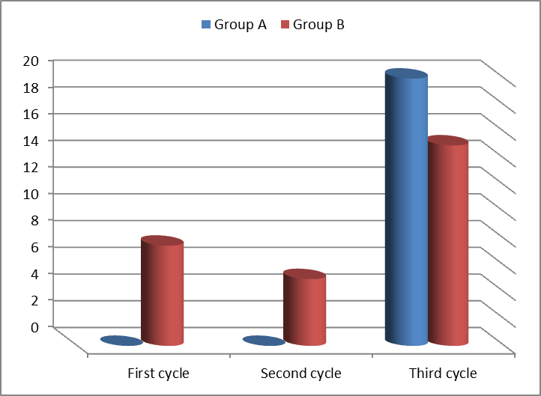
Figure (1): Comparison in pregnancy rate between group A and group B.

Table (2): Comparison of occurrence of lutel phase defect between group A and group B.
 | Group A |  | Group B |  | P-value
 | No. | % | No. | %
First cycle: |  |  |  |  | 0.265
3 – 10 | 22 | 68.8 | 15 | 53.6
> 10 | 10 | 31.3 | 13 | 46.4
Total | 32 | 100.0 | 28 | 100.0
Second cycle: |  |  |  |  | 0.550
3 – 10 | 14 | 35.0 | 10 | 25.0
> 10 | 26 | 65.0 | 26 | 65.0
Total | 40 | 100.0 | 36 | 100.0
Third cycle: |  |  |  |  | 0.016*
3 – 10 | 3 | 8.6 | 11 | 30.6
> 10 | 32 | 91.4 | 25 | 69.4
Total | 35 | 100.0 | 36 | 100.0

Luteal phase deficiency (LPD) has been described as a condition in which endogenous progesterone is not sufficient to maintain a functional secretory endometrium and allow normal embryo implantation and growth. Common method used for the diagnosis of LPD is the measurement of serum progesterone levels which is secreted in pulses that reflect LH pulses.
After exclude the anovulatory patients, this table shows no significant difference between the two groups in occurrence of luteal phase defect in first and second cycles; while a significant difference in the third cycle between the two groups was detected.
The occurrence of luteal phase in all cycles in relation to the progesterone level detected on approximately 6-8 days after ovulation.
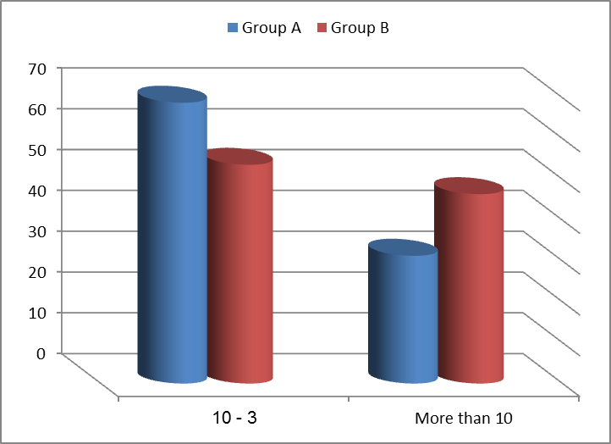
Figure (2): Comparison of occurrence of lutel phase defect between group A and group B.

Figure (2) shows that no significant difference between the two groups in occurrence of luteal phase defect in the first cycle could be detected.
Occurrences of luteal phase defect were detected during the first cycle between the two groups (in group A it was 68.8% while in group B it was 53.6%.

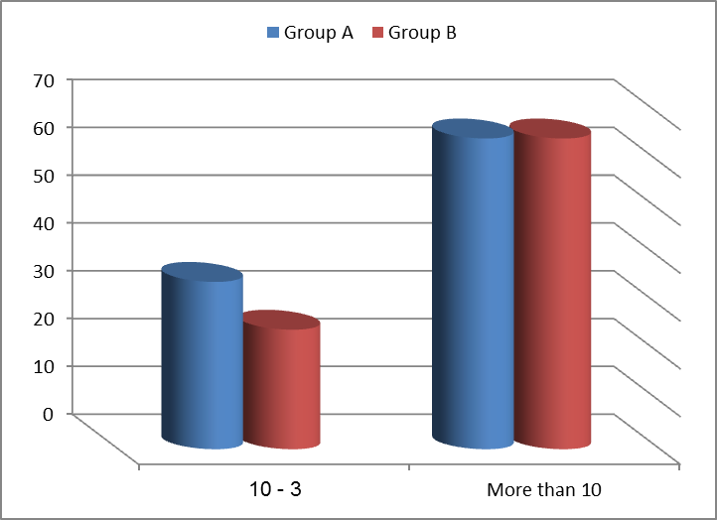
Figure (3): The occurrence of luteal phase defect in the second cycle.

Figure (3) shows that no statistical significant differences between the two groups in occurrence of luteal phase defect in the second cycle could be detected.
The occurrence of luteal phase defect in the second cycle was deceased when compared with the first cycle (in group A it was 35% while in group B it was 25%).
Figure (4) shows that there is a significant difference between the two groups in occurrence of luteal phase defect in the third.
The occurrence of luteal phase defect in the third cycle of group A was deceased more than that found in the second cycle (in group A it was 8.6% while in group B it was 31.2%).
The incidence of luteal phase defect showed a decrease over the three cycles in both groups with observed decrease of occurrence of LPD in group A (8.6%) in the third cycle in compared to group B (31.2%) during the third cycle.

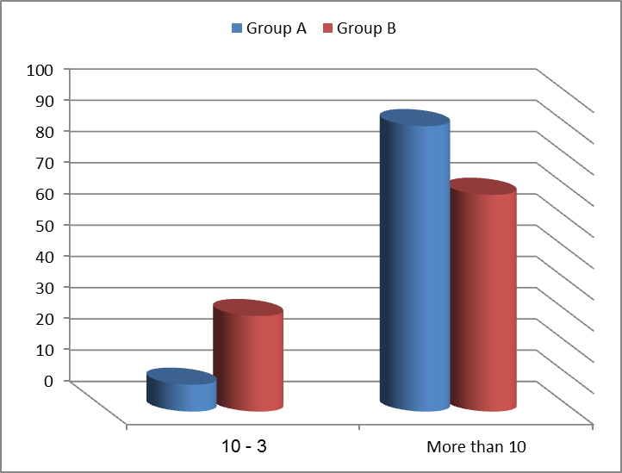
Figure (4): The occurrence of luteal phase defect in the third cycle.

Table (3): Comparison between group A and group B in ovulation rate.
 | Group A |  | Group B |  | P-value
 | No. | % | No. | %
First cycle: |  |  |  |  | 0.284
< 3 | 8 | 20 | 13 | 32.5
3 – 10 | 22 | 55 | 15 | 37.5
> 10 | 10 | 25 | 12 | 30
Total | 40 | 100.0 | 40 | 100.0
Second cycle: |  |  |  |  | 0.191
< 3 | 0 | 0 | 2 | 5.26
3 – 10 | 14 | 35 | 10 | 26.32
> 10 | 26 | 65 | 26 | 68.42
Total | 40 | 100.0 | 38 | 100.0
Third cycle: |  |  |  |  | 0.024*
< 3 | 0 | 0.00 | 0 | 0.00
3 – 10 | 3 | 7.50 | 11 | 30.56
> 10 | 37 | 92.50 | 25 | 69.44
Total | 40 | 100.0 | 36 | 100.0

This table shows no significant difference between the two groups in ovulation rate in the first and second cycles; but a significant difference in ovulation rate was detected between the two groups in the third cycle.
The table shows rates of ovulation variation in the first cycle with relation to the progesterone level detected on approximately 6-8 days after ovulation.

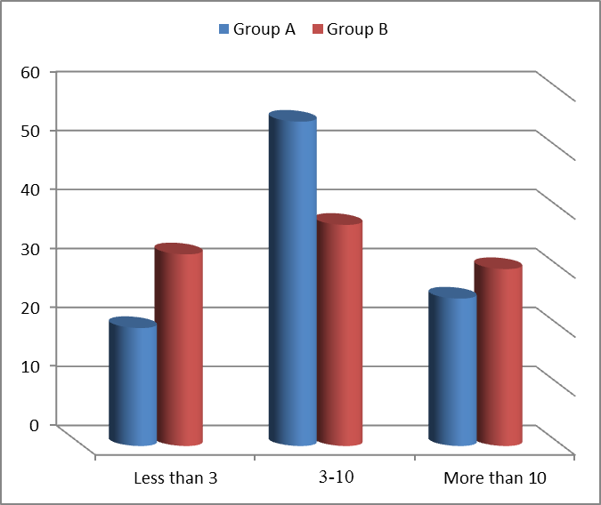
Figure (5): Comparison between group A and group B in ovulation rate in the first cycle.

This figure shows that there is no significant difference between the two groups in ovulation rate in the first cycle.
More ovulatory patients (progesterone level 3-10 range) were detected during this first cycle.
Anovulatory patients (progesterone level < 3 range) were detected during this first cycle in group A: 20% and in group B 32.5%.
If the cycle is anovulatory, the clomiphene citerate dose is increased by 50 mg in the subsequent cycle.

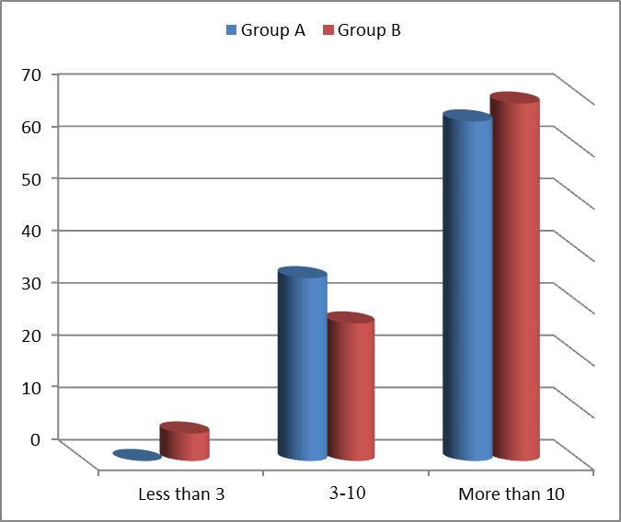
Figure (6): Comparison between group A and group B in ovulation rate in the second cycle.

This figure shows that no significant difference between the two groups in ovulation rate in the second cycle.
More ovulatory patients were detected when progesterone level > 10 during the second cycle. When progesterone level reached <3 a decrease in number of anovulatory patients to nill in group A was observed.

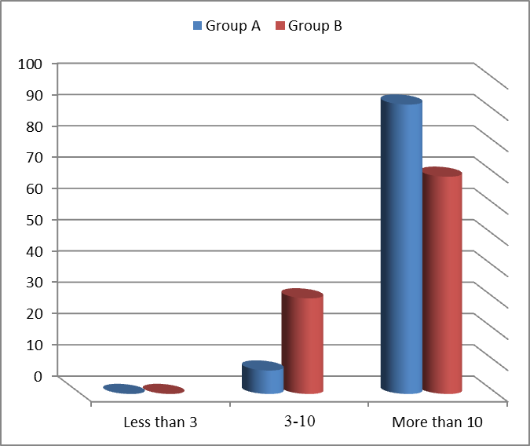
Figure (7): Comparison between group A and group B in ovulation rate in the third cycle.

This figure shows that significant difference could be detected between the two groups in ovulation rate in the third cycle.

An increasing number of ovulatory patients (progesterone level >10) was detected during the third cycle within the two groups was observed. There was a disappearance of the anovulatory patients (when progestrone level was below 3) in group A 92.5% had good ovulation (progesterone level was >10ng/ml) while in group B 69.44% had good ovulation.

4. Discussion
Polycystic ovary syndrome (PCOS) is the most common form of WHO type II anovulatory infertility and is associated with hyperandrogenemia (Abu Hashim, 2012).
The PCOS is the commonest hyperandrogenic disorder in women and one of the most common causes of ovulatory infertility, with an estimated prevalence of 4–7% worldwide (Pasquali, 2009).
Polycystic ovary syndrome is a multifactorial, polygenic, heterogeneous endocrine disorder. Several mechanisms, including disorders in the HPG axis, ovarian and adrenal androgen production, insulin action, and several candidate genes regulating androgen and insulin biosynthetic pathways, have been implicated in the pathogenesis of the disorder, hyperandrogenism and insulin resistance, largely modulated by obesity, appear to be central to the pathophysiology of the disease (Allahbadia & Merchant, 2011).
Management of PCOS includes a symptom-orientated approach to the presenting problem and a preventive strategy for the associated long-term morbidity (Amer, 2009).
For anovulatory infertility in women with PCOS, different treatment approaches have been widely used to restore ovulation such as (Amer, 2009):
- Weight reduction.
- Laparoscopic ovarian drilling (LOD).
- Drugs to induce ovulation and this include:
- Clomiphene Citrate.
- Gonadotropin Therpy.
- Metformin.
- Letrozole.
WHO group II (essentially PCOS): clomiphene citrate, which is an antioestrogenic compound, is considered the first-line treatment for ovulation (Amer, 2009).
CC treatment will successfully induce ovulation in approximately 80% of properly selected candidates. Likelihood of response declines with increasing age, body mass index (BMI), and free androgen index. Approximately 70% to 75% of anovulatory women who respond to CC (50 mg/day to 150 mg/day, as required) may be expected to conceive within six to nine cycles of treatment. Amenorrheic women are more likely to conceive than oligomenorrheic women, probably because those who already ovulate, albeit inconsistently, are more likely to have other co-existing infertility factors. In infertile women with luteal phase deficiency, CC treatment increases luteal phase duration and serum P levels and improves fecundity (ASRM, 2006).
A prospective follow-up of thin women with ovulatory dysfunction has shown high conception rates in ovulatory responders treated with clomiphen, approaching 50% after three cycles of treatment, and 75% withen nine cycles(Norman et al.,2007).
In ovulation induction cycles monitored by ultrasound, once follicular size has reached 18 to 22 mm in size, an ovulation trigger is advocated as a surrogate for the endogenous LH surge. Administration of an ovulation trigger allows better timing of either intercourse or intra-uterine insemination (George et al., 2010).
Urinary-derived human chorionic gonadotrophin (hCG) is commonly used to trigger ovulation. Alternative drugs that are available include recombinant hCG (rhCG), recombinant LH (rLH) or a gonadotrophin-releasing hormone (GnRH) agonist. The hCG (urinary or recombinant) and rLHact directly on the follicle while GnRH agonists stimulate the release of endogenous LH from the pituitary (Fauser & Macklon, 2004).
Unlike hCG triggering of ﬁnal oocyte maturation, GnRHa triggering is a more physiological approach, eliciting a surge of gonadotrophins, similar to that of the natural mid-cycle surge. Thus, in contrast to hCG triggering, GnRHa triggering induces an endogenous surge of FSH as well as LH (Castillo et al., 2010, 2011; Papanikolaou et al., 2011 & Humaidan et al., 2010).
The study included 80 infertile women who were diagnosed as having PCOS (30 patients were from Imbaba general hospital, & 50 patients were from EL SAYED GALAL university hospital).
Patients were assigned randomly to either group A or B through closed envelop and the patient choose their group blindly.
Group A: includes 40 women who received LHRH analogue (Triptorelin) in a single dose of 0.2mg subcutaneous in the day of follicular maturation (by trans-vaginal ultrasonograghy when follicle reach to 18-20mm in diameter)to trigger ovulation followed by planned intercourse within the following 36 hours.
Group B: includes 40 women who received HCG in a dose of 10,000 IU IM in a day of follicular maturation (by trans-vaginal ultrasonograghy when follicle reach to 18-20mm in diameter)to trigger ovulation followed by planned intercourse within the following 36 hours.
Patients who didn't get pregnant followed up with same procedure for 3 successive cycles.
In this study, after induction of ovulation by clomiphene citrate GnRH was given to trigger ovulation in group AversuesHCGin group B, the following parameters were compared in both groups: ovulation rate, occurrence of luteal phase sufficiency, pregnancy rate.
This study showed no significant difference between the two groups in pregnancy rate along three cycles. No pregnancy occurred in the first two cyclefor group A, while an increase of up to 17.1% during the third cycle. The pregnancy rate in group B: in the first cycle was 5.7%, in the second cycle it was 3% and in the third group it was 12.5%.
In the first two cycles lower in pregnancy rates after GnRH trigger than HCG trigger was observed. This is in agreement with Engmann & Benadiva (2012) study.
A single dose of GnRHa induced an endogenous LH surge that has a short half-life, resulting in defective corpus luteum (CL) formation.
These results are in agreement with the finding of (Sismanoglu et al., 2009) GnRH agonist use resulted in significantly lower implantation and clinical pregnancy rates, in addition to a significantly higher rate of early pregnancy loss, than observed with hCG, with these differences likely due to luteal phase deficiency. This study shows that there was a significant increased of pregnancy rate in third cycle of the group A on administration of the GnRH-agonist. Pregnancy rate of group A shows an increase up to %17.1 during the third cycle. On other hand, group B shows a variation in pregnancy rate which increased to %12.5.
Results of this study demonstrated that there are no significant differences between the two groups in occurrence of luteal phase defect in the first and second cycles as opposed to the third cycle in two groups.
In group A: the first cycle was 68.8% (22 out of 32 cases), in the second cycle it was 35% (14 out of 40 cases) and in the third cycle it was 8.6% (3 out of 35 cases), but in group B: the first cycle was 53.6% (15 out of 28 cases), in the second cycle it was 25% (10 out of 36 cases) and in the third cycle it was 30.6% (11 out of 36 cases).
The first two cycles has shown an increase in the incidences of luteal phase defect in group A than group B.
The theoretical background of the luteal phase deficiency seen when GnRHa is used to trigger ovulation. This is usually described as either indirect or direct:
- Indirect: the GnRHa suppresses the pituitary after the initial ‘flair up’ that leads to endogenous LH concentrations to the extent that the function of the corpus luteum is compromised, that leads to corpus luteum demise.
- Direct: the GnRHa compromises the normal function of the corpus luteum via blockage of GnRH receptors present in human granulosa cells. (Humaidan et al., 2006).
In a previous study (Humaidan et al., 2005), comparing HCG with GnRH triggered final oocyte maturation, the mean midluteal progesterone concentration of the GnRHa arm was significantly lower than that of the HCG arm.
While the endogenous LH surge triggered by GnRHa is associated with a normal follicular-luteal shift in ovarian steroidogenesis, serum levels of E and P during the luteal phase are lower compared with those achieved after hCG administration. This may be related to the longer duration of plasma hCG activity compared with the shorter GnRHa induced LH elevation. Normal function of the corpus luteum is dependent on pituitary LH (Kol, 2004).
The occureance of luteal phase showed a decrease over the three cycles in both groups with higher decrease detected in the group A (8.6%) in the third cycle compared to group B (31.2) % during the third cycle.
Clomiphene Citrate (CC) was used for ovarian stimulation during the follicular phase. Due to the long half-life of CC, a higher pituitary secretion of LH during the luteal phase could be expected counteracting the luteolytic action following the GnRHa trigger (Kol et al., 2011).
The luteal phase insufficiency connected with GnRHa triggering seems to be involving both the corpus luteum function as the endometrium and endogenous LH seems to play a crucial role during the luteal phase. LH support during the luteal phase is totally responsible for the maintenance and the steroidogenic activity of the corpus luteum. Moreover, LH is also responsible for the up-regulation of growth factors like vascular endothelial growth factor A and fibroblast growth factor which play a dynamic role in luteal angiogenesi (Humaidan et al., 2009).
This study shows no significant difference between the two groups in ovulation rate in the first cycle. Comparing the two groups, it appears that the number of ovulatory patients in the first cylce is larger than anovulatory patients (in group A, 25.7%were ovulatory (progesterone level was 3-10 ng/ml) and 54.3% had good ovulation (progesterone level was>10 ng/ml), but in group B 37.1% were ovulatory (progesterone level was 3-10 ng/ml) and 31.4% had good ovulation (progesterone level was>10 ng/ml)
Also our results revealed that there isno significant difference between the two groups in ovulation rate in the second cycle. In group A: 34.3% were ovulatory (progesterone level was 3-10 ng/ml) and 65.7% had good ovulation (progesterone level was>10 ng/ml), while in group B27.3% were ovulatory (progesterone level was 3-10 ng/ml) and 66.7% had good ovulation (progesterone level was>10 ng/ml).
This study shows a significant difference between the two groups in ovulation rate in the third cycle. In group A: 8.6%were ovulatory (progesterone level was 3-10 ng/ml) and 91.4% had good ovulation (progesterone level was>10 ng/ml), while in group B: 31.2% were ovulatory (progesterone level was 3-10 ng/ml) and 68.8% had good ovulation (progesterone level was>10 ng/ml).
Clomiphene is a selective oestrogen-receptor modulator that antagonises the negative feedback of endogenous oestrogen on the hypothalamic–pituitary axis. Treatment with clomiphene should return LH to normal and increase FSH secretion, and there by stimulates follicle growth and ovulation. Clomiphene has been the gold standard treatment for induction of ovulation in women with polycystic ovary syndrome for many decades (Norman et al., 2007).
Typically, progesterone levels are obtained approximately 12-14 days after the completion of clomiphene to assess ovulation. If the cycle is anovulatory, the clomiphene dose is increased by 50 mg in the subsequent cycle. Using this approach, 52% ovulate in response to 50 mg, and 22% ovulate with 100 mg, and 12% respond to 150 mg (Hurst et al., 2009).
Rates of ovulation variation in the first cycle with relation to the progesterone level detected on approximately 6-8 days after ovulation.
A prospective follow-up of women with ovulatory dysfunction has shown high conception rates in ovulatory responders treated with clomiphene, approaching 50% after three cycles of treatment, and 75% within nine cycles (Norman et al., 2007).
Furthermore the retrieval of more mature oocytes in the GnRHa triggered group supported previous clinical findings of a possible beneficial effect of the mid-cycle FSH surge on oocyte (Humaidan et al., 2009).
GnRH agonists administered in the midcycle are capable of eliciting the gonadotropin surge from the hypophysary, which is necessary to provoke ﬁnal oocyte maturation (Gülekli et al., 2015).

In conclusion, this study suggests that using of GnRH to trigger ovulation after induction by clomiphene citrate in PCOS patients is considered a more physiological approach as GnRHa trigger lead to reduction in circulating endogenous LH level which is correlated the ovarian function unlike HCG. Which elicits a surge of gonadotropins, similar to that of the natural mid-cycle surge. This protocol will result in enhancement the ovarian function and improvement reproductive outcome. Using CC for induction of ovulation will overlap the short half life of GnRH agonist.

References
- Abu Hashim H (2012): Management of women with clomiphene citrate resistant polycystic ovary syndrome evidence based approach. In Mukherjee S, editor. Polycystic Ovary Syndrome, Croatia: published by in Tech: 1-20.
- Allahbadia GN and Merchant R(2011): Polycystic Ovary syndrome and impact on health. Middle East Fertility Society Journal. (16): 19-37.
- Amer SA (2009): Polycystic ovarian syndrome: diagnosis and management of related infertility. Obestetrice, Gynaecology and Reproductive 19(10): 263-70.
- Archer JS, Chang RJ (2004): Hirsutism and acne in polycystic ovary syndrome. Best Pract Res Clin Obstet Gynaecol 18: 737-754.
- ASRM(2006): The Practice Committee of the American Society for Reproductive Medicine, Use of clomiphene citrate in women, Fertility and sterility Update; 86(l 4): s187-s193.
- Badawy A, Abdel Aal I, Abulatta M (2009): Clomiphene citrate or letrozole for ovulation induction in women with polycystic ovarian syndrome: a prospective randomized trial. Fertil Steril 92: 849-852.
- Castillo JC, Dolz M, Bienvenido E, Abad L, Casan EM, Bonilla-Musoles F (2010): Cycles triggered with GnRH agonist: exploring low-dose HCG for luteal support. Reprod Biomed Online; 20: 175–181.
- De Leo V, Musacchio MC, Cappelli V, Massaro MG, Morgante G and Petraglia F. Genetic, hormonal and metabolic aspects of PCOS: an update. Reprod Biol Endocrinol. 2016 Jul 16;14(1):38.
- Denison FC, Roberts KA, Barr SM, Norman JE. Obesity, pregnancy, inflammation and vascular function. Reproduction. 2010;24:112–45.
- Engmann L and Benadiva C (2012): Agonist trigger: what is the best approach? Agonist trigger with aggressive luteal support. Fertility and Sterility; 97(3): 531-33.
- Fauser and Macklon (2004): Medical approaches to ovarian stimulation forinfertility. In: Strauss JF, Barbieri RL editor(s). Yen and Jaffe’s Reproductive Endocrinology.5th Edition. Philadelphia: Elsevier Saunders: 965–1012.
- George K, Nair R and Tharyan P(2010): Ovulation triggers in anovulatory women undergoing ovulation induction. The Cochrane Collaboration. Published by John Wiley & Sons, Ltd. published in Issue 11:1-21.
- Gülekli B, Gode F, Sertkaya Z, Isik AZ. Gonadotropin-releasing hormone agonist triggering is effective, even at a low dose, for final oocyte maturation in ART cycles: Case series. J Turk Ger Gynecol Assoc 16: 35-40.
- Humaidan P, Bredkjaer HE, Bungum L, Bungum M, Grondahl ML, Westergaard L, Andersen CY (2005): GnRH agonist (buserelin) or hCG for ovulation induction in GnRH antagonist IVF/ICSI cycles: a prospective randomized study. Hum Reprod; 20: 1213–1220.
- Humaidan P, Bungum L, Bungum M, Andersen CY (2006): Rescue of corpus luteum function with periovulatory HCG supplementation in IVF/ICS GnRH antagonist cycles in which ovulation was triggered with a GnRH agonist: a pilot study. Reproductive Bio Medicine; 13(2): 173-178.
- Humaidan P, Ejdrup Bredkjaer H, Westergaard LG, Andersen CY (2010): 1,500 IU human chorionic gonadotropin administered at oocyte retrieval rescues the luteal phase when gonadotropin-releasing hormone agonist is used for ovulation induction: a prospective, randomized, controlled study. Fertil Steril; 93: 847–854.
- Humaidan P, Kol S. and Papanikolaou EG. (2011): GnRH agonist for triggering of final oocyte maturation: time for a change of practice? Hum Reprod Update; 17: 510–524.
- Humaidan P, Westergaard LG, Mikkelsen AL, Fukuda M, Yding Andersen C(2009): Levels of the EGF-like peptide amphiregulin are signiﬁcantly reduced in follicular ﬂuid after GnRHa triggering of ﬁnal oocytre maturation. Hum Reprod;24 (Supplement 1): O-284.
- Hurst BS, Hickman JM, Matthews ML, et al. (2009): Novel clomiphene “stair-step” protocol reduces time to ovulation in women with polycystic ovarian syndrome. Am J Obstet Gynecol; 200: 51.e1-51.e4.
- Kol S (2004): Luteolysis induced by a gonadotropin releasing hormone agonist is the key to prevention of ovarian hyperstimulation syndrome. Fertility and Sterility; 81(1): 510-515.
- Kol S, Humaidan P and Itskovitz-Eldor J(2011): GnRH agonist ovulation trigger and hCG-based, progesterone-free luteal support: a proof of concept study. Human Reproduction; 26(10):2874-7.
- Norman R, Dewaihhy D, Legro RS, Hickey TE (2007): Polycystic ovary syndrome, Lancet; 370: 685-97.
- Palomba S, Russo T, Falbo A, Orio F, Jr., Manguso F, et al. Clinical use of the perifollicular vascularity assessment in IVF cycles: a pilot study. Hum Reprod 2006; 21: 1055-1061.
- Papanikolaou EG, Verpoest W, Fatemi H, Tarlatzis B, Devroey P, Tournaye H(2011): A novel method of luteal supplementation with recombinant LH, when a GnRH-Agonist is used instead of HCG for ovulation triggering. A randomized prospective proof of concept study. Fertil Steril; 95: 1174-1177.
- Pasquali R (2009): Clinical manifestation of PCOS. In. Farid NR· Diamanti - Kandarakis E. Editors. Diagnosis and Mangement of PCOS. USA: 3-14.
- Rotterdam ESHRE/ASRM-Sponsored PCOS Consensus Workshop Group. Revised 2003 consensus on diagnostic criteria and long-term health risks related to polycystic ovary syndrome. Fertil Steril. 2004;81:19–25.
- Sismanoglu A, Tekin HI, Erden HF, Ciray NH, Ulug U and Bahceci M (2009): Ovulation triggering with GnRH agonist vs. hCG in the same egg donor population undergoing donor oocyte cycles with GnRH antagonist: a prospective randomized cross-over trial J Assist Reprod Genet 26: 251–256.
- Sivridis E, Giatromanolaki A. New insights into the normal menstrual cycle-regulatory molecules. Histol Histopathol 2004; 19: 511-516.

5/15/2017

