Production and Evaluation of Breakfast Cereal Flakes Using Pre-Treated Millet Sorghum Flavoured With Coconut Milk

*Okafor D. C.¹; Ofoedu C. E.¹; Njoku N.E.¹; Ibeabuchi J. C.¹; Alagbaoso S. O. ¹; Eluchie, C.N.¹; Onyeka E. U.¹; Obi, P.N.² and Chukudobe K. C¹
¹Dept. of Food Science and Technology, Federal University of Technology, Owerri, P. M. B. 1526 Owerri, Imo State, Nigeria
²Department of curriculum and instruction, Alvan Ikoku Fedral Colledge of Education
Corresponding author: okafordamaris@gmail.com

Abstract: Breakfast cereals were produced from pre-treated grains of millets (Pennisetum americanum) and Sorghum (Sorghum bicolour L Moench), flavoured with coconut milk. The chemical composition and selected functional properties as affected by the treatment given were examined. The pre-treatment of the cereals was intended to improve the nutritional constituents of the grains as well as reduce anti-nutritional factors present in the grains. The ash contents, total dietary fiber, and moisture content showed a slight increase in the sprouted product as compared to the fermented ones. On the other hand, fermented products had higher contents of protein and fat compared to sprouted ones. Mixing of sorghum and millet gave products with higher water absorption capacity for both sprouted and fermented products. The coconut milk helped to mask the bland flavor of cereal grains as evidenced by the high sensory scores of the products in terms of aroma. In terms of overall acceptability, product from a mixture of sprouted sorghum and millet (SMS) had the highest (p=0.05) score of 7.4. It is better to use a mixture of grains in breakfast product production than to use single grain type.
[Okafor DC, Ofoedu CE, Njoku NE, Ibeabuchi JC, Alagbaoso SO, Eluchie CN, Onyeka EU, Obi PN, and Chukudobe KC. Production and Evaluation of Breakfast Cereal Flakes Using Pre-Treated Millet Sorghum Flavoured With Coconut Milk. N Y Sci J 2017;10(6):30-38]. ISSN 1554-0200 (print); ISSN 2375-723X (online). http://www.sciencepub.net/newyork. 5. doi:10.7537/marsnys100617.05.

Keywords: Coconut Milk, Cereal Flakes, Physical properties, Proximate

- Introduction
A breakfast cereal is a processed food manufactured from cereal grains intended to be eaten as a main course. It is usually served with milk during the morning meal. Some breakfast cereals require brief cooking, but these hot cereals are less popular than cold, ready-to-eat cereals. Fast, (1990) defined breakfast cereals as processed product made from cereal grains that are suitable for consumption with or without further cooking which are usually consumed as breakfast foods. Prehistoric people ground whole grains and cooked them with water to form gruels and porridges similar to today’s hot cereals. The origin of many ready-to-eat cereal products can be traced to Battle Creek, Michigan, where the Kellogg brothers, C.W. Post, and others discovered and developed many novel processing technologies for running raw cereal grains into breakfast cereals (Malzahn 1974; Fast et al., 1990b; Le Heron. and Hayward, 2002) Breakfast cereals have their beginnings in the vegetarian movement in the nineteenth century. Ready-to-eat breakfast cereals were invented because of religious beliefs. The first step in this direction was taken by the American Clergyman; Sylvester Graham, who advocated a vegetarian diet. He used non sifted, coarsely ground flour to invent the Graham Cracker in 1829. Influenced by Graham, seventh Day Adventist, who also believes in vegetarianism, founded the Western Health Reform Institute in Battle Creek Sanitarium, Physician; John Harvey, Kellogg invented several grain-based meat substitutes. The main western breakfast as that time was a cooked breakfast of eggs, beans, sausage, bread and beef (Caldwell et al., 1990). The first packaged breakfast cereal; Granula (named after granule) was invented in the United State in 1863 by James Caleb Jackson (Brandth, 2010).
The most important raw material in any breakfast cereal is the grain. The grains commonly used are corn, wheat, rice, oats and barley. Some hot cereals such as oatmeal, and a few cold cereals such as plain shredded wheat, contain no other ingredients. Some breakfast cereals made from whole grains are associated with reasonable amount of dietary fibre which reduces the incidence of those diseases associated with little or no dietary fibre intake such as colon cancer, pile, constipation, diarrhea, and gastro intestinal disorder such as diarrhea and constipation (Fast et al., 1990a).
Selection of a breakfast meal has been a major problem in many homes due to the fact that they cannot afford the present cereal products in the market like cornflakes and golden morn which is mostly consumed by the rich. Breakfast meal has been populated with bread and tea, akara and akamu and in some homes garri, rice or beans which require prolonged processing time. Consumers do not have brands of breakfast cereals to choose from as a result of its constant production either from wheat, corn, rice or oat or a combination of two of these major cereals. These local cereal grains are underutilized, leading to less exploration of the component nutrients in the grains. In this study an attempt is made to produce breakfast cereal from pre-treated sorghum and millet cereal grains which are rarely used for the production of breakfast cereal due to lack of utilization, hence farmers focus their attention on the production of cereals with higher demands and markets value. Millet and sorghum are not common in the production of breakfast cereal unlike cereals such as maize, oats, rye and wheat. Sorghum and millet in general are rich sources of B-complex vitamin. Detectable amounts of other fat-soluble vitamins, namely D, E and K, have also been found in sorghum grain. Sorghum as it is generally consumed is not a source of vitamin C. On germination, some amount of vitamin C is synthesized in the grain and on fermentation there is a further rise in the vitamin content (Kazanas and Fields 1981). Sorghum and millet will be enriched with coconut milk.
The objective of this study therefore includes the following:
- To diversify the use of millet, sorghum and coconut.
- To improve the nutrient quality of breakfast cereal through enrichment.
- Production and evaluation of a ready-to-eat breakfast cereal from millet and sorghum supplemented and enriched with coconut milk.

2.0 Materials And Methods
2.1 Materials
2.1.1 Plant Materials
Millet grain (Pennisetum americanum), sorghum grain (Sorghum bicolour L Moench), coconut, and other ingredients like sugar, baking powder, table salt and vanilla flavor were purchased from market in Owerri.
2.1.2 Chemicals
All the chemicals and reagents used in this study are of analytical grade and were obtained from the Department of Food Science and Technology, Owerri. Reagents including; Hexane, Tetraoxosulphate (VI) acid 200ml, Potassium hydroxide 200ml, Hydrochloric acid, Ethyl glycol 10ml, petroleum ether 10ml, Copper tetraoxosulphate (VI) crystal 0.1g, sodium tetraoxosulphate (VI) crystal 0.1g, Concentrated H₂SO₄ 25ml, 40% Sodium.
2.1.3 Equipments
Attrition mill, oven, crucibles, desiccators, electronic balance, muffle furnace, tongs, soxhlet extractor, filter paper, heating mantle, condenser, muslin cloth, Buchner funnel, conical flask, kjedahl flask, test tubes, distillation unit, and centrifuge. All are of analytical grades and were obtained from the Department of Food Science and Technology, Owerri.
2.2 Methods
2.2.1 Preparation of Sprouted Sorghum-Millet Grits
Millet cereals were cleaned and winnowed and washed, then steeped in water for five minutes then spread on a jute bag to allow for germination/sprouting. The millet cereal was sprayed with water intermittently at three hours interval, until visible sprouting was noticed. Usually sprouts within eighteen-twenty four hours. On sprouting, the cereals are dried by sunlight or airing prior to oven drying at 60ºC for 45-60 minutess. After drying it is allowed to cool and milled to grits. The grits are sieved to achieve a more uniform grits (Michodjehoun-Mestres et al., 2005). The process flow diagram is shown in figure 1.
2.2.2 Preparation of Fermented Sorghum-Millet Grits
The cereals were cleaned, winnowed and washed with portable water to remove sand, debris and other foreign grains. The washed grains were then steeped in water contained in a transparent plastic bucket and the water changed intermittently within three hours interval for 24 hours.
After 24 hours, the water was completely drained and the cereals aired to remove water. Subsequently, they were sun dried and then dried in an air oven at 60ºC for 45-60 minutes. After drying; the cereals were cleaned and winnowed, then milled to grits and sieved to obtain a uniform grit. The process flow diagram for the fermented sorghum/millet grit is illustrated in figure 2.
2.2.3 Preparation Of Coconut Milk
The coconut kernel was cracked and dehulled to obtain the endosperm. The endosperm was washed and grated then with a sterilized muslin cloth. The milk was obtained primarily by extracting juice by pressing the grated coconut’s white kernel. When refrigerated and left to set, coconut cream will rise to the top and separate from the milk (Seow and Gwee, 1997). The flow diagram for coconut milk preparation is shown in figure 3.
2.3 Production of Breakfast Cereals
2.3.1 Recipe for the Breakfast Cereal Production
The recipe for the breakfast cereal production reported by the Bouvier and Clextral (2001) and Okaka and Potter (1996) was used with slight modification. The flour blends was use as the basis while other ingredients were percentage of the flour and the recipe is shown below:
Flour blends - 100%
Sugar - 20%
Salt - 2%
Baking powder – 2%
Coconut milk - 10%
Flavor - 5%

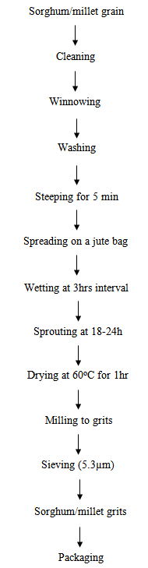
Figure 1: Flow diagram for the preparation of sprouted sorghum-millet grits

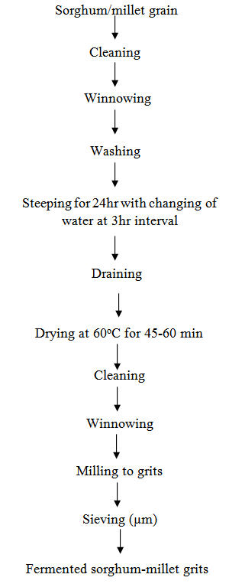
Figure 2: Flow diagram for the preparation of fermented sorghum-millet grits

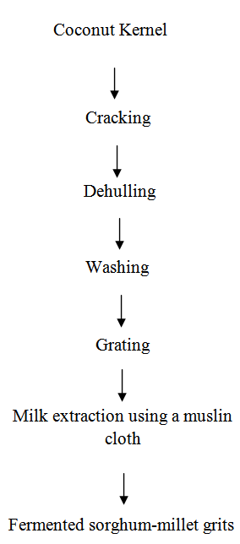
Figure 3: Flow diagram showing coconut milk preparation
2.3.2 Processing of the Breakfast Cereal
Processing of the breakfast cereal was done by mixing the dry ingredients in a bowl, then mixing with the liquid (coconut milk and flavour) then resting for 20-30 minutes for possible rising of the flour, then drying on flat metal surface at 121ºC (an improvised drum drier), then breaking into flaky shapes, cooling and storage of the breakfast cereals. The flour samples were supplemented with different proportions as follows: 100% millet, 100% sorghum and 50% millet: 50% sorghum; then sugar 10%, salt 2%, baking powder 0.5%, flavour 1% and water variable amount was added. The process flow diagram is illustrated in figure 4.

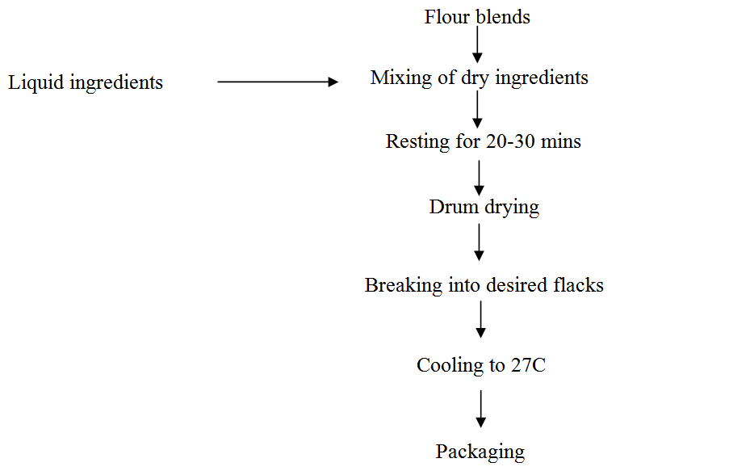

Figure 4: Process flow diagram for breakfast cereal production.

2.4 Proximate Analysis on Breakfast Cereal Product
The analysis was carried out according to the official methods of analysis of Association of Official Analytical Chemists (AOAC, 1984 and 2006).
2.4.1 Moisture Content Determination
An empty aluminum pan (dish) is washed, dried in the oven and weighed using a sensitive analytical balance. Two grams of the sample is introduced into the aluminum pan (dish) and weighed together, then the weight was recorded. The aluminum dish containing the sample is put into an oven at a temperature of 105ºc for 10minutes; the dish is placed in a desiccator to cool. After cooling, the weight was recorded and the aluminum pan was put back into the oven and heated again for another 5minutes. At 15minutes, the aluminum pan was brought out again from the oven, cooled, re-weighed and re-introduced into the oven for another 5minutes. At 20minutes, the same procedure was carried out, after which the dish with its content was finally cooled in the dessicator. At this point, there is a complete loss in water.
Calculation
% moisture =$\frac{Weight loss of sample}{Weight of original sample}$×100
2.4.2 Ash Content
The crucible was washed, dried and cooled and weighed using a sensitive analytical balance. Two grams of the sample is weighed into a crucible. The crucible containing the sample is then placed in a muffle furnace and charred at a temperature of 550ºc until it is carbonized. The sample was incinerated until the sample was no more than a light grey ash matter. The sample was removed from the muffle furnace using a pair of tongs and cooled in a dessicator, weighed and the result was recorded.
% Ash content is calculated thus:
% Ash content =$\frac{Weight of ash}{Weight of sample}$×100
2.4.3 Crude Protein Fibre
Digestion: From each of the raw material samples 0.1g was carefully weighed into washed and dried kjedahl flask for digesting and 0.1g of copper tetraoxosulphate (vi) crystal and 25ml of concentrated tetraoxosulphate (vi) acid were added into the flask with their contents, they were transferred to the digesting chamber to digest the sample, the digestion continued until the sample changed colour from black to light blue. The digestion flask was removed from the chamber and allowed to cool. The digest was made up to 100ml with distilled and vigorously shaken into a homogenous solution.
Distillation: Out of the made up digest, 20mls was pipette into a distillation flask, 20mls of 40% sodium hydroxide was added into the distillation flask with aid of a funnel. 10ml of 2% boric acid was pipette into 5ml beaker and 2 drops of mixed indicator (methyl red and guinea green) were put into a glass tuber, the distillation unit was filtered such that the condenser is connected to the receiving flask and the condenser cooled with constant supply of cold water from a bucket of water and also the tip of the glass tube was properly immersed in the boric acid. The distillation unit was then heated for about 35minutes until the pink solution of the boric acid and the indicator turned blue and volume increased to about 30mls by the distillate.
Titration: The bluish distillate was titrated against 0.1normal Hydrochloric acid to a colorless end point. A blank was titrated also to get any trace of nitrogen in the blank. All the titre columns were noted for each sample.
The percentage crude protein was calculated thus:
% crude protein = % nitrogen x 6.25
Where % nitrogen =$\frac{28}{100}$×$\frac{Vt - Vb}{Wo}$
V_{t} =titre volume of sample
V_{b}=titre volume of blank
W_{o} = weight of sample
2.4.4 Crude Fat
A 250ml conical flask was washed thoroughly and dried in an oven, cooled and then weighed with an electronic balance. 2g each of the sample was weighed out and wrapped with filter paper and put into the sample holder, hexane was assembled.
The flasks were placed on the heating mantle at 80ºc. the fat was extracted for hours until all the hexane in the sample became clear and the filter paper looking transparent enough. The flask containing the oil was dried in the oven to evaporate all residual hexane until a constant weight was obtained. The percentage crude fat was calculated based on the weight of the oil with respect to the initial weight of the sample thus:
$\frac{Weight of flask + oil – weight of empty flask}{Initial weight of sample}$×100
2.4.5 Total Dietary Fibre Determination
The total dietary fibre was determined according to the method of the Association of Official Analytical Chemists (AOAC, 1995) with slight modifications. One gram of each sample (dry basis) was put in a beaker and 10ml of distilled water was added and the mixture stirred. The beaker with the sample was then put into a water bath containing boiling water and was gelatinized over a hot plate while stirring continuously. When the sample had gelatinized, the pH of the sample was adjusted to 6.0. Termamyl was added and incubated at 100ºc for 30min. this was followed by protease incubation and lastly by amyloglucosidase enzyme incubation at 60ºc for 30min. At the end of amyloglucosidase incubation, the sample was precipitated with four volumes of ethanol an acetone. The sample was then dried in a drying oven at 100ºc. Total dietary fibre was calculated as
Total dietary fibre =$\frac{weight of residue after drying}{Weight of sample}$×100
2.4.6 Carbohydrate Content
This was determined using the method of (AOAC, 2006). The carbohydrate content of the slurry samples was determined by difference. It was calculated by subtracting the sum of the moisture content (mc %), ash content (a %), fibre content (f %) from 100% which was the total percentage weight.
Calculation
% carbohydrate = 100 – (Mc%+%Ac+%Fb+%P+%F)
Where: Mc – Moisture content
Ac – ash content
Fb – fibre content
P - Protein content
F – Fat content
2.5 Physical Analysis On The Breakfast Cereal
2.5.1 Bulk Density
Loosed and packed bulk density was determined using the method as described by Jacobsen and Schjønning (1993). Fifty grams of the slurry samples was introduced into a graduated cylinder and tapped gently several times to settle in the cylinder. The ratio of the mass of the slurry samples divided by the settled volume in the cylinder was the bulk density. The loose bulk density was the ratio of the mass of the slurry samples divided by the untapped volume occupied by the slurry samples.
Calculation

Packed bulk density =$\frac{Mass of the slurry samples}{Settled volume of slurry samples}$

Loose bulk density =$\frac{Mass of the slurry samples}{Untapped volume of the slurry samples}$
Calculate

Volume =$\frac{Weight of slurry in air-weight of slurry in water}{Weight of density of water}$
2.5.2 Porosity
The slurry porosity was determined using the method described by (AOAC 2006). First, the volume occupied by a given quantity of the slurry sample that was poured into a graduated measuring cylinder was determined and noted as V₁. Second, the same quantity of slurry samples was poured in the cylinder filled halfway with water and displaced volume was noted as V₂.
Calculation
Porosity = 1 – $\frac{V_{1}}{V_{2}}$
= 1 – $\frac{loose density}{Tapped density}$

2.5.3 Water Absorption Capacity (WAC)
Water absorption capacity was determined by a combination of the (AOAC, 2006) methods. Two grams of each slurry sample was dispersed in 20ml of distilled water, stirred using a magnetic stirrer at 1000rpm and centrifuged at 4000rpm for 30minutes. The supernatant was carefully decanted, allowed to drain at a 45ºC angel for 10minutes using measuring cylinder. The WAC of the protein was expressed as percentage of water bound. Assume the density of water to be one litre.
2.5.4 Gelling Point
The gelling point and boiling point were determined according to the method of Narciyama and Rao (1982) with slight modification. 3g of each sample was weighed into 50ml beaker; the sample was then dispersed to make 30ml suspension using distilled water. After this, a thermometer was clamped in a retort stand with its bulb submerged in the beaker. The beaker was then supported by a tripod stand, heated on Bunsen burner and stirred gently with a stirring rod. The temperature at which the suspension began to gel was recorded as the gelling point.
2.6 Sensory Evaluation of the Breakfast Cereal Product
Attributes as aroma, colour, texture, taste, mouth feel, reconstitution and overall acceptability, would be evaluated using a 9-point hedonic scale (with a score of indicating excellent, 8-like very much, 7-like moderately, 6-like slightly, 5-neither like nor dislike, 4-dislike slightly, 3-dislike moderately, 2-dislike very much and 1-dislike extremely) as described by Piggot, (1988) and Iwe, (2002).
2.7 Statistical Analysis
The results obtained from the sensory evaluation would be computed into means and analysis of variance (ANOVA) would be carried out to establish the significance of any variation due to the different method of pre-processing treatment. Least significance difference (LSD) would be used to determine if there would be any significance difference between the means, significance would be accepted at p<0.05.
2.8 Experimental Design
Treatment (2 methods of pre-processing treatment: fermentation and germination/sprouting) x2.
3 formulation ratio (100millet: 100sorghum: 50millet + 50sorghum) x3
Experimental design = 3x2 factorial design.

Results and Discussion
3.1 Proximate Composition of Breakfast Cereal as Affected by Grain Pretreatments
The mean score of moisture content of the product ranged from 3.3-4.3% (Table 1). The percentage fat content of the products ranged from 6.17-6.63%. The breakfast products had considerable high percentages of carbohydrate and dietary fibre content. Carbohydrate content ranged from 66.11 to 71.31% while dietary fibre ranged from 2.47-6.33%. The percentage ash content of the products ranged from 3.16-3.30 for fermented products, while sprouted products ranged from 3.30-3.80% (Fig 5). Generally, the increase in nutritional composition of sprouted sorghum and millet corroborates with Chavan et al., (1989) that states that sprouting improves nutritional composition of grains. No wonder the sprouted grains yielded breakfast cereal with higher ash content than the fermented ones. The fermented sorghum samples had the highest protein of 16.20% followed by the sprouted sorghum 15.77%. This conforms to the report by Kent, (1995) which states that breakfast cereals made from cereal grains are low in protein content which is as well deficient in essential amino acid lysine, thus should be enriched with high protein food to increase its protein content. The low moisture content as observed in this work may cause an extension of shelf-life of the products which is desirable, anyway. This conforms to the report of Potter and Hotchkiss (1996) that crispiness of breakfast cereals requires that many ready-to-eat breakfast cereals be dried to about 3-5% moisture. The fat content obtained in the present cereal product could be as a result of the presence of fat from the coconut milk. Through the high fat content means high energy value but the high fat content could make the product prone to rancidity due to fat oxidation.
The high carbohydrate content of the breakfast cereals might be as a result of the inclusion of sucrose in the ingredient mixture (since fermentation and sprouting might have reduced the grain carbohydrate content). The carbohydrate content is adequate for supply of energy, which entails good health effect on consumers.
It was observed (Fig 6) that fermentation for 24hours decreased the carbohydrate content of the products more than sprouting. The reason why sprouted grains produce breakfast cereals with higher carbohydrate content compared with the fermented ones could be because the sprouted grain stayed for a shorter period (18h) before the shoots came out and the grains were used.

TABLE 1: Proximate Composition and Dietary Fibre Content of Breakfast Cereals as Affected by Grain Pre-Treatment Proximate and Dietary Fibre Content (%)
Products | Carb | Tdf | Protein | Fat | Ash | Moisture
FMM | 70.84ª | 4.39^{b} | 11.42^{cd} | 6.63ª | 3.30^{b} | 3.73^{bc}
FMS | 66.11^{d} | 6.33ª | 12.94^{b} | 6.45^{abc} | 3.63ª | 4.17^{ab}
FSS | 67.45^{c} | 2.70^{c} | 16.20ª | 6.56^{ab} | 3.16ª | 3.80^{abc}
SMM | 71.39ª | 4.83^{b} | 10.56^{d} | 6.28^{bc} | 3.70ª | 3.30^{d}
SMS | 67.79^{bc} | 5.67ª | 12.19^{bc} | 6.17^{c} | 3.80^{b} | 3.51^{c}
SSS | 68.11^{b} | 2.47^{c} | 15.77^{c} | 6.38^{abc} | 3.30^{b} | 4.30ª
LSD | 0.63 | 0.77 | 1.35 | 0.30 | 0.21 | 0.56

Carb = Carbohydrate.
FMM = Fermented millet.
FMS = Fermented millet and sorghum.
FSS = Fermented Sorghum.
SMM = Sprouted millet.
SMS = Sprouted millet and Sorghum.
SSS = Sprouted Sorghum.

Fig 5: Effects of sprouting and fermentation on proximate composition of breakfast cereals

Fig 6: Effects of Sprouting and Fermentation on Carbohydrate Content of Breakfast Cereals
3.2 Functional Properties of Break Fast Cereal as Affected by Grain Pre-Treatments
Sample SSS (sprouted sorghum) had the highest (p=0.05) bulk density of 3.85g/cm³ while sample SMM (sprouted millet) had the lowest bulk density of 3.71g/cm³. Sample SMS (sprouted millet and sorghum) has the highest water absorption capacity (WAC) of 2.35g/ml and 2.11g/ml respectively. Sample FMM (fermented millet) had the least water absorption capacity of 1.95g/ml. The rate of water absorption of a sample may be deduced by its particle size which is affected by the rate of milling. Sample SMS has a finer particle size when compared to other samples and sample FMM had a larger (gritty) particle size. The highest gelling point of 77ºC were obtained in samples SMS (sprouted millet and sorghum) and FMS (fermented millet and sorghum) while sample SMM had the lowest gelling point of 74.66ºC (table 2). Samples FMM and FSS showed a relative close gelling point of 75.66ºC and 75.33ºC respectively. The porosity of the products shows that SMS had the highest porosity of 1.34ml, SSS, FMS, SMM, had 1.31ml, 1.28ml and 1.25ml respectively. FMM and FSS had the least porosity value with 1.23ml.
3.3 Sensory Evaluation of the Breakfast Cereal
The results of mean sensory scores for colour, aroma, taste, mouth feel, crispness and the overall acceptability of the breakfast cereal are shown in Fig. 7 and 8. The sample SMS showed considerable acceptance in taste, colour, aroma and acceptability while sample FMS showed high scores for mouth feel. In general, there was little or no difference in the aroma of the six products. This could be because the main flavour was attributed to the flavour of the coconut milk which was added to all the samples in the same quantity. The SSS sample however, had the best crispness with FMS coming after and FMM having the lowest. It appears that samples SMS was the most favored among the breakfast cereals.

TABLE 2 Functional Properties of Breakfast Cereals as Affected by Grain Pre-Treatment Parameters
Products | WAC (G/Ml) | Bulk Density (g/cm³) | GP (^{O}c) | Porosity
FMM | 1.95ª | 3.82ª | 75.66^{ab} | 1.23^{b}
FMS | 2.33ª | 3.82ª | 77.00ª | 1.28^{ab}
FSS | 2.11ª | 3.78ª | 75.33^{ab} | 1.23^{b}
SMM | 2.32ª | 3.71ª | 74.66^{b} | 1.25^{ab}
SMS | 2.35ª | 3.75ª | 77.00ª | 1.34ª
SSS | 2.19ª | 3.85ª | 76.00^{ab} | 1.31^{ab}
LSD | 0.67 | 0.28 | 2.29 | 0.09
Gp = Gelling point FMM = Fermented millet FMS = Fermented millet and Sorghum FSS = Fermented sorghum SMM = Sprouted millet SMS = Sprouted millet and sorghum SSS = Sprouted sorghum

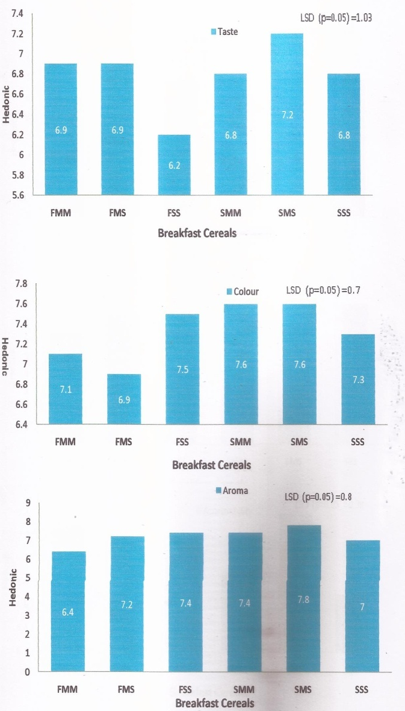
Fig 7: Sensory scores of the taste, colour and aroma of sorghum/millet breakfast cereal FMM = fermented millet, FMS = fermented millet and sorghum, FSS = fermented sorghum, SMM = sprouted millet, SMS = sprouted millet and sorghum, SSS = sprouted sorghum

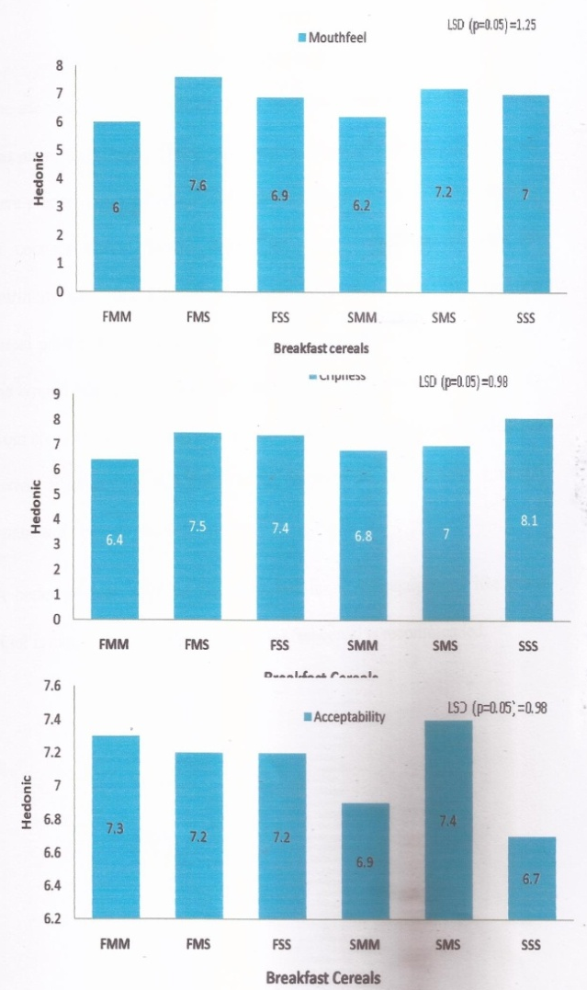
Fig 8: Sensory scores of the mouthfeel, crispness an acceptability of sorghum/millet breakfast cereal FMM = fermented millet, FMS = fermented millet and sorghum, FSS = fermented sorghum, SMM = sprouted millet, SMS = sprouted millet and sorghum, SSS = sprouted sorghum

4.0 Conclusion and Recommendation
The acceptability of coconut flavored breakfast cereal made in this research was interestingly high. This is encouraging, despite the fact that the products were prepared through improvised technology/equipment’s. The introduction of coconut natural flavour among the ingredients improved both nutritional and sensory parameters of the breakfast cereals. The breakfast cereal produced from a mixture of sprouted sorghum and millet grain gave the overall best product. Breakfast cereals popularly consumed are mainly from corn, wheat and rice grains, an affordable ready-to-eat cereal made from cereals like sorghum and millet could replicate the use of these common grains and be made more affordable.
This paper recommends that for better products, improved equipments should be used. Clinical testing of the breakfast cereal is recommended.

References
- Association of Official Analytical Chemist (1984): official method of analysis, 13th edition. Washington D.C.
- Association of Official Analytical Chemist (1995): official method of analysis, 16th edition. Washington D.C.
- Association of Official Analytical Chemist (2006): official method of analysis, 18th edition. Washington D.C.
- Bouvier, J. M., and Clextral, F. (2001). Breakfast cereals. Extrusion cooking technologies and applications. Woodhead Publishing Ltd. and CRC Press, Cambridge, UK, 133-160.
- Brandth, F.N.(2010): The history of breakfast cereal. Available at: http://www.battleby.com/achieve/breakfastcereal/history/info.com258711. As retrieved on 10th September, 2011.
- Caldwell, E.F.; Fast, R.B.; Laihoff, C. and Miller, R.C. (1990). Chapter 3. Unit Operations and equipment. I. Blending and cooking. In: Fast, R.B. and Caldwell, E.F (eds). Breakfast Cereals and How They Are Made. American Association of Cereal Chemists, Inc., St Paul, Minn.. Pp56-78.
- Chavan, J. K., Kadam, S. S., & Beuchat, L. R. (1989). Nutritional improvement of cereals by sprouting. Critical Reviews in Food Science & Nutrition, 28(5), 401-437.
- Fast, R.B. (1990). Manufacturing Technology of ready-to-eat cereal. Breakfast cereal and How They Are Made. American Association of Cereal Chemists Inc. 5:15-42.
- Fast, R.B.; Lauhoff, G.H.; Taylor, D.D and Getgood, S.J. (1990_{a}). flaking ready to-eat breakfast cereals. Cereal Foods World 35:295-298.
- Fast, R.B.; Shouldice, F.J; Thompson, W.J.; Taylor, D.D. and Getgood, S.J. (1990_{b}). Toasting and toasting ovens for breakfast cereals. Cereal Foods World. 35:299-310.
- Iwe, M. O. (2002). Handbook of sensory methods and analysis. PROJOINT Communications Services Ltd, Enugu, 70-72.
- Kazanas, N. and Fields, M. L. (1981). Nutritional improvement of sorghum by fermentation. Journal of Food Science, 46(3), 819-821.
- Kent, N. (1995). Technology of Cereals.An Introduction for Students of Food Science and Agriculture. 3rd ed. Pergamon Press, New York.
- Le Heron, K., & Hayward, D. (2002). The moral commodity: production, consumption, and governance in the Australasian breakfast cereal industry. Environment and Planning A, 34(12), 2231-2251.
- Malzahn, W. (1974). U.S. Patent No. 3,852,491. Washington, DC: U.S. Patent and Trademark Office.
- Michodjehoun-Mestres, L., Hounhouigan, J. D., Dossou, J., & Mestres, C. (2005). Physical, chemical and microbiological changes during natural fermentation of" gowé", a sprouted or non sprouted sorghum beverage form West-Africa. African Journal of Biotechnology, 4(6), 487-496.
- Narciyama, K.M and Rao, M.S.N. (1982). Functional Properties of raw and heat processed winged bean (Psophocarpustetragonolobus) flour. J. Food Sci. 47:1534-1538.
- Okaka, J. C., & Potter, N. N. (1996). Physico‐chemical and functional properties of cowpea powders processed to reduce beany flavor. Journal of Food science, 44(4), 1235-1240.
- Piggot, J.R. (1988). Scaling and Ranking Methods In: Sensory Analysis of Food (2nd Ed). Elservicee. Science pub. Ltd, England. Pp 156-7, 169-171.
- Potter, N., and Hotchkiss, J. (1996). Food Science, (5th edn).
- Schjønning, P. and Jacobsen, O. H., (1993). A laboratory calibration of time domain reflectometry for soil water measurement including effects of bulk density and texture. Journal of Hydrology, 151(2-4), 147-157.
- Seow, C. C., and Gwee, C. N. (1997). Coconut milk: chemistry and technology. International journal of food science & technology, 32(3), 189-201.

5/13/2017

