Clinical Comparative Study Of The Effects Of Intravenous Ondansetron And Granisetron On Hemodynamic Changes, Shivering, And Motor & Sensory Blockade Induced By Spinal Anesthesia In Women Undergoing Cesarean Section.

Mostafa Abu Bakr Megahed, Anis Mekhaimer Abdel Hady, Alaa El Deen Mahmoud Sayed and Mohamed Ali Mohamed.

¹Department of Anesthesiology and intensive Care, Faculty of Medicine, Al-Azhar University, Cairo, Egypt.
² Department of Obstetrics and gynecology, Faculty of Medicine, Al-Azhar University, Cairo, Egypt
sasa.elshewy@yahoo.com, alaa.deen.1965@gmail.com

Abstract: Background: Spinal anesthesia avoids the risks involved in managing the airway of the parturient. Hypotension, shivering, nausea and vomiting are frequent risks in patients undergoing cesarean delivery under spinal anesthesia, Prophylactic intravenous (i.v.) administration of serotonin receptor antagonists such as ondansetron and granisetron has been used to overcome this problems. Objective: This study evaluate the efficacy of intravenous ondansetron and granisetron on hemodynamics, shivering and motor & sensory block in pregnant female undergoing elective cesarean section under spinal anesthesia. Patient and Method: Sixty patients were assigned to three equal groups, group A received 4mg Ondansetron, group B received 1mg Granisetron and group C (control group) received 10ml normal saline 5min before spinal anesthesia. The incidence of hypotension, bradycardia, ECG changes, SaO2 changes, shivering, nausea and vomiting were recorded at baseline monitoring, intraoperative and postoperative. Also propagation and regression of motor and sensory block were assessed. Results: As regard mean arterial blood pressure, there was significant decrease in group C in comparison with group A & B. As regard incidence of shivering, nausea and vomiting there was significant difference between group C and both groups A & B, also there was significant difference as regard faster time to regression of sensory block in group B in comparison with group A & C. Conclusion: In pregnant females undergoing cesarean section under spinal anesthesia, prophylactic intravenous administration of 4mg ondansetron or 1mg granisetron 5min before induction of spinal anesthesia will be significantly reduce the severity of spinal-induced hypotension and reduce the incidence of nausea, vomiting and shivering. Regression of sensory block faster with granisetron more than ondansetron and normal saline.
[Mostafa Abu Bakr Megahed, Anis Mekhaimer Abdel Hady, Alaa El Deen Mahmoud Sayed and Mohamed Ali Mohamed. Clinical Comparative Study Of The Effects Of Intravenous Ondansetron And Granisetron On Hemodynamic Changes, Shivering, And Motor & Sensory Blockade Induced By Spinal Anesthesia In Women Undergoing Cesarean Section. N Y Sci J 2017;10(6):7-16]. ISSN 1554-0200 (print); ISSN 2375-723X (online). http://www.sciencepub.net/newyork. 2. doi:10.7537/marsnys100617.02.

Keywords: Cesarean section, ondansetron, granisetron, 5-HT3, spinal anesthesia.

1. Introduction
Maternal physiologic and anatomic changes that accompany pregnancy, as well as consideration of the developing fetus, influence the conduct of anesthesia during pregnancy. Physiologic changes associated with pregnancy may affect maternal safety during anesthesia. Fetal oxygenation depends on maternal oxygen carrying capacity, maternal cardiac output, and uteroplacental perfusion. Therefore, any interventions that compromise these factors may lead to fetal asphyxia (Puvanesarajah et al., 2016).
Spinal anesthesia is a popular technique for cesarean delivery as it is easy to perform and provides a rapid-onset, dense surgical block. It is not associated with maternal or fetal risk for toxicity to local anesthetics (Nag et al., 2015), but it is associated with hypotension and bradycardia, which may be deleterious to both parturient and baby (Hajian et al., 2017).
Hypotension results primarily from decreased vascular resistance, whereas bradycardia is secondary to a relative parasympathetic dominance, increased baroreceptor activity, or induction of the Bezold-Jarisch reflex (BJR) (Heesen et al., 2016).
The Bezold-Jarisch reflex (BJR) is one of the mechanisms, which explain the occurrence of hypotension after spinal anesthesia through serotonin with decreased blood volume (Arivumani & Ushadevi, 2016).
This study concentrated on two medications, which can minimize the occurrence of maternal hypotension after spinal anesthesia. They are ondansetron and granisetron selective 5-hydroxytryptamine 3 (5-HT3) receptor antagonists.
Moreover, 5-HT3 receptors are present also in the spine and have antinociceptive effect, which can be antagonized by selective 5-HT3 receptor antagonist (El Khouly & Meligy, 2016).
One of the aims of this study was to compare the effects of ondansetron and granisetron on sensory, and motor block after intrathecal hyperbaric bupivacaine in parturients undergoing cesarean sections.
Also postoperative nausea and vomiting (PONV) are common sequelae of general as well as regional anaesthesia and a leading cause of delayed discharge and unanticipated hospital admission after surgical procedure (Mattoo & Thosani, 2017).
Ondansetron and Granisetron are selective 5-hydroxytryptamine 3 (5-HT3) receptor antagonists which are used primary as strong antiernetics, and may be beneficial for preventing bradycardia and hypotension induced by spinal blockade (Marashi et al., 2014).
Another postanesthetic side effect is shivering. Postanesthetic shivering (PAS) was first described over fifty years ago with a worldwide incidence of 20-60% (Obasuyi et al., 2013). While patients find shivering very uncomfortable, it causes artifacts in monitors and increases postoperative pain, heart rate, cardiac output, oxygen consumption by fivefold and metabolic rate by 600% (Rupwate et al., 2016). This may lead to myocardial ischemia, hypoxaemia, hypercarbia and lactic acidosis that could complicate recovery from anaesthesia. Preventing postanaesthesia shivering may reduce morbidity and improve patient’s satisfaction (Kaushik et al., 2013).
Also serotonin (5-HT) is a critical thermoregulatory neurotransmitter, it decreases core temperature attenuation that triggers shivering (Khalifa, 2015).

2. Methodology
For this prospective, randomized, controlled, parallel-group, effectiveness study.
Patients aged between 20 to 40 years, with an ASA physical status of I–II, with GCS 15 were eligible if they were scheduled to undergo elective cesarean section under spinal anesthesia. Patients were excluded if have any of the following exclusion criteria:
1) Who refused to participate.
2) Had any contraindications to subarachnoid block.
3) Had a history of hypersensitivity to studied drugs.
4) Had a hypertensive disorders with pregnancy.
5) Were receiving selective serotonin reuptake inhibitors or migraine medications.
After approval of the departmental ethical committee, this study will be conducted from June 15, 2016 through February 22, 2017 at Al Azhar University hospitals on sixty parturient after signing a written informed consent.
Patients were randomly assigned to receive Ondansetron 4mg (Group A), Granisetron 1mg (Group B) or normal saline (Group C), each group contain 20 parturients. Study medications were prepared, presented as identical 10ml filled syringes and injected 5min before spinal anesthesia.
For eligible patients, demographic information was collected and a physical examination was performed. A standardized anesthesia regimen was followed. Age, weight, height, duration of surgery and ASA (I/II) were recorded and analyzed.
In the preoperative preparation room, nearly 500 ml crystalloid (lactated ringer's or normal saline 0.9%) given IV after insertion of IV 18 gauge cannula in non-dominant hand.
On arrival in the operating room, patients will be monitored for mean arterial blood pressure MAP, electrocardiogram & pulse oximeter and this become baseline monitoring.
After sterilization of the back, spinal anesthesia was induced at L3–L4, with the patient in the sitting position, with 2.5ml (12.5mg) of 0.5% hyperbaric bupivacaine after confirmation of free flow of cerebrospinal fluid through a 25-G Quincke spinal needle. The patients were then placed in the supine position with 15° left tilt.
Supplemental oxygen was administered via facemask at 4L/min. Maintenance fluids (10 ml/kg in the first one hour and 5ml/kg in the subsequent hours) were given at room temperature. Oxytocin was given following delivery of the fetus.
Hemodynamic data [mean arterial pressure (MAP), heart rate, oxygen saturation SaO2 and ECG changes], sensory block, motor block, nausea, vomiting and shivering were recorded at 2-min interval in the first 15-min and then every 15-min until the end of procedure.
Rescue i.v. bolus doses of 9mg ephedrine were given if the parturient became hypotensive (hypotension was defined as a decrease in MAP more than 20% from the baseline). Decrease in HR to less than 50 beat/min was treated with 0.5 mg atropine intravenous.
Rescue i.v. 10mg metoclopramide for vomiting episode and i.v. 25mg pethidine for shivering episode. Persistent pain sensation or movement of lower half was considered failed spinal anesthesia and patient anesthetized generally and excluded from the study.
The height of sensory blockade was assessed as the highest dermatome with loss of fine pinprick sensation at two consecutive times.
The time to two-segment regression and sensory regression to T10 and S1 were recorded and analyzed.
The Bromage scale (table 1) was used to evaluate motor block.
Sensory and motor recovery time will be noted, attacks of nausea & vomiting, attacks of shivering and hemodynamic monitoring (MAP, HR, SPO2 and ECG) will be recorded 30 min, 2, 4, 6, 12 and 24 hours postoperative.

Table (1): Bromage scale for grading of motor block (Ziyaeifard et al., 2014).
Grade | Criteria | Degree of block
I | Free movement of legs and feet | Nil (0)
II | Just able to flex knees with free movement of feet | Partial (33)
III | Unable to flex knees, but with free movement of feet | Almost complete (66)
IV | Unable to move legs or feet | Complete (100)

Statistical analysis
The Statistical Program SPSS for Windows, version 20, was used for data entry and analysis. Quantitative data were presented as mean and SD, whereas qualitative data were presented as frequency distribution. Analysis of variance was used to compare the means between groups, followed by post-hoc analysis. The χ2-test and Fisher’s exact test were used to compare between proportions.

3. Results
A total of 60 patients were selected, divided into three groups of 20 each. As regard demographic data (age, weight, height, procedure duration and ASA I/II) there were no significant differences between the three groups and as regard the basal monitoring (MAP, HR, SaO2, ECG, sensory block, motor block, nausea, vomiting and shivering) there were nonsignificant differences among three groups.
But as regards intraoperative MAP, there were significant decrease in group C compared with both groups A and B at 4, 6, 8, 10, 12 and 60min with P values 0.035, 0.003, 0.006, 0.005, 0.011 and 0.042 respectively (table 2). While there were nonsignificant differences between groups A and B as regard MAP.
As regard postoperative MAP, there were nonsignificant differences among the three group.

Table (2): Comparison between groups of study regarding MAP intra operative at 4, 6, 8, 10, 12 and 60min. P > 0.05: Non significant, P < 0.05: Significant, P < 0.01: Highly significant.
MAP | Group A  (Ondansetron) (N0.=20) |  | Group B  (Granisetron) (N0.=20) |  | Group C  (Normal saline) (N0.=20) |  | One way ANOVA
 | Mean | SD | Mean | SD | Mean | SD | F | P-value
Intra operative monitoring
4 min | 75.20 | 6.75 | 75.65 | 7.22 | 70.45 | 6.54 | 3.564 | 0.035
6 min | 74.80 | 7.67 | 73.40 | 7.10 | 67.05 | 7.04 | 6.445 | 0.003
8 min | 71.95 | 7.75 | 72.10 | 7.17 | 65.05 | 7.94 | 5.557 | 0.006
10 min | 72.05 | 9.59 | 71.65 | 8.66 | 62.95 | 10.43 | 5.754 | 0.005
12 min | 70.35 | 8.37 | 71.95 | 8.49 | 63.70 | 9.52 | 4.934 | 0.011
60 min | 75.80 | 7.73 | 74.25 | 8.12 | 69.75 | 7.13 | 3.357 | 0.042

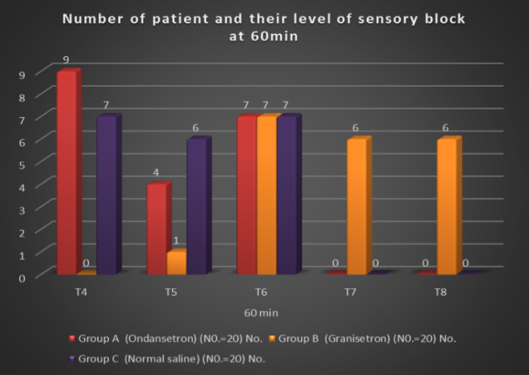
Figure (1): Level of sensory block at 60 min intraoperative regarding study groups.

As regard heart rate, oxygen saturationand ECG, there were no significant differencesamong the three groups.
As regard the maximum cephalad spread of sensory block, there were no significant differences.
At 60min intraoperative there was significant regression in sensory block in group B faster than both groups A and C, p value <0.001(figure 1).
At 1:30hr, 2:00hr and 4:00hr there were significant regression in sensory block in group B faster than both groups A and C, p value <0.001 (figure 2).

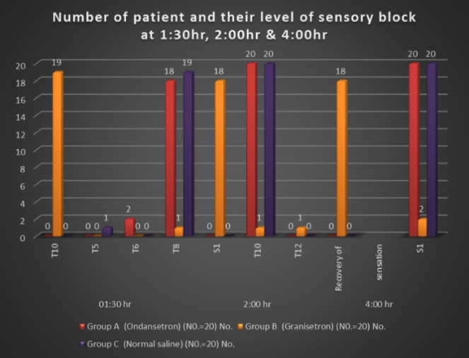
Figure (2): Sensory block at 1:30hr, 2:00hr and 4:00hr postoperative regarding study groups.

On the other hand, there were significant difference as regard time to two segment regression and regression to T10, and S1 were faster in group B than groups A and C, p value <0.05, but no significant differences found between groups A and C (table 3).
While there was no significant difference between group A & C as regard sensory regression.
As regard motor block, there were no significant differences among the three groups in the time to maximum motor block and the time to complete motor recovery.
As regard nausea, there were significant increase of incidence of nausea in group C compared with both group A and B at 14min, 30min intraoperative and 1:30hr postoperative with p values 0.046, 0.042 and 0.017 respectively (figure 3). While there was no significant difference between group A & C as regard nausea.
Also the total number of patient in group C had nausea episodes is 11/20 (55%) but in group A is 4/20 (20%) and group B is 3/20 (15%).

Table (3): Comparison between times of regression of sensory block as regard groups of study, P > 0.05: Non significant, P < 0.05: Significant, P < 0.01: Highly significant.
Time to level of regression (min) | Group A  (Ondansetron) (N0.=20) |  | Group B  (Granisetron) (N0.=20) |  | Group C  (Normal saline) (N0.=20) |  | One way ANOVA
 | Mean | SD | Mean | SD | Mean | SD | F | P-value
to T6 | 35.45 | 22.03 | 28.94 | 19.93 | 35.33 | 21.74 | 0.49 | <0.05
to T8 | 50.85 | 43.55 | 38.11 | 30.67 | 51.06 | 42.91 | 0.45 | <0.05
to T10 | 62.51 | 29.75 | 47.9 | 25.57 | 61.22 | 39.75 | 0.42 | <0.05
To S1 | 198.4 | 31.63 | 132.4 | 36.94 | 197.5 | 32.74 | 0.56 | <0.05

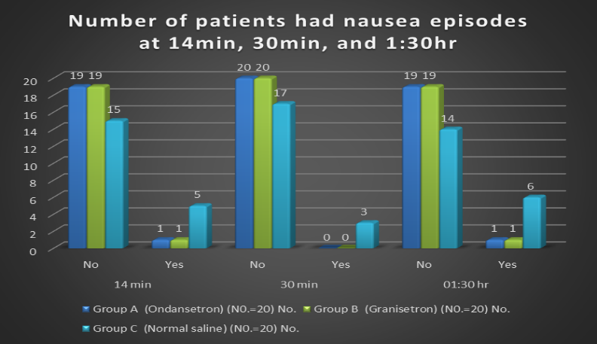
Figure (3): Nausea at 14, 30 min (intraoperative) and 1:30 hr (postoperative) regarding study groups.

As regard vomiting, there was significant increase in incidence of vomiting in group C compared with both group A and B at 30min, 45min intraoperative and 2:00hr postoperative with p values 0.003, 0.020 and 0.002 respectively (figure 4). While there was no significant difference between group A & C as regard vomiting.
Also the total number of patient in group C had vomiting episodes is 11/20 (55%) but in group A is 4/20 (20%) and group B is 3/20 (15%).

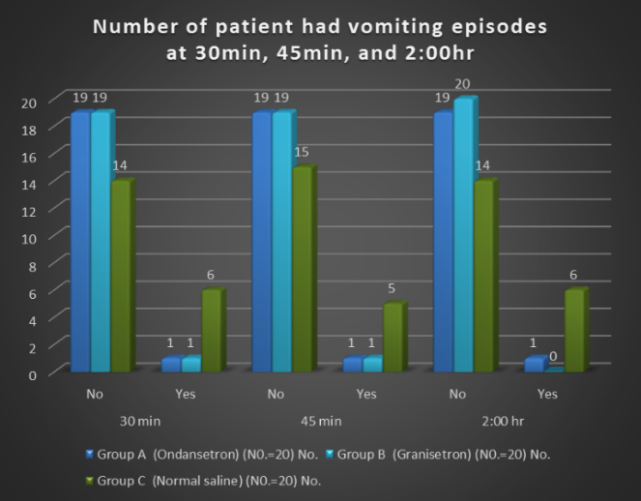
Figure (4): Vomiting at 30, 45 min (intraoperative) and 2:00 hr (postoperative) regarding study groups.

As regard shivering, there was significant increase of incidence of shivering in group C and both group A and B at 30min, 60min intraoperative and 2:00hr postoperative with p values 0.042, 0.003, and 0.043 respectively (figure 5). While there was no significant difference between group A & C as regard shivering.
Also the total number of patient in group C had nausea episodes is 13/20 (65%) but in group A is 2/20 (10%) and group B is 2/20 (10%).

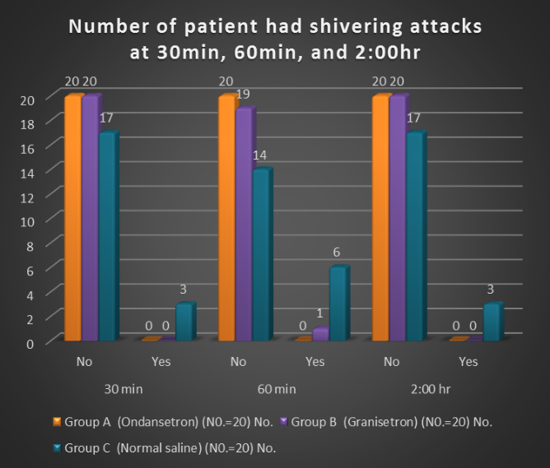
Figure (5): Shivering at 30min, 60 min (intraoperative) and 2:00hr (postoperative) regarding study groups.

4. Discussion
As regard hemodynamics, spinal anesthesia for cesarean section may cause hypotension, which can jeopardize the fetus and the mother (Klöhr et al., 2010). Prevention of maternal hypotension during spinal anesthesia may result in better outcomes compared with that following treatment after it has occurred (Khan et al., 2013).
In the present study, two 5-HT3 antagonists, ondansetron and granisetron, as they block the BJR and may successfully treat postspinal hypotension, were used prophylactically and given 5 min before spinal blockade.
Khalifa, (2015) studied 80 parturients who received either granisetron 1mg, ondansetron 4mg, ephedrine 10mg or 10ml normal saline. They concluded that in the cesarean section, prophylactic use of i.v. granisetron, ondansetron, or ephedrine reduced the severity of spinal-induced hypotension, nausea, and vasopressor need.
The important finding in this study is that, despite the reduction in mean blood pressure in the two therapeutic groups, it still less than that in group C, with significant difference recorded. Although nonsignificant differences in heart rate were observed between the groups at any time of study duration with higher rates noticed in groups A and B.
Oxygen saturation (SaO2) and ECG were closely similar in three groups with nonsignificant differences in SaO2 and nonapplicable results as regard ECG in all groups.
These findings agree with those of Marashi et al. (2014) who observed that the administration of two different doses of intravenous ondansetron, 6 mg and 12 mg, significantly attenuates spinal induced hypotension, bradycardia and shivering compared to the control saline group. However, the hemodynamic profiles and shivering in experimental groups were not statistically different.
Eldaba and Amr, (2015) showed that administration of 1 mg of granisetron at 5 minutes before spinal anesthesia can reduce significantly the incidence of hypotension in these patients in comparison with placebo (normal saline). Moreover, they also reported that the dosages of ephedrine and atropine in the granisetron group were significantly lower than those of the placebo group.
Trabelsi et al. (2015) showed in their study that prophylactic ondansetron had a significant effect on the incidence of hypotension in healthy parturients undergoing spinal anesthesia with bupivacaine and sufentanil for elective caesarean delivery.
Further, in the study Arivumani & Ushadevi, (2016) administration of intravenous Ondansetron 4mg given 5 minutes prior to spinal anesthesia significantly reduces the hypotension. The episodes of bradycardia as well as the requirement of vasopressors in parturients were low in ondansetron group, which was found to be statistically insignificant, may be due to less number of study population.
Jarineshin et al. (2016) believed that their findings show the preventive effect of ondansetron on serotonin-induced BJR, reduction of vasodilation, and improvement of venous return, leading to less reduction in DBP and MAP. The blockade of 5-HT3 receptors inhibits serotonin-induced BJR.
In contrast to the present study, Mowafi et al. (2008) found that i.v. granisetron administration had no effect on hemodynamic variables. In addition, the study by Ortiz-Gómez et al. (2014)showed that prophylactic ondansetron at 2, 4, or 8 mg i.v. had little effect on the incidence of hypotension in healthy parturients undergoing spinal anesthesia with bupivacaine and fentanyl for elective cesarean delivery.
Shrestha et al. (2015) concluded that granisetron given intravenously does not decrease the incidence of hypotension and bradycardia following subarachnoid block in patients undergoing lower abdominal surgery. However, it attenuates the fall of diastolic and mean arterial pressure spinal anesthesia.
As regard motor and sensory block, on evaluating the effect of the studied drugs on motor and sensory blockade, the groups were not significantly different considering the motor block or recovery.
Also, no difference were found regarding onset of upper sensory blockade, however, faster recovery of the sensory blockade was found in the granisetron group.
The important finding in this study is that IV granisetron administration before spinal bupivacaine results in a faster recovery of the sensory blockade. On the contrary, the offset of motor blockade was similar in all groups.
Granisetron, in contrast to ondansetron, which acts on mixed receptors, strongly and selectively binds to the 5-HT3 receptors with minimal or no affinity for other 5-HT receptors, or dopaminergic, adrenergic, histaminic, and opioid receptors (Lummis & Thompson, 2013). Additionally, it has minimal adverse effects and possible drug interactions (Aapro, 2004).
The electrophysiologic and behavioral studies in animals have clarified the antinociceptive mechanisms of the descending serotonergic system at the spinal cord level (Yoshimura & Furue, 2006).
It directly hyperpolarizes the membrane of substantia gelatinosa neurons, inhibits the excitatory transmitter, glutamate release from A and C afferent fibers presynaptically and increases the inhibitory transmitters release including aminobutyric acid and glycine from the interneurons (Song et al., 2009).
These findings agree with prior studies by Khalifa, (2015), Mowafi et al. (2008) and Rashad and Farmawy, (2013) as they concluded that i.v. granisetron facilitated the recovery of sensory block after bupivacaine subarachnoid anesthesia.
Kasem, (2016) found that administration of 1mg of granisetron before spinal anesthesia in ambulatory surgeries resulted in a statistically faster sensory regression and earlier home discharge from the day-surgery unit.
Marashi et al. (2014) did not observe any significant changes in sensory block on using two different doses of ondansetron. Further, Samra et al. (2011) concluded that i.v. ondansetron does not affect the intensity or duration of sensory and motor block after spinal anesthesia with hyperbaric bupivacaine.
Soltani et al. (2015) investigate granisetron on patient undergoing cystoscopy under spinal anesthesia and found that systemic granisetron had no effect on the duration of sensory and motor block produced by spinal anesthesia with hyperbaric bupivacaine.
In contrast, Fassoulaki et al. (2005) reported that ondansetron antagonizes the sensory block, but they used hyperbaric lidocaine in their study.
As regard nausea and vomiting, nausea and vomiting are common and sometimes dangerous side effects following surgery. Most of the incidence of nausea and vomiting occur during the first two hours of recovery from anesthesia. The etiology of postoperative nausea and vomiting is multi-factorial (Karmakar et al., 2014).
Nausea and vomiting during regional anesthesia for cesarean section is relatively high without prophylactic antiemetic. The etiology of emetic symptoms in these cases is complex (Griffiths et al., 2012).
Maternal hypotension after induction of spinal anesthesia may trigger the vomiting center to induce emesis due to hypoxia (Tong, 2006).
Janelsins et al. (2013) in their study to prevent nausea and vomiting following cancer chemotherapy concluded that both ondansetron and granisetron have similar antiemetic efficacy but dose of granisetron is much less than ondansetron.
We have therefore studied the effects of ondansetron and granisetron in nausea and vomiting in cesarean deliveries under spinal anesthesia and found that the two studied drugs reduced the ephedrine requirement and decreased significantly the incidence of nausea and vomiting.
As granisetron and ondansetron are used primarily for prophylaxis or treatment of postoperative nausea and vomiting, many studies support our results in this aspect, Schwartzberg et al. (2014) concluded that both granisetron and ondansetron have similar antiemetic efficacy for prophylaxis of chemotherapy-induced nausea and vomiting.
Norowzi et al. (2013) reported significantly lower frequency of nausea and vomiting in Ondansetron group than Normal saline group. Entezariasl et al. (2011) reported no incidence of nausea and vomiting among Ondansetron group.
Babu and Penchalaiah, (2015) in their study concluded that injection of Granisetron in a dose of 1 mg. I.V. is much more effective in minimizing severe nausea and vomiting than ondansetron in a dose of 4 mg. I.V. and is free from the side effect headache which is a drawback of ondansetron.
Makker et al. (2017) concluded that in the early postoperative period both Ondansetron and Granisetron are equally effective in preventing postoperative nausea and vomiting in patients undergoing gynecological surgery under spinal anesthesia.
In contrast, Jabalameli et al. (2012) concluded that the most effective method for prevention of hypotension was administration of crystalloid preload plus ephedrine, but there was no significant effect on the severity of nausea.
Also Daria & Kumar, (2012) in their study on laparoscopic gynecological surgery under general anesthesia found that the success rate in the prevention of PONV is poor in Ondansetron & Granisetron (nearly two-third, 63.3% & 66.7% respectively) and very good in combination of Ondansetron & Granisetron with Dexamethasone (90% in both).
As regard shivering, postoperative shivering reportedly complicates emergence from anesthesia in 5% to 60% of cases (Sagir et al., 2007).
Opioid and non-opioid drugs are often used to treat postoperative shivering, but they have potential side effects, including hypotension, hypertension, sedation, respiratory depression, nausea and vomiting (Kayalha et al., 2014).
Ondansetron and granisetron, which are 5-HT3-receptor antagonists, have been used effectively to decrease postanesthetic shivering. The mechanism for 5-HT3- receptor antagonists is still unclear but is thought to be related to inhibition of serotonin reuptake on the preoptic anterior hypothalamic region (Kim et al., 2010).
On evaluating the occurrence of shivering, it was found that all of the studied drugs reduced shivering in comparison with the placebo group, and presence of more anti shivering effect with granisetron than ondansetron without significant difference.
These results are supported by the findings of Iqbal et al. (2009) in which prophylactic use of granisetron (40 μg/kg) and pethidine (25 mg) i.v. was effective in preventing postoperative shivering.
Our results were also similar to the findings of Shakya et al. (2010) who suggested that the prophylactic administration of low dose ketamine 0.25mg/kg and ondansetron 4mg produces significant antishivering effect in comparison with placebo in patients undergoing spinal anesthesia and that ketamine 0.25 mg/kg is significantly more effective than ondansetron (4 mg).
Moreover Shah et al. (2016) in study done on efficacy of IV ondansetron for prevention of shivering in spinal anesthesia administered in elderly patients concluded that Intravenous administration of 08 mg of Intravenous Ondansetron prior to subarachnoid block, is effective in decreasing frequency of shivering.
Abotaleb et al. (2016) in study compared between dexmedetomidine and granisetron for the management of postspinal shivering and found granisetron 2mg effectively reduce postspinal shivering without any major adverse effects.
Also Kabade et al. (2016) obtained that Prophylactic granisetron 40 µg/kg IV is as effective as pethidine 0.4 mg/kg IV in preventing perioperative shivering following spinal anesthesia and also reduces the need of antiemetics.
Tie et al. (2014) obtained that Ondansetron has a preventive effect on post anesthetic shivering without a paralleled side effect of bradycardia.
In contrast with our study results Sayed & Ezzat, (2014) in their study showed that preoperative intravenous granisetron for shivering prophylaxis in cesarean section under spinal anesthesia did not significantly reduce the incidence or severity of shivering.
Also Browning et al. (2013) concluded that intravenous ondansetron 8mg prior to performing combined spinal epidural anesthesia in women undergoing elective cesarean delivery does not decrease the incidence or severity of shivering.

Conclusion
In female parturients undergoing lower uterine cesarean section (LUCS) under spinal anesthesia, prophylactic intravenous administration of 4mg ondansetron or 1mg granisetron 5min before induction of spinal anesthesia will be significantly reduce the severity of spinal-induced hypotension in addition to the need for rescue vasopressor.
Ondansetron and granisetron reduce the incidence of nausea, vomiting and shivering, and due to their hemodynamic stability, lack of significant side effects and better patient satisfaction they preferred to another anti-emetic and anti-shivering drugs.
Another finding as regard sensory block, there was significant faster recovery of sensory block was noticed with granisetron compared to both the ondansetron and saline groups, with no significant differences between the latter two groups, so granisetron may be useful in day case surgery and faster departure of patients.

Financial support and sponsorship
Nil.

Conflicts of interest
There are no conflicts of interest.

References
- Aapro, M. (2004). Granisetron: an update on its clinical use in the management of nausea and vomiting. Oncologist, 9: 673–86.
- Abotaleb, U. I., Abdalla, A. M., Abdelrahman, A. S., Gad, G. S., & Elsayed, A. M. (2016). Dexmedetomidine versus granisetron for the management of postspinal shivering. Ain-Shams Journal of Anaesthesiology, 9(4), 517.
- Arivumani, T. A., & Ushadevi, G. (2016). Evaluation of the effects of prespinal administration of Ondansetron on maternal hemodynamics. International Journal of Medical Research and Review, 4(05). Review and Meta-analysis and Meta-regression. Anesthesia & Analgesia, 123(4), 977-988.
- Babu, N. J., & Penchalaiah, C. (2015). A Comparative Study Of The Efficacy Of Granisetron And Ondansetron In The Prevention Of Post-Operative Nausea And Vomiting In LSCS Patients Under Spinal Anaesthesia. Journal of Evidence based Medicine and Healthcare; Volume, 2(34), 5293-5301.
- Browning, R. M., Fellingham, W. H., O’Loughlin, E. J., Brown, N. A., & Paech, M. J. (2013). Prophylactic ondansetron does not prevent shivering or decrease shivering severity during cesarean delivery under combined spinal epidural anesthesia: a randomized trial. Regional anesthesia and pain medicine, 38(1), 39-43.
- Daria, U., & Kumar, V. (2012). Qualitative comparison of Metoclopramide, ondansetron and granisetron alone and in combination with dexamethasone in the prevention of postoperative nausea and vomiting in day care laparoscopic surgery under general anaesthesia. Asian J. Pharm. 5: 165-167.
- El Khouly, N. I., & Meligy, A. M. (2016). Randomized controlled trial comparing ondansetron and placebo for the reduction of spinal anesthesia-induced hypotension during elective cesarean delivery in Egypt. International Journal of Gynecology & Obstetrics, 135(2), 205-209.
- Eldaba, A. A., & Amr, Y. M. (2015). Intravenous granisetron attenuates hypotension during spinal anesthesia in cesarean delivery: A double-blind, prospective randomized controlled study. Journal of anaesthesiology, clinical pharmacology, 31(3), 329.‏
- Entezariasl, M., Isazadefar, K., Mohammadian, A., & Khoshbaten, M. (2011). Ondansetron and meperidine prevent postoperative shivering after general anesthesia. Middle East journal of anaesthesiology, 21, 67-70.
- Fassoulaki, A., Melemeni, A., Zotou, M., & Sarantopoulos, C. (2005). Systemic ondansetron antagonizes the sensory block produced by intrathecal lidocaine. Anesthesia & Analgesia, 100(6), 1817-1821.‏
- Griffiths, J. D., Gyte, G. M., Paranjothy, S., Brown, H. C., Broughton, H. K., & Thomas, J. (2012). Interventions for preventing nausea and vomiting in women undergoing regional anaesthesia for caesarean section. The Cochrane Library.‏
- Hajian, P., Nikooseresht, M., & Lotfi, T. (2017). Comparison of 1-and 2-Minute Sitting Positions versus Immediately Lying Down on Hemodynamic Variables after Spinal Anesthesia with Hyperbaric Bupivacaine in Elective Cesarean Section. Anesthesiology and Pain Medicine, (In press).
- Iqbal, M. S., Ishaq, M., Masood, A., & Khan, M. Z. (2010). Optimal dose of prophylactic intravenous ephedrine for spinal-induced hypotension during cesarean section. Group, 1(30), 27-2.‏
- Jabalameli, M., Soltani, H. A., Hashemi, J., Behdad, S., Soleimani, B. (2012). Prevention of post-spinal hypotension using crystalloid, colloid and ephedrine with three different combinations: a double blind randomized study. Adv. Biomed Res. 1:36.
- Janelsins, M. C., Tejani, M. A., Kamen, C., Peoples, A. R., Mustian, K. M., & Morrow, G. R. (2013). Current pharmacotherapy for chemotherapy-induced nausea and vomiting in cancer patients. Expert opinion on pharmacotherapy, 14(6), 757-766.‏
- Jarineshin, H., Fekrat, F., & Kashani, S. (2016). Effect of Ondansetron in Prevention of Spinal Anesthesia-Induced Hypotension in Pregnant Women Candidate for Elective Cesarean Section. Journal of Current Research in Science, 4(1), 57.
- Kabade, S. D., Venkatesh, Y., Karthik, S., & Kumar, V. (2016). Comparative study of granisetron versus pethidine for the prevention of perioperative shivering under spinal Anesthesia. Karnataka Anaesthesia Journal, 2(1), 14.‏
- Karmakar, K. K., Sarker, P. C., Islam, M. M., Begum, R., Wadud, M. M. A., Ali, N. P., & Alam, A. B. M. M. (2014). Effect of peroperative use of granisetron and ondansetron on postoperative nausea and vomiting–a comparative study. Journal of the Bangladesh Society of Anaesthesiologists, 24(1), 18-22.‏
- Kasem, A. (2016). The role of granisetron in the enhancement of recovery and home discharge in ambulatory surgery performed under spinal anesthesia. Ain-Shams Journal of Anaesthesiology, 9(3), 366.
- Kaushik, N. K., Kaushik, N., Attri, P., Kumar, N., Kim, C. H., Verma, A. K., & Choi, E. H. (2013). Biomedical importance of indoles. Molecules, 18(6), 6620-6662.
- Kayalha, H., Roushanfekr, M. G., and Ahmadi, M. (2014). The comparison of ondansetron and meperidine to prevent shivering after anesthesia in patients undergoing lower limb orthopedic surgeries with general anesthesia. Journal of Zanjan University of Medical Sciences and Health Services. 22: 14–22.
- Khalifa, O. S. M. (2015). A comparative study of prophylactic intravenous granisetron, ondansetron, and ephedrine in attenuating hypotension and its effect on motor and sensory block in elective cesarean section under spinal anesthesia. Ain-Shams Journal of Anesthesiology, 8(2), 166.‏
- Khan, M., Nisai-ul-Waqar, Farooqi, A., Ahmad, N., & Qaz, S. (2013). Crystalloid coload: a better option than crystalloid pre-load for prevention of postspinal hypotension in elective cesarean section. Internet J Anesthesiol. 32: 1.
- Kim, M. S., Kim, D. W., Woo, S. H., Yon, J. H., & Lee, S. (2010). Effect of ramosetron on shivering during spinal anesthesia. Korean J. Anesthesiol. 58:256-9.
- Klöhr, S., Roth, R., Hofmann, T., Rossaint, R., & Heesen, M. (2010). Definitions of hypotension after spinal anesthesia for cesarean section: literature search and application to parturient. Acta Anaesthesiol. Scand. 54:909– 921.
- Lummis, S. C., & Thompson, A. J. (2013). Agonists and antagonists induce different palonosetron dissociation rates in 5-HT 3 A and 5-HT 3 AB receptors. Neuropharmacology, 73, 241-246.‏
- Makker, R., Bhardwaj, A., Singh, A. P., & Anand, A. (2017). Comparative efficacy of ondansetron versus granisetron to prevent perioperative nausea and vomiting in patients undergoing gynaecological surgery under spinal anaesthesia. Int. J. Med. and Dent. Sci. 6(1):1371-1375.
- Marashi, S. M., Soltani-Omid, S., Mohammadi, S. S., Aghajani, Y., & Movafegh, A. (2014). Comparing two different doses of intravenous ondansetron with placebo on attenuation of spinal-induced hypotension and shivering. Anesthesiology and pain medicine, 4: e12 055.
- Mattoo, J., & Thosani, R. (2017). Comparative study of ondansetron, granisetron and ramosetron in prevention of postoperative nausea and vomiting. Indian Journal of Applied Basic Medical Sciences, 19(28), 51-66.
- Mowafi, H. A., Arab, S. A., Ismail, S. A., & Al-Ghamdi, A. (2008). The effects of intravenous granisetron on the sensory and motor blockade produced by intrathecal bupivacaine. Anesth. Analg. 106:1322–5.
- Nag, D. S., Samaddar, D. P., Chatterjee, A., Kumar, H., & Dembla, A. (2015). Vasopressors in obstetric anesthesia: A current perspective. World journal of clinical cases, 3(1), 58-64.
- Norowzi, A., Jamilian, M., Khalili, M., Kamali, A., & Melikoof, L. (2013). Comparing the effect of oral and parentral ondansetrone in attenuating nausea and vomiting after cesarean section under spinal anesthesia. Mejele Daneshgaheh Oloom Pezeshki Erak, 16, 8-13.
- Obasuyi, B. I., Fyneface-Ogan, S., & Mato, C. N. (2013). A comparison of the haemodynamic effects of lateral and sitting positions during induction of spinal anaesthesia for caesarean section. International journal of obstetric anesthesia, 22(2), 124-128.
- Ortiz-Gómez, J. R., Palacio-Abizanda, F. J., Morillas-Ramirez, F., Fornet-Ruiz, I., Lorenzo-Jiménez, A., & Bermejo-Albares, M. L. (2014). The effect of intravenous ondansetron on maternal haemodynamics during elective caesarean delivery under spinal anaesthesia: a double-blind, randomised, placebo-controlled trial. International journal of obstetric anesthesia, 23(2), 138-143.
- Puvanesarajah, V., Spiker, A. M., Shannon, B. A., Grundy, M., Levin, A. S., & Morris, C. D. (2016). Evaluation and management of the pregnant patient with suspected primary musculoskeletal tumor or metastatic carcinoma to bone. Surgical Oncology, 25(3), 212-222.
- Rashad, M. M., & Farmawy, M. S. (2013). Effects of intravenous ondansetron and granisetron on hemodynamic changes and motor and sensory blockade induced by spinal anesthesia in parturients undergoing cesarean section. Egyptian Journal of Anesthesia, 29(4), 369-374.‏
- Rupwate, K. R., Pardeshi, S. K., & Tendolkar, B. A. (2016). Prospective, randomized, double blind, placebo controlled clinical study to different doses of ketamine for prevention of shivering during spinal anaesthesia. International Journal of Basic & Clinical Pharmacology, 5(5), 1866-1876.
- Sagir, O., Gulhas, N., Toprak, H., Yucel, A., Begec, Z., & Ersoy, O. (2007). Control of shivering during regional anaesthesia: Prophylactic ketamine and granisetron. Acta Anaesthesiol Scand. 51:44-9.
- Samra, T., Bala, I., Chopra, K., & Podder, S. (2011). Effect of intravenous ondansetron on sensory and motor block after spinal anaesthesia with hyperbaric bupivacaine. Anaesthesia and intensive care, 39(1), 65.
- Sayed, A. M., & Ezzat, S. M. (2014). Preoperative granisetron for shivering prophylaxis in cesarean section under spinal anesthesia. Ain-Shams Journal of Anaesthesiology, 7(2), 151.
- Schwartzberg, L., Barbour, S. Y., Morrow, G. R., Ballinari, G., Thorn, M. D., & Cox, D. (2014). Pooled analysis of phase III clinical studies of palonosetron versus ondansetron, dolasetron, and granisetron in the prevention of chemotherapy-induced nausea and vomiting (CINV). Supportive Care in Cancer, 22(2), 469-477.‏
- Shah, S. A. R. A., Abbas, M. A., & Naqvi, S. S. (2016). Efficacy Of Intravenous Ondansetron For Prevention Of Shivering In Spinal Anaesthesia Administered In Elderly Patients. Editorial Advisory Board, 66, 91.
- Shakya, B., Chaturvedi, A., & Sah, B. P. (2010). Prophylactic low dose ketamine and ondansetron for prevention of shivering during spinal anaesthesia. Journal of Anaesthesiology Clinical Pharmacology, 26(4), 465.‏
- Shrestha, B. K., Acharya, S. P., & Marhatta, M. N. (2015). Use of Granisetron for prevention of hypotension and bradycardia due to spinal anesthesia: A double blind randomised control trial. Journal of Society of Anesthesiologists of Nepal, 1(1), 36-39.‏
- Soltani-Mohammadi, S., Esmaeili, S., & Saliminia, A. (2015). Effect of Systemic Granisetron in the Clinical Course of Spinal Anesthesia with Hyperbaric Bupivacaine for Outpatient Cystoscopy. Academic Journal of Surgery, 1(3), 87-91.
- Song, Z., Ultenius, C., Meyerson, B. A., & Linderoth, B. (2009). Pain relief by spinal cord stimulation involves serotonergic mechanisms: an experimental study in a rat model of mononeuropathy. PAIN®, 147(1), 241-248.‏
- Tie, H. T., Su, G. Z., He, K., Liang, S. R., Yuan, H. W., & Mou, J. H. (2014). Efficacy and safety of ondansetron in preventing postanesthesia shivering: a meta-analysis of randomized controlled trials. BMC anesthesiology, 14(1), 12.‏
- Tong, J. (2006). Risk factors for postoperative nausea and vomiting. Anesth Analg. 102:1884–98.
- Trabelsi, W., Romdhani, C., Elaskri, H., Sammoud, W., Bensalah, M., Labbene, I., & Ferjani, M. (2015). Effect of ondansetron on the occurrence of hypotension and on neonatal parameters during spinal anesthesia for elective caesarean section: a prospective, randomized, controlled, double-blind study. Anesthesiology research and practice.
- Yoshimura, M., & Furue, H. (2006). Mechanisms for the antinociceptive actions of the descending noradrenergic and serotonergic systems in the spinal cord. J. Pharmacol. Sci. 101:107–17.
- Ziyaeifard, M., Azarfarin, R., & Golzari, S. E. (2014). A review of current analgesic techniques in cardiac surgery. Is epidural worth it? Journal of cardiovascular and thoracic research, 6(3), 133.

5/8/2017

