Effect of Malathion on Testicular Histology in Albino Mice and the Protective Effect of Vitamin E

Melebary, S.J.¹; Elnaggar, M.H.^{1,2}; Abu-Zinadah, O.A.¹; Kurdi, L.A.^{*1} and Algamdi, M.S.¹

¹Department of Biology, Faculty of Science; King Abdulaziz University, Jeddah, Saudi Arabia
²Department of Zoology, Faculty of Science, Suez Canal University, Ismailia, Egypt.
dr.lina_kurdi@hotmail.com

Abstract: The present study shed the light on the possible preventive effect of Vitamin E against the toxicity of malathion (MP), an organophosphate pesticide, on body and testes weight, morphometry of the testes and epididymis as well as histological structure of testes in albino mice. Mice were divided into six groups: control (C), Vitamin E-treated group (VE), Low dose malathion-treated group (LD), High dose malathion-treated group (HD), Low dose malathion plus Vitamin E-treated group (LD+VE), and High dose malathion plus Vitamin E-treated group (HD+VE). The obtained results showed that the treatments with LD and HD have caused highly significant decreases in the average body weight and both right and left testes ratio weights. Furthermore, light microscopic examination disclose that a month of malathion exposure was linked with necrosis and edema in seminiferous tubules and interstitial tissues. Decaying changes in the seminiferous tubules were also noted in mice that were treated with malathion and vitamin E but histopathological alteration were clement in interstitial tissues. Based on the observation it seems that vitamins E enhance malathion testicular toxicity but still remains un-preventive to a degree.
[Melebary, S.J.; Elnaggar, M.H.; Abu-Zinadah, O.A.; Kurdi, L.A. and Algamdi, M.S. Effect of Malathion on Testicular Histology in Albino Mice and the Protective Effect of Vitamin E. N Y Sci J 2017;10(5):97-105]. ISSN 1554-0200 (print); ISSN 2375-723X (online). http://www.sciencepub.net/newyork. 14. doi:10.7537/marsnys100517.14.

Key words: Malathion pesticide – Vitamin E - Testes – Antioxidant – Histology.

1. Introduction
In recent decades, the usage of pesticides has dramatically increased, and they have become familiar in many Saudi’s homes. The wide spread use of these products has greatly affected the environment and poses risks to human health. These concerns provided the starting point for this search.
According to the data provided by the World Health Organization (WHO), pesticides with significant ratio of insecticides claim 20,000 lives per year [1]. Public health safety is a major concern as Pesticides are found abundantly in the environment. Their contribution to mortality rate in developing countries is significant due to poor marketing practices that fail to uphold world class standards [2], [3].
Male reproductive system including testes, the accessory sex glands and the central nervous system (CNS) even the neuroendocrine system are susceptible to Insecticides [4]. In vitro or in vivo exposing to Insecticides may cause many problems in function of Sertoli cells or Leydig cells, and deactivate any stage of hormonal regulation in endocrine mechanisms (hormone synthesis, release, transport, storage, and clearance; receptor recognition and binding; thyroid function; and the CNS) [5].
According to the classification of the WHO, Class Ia belongs to extremely toxic OPs, Ib are highly toxic, Class II comprises moderately toxic, whereas Class III consists of mildly toxic OP compounds. In addition, there are also the deadly organophosphorus chemical weapons (OPWs), called nerve agents [6].
Malathion [S-1,2(bis-ethoxycarbonyl) etyl O,O-dimetylphosphorodithioate] is one of the organophosphate pesticides(OP) which is most widely utilized for farming and public health programs [7]. It is categorized as class III (slightly toxic) in terms of risk according to the WHO. It has been widely used since the 1950s. Beside its use as a pesticide, MP is registered for other uses on food and as an ingredient in shampoos for head lice [8]. Most products containing MP are used outdoors to fight insects specifically in agricultural places. It kills insects by attacking their nervous system and causing continuous signals that lead to death.
In one study, commercial malathion (96.6% purity) was injected in a single dose (250 mg/kg body). After 26 days, cytogenetic and genotoxic damage was noticed in cells [9].
In another study, malathion was given to rats orally and the results showed decrease in the weight of testes, seminal vesicle, epididymis and ventral prostate. Moreover, testicular and epididymal sperm density were minimized in rats treated with (MP). The level of testosterone was suppressed significantly. The study clearly showed a considerable toxic effect on the male reproductive cells in rats [10] and [11]. Another recent study concluded that the function and structure of reproductive cells in rats were seriously affected by toxicity of malathion. According to the study, exposure to malathion can cause serious damage to the testes and sperms. Malathion decreased both the sperms mobility and count and the results showed 80% negative fertility in all the pesticide treated rats. The infertility results on the findings were also confirmed by sperm DNA damage test [12].
Vitamin E (VE) (α-tocopherol) is one of the famous lipid soluble antioxidant and which prevents lipoproteins and cellular membranes from peroxidation [13]. Studies have appeared that (VE) changes free radical structure [14] and may reduce lipid peroxidation in body system [15]. It is a constituent of plasma membrane, effective antioxidant which can decline the toxic effects of reactive oxygen species (ROS) [16].
Malathion causes testicular toxicity if given in low dose but antioxidant vitamins C and E preventive properties help in sperm counts, morphology and motility. The combination of (MP) and vitamins C and E cause deterioration in seminiferous tubules but in the interstitial tissues milder histopathological effects were seen [17].
The current study focused on potential protective impact of (VE) against the poisonous effects of (MP) on reproductive cells of male mice.
Materials and Methodes
Malathion:
(Agrothion 57% EC) which is a commercial formulation of (MP) was bought from a local commercial market in Jeddah, Saudi Arabia and was utilized in this study. All other chemicals were obtained from Caymoan Chemical Co. (1180 E. Ellsworth Rd, Ann Arbor. MI, USA) and Sigma-Aldrich Chemicals Co. (St. Louis, Mo, USA).
Experimental Animals:
Male Swiss albino mice (WRS), weighing 36-40 g and 6-7 weeks of age, were selected from the Animal House of King Fahd Center of Medical Research King Abdulaziz University, Jeddah, Saudi Arabia. Mice acclimatized under controlled hygienic conditions and maintained at a temperature of 25±2°C, relative humidity of 50±5% and photoperiod at 12-h dark/light. During the experiment period the diet and water was offered and allowed ad libitum. It was ensured that experiments were carried out in accordance with ethical guidelines of the Animal Care and Use Committee of King Abdulaziz University.
Acute toxicity experiment:
For estimating the LD₅₀ of malathion, 50 male mice (WRS strain) were divided into five groups of 10. Graded doses of (MP) were administered through stomach tube. Logs were recorded after observing the Toxic symptoms and quantity of mice that died after 48 hrs duration in each group. The LD₅₀ of malathion was then calculated per the method in [18]. In this study, the toxicity of malathion in mice (WRS strain) was calculated to determine lethal and sub lethal doses LD₅₀. For malathion, the LD₅₀ was 775 mg/kg b.w.
Experimental design:
The 120 mice were distributed into six main groups each with 20 mice:
- Control group (C): Mice received distilled water through gastric intubations daily for 30 days.
- Vitamin E treated group (VE): Mice orally administered (200 mg/kg b.w.) of Vitamin E by using the stomach tube once a day for 30 days.
- Low dose malathion treated group (LD): Mice were orally administered ¹/₁₀₀LD₅₀ of malathion (7.75 mg/kg b.w.) by using the stomach tube once a day for 30 days.
- High dose malathion treated group (HD): Mice were orally administered ¹/₁₀LD₅₀ of malathion (77.5 mg/kg b.w.) by using the stomach tube once a day for 30 days.
- Low dose malathion + Vitamin E treated group (LD+VE): Mice orally administered ¹/₁₀₀LD₅₀ of Malathion (7.75 mg/kg b.w.) then given (200 mg/kg b.w.) of Vitamin E by using the stomach tube once a day for 30 days.
- High dose malathion + Vitamin E treated group (HD+VE): Mice orally administered ¹/₁₀LD₅₀ of malathion (77.5 mg/kg b.w.) then given (200 mg/kg b.w.) of Vitamin E by using the stomach tube once a day for 30 days.
Body Weight Determinations
The body weights of mice were measured at the beginning and at the end of the experimental period, after 30 days, using a digital balance from (OHAUS, Model: Scout Pro SPU601, Made in China). These weights were measured during the morning at the same time [19].
Weight Changes of Testes
After 30 days, the right and left testes were carefully extracted and weighted for the assessment of their ratios to body weight. The following equation: (Organ Weight100) / Body Weight was used to calculate the ratio [20].
Histopathological Examinations
At the end of the experiment (30 days), mice were anesthetized using ether, the testes were carefully extracted and washed by distilled water to prepare for examination under the light and electron microscopy for identification of any histopathological changes. The collected testes were immediately fixed in 10% formalin, dehydrated by ascending grades of isopropyl alcohol, and then embedded in paraffin blocks. Sections of 4 μm were prepared and stained with hematoxylin and eosin [21]. Testes sections were examined using light microscope (Olympus BX51- USA) connected to motorized controller unit (Olympus Bx-Ucb- USA) and photographed by a camera (Olympus DP72- USA) in the microscope unit at King Fahd Medical Research Center.
Statistical analysis:
The data were statistically analyzed with completely randomized design by using the Statistical Package for Social Sciences (SPSS for windows, version 12.0). Significant differences between treatments were tested with Student’s t-test and (ANOVA) analysis [22].

3. Results
Evaluation of body weights and testes weight ratios in different groups:
Treatment with Vitamin E (VE):
Vitamin E (VE) treatment resulted in a significant increase in body weight (41.17±0.42 g) compared to control (40.22±0.21 g). The left testis weight ratio showed significant increase (0.513±0.01 %) compared to control (0.488±0.01 %), while the right testis weight ratio was non-significantly increased (0.535±0.01 %) compared to control (0.498±0.03 %) (Table 1).
Treatment with LD and HD of malathion:
The body weight showed highly significant decreases when treated with LD (36.77±0.50 g) and HD (33.88±1.08 g) of malathion compared to control (40.22±0.21 g). Also, the relative weight ratio showed highly significant decreases due to LD and HD treatment of both the left testis (0.415±0.01, 0.388±0.01 %) and the right testis (0.400±0.01, 0.377±0.01 %), respectively (Table 1).
Treatment with LD+VE and HD+VE
The LD+VE treatment revealed highly significant in the average of each of the relative weight of the left testis and the right testis by the value of 0.442±0.01, and 0.427±0.01, respectively. The HD+VE treatment has brought highly significant decreases in the average body weight, and the relative weight ratio of the left testis, and the relative weight ratio of the right testis with values of 37.86±0.49, 0.428±0.02, and 0.413±0.02, respectively (Table 1).

Table (1): Mean values ±SE of the body weights and weight ratios of the Left and Right Testes in different groups.
Parameter  Groups | Start Body weight (g) | End Bodyweight (g) | Testes Weight ratio (%)
 |  |  | Left Testis | Right Testis
C | 37.92±0.24 | 40.22±0.21 | 0.488±0.01 | 0.498±0.03
VE | 37.34±0.18 | 41.17±0.42ª | 0.513±0.01ª | 0.535±0.01
LD | 38.01±0.38 | 36.77±0.50^{b} | 0.415±0.01^{b} | 0.400±0.01^{b}
HD | 38.13±0.23 | 33.88±1.08^{b} | 0.388±0.01^{b} | 0.377±0.01^{b}
LD+VE | 36.86±0.14 | 37.88±0.45 | 0.442±0.01^{b} | 0.427±0.01^{b}
HD+VE | 37.66±0.13 | 37.86±0.49^{b} | 0.428±0.02^{b} | 0.413±0.02^{b}
a= P<0.05(significant) b = P<0.01 (highly significant)
Values are given as means ±SE for 20 mice in each group.

The morphometry of the testes and epididymis in different groups:
Treatment with Vitamin E (VE):
The diameter of the testes was increased when treated with VE compared to control (3940±2.60, 3890±2.30 μm, respectively), while the epithelial cells height was increased significantly when treated with VE compared to control (60.83±0.27, 59.38±0.47 μm, respectively). Also, the seminiferous tubules diameter was non-significantly increased compared to control (214.41±0.54, 213.19±0.30 μm, respectively). The diameter of the epididymis was increased than control (121.56±0.56, 120.74±0.60 μm, respectively), while its epithelial cells height was decreased compared to control (19.34±0.49, 20.01±0.24 μm, respectively) (Table 2).
Treatment with LD and HD of malathion:
Treatment with both LD and HD of malathion showed highly significant decreases in the diameter of the testes (3515±4.03, 3380±5.35 μm, respectively) compared with control (3890±2.30 μm), the diameter of seminiferous tubules (209.55±0.67, 196.94±0.35 μm, respectively) compared with control (213.19±0.30μm), and also in the testes’ epithelial cells height(56.83±0.38, 54.90±0.31 μm, respectively) compared with control (59.38±0.47μm). Also, treatment with both LD and HD of malathion showed highly significant decreases in the diameter of the epididymis (118.33±0.34, 112.51±0.23 μm, respectively) compared with control (120.74±0.60 μm), while the epithelial cells height of the epididymis showed highly significant increases (21.84±0.36, 23.16±0.16 μm, respectively) compared to control (20.01±0.24 μm) (Table 2).
Treatment with LD+VE and HD+VE
Treatment with both LD and HD of malathion and VE showed non-significant decreases in the diameter of the testes (3750±3.90, 3620±3.35 μm, respectively) compared with control (3890±2.30 μm), the diameter of seminiferous tubules (210.50±0.42, 198.15±0.43 μm, respectively) compared with control (213.19±0.30μm), and also in the testes’ epithelial cells height (57.62±0.29, 56.38±0.66 μm, respectively) compared with control (59.38±0.47μm). Also, treatment with LD of malathion and VE showed significant decrease in the diameter of the epididymis (119.12±0.09 μm) and highly significant decreasewith LD of malathion and VE (115.09±0.66 μm) compared with control (120.74±0.60 μm), while the epithelial cells height of the epididymis showed no significant increase with LD+VE (21.31±0.40 μm) and it was highly significantly increased with HD+VE (22.15±0.26 μm) compared with control (20.01±0.24 μm) (Table 2).

Table (2): Mean values ± SE of the morphometry of the testes and epididymis in different groups.
Parameter  Groups | Testes (μm) |  |  | Epididymis (μm)
 | Diameter | Seminiferous  tubules | Epithelial height | Diameter | Epithelial height
C | 3890±2.30 | 213.19±0.30 | 59.38±0.47 | 120.74±0.60 | 20.01±0.24
VE | 3940±2.60 | 214.41±0.54 | 60.83±0.27ª | 121.56±0.56 | 19.34±0.49
LD | 3515±4.03^{b} | 209.55±0.67^{b} | 56.83±0.38^{b} | 118.33±0.34^{b} | 21.84±0.36^{b}
HD | 3380±5.35^{b} | 196.94±0.35^{b} | 54.90±0.31^{b} | 112.51±0.23^{b} | 23.16±0.16^{b}
LD+VE | 3750±3.90 | 210.50±0.42 | 57.62±0.29 | 119.12±0.09ª | 21.31±0.40
HD+VE | 3620±3.35 | 198.15±0.43 | 56.38±0.66 | 115.09±0.66^{b} | 22.15±0.26^{b}
a = P<0.05 (significant) b = P<0.01 (highly significant)
Values are given as means ±SE for 10 mice in each group.

Histological structure of the testes
Structure of control group testes:
The testes of control mice (Fig. 1) showed normal seminiferous tubules, a wall of both of them contains many layers of different spermatocytes arrange them from the outside to the inside: spermatogonia, primary spermatocytes, secondary spermatocytes, spermatids and spermatozoa. Besetment this tubules connective tissues with normal interstitial cells which known as Leydig cell. The epithelial cells lining was intact and contained normal Sertoli cells which based on the basement membrane, together with spermatogonia.
Treatments with Vitamin E:
The testes of mice received vitamin E showed approximately normal structure as control group (Fig.
Treatments LD and HD malathion:
The testes of mice received LD of malathion (Fig. 3) showed hemolytic changes, necrosis and atrophy in the most of the seminiferous tubules.. Few desquamated spermatocytes were seen in the lumen of some seminiferous tubules. Single or more layers of vacuolated spermatocytes were showed. Leydig cells showed an irregular shape and lost the nuclear shape. These lesions became prominent in the high dose HD of malathion group (Fig 4) and represented by shrunk and unorganized seminiferous tubules, maladjustment basement membrane with imperfection of spermatogenesis. Other seminiferous tubules showed necrosis, germinal epithelium depletion, most of the seminiferous tubules were without of spermatids and spermatozoa. Vacuolar decay of Sertoli cells and spermatogonia was found. Degenerated germinal epithelial cells dissociate in the most seminiferous tubules.
Treatments LD and HD malathion with VE:
The mice received the dual treatment with LD+VE (Fig. 5) and HD+VE (Fig. 6) showed normal testicular tissue and normal seminiferous tubules with intact epithelial lining, large numbers of spermatozoa in the most of the seminiferous tubules, normal Sertoli cells based on the basement membrane, together with spermatocytes and spermatogonia. The Leydig cells increased in number, with normal shape and nuclei as compared with mice treated with LD and HD of malathion alone.

4. Discussion:
Malathion exposure in the current study has a major effect on the weight of the body of the two doses. Those findings are in line with the research of [23] who concluded that sub-chronic exposure to a very toxic Chlorpyrifos, organophosphate, lowered the body weight in a significant degree. This might be because of cholinergic overstimulation that increases gastric motility and lowering in intake [24]. But, no loss in weight was noticed in the young rat (PND 12-14), as they were administered orally for four sequential days to the same doses of malathion as these which used in the current research [25]. These oversights indicate that malathion effects aren’t just connected to responding to doses and toxicity level, but interval and time of exposure can be major factor to illustrate that deficit.
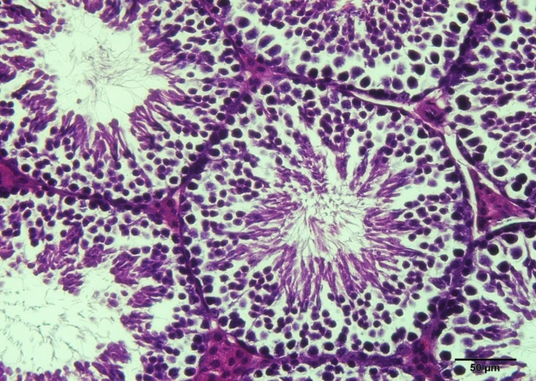
Fig. 1: T.S. of the testis of mice of control group showing normal and regular seminiferous tubules (X 400, H and E Stain).

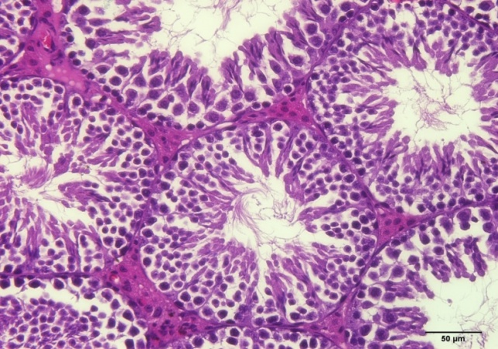
Fig. 2: T.S. of the testis of mice of vitamin E-treated group showing normal and regular seminiferous tubules (X 400, H and E Stain).

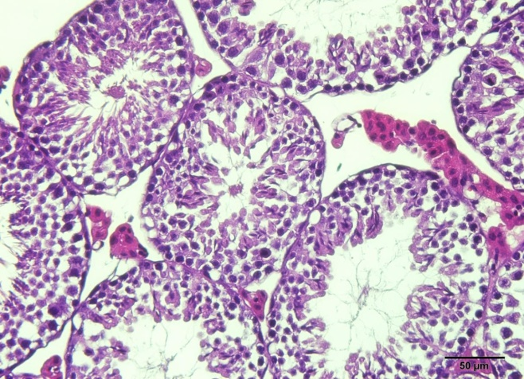
Fig. 3: T.S. of the testis of mice of low dose (LD) malathion-treated group (X 400, H and E Stain).

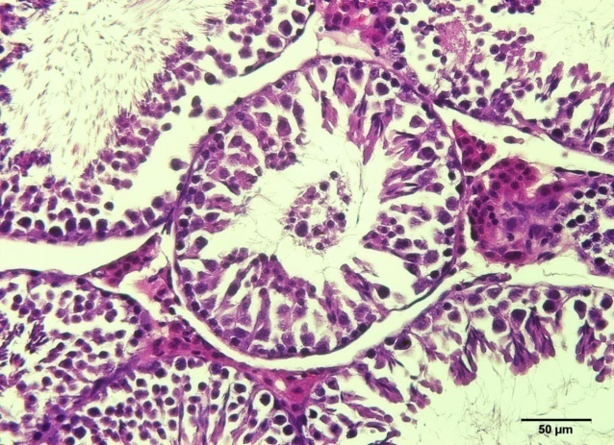
Fig. 4: T.S. of the testis of mice of High dose (HD) malathion-treated group (X 400, H and E Stain).

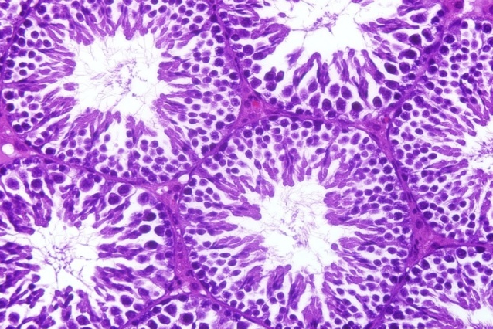
Fig. 5: T.S. of the testis of mice of low dose (LD) malathion + vitamin E-treated group (X 400, H and E Stain).

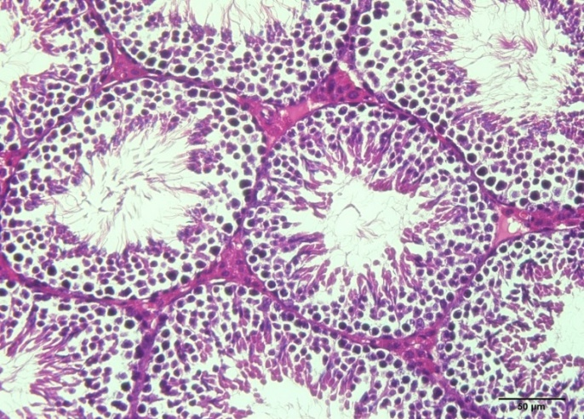
Fig. 6: T.S. of the testis of mice of High dose (HD) malathion + vitamin E-treated group (X 400, H and E Stain).

[26] mentioned that organophosphate pesticide leaded to lowering in organ and body weights of experimented animals. In another study by [27], rats were given acute, sub-acute and sub-chronic doses of methyl parathion which stimulated decreasing in the weight of the body, absolute and relative testicles weights. They thought that this decrease in rats happened because of food absorption. Due to, when experimental group rats were in comparison with control rats, it was noticed that food consumption was lower than control group.
The importance of the decrease in body weight mentioned in some studies is undefined, however, we may consider reduced palatableness of the food with added malathion. So, it may reduce the need for food of rats. Another possible reason of this decrease is owing to the poisonous impact or hormonal imbalance in any stage in the testicular axis–hypophysial–hypothalamo, possibly stimulated by malathion exposure. [28] found that, food consumption was not decreased by giving the malathion. Both female and male mice of (B6C3F1) also demonstrated lowering in the weight of their body occurred after giving nearly 1,490 mg for every kg per day of MP (95% pure) for 560 days [29]. A result that is similar to this was stated by [30] in male mouse after dietary giving of 1,476 mg for every kg per day MP (96.4% pure) for 540 days; in this situation, the lost weight occurred was accompanied by a low food consumption [31] stated a 17% lowering in last weight related to the controls in rat given 593 mg for every kg per day MP (unrecognized purity)in food for 1 week. This reduction was associated with a very high lowering in food intake; the NOAEL was 451 mg for every kg per day. Another research by [32] mentioned a lowering of 22% in the weight of the body gained while gestation in rats given 500 mg for every kg per day MP (98% pure) by a tube on 6, 10, and 14 pregnancy days.
The current study findings illustrated a high degree decreasing in body and related testicles weights with more amounts of MP dosage, which was in line with these of [33] who noticed reducing in both testicular and body weight, pathological alterations in the testicles and discouraged activities of testicular enzymes in the rats that were exposed to MP. Findings from that research also approved the harmful impacts of MP on the whole and sexual system in mammalian animals. The malathion-caused deviated degrees of hormones related to proliferation and apoptotic protein degrees engaged in apoptosis could do substantial functions in those effects.
The weight of testicles is dependent significantly on the size of differentiated spermatogenic cells and the decrease in testicles weight may be due to decreased tubule size, reduced number of elongated spermatids and germ cells [34], [35]. The observed decrease in weight of accessory reproductive organs may be because of decreased biological availableness of estrogenic or / and anti-androgenic activities of MP [36] and this may cause the lowering of the testicles weight as noticed in this research.
On the other hand,[37] demonstrated the increase in the relative body and liver weight of mice during intoxication could be due to the animal ability to adapt to toxic effect and also due to the rapid elimination of the compound through rapid metabolization and excretion. Giving an acute sublethal dose of MP is capable of inducing proliferation, reducing steroidogenesis, and causing apoptosis of the seminiferous epithelium in mouse [38].
The alteration existed in spermatocytes enhances the results of [39] and [40], as he found harm in primary spermatocytes within pachytene phase, including changes in the synthesis or DNA repair in late zygotene phase. Degenerative ultra-structural results in the germinal epithelium because of malathion, like it was resulted in the current research, it was demonstrated previously when abnormal patterns of nuclear concentration of elongated spermatids. Vacuolization in the cytoplasm of Sertoli cells has been mentioned as in the current research. This kind of incidents is an early clue of testicular harm. When the small vacuoles are explained as reduction of germ cells, the essential ones match to metabolic changes of the Sertoli cell [40],[41],[9]. Those alterations suggest retreating of apical functions of Sertoli cells, impacting specialized intercellular cross, thereafter liberates the germ cells to the tubular lumen.
These results refer to that malathion impacts both germ and somatic cells of the testicles, and beside the alkylation reflexes which happen with proteins and DNA, may formulate side effects too, including extra-testicular organs as a reaction to the pesticide [17]. We can conclude that malathion changes the regular development and growth of cell cycle phases associations in the early times of spermatogenesis. The tubular diameter depends on the phase [43].
Lowered levels of testosterone were noticed by 16.2 days and were stable at 33.2 days. The histo-pathological results showed nuclear changes in Leydig cells of animals exposed to the insecticide. That result is in line with the finding of [11] demonstrating a poisonous impact of malathion on the Leydig cells that, as other organophosphates [9], prevent non-detailed esterase activity of those cells, decrease the output of male steroids [44].
[45] illustrated the harmful impact of phoxim, an anti-cholynesterase insecticide on the testosterone synthesis. [46] and [47] showed that malathion harm the Leydig cells and decrease testosterone degrees. This intervene in the function of spermatogenesis, by inhibiting the ripeness in the later post-meiotic phases, that are androgen-dependent [41]. And [46] referred to the decrease in the count of immature germ cells, as a result of reduced steroidogenic activity and harm of the Sertoli cells.
The impact on the steroidogenic process has been demonstrated by alkylating cytotoxic activity done by organophosphates on the steroidogenic cells [46]. A few organophosphates prevents reproduction of the protein that works on limiting enzymatic level, while the shift of cholesterol from the outside to the inside mitochondrial velum [48].
Current research results and others showed in the previous studies demonstrated that malathion changes the function of testicular that affecting (DNA). Due to the terms of this research, malathion intervenes with the two of steroidogenesis and spermatogenesis [38].
An important result in the assay of testicles and body was that just Vitamin (E) raised the two weights in comparison with the control group and ameliorated the poisonous effects of malathion on the health of the testicles. Vitamin E is usually called an anti- sterility vitamin and its combination with normal process of male genital system has been well determined [49].
[27] mentioned that giving vitamins E and C enhance sperm morphology, movement, and numbers. Antioxidant vitamins have several biological functions, some of which, immune stimulation and alteration of the metabolic processes of carcinogens. Also, these vitamins may inhibit genetic alterations by preventing the harm of (DNA) occurred because of reactive oxygen metabolites [50]. Vitamin E is a lipid-soluble vitamin that exists in biological vellums [51]. It guards against fat peroxidation efficiently by its chain-breaking antioxidant function [52], as vitamin E is transferred into a weakened freeradical (the α-tocopherol radical) [53].
Malathion was much pronounced than spinosad. Both insecticides showed an accumulative effect on the induction of biochemical changes and chromosome damage in male rat. However, the impact of MP might be because of the metabolic biotransformation of malathion to malaoxon or the presence of malaoxon or/and isomalathion [54].
In some studies, vitamin E was given along with MP to examine how this vitamin can prevent any toxic effect caused by the malathion especially on reproductive cells. Some researchers showed that vitamin E or other antioxidants are not completely protective [17]. In one study, rats were treated orally with vitamin E before taking a low dose of malathion. The results showed a possible effect of using vitamin E in slightly decreasing the toxic impact of malathion [16]. When taken with selenium, vitamin E showed a significant protective effect [55]. Therefore, it appears that most studies agree that vitamin E may decrease MP toxicity, although the significant of preservation is bounded [56].

References
- Roberts, D.M., Karunarathna, A., Buckley, N.A., Manuweera, G., Sheriff, M.H. and Eddleston, M. (2003). Influence of pesticide regulation on acute poisoning deaths in Sri Lanka. Bull. WHO, 81(11), 789-798.‏
- Ngoula, F., Defang, H.F., Kana, J.R., Tchoumboué, J., Ngouateu, O.B., Kamtchouing, P. and Watcho, P. (2012). Reproductive and developmental toxicity of insecticides. agricultural and biological sciences, Insecticides - Advances in Integrated Pest Management. Farzana Perveen (Ed.), INTECH Open Access Publisher, 429-456.
- Mansour, S. A., Mossa, A. H., and Heikal, T. M. (2008). Cytogenetic and hormonal alteration in rats exposed to recommended “safe doses” of spinosad and malathion insecticides. Int J Agric Biol, 10, 9-14.‏
- Moline, J.M., Golden, A.L., Bar-Chama, N., Smith, E., Rauch, M.E., Chapin, R.E., Perreault, S.D., Schrader, S.M., Suk, W.A. and Landrigan, P.J. (2000). Exposure to hazardous substances and male reproductive health: a research framework. Environ. Health Perspect., 108(9), 803-813.‏
- Mathur, N., Pandey, G. and Jain, G.C. (2010). Pesticides: A review of the male reproductive toxicity. J. Herb. Med. Toxicol., 4, 1-8.‏
- WHO (World Health Organization) (2010). The WHO recommended classification of pesticides by hazard and guidelines to classification 2009.‏
- Maroni, M., Colosio, C., Ferioli, A. and Fait, A. (2000). Biological monitoring of pesticide exposure: a review. Introduction. Toxicology, 143(1), 1-118.
- Gervais, J.A., Luukinen, B., Buhl, K. and Stone, D. (2009). Malathion technical fact sheet. National Pesticide Information Center, Oregon State University extension services.‏
- Contreras, H.R. and Bustos‐Obregón, E. (1999). Morphological alterations in mouse testis by a single dose of malathion. J. Exp. Zool., 284(3), 355-359.‏
- Choudhary, N., Goyal, R. and Joshi, S.C. (2008). Effect of malathion on reproductive system of male rats. J. Environ. Biol., 29(2), 259-262.‏
- Bustos-Obregón, E. and González-Hormazabal, P. (2003). Effect of a single dose of malathion on spermatogenesis in mice. Asian J. Androl., 5(2), 105-107.‏
- Jain, N., Sharma, A. and Joshi, S.C. (2012). Cauda epididymal lesion in male rats after subchronic exposure of malathion. Res. J. Pharm., Biol. Chem. Sci., 3(2), 190-197.‏
- Yavuz, T., Delibas, N., Yildirim, B., Altuntas, I., Candır, O., Cora, A., Karaman, N., Ibrisim, E. and Kutsal, A. (2004). Vascular wall damage in rats induced by methidathion and ameliorating effect of vitamins E and C. Arch. Toxicol., 78(11), 655-659.
- Kalender, S., Kalender, Y., Ogutcu, A., Uzunhisarcikli, M., Durak, D., and Açikgoz, F. (2004). Endosulfan-induced cardiotoxicity and free radical metabolism in rats: the protective effect of vitamin E. Toxicology, 202(3), 227-235.‏
- Traber, M.G. (2007). Vitamin E regulatory mechanisms. Annu. Rev. Nutr., 27, 347-362.
- John, S., Kale, M., Rathore, N., and Bhatnagar, D. (2001). Protective effect of vitamin E in dimethoate and malathion induced oxidative stress in rat erythrocytes. The J. Nutr. Biochem., 12(9), 500-504.
- Uzun, F.G., Kalender, S., Durak, D., Demir, F. and Kalender, Y. (2009). Malathion-induced testicular toxicity in male rats and the protective effect of vitamins C and E. Food Chem. Toxicol., 47(8), 1903-1908.‏
- Gad, C.S. and Weil, S.C. (1982). In: Hays AW (Ed.), Principles and Methods of Toxicology, 2nd ed. Raven Press, USA, 292–293.
- Al-Attar, A.M. (2010b). Physiological effects of some plant oils supplementation on streptozotocin-induced diabetic rats. Res. J. Med. Sci, 5, 55-71.‏
- Al-Attar, A. M., and Zari, T. A. (2010). Influences of crude extract of tea leaves, Camellia sinensis, on streptozotocin diabetic male albino mice. Saudi J. Biol. Sci., 17(4), 295-301.
- Culling, C.F.A. (1974). Handbook of histopathological and histochemical techniques: including museum techniques. 3rd ed. Butterworth-Heinemann.
- ‏Haseman, J.K. and Soares, E.R. (1976). The distribution of fetal death control mice and its implications on statistical tests for dominant lethal effects. Mut. Res., 41(2), 277-287.‏
- Lim, K.L., Tay, A., Nadarajah, V.D. and Mitra, N. K. (2011). The effect of consequent exposure of stress and dermal application of low doses of chlorpyrifos on the expression of glial fibrillary acidic protein in the hippocampus of adult mice. J. Occu. Med. Toxicol., 6(1), 1.‏
- Jones, A.L. and Karalliedde, L. (2006). Poisoning. In: Boon, N.A., Colledge, N.R., Davidson, S.S. and Walker, B.R., Eds., Davidson’s Principles and Practice of Medicine, 20th Edition, Churchill Livingstone, Edinburgh, 203-226.
- Acker, C.I., Souza, A.C.G., Pinton, S., da Rocha, J.T., Friggi, C.A., Zanella, R. and Nogueira, C.W. (2011). Repeated malathion exposure induces behavioral impairment and ACh E activity inhibition in brains of rat pups. Ecotoxicol. Environ. Saf., 74(8), 2310-2315.
- Chung, M.K., Kim, J.C. and Han, S.S. (2002). Developmental toxicity of flupyrazofos, a new organophosphorus insecticide, in rats. Food Chem. Toxicol., 40(5), 723-729.‏
- Uzunhisarcikli, M., Kalender, Y., Dirican, K., Kalender, S., Ogutcu, A. and Buyukkomurcu, F. (2007). Acute, subacute and subchronic administration of methyl parathion-induced testicular damage in male rats and protective role of vitamins C and E. Pest. Biochem. Physiol., 87(2), 115-122.‏
- Daly, I. (1996). A 24-month oral toxicity/oncogenicity study of malathion in the rat via dietary administration: Final Report: Lab Project No. 90-3641; J-11 90-3641.
- NCI (National Cancer Institute). (1978). Bioassay of malathion for possible carcinogenicity. Technical Report Series No. 24. U.S. Department of Health. Education and Welfare. Public Health Service. National Institute of Health.
- Slauter, R.W. (1994). 18-Month oral (dietary) oncogenicity study in mice, test substance malathion. International Research and Development Corporation, Proj, No. 668-001, Cheminova Agra A.S., Denmark, CHA Doc, No. 94 FYF.
- Ojha, S., Norton, S.P., Shrivastava, N. and Jain, S. (1992). Toxic effect of malathion on the reproductive system of albino rats. Environ. Ecol. Kalyani, 10(4), 833-836.
- Prabhakaran, S. and Devi, K.S. (1993). Impact of protein deficiency and exposure to hexachlorocyclohexane or malathion on lipid metabolism in pregnant rats. Indian J. Biochem. Biophys., 30(4), 234-238.‏
- Geng, X., Shao, H., Zhang, Z., Ng, J.C. and Peng, C. (2015). Malathion-induced testicular toxicity is associated with spermatogenic apoptosis and alterations in testicular enzymes and hormone levels in male Wistar rats. Environ. Toxicol. Pharmacol., 39(2), 659-667.
- Chiou, T.J., Chu, S.T., Tzeng, W.F., Huang, Y.C. and Liao, C.J. (2008). Arsenic trioxide impairs spermatogenesis via reducing gene expression levels in testosterone synthesis pathway. Chem. Res. Toxicol., 21(8), 1562-1569.‏
- Sánchez-Peña, L.C., Reyes, B.E., López-Carrillo, L., Recio, R., Morán-Martínez, J., Cebrián, M.E. and Quintanilla-Vega, B. (2004). Organophosphorus pesticide exposure alters sperm chromatin structure in Mexican agricultural workers. Toxicol. App. Pharmacol., 196(1), 108-113.‏
- Linder, R.E., Rehnberg, G.L., Strader, L.F. and Diggs, J.P. (1988). Evaluation of reproductive parameters in adult male Wistar rats after subchronic exposure (gavage) to benomyl. J. Toxicol. Environ. Health, Part A, 25(3), 285-298.
- Kaware, M.K. (2013). Changes in liver and body weight of mice exposed to toxicant. Int. Res. J. Sci. Eng., 1(3), 92-95.
- Penna-Videau, S., Bustos-Obregón, E., Cermeño-Vivas, J.R. and Chirino, D. (2012). Malathion affects spermatogenic proliferation in mouse. Int. J. Morphol., 30(4), 1399-1407.
- Bustos-Obregón, E., Gormaz, C., and Del Valle, L. (1994). Testicular toxicity of agropesticides. Arch. Std. Hiv. Res., 9, 57-63.‏
- Bustos-Obregón, E., Valenzuela-Estrada, M. and Rojas, M. (1998). Agropesticides and testicular damage. In: Male reproduction: a multidisciplinary overview. Martinez-García, J.; Regadera, J. and Churchill, J. (Edit.). Madrid, Communications Europe, 257-64.
- Russell, L.D. (1990). Histological and histopathological evaluation of the testis. Cache River Press.‏
- Nolte, T., Harleman, J.H. and Jahn, W. (1995). Histopathology of chemically induced testicular atrophy in rats. Exp. Toxicol. Pathol., 47(4), 267-286.‏
- Wing, T.Y. and Christensen, A.K. (1982). Morphometric studies on rat seminiferous tubules. Am. J. Anat., 165(1), 13-25.‏
- Chapin, R.E., Phelps, J.L., Somkuti, S.G., Heindel, J.J. and Burka, L.T. (1990). The interaction of sertoli and leydig cells in the testicular toxicity of tri-o-cresyl phosphate. Toxicol. Appl. Pharmacol., 104(3), 483-495.
- Atef, M., Youssef, S.A., Ramadan, A., Nawito, M.F., El-Sayed, M.K. and Abd, E.R.H. (1995). Influence of Phoxim on testicular and seminal vesicle organs, testosterone and cholinesterase level and its tissue residues in male rats. DTW. Deutsche Tierarztliche Wochenschrift, 102(8), 1-5.‏
- Krause, W., Hamm, K. and Weissmüller, J. (1974). [The effect of perorally administered DDVP and malathion on spermatogenesis and Leydig cells in the juvenile rat]. Andrologia, 7(2), 109-116.
- Krause, W. (1977). Influence of DDT, DDVP and malathion on FSH, LH and testosterone serum levels and testosterone concentration in testis. Bull. Environ. Cont. Toxicol., 18(2), 231-242.
- Walsh, L.P., Webster, D.R. and Stocco, D.M. (2000). Dimethoate inhibits steroidogenesis by disrupting transcription of the steroidogenic acute regulatory (St AR) gene. J. Endocrinol., 167(2), 253-263.‏
- Chen, H., Liu, J., Luo, L., Baig, M.U., Kim, J.M. and Zirkin, B. R. (2005). Vitamin E, aging and Leydig cell steroidogenesis. Exp. Gerontol., 40(8), 728-736.‏
- Verma, R.S., Mehta, A. and Srivastava, N. (2007). In vivo chlorpyrifos induced oxidative stress: attenuation by antioxidant vitamins. Pest. Biochem. Physiol., 88(2), 191-196.‏
- Senthil Kumar, J., Banudevi, S., Sharmila, M., Murugesan, P., Srinivasan, N., Balasubramanian, K., Aruldhas, M.M., Arunakaran, J., 2004. Effects of vitamins C and E on PCB (Aroclor 1254) induced oxidative stress, androgen binding protein and lactate in rat sertoli cells. Reprod. Toxicol. 19, 201– 208.
- Serbecic, N. and Beutelspacher, S.C. (2005). Anti-oxidative vitamins prevent lipid-peroxidation and apoptosis in corneal endothelial cells. Cell Tissue Res., 320(3), 465-475.‏
- Zaken, V., Kohen, R. and Ornoy, A. (2001). Vitamins C and E improve rat embryonic antioxidant defense mechanism in diabetic culture medium. Teratol., 64(1), 33-44.
- Zidan, N.E.A. and Galal, O.A. (2012). Evaluation of hematological, cytogenetical and biochemical effects of malathion and spinosad on male albino rats. Am-Euras. J. Toxicol. Sci, 4(2), 118-130.
- El-Desoky, G., Abdelreheem, M., Abdulaziz, A.O., ALOthman, Z., Mahmoud, M. and Yusuf, K. (2012). Potential hepatoprotective effects of vitamin E and selenium on hepatotoxicity induced by malathion in rats. African J. Pharm. Pharmacol., 6(11), 806-813.‏
- Kalender, S., Uzun, F. G., Durak, D., Demir, F., and Kalender, Y. (2010). Malathion-induced hepatotoxicity in rats: the effects of vitamins C and E. Food and chemical toxicology, 48(2), 633-638.‏

5/2/2017

