**Primary Rhino-cheiloplasty in unilateral Cleft lip**

Abd Elmoneim H. Hota1, Magdy A. Abdelmoktader1, Refaat I. El Badawy2 and Ahmed F. Salem1

1Plastic Surgery Department Faculty of Medicine, Alazhar University, Egypt

2Pediatric Surgery Department Faculty of Medicine, Alazhar University, Egypt

[Master_boyx111@yahoo.com](mailto:Master_boyx111@yahoo.com)

**Abstract: Objective:** to evaluate the repair of nasal deformity at the same time with lip and to evaluate the percentage of nose asymmetry in patients with either complete or incomplete unilateral cleft lip and palate who underwent primary cleft lip repair with the modified millard technique and closed rhinoplasty. **Background:** Cleft lip is one of the most common congenital anomalies that affect infants worldwide. In the past, the nose was left untouched during lip surgery. this dogmatic attitude caused functional and aesthetic (psychological) problems for the child until secondary corrections during adolescence were performed. **Patients and Methods:** In this study primary rhinoplasty was done at the same time of lip repair in 40 patients. Their ages ranged from 3-12 months. Most of them were males 60% while 40% were females. The fourty patients divided into 25 patients with complete unilateral cleft lip and 15 patients with incomplete unilateral cleft lip. Their were 12 patients from 25 patients with complete cleft lip and palate. The technique used in all patients simultaneous repair of cleft lip and nasal deformity repair with (Modified Millard`s Rotation Advancement technique with closed rhinoplasty). **Results:** Improvement of the aesthetic and functional results. patients have been operated on with this method, showing 62.5% of excellent results, 25% of good results and 12.5% of fair results. **Conclusions:** Because of the good results of this method, this approach is to be recommended.

[Abd Elmoneim H. Hota, Magdy A. Abdelmoktader, Refaat I. El Badawyand Ahmed F. Salem. **Primary Rhino-cheiloplasty In unilateral Cleft lip.** *N Y Sci J* 2017;10(5):90-96]. ISSN 1554-0200 (print); ISSN 2375-723X (online). <http://www.sciencepub.net/newyork>. 13. doi:[10.7537/marsnys100517.13](http://www.dx.doi.org/10.7537/marsnys100517.13).

**Keywords:**unilateral Cleft lip - Cleft nasal deformity – Cheiloplasty - Primary cleft nasal surgery – closed rhinoplasty.

**1. Introduction**

The presence of unilateral cleft lip is one of the most common congenital deformities. A broad spectrum of variations in clinical practice exists. Unilateral cleft lip involves deformity of the lip in addition to the alveolus and nose. Patients with deformity require short-term care and long-term care and follow up from practitioners in multiple specialties. Normal appearance and function is a realistic treatment goal. The most important surgical stage is the primary repair. At the first operation, the nose and the lip should be primarily reconstructed (1).

It is natural for the cleft lip surgeon to be so pleased with a satisfactory lip repair that his eyes will be temporarily out of focus while gazing upon the nose. An aesthetically pleasing repair of the unilateral cleft lip is now common place and as techniques in cleft lip surgery have advanced with correspondingly improved results, there has been an increased focus on the nasal deformity associated with the cleft lip condition. The cleft nasal deformity is now the most visible stigmata of the cleft deformity and can be readily visualized well before one would notice the quality of the cleft lip repair (2).

The goal of surgical correction of unilateral cleft lip deformity and it is nasal deformity is to have reasonable equality of the height and width of the lip on the cleft and the normal side, reforming the philtrum, a smooth vermillion and concealed scar as it lies in the philtral ridges. goals for the nose is to correct The flattening of the ala nasii resulting in a near normal nose and achieving a good percentage of nostril symmetry (3).

Major advances have been made in cleft care in the past years. Deformity can consistently be transformed early in life to minimal or residual variations from normal so that predictable outcomes for patients with unilateral cleft lip–nasal deformity can be achieved (1).

**Embryology**

The face develops from five basic embryologic components, which include the frontonasal prominence, and the paired maxillary and mandibular prominences. The nose and the lips develop from derivatives of these prominences (Fig. 1) as follows (4):

* Frontonasal prominence: Forehead and dorsum of nose.
* Lateral nasal process: Sides (alae) of the nose.
* Medial nasal process: Nasal septum, premaxilla, philtrum of the upper lip, columella, and nasal tip.
* Maxillary prominences: Upper cheek region and most of the upper lip.
* Mandibular prominences: Chin, lower lip, and lower cheek regions.
* Mesenchyme in the facial prominences: Fleshy derivatives and various bones.

A complicated series of morphogenic movements occurs between the fourth and eighth week of embryogenesis (5).

Complete closure of the lip is usually accomplished by 35 days post conception as the lateral nasal, median nasal, and maxillary mesodermal processes merge. Failure of closure of any one of three normal sites of fusion can produce unilateral, bilateral, or median lip clefting. Lack of fusion of the facial elements can be mild, involving only the lip, or can extend into the palate and midface thereby affecting the nose, forehead, eyes, and brain. Unilateral cleft lip on the left side is the most common type of cleft lip (6).

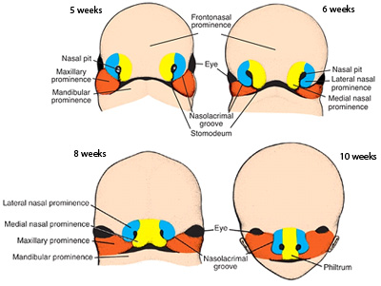

**Figure 1:** embryologic components of nasolabial region (4).

**Anatomical consideration of the Unilateral Cleft Nasal Deformity**

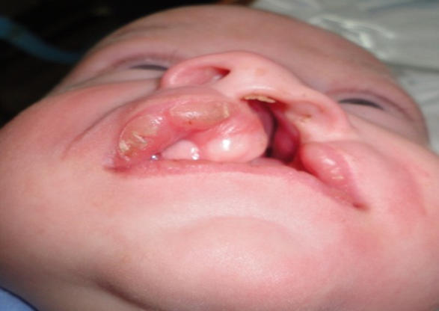

**Figure 2:** patient with severe nasal deformity (8).

The etiology of the primary unilateral cleft nasal deformity is a lack of skeletal support of the cleft alar base. The unilateral cleft malformation also includes a hypoplastic and malaligned orbicularis oris muscle on the involved side. The combination of the lack of cleft side skeletal support and abnormally oriented muscle results in a characteristic caudal deviation of the nasal septum to the non-cleft side (Fig.2). Lack of muscular continuity often is associated with an abnormal configuration of the cleft nasal sill. The unilateral cleft side nasal base is lateral, posterior, and inferior to its non-cleft counterpart alar base(7).

**Aim of the work**

The aim of this work is to Review of advantage and disadvantage of unilateral cleft lip nasal deformity correction at the same time with lip repair.

**2. Patients and Methods**

This study is conducted as prospective study on 40 infants with unilateral cleft lip. The study was done in Al-Azhar University hospitals. El sayed galal hospital and Al hussien hospital at plastic and paediatric surgery departments of Faculty of Medicine. During the period from April 2016 to April 2017.

The infant with unilateral cleft lip presented in the out patient clinic, scheduled for primary surgery according to investigations and fitness for surgery. Their age at presentation was ranged between 3 to 12 months. Out of fourty patients, 24 (60%) were males and 16(40%) were females. The fourty patients divided into 25 patients with complete unilateral cleft lip and 15 patients with incomplete unilateral cleft lip. Twelve patients of 25 patients was with complete unilateral cleft lip and palate.

**The inclusion criteria in patient selection for this study were:**

1. Unilateral cleft lip with nasal deformity, with or without cleft alveolas or cleft palate.
2. Isolated ( non syndromic).

***The exclusion criteria in patient selection for this study were:***

a. Bilateral cleft lip.

b. Syndromic and other congenital deformities.

c. Cranial clefts.

d. cases with low birth weight or weight less than 4kg at time of operation.

e. cases of hemoglobin less than 10 gm/dl.

The patients undergo Pre-operative Preparation as history taking of Antenatal and perinatal, medical illness, medications during pregnancy, Family history ( microform type ) and Cigarette smoking ( active or passive ). The patients undergo Clinical assessment of Age, sex, body weight and Assessment of associated congenital anomalies and Lab investigations including (CBC, prothrombin time, partial thrombo plastin time, INR).

The studied patients underwent simultaneous repair of cleft lip and nasal deformity repair (Modified Millard Rotation Advancement technique with closed rhinoplasty). The operative time was recorded for each case. the average of operative time was 80-120 minute.

pre –operative and post-operative direct Measurements of the lip width and lip length were taken on clefted and non clefted side.

pre-operative and post-operative direct Measurements of the nostril width were taken on clefted and non clefted side and also direct Measurements of the nostril height on the non clefted side. direct measurement of nostril height on the clefted side was taken post-operative after repair only.

Postoperative follow up starts immediately after operation, we checked for any bleeding, respiratory distress, flap necrosis, or any other complications. Clear fluids orally is to be given after 4 to 6 hours of operation. Patients were discharged on 5th postoperative day, with the advice of topical and oral antibiotics, analgesia, and feeding with spoon (for at list for 2 weeks). Patients were also advised to come for follow up (and for lip stitch removal) on the 7th postoperative day and anti-tension adhesive strips were applied and silicone scar gel is encouraged. During discharge contact number of the investigator was given to the parents to communicate in case any problem arises. On immediate postoperative and subsequent follow up, we checked for any complications such as bleeding, respiratory distress, flap necrosis, wound disruption, wound infection, etc.

Patients after 3 months of repair were followed of Scars. If there is early evidence of aggressive hypertrophic scar formation, the parents taught how to perform gentle massage with some kind of an anti-scar preparation until the wound was soft and without evidence of contraction, intralesional injection of a dilute steroid can be considered.

Patients were followed and observed after 6months of repair for functional and cosmetic outcome. assessment of the results of correction of the nasal deformities and cleft lip. We checked for any late complications such as unsatisfactory appearance of the surgical result, stenosis of the nostril, very asymmetric lower third of the nose and nostrils.

**Consent and Photographic documentation**

The study was approved by the ethical committee of department of surgery of Al-Azhar University. The technique were explained to the parents of the patients, also informed about possibility of occurrence of some complication, and we asked about taking photographs pre-operative and post-operative. The parents accepted about all of that with a written consent.

**Surgical technique**

1. **Positioning:** the supine position with the neck slightly extended using a small shoulder roll and head support.
2. **Anesthesia and preparations:** All patients received general anesthesia with midline oral endotracheal intubation. A straight, cuffed endotracheal tube is taped to the chin to avoid distortion of the lower lip and alteration of landmarks. The eyes are protected with occlusive patches, and a throat pack is inserted. The patients were placed in. The face was prepared and draped.
3. **Skin Markings:** The first step with lip repair is to locate the normal features of the lip: the midline and Cupid’s bow at the cutaneous vermilion junction (white skin roll), and the vermilion-mucosa junction (red line). Markings were made to guide the design of the flaps. Important points of reference in a unilateral cleft lip were accurately identified.
4. **Measurement:** Measurement of lip height (from alar base to edge of cupid bow), and lip width ( from commissure to edge of the cupoid bow) was done on both sides clefted and non clefted. Measurement of nostril height on the non clefted side and nostril width measurement was done on both sides clefted and non clefted.
5. **Lip Incisions and Flaps Design:**

Infiltrate the nose and the upper lip mucosa with local anesthetics: 1 % Xylocaine with 1:200,000 epinephrine then,

1. **Medial unit dissection** The dry red lip and mucosa were incised just superior to point 3 (peak of Philtrum of non cleft side) to allow for a slight redundancy of mucosa at the final mucosal closure and then carried in a gentle curve up to point 4 (midcolumellar point). Depending on how much length was needed, a small back cut was made at the initial incision, but the final extent of the back cut was determined after release of the orbicularis muscle from the nasal spine. A skin only flap (c flap) was then raised, based at the columella (Raising of the c flap and skin undermining of the rotation flap facilitates dissection of the orbicularis and release of the aberrantly inserted muscle from the nasal spine; resulting in full rotation of the flap into a more anatomically correct position).
2. **Lateral unit dissection:** The advancement flap from the lateral segment was then incised, with slight excess of dry red lip and mucosa, similar to that on the non-cleft side. The incision extended from point 7 (new beak of the cupid`s bow on the clefted side) to point 8 (superior point on the advancement flab). Millard’s original technique has also been modified to reduce the length of the incision around the base of the nostril, limited to alar cartilage. The incision along the cleft can also be rounded to gain more length in wide clefts and to provide a wider tip of the flap to insert above the medial lip flap. The vermilion and mucosa along the cleft are retained based on the inferior border of the lip until final mucosal adjustment at the end of the lip closure. dissection of the aberrantly oriented orbicularis fibers from the margin of the piriform aperture and alar base. A gingival-labial incision was made to allow for advancement of the flap medially. Further freedom was gained by dissection in a sub-periosteal plane over the anterior maxilla and the abnormal insertion of all paranasal and orbicularis fibers to the maxillary segment was detached.
3. **Muscle Manipulation:** Once the skin incision has been made, the muscle is undermined laterally more extensively than on the medial side. The muscle is completely freed from the alar base and the periosteum along the pyriform aperture. This maneuver separated the orbicularis muscle from the nasal muscle complex. The deforming force of the orbicularis oris on the nasal tip (lateral and superior pull on ala) is therefore released and nasal tip correction is easier. This allows for a substantial amount of muscle fibres to be brought medially to be reattached at the base of the columella, centralizing the columella and lengthening the lip**.**
4. **Nasal Floor and Nostril Sill:** Reconstruction of the nasal floor was achieved by dissection, approximation, and suturing together of a muco-periochondrial flap from the septum (vomerine flap) and a muco-periosteal flap from the lateral nasal wall. Once the floor of the nose had been created, the alar base was positioned so that it was symmetrical with the non-cleft side and the cleft nostril just slightly larger than the non-cleft nostril, to account for wound-healing contracture. A deep suture secured the alar base to the underlying muscle to give a normal curve (lateral dip) to the sill. The 'C' flap was incorporated into the nostril sill.
5. **Lip muscle, Mucosal and Cutaneous Closure:** Sutures were pre-placed in the muscle; beginning at the level of the mucocutaneous junction. The planned muscle tension was minimized inferiorly by placing sutures near the edge of the muscle. Tension was progressively increased superiorly by taking slightly wider bites of muscle and vertical mattress sutures were used. The lateral labial element was advanced as the gingivolabial sulcus was closed. Vertical skin wound closure was carried out from vermilion border upwards.
6. **Tajima sutures (suspension sutures):** This continuous dissection plane between the non-cleft upper lateral and cleft lower lateral cartilages will later be used to place subcutaneous Tajima suspension sutures to adjust the alar rim contour. The needle enters the nasal surface of the cleft lower lateral cartilage at the point of desired elevation, enters into the previously described subcutaneous nasal tip dissection pocket, exits into the non-cleft nostril at the levd of the ULC, and then returns on its path, such that tightening of the suture will elevate the cleft alar rim. Lateral alar cinch sutures of 4-0 Prolene can also be used to contour the lateral alar rim and nasal lining in the new position, by exiting and entering the same percutaneous hole in the alar groove. The number of suspension and cinch sutures required will depend on the degree of the deformity. With good degree of nasal dissection the number of sutures required are minimized. With this approach, the lip and nasal deformities can be addressed in a single surgery.
7. **Wound care:** nostril was packed (and lip wound was covered) with vaselinized wide pore gauze (impregnated with antibiotic ointment) Adhesive strips were applied to decrease tension on the lip wound.

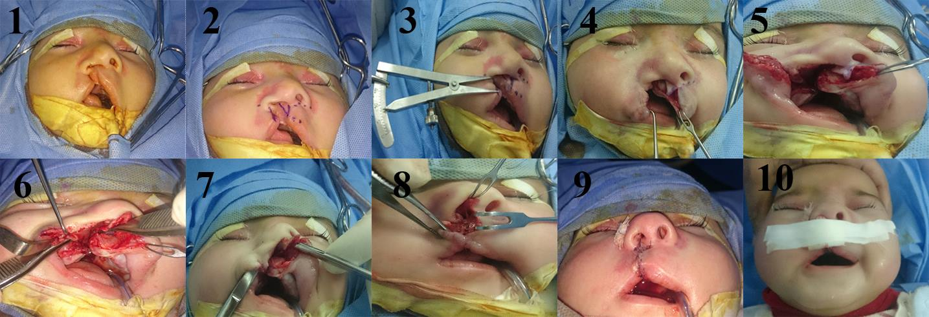

**Figure 3:** intra-operative steps of repair of unilateral cleft lip and nose.

**3. Results**

This study included 40 patients with primary unilateral cleft lip. This included 26 males and 14 femalesthat were submitted to the current study, the youngest age (at time of surgery) was 3 months and the oldest age was 12 months (mean age was 6 months). the most frequent age at time of surgery was 5 months. the follow-up periods of the forty patients, which ranged from 3months to 8 months.

The 40 patients along the three clinical types of clefts submitted to the current study; namely: incomplete cleft lip (ICL; 37.5%), complete cleft lip (CCL; 62.5%), and complete cleft lip and palate (CCLP; 30%). 25 cases were of complete type. nasal floor repair was done in all 25 cases and in 5 of incomplete type.24cases were left sided and 16 cases were right sided.

All cases were done by modified millard`s technique in all types complete or incomplete, with nasal repair in the same setting with closed rhinoplasty from the same incisons of the lip repair.

The operative time was recorded for each case. the average of operative time was from 60-120 minute for all cases. The mean of operative time was 86 minutes.

During the course of study, we were confronted with a number of complications, both aesthetic and non-aesthetic complications included:

**Wound infection**: 5/40 cases (6.67%). By asking the mother about postoperative care, we found that the dressing with antibiotic ointment applied was kept resuting in soiling from feeding and nasal discharge.

Wound disruption: 2/40 case from the 2 cases complicated by wound infection. Stri-strips were applied with conservative management of infection and no further complications arose.

**vermilion**: 13/40 cases (32.5%) with irregular non smooth vermilion and 3/40 case with vermillion notch.

**Hypertophic scar formation**: 5/40 cases (12.5%) presented with hypertrophic scar but no cases presented with nostril stenosis.

**clinical photographs of patients managed with modified millard`s and closed rhinoplasty.**

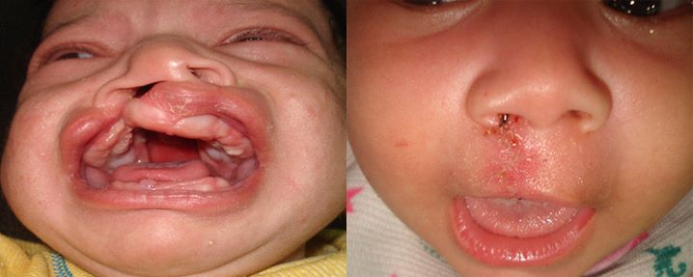

**Figure 4:** pre-operative and post-operative photos of acase with complete cleft lip and palate.

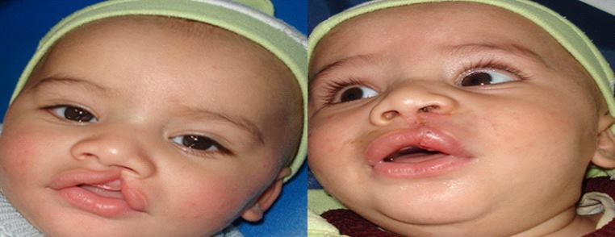

**Figure 5:** pre-operative and post-operative photos of acase with incomplete cleft lip and palate.

**outcome:**

After follow up periods the data was analysed as follow:

1. All the patients had good lip function.
2. There were not facial growth disturbances.
3. No cases presented with nostril stenosis.
4. Minimal Scar in 11 cases with good scar, hypertrophic scar in 5 cases and 24 cases with excellent scar.
5. Wound edema in 10 cases.
6. Wound infection in 5 cases.
7. Wound disruption in 2 cases.
8. Our professors judging 25 cases to be of excellent result, 10 cases to be of good result and 5 cases of fair result.

**4. Discussion**

Mc Comb (9) emphasized the relocation of caudal rotated alar cartilage, and they shortened abnormally longer nasal length on the cleft side by relocating alar cartilage to an upper position and made the position of the nostril sill symmetrical. There has been no recurrenc of drooping of the nostril rims, the nasal tips are reasonably symmetrical, there is no nostril flare, and in many cases, the oblique ridges within the vestibules have been corrected in long-term outcome (10). They also mentioned several advantages of primary rhinoplasty for unilateral cleft lip children. It can reduce psychological trauma in early childhood, and repeated hospitalization is not necessary for correction of persisting nasal deformity. The most minimal scars after cheiloplasty can be achieved at the time of primary repair in infancy, and the most important advantage of primary rhinoplasty is suspension of the displaced alar cartilages. Not all deformities can be simultaneously corrected in cleft lip nasal deformity operations. Primary rhinoplasty is not perfect as a correcting method of cleft lip nasal deformities nor is it applicable to every patient.

Salyer,(1) who has had the experience of performing primary rhinoplasty on more than 400 patients with cleft lip nasal deformity over 15 years, reported that it is too radical to completely dissect alar cartilage from the skin in child patients because alar cartilage in infants is friable and soft. He added that his method was effective as a less extensive approach and that this simultaneous rhinoplasty does not correct all cleft lip nasal deformities. It helps to relocate alar cartilage in a normal position after completing it, to close the nostril sill, to correct the displaced alar base, and to make the nasal tip well balanced and projected.

Many Western researchers have reported that primary rhinoplasty, as a means of repairing cleft lip and nasal deformity, did not interfere with nasal growth after surgery. Kim et al.(11)also proves that primary simultaneous correction of cleft lip and nasal deformity does not interfere with nasal growth but rather promotes well-balanced nasal growth. This findings the result of investigating 217Asian cleft lip patients. Primary correction of cleft lip and nasal deformity can benefit patients who need secondary rhinoplasty.

Our method for the correction of displaced alar cartilage and contralateral alar cartilage was to dissect through the same inscions of modified millard`s technique, and the displaced alar cartilage was suspended by Tajima’s sutures with 4-0 prolene. The needle enters the nasal surface of the cleft lower lateral cartilage at the point of desired elevation, enters into the previously described subcutaneous nasal tip dissection pocket, exits into the non-cleft nostril at the level of the ULC, and then returns on its path, such that tightening of the suture will elevate the cleft alar rim, the bolster suture was also performed once or twice from vestibule to dorsum and alar groove (Fig.6).

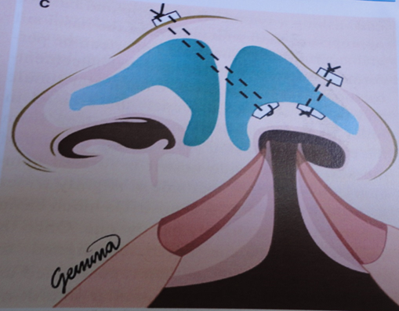

**Figure 6:** diagrame showing after repositioning of the cleft lower lateral cartilages with bolster sutures (9).

**Conclusions**

Primary rhinoplasty performed simultaneously with cleft lip surgery can help to promote more symmetrical and natural nasal growth and better appearance at an early age. Furthermore, this method can reduce psychological trauma in young patients and achieve better results as a result of less deformity in the final rhinoplasty. Therefore, in this study, the authors present operative methods with illustrated documented cases and demonstrate that simultaneous primary rhinoplasty with cleft lip repair can be more effective for patients.

**References**

1. Salyer, K. E., Genecov, E. R., & Genecov, D. G. (2004). Unilateral cleft lip-nose repair–long-term outcome. Clinics in plastic surgery, 31(2), 191-208.‏
2. Rettinger, G., & O'Connell, M. (2002). The nasal base in cleft lip rhinoplasty. Facial plastic surgery, 18(03), 165-178.‏
3. Anderl, H., Hussl, H., & Ninkovic, M. (2008). Primary simultaneous lip and nose repair in the unilateral cleft lip and palate. Plastic and reconstructive surgery, 121(3), 959-970.‏
4. Wantia, N., & Rettinger, G. (2002). The current understanding of cleft lip malformations. Facial plastic surgery, 18(03), 147-154.‏
5. Clark, J. M., Skoner, J. M., & Wang, T. D. (2003). Repair of the unilateral cleft lip/nose deformity. Facial plastic surgery, 19(01), 029-040.‏
6. Young, D. L., Schneider, R. A., Hu, D., & Helms, J. A. (2000). Genetic and teratogenic approaches to craniofacial development. Critical Reviews in Oral Biology & Medicine, 11(3), 304-317.‏
7. Sykes, J. M., & Jang, Y. J. (2009). Cleft lip rhinoplasty. Facial plastic surgery clinics of North America, 17(1), 133-144.‏
8. Abd-Al Moktader, M. A. (2016). Personal communication.‏
9. Mc Comb, H. (1985). Primary correction of unilateral cleft lip nasal deformity: a 10-year review. Plastic and reconstructive surgery, 75(6), 791-797.‏
10. Mc Comb, H. K., & Coghlan, B. A. (1996). Primary repair of the unilateral cleft lip nose: completion of a longitudinal study. The Cleft palate-craniofacial journal, 33(1), 23-31.‏
11. Kim, S. K., Cha, B. H., Lee, K. C., & Park, J. M. (2004). Primary correction of unilateral cleft lip nasal deformity in Asian patients: anthropometric evaluation. Plastic and reconstructive surgery, 114(6), 1373-1381.‏

5/2/2017