Chemical and Mass Spectra Analysis of Fractions obtained from Methanol Leaf Extract of
Corymbia torelliana with Trypanosoma congolense effect

^{*1}Ogbole, E., ²Daben J.M., ³Dashak, D.A. ⁴Nvau, J.B., ³Ekwenchi, M.M., ¹Ikyase C., and ⁵Igweh, A.C.

¹Nigerian Institute for Trypanosomiasis Research, PMB 03 Vom, Plateau State, Nigeria.
²Department of Science Laboratory Technology, Faculty of Natural Sciences, University of Jos, Jos, Plateau State, Nigeria.
³Department of Chemistry, Faculty of Natural Sciences, University of Jos, Jos, Plateau State, Nigeria.
⁴Department of Chemistry, Faculty of Natural Sciences, Plateau State University, Bokkos, Plateau State, Nigeria.
⁵Nigerian Institute for Trypanosomiasis Research, PMB 2077 Kaduna, Kaduna State, Nigeria.
estherogbole@gmail.com

Abstract: The use of drugs for the prevention and treatment of trypanosomiasis has been important for many decades, although trypanosomes have developed resistance to each drug introduced. This study is aimed at exploring Chromatography techniques to proffer solution for antitrypanosomal action from the leaves of Corymbia torelliana. The Chemical and Mass Spectra Analysis of compounds identified in the methanol leaves extract of Corymbia torelliana with Trypanosoma congolense effect was achieved using Column Chromatography, Thin Layer Chromatography and Gas Chromatography-Mass Spectral analysis. Column Chromatography was ran to obtain the separated fractions, which was pooled together for Thin Layer Chromatography. The GCMS analysis help to identify the compound by showing their molecular masses, fragmentation patterns, thermostatically molecular mass ions and the major ions of the fragments while the TLC was employed to locate the positions of various fractions as it untie the compounds identification in the system. These compounds are: 2(4H)- Benzofuranone, 5, 6, 7, 7a-tetrahydro-4, 4,7a-trimethyl; 2-Naphthalene methanol, decahydro-alpha, alpha, 4a-trimethyl-8-methylene; Octanal, 2-(phenyl methylene); Hexadecanoic acid, methyl ester; Hexadecanoic acid; 1, 2, 3-Benzenetriol; 3, 5-Di-tert-butylphenol; Benzoic acid, 2-hydroxy-phenylmethyl ester; Hexadecanoic acid; Octadecanoic acid; 9,12,-Octadecadienoic acid methyl ester; 4H-Pyran-4-one, 2,3-dihydro-3,5-dihydroxy-6-methyl; Tetradecanoic acid, methyl ester; 11-Octadecenoic acid, methyl ester; 5-(p-tert-Butylphenoxymethyl)-3-(2-pyridyl)-2-oxazolidone and 1,2-Benzenedicarboxylic acid, dioctyl ester. The presence of these compounds suggest potentials of the leaves of Corymbia torelliana plant for possible uses as antitrypanosomal agent, anti-oxidant, anti-cancer, anti-tumour, anti-inflammatory, insectifuge and remedy for mood and sleep disorder.
[Ogbole, E., Daben J.M., Dashak, D.A. Nvau, J.B., Ekwenchi, M.M., Ikyase C., and Igweh, A.C. Chemical and Mass Spectra Analysis of Fractions obtained from Methanol Leaf Extract of Corymbia torelliana with Trypanosoma congolense effect. N Y Sci J 2017;10(5):60-75]. ISSN 1554-0200 (print); ISSN 2375-723X (online). http://www.sciencepub.net/newyork. 10. doi:10.7537/marsnys100517.10.

Key words: Corymbia torelliana, Chromatography techniques, Methanol leaves extract, Mass spectra, GC-MS analysis, Anti-trypanosomal action.

1. Introduction
Trypanosomiasis which is caused by different species of Trypanosomes is a severe parasitic disease and has devastifying effects on both human and livestock (Chammond et al., 2010; Adams et al., 2010). Human African Trypanosomiasis (HAT) is commonly called sleeping sickness caused mostly by Trypanosoma brucei gambiense which occurs in 36 states of sub-saharan African countries (Simarro et al., 2011; WHO, 2015). Trypanosomiasis and other neglected tropical diseases constitute great disease burden especially in developing countries of the world (Houmsou et al., 2012; Kamga et al., 2012; Daben et al., 2015; Beyene et al.,2015).
The disease affects mostly poor population living in the remote rural areas. Regions where the insects are common travelers are at risk. The disease constantly threatens to reach epidemic proportions, as was the case at the beginning of the 20th century (WHO, 2015). The estimation of the numbers and location of undetected and unreported cases, including areas where epidemiological knowledge is limited due to lack of surveillance and accessibility is difficult because of topographic or security constraints. African Animal Trypanosomiasis (AAT) remains one of the major constraints to health and productivity of cattle and other domestic animals in tsetse fly infested areas of tropical Africa (Houmsou et al., 2012). AAT is a major obstacle to economic development of affected rural areas, a serious barrier to human welfare because of the nutritional and economic problems it causes (Daben et al., 2015; WHO, 2015). The use of drugs for the prevention and treatment of trypanosomiasis has been important for many decades, although trypanosomes have developed resistance to each drug introduced (Essam et al., 2009; Kamga et al., 2012; Beyene et al., 2015). Pathogenic trypanosomes like T. congolense infections in cattle have been reported to increase trypanocidal drug use and consequently accelerated the development of resistance against trypanocidal drugs ((Essam et al., 2009).
Corymbia is a remarkable species of the family Myrtaceae, with a large genus of aromatic trees long known to be indigenous to Australia (Adeniyi and Ayepola, 2008), Tasmania and the neighbouring islands but today can be found growing in tropical and subtropical regions of the world (Coffi et al., 2012). This genus, which includes over 800 species ( Pinto et al., 2016) is the second most widely planted multipurpose woody tree species in the world, they occur under a wide range of environmental conditions. The remarkable adaptability of Corymbia coupled with their fast growth and superior wood properties has driven their rapid adoption for plantation forestry in more than 100 countries (Ololade and Olawore, 2013).
The essential oils of the Corymbia plant parts are most used as a remedy for cold and cough and in pharmaceuticals such as cough syrups (Coffi et al., 2012), lozenges, nasal drops and mouthwash (Coffi et al., 2012; Alian et al., 2012). They also have long history of safe use in food preservation, physiotherapies, pesticides (Chalchat et al., 2000), just as the seeds and the leaves oils have antibacterial activities against enteric pathogens (Farah et al., 2002), antiviral, anti-inflammatory, anti-oxidant, antifungal, antimicrobial, antibiotic and anti-carcinogenic properties (Chalchat et al., 2000; Adeniyi et al., 2006; Ben-Hadj et al., 2011; Gaballero-Gallardo et al., 2011).
Corymbia torelliana is one of the notable specie in the genus Corymbia (Eucalyptus), and have drawn researches from Nigeria, Mali, Congo-Brazzavilla and Australia to report the significance of C. torelliana essential oils rich natural compounds- hydrocarbon monoterpenol, spatulenol, $α$ and $β$-pinenes, ocimene, aromadendrene and caryophyllene oxide as its characteristic constituents (Elaissi et al.,12:81 ). Dashak et al., (2016) reported some compounds that suggest the potentials of the leaves, seed buds and fruits of Corymbia torelliana plant for possible uses as antiseptics, disinfectants food additives. Ogbole et al., (2017) had reported the leaves for antitrypanosomal action.
Other uses in Nigeria include gastrointestinal disorders; the decoction of the leaves has been reported for sore throat remedy and other bacterial infections of respiratory and urinary tract (Adeniyi et al., 2006). The poultice of the leaves is applied over wounds and ulcers (Alian et al., 2012) the leaves extract also decreases gastric acid production and used for the treatment of gastric and duodenal ulcers, cough associated with most pulmonary diseases (Farah et al., 2002; Adeniyi et al., 2006; Alian et al., 2012).
In our search for complementary and alternative medicine through chromatographic techniques as the plant have been documented with preference for the management of anti-tumour, anti-cancer, antiviral, antibacterial, antibiotic, antioxidant and antifungal. Some of these activities have been screened for trypanosomal action. Chromatographic technique in it many forms is widely used as separative and analytical technique that has helped to expatiate the natural components ready to diagnose trypanosomes. To proffer solutions, chromatographic techniques have been used to advance this search.
This work is aimed at identifying the effect of the compounds on Trypanosoma congolense, giving the mass spectra of compounds obtained from the Gas Chromatography-Mass Spectrometry analysis and showing possible mechanisms of the mass of fragment lost from the fragmentation patterns of the methanol leaves extract of C. torelliana.

2.0 Materials and Methods
2.1. Collection and Identification of Plant Samples
Fresh leaves of the plant, Corymbia torelliana (blood-leaf gum) were obtained in the paddock of the Nigerian Institute for Trypanosomiasis Research (NITR), Vom, Jos, Plateau State, in the month of March 2014. It was identified, Voucher No. FHJ 028, authenticated and deposited in the Herbarium, Department of Horticulture, Federal College of Forestry, Jos, Nigeria. The samples were stored in plastic containers and brought to National Veterinary Research Institute (NVRI), Vom laboratory for analysis.
2.2. Preparation of Plant Material
The plant leaves were cleaned and air-dried to constant weight under shade, pulverized into a fine powder with mortar and pestle and then stored in a plastic container for use when required.
2.3. Extraction and Concentration of the Samples
Three hundred grams (300g) of the powdered samples was dissolved in 1 litre of 98 % methanol. The mixture was dissolved to stand for 48 hours. The marc was separated from the solvent by decanting and filtration using a clean piece of muslin cloth and subsequently with Whatman filters paper No. 1. Additional fresh solvent was added to the marc, it was occasionally agitated and the extraction process continued daily for five days until for the maximum extraction of the chemical constituents. The filtrate was pooled together and concentrated using vacuum rotary evaporator (R-205) at 35⁰C.

2.4. Column Chromatography Analysis
Twenty grams (20g) of the crude extract was dissolved in 10ml of methanol and ethyl acetate which was then adsorbed on 45g of silica gel. The slurry was prepared using 180g of the adsorbent (Silica gel 70-200 mesh) in 500 ml n-hexane and it was gently poured into the column, ensuring no air bubbles were trapped. The packed column was allowed to settle evenly. And the sample was applied on top of the column allowing running through the column.
A steady eluate flow was maintain ed through the column during the complete period of the separation by gravitational feed. The methanol extract was separated using n-hexane: ethyl acetate mobile phase in the ratios (100:0, 95:5, 80:20, 60:40, 40:60, and 20:80) obtaining fractions (F1-F7, F8-F14, F15-F21, F22-F28, F29-F35 and F36-F44) respectively. Similarly Ethyl acetate: methanol mobile phase was also used in the ratio (100:0, 90:10, 70:30, 50:50) obtaining fractions (F45-50, F51-56, F57-F62, F63-68) respectively and methanol mobile phase 100:0 obtaining fractions F69-F75. The effluent was collected in small fractions of 100 ml each in 250 ml beakers.
2.5. Thin Layer Chromatography Analysis
The activated silica gel pre-coated plates were spotted with the separated fractions using micro pipette and was allowed to dry. The plates were transferred into the developing tank already saturated with the mobile phases of varying polarity ratio (n-hexane: ethyl acetate; 9:1, 4:1, 3:1, 1:1) and (Chloroform: Methanol; 9:1) for the fractions. The mobile phase for each run was allowed to rise to about 18cm from the origin of the plates, then removed from the tank, allowed to dry and the separated components were viewed under uv-light and their positions circled for determination of their R_{f} values (Harborne, 1991). The fractions were pooled together according to their TLC profiles. Fractions F4, F10 and F11 were found to show anti-trypanosoma congolense activity (Ogbole et al., 2017) and were analyzed using IR and GC-MS spectral analysis.
2.6. Chemical Analysis of Extracts
Gas Chromatography and Mass-Spectrophotometer Analysis.
Analysis of the leaves of Corymbia torelliana using Gas Chromatography and Mass-Spectrophotometer (Shimadzuma Japan QP2010 PLUS); under the following conditions: AOC-20i auto-injection, column flow rate 1.58ML/ min, injection volume of 1$μ$L at 250⁰C with initial temperature of column at 80⁰C, pressure of 108pKa, total flow of 6.2mL/min and total run time-28mins. Carrier gas Helium at a constant flow rate of 0.99ml/min.

Table 1. Thin Layer Chromatographic Profile of Fractions
Mobile Phase (v/v) | Ratio | C.C Fractions (F) | T.L.C Pooled Fractions (F’)
Hexane – EtOAc | 9: 1 | 1 – 9 | No spot
Hexane – EtOAc | 4: 1 | 10 – 14 | F’1
Hexane – EtOAc | 4: 1 | 15 – 16 | F’2
Hexane – EtOAc | 4: 1 | 17− 21 | F’3
Hexane – EtOAc | 3: 1 | 22 – 28 | F’4
Hexane – EtOAc | 1: 1 | 29 – 31 | F’5
Hexane – EtOAc | 1: 1 | 32 – 34 | F’6
Hexane – EtOAc | 1: 1 | 35 – 36 | F’7
Hexane – EtOAc | 1: 1 | 37 – 41 | F’8
Hexane – EtOAc | 1: 1 | 42 – 49 | F’9
Hexane – EtOAc | 1: 1 | 50 −54 | F’10
Hexane – EtOAc | 1: 1 | 55 – 59 | F’11
Hexane – EtOAc | 1: 1 | 60 – 69 | F’12
CHCl₃ – MeOH | 9: 1 | 70 – 76 | F’13

2.7. Identification of GC-MS Chromatograms
Identification of leaves chromatograms were compared with published Electron Impact-Mass Spectral (EI-MS) in the NIST (National Institute of Standards of Technology),Shimadzu’s Flavours and Fragrance of Natural Synthetic Compounds (FFNSC), and published spectral data. The retention indices were determined based on a homologous series of n-alkanes internal standard analyzed under the same operating conditions. Calibration based on the Automatic Adjustment of Compound Retention Time (AACRT) function of the GC-MS. Relative concentration of the essential oil component were calculated based on GC peak area with computer matching using NIST libraries provided with computer controlling the GC-MS System. The spectrum of unknown component was compared with the spectrums of known components stored in the libraries. The name, molecular weight and structure of the components of the test materials ascertained (Silverstein et al, 1974; Lee, 1998).
3.0 Results
3.1 Chromatographic Profiles and Percentage Yields of the Fractions.
The percentage yield of the crude methanol extract was 28.24%. The profile of thin layer chromatography revealed 13 fractions (F'1-F'13) and the percentage yields of the fractions are shown in Tables 1 and 2 respectively.

Table 2. Percentage Yields of the Fractions
Fractions | F’1 | F’2 | F’3 | F’4 | F’5 | F’6 | F’7 | F’8 | F’9 | F’10 | F’11 | F’12 | F’13 | Total yield
% Yield | 1.1 | 1.6 | 4.1 | 3.6 | 3.9 | 1.3 | 1.5 | 1.7 | 9.5 | 12.5 | 11.6 | 21.9 | 6.2 | 80.5

3.2 Gas Chromatography-Mass Spectral (GC-MS) Analysis.
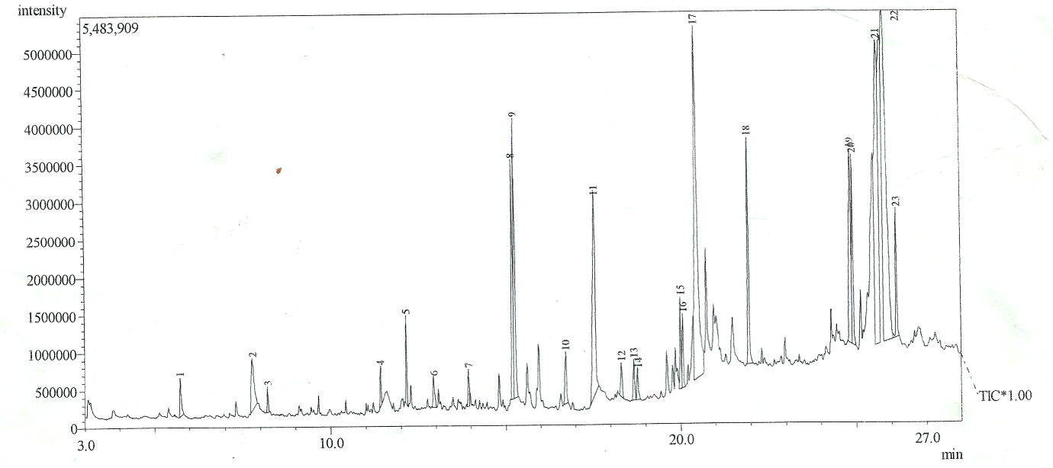
Figure 1: GC-MS Chromatograms of F'4. (n- Hexane: Ethyl acetate - 60:40)3.2.1 Fragmentation Pattern and Structural Elucidation of 2(4H)-Benzofuranone, 5, 6, 7, 7a-tetrahydro-4, 4,7a-trimethyl (C₁₁H₁₆O₂)

R.Time: 11.425mins
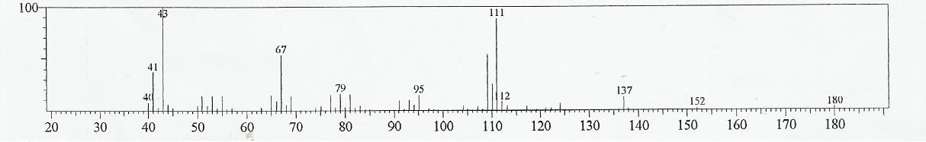
Figure 2: Mass Spectrum of Peak 4 of figure 1

The Fragmentation Pattern of 180,152, 137, 111, 95, 79, 67, 43, 41 and 40 in figure 2a has it thermostatically molecular mass ion and major ion of the fragments as 43. The mass of fragments of the molecular ions loss between these fragmentations are: 28(-CO), 15(CH₃), 26(-CH₂=CH₂, +2H), 16(-CH_{3,} -H), 16(-CH_{3,} -H), 12(-CH +H), 24(-C$≡$C), 2(-2H), 1(-1H), as shown possible in the structure of 2(4H)-Benzofuranone, 5,6,7,7a-tetrahydro-4,4,7a-trimethyl.

Ring opening

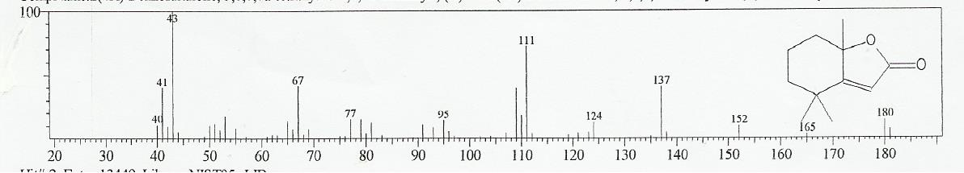
Figure 2b: Corresponding match from the library for figure 2a 2(4H)-Benzofuranone, 5,6,7,7a-tetrahydro-4,4,7a-trimethyl (C₁₁H₁₆O₂)

3.2.2 Fragmentation Pattern and Structural Elucidation of 2-Naphthalene methanol, decahydro-alpha, alpha, 4a-trimethyl-8-methylene (C₁₅H₂₆O)
R. Time: 12. 933mins
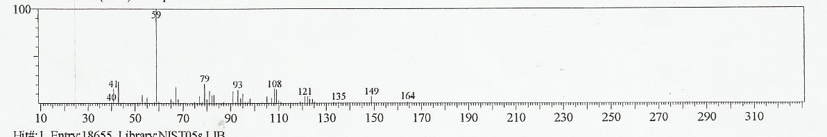
Figure 3: Mass Spectrum of Peak 6 of figure 1

The Fragmentation Pattern of 164,149, 135, 121,108, 93, 79, 53, 41 and 40 in figure 3 has it thermostatically molecular mass ion and major ion of the fragments as 53. The mass of fragments of the molecular ions loss between these fragmentations are: 15(-CH₃), 14(-CH₂), 14(-CH₂), 13(-CH_{2,} +H), 15(-CH₃), 14(-CH₂), 26(-CH$≡$CH), 12(-CH_{2,} +2H), 1(-H), as shown possible in the structure of 2-Naphthalenemethanol, decahydro-alpha, alpha, 4a-trimethyl-8-methylene.

3.2.3 Fragmentation Pattern and Structural Elucidation of Octanal, 2-(phenylmethylene) (C₁₅H₂₀O)

R.Time: 13.933mins
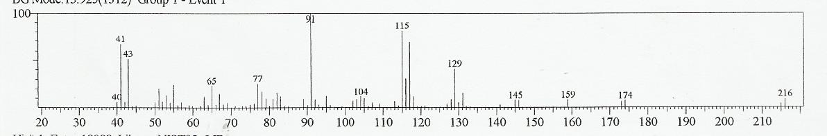
Figure 4: Mass Spectrum of Peak 7 of figure 1

The Fragmentation Pattern of 216,174, 159, 145,129, 115, 104, 91, 77, 65, 43, 41 and 40 in figure 4 has it thermostatically molecular mass ion and major ion of the fragments as 91. The mass of fragments of the molecular ions loss between these fragmentations are: 42(-CH₂-CH₂-CH₂), 15(-CH₃), 14(-CH₂), 16(-CH₂, -2H), 14(-CH₂), 11(-C, +H), 13(-CH), 14(-CH, -H), 22(-C$≡$C, +2H), 2(-2H), 1(-H), as shown possible in the structure of Octanal, 2-(phenylmethylene).

3.2.4 Fragmentation Pattern and Structural Elucidation of Hexadecanoic acid, methylester (C₁₇H₃₄O₂)

R. Time: 16.725mins
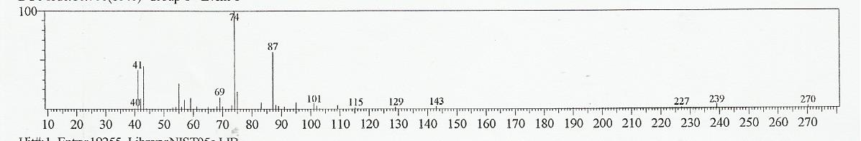
Figure 5: Mass Spectrum of Peak 10 of figure 1

The Fragmentation Pattern of 270,239, 227, 143, 129, 115, 101, 87, 74, 69, 41, and 40 in figure 5 has it thermostatically molecular mass ion and major ion of the fragments as 74. The mass of fragments of the molecular ions loss between these fragmentations are: 31(-OCH₃), 12(-CH_{2,} +2H), 84(-CH₂)₆, 14(-CH₂), 14(-CH₂), 14(-CH₂), 14(-CH₂), 13(-CH₂, +H), 5(-5H), 28(-CH₂=CH₂), 1(-H), as shown possible in the structure of Hexadecanoic acid, methyl ester.

3.2.5 Fragmentation Pattern and Structural Elucidation of Hexadecanoic acid (C₁₆H₃₂O₂)

R.Time:17.575mins
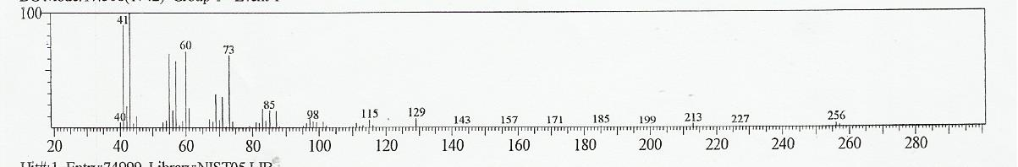
Figure 6: Mass Spectrum of Peak 11 of figure 1

The Fragmentation Pattern of 256, 227, 213, 199, 185, 171, 157, 143, 129, 115, 98, 85, 73, 60, 41 and 40 in figure 6 has it thermostatically molecular mass ion and major ion of the fragments as 43. The mass of fragments of the molecular ions loss between these fragmentations are: 29(-CH₃CH₂), 14(-CH₂), 14(-CH₂), 14(-CH₂), 14(-CH₂), 14(-CH₂), 14(-CH₂), 14(-CH₂), 14(-CH₂), 17(-OH), 13(-CH_{2,} +H), 12(-CH_{2,} +2H), 13(-CH_{2,} +H), 19(H₂O, -H) and 1(-H), as shown possible in the structure of Hexadecanoic acid.

Figure 7: GC-MS Chromatogram of F'10. (Ethyl acetate: Methanol - 70:30)

3.2.6 Fragmentation Pattern and Structural Elucidation of 1, 2, 3-Benzenetriol (C₆H₆O₃)

R. Time: 9.450mins
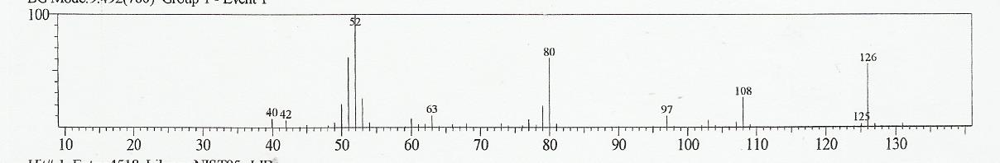
Figure 8: Mass Spectrum of Peak 3 of figure 7

The Fragmentation Pattern of 126, 108, 97, 80, 63, 52, 42 and 40 in figure 8 has it thermostatically molecular mass ion and major ion of the fragments as 52. The mass of fragments of the molecular ions loss between these fragmentations are: 18(-OH, -H), 11(-CH, +2H), 17(-OH), 23(C$=$CH, +2H), 11(CH,+2H),10(CH₂,+4H), 2(-2H), as shown possible in the structure of 1, 2, 3-Benzenetriol.

3.2.7 Fragmentation Pattern and Structural Elucidation of 3, 5-Di-tert-butylphenol (C₁₄H₂₂O)

R. Time: 11.067mins
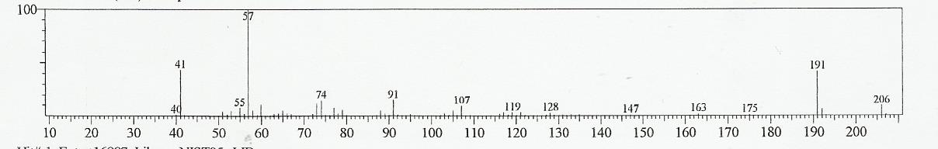
Figure 9: Mass Spectrum of Peak 4 of figure

The Fragmentation Pattern of 206, 191, 175, 163,147, 128, 119, 107, 91, 74, 57, 55, 41 and 40 in figure 9 has it thermostatically molecular mass ion and major ion of the fragments as 57. The mass of fragments of the molecular ions loss between these fragmentations are: 15(-CH₃), 16(-CH_{3,} -H), 12(-CH, +H), 16(-CH₃, -H), 19(-OH, -2H), 9(-9H), 12(-C), 16(-C$≡$C, +8H), 17(-CH_{3,} -2H), 2(-2H), 14(-CH₂), 1(-1H), as shown possible in the structure of 3,5-Di-tert-butylphenol.

3.2.8 Fragmentation Pattern and Structural Elucidation of Benzoic acid, 2- hydroxy-phenylmethyl ester (C₁₄H₁₂O₃)

R. Time: 15.900mins
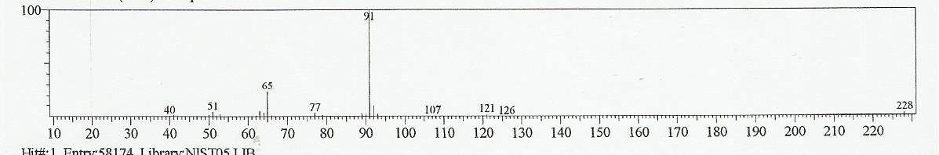
Figure 10: Mass Spectrum of Peak 9 of figure 7

The Fragmentation Pattern of 228, 126, 121, 107, 91, 77, 65, 51 and 40 in figure 10 has it thermostatically molecular mass ion and major ion of the fragments as 91. The mass of fragments of the molecular ions loss between these fragmentations are: 102(C₆H₅CO, +5H), 5(-5H), 14(-CH, -H), 16(-O), 14(-CH, -H), 12(-CH, +H), 14(-CH, -H), 11(-C, +H), as shown possible in the structure of Benzoic acid, 2-hydroxy-phenylmethyl ester.
3.2.9 Fragmentation Pattern and Structural Elucidation of Hexadecanoic acid (C₁₆H₃₂O₂)
R. Time: 17.633mins
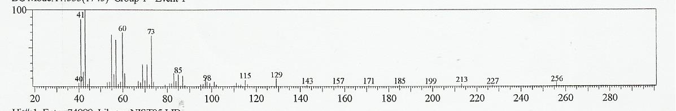
Figure 11: Mass Spectrum of Peak 11 of figure 7

The Fragmentation Pattern of 256, 227, 213, 199, 185, 171, 157, 143, 129, 115, 98, 85, 73, 60, 43, 41 and 40 in figure 11 has it thermostatically molecular mass ion and major ion of the fragments as 43. The mass of fragments of the molecular ions loss between these fragmentations are: 29(-CH₃CH₂), 14(-CH₂), 14(-CH₂), 14(-CH₂), 14(-CH₂), 14(-CH₂), 14(-CH₂), 14(-CH₂), 14(-CH₂), 17(-OH), 13(-CH_{2,} +H), 13(-CH_{2,} +H), 17(-OH), 2(-2H), 1(-H), as shown possible in the structure of Hexadecanoic acid.

3.2.10 Fragmentation Pattern and Structural Elucidation of Octadecanoic acid (C₁₈H₃₆O₂)
R. Time: 20.808mins
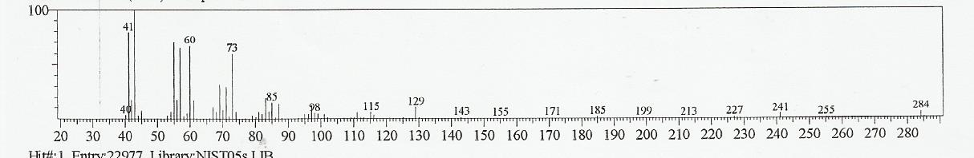
Figure 12: Mass Spectrum of Peak 15 of figure 7

The Fragmentation Pattern of 284, 255, 241, 227, 213, 199, 185, 171, 155, 143, 129, 115, 98, 85, 73, 60, 43, 41 and 40 in figure 12 has it thermostatically molecular mass ion and major ion of the fragments as 43. The mass of fragment loss between these fragmentations are: 29(-CH₃CH₂), 14(-CH₂), 14(-CH₂), 14(-CH₂), 14(-CH₂), 14(-CH₂), 14(-CH₂), 16(-CH_{3,} -H), 12(-CH_{2,} +2H), 14(-CH₂), 14(-CH₂), 17(-OH), 13(-CH_{2,} +H), 12(-CH_{2,} +2H), 13(-CH_{2,} +H), 19(-OH, -2H), 1(-H), as shown possible in the structure of Octadecanoic acid.

3.2.11 Fragmentation Pattern and Structural Elucidation of 9, 12,-Octadecadienoic acid, methyl ester

R.Time: 21.042mins
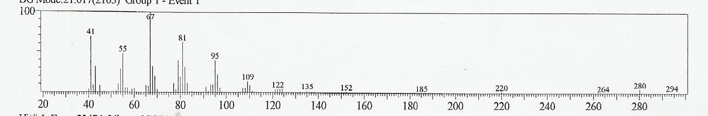
Figure 13: Mass Spectrum of Peak 16 of figure 7

The Fragmentation Pattern of 294, 280, 264, 220, 185, 152, 135, 122, 109, 95, 81, 67, 55, 41 in figure 13 has it thermostatically molecular mass ion and major ion of the fragments as 67. The mass of fragments of the molecular ions loss between these fragmentations are: 14(-CH₂), 16(-CH_{3,} -H), 44(-CH₂C=O, -2H), 35(-OCH₃, -4H), 33(-CH₂-CH_{2,} -4H), 17(-CH_{3,} -2H), 13(-CH_{2,} +H), 13(-CH), 14(-CH₂), 14(-CH₂), 14(-CH₂), 12(-CH_{2,}+2H), 13(-CH), 14(-CH₂), as shown possible in the structure of 9,12,-Octadecadienoic acid, methyl ester.

Figure 14: GC-MS Chromatogram of F'11. (Ethyl acetate: Methanol - 50:50)

3.1.12 Fragmentation Pattern and Structural Elucidation of 4H-Pyran-4-one, 2,3- dihydro-3,5-dihydroxy-6-methyl (C₆H₈O₄)

R. Time: 6.158mins
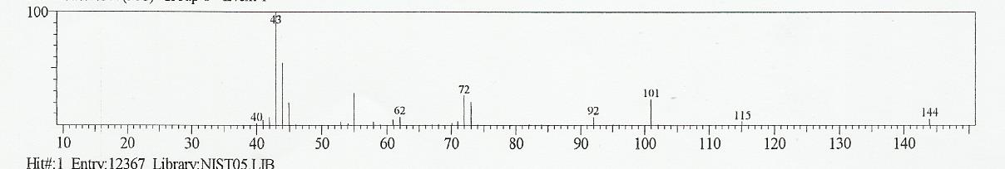
Figure 15: Mass Spectrum of Peak 3 of figure 14

The Fragmentation Pattern of 144, 115, 101, 92, 72, 62, 43, 40 in figure 15 has it thermostatically molecular mass ion and major ion of the fragments as 43. The mass of fragments of the molecular ions loss between these fragmentations are: 29(-C-OH), 14(-CH₂), 9+20(-CH-OH,+H), 10(-CH_{3,}+5H), 19(-OH,-2H), 3(-3H), as shown possible in the structure of 4H-Pyran-4-one, 2,3-dihydro-3,5-dihydroxy-6-methyl.

3.2.13 Fragmentation Pattern and Structural Elucidation of Tetradecanoic acid, methyl ester (C₁₅H₃₀O₂)

R. Time: 13.517mins
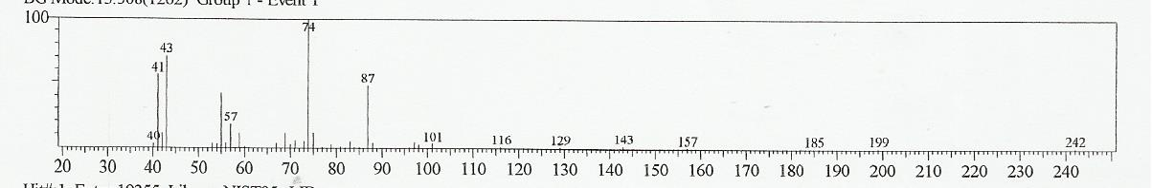
Figure 16: Mass Spectrum of Peak 8 of figure 14

The Fragmentation Pattern of 242, 199, 185, 157, 143, 129, 116, 101, 87, 74, 57, 43, 41and 40 in figure 16 has it thermostatically molecular mass ion and major ion of the fragments as 74. The mass of fragments of the molecular ions loss between these fragmentations are: 43(-C₃H₇), 14(-CH₂), 28(-CH₂=CH₂), 14(-CH₂), 14(-CH₂), 13(-CH_{2,}+H), 15(-CH₃), 14(-CH₂), 13(-CH_{2,} +H), 17(-OH), 14(-CH₂), 2(-2H), and 1(-H), as shown possible in the structure of Tetradecanoic acid, methyl ester.

3.2.14 Fragmentation Pattern and Structural Elucidation of 11-Octadecenoic acid, methyl ester (C₁₉H₃₆O₂)

R. Time: 19.858mins
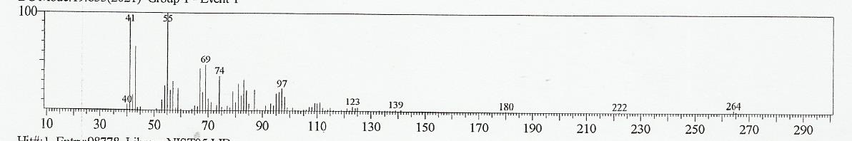
Figure 17: Mass Spectrum of Peak 12 of figure 14

The Fragmentation Pattern of 264, 222, 180, 139, 123, 97, 74, 69, 55, 41 and 40 in figure 17 has it thermostatically molecular mass ion and major ion of the fragments as 55. The mass of fragments of the molecular ions loss between these fragmentations are: 42(-CH₂-CH₂-CH₂), 42(-CH₂C=O), 41(-CH₂-CH₂-CH₂, +H), 16(-CH₃), 26(-CH₂$-$CH₂), 23+5(-CH₂$=$CH₂), 14(-CH₂), 14(-CH₂), 1(-H), as shown possible in the structure of 11-Octadecenoic acid, methyl ester.

3.2.15 Fragmentation Pattern and Structural Elucidation of 5-(p-tert- Butylphenoxymethyl)-3-(2-pyridyl)-2-oxazolidone (C₁₉H₂₂ N₂O₃)

R. Time: 23.542mins
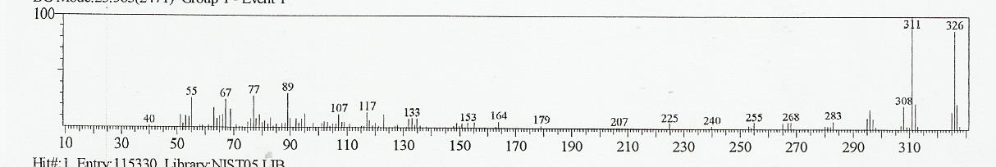
Figure 18: Mass Spectrum of Peak 17 of figure 14

The Fragmentation Pattern of 326, 311, 308, 283, 255, 240,225, 207, 164,153, 133, 117, 107, 89, 77, 67, 55 and 40 in figure 18 has it thermostatically molecular mass ion and major ion of the fragments as 311. The mass of fragments of the molecular ions loss between these fragmentations are: 15(-CH₃), 3(-3H), 25(-CH$≡$CH), 28(-CH₂=CH₂), 15(-CH₃), 15(-CH₂), 18(-CH_{3,} -3H), 43(-CH₃C=O), 11(-CH₂), 20(-OH, -2H), 16(-CH_{3,}-H), 28(-CH₂=CH₂), 12(-CH_{2,} +2H), 10(-CH_{2,} +4H), 12(-CH_{2,}+2H), 15(-CH₃), as shown possible in the structure of 5-(p-tert-Butylphenoxymethyl)-3-(2-pyridyl)-2-oxazolidone.

3.2.16 Fragmentation Pattern and Structural Elucidation of 1,2-Benzenedicarboxylic acid, dioctyl ester (C₂₄H₃₈ O₄)

R. Time: 24.808mins
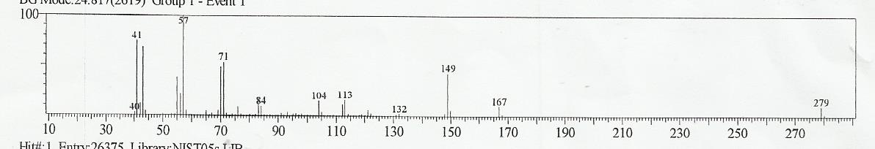
Figure 19: Mass Spectrum of Peak 19 of figure 16 The Fragmentation Pattern of 279, 167,149, 132, 113, 104, 84, 71, 57, 41 and 40 in figure 19 has it thermostatically molecular mass ion and major ion of the fragments as 57. The mass of fragments of the molecular ions loss between these fragmentations are: 112(), 18(-CH_{3,} -3H), 17(-OH), 19(-OH, -2H), 9(-9H), 20(-OH, -3H), 13(-CH_{2,} +H), 14(-CH₂), 16(-CH_{3,}-H), 1(-H), as shown possible in the structure of 1,2-Benzenedicarboxylic acid, dioctyl ester.

4. Discussion
The GC-MS results of Fractions (4, 10 and 11) obtained from Methanol Leaf Extract of Corymbia torelliana with anti-trypanosoma congolense action revealed the presence of hexadecanoic acid and hexadecanoic acid methyl ester as the common compounds. These compounds have approximately the same retention times, molecular mass, mass of fragment lost, major ion of the fragments, fragmentation pattern and thus the mechanisms. This further confirms that they are the same compound and studies have shown that they are used as anti-oxidant, hypocholesterolemic nematicide, pesticide, anti-androgenic flavor, hemolytic, 5-alpha reductase inhibitor (Omotoso et al., 2014; Hema et al., 2011). Previous studies suggest that trypanosomes are more susceptible to cellular damages by activated oxygen species (O₂, OH, H₂O₂) than mammalian cells (Fairlamb, 1982). This forms the basis for the use of nifurtimox and haematoprophyrin as trypanocides (Docampo and Stoppani, 1979).
9,12-octadecadienoic methyl ester, phytol present in the fractions have anti-cancer activity (Omotoso et al., 2014, Hema et al., 2011). 9-octadecenoic acid however, possesses anti-tumour activity (Omotosho et al., 2014). Anti-tumour drugs are screened for trypanocidal action (Williamson and Scott-Finnigan, 1978). Trypanocidal drugs are also screened for anti-cancer activity (Barrett and Barrett, 2000, Ivan et al., 2014)). This is perhaps due to the fact that Hide, (1989) suggested that protozoan parasites, such as those of malaria, trypanosomiasis and leishmaniasis, have a number of features in common with the proliferating cells of cancer and some forms of heart diseases. They appear, for instance, to have molecules that function as uptake points (receptors) for essential nutrients and growth factors that they must acquire from their hosts if they are to survive and thrive. In addition, trypanosomes exhibit antigenic variation, and cancer cells also have the capacity to undergo antigenic modulation (Ouaissi and Ouaissi, 2005). DL-alpha-difluoromethylornithine (DFMO) originally developed for use against cancer has been found to be an effective inhibitor of polyamine synthesis by inhibiting ornithine decarboxylase, an enzyme essential for the growth and multiplication of trypanosomes (Bacchi et al., 1982; McCann et al., 1983).
Anti-inflammatory activity has been ascribed to 9-octadecenoic acid, phytol and 9, 12-octadecadienoic acid. Trypanosomiasis gives rise to the development of inflammatory responses that contribute to the development of inflammation associated with tissue injury. The production of excessive inflammatory cytokines has been implicated in the induction of infection-associated pathogenicity (Mekata et al., 2012).
9,12 -octadecadienoic acid methyl ester is associated with insectifuge activity which can be harnessed as repellent against the tsetse fly, vector of trypanosomes. Avoidance of host-vector has been recommended as a method of choice for the control of vector borne diseases (WHO, 2015).
9-Octadecenamide has been used for the treatment of mood and sleep disorders as well as cannabinoid-regulated depression and for the treatment of atherosclerosis (Mechoulam et al., 1997).
In the second stage of trypanosomiasis infection, the parasites cross the blood-brain barrier to infect the central nervous system; the neurological or meningo-encephalic stage. Changes of behaviour, confusion, sensory disturbances, poor co-ordination, and disturbance of the sleep cycle are typical of the disease (WHO, 2015). Thus the use of the plant material studied in this work would be of some importance in late stage treatment of Human African Trypanosomiasis.
It is obvious that the plant has gained popularity in Nigeria to be widely used as traditional medicine justify by the presence of Phytol. For it is use as a precursor for the manufacturing of synthetic form of vitamins E and K₁ that protect animals against status epilepticus induced pilocarpine and decreased the mortality rate (Costa et al. 2012) and part of chlorophyll (Vetter et al., 2012).
A growing evidence have shown to indicate that octadecanamide mediate fundamental neurochemical process including sleep thermoregulation, nociception, prostaglandins and other lipids (Chaturvedi et al., 2006). 9,12-octadecadienoic acid (antibacterial), octadecanoic acid (antimicrobial, hardener and thickener use as skin cleaner in soap industries) 9,12,15 octadecatrienoic acid methyl ester for antibacterial, anticandidal, antiinflammatory, hypocholesterolemic, cancer preventive, hepatoprotective, nematicide, insectifuge antihistaminic, antiarthritic, anticoronary, antieczemic antiacne, 5-alpha reductase inhibitor antiandrogenic and 2(4H)-Benzofuran-5,6,7,7a-tetrahydro-4,4,7a-trimethyl for antimicrobial (Mujeeb, 2014). 2,2,4,4-tetrametyl-1,3-cyclobutanedione is well known building block for the sterically congested system (Brunck, 2001). These compounds are synergiscally responsible for the activities of the plant which can be harness for the development of our developing countries in the area of pharmacological techniques and economic improvement.

Acknowledgements
Authors acknowledge the support of the technologists in Nigeria Institute of Trypanosomiasis Research Laboratory, Vom and to the technical staff in Federal School Forestry, Jos for their various efforst they have put in to bring out the research study to this conclusion.

Corresponding Author:
Esther OgbolE Biochemistry and Biotherapy Division Nigeria Institute of Trypanosomiasis Research, Vom. Plateau State
Telephone: 08035267117
E-mail: estherogbole@gmail.com

References
- Chammond, N., Cosson, A., Blom-Potter. M.C., Jouvion, G., D’Archivio, S., Medina, M., and Minoprio, P.. Trypanosoma vivax infections: Pushing ahead with mouse models for the study of Nagana. Parasitological, haematological and pathological parameters, 2010. PLoS neglected Tropical Diseases 2010; 4(8): e702. DOI: 10.1371/journal.pntd.0000792.
- Adams, E.R., Hamilton, P.B., Rodrigues, A.C., Malele, I.I., Delespaux, V., Teixeira, M.M. and Gibson, W. New Trypanosoma (Duttonella) vivax genotypes from tsetse flies in East Africa, 2010. Parasitology 2010; 137 (4): 641-650.
- Simarro, P.P; Diarra, A; Ruiz, P; Franco, J. R and Jannin, J. G. The human and African trypanosomiasis control and surveillance programme of the World Health Organization: The way forward, 2011. PLoS Neglected Tropical Diseases 2011; 5(2): e1007. Doi: 10.1371/journal.pntd.0001007.
- World Health Organization. African Trypanosomiasis (Sleeping sickness). Fact sheet, no. 259, 2015. Retrieved August 25, 2016 from www.who.int/mediac centre/factsheets/fs259/en/
5. Houmsou R.S, Amuta E.U and Sar T.T. Profile of an epidemiological study of urinary schistosomiasis in two local government areas of Benue state, Nigeria. Int J Med Biomed Res 2012;1:39-48.
- Kamga, H.L.F., Assob, N.J.C., Nsagha, D.S., Njunda., A.L. and Njimoh, D.L. A community survey on the knowledge of neglected tropical diseases in Cameroon, 2012. Int J Med Biomed Research 2012;1(2):131-140.
- Daben, M.R., Mwansat, G.S. and Njila, L.H. The treatment-seeking behavior and economic burden of urinary schistosomiasis infection amongst Fadama farmers in Bassa, Plateau State, Central Nigeria, 2015. Int J infect Trop Dis, 2015;3(2):36-43.
- Beyene, H.B., Alemu, M. and Degife, M. Prevalence and clinical features of cutaneous leishmaniasis in Dembidolo District, Western Ethiopia: A cross-sectional study, Int J Infect Trop Dis 2015;2(1):31-38.
9 Essam A, Scattar F, Harraz S, Man M.A, Al-Ansari Chikara I, Hiroaki K, Kazuhiko O, Satoshi O. and Haruk Y. Antiplasmodial and antiantitrypanosomal activity of plants from the Kingdom of Saudi Arabia. Journal of Natural Medicine 2009;63:232-239.
- Adeniyi B.A. and Ayepola O. O. The Phytochemical Screening and Antimicrobial Activity of Leaf Extracts of Eucalyptus camaldulensis and Eucalyptus torelliana (Myrtaceae). Research Journal of Medicinal Plants, 2008; 2: 34-38.
- Coffi K., Soleymane K., Harisolo R., Balo T., Claude C.J., Pierre C., Gilles F. and Antoine A. Monoterpene Hydrocarbons, Major Components of the Dried Leaves Essential Oils of Five Species of the Genus Eucalyptus from Côted’Ivoire. Natural Science, 2012; 4(2): 106-111.
- Pinto G., Correia S., Corredoira E., Ballester A., Correia B., Neves L. and Canhoto J. In Vitro Culture of Eucalyptus: where do we stand? In Park Y., Bonga J.M. and Moon H. (Eds.), Vegetative Propagation of Forest Trees. (National Institute of Forest Science (NIFoS) Seoul, Korea. 2016); 507-532.
- Ololade Z.S and Olawore N.O. Chemistry and Medicinal Potentials of the Seed Essential Oil of Eucalyptus torelliana F.Muell Grown in Nigeria Global Journal of Science Frontier Research Chemistry, 2013; 13(3):1-11.
- Alian A.G., Felician A., Boniface Y., Alian K.Y., Chantal M. and Dominique S. Chemical and Biological Investigation of Leaves of Eucalyptus torelliana Essential Oil from Benin. International Research Journal of Biological Science, 2012; 1(5): 6-12.
- Chalchat J.C., Gary R.P., Sidibe L. and Harama M. Aromatic Plant of Mali (v): Chemical composition of four Eucalyptus species implanted in Mali E. Camaldulensis, E. torelliana, E. citriodora, E.tereticornis. J of Ess Oil Res, 2000; 12: 695-701.
- Farah A., Fechtal M., Chouch A. and Zarira S. The Essential Oil of Eucalyptus camaldulensis and its Natural Hybrid (clone 583) from Morocco. Flav Fragr J, 2002; 17: 395-397.
- Adeniyi A.G., Odufowoke R.O. and Olaleye S. B. Antimicrobial and Gastroprotective properties of Eucalyptus torelliana (Myrtaceae) Crude extracts. Intl J Pharmac, 2006; 2:362-365.
- Ben-Hadj A.S., Sghaier R. M., Guesmi F., Kaabi b., Mejri M., Attia H., Laouini D. and Smaali I. Evaluation of Antileishmanial Cyctotoxic and Antioxidant Activities of Essential Oils Extracted from Plants Issued from the Leishmaniasis-endemic Region of Sned (Tunisia). Nat Prod Res,25:2011, 1195-1201.
- Caballero-Gallardo K., Olivero-Verbel J. and Stashenko E.E. Repellent Activity of Essential Oil and Some of Their Individual Constituents Against Tribolium castaneum Herbs. J Agric Food Chem, 2011; 59: 1690-1696.
- Elaissi A., Rouis Z., Salem N.A.B., Mabrouk S., Salem Y.B., Salah K.B.H., Aouni M., Farhat F., Chemli R., Harzallah-Skhiri F. and Khouja M.L Chemical Composition of Eight Eucalyptus Species Essential Oils and the Evaluation of Their Antibacterial Antifungal Antiviral Activities. BMC Compl and Alter Med.12:81.
- Dashak, D. A., Daben, J. M., Olaoye, F.M., Agunbiade, A.T. And Ogbole, E.Evaluation of the Essential Oils Constituents from the Leaves, Seed Buds and Fruits of Eucalyptus torelliana F. Muel Plant by Gas Chromatography-Mass Spectral Analysis. IOSR Journal of Applied Chemistry, 2016; 9(10): 45-60.
- Ogbole E, Dashak DA, Nvau JB, Daben MR, Abongaby G, Obaloto OB, Oladipo OO, Igweh AC Phytochemical screening and in vitro evaluation of the antitrypanosomal action of the methanolic leaf extract of Corymbia torelliana. International Journal of Ethnomedicine and Pharmacology 2016;3(1): 20-29.
- Harborne, J.B. (1991). Phytochemical methods. A guide to modern techniques of plant analysis. 2nd ed. Chapman and Hall, London, pp 17-20.
- Silverstein R. M., Bassler G. C. and Morrill T.C. Spectrometric Identification of Organic Compounds. John Wiley and Sons Inc. (NY) Third Edition 1974.
- Lee T.A. A Beginner’s Guide to Mass Spectral Interpretation. John Wiley and Sons Inc. (NY), 1998.
- Omotoso, A.E. Eseyin, O.O. and Suleiman, M. (2014). Phytochemical analysis of Cnidoscolus aconitifolius (Euphorbiaceae) leaf with spectrometric techniques. Nigerian Journal of Pharmaceutical and Applied Science Research, 3(1): 38-49.
- Hema, R., Kumaravel, S. And Lagusundaram, A. (2011). GC/MS determination of bioactive components of Murraya koenigii. Journal of American Science; 7(1)
- Fairlamb, A.H. Trends Biochem. Sci. 1982; 7, 249-253 McCann, P.P., Bacci, C.J., Nathan, H.C. and Sjoerdsma, A. 1983. Difluoromethyornithine and the rationale development of polyamine antagonism in the cure of protozoa infection. In: Mechanism of Drug Action. Eds. P. Singer, T.E. Mansur and R.N. Underza, Orlando, F.A. USA. Academic press. Pp. 159-173.
- Docampo, R. and Stoppani, A.O. Generation of superoxide anion and hydrogen peroxide induced by nifurtimox in Trypanosoma cruzi. Arch Biochem Biophys. 1979; 197(1):317-321.
- Williamson, J. And Scott-Finnigan, T.J. Trypanocidal activity of antitumour antibiotics and other metabolic inhibitors. Antimicrobial Agents and Chemotherapy, 1978;13:735-744.
- Barret SV and Barret MP. Anti-sleeping sickness drugs and cancer. Chemotherapy and Parasitology Today 2000;16: 7-9.
- Ivan, S., Pablo, T., Juan, C. E., Natalia, Q., Mauricio, A.C., Juan, V., Christian, E., Angelica, F., Ricardo, A.T., Juan, D.M., Rodrigo, L., Bruce, K.C., Ramon, J.E. and Christian, O.S. 2-Phenylaminonaphthoquinones and related compounds: Synthesis, trypanocidal and cytotoxic activities. Bioorganic & Medicinal Chemistry 2014; 22 (17):4609-4620.
- Hide, G. Growth Factor Receptors in Trypanosomes in Application of Modern Technology to African Trypanosomiasis, Gray A. Keith, K. Tait, A. (eds). University of Glasgow, 1989: 13-14.
- Ouaissi, A. And Ouaissi, M. Molecular basis of Trypanosoma cruzi and Leishmania interaction with their host(s): Exploitation of immune and defense mechanisms by the parasite leading to persistence and chronicity, features reminiscent of immune system evasion strategies in cancer diseases. Arch Immunol Ther Exp, 2005;53:102-114.
- Bacci, C.J., Nathan, H., McCann, P.P. and Hutner, S.H. 1982 In vivo biochemical effects of DL-alpa-difluoromethylornithine on Trypanosoma brucei brucei. Molecular and Biochemical Parasitology. Supplement: Parasites – their world and ours, 1982; 186.
- McCann, P.P., Bacci, C.J., Nathan, H.C. and Sjoerdsma, A. 1983. Difluoromethyornithine and the rationale development of polyamine antagonism in the cure of protozoa infection. In: Mechanism of Drug Action. Eds. P. Singer, T.E. Mansur and R.N. Underza, Orlando, F.A. USA. Academic press. Pp. 159-173.
- Mekata, H., Konnai, S., Mingala, C.N., Abes, N.S., Gutierrez, C.A., Dargantes, A.P., Witola, W.H., Inoue, N., Onuma, M., Murata, S. and Ohashi, K. Kinetics of regulatory dendritic cells in inflammatory responses during Trypanosoma evansi infection. Parasitology Immunology 2012; 34(6):318-329.
- Mechoulam, R., Fride Ester, Hanu, L. Sheskin, T., Bisogno, T., Marzo, V., Bayewitch, M. and Vogel, Z. Anandamide may mediate sleep induction. Nature International weekly Journal of Science. Nature, 1997; 389: 25-26.
- Kilulya, K. F., Msagati., T.A.M., Mamba., B.M., Ngila, J.C. and Bush, T. 2012 Ionic Liquid-Liquid extraction and supported liquid membrane analysis of lipophilic wood extractives from dissolving pulp. Chromatographia, 2012; 75:513-.520.
- Costa JP, Ferreira PB, De Sousa DP, Jordan J & Freitas RM Anticonvulsant effect of phytol in a pilocarpine model in mice. Neuroscience letter, 2012; 523(2): 115-118.
- Vetter W, Schröder M & Lehnert K Differentiation of refined and virgin edible oils by means of the trans- and cis-phytol isomer distribution. Journal of Agriculture and Food Chemistry, 2012; 60(24): 6103-6107.
- Chaturvedi S, Driscoll WJ, Elliot BM, Faraday MM, Grunberg NE & Mueller GP In vivo evidence that N-oleoylglycine act independently of its conversion to oleamide. Prostaglandins and other Lipid Mediat, 2006; 81(3-4): 136-149.
- Mujeeb F, Bajpai P & Pathak N (2014) Phytochemical evaluation, antimicrobial activity and determination of bioactive compounds from leaves of Aegle marmelos. BioMed Research International Available at: http://dx.doi.org/10.1155/2014/497606 (accessed 25 March 2016).
- Brunck JS, Koch A, Grzegorz M, Lehnhoff S, Margaretha P, Prakash GKS, Rasul G, Bau R & Olah GA 1,2 addition of TMS-CF3 TMS-CN to serially crowded 2,2,4,4-tetramethyl-1-3-cyclobutanedione. Journal of Indian Institute of Science, 2001; 81: 227-237.

4/22/2017

